CSS Interview & Revision Notes
Quick-reference: concepts, syntax & examples

1. What is CSS?
- CSS = Cascading Style Sheet — a styling language (not a programming language).
- Used to give style to an HTML document.
- HTML → structure, CSS → style, JS → logic.

2. Basic Syntax
selector {
property: value;
}
- Example:
h1 {
color: red;
}
Always end a declaration with a semicolon — it won't error without it, but it's best practice.

3. Ways to Include CSS
Method | Syntax / Notes
Inline | <h1 style="color: red">Apna College</h1>
Internal (<style> tag) | <style>h1 { color: red; }</style> — inside <head>
External Stylesheet | Separate .css file linked via <link> — BEST PRACTICE
Priority (specificity of source): Inline > Internal > External. Inline style always overrides the other two.

4. Color Properties

color — sets foreground (text) color
color: red;
color: blue;

background-color — sets background color
background-color: pink;
background-color: green;

Color Systems
System | Example
Named colors | red, blue, green
RGB | rgb(255, 0, 0)
Hex | #ff0000
Use an online color-picker tool instead of memorizing hex/RGB values.

5. Selectors
Selector | Syntax | Selects
Universal | * { } | All elements
Element | h1 { } | All <h1> elements
Class | .myClass { } | Elements with class="myClass"
ID | #myId { } | Element with id="myId"

6. Text Properties
- text-align:
  - left / right / center / start / end
  - Aligns relative to the PARENT container, not the page.
- text-decoration:
  - underline / overline / line-through / none
  - Can also set style (wavy, dotted) & color. Use 'none' to remove hyperlink underline.
- text-transform:
  - uppercase / lowercase / capitalize / none
- font-weight:
  - normal / bold / bolder / lighter
  - Or numeric: 100–900 (controls thickness/darkness)
- font-family:
  - font-family: arial, roboto; — comma-separated fallback list
  - Generic families: serif, sans-serif, monospace, cursive, fantasy
- line-height:
  - line-height: 3; (unitless, multiplier) or line-height: 20px;

7. Units in CSS

Absolute — pixels (px)
font-size: 16px;
96px = 1 inch. Pixels are the most used unit. (cm, mm, in also exist but rarely used on screen.)

8. Box Model

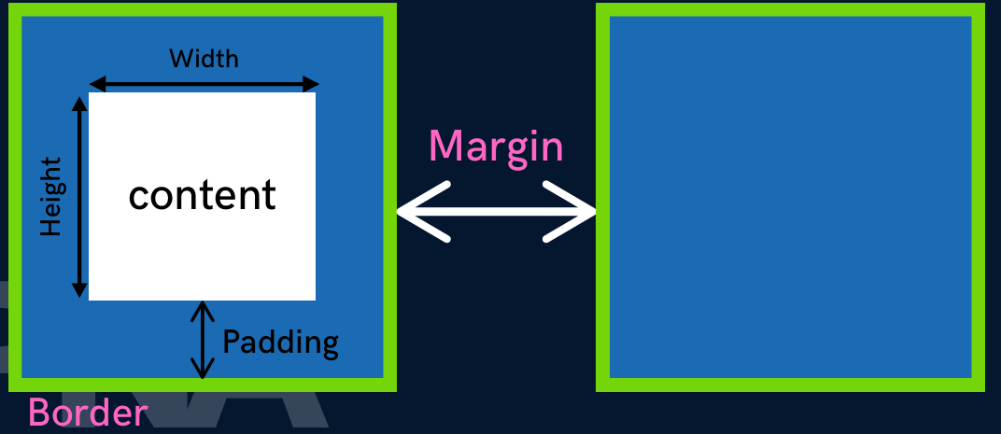
Every element is a box made up of (from inside out): Content → Padding → Border → Margin.
Property | Purpose
width / height | Sets size of the CONTENT area
padding | Space between content and border (inside the box)
border | Line around the padding/content
margin | Space outside the border, between this box and others

Height & Width
div {
height: 50px;
width: 50px;
}

Border
border-width: 2px;
border-style: solid; /* dotted | dashed */
border-color: black;
/* Shorthand */
border: 2px solid black;

Border Radius (rounded corners)
border-radius: 10px;
border-radius: 50%; /* makes a circle on a square box */

Padding
padding-top: 10px;
padding-right: 10px;
padding-bottom: 10px;
padding-left: 10px;
/* Shorthand */
padding: 50px; /* all sides */
padding: 1px 2px 3px 4px; /* top right bottom left (clockwise) */

Margin
margin-top: 10px;
margin-right: 10px;
margin-bottom: 10px;
margin-left: 10px;
/* Shorthand */
margin: 50px; /* all sides */
margin: 1px 2px 3px 4px; /* top right bottom left (clockwise) */
Shorthand order for both padding & margin (4 values) = top | right | bottom | left, going clockwise.

9. Display Property
display: inline / block / inline-block / none;
Value | Behavior
inline | Takes only the space required by content. No margin/padding effect.
block | Takes full width available.
inline-block | Like inline, but margin & padding DO work.
none | Removes element from document flow entirely (no space reserved).

10. Visibility
visibility: hidden;
visibility:hidden → element is hidden but its space is still reserved. display:none → no space is reserved at all. This is the key interview distinction.

11. Alpha Channel (RGBA)
opacity ranges from 0 (transparent) to 1 (opaque). The 4th value in rgba() controls this alpha channel.
color: rgba(255, 0, 0, 0.5); /* 50% transparent red */
color: rgba(255, 0, 0, 1); /* fully opaque red */

12. Units in CSS — Relative
Unit | Relative to
% | Size relative to the parent element (e.g. width: 33%).
em | Parent's font-size (for font-size itself) OR the element's own font-size (for other properties like width).
rem | Root element's (<html>) font-size — consistent regardless of nesting.
vh / vw | 1% of the viewport height / width respectively.
width: 33%;
margin-left: 50%;
font-size: 0.5em; /* half of parent's font-size */
font-size: 1.5rem; /* 1.5x the root font-size */
Prefer rem for consistent sizing across nested elements, since it always refers back to the root, not intermediate parents.

13. Position
The position property sets how an element is positioned in the document.
position: static / relative / absolute / fixed / sticky;
Value | Behavior
static | Default. top/right/bottom/left/z-index have NO effect.
relative | Positioned relative to its own normal position. top/right/bottom/left work.
absolute | Positioned relative to nearest positioned ancestor. Removed from normal flow.
fixed | Positioned relative to the browser viewport. Removed from flow; stays on scroll.
sticky | Toggles between relative & fixed based on scroll position.

14. z-index
Controls the stack (layering) order of overlapping elements — higher z-index sits on top of lower ones.
z-index: auto; /* default, treated as 0 */
z-index: 1;
z-index: -1;
z-index only works on elements with a position value other than static.

15. Background Image & Size
background-image: url("image.jpeg");
background-size: cover / contain / auto;
Value | Behavior
cover | Fills the box completely, no empty space (may crop image).
contain | Fits the whole image inside the box (may leave empty space).
auto | Uses the image's original size.

16. Flexbox (Flexible Box Layout)
A one-dimensional layout method for arranging items in rows or columns. Set display: flex on the container first.
Term | Meaning
flex container | The parent element with display: flex.
flex item | Direct children of the flex container.
main axis | The primary direction items are laid out (row or column).
cross axis | Perpendicular to the main axis.

flex-direction (on container)
flex-direction: row; /* default */
flex-direction: row-reverse;
flex-direction: column;
flex-direction: column-reverse;

Other Container Properties
Property | Purpose
justify-content | Alignment along the MAIN axis: flex-start / flex-end / center / space-evenly / space-between / space-around
flex-wrap | nowrap / wrap / wrap-reverse — whether items wrap to new lines
align-items | Alignment along the CROSS axis for all items
align-content | Alignment of space between/around lines along the cross axis (multi-line only)

Flex Item Properties
Property | Purpose
align-self | Overrides align-items for ONE individual flex item
flex-grow | How much an item grows relative to others when space is available (0 = no growth)
flex-shrink | How much an item shrinks relative to others when space is tight
align-self overrides align-items for that specific item — this is a common interview question.

17. Media Queries
Media queries help create a responsive website — one that adapts its layout to different screen sizes, devices, and orientations.
@media (min-width: 600px) {
div {
background-color: red;
}
}

Combining Conditions
@media (min-width: 200px) and (min-width: 300px) {
div {
background-color: red;
}
}
min-width means 'from this width upward'; plain width matches only that exact breakpoint context — min-width/max-width are used far more often in practice.

18. Transitions
Transitions define a smooth change between two states of an element (e.g. on hover).
Property | Purpose
transition-property | Which property to animate (font-size, width, etc.)
transition-duration | How long the transition takes: 2s / 400ms
transition-timing-function | Speed curve: ease-in / ease-out / linear / steps
transition-delay | Wait time before transition starts: 2s / 400ms

Shorthand
/* property | duration | timing-function | delay */
transition: font-size 2s ease-in-out 0.2s;

19. CSS Transform
Applies 2D & 3D transformations to an element.
Function | Example | Effect
rotate | transform: rotate(45deg); | Rotates the element by an angle
scale | transform: scale(2); / scale(0.5); / scale(1, 2); | Resizes element (single value = both axes; two values = x, y)
scaleX / scaleY | transform: scaleX(0.5); | Scales only one axis
translate | transform: translate(20px, 50px); | Moves the element (x, y offsets)
translateX / translateY | transform: translateX(20px); | Moves along one axis only
skew | transform: skew(30deg); | Slants/shears the element

20. Animation
Used to animate CSS elements through defined keyframes.
@keyframes myName {
from { font-size: 20px; }
to { font-size: 40px; }
}
/* or using percentages for more control */
@keyframes myName {
0% { font-size: 20px; }
50% { font-size: 30px; }
100% { font-size: 40px; }
}

Animation Properties
- animation-name
- animation-duration
- animation-timing-function
- animation-delay
- animation-iteration-count
- animation-direction

Shorthand
/* name | duration | timing-function | delay | iteration-count | direction */
animation: myName 2s linear 3s infinite normal;

21. Quick Interview Recall
- CSS = Cascading Style Sheet → styles HTML content.
- 3 ways to add CSS: inline, internal (<style>), external (.css file) — external is best practice.
- Inline style has highest priority (overrides internal & external).
- Color can be set via name, RGB, or Hex.
- 4 core selectors: universal (*), element, class (.), id (#).
- Box Model order (inside→out): content → padding → border → margin.
- border-radius: 50% turns a square box into a circle.
- Shorthand (padding/margin/border) saves lines — remember clockwise order: T R B L.
- text-align aligns relative to parent, not the browser window.
- display:none removes space; visibility:hidden keeps space reserved.
- inline elements ignore margin/padding; inline-block respects them.
- rem is relative to root font-size; em is relative to parent (or own) font-size.
- position:absolute removes element from flow, positions relative to nearest positioned ancestor.
- position:fixed → relative to viewport, stays fixed on scroll; sticky → toggles relative/fixed on scroll.
- z-index only works when position is NOT static.
- background-size: cover crops to fill; contain fits fully without cropping.
- Flexbox is one-dimensional (row OR column); set display:flex on the container first.
- justify-content aligns along the main axis; align-items aligns along the cross axis.
- align-self overrides align-items for a single flex item.
- Media queries use min-width/max-width to make layouts responsive to screen size.
- Transition shorthand order: property | duration | timing-function | delay.
- transform functions: rotate, scale/scaleX/scaleY, translate/translateX/translateY, skew.
- Animation needs @keyframes (from/to or 0%-100%) PLUS the animation property to apply it.
- Animation shorthand order: name | duration | timing-function | delay | iteration-count | direction.

