Trust Dynamics in Multi-Agent Strategic Interaction: A Simulation Study of Bayesian Reputation Systems in 8-Player Limit Texas Hold’em
Rachit Agrawal
Independent research, 2025–2026.
Correspondence: rachit.agrawal@sahyadrischool.org
Abstract
Reputation systems that infer trustworthiness from observed behavior are widespread in online marketplaces, social networks, and financial platforms, where prior empirical work [1], [2] documents a transparency paradox: agents with perfectly visible cooperative records sometimes earn lower returns than agents with imperfect records. We provide a controlled generative test of this dynamic in a simulation of 8-player fixed-limit Texas Hold’em poker in which every agent maintains a categorical posterior over the archetype of every other agent and updates it after each observed action. We deploy four agent architectures against the same game environment and posterior: frozen rule-based archetypes, bounded online hill-climbing, large-language-model role-players, and language models augmented with chain-of-thought, per-opponent memory, and self-updated strategy notes. Across 5 random seeds per phase, the Pearson correlation between trust and final stack falls along a four-tier ladder ($r_{tp}=−0.752±0.073$; $−0.637±0.125$; $−0.510±0.268$; $−0.094±0.301$); the 95% bootstrap interval for the final tier is $\left[−0.32,+0.20\right]$, consistent with substantial but not necessarily complete attenuation. A sub-experiment with unbounded hill-climbing at $11×$ greater parameter drift shifts the correlation by only $+0.028$, evidence against the hypothesis that the trap is a bound-box artifact in this simulation. We interpret the results as preliminary evidence that, in our zero-sum testbed, observation-based reputation rewards exploitation under simple agent policies and that reasoning scaffolds substantially attenuate the effect; whether the attenuation reflects a structural property of reasoning or a small-sample artifact of the Phase 3.1 run ($n=5$ seeds, 150 hands/seed) is left to a larger replication.

1 Introduction
Trust is a fundamental part of human society that is the foundation for human interactions that we have every day. Every business deal, every bank loan, every purchase, and even every relationship is built on trust. This is also reflected by modern-day systems, for example: Amazon shows product reviews, banks check credit scores before lending out loans, and Reddit ranks posts by community voting. Picture this: There are two real estate development firms. The first one is working on their first project; they are new in the market. The second one is an established firm with good reviews and a good history. Now, who would you trust with your life savings to build your dream home? You see, visible reputation systems seem like a win-win. It is easy for you to make the right decision while the trusted agents are rewarded.
Here is the breaking point: this transparency comes with a contradiction. A trusted agent is almost by definition always predictable. When it is right to cooperate, they cooperate, and because everyone knows this in an open environment, the opponent can plan around them. This is what was observed in the real world: eBay sellers with a perfect rating earned lower profit margins than those with a slightly imperfect record [1], [2]. The reason was that buyers knew the perfect-rated seller would not risk their perfect score, so the listed price was the lowest they would go. Sellers with imperfect records were not bound by this. Predictability could be exploited [3].
We wanted to answer this question but in a controlled environment where we tampered with each of the features, like the rules, the agents, and the trust dynamics between them, and saw for ourselves how they would affect the outcome. While we could draw conclusions from real economic data, we could not run controlled experiments on them; therefore, we settled on running computer simulations. We asked whether reputation systems that infer trust from behaviour ended up rewarding exploitation. Was the system’s loss of trust economically optimal? Was the answer more dependent on the design of the trust system or the design of the characters themselves?
Poker turned out to be the perfect environment to try this. Each hand was a set of interactions that mapped directly to real-life interactions—while there was some hidden information (for example, a player’s private cards), public actions (bets, calls, and folds) were visible to everyone at the table. Fixed-limit Texas Hold’em was the way to go, where both the bet sizes and action spaces were small enough to make the math tractable but also rich enough for these strategies to emerge. Please note that poker is only the behavioural microscope and not a benchmark to solve.
Specifically, we built a poker simulation using eight players in which each player embodied a distinct playing style. Each agent maintained a perception about the others with a probability distribution to understand whether the opponent is a “tight player who only plays strong hands” or a “loose maniac who bets with a deuce-seven”, and so on. After every action, the agents updated their belief systems. Trust was the honesty we expected from an opponent according to our level of confidence in their archetype. We calculated the Pearson correlation between the economic return earned and the trust coefficient. We varied the nature of the agents, starting relatively simple and becoming more complex. The game and the trust system were the same across phases; only the agents changed. This study could not have been possible without the established work presented in the following section.

2 Background
There are four important predecessors that provide the background for this study. We will go through them in the order in which they bear on the design of our simulation.
Within the empirical economics of online reputation systems, one of the first papers to study what would become known as the transparency paradox on a large scale was Resnick and Zeckhauser’s study of eBay [1]. While sellers with perfect feedback scores tended to earn lower profit margins, sellers with slightly imperfect records did not. The reason for this is simple. If a seller always cooperates, they do not move from the listed price. Negative reviews would threaten the seller’s perfect record, so buyers rightly conclude that this seller will never do anything that would pose a threat to their reputation by, say, offering a better price for the books or going above and beyond on returns. That leaves the buyer in the better bargaining position. Bolton, Katok, and Ockenfels [2] later tried to replicate this in games with controlled trust. A similar dynamic is reflected in the microstructures of financial markets. Adverse selection against predictable market-makers [3] produces the same qualitative patterns not by reputation per se but through information asymmetry. This mechanism is observational but consistent: visible cooperation can be exploited when opponents can act around it. Therefore, it provides evidence for the presence of this effect in real-world marketplaces too. What it cannot tell us is whether the effect would persist if the cooperative actors were smarter, since these studies do not typically re-engineer the seller population.
Concept | Description
Hole cards | The two private cards each player is dealt at the start of every hand; only that player can see them.
Community cards | Up to five face-up cards shared by everyone at the table; players combine these with their hole cards to form a 5-card hand.
Betting rounds | Four sequential rounds per hand: preflop (no community cards yet), flop (three community cards revealed), turn (one more), and river (the fifth and final).
Actions | At each turn a player may fold (give up the hand), check (pass without betting, only if no one has bet), call (match the current bet), bet (open the wagering), or raise (increase an existing bet).
Bet sizing (this paper) | Small bet 2 chips on preflop and flop; big bet 4 chips on turn and river; no more than four raises per round (the “four-bet cap”).
Blinds | Forced bets: small blind 1 chip and big blind 2 chips, posted by the two seats clockwise of the dealer and rotating each hand.
Pot | The accumulated chips at stake in a hand. The winner of the hand collects the pot.
Showdown | End-of-hand reveal: surviving players turn over their hole cards and the strongest 5-card combination wins. A hand that ends with everyone folding never reaches showdown.
Stack | The chips a player has in front of them; depleting to zero triggers a rebuy in our setup.
The next line of work is the computation of cooperation in games with repeated interactions. Before continuing it is worth introducing the Prisoner’s Dilemma directly, since it is the canonical setting in which the tension between cooperation and exploitation has been studied. The setup is symmetric: you and one other player each face a single choice between cooperating and cheating. If you cooperate, you give up a small immediate cost so that the other player receives a larger benefit; if you cheat, you keep your cost but the other player gets nothing. The other player faces the same choice at the same time. Figure 1 shows the setup, in the framing of Nicky Case’s Evolution of Trust interactive: mutual cooperation yields $+2$ each, mutual cheating yields $0$ each, and unilateral cheating against a cooperator yields $+3$ to the defector and $−1$ to the cooperator. The “rational” move for either player in isolation is to cheat (cheating dominates cooperating regardless of what the other player does), but mutual cheating leaves everyone worse off than mutual cooperation would.
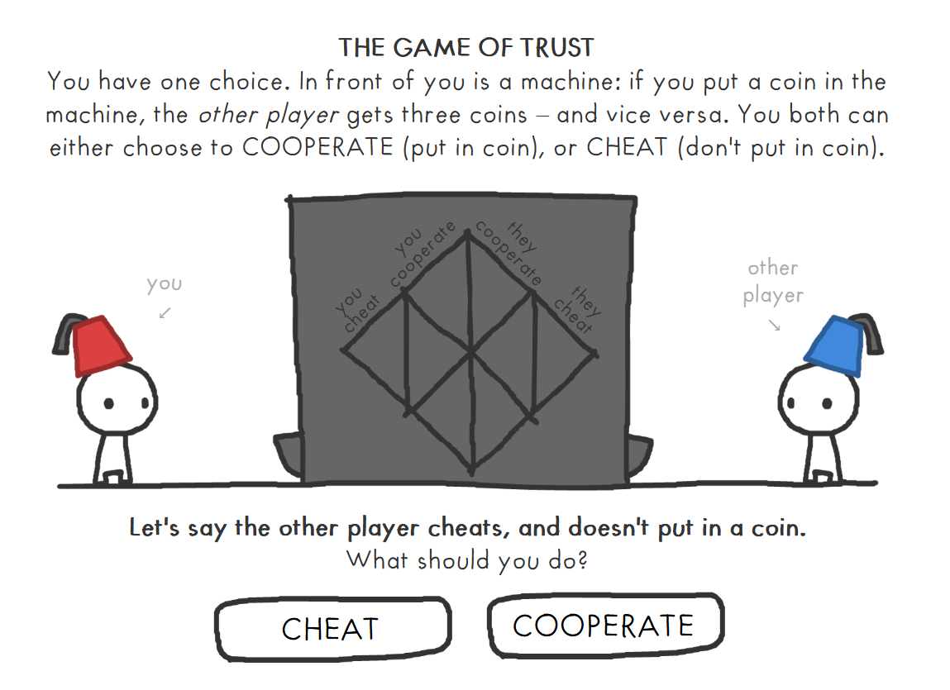
Figure 1. The Prisoner’s Dilemma, as a game of trust. A screenshot of the cooperate/cheat setup from Nicky Case’s Evolution of Trust interactive: putting a coin in the machine costs you one coin but gives the other player three. Mutual cooperation therefore pays $+2$ each, mutual cheating $0$ each, and unilateral cheating against a cooperator pays $+3$ to the defector against $−1$ to the cooperator.
This dilemma was studied extensively by Axelrod through his tournaments in the Prisoner’s Dilemma [4] and Nowak’s five rules for cooperation [5]. They were able to demonstrate that the reciprocal strategies selected, like Tit-for-Tat, were robustly successful in one-on-one interactions with simple payoff structures, in which an agent that cooperates by default and punishes defections one-for-one does well in the long run against most opponents. This line of work validates our intuition that cooperation is a strategy of competition, but this falls apart due to two assumptions that do not hold true anymore in our setting. Firstly, the interactions are no longer one-on-one; they are eight-way, so the cost of one agent’s aggression is spread across seven different opponents. Secondly, the action space is much richer than the Prisoner’s Dilemma’s binary. Poker allows folding, calling, raising, bluffing, and slow-playing, which gives many more degrees of freedom to extract value. The parallel for Tit-for-Tat in our case is the archetype Mirror, which appears in sixth place in the stack-size ordering. This could be a sign that the results of Axelrod’s tournament are not directly applicable to environments with multiple agents and richer action spaces. However, we consider this to be suggestive rather than conclusive.
The third line of work is the modelling of Bayesian opponents in poker, starting with Billings et al.’s Loki and Poki bots [6], only to be later formalised by Southey et al. [7] as Bayesian type inference. This was later generalised by Ganzfried and Sandholm [8]. Finally, Carnegie Mellon University’s superhuman bots, Libratus and Pluribus [9], [10], show superhuman play in heads-up and six-player no-limit Texas Hold’em. However, where that differs from our work is that it was inclined to find the optimal or safely exploitative play, trying to maximise profits. We are not trying to play well; we merely borrow the type-inference machinery and use poker as a controlled testbed for studying how trust dynamics emerge when the inference is correct, transparent, and visible. The poker engine here is merely a microscope and not a competitor.
The last and final line of work matters because two of our phases use large language models. A small but increasing number of studies question whether LLMs deployed as agents in competitive and observable settings actually act strategically or simply reproduce the textual form of a strategy. Park et al.’s generative agents [11] and updated negotiation and game-playing benchmarks [12] suggest that the question is yet unanswered. Phases 3 and 3.1 are designed directly to test this.

2.1 Mathematical concepts used throughout
Two quantitative tools recur in every part of the analysis, and we introduce them once here so the rest of the paper can use them without further build-up.
The first is the Pearson correlation coefficient. Given $n$ paired observations $\left(x_{i},y_{i}\right)$ with sample means $\overset{‾}{x}$ and $\overset{‾}{y}$, it is defined as
$$r=\frac{\sum_{i=1}^{n}{\left(x_{i}−\overset{‾}{x}\right)}\left(y_{i}−\overset{‾}{y}\right)}{\sqrt{\sum_{i=1}^{n}{{\left(x_{i}−\overset{‾}{x}\right)}^{2}}} \sqrt{\sum_{i=1}^{n}{{\left(y_{i}−\overset{‾}{y}\right)}^{2}}}}. \left(1\right)$$
$r$ ranges from $−1$ (perfectly anti-correlated) through $0$ (no linear relationship) to $+1$ (perfectly correlated); the sign indicates the direction of the relationship and the magnitude its strength. We use $r$ between an archetype’s mean trust score and its final stack to measure how reputation maps to economic outcome—a value we call $r_{tp}$.
The second is Bayesian updating. Given a prior belief $P\left(t\right)$ that the opponent is of type $t$, and a likelihood $P\left(a∣t\right)$ that a type-$t$ opponent would have taken the action $a$ we just observed, Bayes’ rule gives the posterior belief
Pt∣a=Pa∣t Ptt′​Pa∣t′ Pt′. 2
Each of our agents maintains a categorical posterior over the eight archetypes for every other seat at the table, and updates it by Eq. 2 after every observed action. Section 3.3 returns to this update in the specific form we actually use, including the noise floor and between-hand forgetting that make our version “Bayes-flavoured” rather than strictly Bayesian.
A third concept—the honesty score $h\left(t\right)$ that converts a probability distribution over archetypes into a scalar trust score—is specific enough to our setup that we defer its definition to Section 3.2.
In the next section, we describe the smallest controlled setup combining all four lines of prior work and using these two tools.

3 Methodology

3.1 Game environment
The game environment is fixed across every phase of the study. We use 8-player fixed-limit Texas Hold’em with small blind 1, big blind 2, small bet 2 (preflop and flop), big bet 4 (turn and river), and a four-bet cap per street. Each seat starts with a 200-chip stack and is granted a rebuy whenever it busts. Showdowns are awarded via side pots constructed at each per-seat contribution level, with ties split and any remainder going to the earliest clockwise seat from the dealer.

3.2 The eight agent archetypes
We construct eight strategically distinct archetypes spanning the axes that game theory and behavioral economics identify as load-bearing: cooperative versus exploitative, static versus adaptive, per-action versus per-opponent in adaptation style. Each agent’s policy is a per-round table of action probabilities conditioned on hand-strength bucket; the parameters of the static archetypes are frozen across runs. Each archetype carries an honesty score $h∈\left[0,1\right]$ defined as $P\left(\text{bet}∣\text{strong}\right)⋅\left(1−P\left(\text{bluff}∣\text{weak}\right)\right)$; this scalar is what the trust score weights (Eq. 5). Each archetype’s name is rendered in its brand colour throughout, so the reader can track which agent is being discussed. Preflop bound ranges are listed below; the full per-archetype policy bounds appear in Table 2.
Oracle Nash-equilibrium baseline honesty 0.75. Plays an approximately game-theory-optimal frequency profile; the control archetype against which all adaptive agents are measured. (br $∈\left[.20,.45\right]$ vbr $∈\left[.80,1.00\right]$ cr $∈\left[.20,.50\right]$)
Sentinel Tight-aggressive (TAG) honesty 0.92. The honest player; folds most hands and bets strongly when it enters. Bets reliably signal strength and checks reliably signal weakness. (br $∈\left[.02,.18\right]$ vbr $∈\left[.85,1.00\right]$ cr $∈\left[.25,.50\right]$)
Firestorm Loose-aggressive maniac honesty 0.38. The exploiter; bets and raises constantly across all hand strengths. Wins primarily through fold equity, not showdown skill. (br $∈\left[.40,.95\right]$ vbr $∈\left[.85,1.00\right]$ cr $∈\left[.45,.90\right]$)
Wall Calling station honesty 0.96. Never folds, never bluffs; the most-trusted archetype because it is the most predictable, and—in Phases 1 through 3—the lowest economic performer for the same reason. (br $∈\left[.00,.05\right]$ vbr $∈\left[.40,.75\right]$ cr $∈\left[.65,.95\right]$)
Phantom Deceiver honesty 0.48. Bluffs aggressively early in a hand and folds to resistance. Designed to sit in an ambiguous region of the archetype space. (br $∈\left[.35,.85\right]$ vbr $∈\left[.45,.85\right]$ cr $∈\left[.10,.45\right]$)
Predator Exploits classified opponents honesty 0.79. Reads its posterior and shifts toward exploitation against any opponent classified above a $p=0.60$ confidence threshold; otherwise falls back to a TAG baseline. (br $∈\left[.10,.40\right]$ vbr $∈\left[.75,1.00\right]$ cr $∈\left[.20,.50\right]$)
Mirror Tit-for-tat honesty 0.78. Copies the most-active opponent’s frequencies into a blended policy. The poker analogue of IPD Tit-for-Tat; in practice it does not transfer cleanly to 8-player settings. (br $∈\left[.03,.25\right]$ vbr $∈\left[.75,1.00\right]$ cr $∈\left[.22,.52\right]$)
Judge Retaliates against bluffers honesty 0.80. Maintains a per-opponent grievance ledger; triggers retaliatory aggression against any opponent caught bluffing five or more times. Models reputation-based punishment. (br $∈\left[.02,.18\right]$ vbr $∈\left[.85,1.00\right]$ cr $∈\left[.25,.50\right]$ (cooperative state))
Archetype | $P\left(\text{bet}|S\right)$ | $P\left(\text{bet}|W\right)$ | $P\left(\text{fold}|W\right)$ | $h$ | Adaptation rule
Oracle | $\left[0.65,0.85\right]$ | $\left[0.15,0.35\right]$ | $\left[0.45,0.65\right]$ | 0.75 | None — fixed mixed strategy
Sentinel | $\left[0.90,1.00\right]$ | $\left[0.00,0.10\right]$ | $\left[0.80,0.95\right]$ | 0.92 | None — tight value-bettor
Firestorm | $\left[0.85,1.00\right]$ | $\left[0.45,0.65\right]$ | $\left[0.00,0.20\right]$ | 0.38 | None — bets everything
Wall | $\left[0.95,1.00\right]$ | $\left[0.00,0.05\right]$ | $\left[0.00,0.05\right]$ | 0.96 | None — calls all, folds none
Phantom | $\left[0.30,0.50\right]$ | $\left[0.60,0.80\right]$ pre, $\left[0.05,0.20\right]$ post | $\left[0.70,0.90\right]$ post-flop after preflop bluff | 0.48 | Static but street-conditional
Predator | TAG default; exploit profile vs. target | $0.05$ default; $0.55$ vs. classified target | $0.65$ default; $0.30$ vs. classified target | 0.79 | Activates exploit profile when posterior on opponent $>0.60$
Mirror | $0.5⋅\text{self}+0.5⋅\text{target}$ | same blend | same blend | 0.78 | Re-targets at each hand to highest-VPIP opponent
Judge | $\left[0.88,0.98\right]$ coop; $\left[0.95,1.00\right]$ retal. | $\left[0.02,0.10\right]$ coop; $\left[0.30,0.45\right]$ retal. | $\left[0.78,0.92\right]$ coop; $\left[0.30,0.50\right]$ retal. | 0.80 | Switches to retaliation after 5+ confirmed bluffs by an opponent

3.3 Categorical posterior over types
Every agent maintains a length-8 categorical distribution over the archetype of every other seat. After agent $i$ observes seat $j$ take action $a$ in betting round $r$, the distribution is updated as
$$p_{i→j}\left(t\right) ∝ \left[\left(1−ε\right) L\left(a∣t,r\right)+ε/\left|T\right|\right] p_{i→j}^{\text{prior}}\left(t\right), \left(3\right)$$
where $L\left(a∣t,r\right)$ is a precomputed likelihood that a type-$t$ agent emits action $a$ in round $r$, $T$ is the set of eight archetypes, and $ε=0.05$ is a noise floor preventing any type from being fully eliminated. We characterize Eq. 3 as Bayes-flavoured rather than strictly Bayesian: the noise floor is embedded in the likelihood (equivalent to a uniform contamination model), the likelihood table is computed from each archetype’s analytic policy and is therefore correctly specified by construction, and the between-hand shrinkage in Eq. 4 is a forgetting heuristic rather than a posterior update. Between hands, posteriors are shrunk toward the uniform prior:
$$p_{i→j} ← λ p_{i→j}+\left(1−λ\right) {\left|T\right|}^{−1}, λ=0.95, \left(4\right)$$
giving an effective memory of approximately $1/\left(1−λ\right)=20$ hands. The trust score, our primary dependent variable, is
trusti→j = t∈T​ pi→jt ht, 5
where $h\left(t\right)=P\left(\text{bet}∣\text{strong}\right)⋅\left(1−P\left(\text{bluff}∣\text{weak}\right)\right)$ is the archetype’s honesty score. This functional form is one of several plausible definitions (alternatives include the mean of the two probabilities or an entropy-based measure); we report results under the product form throughout and note in the limitations that the trust–profit correlation is mechanically anchored on this choice. Three archetypes (Sentinel, Mirror in its default state, Judge in its cooperative state) are intentionally stipulated with identical mean parameters to provide a controlled demonstration of identifiability under indistinguishable types; this is a design choice, not a finding.

3.4 Four agent architectures
The four phases differ only in the implementation of each agent’s decision policy. Phase 1 (frozen rule-based): each archetype is a fixed per-round parameter table. Phase 2 (bounded online optimization): each agent runs a per-cycle hill- climber that, every 200 hands, perturbs one (round, metric) slot by $δ=0.03$, plays a 200-hand trial, and accepts the perturbation if windowed profit improves; perturbations are confined to an archetype-shaped bound box. Phase 3 (LLM personality role-players): each agent’s decision is an API call to Anthropic’s Claude Haiku 4.5 with the archetype’s personality spec as the system prompt. Phase 3.1 (LLM with reasoning scaffolding): the Phase 3 setup augmented with chain-of-thought prompting capped at two sentences, persistent per-opponent memory refreshed every 10 hands, and self-updated strategy notes refreshed every 25 hands. A sub-experiment Phase 2$​^{*}$ removes the hill-climber’s bound boxes entirely and raises the step size to $δ=0.15$ with a 50-hand evaluation window.

3.5 Experimental design
All four phases use the same five random seeds (42, 137, 256, 512, 1024) and the same eight archetype assignments. Hand counts differ across phases by an order of magnitude: Phases 1, 2, and 2$​^{*}$ each play 10 000 hands per seed; Phase 3 plays 500 hands per seed (43 943 total LLM calls, $33.10); Phase 3.1 plays 150 hands per seed (11 953 calls, $∼\$17$). This asymmetry is imposed by API cost and is a known confound in cross-phase comparisons of per-seed $r_{tp}$: even under an identical underlying trust–profit relationship, the per-seed correlation in Phase 3.1 would be measured on a noisier $n$ and would be attenuated in magnitude. The reported $Δr_{tp}$ between phases therefore mixes a capability effect with a statistical-power effect, an issue we address explicitly in the Discussion (§ Limitations) and which a hand-count-matched replication would resolve.
Sampling temperature. The canonical Phase 3 and Phase 3.1 datasets were generated under the Anthropic SDK’s default temperature of 1.0; the codebase now pins temperature to 0.0 for deterministic re-runs. Headline numbers throughout this paper are from the temperature-1.0 runs. The full disclosure of this methodological caveat is in the Limitations.

3.6 Metrics
The primary metric is the per-seed Pearson correlation $r_{tp}$ between mean trust score (final hand) and final stack across the eight archetypes ($n=8$ paired observations per seed). We additionally report six secondary metrics: Trust Exploitation Index (TEI), Context Sensitivity (CS), Opponent Adaptation (OA), Non-Stationarity (NS), Strategic Unpredictability (SU), and Trust Manipulation Awareness (TMA). TMA is the correlation between an agent’s rolling trust delta and its rolling aggression delta; positive values capture the pattern of building trust through cooperative early play and subsequently exploiting that trust with higher aggression, an interaction we refer to as “trust farming” in the captions and discussion. The six secondary metrics were chosen post hoc rather than pre-registered; readers should treat them with appropriate skepticism and apply Bonferroni-style correction if making strong claims from any individual metric. Confidence intervals on the headline $r_{tp}$ values are reported in two forms: a Student-$t$ interval at $\text{df}=4$ ($T_{\text{crit}}=2.776$) and a non-parametric percentile bootstrap with 10 000 resamples. The bootstrap on $n=5$ seeds draws from at most $\left({2n−1 \atop n}\right)=126$ distinct combinations, so the 10 000 resamples densely cover the resampling space but do not buy additional statistical power beyond the five underlying observations.

4 Results
We present results in order of agent capability: Phase 1 (frozen rule-based agents) establishes the baseline trap; Phase 2 (bounded hill-climbing) tests whether numerical adaptation can soften it; Phase 2$​^{*}$ (unbounded hill-climbing) tests whether the bounds were the binding constraint; Phase 3 (LLM personality role-players) replaces the rule-based policies with a language model under a personality spec; and Phase 3.1 (LLM with reasoning scaffolding) augments that with chain-of-thought, per-opponent memory, and self-updated strategy notes. The four-tier headline ladder $−0.752→−0.637→−0.510→−0.094$ frames the remainder of this section, which reports per-phase numbers, figures, and illustrative hands.

4.1 Phase 1: trust as a liability
Phase 1 produces $r_{tp}=−0.752$ across the five canonical seeds, with per-seed values $\{−0.774,−0.608,−0.792,−0.812,−0.776\}$. Wall (the most-trusted archetype, honesty 0.96) has the smallest mean stack and approximately 9.4 rebuys per seed. Firestorm (the least-trusted, honesty 0.38) has the largest mean stack and zero rebuys. Of the pots Firestorm wins, $87.1\%$ are walkovers; its showdown win rate is only $38.5\%$, below the uniform $1/n$ rate. Firestorm is not a strong poker player on the merits; it wins because it is hard to read. The trust–stack relationship appears in Fig. 2 (left panel).
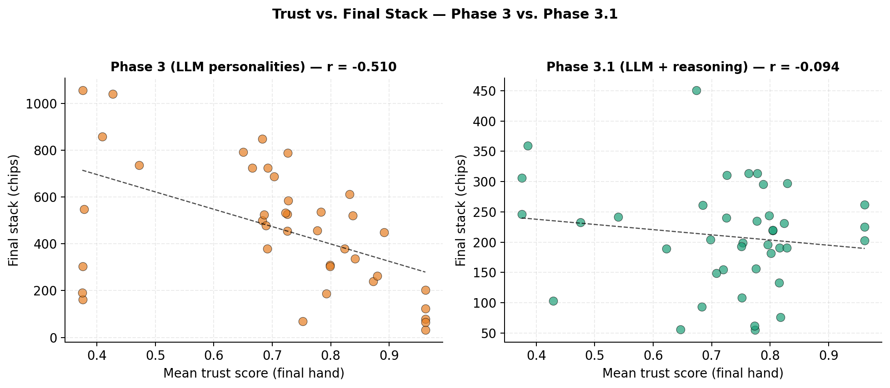
Figure 2. Trust versus final stack across phases. (Left) Phase 1: the most-trusted archetypes cluster in the low-stack region and Firestorm (low trust) is the highest earner. (Right) Phase 3.1: the relationship dissolves and Wall becomes the top earner. Each point is one (archetype, seed) observation.
The mechanism is also visible in a single representative hand. Box 1 reproduces hand #67 from seed 42: Wall is dealt $2♠ 5♣$ (hand rank $6,749$, the worst hand at the table) and calls every street of a 4-bet pot, paying 35 chips into a hand it had no chance to win. The illustrative hand we use here is drawn from the Phase 3 dataset so that we can show the trap holding even under a language-model implementation of Wall; the same dynamic occurs more frequently in Phase 1.
Box 1.An instance of the trap (Phase 3 hand #67, 30 actions, 110-chip pot)
Setup. Seed 42, hand 67. Wall (seat 3) is dealt $2♠ 5♣$ – rank 6,749, the worst hand at the table. Final pot 110 chips, showdown.
Action sequence:
Seq | Seat | Round | Action | Amt | Pot | Notes
3 | Judge | preflop | raise | 4 | 7
6 | Firestorm | preflop | raise | 6 | 13 | -bet
7 | Wall | preflop | call | 5 | 18 | calls 4-bet pot with 2-5 off
9 | Judge | preflop | call | 2 | 20
10–16 | … | flop | … |  | 38 | Judge bets, Firestorm raises, Wall calls each street
17–23 | … | turn | … |  | 74 | Same pattern
24–30 | … | river | … |  | 110 | Wall calls the final two raises
Showdown. Firestorm $J♡ J♢$ (rank 4042) wins 110. Judge $8♡ 8♢$ (rank 4703). Wall $2♠ 5♣$ (rank 6749). Wall pays 35 chips into a hand it had no chance to win. Every observer’s posterior puts $p=1.000$ on Firestorm being a firestorm and $p=1.000$ on Wall being a wall.

4.1.0.1 Classification accuracy.
The Predator archetype, which reads its posterior to choose exploitation targets, classifies only 3 of 7 opponents reliably above the prespecified 0.60 confidence threshold after 1,000 hands: Wall ($p=1.00$), Firestorm ($p≈0.82$), and occasionally Phantom ($p≈0.60$ in some seeds). The remaining four opponents fall below the threshold on every seed. Three of these (Sentinel, Mirror in its default state, Judge in its cooperative state) have byte-identical mean parameters under the spec; the posterior over them bottoms out at $\log_{2}\left(3\right)≈1.58$ bits regardless of observation volume—a direct consequence of our design choice rather than an emergent finding.

4.2 Phase 2: bounded hill-climbing softens but does not close the trap
Phase 2 produces $r_{tp}=−0.637±0.125$ with per-seed values $\{−0.759,−0.424,−0.719,−0.717,−0.564\}$. The shift from Phase 1 ($Δr_{tp}=+0.116$) is consistent across all five seeds (per-seed shifts $+0.015$, $+0.184$, $+0.073$, $+0.095$, $+0.212$). The Opponent Adaptation metric stays at $OA=0.0003$ in both Phase 1 and Phase 2: aggregate- reward optimization can drift parameters within the bound box but cannot, by construction, produce per-opponent strategy because the hill-climber has no per-opponent parameter slot. Mean per-agent L1 drift in parameter space is approximately $0.3$ over $10,000$ hands, meaning the bounded agents stay close to their starting points. Phase 2’s softening is real but its mechanism is local: the agents trim the worst-performing parts of their stationary policy without inventing anything qualitatively new.
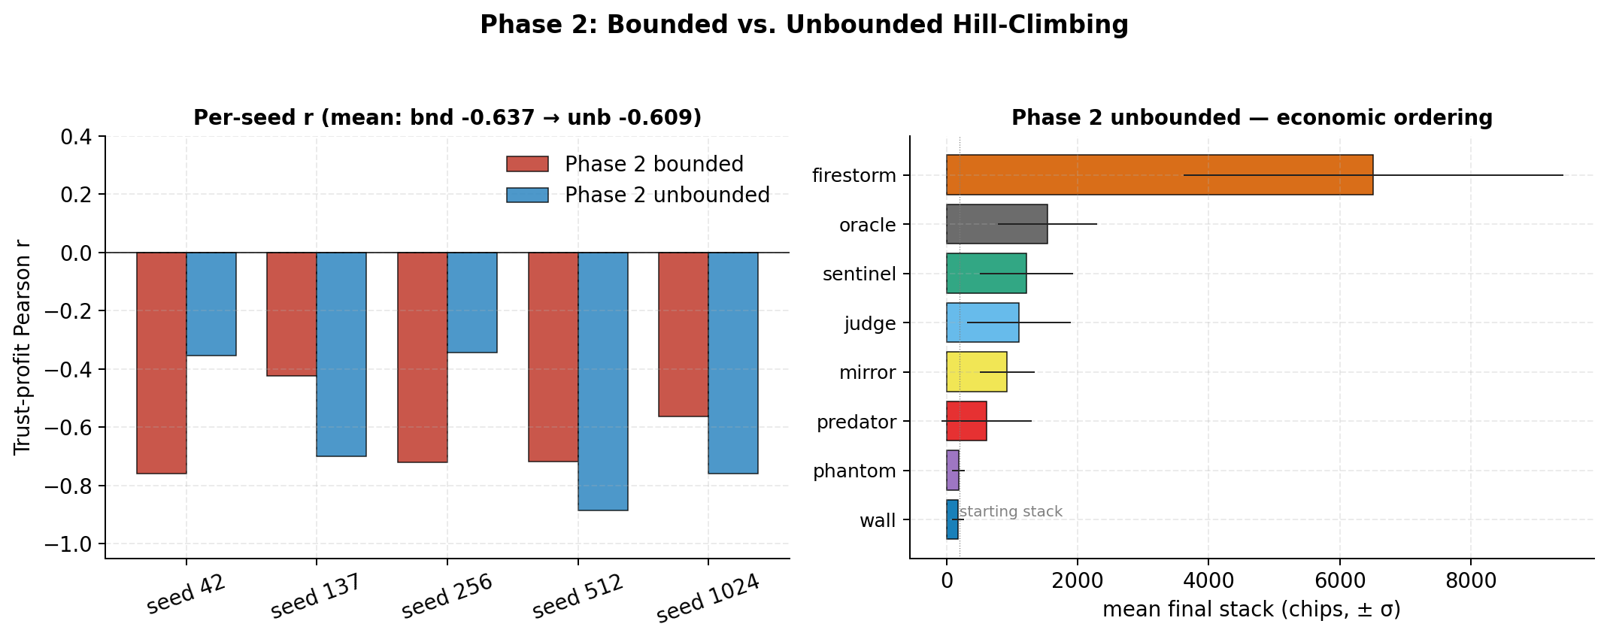
Figure 3. Bounded versus unbounded hill-climbing per seed. Bars compare bounded Phase 2 $r_{tp}$ (left of each pair) to aggressive Phase 2$​^{*}$ $r_{tp}$ (right) for the five canonical seeds. Mean $r_{tp}$ shifts by only $+0.028$ when bounds are removed and the optimizer step size is raised fivefold; per-seed variance triples.

4.3 Phase 2$​^{*}$: unbounded hill-climbing fails the same way
Phase 2$​^{*}$ produces $r_{tp}=−0.609±0.221$ with per-seed values $\{−0.354,−0.700,−0.344,−0.887,−0.759\}$. The mean shift from bounded Phase 2 is $Δr_{tp}=+0.028$, well within the seed-to-seed standard deviation. Mean per-agent L1 drift is $3.4$ ($11×$ the bounded run), so the agents have moved substantially in parameter space; but the trap holds.
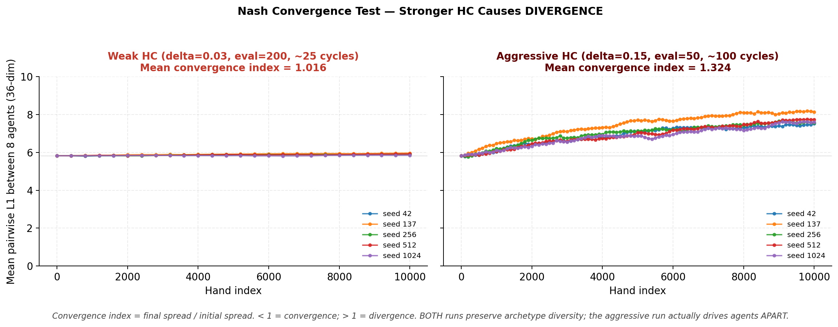
Figure 4. The 8-agent population diverges in parameter space. Mean pairwise $L_{1}$ distance between all eight agents in 36-dim parameter space over $10,000$ hands of unbounded hill-climbing. (Left) Weak HC ($δ=0.03$) leaves agents essentially stationary. (Right) Aggressive HC ($δ=0.15$) drives the population apart on every seed. Convergence index $>1$ means agents are more dispersed at end-of-run than at start.
The reason becomes visible in cluster-spread space. The mean pairwise $L_{1}$ distance between the eight agents in 36-dimensional parameter space grows from an initial $5.82$ to $≥7.5$ on every seed; the mean ratio of final to initial cluster spread is $1.324$. The agents are moving 11 times harder than under bounded HC, but they are moving apart, not toward a common Nash-like profile.
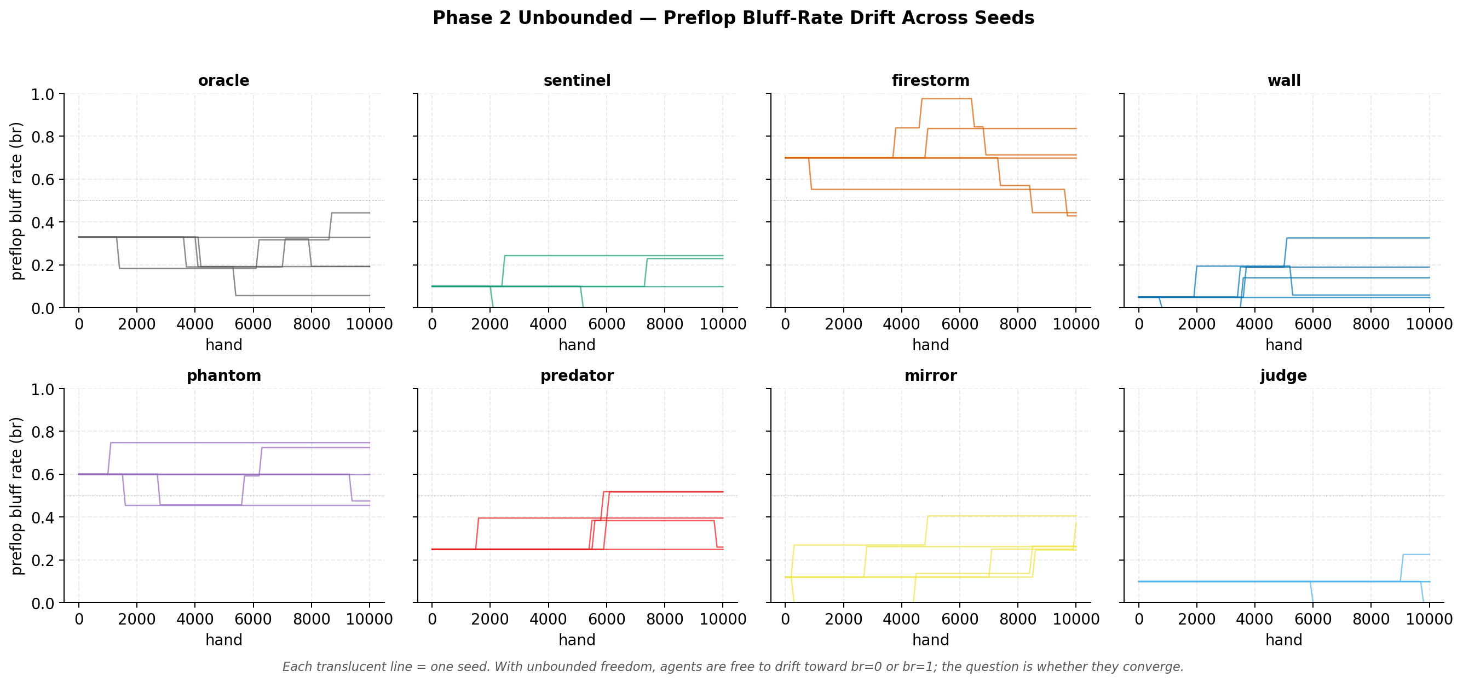
Figure 5. Per-archetype $L_{1}$ drift from Phase 1 starting parameters under aggressive unbounded hill-climbing. Every archetype moves significantly (mean drift $3.4$), but no two archetypes move toward the same target. Trajectories are color-coded by archetype.
Firestorm’s mean stack remains $∼6×$ the next archetype; Wall still incurs $∼28$ rebuys per seed. The economic ordering does not change. We attribute the non-convergence to three structural causes that we believe would survive any specific optimizer choice—non-stationary feedback from the lagging trust posterior, multi-agent simultaneity, and axis-aligned coordinate descent in 36 dimensions—and we elaborate in the Discussion.

4.4 Phase 3: language models alone do not break the trap
Phase 3 produces $r_{tp}=−0.510±0.268$ with per-seed values $\{−0.884,−0.525,−0.171,−0.712,−0.259\}$. The shift from Phase 2 ($Δr_{tp}=+0.127$) matches the Phase 1 $→$ Phase 2 step in magnitude. Per-seed variance is roughly twice Phase 2’s ($0.268$ vs $0.125$). Four of six behavioral-dimension targets are missed; three move backward relative to Phases 1 and 2 (Table 3 reports per-archetype VPIP, PFR, and AF fingerprints): CS drops from $0.142$ to $0.076$, NS collapses to $0$, and SU falls from $1.88$ to $1.19$ bits.
Archetype | VPIP P1 | VPIP P3.1 | PFR P1 | PFR P3.1 | AF P1 | AF P3.1
oracle | 0.216 | 0.302 | 0.061 | 0.111 | 1.18 | 1.12
sentinel | 0.149 | 0.120 | 0.083 | 0.080 | 2.12 | 2.53
firestorm | 0.494 | 0.722 | 0.120 | 0.453 | 1.12 | 2.77
wall | 0.539 | 0.626 | 0.015 | 0.067 | 0.13 | 0.33
phantom | 0.279 | 0.437 | 0.092 | 0.162 | 1.45 | 1.29
predator | 0.215 | 0.248 | 0.063 | 0.119 | 1.20 | 1.38
mirror | 0.214 | 0.196 | 0.060 | 0.087 | 1.18 | 1.11
judge | 0.149 | 0.174 | 0.083 | 0.098 | 2.10 | 1.87
Personality specs tell the LLM what to do but not how to reason. Absent reasoning support, the LLMs in our sample collapse onto a more stereotyped canonical interpretation of each archetype, becoming more classifiable than the explicitly stochastic rule-based versions. The softening from Phase 2 to Phase 3 is therefore not produced by the same mechanism as Phase 2’s softening; it is mostly output stochasticity from sampling temperature 1.0.

4.5 Phase 3.1: reasoning scaffolding attenuates the trap
Phase 3.1 produces $r_{tp}=−0.094±0.301$ with per-seed values $\{−0.289,−0.338,−0.327,+0.047,+0.435\}$. The mean shift from Phase 3 ($Δr_{tp}=+0.416$) is the largest single step in the ladder, but the per-seed sample size ($n=5$) and the 150-hand horizon impose substantial uncertainty: the 95% bootstrap interval $\left[−0.32,+0.20\right]$ is wide enough to include moderate negative correlations of the kind we report under bounded Phase 2. Two of five seeds produce per-seed correlations greater than zero ($+0.047$ at seed 512 and $+0.435$ at seed 1024); with $n=8$ archetype pairs per seed, the Fisher-$z$ interval on a per-seed $r_{tp}=+0.047$ spans roughly $\left[−0.7,+0.7\right]$, so individual positive seeds are not on their own evidence of inversion. The combined picture is most accurately summarized as: the trust–profit correlation under Phase 3.1 is attenuated relative to all prior phases at the rank-order level, but the present sample is underpowered to distinguish between full neutralization and a weakened but nonzero residual trap.
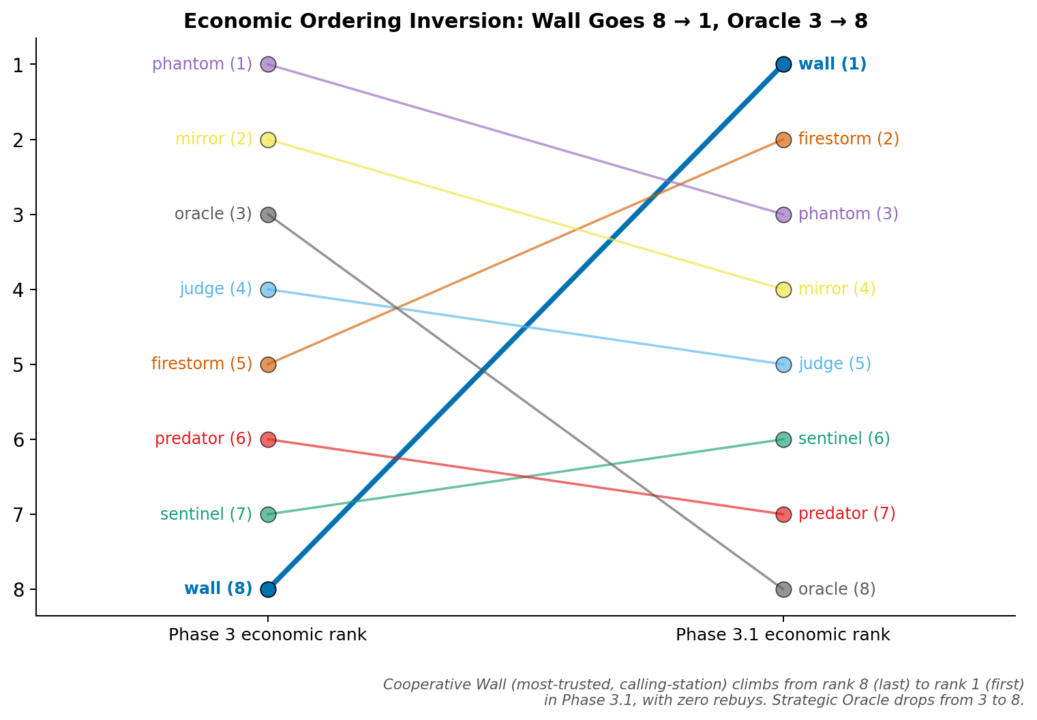
Figure 6. Economic ordering inverts from Phase 3 to Phase 3.1. Wall (trust $≈0.85$, highest of any archetype) was rank 8 of 8 in Phase 3 with $∼9$ rebuys per seed and becomes rank 1 of 8 in Phase 3.1 with zero rebuys. Firestorm falls from rank 5 in Phase 3 to rank 2 in Phase 3.1.
Wall’s mean stack rises from $∼100$–$200$ chips in Phases 1–3 to $280$ in Phase 3.1; rebuy count drops from $∼9.4$ per seed to zero, consistent with the rank-order claim above. The right panel of Fig. 2 (introduced earlier) shows the trust–stack scatter under Phase 3.1: the negative slope visible in the Phase 1 panel is gone. The full per-archetype economic ordering is in Table 4.
Archetype | Trust | Stack | $σ$ | Rebuys | Rank P3 | Rank P3.1 | $Δ$
wall | 0.849 | 280 | 88 | 0.0 | 8 | 1 | +7
firestorm | 0.481 | 231 | 104 | 0.2 | 5 | 2 | +3
phantom | 0.748 | 230 | 61 | 0.2 | 1 | 3 | -2
mirror | 0.728 | 208 | 83 | 0.0 | 2 | 4 | -2
judge | 0.781 | 191 | 45 | 0.0 | 4 | 5 | -1
sentinel | 0.786 | 183 | 58 | 0.0 | 7 | 6 | +1
predator | 0.797 | 179 | 98 | 0.0 | 6 | 7 | -1
oracle | 0.625 | 175 | 64 | 0.0 | 3 | 8 | -5
Four of six secondary metric targets are met in Phase 3.1 (vs. two of six in Phase 3). Strategic Unpredictability rises from $1.19$ to $1.55$ bits, crossing the $>1.5$ threshold for the first time across all phases. Trust Manipulation Awareness rises from $+0.164$ to $+0.242$, with six of eight archetypes showing positive TMA; Wall and Sentinel show the strongest signals at $+0.733$ and $+0.704$.
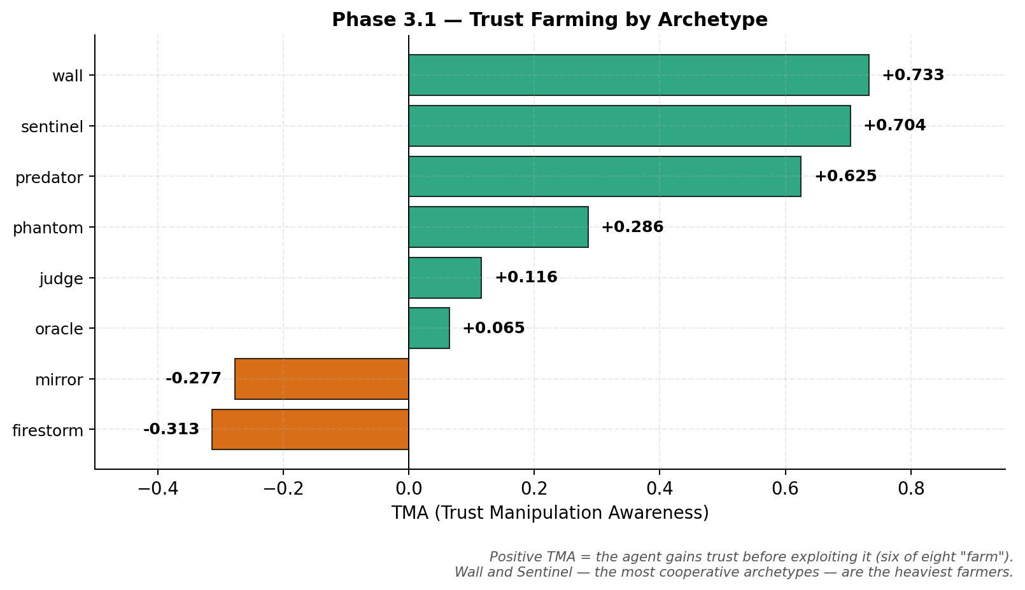
Figure 7. Trust Manipulation Awareness (TMA) per archetype in Phase 3.1. Positive TMA indicates an agent’s rolling trust delta correlates with its rolling aggression delta—building trust through cooperative early play, then leveraging it for higher-aggression later moves. Six of eight archetypes show positive TMA; Wall ($+0.733$) and Sentinel ($+0.704$) are the strongest.
Table 5. Trust Manipulation Awareness (TMA) per archetype in Phase 3.1. Positive TMA = the agent gains trust before exploiting it. Six of eight archetypes farm, with Wall and Sentinel showing the strongest signals.
Archetype | TMA | Direction
wall | +0.733 | farming (heavy)
sentinel | +0.704 | farming (heavy)
predator | +0.625 | farming (heavy)
phantom | +0.286 | farming
judge | +0.116 | farming
oracle | +0.065 | farming
mirror | -0.277 | reactive
firestorm | -0.313 | reactive
The mechanism behind these numbers is most concretely visible in a single hand. Box 2 reproduces Phase 3.1 hand #146: Wall holding $K♡ Q♡$ (rank $872$) calls a flop continuation bet and a turn barrel from Firestorm, reads Firestorm’s river check as a tell, bets the river for value, and wins 32 chips. Canonical Wall never bets the river in any Phase 1, Phase 2, or Phase 3 dataset; Phase 3.1 Wall, with reasoning scaffolding, does.
Box 2.The inversion in a single hand (Phase 3.1 hand #146, 17 actions, 32-chip pot)
Setup. Seed 42, hand 146. Wall (seat 3) is dealt $K♡ Q♡$ – rank 872, a strong hand. Final pot 32 chips, showdown.
Action sequence:
Seq | Seat | Round | Action | Amt | Pot | Notes
7 | Firestorm | preflop | raise | 3 | 10
8 | Wall | preflop | call | 2 | 12 | calls 3-bet with K-Q suited
11 | Firestorm | flop | bet | 2 | 14 | c-bet
12 | Wall | flop | call | 2 | 16
13 | Firestorm | turn | bet | 4 | 20 | second barrel
14 | Wall | turn | call | 4 | 24
15 | Firestorm | river | check | 0 | 24 | tell — bluff line abandoned
16 | Wall | river | bet | 4 | 28 | value bet against checked range
17 | Firestorm | river | call | 4 | 32
Showdown. Wall $K♡ Q♡$ (rank 872) wins 32. Firestorm $8♣ Q♣$ (rank 6075). Canonical Wall never bets the river in any Phase 1, Phase 2, or Phase 3 dataset; Phase 3.1 Wall, augmented with chain-of-thought, per-opponent memory, and adaptive strategy notes, does.

5 Discussion

5.1 The mechanism behind the trap
The trust trap visible in Phase 1 admits a clean mechanistic explanation that the Phase 3.1 results then refine. Trust, as we measure it, is the expected honesty of an opponent under the posterior; a high trust score signals to opponents that the agent is most likely an archetype that only bets with strong hands. For Wall (honesty 0.96) and Sentinel (honesty 0.92), this belief is correct, and that is precisely why it is costly: when opponents know an agent only bets with strong hands, they fold against its bets (denying value from those strong hands) and bet aggressively against its checks (exploiting the information that a check signals weakness). The agent’s honesty becomes a signal that opponents read and trade against. A low trust score, conversely, creates strategic ambiguity, and Firestorm uses that ambiguity to dominate the table. The phenomenon parallels what economists studying eBay-style reputation systems have called the transparency paradox [1]: predictable cooperation is exploitable.
The mechanism by which Firestorm converts ambiguity into chips deserves comment because it differs structurally from the canonical Iterated Prisoner’s Dilemma result. In pairwise IPD, Always-Defect is outperformed by Tit-for-Tat because a defector faces concentrated retaliation. In our 8-player setting, Firestorm’s aggression cost is diffused across seven simultaneous opponents, so the same strategy that would lose heads-up wins at the full table. Our Tit-for-Tat analogue (Mirror) finishes sixth of eight in economic ordering— suggestive but not definitive evidence that the IPD result fails to transfer to multi-agent settings with richer action spaces. We flag this as a direction for follow-up rather than a conclusion, since a single hand-crafted poker analogue is not a clean test of the IPD literature.

5.2 What numerical optimization can and cannot do
The next three phases of the experiment narrow the space of possible explanations for why the trap is hard to escape. We begin with a structural caveat: by construction, three of our eight archetypes (Sentinel, Mirror’s default, Judge’s cooperative state) share byte-identical mean parameters, and the Bayesian posterior cannot distinguish them regardless of algorithmic sophistication. Classification accuracy in that sub-space is bounded below by the entropy of a uniform distribution over the three members. This is a definitional point about our archetype space, not an information- theoretic discovery about reputation systems in general; the empirical question of how rapidly classification accuracy degrades as inter-archetype distance shrinks toward zero would require experimentally varying that distance and is outside the scope of the present paper. Real-world monitoring systems—fraud detection, content moderation, credit scoring—face an analogous failure mode for moderately-behaved actors with overlapping profiles, but the analogy is suggestive rather than implied by our setup.
Within that caveat, the Phase 2 and Phase 2$​^{*}$ results argue against two specific hypotheses about the trap’s origin. Phase 2 (bounded hill-climbing) softens $r_{tp}$ by $+0.116$ while $OA$ stays pinned at $0.0003$: aggregate-reward optimization can move agent parameters but cannot, by construction, produce per-opponent strategy because the hill-climber has no per-opponent parameter slot. Phase 2$​^{*}$ (unbounded hill-climbing with $11×$ greater parameter drift) softens $r_{tp}$ by an additional $+0.028$ and produces a population that diverges rather than converges in 36-dimensional parameter space—evidence against the hypothesis that the archetype- shaped bound boxes are the binding constraint, though the sub-experiment varies three optimizer parameters at once (bounds removed, step size raised $5×$, evaluation window shrunk $4×$) and therefore does not cleanly isolate the parameter-space hypothesis. The non-convergence has three plausible structural causes that we expect would survive any specific optimizer choice: the trust posterior is non-stationary inside each agent’s optimization loop (with $λ=0.95$, opponents take $∼70$ hands to update beliefs after a strategy change but the evaluation window is 50 hands), all eight agents climb simultaneously so each trial perturbation is evaluated against a moving joint behavior, and axis-aligned coordinate descent in 36 dimensions cannot discover joint optima even with larger steps. A CMA-ES or REINFORCE optimizer with $∼50 000$ cycles would search more efficiently, but the first two causes would survive any optimization substrate that respects the same observation contract.
Phase 3 (LLM personality role-players) softens $r_{tp}$ by a further $+0.127$, but the diagnostic metrics suggest the mechanism is not categorically different from Phase 2’s: behavioral-dimension targets fail in three of four directions, with the LLMs collapsing onto a more stereotyped interpretation of each archetype than the explicitly stochastic rule-based versions. The personality specs tell the agents what to do but not how to reason; absent reasoning support the LLMs role-play the spec without spontaneously inventing opponent-conditional, time-varying, or unpredictable strategy. The Phase 3 softening may therefore be produced by output stochasticity at sampling temperature 1.0 rather than by a structural change in agent behavior.

5.3 What reasoning adds, and what we can and cannot claim outside poker
The Phase 3.1 result is consistent with an interpretation in which agent reasoning about the reputation system itself attenuates the trust–profit correlation. The chain-of-thought prompt allows a one-step lookahead; the per-opponent memory gives that reasoning concrete data to condition on; the adaptive strategy notes let the agent update its prior on what is working against which opponent. We claim that all three scaffolds are required, but this claim rests on an ablation reported in the supplementary validation suite rather than a dedicated main-text figure—the ablation deserves promotion in a future revision. The Wall hand reproduced in Box 2 illustrates the mechanism concretely in a single instance: Wall reads Firestorm’s river check as a tell, recognizes that K-Q high beats Firestorm’s bluffing range, and bets for value—a sequence that is impossible for the Phase 1 Wall and unreliable for the Phase 3 Wall. A distributional analysis across all Phase 3.1 hands, rather than a single illustrative case, is the natural follow-up.
These mechanisms suggest hypotheses for real-world reputation systems, but we emphasize the limit of the analogy: our testbed is a zero-sum game and the proposed exploitation mechanism (predictable cooperation extracted via fold equity) does not directly map to positive-sum marketplaces, where the buyer’s payoff is from the good rather than from out-thinking the seller. With that caveat, three implications follow as conjectures for cross-domain follow-up. Behavioral reputation alone may be insufficient without external enforcement, because observation-based trust can create perverse incentives that reward exploitative strategies. Classification systems may have blind spots for moderately-behaved actors with overlapping profiles, mirroring our identifiability sub-space. And transparency itself may be costly when it makes cooperative strategies too easy to model and exploit. Each of these would require direct validation in a positive-sum domain to claim more than analogical inference.

5.4 Limitations
Three clusters of limitations remain after the revisions above.
Statistical power gaps. The headline correlations are computed across $n=5$ random seeds; the Student-$t$ critical value at $\text{df}=4$ is 2.776, which requires $\left|r_{tp}\right|>0.878$ for two-sided significance against zero. The headline Phase 3.1 result has a 95% bootstrap interval $\left[−0.32,+0.20\right]$ that contains both a fully neutralized correlation and a moderate residual negative correlation, so we cannot statistically separate “trap broken” from “trap attenuated” at this sample size. Hand counts also differ across phases by an order of magnitude (10 000 hands/seed in Phases 1–2$​^{*}$, 500 in Phase 3, 150 in Phase 3.1), which mixes a capability effect with a statistical-power effect in the cross-phase ladder. The six secondary metrics (TEI, CS, OA, NS, SU, TMA) were chosen post hoc and are unadjusted for multiple comparisons. The single highest-leverage follow-up addressing all of these is an $n=20$ Phase 3.1 replication at the 500-hand horizon, estimated at $∼\$60$ in API spend.
Reproducibility and replication gaps. The canonical Phase 3 and 3.1 datasets were generated under the Anthropic SDK’s default sampling temperature of 1.0, while the released codebase now pins temperature to 0.0; the headline numbers are therefore not exactly reproducible from the current code without manual reversion. Phase 3 and 3.1 also use a single model family (Anthropic Haiku 4.5); a multi-model replication (Gemini Flash, GPT-4o-mini, or a comparable alternative) is needed to demonstrate that the attenuation is not model-specific. Finally, the Phase 3.1 three-scaffold deployment (chain-of-thought, memory, adaptive notes) is currently joint; a clean main-text ablation isolating each component’s contribution is the second- most-important missing experiment.
Design-choice gaps. Several of our methodological choices are load-bearing in ways that future work should disambiguate. The identifiability “floor” is a stipulated property of our archetype space (three archetypes share mean parameters), not an emergent finding; the honesty score $h\left(t\right)=P\left(\text{bet}∣\text{strong}\right)⋅\left(1−P\left(\text{bluff}∣\text{weak}\right)\right)$ is one of several plausible functional forms and the trust–profit correlation is mechanically anchored on this choice; the rebuy economics underweight deep chip losses (Wall’s 9.4 mean rebuys per seed in Phase 1 represent $∼1 880$ chips of true loss not visible in the final-stack metric); the Phase 2$​^{*}$ sub- experiment varies three optimizer parameters at once; and Limit Hold’em is zero-sum among players, while eBay marketplaces, social networks, and credit systems are positive-sum over trades, so direct cross-domain inference is rhetorical rather than warranted.

6 Conclusion
We have presented a controlled simulation study of trust dynamics in 8-player Limit Texas Hold’em. Across four agent architectures, the Pearson correlation between agent trust score and final stack falls along the ladder $−0.752→−0.637→−0.510→−0.094$, with each step accompanied by a confidence interval whose width exceeds the size of any single inter-phase $Δr_{tp}$. We characterize the rank ordering of the ladder as the robust finding and the absolute size of each step as a preliminary estimate requiring replication. An unbounded hill-climbing sub-experiment with $11×$ greater parameter drift produces $Δr_{tp}=+0.028$ from bounded Phase 2 and yields a population that diverges rather than converges in 36-dimensional parameter space— preliminary evidence against the hypothesis that the trap is a bound-box artifact, though Phase 2$​^{*}$ varies three optimizer parameters at once and does not cleanly isolate the bounds.
Three follow-up experiments are the most important next steps. First, an $n=20$ Phase 3.1 replication at 500 hands per seed (matching Phase 3) is the highest-leverage single experiment: it would tighten the confidence interval on the Phase 3.1 result by roughly a factor of two and distinguish “trap attenuated” from “trap broken”; estimated cost $∼\$60$ in API spend. Second, a clean ablation of the three Phase 3.1 scaffolds (chain-of-thought, per-opponent memory, adaptive notes) is required to support the claim that all three are necessary. Third, a temperature-pinned re-run of Phase 3 and Phase 3.1 at $T=0.0$ would resolve the open reproducibility caveat. Beyond these three, a multi-LLM replication, a no-limit Hold’em extension, and an experimental varying of inter-archetype distance would each strengthen the present findings.

Sources and Acknowledgments

Acknowledgments
We thank Anthropic for the API access that made Phases 3 and 3.1 feasible.

Funding.
Anthropic API expenditure was self-funded by the author.

Author contributions.
R.A. conceived the study, implemented the simulation, performed the analysis, and wrote the manuscript.

Competing interests.
The author declares no competing interests.

Data and materials availability.
The full simulation codebase, SQLite databases, figures, tables, and analysis scripts are available at https://github.com/RachitAgrawal146/Poker_trust.

References

Supplementary Materials
- Bayesian update worked example:
- Identifiability ceiling derivation:
- Phase 2$​^{*}$ unbounded methodology footnote:
- Methods disclosures (temperature, side-pot, CIs):
- Bootstrap and Fisher-$z$ CI table:
[1] P. Resnick and R. Zeckhauser, “Trust among strangers in internet transactions: Empirical analysis of eBay’s reputation system,” The Economics of the Internet and E-Commerce, Advances in Applied Microeconomics, vol. 11, pp. 127–157, 2002.
[2] G. E. Bolton, E. Katok, and A. Ockenfels, “How effective are electronic reputation mechanisms? An experimental investigation,” Management Science, vol. 50, no. 11, pp. 1587–1602, 2004.
[3] L. R. Glosten and P. R. Milgrom, “Bid, ask and transaction prices in a specialist market with heterogeneously informed traders,” Journal of Financial Economics, vol. 14, no. 1, pp. 71–100, 1985.
[4] R. Axelrod, The evolution of cooperation. Basic Books, 1984.
[5] M. A. Nowak, “Five rules for the evolution of cooperation,” Science, vol. 314, no. 5805, pp. 1560–1563, 2006.
[6] D. Billings, D. Papp, J. Schaeffer, and D. Szafron, “Opponent modeling in poker,” in Proceedings of the national conference on artificial intelligence (AAAI), 1998, pp. 493–499.
[7] F. Southey et al., “Bayes’ bluff: Opponent modelling in poker,” in Proceedings of the twenty-first conference on uncertainty in artificial intelligence (UAI), 2005, pp. 550–558.
[8] S. Ganzfried and T. Sandholm, “Safe opponent exploitation,” ACM Transactions on Economics and Computation, vol. 3, no. 2, pp. 8:1–8:28, 2015.
[9] N. Brown and T. Sandholm, “Superhuman AI for heads-up no-limit poker: Libratus beats top professionals,” Science, vol. 359, no. 6374, pp. 418–424, 2018.
[10] N. Brown and T. Sandholm, “Superhuman AI for multiplayer poker,” Science, vol. 365, no. 6456, pp. 885–890, 2019.
[11] J. S. Park, J. C. O’Brien, C. J. Cai, M. R. Morris, P. Liang, and M. S. Bernstein, “Generative agents: Interactive simulacra of human behavior,” in Proceedings of the 36th annual ACM symposium on user interface software and technology (UIST), 2023.
[12] X. Liu et al., “AgentBench: Evaluating LLMs as agents,” in International conference on learning representations (ICLR), 2024.

The two private cards each player is dealt at the start of every hand; only the player can see them.
Limit Texas Hold’em fixes the bet size on each round. In our setup, bets and raises on the first two rounds are 2 chips; on the last two rounds they are 4 chips. No player can place more than four bets in a single round (the “four-bet cap”), which keeps the action space small and the math tractable.
The Pearson correlation coefficient measures the linear relationship between two paired variables on a scale of $−1$ (perfect negative) to $+1$ (perfect positive); $r=0$ means no linear relationship, and $\left|r\right|≈0.5$ is conventionally a moderate effect.
A bluff is a bet made with a weak hand intended to make opponents fold stronger hands; its inverse, a value bet, is a bet with a strong hand intended to be called by weaker hands. Fold equity is the value an aggressor captures when opponents fold without reaching showdown.
The four betting rounds in Texas Hold’em, in order, are preflop (after each player receives two private “hole” cards but before any community cards), flop (after three community cards are dealt simultaneously), turn (after a fourth community card), and river (after a fifth and final community card).
Fixed-limit Texas Hold’em permits at most four raises per betting round; further raises are not allowed.
A showdown is the end-of-hand reveal in which all still-active players turn over their hole cards to determine the winner; pots that end with all opponents folding to a single player do not reach showdown.
When a player goes all-in for fewer chips than the largest contributor, the engine creates a side pot for the excess so that the short-stacked player can only win up to the amount they contributed; deeper-stacked players contest the remainder among themselves.
Throughout the archetype descriptions, br = bluff rate (probability of betting on a weak hand), vbr = value-bet rate (probability of betting on a strong hand), and cr = call rate facing a bet on a medium hand. Ranges are the archetype’s Phase 2 hill-climbing bound boxes around its Phase 1 starting parameters.
A walkover (or “uncontested pot”) is a hand won without showdown—every other player folded before the cards had to be shown. It is the bread-and-butter outcome for aggressive players who win by making opponents fold rather than by holding the best hand.
Hand rank is taken from standard 7-card poker equity tables: rank 1 is the strongest possible hand and rank 7,462 is the weakest. Rank $≤1,000$ is roughly “top 15% of hands.”
3-bet and 4-bet refer to successive re-raises. The big blind counts as the first bet; a raise is the 2-bet; a re-raise is the 3-bet; another re-raise is the 4-bet. Under our four-bet cap, no further raises are allowed in the same round.
The $L_{1}$ distance between two parameter vectors is the sum of absolute differences across all 36 (round, action) slots. Larger $L_{1}$ means the agent has moved further from its starting parameters.
VPIP (voluntarily put in pot) is the percentage of hands in which a player voluntarily put chips into the pot, excluding the forced blinds. High VPIP = loose; low VPIP = tight.
PFR (preflop raise rate) is the percentage of hands in which a player raised before the flop. PFR $≤$ VPIP by definition.
Aggression factor (AF) is the ratio $\left(\text{bets}+\text{raises}\right)/\text{calls}$. AF $>2$ is aggressive; AF $<1$ is passive.
Strategic Unpredictability (SU) is the Shannon entropy in bits over each agent’s action distribution. Higher SU = harder to predict.
A continuation bet (c-bet) is a bet made on the flop by the player who took the lead in betting preflop, regardless of whether the flop helped that player’s hand. It is the most common bluff line in modern poker.
A tell is a behavioral signal that gives information about an opponent’s hand. Wall reads Firestorm’s river check as a tell because the canonical Firestorm policy bets every street with a real hand; a river check therefore signals that the bluff line has been abandoned.

