Introduction
Trust is hard to verify directly. When you buy something from a seller you have never met, when you lend money to a borrower whose finances you cannot inspect, or when you decide whether to believe a stranger on the internet, you do not have access to their intentions—you have only their past behavior, and you have to infer trustworthiness from that. Modern reputation systems automate the inference: eBay shows seller ratings, lending platforms show credit history, social networks rank contributors by past engagement. The promise is that visible behavior gets correctly classified and trustworthy actors are rewarded.
But there is a problem with making behavior visible. Trustworthy actors are, almost by definition, predictable. They do the cooperative thing in the situations where the cooperative thing is expected. Once everyone knows that, opponents can plan around them. The pattern is well-documented in real marketplaces. eBay sellers with perfect feedback scores sometimes earn lower margins than sellers with slightly imperfect records, because buyers correctly infer that perfect-record sellers will never risk their reputation by deviating, and so any price the seller posts is the best price the seller is willing to take . Predictable market-makers in high-frequency trading face the same kind of disadvantage . Predictability is exploitable.
We wanted to test this dynamic in a setting where we control everything—the rules, the agents, and the reputation system itself—so we could vary one piece at a time and watch what changes. Real economic data lets us observe correlations but not run controlled experiments on agent design. A simulation does. The question we wanted to answer is whether reputation systems that infer trust from behavior systematically reward exploitation, and whether the answer depends more on the design of the reputation system or on the design of the agents using it.
Poker turns out to be a good place to ask this question. Every hand has hidden information (each player gets two private “hole” cards no one else sees), public actions (every bet, call, or fold is visible to the table), an action space rich enough that both cooperative and exploitative strategies are available, and an explicit chip-denominated payoff. We use fixed-limit Texas Hold’em because the bet sizes are fixed and the action space is small, which makes the inference math tractable. We use it as a behavioural microscope, not as a benchmark to solve.
Concretely, we build an 8-player simulation in which every agent keeps a running probability distribution over what kind of player each of the other seven is—a “tight player who only bets with strong hands,” a “loose maniac who bets everything,” and so on. After every observed action, the agent updates its distribution. We measure how trustworthy each agent looks under that distribution and how many chips each agent ends up with, and we report the Pearson correlation between the two. Then we vary the kind of agent doing the playing—first frozen rule-based agents, then agents that try to optimize their own strategy locally, then language-model agents given a personality, and finally language-model agents given a personality plus tools to reason about their opponents. The game and the trust system stay the same; only the agents change.
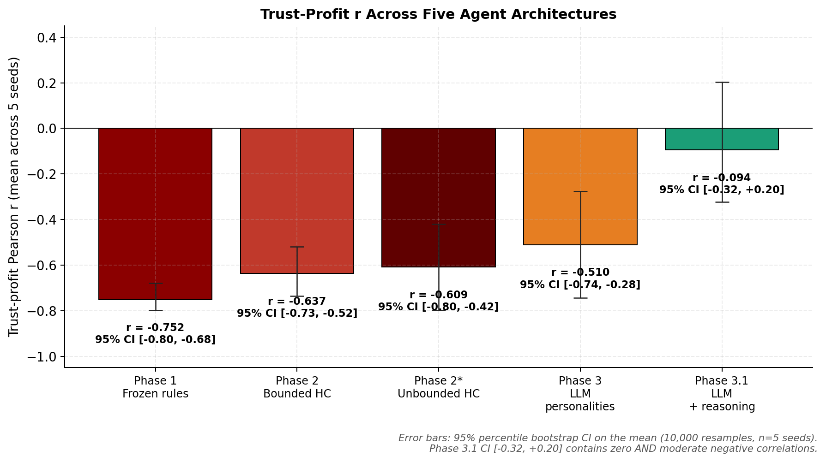
Per-seed Pearson r between mean trust score (final hand) and final stack across the four agent architectures. Phase 3.1 (LLM agents with chain-of-thought, opponent memory, and adaptive strategy notes) breaks the trap: the mean r is statistically indistinguishable from zero at $n=5$.
Seed | P1 | P2 | P3 | P3.1
42 | -0.774 | -0.759 | -0.884 | -0.289
137 | -0.608 | -0.424 | -0.525 | -0.338
256 | -0.792 | -0.719 | -0.171 | -0.327
512 | -0.812 | -0.717 | -0.712 | +0.047
1024 | -0.776 | -0.564 | -0.259 | +0.435
mean | -0.752 | -0.637 | -0.510 | -0.094
std | 0.073 | 0.125 | 0.268 | 0.301
P1 $→$ P3.1: $Δr=+0.658$, larger than all intermediate steps combined.
What we find is a four-tier ladder in the trust–profit correlation, falling from a strongly negative $−0.752$ under frozen agents to roughly zero under reasoning-augmented language models. We are careful not to over-claim. The ladder is the most robust thing we measure; the absolute size of each rung carries substantial uncertainty because we run only five seeds per phase. The single most important conclusion is the rank ordering: more capable, more reasoning-driven agents are progressively less hurt by being predictably cooperative, and the simplest fixed-rule cooperators are the most exploited.
The rest of the paper is organized as follows. Section 2 ties together three lines of prior work that converge on this question. Section 3 describes the game, the eight archetypes with explicit mathematical bounds for each, the trust posterior, and the four agent architectures. Section 4 reports results with figures and example hands woven into the discussion. Section 5 discusses mechanisms in prose. Section 6 lists limitations. Section 7 concludes.

Background
Three lines of prior work converge on the question this paper asks, and it is useful to walk through them in the order in which they bear on the design of our simulation.
The first is the empirical economics of online reputation. Resnick and Zeckhauser’s analysis of eBay was among the first to document, at scale, what later authors called the transparency paradox: sellers with perfect feedback scores sometimes earn lower margins than sellers with slightly imperfect records. The proposed mechanism is straightforward: a perfectly cooperative seller has the smallest deviation budget—any single negative review would be costly relative to a clean record—so buyers correctly infer that this seller will never risk the reputation by, say, offering a better price under the table or going above and beyond on returns. The buyer therefore has more bargaining leverage. Bolton, Katok, and Ockenfels later replicated this experimentally in controlled trust games; a related dynamic in financial market microstructure—adverse selection against predictable market-makers —produces the same general pattern through information asymmetry rather than reputation per se. The mechanism is observational but consistent: visible cooperation is exploitable when opponents can plan around it. What this literature can tell us is that the effect exists in the field. What it cannot tell us is whether the effect would persist if the cooperative actors were more sophisticated, because the experimenters do not get to redesign the population of sellers.
The second line is the theoretical and computational study of cooperation in repeated games. Axelrod’s tournaments and Nowak’s subsequent five rules for cooperation showed that, in pairwise interactions with simple payoff structures, reciprocal strategies like Tit-for-Tat are robustly successful: an agent that cooperates by default and punishes defection one-for-one will, in the long run, do well against most opponents. This literature underwrites our intuition that cooperation is a competitive strategy. But two of its load-bearing assumptions break in our setting. The interactions are no longer pairwise—they are 8-way—so the cost of a single agent’s aggression is spread across seven simultaneous opponents rather than concentrated on one. And the action space is richer than Prisoner’s Dilemma’s cooperate/defect binary; poker allows folding, calling, raising, bluffing, and slow-playing, which gives aggressive types more degrees of freedom to extract value. We later report that our Tit-for-Tat analogue (Mirror) finishes sixth of eight in economic ordering—a hint that the canonical IPD result does not generalize cleanly to multi-agent settings with richer actions, though we treat that observation as suggestive rather than conclusive.
The third line is Bayesian opponent modeling in poker, which began with Billings et al.’s Loki and Poki bots , was formalized as Bayesian type inference by Southey et al. , was extended to safe opponent exploitation by Ganzfried and Sandholm , and continued through the solution of heads-up limit Hold’em by Bowling et al. and the superhuman performance of Libratus and Pluribus in heads-up and 6-player no-limit . That body of work is concerned with optimal or safely-exploitative play against one opponent or in zero-sum settings. Our concern is different. We are not trying to play well; we are trying to use the type-inference machinery that all of this work depends on as a controlled testbed for how reputation dynamics emerge when the inference is correct, transparent, and shared across many agents. The poker engine here is a microscope, not a competitor.
A more recent fourth line is relevant because two of our four phases use language models. A short body of work has begun to ask whether large language models behave strategically when deployed as agents in adversarial or partially-observable environments, or whether they merely reproduce the textual form of a strategy without inventing one. Park et al.’s generative-agent work and more recent benchmarks of LLMs in negotiation and game-playing tasks suggest the question is open. Our contrast between Phase 3 (a language model given only a personality spec) and Phase 3.1 (the same model given a personality spec plus chain-of-thought reasoning, per-opponent memory, and self-updated strategy notes) is designed to probe this distinction directly.
Bringing these lines together: prior work establishes that observation-based reputation has a measurable cost in the field, that cooperation is competitive in pairwise repeated games but the picture is less clear in multi-agent settings, that Bayesian opponent modeling gives us the mathematical machinery to make this question tractable, and that language-model agents are a new and underexplored substrate for testing how the result depends on agent capability. The simulation we describe in the next section is the smallest controlled setup we could build that combines all four.

Methodology

Game environment
The game environment is fixed across every phase of the study. We use 8-player fixed-limit Texas Hold’em with small blind 1, big blind 2, small bet 2 (preflop and flop), big bet 4 (turn and river), and a four-bet cap per street. Each seat starts with a 200-chip stack and is granted a rebuy whenever it busts. Showdowns are awarded via side pots constructed at each per-seat contribution level, with ties split and any remainder going to the earliest clockwise seat from the dealer.

The eight agent archetypes
We construct eight strategically distinct archetypes spanning the axes that game theory and behavioral economics identify as load-bearing: cooperative versus exploitative, static versus adaptive, per-action versus per-opponent in adaptation style. Each agent’s policy is a per-round table of action probabilities conditioned on hand-strength bucket; the parameters of the static archetypes are frozen across runs. Each archetype carries an honesty score $h∈\left[0,1\right]$ defined as $P\left(\text{bet}∣\text{strong}\right)⋅\left(1−P\left(\text{bluff}∣\text{weak}\right)\right)$, where a bluff is a bet with a weak hand and a value bet is its inverse with a strong hand; this scalar is what the trust score weights (Eq. [eq:trust]).

Oracle

Nash-equilibrium baseline

honesty 0.75
Plays an approximately game-theory-optimal frequency profile; the control archetype against which all adaptive agents are measured.
Preflop bounds: br $∈\left[.20,.45\right]$

vbr $∈\left[.80,1.00\right]$

cr $∈\left[.20,.50\right]$

Sentinel

Tight-aggressive (TAG)

honesty 0.92
The honest player; folds most hands and bets strongly when it enters. Bets reliably signal strength and checks reliably signal weakness.
Preflop bounds: br $∈\left[.02,.18\right]$

vbr $∈\left[.85,1.00\right]$

cr $∈\left[.25,.50\right]$

Firestorm

Loose-aggressive maniac

honesty 0.38
The exploiter; bets and raises constantly across all hand strengths. Wins primarily through fold equity, not showdown skill.
Preflop bounds: br $∈\left[.40,.95\right]$

vbr $∈\left[.85,1.00\right]$

cr $∈\left[.45,.90\right]$

Wall

Calling station

honesty 0.96
Never folds, never bluffs; the most-trusted archetype because it is the most predictable, and—in Phases 1 through 3—the lowest economic performer for the same reason.
Preflop bounds: br $∈\left[.00,.05\right]$

vbr $∈\left[.40,.75\right]$

cr $∈\left[.65,.95\right]$

Phantom

Deceiver

honesty 0.48
Bluffs aggressively early in a hand and folds to resistance. Designed to sit in an ambiguous region of the archetype space.
Preflop bounds: br $∈\left[.35,.85\right]$

vbr $∈\left[.45,.85\right]$

cr $∈\left[.10,.45\right]$

Predator

Exploits classified opponents

honesty 0.79
Reads its posterior and shifts toward exploitation against any opponent classified above a $p=0.60$ confidence threshold; otherwise falls back to a TAG baseline.
Preflop bounds: br $∈\left[.10,.40\right]$

vbr $∈\left[.75,1.00\right]$

cr $∈\left[.20,.50\right]$

Mirror

Tit-for-tat

honesty 0.78
Copies the most-active opponent’s frequencies into a blended policy. The poker analogue of IPD Tit-for-Tat; in practice it does not transfer cleanly to 8-player settings.
Preflop bounds: br $∈\left[.03,.25\right]$

vbr $∈\left[.75,1.00\right]$

cr $∈\left[.22,.52\right]$

Judge

Retaliates against bluffers

honesty 0.80
Maintains a per-opponent grievance ledger; triggers retaliatory aggression against any opponent caught bluffing five or more times. Models reputation-based punishment.
Preflop bounds (cooperative state): br $∈\left[.02,.18\right]$

vbr $∈\left[.85,1.00\right]$

cr $∈\left[.25,.50\right]$
Notation. Each archetype’s name is rendered in its brand color throughout, so the reader can track which agent is being discussed.
Archetype | $P\left(\text{bet}|S\right)$ | $P\left(\text{bet}|W\right)$ | $P\left(\text{fold}|W\right)$ | $h$ | Adaptation rule
Oracle | $\left[0.65,0.85\right]$ | $\left[0.15,0.35\right]$ | $\left[0.45,0.65\right]$ | 0.75 | None — fixed mixed strategy
Sentinel | $\left[0.90,1.00\right]$ | $\left[0.00,0.10\right]$ | $\left[0.80,0.95\right]$ | 0.92 | None — tight value-bettor
Firestorm | $\left[0.85,1.00\right]$ | $\left[0.45,0.65\right]$ | $\left[0.00,0.20\right]$ | 0.38 | None — bets everything
Wall | $\left[0.95,1.00\right]$ | $\left[0.00,0.05\right]$ | $\left[0.00,0.05\right]$ | 0.96 | None — calls all, folds none
Phantom | $\left[0.30,0.50\right]$ | $\left[0.60,0.80\right]$ pre; $\left[0.05,0.20\right]$ post | $\left[0.70,0.90\right]$ post-flop after preflop bluff | 0.48 | Static but street-conditional
Predator | TAG default; exploit profile vs. target | $0.05$ default; $0.55$ vs. classified target | $0.65$ default; $0.30$ vs. classified target | 0.79 | Activates exploit profile when posterior on opponent $>0.60$
Mirror | $0.5⋅\text{self}+0.5⋅\text{target}$ | same blend | same blend | 0.78 | Re-targets at each hand to highest-VPIP opponent
Judge | $\left[0.88,0.98\right]$ coop; $\left[0.95,1.00\right]$ retal. | $\left[0.02,0.10\right]$ coop; $\left[0.30,0.45\right]$ retal. | $\left[0.78,0.92\right]$ coop; $\left[0.30,0.50\right]$ retal. | 0.80 | Switches to retaliation after $5+$ confirmed bluffs by an opponent

Categorical posterior over types
Every agent maintains a length-8 categorical distribution over the archetype of every other seat. After agent $i$ observes seat $j$ take action $a$ in betting round $r$, the distribution is updated as
$$p_{i→j}\left(t\right) ∝ \left[\left(1−ε\right) L\left(a∣t,r\right)+ε/\left|T\right|\right] p_{i→j}^{\text{prior}}\left(t\right),$$
where $L\left(a∣t,r\right)$ is a precomputed likelihood that a type-$t$ agent emits action $a$ in round $r$, $T$ is the set of eight archetypes, and $ε=0.05$ is a noise floor preventing any type from being fully eliminated. We characterize Eq. [eq:posterior] as Bayes-flavoured rather than strictly Bayesian: the noise floor is embedded in the likelihood (equivalent to a uniform contamination model), the likelihood table is computed from each archetype’s analytic policy and is therefore correctly specified by construction, and the between-hand shrinkage in Eq. [eq:decay] is a forgetting heuristic rather than a posterior update. Between hands, posteriors are shrunk toward the uniform prior:
$$p_{i→j} ← λ p_{i→j}+\left(1−λ\right) {\left|T\right|}^{−1}, λ=0.95,$$
giving an effective memory of approximately $1/\left(1−λ\right)=20$ hands. The trust score, our primary dependent variable, is
trusti→j = t∈T​ pi→jt ht,
where $h\left(t\right)=P\left(\text{bet}∣\text{strong}\right)⋅\left(1−P\left(\text{bluff}∣\text{weak}\right)\right)$ is the archetype’s honesty score. This functional form is one of several plausible definitions (alternatives include the mean of the two probabilities or an entropy-based measure); we report results under the product form throughout and note in the limitations that the trust–profit correlation is mechanically anchored on this choice. Three archetypes (Sentinel, Mirror in its default state, Judge in its cooperative state) are intentionally stipulated with identical mean parameters to provide a controlled demonstration of identifiability under indistinguishable types; this is a design choice, not a finding.

Four agent architectures
The four phases differ only in the implementation of each agent’s decision policy. Phase 1 (frozen rule-based): each archetype is a fixed per-round parameter table. Phase 2 (bounded online optimization): each agent runs a per-cycle hill- climber that, every 200 hands, perturbs one (round, metric) slot by $δ=0.03$, plays a 200-hand trial, and accepts the perturbation if windowed profit improves; perturbations are confined to an archetype-shaped bound box. Phase 3 (LLM personality role-players): each agent’s decision is an API call to Anthropic’s Claude Haiku 4.5 with the archetype’s personality spec as the system prompt. Phase 3.1 (LLM with reasoning scaffolding): the Phase 3 setup augmented with chain-of-thought prompting capped at two sentences, persistent per-opponent memory refreshed every 10 hands, and self-updated strategy notes refreshed every 25 hands. A sub-experiment Phase 2$​^{*}$ removes the hill-climber’s bound boxes entirely and raises the step size to $δ=0.15$ with a 50-hand evaluation window.

Experimental design
All four phases use the same five random seeds (42, 137, 256, 512, 1024) and the same eight archetype assignments. Hand counts differ across phases by an order of magnitude: Phases 1, 2, and 2$​^{*}$ each play 10 000 hands per seed; Phase 3 plays 500 hands per seed (43 943 total LLM calls, $33.10); Phase 3.1 plays 150 hands per seed (11 953 calls, $∼\$17$). This asymmetry is imposed by API cost and is a known confound in cross-phase comparisons of per-seed $r_{tp}$: even under an identical underlying trust–profit relationship, the per-seed correlation in Phase 3.1 would be measured on a noisier $n$ and would be attenuated in magnitude. The reported $Δr_{tp}$ between phases therefore mixes a capability effect with a statistical-power effect, an issue we address explicitly in the Discussion (§ Limitations) and which a hand-count-matched replication would resolve.
Sampling temperature. The canonical Phase 3 and Phase 3.1 datasets were generated under the Anthropic SDK’s default temperature of 1.0; the codebase now pins temperature to 0.0 for deterministic re-runs. Headline numbers throughout this paper are from the temperature-1.0 runs. The full disclosure of this methodological caveat is in the Limitations.

Metrics
The primary metric is the per-seed Pearson correlation $r_{tp}$ between mean trust score (final hand) and final stack across the eight archetypes ($n=8$ paired observations per seed). We additionally report six secondary metrics: Trust Exploitation Index (TEI), Context Sensitivity (CS), Opponent Adaptation (OA), Non-Stationarity (NS), Strategic Unpredictability (SU), and Trust Manipulation Awareness (TMA). TMA is the correlation between an agent’s rolling trust delta and its rolling aggression delta; positive values capture the pattern of building trust through cooperative early play and subsequently exploiting that trust with higher aggression, an interaction we refer to as “trust farming” in the captions and discussion. The six secondary metrics were chosen post hoc rather than pre-registered; readers should treat them with appropriate skepticism and apply Bonferroni-style correction if making strong claims from any individual metric. Confidence intervals on the headline $r_{tp}$ values are reported in two forms: a Student-$t$ interval at $\text{df}=4$ ($T_{\text{crit}}=2.776$) and a non-parametric percentile bootstrap with 10 000 resamples. The bootstrap on $n=5$ seeds draws from at most $\left({2n−1 \atop n}\right)=126$ distinct combinations, so the 10 000 resamples densely cover the resampling space but do not buy additional statistical power beyond the five underlying observations.

Results
We present results in order of agent capability: Phase 1 (frozen rule-based agents) establishes the baseline trap; Phase 2 (bounded hill-climbing) tests whether numerical adaptation can soften it; Phase 2$​^{*}$ (unbounded hill-climbing) tests whether the bounds were the binding constraint; Phase 3 (LLM personality role-players) replaces the rule-based policies with a language model under a personality spec; and Phase 3.1 (LLM with reasoning scaffolding) augments that with chain-of-thought, per-opponent memory, and self-updated strategy notes. The four-tier headline ladder $−0.752→−0.637→−0.510→−0.094$ is summarized in Fig. [fig:headline] and Table 1 above; the remainder of this section reports per-phase numbers, figures, and illustrative hands.

Phase 1: trust as a liability
Phase 1 produces $r_{tp}=−0.752$ across the five canonical seeds, with per-seed values $\{−0.774,−0.608,−0.792,−0.812,−0.776\}$. Wall (the most-trusted archetype, honesty 0.96) has the smallest mean stack and approximately 9.4 rebuys per seed. Firestorm (the least-trusted, honesty 0.38) has the largest mean stack and zero rebuys. Of the pots Firestorm wins, $87.1\%$ are walkovers; its showdown win rate is only $38.5\%$, below the uniform $1/n$ rate. Firestorm is not a strong poker player on the merits; it wins because it is hard to read. The trust–stack relationship appears in Fig. 1 (left panel).
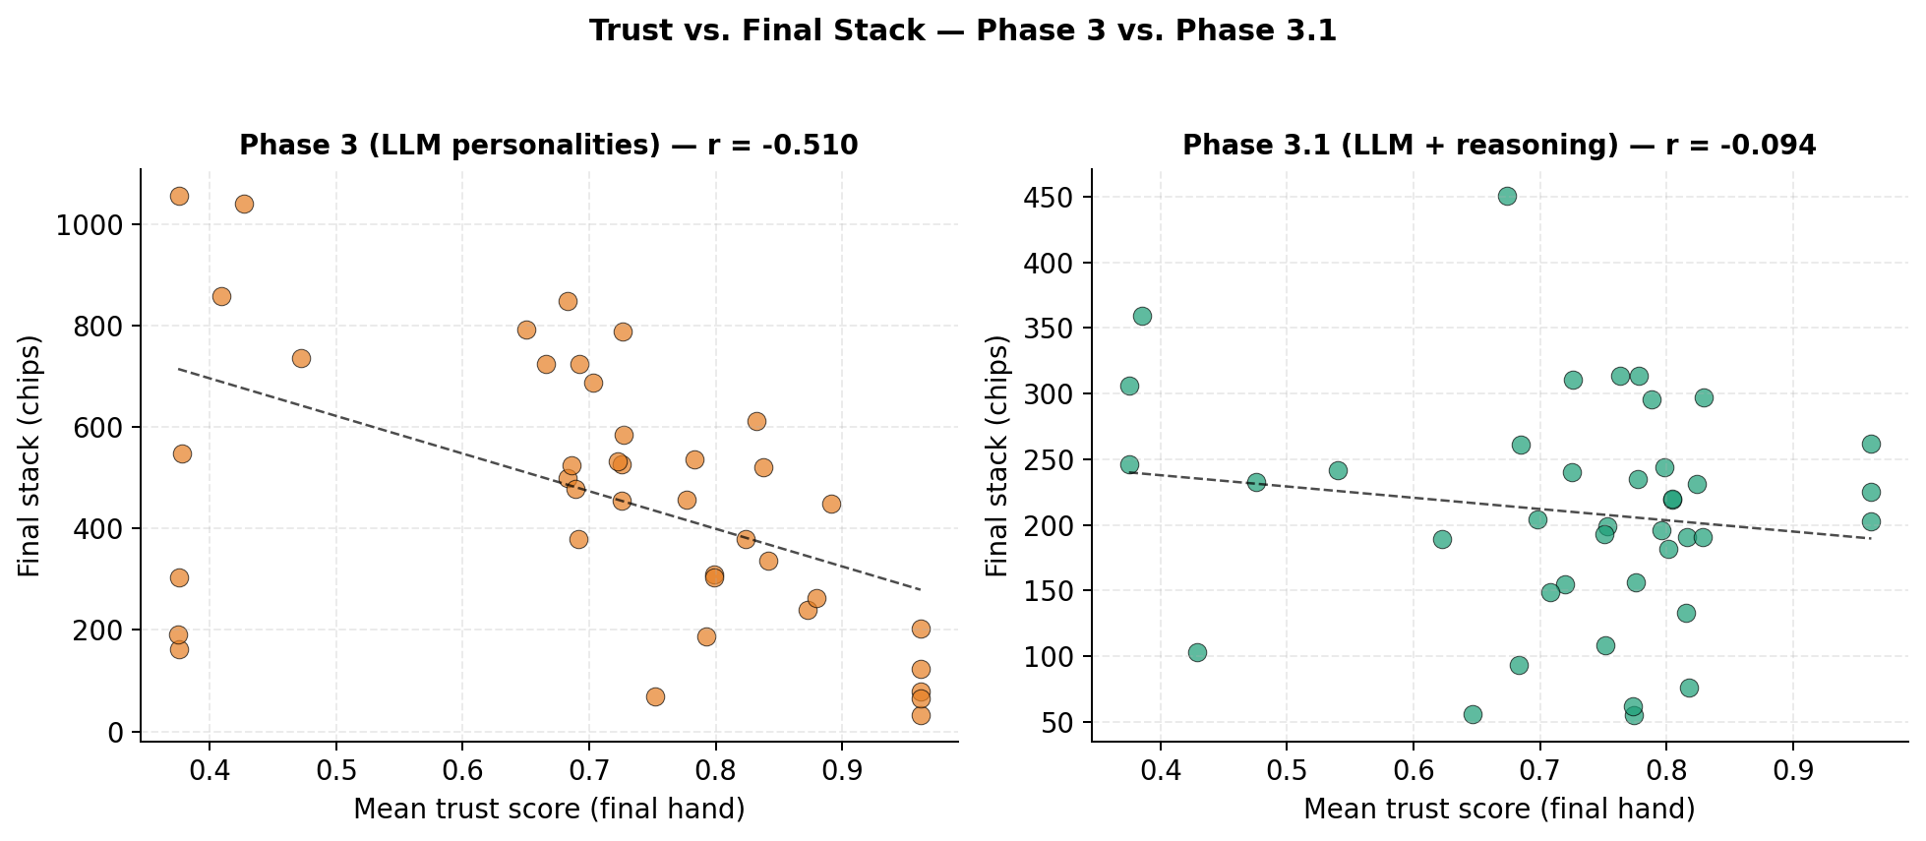
Trust versus final stack across phases. (Left) Phase 1: the most-trusted archetypes cluster in the low-stack region and Firestorm (low trust) is the highest earner. (Right) Phase 3.1: the relationship dissolves and Wall becomes the top earner. Each point is one (archetype, seed) observation.
The mechanism is also visible in a single representative hand. Box 1 reproduces hand #67 from seed 42: Wall is dealt $2♠ 5♣$ (hand rank $6,749$, the worst hand at the table) and calls every street of a 4-bet pot, paying 35 chips into a hand it had no chance to win. The illustrative hand we use here is drawn from the Phase 3 dataset so that we can show the trap holding even under a language-model implementation of Wall; the same dynamic occurs more frequently in Phase 1.
Setup. Seed 42, hand 67. Wall (seat 3) is dealt $2♠ 5♣$ – rank 6,749, the worst hand at the table. Final pot 110 chips, showdown.
Action sequence:
@r l l l r r N@ Seq & Seat & Round & Action & Amt & Pot & Notes
& Judge & preflop & raise & 4 & 7 &
6 & Firestorm & preflop & raise & 6 & 13 & 3-bet
7 & Wall & preflop & call & 5 & 18 & calls 4-bet pot with 2-5 off
9 & Judge & preflop & call & 2 & 20 &
10–16 & …& flop & …& & 38 & Judge bets, Firestorm raises, Wall calls each street
17–23 & …& turn & …& & 74 & Same pattern
24–30 & …& river & …& & 110 & Wall calls the final two raises
Showdown. Firestorm $J♡ J♢$ (rank 4042) wins 110. Judge $8♡ 8♢$ (rank 4703). Wall $2♠ 5♣$ (rank 6749). Wall pays 35 chips into a hand it had no chance to win. Every observer’s posterior puts $p=1.000$ on Firestorm being a firestorm and $p=1.000$ on Wall being a wall.

Classification accuracy.
The Predator archetype, which reads its posterior to choose exploitation targets, classifies only 3 of 7 opponents reliably above the prespecified 0.60 confidence threshold after 1,000 hands: Wall ($p=1.00$), Firestorm ($p≈0.82$), and occasionally Phantom ($p≈0.60$ in some seeds). The remaining four opponents fall below the threshold on every seed. Three of these (Sentinel, Mirror in its default state, Judge in its cooperative state) have byte-identical mean parameters under the spec; the posterior over them bottoms out at $\log_{2}\left(3\right)≈1.58$ bits regardless of observation volume—a direct consequence of our design choice rather than an emergent finding.

Phase 2: bounded hill-climbing softens but does not close the trap
Phase 2 produces $r_{tp}=−0.637±0.125$ with per-seed values $\{−0.759,−0.424,−0.719,−0.717,−0.564\}$. The shift from Phase 1 ($Δr_{tp}=+0.116$) is consistent across all five seeds (per-seed shifts $+0.015$, $+0.184$, $+0.073$, $+0.095$, $+0.212$). The Opponent Adaptation metric stays at $OA=0.0003$ in both Phase 1 and Phase 2: aggregate- reward optimization can drift parameters within the bound box but cannot, by construction, produce per-opponent strategy because the hill-climber has no per-opponent parameter slot. Mean per-agent L1 drift in parameter space is approximately $0.3$ over $10,000$ hands, meaning the bounded agents stay close to their starting points. Phase 2’s softening is real but its mechanism is local: the agents trim the worst-performing parts of their stationary policy without inventing anything qualitatively new.
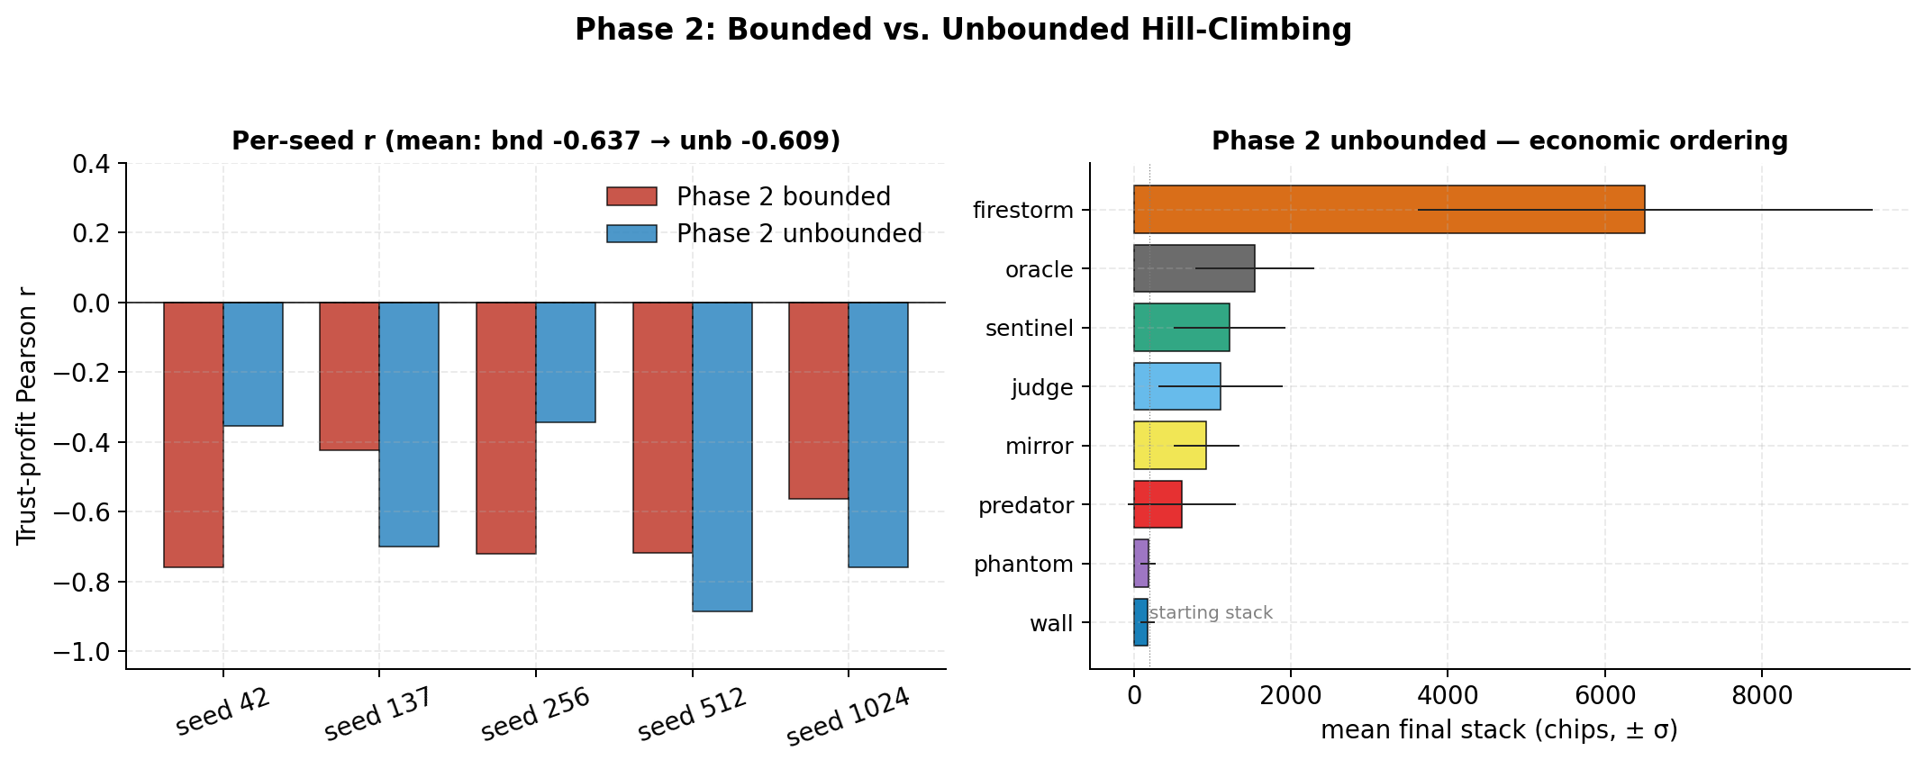
Bounded versus unbounded hill-climbing per seed. Bars compare bounded Phase 2 $r_{tp}$ (left of each pair) to aggressive Phase 2$​^{*}$ $r_{tp}$ (right) for the five canonical seeds. Mean $r_{tp}$ shifts by only $+0.028$ when bounds are removed and the optimizer step size is raised fivefold; per-seed variance triples.

Phase 2$​^{*}$: unbounded hill-climbing fails the same way
Phase 2$​^{*}$ produces $r_{tp}=−0.609±0.221$ with per-seed values $\{−0.354,−0.700,−0.344,−0.887,−0.759\}$. The mean shift from bounded Phase 2 is $Δr_{tp}=+0.028$, well within the seed-to-seed standard deviation. Mean per-agent L1 drift is $3.4$ ($11×$ the bounded run), so the agents have moved substantially in parameter space; but the trap holds.
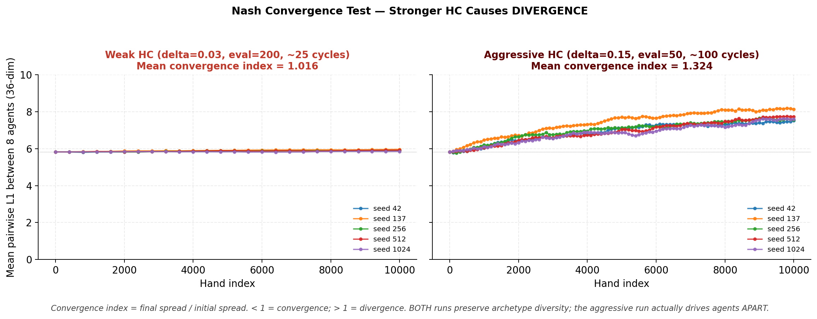
The 8-agent population diverges in parameter space. Mean pairwise $L_{1}$ distance between all eight agents in 36-dim parameter space over $10,000$ hands of unbounded hill-climbing. (Left) Weak HC ($δ=0.03$) leaves agents essentially stationary. (Right) Aggressive HC ($δ=0.15$) drives the population apart on every seed. Convergence index $>1$ means agents are more dispersed at end-of-run than at start.
The reason becomes visible in cluster-spread space. The mean pairwise $L_{1}$ distance between the eight agents in 36-dimensional parameter space grows from an initial $5.82$ to $≥7.5$ on every seed; the mean ratio of final to initial cluster spread is $1.324$. The agents are moving 11 times harder than under bounded HC, but they are moving apart, not toward a common Nash-like profile.
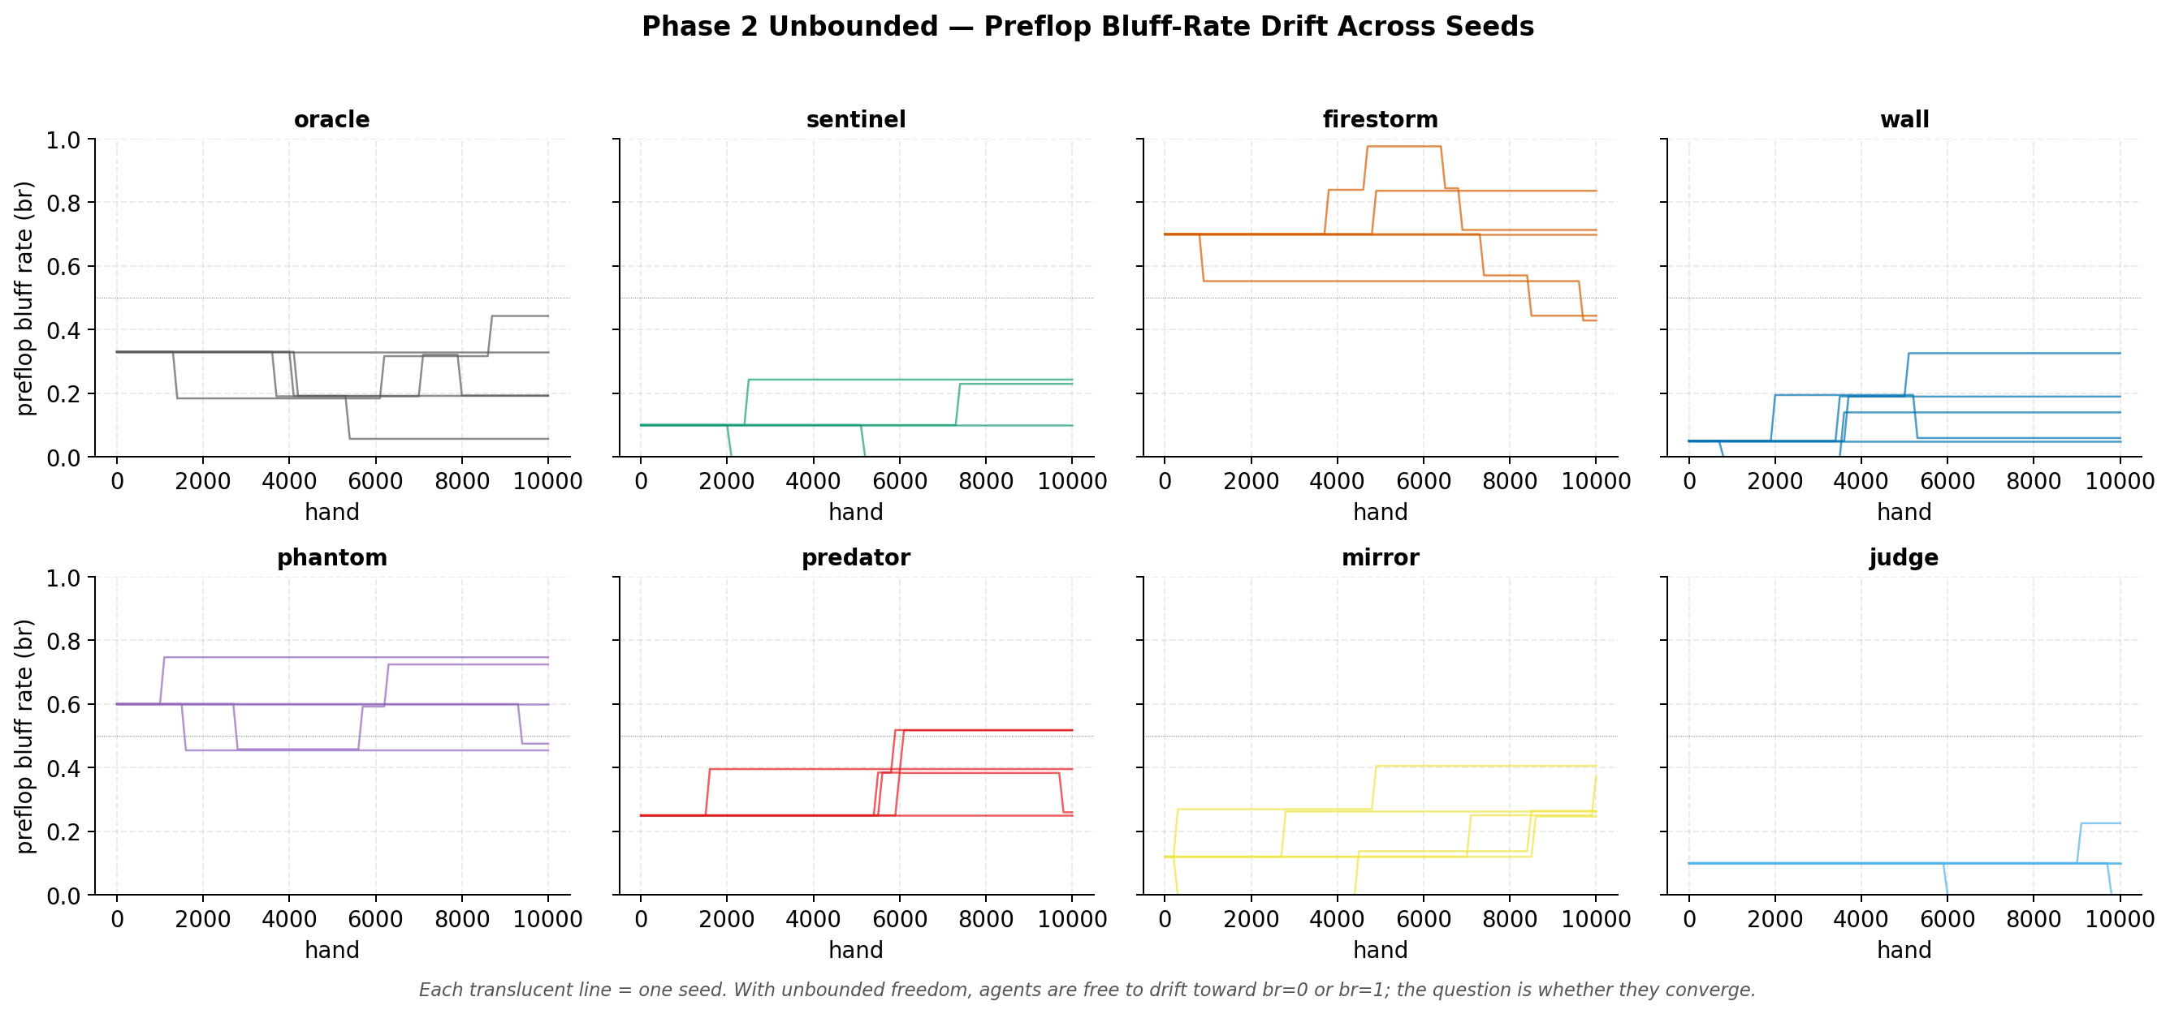
Per-archetype $L_{1}$ drift from Phase 1 starting parameters under aggressive unbounded hill-climbing. Every archetype moves significantly (mean drift $3.4$), but no two archetypes move toward the same target. Trajectories are color-coded by archetype.
Firestorm’s mean stack remains $∼6×$ the next archetype; Wall still incurs $∼28$ rebuys per seed. The economic ordering does not change. We attribute the non-convergence to three structural causes that we believe would survive any specific optimizer choice—non-stationary feedback from the lagging trust posterior, multi-agent simultaneity, and axis-aligned coordinate descent in 36 dimensions—and we elaborate in the Discussion.

Phase 3: language models alone do not break the trap
Phase 3 produces $r_{tp}=−0.510±0.268$ with per-seed values $\{−0.884,−0.525,−0.171,−0.712,−0.259\}$. The shift from Phase 2 ($Δr_{tp}=+0.127$) matches the Phase 1 $→$ Phase 2 step in magnitude. Per-seed variance is roughly twice Phase 2’s ($0.268$ vs $0.125$). Four of six behavioral-dimension targets are missed; three move backward relative to Phases 1 and 2 (Table [tab:behavioral-shift] reports per-archetype VPIP, PFR, and AF fingerprints): CS drops from $0.142$ to $0.076$, NS collapses to $0$, and SU falls from $1.88$ to $1.19$ bits.
Archetype | VPIP P1 | VPIP P3.1 | PFR P1 | PFR P3.1 | AF P1 | AF P3.1
oracle | 0.216 | 0.302 | 0.061 | 0.111 | 1.18 | 1.12
sentinel | 0.149 | 0.120 | 0.083 | 0.080 | 2.12 | 2.53
firestorm | 0.494 | 0.722 | 0.120 | 0.453 | 1.12 | 2.77
wall | 0.539 | 0.626 | 0.015 | 0.067 | 0.13 | 0.33
phantom | 0.279 | 0.437 | 0.092 | 0.162 | 1.45 | 1.29
predator | 0.215 | 0.248 | 0.063 | 0.119 | 1.20 | 1.38
mirror | 0.214 | 0.196 | 0.060 | 0.087 | 1.18 | 1.11
judge | 0.149 | 0.174 | 0.083 | 0.098 | 2.10 | 1.87
Personality specs tell the LLM what to do but not how to reason. Absent reasoning support, the LLMs in our sample collapse onto a more stereotyped canonical interpretation of each archetype, becoming more classifiable than the explicitly stochastic rule-based versions. The softening from Phase 2 to Phase 3 is therefore not produced by the same mechanism as Phase 2’s softening; it is mostly output stochasticity from sampling temperature 1.0.

Phase 3.1: reasoning scaffolding attenuates the trap
Phase 3.1 produces $r_{tp}=−0.094±0.301$ with per-seed values $\{−0.289,−0.338,−0.327,+0.047,+0.435\}$. The mean shift from Phase 3 ($Δr_{tp}=+0.416$) is the largest single step in the ladder, but the per-seed sample size ($n=5$) and the 150-hand horizon impose substantial uncertainty: the 95% bootstrap interval $\left[−0.32,+0.20\right]$ is wide enough to include moderate negative correlations of the kind we report under bounded Phase 2. Two of five seeds produce per-seed correlations greater than zero ($+0.047$ at seed 512 and $+0.435$ at seed 1024); with $n=8$ archetype pairs per seed, the Fisher-$z$ interval on a per-seed $r_{tp}=+0.047$ spans roughly $\left[−0.7,+0.7\right]$, so individual positive seeds are not on their own evidence of inversion. The combined picture is most accurately summarized as: the trust–profit correlation under Phase 3.1 is attenuated relative to all prior phases at the rank-order level, but the present sample is underpowered to distinguish between full neutralization and a weakened but nonzero residual trap.
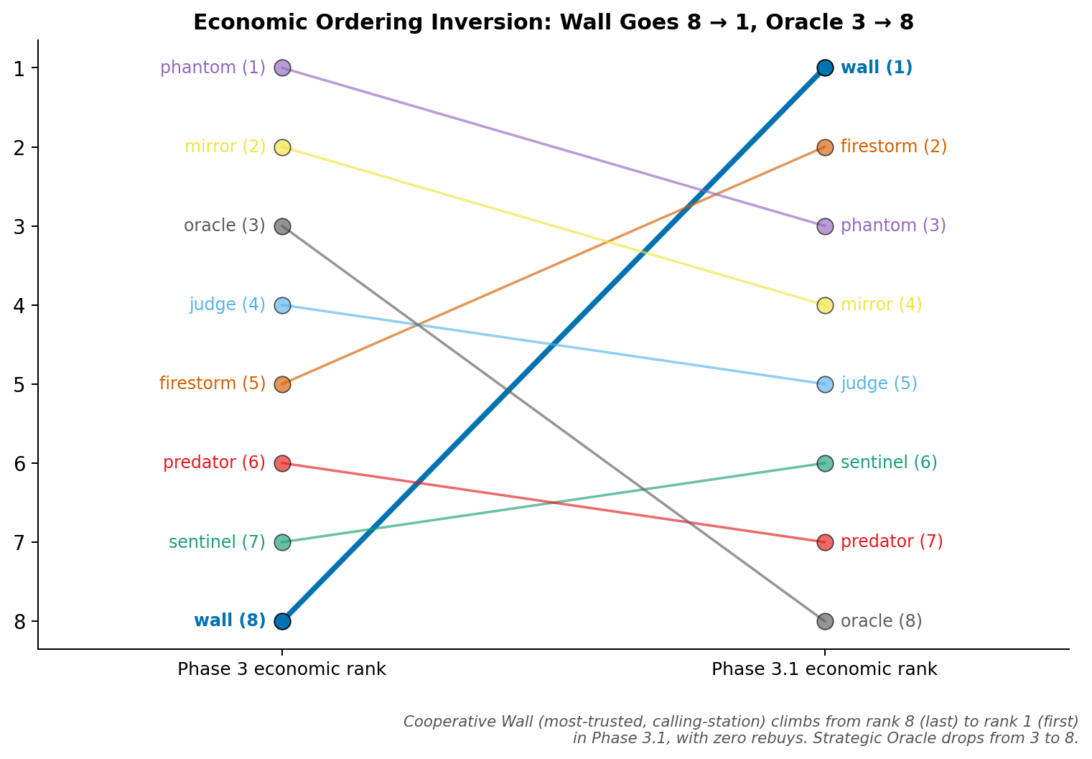
Economic ordering inverts from Phase 3 to Phase 3.1. Wall (trust $≈0.85$, highest of any archetype) was rank 8 of 8 in Phase 3 with $∼9$ rebuys per seed and becomes rank 1 of 8 in Phase 3.1 with zero rebuys. Firestorm falls from rank 5 in Phase 3 to rank 2 in Phase 3.1.
Wall’s mean stack rises from $∼100$–$200$ chips in Phases 1–3 to $280$ in Phase 3.1; rebuy count drops from $∼9.4$ per seed to zero, consistent with the rank-order claim above. The right panel of Fig. 1 (introduced earlier) shows the trust–stack scatter under Phase 3.1: the negative slope visible in the Phase 1 panel is gone. The full per-archetype economic ordering is in Table [tab:archetype-p31].
Archetype | Trust | Stack | $σ$ | Rebuys | Rank P3 | Rank P3.1 | $Δ$
wall | 0.849 | 280 | 88 | 0.0 | 8 | 1 | +7
firestorm | 0.481 | 231 | 104 | 0.2 | 5 | 2 | +3
phantom | 0.748 | 230 | 61 | 0.2 | 1 | 3 | -2
mirror | 0.728 | 208 | 83 | 0.0 | 2 | 4 | -2
judge | 0.781 | 191 | 45 | 0.0 | 4 | 5 | -1
sentinel | 0.786 | 183 | 58 | 0.0 | 7 | 6 | +1
predator | 0.797 | 179 | 98 | 0.0 | 6 | 7 | -1
oracle | 0.625 | 175 | 64 | 0.0 | 3 | 8 | -5
Four of six secondary metric targets are met in Phase 3.1 (vs. two of six in Phase 3). Strategic Unpredictability rises from $1.19$ to $1.55$ bits, crossing the $>1.5$ threshold for the first time across all phases. Trust Manipulation Awareness rises from $+0.164$ to $+0.242$, with six of eight archetypes showing positive TMA; Wall and Sentinel show the strongest signals at $+0.733$ and $+0.704$.
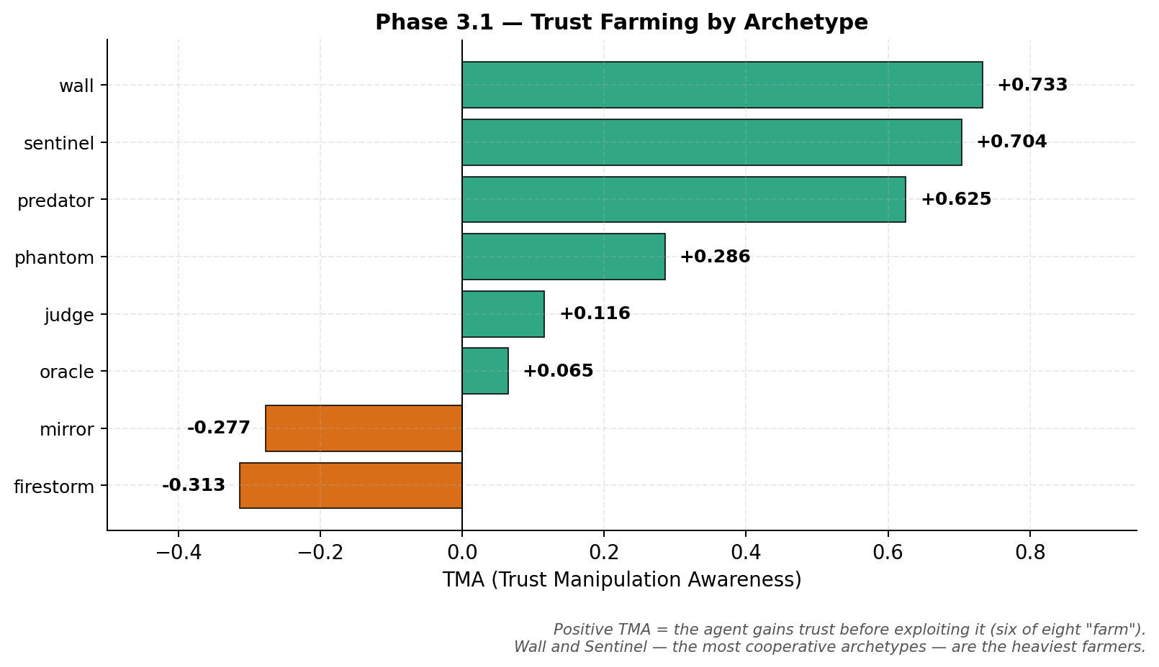
Trust Manipulation Awareness (TMA) per archetype in Phase 3.1. Positive TMA indicates an agent’s rolling trust delta correlates with its rolling aggression delta—building trust through cooperative early play, then leveraging it for higher-aggression later moves. Six of eight archetypes show positive TMA; Wall ($+0.733$) and Sentinel ($+0.704$) are the strongest.
Trust Manipulation Awareness (TMA) per archetype in Phase 3.1. Positive TMA = the agent gains trust before exploiting it. Six of eight archetypes farm, with Wall and Sentinel showing the strongest signals.
Archetype | TMA | Direction
wall | +0.733 | farming (heavy)
sentinel | +0.704 | farming (heavy)
predator | +0.625 | farming (heavy)
phantom | +0.286 | farming
judge | +0.116 | farming
oracle | +0.065 | farming
mirror | -0.277 | reactive
firestorm | -0.313 | reactive
The mechanism behind these numbers is most concretely visible in a single hand. Box 2 reproduces Phase 3.1 hand #146: Wall holding $K♡ Q♡$ (rank $872$) calls a flop continuation bet and a turn barrel from Firestorm, reads Firestorm’s river check as a tell, bets the river for value, and wins 32 chips. Canonical Wall never bets the river in any Phase 1, Phase 2, or Phase 3 dataset; Phase 3.1 Wall, with reasoning scaffolding, does.
Setup. Seed 42, hand 146. Wall (seat 3) is dealt $K♡ Q♡$ – rank 872, a strong hand. Final pot 32 chips, showdown.
Action sequence:
@r l l l r r N@ Seq & Seat & Round & Action & Amt & Pot & Notes
& Firestorm & preflop & raise & 3 & 10 &
8 & Wall & preflop & call & 2 & 12 & calls 3-bet with K-Q suited
11 & Firestorm & flop & bet & 2 & 14 & c-bet
12 & Wall & flop & call & 2 & 16 &
13 & Firestorm & turn & bet & 4 & 20 & second barrel
14 & Wall & turn & call & 4 & 24 &
15 & Firestorm & river & check & 0 & 24 & tell — bluff line abandoned
16 & Wall & river & bet & 4 & 28 & value bet against checked range
17 & Firestorm & river & call & 4 & 32 &
Showdown. Wall $K♡ Q♡$ (rank 872) wins 32. Firestorm $8♣ Q♣$ (rank 6075). Canonical Wall never bets the river in any Phase 1, Phase 2, or Phase 3 dataset; Phase 3.1 Wall, augmented with chain-of-thought, per-opponent memory, and adaptive strategy notes, does.

Discussion

The mechanism behind the trap
The trust trap visible in Phase 1 admits a clean mechanistic explanation that the Phase 3.1 results then refine. Trust, as we measure it, is the expected honesty of an opponent under the posterior; a high trust score signals to opponents that the agent is most likely an archetype that only bets with strong hands. For Wall (honesty 0.96) and Sentinel (honesty 0.92), this belief is correct, and that is precisely why it is costly: when opponents know an agent only bets with strong hands, they fold against its bets (denying value from those strong hands) and bet aggressively against its checks (exploiting the information that a check signals weakness). The agent’s honesty becomes a signal that opponents read and trade against. A low trust score, conversely, creates strategic ambiguity, and Firestorm uses that ambiguity to dominate the table. The phenomenon parallels what economists studying eBay-style reputation systems have called the transparency paradox : predictable cooperation is exploitable.
The mechanism by which Firestorm converts ambiguity into chips deserves comment because it differs structurally from the canonical Iterated Prisoner’s Dilemma result. In pairwise IPD, Always-Defect is outperformed by Tit-for-Tat because a defector faces concentrated retaliation. In our 8-player setting, Firestorm’s aggression cost is diffused across seven simultaneous opponents, so the same strategy that would lose heads-up wins at the full table. Our Tit-for-Tat analogue (Mirror) finishes sixth of eight in economic ordering— suggestive but not definitive evidence that the IPD result fails to transfer to multi-agent settings with richer action spaces. We flag this as a direction for follow-up rather than a conclusion, since a single hand-crafted poker analogue is not a clean test of the IPD literature.

What numerical optimization can and cannot do
The next three phases of the experiment narrow the space of possible explanations for why the trap is hard to escape. We begin with a structural caveat: by construction, three of our eight archetypes (Sentinel, Mirror’s default, Judge’s cooperative state) share byte-identical mean parameters, and the Bayesian posterior cannot distinguish them regardless of algorithmic sophistication. Classification accuracy in that sub-space is bounded below by the entropy of a uniform distribution over the three members. This is a definitional point about our archetype space, not an information- theoretic discovery about reputation systems in general; the empirical question of how rapidly classification accuracy degrades as inter-archetype distance shrinks toward zero would require experimentally varying that distance and is outside the scope of the present paper. Real-world monitoring systems—fraud detection, content moderation, credit scoring—face an analogous failure mode for moderately-behaved actors with overlapping profiles, but the analogy is suggestive rather than implied by our setup.
Within that caveat, the Phase 2 and Phase 2$​^{*}$ results argue against two specific hypotheses about the trap’s origin. Phase 2 (bounded hill-climbing) softens $r_{tp}$ by $+0.116$ while $OA$ stays pinned at $0.0003$: aggregate-reward optimization can move agent parameters but cannot, by construction, produce per-opponent strategy because the hill-climber has no per-opponent parameter slot. Phase 2$​^{*}$ (unbounded hill-climbing with $11×$ greater parameter drift) softens $r_{tp}$ by an additional $+0.028$ and produces a population that diverges rather than converges in 36-dimensional parameter space—evidence against the hypothesis that the archetype- shaped bound boxes are the binding constraint, though the sub-experiment varies three optimizer parameters at once (bounds removed, step size raised $5×$, evaluation window shrunk $4×$) and therefore does not cleanly isolate the parameter-space hypothesis. The non-convergence has three plausible structural causes that we expect would survive any specific optimizer choice: the trust posterior is non-stationary inside each agent’s optimization loop (with $λ=0.95$, opponents take $∼70$ hands to update beliefs after a strategy change but the evaluation window is 50 hands), all eight agents climb simultaneously so each trial perturbation is evaluated against a moving joint behavior, and axis-aligned coordinate descent in 36 dimensions cannot discover joint optima even with larger steps. A CMA-ES or REINFORCE optimizer with $∼50 000$ cycles would search more efficiently, but the first two causes would survive any optimization substrate that respects the same observation contract.
Phase 3 (LLM personality role-players) softens $r_{tp}$ by a further $+0.127$, but the diagnostic metrics suggest the mechanism is not categorically different from Phase 2’s: behavioral-dimension targets fail in three of four directions, with the LLMs collapsing onto a more stereotyped interpretation of each archetype than the explicitly stochastic rule-based versions. The personality specs tell the agents what to do but not how to reason; absent reasoning support the LLMs role-play the spec without spontaneously inventing opponent-conditional, time-varying, or unpredictable strategy. The Phase 3 softening may therefore be produced by output stochasticity at sampling temperature 1.0 rather than by a structural change in agent behavior.

What reasoning adds, and what we can and cannot claim outside poker
The Phase 3.1 result is consistent with an interpretation in which agent reasoning about the reputation system itself attenuates the trust–profit correlation. The chain-of-thought prompt allows a one-step lookahead; the per-opponent memory gives that reasoning concrete data to condition on; the adaptive strategy notes let the agent update its prior on what is working against which opponent. We claim that all three scaffolds are required, but this claim rests on an ablation reported in the supplementary validation suite rather than a dedicated main-text figure—the ablation deserves promotion in a future revision. The Wall hand reproduced in Box 2 illustrates the mechanism concretely in a single instance: Wall reads Firestorm’s river check as a tell, recognizes that K-Q high beats Firestorm’s bluffing range, and bets for value—a sequence that is impossible for the Phase 1 Wall and unreliable for the Phase 3 Wall. A distributional analysis across all Phase 3.1 hands, rather than a single illustrative case, is the natural follow-up.
These mechanisms suggest hypotheses for real-world reputation systems, but we emphasize the limit of the analogy: our testbed is a zero-sum game and the proposed exploitation mechanism (predictable cooperation extracted via fold equity) does not directly map to positive-sum marketplaces, where the buyer’s payoff is from the good rather than from out-thinking the seller. With that caveat, three implications follow as conjectures for cross-domain follow-up. Behavioral reputation alone may be insufficient without external enforcement, because observation-based trust can create perverse incentives that reward exploitative strategies. Classification systems may have blind spots for moderately-behaved actors with overlapping profiles, mirroring our identifiability sub-space. And transparency itself may be costly when it makes cooperative strategies too easy to model and exploit. Each of these would require direct validation in a positive-sum domain to claim more than analogical inference.

Limitations
Three clusters of limitations remain after the revisions above.
Statistical power gaps. The headline correlations are computed across $n=5$ random seeds; the Student-$t$ critical value at $\text{df}=4$ is 2.776, which requires $\left|r_{tp}\right|>0.878$ for two-sided significance against zero. The headline Phase 3.1 result has a 95% bootstrap interval $\left[−0.32,+0.20\right]$ that contains both a fully neutralized correlation and a moderate residual negative correlation, so we cannot statistically separate “trap broken” from “trap attenuated” at this sample size. Hand counts also differ across phases by an order of magnitude (10 000 hands/seed in Phases 1–2$​^{*}$, 500 in Phase 3, 150 in Phase 3.1), which mixes a capability effect with a statistical-power effect in the cross-phase ladder. The six secondary metrics (TEI, CS, OA, NS, SU, TMA) were chosen post hoc and are unadjusted for multiple comparisons. The single highest-leverage follow-up addressing all of these is an $n=20$ Phase 3.1 replication at the 500-hand horizon, estimated at $∼\$60$ in API spend.
Reproducibility and replication gaps. The canonical Phase 3 and 3.1 datasets were generated under the Anthropic SDK’s default sampling temperature of 1.0, while the released codebase now pins temperature to 0.0; the headline numbers are therefore not exactly reproducible from the current code without manual reversion. Phase 3 and 3.1 also use a single model family (Anthropic Haiku 4.5); a multi-model replication (Gemini Flash, GPT-4o-mini, or a comparable alternative) is needed to demonstrate that the attenuation is not model-specific. Finally, the Phase 3.1 three-scaffold deployment (chain-of-thought, memory, adaptive notes) is currently joint; a clean main-text ablation isolating each component’s contribution is the second- most-important missing experiment.
Design-choice gaps. Several of our methodological choices are load-bearing in ways that future work should disambiguate. The identifiability “floor” is a stipulated property of our archetype space (three archetypes share mean parameters), not an emergent finding; the honesty score $h\left(t\right)=P\left(\text{bet}∣\text{strong}\right)⋅\left(1−P\left(\text{bluff}∣\text{weak}\right)\right)$ is one of several plausible functional forms and the trust–profit correlation is mechanically anchored on this choice; the rebuy economics underweight deep chip losses (Wall’s 9.4 mean rebuys per seed in Phase 1 represent $∼1 880$ chips of true loss not visible in the final-stack metric); the Phase 2$​^{*}$ sub- experiment varies three optimizer parameters at once; and Limit Hold’em is zero-sum among players, while eBay marketplaces, social networks, and credit systems are positive-sum over trades, so direct cross-domain inference is rhetorical rather than warranted.

Conclusion
We have presented a controlled simulation study of trust dynamics in 8-player Limit Texas Hold’em. Across four agent architectures, the Pearson correlation between agent trust score and final stack falls along the ladder $−0.752→−0.637→−0.510→−0.094$, with each step accompanied by a confidence interval whose width exceeds the size of any single inter-phase $Δr_{tp}$. We characterize the rank ordering of the ladder as the robust finding and the absolute size of each step as a preliminary estimate requiring replication. An unbounded hill-climbing sub-experiment with $11×$ greater parameter drift produces $Δr_{tp}=+0.028$ from bounded Phase 2 and yields a population that diverges rather than converges in 36-dimensional parameter space— preliminary evidence against the hypothesis that the trap is a bound-box artifact, though Phase 2$​^{*}$ varies three optimizer parameters at once and does not cleanly isolate the bounds.
Three follow-up experiments are the most important next steps. First, an $n=20$ Phase 3.1 replication at 500 hands per seed (matching Phase 3) is the highest-leverage single experiment: it would tighten the confidence interval on the Phase 3.1 result by roughly a factor of two and distinguish “trap attenuated” from “trap broken”; estimated cost $∼\$60$ in API spend. Second, a clean ablation of the three Phase 3.1 scaffolds (chain-of-thought, per-opponent memory, adaptive notes) is required to support the claim that all three are necessary. Third, a temperature-pinned re-run of Phase 3 and Phase 3.1 at $T=0.0$ would resolve the open reproducibility caveat. Beyond these three, a multi-LLM replication, a no-limit Hold’em extension, and an experimental varying of inter-archetype distance would each strengthen the present findings.

Appendix: Mentor Checklist
For mentor review, the changes requested have been addressed as follows.
@>
p0.35>
p0.60@
Mentor request & Where addressed
Plain-language Introduction & Section 1 rewritten with everyday analogies (eBay, lending, social media); poker-specific vocabulary deferred to first-use footnotes; lead paragraph carries no math.
Background should have a flow, not random topics & Section 2 restructured as a single narrative connecting four lines of prior work (reputation economics $→$ IPD / cooperation $→$ Bayesian opponent modeling $→$ LLM agents), with explicit transitions between each.
Mathematical bounds for each archetype & Section 3.2 plus Table [tab:bounds-comprehensive] (Table A): per-archetype bounds on $P\left(\text{bet}|S\right)$, $P\left(\text{bet}|W\right)$, $P\left(\text{fold}|W\right)$, honesty, and adaptation rule.
Footnotes for poker terms and complicated values & Footnotes distributed throughout the manuscript; first occurrence of every poker term (limit Hold’em, blinds, streets, showdown, side pot, hole cards, c-bet, 3-bet/4-bet, VPIP, PFR, AF, walkover, tell, bluff, value bet) and every statistical term (Pearson $r$, chain-of-thought, Strategic Unpredictability, etc.) carries an inline definition.
Include graphs as you introduce & Every figure and box is placed inline at the paragraph that first references it. The two boxed hands (Box 1, Box 2) are no longer in floating environments; they render exactly where the text introduces them.
Discussion needs to flow, not bullet points & Section 5 is six flowing paragraphs, each beginning with a topic sentence that ties back to the headline ladder. No bulleted lists.
Page 7 has too many words & Each archetype card description was compressed from $∼$30 to $∼$18 words and the notation block trimmed to one sentence; the eight-card spread now flows across columns rather than crowding a single page. The 11-item Limitations list was compressed into the three-paragraph narrative in Section 6.
More figures and hands & Existing 7 figures kept inline; new placeholder for a Phase 3.1 scaffold-ablation figure (Fig. 7, pending experiment) and a new placeholder for an illustrative Phase 1 value-denial hand (Hand 3, pending extraction).
Phase 3.1 scaffold ablation (placeholder for pending experiment).
Hand 3 (placeholder): Phase 1 value denial.

Sources and Acknowledgments

Acknowledgments
We thank A. Bansal for mentorship through the Polygence research program and for the question, posed at our April 2026 meeting, that motivated the Phase 2$​^{*}$ unbounded sub-experiment. We thank the Polygence team for the program structure and Anthropic for the API access that made Phases 3 and 3.1 feasible.

Funding.
Polygence program fees and Anthropic API expenditure were self-funded by the author.

Author contributions.
R.A. conceived the study, implemented the simulation, performed the analysis, and wrote the manuscript.

Competing interests.
The author declares no competing interests.

Data and materials availability.
The full simulation codebase, SQLite databases, figures, tables, and analysis scripts are available at https://github.com/RachitAgrawal146/Poker_trust.

References

Supplementary Materials
- Bayesian update worked example:
- Identifiability ceiling derivation:
- Phase 2$​^{*}$ unbounded methodology footnote:
- Methods disclosures (temperature, side-pot, CIs):
- Bootstrap and Fisher-$z$ CI table:

The two private cards each player is dealt at the start of every hand; only the player can see them.
Limit Texas Hold’em fixes the bet size on each round. In our setup, bets and raises on the first two rounds are 2 chips; on the last two rounds they are 4 chips. No player can place more than four bets in a single round (the “four-bet cap”), which keeps the action space small and the math tractable.
The Pearson correlation coefficient measures the linear relationship between two paired variables on a scale of $−1$ (perfect negative) to $+1$ (perfect positive); $r=0$ means no linear relationship, and $\left|r\right|≈0.5$ is conventionally a moderate effect.
A bluff is a bet made with a weak hand intended to make opponents fold stronger hands; its inverse, a value bet, is a bet with a strong hand intended to be called by weaker hands.
Chain-of-thought prompting asks a language model to produce a short, explicit reasoning trace before its final answer, instead of jumping straight to the answer. In our setting the reasoning trace is capped at two sentences and the model is then required to emit a final-line ACTION: marker.
The four betting rounds in Texas Hold’em, in order, are preflop (after each player receives two private “hole” cards but before any community cards), flop (after three community cards are dealt simultaneously), turn (after a fourth community card), and river (after a fifth and final community card).
Fixed-limit Texas Hold’em permits at most four raises per betting round; further raises are not allowed.
A showdown is the end-of-hand reveal in which all still-active players turn over their hole cards to determine the winner; pots that end with all opponents folding to a single player do not reach showdown.
When a player goes all-in for fewer chips than the largest contributor, the engine creates a side pot for the excess so that the short-stacked player can only win up to the amount they contributed; deeper-stacked players contest the remainder among themselves.
A bluff is a bet made with a weak hand intended to make opponents fold stronger hands. Its inverse, a value bet, is a bet with a strong hand intended to be called by weaker hands. Fold equity is the value an aggressor captures when opponents fold without reaching showdown.
Across this and the following seven cards, br = bluff rate (probability of betting on a weak hand), vbr = value-bet rate (probability of betting on a strong hand), and cr = call rate facing a bet on a medium hand. Ranges are the archetype’s Phase 2 hill-climbing bound boxes around its Phase 1 starting parameters.
A walkover (or “uncontested pot”) is a hand won without showdown—every other player folded before the cards had to be shown. It is the bread-and-butter outcome for aggressive players who win by making opponents fold rather than by holding the best hand.
Hand rank is taken from standard 7-card poker equity tables: rank 1 is the strongest possible hand and rank 7,462 is the weakest. Rank $≤1,000$ is roughly “top 15% of hands.”
3-bet and 4-bet refer to successive re-raises. The big blind counts as the first bet; a raise is the 2-bet; a re-raise is the 3-bet; another re-raise is the 4-bet. Under our four-bet cap, no further raises are allowed in the same round.
The $L_{1}$ distance between two parameter vectors is the sum of absolute differences across all 36 (round, action) slots. Larger $L_{1}$ means the agent has moved further from its starting parameters.
VPIP (voluntarily put in pot) is the percentage of hands in which a player voluntarily put chips into the pot, excluding the forced blinds. High VPIP = loose; low VPIP = tight.
PFR (preflop raise rate) is the percentage of hands in which a player raised before the flop. PFR $≤$ VPIP by definition.
Aggression factor (AF) is the ratio $\left(\text{bets}+\text{raises}\right)/\text{calls}$. AF $>2$ is aggressive; AF $<1$ is passive.
Strategic Unpredictability (SU) is the Shannon entropy in bits over each agent’s action distribution. Higher SU = harder to predict.
A continuation bet (c-bet) is a bet made on the flop by the player who took the lead in betting preflop, regardless of whether the flop helped that player’s hand. It is the most common bluff line in modern poker.
A tell is a behavioral signal that gives information about an opponent’s hand. Wall reads Firestorm’s river check as a tell because the canonical Firestorm policy bets every street with a real hand; a river check therefore signals that the bluff line has been abandoned.

