Task 7: Monitoring Using Prometheus and Grafana
- Set up Prometheus and Grafana inside the Kubernetes cluster.
- Monitor:
  - Pod health
  - CPU and Memory usage
- Create Grafana dashboards based on Prometheus data.

Step 1: Open VS Code and Prepare Kubernetes Environment
1. Launch Visual Studio Code.
2. Open a folder (T-7-Monitoring) to save your YAML files.
3. Open a terminal inside VS Code (Ctrl + `) and start your cluster:
- minikube start
4. Verify Kubernetes is running:
- kubectl get nodes
Step 2: Install Prometheus and Grafana Using Helm
- Add Prometheus community Helm chart:
- helm repo add prometheus-community https://prometheus-community.github.io/helm-charts
- helm repo update

- Def: We use Helm to install Prometheus and Grafana easily.
2. Create a namespace (optional):
- kubectl create namespace monitoring

- Def: This keeps all monitoring tools in one place.
3. Install Prometheus:
- helm install prometheus prometheus-community/prometheus --namespace monitoring

- Def: This installs Prometheus in the Kubernetes cluster.
4. Install Grafana:
- helm repo add grafana https://grafana.github.io/helm-charts --namespace monitoring
- Def: Uses Helm to deploy tools cleanly in monitoring namespace.

- Confirm pods are running:
- kubectl get pods -n monitoring

Step 3: Access Prometheus and Grafana Dashboards
1. Port-forward Prometheus:
- kubectl port-forward svc/prometheus-server 9090:80 -n monitoring
- Open browser: http://localhost:9090
Def: This opens Prometheous in the browser. We use admin/admin123 to log in.
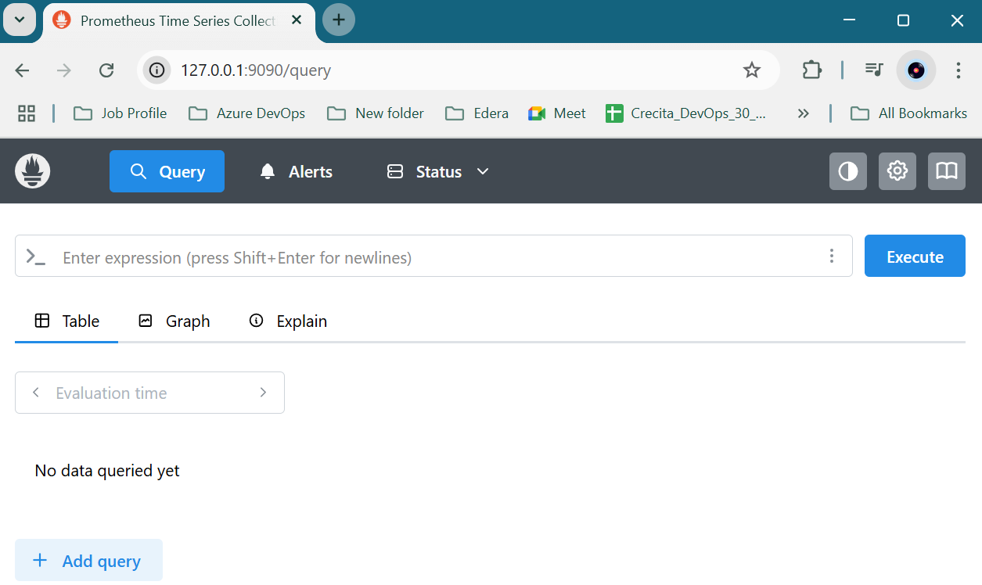
2. Port-forward Grafana:
- kubectl port-forward svc/grafana 3000:80 -n monitoring
- Open browser: http://localhost:3000

- Def: This opens Prometheous in the browser. We use admin/admin123 to log in.

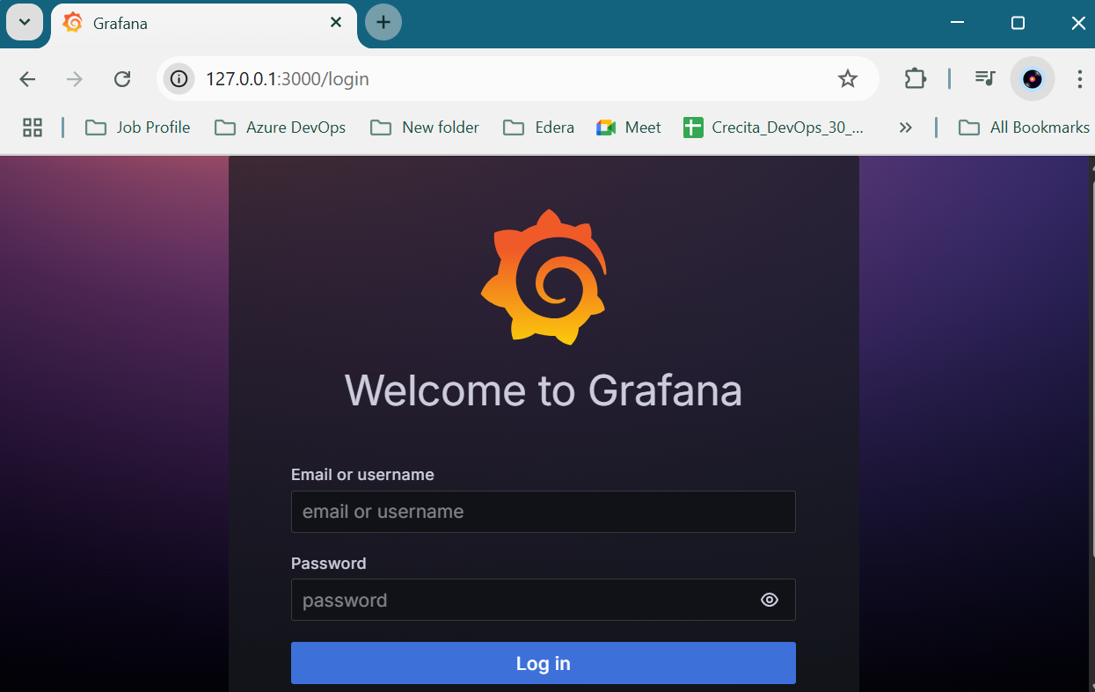
3. Default Grafana login:
Username: admin
Password: (use the command below)
- kubectl get secret --namespace monitoring grafana -o jsonpath="{.data.admin-password}" | base64 –decode
Pass: 8VXNkhKFHWushsX2nDqjuuKSmTuyaRuj3vPwuhR5
Step 4: Add Prometheus as a Grafana Data Source
1. In Grafana UI:
- Go to Settings → Data Sources
- Click Add data source
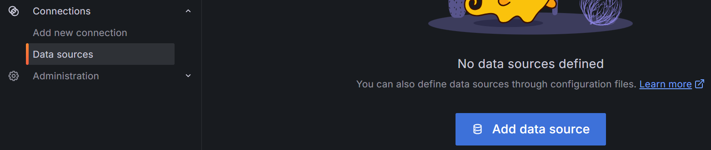
- Choose Prometheus
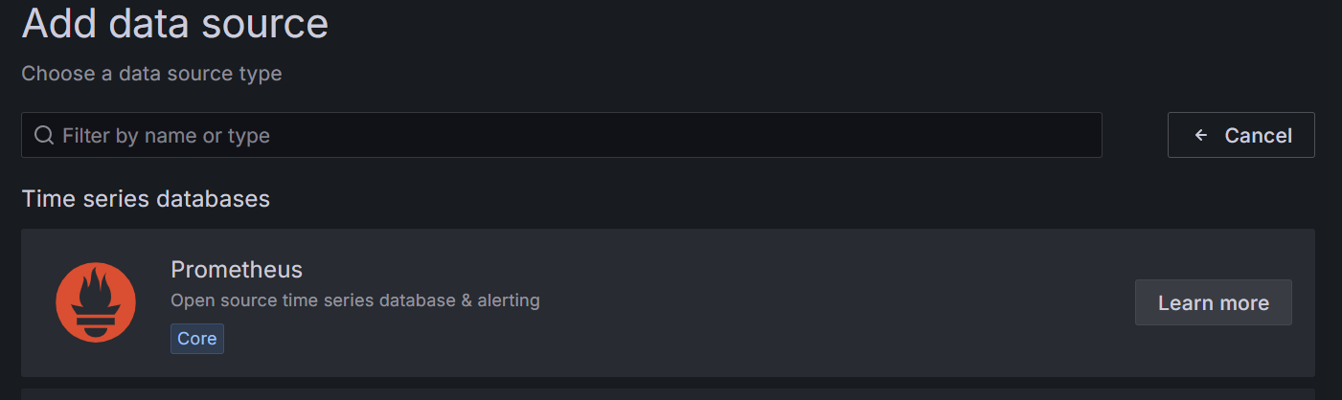
- URL: http://prometheus-server.monitoring.svc.cluster.local

- Click Save & Test
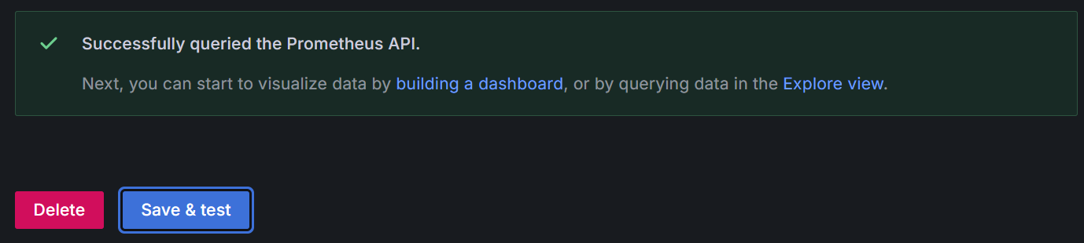
- Def: Now Grafana can read data from Prometheus.
Step 5: Monitor Pods, CPU, and Memory
Prometheus collects metrics from K8s. You can monitor:
- Pod Health:
- kube_pod_status_ready{condition="true"}
- CPU Usage:
- rate(container_cpu_usage_seconds_total{image!=""}[5m])
- Memory Usage:
- container_memory_usage_bytes{image!=""}
Step 6: Create Dashboards in Grafana
- Login to Grafana (http://localhost:3000)
- Go to Dashboards > + New > New Dashboard
- Add a new panel.
- Use Prometheus as the data source.
- Example queries for panels:
CPU:
- rate(container_cpu_usage_seconds_total{namespace="default"}[2m])
Memory:
- container_memory_usage_bytes{namespace="default"}
Pod health:
- count(kube_pod_status_ready{condition="true"}) by (namespace)
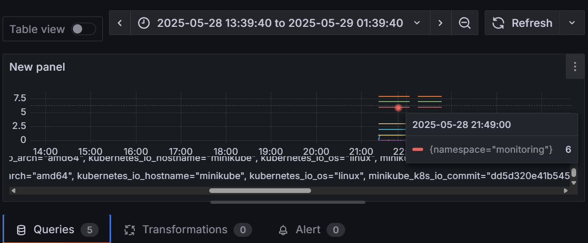
- Save the dashboard with a name like “T-7-Monitoring”
Use in Daily Standup:
"Yesterday, I implemented centralized monitoring using Prometheus and Grafana on our Kubernetes cluster. I configured data collection for pod health, CPU, and memory metrics. I also created Grafana dashboards using PromQL queries to visualize key metrics. The setup uses Helm for installation and is running in an isolated monitoring namespace."
Why do we need Helm?
"I’m using Helm to simplify the deployment of Prometheus and Grafana. It helps us avoid manual YAML configurations and allows quick rollbacks or upgrades. This saves setup time and ensures consistency across environments."

