Rachit Kumar

12-A

Report File

Section A: Functions

1. Twin Primes

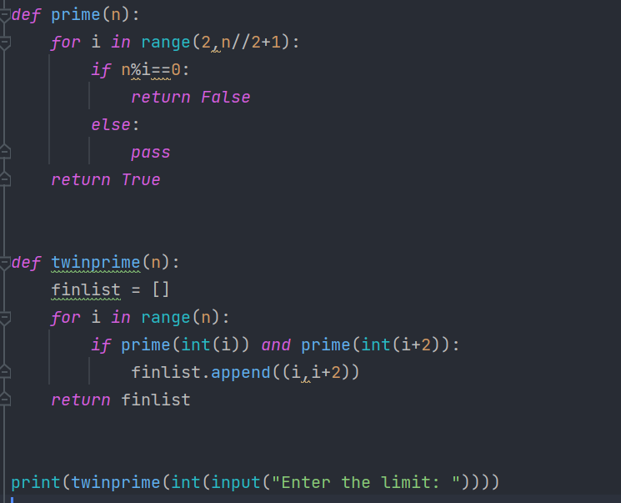



1. Quadratic Equation

1. Twin Primes

1. Dice Roll

1. Krishnamurthy Number

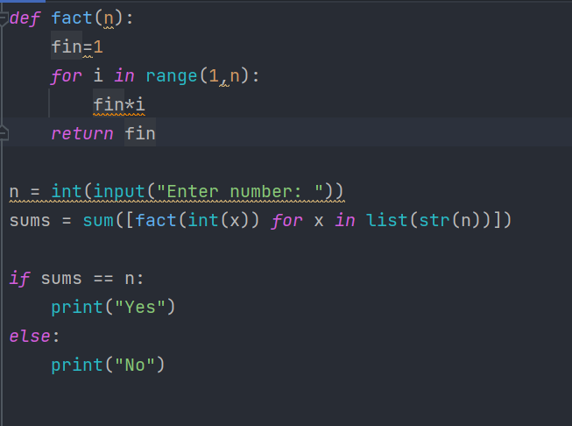

1. Quiz

Section B: Recursion

1. Fibonacci

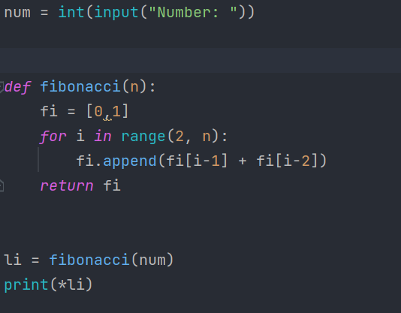

1. Factorial

Section C: Text filing

1. Vowel and consonant detection

1. Hashtag

Section D: Binary filing

1. Phonebook

1. Roll No, Name and Marks

Part B: SQL

1. SHOP Structure, Contents

1. SHOP details not from CP

1. SHOP details in alphabetical order

1. Three lettered accessories

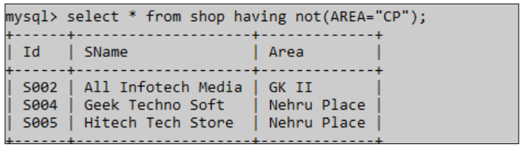

1. Structure of ACCESSORIES

1. Table Content of ACCESSORIES

1. Price of Keyboard

1. Product higher than 4900

1. Product between 100 and 999

1. ACCESSORIES Name of S001 and S002

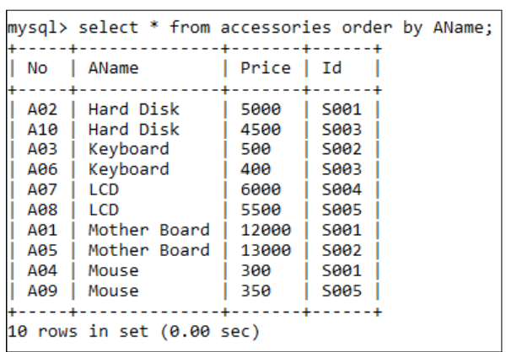

1. ACCESSORIES Details of Mouse or Motherboard

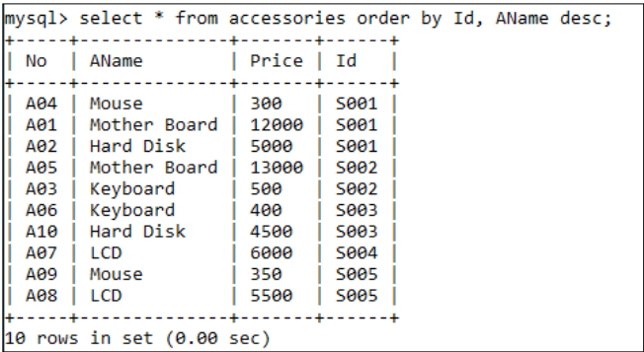

1. ACCESSORIES Details in Alphabetical Order

1. Details in desc order of price

1. AName and 10 percent high price

1. Total number of ACCESSORIES

1. Total price of ACCESSORIES

1. ACCESSORIES with A in them

1. Max price of Accessories

1. Min price of Accessories

1. AName ending with ‘D’

Project Synopsis:

In class 11 and 12, most science students either start preparing for JEE or NEET entrance examinations. With the preparation, comes the gruelling task of learning thousands of formulae and expressions, some of which are incredibly complicated with a number of variables. We have thought of addressing this problem. Our solution: a database of all formulas that are needed in classes 11 and 12 in physics, chemistry and maths, a facility to enter the name of the chapter, search for the formula, get the formula as well as put in values for a solution of a sample question. We believe that this can help all students that are preparing for competitive examinations as it becomes a all in one hub for all formulas.

Light and Sound Project:

<https://github.com/RachitKumar205/moodical>

<https://github.com/RachitKumar205/moodical-frontend>