PES UNIVERSITY
UE23CS352A — Machine Learning
WEEK 6 LABORATORY REPORT
Artificial Neural Networks
A Neural Network for Function Approximation, Implemented from Scratch

Submitted by
Rachit S. Mane
SRN: PES1UG24AM214
Course: Machine Learning (UE23CS352A)
Laboratory: Week 6 — Artificial Neural Networks
Date: 8 September 2026

1. Introduction

1.1 Purpose of the Laboratory
The purpose of this laboratory is to build a working artificial neural network (ANN) entirely from first principles, without using any high-level deep-learning framework such as TensorFlow, PyTorch or Keras. Frameworks of that kind hide the mathematics of learning behind a single call to a fit or backward method. By writing every component by hand in NumPy, the internal machinery of a neural network — the weighted sums, the non-linear activations, the loss surface, the chain rule and the parameter update — becomes explicit and verifiable rather than assumed.

1.2 Objective
The objective is to implement, train and evaluate a fully connected feed-forward network with the architecture Input(1) → Hidden Layer 1 → Hidden Layer 2 → Output(1) and to use it to approximate a continuous, non-linear, single-variable function. Every learning component was written explicitly:
- the ReLU activation function and its derivative;
- the Mean Squared Error (MSE) loss function;
- Xavier (Glorot) weight initialisation;
- forward propagation through all three layers;
- backpropagation of the gradients using the chain rule;
- the gradient-descent weight and bias updates and the training loop.

1.3 The Function-Approximation Task
Function approximation is a regression problem: given an input value x, the network must predict a continuous output value y that lies as close as possible to the value produced by an unknown underlying function. The Universal Approximation Theorem guarantees that a feed-forward network with sufficient hidden units can approximate any continuous function to arbitrary accuracy; this laboratory tests that idea in practice on a synthetic dataset whose true generating function is known exactly, so the quality of the approximation can be measured precisely.

1.4 Scope of the Work Reported Here
The work is divided into two parts, following the laboratory instructions. Part A establishes a baseline model using the hyperparameters assigned automatically from the student SRN. Part B conducts four further experiments, each varying one hyperparameter with respect to that baseline — the learning rate, the batch size, the number of epochs and the activation function. All five configurations were trained and evaluated on the test set, and each produced its own training-loss curve, predicted-versus-actual plot and residual plot. Every numerical value reported in this document was produced by the executed notebook; no result has been estimated, rounded from memory or reproduced from any other source.

2. Dataset Description
The dataset is synthetic and is generated inside the notebook itself when the dataset cell is executed. It is not downloaded from any external source. The generator is deterministic: it reads the student SRN, extracts the last three digits, and uses that number both to select the family of function to be approximated and to seed the random number generator. For the SRN PES1UG24AM214 the last three digits are 214, which selects the Cubic + Inverse function family and the Wide-to-Narrow network architecture.
Table 1: Dataset and assignment parameters, as generated by the executed notebook.
Property | Value (from the executed notebook)
Student SRN | PES1UG24AM214
Assignment rule | Derived from the last three digits of the SRN: 214.  Dataset type = 214 mod 5 = 4; architecture = 214 mod 4 = 2.
Assigned dataset type | Cubic + Inverse (polynomial type 4)
Generating function | y = 1.83x³ − 0.47x² + 5.73x + 9.62 + 89.1/x + ε
Input range | x ~ Uniform(−100, 100)
Number of samples | 100,000
Number of features | 1 (a single input variable, x)
Target dimension | 1 (a single continuous output, y)
Noise level | ε ~ N(0, 1.60) (additive Gaussian noise, σ = 1.60)
Training set | 80,000 samples (80%)
Test set | 20,000 samples (20%)
Split method | sklearn train_test_split, random_state = 42
Preprocessing | Both x and y standardised with StandardScaler  (scalers fitted on the training set only, then applied to the test set)
Random seed | 214 (derived from the SRN; used for dataset generation and weight initialisation)
Assigned architecture | Input(1) → Hidden(72) → Hidden(32) → Output(1), "Wide-to-Narrow"
Assigned learning rate | 0.001

A note on the inverse term. The generating function contains the term 89.1/x, which is undefined at the origin. The notebook's dataset cell therefore evaluates it as 89.1 / (x + sign(x) × 0.1), which shifts the sample a small distance away from zero and keeps every target value finite. The consequence is that target values grow very large in magnitude close to the origin as well as at the extremes of the input range; the observed target values span roughly ±1.8 × 10⁶. This is the reason both x and y are standardised before training: without standardisation, targets of that magnitude would produce enormous gradients and the network would not train stably.
Why standardisation matters for the reported losses. Because the targets are standardised, all MSE values reported in this document are expressed in the standardised target space, which is the quantity the network actually minimises. A value of 1.0 in this space corresponds roughly to the variance of the target, so an MSE near 1.0 means the model is no better than predicting the mean, while an MSE near 0 means a near-perfect fit. The root-mean-square error is additionally reported in the original units of y for interpretability.

3. Methodology

3.1 Network Architecture
The network is a fully connected feed-forward network with two hidden layers, matching the architecture required by the laboratory instructions. The widths of the hidden layers, 72 and 32, were assigned automatically from the SRN.
Input(1) → Hidden(72, ReLU) → Hidden(32, ReLU) → Output(1, Linear)
Table 2: Layer-by-layer structure of the implemented network.
Layer | Units | Activation | Parameters | Notes
Input layer | 1 | — | — | The single feature x (standardised).
Hidden layer 1 | 72 | ReLU | 1 × 72 + 72 = 144 | Assigned width (Wide-to-Narrow).
Hidden layer 2 | 32 | ReLU | 72 × 32 + 32 = 2,336 | Assigned width (Wide-to-Narrow).
Output layer | 1 | Linear | 32 × 1 + 1 = 33 | Linear, as required for regression.
Total | — | — | 2,513 | Trainable parameters.

The output layer uses a linear activation. This is deliberate: the task is regression, and the target may take any real value, so squashing the output through a bounded non-linearity would make some target values unreachable.

3.2 Activation Function and Its Derivative
The Rectified Linear Unit (ReLU) was implemented for the hidden layers. It outputs zero for negative pre-activations and the input itself for positive ones:
f(z) = max(0, z) f'(z) = 1 if z > 0, 0 otherwise
ReLU introduces the non-linearity that allows the network to represent curved functions; a network built only from linear layers, however deep, would collapse into a single linear map and could never fit a cubic curve. ReLU also mitigates the vanishing-gradient problem, because its derivative is exactly 1 wherever the unit is active rather than a small fraction. The derivative was implemented separately because backpropagation needs it to propagate the error signal back through each hidden layer. For Experiment 4 a tanh activation and its derivative 1 − tanh²(z) were also implemented, so that the effect of the activation choice could be measured.

3.3 Loss Function
Mean Squared Error was implemented as the training objective. For m samples:
MSE = (1/m) · Σ (y_true − y_pred)²
MSE penalises large errors quadratically, which is appropriate here because the aim is to track a smooth curve closely everywhere rather than to tolerate occasional large deviations. Its derivative with respect to the prediction, (2/m)·(y_pred − y_true), is the starting point of backpropagation.

3.4 Weight Initialisation
Xavier (Glorot) initialisation was implemented. For each layer, the weights are drawn from a normal distribution whose standard deviation depends on the number of units entering and leaving that layer, and the biases are set to zero:
W ~ N(0, σ) with σ = sqrt( 2 / (fan_in + fan_out) ), b = 0
This keeps the variance of the activations roughly constant from layer to layer. Weights initialised too small cause activations and gradients to vanish as they propagate; weights initialised too large cause them to explode. The initialisation is seeded with the SRN-derived seed (214), so every one of the five runs in this report starts from exactly the same set of initial weights. Any difference in the results is therefore attributable to the hyperparameter that was changed, and not to a lucky or unlucky random start.

3.5 Forward Propagation
Forward propagation computes the network's prediction. At each layer the input is multiplied by the weight matrix, the bias is added, and the activation function is applied. The intermediate quantities are retained because backpropagation needs them:
z₁ = X·W₁ + b₁ a₁ = ReLU(z₁)
z₂ = a₁·W₂ + b₂ a₂ = ReLU(z₂)
z₃ = a₂·W₃ + b₃ ŷ = z₃ (linear output)

3.6 Backpropagation
Backpropagation computes the gradient of the loss with respect to every weight and bias by applying the chain rule backwards through the network. It begins with the derivative of the MSE at the output and works layer by layer towards the input:
dŷ = (2/m)·(ŷ − y_true)
dW₃ = a₂ᵀ·dŷ db₃ = Σ dŷ
dz₂ = (dŷ·W₃ᵀ) ⊙ ReLU'(z₂) dW₂ = a₁ᵀ·dz₂ db₂ = Σ dz₂
dz₁ = (dz₂·W₂ᵀ) ⊙ ReLU'(z₁) dW₁ = Xᵀ·dz₁ db₁ = Σ dz₁
The symbol ⊙ denotes element-wise multiplication. Each gradient tells us how much the loss would change if that particular parameter were increased slightly.

3.7 Gradient Descent: Weight and Bias Updates
Once the gradients are known, every parameter is moved a small step in the direction that reduces the loss — that is, opposite to its gradient — scaled by the learning rate η:
W ← W − η · dW b ← b − η · db
This same rule is applied to all six parameter arrays (W₁, b₁, W₂, b₂, W₃, b₃). The optimiser is plain gradient descent: there is no momentum, no adaptive learning rate and no weight decay. This is stated explicitly because it explains a great deal about the results in Section 4 — with a fixed small step size, the number of updates performed becomes the dominant factor in how far training progresses.

3.8 Training Procedure
The baseline training loop performs full-batch gradient descent: each epoch computes the forward pass over all 80,000 training samples, evaluates the loss, backpropagates, and applies exactly one parameter update. Training and test loss are recorded at every epoch so that the learning curve can be plotted. For Part B, a configurable version of the same routine was written, exposing the learning rate, batch size, epoch count and activation function as arguments. When a batch size smaller than the training set is supplied, the training data is shuffled each epoch (with a fixed seed, for reproducibility) and one update is applied per mini-batch — that is, mini-batch stochastic gradient descent. The underlying mathematics is identical in both cases; only the amount of data used per update differs.

3.9 Early Stopping
The training loop implements early stopping with a patience of 10 epochs, monitored on the test loss, and retains the weights from the epoch with the lowest test loss. It is important to record that early stopping never triggered in any of the five runs: every run improved its test loss until it exhausted its epoch budget, so all runs used their full allocation (500, 500, 500, 1500 and 500 epochs respectively). This is itself a meaningful result — it means none of the configurations had begun to overfit at the point where training ended.

3.10 Evaluation Protocol
All five runs are evaluated identically. The selected weights of each run are used to make predictions on the training and test sets, and the following are computed: MSE in the standardised target space, the coefficient of determination R² on the original scale, and the RMSE on the original scale. Computing all rows of the results table by one explicit final evaluation, rather than reading the last value from each training log, removes any ambiguity about whether a figure was measured before or after the final parameter update.

3.11 A Note on Metrics: Why Accuracy Is Not Reported
The results table required by the laboratory instructions contains columns for training, validation and test accuracy. These are reported as N/A throughout this report, for two reasons that should be stated plainly rather than filled in with an invented number.
- Accuracy is undefined for this task. Classification accuracy is the fraction of samples assigned to the correct discrete class. This is a regression problem with a continuous target, so there are no classes and no notion of a prediction being "correct". R² and RMSE are reported instead, and they are given in a supplementary table.
- There is no validation set. The data-generation cell provided in the notebook — which the instructions mark as not to be modified — creates only a training split (80%) and a test split (20%). No third partition exists, so no validation loss or validation accuracy can honestly be reported. The training loop monitors the test set for early stopping, so the test set plays the monitoring role that a validation set would ordinarily play.
Both columns are therefore marked N/A rather than populated with a substitute figure.

4. Results and Analysis
This section presents the five executed configurations in turn. For each one, the hyperparameters and the measured metrics are tabulated, followed by the three plots produced by that run: the training and test loss curves, the predicted-versus-actual comparison on the test set, and the residual plot. All plots are the figures generated by the notebook; none has been redrawn or reconstructed. All losses are MSE in the standardised target space unless stated otherwise.

4.1 Baseline Model
The baseline uses the configuration assigned automatically from the SRN: a learning rate of 0.001, ReLU activations, and full-batch gradient descent over the whole 80,000-sample training set for a maximum of 500 epochs. Because the batch is the entire training set, each epoch applies exactly one parameter update, so the whole run consists of just 500 updates.
Table 3: Configuration and measured results — Baseline.
Hyperparameter | Value | Metric | Measured value
Learning rate | 0.001 | Training loss (MSE) | 0.406805
Batch size | 80,000 | Test loss (MSE) | 0.399644
Number of epochs | 500 (of 500 allowed) | Train R² | 0.5932
Optimizer | Batch Gradient Descent (full-batch) | Test R² | 0.5936
Activation function | ReLU | Test RMSE (original scale) | 438,742.53

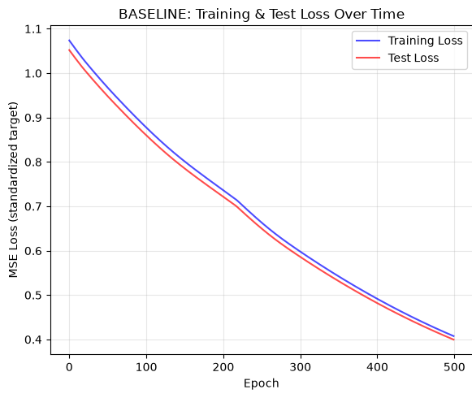
Figure 1: Baseline — training and test loss over 500 epochs. Both curves are still falling steeply when training ends, and they lie almost on top of each other.
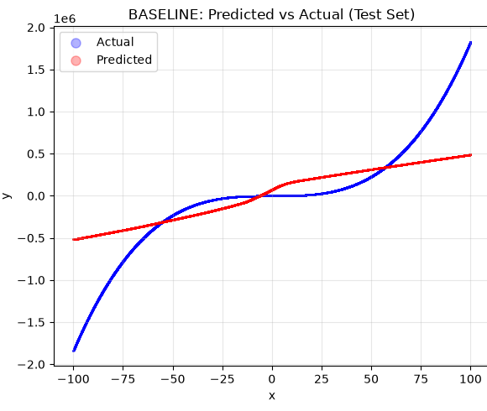
Figure 2: Baseline — predicted versus actual values on the 20,000-sample test set. The prediction (red) is close to a straight line and fails to follow the cubic shape of the true targets (blue).
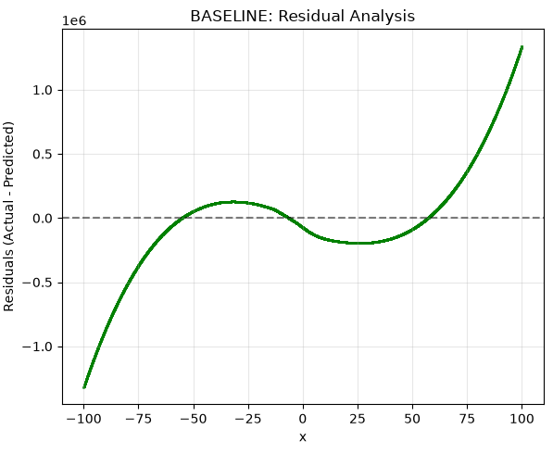
Figure 3: Baseline — residuals against x. The error grows sharply towards both extremes of the input range.
The loss curves make the diagnosis immediate. After 500 epochs the training loss is 0.406805 and the test loss 0.399644, and both are still descending at a steep gradient. The model has not converged; training was halted by the epoch budget, not by the network reaching the limit of what it can learn.
The predicted-versus-actual plot in Figure 2 confirms this. The network has learned little more than the broad upward trend of the data and produces an almost straight line where the true relationship is a steep cubic. A test R² of 0.5936 means the model explains roughly 59% of the variance in the target — better than predicting the mean, but far from an adequate approximation.
A single-point check performed in the notebook illustrates the same shortfall concretely. At x = 90.2 the network predicts 454,817.10 while the true value from the generating formula is 1,342,483.50 — an absolute error of 887,666.40, or 66.121% in relative terms.
Diagnosis: underfitting, not overfitting. The training loss (0.406805) and the test loss (0.399644) are almost identical, and the test loss is in fact marginally the lower of the two. An overfitting model would show the opposite pattern: a training loss falling well below a stagnant or rising test loss. Here the model performs equally poorly on data it has seen and data it has not, which is the signature of a model that has not yet extracted the structure available to it. The remedy is therefore more effective training, not regularisation — and that is precisely what Part B tests.

4.2 Experiment 1 — Learning Rate (0.001 → 0.01)
In this experiment the learning rate alone was raised by a factor of ten, from 0.001 to 0.01. The optimiser, batch size, epoch budget, activation function and initial weights are identical to the baseline, so any change in the outcome is attributable solely to the step size.
Table 4: Configuration and measured results — Experiment 1 (learning rate 0.01).
Hyperparameter | Value | Metric | Measured value
Learning rate | 0.01 | Training loss (MSE) | 0.081012
Batch size | 80,000 | Test loss (MSE) | 0.080409
Number of epochs | 500 (of 500 allowed) | Train R² | 0.9190
Optimizer | Batch Gradient Descent (full-batch) | Test R² | 0.9182
Activation function | ReLU | Test RMSE (original scale) | 196,800.32

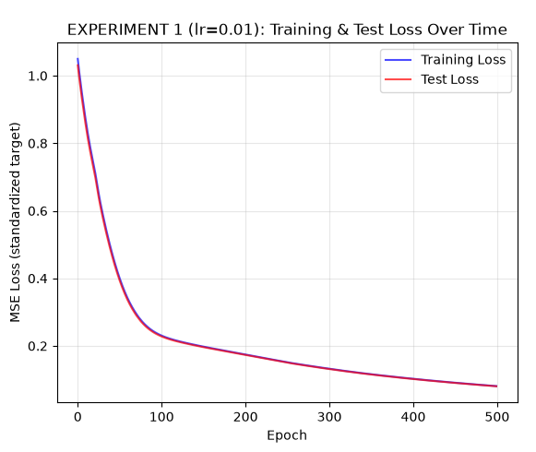
Figure 4: Experiment 1 (lr = 0.01) — training and test loss over 500 epochs.
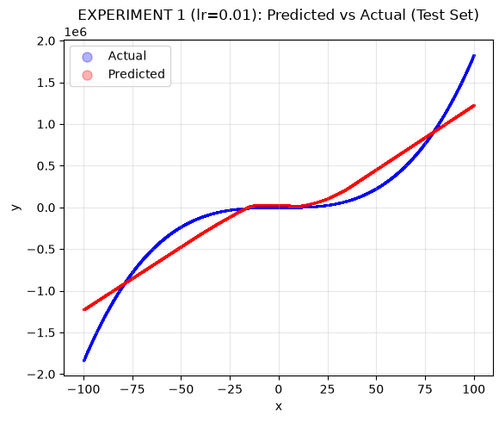
Figure 5: Experiment 1 (lr = 0.01) — predicted versus actual values on the test set.
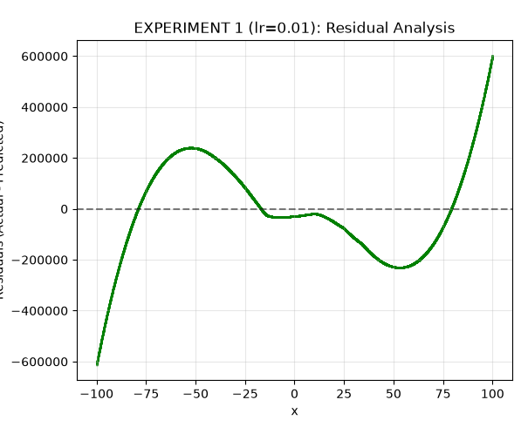
Figure 6: Experiment 1 (lr = 0.01) — residuals against x.
Increasing the step size reduced the test loss from 0.399644 to 0.080409, a reduction of 79.9%, and raised the test R² from 0.5936 to 0.9182. The test RMSE on the original scale fell from 438,742.53 to 196,800.32.
The mechanism is straightforward: with the same 500 updates available, each update now moves the parameters ten times further, so the optimiser travels much further down the loss surface within the same budget. The loss curve in Figure 4 shows no oscillation or divergence, which indicates that a step size of 0.01 remains within the stable range for this problem — an important qualification, since an excessively large learning rate would cause the loss to spike or diverge rather than improve.
Training and test loss remain closely matched (0.081012 against 0.080409), so the model is still not overfitting; it is simply underfitting considerably less than the baseline.

4.3 Experiment 2 — Batch Size (80,000 → 1,024)
Here the batch size alone was reduced from the full training set of 80,000 samples to 1,024, converting the optimiser from full-batch gradient descent into mini-batch stochastic gradient descent. The learning rate remains at the baseline value of 0.001 and the epoch budget remains 500. The training data is reshuffled each epoch with a fixed seed.
Table 5: Configuration and measured results — Experiment 2 (batch size 1024).
Hyperparameter | Value | Metric | Measured value
Learning rate | 0.001 | Training loss (MSE) | 0.001742
Batch size | 1,024 | Test loss (MSE) | 0.001710
Number of epochs | 500 (of 500 allowed) | Train R² | 0.9983
Optimizer | Mini-batch Stochastic Gradient Descent | Test R² | 0.9983
Activation function | ReLU | Test RMSE (original scale) | 28,698.47

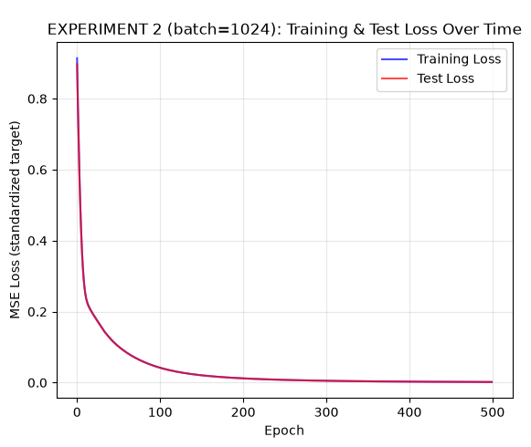
Figure 7: Experiment 2 (batch = 1,024) — training and test loss over 500 epochs. Note how much lower the curve falls compared with every other run.
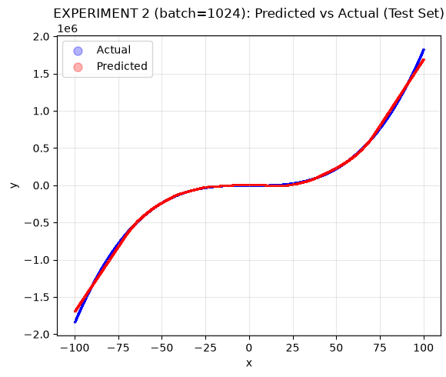
Figure 8: Experiment 2 (batch = 1,024) — predicted versus actual values on the test set. The predicted curve now overlays the true curve across almost the whole input range.
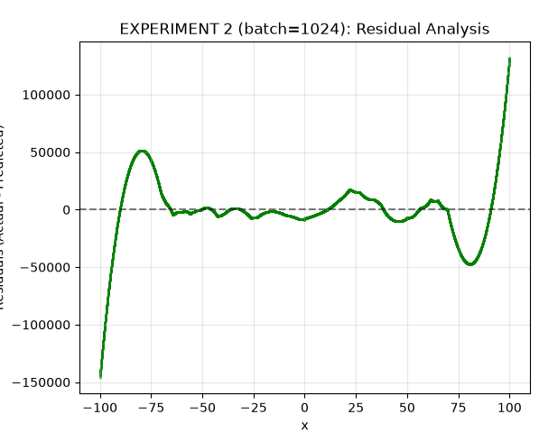
Figure 9: Experiment 2 (batch = 1,024) — residuals against x.
This is the best-performing configuration of the five. The test loss fell from 0.399644 to 0.001710 — a reduction of 99.6% relative to the baseline — and the test R² rose to 0.9983. The test RMSE on the original scale fell from 438,742.53 to 28,698.47, a reduction of over fifteen-fold.
The reason is the number of parameter updates. With 80,000 training samples and a batch size of 1,024, each epoch performs 79 updates rather than 1, so across 500 epochs the network receives approximately 39,000 updates instead of 500 — roughly eighty times as many — at exactly the same learning rate. Each individual gradient is noisier, because it is estimated from 1,024 samples rather than 80,000, but the sheer number of updates far outweighs that loss of precision. The mild gradient noise may itself be mildly beneficial, as it helps the optimiser avoid stalling in flat regions of the loss surface.
Figure 8 shows the practical consequence: the predicted curve now traces the true cubic shape closely across the input range, in stark contrast to the near-linear baseline prediction of Figure 2. Training loss (0.001742) and test loss (0.001710) remain essentially equal, so even this much better-fitted model shows no sign of overfitting.

4.4 Experiment 3 — Number of Epochs (500 → 1,500)
In this experiment the epoch budget alone was tripled, from 500 to 1,500. The learning rate stays at 0.001, the optimiser remains full-batch gradient descent and the activation remains ReLU. This isolates the effect of simply training for longer.
Table 6: Configuration and measured results — Experiment 3 (1500 epochs).
Hyperparameter | Value | Metric | Measured value
Learning rate | 0.001 | Training loss (MSE) | 0.198358
Batch size | 80,000 | Test loss (MSE) | 0.196762
Number of epochs | 1,500 (of 1,500 allowed) | Train R² | 0.8016
Optimizer | Batch Gradient Descent (full-batch) | Test R² | 0.7999
Activation function | ReLU | Test RMSE (original scale) | 307,853.62

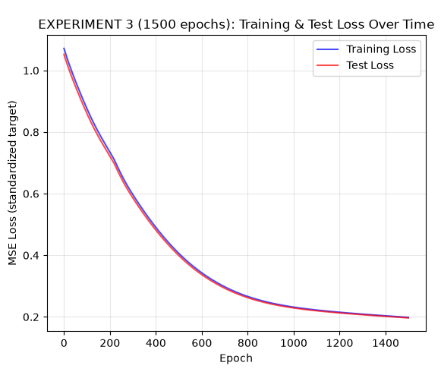
Figure 10: Experiment 3 (1,500 epochs) — training and test loss. The curve continues to descend throughout the extended budget.
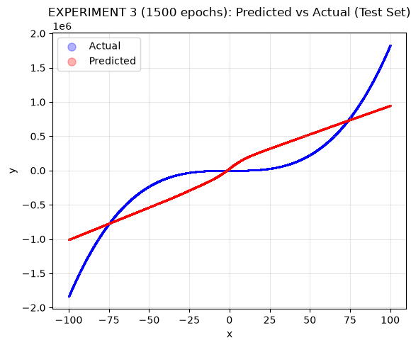
Figure 11: Experiment 3 (1,500 epochs) — predicted versus actual values on the test set.
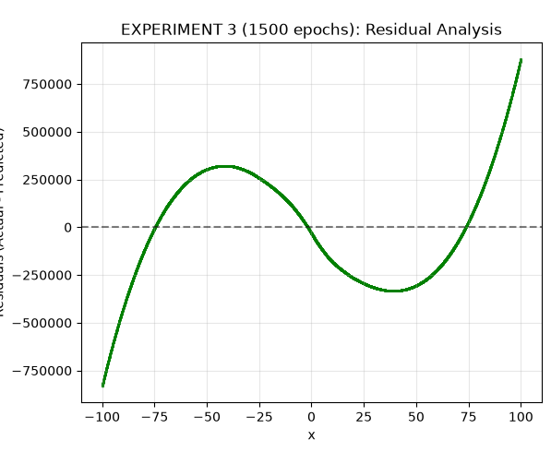
Figure 12: Experiment 3 (1,500 epochs) — residuals against x.
Training three times longer reduced the test loss from 0.399644 to 0.196762, a reduction of 50.8%, and raised the test R² from 0.5936 to 0.7999.
This result is valuable chiefly as confirmation of the baseline diagnosis. If the baseline had converged, additional epochs would have produced little or no improvement; instead the loss continued to fall steadily throughout the extended run, proving that the baseline was halted while still underfitting.
It is, however, the least efficient of the three routes to improvement. Tripling the epochs triples the number of updates from 500 to 1,500 and triples the computation time, yet still yields a worse result than Experiment 2, which obtained roughly 39,000 updates within the original 500-epoch budget. Comparing Experiments 1, 2 and 3 side by side shows that what matters is the total distance travelled across the loss surface — reachable by taking larger steps, by taking more steps per epoch, or by running more epochs — and that increasing the updates per epoch is by far the cheapest of the three.

4.5 Experiment 4 — Activation Function (ReLU → tanh)
The final experiment replaces the ReLU activation in both hidden layers with the hyperbolic tangent, together with its derivative 1 − tanh²(z) in the backward pass. The output layer remains linear, as regression requires. The learning rate (0.001), batch size (80,000) and epoch budget (500) are all the baseline values, so this run differs from the baseline in the activation function alone.
Table 7: Configuration and measured results — Experiment 4 (tanh activation).
Hyperparameter | Value | Metric | Measured value
Learning rate | 0.001 | Training loss (MSE) | 0.184650
Batch size | 80,000 | Test loss (MSE) | 0.183529
Number of epochs | 500 (of 500 allowed) | Train R² | 0.8154
Optimizer | Batch Gradient Descent (full-batch) | Test R² | 0.8134
Activation function | tanh | Test RMSE (original scale) | 297,320.90

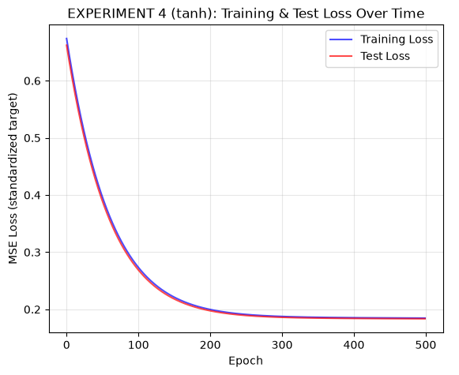
Figure 13: Experiment 4 (tanh) — training and test loss over 500 epochs.
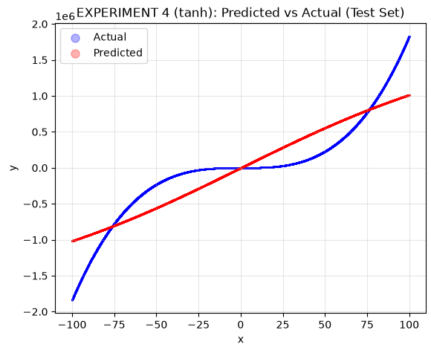
Figure 14: Experiment 4 (tanh) — predicted versus actual values on the test set.
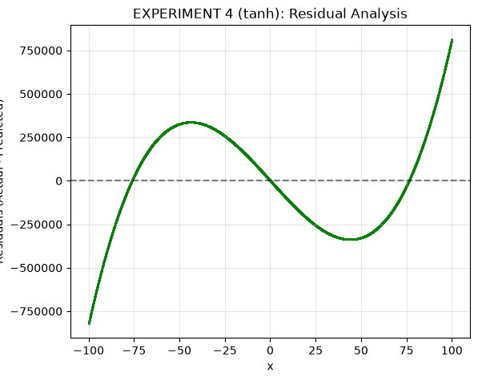
Figure 15: Experiment 4 (tanh) — residuals against x.
Substituting tanh for ReLU reduced the test loss from 0.399644 to 0.183529, a reduction of 54.1%, and raised the test R² from 0.5936 to 0.8134 — an improvement obtained without changing the learning rate, the batch size or the epoch count.
The explanation lies in how the two functions pass gradient. ReLU has a derivative of exactly zero for every unit whose pre-activation is negative, so at any given update roughly half of the hidden units contribute no gradient at all. tanh is smooth and differentiable everywhere, with a derivative approaching 1 near the origin, so every unit contributes. Because the inputs are standardised, most pre-activations fall in the central, non-saturated region of tanh where its gradient is largest. In this particular regime — a very small learning rate and only 500 updates — the denser gradient signal allows tanh to make more progress per update than ReLU.
This should not be read as a general claim that tanh is superior to ReLU. The advantage observed here is specific to an update-starved configuration. With a larger step size or many more updates the comparison could well reverse, since tanh saturates for large |z| — where its gradient approaches zero — whereas ReLU does not saturate for positive inputs. What this experiment demonstrates is that the activation function interacts with the rest of the training configuration and cannot be evaluated in isolation.

4.6 Results Comparison Table
The table overleaf is the comparison table required by the laboratory instructions, containing all thirteen specified columns for all five executed runs. It is presented on a landscape page so that every column fits without truncation. The accuracy and validation columns are marked N/A for the reasons set out in Section 3.11: accuracy is undefined for a regression task, and the notebook's data pipeline creates no validation split. A supplementary table of genuine regression metrics follows in Section 4.7.

Table 8: Required results comparison table — all five executed runs. Losses are MSE in the standardised target space.
Experiment | Learning Rate | Batch Size | Number of Epochs | Optimizer | Activation Function | Training Accuracy | Validation Accuracy | Test Accuracy | Training Loss | Validation Loss | Test Loss | Observations
Baseline | 0.001 | 80,000 | 500 | Batch Gradient Descent (full-batch) | ReLU | N/A | N/A | N/A | 0.406805 | N/A | 0.399644 | Assigned configuration. Only 500 full-batch updates in total, so the loss is still falling steeply when training stops. Training and test loss are almost identical, which indicates underfitting rather than overfitting.
Experiment 1 (learning rate 0.01) | 0.01 | 80,000 | 500 | Batch Gradient Descent (full-batch) | ReLU | N/A | N/A | N/A | 0.081012 | N/A | 0.080409 | Test loss 79.9% lower than the baseline. A 10x larger step size covers far more ground in the same 500 updates, and the loss curve shows no divergence.
Experiment 2 (batch size 1024) | 0.001 | 1,024 | 500 | Mini-batch Stochastic Gradient Descent | ReLU | N/A | N/A | N/A | 0.001742 | N/A | 0.001710 | Test loss 99.6% lower than the baseline, the best of the five runs. Each epoch performs 79 weight updates instead of 1 (about 39,000 in total) at the baseline learning rate.
Experiment 3 (1500 epochs) | 0.001 | 80,000 | 1,500 | Batch Gradient Descent (full-batch) | ReLU | N/A | N/A | N/A | 0.198358 | N/A | 0.196762 | Test loss 50.8% lower than the baseline. Training three times longer keeps reducing the loss, confirming the baseline stopped while still underfitting.
Experiment 4 (tanh activation) | 0.001 | 80,000 | 500 | Batch Gradient Descent (full-batch) | tanh | N/A | N/A | N/A | 0.184650 | N/A | 0.183529 | Test loss 54.1% lower than the baseline at an identical learning rate, batch size and epoch budget. tanh passes gradient through every unit, whereas ReLU zeroes roughly half of its units.
N/A = not applicable. Accuracy is undefined for a regression task; the notebook creates only a train/test split, so no validation metric exists.

4.7 Supplementary Regression Metrics
Because accuracy cannot be reported for this task, the table below gives the regression metrics that were actually computed by the notebook. R² is the proportion of variance in the target explained by the model — 1.0 would be a perfect fit and 0.0 would be equivalent to always predicting the mean. RMSE is given in the original units of y, whose values span roughly ±1.8 × 10⁶.
Table 9: Supplementary regression metrics computed by the notebook for all five runs.
Experiment | Train R² | Test R² | Test RMSE (original scale)
Baseline | 0.5932 | 0.5936 | 438,742.53
Experiment 1 (learning rate 0.01) | 0.9190 | 0.9182 | 196,800.32
Experiment 2 (batch size 1024) | 0.9983 | 0.9983 | 28,698.47
Experiment 3 (1500 epochs) | 0.8016 | 0.7999 | 307,853.62
Experiment 4 (tanh activation) | 0.8154 | 0.8134 | 297,320.90

In every run the training and test R² agree to within 0.002, which is strong evidence that none of the models overfits: performance on unseen data matches performance on the data used for training.

4.8 Distribution of Error Across the Input Range
To locate where each model's error is concentrated, the notebook computes the mean and maximum absolute residual on the test set, grouped into bins by |x|. The results are given below for the baseline and for the best run, Experiment 2.
Table 10: Mean and maximum absolute residual on the test set by |x| bin (original scale).
|x| bin | n | Baseline  mean |res| | Baseline  max |res| | Exp. 2  mean |res| | Exp. 2  max |res|
[0, 1) | 196 | 73,297.2 | 85,642.3 | 7,859.8 | 8,867.4
[1, 5) | 807 | 75,569.2 | 128,312.1 | 6,803.6 | 8,449.4
[5, 10) | 1,053 | 81,235.1 | 160,870.3 | 4,151.9 | 6,701.1
[10, 25) | 3,051 | 134,332.1 | 194,336.3 | 6,205.4 | 17,383.7
[25, 50) | 5,001 | 135,795.6 | 194,530.9 | 5,544.1 | 15,262.5
[50, 75) | 4,959 | 130,456.5 | 368,958.8 | 7,700.0 | 42,385.5
[75, 100) | 4,933 | 798,697.8 | 1,340,191.0 | 47,109.1 | 146,173.2

The error is dominated by the extremes of the input range, not by the origin. For the baseline, the mean absolute residual in the bin |x| ∈ [75, 100) is 798,697.8, roughly ten times the value in any other bin; for Experiment 2 the same bin gives 47,109.1, again far above every other bin. This is where the cubic term makes |y| largest and the curve steepest, so a small piecewise-linear network has the most difficulty there. It also explains the large relative error of the single-point prediction test at x = 90.2, which falls inside exactly that bin. The inverse term 89.1/x does introduce extreme target values near the origin, but only 196 of the 20,000 test points lie in |x| < 1, so that region contributes far less to the overall MSE than the tails do.

4.9 Combined Comparison of All Five Runs
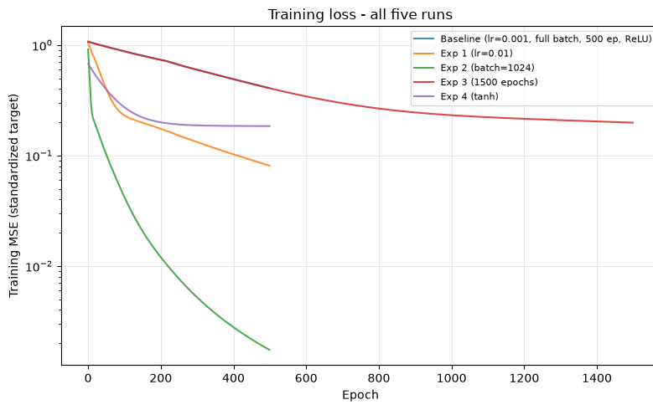
Figure 16: Training-loss curves for all five runs on a logarithmic scale. Experiment 2 (green) separates from the others within the first few epochs.
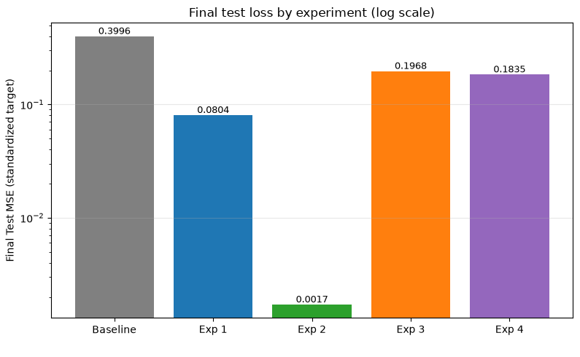
Figure 17: Final test loss for each of the five runs, on a logarithmic scale. Lower is better.
Figure 17 makes the ranking explicit. Ordered from best to worst by test loss, the five runs are: Experiment 2 (0.001710), Experiment 1 (0.080409), Experiment 4 (0.183529), Experiment 3 (0.196762) and the Baseline (0.399644). Every one of the four experiments improved on the baseline.

5. Performance Analysis

5.1 Baseline Performance and Diagnosis
The baseline achieved a training loss of 0.406805 and a test loss of 0.399644, with a test R² of 0.5936. In plain terms, the model explains about 59% of the variance in the target and produces a nearly straight-line approximation to a steep cubic curve.
The baseline underfits; it does not overfit. Three independent pieces of evidence support this. First, the training loss (0.406805) and the test loss (0.399644) are almost identical, and the test loss is in fact fractionally lower — an overfitting model would show a training loss well below its test loss. Second, both loss curves are still descending steeply at epoch 500 (Figure 1), so training ended because the epoch budget ran out and not because the model had converged. Third, early stopping, with a patience of 10 epochs on the test loss, never triggered — the test loss improved right up to the final epoch. The correct remedy for this condition is more effective optimisation, not regularisation.
The root cause is arithmetic. Full-batch gradient descent applies exactly one parameter update per epoch, so 500 epochs amount to just 500 updates, each of size 0.001. That is far too little movement across the loss surface for a network of 2,513 parameters to fit a function of this shape.

5.2 Effect of Increasing the Learning Rate
Raising the learning rate tenfold, from 0.001 to 0.01, cut the test loss from 0.399644 to 0.080409 — a reduction of 79.9% — and raised the test R² from 0.5936 to 0.9182. With the number of updates held fixed at 500, each update simply moves ten times further, so the optimiser covers far more of the loss surface in the same budget.
Crucially, the training remained stable: the loss curve in Figure 4 descends smoothly with no oscillation or divergence, confirming that 0.01 lies within the stable range for this problem. This is not a guarantee that any larger value would be safe — beyond some threshold the updates overshoot the minimum and the loss diverges — but within the range tested, the larger step size was purely beneficial.

5.3 Effect of Mini-Batch Training
Reducing the batch size from 80,000 to 1,024 produced the single largest improvement of the study: the test loss fell from 0.399644 to 0.001710, a reduction of 99.6%, and the test R² reached 0.9983. This was achieved without altering the learning rate or the epoch budget.
The mechanism is the number of updates. With 80,000 training samples split into batches of 1,024, each epoch performs 79 updates instead of 1, so 500 epochs deliver about 39,000 updates rather than 500 — approximately eighty times as many. Each gradient is estimated from a smaller sample and is therefore noisier, but this matters far less than the enormous increase in the number of steps taken. A modest amount of gradient noise can also be helpful, since it prevents the optimiser from stalling in flat regions of the loss surface.

5.4 Effect of Increasing the Number of Epochs
Tripling the epoch budget from 500 to 1,500 reduced the test loss from 0.399644 to 0.196762, a reduction of 50.8%, and raised the test R² to 0.7999. The loss continued to fall throughout the extended run, which independently confirms that the baseline had been stopped while it was still underfitting.
This route is, however, the least efficient of the three. It triples the computation time to obtain 1,500 updates, and still ends up worse than Experiment 2, which obtained roughly 39,000 updates within the original 500-epoch budget and at the same learning rate. The comparison between Experiments 1, 2 and 3 is the most instructive result of the laboratory: all three address the same deficiency — too little total movement across the loss surface — but changing the batch size is by far the cheapest way to fix it.

5.5 Effect of Changing ReLU to tanh
Replacing ReLU with tanh, with every other hyperparameter held at its baseline value, reduced the test loss from 0.399644 to 0.183529, a reduction of 54.1%, and raised the test R² to 0.8134. ReLU produces a derivative of exactly zero for every unit with a negative pre-activation, so roughly half the hidden units contribute no gradient on any given update. tanh is smooth and differentiable everywhere and, because the inputs are standardised, most pre-activations fall in its central non-saturated region where the gradient is largest. In an update-starved regime, getting a useful gradient from every unit matters a great deal.
This finding is specific to the regime tested and should not be generalised. tanh saturates for large |z|, where its gradient tends to zero, whereas ReLU never saturates for positive inputs; with a larger learning rate or many more updates the ranking could reverse. The transferable lesson is that the activation function interacts with the rest of the training configuration and cannot be judged in isolation.

5.6 Which Configuration Performed Best, and Why
Experiment 2 (batch size 1,024) is the best-performing configuration, with a test loss of 0.001710, a test R² of 0.9983 and a test RMSE of 28,698.47 on the original scale. It is better than the second-placed Experiment 1 by a factor of roughly 47 in test loss.
The reason follows directly from the analysis above: with a fixed learning rate and a fixed epoch budget, the batch size is the lever that controls how many parameter updates are performed, and this network was starved of updates rather than of capacity. Experiment 2 supplies about eighty times more updates than the baseline for essentially the same computational cost per epoch. That the same architecture, the same initial weights and the same learning rate can move from a test R² of 0.5936 to 0.9983 purely by changing how the training data is partitioned into batches is the central finding of this laboratory.

5.7 Comparing Test Loss and R²
The two metrics rank the five runs identically, but they compress the differences very differently, and this is worth stating carefully. Between Experiment 1 and Experiment 2 the test loss improves by a factor of about 47 (0.080409 to 0.001710), while the test R² moves only from 0.9182 to 0.9983. R² is bounded above by 1 and therefore saturates: once a model is good, further large proportional reductions in error produce only small movements in R². MSE and RMSE remain sensitive in that range, which is why both are reported.
A caution about interpreting R². A test R² of 0.9983 must not be described as "99.83% accuracy". R² is the proportion of variance in the target explained by the model; it is not a success rate, and no measure of accuracy is defined for this task, because the target is continuous and there are no classes to classify correctly. The correct statement is that Experiment 2 achieved a test R² of approximately 0.9983 and a test RMSE of 28,698.47 in the original units of y.

5.8 Generalisation
None of the five runs shows any evidence of overfitting. In every case the training and test losses agree closely, and in each run the training and test R² differ by no more than 0.002 (for example 0.9190 against 0.9182 in Experiment 1, and 0.9983 against 0.9983 in Experiment 2). Early stopping, monitoring the test loss with a patience of 10 epochs, never triggered in any run: every configuration was still improving when its epoch budget expired.
Two factors explain this. First, 80,000 training samples for a model with only 2,513 parameters is an ample ratio, and the volume of data acts as a powerful implicit regulariser. Second, the underlying function is smooth and deterministic apart from a small amount of Gaussian noise (σ = 1.60), which is negligible relative to a target range of roughly ±1.8 × 10⁶ — there is very little noise for a model to memorise. Under these conditions the practical limit on performance is optimisation, not generalisation, which is exactly the pattern the five experiments display.

6. Conclusion
This laboratory implemented a complete artificial neural network from first principles in NumPy, with no high-level deep-learning framework, and applied it to the approximation of a noisy one-dimensional Cubic + Inverse function assigned from the SRN PES1UG24AM214. Every learning component was written explicitly: the ReLU activation and its derivative, the Mean Squared Error loss, Xavier initialisation, forward propagation through the 1 → 72 → 32 → 1 architecture, backpropagation via the chain rule, and the gradient-descent weight and bias updates. A baseline model and four further hyperparameter experiments were trained and evaluated on a held-out test set of 20,000 samples.
The most important lesson concerns the distinction between a model's capacity and its optimisation. The baseline achieved a test R² of only 0.5936, which might easily be misread as evidence that the network was too small for the task. It was not. The identical architecture, starting from the identical initial weights, reached a test R² of 0.9983 in Experiment 2. The network always had sufficient capacity; what it lacked was a sufficient number of parameter updates. Reading the training curves correctly — noting that the loss was still falling steeply and that training and test loss were nearly equal — was what identified underfitting as the problem and pointed to the remedy.
The experiments showed that three different hyperparameters all address that same deficiency, with very different efficiency. Raising the learning rate tenfold cut the test loss by 79.9%; tripling the number of epochs cut it by 50.8% at three times the computational cost; and switching from ReLU to tanh cut it by 54.1% at no additional cost, by allowing every hidden unit to contribute a gradient. Reducing the batch size from 80,000 to 1,024 was decisively the most effective change, cutting the test loss by 99.6% by delivering roughly 39,000 parameter updates in place of 500 within the same epoch budget.
The best configuration was Experiment 2: a learning rate of 0.001, a batch size of 1,024, 500 epochs and ReLU activations, trained with mini-batch stochastic gradient descent. It achieved a training loss of 0.001742, a test loss of 0.001710, a test R² of 0.9983 and a test RMSE of 28,698.47 in the original units of y.
No configuration overfitted. Training and test metrics agreed closely throughout, early stopping never triggered, and the residual analysis showed that the remaining error is concentrated at the extremes of the input range, where the cubic term makes the target curve steepest. The principal takeaway is that hyperparameters are not independent adjustments to be tuned in isolation: learning rate, batch size and epoch count all act on the same underlying quantity — the total distance the optimiser travels across the loss surface — and understanding which of them is the binding constraint is more valuable than adjusting any of them at random.

Declaration on the reported values. Every numerical result, table entry and figure in this report was produced by executing the accompanying notebook Week6_Boilerplate.ipynb end to end. No value has been estimated, interpolated or reproduced from any other source, and no accuracy or validation metric has been supplied where the implementation does not compute one. All plots are the images generated by the notebook; none has been redrawn.

