Software Architecture and Design Specification
Project: Real-Time Collaborative Virtual Whiteboard
Team: Team 11 — Rachit S Mane, P Chinni Krishna Reddy, Pranav V Menon, Prithvi W
Version: 1.0
Date: 11-10-2026
Status: Final for submission — written against SRS v1.0; team sign-off pending (see Approvals); design only, not yet implemented

Revision History
Version | Date | Author | Change Summary
0.1 | 10-10-2026 | Krishna, Rachit, Prithvi (draft) | First complete draft for team review
0.2 | 10-10-2026 | Krishna, Rachit, Prithvi (draft) | Acknowledgement/reconciliation protocol and reconnection settings (§4.1); ownership-transfer endpoint and SD-04; snapshot size policy and FR-008; security control mapping; test hooks
0.3 | 10-10-2026 | Krishna, Rachit, Prithvi (draft) | Board limit defined on BSON size with conservative accounting; clear/restore never completed without their version (restore writes the version first, roll-forward on start-up); sequence diagrams split into legible parts, SD-01 adds reconnection, SD-04 adds all rejection cases; component diagram shows Version History → Board & Access and Board & Access → Real-time dependencies; numbered figures
0.4 | 10-10-2026 | Krishna, Rachit, Prithvi (draft) | Size measures M1–M4 with version-document margin derivation; restore consistency and recovery design with mandatory start-up order (roll-forward before sequence recovery); component diagram split into overview and server-dependency figures; FAULT_INJECT test hook; message limit stated in bytes
1.0 | 11-10-2026 | Krishna, Rachit, Prithvi | Final for submission: durable per-board journal (pendingOp) for clear and restore with start-up recovery; idempotent restore (Idempotency-Key); new SD-05 (clear); SD-02 redrawn; size bound checked by computing the encoded worst case (tools/size_model.py; a calculation, not a test of the system); selected technology stack; security event record (§4.4, D13b); restore pre-commit checks, failed start-up recovery and retry/concurrency rules made explicit (§3.6, API-03, SD-02, SD-05); failed logins without account enumeration and subjectId defined (§3.9.6, §4.4)

Approvals
Role | Name | Signature/​Date
SAD Lead | P Chinni Krishna Reddy
SRS Lead | Rachit S Mane
STP Lead | Pranav V Menon
Security & Traceability Lead | Prithvi W

1. Introduction

1.1 Purpose
This document specifies the architecture and design of the Real-Time Collaborative Virtual Whiteboard. It explains how the requirements of the SRS are realised by components, interfaces, data stores and protocols, and records the main design decisions and their rationale.

1.2 Scope
The document covers the browser client, the application server (request interface, real-time collaboration, access control and version history), the database, and the cross-cutting concerns of security, error handling, logging and monitoring for version 1.0 as scoped in SRS §1.2. Technologies named here are the selected stack for version 1.0 (DECISIONS.md D10).

1.3 Audience
Team 11 developers and testers, the course instructor and teaching assistants, and reviewers assessing security and maintainability.

1.4 Definitions
Terms defined in SRS §1.4 apply. Additional terms: ADR — architecture decision record; JWT — JSON Web Token; Room — the Socket.IO group of connections attached to one board; STRIDE — Spoofing, Tampering, Repudiation, Information disclosure, Denial of service, Elevation of privilege; SPA — single-page application; ODM — object-document mapper.

2. Document Overview

2.1 How to use this document
Section 3 describes the architecture: goals, stakeholders, components (COMP-xx), the chosen pattern, technology, risks, requirement traceability and security architecture. Section 4 describes the design: sequence diagrams (SD-xx), API contracts (API-xx), error handling, logging, monitoring and UX. Every component and API lists the SRS requirement IDs it realises.

2.2 Related Documents
• Team 11 SRS v1.0 (requirement IDs FR-, NFR-, SEC-OBJ-, SEC-REQ-).
• Team 11 STP v1.0 (test case IDs TC-).
• Requirements Traceability Matrix (docs/traceability/rtm.md) and ID registry.
• Decision Log (docs/DECISIONS.md).

3. Architecture

3.1 Goals & Constraints
Goals:
• Consistency: every participant converges on the same board state, defined by server order (FR-021 to FR-023).
• Responsiveness: operations visible to others within the target of NFR-001; local edits shown immediately.
• Security by default: every request and real-time message authenticated and authorised on the server (SEC-REQ-002, SEC-REQ-003).
• Recoverability: no acknowledged operation is lost (FR-027); clients resynchronise after disconnection (FR-025, NFR-004).
• Simplicity: an architecture that a four-person student team can build, test and explain within the course.
Constraints:
• Single server instance for version 1.0 (SRS §2.5); no horizontal scaling.
• Selected stack: MongoDB, Express.js, React, Node.js, Socket.IO (D10).
• Desktop browsers only (NFR-006).
• MongoDB's 16 MiB maximum document size limits one stored snapshot; v1.0 therefore limits board content to 15 MiB (FR-008, §3.6).

3.2 Stakeholders & Concerns
Stakeholder | Main concerns
Board owners | Control over who can see and change a board; ability to recover earlier content.
Editors and viewers | Low latency, no lost work, clear feedback when something is rejected or the connection drops.
Guests | Joining quickly without an account; clear notice when access ends.
Developers (Team 11) | Modularity, clear contracts between client and server, testability.
Testers (Team 11) | Observable behaviour, measurable targets, test hooks (logs, metrics, health check).
Instructor / assessors | Traceability to requirements, documented rationale, security analysis.

3.3 Component (UML) Diagram
The template placeholder mentions a class diagram; the assignment brief requires a UML component diagram, which is provided here in two parts so that its labels stay legible:
• Figure 1 (overview) shows the client and server packages, the two external interfaces — API-01 (Socket.IO events) and API-02/API-03 (REST over HTTPS) — as provided (lollipop) and required (socket) interfaces, and the server layers. The four service components are grouped in one box; their individual dependencies are shown in Figure 2.
• Figure 2 (server dependencies) shows the labelled dependencies between the server components, including Version History → Board & Access (authorize, SD-02) and Board & Access → Real-time Collaboration Server (role changes and revocations, SD-03, SD-04). Every server component also writes logs and metrics to COMP-09 (§4.4); these arrows are omitted for readability.
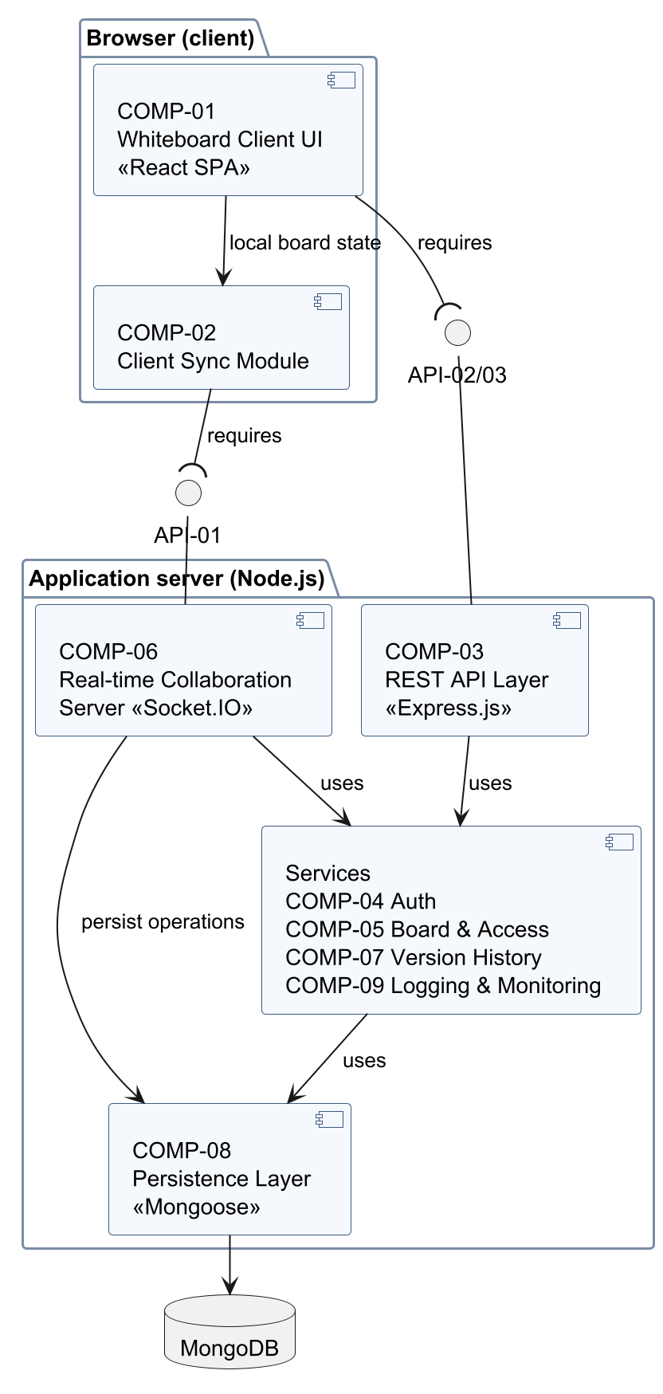
Figure 1 — UML component diagram, part 1: overview

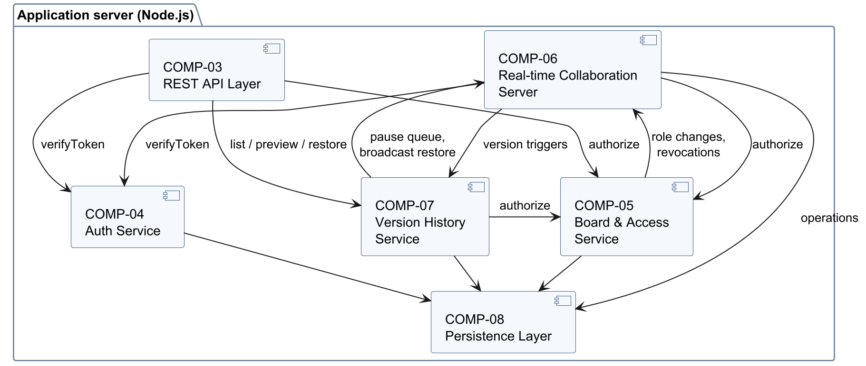
Figure 2 — UML component diagram, part 2: dependencies between server components

3.4 Component Descriptions
ID | Component | Responsibilities | Provided interfaces | Realises
COMP-01 | Whiteboard Client UI | React single-page application: dashboard, board canvas rendering, toolbar, participant panel, version panel, sharing and members dialogs (including ownership transfer with confirmation); role-aware enabling of controls; error, board-full and connection-status messages; board-ready performance mark. | Browser UI | FR-001–FR-007, FR-031, FR-032, FR-043, FR-052, NFR-003, NFR-006, NFR-007
COMP-02 | Client Sync Module | Keeps confirmed state, pending own operations and an out-of-order buffer (§4.1.3); renders optimistically; applies acknowledgements and op:applied strictly by sequence number; repairs gaps with board:join; rolls back rejected operations; reconnects with bounded backoff and resynchronises (§4.1.4). | Board state store used by COMP-01 | FR-020–FR-026, NFR-001, NFR-004
COMP-03 | REST API Layer | Express.js routes for API-02 and API-03; middleware chain for token verification, schema validation, rate limiting, error formatting and request IDs. | API-02, API-03 (HTTPS, JSON) | FR-040–FR-050, SEC-REQ-002, SEC-REQ-005, SEC-REQ-006
COMP-04 | Auth Service | Registration, password hashing and verification, issuing and verifying session tokens, logout revocation list, guest tokens derived from share links. | verifyToken, issueSession, issueGuestToken (internal) | FR-040, FR-041, FR-046, SEC-REQ-001, SEC-REQ-002
COMP-05 | Board & Access Service | Boards, members and share links; the permission policy (single implementation of the FR-051 matrix) used by every other server component; link creation, expiry and revocation; ownership transfer (API-02, SD-04); board deletion. | authorize(actor, boardId, action), board/link/member operations (internal) | FR-042–FR-051, SEC-REQ-003, SEC-REQ-004
COMP-06 | Real-time Collaboration Server | Socket.IO server: connection authentication, one room per board, per-board task queue that serialises operations, clear, restore and version tasks, validation and authorisation of every event, board size limit, sequence-number assignment, persistence before acknowledgement and broadcast (§4.1.2), presence, role-change notifications and forced disconnects on revocation, removal, deletion and ownership transfer. | API-01 (Socket.IO events) | FR-001–FR-008, FR-020–FR-027, FR-047–FR-050, FR-052, NFR-001, NFR-002, SEC-REQ-003, SEC-REQ-005, SEC-REQ-006
COMP-07 | Version History Service | Automatic version triggers (interval T, before clear, last participant leaves) with the no-change rule; version list and preview; owner-only, journalled and idempotent restore that always creates a new version; retention of the 20 newest; defensive snapshot size check; hand-off of restored state to COMP-06 for broadcast. | API-03 operations, snapshot(boardId, trigger) (internal) | FR-007, FR-030–FR-035, NFR-005
COMP-08 | Persistence Layer | MongoDB database and Mongoose models/repositories for users, boards, board objects, memberships, share links, versions and revoked tokens; indexes and atomic updates. | Repository functions (internal) | FR-007, FR-027, FR-033 (journal and start-up recovery), FR-035, FR-044, SEC-REQ-001, SEC-REQ-004
COMP-09 | Logging & Monitoring | Structured JSON logging with request and correlation IDs, security event log, metrics (operation latency, connections, rejections, restores), health-check endpoint. | log, metric (internal); GET /api/v1/health | SEC-REQ-008, NFR-001, NFR-004 (measurement support)

3.5 Chosen Architecture Pattern and Rationale
Pattern: client–server with a layered server (interface layer → service layer → persistence layer) combined with event-driven publish/subscribe for real-time collaboration (one Socket.IO room per board) and a server-authoritative state model.
• The interface layer (COMP-03 for REST, COMP-06 for Socket.IO) authenticates, validates and authorises every input before calling services.
• The service layer (COMP-04, COMP-05, COMP-07, and the sequencing logic of COMP-06) contains the business rules; the permission policy exists in exactly one place (COMP-05).
• The persistence layer (COMP-08) hides MongoDB behind repository functions.
• The server orders every operation (sequence numbers) and is the only source of truth; clients render optimistically but always converge to server order.
Why this pattern:
Concern | How the pattern addresses it
Consistency (FR-021–FR-023) | One authority orders all operations; per-property last-write-wins is deterministic because order is global per board.
Security (SEC-REQ-003) | All changes pass through the server, where role checks use server-side data only.
Latency (NFR-001) | Persistent Socket.IO connections avoid per-operation HTTP overhead; rooms limit broadcast to one board.
Team size and testability | Layers can be developed and unit-tested separately; REST and Socket.IO contracts are explicit (§4.3).

Alternatives considered and rejected:
Alternative | Reason for rejection
Peer-to-peer (WebRTC mesh) | No central authority for ordering and permission checks; harder to secure and persist.
CRDT or operational transformation | Merges concurrent edits more precisely but adds significant complexity; per-property LWW is sufficient for strokes, shapes and short text (limitation recorded in SRS §4.2).
Microservices | Operational overhead disproportionate to a single-instance student project.
REST polling for updates | Cannot meet NFR-001 efficiently; higher server load.

3.6 Technology Stack & Data Stores
Selected technology stack (DECISIONS.md D10):
Layer | Technology | Purpose
Client | React (SPA) with the HTML Canvas 2D API | UI, rendering of board objects
Real-time transport | Socket.IO (server and client libraries) | Board events, presence, notifications (API-01)
Server runtime | Node.js (current LTS release) | Application server
HTTP framework | Express.js | REST API (API-02, API-03), middleware
Database | MongoDB (Community edition, local) with Mongoose ODM | Persistent data
Authentication | JWT session tokens; bcrypt password hashing (D13) | SEC-REQ-001, SEC-REQ-002
Validation | JSON-schema validation of REST bodies and Socket.IO payloads | SEC-REQ-005

Data stores (MongoDB collections):
Collection | Key fields | Notes
users | _id, email (unique index), passwordHash, displayName, createdAt | No plain-text password (SEC-REQ-001)
boards | _id, title, ownerId, seq (last committed sequence number), contentBytes, pendingOp, updatedAt | seq advanced once per accepted operation (§4.1.2); contentBytes = M3 (FR-008); pendingOp = durable journal of an unfinished clear or restore (see below)
boardObjects | boardId, objectId, kind, geometry, color, strokeWidth, text, updatedSeq | Unique index (boardId, objectId); current state only
memberships | boardId, userId, role (editor/viewer) | The Owner is stored on the board, not here
shareLinks | _id, boardId, tokenHash, role, expiresAt, revokedAt, createdBy | Token stored only as SHA-256 hash (SEC-REQ-004); TTL index for cleanup
versions | boardId, number, boardSeq, trigger, restoredFrom, requestId, createdAt, createdBy, objects[] | Full snapshot; unique index (boardId, number); sparse unique index (boardId, requestId) for idempotent restores; boardSeq implements the no-change rule
revokedTokens | jti, expiresAt | Logout revocation list; TTL index removes entries after expiry

Database prerequisites. Version 1.0 runs one MongoDB server without a replica set, so multi-document transactions are not used. The design relies only on guarantees a standalone server provides: every single-document write is atomic, and writes issued with write concern {w: 1, j: true} are durable in the journal before they are acknowledged. Journaling must be enabled (the WiredTiger default). Running a single-node replica set would allow transactions, but the recovery design below does not depend on them.
Version storage, triggers and retention (behaviour per SRS §4.3):
• Storage: each version is one document containing a full copy of the board's objects (objects[]) and the board seq it corresponds to (boardSeq). Each element of objects[] is the object in snapshot form — id, kind, geometry, color, strokeWidth, text — without the storage-only fields _id, boardId and updatedSeq of boardObjects.
• Triggers: (a) every T = 5 minutes (configuration VERSION_INTERVAL_MS, D11a), (b) before a clear, (c) when the last participant leaves. Each automatic trigger creates a version only if boards.seq differs from the latest version's boardSeq (no-change rule). A restore always creates a version with trigger = "restore" and restoredFrom = n.
• Retention: after each completed version write, versions older than the 20 most recent are deleted (FR-035), except a version referenced by pendingOp. No other operation modifies or deletes a version.
Serialisation. Every change to a board — real-time operations, clear, restore, automatic version creation and ownership transfer — runs as a task in that board's single FIFO queue in COMP-06 (one task at a time per board). A REST restore request is enqueued as such a task and its HTTP response is sent when the task finishes. Start-up recovery (below) completes before the server accepts any connection or request. The design assumes exactly one server instance; several instances would need a distributed lock and are out of scope (§4.6).
Durable operation journal (boards.pendingOp). Clear and restore are the two operations that change many documents. Before their first destructive write, the task records the operation in boards.pendingOp with one atomic, journaled single-document update; the same update that sets the new seq at the end also removes pendingOp. The commit point is the journaled write of pendingOp: from then on the operation is always completed (never rolled back), either by the running task or by start-up recovery. No client receives an acknowledgement, op:applied, board:state or HTTP success before pendingOp has been removed.
Step | Clear (task for board:clear, FR-007) | Restore of version n (API-03, FR-033)
1 | If the board is empty: acknowledge {ok: true, seq: null, noop: true}; stop. | If a version with the request's requestId exists for this board: if its restoredFrom is n, return the recorded result {newVersion: number, restoredFrom, seq: boardSeq} without applying anything again (idempotent retry); otherwise reject with 409 IDEMPOTENCY_KEY_REUSED; stop. Load snapshot n (VERSION_NOT_FOUND if not retained).
2 | Apply the "before clear" trigger: write version v if the board has changed content (no-change rule). On failure: reject with INTERNAL; nothing else changed. | Compute M4 of version r (snapshot n plus metadata); above the defensive threshold, reject with INTERNAL and log version.snapshot_too_large (should not occur, FR-008).
3 | Commit: set pendingOp = {type: "clear", seq: s, preClearVersion: v} where s = seq + 1 (journaled). | Commit: set pendingOp = {type: "restore", seq: s, version: r, restoredFrom: n, requestId} where s = seq + 1 and r is the next version number (journaled).
4 | Delete all boardObjects of the board. | Insert version r (trigger: "restore", restoredFrom: n, boardSeq: s, requestId) unless it already exists.
5 | — | Delete all boardObjects of the board; insert the snapshot objects with updatedSeq = s.
6 | Complete: set seq = s, contentBytes = 0, unset pendingOp (one atomic, journaled update). | Complete: set seq = s, contentBytes = M3 of the snapshot, unset pendingOp (one atomic, journaled update); apply retention.
7 | Acknowledge the submitter {ok: true, seq: s}; broadcast op:applied (type board:clear). | Broadcast board:state and version:restored; respond 201 {newVersion: r, restoredFrom: n, seq: s}.

Failure handling and recovery (D5c):
Failure point | State left behind | What happens
Before step 3, or the commit write itself fails (including a failed before-clear version, a missing snapshot or a refused size check) | Board unchanged; at most an extra "before clear" version identical to the current content | Request rejected (INTERNAL or VERSION_NOT_FOUND); the extra version is harmless (its boardSeq equals seq, so the no-change rule is unaffected).
After step 3, before step 6 (server crash) | pendingOp present; objects partly or fully deleted (clear) or partly replaced (restore); version r may or may not exist | Start-up recovery completes the operation from pendingOp, repeating steps 4–6. Every step is idempotent: deleting already-deleted objects changes nothing; version r is inserted only if missing; the object set is replaced as a whole.
After step 6, before or during step 7 (crash, or the acknowledgement or HTTP response is lost) | Operation complete; pendingOp absent | Nothing is repeated. Clients resynchronise from the full state (FR-025) and see the result; the Owner's restore retry with the same key returns the recorded result.
During start-up recovery (crash or database error) | pendingOp still present | A crash: recovery runs again on the next start-up with the same result, because steps 4–6 are idempotent. A database error: retried up to 3 times; then recovery.required is logged with the board ID and the server exits with a non-zero status without accepting any connection, so no client ever sees a half-completed board; recovery is repeated at the next start.
A database error (not a crash) during steps 4–6 | pendingOp present | The task retries the remaining steps up to 3 times; if they still fail, the server logs recovery.required, stops accepting new tasks for that board (operations are rejected with INTERNAL) and completes the operation at the next start-up. It never reports success.

Start-up recovery order (for every board, before the server accepts any connection or request):
1. Complete journalled operations: if pendingOp is set, repeat steps 4–6 of its type (for a restore, re-create version r from snapshot restoredFrom if missing). The snapshot is still available because retention never deletes a version referenced by pendingOp. Log board.clear_rolled_forward or version.restore_rolled_forward.
2. Sequence recovery: set boards.seq to the maximum of boards.seq and the largest updatedSeq in boardObjects (covers a crash between the two writes of an ordinary operation, §4.1.2). Step 1 runs first so that objects written by an unfinished restore cannot raise seq past an incomplete operation.
3. Content size: recompute contentBytes (M3) from boardObjects.
Duplicate requests and client view.
• Distinct restores: every restore request carries an Idempotency-Key (a new UUID per user action, API-03). A request with a new key is a distinct restore and always creates a new version, even if the same version was restored before.
• Retries: a retry with the same key and the same version n returns the recorded result (same newVersion, restoredFrom and seq) and applies nothing again. Because tasks of a board run in FIFO order, a retry that arrives while the original is still queued or running is processed after it and therefore sees its result. A failure before the commit point writes no requestId, so a later retry with that key performs the restore normally.
• Key reuse: the same key with a different version number is rejected with 409 IDEMPOTENCY_KEY_REUSED; nothing changes.
• Concurrency: concurrent restores (and clears) of one board are serialised by the board queue; each distinct request gets its own version number and sequence number in queue order.
• Limit: the key is remembered through the requestId of version r; once retention (FR-035) has removed version r, the key is no longer recognised. Clients retry only immediately after a failed or interrupted request, so this does not arise in normal use.
• Clear: a clear has no idempotency key. A clear repeated after it was applied finds an empty board and is a no-op; the client never resubmits a clear automatically (pending operations are discarded after resynchronisation, §4.1.4), so a second clear always needs a new Owner confirmation.
• Client view: a client whose request was interrupted receives no success; after reconnection it shows the server state, and the Owner's client retries an interrupted restore once with the same key to learn the outcome.
Logged events (§4.4): op.clear_failed, version.restore_failed, board.clear_rolled_forward, version.restore_rolled_forward, recovery.required.
These mechanisms are a design specification; they are to be verified by TC-024 (restore) and TC-025 (clear) once the system exists. Neither test has been executed.
Size measures (used consistently in SRS FR-008, SEC-REQ-005 and STP TC-022, TC-107):
Measure | Definition | Limit | Enforced by
M1 — message size | Bytes of one Socket.IO packet as received by the server (event name, acknowledgement id, framing and JSON payload) | 64 KiB = 65,536 bytes (maxHttpBufferSize) | Socket.IO engine before any handler runs (SEC-REQ-005)
M2 — object size | BSON.calculateObjectSize(object) of one board object in snapshot form (id, kind, geometry, color, strokeWidth, text) | none on its own; bounded in practice by M1 | Computed by COMP-06 for every add/update
M3 — content size | Sum over all objects of (M2 + 9 bytes); the 9 bytes cover the array element header (type byte, index key of up to 7 digits, terminator) and over-estimate it for indices below 10^6 | 15 MiB = 15,728,640 bytes (FR-008) | COMP-06, before any write (BOARD_FULL)
M4 — version document size | BSON.calculateObjectSize of the complete versions document (metadata + objects[]) | MongoDB maximum 16 MiB = 16,777,216 bytes; defensive refusal above 16 MiB − 64 KiB = 16,711,680 bytes | COMP-07, before inserting a version

M1 and M3 are independent: a single message can never exceed 65,536 bytes, while M3 accumulates over many operations. JSON (M1) and BSON (M2) sizes of the same object differ — BSON stores each coordinate as an 8-byte double with a per-element header — therefore neither size is inferred from a point count; TC-022 measures both.
Bound of M4 (derivation): a version document consists of the document header and terminator (5 bytes); the metadata fields _id (ObjectId, 17 bytes), boardId (ObjectId, 21), number (int32, 12), boardSeq (int64, 18), trigger (string of at most 16 characters, ≤ 30), restoredFrom (int32 or null, ≤ 18), createdAt (date, 19), createdBy (ObjectId or guest ID of at most 64 characters, ≤ 80) and requestId (UUID string or null, ≤ 52) — at most 267 bytes; the objects field header (9 bytes) and the array's own header and terminator (5 bytes); and the elements. The elements occupy at most M3 bytes because M3 counts every element header with 9 bytes, the maximum for indices below 10^7 (a 15 MiB board cannot hold that many objects: the smallest object is larger than 30 bytes). Hence M4 ≤ M3 + 286 bytes ≤ 15,728,926 bytes, which is 982,754 bytes below the defensive threshold and 1,048,290 bytes below MongoDB's limit. COMP-06 therefore rejects every operation that would break the bound before anything is stored, acknowledged or broadcast, and COMP-07 additionally measures M4 before every insert. The derivation assumes that versions store objects in snapshot form only and that the schema enforces the metadata bounds above; tools/size_model.py reproduces this calculation with a BSON encoder (a design calculation, not a measurement of the application), and TC-022 measures the real system.
Snapshot size (version 1.0 vs. future):
Aspect | Version 1.0 (specified) | Future option (not in v1.0)
Maximum board content | M3 ≤ 15 MiB (15,728,640 bytes), enforced by COMP-06 on every add/update before anything is written (BOARD_FULL, FR-008, D11c). contentBytes increases on add, changes by the size difference on update, decreases on delete and clear, and is recomputed from boardObjects at start-up. | Higher limit with chunked storage
Snapshot storage | One MongoDB document per version; M4 ≤ M3 + 286 bytes (derivation above) | Chunked snapshots (e.g. GridFS)
Snapshot larger than allowed | Prevented by the M3 limit. Defensive check: above 16,711,680 bytes the version is not written and version.snapshot_too_large is logged; for a periodic or last-participant trigger the Owner gets an error notice and the live board continues unchanged; for a before-clear trigger the clear is rejected; for a restore the restore is rejected | —
Reference size | TB-STD is estimated at about 2 MiB BSON (300 strokes × 200 points; see tools/size_model.py for the calculated value) | —

3.7 Risks & Mitigations
Risk | Impact | Mitigation
Single server instance is a single point of failure | Board unavailable during outages | Persistence before broadcast (FR-027); automatic client reconnection (FR-025); scaling with a Socket.IO adapter recorded as future work (§4.6).
Snapshot exceeds MongoDB 16 MiB document limit | Version creation would fail | Prevented in v1.0 by the 15 MiB board content limit (FR-008) and a defensive size check before writing; snapshot_bytes metric; chunked storage is future work (§4.6).
LWW overwrites a concurrent change to the same object | User's edit silently replaced | Documented limitation (SRS §4.2); updates carry complete property values so every client converges; candidate future CRDT.
Performance targets prove infeasible when measured | NFRs fail | Latency harness (TC-019) built in the first implementation sprint; if a target cannot be met, a change request updates NFR-001 to NFR-005.
Leaked share link | Unauthorised access | Expiry, revocation with forced disconnect, hashed storage, Owner-visible link list (§3.9).
Team unfamiliar with canvas rendering or Socket.IO | Schedule slip | Spike prototypes before implementation; pair work on COMP-02/COMP-06.
Clock differences distort latency measurement | Misleading NFR-001 results | Measure with all clients in one process or one machine (SRS §5 test conditions).

3.8 Traceability to Requirements
Every SRS requirement is realised by at least one component. The component column must match the "Module" column, and the design elements must match the "Design Spec" part, of the master RTM; tools/check_trace.py verifies this.
Req ID | Requirement short | Component(s) | Design elements
FR-001 | Freehand stroke | COMP-01, COMP-02, COMP-06 | SD-01, API-01
FR-002 | Colour and stroke width | COMP-01 | API-01
FR-003 | Rectangle, ellipse, line | COMP-01, COMP-02, COMP-06 | API-01
FR-004 | Text objects | COMP-01, COMP-02, COMP-06 | API-01
FR-005 | Select, move, restyle, delete | COMP-01, COMP-02, COMP-06 | API-01
FR-006 | Object eraser | COMP-01, COMP-02, COMP-06 | API-01
FR-007 | Owner-only clear; pre-clear content kept; recovery | COMP-05, COMP-06, COMP-07, COMP-08 | SD-05, API-01
FR-008 | Board content size limit 15 MiB (M3) | COMP-01, COMP-06 | SD-01, API-01
FR-020 | Broadcast accepted operations | COMP-02, COMP-06 | SD-01, API-01
FR-021 | Server sequence numbers and ordering | COMP-02, COMP-06 | SD-01, API-01
FR-022 | Independent edits preserved | COMP-06 | SD-01
FR-023 | Same-object last write wins | COMP-02, COMP-06 | SD-01
FR-024 | Full state on join | COMP-06, COMP-08 | SD-03, API-01
FR-025 | Disconnect indicator and resync | COMP-02, COMP-06 | SD-01, API-01
FR-026 | Rejection feedback and rollback | COMP-02, COMP-06 | SD-01, API-01
FR-027 | Persist before broadcast | COMP-06, COMP-08 | SD-01
FR-030 | Automatic versions, no-change rule | COMP-07, COMP-08 | API-03
FR-031 | Version list for all roles | COMP-01, COMP-07 | API-03
FR-032 | Read-only version preview | COMP-01, COMP-07 | API-03
FR-033 | Owner-only restore as new version; recovery | COMP-05, COMP-07, COMP-08 | SD-02, API-03
FR-034 | Restored state pushed to all | COMP-06, COMP-07 | SD-02, API-01
FR-035 | Retain at least 20 versions | COMP-07, COMP-08 | API-03
FR-040 | Register account | COMP-03, COMP-04 | API-02
FR-041 | Log in and log out | COMP-03, COMP-04 | API-02
FR-042 | Create board, creator is Owner | COMP-03, COMP-05 | API-02
FR-043 | Dashboard of boards | COMP-01, COMP-03, COMP-05 | API-02
FR-044 | Owner-only board deletion | COMP-05, COMP-06 | API-02
FR-045 | Create share link with role and expiry | COMP-05 | API-02
FR-046 | Join via link (member or guest) | COMP-04, COMP-05 | SD-03, API-02
FR-047 | Revoke share link | COMP-05, COMP-06 | SD-03, API-02
FR-048 | Expired link rejected | COMP-05, COMP-06 | SD-03
FR-049 | Change member role or remove | COMP-05, COMP-06 | API-02
FR-050 | Transfer ownership to a member | COMP-03, COMP-05, COMP-06 | SD-04, API-02
FR-051 | Permission matrix enforced | COMP-03, COMP-05, COMP-06 | SD-01, SD-02, SD-03, SD-04, SD-05
FR-052 | Participant presence list | COMP-01, COMP-06 | API-01
NFR-001 | 95% of updates visible within 500 ms | COMP-02, COMP-06, COMP-09 | SD-01
NFR-002 | At least 10 concurrent participants | COMP-06 | —
NFR-003 | TB-STD loads within 3 s | COMP-01, COMP-03 | —
NFR-004 | Reconnect recovery within 5 s | COMP-02, COMP-06 | SD-01
NFR-005 | Restore visible to all within 3 s | COMP-06, COMP-07 | SD-02
NFR-006 | Chrome, Firefox, Edge support | COMP-01 | —
NFR-007 | Role/status visible, labelled toolbar | COMP-01 | —
SEC-REQ-001 | Password policy and salted hashing | COMP-04, COMP-08 | API-02
SEC-REQ-002 | Tokens required, expiry, logout | COMP-03, COMP-04, COMP-06 | SD-03, API-01, API-02
SEC-REQ-003 | Server-side authorisation of every request/event | COMP-03, COMP-05, COMP-06 | SD-01, SD-02, SD-03, SD-04, SD-05
SEC-REQ-004 | Link token entropy, hashing, expiry | COMP-05, COMP-08 | SD-03, API-02
SEC-REQ-005 | Schema validation, size limit, no HTML | COMP-01, COMP-03, COMP-06 | API-01, API-02, API-03
SEC-REQ-006 | Login and operation rate limits | COMP-03, COMP-06 | API-01, API-02
SEC-REQ-007 | TLS 1.2+ in deployment | COMP-03, COMP-06 | —
SEC-REQ-008 | Security event logging without secrets | COMP-03, COMP-04, COMP-05, COMP-06, COMP-07, COMP-09 | SD-04

Reverse view: each component lists the requirements it realises in 3.4, and each API lists its requirements in 4.3.

3.9 Security Architecture
All controls below are design specifications (D13); none is implemented yet.

3.9.1 Trust boundaries
1. Browser ↔ server: everything arriving from a browser (REST bodies, Socket.IO payloads, tokens) is untrusted. All checks happen on the server; client-side role checks are only for convenience.
2. Server ↔ database: only COMP-08 talks to MongoDB, through Mongoose models with schema-typed query values (no string-built queries); the database listens only on the server host.

3.9.2 Authentication (same tokens for REST and Socket.IO)
• Registered users: POST /api/v1/auth/login verifies the bcrypt hash (cost factor 12, D13a) and returns a signed JWT (HS256; secret from an environment variable, never committed) with claims sub (user ID), jti (token ID), typ: "session" and exp = issue time + 24 hours (D8c). Logout stores the jti in revokedTokens until expiry (SEC-REQ-002).
• Guests: POST /api/v1/links/resolve validates a share-link token and returns a guest JWT with claims guestId, boardId, linkId, role, typ: "guest" and exp = min(link expiry, issue time + 24 hours). A guest token is accepted only for its own board; it is kept in the browser's sessionStorage, so it ends with the browser session (FR-046). When a guest token expires while the link is still valid, the client returns the guest to the guest entry page, where the link can be resolved again for a new token.
• Transport of tokens: always in the Authorization: Bearer header (REST) or the Socket.IO handshake auth field — never in cookies or URLs. Because no cookie carries authority, cross-site request forgery does not apply; CORS on Express and Socket.IO allows only the configured client origin.
• Verification: COMP-04 verifyToken checks signature, exp, typ and (for sessions) the jti revocation list. COMP-03 calls it for every protected route; COMP-06 calls it in connection middleware before a socket can join a room, and re-checks expiry on every op:submit so an expired token cannot keep editing over an open socket. Failures → 401 UNAUTHENTICATED / connect_error with code UNAUTHENTICATED.

3.9.3 Authorisation (same policy for REST and Socket.IO)
• COMP-05 provides one function authorize(actor, boardId, action) implementing the FR-051 matrix. The role is always loaded from server data: boards.ownerId, memberships, or — for a guest — the shareLinks entry of the token's linkId, re-checked for expiry and revocation. A role or board ID inside a request payload is never trusted (SEC-REQ-003).
• Every REST route and every Socket.IO event handler calls authorize before reading or changing board data. A requester with no role on the board receives BOARD_NOT_FOUND (existence not revealed); a requester whose role is too low receives FORBIDDEN. Rejected attempts change nothing, are not broadcast and are logged as authz.denied (SEC-REQ-008).
• Role changes, member removal, ownership transfer, link revocation or expiry and board deletion are pushed to COMP-06, which updates the cached role of affected sockets immediately and disconnects sockets that lost access within 5 seconds (FR-047 to FR-050, D3a).

3.9.4 Share-link security
• Token = 32 random bytes from Node.js crypto.randomBytes (256 bits; meets SEC-REQ-004's 128-bit minimum), encoded base64url (43 characters, D8e). Link URL: https://<host>/join#<token> — the token is in the URL fragment, so browsers do not send it in HTTP request lines and it does not appear in server access logs; the client posts it to /links/resolve.
• Only SHA-256(token) is stored in shareLinks.tokenHash; the plain token is shown to the Owner once at creation.
• Expiry (expiresAt) and revocation (revokedAt) are checked on resolve and every time a guest's role is evaluated. A COMP-06 timer (every 1 s) disconnects guest sockets whose link has expired, which keeps disconnection within the 5 s of FR-048.

3.9.5 Threat model (STRIDE)
STRIDE category | Threat to this system | Affected components | Mitigation | Requirement /​ test
Spoofing | Attacker reuses a stolen session token, guesses a share-link token, or brute-forces a password. | COMP-03, COMP-04, COMP-06 | 24-hour token expiry and logout revocation; guest tokens bound to one board; 256-bit link tokens; login rate limit; TLS in deployment. | SEC-REQ-002, SEC-REQ-004, SEC-REQ-006, SEC-REQ-007; TC-104, TC-106, TC-108, TC-109
Tampering | Viewer or guest sends crafted op:submit events or changes boardId/role fields in payloads; malformed objects corrupt board state. | COMP-05, COMP-06 | authorize on every event using server-held roles; schema validation and 65,536-byte message limit; whole-object validation before applying. | SEC-REQ-003, SEC-REQ-005; TC-101, TC-107
Repudiation | A user denies having restored a version, revoked a link, transferred ownership or deleted a board. | COMP-09, COMP-05, COMP-07 | Security event log (§4.4) with event type, UTC time, request ID, actor (null before identification), board (null if none) and reason code; createdBy on versions and links. | SEC-REQ-008; TC-104
Information disclosure | Leaked share link; non-member reads a board by guessing its ID (IDOR); tokens or passwords in logs; user text rendered as HTML (XSS) steals tokens. | COMP-01, COMP-03, COMP-05, COMP-09 | Link expiry and revocation; authorize on every read with 404 for non-members; token in URL fragment and hashed at rest; log redaction; text rendered as plain text only. | SEC-REQ-003, SEC-REQ-004, SEC-REQ-005, SEC-REQ-008; TC-102, TC-103, TC-104, TC-107
Denial of service | One client floods operations or sends oversized payloads; a board grows without bound; brute-force login. | COMP-03, COMP-06, COMP-08 | 30 operations/s per connection; 64 KiB (65,536-byte) message limit (maxHttpBufferSize, measure M1); 15 MiB board content limit; login rate limit; capacity to be verified by TC-019 (not executed). | SEC-REQ-005, SEC-REQ-006, FR-008, NFR-002; TC-107, TC-108, TC-022, TC-019
Elevation of privilege | Editor attempts Owner actions (clear, restore, manage links, transfer ownership); guest calls Owner endpoints; removed member keeps an open socket. | COMP-03, COMP-05, COMP-06 | Permission matrix in one place (COMP-05); Owner actions checked on the server; guest tokens can never act as Owner; role cache updated and socket disconnected on removal or revocation. | FR-051, SEC-REQ-003, FR-047, FR-049, FR-050; TC-101, TC-102, TC-103, TC-018, TC-023

3.9.6 Security control mapping
Security requirement | Design control(s) | Component(s) | Validating test(s)
SEC-REQ-001 | Length check 8–72 in schema; bcrypt (cost 12) with per-password salt; password fields redacted from logs | COMP-03, COMP-04, COMP-08, COMP-09 | TC-105
SEC-REQ-002 | JWT session tokens (24 h, jti revocation on logout); board-bound guest tokens (min(link expiry, 24 h)); verification on every route, socket connection and operation | COMP-03, COMP-04, COMP-06 | TC-106
SEC-REQ-003 | Single authorize policy with server-held roles; 404/403 rule; no trust in payload roles or board IDs | COMP-03, COMP-05, COMP-06 | TC-101, TC-102
SEC-REQ-004 | 256-bit CSPRNG tokens; SHA-256 hash at rest; token only in URL fragment; expiry and revocation checks; 1 s expiry timer | COMP-05, COMP-06, COMP-08 | TC-103, TC-104
SEC-REQ-005 | JSON-schema validation of every REST body and Socket.IO payload; 65,536-byte maxHttpBufferSize (M1); text rendered with React text nodes only (no dangerouslySetInnerHTML) | COMP-01, COMP-03, COMP-06 | TC-107
SEC-REQ-006 | Login limiter (5 failures / entered e-mail address / 15 min, registered or not, keyed by an HMAC of the address; identical status, code and message either way, §4.4); token-bucket limiter (30 ops/s / connection) | COMP-03, COMP-06 | TC-108
SEC-REQ-007 | TLS 1.2+ at the deployment's HTTPS endpoint; HTTP→HTTPS redirect; wss:// for Socket.IO | COMP-03, COMP-06 (deployment configuration) | TC-109
SEC-REQ-008 | Security event record (§4.4) created by the detecting component (COMP-03 to COMP-07) and written by COMP-09 with a field allow-list: event, timestamp, request ID, actor or null, board or null, affected account (subjectId) or null, outcome and reason; passwords, tokens, Authorization headers, entered e-mail addresses and board content are never written | COMP-03, COMP-04, COMP-05, COMP-06, COMP-07, COMP-09 | TC-104

3.9.7 Secrets handling
The JWT signing secret and database connection string are read from environment variables (.env locally, excluded from Git). No secret, password or token appears in the repository, in documentation examples (placeholders such as <token> are used) or in logs. Test builds use a separate test secret (.env.test, also excluded from Git).

4. Design

4.1 Design Overview
This section is a design specification. No application code exists yet; nothing here is claimed to be implemented.

4.1.1 Board object model and operations
Every board object has a client-generated UUID id, a kind (stroke, rect, ellipse, line, text) and kind-specific properties: points (array of [x, y], at most 2,000 points) for strokes; x, y, w, h for rectangles and ellipses; x1, y1, x2, y2 for lines; x, y, text (≤ 500 characters) for text; and color (#RRGGBB) and strokeWidth (1–20) for all kinds.
Four operation types travel over API-01: object:add (full object), object:update (object id plus the complete new values of the changed properties), object:delete (id) and board:clear (Owner only). Moving, restyling and editing text are object:update; erasing sends one object:delete per touched object.

4.1.2 Server processing of an operation (COMP-06)
Operations for one board pass through a per-board FIFO queue and are processed one at a time, so the server's acceptance order is a total order. For each op:submit the server:
1. Checks the per-connection rate limit (SEC-REQ-006) and the payload schema and size (SEC-REQ-005).
2. Calls authorize(actor, boardId, action) with the role held on the server (SEC-REQ-003).
3. Checks preconditions: update or delete of a missing object → OBJECT_NOT_FOUND; contentBytes (conservative BSON size, §3.6) above 15 MiB after the change → BOARD_FULL (FR-008), checked before any write; board:clear on an empty board → accepted as a no-op without a sequence number (FR-007).
4. Assigns seq = board.seq + 1 and writes the effect to boardObjects (with updatedSeq = seq) and the new seq to boards, both with journaled write concern ({w: 1, j: true}). A board:clear does not use steps 4–5: it follows the journalled clear procedure of §3.6 (before-clear version, pendingOp commit, deletion, completion), so a clear is never acknowledged or broadcast before it is complete and an interrupted clear is completed at start-up (FR-007).
5. Only after both writes succeed: updates the in-memory board cache, sends the acknowledgement to the submitter and broadcasts op:applied to the other sockets in the room (persist before acknowledge and broadcast, FR-027). If a write fails, the operation is rejected with INTERNAL; nothing is acknowledged or broadcast and seq is not advanced.
Crash safety without multi-document transactions (a standalone MongoDB does not support them): on start-up COMP-06 sets each board's seq to the maximum of the stored boards.seq and the largest updatedSeq in boardObjects — as step 2 of the start-up recovery order in §3.6, after step 1 has completed every journalled clear or restore (boards.pendingOp). A sequence number can only be reused if the server crashed after writing but before acknowledging, in which case no client ever saw it.

4.1.3 Acknowledgement and client reconciliation (COMP-02)
Acknowledgement contents. Success: {ok: true, clientOpId, seq}. Rejection: {ok: false, clientOpId, error: {code, message, requestId}}. The server never alters an accepted payload, so the acknowledged effect equals the submitted operation.
Client state. Each client keeps:
• confirmed — the canonical board state up to lastSeq (all operations with sequence number ≤ lastSeq applied in order);
• pending — its own submitted but unacknowledged operations, in submission order;
• buffer — events received with a sequence number greater than lastSeq + 1.
The rendered view is confirmed with the pending operations applied on top (optimistic display).
Processing rules.
1. Every accepted operation reaches a client exactly once with its sequence number: as op:applied (operations of others) or as a success acknowledgement (own operation).
2. An event with seq = lastSeq + 1 is applied to confirmed, lastSeq is incremented, and any buffered events that are now in order are applied. For a success acknowledgement the operation is also removed from pending.
3. An event with seq ≤ lastSeq is a duplicate or already contained in a resynchronised state: it is not applied again (an acknowledgement still removes its operation from pending).
4. An event with seq > lastSeq + 1 is placed in buffer. A gap exists while buffer is non-empty. If the gap is not closed within 1 s, or buffer holds more than 100 events (D6b), the client resynchronises: it emits board:join, replaces confirmed with the returned state, sets lastSeq to the returned seq, discards buffer and keeps pending.
5. On a rejection acknowledgement the operation is removed from pending, the view is recomputed (its local effect disappears) and the error message is shown (FR-026). Later pending operations that depended on it (e.g. an update of a rejected new object) are rejected by the server with OBJECT_NOT_FOUND and handled the same way.
6. If no acknowledgement arrives within 10 s (D6b), the client treats the connection as unhealthy, disconnects and follows the reconnection procedure.
Convergence. Each client applies exactly the server's accepted operations in sequence order to confirmed. Because updates carry complete property values, applying the same sequence to the same starting state gives the same result on every client and on the server, so all confirmed states equal the server state at the same seq. Pending operations only affect the submitter's view until they are acknowledged (then part of confirmed) or rejected (then removed). Since Socket.IO delivers messages on one connection in order and the server emits in sequence order, rules 3 and 4 are safeguards rather than the normal path.
Conflict policy (last write wins). When two updates change the same property of the same object, the one with the higher sequence number is applied last and determines the final value on every client (FR-023). Different properties or different objects are both preserved (FR-022). A delete followed by an update of the same object rejects the update with OBJECT_NOT_FOUND. Limitation: a concurrent edit of the same text object keeps only the later text; no merge is performed.

4.1.4 Reconnection (COMP-02, COMP-06)
• The Socket.IO client reconnects automatically with reconnectionDelay 500 ms, reconnectionDelayMax 2,000 ms and randomizationFactor 0.2 (D6b). The library default maximum of 5,000 ms would make NFR-004 (5 s) unattainable, so the lower maximum is required.
• While disconnected the client shows the indicator and disables tools (FR-025).
• After connect the client emits board:join, replaces confirmed with the returned state and lastSeq with the returned seq, and clears buffer. Pending operations whose acknowledgement was lost cannot be distinguished from operations that never reached the server; version 1.0 therefore discards all pending operations after resynchronisation and shows the "unconfirmed changes may not have been saved" notice if any were pending (FR-025). Idempotent resubmission using clientOpId is future work (§4.6).
• The client records the board-ready performance mark after the resynchronised state is rendered and tools are enabled (used by NFR-004).

4.1.5 Version triggers (COMP-07)
COMP-07 keeps one timer per active board with interval T (configuration VERSION_INTERVAL_MS; 5 minutes, D11a). It also receives "before clear" and "last participant left" events from COMP-06. Every automatic trigger applies the no-change rule of SRS §4.3: COMP-07 compares the board's seq with the seq recorded in the latest version (versions.boardSeq) and creates a snapshot only if they differ. Restore always creates a version. Version creation, clear and restore run as tasks in the board's queue (§3.6), so every snapshot corresponds exactly to one sequence number and no operation is applied while a clear or restore is in progress.

4.1.6 Test hooks (test builds only)
The STP relies on the following hooks. None of them exists yet (no application code has been written). They are to be compiled only into test builds (NODE_ENV=test / client test build) and are never enabled in a deployed system:
Hook | Purpose | Used by
performance.mark("board-ready") in COMP-01 | Defines the end point of load and reconnection timing (always present; harmless in production) | NFR-003, NFR-004; TC-009, TC-020
window.__wbTest.exportState() | Returns {lastSeq, objects} of the client for comparison | TC-006 to TC-008, TC-011
window.__wbTest.submitRaw(op) | Submits an operation without client-side validation | TC-010, TC-107
VERSION_INTERVAL_MS | Shorter periodic version interval in tests (value recorded in the test log) | TC-012, TC-014
LINK_EXPIRY_OVERRIDE_SEC | Allows a 60 s link expiry in tests | TC-103
Test JWT secret in .env.test | Lets tests sign deliberately expired tokens | TC-106
FAULT_INJECT (version_write_error, after_preclear_version, commit_write_error, after_pending_clear, during_object_delete, after_pending_restore, after_version_insert, during_object_replace, after_complete, db_error_after_commit, recovery_db_error) | Makes the server stop the process or fail a database write at a chosen point of a clear, a restore or start-up recovery (§3.6) | TC-024, TC-025

4.2 UML Sequence Diagrams
Five project-specific flows are specified (the template requires at least two). Each is split into numbered parts so that its labels stay legible; wide parts are printed on landscape pages. Sources are in docs/diagrams/src/.

SD-01 — Live drawing synchronisation, acknowledgement and reconciliation
Realises FR-001, FR-008, FR-020 to FR-023, FR-026, FR-027, FR-051, NFR-001. Editor A adds a stroke: the client shows it optimistically, the server persists it, acknowledges it with its sequence number and broadcasts it. Then A and Editor B update the same object at nearly the same time and the server's queue order decides the final state. The diagram also shows the gap-repair safeguard, the rollback of a rejected operation and reconnection recovery (protocol rules in §4.1.3–§4.1.4).

Figures 3–8 show the flow in 6 parts.
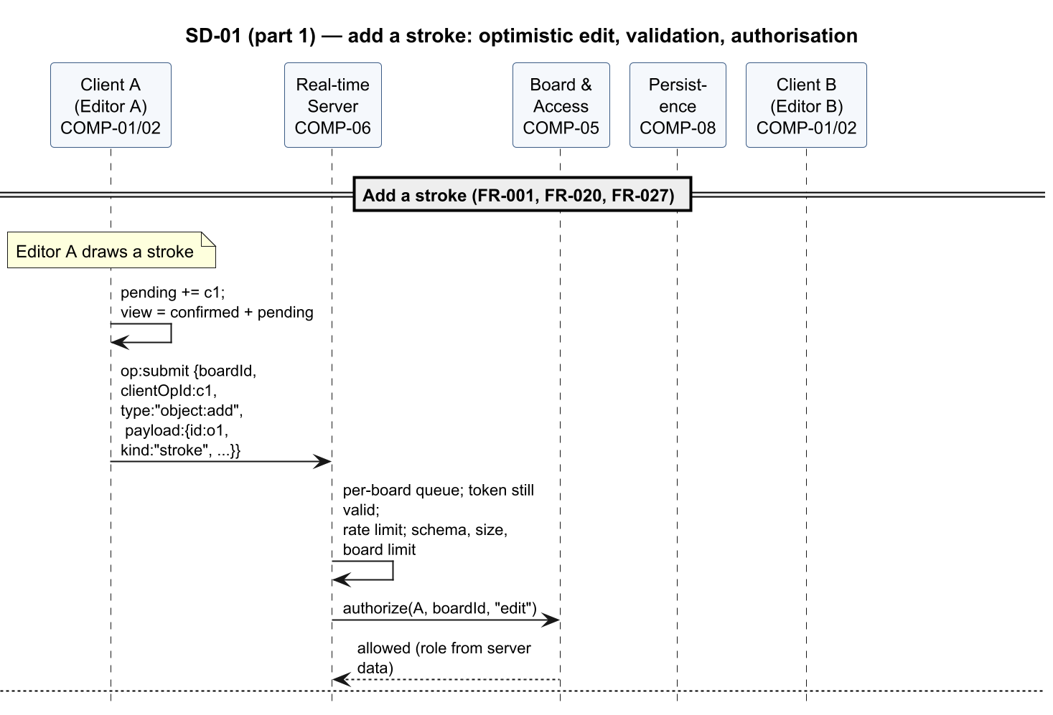
Figure 3 — SD-01 (part 1 of 6): add a stroke: optimistic edit, validation, authorisation
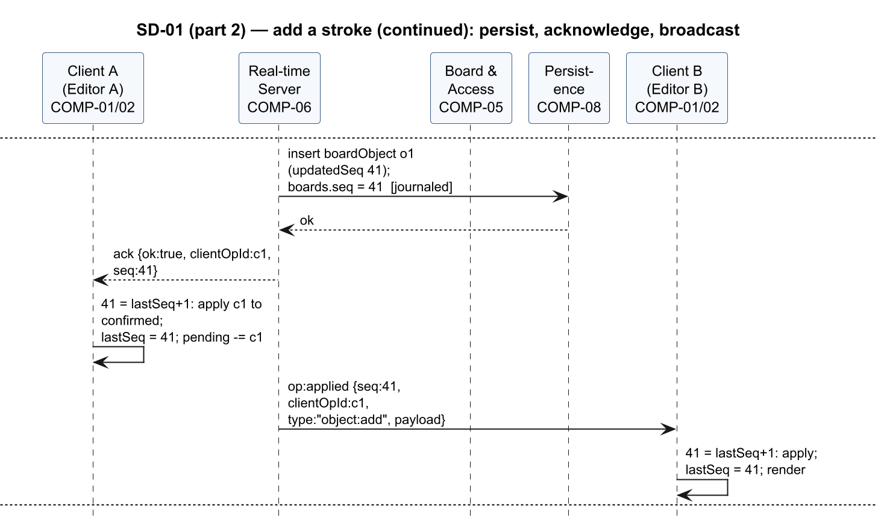
Figure 4 — SD-01 (part 2 of 6): add a stroke (continued): persist, acknowledge, broadcast
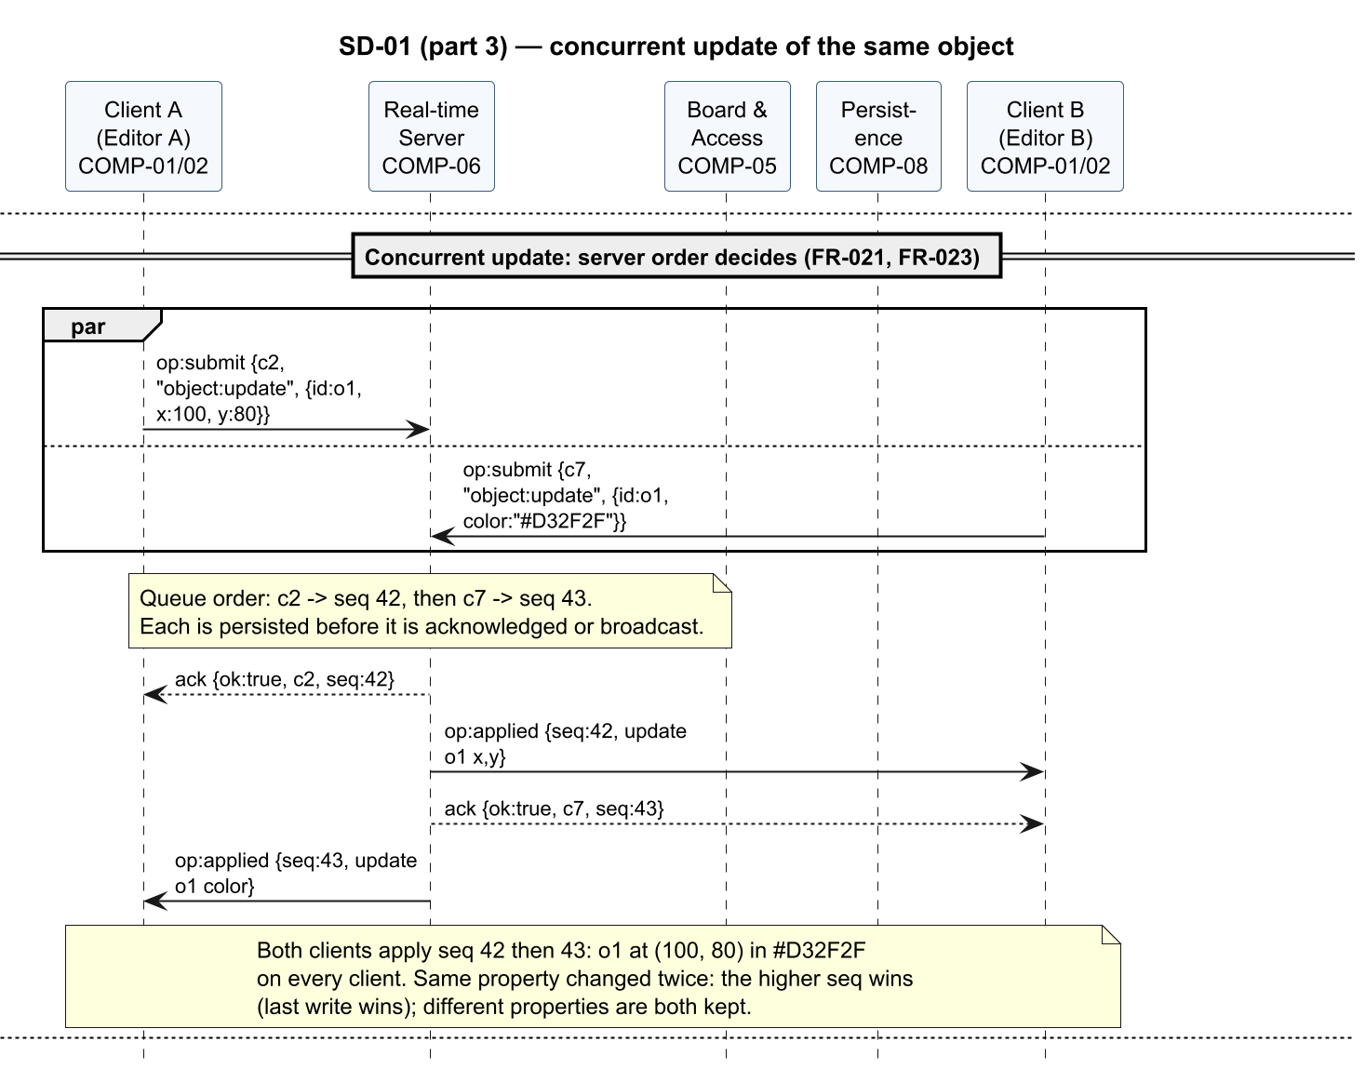
Figure 5 — SD-01 (part 3 of 6): concurrent update of the same object
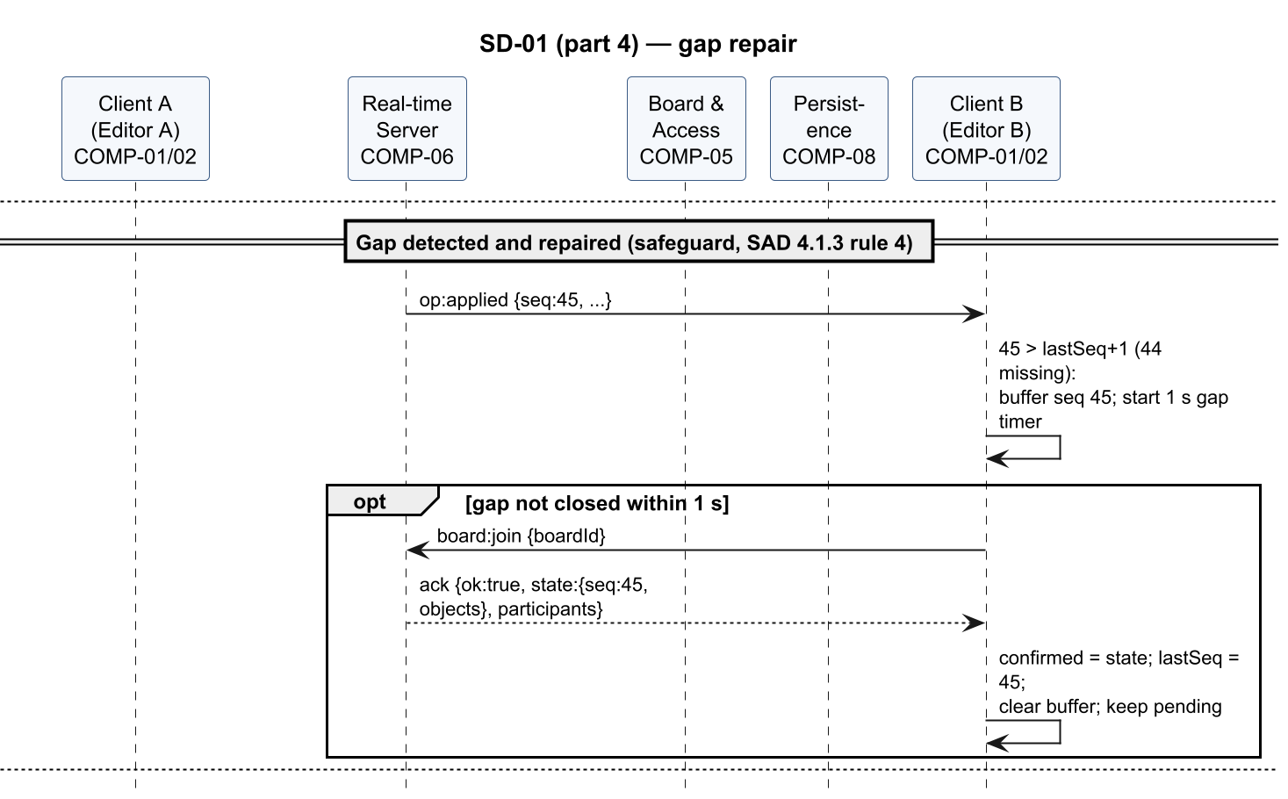
Figure 6 — SD-01 (part 4 of 6): gap repair
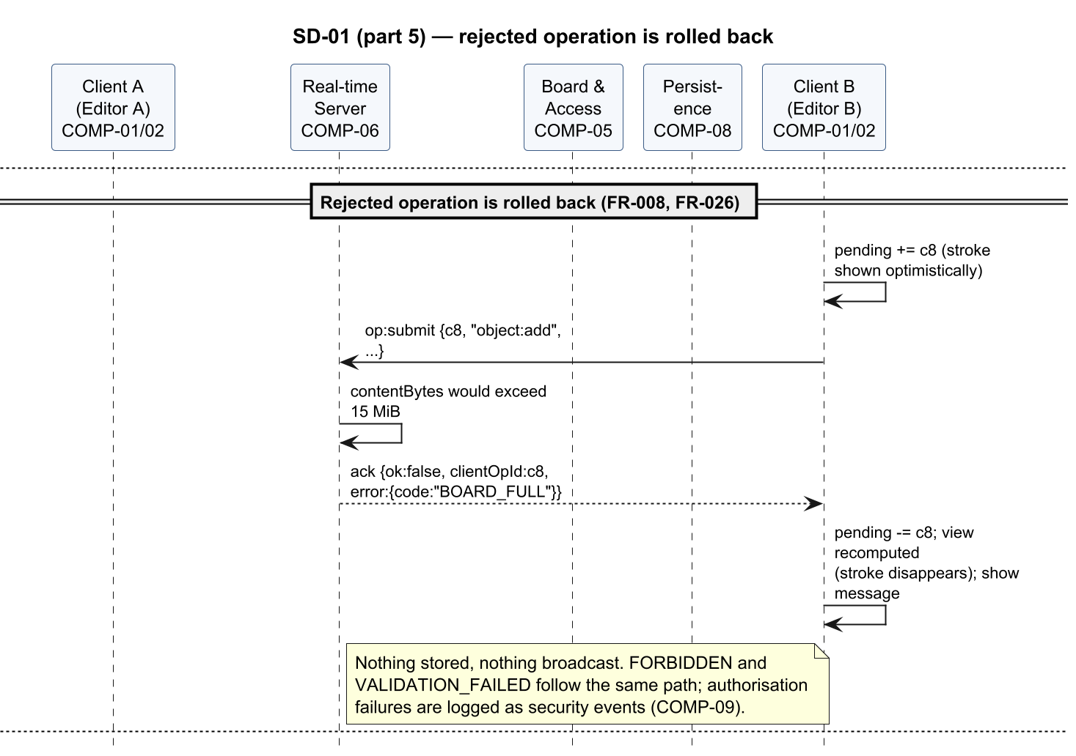
Figure 7 — SD-01 (part 5 of 6): rejected operation is rolled back
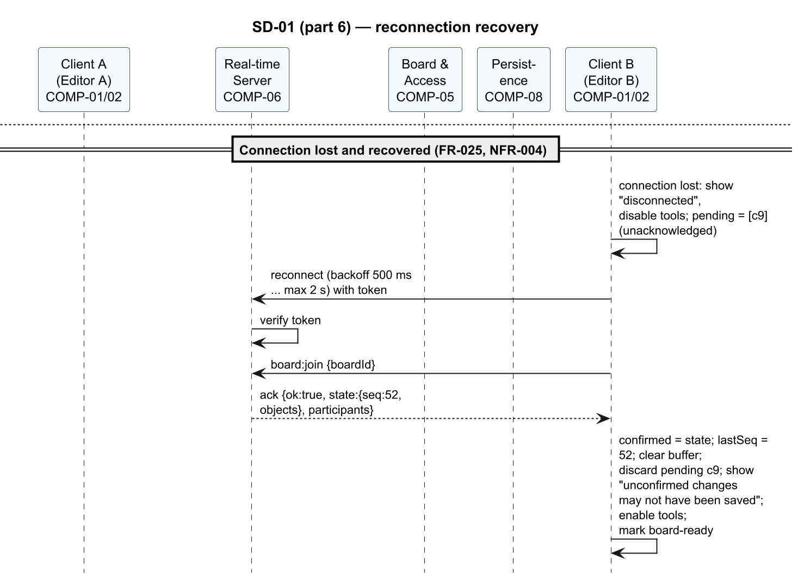
Figure 8 — SD-01 (part 6 of 6): reconnection recovery

SD-02 — Restore a previous version
Realises FR-033, FR-034, FR-051, NFR-005. The Owner restores version n through API-03. The restore runs as a task in the board queue: it checks the Owner role and the idempotency key, commits the operation in the durable journal (boards.pendingOp), stores the restore version, replaces the board objects, completes the journal entry and only then pushes the restored state to every participant (§3.6). A restore from a non-Owner, or one that fails before its commit, is rejected without any change; a restore interrupted after its commit is completed at start-up.
Figures 9–17 show the flow in 9 parts.
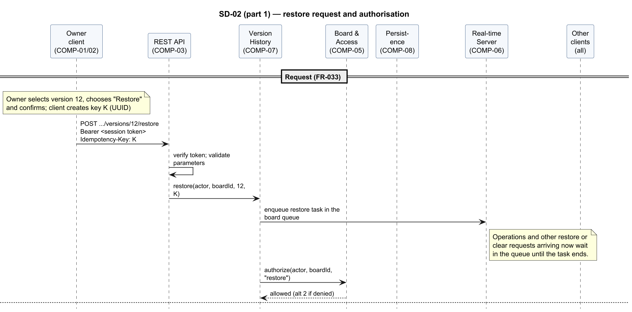
Figure 9 — SD-02 (part 1 of 9): restore request and authorisation
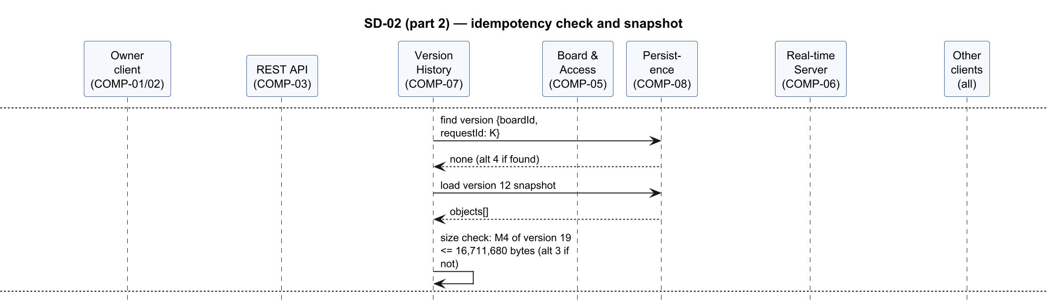
Figure 10 — SD-02 (part 2 of 9): idempotency check and snapshot
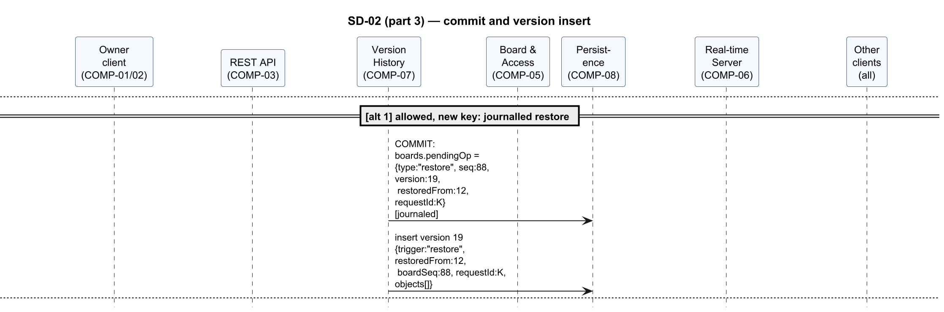
Figure 11 — SD-02 (part 3 of 9): commit and version insert
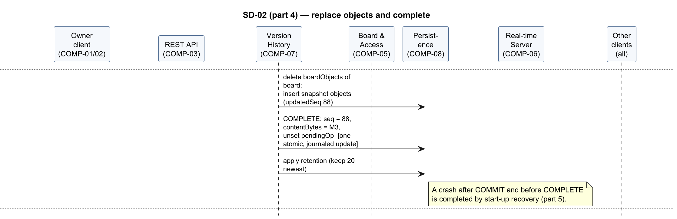
Figure 12 — SD-02 (part 4 of 9): replace objects and complete
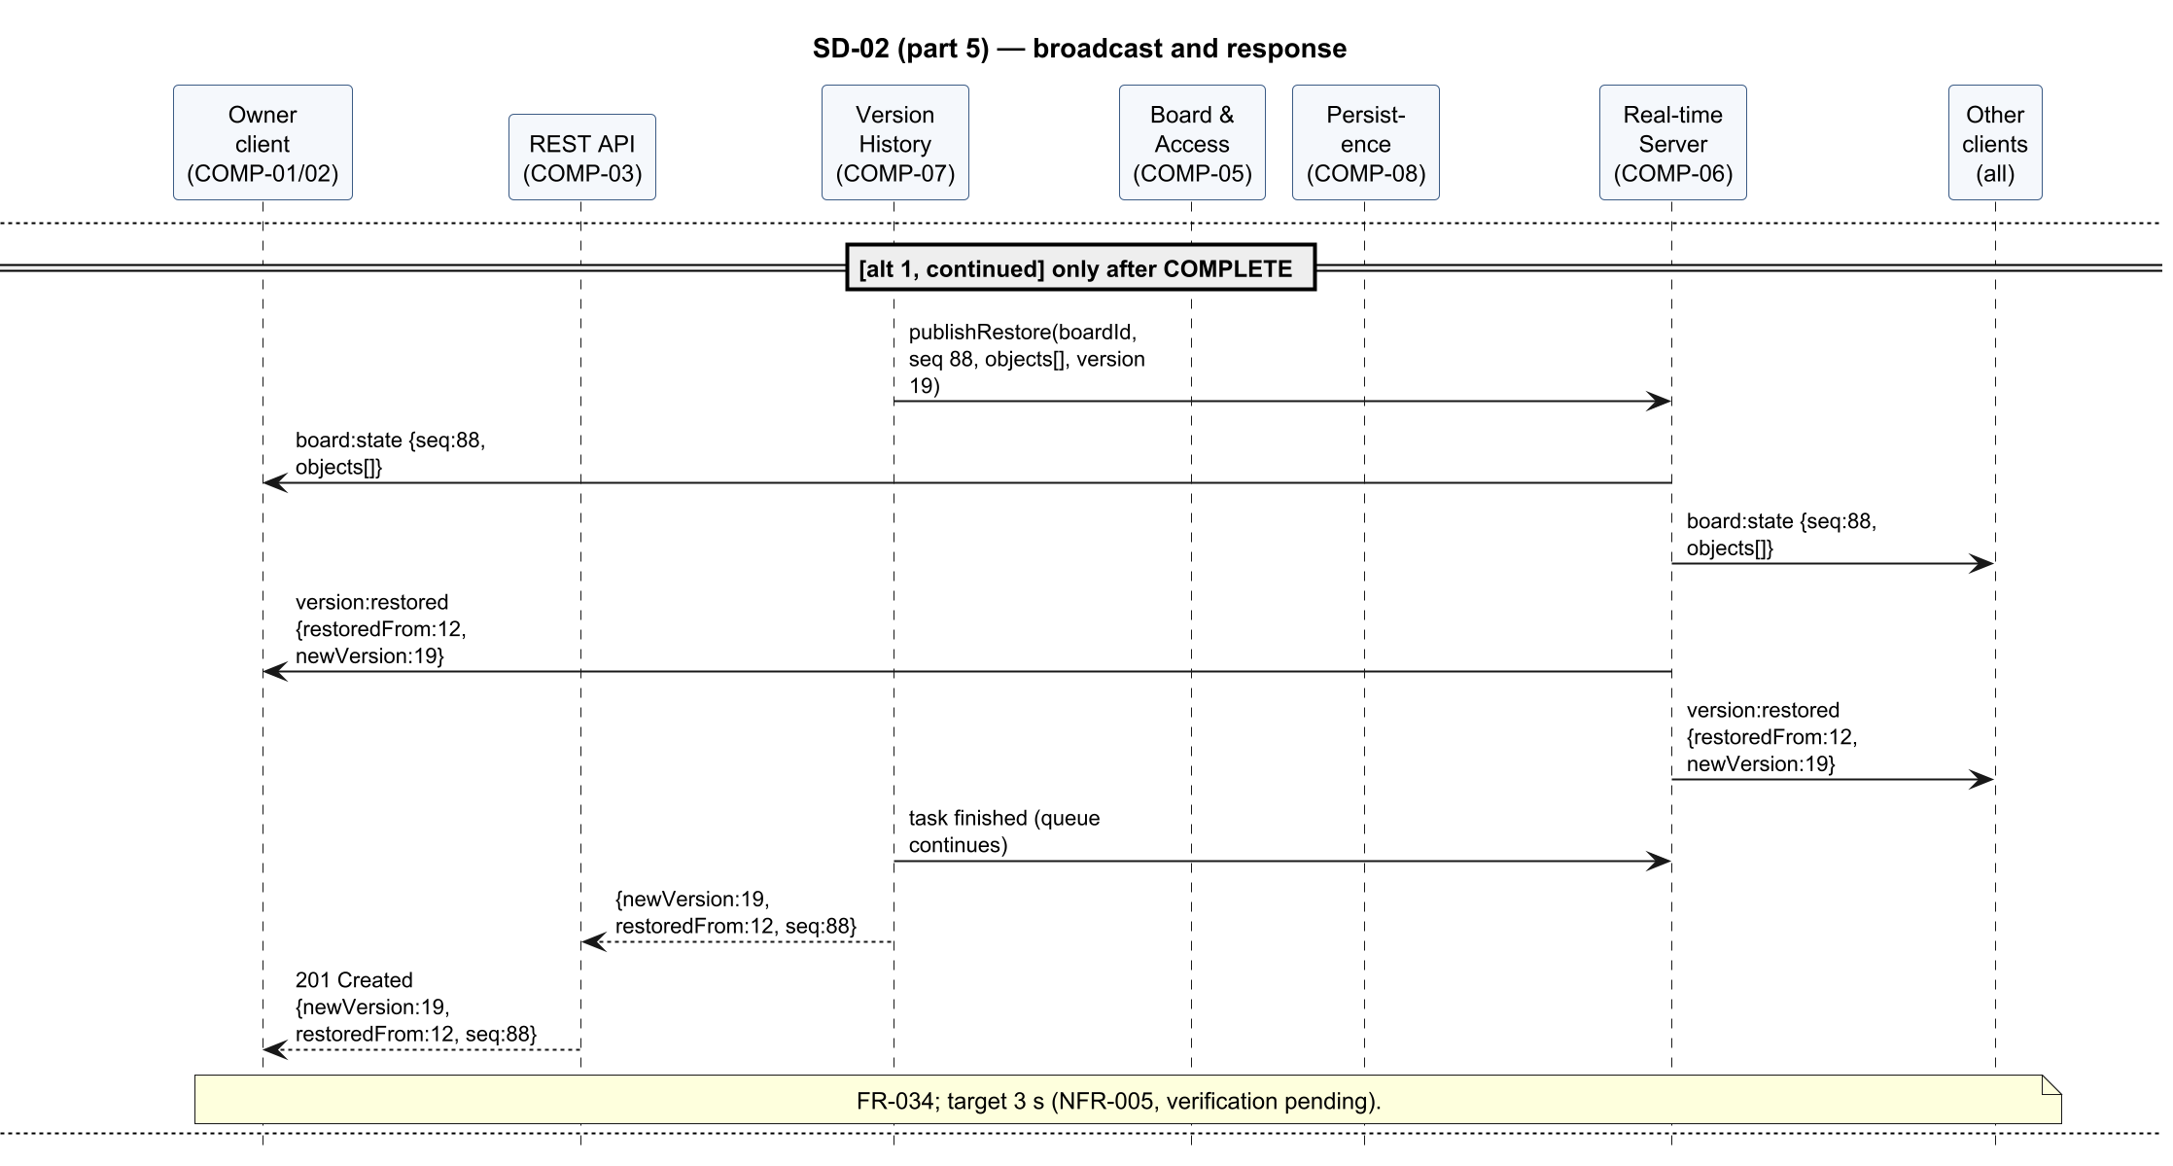
Figure 13 — SD-02 (part 5 of 9): broadcast and response
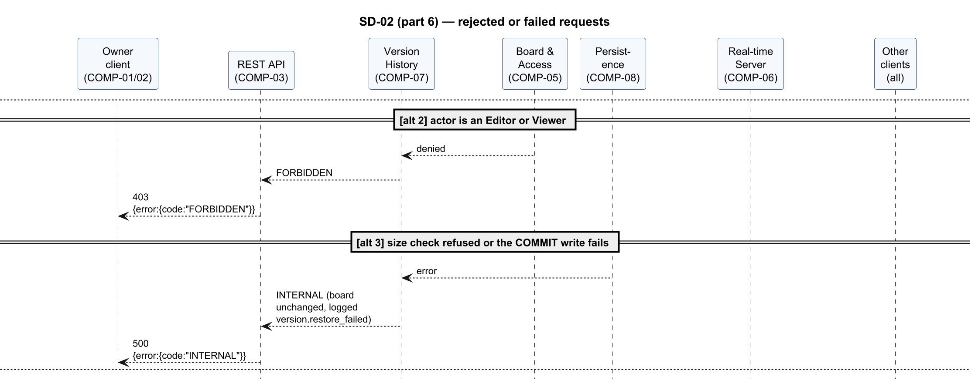
Figure 14 — SD-02 (part 6 of 9): rejected or failed requests
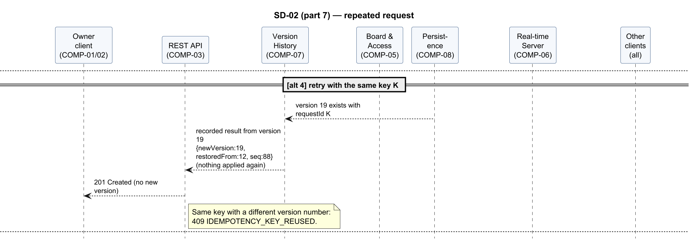
Figure 15 — SD-02 (part 7 of 9): repeated request
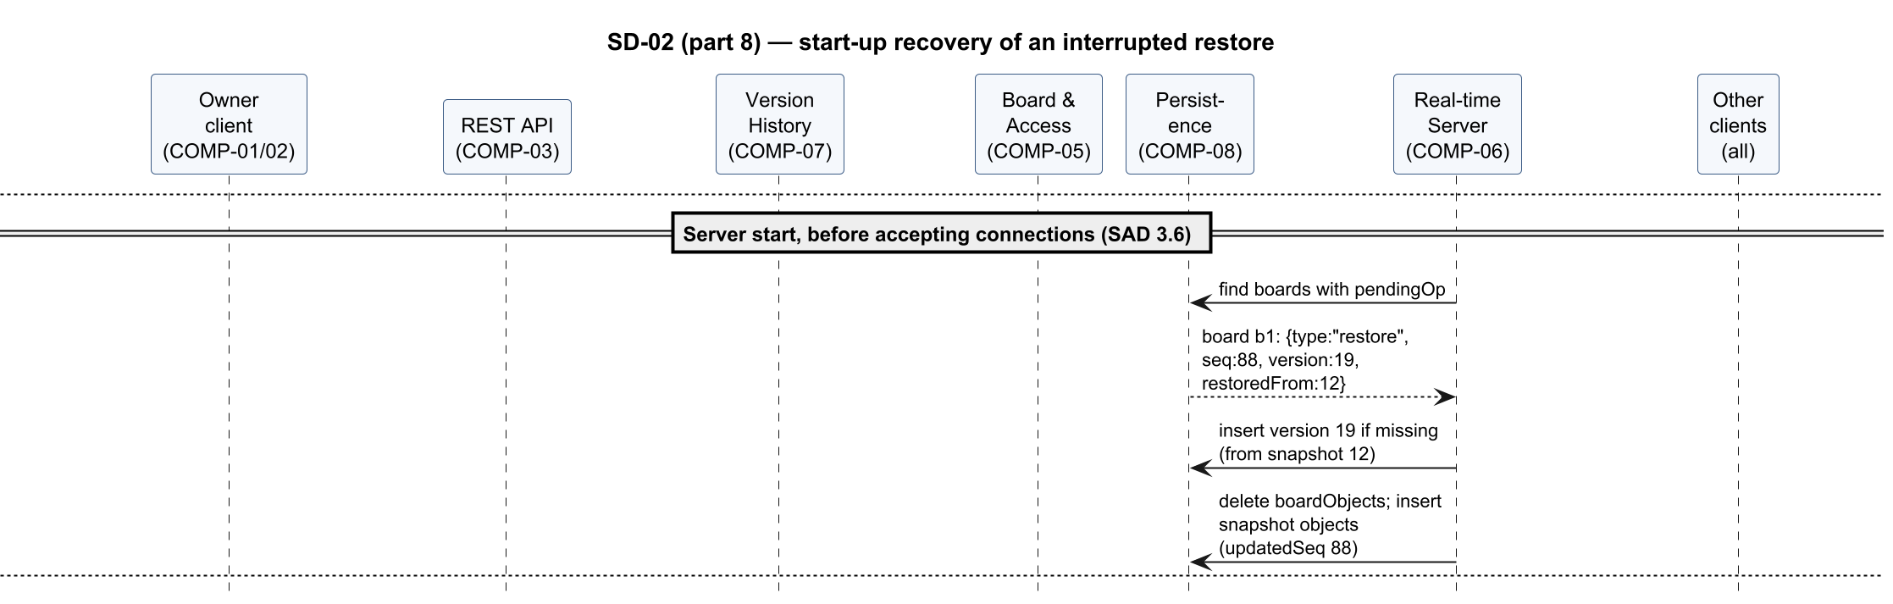
Figure 16 — SD-02 (part 8 of 9): start-up recovery of an interrupted restore
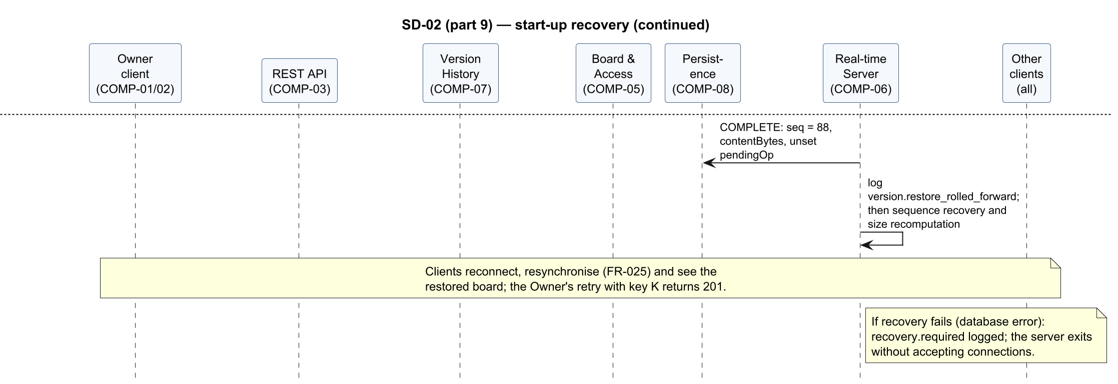
Figure 17 — SD-02 (part 9 of 9): start-up recovery (continued)

SD-03 — Join through a share link, then revocation
Realises FR-024, FR-046, FR-047, FR-048, FR-051, SEC-REQ-002, SEC-REQ-004. A guest opens a share link, the server validates the hashed token and issues a board-scoped guest token, and the guest joins the board room and receives the full state. When the Owner later revokes the link, the guest's socket is notified and disconnected.
Figures 18–22 show the flow in 5 parts.
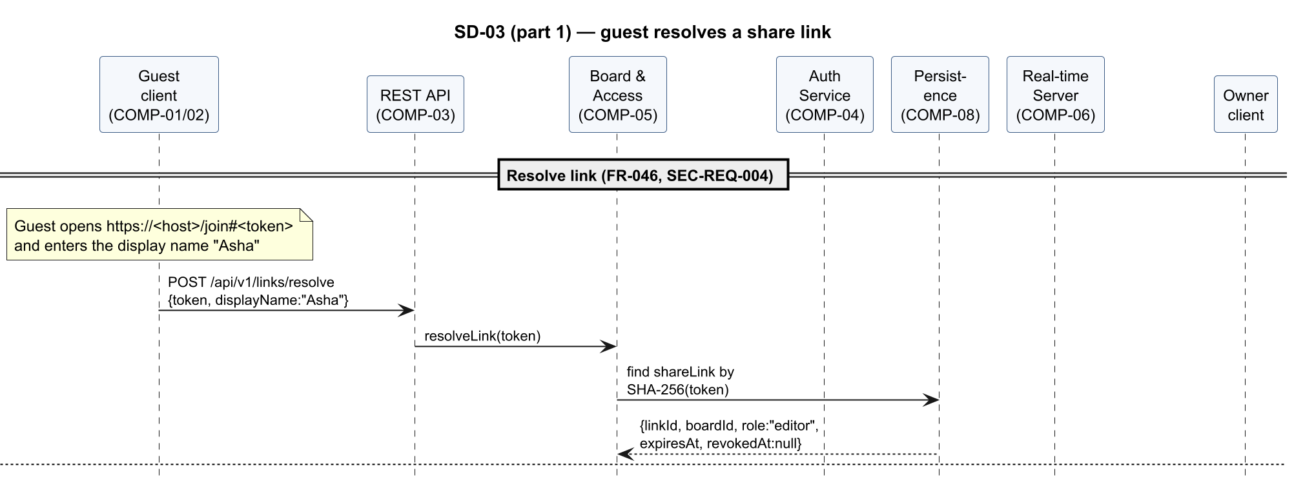
Figure 18 — SD-03 (part 1 of 5): guest resolves a share link
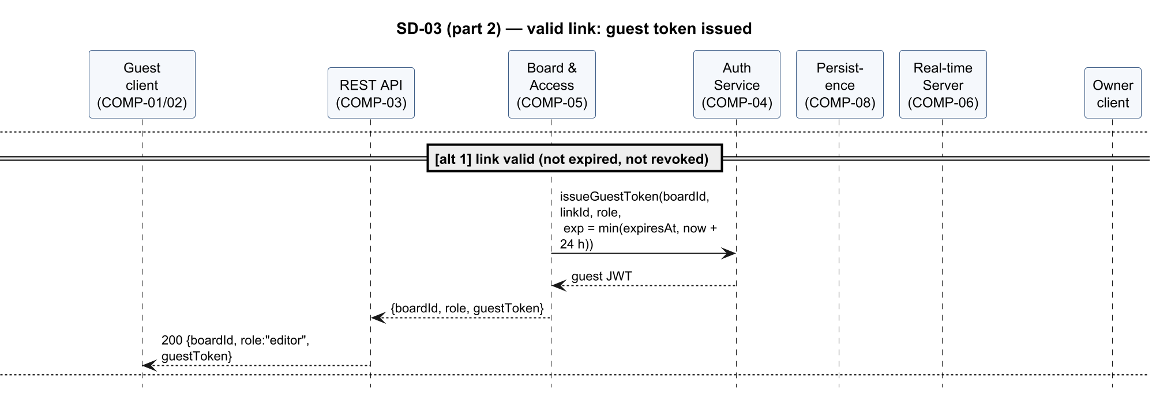
Figure 19 — SD-03 (part 2 of 5): valid link: guest token issued
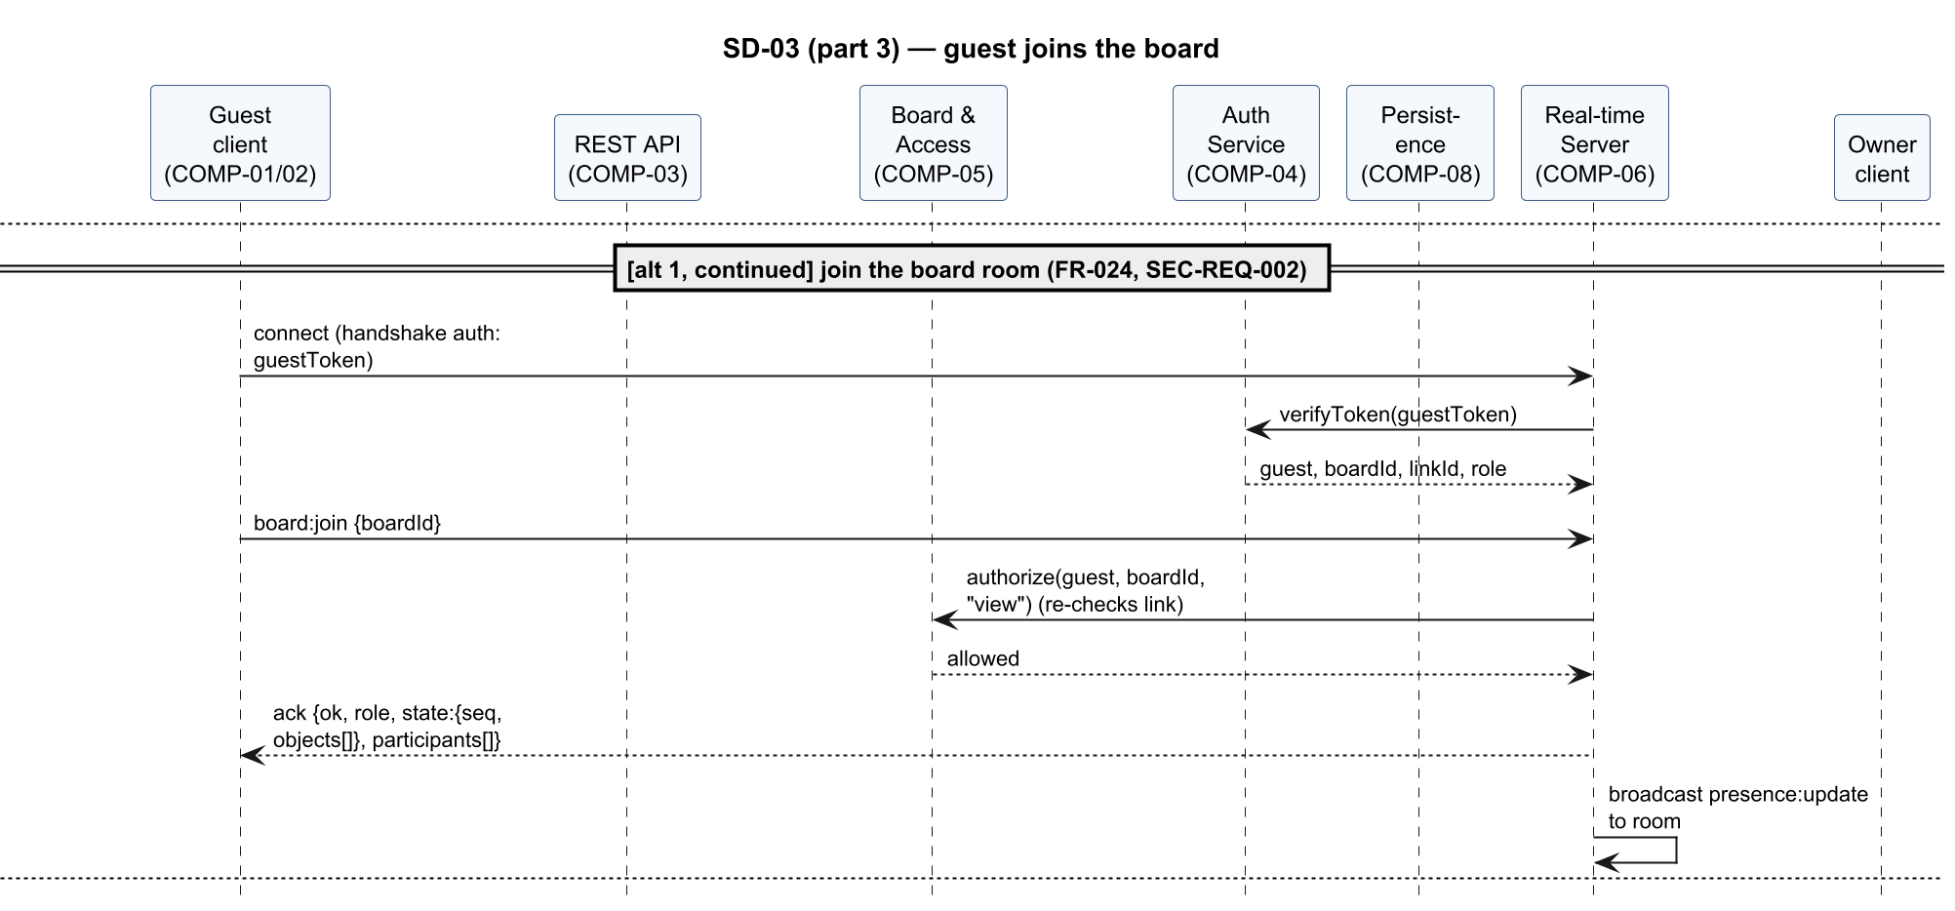
Figure 20 — SD-03 (part 3 of 5): guest joins the board
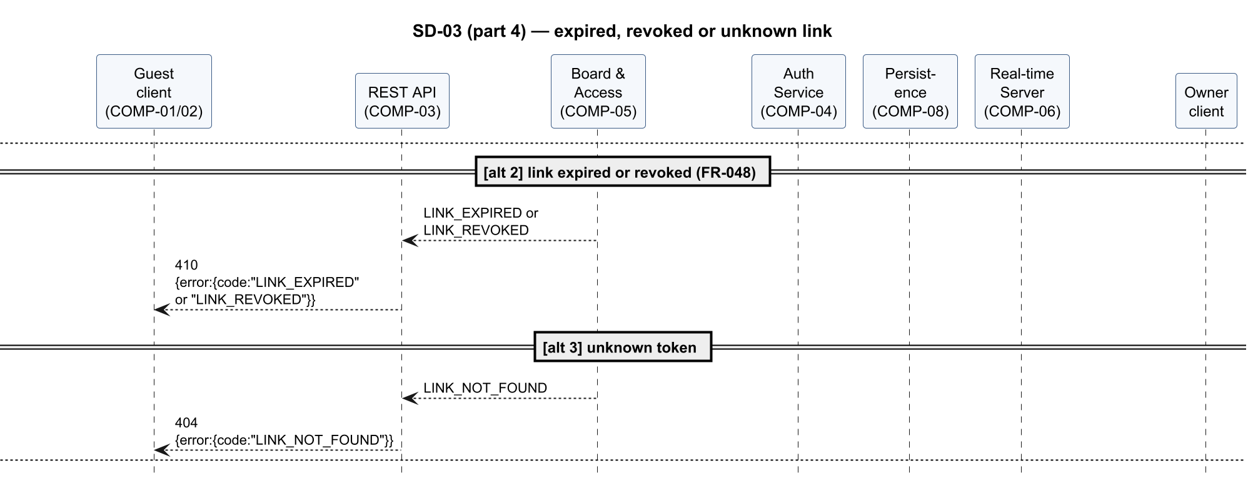
Figure 21 — SD-03 (part 4 of 5): expired, revoked or unknown link
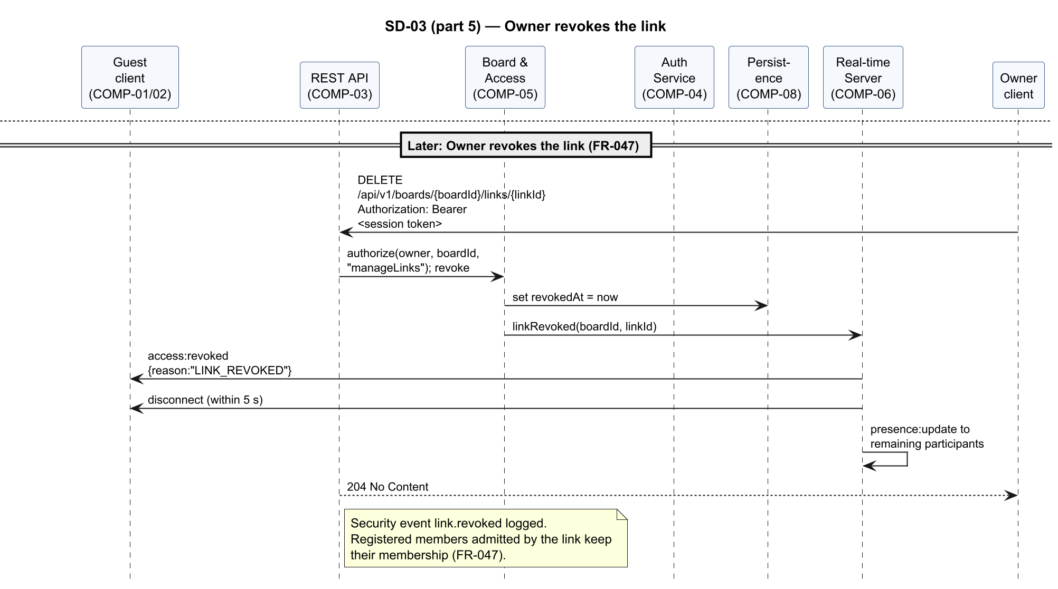
Figure 22 — SD-03 (part 5 of 5): Owner revokes the link

SD-04 — Transfer board ownership
Realises FR-050, FR-051, SEC-REQ-003, SEC-REQ-008. The Owner transfers ownership to an Editor or Viewer member through API-02 (POST /api/v1/boards/{boardId}/transfer-ownership). The Board & Access Service verifies that the requester is the Owner and that the target is eligible, updates the ownership and memberships, and the Real-time Collaboration Server pushes the new roles to both users. Requests without confirm: true, from non-Owners or guests, for a board the requester has no role on, for an ineligible target, or that lose a race with a concurrent transfer are rejected and change no role.
Figures 23–28 show the flow in 6 parts.
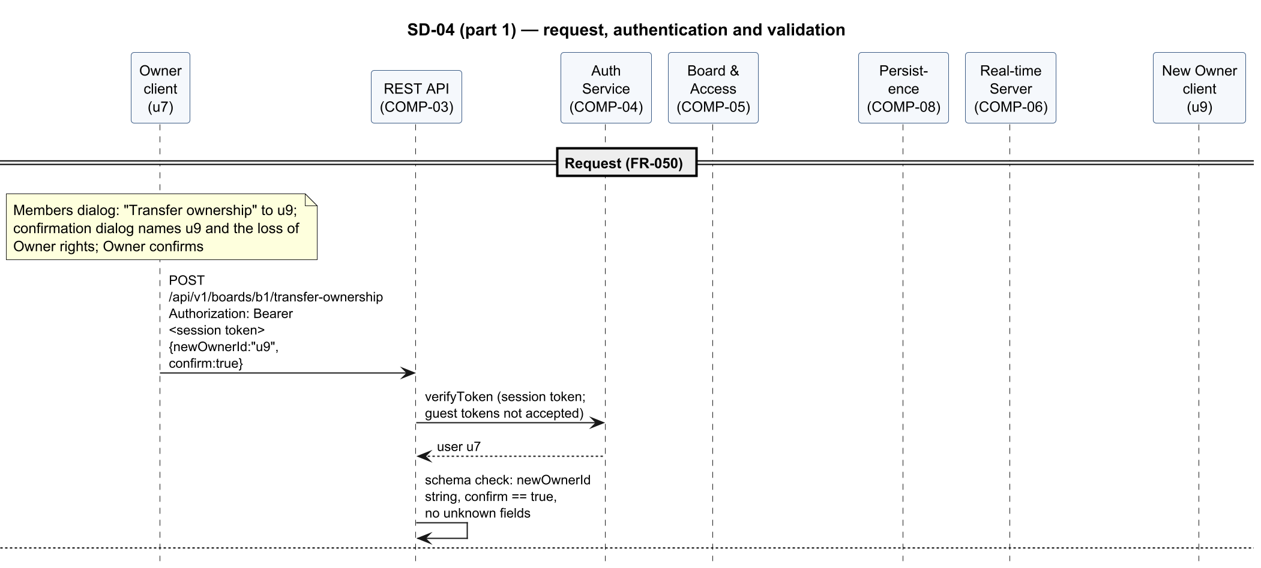
Figure 23 — SD-04 (part 1 of 6): request, authentication and validation
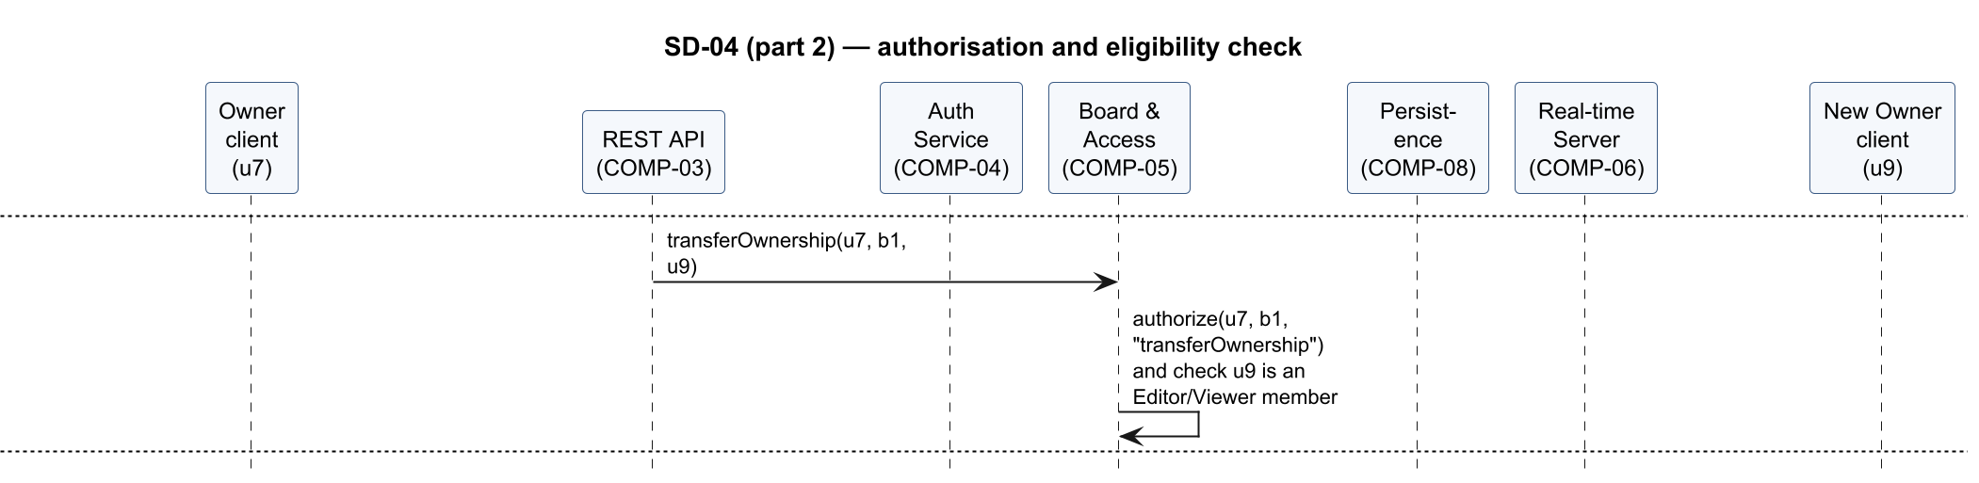
Figure 24 — SD-04 (part 2 of 6): authorisation and eligibility check
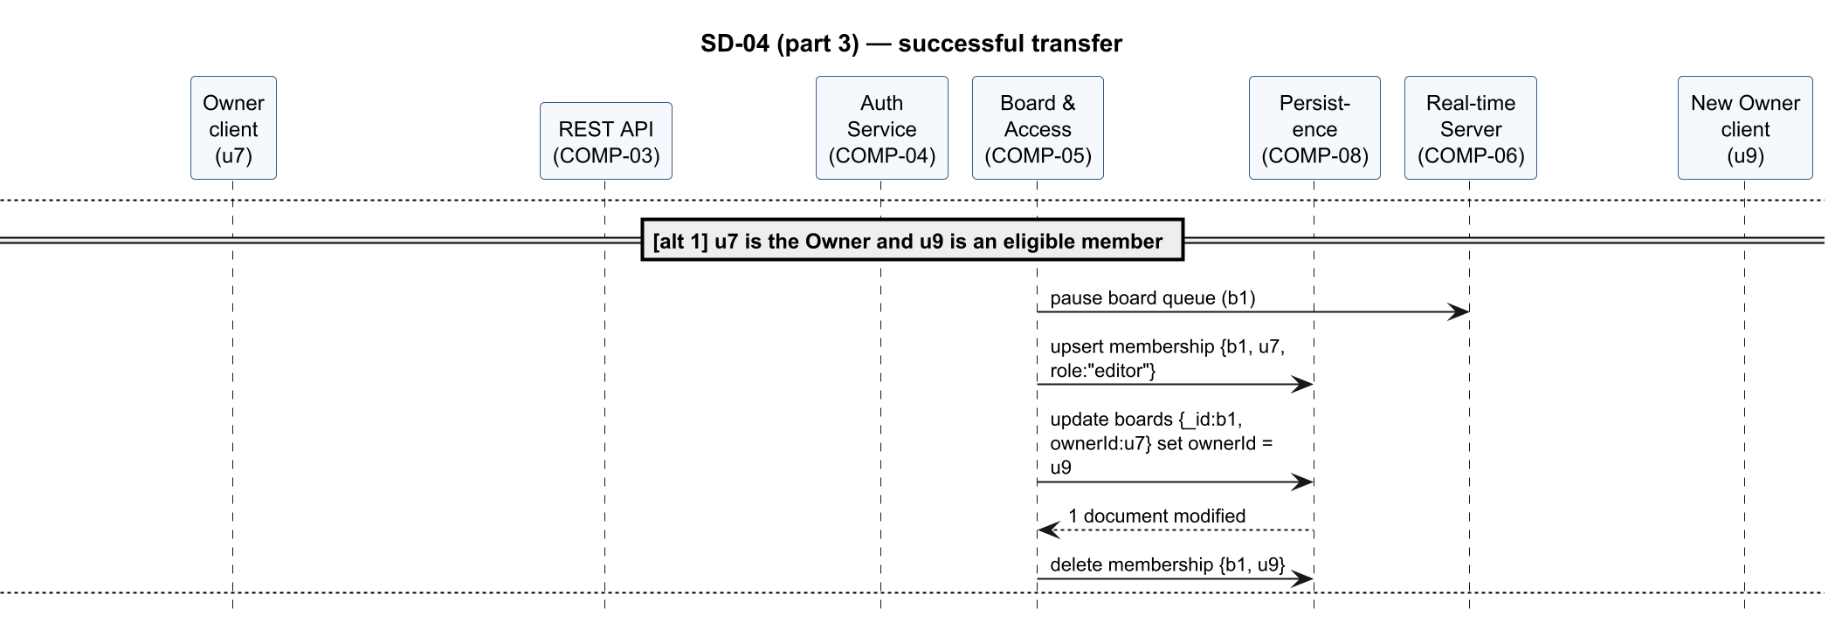
Figure 25 — SD-04 (part 3 of 6): successful transfer
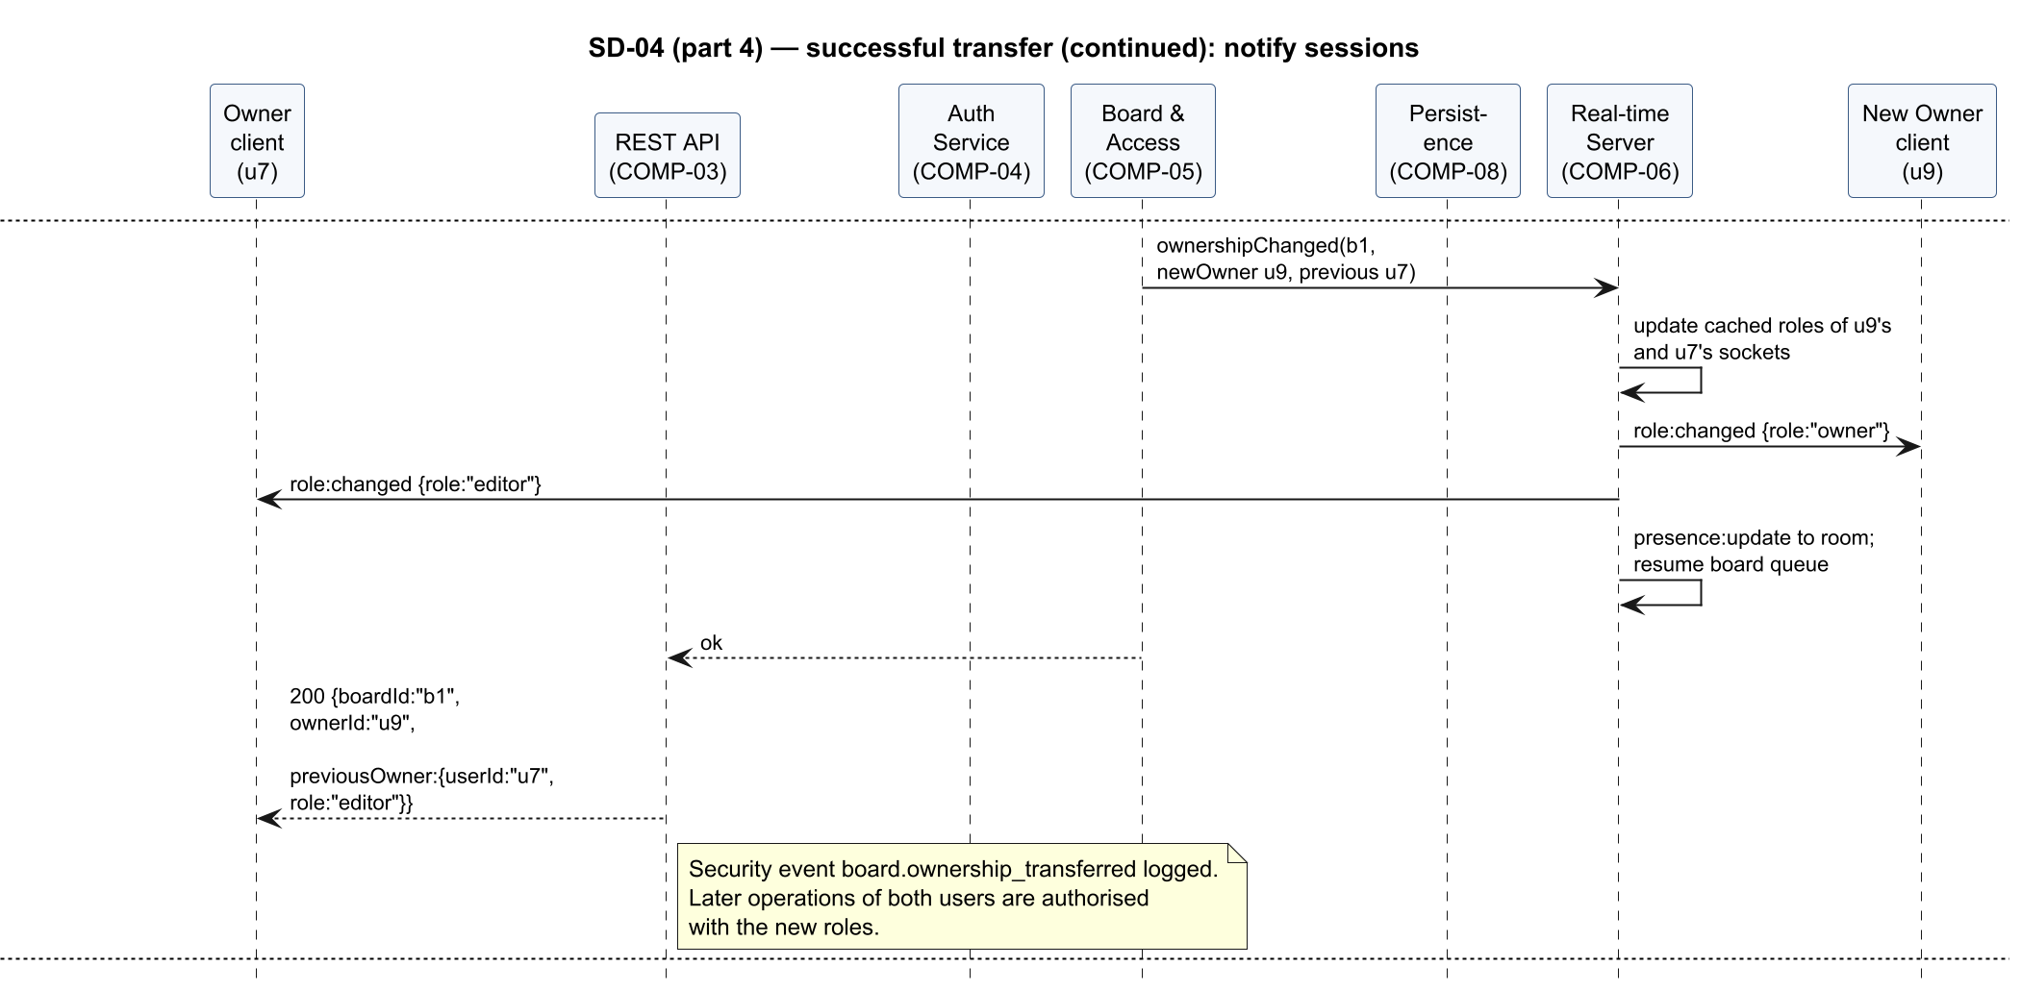
Figure 26 — SD-04 (part 4 of 6): successful transfer (continued): notify sessions
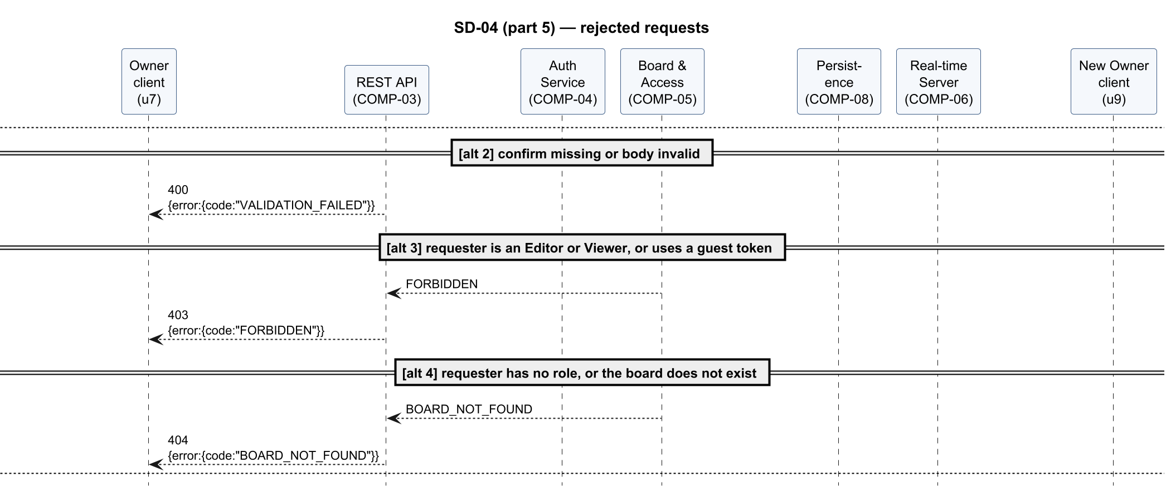
Figure 27 — SD-04 (part 5 of 6): rejected requests
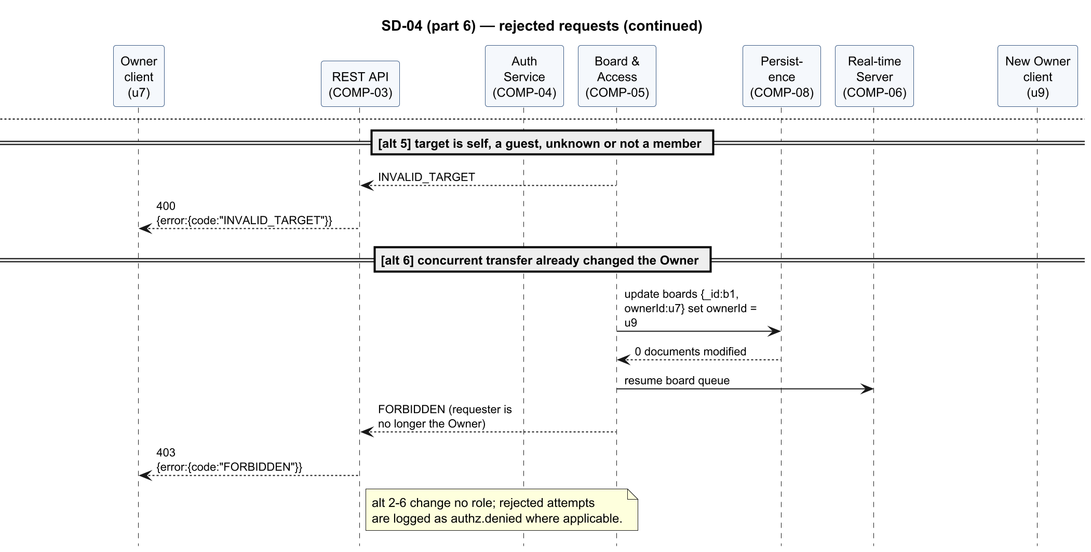
Figure 28 — SD-04 (part 6 of 6): rejected requests (continued)

SD-05 — Clear the board with interrupted-clear recovery
Realises FR-007, FR-030, FR-051. The Owner's board:clear runs as a task in the board queue: the server applies the "before clear" version trigger, commits the clear in the durable journal (boards.pendingOp), deletes the board objects and completes the journal entry with the new sequence number in one atomic update; only then is the clear acknowledged and broadcast. If the server stops after the commit, start-up recovery completes the clear before any client can reconnect (§3.6).
Figures 29–31 show the flow in 3 parts.
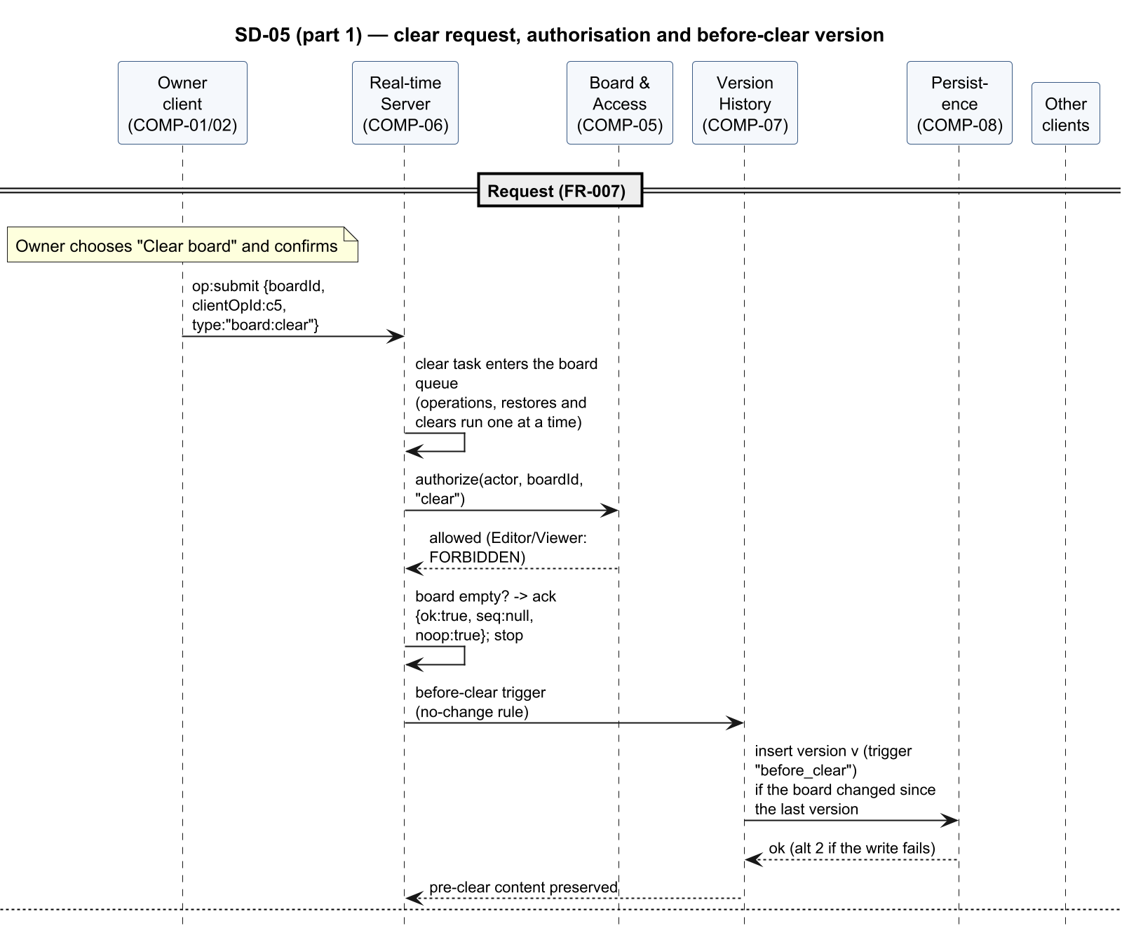
Figure 29 — SD-05 (part 1 of 3): clear request, authorisation and before-clear version

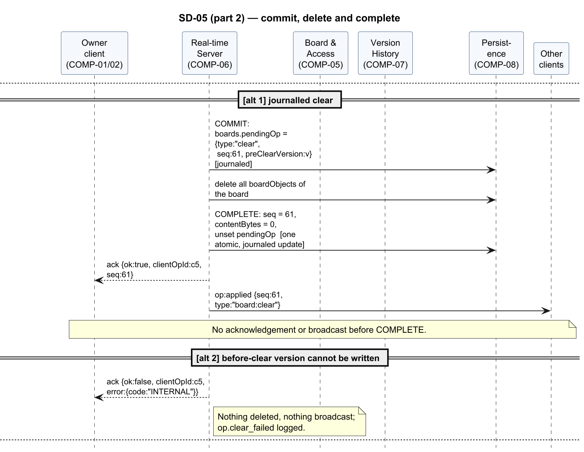
Figure 30 — SD-05 (part 2 of 3): commit, delete and complete
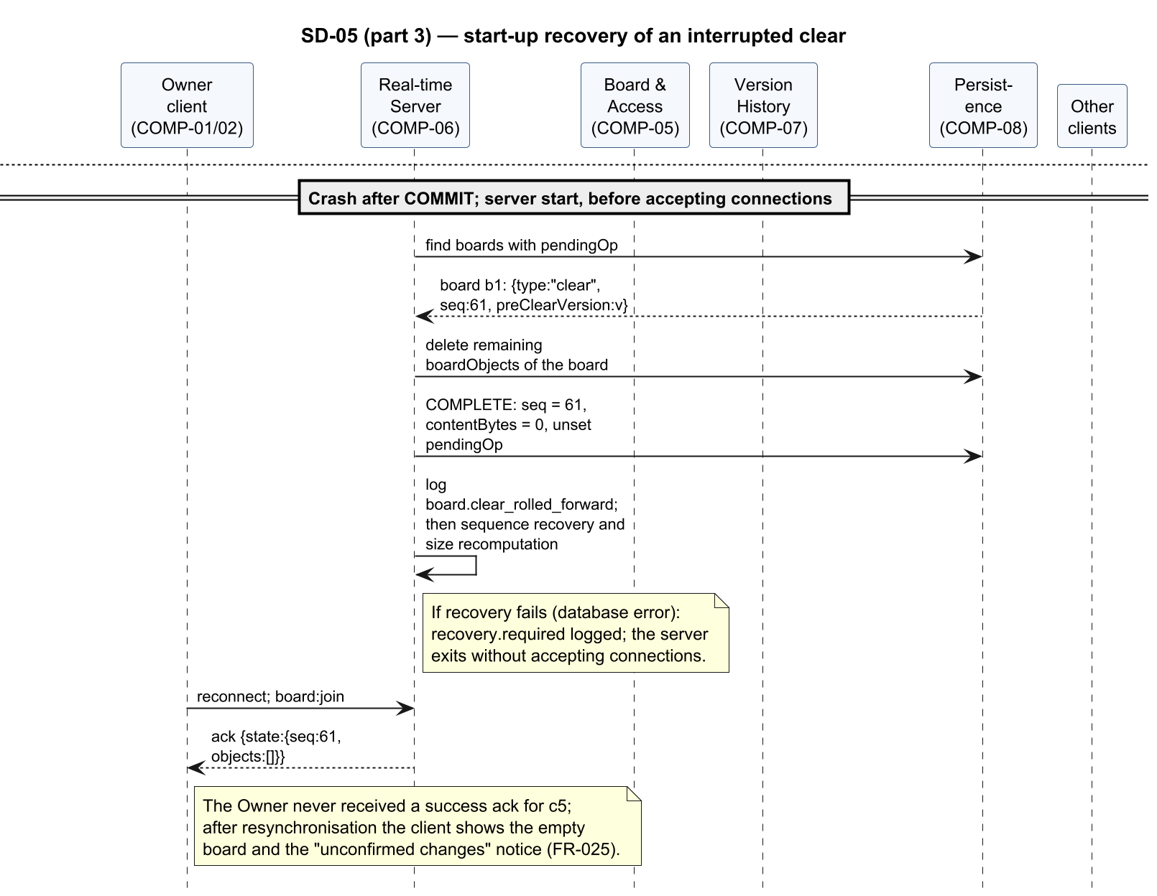
Figure 31 — SD-05 (part 3 of 3): start-up recovery of an interrupted clear

4.3 API Design
Three interfaces are specified (the template requires at least two components): API-01 for the Real-time Collaboration Server (COMP-06), API-02 for accounts, boards, links, members and ownership transfer (COMP-03/04/05) and API-03 for version history (COMP-03/07). REST and Socket.IO use the same tokens (SAD §3.9.2) and the same authorize policy (§3.9.3). All payloads are JSON. Placeholders such as <token> stand for real values and are never real secrets.
Common error object (REST bodies and Socket.IO acknowledgements): {"error": {"code": "<CODE>", "message": "<human-readable text>", "requestId": "<id>"}}
Code | HTTP status (REST) | Meaning
VALIDATION_FAILED | 400 | Payload does not match the schema or exceeds limits, or a required confirmation is missing (SEC-REQ-005)
INVALID_TARGET | 400 | Ownership-transfer target is not an eligible registered member (FR-050)
UNAUTHENTICATED | 401 | Missing, invalid, expired or revoked token (SEC-REQ-002)
FORBIDDEN | 403 | Role does not permit the action (FR-051, SEC-REQ-003)
BOARD_NOT_FOUND, VERSION_NOT_FOUND, LINK_NOT_FOUND, OBJECT_NOT_FOUND | 404 | Target does not exist (also used when the requester may not know it exists)
EMAIL_TAKEN | 409 | Registration with an existing e-mail (FR-040)
BOARD_FULL | — (Socket.IO only) | Operation would exceed the 15 MiB BSON board content limit (FR-008); rejected before anything is stored
IDEMPOTENCY_KEY_REUSED | 409 | A restore Idempotency-Key was reused for a different version (API-03)
LINK_EXPIRED, LINK_REVOKED | 410 | Share link no longer valid (FR-047, FR-048)
RATE_LIMITED | 429 | Rate limit exceeded (SEC-REQ-006)
INTERNAL | 500 | Unexpected server error; details only in server log

API-01 — Real-time board events (Socket.IO, COMP-06)
Realises FR-001–FR-008 (operations), FR-020–FR-026, FR-034, FR-047–FR-050, FR-052, SEC-REQ-002, SEC-REQ-003, SEC-REQ-005, SEC-REQ-006.
Connection. Namespace /board. Handshake: io("/board", { auth: { token: "<session or guest token>" } }). Invalid token → connect_error with data.code = "UNAUTHENTICATED". Maximum message size 65,536 bytes per packet (measure M1, SAD §3.6).
Client → server events (every event uses a Socket.IO acknowledgement callback):
Event | Payload | Acknowledgement (success) | Errors
board:join | {boardId} | {ok: true, role, state: {seq, objects: [...]}, participants: [{id, displayName, role, guest}]} | FORBIDDEN, BOARD_NOT_FOUND, LINK_EXPIRED, LINK_REVOKED
board:leave | {boardId} | {ok: true} | —
op:submit | {boardId, clientOpId, type, payload} with type ∈ object:add (payload = full object), object:update ({id, ...changedProperties} with complete new values), object:delete ({id}), board:clear ({}, Owner only) | {ok: true, clientOpId, seq}; for board:clear on an empty board {ok: true, clientOpId, seq: null, noop: true} | {ok: false, clientOpId, error} with VALIDATION_FAILED, FORBIDDEN, OBJECT_NOT_FOUND, BOARD_FULL, RATE_LIMITED, INTERNAL

Server → client events:
Event | Payload | When
op:applied | {boardId, seq, clientOpId, actor: {id, displayName}, type, payload} | After every accepted operation, to all sockets in the room except the submitter (who receives the acknowledgement)
board:state | {boardId, seq, objects: [...]} | After a restore, to every socket in the room (FR-034); the client replaces confirmed and lastSeq and keeps its pending operations. Gap repair uses the board:join acknowledgement instead (§4.1.3)
version:restored | {boardId, restoredFrom, newVersion, actor} | After a restore, for the version panel and notification
version:created | {boardId, number, trigger, createdAt} | After any new version (version panel refresh)
presence:update | {boardId, participants: [{id, displayName, role, guest}]} | On join, leave, disconnect, role change
role:changed | {boardId, role} | When the Owner changes this member's role (FR-049), and to both users after an ownership transfer (FR-050); the client updates its enabled tools immediately
access:revoked | {boardId, reason} with reason ∈ LINK_REVOKED, LINK_EXPIRED, MEMBER_REMOVED, BOARD_DELETED | Immediately before the server disconnects the socket (FR-044, FR-047–FR-049)

Example. Each line shows the direction and event name, followed by the complete JSON payload of that message.
client → op:submit {"boardId":"b1","clientOpId":"c1","type":"object:add",
"payload":{"id":"o1","kind":"rect","x":10,"y":20,"w":120,"h":60,
"color":"#1E88E5","strokeWidth":3}}
server → ack {"ok":true,"clientOpId":"c1","seq":41}
server → room op:applied {"boardId":"b1","seq":41,"clientOpId":"c1",
"actor":{"id":"u7","displayName":"Rachit"},
"type":"object:add",
"payload":{"id":"o1","kind":"rect","x":10,"y":20,"w":120,"h":60,
"color":"#1E88E5","strokeWidth":3}}

Ordering and delivery guarantees (details in §4.1.2–§4.1.4): the server processes operations of one board strictly in queue order, persists each before acknowledging or broadcasting it, and emits acknowledgements and op:applied events in sequence order. Clients apply events strictly by seq, ignore duplicates, buffer out-of-order events and resynchronise with board:join when a gap is not closed within 1 s or after reconnection.

API-02 — Accounts, boards, share links, members and ownership (REST, COMP-03/04/05)
Realises FR-040–FR-051, SEC-REQ-001, SEC-REQ-002, SEC-REQ-003, SEC-REQ-004, SEC-REQ-005, SEC-REQ-006, SEC-REQ-008. Base path /api/v1. Authenticated endpoints require Authorization: Bearer <token>. "Role" is the minimum board role required (checked by COMP-05). 403 vs 404 rule: a requester with no role on the board receives 404 BOARD_NOT_FOUND (the board's existence is not revealed); a requester with a role that is too low receives 403 FORBIDDEN.
Method and path | Auth /​ role | Request body | Success response | Errors
POST /auth/register | none | {email, password, displayName} | 201 {userId} | 400 VALIDATION_FAILED, 409 EMAIL_TAKEN
POST /auth/login | none | {email, password} | 200 {token, expiresAt, user: {id, displayName}} | 401 UNAUTHENTICATED, 429 RATE_LIMITED
POST /auth/logout | registered user | — | 204 | 401
GET /boards | registered user | — | 200 [{id, title, role, updatedAt}] | 401
POST /boards | registered user | {title} | 201 {id, title, role: "owner"} | 400, 401
GET /boards/{boardId} | Viewer | — | 200 {id, title, ownerId, role, updatedAt} | 401, 403, 404
DELETE /boards/{boardId} | Owner | — | 204 | 401, 403, 404
POST /boards/{boardId}/links | Owner | {role: "viewer" | "editor", expiresIn: "1h" | "24h" | "7d"} | 201 {linkId, url, role, expiresAt} (url contains the token; shown once) | 400, 401, 403, 404
GET /boards/{boardId}/links | Owner | — | 200 [{linkId, role, expiresAt, createdAt}] (no tokens) | 401, 403, 404
DELETE /boards/{boardId}/links/{linkId} | Owner | — | 204 (revokes; COMP-06 disconnects affected guests) | 401, 403, 404
POST /links/resolve | link token in body; bearer session token optional | {token, displayName?} (displayName required when no session token is sent) | With a valid session token: 200 {boardId, role} and membership created or kept (FR-046); without: 200 {boardId, role, guestToken, expiresAt} | 400, 404 LINK_NOT_FOUND, 410 LINK_EXPIRED/LINK_REVOKED, 429
GET /boards/{boardId}/members | Viewer | — | 200 [{userId, displayName, role}] | 401, 403, 404
PATCH /boards/{boardId}/members/{userId} | Owner | {role: "viewer" | "editor"} | 200 {userId, role} | 400, 401, 403, 404
DELETE /boards/{boardId}/members/{userId} | Owner | — | 204 | 401, 403, 404
POST /boards/{boardId}/transfer-ownership | Owner (session token) | {newOwnerId, confirm: true} | 200 {boardId, ownerId, previousOwner: {userId, role: "editor"}} | 400 VALIDATION_FAILED/INVALID_TARGET, 401, 403, 404 (details below)
GET /health | none | — | 200 {status: "ok", db: "up"} | 503 if the database is down

Example.
POST /api/v1/boards/b1/links
Authorization: Bearer <session token>
{"role":"editor","expiresIn":"24h"}

201 Created
{"linkId":"l3","url":"https://<host>/join#<token>","role":"editor",
"expiresAt":"2026-10-11T18:30:00Z"}

Transfer ownership — POST /api/v1/boards/{boardId}/transfer-ownership
Realises FR-050 (with FR-051, SEC-REQ-003, SEC-REQ-008). Flow: SD-04. Tests: TC-018, TC-102.
Aspect | Specification
Authentication | Bearer session token of a registered user. A guest token is rejected with 403 FORBIDDEN (guests can never hold the Owner role). Missing, invalid or expired token → 401 UNAUTHENTICATED.
Authorisation | The requester must be the board's current Owner (boards.ownerId). Editor or Viewer → 403 FORBIDDEN; no role on the board → 404 BOARD_NOT_FOUND.
Request body | {"newOwnerId": "<userId>", "confirm": true}. Unknown fields are rejected.
Safeguards | The client shows a confirmation dialog naming the new Owner and the loss of Owner rights; the API additionally requires confirm: true (missing or not true → 400 VALIDATION_FAILED). The update is conditional on the requester still being the Owner, so two concurrent transfers cannot both succeed (the second receives 403).
Target validation | newOwnerId must identify a registered user who currently has an Editor or Viewer membership on this board. Self, unknown user IDs, non-members and guest IDs → 400 INVALID_TARGET.
Effect (in this order) | 1. Board queue paused. 2. Upsert membership of the requester with role editor. 3. Conditional update boards.ownerId: requester → newOwnerId. 4. Delete the new Owner's membership row (the Owner is stored on the board only). 5. Queue resumed. A crash after step 2 leaves the requester as Owner (the Owner check precedes membership lookup); a crash after step 3 leaves a redundant membership row for the new Owner that is ignored and removed on the next membership change.
Success response | 200 {"boardId": "b1", "ownerId": "<newOwnerId>", "previousOwner": {"userId": "<requesterId>", "role": "editor"}}
Notifications | COMP-06 sends role:changed {role: "owner"} to the new Owner's sockets and role:changed {role: "editor"} to the former Owner's sockets, then presence:update to the room. Both dashboards show the new roles on next load.
Logging | Security event board.ownership_transferred (§4.4): actorId = former Owner, subjectId = new Owner, boardId, time, request ID, outcome (SEC-REQ-008).
Errors | 400 VALIDATION_FAILED (body invalid or confirm missing), 400 INVALID_TARGET, 401 UNAUTHENTICATED, 403 FORBIDDEN (not Owner, or guest token), 404 BOARD_NOT_FOUND (board missing or requester has no role), 500 INTERNAL.

POST /api/v1/boards/b1/transfer-ownership
Authorization: Bearer <session token>
{"newOwnerId":"u9","confirm":true}

200 OK
{"boardId":"b1","ownerId":"u9","previousOwner":{"userId":"u7","role":"editor"}}

API-03 — Version history (REST, COMP-03/07)
Realises FR-030–FR-035, FR-051, NFR-005. Base path /api/v1; bearer token required (session or guest token for the same board).
Method and path | Role | Request | Success response | Errors
GET /boards/{boardId}/versions | Viewer | query limit (1–50, default 20), before (version number, for paging) | 200 [{number, trigger, restoredFrom, createdAt, createdBy}], newest first | 401, 403, 404
GET /boards/{boardId}/versions/{number} | Viewer | — | 200 {number, trigger, createdAt, objects: [...]} (read-only preview, FR-032) | 401, 403, 404 VERSION_NOT_FOUND (never existed or removed by retention, FR-035)
POST /boards/{boardId}/versions/{number}/restore | Owner | header Idempotency-Key: <UUID> (required, one per user action) | 201 {newVersion, restoredFrom, seq}; creates a new version, even if the content equals the current board; COMP-06 then emits board:state and version:restored to the room (SD-02). A retry with the same key and version returns the recorded 201 body (same newVersion, restoredFrom, seq) without restoring again or creating another version; a new key is a new restore | 400 (missing or malformed key), 401, 403, 404 BOARD_NOT_FOUND/VERSION_NOT_FOUND, 409 IDEMPOTENCY_KEY_REUSED (key already used for a different version), 500 INTERNAL (no success: before the commit point nothing changed; after it the restore is completed by recovery, and a retry with the same key reports the outcome)

trigger ∈ periodic, before_clear, last_left, restore. Automatic versions follow the no-change rule of SRS §4.3 (D5b). Versions are created only by the server (FR-030); there is no endpoint to create, edit or delete a version directly, which protects history integrity (SEC-OBJ-002).
Restore semantics (journal, commit point, recovery, serialisation and the key-retention limit) are specified in SAD §3.6.
Example.
POST /api/v1/boards/b1/versions/12/restore
Authorization: Bearer <session token>
Idempotency-Key: 6f1c2a9e-3b7d-4e21-9a55-0c8d4f2b7e10

201 Created
{"newVersion":19,"restoredFrom":12,"seq":88}

Retry of the same request with the same key (recorded result; nothing restored again):
201 Created
{"newVersion":19,"restoredFrom":12,"seq":88}

Same key reused for a different version:
POST /api/v1/boards/b1/versions/15/restore
Authorization: Bearer <session token>
Idempotency-Key: 6f1c2a9e-3b7d-4e21-9a55-0c8d4f2b7e10

409 Conflict
{"error":{"code":"IDEMPOTENCY_KEY_REUSED",
"message":"This Idempotency-Key was already used to restore version 12",
"requestId":"<id>"}}

4.4 Error Handling, Logging & Monitoring
Error handling principles
• Every error returned to a client uses the common error object (§4.3) with a stable code; messages never contain stack traces, database details, tokens or other users' data.
• REST: a central Express error middleware maps errors to the HTTP statuses in §4.3; unknown errors become 500 INTERNAL and are logged with the request ID.
• Socket.IO: handlers never throw to the client; they acknowledge {ok: false, clientOpId, error}. The connection stays open after operation-level errors; it is closed only for authentication failure, revocation, removal, board deletion (each preceded by access:revoked) or by the client after an acknowledgement timeout (§4.1.3).
• Persistence first: a database error while applying an operation causes rejection with INTERNAL, no acknowledgement of success, no broadcast and no change of seq, so clients never see an operation that was not stored (FR-027).
• Restore, clear and ownership transfer pause the board queue while they change state, so no operation is applied to a half-changed board (SD-02, SD-04).
• Snapshot too large (defensive, should not occur because of FR-008): the version is not written and version.snapshot_too_large is logged. Periodic or last-participant trigger: the Owner's client shows "This version could not be saved" and the live board is unaffected. Before-clear trigger: the clear is rejected (INTERNAL). Restore: the restore is rejected (INTERNAL).
• Version write failure (database error) follows the same rules: a clear or restore is never completed without its version (FR-007, FR-033). After its commit point a clear or restore is completed by the running task or by start-up recovery and is never reported as successful before completion (§3.6).
Client reactions (COMP-01/02)
Situation | Client behaviour
VALIDATION_FAILED, FORBIDDEN, OBJECT_NOT_FOUND, BOARD_FULL on an operation | Remove the operation from pending, recompute the view, show a short message naming the reason (FR-026)
RATE_LIMITED | As above, with "You are sending changes too quickly"
UNAUTHENTICATED | Go to the login page (registered user) or the guest entry page (guest)
access:revoked | Show the reason (link revoked or expired, removed, board deleted) and leave the board
role:changed | Enable or disable tools for the new role without reload (FR-049, FR-050)
Connection lost | "Disconnected — reconnecting…" banner, tools disabled; after resynchronisation, notice if unconfirmed changes were discarded (FR-025)
REST INVALID_TARGET (transfer) | Keep the Members dialog open and explain that only Editor or Viewer members can become Owner

Logging (COMP-09)
• Format: one JSON object per line, written by COMP-09 to the server's standard output, which the test environment and a deployment redirect to an append-only log file (logs/server.log). Common fields: timestamp (ISO 8601, UTC), level (error, warn, info, debug), event, requestId, boardId, actorId, outcome, errorCode and durationMs where relevant.
• requestId is the correlation ID: a UUID generated by COMP-03 for every HTTP request (and returned in the error object, §4.3) and by COMP-06 for every Socket.IO event it handles; Socket.IO entries also carry socketId. Entries written by start-up recovery have requestId: null.
• Security events (SEC-REQ-008): auth.login_failed, auth.rate_limited, authz.denied, link.created, link.revoked, link.expired_disconnect, member.role_changed, member.removed, board.ownership_transferred, version.restored, board.deleted.
• Operational events: op.rejected (with errorCode), board.resync_requested, version.created, version.snapshot_too_large, version.restore_failed, version.restore_rolled_forward, op.clear_failed, board.clear_rolled_forward, recovery.required, db.write_failed.
• Never logged: passwords, session or guest tokens, share-link tokens, Authorization headers, the e-mail address entered at login, board object content or text. The allow-list above enforces this for security events, and a redaction function removes these fields from all other entries before writing; TC-104 is planned to search the log for them.
• Default level info in test and deployment; debug only on developer machines.
Security event record (SEC-REQ-008, D13b). The component that detects the event creates the record and passes it to COMP-09 (log.security): COMP-04 for auth.login_failed; COMP-03 for auth.rate_limited and REST authz.denied; COMP-06 for Socket.IO authz.denied and link.expired_disconnect; COMP-05 for link, member, ownership and board-deletion events; COMP-07 for version.restored. COMP-09 writes only the fields below (an allow-list; any other field is dropped) and adds timestamp.
Field | Content | When not applicable
event | One of the security event types above | Always present
timestamp | ISO 8601, UTC, millisecond precision | Always present
requestId | Correlation ID of the HTTP request or Socket.IO event that caused the entry, plus socketId for Socket.IO; for an event raised by a server timer (link expiry), a newly generated UUID | Always present for security events
actorType, actorId | user with the account ID, or guest with the guest session ID, once a valid token or login has identified the requester | actorType: "anonymous", actorId: null (failed login, missing or invalid token)
boardId | The board the event concerns | null (login events, rate limits not tied to a board)
subjectId | Internal account ID (users._id, never an e-mail address) of the account affected by the action: member whose role changed or who was removed, new Owner, or the registered account whose e-mail was entered at a failed login (COMP-04 looks the address up and writes only the ID) | null (no such account, or not relevant)
outcome, reason | success or rejected; for a rejection the error code of §4.3 (e.g. UNAUTHENTICATED, FORBIDDEN, RATE_LIMITED, LINK_REVOKED); a failed login always uses UNAUTHENTICATED, so the log does not say whether the e-mail exists | reason: null for successful events
details | Non-sensitive values only: role, fromRole, toRole, linkId, restoredFrom, newVersion | Omitted

Failed logins without account enumeration (SEC-REQ-006, SEC-REQ-008, FR-041). Every failed login returns the same response, 401 UNAUTHENTICATED with one generic message, whether the e-mail is unknown or the password is wrong — the bodies differ only in the per-request requestId (§4.3); for an unknown e-mail COMP-04 still runs one bcrypt comparison against a fixed dummy hash, a design measure intended to keep the response times of both cases similar; it does not prove constant-time behaviour, and response timing has not been measured (it is not part of TC-108). The login limiter counts failures per entered e-mail address (lower-cased), registered or not, so the 6th failure returns 429 RATE_LIMITED in both cases. The limiter keeps only an HMAC of the address (key from an environment variable) in memory for 15 minutes; the address itself is never stored or logged. Only the server log, which is readable by operators and not by clients, records subjectId for a registered account.
Monitoring metrics (written to the log every 10 s and exposed on a development-only metrics endpoint)
Metric | Purpose
op_server_latency_ms (receive → broadcast, per operation) | Server share of NFR-001 latency
connected_sockets, participants_per_board | Capacity (NFR-002)
ops_rejected_total{code} | Validation, authorisation, size and rate-limit rejections (SEC-REQ-003, -005, -006, FR-008)
resyncs_total{reason} (gap, reconnect), resync_duration_ms | Recovery behaviour (NFR-004)
restore_duration_ms | NFR-005
snapshot_bytes, board_content_bytes | Early warning for the 15 MiB board limit and 16 MiB document limit (§3.6)
http_requests_total{status} | Error rate of the REST API

GET /api/v1/health reports server and database status for test-environment checks (STP §6). Metrics support diagnosis only; NFR results are measured by the STP harness, not by these metrics.

4.5 UX Design
• Layout: top bar (board title, role badge, connection status, Share and Members buttons for the Owner); left toolbar (select, pen, eraser, rectangle, ellipse, line, text, colour, stroke width); central canvas; right panel with tabs "Participants" and "History".
• Role awareness: Viewers see no drawing tools and a "View only" badge; Editors do not see Clear, Share, Members or Restore; disabled actions show a tooltip explaining why (NFR-007).
• Feedback: local strokes appear immediately (optimistic rendering); rejected changes disappear with a short message, including "Board is full" (FR-008, FR-026); a banner "Disconnected — reconnecting…" appears and tools are disabled while offline, followed by a notice if unconfirmed changes were discarded (FR-025); a notice is shown when the board is restored by the Owner (version:restored) or when access ends (access:revoked).
• Destructive actions: Clear board, Restore version, Delete board, Revoke link and Transfer ownership require a confirmation dialog naming the consequence (the transfer dialog names the new Owner and states that the current Owner becomes an Editor).
• Version history panel: list newest first with number, time and trigger (FR-031); selecting a version opens a read-only preview overlay with "Restore" (Owner only) and "Close" (FR-032).
• Sharing dialog: role selector (Viewer/Editor), expiry selector (1 h / 24 h / 7 days), "Create link", copy-to-clipboard; list of active links with revoke buttons (FR-045, FR-047).
• Accessibility and viewport: toolbar buttons have visible labels or tooltips and can be reached and activated with the keyboard (NFR-007); status is never shown by colour alone; the layout fits a 1280 px wide viewport without horizontally cut-off controls (NFR-006).

4.6 Open Issues & Next Steps
• Team sign-off of the v1.0 documents (DECISIONS.md E1).
• Measured verification of NFR-001 to NFR-005 with the latency harness during implementation; a target that cannot be met is changed through a change request.
• Implementation of the system and of the planned test assets (generator, scripted clients, fault-injection hook), then execution of the STP.
• Future work (not in version 1.0): idempotent resubmission of unacknowledged real-time operations using clientOpId; replay of missed operations instead of full resynchronisation; several server instances with a Socket.IO adapter and a distributed lock for the board queue; chunked snapshot storage (e.g. GridFS) for boards above 15 MiB; CRDT-based merging for text; undo/redo across users; live cursors; export to PNG/PDF.

5. Appendices
5.1 Glossary: see SRS §1.4 and SAD §1.4 (Board, Board object, Operation, Participant, Share link, Version, Sequence number, LWW, ADR, JWT, Room, STRIDE, SPA, ODM).
5.2 References: ISO/IEC/IEEE 42010 (architecture description); OWASP Top 10 and OWASP Cheat Sheet Series (authentication, session management, input validation); NIST SP 800-160 (systems security engineering); Socket.IO, Express.js, MongoDB and React official documentation.
5.3 Tools: PlantUML (all UML diagrams; sources in docs/diagrams/src/), Markdown working sources assembled into the supplied Word template by tools/build_docs.py, and tools/check_trace.py for ID and traceability checks, tools/size_model.py for the size calculation, and tools/export_pdf.ps1 for the PDF export.
5.4 Architecture decision summary:
ADR | Decision | Status
ADR-1 | Client–server, layered server, Socket.IO rooms, server-authoritative state (§3.5) | Selected (D10, D12)
ADR-2 | MERN + Socket.IO technology stack (§3.6) | Selected (D10)
ADR-3 | Per-property last-write-wins in server sequence order; persist before acknowledge/broadcast; client reconciliation and full-state resync (§4.1.2–§4.1.4) | Selected (D6, D12)
ADR-4 | Full snapshots for versions with the no-change rule; restore always creates a new version; 15 MiB board content limit; durable per-board journal for clear and restore (§3.6) | Selected (D5, D5b, D11, D11c)
ADR-5 | JWT sessions, bcrypt, hashed 256-bit share-link tokens in URL fragment (§3.9) | Selected (D13)

