Query Examples
A. Scalar Subquery
Find all orders whose total amount is above the average of all orders.

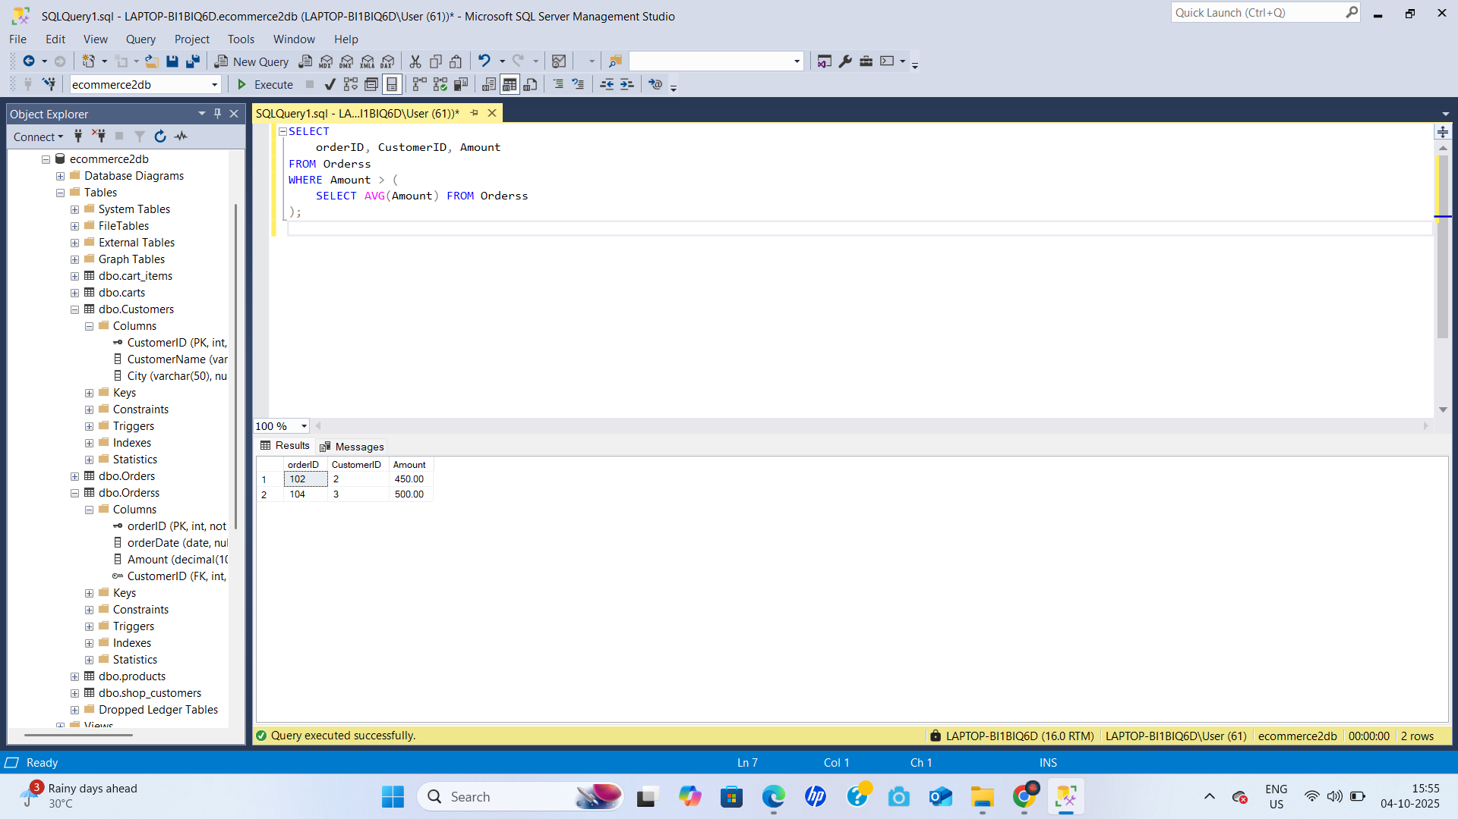

B. Correlated Subquery
Find orders that are above the average order amount for the same customer.

C. Subquery with IN
Find all customers who have placed at least one order.



D. Subquery with EXISTS
Find customers who have placed orders above ₹5000.



E. Subquery with =
Find customers whose total spending equals the maximum total spending among all customers.



