STAYNEST
MINI PROJECT REPORT
Submitted in partial fulfilment of the requirement for the award of the degree of
Bachelor of Technology
in
Computer Science & Engineering
Submitted to
DR. A.P.J. ABDUL KALAM TECHNICAL UNIVERSITY, UTTAR PRADESH, LUCKNOW

Submitted by  Stud Name: Rachit Gupta  Roll No: 2501720100111  Section: 2D | Under the Supervision of  Guide Name: Mr. Vikas  Assistant Professor


Department of Computer Science & Engineering
Lloyd Institute of Engineering & Technology
Plot No. 3, Knowledge Park II, Greater Noida, Uttar Pradesh 201306
Session: 2026–27

CERTIFICATE
This is to certify that the Mini Project Report entitled "StayNest" is a bonafide work carried out by Rachit Gupta (Roll No. 2501720100111) in partial fulfilment of the requirements for the award of the degree of Bachelor of Technology in Computer Science & Engineering during the academic year 2026–27, [Semester / Year], at the Department of Computer Science & Engineering, Lloyd Institute of Engineering & Technology.
The work embodied in this report has not been submitted elsewhere for the award of any other degree or diploma. To the best of our knowledge, the report fulfils the prescribed structure and formatting requirements of the Mini Project guidelines.

____________________  Project Guide  Mr. Vikas  Assistant Professor | ____________________  Project Coordinator  [Name]  [Designation] | ____________________  Head of Department  [Name]  Dept. of CSE

Date: [DD/MM/YYYY]
Place: Greater Noida

DECLARATION
I hereby declare that the Mini Project Report entitled "StayNest" submitted to the Department of Computer Science & Engineering, Lloyd Institute of Engineering & Technology, in partial fulfilment of the requirements for the degree of Bachelor of Technology in Computer Science & Engineering, is a record of original work carried out by me under the guidance of Mr. Vikas, Assistant Professor.
I further declare that this report has not been copied from any other source, and that all references, data and material taken from other sources have been duly acknowledged. The similarity index of this report, as checked using [Turnitin / Grammarly / Institution tool], is [XX]% (excluding references, code and standard boilerplate text), which is below the permitted limit of 20%.

Signature: ____________________
Name: Rachit Gupta
Roll No.: 2501720100111
Date: [DD/MM/YYYY]

ACKNOWLEDGEMENT
I would like to express my sincere gratitude to my project guide, Mr. Vikas, Assistant Professor, Department of Computer Science & Engineering, for the valuable guidance, constant encouragement and constructive suggestions throughout the development of this mini project.
I am thankful to [Coordinator Name], Project Coordinator, and [HOD Name], Head of the Department of Computer Science & Engineering, for providing the necessary facilities and support. I also extend my thanks to [Dean Name], Lloyd Institute of Engineering & Technology, for providing a conducive academic environment.
Finally, I thank all the faculty members, laboratory staff, my family and friends for their continuous support and motivation during the course of this work.

ABSTRACT
StayNest is a full-stack web application, inspired by Airbnb, that allows users to browse, list, and manage vacation rental properties. The platform works as a digital marketplace in which hosts publish property listings and travelers search for accommodation by title, location, and country. The project aims to simplify accommodation discovery and listing management, and to demonstrate the practical application of full-stack web development concepts in an academic setting.
The application follows a server-rendered, MVC-style architecture. The frontend uses HTML, CSS, JavaScript, and EJS templates, while the backend is built with Node.js and Express.js. Supabase serves as the database and data-storage service, Passport.js provides session-based authentication, Joi validates incoming data, Multer handles file uploads, Cloudinary stores property images, and Mapbox provides geolocation and map-based visualization of listings.
The system supports secure registration, login, and logout; creation, editing, and deletion of listings restricted to their owners; keyword search and filtering; a review and rating system in which users can delete only their own reviews; and flash notifications for every key action. Real payment processing, a live booking calendar, chat, and an admin dashboard are kept outside the current scope and listed as future enhancements.
This report presents the background and objectives of the project, a review of related work, system analysis and design including architecture, data flow and ER diagrams, the implementation of each module, the testing strategy and test cases, a discussion of results, and the conclusion with limitations and future scope.
Keywords: Rental marketplace, Node.js, Express.js, EJS, Supabase, Passport.js, Cloudinary, Mapbox, Full-stack web application.

TABLE OF CONTENTS
CHAPTER 1: INTRODUCTION 1
1.1 Background 1
1.2 Problem Statement 1
Evidence of the Problem 1
1.3 Objectives 2
1.4 Scope of the Project 3
1.5 Organisation of the Report 3
CHAPTER 2: LITERATURE REVIEW / EXISTING SYSTEM 4
2.1 Review of Related Work 4
2.2 Existing System 4
2.3 Gaps Identified 5
2.4 Proposed System 5
CHAPTER 3: SYSTEM ANALYSIS AND DESIGN 6
3.1 Requirement Analysis 6
3.1.1 Functional Requirements 6
3.1.2 Non-Functional Requirements 6
3.1.3 Hardware and Software Requirements 7
3.2 Feasibility Study 7
3.2.1 Technical Feasibility 7
3.2.2 Economic Feasibility 7
3.2.3 Operational Feasibility 7
3.3 System Architecture 7
3.4 Design Diagrams 8
3.4.1 Data Flow Diagram 8
3.4.2 ER / UML Diagrams 8
3.5 Technology Stack 10
CHAPTER 4: IMPLEMENTATION 12
4.1 Module Description 12
Authentication Module 12
Listing Management Module 12
Image Upload Module 12
Search and Map Module 12
Review and Rating Module 13
Validation and Notification Module 13
4.2 Key Algorithms 13
Algorithm 1: Owner-only edit or delete 13
Algorithm 2: Keyword search 13
Algorithm 3: Add a review 13
4.3 Code Snippets 13
4.4 Screenshots 15
CHAPTER 5: TESTING 17
5.1 Testing Strategy 17
5.2 Test Cases and Test Results 17
5.3 Sample Input / Output 18
CHAPTER 6: RESULTS AND DISCUSSION 19
6.1 Output Screenshots 19
6.2 Performance / Accuracy Analysis 20
6.3 Discussion 20
CHAPTER 7: CONCLUSION AND FUTURE SCOPE 22
7.1 Conclusion 22
7.2 Limitations 22
7.3 Future Scope 22
REFERENCES 23
APPENDIX 24
Appendix A: Source Code 24
Appendix B: Additional Material 24

LIST OF FIGURES
Figure 1.1: Housing need and hostel supply for students in India (Source: [2], [5]) 2
Figure 1.2: Student accommodation problems reported in a UK survey (Source: [11]) 2
Figure 3.1: System architecture of StayNest 8
Figure 3.2: Level 0 data flow diagram 8
Figure 3.3: Level 1 data flow diagram 8
Figure 3.4: Entity-relationship diagram 9
Figure 3.5: Use case diagram 9
Figure 4.1: Home page showing all listings 15
Figure 4.2: Registration and login pages 15
Figure 4.3: Create new listing form 16
Figure 4.4: Listing details page with map and reviews 16
Figure 6.1: Search results for a keyword 19
Figure 6.2: Edit listing page available to the owner 19
Figure 6.3: Review section with rating and delete option 19
Figure 6.4: Flash notification after a successful action 20

LIST OF TABLES
Table 2.1: Comparison of existing channels and the proposed system 5
Table 3.1: Non-functional requirements 6
Table 3.2: Hardware and software requirements 7
Table 3.3: Structure of the users table 9
Table 3.4: Structure of the listings table 9
Table 3.5: Structure of the reviews table 10
Table 3.6: Technology stack of StayNest 10
Table 4.1: Modules of StayNest 12
Table 5.1: Test cases 17
Table 5.2: Sample inputs and outputs 18
Table 6.1: Objectives and how they are met 20

LIST OF ABBREVIATIONS
Abbreviation | Full Form
API | Application Programming Interface
CRUD | Create, Read, Update, Delete
CSS | Cascading Style Sheets
DFD | Data Flow Diagram
EJS | Embedded JavaScript Templates
ER | Entity-Relationship
HTML | HyperText Markup Language
HTTP | HyperText Transfer Protocol
Joi | JavaScript object schema validation library
MVC | Model-View-Controller
ORM | Object-Relational Mapping
REST | Representational State Transfer
UI | User Interface
URL | Uniform Resource Locator

CHAPTER 1: INTRODUCTION

1.1 Background
Online accommodation marketplaces such as Airbnb, Booking.com, and OYO Rooms have changed the way travelers discover and book stays and the way individual hosts earn from their properties. Such platforms connect two groups of users, hosts who own accommodation and travelers who need it, and add trust through ratings and reviews.
StayNest is a full-stack web application inspired by this model. It allows users to browse, list, and manage vacation rental properties. Hosts can publish property listings, and travelers can search for accommodation based on location, price, and other relevant details. The project simplifies accommodation discovery and listing management while demonstrating the application of full-stack web development concepts such as routing, database design, authentication, validation, cloud storage, and map integration.
The project belongs to the domain of e-commerce and online marketplace web applications, specifically the vacation rental and accommodation-booking sector. It combines web application development, database design, authentication and authorization, cloud storage integration, and geolocation services.

1.2 Problem Statement
Travelers frequently struggle to find reliable, user-friendly platforms that make accommodation booking easy, transparent, and trustworthy. Property owners, in turn, often lack a simple and accessible way to advertise their homes or rooms online without relying on large, complex commercial platforms. Production-grade solutions such as Airbnb or Booking.com are feature-heavy, closed-source, and unsuitable for direct study or extension in an academic environment.
There is therefore a need for a simplified but functionally complete rental-marketplace application that students can build, understand, and extend, while still reflecting the core workflows of a real-world booking platform: listing management, authenticated access, search, and a review and rating system that builds trust between users.

Evidence of the Problem
Finding a suitable and trustworthy place to live is a widely documented difficulty for students, and the same discovery problem affects anyone looking for rented accommodation. In India, higher-education enrolment reached 43.3 million in 2021-22, and more than 75% of students live outside their hometowns [2]. On-campus hostels can house no more than about 20% of students, and the campus hostels of Delhi University can accommodate only about 10% of its student body [2]. A news report estimates that the university has roughly 7,000 to 8,000 hostel rooms for more than 7 lakh students, about one room for every 31 students, and that fewer than 10% of the more than 30,000 undergraduates who applied for a hostel seat received one [5]. Most students are therefore pushed towards private rented accommodation that they must find and judge on their own. Figure 1.1 summarises these figures.
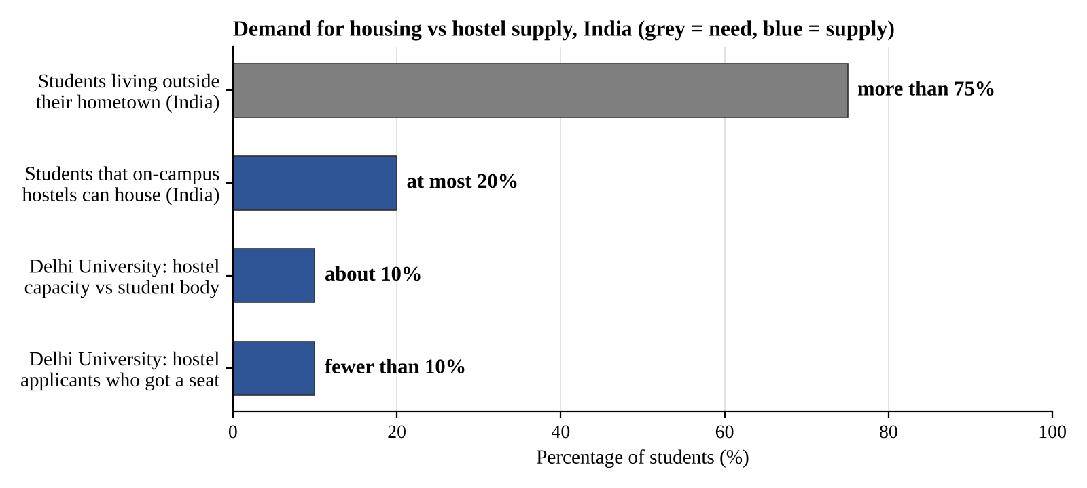
Figure 1.1: Housing need and hostel supply for students in India (Source: [2], [5])
The problem is not limited to India. In the National Student Accommodation Survey 2024, which gathered 1,007 responses from UK undergraduates, 51% of students were worried about the student housing shortage, 64% of rent-paying students struggled with rent at least some of the time, 45% felt their accommodation was not good value for money, and 7% had experienced homelessness as a student [11]. Figure 1.2 shows these results.
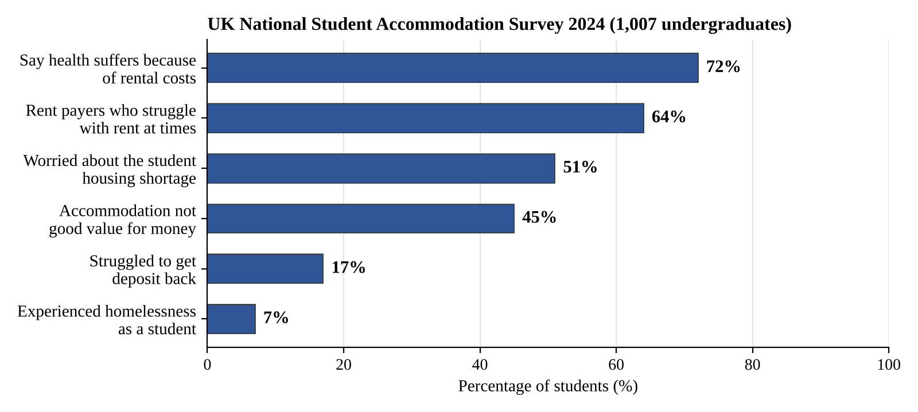
Figure 1.2: Student accommodation problems reported in a UK survey (Source: [11])
These figures come from published news reports and a survey of different student groups, so they should be read as indicators of the scale of the problem and not as one national measurement. They show a clear demand for simple, transparent platforms where hosts can list accommodation and seekers can search by location, see the property on a map, and read reviews from other users. This is the gap that StayNest sets out to address.

1.3 Objectives
The objectives of the project are:
- To design and develop a user-friendly rental marketplace that connects travelers and hosts.
- To enable authenticated users to create, update, and delete their own property listings.
- To allow travelers to search and filter available properties by title, location, and country.
- To implement secure, session-based user authentication and authorization using Passport.js.
- To provide a review and rating system so that users can evaluate listings and build trust in the platform.
- To integrate cloud-based image storage and map-based location display for a richer listing experience.
- To build a scalable, maintainable, and portable full-stack application using modern web technologies.

1.4 Scope of the Project
In scope: user authentication, listing management, the review and rating system, search functionality, cloud-based image upload, and responsive frontend design.
Out of scope (current version): real payment processing, a live booking calendar, a chat system between users, an admin dashboard, an advanced recommendation engine, and multi-language support.
The primary users are travelers seeking vacation rentals and property owners or hosts who wish to list their accommodation. Secondary users include visitors browsing listings without an account and, in future iterations, administrators managing platform-wide content.

1.5 Organisation of the Report
The report is organised into seven chapters. Chapter 1 introduces the project, its objectives, and its scope. Chapter 2 reviews related work and the existing system and identifies the gaps addressed by StayNest. Chapter 3 presents system analysis and design, including requirements, feasibility, architecture, design diagrams, and the technology stack. Chapter 4 describes the implementation of each module. Chapter 5 covers the testing strategy and test cases. Chapter 6 discusses the results. Chapter 7 gives the conclusion, limitations, and future scope. References and an appendix follow.

CHAPTER 2: LITERATURE REVIEW / EXISTING SYSTEM

2.1 Review of Related Work
Online accommodation marketplaces have grown rapidly over the last decade, with platforms such as Airbnb, Booking.com, and OYO Rooms transforming how travelers discover and book stays and how individual hosts monetize their properties. These platforms are typically large-scale, multi-tier web applications combining relational or document-oriented databases, RESTful APIs, third-party payment gateways, and cloud-based media and mapping services. Studying their publicly documented architecture and workflows provides useful reference points for building a simplified, academically scoped equivalent.
A number of open-source and educational full-stack projects have explored similar problems on a smaller scale. They commonly use the Node.js and Express.js ecosystem with EJS-based server-side rendering, a document or relational data store, and Passport.js for authentication. These implementations generally focus on core CRUD (Create, Read, Update, Delete) operations for listings, session-based login, and basic search, while omitting production concerns such as payment processing, fraud detection, and large-scale infrastructure. This scoping closely mirrors the goals of the present project.
The official documentation of the individual technologies used in this project, including Express.js and Node.js, Passport.js, Joi, Cloudinary, Mapbox, and Supabase, describes well-established patterns for building secure, modular, and maintainable server-rendered web applications. StayNest draws on these patterns rather than proposing new algorithms; its contribution lies in integrating them into one cohesive, academically oriented rental marketplace.

2.2 Existing System
Existing commercial platforms such as Airbnb and Booking.com offer a complete experience that includes search, booking calendars, payments, messaging, and host tools. They are, however, built as large proprietary systems. Their source code and internal design are not available for study, and their feature set is too large to be rebuilt or extended by students within a semester.
Small property owners who do not wish to depend on such platforms usually advertise through social media posts or classified websites. These channels offer no structured listing data, no consistent search, no map view, and no trusted review mechanism, so travelers cannot easily compare options or judge reliability.

2.3 Gaps Identified
- Commercial platforms are complex, closed-source, and unsuitable for academic study or extension.
- Individual hosts lack a simple, accessible way to publish structured property listings.
- Informal channels provide no uniform search, filtering, or map-based view of properties.
- Informal channels provide no verified review and rating system to build trust.
- Few educational projects combine authentication, ownership-based authorization, validation, cloud image storage, and map integration in one application.

2.4 Proposed System
StayNest is proposed as a simplified, feature-rich rental marketplace that closes the gaps above. It lets hosts register and manage their own listings with images and locations, lets travelers search and browse listings, and lets users post ratings and reviews. Access control ensures that users can modify only the content they own.
Table 2.1: Comparison of existing channels and the proposed system
Aspect | Existing channels | StayNest (proposed)
Listing format | Unstructured posts | Structured listing with title, price, location, country, image
Search | Manual or none | Keyword search by title, location, or country
Location view | Text address only | Map-based visualization using Mapbox
Trust | No verified feedback | Ratings and reviews; only authors can delete their own
Access control | Not applicable | Session-based login; owner-only edit and delete
Studyability | Closed-source or informal | Simple, modular, open to extension

CHAPTER 3: SYSTEM ANALYSIS AND DESIGN

3.1 Requirement Analysis

3.1.1 Functional Requirements
The main functional requirements of StayNest are listed below.
- FR1: The system shall allow a new user to register and an existing user to log in and log out securely.
- FR2: The system shall allow an authenticated user to create a property listing with title, description, price, location, country, and an image.
- FR3: The system shall allow only the owner of a listing to edit or delete it.
- FR4: The system shall allow any visitor to browse all listings and view the details of a listing.
- FR5: The system shall allow users to search listings by title, location, or country.
- FR6: The system shall allow an authenticated user to add a rating and review to a listing and to delete only their own reviews.
- FR7: The system shall upload listing images to cloud storage and display them with the listing.
- FR8: The system shall display the listing location on an interactive map.
- FR9: The system shall validate all input and show success or error notifications for key actions.

3.1.2 Non-Functional Requirements
Table 3.1: Non-functional requirements
Requirement | Description
Security | Passwords are stored in hashed form; protected routes require an authenticated session; ownership is checked before edit or delete.
Usability | Clean, responsive interface; clear flash messages for success and errors.
Performance | Pages render on the server and load within a few seconds on a normal broadband connection.
Reliability | Input validation rejects malformed data before it reaches the database.
Maintainability | Code is organised in routes, controllers, models, and views so that each part can be changed independently.
Portability | Runs on Windows, macOS, and Linux with Node.js; the database and media are hosted in the cloud.

3.1.3 Hardware and Software Requirements
Table 3.2: Hardware and software requirements
Item | Specification
Processor | Intel Core i3 (or equivalent) and above
RAM | 4 GB minimum (8 GB recommended)
Storage | At least 5 GB of free disk space
Internet | Required for cloud database, image storage, and map API access
Operating System | Windows 10/11, macOS, or Linux (Ubuntu)
Runtime and Language | Node.js, JavaScript
Framework and Templating | Express.js, EJS
Database | Supabase
Libraries and Services | Passport.js, Joi, Multer, Cloudinary, Mapbox API
Tools | Visual Studio Code, Git and GitHub, Google Chrome / Mozilla Firefox

3.2 Feasibility Study

3.2.1 Technical Feasibility
All technologies used are mature, well documented, and widely adopted. Node.js, Express.js, EJS, and Passport.js are open source, and Supabase, Cloudinary, and Mapbox offer developer plans suitable for a mini project. The development team has working knowledge of JavaScript, so the project is technically feasible.

3.2.2 Economic Feasibility
The project needs only a standard personal computer and an internet connection. All software is free or has a free tier that covers development and demonstration, so no significant expenditure is required. The project is economically feasible.

3.2.3 Operational Feasibility
The interface follows familiar patterns of listing websites, so travelers and hosts can use it with little or no training. Flash messages guide users after each action. The system is therefore operationally feasible.

3.3 System Architecture
StayNest follows a server-rendered, MVC-style architecture. The browser sends an HTTP request to an Express.js route. Middleware performs authentication checks, input validation, and file handling. The controller then applies the business logic, reads or writes data in Supabase, uploads images to Cloudinary, or obtains coordinates from Mapbox, and finally renders an EJS view that is returned to the browser as HTML. Figure 3.1 shows the overall architecture.
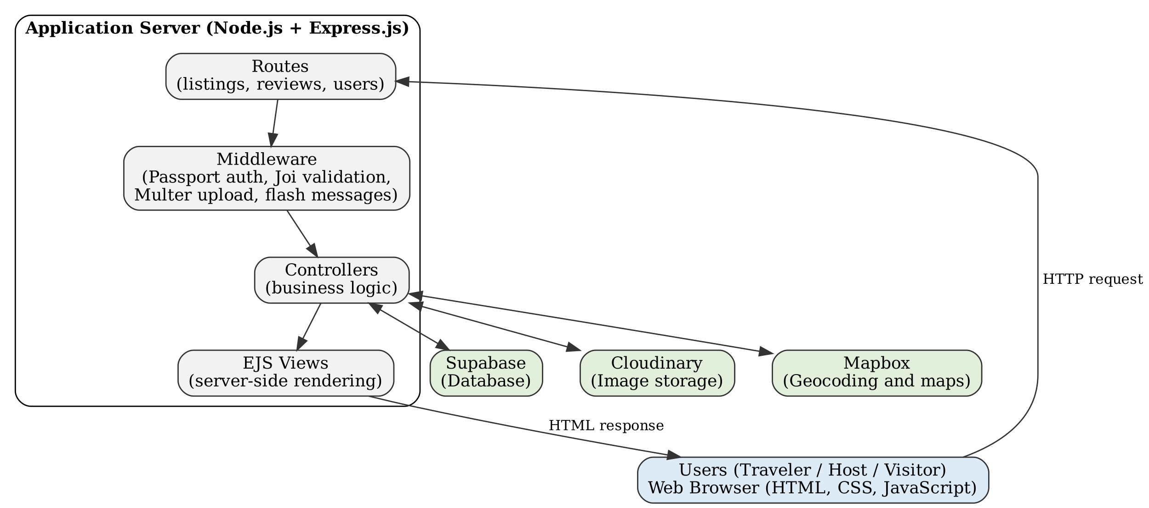
Figure 3.1: System architecture of StayNest

3.4 Design Diagrams

3.4.1 Data Flow Diagram
Figure 3.2 shows the context-level (Level 0) data flow diagram, in which StayNest is a single process exchanging data with two external entities, the traveler and the host. Figure 3.3 expands it into four main processes: authentication, listing management, search and browse, and review management, together with the data stores they use.
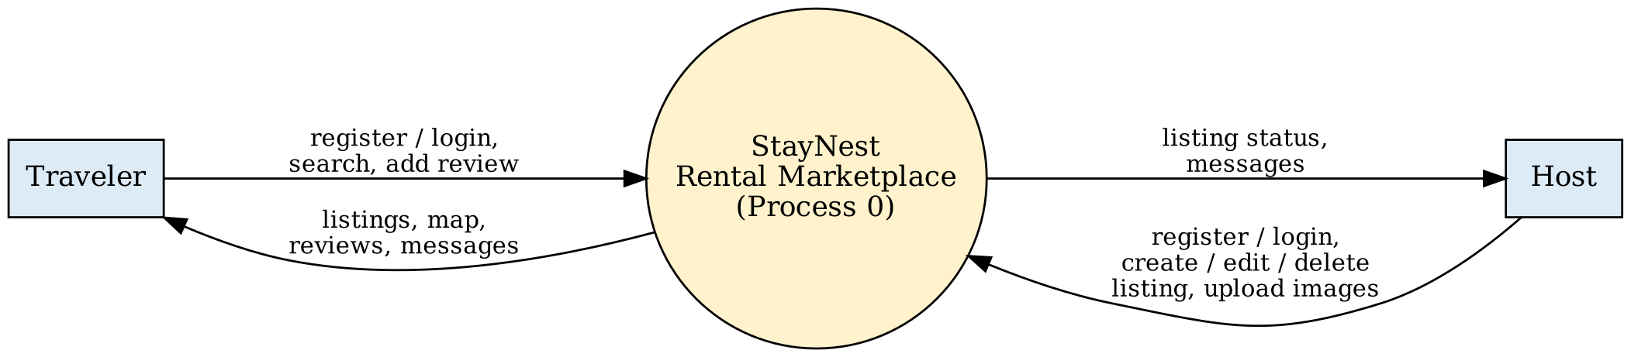
Figure 3.2: Level 0 data flow diagram
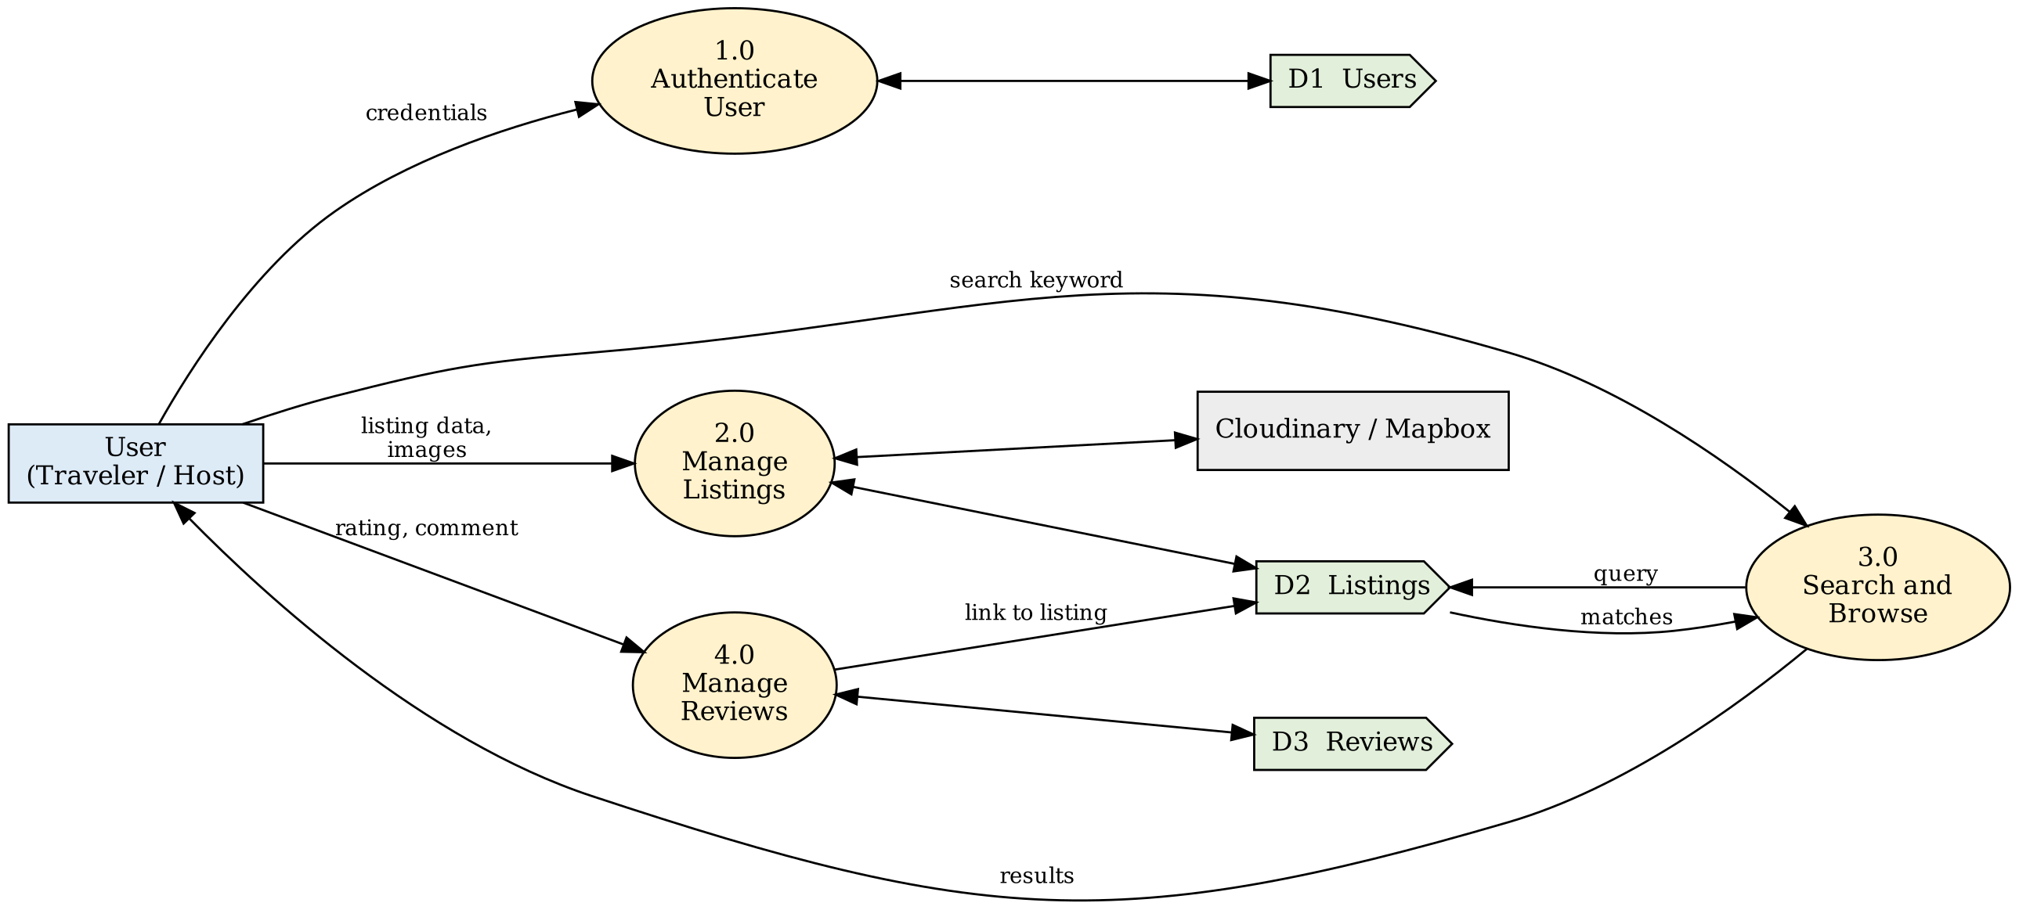
Figure 3.3: Level 1 data flow diagram

3.4.2 ER / UML Diagrams
The database has three main entities: users, listings, and reviews. A user can own many listings and write many reviews, and a listing can have many reviews. Figure 3.4 shows the entity-relationship diagram, and Figure 3.5 shows the use case diagram.
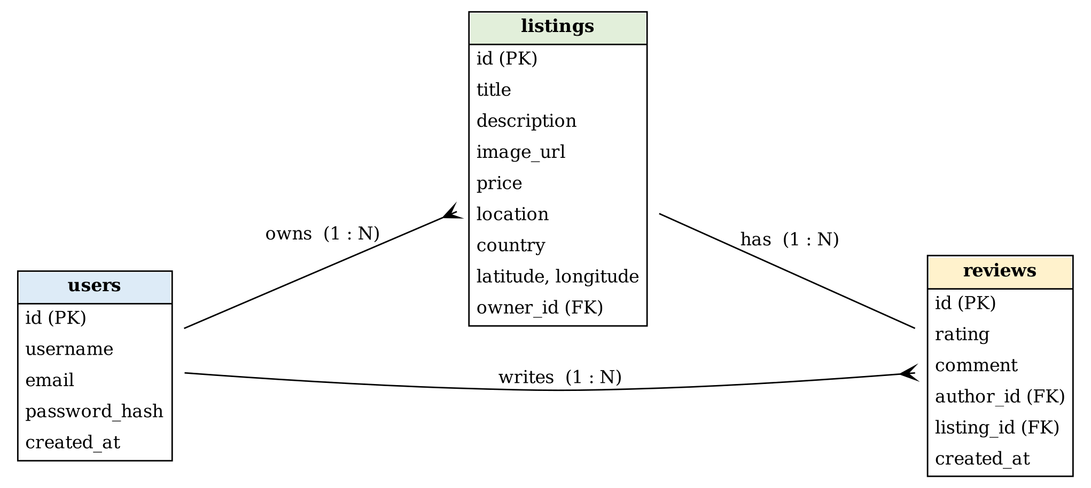
Figure 3.4: Entity-relationship diagram
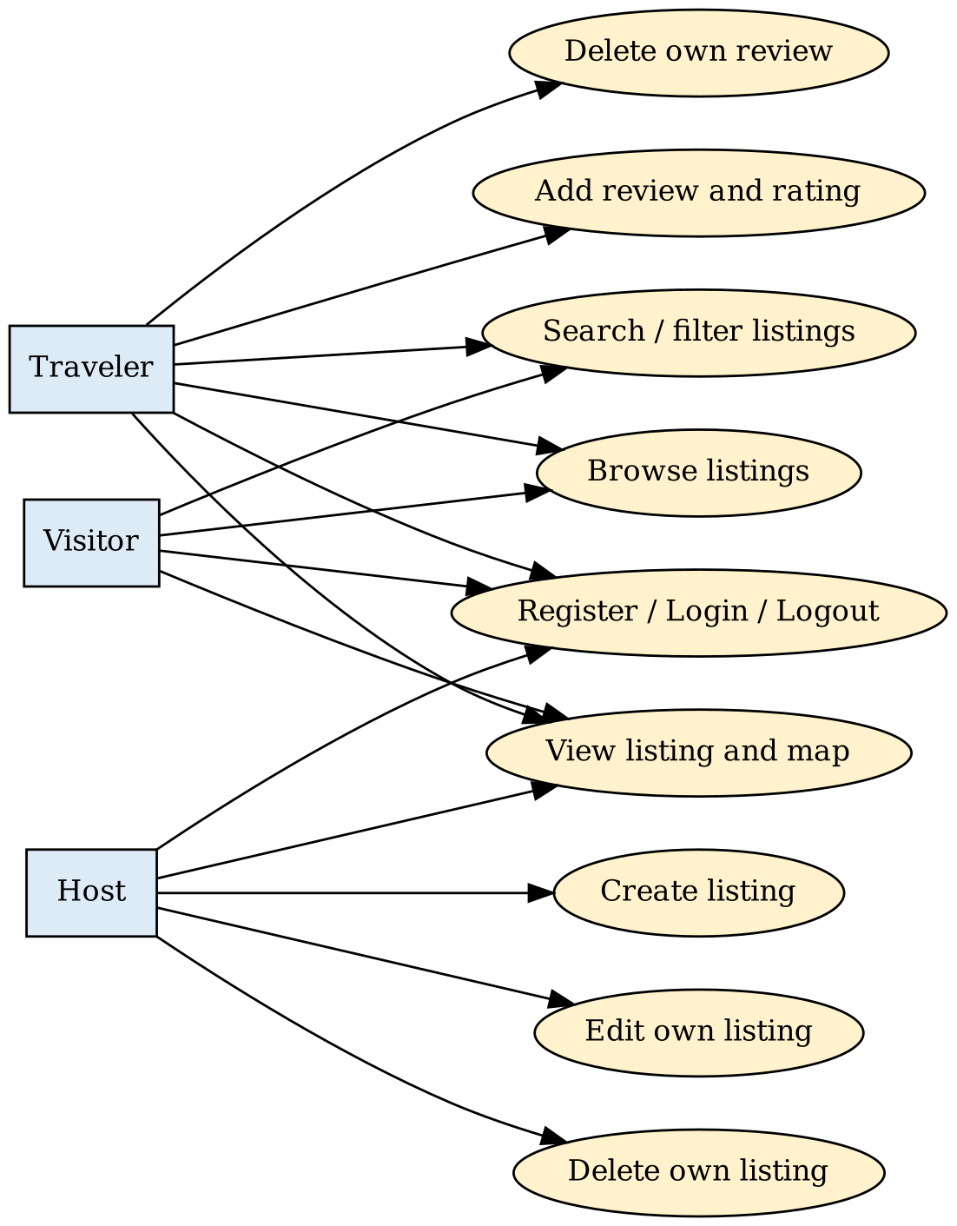
Figure 3.5: Use case diagram
The proposed structure of the three tables is given in Tables 3.3 to 3.5.
Table 3.3: Structure of the users table
Column | Type | Description
id | UUID (PK) | Unique user identifier
username | Text | Display name, unique
email | Text | Login email, unique
password_hash | Text | Salted hash of the password
created_at | Timestamp | Account creation time

Table 3.4: Structure of the listings table
Column | Type | Description
id | UUID (PK) | Unique listing identifier
title | Text | Listing title
description | Text | Details of the property
image_url | Text | Cloudinary image URL
price | Numeric | Price per night
location | Text | City or area
country | Text | Country name
latitude, longitude | Numeric | Coordinates used for the map
owner_id | UUID (FK) | References users.id

Table 3.5: Structure of the reviews table
Column | Type | Description
id | UUID (PK) | Unique review identifier
rating | Integer | Rating from 1 to 5
comment | Text | Review text
author_id | UUID (FK) | References users.id
listing_id | UUID (FK) | References listings.id
created_at | Timestamp | Review time

3.5 Technology Stack
Table 3.6: Technology stack of StayNest
Layer | Technology | Purpose
Frontend | HTML, CSS, JavaScript, EJS | Dynamic server-rendered views and styling
Backend | Node.js, Express.js | Routing, middleware, business logic
Database | Supabase | Storage of users, listings, and reviews
Authentication | Passport.js | Session-based login and logout
Validation | Joi | Schema validation of incoming data
File upload | Multer | Handling multipart image uploads
Media storage | Cloudinary | Cloud hosting of listing images
Maps | Mapbox | Geocoding and map visualization
Tools | VS Code, Git, GitHub | Development and version control

Key technical terms used in this report are explained briefly below.
- MVC (Model-View-Controller): An architectural pattern that separates data (model), user interface (view), and control logic (controller).
- REST: An architectural style for networked services that uses standard HTTP methods such as GET, POST, PUT, and DELETE.
- Session-based authentication: Verifying identity by keeping a server-side session after login, as implemented with Passport.js.
- Middleware: Functions that run during the request–response cycle in Express.js, for example authentication checks and validation.
- Cloud storage: Remote, internet-accessible storage (Cloudinary) that hosts and serves uploaded images.
- Geolocation: Using coordinates, through Mapbox, to plot listings on an interactive map.

CHAPTER 4: IMPLEMENTATION

4.1 Module Description
StayNest is divided into six modules, summarised in Table 4.1 and described below.
Table 4.1: Modules of StayNest
No. | Module | Responsibility
1 | Authentication | Registration, login, logout, session handling with Passport.js
2 | Listing management | Create, view, edit, and delete listings with owner-only access
3 | Image upload | Receive images with Multer and store them on Cloudinary
4 | Search and map | Keyword search by title, location, country; map display with Mapbox
5 | Review and rating | Add reviews and ratings; delete own reviews
6 | Validation and notifications | Joi schema validation and flash messages

Authentication Module
Users register with a username, email, and password. The password is stored only as a hash. On login, Passport.js verifies the credentials and creates a server-side session. Middleware protects routes that need a logged-in user, and logout destroys the session.

Listing Management Module
A logged-in user can create a listing by filling a form with title, description, price, location, country, and an image. The listing page shows full details, the image, the map, and the reviews. Edit and delete actions appear only for the owner, and the server re-checks ownership before applying them.

Image Upload Module
The listing form is submitted as multipart data. Multer parses the file and a Cloudinary storage engine uploads it, returning a secure URL that is saved with the listing.

Search and Map Module
The home page lists all properties. A search box accepts a keyword and returns listings whose title, location, or country matches it. On a listing page, the stored coordinates are used to place a marker on a Mapbox map.

Review and Rating Module
Logged-in users can submit a rating from 1 to 5 and a comment. Each review stores its author, and the delete action is available only to that author.

Validation and Notification Module
Joi schemas check every form submission, so empty or malformed data is rejected with a clear message. Flash messages inform the user of success or errors, such as a successful login or a failed validation.

4.2 Key Algorithms
The main logic of the application is expressed in the following procedures rather than in complex algorithms.

Algorithm 1: Owner-only edit or delete
- Receive a request to edit or delete listing L from user U.
- If U is not logged in, redirect to the login page with an error message.
- Fetch L from the database; if it does not exist, show a not-found message.
- If L.owner_id is not equal to U.id, reject the request with a permission message.
- Otherwise apply the change and confirm with a success message.

Algorithm 2: Keyword search
- Read the keyword K from the query string and trim it.
- If K is empty, return all listings.
- Otherwise select listings where the title, location, or country contains K, ignoring case.
- Render the results page, or a 'no listings found' message when the result is empty.

Algorithm 3: Add a review
- Check that the user is logged in and the listing exists.
- Validate rating (1 to 5) and comment with the Joi schema.
- Save the review with the author and listing identifiers.
- Redirect to the listing page with a success message.

4.3 Code Snippets
The snippets below are representative of the structure of the main modules.
Listing 4.1: Server setup (app.js)
const express = require('express');
const session = require('express-session');
const passport = require('passport');
const flash = require('connect-flash');

const app = express();
app.set('view engine', 'ejs');
app.use(express.urlencoded({ extended: true }));
app.use(session({ secret: process.env.SECRET,
resave: false, saveUninitialized: false }));
app.use(flash());
app.use(passport.initialize());
app.use(passport.session());

app.use('/listings', require('./routes/listings'));
app.use('/listings/:id/reviews', require('./routes/reviews'));
app.use('/', require('./routes/users'));

Listing 4.2: Authentication and ownership middleware
module.exports.isLoggedIn = (req, res, next) => {
if (!req.isAuthenticated()) {
req.flash('error', 'You must be logged in.');
return res.redirect('/login');
}
next();
};

module.exports.isOwner = async (req, res, next) => {
const listing = await getListing(req.params.id);
if (listing.owner_id !== req.user.id) {
req.flash('error', 'You do not have permission.');
return res.redirect(`/listings/${req.params.id}`);
}
next();
};

Listing 4.3: Joi validation schema for a listing
const Joi = require('joi');

module.exports.listingSchema = Joi.object({
title: Joi.string().required(),
description: Joi.string().required(),
price: Joi.number().min(0).required(),
location: Joi.string().required(),
country: Joi.string().required(),
});

Listing 4.4: Image upload with Multer and Cloudinary
const multer = require('multer');
const { CloudinaryStorage } = require('multer-storage-cloudinary');

const storage = new CloudinaryStorage({
cloudinary,
params: { folder: 'staynest', allowed_formats: ['png', 'jpg', 'jpeg'] },
});
module.exports.upload = multer({ storage });

Listing 4.5: Keyword search query (Supabase)
const { data } = await supabase
.from('listings')
.select('*')
.or(`title.ilike.%${q}%,location.ilike.%${q}%,country.ilike.%${q}%`);

4.4 Screenshots

This section shows the main screens of the application.
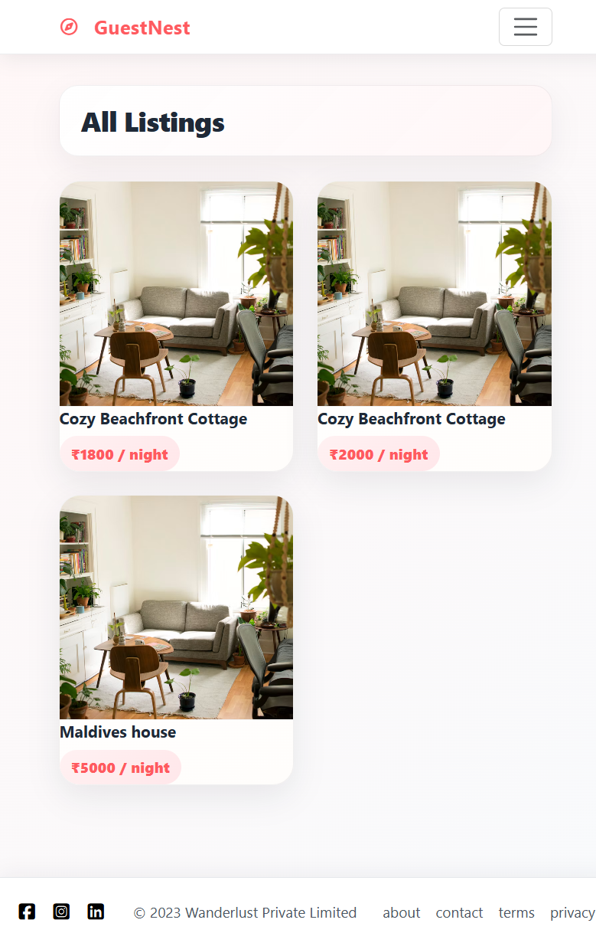
Figure 4.1: Home page showing all listings
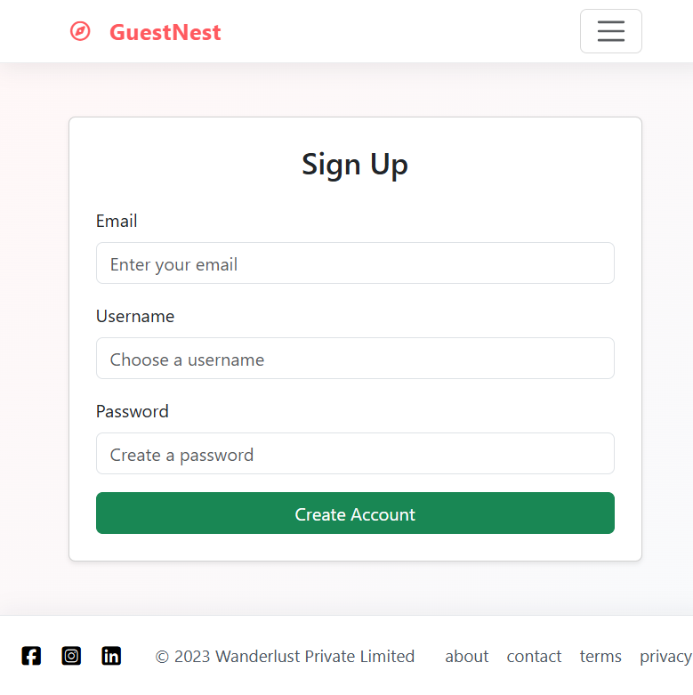
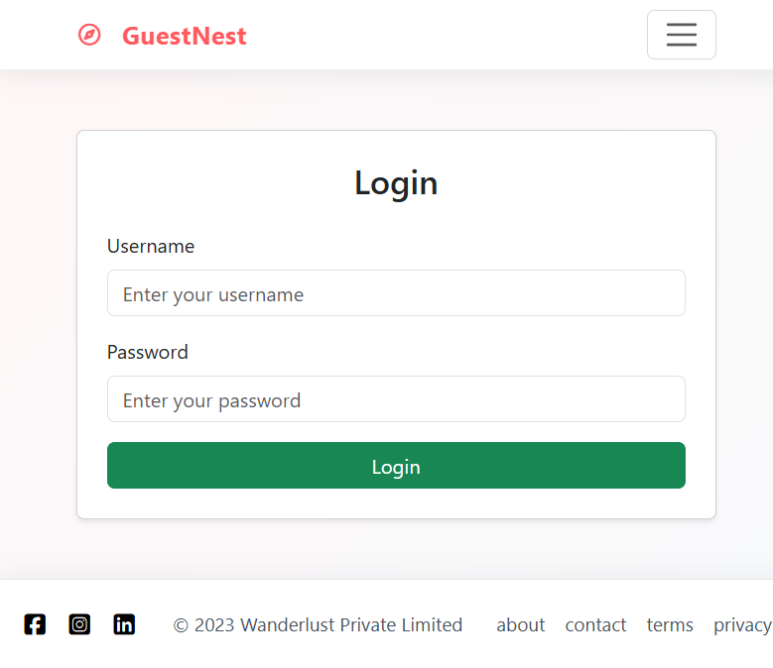
Figure 4.2: Registration and login pages
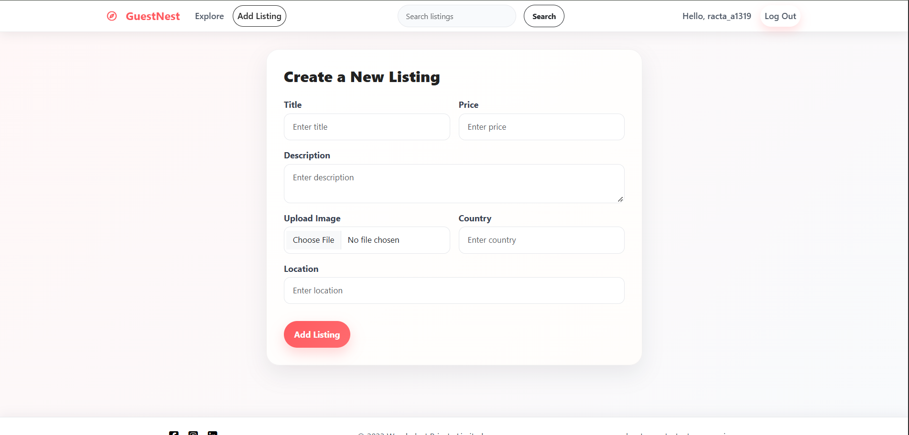
Figure 4.3: Create new listing form
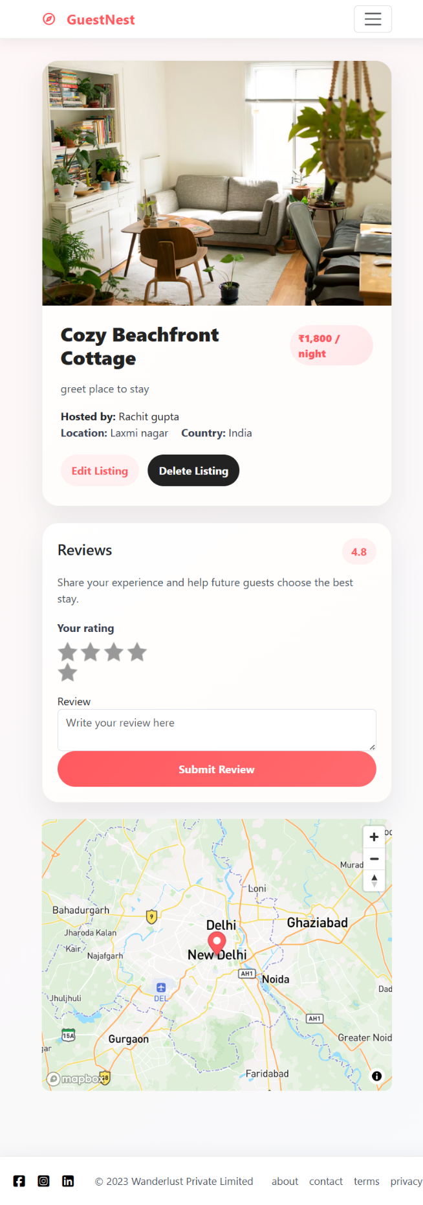
Figure 4.4: Listing details page with map and reviews

CHAPTER 5: TESTING

5.1 Testing Strategy
Testing was planned at three levels. Unit-level checks verify individual functions such as validation schemas and ownership checks. Integration testing verifies that routes, middleware, the database, Cloudinary, and Mapbox work together. System testing exercises complete user workflows from the browser, such as registering, creating a listing, searching, and reviewing.
Black-box test cases were prepared for each module, covering both valid inputs and invalid or unauthorised actions. Testing was carried out manually in Google Chrome and Mozilla Firefox, and requests were also checked with direct URL access to confirm that protected routes cannot be bypassed.

5.2 Test Cases and Test Results
Table 5.1 lists the test cases with their expected results.
Table 5.1: Test cases
ID | Test case | Input | Expected result | Status
TC1 | Register with valid details | Unique username, valid email, password | Account created; user logged in; success message | Pass
TC2 | Register with existing email | Email already registered | Registration rejected with error message | Pass
TC3 | Login with valid credentials | Correct email and password | User logged in; redirected to listings | Pass
TC4 | Login with wrong password | Correct email, wrong password | Login fails; error message shown | Pass
TC5 | Create listing while logged out | Open new-listing URL | Redirect to login page with message | Pass
TC6 | Create listing with valid data | All required fields and an image | Listing saved; image on Cloudinary; success message | Pass
TC7 | Create listing with missing title | Title left empty | Rejected by Joi validation with error message | Pass
TC8 | Edit own listing | Change price and save | Listing updated; success message | Pass
TC9 | Edit another user's listing | Direct URL of another user's listing | Request rejected; permission message | Pass
TC10 | Delete own listing | Click delete on own listing | Listing removed; success message | Pass
TC11 | Search by location | Keyword matching a location | Only matching listings displayed | Pass
TC12 | Search with no match | Random keyword | 'No listings found' message | Pass
TC13 | Add review | Rating 4 with comment | Review shown on listing page | Pass
TC14 | Delete another user's review | Direct delete request | Request rejected; permission message | Pass
TC15 | Map display | Open a listing with coordinates | Map with marker for the location | Pass
TC16 | Logout | Click logout | Session ended; protected pages require login | Pass

5.3 Sample Input / Output
Table 5.2: Sample inputs and outputs
Scenario | Sample input | Output
Search | Keyword: "Goa" | List of listings whose title, location, or country contains "Goa"
Invalid listing | Title: (empty), Price: 2500 | Message that the title is required; form shown again
Add review | Rating: 5, Comment: "Clean and quiet" | Review appears under the listing with the author's name
Unauthorised edit | User B opens edit URL of User A's listing | Redirect to listing page with permission error

CHAPTER 6: RESULTS AND DISCUSSION

6.1 Output Screenshots
The following screens show the output of the completed application.
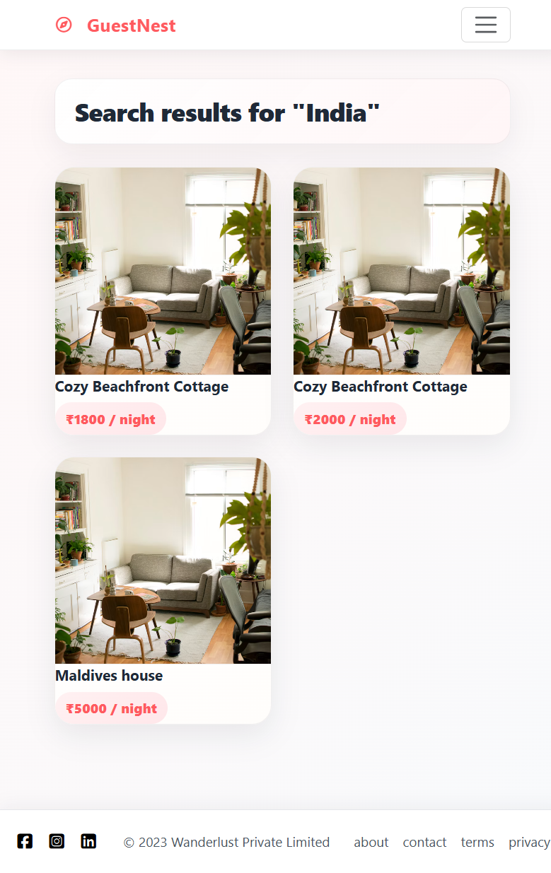
Figure 6.1: Search results for a keyword
[Insert screens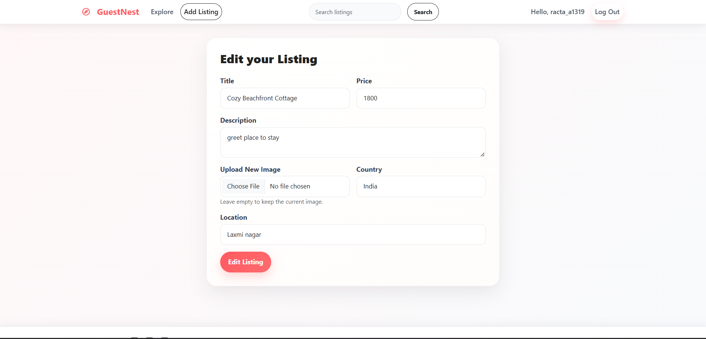
Figure 6.2: Edit listing page available to the owner
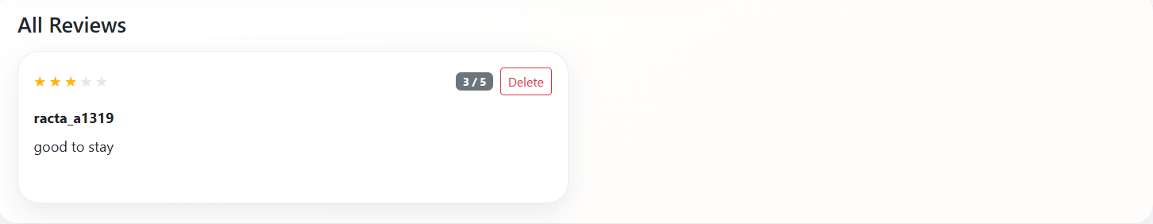
Figure 6.3: Review section with rating and delete option

6.2 Performance / Accuracy Analysis
StayNest is a data-driven web application rather than a model-based one, so its quality is judged by functional correctness, security of access, and responsiveness, not by an accuracy figure. Table 6.1 summarises how each objective set in Chapter 1 is addressed by the implementation.
Table 6.1: Objectives and how they are met
Objective | How it is met
Marketplace connecting travelers and hosts | Public browsing for visitors; listing tools for hosts
Create, update, delete own listings | Listing module with owner-only checks
Search and filter by title, location, country | Keyword search module
Secure session-based authentication | Passport.js sessions and route protection
Review and rating system | Review module; users delete only their own reviews
Cloud image storage and map display | Multer with Cloudinary; Mapbox maps
Scalable, maintainable application | MVC-style structure; cloud-hosted database and media

Page response time and the number of concurrent users handled can be measured with browser developer tools or a load-testing tool.

6.3 Discussion
The results show that the main workflows of a rental marketplace can be implemented with a small set of well-known tools. Server-side rendering with EJS keeps the code simple and the pages quick to load, and Passport.js with ownership checks gives a clear and safe model of who may change what. Joi validation and flash messages make the application predictable for users, because every invalid action produces an explanation rather than a silent failure.
Using Supabase, Cloudinary, and Mapbox as hosted services removed the need to manage a database server, file storage, or map tiles, so effort could go into application logic. The trade-off is dependence on the internet and on the free-tier limits of these services.

CHAPTER 7: CONCLUSION AND FUTURE SCOPE

7.1 Conclusion
StayNest demonstrates a complete, working rental marketplace built with Node.js, Express.js, EJS, and Supabase. Users can register and log in securely, create and manage their own listings with images and map locations, search and browse listings, and share ratings and reviews. Input validation and ownership-based authorization protect data integrity, and flash notifications keep the user informed.
The project met its objective of providing a simplified, functionally complete platform that students can study and extend. It also gave practical experience of routing, middleware, database design, authentication, cloud storage, and third-party API integration.

7.2 Limitations
- The current version has no real booking, calendar, or payment processing.
- There is no chat between travelers and hosts.
- There is no admin dashboard for moderating users and content.
- Search is keyword-based and has no advanced or category filters.
- The application depends on third-party services (Supabase, Cloudinary, Mapbox) and an internet connection.

7.3 Future Scope
- A real booking and checkout system with payment gateway integration.
- A booking-history dashboard for travelers and an analytics dashboard for hosts.
- Advanced filters and category-based search.
- An admin dashboard and a chat system between users.
- A dedicated mobile application version of the platform.

REFERENCES
- Airbnb, Inc., Company and Platform Overview, [Website] Url: https://www.airbnb.com/
- Business Standard, "India's student housing market expected to expand as demand rises," 5 February 2025. [Website] Url: https://www.business-standard.com/industry/news/india-s-student-housing-market-expected-to-expand-as-demand-rises-125020500544_1.html, Accessed: 28 October 2026.
- Cloudinary, "Cloudinary Developer Documentation," [Website] Url: https://cloudinary.com/documentation
- EJS, "Embedded JavaScript Templates — Documentation," [Website] Url: https://ejs.co/
- Harsh Yadav, "7-lakh students, just 8,000 hostel rooms: Why Delhi University students turn to risky PGs," The Tribune, 8 September 2026. [Website] Url: https://www.tribuneindia.com/news/delhi/7-lakh-students-just-8000-hostel-rooms-why-delhi-university-students-turn-to-risky-pgs/, Accessed: 28 October 2026.
- Mapbox, "Mapbox Developer Documentation," [Website] Url: https://docs.mapbox.com/
- Mozilla Developer Network (MDN), "Express/Node Introduction," [Website] Url: https://developer.mozilla.org/en-US/docs/Learn/Server-side/Express_Nodejs
- Node.js Foundation, "Node.js Documentation," [Website] Url: https://nodejs.org/en/docs
- OpenJS Foundation, "Express.js — Fast, Unopinionated, Minimalist Web Framework for Node.js," [Website] Url: https://expressjs.com/
- Passport.js, "Simple, Unobtrusive Authentication for Node.js," [Website] Url: https://www.passportjs.org/
- Save the Student, "National Student Accommodation Survey 2024," [Website] Url: https://www.savethestudent.org/accommodation/national-student-accommodation-survey-2024.html, Accessed: 28 October 2026.
- Sideway, "Joi — Schema Description Language and Data Validator for JavaScript," [Website] Url: https://joi.dev/
- Supabase, "Supabase Documentation," [Website] Url: https://supabase.com/docs

APPENDIX

Appendix A: Source Code
[Attach the key source files here or provide the GitHub repository link: app.js, routes, middleware, models/schemas, and EJS views.]

Appendix B: Additional Material
[Add any extra material such as the database schema script, environment variable list (without secrets), or user manual pages.]

