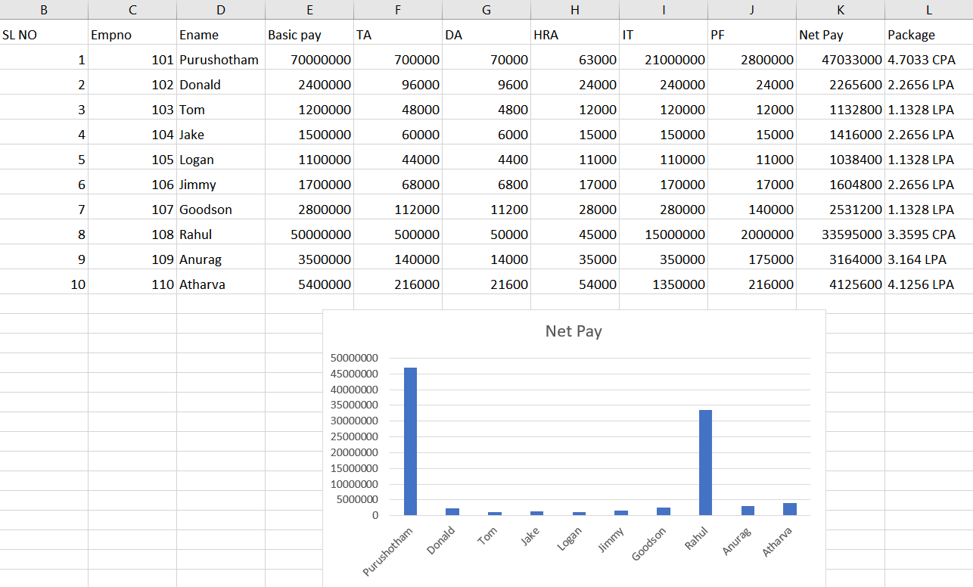

Steps to create the above data sheet:
Note: All formulas are given with respect to the first data entry made in the above excel sheet.
- Enter Column Names as SL NO, Empno, Ename, Basic Pay, TA (Travel Allowance), DA (Dearness Allowance), HRA (Home Rent Allowance), IT (Income Tax), PF (Provident Fund), Net Pay, Package

- Enter Appropriate data for SL NO, Empno, Ename, Basic Pay.

- Using basic pay data, we calculate the employee’s Travel Allowance using the formula,
=IF(E3>=10000000, 0.01*E3, 0.04*E3), condition true if Basic Pay is above 1 Crore

- Similarly, we calculate the employee’s Dearness Allowance using the formula and it depends on the basic pay of the employee , =IF(E3>=10000000, 0.001*E3, 0.004*E3), condition is true if Basic Pay is above 1 Crore

- Home rent Allowance is calculated using the formula which also depends on the basic pay of the employee, =IF(E3>=10000000,0.0009*E3,0.01*E3), condition true if Basic Pay is above 1 Crore

- Income Tax is calculated using ‘IFS’ which allows us to evaluate multiple conditions.
Income Tax also depends on basic pay of the employee and the formula is,
=IFS(E3>=7000000,0.3*E3,E3>=4000000,0.25*E3,E3>=1000000,0.1*E3)
where we impose 30% tax for basic pay above 70 lakhs, 25 % for basic pay above 40 lakhs, 10% for basic pay

- Provident Fund is also calculated using “IFS”. PF also depends on our basic pay as follows:
=IFS(E3>=5000000,0.04*E3,E3>=2500000,E3*0.05,E3>=1000000,0.01*E3)
where 4% of Basic pay is taken if salary is above 50 lakhs,
5% if salary is between 50 and 25 lakhs
1% if between 25 and 10 lakhs

- The netpay is calculated by adding Basic Pay Travel Allowance, Dearness Allowance, Home Rent allowance and subtracted by Provident Fund and Income Tax.
The formula as per the above table is:
=E3+F3+G3+H3-I3-J3

