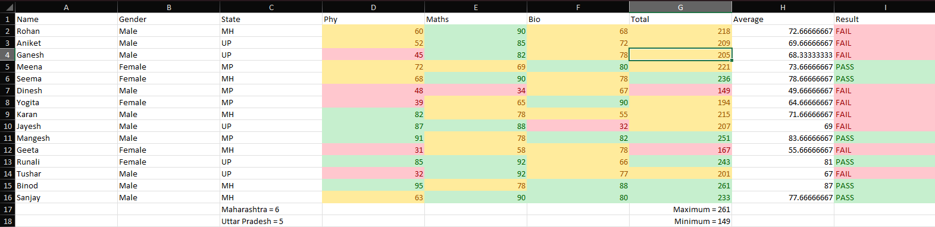

Steps to construct the above data sheet:
- We enter the data collected into appropriate columns. Here we first enter the names of the students, Genders of the respective students, the state from where they belong to, and their respective scores in physics, mathematics and biology.

- We then calculate the total of each student’s marks using the “SUM” function. First, we calculate the sum at the cell “G2” like, “=SUM(D2+E2+F2)”.
Then, we drag and apply the same to the entire column and hence calculating the sum of each student’s marks

- The “Average” column represents the average of each student’s marks. We can calculate the average using the “AVERAGE” function at the cell “H2” like,
“=AVERAGE(D2+E2+F2)”. Then, we drag and apply the same to the entire column through which we get the average of each student’s marks.

- The “Result” column represents whether the student has failed or passed. We can determine this using a conditional formatting function called “IF”. Here we have set the passing marks as above 220, therefore we write the function as,
“=IF(G2>220,” PASS”,” FAIL”)”, i.e., if the total marks are above 220 then the student passed, else he is considered to have failed.
We drag and apply the same to the entire column and we can see the students who have failed and passed.

- We can retrieve the count of how many students are from Maharashtra and Uttar Pradesh by using the “COUNTIF” function as, “=COUNTIF (C2:C16, “MH”)” for Maharashtra, and “=COUNTIF (C2:C16, “UP”).

- We can retrieve the maximum and minimum from the total marks column using the “MAX” and “MIN” functions as “=MAX(G2:G16)” and =”MIN(G2:G16)”
- Further, we can format cells using conditional formatting by setting a criterion for each column such that it can help us derive conclusions from the data. For example, in the total marks column, we can see that cells are highlighted in green, yellow and red which signifies how close the data is to the pass marks which we have set.

