**Index.html**

<!DOCTYPE html>

<html>

<head>

<meta name="viewport" content="width=device-width, initial-scale=1">

<link rel="stylesheet" href="https://stackpath.bootstrapcdn.com/bootstrap/4.1.3/css/bootstrap.min.css" integrity="sha384-MCw98/SFnGE8fJT3GXwEOngsV7Zt27NXFoaoApmYm81iuXoPkFOJwJ8ERdknLPMO" crossorigin="anonymous">

<script src="https://ajax.googleapis.com/ajax/libs/jquery/3.2.1/jquery.min.js"></script>

<script src="https://maxcdn.bootstrapcdn.com/bootstrap/3.3.7/js/bootstrap.min.js"></script>

</head>

<body>

<nav class="navbar navbar-expand-md">

<a class="navbar-brand" href="#"><img src="images/noodle.png" alt=""></a>

<button class="navbar-toggler navbar-dark" type="button" data-toggle="collapse" data-target="#main-navigation">

<span class="navbar-toggler-icon"></span>

</button>

<div class="collapse navbar-collapse" id="main-navigation">

<ul class="navbar-nav">

<li class="nav-item">

<a class="nav-link" href="index.html">Home</a>

</li>

<li class="nav-item">

<a class="nav-link" href="form.html">Contact</a>

</li>

<li class="nav-item">

<a class="nav-link" href="page.html">Pagination</a>

</li>

</ul>

</div>

</nav>

<p>The 'nav' tag is used to define a block of links for navigation, for the current page, or for other pages.</p>

</body>

</html>

Output:

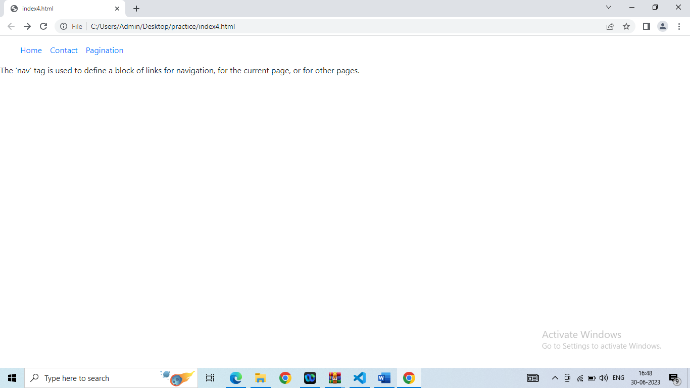

<!DOCTYPE html>

<html>

<head>

<meta name="viewport" content="width=device-width, initial-scale=1">

<link rel="stylesheet" href="https://stackpath.bootstrapcdn.com/bootstrap/4.1.3/css/bootstrap.min.css" integrity="sha384-MCw98/SFnGE8fJT3GXwEOngsV7Zt27NXFoaoApmYm81iuXoPkFOJwJ8ERdknLPMO" crossorigin="anonymous">

<script src="https://ajax.googleapis.com/ajax/libs/jquery/3.2.1/jquery.min.js"></script>

<script src="https://maxcdn.bootstrapcdn.com/bootstrap/3.3.7/js/bootstrap.min.js"></script>

</head>

<body>

<p>Pagination is used to divide a document into different pages with numbers.</p>

<nav aria-label="Pagination Demo">

<ul class="pagination">

<li class="page-item"><a class="page-link" href="#">Previous</a></li>

<li class="page-item"><a class="page-link" href="index.html">1</a></li>

<li class="page-item"><a class="page-link" href="form.html">2</a></li>

<li class="page-item"><a class="page-link" href="nav.html">3</a></li>

<li class="page-item"><a class="page-link" href="#">Next</a></li>

</ul>

</nav>

</body>

</html>

