**Two – way Binding**

**Source Code:**

**1. Create Project**

**ng new two-way-binding-demo**

**2. Navigate into the project folder**

**cd two-way-binding-demo**

**3. Input-component.component.html**

**<input [(ngModel)]="name" placeholder="Enter your name">**

**<p>Your name is: {{name}}</p>**

**4. Input-component.component.html**

**import { Component } from '@angular/core';**

**@Component({**

**selector: 'app-input-component',**

**templateUrl: './input-component.component.html',**

**styleUrls: ['./input-component.component.css']**

**})**

**export class InputComponentComponent {**

**name = '';**

**}**

**5. App.module.ts**

**import { NgModule } from '@angular/core';**

**import { FormsModule } from '@angular/forms';**

**import { BrowserModule } from '@angular/platform-browser';**

**import { AppComponent } from './app.component';**

**import { InputComponentComponent } from './input-component/input-component.component';**

**@NgModule({**

**declarations: [**

**AppComponent,**

**InputComponentComponent**

**],**

**imports: [**

**BrowserModule,**

**FormsModule // Add this line**

**],**

**providers: [],**

**bootstrap: [AppComponent]**

**})**

**export class AppModule { }**

**6. Run**

**ng serve**

**Output:1**

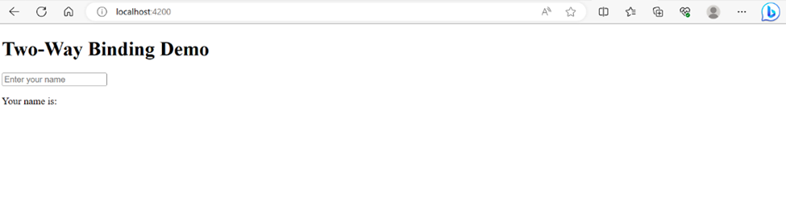

**Output 2:**

