**PROJECT REPORT**

On

**“SOCIAL NETWORKING PROTYPE”**

Designed and Developed

By

**MR. RUCHIT MEHTA**

Sincere Thanks from,

(RUCHIT MEHTA)

**INDEX**

|  |  |  |
| --- | --- | --- |
| **Sr. No.** | **Contents** | **Page No.** |
| 1. | Project Title | 1 |
|  | Introduction | 4 |
|  | Scope of the project | 4 |
| 2. | Analysis |  |
| 3. | Design Phase |  |
|  | Detailed Life Cycle of project(Logical design) | 7 |
|  | Class Diagram | 8 |
|  | Flow Chart | 9 |
|  | Use Case Diagram | 10 |
| 4. | Coding phase |  |
|  | Source Code | 11 |
| 5. | Testing Phase | 194 |
| 6. | Snapshots | 198 |
| 7. | Future Enhancements | 204 |
| 8. | References | 205 |

**INTRODUCTION**

The social networking Model is an online community designed to make your social life more active and stimulating. The social network prototype model can help you maintain existing relationships with people and share pictures and messages, and establish new ones by reaching out to people you've never met before.This website also provides the features of blogging all at one place. The main idea behind this is to share your thoughts with all your friends which can be read by all the users using the website.

SCOPE

* This software provies the facility for the user to Communicate to share,enhance their thought.
* Any number of user can connect to this platform

MODULES

* Registered User.
* Visitors.

HARDWARE SPECIFICATIONS

* Operating System: Windows 7/XP/8/10
* RAM: 2GB or higher
* Processor: 2GHz or optimal
* Disk Space: Minimum 1GB

SOFTWARE SPECIFICATIONS

* FRONT END: VISUAL STUDIO CODE /NOTEPAD
* CHROME,FIREFOX,MICROSOFT EDGE

**ANALYSIS**

System analysis is a process of gathering and interpreting facts, diagnosing problems and the information to recommend improvements on the system. It is a problem solving activity that requires intensive communication between the system users and system developers. System analysis or study is an important phase of any system development process. The system is studied to every minute detail and analyzed. The system analyst plays the role of the interrogator and dwells deep into the working of the present system. The system is viewed as a whole and the input to the system are identified. The outputs from the organizations are traced to the various processes. System analysis is concerned with becoming aware of the problem, identifying the relevant and decisional variables, analyzing and synthesizing the various factors and determining an optimal or at least a satisfactory solution or program of action.

MODULE FUNCTIONS

REGISTERED USER INCLUDES :

* Add Friends
* Add Post
* Add Pictures
* View Messages
* Edit Profile.
* Edit Post
* View Status.
* View Friend List
* View Notification

REQUIREMENT ANALYSIS

* Refines project goals into defined functions and operation of intended application.
* A key question is : 'What is needed for project and how the system will achieve its goal?'
* Once the analysis is complete, the developer has a firm understanding of what is to be done.
* The goal of the requirement specification phase is to produce the Software Requirement Specification (SRS) document.

TOOLS AND TECHNOLOGY USED

* Browser : Microsoft Edge/Google Chrome,/Mozilla firefox, etc.
* Visual Studio Code or any Editor Application.
* Html,Css,JavaScript.
* Any Desktop computer meeting the minimum system requirements.

**DESIGN PHASE**

**PROJECT LIFE-CYCLE**

**Initialization**

(Starting Project)

**Closure**

**Monitoring & Control**

**Execution**

**Planning**

(Organizing & Performing)

(Arranging Work)

(Testing Project)

(Finalizing Project)

**CLASS DIAGRAM**

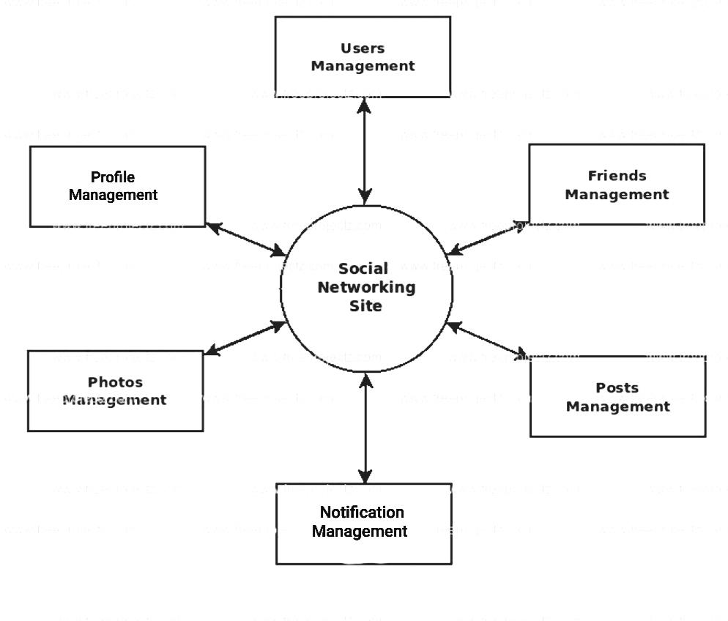

**FLOW CHART**

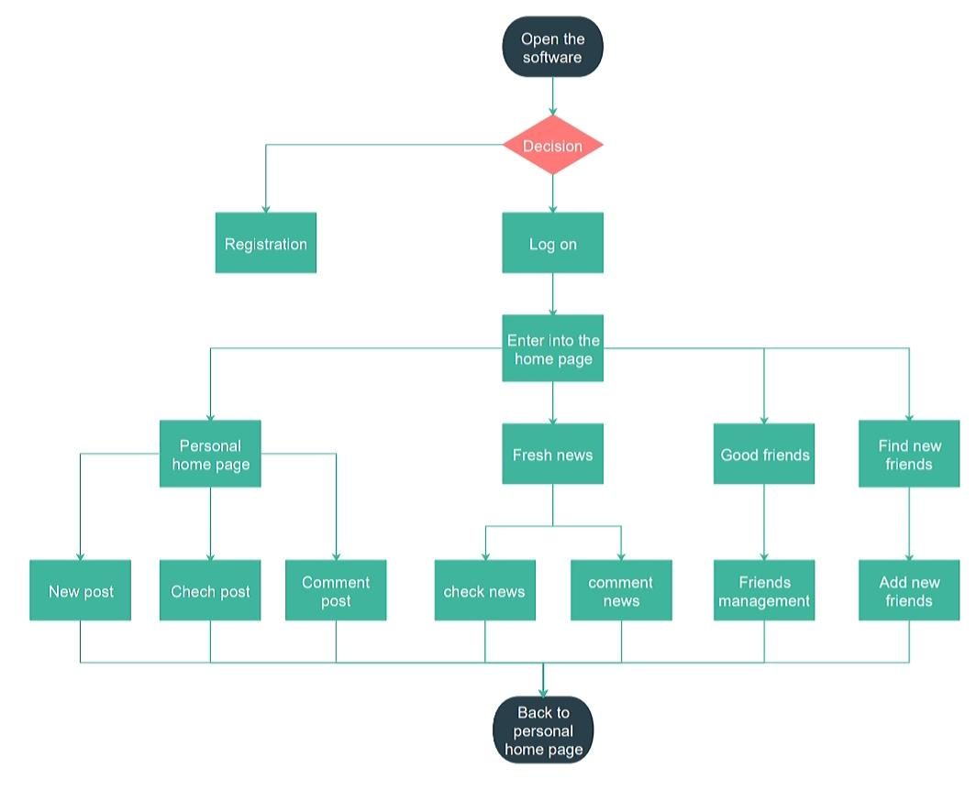

**CASE DIAGRAM**

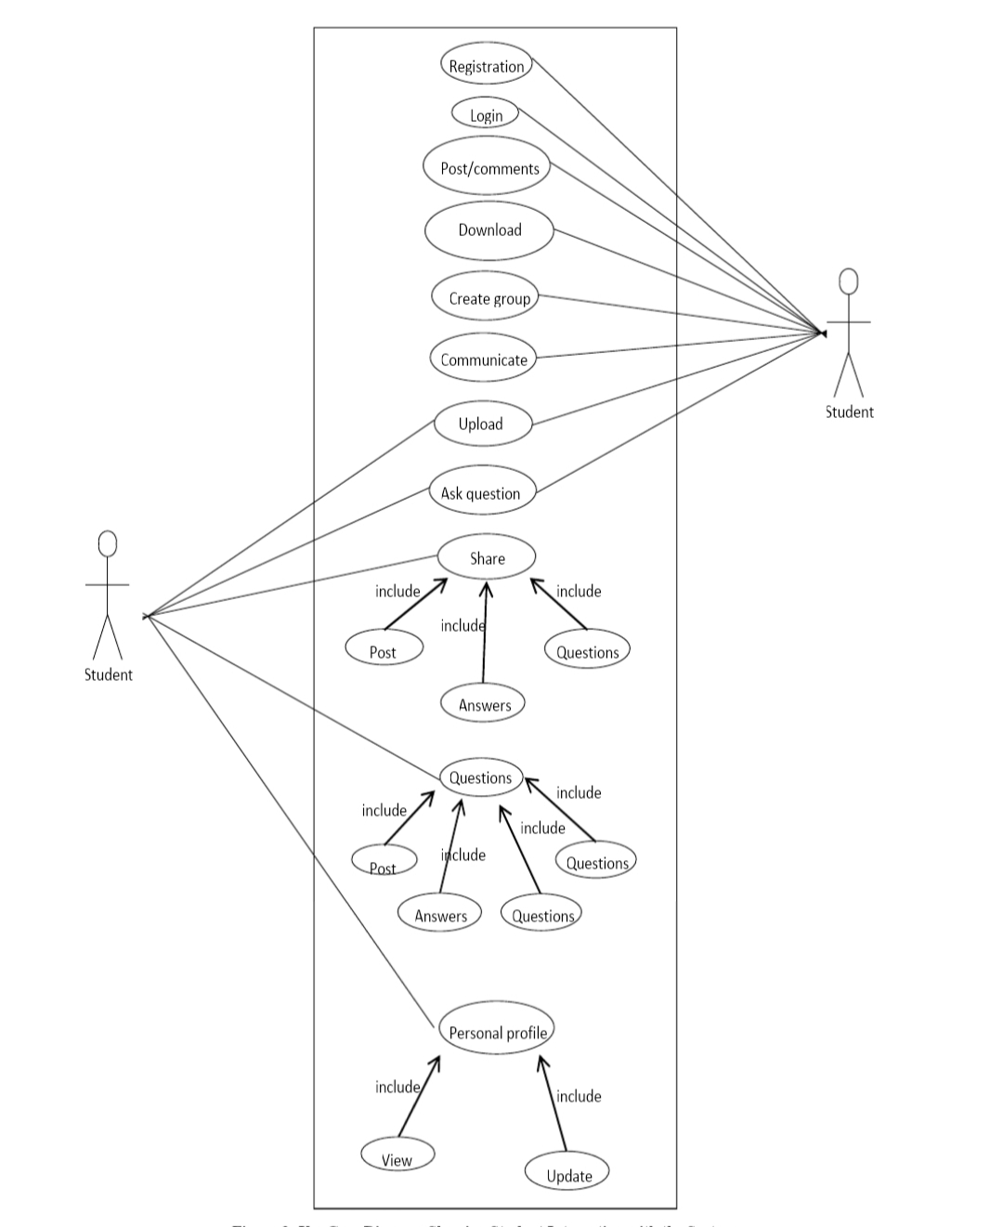

**SOURCE CODE**

About Index.html

<!DOCTYPE html>

<html>

<head>

<title>Arcten</title>

<link rel="stylesheet" type="text/css" href="./CSS/style.css"/>

</head>

<body>

<div class="header">

<div class="wrapper">

<img src="images/bg.jpg" width=160 height=70 class="logoletter"/>

<form action="./login/home.html" class="loginuser">

<table id="login">

<tr style="height: 20px">

<td><label for="email">Email</label> </td>

<td><label for="logpassword">Password</label></td>

<td rowspan=3><input type="submit" value="Log In" id="loginbutton"></td>

</tr>

<tr>

<td><input type="text" id="email" class="inputtext" required/></td>

<td><input type="password" id="logpassword" class="inputtext" required/></td>

</tr>

<tr style="height: 20px">

<td></td>

<td><a href="" style="color:white;text-decoration:none;padding-top: 3px;">Forgot password?</a></td>

</tr>

</table>

</form>

</div>

</div>

<div class="main">

<div class="wrapper">

<img src="images/bg.jpg" class="logopic"/>

<div class="signup">

<h1>Join Arcten today</h1>

<form action="join/profile1.html">

<table id="signuptable">

<tr>

<td><label for="fname">First Name:</label></td>

<td><input type="text" id="fname" class="inputtext2" name="fname" required/></td>

</tr>

<tr>

<td><label for="lname">Last Name:</label></td>

<td><input type="text" id="lname" class="inputtext2" name="lname" required/></td>

</tr>

<tr>

<td><label for="emailadd"> Email:</label></td>

<td><input type="email" id="emailadd" class="inputtext2" name="emailid" required/></td>

</tr>

<tr>

<td><label for="pwd">Password:</label></td>

<td><input type="password" id="pwd" class="inputtext2" name="pwd" required/></td>

</tr>

<tr id="fm">

<td style="text-align:right;"><input type="radio" name="sex" id="male" required/>

<label for="male">Male</label></td>

<td style="padding-left:20px;"><input type="radio" name="sex" id="female" required/>

<label for="female" id="fm1">Female</label></td>

<td style="text-align:right;"><input type="radio" name="sex" id="other" required/>

<label for="other" id="fm2">other</label></td>

</tr>

<tr>

<td><label for="date">Birthday:</label></td>

<td id="dob"><select title="Day" id="date" name="date">

<option value="0">Day</option>

<option value="1">1</option>

<option value="2">2</option>

<option value="3">3</option>

<option value="4">4</option>

<option value="5">5</option>

<option value="6">6</option>

<option value="7">7</option>

<option value="8">8</option>

<option value="9">9</option>

<option value="10">10</option>

<option value="11">11</option>

<option value="12" selected="1">12</option>

<option value="13">13</option>

<option value="14">14</option>

<option value="15">15</option>

<option value="16">16</option>

<option value="17">17</option>

<option value="18">18</option>

<option value="19">19</option>

<option value="20">20</option>

<option value="21">21</option>

<option value="22">22</option>

<option value="23">23</option>

<option value="24">24</option>

<option value="25">25</option>

<option value="26">26</option>

<option value="27">27</option>

<option value="28">28</option>

<option value="29">29</option>

<option value="30">30</option>

<option value="31">31</option>

</select>

<select title="month" style="width: 65px" name="month">

<option value="0">Month</option>

<option value="1">Jan</option>

<option value="2">Feb</option>

<option value="3">Mar</option>

<option value="4">Apr</option>

<option value="5">May</option>

<option value="6">Jun</option>

<option value="7">Jul</option>

<option value="8">Aug</option>

<option value="9">Sept</option>

<option value="10" selected="1">Oct</option>

<option value="11">Nov</option>

<option value="12">Dec</option>

</select>

<select title="year" style="width: 65px" name="year">

<option value="0">Year</option>

<option value="2021">2021</option>

<option value="2020">2020</option>

<option value="2019">2019</option>

<option value="2018">2018</option>

<option value="2017">2017</option>

<option value="2016">2016</option>

<option value="2015">2015</option>

<option value="2014">2014</option>

<option value="2013">2013</option>

<option value="2012">2012</option>

<option value="2011">2011</option>

<option value="2010">2010</option>

<option value="2009">2009</option>

<option value="2008">2008</option>

<option value="2007">2007</option>

<option value="2006">2006</option>

<option value="2005">2005</option>

<option value="2004">2004</option>

<option value="2003">2003</option>

<option value="2002">2002</option>

<option value="2001">2001</option>

<option value="2000">2000</option>

<option value="1999">1999</option>

<option value="1998">1998</option>

<option value="1997">1997</option>

<option value="1996">1996</option>

<option value="1995">1995</option>

<option value="1994">1994</option>

<option value="1993">1993</option>

<option value="1992">1992</option>

<option value="1991">1991</option>

<option value="1990"selected="1">1990</option>

</select></td>

</tr>

<tr id="joinbut">

<td colspan=2 style="padding-left:40px;padding-right: 0px"><input id="joinnowbttn" type="submit" value="Join now"/></td>

</tr>

</table>

</form>

</div>

</div>

</div>

<div class="footer">

<div class="wrapper">

<div class="foot">

<ul>

<li><a href="">About</a></li>

<li><a href="">Contact</a></li>

<li><a href="">Privacy and Policy</a></li>

<li><a href="">Help</a></li>

</ul>

<p>Copyright © mrachm01@gmail.com 2020 All Rights Reserved.</p>

</div>

</div>

</div>

</body>

</html>

**About Login**

About home.html

<!DOCTYPE html>

<html>

<head>

<title>Arcten Home</title>

<!-- CSS and JavaScript references -->

<link rel="stylesheet" type="text/css" href="../CSS/header.css">

<link rel="stylesheet" type="text/css" href="../CSS/home.css">

<link rel="stylesheet" type="text/css" href="../fonts/font-awesome/css/font-awesome.min.css">

<script src="../javascript/header.js"></script>

<script src="../javascript/home.js"></script>

<!-- Ending of CSS and JavaScrit -->

</head>

<body onload="newpost();">

<!-- Header section -->

<div class="headerfixed">

<!-- Header start -->

<div class="header">

<!-- Wrapper start of heading-->

<div class="wrapper">

<!-- arlogo -->

<a href="home.html"><img src="../images/bg.jpg" width=120 height=45 class="logoletter"/></a>

<!-- Search bar -->

<form id="searching">

<input type="text" name="search" placeholder="Search.." id="search">

</form>

<!-- icon bar to navigate to all pages -->

<div class="icon-bar">

<ul>

<!-- home -->

<li style="border-bottom: 6px solid white;"><a href="home.html" onmouseover="headerchange(1);" onmouseout="headerorigin(1);"><img src="../images/login/home.png" id="Rachit-home"><p id="p1">Home</p></a></li>

<!-- profile -->

<li> <a href="profile.html" onmouseover="headerchange(2);" onmouseout="headerorigin(2);"><img src="../images/login/profile.png" id="Rachit-profile"><p id="p2">Profile</p></a> </li>

<!-- society -->

<li><a href="society.html" onmouseover="headerchange(3);" onmouseout="headerorigin(3);"><img src="../images/login/society.png" id="Rachit-society"><p id="p3">Society</p></a></li>

<!-- message -->

<li> <a href="messages.html" onmouseover="headerchange(4);" onmouseout="headerorigin(4);"><img src="../images/login/message.png" id="Rachit-message"><p id="p4">Messages</p></a></li>

<!-- notification -->

<li><a href="#" onmouseover="headerchange(5);" onmouseout="headerorigin(5);"><img src="../images/login/notification.png" id="Rachit-notification"><p id="p5">Notifications</p></a>

<div id="notify">

<p>No New Notification</p>

<hr style="background-color:white;width: 90%;">

</div>

</li>

</ul>

</div>

<!-- Ending of Icon bar -->

</div>

<!-- Wrapper End of heading -->

</div>

<!-- End of header -->

</div>

<!-- End of header section -->

<!-- Content Section -->

<div class="content">

<!-- Start wrapper -->

<div class="wrapper">

<!-- Start Left section -->

<div class="leftfixed">

<!-- start sidebar left -->

<div class="sidebarleft">

<img src="../images/profile/upload.png"/>

<p id="sidename"> Ruchit mehta </p>

<p id="ssn"> S.K Somaiya College of Arts,Science & Commerce</p>

<p id="country">India</p>

<a href="profile.html" id="viewall">View All</a>

<hr>

<p id="nosociety">31</p>

<p id="societyname"><a href="society.html">Society</a></p>

<p id="logout"><a href="../index.html">Log Out</a></p>

</div>

<!-- End of sidebar left -->

</div>

<!-- End of leftfixed -->

<!-- start of main content section -->

<div class="mainnotfixed" id="mainnotfixed">

<!-- Start of post an content -->

<div class="main mainpost" style="margin-bottom:20px; padding-bottom:10px;">

<div class="userimg"><img src="../images/profile/upload.png"/>

</div>

<div class="username">

<p class="name" style="top:15px;">Ruchit Mehta </p>

</div>

<p class="quotes">

<textarea id="mypara" placeholder="Share an article ,photo ,video or idea."></textarea>

</p>

<!-- image load to post -->

<div class="post">

<img id="load2" class="postimg" src=" "/>

</div>

<div class="postbar">

<input type="file" accept="images/*" id="chooseimg" onchange="loadFile(event)" onmouseover="onbuttoncolor()" onmouseout="outbuttoncolor()"/>

<button type="button" class="imgbttn" id="imgbttn">&#x1f4f7; Images</button>

<button type="button" id="postmypost" class="postmypost" onclick="mypost();">Post</button>

</div>

</div>

<!-- End of post an content -->

<hr>

<!-- posted content view -->

<div class="allpost">

<!-- post 1 by creator-->

<div class="mainpost">

<div class="userimg"><img src="../images/bg.jpg"/>

</div>

<div class="username"> <p class="name">Arcten group</p>

</div>

<p class="time">2min ago</p>

<p class="quotes">

Welcome to our society. You will be judged on what you wear, which music you listen to, what you look like, how you act, who you hang around with, and on practically every other personal trait and imperfection about you, and you'll be made fun of for being who you are. Enjoy your stay.

</p>

<div class="post">

<img class="postimg" src="../images/login/network society.jpg"/>

</div>

<div class="likedislike">

<p class="like">

<span class="nooflike" id="like1">0 </span> likes &nbsp <span class="noofdislike" id="dislike1">0 </span> dislikes

</p>

<p class="likedisbttn">

<span id="thumbsup1" class="fa fa-thumbs-up" onclick="increase('like1','dislike1','thumbsup1','thumbsdown1');"></span> <span id="thumbsdown1" class="fa fa-thumbs-down" onclick="decrease('like1','dislike1','thumbsup1','thumbsdown1');"></span>

</p>

</div>

</div>

<!-- end of post 1 by creator -->

<!-- post 2 by creator -->

<div class="mainpost">

<div class="userimg"><img src="../images/bg.jpg"/>

</div>

<div class="username"> <p class="name">Arcten group</p>

</div>

<p class="time">8min ago</p>

<p class="quotes">

A gender-equal society would be one where the word 'gender' does not exist: where everyone can be themselves.

</p>

<div class="post">

<img class="postimg" src="../images/login/society.jpg"/>

</div>

<div class="likedislike">

<p class="like">

<span class="nooflike" id="like2">0 </span> likes &nbsp <span class="noofdislike" id="dislike2">0 </span> dislikes

</p>

<p class="likedisbttn">

<span id="thumbsup2" class="fa fa-thumbs-up" onclick="increase('like2','dislike2','thumbsup2','thumbsdown2');"></span> <span id="thumbsdown2" class="fa fa-thumbs-down" onclick="decrease('like2','dislike2','thumbsup2','thumbsdown2');"></span>

</p>

</div>

</div>

<!-- end of post 2 by creator -->

</div>

<!-- end of posted content view -->

<!-- button to view more previous post -->

<button type="button" id="viewmore" class="viewmore" onclick="newpost();">View More</button>

</div>

<!-- End of main content section -->

<!-- start of right section suggestion user -->

<div class="rightfixed">

<div class="suggesfixed"><p id="suggestion">Suggestion</p></div>

<!-- Start of right fixed -->

<div class="sidebarright">

<!-- suggested user -->

<div class="rightcontent">

<img src="../images/profile/other_profile.png"/>

<p class="name">Arjun sethi</p>

<a href="#" id="connect1" onclick="changelogo('connect1');">&#x271A; Connect</a>

</div>

<div class="rightcontent">

<img src="../images/profile/other_profile.png"/>

<p class="name">Khushi vyas</p>

<a href="#" id="connect2" onclick="changelogo('connect2');">&#x271A; Connect</a>

</div>

<div class="rightcontent">

<img src="../images/profile/other_profile.png"/>

<p class="name">Shubam sankalp</p>

<a href="#" id="connect3" onclick="changelogo('connect3');">&#x271A; Connect</a>

</div>

<div class="rightcontent">

<img src="../images/profile/other_profile.png"/>

<p class="name">shushant singh</p>

<a href="#" id="connect4" onclick="changelogo('connect4');">&#x271A; Connect</a>

</div>

<div class="rightcontent">

<img src="../images/profile/other_profile.png"/>

<p class="name">Arjit singh</p>

<a href="#" id="connect5" onclick="changelogo('connect5');">&#x271A; Connect</a>

</div>

<!-- End of sugested user -->

</div>

<!-- End of right fixed -->

</div>

<!-- End of right section suggestion user -->

About profile1.html

<!DOCTYPE html>

<html>

<head>

<title>homaj Profile Detail 1</title>

<link rel="stylesheet" type="text/css" href="../CSS/styleprofile.css"/>

</head>

<body>

<div class="header">

<div class="wrapper">

<img src="../images/bg.jpg" width=160 height=70 class="logoletter"/>

</div>

</div>

<div class="main">

<div class="wrapper">

<div class="signup">

<!-- <h1>Join homaj today</h1> -->

<img src="../images/profile/profile1.png"/>

<form action="profile2.html">

<table id="signuptable">

<tr>

<td style="padding-top:18px;"><select title="country">

<option value=0>India</option>

<option value=0>Argentina</option>

<option value=0>Spain</option>

<option value=0>United States</option>

</td>

</tr>

<tr>

<td><input type="number" id="phoneno" class="inputtext2" placeholder="Phone number" required/></td>

</tr>

<tr>

<td><input type="number" id="zipcode" class="inputtext2" placeholder="ZIP code" required/></td>

</tr>

<tr>

<td><input type="text" id="state" class="inputtext2" placeholder="State" required/></td>

</tr>

<tr>

<td><input type="text" id="District" class="inputtext2" placeholder="District" required/>

</tr>

<tr id="nextbut">

<td><input id="nextbttn" type="submit" value="Next"/></td>

</tr>

</table>

</form>

</div>

</div>

</div>

<div class="footer">

<div class="wrapper">

<div class="foot">

<ul>

<li><a href="">About</a></li>

<li><a href="">Contact</a></li>

<li><a href="">Privacy and Policy</a></li>

<li><a href="">Help</a></li>

</ul>

<p>Copyright © www.ruchit.com All Rights Reserved.</p>

</div>

</div>

</div>

</body>

</html>

About Profile2.html

<!DOCTYPE html>

<html>

<head>

<title>homaj Profile Detail 2</title>

<link rel="stylesheet" type="text/css" href="../CSS/styleprofile.css"/>

</head>

<body>

<div class="header">

<div class="wrapper">

<img src="../images/bg.jpg" width=160 height=70 class="logoletter"/>

</div>

</div>

<div class="main">

<div class="wrapper">

<div class="signup">

<!-- <h1>Join rachit today</h1> -->

<img src="../images/profile/profile2.png"/>

<form action="profile3.html">

<table id="signuptable">

<tr>

<td style="padding-top:18px"><input type="text" id="school" class="inputtext2" placeholder="Secondary School" required/></td>

</tr>

<tr>

<td><input type="text" id="High school" class="inputtext2" placeholder="Language Known" required/></td>

</tr>

<tr>

<td><input type="text" id="" class="inputtext2" placeholder="Religion" required/></td>

</tr>

<tr>

<td><select title="Interest">

<option value=0>Interest in</option>

<option value=1>college campus</option>

<option value=2>college teacher & staff</option>

<option value=3>students</option>

</td>

</tr>

<tr id="nextbut">

<td><input id="nextbttn" type="submit" value="Next"/></td>

</tr>

</table>

</form>

</div>

</div>

</div>

<div class="footer">

<div class="wrapper">

<div class="foot">

<ul>

<li><a href="">About</a></li>

<li><a href="">Contact</a></li>

<li><a href="">Privacy and Policy</a></li>

<li><a href="">Help</a></li>

</ul>

<p>Copyright © www.rachit.com All Rights Reserved.</p>

</div>

</div>

</div>

</body>

</html>

About Profile.html

<!DOCTYPE html>

<html>

<head>

<title>homaj Profile Picture</title>

<link rel="stylesheet" type="text/css" href="../CSS/styleprofile.css"/>

<script src="../javascript/profilescript.js"></script>

</head>

<body>

<div class="header">

<div class="wrapper">

<img src="../images/bg.jpg" width=160 height=70 class="logoletter"/>

</div>

</div>

<div class="main">

<div class="wrapper">

<div class="signup">

<!-- <h1>Join homaj today</h1> -->

<img src="../images/profile/profile3.png"/>

<form action="../login/home.html">

<table id="signuptable">

<tr>

<td style="padding-bottom:0px;"><img src="../images/profile/upload.png" id="load1" style="width:220px; height:230px;"/>

</td>

</tr>

<tr id="nextbut">

<td><input id="nextbttn" type="submit" value="Let's Start" /></td>

</tr>

</table>

</form>

</div>

</div>

</div>

<div class="footer">

<div class="wrapper">

<div class="foot">

<ul>

<li><a href="">About</a></li>

<li><a href="">Contact</a></li>

<li><a href="">Privacy and Policy</a></li>

<li><a href="">Help</a></li>

</ul>

<p>Copyright © www.ruchit.com All Rights Reserved.</p>

</div>

</div>

</div>

</body>

</html>

About message.html

<!DOCTYPE html>

<html>

<head>

<title>Arcten message</title>

<!-- CSS and JavaScript references -->

<link rel="stylesheet" type="text/css" href="../CSS/header.css">

<link rel="stylesheet" type="text/css" href="../CSS/message.css">

<script src="../javascript/header.js"></script>

<script src="../javascript/message.js"></script>

<!-- Ending of CSS and JavaScrit -->

</head>

<body onload="loadcontact()">

<!-- Header section -->

<div class="headerfixed">

<!-- Header start -->

<div class="header">

<!-- Wrapper start of heading-->

<div class="wrapper">

<!-- Arcten logo -->

<a href="home.html"><img src="../images/bg.jpg" width=120 height=45 class="logoletter"/></a>

<!-- Search bar -->

<form id="searching">

<input type="text" name="search" placeholder="Search.." id="search">

</form>

<!-- icon bar to navigate to all pages -->

<div class="icon-bar">

<ul>

<!-- home -->

<li><a href="home.html" onmouseover="headerchange(1);" onmouseout="headerorigin(1);"><img src="../images/login/home.png" id="Arcten-home"><p id="p1">Home</p></a></li>

<!-- profile -->

<li> <a href="profile.html" onmouseover="headerchange(2);" onmouseout="headerorigin(2);"><img src="../images/login/profile.png" id="Arcten-profile"><p id="p2">Profile</p></a> </li>

<!-- society -->

<li><a href="society.html" onmouseover="headerchange(3);" onmouseout="headerorigin(3);"><img src="../images/login/society.png" id="Arcten-society"><p id="p3">Society</p></a></li>

<!-- message -->

<li style="border-bottom: 6px solid white;"> <a href="messages.html" onmouseover="headerchange(4);" onmouseout="headerorigin(4);"><img src="../images/login/message.png" id="Arcten-message"><p id="p4">Messages</p></a></li>

<!-- notification -->

<li><a href="#" onmouseover="headerchange(5);" onmouseout="headerorigin(5);"><img src="../images/login/notification.png" id="Arcten-notification"><p id="p5">Notifications</p></a>

<div id="notify">

<p>No New Notification</p>

<hr style="background-color:white;width: 90%;">

</div>

</li>

</ul>

</div>

<!-- Ending of Icon bar -->

</div>

<!-- Wrapper End of heading -->

</div>

<!-- End of header -->

</div>

<!-- End of header section -->

<!-- Content Section -->

<div class="content">

<!-- Start wrapper -->

<div class="wrapper">

<!-- Start Left section -->

<div class="leftfixed">

<!-- start sidebar left -->

<div class="sidebarleft">

<img src="../images/profile/upload.png"/>

<p id="sidename"> Ruchit Mehta</p>

<p id="ssn"> S.K Somaiya college of Arts , Science & commerce</p>

<p id="country">India</p>

<a href="profile.html" id="viewall">View All</a>

<hr>

<p id="nosociety">31</p>

<p id="societyname"><a href="society.html">Society</a></p>

<p id="logout"><a href="../index.html">Log Out</a></p>

</div>

<!-- End of sidebar left -->

</div>

<!-- End of leftfixed -->

<!-- start of main content section -->

<div class="mainnotfixed">

<!-- Start of left contact section -->

<div class="contact">

<!-- heading messaging -->

<div class="headmsg">

<p>Messaging</p>

</div>

<!-- contact section content -->

<div class="leftcontent">

<!-- Search bar -->

<form id="contactsearch">

<input type="text" name="search" placeholder="Search.." id="searchcontact">

</form>

<!-- Contacts -->

<div class="contacts">

<!-- users -->

<div class="contactuser" style="border-left: 8px solid #009688; margin-top: 18px;" onclick="select(1)">

<img src="../images/login/messages/dennis.png" class="contimg">

<p class="name">Rachit Mehta</p>

</div>

<div class="contactuser" onclick="select(2);">

<img src="../images/profile/other_profile.png" class="contimg"/>

<p class="name">Rajat</p>

</div>

<!-- End user -->

</div>

<!-- End contacts -->

</div>

<!-- End contact section -->

</div>

<!-- End of left contact section -->

<!-- Start of right chat section -->

<div class="chat">

<!-- heading chat user -->

<div class="chatuser">

<!-- heading chat user name and pic -->

<img src="../images/login/messages/dennis.png" class="chatimg"/>

<p class="viewname">Rachit Mehta</p>

</div>

<!-- End of chat user heading -->

<!-- chat msg start -->

<div class="chatmsg">

<div class="received">

<p>Hello</p>

</div>

<div class="send">

<p>Hi!</p>

</div>

<div class="received">

<p>How are you?</p>

</div>

</div>

<!-- End of chat msg -->

<!-- to send msg box and button -->

<div class="sendmessage">

<textarea id="textarea"></textarea>

<p id="sendsymbol" onclick="sendmsg();">&#x27A4;</p>

</div>

<!-- end of msg box -->

</div>

<!-- End of right chat section -->

</div>

<!-- End of main content section -->

<!-- start of right section suggestion user -->

<div class="rightfixed">

<div class="suggesfixed"><p id="suggestion">Suggestion</p></div>

<!-- Start of right fixed -->

<div class="sidebarright">

<!-- suggested user -->

<div class="rightcontent">

<img src="../images/profile/other_profile.png"/>

<p class="name">Arjit Singh</p>

<a href="#" id="connect1" onclick="changelogo('connect1');">&#x271A; Connect</a>

</div>

<div class="rightcontent">

<img src="../images/profile/other_profile.png"/>

<p class="name">Arjun</p>

<a href="#" id="connect2" onclick="changelogo('connect2');">&#x271A; Connect</a>

</div>

<div class="rightcontent">

<img src="../images/profile/other_profile.png"/>

<p class="name">Raman</p>

<a href="#" id="connect3" onclick="changelogo('connect3');">&#x271A; Connect</a>

</div>

<div class="rightcontent">

<img src="../images/profile/other_profile.png"/>

<p class="name">zehad</p>

<a href="#" id="connect4" onclick="changelogo('connect4');">&#x271A; Connect</a>

</div>

<div class="rightcontent">

<img src="../images/profile/other_profile.png"/>

<p class="name">Rehan</p>

<a href="#" id="connect5" onclick="changelogo('connect5');">&#x271A; Connect</a>

</div>

<!-- End of sugested user -->

</div>

<!-- End of right fixed -->

</div>

<!-- End of right section suggestion user -->

<!-- Start of about Arcten -->

<div class="rightfixed">

<div class="sidebarright" style="width: 280px;padding: 4px;margin-top: 20px;height: 150px;">

<hr style="top: -25px;">

<div class="foot">

<ul>

<li><a href="">About</a></li>

<li><a href="">Contact</a></li>

<li><a href="">Privacy and Policy</a></li>

<li><a href="">Help</a></li>

</ul>

<img src="../images/bg.jpg"/>

<p>Copyright © www.Arcten.com All Rights Reserved.</p>

</div>

</div>

</div>

<!-- End of about Arcten -->

<!-- message bar at the bottom -->

<div class="message" id="msg1">

<button id="msg2" onclick="showhide()">Messaging</button>

<p> No New Messages.</p>

</div>

<!-- End of message bar at the bottom -->

</div>

<!-- End of wrapper -->

</div>

<!-- End of content section -->

</body>

</html>

About profile.html

<!DOCTYPE html>

<html>

<head>

<title>Arcten Profile</title>

<!-- CSS and JavaScript references -->

<link rel="stylesheet" type="text/css" href="../CSS/header.css">

<link rel="stylesheet" type="text/css" href="../CSS/profile.css">

<script src="../javascript/header.js"></script>

<script src="../javascript/profile.js"></script>

<!-- Ending of CSS and JavaScrit -->

</head>

<body onload="showSlides(1);">

<!-- Header section -->

<div class="headerfixed">

<!-- Header start -->

<div class="header">

<!-- Wrapper start of heading-->

<div class="wrapper">

<!-- Arcten logo -->

<a href="home.html"><img src="../images/bg.jpg" width=120 height=45 class="logoletter"/></a>

<!-- Search bar -->

<form id="searching">

<input type="text" name="search" placeholder="Search.." id="search">

</form>

<!-- icon bar to navigate to all pages -->

<div class="icon-bar">

<ul>

<!-- home -->

<li><a href="home.html" onmouseover="headerchange(1);" onmouseout="headerorigin(1);"><img src="../images/login/home.png" id="Arcten-home"><p id="p1">Home</p></a></li>

<!-- profile -->

<li style="border-bottom: 6px solid white;"> <a href="profile.html" onmouseover="headerchange(2);" onmouseout="headerorigin(2);"><img src="../images/login/profile.png" id="Arcten-profile"><p id="p2">Profile</p></a> </li>

<!-- society -->

<li><a href="society.html" onmouseover="headerchange(3);" onmouseout="headerorigin(3);"><img src="../images/login/society.png" id="Arcten-society"><p id="p3">Society</p></a></li>

<!-- message -->

<li> <a href="messages.html" onmouseover="headerchange(4);" onmouseout="headerorigin(4);"><img src="../images/login/message.png" id="Arcten-message"><p id="p4">Messages</p></a></li>

<!-- notification -->

<li><a href="#" onmouseover="headerchange(5);" onmouseout="headerorigin(5);"><img src="../images/login/notification.png" id="Arcten-notification"><p id="p5">Notifications</p></a>

<div id="notify">

<p>No New Notification</p>

<hr style="background-color:white;width: 90%;">

</div>

</li>

</ul>

</div>

<!-- Ending of Icon bar -->

</div>

<!-- Wrapper End of heading -->

</div>

<!-- End of header -->

</div>

<!-- End of header section -->

<!-- Content Section -->

<div class="content">

<!-- Start wrapper -->

<div class="wrapper">

<!-- Start Left section profile -->

<div class="leftfixedprofile">

<!-- area of slide show -->

<div class="slideshowcontainer">

<!-- change slideshow image -->

<input type="file" name="pic" class="chooseslide" accept="image/*" title="change slideshow image"

onchange="loadFile(event)" onmouseover="stoptime()" onmouseout="starttime()"/>

<p class="slideEdit">&#9998;</p>

<!-- end of change slideshow image -->

<div class="bubble">

<span class="dot" onclick="currentslide(1)"></span>

<span class="dot" onclick="currentslide(2)"></span>

<span class="dot" onclick="currentslide(3)"></span>

</div>

<!-- sildeshow images -->

<div class="singleslide">

<div class="number">1/3</div>

<img src="../images/login/profile/society1.jpg" class="slidimg"/>

</div>

<div class="singleslide">

<div class="number">2/3</div>

<img src="../images/login/profile/society2.jpg" class="slidimg"/>

</div>

<div class="singleslide">

<div class="number">3/3</div>

<img src="../images/login/profile/society3.jpg" class="slidimg"/>

</div>

<!-- End of slideshow images -->

<!-- prev and next button to change slideshow -->

<div class="prev" onclick="plusSlides(-1);">&#10094;</div>

<div class="next" onclick="plusSlides(1);">&#10095;</div>

</div>

<!-- End area of slideshow -->

<!-- start sidebar left profile -->

<div class="sidebarleftprofile">

<!-- change image -->

<input type="file" name="pic" class="chooseslide1" accept="image/*" onchange="loadFile1(event)" title="change profile pic"/>

<p class="slideEdit1">&#9998;</p>

<!-- End change image -->

<img src="../images/profile/upload.png" title="Profile Pic" class="profilepic"/>

<p id="sidename"> Ruchit Mehta </p>

<p id="nosociety">31</p>

<p id="societyname"><a href="society.html">Society</a></p>

<p id="logout"><a href="../index.html">Log Out</a></p>

</div>

<!-- End of sidebar left profile -->

<!-- start of timeline of profile info -->

<div class="timeline">

<div class="container left">

<p class="slideEdit2" title="Edit" onclick="enablemodal()">&#9998;</p>

<div class="tcontent">

<h2>Personal Detail</h2>

<h4>First Name:</h4>

<p>Ruchit</p>

<h4>Last Name:</h4>

<p>Mehta</p>

<h4>Email:</h4>

<p>Katputlirocks@gmail.com</p>

<h4>Date Of Birth:</h4>

<p>12 Feb 2001</p>

<h4>Gender:</h4>

<p>Male</p>

<h4>Phone no:</h4>

<p>8282828254</p>

<h4>Religion</h4>

<p>Hindu</p>

</div>

</div>

<div class="container right">

<p class="slideEdit2" title="Edit" onclick="enablemodal1(1)">&#9998;</p>

<div class="tcontent">

<h2>Primary Education</h2>

<h4>Primary School:</h4>

<p>Don Bosco High School</p>

<h4>Degree:</h4>

<p>Higher Secondary</p>

<h4>Field of Study:</h4>

<p>Science</p>

<h4>Academy Year:</h4>

<p>2004-2015</p>

</div>

</div>

<div class="container left">

<p class="slideEdit2" title="Edit" onclick="enablemodal1(2)">&#9998;</p>

<div class="tcontent">

<h2>Secondary Education</h2>

<h4>Secondary School:</h4>

<p>S.K Somaiya College of Arts , Science & Commerce</p>

<h4>Degree:</h4>

<p>Bachelor of Science</p>

<h4>Field of Study:</h4>

<p>Computer Science</p>

<h4>Academy Year:</h4>

<p>2018-2021</p>

</div>

</div>

<div class="container right">

<p class="slideEdit2" title="Edit" onclick="enablemodal2()">&#9998;</p>

<div class="tcontent">

<h2>Address</h2>

<h4>Country:</h4>

<p>India</p>

<h4>State:</h4>

<p>Maharashtra</p>

<h4>City:</h4>

<p>Mumbai</p>

<h4>ZIP code:</h4>

<p>400083</p>

</div>

</div>

<div class="container left">

<p class="slideEdit2" title="Edit" onclick="enablemodal3()">&#9998;</p>

<div class="tcontent">

<h2>More About You</h2>

<h4>Interested In:</h4>

<p>Students</p>

<h4>Hobby</h4>

<p>Playing Football</p>

<h4>Language Known:</h4>

<p>English, Hindi, German, French</p>

</div>

</div>

</div>

<!-- End of timeline -->

<!-- Edit when click on timeline edit option -->

<!-- Personal Detail Edit -->

<div class="modal animate">

<div class="Edit">

<span class="close" title="Close Modal" onclick="disablemodal(0)">&times;</span>

<h2 align="center">Personal Detail Edit</h2>

<form action="#" onsubmit="return false">

<br/>

<label for="fname">First Name</label>

<br/>

<input type="text" id="fname" placeholder="Enter First Name" required/>

<br/>

<label for="lname">Last Name</label>

<br/>

<input type="text" id="lname" placeholder="Enter Last Name" required/>

<br/>

<label for="email">Email</label>

<br/>

<input type="email" id="email" placeholder="Enter Email-ID" required/>

<br/>

<label for="date">Birthday:</label>

<br/>

<select title="Day" id="date name="date" style="width: 27%; padding: 8px 10px; margin:12px 0; display: inline-block;border: 1px solid #ccc;box-sizing: border-box;border-radius: 5px; font-size: 14px;">

<option value="0">Day</option>

<option value="1">1</option>

<option value="2">2</option>

<option value="3">3</option>

<option value="4">4</option>

<option value="5">5</option>

<option value="6">6</option>

<option value="7">7</option>

<option value="8">8</option>

<option value="9">9</option>

<option value="10">10</option>

<option value="11">11</option>

<option value="12" selected="1">12</option>

<option value="13">13</option>

<option value="14">14</option>

<option value="15">15</option>

<option value="16">16</option>

<option value="17">17</option>

<option value="18">18</option>

<option value="19">19</option>

<option value="20">20</option>

<option value="21">21</option>

<option value="22">22</option>

<option value="23">23</option>

<option value="24">24</option>

<option value="25">25</option>

<option value="26">26</option>

<option value="27">27</option>

<option value="28">28</option>

<option value="29">29</option>

<option value="30">30</option>

<option value="31">31</option>

</select>

<select title="month" name="month" style="width: 32%; padding: 8px 10px; margin:12px 0; display: inline-block;border: 1px solid #ccc;box-sizing: border-box;border-radius: 5px; font-size: 14px;">

<option value="0">Month</option>

<option value="Jan">Jan</option>

<option value="Feb" selected="1">Feb</option>

<option value="Mar">Mar</option>

<option value="Apr">Apr</option>

<option value="May">May</option>

<option value="Jun">Jun</option>

<option value="Jul">Jul</option>

<option value="Aug">Aug</option>

<option value="Sept">Sept</option>

<option value="Oct">Oct</option>

<option value="Nov">Nov</option>

<option value="Dec">Dec</option>

</select>

<select title="year" style="width: 30%; padding: 8px 10px; margin:12px 0; display: inline-block;border: 1px solid #ccc;box-sizing: border-box;border-radius: 5px; font-size: 14px;" name="year">

<option value="0">Year</option>

<option value="2017">2017</option><option value="2016">2016</option><option value="2015">2015</option><option value="2014">2014</option><option value="2013">2013</option><option value="2012">2012</option><option value="2011">2011</option><option value="2010">2010</option><option value="2009">2009</option><option value="2008">2008</option><option value="2007">2007</option><option value="2006">2006</option><option value="2005">2005</option><option value="2004">2004</option><option value="2003">2003</option><option value="2002">2002</option><option value="2001">2001</option><option value="2000">2000</option><option value="1999" selected="1">1999</option><option value="1998">1998</option><option value="1997">1997</option><option value="1996">1996</option><option value="1995">1995</option><option value="1994">1994</option><option value="1993">1993</option><option value="1992">1992</option><option value="1991">1991</option><option value="1990">1990</option><option value="1989">1989</option><option value="1988">1988</option><option value="1987">1987</option><option value="1986">1986</option><option value="1985">1985</option><option value="1984">1984</option><option value="1983">1983</option><option value="1982">1982</option><option value="1981">1981</option><option value="1980">1980</option><option value="1979">1979</option><option value="1978">1978</option><option value="1977">1977</option><option value="1976">1976</option><option value="1975">1975</option><option value="1974">1974</option><option value="1973">1973</option><option value="1972">1972</option><option value="1971">1971</option><option value="1970">1970</option><option value="1969">1969</option><option value="1968">1968</option><option value="1967">1967</option><option value="1966">1966</option><option value="1965">1965</option><option value="1964">1964</option><option value="1963">1963</option><option value="1962">1962</option><option value="1961">1961</option><option value="1960">1960</option><option value="1959">1959</option><option value="1958">1958</option><option value="1957">1957</option><option value="1956">1956</option><option value="1955">1955</option><option value="1954">1954</option><option value="1953">1953</option><option value="1952">1952</option><option value="1951">1951</option><option value="1950">1950</option><option value="1949">1949</option><option value="1948">1948</option><option value="1947">1947</option><option value="1946">1946</option><option value="1945">1945</option><option value="1944">1944</option><option value="1943">1943</option><option value="1942">1942</option><option value="1941">1941</option><option value="1940">1940</option><option value="1939">1939</option><option value="1938">1938</option><option value="1937">1937</option><option value="1936">1936</option><option value="1935">1935</option><option value="1934">1934</option><option value="1933">1933</option><option value="1932">1932</option><option value="1931">1931</option><option value="1930">1930</option><option value="1929">1929</option><option value="1928">1928</option><option value="1927">1927</option><option value="1926">1926</option><option value="1925">1925</option><option value="1924">1924</option><option value="1923">1923</option><option value="1922">1922</option><option value="1921">1921</option><option value="1920">1920</option><option value="1919">1919</option><option value="1918">1918</option><option value="1917">1917</option><option value="1916">1916</option><option value="1915">1915</option><option value="1914">1914</option><option value="1913">1913</option><option value="1912">1912</option><option value="1911">1911</option><option value="1910">1910</option><option value="1909">1909</option><option value="1908">1908</option><option value="1907">1907</option><option value="1906">1906</option><option value="1905">1905</option>

</select>

<br/>

<input type="radio" value="Male" name="sex" id="male" required/>

<label for="male">Male</label>

<input type="radio" value="Female" name="sex" id="female" style="margin-bottom: 16px;" required/>

<label for="female" id="fm1">Female</label>

<br/>

<label for="phoneno">Phone no</label>

<br/>

<input type="number" id="phoneno" placeholder="Enter Phone no" required/>

<br/>

<label for="religion">Religion</label>

<br/>

<input type="text" id="religion" placeholder="Enter Religion" required/>

<br/>

<button type="submit" onclick="update1()">Update</button>

<br/>

<button type="button" class="cancelbtn" onclick="disablemodal(0)">Cancel</button>

<br/>

</form>

</div>

</div>

<!-- End of personal detail Edit -->

<!-- Primary school edit -->

<div class="modal animate">

<div class="Edit">

<span class="close" title="Close Modal" onclick="disablemodal(1)">&times;</span>

<h2 align="center">Primary School Edit</h2>

<form action="#" onsubmit="return false">

<br/>

<label for="pschool">Primary School</label>

<br/>

<input type="text" id="pschool" placeholder="Enter Primary School" required/>

<br/>

<label for="degree1">Degree</label>

<br/>

<input type="text" id="degree1" placeholder="Enter Degree" required/>

<br/>

<label for="fstudy1">Field of Study</label>

<br/>

<input type="text" id="fstudy1" placeholder="Enter Field of Study" required/>

<br/>

<label for="syear1">Start Year</label>

<label style="position: absolute;left:50.6%;" for="eyear1">End Year</label>

<br/>

<input style="width:49%;" type="number" id="syear1" placeholder="Start Year" min="1970" max="2017" required/>

<input style="width:49%;" type="number" id="eyear1" placeholder="End Year" min="1970" required/>

<br/>

<button type="submit" onclick="update2(1)">Update</button>

<br/>

<button type="button" class="cancelbtn" onclick="disablemodal(1)">Cancel</button>

<br/>

</form>

</div>

</div>

<!-- End of primary school edit -->

<!-- Secondary school edit -->

<div class="modal animate">

<div class="Edit">

<span class="close" title="Close Modal" onclick="disablemodal(2)">&times;</span>

<h2 align="center">Secondary School Edit</h2>

<form action="#" onsubmit="return false">

<br/>

<label for="sschool">Secondary School</label>

<br/>

<input type="text" id="sschool" placeholder="Enter Secondary School" required/>

<br/>

<label for="degree2">Degree</label>

<br/>

<input type="text" id="degree2" placeholder="Enter Degree" required/>

<br/>

<label for="fstudy2">Field of Study</label>

<br/>

<input type="text" id="fstudy2" placeholder="Enter Field of Study" required/>

<br/>

<label for="syear1">Start Year</label>

<label style="position: absolute;left:50.6%;" for="eyear1">End Year</label>

<br/>

<input style="width:49%;" type="number" id="syear1" placeholder="Start Year" min="1970" max="2017" required/>

<input style="width:49%;" type="number" id="eyear1" placeholder="End Year" min="1970" required/>

<br/>

<button type="submit" onclick="update2(2)">Update</button>

<br/>

<button type="button" class="cancelbtn" onclick="disablemodal(2)">Cancel</button>

<br/>

</form>

</div>

</div>

<!-- End of Secondary school edit -->

<!-- Address edit -->

<div class="modal animate">

<div class="Edit">

<span class="close" title="Close Modal" onclick="disablemodal(3)">&times;</span>

<h2 align="center">Address Edit</h2>

<form action="#" onsubmit="return false">

<br/>

<label for="country">Country</label>

<br/>

<input type="text" id="country" placeholder="Enter Country" required/>

<br/>

<label for="state">State</label>

<br/>

<input type="text" id="state" placeholder="Enter State" required/>

<br/>

<label for="district">District</label>

<br/>

<input type="text" id="district" placeholder="Enter District" required/>

<br/>

<label for="zipcode">ZIP code</label>

<br/>

<input type="number" id="zipcode" placeholder="Enter ZIP code" required/>

<br/>

<button type="submit" onclick="update3()">Update</button>

<br/>

<button type="button" class="cancelbtn" onclick="disablemodal(3)">Cancel</button>

<br/>

</form>

</div>

</div>

<!-- End of address edit -->

<!-- More about you edit -->

<div class="modal animate">

<div class="Edit">

<span class="close" title="Close Modal" onclick="disablemodal(4)">&times;</span>

<h2 align="center">More About You Edit</h2>

<form action="#" onsubmit="return false">

<br/>

<label for="interest">Interest In</label>

<br/>

<select style="width: 100%;

padding: 10px 16px;

margin: 12px 0;

display: inline-block;

border: 1px solid #ccc;

box-sizing: border-box;

border-radius: 5px;

font-size: 14px;" title="Interest" id="interest">

<option value="Interest In">Interest In</option>

<option value="Men">Men</option>

<option value="Woman">Women</option>

<option value="Men and Woman">Men and Women</option>

</select>

<br/>

<label for="hobby">Hobby</label>

<br/>

<input type="text" id="hobby" placeholder="Enter Hobby" required/>

<br/>

<label for="lknown">Language Known</label>

<br/>

<input type="text" id="lknown" placeholder="Enter Language Known" required/>

<br/>

<button type="submit" onclick="update4()">Update</button>

<br/>

<button type="button" class="cancelbtn" onclick="disablemodal(4)">Cancel</button>

<br/>

</form>

</div>

</div>

</div>

<!-- End of leftfixed profile-->

<!-- start of right section suggestion user -->

<div class="rightfixed">

<div class="suggesfixed"><p id="suggestion">Suggestion</p></div>

<!-- Start of right fixed -->

<div class="sidebarright">

<!-- suggested user -->

<div class="rightcontent">

<img src="../images/profile/other_profile.png"/>

<p class="name">Rohan Raj</p>

<a href="#" id="connect1" onclick="changelogo('connect1');">&#x271A; Connect</a>

</div>

<div class="rightcontent">

<img src="../images/profile/other_profile.png"/>

<p class="name">Inzamam sayyed</p>

<a href="#" id="connect2" onclick="changelogo('connect2');">&#x271A; Connect</a>

</div>

<div class="rightcontent">

<img src="../images/profile/other_profile.png"/>

<p class="name">Priya Gusain</p>

<a href="#" id="connect3" onclick="changelogo('connect3');">&#x271A; Connect</a>

</div>

<div class="rightcontent">

<img src="../images/profile/other_profile.png"/>

<p class="name">Bhargav Jani</p>

<a href="#" id="connect4" onclick="changelogo('connect4');">&#x271A; Connect</a>

</div>

<div class="rightcontent">

<img src="../images/profile/other_profile.png"/>

<p class="name">Riddhish keny</p>

<a href="#" id="connect5" onclick="changelogo('connect5');">&#x271A; Connect</a>

</div>

<!-- End of sugested user -->

</div>

<!-- End of right fixed -->

</div>

<!-- End of right section suggestion user -->

<!-- Start of about Arcten -->

<div class="rightfixed">

<div class="sidebarright" style="width: 280px;padding: 4px;margin-top: 20px; height: 150px;">

<hr style="top: -25px;">

<div class="foot">

<ul>

<li><a href="">About</a></li>

<li><a href="">Contact</a></li>

<li><a href="">Privacy and Policy</a></li>

<li><a href="">Help</a></li>

</ul>

<img src="../images/bg.jpg"/>

<p>Copyright © www.Arcten.com All Rights Reserved.</p>

</div>

</div>

</div>

<!-- End of about Rcten -->

<!-- message bar at the bottom -->

<div class="message" id="msg1">

<button id="msg2" onclick="showhide()">Messages</button>

<p> No New Messages.</p>

</div>

<!-- End of message bar at the bottom -->

</div>

<!-- End of wrapper -->

</div>

<!-- End of content section -->

</body>

</html>

About society.html

<!DOCTYPE html>

<html>

<head>

<title>Arcten Society</title>

<!-- CSS and JavaScript references -->

<link rel="stylesheet" type="text/css" href="../CSS/header.css">

<link rel="stylesheet" type="text/css" href="../CSS/society.css">

<script src="../javascript/header.js"></script>

<script src="../javascript/society.js"></script>

<!-- Ending of CSS and JavaScrit -->

</head>

<body onload="loadconnection();">

<!-- Header section -->

<div class="headerfixed">

<!-- Header start -->

<div class="header">

<!-- Wrapper start of heading-->

<div class="wrapper">

<!-- Arcten logo -->

<a href="home.html"><img src="../images/bg.jpg" width=120 height=45 class="logoletter"/></a>

<!-- Search bar -->

<form id="searching">

<input type="text" name="search" placeholder="Search.." id="search">

</form>

<!-- icon bar to navigate to all pages -->

<div class="icon-bar">

<ul>

<!-- home -->

<li><a href="home.html" onmouseover="headerchange(1);" onmouseout="headerorigin(1);"><img src="../images/login/home.png" id="Arcten-home"><p id="p1">Home</p></a></li>

<!-- profile -->

<li> <a href="profile.html" onmouseover="headerchange(2);" onmouseout="headerorigin(2);"><img src="../images/login/profile.png" id="Arcten-profile"><p id="p2">Profile</p></a> </li>

<!-- society -->

<li style="border-bottom: 6px solid white;"><a href="society.html" onmouseover="headerchange(3);" onmouseout="headerorigin(3);"><img src="../images/login/society.png" id="Arcten-society"><p id="p3">Society</p></a></li>

<!-- message -->

<li> <a href="messages.html" onmouseover="headerchange(4);" onmouseout="headerorigin(4);"><img src="../images/login/message.png" id="Arcten-message"><p id="p4">Messages</p></a></li>

<!-- notification -->

<li><a href="#" onmouseover="headerchange(5);" onmouseout="headerorigin(5);"><img src="../images/login/notification.png" id="Arcten-notification"><p id="p5">Notifications</p></a>

<div id="notify">

<p>No New Notification</p>

<hr style="background-color:white;width: 90%;">

</div>

</li>

</ul>

</div>

<!-- Ending of Icon bar -->

</div>

<!-- Wrapper End of heading -->

</div>

<!-- End of header -->

</div>

<!-- End of header section -->

<!-- Content Section -->

<div class="content">

<!-- Start wrapper -->

<div class="wrapper">

<!-- Start Left section -->

<div class="leftfixed">

<!-- start sidebar left -->

<div class="sidebarleft">

<img src="../images/profile/upload.png"/>

<p id="sidename"> Ruchit Mehta</p>

<p id="ssn"> S.K Somaiya college of Arts , Science & commerce</p>

<p id="country">India</p>

<a href="profile.html" id="viewall">View All</a>

<hr>

<p id="nosociety">31</p>

<p id="societyname"><a href="society.html">Society</a></p>

<p id="logout"><a href="../index.html">Log Out</a></p>

</div>

<!-- End of sidebar left -->

</div>

<!-- End of leftfixed -->

<!-- start of main content section -->

<div class="mainnotfixed">

<!-- connection suggestion -->

<div class="people">

<!-- <div class="connection">

<img src="../images/profile/upload1.png">

<h5>User Name</h5>

<p>Secondary School</p>

<a href="#" id="connect6" onclick="changelogo1('connect6');" style="margin: 10px auto;">&#x271A; Connect</a>

</div> -->

</div>

<!-- end of connection suggestion -->

<!-- button to view more friends -->

<button type="button" id="viewmore" class="viewmore" onclick="loadconnection();">More</button>

</div>

<!-- end of main content section -->

<!-- start of right section suggestion user -->

<div class="rightfixed">

<div class="suggesfixed"><p id="suggestion">Suggestion</p><div>

<!-- Start of right fixed -->

<div class="sidebarright">

<!-- suggested user -->

<div class="rightcontent">

<img src="../images/profile/other_profile.png"/>

<p class="name">Bharti sandu</p>

<a href="#" id="connect1" onclick="changelogo('connect1');">&#x271A; Connect</a>

</div>

<div class="rightcontent">

<img src="../images/profile/other_profile.png"/>

<p class="name">Pooja sawant</p>

<a href="#" id="connect2" onclick="changelogo('connect2');">&#x271A; Connect</a>

</div>

<div class="rightcontent">

<img src="../images/profile/other_profile.png"/>

<p class="name">Dharmesh bair</p>

<a href="#" id="connect3" onclick="changelogo('connect3');">&#x271A; Connect</a>

</div>

<div class="rightcontent">

<img src="../images/profile/other_profile.png"/>

<p class="name">Faraha khan</p>

<a href="#" id="connect4" onclick="changelogo('connect4');">&#x271A; Connect</a>

</div>

<div class="rightcontent">

<img src="../images/profile/other_profile.png"/>

<p class="name">Ragav joya</p>

<a href="#" id="connect5" onclick="changelogo('connect5');">&#x271A; Connect</a>

</div>

<!-- End of sugested user -->

</div>

<!-- End of right fixed -->

</div>

<!-- End of right section suggestion user -->

<!-- Start of about Arcten -->

<div class="rightfixed">

<div class="sidebarright" style="width: 280px;padding: 4px;margin-top: 20px;height: 150px;">

<hr style="top: -25px;">

<div class="foot">

<ul>

<li><a href="">About</a></li>

<li><a href="">Contact</a></li>

<li><a href="">Privacy and Policy</a></li>

<li><a href="">Help</a></li>

</ul>

<img src="../images/bg.jpg"/>

<p>Copyright © www.Arcten.com All Rights Reserved.</p>

</div>

</div>

</div>

<!-- End of about Arcten -->

<!-- message bar at the bottom -->

<div class="message" id="msg1">

<button id="msg2" onclick="showhide()">Messaging</button>

<p> No New Messages.</p>

</div>

<!-- End of message bar at the bottom -->

</div>

<!-- End of wrapper -->

</div>

</body>

</html>

**ABOUT CSS**

About header.css

body

{

margin:0px;

padding: 0px;

width: 100%;

border:0px;

background-color: #d7dbd7;

font-family: arial;

}

.wrapper

{

margin: 0 auto;

width: 1100px;

height: 100%;

}

/*============ HEADER ===================*/

.logoletter:hover

{

animation: shake 0.5s;

animation-iteration-count: infinite;

}

@keyframes shake {

0% { transform: translate(1px, 1px) rotate(0deg); }

10% { transform: translate(-1px, -2px) rotate(-1deg); }

20% { transform: translate(-3px, 0px) rotate(1deg); }

30% { transform: translate(3px, 2px) rotate(0deg); }

40% { transform: translate(1px, -1px) rotate(1deg); }

50% { transform: translate(-1px, 2px) rotate(-1deg); }

60% { transform: translate(-3px, 1px) rotate(0deg); }

70% { transform: translate(3px, 1px) rotate(-1deg); }

80% { transform: translate(-1px, -1px) rotate(1deg); }

90% { transform: translate(1px, 2px) rotate(0deg); }

100% { transform: translate(1px, -2px) rotate(-1deg); }

}

.header

{

width: 100%;

height: 50px;

background-color: #009688;

position: fixed;

z-index: 9999;

}

.headerfixed

{

width: 100%;

height: 50px;

}

.header .wrapper .logoletter

{

padding-top: 5px;

}

#searching

{

display: inline;

}

#search

{

/*width: 420px;*/

width: 220px;

background-image: url('../images/login/search.png');

background-position: 5px 4px;

background-size: 30px 30px;

background-repeat: no-repeat;

border-radius: 8px;

font-size: 16px;

padding: 10px 20px 10px 40px;

background-color: #E1E9EE;

border: 0px;

position : absolute;

top: 5px;

/*margin-left: 100px;*/

margin-left: 50px;

transition: width 1.5s ease-in-out;

}

#search:focus

{

width: 420px;

outline: 0px

}

.icon-bar

{

float: right;

/*width: 420px;*/

width: 410px;

height: 45px;

position:relative;

}

.icon-bar ul

{

margin:0px;

margin-top: 3px;

height: 42px;

padding-left: 40px;

}

.icon-bar ul li

{

display: inline-block;

/*margin-left: 20px;

padding: 0px 5px;*/

height: 42px;

width: 70px;

}

#notify

{

position: absolute;

width: 80%;

height: 370px;

background-color: rgba(0,0,0,0.7);

right: -4px;

top:112%;

display:none;

animation: notifyzoom 0.5s;

}

@keyframes notifyzoom

{

0%

{

transform: scaleY(0);

}

100%

{

transform: scaleY(1);

}

}

.icon-bar ul li:hover #notify

{

display: block;

}

#notify p

{

color:white;

font-size: 14px;

font-family: sans-serif;

font-weight: bold;

text-align: center;

}

.icon-bar img

{

width: 34px;

height: 27px;

padding-left:20px;

}

.icon-bar a

{

width: 52px;

height: 50px;

position: relative;

}

.icon-bar a p

{

display: inline;

position: absolute;

left:0px;

top: 2px;

color: black;

font-size: 13px;

margin-bottom: 0px;

}

#p1

{

padding-left: 20px;

}

#p2

{

padding-left: 20px;

}

#p3

{

padding-left: 18px;

}

#p4

{

padding-left: 10px;

}

#p5

{

padding-left: 4px;

}

/*============== Message box ===========*/

.message

{

position: fixed;

bottom: 2px;

right: 20px;

height: 30px;

background-color: #FFFFFF;

border: 1px solid #B7B7B7;

border-top-right-radius: 3px;

border-top-left-radius: 3px;

transition: height 1s ease-in-out;

}

.message button

{

width: 250px;

height: 30px;

font-size: 14px;

padding: 0px;

margin: 0px;

background-color: #FFFFFF;

border-radius: 4px;

text-align: center;

border:0px;

}

.message p

{

text-align: center;

font-size: 14px;

color: #666666;

}

.message button:focus

{

outline: 0px

}

.content

{

margin-top: 4%;

}

/*========== SIDEBAR LEFT ================*/

.sidebarleft

{

width: 200px;

/*height: 100px;*/

background-color: #FFFFFF;

position: fixed;

border: 1px solid #B7B7B7;

border-radius: 4px;

box-shadow: 2px 6px 6px #999999;

}

.leftfixed

{

width: 200px;

height: 500px;

float: left;

margin-right: 20px;

}

.sidebarleft img

{

width: 150px;

height: 150px;

padding: 25px;

/*padding-bottom: 10px;*/

border-radius: 50%;

}

.sidebarleft #sidename

{

text-align: center;

position: relative;

top: -25px;

margin: 0px;

font-size: 16px;

font-family: "Comic Sans MS";

font-weight: bold;

padding-left: 10px;

padding-right: 10px;

}

.sidebarleft p

{

text-align: center;

margin: 0px;

font-size: 12px;

font-family: "verdana";

padding-left: 10px;

padding-right: 10px;

color: #525252;

}

#ssn

{

position: relative;

top: -8px;

}

#country

{

margin-bottom: 13px;

}

#viewall

{

display: block;

/*margin-left: 75px;*/

margin: 0 auto;

font-size: 13px;

border-radius: 5px;

border: 0px;

outline: 0px;

background-color: #00aeef;

color: white;

text-decoration: none;

width: 55px;

text-align: center;

padding: 2px;

margin-bottom: 15px;

}

#viewall:hover

{

background-color: #4F82C3;

}

.sidebarleft hr

{

width: 80%;

border: 0.8px solid #B7B7B7;

margin-bottom: 15px;

}

#nosociety

{

color: #E91E63;

font-size: 24px;

font-family: "Comic Sans MS";

font-weight: bold;

}

#societyname a

{

color: black;

}

#societyname a:hover

{

color: #E91E63;

}

#logout

{

color: #009688;

margin: 2px;

margin-top: 18px;

text-align: center;

background-color: #009688;

}

#logout a

{

display: block;

color: white;

font-size: 14px;

text-decoration: none;

font-weight: bold;

padding: 4px;

}

#logout a:hover

{

color: black;

}

/*=========== SIDEBAR RIGHT =============*/

/*parent of suggestion*/

.rightfixed

{

float: right;

width: 290px;

height: 300px;

clear: right;

}

/*parent of right content*/

.sidebarright

{

position: fixed;

/*float: right;*/

width: 250px;

/*height: 240px;*/

background-color: #FFFFFF;

border: 1px solid #B7B7B7;

border-radius: 4px;

box-shadow: 2px 6px 6px #999999;

padding: 20px;

}

/*design of suggestion content*/

.suggesfixed

{

position: fixed;

}

/*design of suggestion text*/

#suggestion

{

margin: 0px;

padding: 0px;

position: relative;

float: left;

top: -18px;

left: 2px;

text-decoration: underline;

color: #666666;

font-size: 14px;

height: 300px;

}

/*design of rightcontent i.e suggestion*/

.rightcontent

{

/*margin-top: -20px;*/

padding-bottom: 5px;

margin-bottom: 5px;

height: 40px;

}

/*design userimage in suggestion*/

.sidebarright .rightcontent img

{

display: inline;

width: 40px;

height: 40px;

border-radius: 50%;

float: left;

}

/*design of username in suggestion*/

.rightcontent p

{

display: block;

width: 120px;

margin: auto auto;

margin-left: 15px;

margin-top: 12px;

float: left;

text-align: left;

font-size: 14px;

}

/*design of connect in suggestion*/

.rightcontent a

{

display: block;

float: right;

width: 68px;

font-size: 13px;

margin-top: 7px;

text-decoration: none;

text-align: center;

color: rgba(0,0,0,.85);

height: 19px;

padding: 1px;

border: 2px solid #B7B7B7;

border-radius: 4px;

/*transition: width 2s ease-in-out;*/

}

/*hover effect on connect button*/

.rightcontent a:hover

{

background-color: #009688;

width: 70px;

height: 21px;

border: none;

color: white;

}

/*horizontal line below suggestion*/

.rightfixed .sidebarright hr

{

border: 0.5px solid #B7B7B7;

outline: 0px;

width: 80%;

box-shadow: 1px 1px 5px #999999;

margin-bottom: 12px;

position: relative;

}

/*about creator info design below suggestion*/

.foot

{

background-color: white;

text-align: center;

position: relative;

top: -10px;

}

.foot ul

{

padding: 5px;

list-style-type: none;

text-align: center;

margin: 5px;

border-radius: 5px;

}

.foot ul li

{

display: inline-block;

padding: 3px;

}

.foot ul li a

{

text-decoration: underline;

/*padding: 10px;*/

color: #615D5E;

font-size: 13px;

}

/*hover effect on link below suggestion*/

.foot ul li a:hover

{

color: #009688;

font-size: 14px;

}

/*copyright info design*/

.foot p

{

color: #666666;

text-align: center;

font-size: 12px;

padding-top: 6px;

padding-bottom: 1%;

}

/*homaj logo below suggestion*/

.foot img

{

width: 50px;

height: 40px;

display: block;

margin: 0 auto;

}

/*creating animation when click connect*/

@-webkit-keyframes spin {

0% { -webkit-transform: rotate(0deg); }

100% { -webkit-transform: rotate(360deg); }

}

@keyframes spin {

0% { transform: rotate(0deg); }

100% { transform: rotate(360deg); }

}

About home.css

/*==================== MAIN SECTION ================*/

/*parent of main*/

.mainnotfixed

{

float: left;

width: 570px;

/*height: 240px;*/

}

/*to post an content section*/

.main

{

/*width: 558px;*/

/*height: 220px;*/

background-color: #FFFFFF;

border: 1px solid #B7B7B7;

/*position: fixed;*/

border-radius: 4px;

padding: 15px;

margin-bottom: 20px;

box-shadow: 4px 1.5px 5px #999999;

}

/*horizontal line to seperate post and posted content*/

.mainnotfixed hr

{

border: 0.5px solid #B7B7B7;

outline: 0px;

width: 90%;

box-shadow: 1px 1px 5px #999999;

margin-bottom: 18px;

}

/*same class naem of post and posted content*/

.mainpost

{

background-color: #FFFFFF;

border: 1px solid #B7B7B7;

/*position: fixed;*/

border-radius: 4px;

padding: 15px;

box-shadow: 4px 1.5px 5px #999999;

margin-bottom: 5px;

}

/*user image size of the post and posted content*/

.mainpost .userimg img

{

width: 45px;

height: 45px;

/*padding-bottom: 30px;*/

float: left;

}

/*user name design of post and posted content*/

.mainpost .name

{

display: inline;

padding-left: 8px;

font-size: 16px;

position: relative;

top: 4px;

font-weight: bold;

/*float: left;*/

}

/*time of post of design for post and posted content*/

.mainpost .time

{

display: inline;

padding-left: 8px;

font-size: 12px;

color: #999999;

/*float: left;*/

}

/*parent of content image of the post and posted content*/

.mainpost .post

{

/*padding: 30px;*/

/*margin-top: 10px;*/

max-height: 250px;

}

/*content image of the post and posted content*/

.mainpost .postimg

{

max-width: 100%;

max-height: 250px;

display: block;

margin: 0 auto;

}

/*paragraph of the posted content*/

.mainpost .quotes

{

margin: 12px 4px 8px 4px;

font-size: 14px;

/*letter-spacing: 0.5px;*/

font-family: sans-serif;

text-align: justify;

padding: 5px;

}

/*post article of the input area*/

.main .quotes textarea

{

margin-top: 8px;

width: 100%;

height: 70px;

outline: 0px;

padding: 5px;

border: 1px solid #D1D1D1;

font-size: 14px;

font-family: sans-serif;

text-align: justify;

resize: none;

box-sizing: border-box;

}

/*post bar where post and image button available*/

.main .postbar

{

padding: 10px 10px 1px 10px;

}

/*design button of post in postbar*/

.main .postbar .imgbttn

{

display: inline;

/*float: left;*/

font-size: 15px;

background-color: white;

border: 3px solid #615D5E;

border-radius: 4px;

outline: 0px;

/*position: absolute;

left: 10px;*/

box-shadow: 3px 3px 5px #999999;

}

/*design button of post in postbar*/

.main .postbar .postmypost

{

display: inline;

float: right;

font-size: 16px;

padding: 6px 9px 4px 9px;

background-color: #43d854;

outline: 0px;

border: 0px;

border-radius: 4px;

box-shadow: 3px 3px 5px #999999;

}

/*post button hover effect*/

.main .postbar .postmypost:hover

{

background-color: #009688;

color: white;

}

/*post button when click effect*/

.main .postbar .postmypost:active

{

background-color: #4CAF50;

box-shadow: 0 5px 4px #666;

transform: translateY(5px);

}

/*choose image which overwritten by imgbttn*/

.main .postbar #chooseimg

{

width: 90px;

/*float: left;*/

height: 28px;

font-size: 12px;

position:absolute;

opacity: 0;

}

.main .postimg

{

max-height: 150px;

}

/*like count in posted content*/

.likedislike .like

{

font-size: 11px;

font-family: Verdana;

color: #999;

}

/*like dislike button section in posted section*/

.likedisbttn

{

margin: 0px;

border: 1px solid #D1D1D1;

padding: 5px;

}

/*common class for like and dislike button*/

.likedisbttn .fa

{

/*color: #009688;*/

font-size: 18px;

margin-right: 10px;

}

/*like button of posted content*/

.likedisbttn .fa-thumbs-up

{

margin-left: 8px;

}

/*dislike button of posted content*/

.likedisbttn .fa-thumbs-down

{

margin-left: 13px;

}

/*mouse over effect in like and dislike button*/

.likedisbttn .fa:hover

{

color: #2196F3;

/*color: red;*/

}

/*mouse click effect in like and dislike button*/

.likedisbttn .fa:active

{

transform: translateY(2px);

}

/*view more button in main content*/

.viewmore

{

display: block;

margin: 35px auto;

padding: 1px;

border: 2px solid #B7B7B7;

outline: 0px;

color: black;

background-color: white;

border-radius: 5px;

box-shadow: 3px 3px 5px #999999;

font-size: 16px;

}

/*view more button when click change class name to loader*/

.loader {

display: block;

margin: 35px auto;

padding: 1px;

outline: 0px;

border: 8px solid #f3f3f3;

border-radius: 50%;

border-top: 8px solid #00aeef;

width: 40px;

height: 40px;

-webkit-animation: spin 1s linear infinite;

animation: spin 1s linear infinite;

}

@-webkit-keyframes spin {

0% { -webkit-transform: rotate(0deg); }

100% { -webkit-transform: rotate(360deg); }

}

@keyframes spin {

0% { transform: rotate(0deg); }

100% { transform: rotate(360deg); }

}

.viewmore:hover

{

border: 2px solid #2196F3;

background-color: #00aeef;

color: white;

}

.viewmore:active

{

background-color: #4F82C3;

box-shadow: 0 5px 4px #666;

transform: translateY(5px);

}

About message.css

body

{

/*overflow: hidden;*/

}

/*==================== MAIN SECTION ================*/

/*parent of contact and chat section*/

.mainnotfixed

{

float: left;

width: 570px;

/*height: 240px;*/

}

/*Design of contact section on left*/

.contact

{

background-color: #F3F3F3;

border: 1px solid #B7B7B7;

border-radius: 4px 0 0 4px;

/*padding: 15px;*/

box-shadow: 4px 1.5px 5px #999999;

width: 35%;

box-sizing: border-box;

float: left;

height: 540px;

border-right: 1px solid black;

}

/*heading text design*/

.headmsg

{

height: 50px;

background-color: #009688;

width: 100%;

}

.headmsg p

{

margin: 0px;

color: white;

font-family: verdana;

font-size: 20px;

padding-top: 12px;

text-align: center;

}

/*left content*/

.leftcontent

{

width: 100%;

padding: 2px;

padding-top: 4px;

}

#contactsearch

{

margin-bottom: 4px;

}

/*design search bar*/

#searchcontact

{

background-image: url('../images/login/search.png');

background-position: 5px 4px;

background-size: 20px 20px;

background-repeat: no-repeat;

padding:8px;

padding-left:30px;

border-radius: 8px;

font-size: 14px;

width:98%;

border:0px;

outline: 0px;

box-sizing: border-box;

border: 1px solid rgba(0,0,0,0.3);

}

.contacts

{

overflow: auto;

height: 440px;

width: 99%;

}

.contacts .contactuser

{

width: 100%;

padding: 4px 2px 4px 2px;

overflow: hidden;

margin-bottom: 10px;

box-sizing: border-box;

cursor: pointer;

}

.contacts .contactuser img

{

display: inline;

width: 35px;

height: 35px;

float: left;

border-radius: 50%;

}

.contacts .contactuser p

{

display: inline;

position: relative;

top: 10px;

left: 15px;

font-size: 15px;

}

/*Design of chat section on right*/

.chat

{

background-color: #F3F3F3;

border: 1px solid #B7B7B7;

border-radius: 0 4px 4px 0;

/*padding: 15px;*/

box-shadow: 4px 1.5px 5px #999999;

width:65%;

box-sizing: border-box;

float: right;

height: 540px;

border-left: 1px solid black;

position: relative;

}

/*chat user heading design*/

.chatuser

{

height: 50px;

background-color: #009688;

width: 100%;

}

/*text area to send msg design*/

#textarea

{

width: 83%;

height: 40px;

position: absolute;

bottom: 0;

left: 1px;

resize: none;

border-radius: 5px;

overflow: hidden;

border: 1px solid rgba(0,0,0,0.4);

outline: 0px;

padding: 5px;

font-size: 14px;

}

/*send symbol design*/

#sendsymbol

{

position: absolute;

/*bottom: 2px;*/

bottom: -4px;

right: -1px;

margin: 0px;

padding: 0px;

font-size: 48px;

color: #43E954;

font-weight: bold;

/*color: #009688;*/

cursor: pointer;

}

/*hover effect on send symbol*/

#sendsymbol:hover

{

color: #009688;

/*color: #48FFA8;*/

}

/*chat user picture*/

.chatuser img

{

width: 40px;

height: 40px;

float: left;

margin-left: 10px;

margin-top: 5px;

border-radius: 50%;

}

/*chat msg user name*/

.chatuser p

{

display: inline-block;

margin-top: 15px;

font-size: 18px;

margin-left: 12px;

color: white;

font-family: verdana;

}

/*chat msg box*/

.chatmsg

{

width: 100%;

height: 433px;

background-color: #79CFA2;

box-shadow: 0px 4px 8px #79CFA2;

overflow: auto;

}

/*msg received and send box*/

.received, .send

{

display: none;

overflow: hidden;

position: relative;

}

/*chat msg design*/

.chatmsg p

{

padding: 6px;

margin: 10px;

/*border: 1px solid #43E954;*/

border: none;

max-width: 260px;

/*width:100%;*/

font-size: 14px;

}

/*msg received design*/

.received p

{

float: left;

background-color: #F3F3F3;

margin-left: 15px;

border-radius: 0px 5px 5px 5px;

}

/*msg send desing*/

.send p

{

float: right;

background-color: #DCF8C6;

margin-right: 15px;

border-radius: 5px 0px 5px 5px;

}

/* Add arrows to the left container (pointing left) */

.send::before {

content: " ";

height: 0;

position: absolute;

top: 10px;

width: 0;

z-index: 1;

right: 0px;

border: medium solid white;

border-width: 0px 0px 15px 15px;

border-color: transparent transparent transparent #DCF8C6;

}

/* Add arrows to the right container (pointing left) */

.received::before {

content: " ";

height: 0;

position: absolute;

top: 10px;

width: 0;

z-index: 1;

left: 0px;

border: medium solid white;

border-width: 0px 15px 15px 0;

border-color: transparent #F3F3F3 transparent transparent;

}

About profile.css

.leftfixedprofile

{

width: 790px;

height: 900px;

background-color: #F3F3F3;

float:left;

}

.bubble

{

left: 46%;

top: 12px;

position: absolute;

z-index: 8888;

}

.dot

{

background-color: #bbb;

border-radius: 50%;

height: 15px;

width:15px;

margin:0 4px;

display: inline-block;

}

.active, .dot:hover

{

background-color: #717171;

}

.slideshowcontainer

{

position: relative;

margin: 0px;

padding: 0px;

height: 360px;

}

.chooseslide

{

position: absolute;

right: 14px;

top: 7px;

z-index:7777;

width: 20px;

opacity: 0;

}

.slideEdit

{

cursor: pointer;

transform: scaleX(-1);

position:absolute;

right: 10px;

font-size: 26px;

padding: 0px;

margin: 0px;

z-index: 7666;

color: blue;

}

.chooseslide:hover ~ .slideEdit

{

color: black;

opacity: 1;

}

/*change profile pic*/

.chooseslide1

{

position: absolute;

top: 38%;

right: 15px;

z-index:7777;

width: 20px;

opacity: 0;

}

.sidebarleftprofile .slideEdit1

{

cursor: pointer;

transform: scaleX(-1);

position:absolute;

top: 35%;

right: 13px;

font-size: 26px;

padding: 0px;

margin: 0px;

z-index: 7666;

color: blue;

}

.chooseslide1:hover ~ .slideEdit1

{

color: black;

}

.slideshowcontainer .singleslide img

{

width: 100%;

height: 360px;

}

.singleslide

{

width: 100%;

display:none;

animation: 1s fade;

}

@keyframes fade

{

from

{

opacity: 0.2;

position: relative;

left: 100%;

width:0%;

}

to

{

opacity: 1;

position: relative;

width:100%;

left:0%;

}

}

.slideshowcontainer .singleslide .number

{

position: absolute;

padding: 10px;

font-size: 18px;

font-family: verdana;

color: rgba(0,0,0,0.5);

}

.prev, .next

{

cursor: pointer;

position: absolute;

top: 45%;

font-size: 26px;

font-weight: bold;

padding: 10px;

transition: all 0.5s ease-in-out;

border-radius: 0px 4px 4px 0px;

}

.next

{

right: 0px;

border-radius: 4px 0px 0px 4px;

}

.prev:hover, .next:hover

{

background-color: rgba(0,0,0,0.8);

color: white;

}

.sidebarleftprofile

{

width: 200px;

/*height: 100px;*/

background-color: transparent;

/*border: 1px solid #B7B7B7;*/

/* border-radius: 4px;*/

/* box-shadow: 2px 6px 6px #999999;*/

margin: 0px auto;

position: relative;

top: -80px;

}

.sidebarleftprofile img

{

width: 150px;

height: 150px;

/*padding: 15px;*/

/*padding-bottom: 10px;*/

border-radius: 50%;

display: block;

margin: 4px auto 25px auto;

}

.sidebarleftprofile #sidename

{

text-align: center;

position: relative;

top: -10px;

margin: 0px;

font-size: 16px;

font-family: "Comic Sans MS";

font-weight: bold;

padding-left: 10px;

padding-right: 10px;

}

.sidebarleftprofile p

{

text-align: center;

margin: 0px;

font-size: 12px;

font-family: "verdana";

padding-left: 10px;

padding-right: 10px;

color: #525252;

}

#nosociety

{

color: #E91E63;

font-size: 24px;

font-family: "Comic Sans MS";

font-weight: bold;

}

#societyname a

{

color: black;

}

#societyname a:hover

{

color: #E91E63;

}

#logout

{

color: #009688;

margin: 2px;

margin-top: 18px;

text-align: center;

background-color: #009688;

}

#logout a

{

display: block;

color: white;

font-size: 14px;

text-decoration: none;

font-weight: bold;

padding: 4px;

}

#logout a:hover

{

color: black;

}

.line

{

position: relative;

top: -50px;

width: 90%;

}

.line1

{

width: 0px;

border: 0.5px solid rgba(0,0,0,0.4);

height: 20%;

position: relative;

top: -60px;

}

/*parent of timeline*/

.timeline

{

width: 700px;

padding: 45px;

/*height: 400px;*/

position: relative;

top: -58px;

background-color: #474e5d;

font-family: Helvetica, sans-serif;

margin-bottom: 45px;

}

/* The actual timeline (the vertical ruler) */

.timeline:after

{

content:'';

position: absolute;

left: 50%;

width: 6px;

background-color: white;

/*height: 100%;*/

top: 0px;

bottom: 0px;

margin-left: -3px;

}

/* Container around content */

.container

{

background-color: white;

padding: 10px 30px;

position:relative;

width: 35%;

}

.container p

{

margin: 4px;

}

/* The circles on the timeline left*/

.container::after

{

content: '';

position: absolute;

width: 25px;

height: 25px;

right: -61px;

background-color: white;

border: 4px solid #FF9F55;

top: 15px;

border-radius: 50%;

z-index: 1;

}

/* The circles on the timeline right */

.right::after

{

content: '';

position: absolute;

width: 25px;

height: 25px;

left: -61px;

background-color: white;

border: 4px solid #FF9F55;

top: 15px;

border-radius: 50%;

z-index: 1;

}

/* Place the container to the left */

.left

{

left: 0px;

}

/* Place the container to the right */

.right

{

left: 56.34%;

}

/* Add arrows to the left container (pointing right) */

.left::before {

content: " ";

height: 0;

position: absolute;

top: 22px;

width: 0;

z-index: 1;

right: -10px;

border: medium solid white;

border-width: 10px 0 10px 10px;

border-color: transparent transparent transparent white;

}

/* Add arrows to the right container (pointing left) */

.right::before {

content: " ";

height: 0;

position: absolute;

top: 22px;

width: 0;

z-index: 1;

left: -10px;

border: medium solid white;

border-width: 10px 10px 10px 0;

border-color: transparent white transparent transparent;

}

h2

{

color: #009688;

}

h4

{

margin: 4px;

}

.tcontent p

{

font-size: 15px;

margin: 4px;

}

.container .slideEdit2

{

cursor: pointer;

position: absolute;

transform: scaleX(-1);

font-size: 24px;

color: blue;

right: 5px;

top: -4px;

}

.container .slideEdit2:hover

{

color: black;

}

/* The Modal (background) */

.modal {

display: none;

position: fixed; /* Stay in place */

z-index: 999998;

left: 0;

top: 0;

width: 100%; /* Full width */

height: 100%; /* Full height */

overflow: auto; /* Enable scroll if needed */

background-color: rgba(0,0,0,0.7); /* Black w/ opacity */

padding-top: 60px;

}

/*modal content to edit*/

.Edit

{

background-color: #fefefe;

margin: 0% auto 10% auto;

border: 1px solid #888;

width: 50%;

position: relative;

}

/* The Close Button (x) */

.close {

position: absolute;

right: 15px;

top: 5px;

color: #000;

font-size: 35px;

font-weight: bold;

}

.close:hover,

.close:focus {

color: red;

cursor: pointer;

}

.Edit form

{

margin: 20px auto;

width: 40%;

}

/* Full-width input fields */

.Edit form input[type=text], .Edit form input[type=password],

.Edit form input[type=number], .Edit form input[type=email] {

width: 100%;

padding: 10px 16px;

margin: 12px 0;

display: inline-block;

border: 1px solid #ccc;

box-sizing: border-box;

border-radius: 5px;

font-size: 14px;

}

/* Set a style for all buttons */

.Edit form button {

background-color: #4CAF50;

color: white;

padding: 14px 20px;

margin: 25px 0 6px 0;

border: none;

cursor: pointer;

width: 100%;

}

.Edit form button:hover {

opacity: 0.8;

}

/* Extra styles for the cancel button */

.Edit form .cancelbtn {

margin-top: 13px;

background-color: #f44336;

}

/* Add Zoom Animation */

.animate {

-webkit-animation: animatezoom 0.6s;

animation: animatezoom 0.6s;

}

@-webkit-keyframes animatezoom {

from {-webkit-transform: scale(0);}

to {-webkit-transform: scale(1);}

}

@keyframes animatezoom {

from {transform: scale(0);}

to {transform: scale(1);}

}

/*Add Zoom out animation*/

.deanimate

{

animation: animatezoomout 0.6s;

}

@keyframes animatezoomout

{

from{transform: scale(1);}

to{transform: scale(0);}

}

/*----Removing the number increment in input --*/

.Edit form input[type=number]::-webkit-inner-spin-button,

.Edit form input[type=number]::-webkit-outer-spin-button {

-webkit-appearance: none;

margin: 0;

}

About society.css

.leftfixedprofile

{

width: 790px;

height: 900px;

background-color: #F3F3F3;

float:left;

}

.bubble

{

left: 46%;

top: 12px;

position: absolute;

z-index: 8888;

}

.dot

{

background-color: #bbb;

border-radius: 50%;

height: 15px;

width:15px;

margin:0 4px;

display: inline-block;

}

.active, .dot:hover

{

background-color: #717171;

}

.slideshowcontainer

{

position: relative;

margin: 0px;

padding: 0px;

height: 360px;

}

.chooseslide

{

position: absolute;

right: 14px;

top: 7px;

z-index:7777;

width: 20px;

opacity: 0;

}

.slideEdit

{

cursor: pointer;

transform: scaleX(-1);

position:absolute;

right: 10px;

font-size: 26px;

padding: 0px;

margin: 0px;

z-index: 7666;

color: blue;

}

.chooseslide:hover ~ .slideEdit

{

color: black;

opacity: 1;

}

/*change profile pic*/

.chooseslide1

{

position: absolute;

top: 38%;

right: 15px;

z-index:7777;

width: 20px;

opacity: 0;

}

.sidebarleftprofile .slideEdit1

{

cursor: pointer;

transform: scaleX(-1);

position:absolute;

top: 35%;

right: 13px;

font-size: 26px;

padding: 0px;

margin: 0px;

z-index: 7666;

color: blue;

}

.chooseslide1:hover ~ .slideEdit1

{

color: black;

}

.slideshowcontainer .singleslide img

{

width: 100%;

height: 360px;

}

.singleslide

{

width: 100%;

display:none;

animation: 1s fade;

}

@keyframes fade

{

from

{

opacity: 0.2;

position: relative;

left: 100%;

width:0%;

}

to

{

opacity: 1;

position: relative;

width:100%;

left:0%;

}

}

.slideshowcontainer .singleslide .number

{

position: absolute;

padding: 10px;

font-size: 18px;

font-family: verdana;

color: rgba(0,0,0,0.5);

}

.prev, .next

{

cursor: pointer;

position: absolute;

top: 45%;

font-size: 26px;

font-weight: bold;

padding: 10px;

transition: all 0.5s ease-in-out;

border-radius: 0px 4px 4px 0px;

}

.next

{

right: 0px;

border-radius: 4px 0px 0px 4px;

}

.prev:hover, .next:hover

{

background-color: rgba(0,0,0,0.8);

color: white;

}

.sidebarleftprofile

{

width: 200px;

/*height: 100px;*/

background-color: transparent;

/*border: 1px solid #B7B7B7;*/

/* border-radius: 4px;*/

/* box-shadow: 2px 6px 6px #999999;*/

margin: 0px auto;

position: relative;

top: -80px;

}

.sidebarleftprofile img

{

width: 150px;

height: 150px;

/*padding: 15px;*/

/*padding-bottom: 10px;*/

border-radius: 50%;

display: block;

margin: 4px auto 25px auto;

}

.sidebarleftprofile #sidename

{

text-align: center;

position: relative;

top: -10px;

margin: 0px;

font-size: 16px;

font-family: "Comic Sans MS";

font-weight: bold;

padding-left: 10px;

padding-right: 10px;

}

.sidebarleftprofile p

{

text-align: center;

margin: 0px;

font-size: 12px;

font-family: "verdana";

padding-left: 10px;

padding-right: 10px;

color: #525252;

}

#nosociety

{

color: #E91E63;

font-size: 24px;

font-family: "Comic Sans MS";

font-weight: bold;

}

#societyname a

{

color: black;

}

#societyname a:hover

{

color: #E91E63;

}

#logout

{

color: #009688;

margin: 2px;

margin-top: 18px;

text-align: center;

background-color: #009688;

}

#logout a

{

display: block;

color: white;

font-size: 14px;

text-decoration: none;

font-weight: bold;

padding: 4px;

}

#logout a:hover

{

color: black;

}

.line

{

position: relative;

top: -50px;

width: 90%;

}

.line1

{

width: 0px;

border: 0.5px solid rgba(0,0,0,0.4);

height: 20%;

position: relative;

top: -60px;

}

/*parent of timeline*/

.timeline

{

width: 700px;

padding: 45px;

/*height: 400px;*/

position: relative;

top: -58px;

background-color: #474e5d;

font-family: Helvetica, sans-serif;

margin-bottom: 45px;

}

/* The actual timeline (the vertical ruler) */

.timeline:after

{

content:'';

position: absolute;

left: 50%;

width: 6px;

background-color: white;

/*height: 100%;*/

top: 0px;

bottom: 0px;

margin-left: -3px;

}

/* Container around content */

.container

{

background-color: white;

padding: 10px 30px;

position:relative;

width: 35%;

}

.container p

{

margin: 4px;

}

/* The circles on the timeline left*/

.container::after

{

content: '';

position: absolute;

width: 25px;

height: 25px;

right: -61px;

background-color: white;

border: 4px solid #FF9F55;

top: 15px;

border-radius: 50%;

z-index: 1;

}

/* The circles on the timeline right */

.right::after

{

content: '';

position: absolute;

width: 25px;

height: 25px;

left: -61px;

background-color: white;

border: 4px solid #FF9F55;

top: 15px;

border-radius: 50%;

z-index: 1;

}

/* Place the container to the left */

.left

{

left: 0px;

}

/* Place the container to the right */

.right

{

left: 56.34%;

}

/* Add arrows to the left container (pointing right) */

.left::before {

content: " ";

height: 0;

position: absolute;

top: 22px;

width: 0;

z-index: 1;

right: -10px;

border: medium solid white;

border-width: 10px 0 10px 10px;

border-color: transparent transparent transparent white;

}

/* Add arrows to the right container (pointing left) */

.right::before {

content: " ";

height: 0;

position: absolute;

top: 22px;

width: 0;

z-index: 1;

left: -10px;

border: medium solid white;

border-width: 10px 10px 10px 0;

border-color: transparent white transparent transparent;

}

h2

{

color: #009688;

}

h4

{

margin: 4px;

}

.tcontent p

{

font-size: 15px;

margin: 4px;

}

.container .slideEdit2

{

cursor: pointer;

position: absolute;

transform: scaleX(-1);

font-size: 24px;

color: blue;

right: 5px;

top: -4px;

}

.container .slideEdit2:hover

{

color: black;

}

/* The Modal (background) */

.modal {

display: none;

position: fixed; /* Stay in place */

z-index: 999998;

left: 0;

top: 0;

width: 100%; /* Full width */

height: 100%; /* Full height */

overflow: auto; /* Enable scroll if needed */

background-color: rgba(0,0,0,0.7); /* Black w/ opacity */

padding-top: 60px;

}

/*modal content to edit*/

.Edit

{

background-color: #fefefe;

margin: 0% auto 10% auto;

border: 1px solid #888;

width: 50%;

position: relative;

}

/* The Close Button (x) */

.close {

position: absolute;

right: 15px;

top: 5px;

color: #000;

font-size: 35px;

font-weight: bold;

}

.close:hover,

.close:focus {

color: red;

cursor: pointer;

}

.Edit form

{

margin: 20px auto;

width: 40%;

}

/* Full-width input fields */

.Edit form input[type=text], .Edit form input[type=password],

.Edit form input[type=number], .Edit form input[type=email] {

width: 100%;

padding: 10px 16px;

margin: 12px 0;

display: inline-block;

border: 1px solid #ccc;

box-sizing: border-box;

border-radius: 5px;

font-size: 14px;

}

/* Set a style for all buttons */

.Edit form button {

background-color: #4CAF50;

color: white;

padding: 14px 20px;

margin: 25px 0 6px 0;

border: none;

cursor: pointer;

width: 100%;

}

.Edit form button:hover {

opacity: 0.8;

}

/* Extra styles for the cancel button */

.Edit form .cancelbtn {

margin-top: 13px;

background-color: #f44336;

}

/* Add Zoom Animation */

.animate {

-webkit-animation: animatezoom 0.6s;

animation: animatezoom 0.6s;

}

@-webkit-keyframes animatezoom {

from {-webkit-transform: scale(0);}

to {-webkit-transform: scale(1);}

}

@keyframes animatezoom {

from {transform: scale(0);}

to {transform: scale(1);}

}

/*Add Zoom out animation*/

.deanimate

{

animation: animatezoomout 0.6s;

}

@keyframes animatezoomout

{

from{transform: scale(1);}

to{transform: scale(0);}

}

/*----Removing the number increment in input --*/

.Edit form input[type=number]::-webkit-inner-spin-button,

.Edit form input[type=number]::-webkit-outer-spin-button {

-webkit-appearance: none;

margin: 0;

}

About style.css

body{

height: 100%;

margin:0px;

padding:0px;

font-family: Helvetica, Arial, sans-serif;

}

.wrapper

{

margin: 0 auto;

width: 960px;

height: 100%;

}

/*========HEADER SECTION ===========*/

.header

{

width: 100%;

height: 80px;

background-color: #009688;

}

.logoletter

{

margin-top:7px;

margin-bottom:5px;

}

.loginuser /*--FORM--*/

{

float:right;

margin-top: 8px;

color: white;

font-size: 14px;

}

#login tr td .inputtext

{

border: 1px solid black;

width: 145px;

height: 18px;

}

#login tr td

{

border: 0px;

padding: 0px;

padding-left: 8px;

}

#logpassword

{

font-size: 24px;

}

#loginbutton

{

border: 0px;

background-color: #43d854;

height: 22px;

color:white;

font-size:14px;

}

#loginbutton:hover

{

background-color: #009688;

border: 1px solid black;

}

#loginbutton:active

{

transform: translateX(8px);

box-shadow: 4px 5px 4px #666;

}

/*==========MAIN SECTION ========*/

.main

{

width: 100%;

height: 100%;

background-color:#d7dbd7;

padding-bottom: 7%;

clear: right;

}

.logopic

{

position: relative;

margin-top: 8%;

width: 450px;

height: 350px;

opacity: 1.0;

transition: opacity 1s ease-in-out;

}

.logopic:hover

{

opacity: 0.5;

}

.signup /* ---- SIGNUP SECTION --- */

{

float:right;

font-size: 18px;

}

.signup h1 /*---- SIGNUP HEADING --*/

{

font-size: 45px;

margin: 0px;

padding-top: 10%;

padding-bottom: 4%;

}

.signup .inputtext2

{

width: 250px;

height: 32px;

font-size: 18px;

border-radius: 5px;

border: 1px solid #bdc7d8;

padding-left: 8px 10px;

}

#signuptable tr td

{

padding-bottom: 10px;

padding-right: 10px;

text-align: right;

}

#pwd

{

font-size:32px;

}

#signuptable #fm td

{

text-align:center;

}

#signuptable tr #dob

{

text-align: left;

}

#signuptable tr #dob select

{

padding: 0px;

margin: 0px -4px;

border:2px solid #bdc7d8;

height: 32px;

font-size: 13px;

}

#joinnowbttn /*---JOING NOW BUTTON ---*/

{

border:0px;

width: 100%;

height: 34px;

font-size: 18px;

background-color: #00aeef;

color:white;

box-shadow: 0 6px 4px #999;

}

#joinnowbttn:hover

{

background-color: #4F82C3;

}

#joinnowbttn:active

{

background-color: #2196F3;

box-shadow: 0 5px 4px #666;

transform: translateY(8px);

}

#joinbut

{

height: 130px;

}

/*====== FOOTER ===========*/

.footer

{

/*height: 40px;*/

}

.foot

{

background-color: white;

text-align: center;

}

.foot ul

{

padding: 5px;

list-style-type: none;

text-align: center;

margin: 10px;

border-radius: 5px;

}

.foot ul li

{

display: inline;

}

.foot ul li a

{

text-decoration: none;

padding: 10px;

color: #615D5E;

font-size: 16px;

}

.foot ul li a:hover

{

color: #009688;

font-size: 17px;

}

.foot p

{

color: #666666;

text-align: center;

padding-bottom: 2%;

padding-top: 8px;

font-size: 14px;

}

.logoletter:hover

{

animation: shake 0.5s;

animation-iteration-count: infinite;

}

@keyframes shake {

0% { transform: translate(1px, 1px) rotate(0deg); }

10% { transform: translate(-1px, -2px) rotate(-1deg); }

20% { transform: translate(-3px, 0px) rotate(1deg); }

30% { transform: translate(3px, 2px) rotate(0deg); }

40% { transform: translate(1px, -1px) rotate(1deg); }

50% { transform: translate(-1px, 2px) rotate(-1deg); }

60% { transform: translate(-3px, 1px) rotate(0deg); }

70% { transform: translate(3px, 1px) rotate(-1deg); }

80% { transform: translate(-1px, -1px) rotate(1deg); }

90% { transform: translate(1px, 2px) rotate(0deg); }

100% { transform: translate(1px, -2px) rotate(-1deg); }

}

About styleprofile.css

body{

height: 100%;

margin:0px;

padding:0px;

font-family: Helvetica, Arial, sans-serif;

}

.wrapper

{

margin: 0 auto;

width: 960px;

height: 100%;

}

/*========HEADER SECTION ===========*/

.header

{

width: 100%;

height: 80px;

background-color: #009688;

}

.logoletter

{

display: block;

padding-top:7px;

padding-bottom:5px;

margin-left: auto;

margin-right: auto;

}

/*==========MAIN SECTION ========*/

.main

{

width: 100%;

height: 100%;

background-color:#d7dbd7;

padding-bottom: 5%;

}

.signup /* ---- SIGNUP SECTION --- */

{

font-size: 18px;

padding-top: 4%;

}

.signup img

{

display: block;

margin-left: auto;

margin-right: auto;

margin-bottom: 20px;

width: 700px;

height: 120px;

}

#signuptable

{

margin-left: auto;

margin-right: auto;

border: 2px solid #999999;

padding: 12px;

position: relative;

}

#signuptable select

{

width: 262px;

height: 36px;

font-size: 18px;

border-radius: 5px;

border: 1px solid #bdc7d8;

padding-left: 10px;

}

.signup h1 /*---- SIGNUP HEADING --*/

{

font-size: 45px;

margin: 0px;

padding-top: 10%;

padding-bottom: 4%;

}

.signup #signuptable .inputtext2

{

width: 250px;

height: 32px;

font-size: 18px;

border-radius: 5px;

border: 1px solid #bdc7d8;

padding-left: 10px;

}

#signuptable tr td

{

padding-bottom: 15px;

padding-right: 10px;

}

#nextbttn /*---JOING NOW BUTTON ---*/

{

border:0px;

width: 100%;

height: 34px;

font-size: 18px;

background-color: #43d854;

color: black;

box-shadow: 0 6px 4px #999;

}

#nextbttn:hover

{

background-color: #81E58D;

}

#nextbut

{

height: 60px;

}

#nextbttn:active

{

background-color: #4CAF50;

box-shadow: 0 5px 4px #666;

transform: translateY(8px);

}

#nextbttn:focus

{

outline: 0px

}

/*====== FOOTER ===========*/

.footer

{

/*height: 40px;*/

}

.foot

{

background-color: white;

text-align: center;

}

.foot ul

{

padding: 5px;

list-style-type: none;

text-align: center;

margin: 10px;

border-radius: 5px;

}

.foot ul li

{

display: inline;

}

.foot ul li a

{

text-decoration: none;

padding: 10px;

color: #615D5E;

font-size: 16px;

}

.foot ul li a:hover

{

color: #009688;

font-size: 17px;

}

.foot p

{

color: #666666;

text-align: center;

font-size: 14px;

padding-top: 8px;

padding-bottom: 2%;

}

/*----Removing the number increment in input --*/

input[type=number]::-webkit-inner-spin-button,

input[type=number]::-webkit-outer-spin-button {

-webkit-appearance: none;

margin: 0;

}

input[type="file"] {

display: inline;

border: 2px solid red;

position: absolute;

left: 12px;

width: 85%;

height: 30px;

opacity: 0;

}

.uploadButton {

display: inline;

background-color: #00AEEF;

border: 0px;

margin: 0px;

padding: 0px;

font-size: 16px;

width: 97%;

height: 30px;

color: white;

transition: width 1s ease-in-out;

}

#load1

{

border-radius: 50%;

}

.logoletter:hover

{

animation: shake 0.5s;

animation-iteration-count: infinite;

}

@keyframes shake {

0% { transform: translate(1px, 1px) rotate(0deg); }

10% { transform: translate(-1px, -2px) rotate(-1deg); }

20% { transform: translate(-3px, 0px) rotate(1deg); }

30% { transform: translate(3px, 2px) rotate(0deg); }

40% { transform: translate(1px, -1px) rotate(1deg); }

50% { transform: translate(-1px, 2px) rotate(-1deg); }

60% { transform: translate(-3px, 1px) rotate(0deg); }

70% { transform: translate(3px, 1px) rotate(-1deg); }

80% { transform: translate(-1px, -1px) rotate(1deg); }

90% { transform: translate(1px, 2px) rotate(0deg); }

100% { transform: translate(1px, -2px) rotate(-1deg); }

}

**ABOUT JAVASCRIPT**

About header.js

// change header icon text color and image when mouse over it

function headerchange(check)

{

if(check==1)

{

var text=document.getElementById('p1').style.color="white";

var img=document.getElementById('homaj-home').src="../images/login/home-hover.png";

}

else if(check==2)

{

var text=document.getElementById('p2').style.color="white";

var img=document.getElementById('homaj-profile').src="../images/login/profile-hover.png";

}

else if(check==3)

{

var text=document.getElementById('p3').style.color="white";

var img=document.getElementById('homaj-society').src="../images/login/society-hover.png";

}

else if(check==4)

{

var text=document.getElementById('p4').style.color="white";

var img=document.getElementById('homaj-message').src="../images/login/message-hover.png";

}

else if(check==5)

{

var text=document.getElementById('p5').style.color="white";

var img=document.getElementById('homaj-notification').src="../images/login/notification-hover.png";

}

}

// change header icon text color and image to origin when mouseout

function headerorigin(check)

{

if(check==1)

{

var text=document.getElementById('p1').style.color="black";

var img=document.getElementById('homaj-home').src="../images/login/home.png";

}

else if(check==2)

{

var text=document.getElementById('p2').style.color="black";

var img=document.getElementById('homaj-profile').src="../images/login/profile.png";

}

else if(check==3)

{

var text=document.getElementById('p3').style.color="black";

var img=document.getElementById('homaj-society').src="../images/login/society.png";

}

else if(check==4)

{

var text=document.getElementById('p4').style.color="black";

var img=document.getElementById('homaj-message').src="../images/login/message.png";

}

else if(check==5)

{

var text=document.getElementById('p5').style.color="black";

var img=document.getElementById('homaj-notification').src="../images/login/notification.png";

}

}

/* ============ Message button bottom =========*/

var check=0; // to check if it is show or not

function showhide()

{

var msg1=document.getElementById("msg1");

var msg2=document.getElementById("msg2");

if(check==0)

{

//Expand message box

msg1.style.height="400px";

msg2.style.borderBottom="2px solid #BBBBBB"

check=1;

}

else

{

//Compress mesage box

msg1.style.height="30px";

check=0;

}

}

var society=0;

// change logo of connect when click

function changelogo(connectID)

{

var connect=document.getElementById(connectID);

// alert("hello");

// connect.style.width="0px";

connect.innerHTML="";

// connect.innerHTML="&#x2714";

connect.style.pointerEvents="none";

connect.style.border= "8px solid #f3f3f3";

connect.style.borderRadius="50%";

connect.style.borderTop= "8px solid #009688";

connect.style.borderBottom= "8px solid #009688";

connect.style.width= "12px";

connect.style.height= "12px";

connect.style.margin="0px";

connect.style.animation= "spin 2s linear 2";

connect.style.marginRight="18px";

// change logo after 3 sec

setTimeout(function(){

connect.style.animationPlayState= "paused";

connect.style.border= "0px";

connect.style.borderRadius="0px";

connect.style.borderTop= "0px";

connect.style.borderBottom= "0px";

connect.style.animation= "";

connect.style.margin="0px";

connect.style.padding="0px";

connect.style.marginRight="30px";

connect.innerHTML="&#x2714";

connect.style.color="#009688";

connect.style.fontSize="28px";

connect.style.pointerEvents="none";

// increasing no. of society when clicked on connect

society=society+1;

var noofsociety=document.getElementById("nosociety");

var place=parseInt(noofsociety.innerHTML)+1;

noofsociety.innerHTML=place;}, 3000);

}

About home.js

var incre=3; //For incrementing the id name for like,dislike,thumbsup and thumbsdown

// function loading()

// {

// }

// function to load a new post when click on viewmore

function newpost()

{

var loader=document.getElementById("viewmore");

loader.className="loader";

loader.innerHTML="";

// load new post after 3 sec

setTimeout(function()

{

for(var i=0;i<10;i++)

{

/*====Parent DIV (mainpost)========*/

var div=document.createElement("DIV");

div.className="mainpost";

/* -------- adding div at the bottom ---------*/

var parent=document.getElementsByClassName("allpost");

parent[0].appendChild(div);

// var hr=document.createElement("hr");

// parent[0].appendChild(hr);

/*============ DIV userimg ===============*/

var div1=document.createElement("DIV");

div1.className="userimg";

var img=document.createElement("img");

img.src="../images/profile/other_profile.png";

div1.appendChild(img);

div.appendChild(div1);

/*============ DIV username ===============*/

var div2=document.createElement("DIV");

div2.className="username";

var para=document.createElement("p");

para.className="name";

var text1=document.createTextNode("User Name");

para.appendChild(text1);

div2.appendChild(para);

div.appendChild(div2);

/*---------- paragraph time ---------------*/

var para1=document.createElement("p");

para1.className="time";

var text2=document.createTextNode("2hr ago");

para1.appendChild(text2);

div.appendChild(para1);

/*---------- paragraph quotes ---------------*/

var para2=document.createElement("p");

para2.className="quotes";

var text3=document.createTextNode("I want a world where everything is welcome, everything is valid, everything is acknowledged, embraced, and accepted. To me, that's a perfect world.");

para2.appendChild(text3);

div.appendChild(para2);

/*============ DIV post ===============*/

var div3=document.createElement("DIV");

div3.className="post";

var img1=document.createElement("img");

img1.className="postimg";

// img1.src="../images/login/society.jpg";

div3.appendChild(img1);

div.appendChild(div3);

/*============ DIV likedislike ===============*/

var div4=document.createElement("DIV");

div4.className="likedislike";

/*$$$$$$$$$$ paragraph like $$$$$$$$$$$$$$$$*/

var para3=document.createElement("p");

para3.className="like";

/*........... Span nooflike ............*/

var span1=document.createElement("span");

span1.className="nooflike";

span1.id="like"+incre;

var spantext=document.createTextNode("0 ");

span1.appendChild(spantext);

var text4=document.createTextNode(" likes \u00a0 ");

para3.appendChild(span1);

para3.appendChild(text4);

div4.appendChild(para3);

/*........... Span noofdislike ............*/

var span2=document.createElement("span");

span2.className="noofdislike";

span2.id="dislike"+incre;

var spantext1=document.createTextNode("0 ");

span2.appendChild(spantext1);

var text5=document.createTextNode(" dislikes");

para3.appendChild(span2);

para3.appendChild(text5);

div4.appendChild(para3);

/*$$$$$$$$$$$ paragraph likedisbttn $$$$$$$$$$$$$$$*/

var para4=document.createElement("p");

para4.className="likedisbttn";

/*........... Span fa fa-thumbs-up ............*/

var span3=document.createElement("span");

span3.className="fa fa-thumbs-up";

span3.id="thumbsup"+incre;

// span3.setAttribute("onClick",fun1);

// para4.appendChild(span3);

// div4.appendChild(para4);

/*........... Span noofdislike ............*/

var span4=document.createElement("span");

span4.className="fa fa-thumbs-down";

span4.id="thumbsdown"+incre;

/*^^^^^^^^^^ Span3 onclick code and append ^^^^^^^^^^*/

var fun1="increase"+"("+"'"+span1.id+"'"+","+"'"+span2.id+"'"+","+"'"+span3.id+"'"+","+"'"+span4.id+"'"+");";

span3.setAttribute("onClick",fun1);

para4.appendChild(span3);

div4.appendChild(para4);

/*^^^^^^^^^^ Span4 onclick code and append ^^^^^^^^^^*/

var fun2="decrease"+"("+"'"+span1.id+"'"+","+"'"+span2.id+"'"+","+"'"+span3.id+"'"+","+"'"+span4.id+"'"+");";

span4.setAttribute("onclick",fun2);

para4.appendChild(span4);

div4.appendChild(para4);

/*############## Appending DIV4 ############*/

div.appendChild(div4);

incre++;

loader.className="viewmore";

loader.innerHTML="View More";

}

},3000);

// end of load a new post after 3 sec

}

// function to post a new post

function mypost()

{

/*====Parent DIV (mainpost)========*/

var div=document.createElement("DIV");

div.className="mainpost";

/* -------- adding div at the top ---------*/

var parent=document.getElementsByClassName("allpost");

parent[0].insertBefore(div, parent[0].childNodes[0]);

// var hr=document.createElement("hr");

// parent[0].insertBefore(hr, parent[0].childNodes[1]);

/*============ DIV userimg ===============*/

var div1=document.createElement("DIV");

div1.className="userimg";

var img=document.createElement("img");

img.src="../images/profile/upload.png";

div1.appendChild(img);

div.appendChild(div1);

/*============ DIV username ===============*/

var div2=document.createElement("DIV");

div2.className="username";

var para=document.createElement("p");

para.className="name";

var text1=document.createTextNode("Ruchit Mehta");

para.appendChild(text1);

div2.appendChild(para);

div.appendChild(div2);

/*---------- paragraph time ---------------*/

var para1=document.createElement("p");

para1.className="time";

var text2=document.createTextNode("Just now");

para1.appendChild(text2);

div.appendChild(para1);

/*---------- paragraph quotes ---------------*/

var para2=document.createElement("p");

para2.className="quotes";

var pararec=document.getElementById("mypara");

// var paapa=pararec.value;

var paapa=pararec.value.replace(/\s/g, "\u00a0");

pararec.value="";

var text3=document.createTextNode(paapa);

para2.appendChild(text3);

div.appendChild(para2);

/*============ DIV post ===============*/

var div3=document.createElement("DIV");

div3.className="post";

var img1=document.createElement("img");

img1.className="postimg";

var output = document.getElementById('load2');

img1.src = output.src;

output.src="";

div3.appendChild(img1);

div.appendChild(div3);

/*============ DIV likedislike ===============*/

var div4=document.createElement("DIV");

div4.className="likedislike";

/*$$$$$$$$$$ paragraph like $$$$$$$$$$$$$$$$*/

var para3=document.createElement("p");

para3.className="like";

/*........... Span nooflike ............*/

var span1=document.createElement("span");

span1.className="nooflike";

span1.id="like"+incre;

var spantext=document.createTextNode("0 ");

span1.appendChild(spantext);

var text4=document.createTextNode(" likes \u00a0 ");

para3.appendChild(span1);

para3.appendChild(text4);

div4.appendChild(para3);

/*........... Span noofdislike ............*/

var span2=document.createElement("span");

span2.className="noofdislike";

span2.id="dislike"+incre;

var spantext1=document.createTextNode("0 ");

span2.appendChild(spantext1);

var text5=document.createTextNode(" dislikes");

para3.appendChild(span2);

para3.appendChild(text5);

div4.appendChild(para3);

/*$$$$$$$$$$$ paragraph likedisbttn $$$$$$$$$$$$$$$*/

var para4=document.createElement("p");

para4.className="likedisbttn";

/*........... Span fa fa-thumbs-up ............*/

var span3=document.createElement("span");

span3.className="fa fa-thumbs-up";

span3.id="thumbsup"+incre;

// span3.setAttribute("onClick",fun1);

// para4.appendChild(span3);

// div4.appendChild(para4);

/*........... Span noofdislike ............*/

var span4=document.createElement("span");

span4.className="fa fa-thumbs-down";

span4.id="thumbsdown"+incre;

/*^^^^^^^^^^ Span3 onclick code and append ^^^^^^^^^^*/

var fun1="increase"+"("+"'"+span1.id+"'"+","+"'"+span2.id+"'"+","+"'"+span3.id+"'"+","+"'"+span4.id+"'"+");";

span3.setAttribute("onClick",fun1);

para4.appendChild(span3);

div4.appendChild(para4);

/*^^^^^^^^^^ Span4 onclick code and append ^^^^^^^^^^*/

var fun2="decrease"+"("+"'"+span1.id+"'"+","+"'"+span2.id+"'"+","+"'"+span3.id+"'"+","+"'"+span4.id+"'"+");";

span4.setAttribute("onclick",fun2);

para4.appendChild(span4);

div4.appendChild(para4);

/*############## Appending DIV4 ############*/

div.appendChild(div4);

incre++;

}

/*======== Like increase =========*/

function increase(likerec,dislikerec,thumbsuprec,thumbsdownrec)

{

var idname1=likerec;

var idname2=dislikerec;

var thumbsup=thumbsuprec;

var thumbsdown=thumbsdownrec;

var like=document.getElementById(idname1);

like.innerHTML=parseInt(like.innerHTML)+1;

var up=document.getElementById(thumbsup);

up.style.color= "#009688";

up.style.pointerEvents="none";

var down=document.getElementById(thumbsdown)

if(down.style.color=="rgb(0, 150, 136)")

{

var dislike=document.getElementById(idname2);

dislike.innerHTML=parseInt(dislike.innerHTML)-1;

}

down.style.color="black";

down.style.pointerEvents="all";

}

/*============== Like decrease ================*/

function decrease(likerec,dislikerec,thumbsuprec,thumbsdownrec)

{

var idname1=likerec;

var idname2=dislikerec;

var thumbsup=thumbsuprec;

var thumbsdown=thumbsdownrec;

var dislike=document.getElementById(idname2);

dislike.innerHTML=parseInt(dislike.innerHTML)+1;

var down=document.getElementById(thumbsdown);

down.style.color= "#009688";

down.style.pointerEvents="none";

var up=document.getElementById(thumbsup);

if(up.style.color=="rgb(0, 150, 136)")

{

var like=document.getElementById(idname1);

like.innerHTML=parseInt(like.innerHTML)-1;

}

up.style.color="black";

up.style.pointerEvents="all";

}

// load view image to be posted

var loadFile = function(event) {

var output = document.getElementById('load2');

output.src = URL.createObjectURL(event.target.files[0]);

};

// changing imagebutton color on hover

function onbuttoncolor()

{

var on=document.getElementById("imgbttn");

on.style.backgroundColor = "#009688";

on.style.color="white";

}

// chaging imagebutton color on hover out

function outbuttoncolor()

{

var out=document.getElementById("imgbttn");

out.style.backgroundColor = "white";

out.style.color="black";

}

About message.js

increm=3; // on cick functoin select incremental number

// automatically load contact user

function loadcontact()

{

for(var i=1;i<=29;i++)

{

var contacts=document.getElementsByClassName("contacts");

var contactuser=document.createElement("div");

contactuser.className="contactuser";

contacts[0].appendChild(contactuser);

var onclick="select("+increm+")";

contactuser.setAttribute("onclick",onclick);

var userimg=document.createElement("img");

userimg.className="contimg";

userimg.src="../images/profile/other_profile.png";

contactuser.appendChild(userimg);

var para=document.createElement("p");

para.className="name";

var text=document.createTextNode("User Name");

para.appendChild(text);

contactuser.appendChild(para);

increm++;

}

// begin chat msg hello after 6ms

setTimeout(chatmsgrec,600);

}

// msg hello received after 6ms

function chatmsgrec()

{

var received=document.getElementsByClassName("received");

received[0].style.display="block";

// chat msg hi send after 6ms

setTimeout(chatmsgsend,600);

}

// msg hi send after 6ms

function chatmsgsend()

{

var send=document.getElementsByClassName("send");

send[0].style.display="block";

// chat msg how are you? received after 8ms

setTimeout(chatmsgrec1,800);

}

// msg received how are you? after 6ms

function chatmsgrec1()

{

var received=document.getElementsByClassName("received");

received[1].style.display="block";

}

// selecting contact user

function select(n)

{

// alert("hello");

var received=document.getElementsByClassName("received");

var send=document.getElementsByClassName("send");

received[0].style.display="none";

send[0].style.display="none";

received[1].style.display="none";

for(var k=1;k<send.length;k++)

{

send[k].remove(); //Deleteing all chat

}

var contactuser=document.getElementsByClassName("contactuser");

for(var i=0;i<contactuser.length;i++)

{

contactuser[i].style.border="none";

}

contactuser[n-1].style.borderLeft="8px solid #009688";

// changing name in chat section

var name=document.getElementsByClassName("name");

var viewname=document.getElementsByClassName("viewname");

viewname[0].innerHTML=name[n-1].innerHTML;

//Changing user img in chat section

var contimg=document.getElementsByClassName("contimg");

var chatimg=document.getElementsByClassName("chatimg");

chatimg[0].src=contimg[n-1].src;

setTimeout(chatmsgrec,600);

}

// sending msg

function sendmsg()

{

var textarea=document.getElementById("textarea");

var chat=document.getElementsByClassName("chatmsg");

var send=document.createElement("div");

send.className="send";

var paapa=textarea.value.replace("paapa");

textarea.value="";

var sendpara=document.createElement("p");

var text3=document.createTextNode(paapa);

sendpara.appendChild(text3);

send.appendChild(sendpara);

send.style.display="block";

chat[0].appendChild(send);

chat[0].scrollTop=chat[0].scrollHeight;

}

About profile.js

var slideIndex=1;

var click=0;

var time1;

function plusSlides(n)

{

click=1;

showSlides(slideIndex+=n);

}

function currentslide(n)

{

click=1;

showSlides(slideIndex=n);

}

function showSlides(n)

{

var slide=document.getElementsByClassName("singleslide");

var bubble=document.getElementsByClassName("dot");

if(n>slide.length)

{

slideIndex=1;

}

if(n<1)

{

slideIndex=slide.length;

}

for(var i=0;i<slide.length;i++)

{

slide[i].style.display="none";

bubble[i].className=bubble[i].className.replace(" active","");

}

slide[slideIndex-1].style.display="block";

bubble[slideIndex-1].className+=" active";

if(click==0)

time1=setTimeout(function(){showSlides(slideIndex+=1);},4000);

else if(click==1)

click=0;

}

// load view image to slideshow

var loadFile = function(event) {

var output = document.getElementsByClassName("slidimg");

output[slideIndex-1].src = URL.createObjectURL(event.target.files[0]);

click=1;

showSlides(slideIndex);

};

function stoptime()

{

clearTimeout(time1);

}

function starttime()

{

if(click==0)

showSlides(slideIndex);

}

// load view image to profile pic

var loadFile1 = function(event) {

var output = document.getElementsByClassName("profilepic");

output[0].src = URL.createObjectURL(event.target.files[0]);

};

function disablemodal(n)

{

var modal=document.getElementsByClassName('modal');

modal[n].className=modal[n].className.replace(" animate"," deanimate");

setTimeout(function(){document.getElementsByClassName('modal')[n].style.display='none';},500);

}

function enablemodal()

{

var modal=document.getElementsByClassName('modal');

modal[0].className=modal[0].className.replace(" deanimate"," animate");

// replacing content

var form=document.getElementsByTagName('form');

form[1].children[3].value=document.getElementsByClassName('tcontent')[0].children[2].innerHTML;

form[1].children[7].value=document.getElementsByClassName('tcontent')[0].children[4].innerHTML;

form[1].children[11].value=document.getElementsByClassName('tcontent')[0].children[6].innerHTML;

var dob=document.getElementsByClassName('tcontent')[0].children[8];

res=dob.innerHTML.split(" ");

form[1].children[15].value=res[0];

form[1].children[16].value=res[1];

form[1].children[17].value=res[2];

if(document.getElementsByClassName('tcontent')[0].children[10].innerHTML=="Male")

{

form[1].children[19].checked=true;

}

else

{

form[1].children[21].checked=true;

}

form[1].children[26].value=document.getElementsByClassName('tcontent')[0].children[12].innerHTML;

form[1].children[30].value=document.getElementsByClassName('tcontent')[0].children[14].innerHTML;

// displaying edit menu

document.getElementsByClassName('modal')[0].style.display='block';

}

function enablemodal1(n)

{

var modal=document.getElementsByClassName('modal');

modal[n].className=modal[n].className.replace(" deanimate"," animate");

// replacing content

var form=document.getElementsByTagName('form');

form[n+1].children[3].value=document.getElementsByClassName('tcontent')[n].children[2].innerHTML;

form[n+1].children[7].value=document.getElementsByClassName('tcontent')[n].children[4].innerHTML;

form[n+1].children[11].value=document.getElementsByClassName('tcontent')[n].children[6].innerHTML;

var dob=document.getElementsByClassName('tcontent')[n].children[8];

res=dob.innerHTML.split("-");

form[n+1].children[16].value=res[0];

form[n+1].children[17].value=res[1];

// displaying edit menu

document.getElementsByClassName('modal')[n].style.display='block';

}

function enablemodal2()

{

var modal=document.getElementsByClassName('modal');

modal[3].className=modal[3].className.replace(" deanimate"," animate");

// replacing content

var form=document.getElementsByTagName('form');

form[4].children[3].value=document.getElementsByClassName('tcontent')[3].children[2].innerHTML;

form[4].children[7].value=document.getElementsByClassName('tcontent')[3].children[4].innerHTML;

form[4].children[11].value=document.getElementsByClassName('tcontent')[3].children[6].innerHTML;

form[4].children[15].value=document.getElementsByClassName('tcontent')[3].children[8].innerHTML;

// displaying edit menu

document.getElementsByClassName('modal')[3].style.display='block';

}

function enablemodal3()

{

var modal=document.getElementsByClassName('modal');

modal[4].className=modal[4].className.replace(" deanimate"," animate");

// replacing content

var form=document.getElementsByTagName('form');

form[5].children[3].value=document.getElementsByClassName('tcontent')[4].children[2].innerHTML;

form[5].children[7].value=document.getElementsByClassName('tcontent')[4].children[4].innerHTML;

form[5].children[11].value=document.getElementsByClassName('tcontent')[4].children[6].innerHTML;

// displaying edit menu

document.getElementsByClassName('modal')[4].style.display='block';

}

function update1()

{

var modal=document.getElementsByClassName('modal');

var form=document.getElementsByTagName('form');

// disabling edit menu

if(form[1].children[3].value.length<1 || form[1].children[7].value.length<1 || form[1].children[11].value.length<1 || form[1].children[26].value.length<1 || form[1].children[30].value.length<1)

{

}

else

{

// replacing content

document.getElementsByClassName('tcontent')[0].children[2].innerHTML=form[1].children[3].value;

document.getElementsByClassName('tcontent')[0].children[4].innerHTML=form[1].children[7].value;

document.getElementsByClassName('tcontent')[0].children[6].innerHTML=form[1].children[11].value;

var dob=form[1].children[15].value+" "+form[1].children[16].value+" "+form[1].children[17].value;

document.getElementsByClassName('tcontent')[0].children[8].innerHTML=dob;

//updating name below profile pic

document.getElementById("sidename").innerHTML=form[1].children[3].value+" "+form[1].children[7].value;

if(form[1].children[19].checked==true)

{

document.getElementsByClassName('tcontent')[0].children[10].innerHTML="Male";

}

else

{

document.getElementsByClassName('tcontent')[0].children[10].innerHTML="Female";

}

document.getElementsByClassName('tcontent')[0].children[12].innerHTML=form[1].children[26].value;

document.getElementsByClassName('tcontent')[0].children[14].innerHTML=form[1].children[30].value;

modal[0].className=modal[0].className.replace(" animate"," deanimate");

setTimeout(function(){document.getElementsByClassName('modal')[0].style.display='none';},500);

}

}

function update2(n)

{

var modal=document.getElementsByClassName('modal');

var form=document.getElementsByTagName('form');

// disabling edit menu

if(form[n+1].children[3].value.length<1 || form[n+1].children[7].value.length<1 || form[n+1].children[11].value.length<1 || form[n+1].children[16].value.length<1 || form[n+1].children[17].value.length<1)

{

}

else

{

// replacing content

document.getElementsByClassName('tcontent')[n].children[2].innerHTML=form[n+1].children[3].value;

document.getElementsByClassName('tcontent')[n].children[4].innerHTML=form[n+1].children[7].value;

document.getElementsByClassName('tcontent')[n].children[6].innerHTML=form[n+1].children[11].value;

var res=form[n+1].children[16].value+"-"+form[n+1].children[17].value;

document.getElementsByClassName('tcontent')[n].children[8].innerHTML=res;

modal[n].className=modal[n].className.replace(" animate"," deanimate");

setTimeout(function(){document.getElementsByClassName('modal')[n].style.display='none';},500);

}

}

function update3()

{

var modal=document.getElementsByClassName('modal');

var form=document.getElementsByTagName('form');

// disabling edit menu

if(form[4].children[3].value.length<1 || form[4].children[7].value.length<1 || form[4].children[11].value.length<1 || form[4].children[15].value.length<1)

{

}

else

{

// replacing content

var form=document.getElementsByTagName('form');

document.getElementsByClassName('tcontent')[3].children[2].innerHTML=form[4].children[3].value;

document.getElementsByClassName('tcontent')[3].children[4].innerHTML=form[4].children[7].value;

document.getElementsByClassName('tcontent')[3].children[6].innerHTML=form[4].children[11].value;

document.getElementsByClassName('tcontent')[3].children[8].innerHTML=form[4].children[15].value;

modal[3].className=modal[3].className.replace(" animate"," deanimate");

setTimeout(function(){document.getElementsByClassName('modal')[3].style.display='none';},500);

}

}

function update4()

{

var modal=document.getElementsByClassName('modal');

var form=document.getElementsByTagName('form');

// disabling edit menu

if(form[5].children[3].value=="Interest In" || form[5].children[7].value.length<1 || form[5].children[11].value.length<1)

{

if(form[5].children[3].value=="Interest In")

alert("Please select one of the following option");

}

else

{

// replacing content

document.getElementsByClassName('tcontent')[4].children[2].innerHTML=form[5].children[3].value;

document.getElementsByClassName('tcontent')[4].children[4].innerHTML=form[5].children[7].value;

document.getElementsByClassName('tcontent')[4].children[6].innerHTML=form[5].children[11].value;

modal[4].className=modal[4].className.replace(" animate"," deanimate");

setTimeout(function(){document.getElementsByClassName('modal')[4].style.display='none';},500);

}

}

About profilescript.js

var loadFile = function(event) {

var output = document.getElementById('load1');

output.src = URL.createObjectURL(event.target.files[0]);

};

function onbuttoncolor()

{

var on=document.getElementById("browser");

on.style.backgroundColor = "#4F82C3";

on.style.width="50%";

}

function outbuttoncolor()

{

var out=document.getElementById("browser");

out.style.backgroundColor = "#00AEEF";

out.style.width="97%";

}

About society.js

var connect=6;

function loadconnection()

{

var loader=document.getElementById("viewmore");

loader.className="loader";

loader.innerHTML="";

setTimeout(function(){var parent=document.getElementsByClassName("people");

for(var i=0;i<12;i++)

{

var connection=document.createElement("div");

connection.className="connection";

parent[0].appendChild(connection);

var image=document.createElement("img");

image.src="../images/profile/upload1.png";

connection.appendChild(image);

var header=document.createElement("h5");

var text=document.createTextNode("User Name");

header.appendChild(text);

connection.appendChild(header);

var para=document.createElement("p");

var text1=document.createTextNode("Secondary School");

para.appendChild(text1);

connection.appendChild(para);

var anchor=document.createElement("a");

// anchor.setAttribute("href", "");

var text2=document.createTextNode("\u271A Connect");

anchor.appendChild(text2);

anchor.id="connect"+connect;

var argument="changelogo1('connect"+connect+"')";

anchor.setAttribute("onclick",argument);

connection.appendChild(anchor);

connect++;

loader.className="viewmore";

loader.innerHTML="More";

}

},3000);

}

// change logo of connect when click

function changelogo1(connectID)

{

var connect=document.getElementById(connectID);

// alert("hello");

// connect.style.width="0px";

connect.innerHTML="";

// connect.innerHTML="&#x2714";

connect.style.pointerEvents="none";

connect.style.border= "8px solid white";

connect.style.borderRadius="50%";

connect.style.borderTop= "8px solid #009688";

connect.style.borderBottom= "8px solid #009688";

connect.style.width= "12px";

connect.style.height= "12px";

connect.style.marginBottom="5px";

connect.style.animation= "spin 2s linear 2";

connect.style.marginLeft="auto";

connect.style.marginRight="auto";

connect.style.boxShadow="none";

// change logo after 3 sec

setTimeout(function(){

connect.style.animationPlayState= "paused";

connect.style.border= "0px";

connect.style.borderRadius="0px";

connect.style.animation= "";

connect.style.marginRight="auto";

connect.style.marginLeft="auto";

connect.innerHTML="&#x2714";

connect.style.color="#009688";

connect.style.fontSize="28px";

connect.style.height= "28px";

connect.style.pointerEvents="none";

// increasing no. of society when clicked on connect

var noofsociety=document.getElementById("nosociety");

var place=parseInt(noofsociety.innerHTML)+1;

noofsociety.innerHTML=place;}, 3000);

}

**TESTING PHASE**

Software Testing

Software Testing is the process of executing software in a controlled manner. Validation is the checking or testing of items, includes software, for conformance and consistency with an associated specification. Software testing is just one kind of verification, which also uses techniques such as reviews, analysis, inspections, and walkthroughs. Validation is the process of checking that what has been specified is what the user actually wanted.

Testing is a set of activity that can be planned in advance and conducted systematically. Testing begins at the module level and work towards the integration of entire computers based system.

There are three ways to test program.

* For correctness
* For implementation efficiency
* For computational complexity

Test for correctness are supposed to verify that a program does exactly what it was designed to do.

Test Plan

A test plan implies a series of desired course of action to be followed in accomplishing various testing methods. The Test Plan acts as a blue print for the action that is to be followed. The software engineers create a computer program, its documentation and related data structures. The software developers is always responsible for testing the individual units of the programs, ensuring that each performs the function for which it was designed. There is an independent test group (ITG) which is to remove the inherent problems associated with letting the builder to test the thing that has been built. The specific objectives of testing should be stated in measurable terms. So that the mean time to failure, the cost to find and fix the defects, remaining defect density or frequency of occurrence and test work-hours per regression test all should be stated within the test plan.

The levels of testing include:

* Unit testing
* Integration Testing
* Data validation Testing
* Output Testing

UNIT TESTING

Unit testing focuses verification effort on the smallest unit of software design – the software component or module. Using the component level design description as a guide, important control paths are tested to uncover errors within the boundary of the module. The relative complexity of tests and uncovered scope established for unit testing. The unit testing is white-box oriented, and step can be conducted in parallel for multiple components. The modular interface is tested to ensure that information properly flows into and out of the program unit under test. The local data structure is examined to ensure that data stored temporarily maintains its integrity during all steps in an algorithm’s execution. Boundary conditions are tested to ensure that all statements in a module have been executed at least once. Finally, all error handling paths are tested.

2 Tests of data flow across a module interface are required before any other test is initiated. If data do not enter and exit properly, all other tests are moot. Selective testing of execution paths is an essential task during the unit test. Good design dictates that error conditions be anticipated and error handling paths set up to reroute or cleanly terminate processing when an error does occur. Boundary testing is the last task of unit testing step. Software often fails at its boundaries.

INTEGRATION TESTING

Integration testing is systematic technique for constructing the program structure while at the same time conducting tests to uncover errors associated with interfacing. The objective is to take unit tested components and build a program structure that has been dictated by design. The entire program is tested as whole. Correction is difficult because isolation of causes is complicated by vast expanse of entire program. Once these errors are corrected, new ones appear and the process continues in a seemingly endless loop.

SYSTEM TESTING

This is the final step in testing. In this the entire system is tested as a whole with all forms, code, modules and class modules. This form of testing is popularly known as Black Box testing or System tests.

Black Box testing method focuses on the functional requirements of the software. That is, Black Box testing enables the software engineer to derive sets of input conditions that will fully exercise all functional requirements for a program.

Black Box testing attempts to find errors in the following categories; incorrect or missing functions, interface errors, errors in data structures or external data access, performance errors and initialization errors and termination errors.

ACCEPTANCE TESTING

The system considered is tested for user acceptance; here it should satisfy the firm’s need. The software should keep in touch with perspective system; user at the time of developing and making changes whenever required. This done with respect to the following points

* Input Screen Design
* Output Screen Designs
* Message to guide the user

The above testing is done taking various kinds of test data. Preparation of test data plays a vital role in the system testing. After preparing the test data, the system under study is tested using that test data. While testing the system by which test data errors are again uncovered and corrected by using above testing steps and corrections are also noted for future use.

SYSTEM MAINTAINANCE

Maintenance is the enigma of system development. The maintenance phase of the

software cycle is the time in which a software product performs useful work. After a

system is successfully implimented, it should be maintained in a proper manner.

System maintenance is an important aspect in the software development life cycle.

The need for system maintenance is for it to make adaptable to the changes in the

system environment. Software maintenance is of course, far more than "Finding

Mistakes". Maintenance may be defined by describing four activities that are undertaken after a program is released for use.

**SNAPSHOTS**

Homepage and Login page

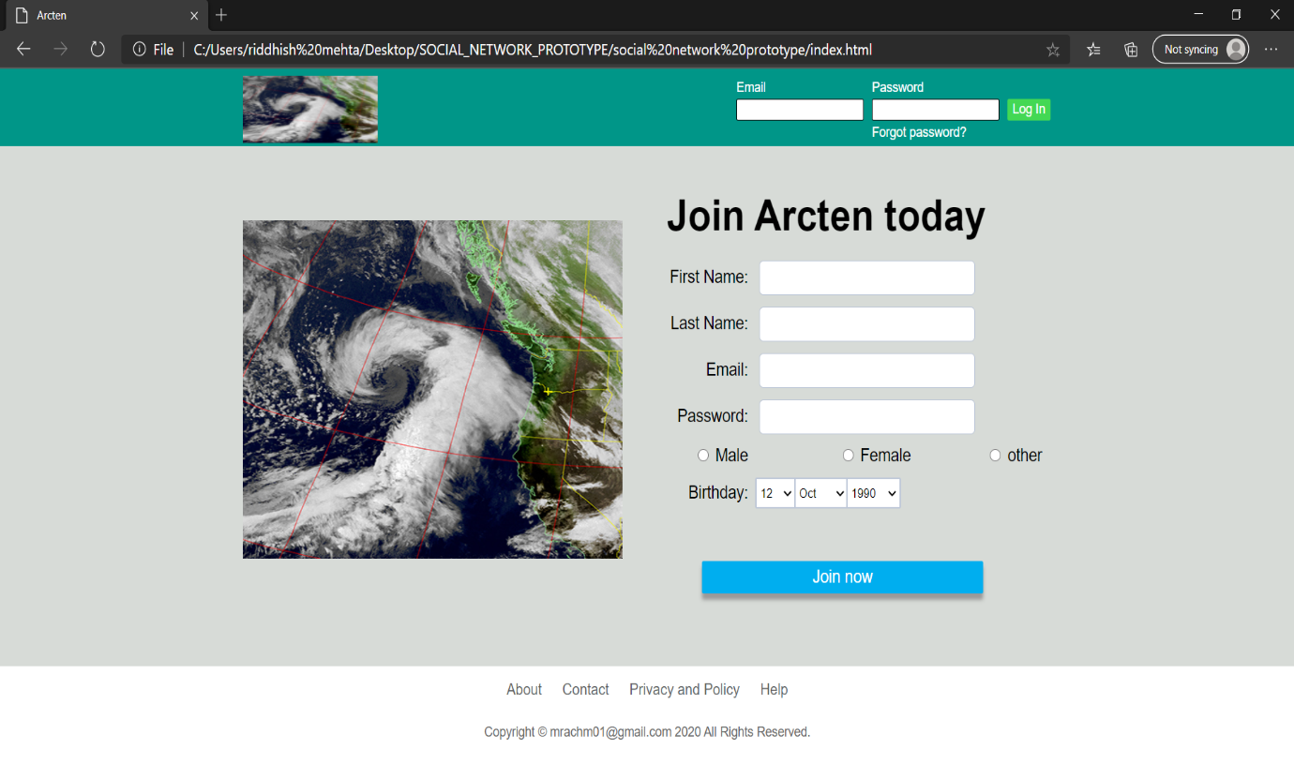

Profile Info1

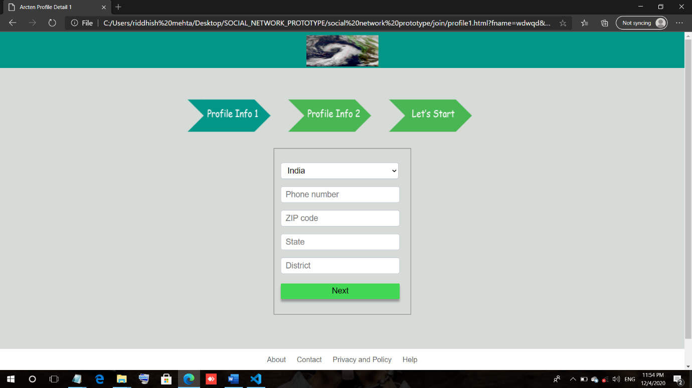

Profile info2

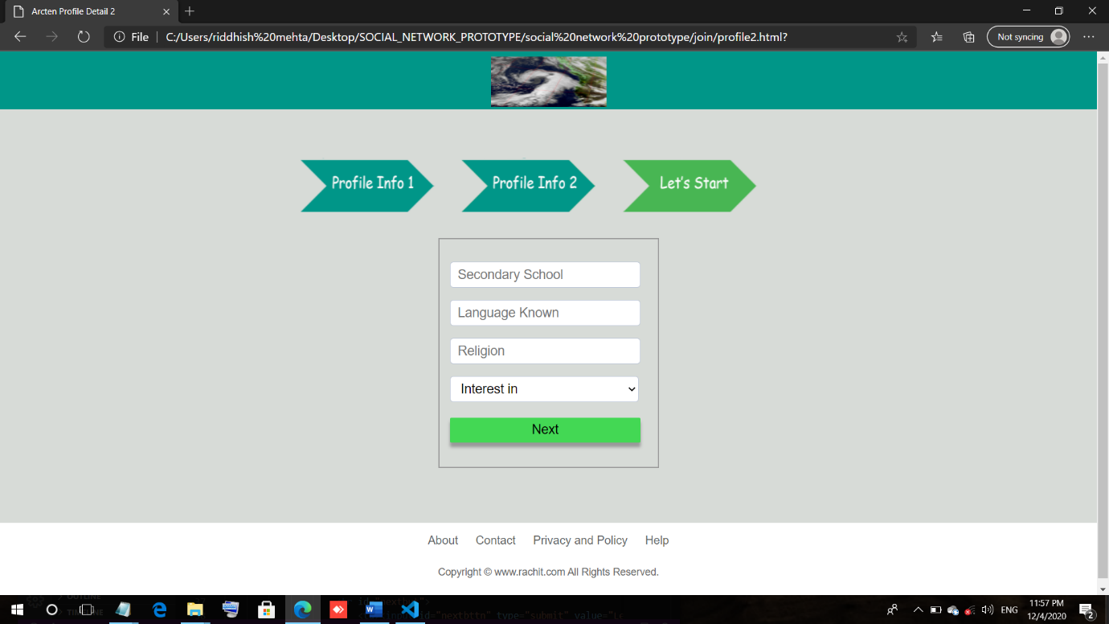

Profile info3

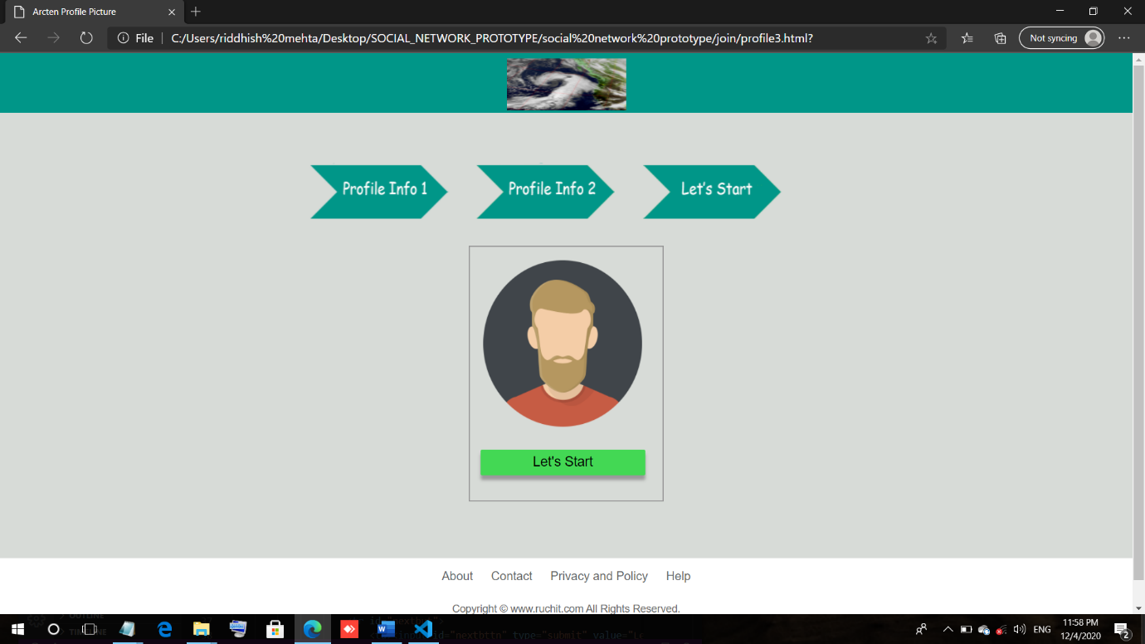

User homepage

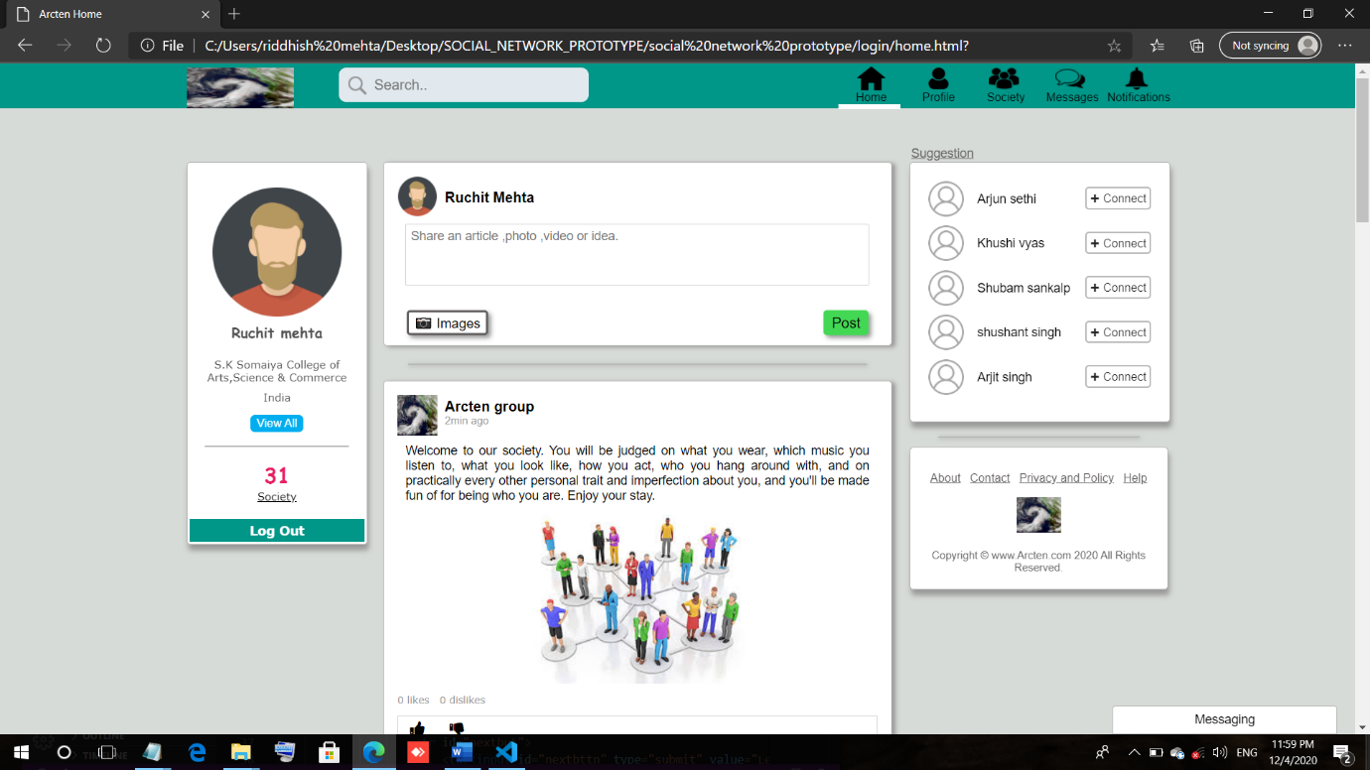

User Profile

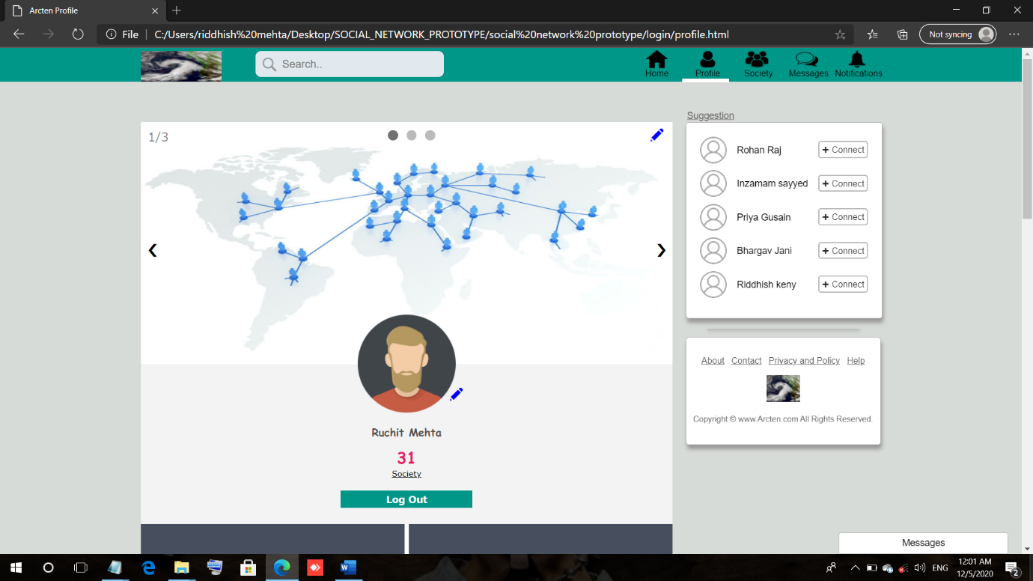

Society

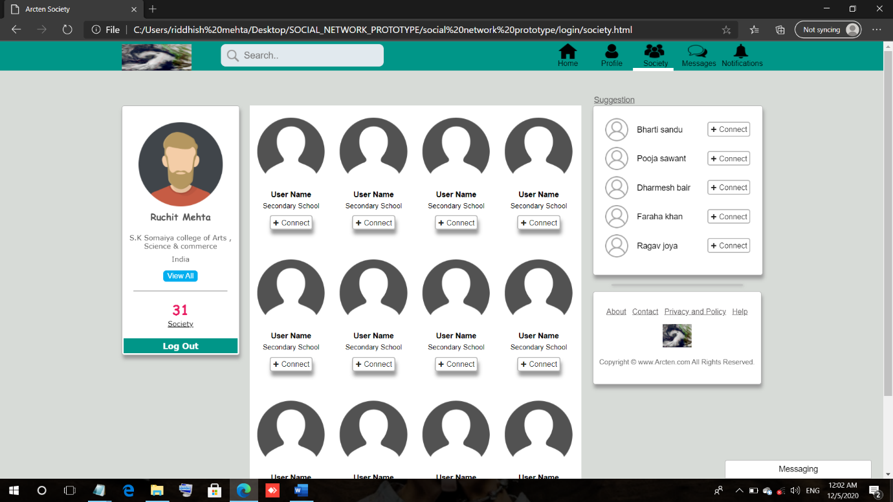

Messages

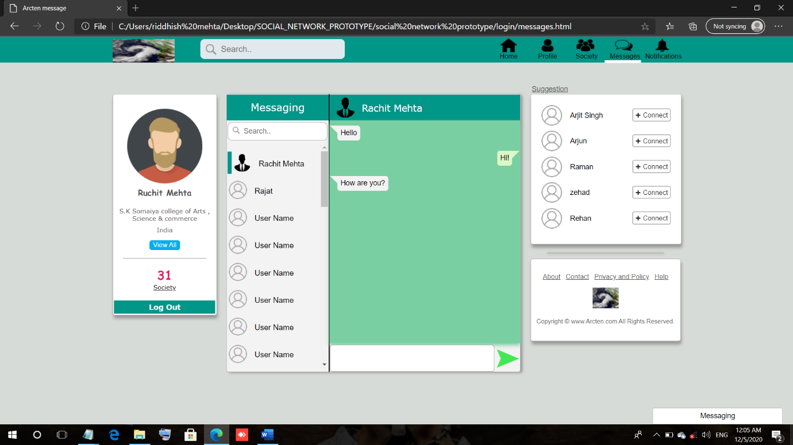

Notification

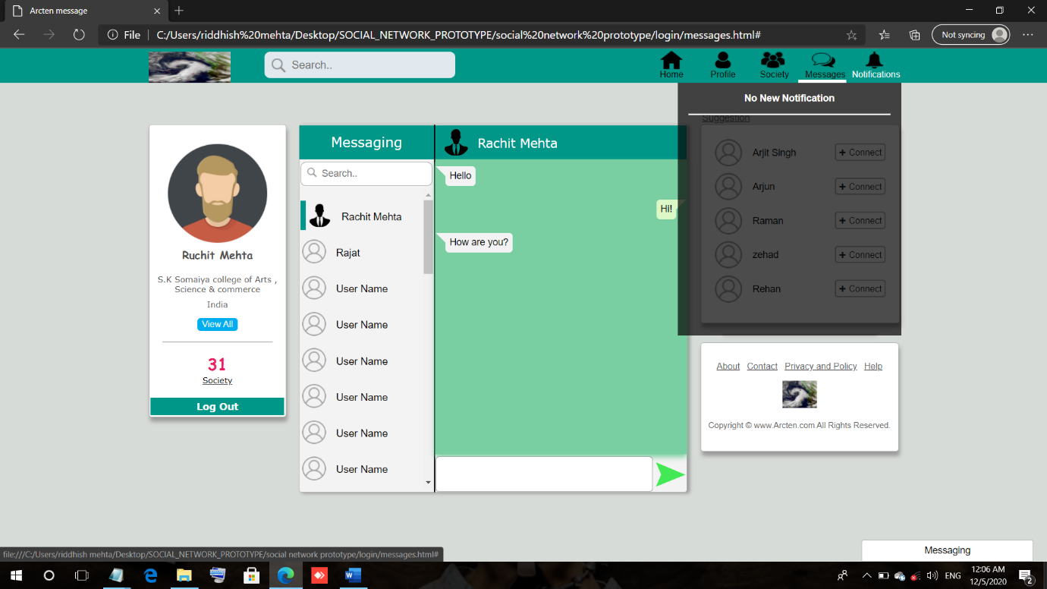

Pending Messages

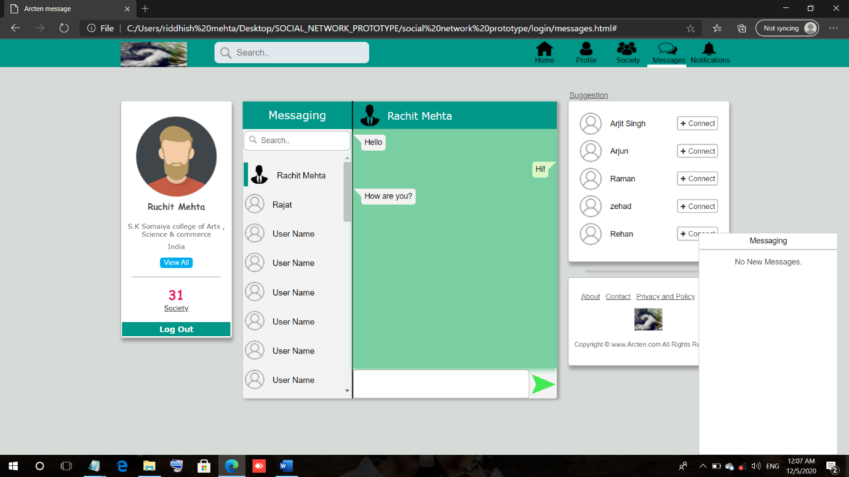

**Future Enhancements**

The software can be developed further to include a lot of modules because the proposed system is developed on the view of future.

With the absence of social gatherings and mandatory social isolation, social media activity and social media consumption is likely to increase dramatically across all demographics. Account usage, new sign ups, and app installations should rise in a bid to replace many forms of face-to-face communication, help users stay informed, and kill time.

Certain businesses may also benefit from heightened usage and potential spikes in organic reach. We are likely to see company updates/announcements posted through these platforms, and even money injected into them to capitalize on a potentially wider, more engaged audience.Social media platforms will continue moving towards uniformity by likes, shares and limiting organic reach through hashtags, contests, and other engagement-boosting techniques.Stripping users’ ability to harness the effect of herd mentality will boost media spend, from influencers in particular, who rely heavily on high engagement rates on their social channels.

**REFERENCES**

**ONLINE REFERENCES:**

* **https://www.geeksforgeeks.org**
* **https://www.tutorialspoint.com**
* **https://www.javatpoint.com**
* **https://www.google.com**