**Customer Churn Analysis and Prediction – Report**

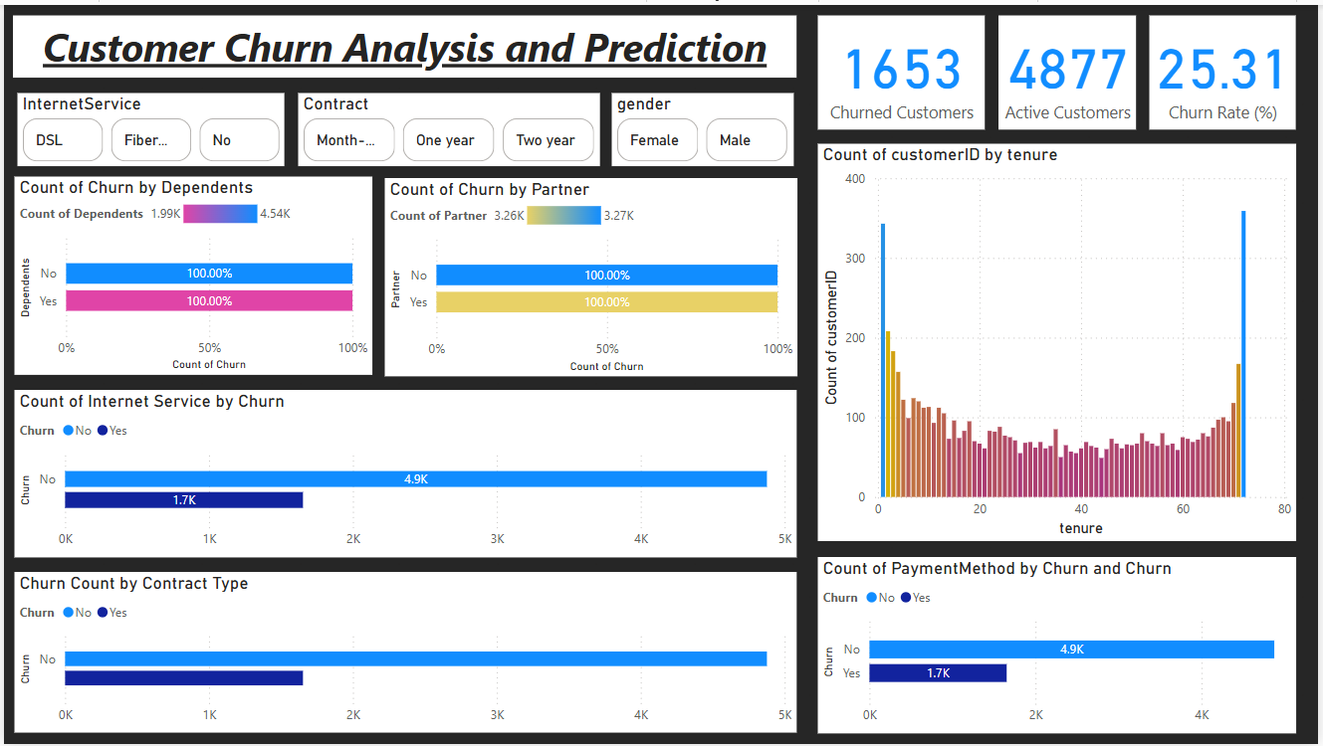

1. Dataset Description

The dataset used in this analysis is a customer churn dataset typically provided by a telecommunications company.   
It includes the following attributes:  
  
- customerID: Unique ID for each customer  
- gender: Whether the customer is a male or a female  
- SeniorCitizen: Whether the customer is a senior citizen or not (1, 0)  
- Partner: Whether the customer has a partner or not (Yes, No)  
- Dependents: Whether the customer has dependents or not (Yes, No)  
- tenure: Number of months the customer has stayed with the company  
- PhoneService: Whether the customer has a phone service or not (Yes, No)  
- MultipleLines: Whether the customer has multiple lines or not  
- InternetService: Customer’s internet service provider (DSL, Fiber optic, No)  
- OnlineSecurity, OnlineBackup, DeviceProtection, TechSupport, StreamingTV, StreamingMovies: Various internet-related services  
- Contract: The contract term of the customer (Month-to-month, One year, Two year)  
- PaperlessBilling: Whether the customer has paperless billing or not (Yes, No)  
- PaymentMethod: The customer’s payment method (Electronic check, Mailed check, Bank transfer, Credit card)  
- MonthlyCharges: The amount charged to the customer monthly  
- TotalCharges: The total amount charged to the customer  
- Churn: Whether the customer has churned (Yes or No)

# 2. Dashboard Insights

## 2.1 KPI Cards

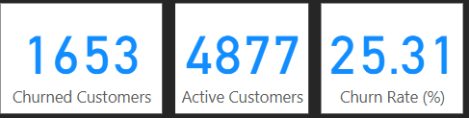

- Churned Customers: 1653  
- Active Customers: 4877  
- Churn Rate: 25.31%  
These KPIs provide an at-a-glance summary of customer retention and churn levels.

## 2.2 Churn by Dependents

Customers without dependents show a higher churn rate. This suggests that customers with family responsibilities might be more stable and less likely to switch providers.

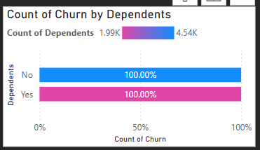

## 2.3 Churn by Partner

Customers who have a partner are slightly less likely to churn compared to those without a partner, indicating possible correlation with lifestyle or stability.

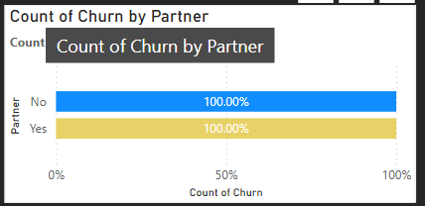

## 2.4 Churn by Internet Service

Fiber optic customers tend to churn more than DSL or No service users. This may point to performance or pricing issues with fiber optic services.

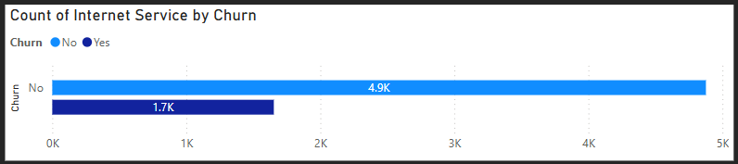

## 2.5 Churn by Contract Type

Customers on Month-to-Month contracts show significantly higher churn than those on One or Two year contracts, suggesting longer contracts improve customer retention.

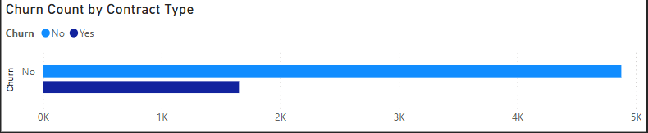

## 2.6 Customer Distribution by Tenure

The tenure distribution reveals higher churn rates among customers with very low tenure. Customers staying longer are less likely to churn.

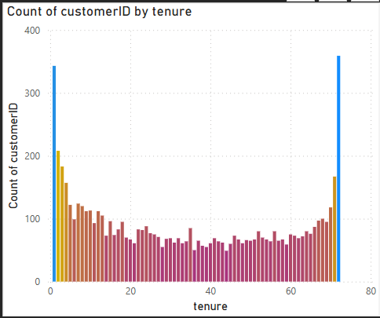

## 2.7 Churn by Payment Method

Electronic Check payment users churn more frequently than users paying via Credit Card, Bank Transfer, or Mailed Check. This might be linked to ease or trust factors.

