# Task 2: Data Visualization and Storytelling

**Objective:** Create visualizations that convey a compelling story.

**Tools:** Power BI

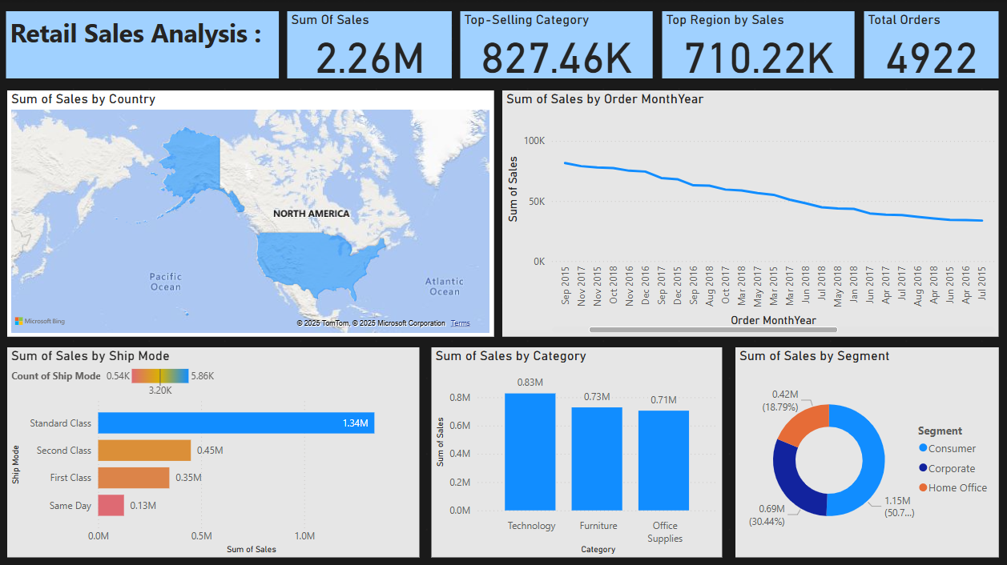

# Retail Sales Analysis Dashboard Report:-

This report presents a comprehensive analysis of retail sales data using a Power BI dashboard. Each visual component has been designed to convey clear business insights related to sales performance, customer segments, shipping preferences, and product categories.

## 1. KPI Highlights

- Total Sales: ₹2.26M  
- Top-Selling Category: ₹827.46K (Technology)  
- Top Region by Sales: ₹710.22K (West)  
- Total Orders: 4922

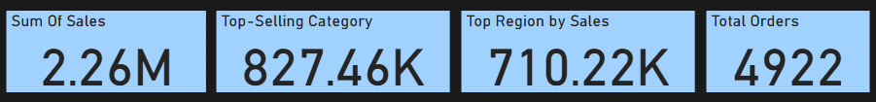  
  
Insight: The business generated over ₹2.2M in revenue, with Technology as the leading category and the Western region contributing the highest sales. A total of nearly 5,000 orders reflects solid engagement.

## 2. Sales by Region (Map Visual)

Insight: The data shows that all sales originate from North America (USA). This emphasizes the need to focus on State and Region-level analysis for effective market strategy.

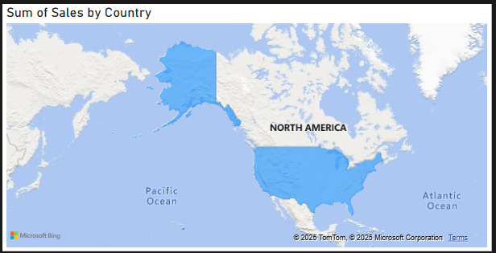

## 3. Sales Trend Over Time

Insight: Sales peaked in late 2018 and declined afterwards. The declining trend might indicate seasonality or external influences affecting demand.

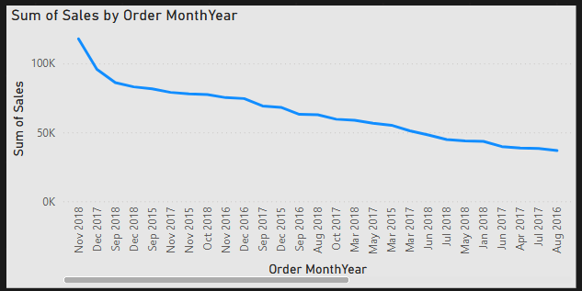

## 4. Sales by Ship Mode

Insight:  
- Standard Class leads with ₹1.34M in sales.  
- Same Day shipping contributes the least.

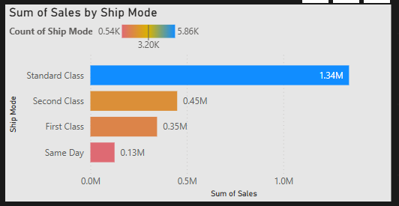  
  
This implies a preference for economical shipping options and suggests room to enhance expedited services.

## 5. Sales by Category

Insight: Technology dominates sales (₹0.83M), but Furniture and Office Supplies also show strong performance, highlighting a well-diversified product base.

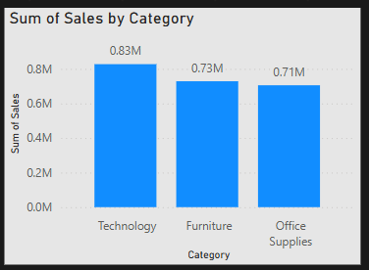

## 6. Sales by Customer Segment

Insight: Consumer segment drives over 50% of total sales. Corporate and Home Office segments have potential for increased targeting through focused campaigns.

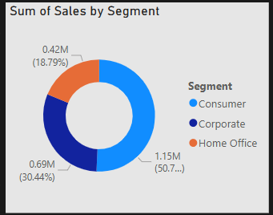

## 7. Summary Insights

- Technology leads category-wise sales.  
- West is the top-performing region.  
- Standard Class dominates shipping preference.  
- Sales are trending down since 2018 – investigate seasonal or external factors.  
- Strong consumer base, but Corporate/Home Office can be leveraged further.