**Task_06 :SQL Script**

**Objective:** Analyze monthly revenue and order volume.

**Tools:** MySQL

# Database Setup

CREATE DATABASE IF NOT EXISTS online_sales_db;  
USE online_sales_db;

# Data Preview

SELECT * FROM `online sales data`;

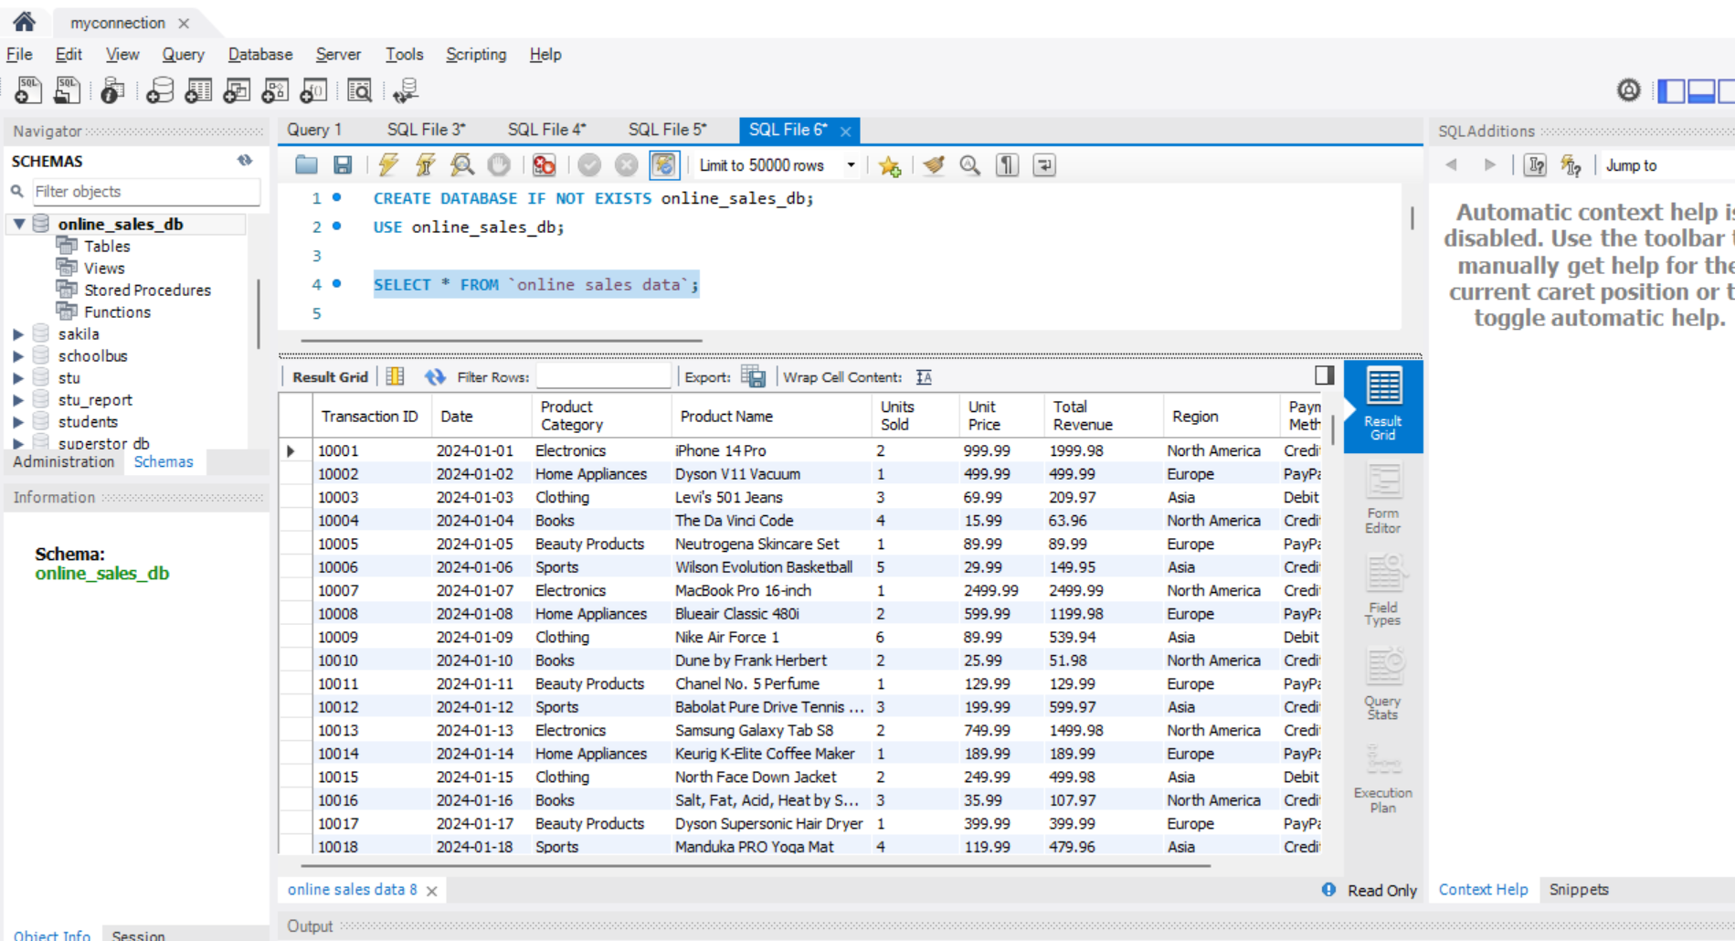

# Preprocessing Checks

## 1. Check for missing dates

SELECT COUNT(*) AS null_dates  
FROM `online sales data`  
WHERE `Date` IS NULL;

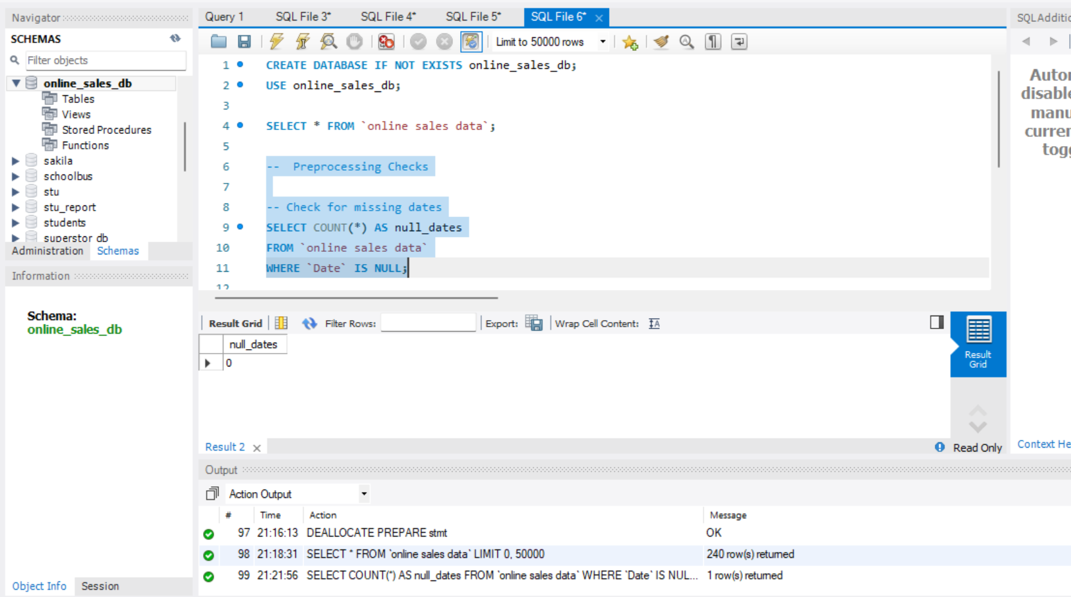

## 2. Check for negative or zero total revenue

SELECT COUNT(*) AS invalid_total_revenue  
FROM `online sales data`  
WHERE `Total Revenue` <= 0;

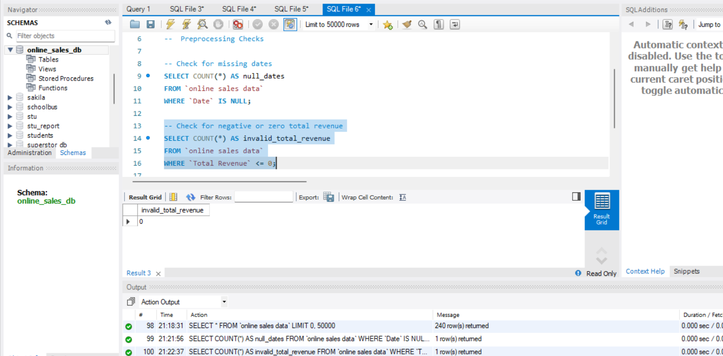

## 3. Check for duplicate Transaction IDs

SELECT `Transaction ID`, COUNT(*) AS count  
FROM `online sales data`  
GROUP BY `Transaction ID`  
HAVING count > 1;  
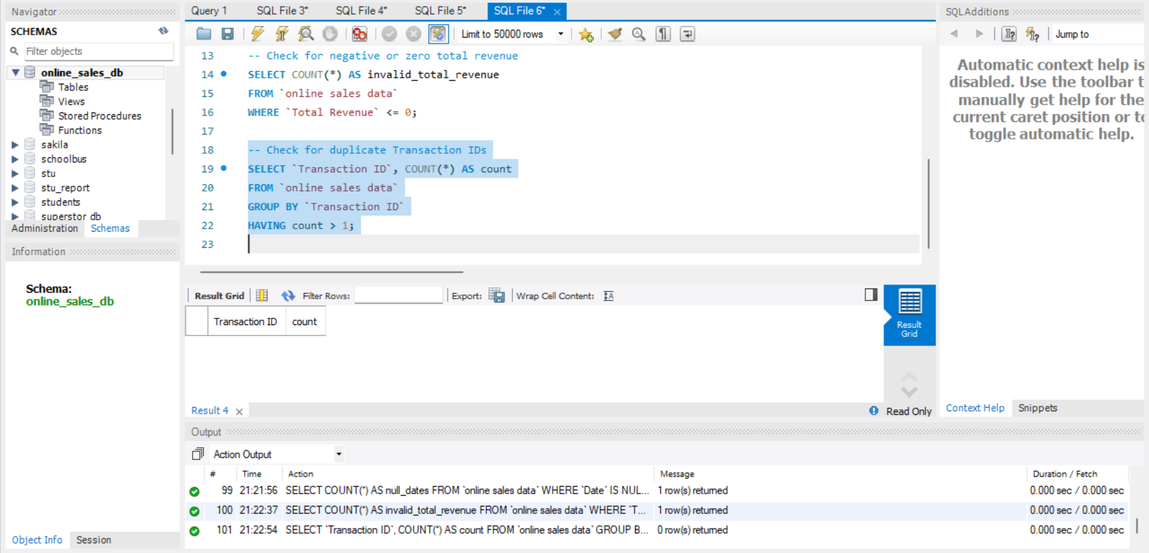

# Sales Trend Analysis Using Aggregations

## 1. Monthly revenue and order volume

SELECT  
 YEAR(STR_TO_DATE(`Date`, '%Y-%m-%d')) AS order_year,  
 MONTH(STR_TO_DATE(`Date`, '%Y-%m-%d')) AS order_month,  
 SUM(`Total Revenue`) AS monthly_revenue,  
 COUNT(DISTINCT `Transaction ID`) AS order_volume  
FROM  
 `online sales data`  
GROUP BY  
 order_year,  
 order_month  
ORDER BY  
 order_year, order_month;

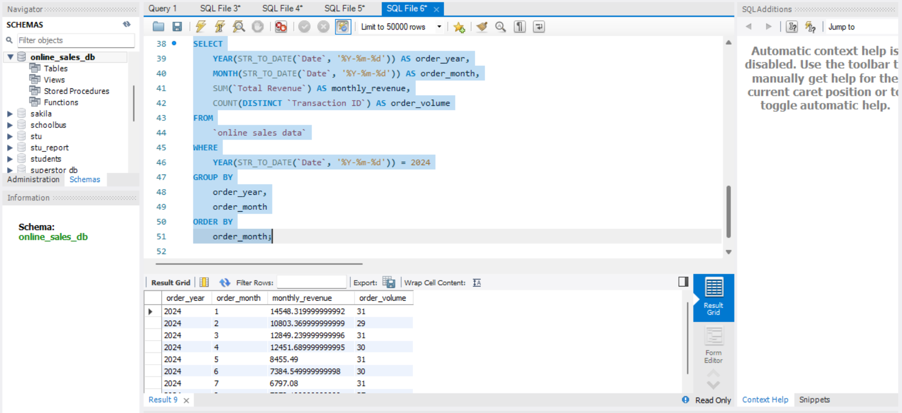

## 2. Monthly revenue and order volume for the year 2024

SELECT  
 YEAR(STR_TO_DATE(`Date`, '%Y-%m-%d')) AS order_year,  
 MONTH(STR_TO_DATE(`Date`, '%Y-%m-%d')) AS order_month,  
 SUM(`Total Revenue`) AS monthly_revenue,  
 COUNT(DISTINCT `Transaction ID`) AS order_volume  
FROM  
 `online sales data`  
WHERE  
 YEAR(STR_TO_DATE(`Date`, '%Y-%m-%d')) = 2024  
GROUP BY  
 order_year,  
 order_month  
ORDER BY  
 order_month;

