**Task 8:** Superstore Sales Performance Dashboard

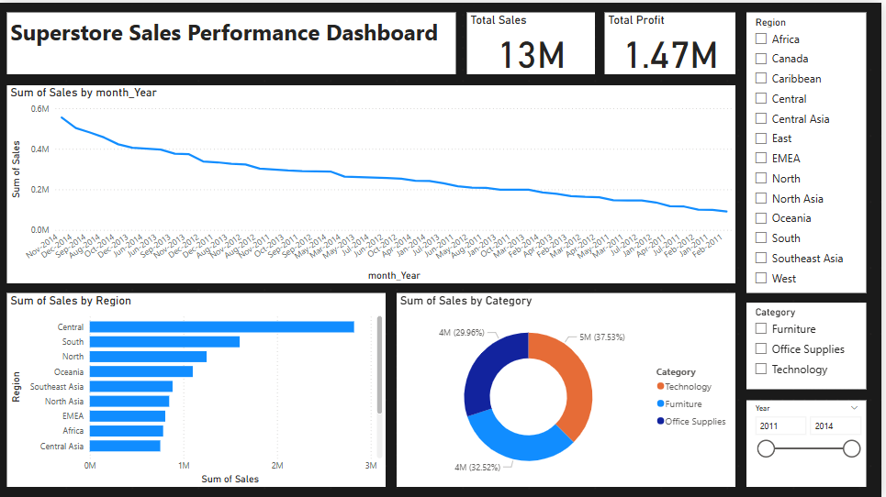

# Objective

To create a clean, interactive dashboard that shows sales performance by Month, Region, and Category, and allows filtering to help business users make data-driven decisions.

# Tools Used

- Power BI Desktop (for dashboard design)

- Power Query (for data preprocessing and transformations)

# Dataset

File: superstore.csv  
Columns used:  
- Order Date (transformed into Month-Year)  
- Region, Category, Sales, Profit, Year

# Preprocessing Done

1. Cleaned `Order.Date` column to remove time (00:00:00)  
2. Created a new `Month-Year` column for time-based trend analysis  
3. Added a `Month Index` column to ensure chronological sorting of months  
4. Verified data types (e.g., Date, Text, Numeric)  
5. Removed or ignored irrelevant columns like Row ID, Customer ID

# Dashboard Components

## 1. Total KPIs

- Total Sales: 13M

- Total Profit: 1.47M

## 2. Line Chart: Sales Over Time

- X-axis: Month-Year  
- Y-axis: Sales  
- Shows overall sales trend from 2011–2014

## 3. Bar Chart: Sales by Region

- Compares performance of different regions  
- Central region has the highest sales

## 4. Donut Chart: Sales by Category

- Shows sales share of:  
 - Technology  
 - Furniture  
 - Office Supplies

## 5. Slicers for Interactivity

- Region Filter  
- Category Filter  
- Year Range Slider

# Insights Observed

- Sales have a declining trend from 2011 to 2014  
- Central region had the highest sales volume  
- Furniture and Technology together make up nearly 70% of total sales  
- Q4 months generally show higher sales across years