**Task 4:** Dashboard Design

**Objective:** Design an interactive dashboard for business stakeholders.

**Tool:** Power BI

**Sales Performance Dashboard Summary**

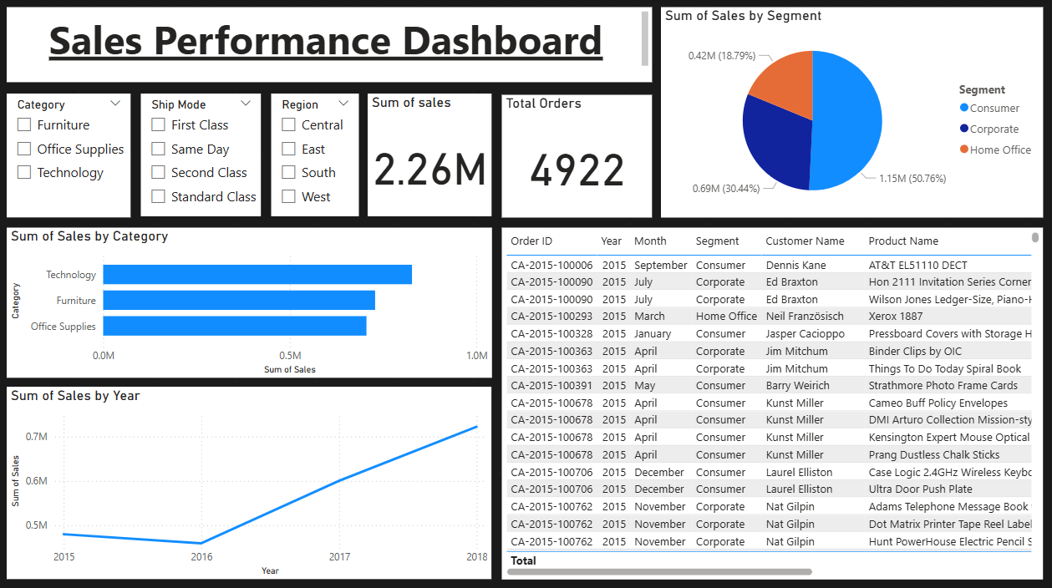

# 1. Dataset Description

The dataset used in this dashboard contains 9,800 rows of transactional sales data.   
It includes fields such as Order ID, Order Date, Ship Date, Customer Name, Segment, Category, Sub-Category, Sales, Region, State, and Product Name.  
The objective of this dashboard is to analyze sales performance across categories, segments, regions, and over time to support business decision-making.

# 2. Data Preprocessing

The following preprocessing steps were performed before creating the dashboard:  
- Removed unnecessary columns like Row ID.  
- Converted 'Order Date' and 'Ship Date' to proper date formats.  
- Created new measures for Total Sales, Total Orders, and Average Sales.  
- Handled 11 missing values in Postal Code (optional drop or fill).

# 3. Dashboard Components and Descriptions

* - Cards (Top Section):

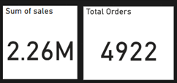

• Total Sales: Displays the total revenue generated from all transactions.  
 • Total Orders: Shows the count of unique Order IDs to represent total customer orders.  
 • These KPIs give a quick overview of business volume.

* - Line Chart (Bottom-Left):

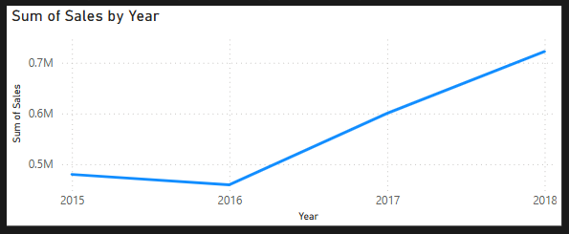

• Visualizes sales trends over the years 2015–2018.  
 • Helps stakeholders analyze performance progression and growth across time.

* - Bar Chart (Middle-Left):

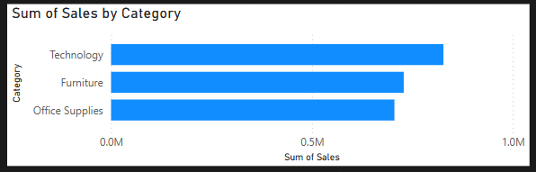

• Displays total sales grouped by Product Category.  
 • Useful for identifying which categories contribute the most to overall revenue.

* - Pie Chart (Top-Right):

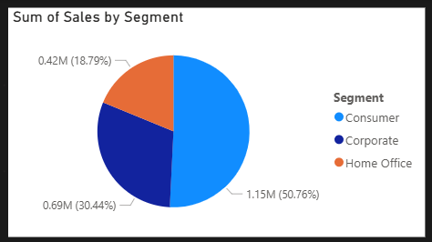

• Represents sales distribution across customer segments: Consumer, Corporate, and Home Office.  
 • Indicates market dominance and customer focus areas.

* - Table (Bottom-Right):

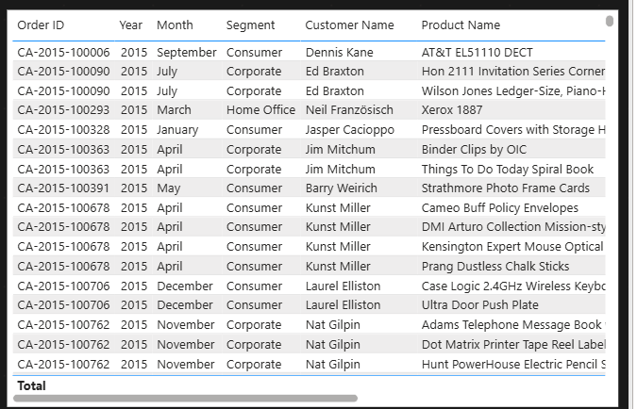

• Displays detailed records including Order ID, Year, Month, Segment, Customer Name, and Product Name.  
 • Enables granular-level analysis and transaction tracking.

* - Slicers (Top Filters):

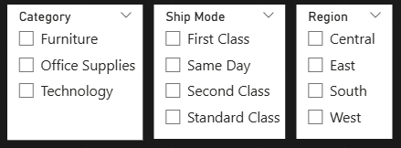

• Provide dynamic filtering by Category, Ship Mode, and Region.  
 • Enhance interactivity, allowing stakeholders to drill down into specific segments.

# 4. Key Insights

- The Consumer segment generates the highest sales among all segments.  
- Technology is the most profitable category based on total sales.  
- Year-over-year sales are increasing steadily from 2016 to 2018.  
- Region-wise sales insights can guide targeted strategies.

# 5. Dashboard Screenshot

