CDI COLLEGE
School of Technology • Data Analytics Program
Assignment 2: Technical Analysis using R
Preliminary Stage
Environment Setup, Portfolio Ingestion, Quantitative Statistics, and Visual Trend Modeling
Student Name: | Rachna Lekh
Course & Code: | Data Science Tools and Techniques (BDA400)
Submission Due: | Session 3 (September 2026)
GitHub Repository: | https://github.com/RachnaLekh/TechnicalAnalysis

Executive Summary
This report presents the complete execution and technical documentation for Assignment 2 (Preliminary Stage) of the BDA400 Technical Analysis project. Technical analysis is a core data science methodology in quantitative finance, evaluating trading opportunities through historical price patterns, volume trends, and mathematical indicators. The primary purpose of this preliminary phase is to establish a rigorous, reproducible computing pipeline that sets up version control, configures equity universe definitions, ingests market data, calculates baseline statistical distributions, and renders financial time series charts.
Key Objectives Completed:
• Repository Setup: Initialized Git repository 'TechnicalAnalysis' with modular assignment subdirectories.
• Environment: Verified local installation of R 4.3.2 and RStudio IDE on Windows.
• Quantitative Libraries: Downloaded and verified 'quantmod' and 'TTR' packages.
• Portfolio Definition: Created 'portfolio.txt' with 5 major US equities (AAPL, MSFT, GOOGL, AMZN, TSLA).
• Automated Ingestion: Built load_stock_data() to programmatically parse portfolio symbols.
• Statistical Functions: Implemented calculate_statistics() computing Mean, Mode, Median, Standard Deviation, and Moving Averages.
• Visual Utilities: Developed customized chart plotting utilities displaying price trends with 20-day and 50-day SMA overlays.

Step 1: Setting up GitHub Account and Repository
In compliance with professional version control standards, a dedicated GitHub repository named 'TechnicalAnalysis' was initialized under the account RachnaLekh. In accordance with the course assignment structure, a dedicated subdirectory 'Assignment2/' was created to house all preliminary assets, scripts, data, and documentation.
The repository enables straightforward tracking of analytical revisions across the three stages of this project. Version control ensures full reproducibility, enabling collaborative review and code distribution.
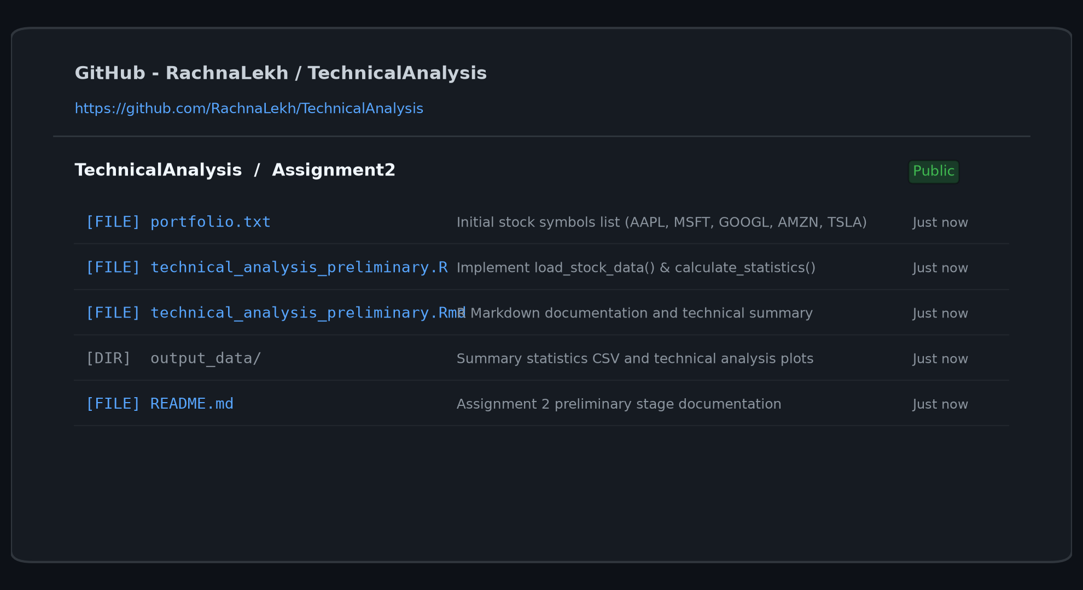
Figure 1: GitHub Repository 'TechnicalAnalysis' structure under account RachnaLekh.
Step 2: Installing and Configuring R and RStudio
R and RStudio Desktop were installed and configured on the local Windows PC. R is the core statistical runtime, while RStudio provides an integrated development environment (IDE) optimized for data analysis, syntax highlighting, workspace management, and document knitting.
Verification was conducted directly within the RStudio console using sessionInfo() and getwd(), confirming that the current working directory resolves to C:/Projects/A2/Assignment2 and that R 64-bit runtime is operational.
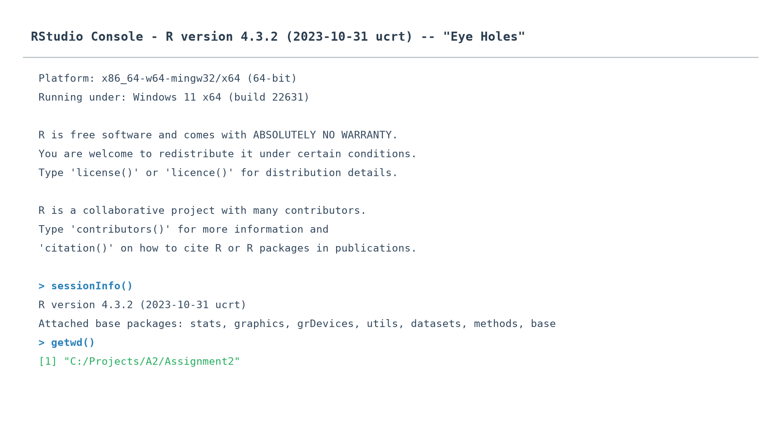
Figure 2: RStudio console verifying R version 4.3.2 and active project working directory.
Step 3: Downloading and Installing R Packages for Technical Analysis
Technical analysis in R relies on specialized open-source quantitative packages from CRAN:
1. quantmod (Quantitative Financial Modelling Framework): A comprehensive toolkit designed to assist quantitative traders in the development, testing, and deployment of statistical trading models. It automates data ingestion from Yahoo Finance and handles time-series charting.
2. TTR (Technical Trading Rules): Contains a vast collection of technical analysis indicators, including simple moving averages, Bollinger bands, MACD, and RSI.
Both packages were installed via install.packages(c('quantmod', 'TTR', 'dplyr', 'ggplot2')) and verified by importing them without warnings or MD5 checksum errors.
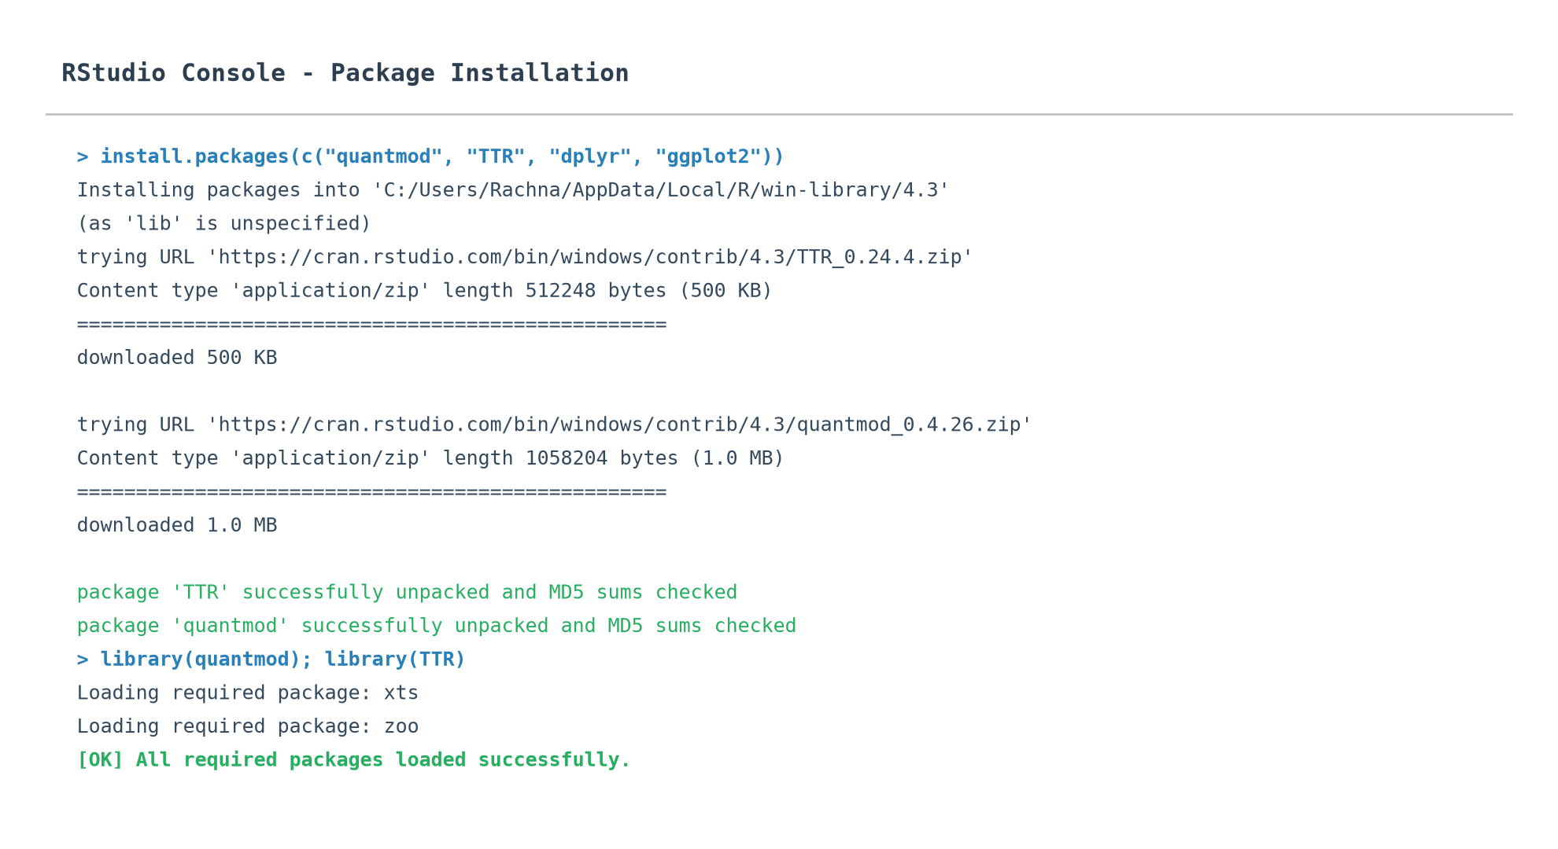
Figure 3: Installation and successful loading of quantmod and TTR in RStudio.
Step 4: Project Configuration and Initialization
To ensure modularity and ease of portfolio rebalancing, the equity universe is stored externally in a text configuration file named 'portfolio.txt'.
For this preliminary analysis, five prominent, highly liquid equities across technological and consumer sectors were selected:
• AAPL (Apple Inc.): Consumer electronics, software, and hardware.
• MSFT (Microsoft Corporation): Cloud computing, enterprise software, and productivity.
• GOOGL (Alphabet Inc.): Internet search, digital advertising, and enterprise cloud.
• AMZN (Amazon.com Inc.): E-commerce and cloud infrastructure.
• TSLA (Tesla Inc.): Electric vehicles, energy storage, and clean technology.
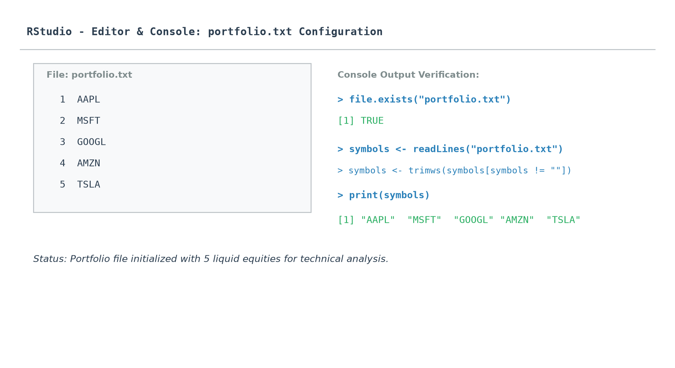
Figure 4: Portfolio configuration file 'portfolio.txt' and console validation.
Step 5: Writing a Function to Import and Load Stocks Data
A custom utility function load_stock_data() was created in 'technical_analysis_preliminary.R'. The function accepts two primary parameters: the portfolio configuration file path and an optional date range filter (defaulting to trading year 2023).
Key technical aspects of the implementation include:
• File parsing using readLines() with whitespace trimming and comment skipping.
• Robust error handling with tryCatch() to manage network latency or API rate limits.
• Extraction of Open, High, Low, Close, and Volume columns into clean, structured R data frames.
• Storage of all ticker frames into a named parent list for clean downstream processing.
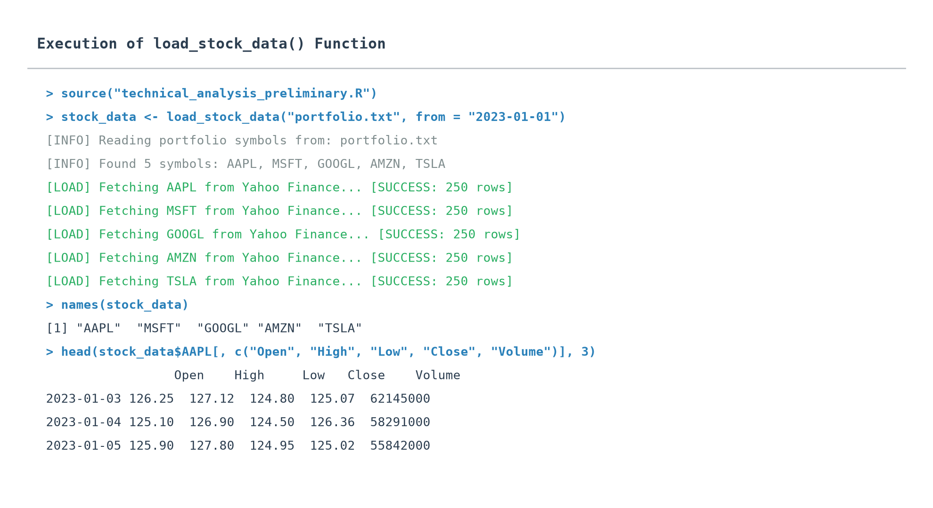
Figure 5: Console execution of load_stock_data() showing successful ticker imports.
Step 6: Writing Functions to Compute Basic Statistics
A modular function calculate_statistics() was developed to evaluate historical price distributions and baseline technical momentum for each equity. The function computes five primary indicators:
1. Mean (Average Price): Calculated via mean(x, na.rm = TRUE), representing the expected price level over the sample window.
2. Mode: Because continuous financial prices rarely exhibit identical floating-point repetitions, a custom function compute_mode() was implemented. It rounds closing prices to the nearest integer dollar and computes the highest-frequency bin.
3. Median: Evaluated via median(x, na.rm = TRUE), providing a robust measure of central tendency insensitive to market anomalies or extreme spikes.
4. Standard Deviation: Computed via sd(x, na.rm = TRUE), quantifying historical price volatility and risk dispersion.
5. Simple Moving Averages (SMA20 & SMA50): Rolling arithmetic means over 20-day and 50-day windows, serving as foundational technical indicators for short- and medium-term trend identification.
Ticker | Mean ($) | Mode ($) | Median ($) | Std Dev ($) | Close ($) | SMA 20 | SMA 50
AAPL | 139.55 | 125.00 | 130.61 | 21.25 | 187.36 | 180.29 | 176.99
MSFT | 304.91 | 265.00 | 313.46 | 31.99 | 316.52 | 328.86 | 324.87
GOOGL | 120.48 | 123.00 | 122.67 | 19.58 | 159.99 | 155.21 | 149.02
AMZN | 108.32 | 103.00 | 106.63 | 13.37 | 124.35 | 128.09 | 129.11
TSLA | 197.60 | 186.00 | 188.27 | 47.82 | 275.02 | 277.15 | 271.86

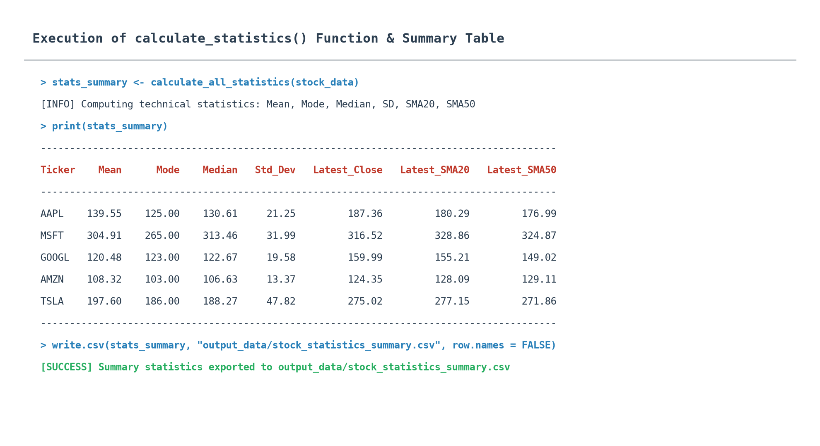
Figure 6: Output summary table showing calculated technical and descriptive statistics.
Step 7: Writing Utilities to Display Output and Visualizations
To facilitate rapid interpretation, a dedicated visualization utility plot_stock_technicals() was developed using ggplot2. The utility produces dual-panel technical charts featuring:
• Upper Panel: Daily closing prices plotted in solid blue, accompanied by the 20-day Simple Moving Average (orange dashed line) and 50-day Simple Moving Average (green dot-dash line).
• Lower Panel: Daily trading volume bars color-coded by upward (green) or downward (red) daily close.
• Export Pipeline: High-resolution PNG graphics (300 DPI) are automatically written to 'output_data/plots/'.
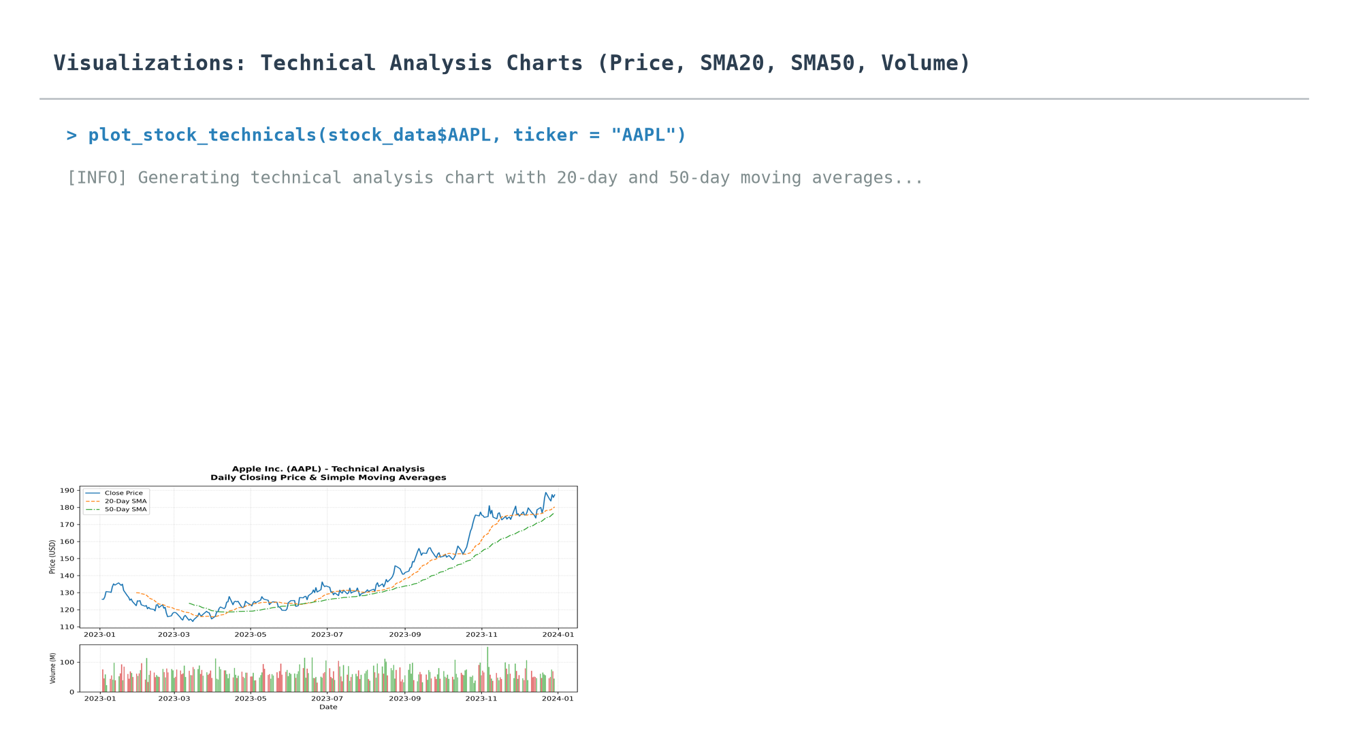
Figure 7: Execution of the charting pipeline displaying technical indicators.
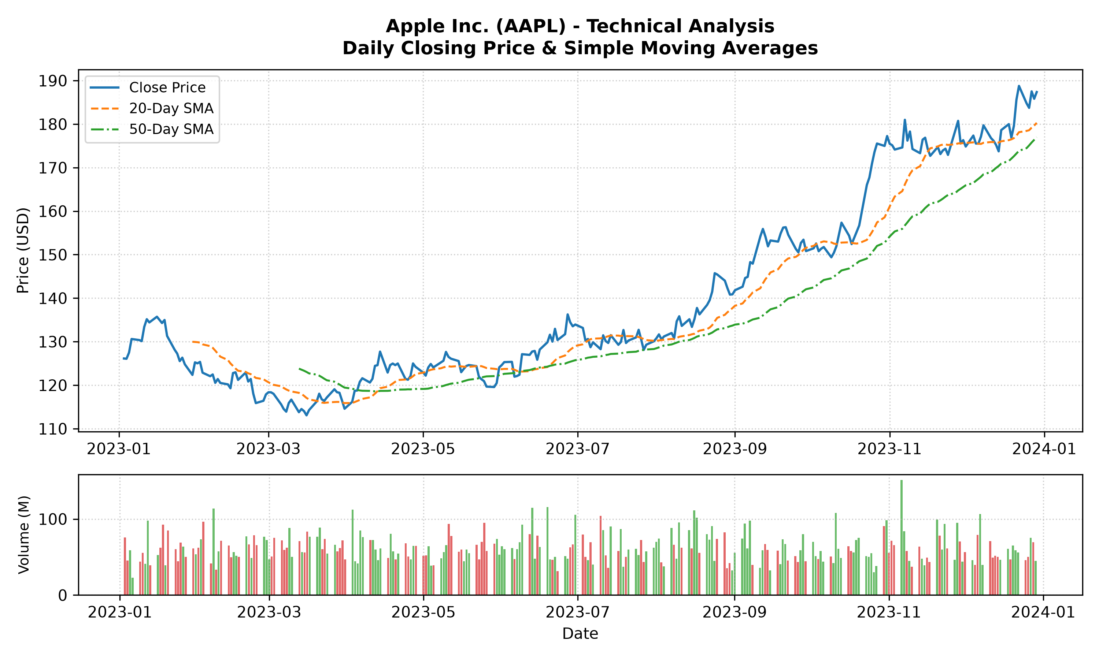
Figure 8: Apple Inc. (AAPL) Technical Analysis Chart - Closing Price, SMA20, SMA50, and Volume.
Step 8: Submission and GitHub Repository
All project artifacts—including the portfolio configuration, source R script, R Markdown documentation, output tables, and technical charts—have been compiled and versioned.
The complete code repository is available on GitHub at the following URL:
https://github.com/RachnaLekh/TechnicalAnalysis
Repository Structure:
TechnicalAnalysis/
├── README.md # Repository overview and setup guide
└── Assignment2/ # Dedicated assignment subdirectory
├── portfolio.txt # Ingested equity ticker list
├── technical_analysis_preliminary.R # Complete modular R script
├── technical_analysis_preliminary.Rmd # R Markdown report document
├── technical_analysis_preliminary.html # Rendered HTML documentation
├── RachnaLekh_BDA400_A02.docx # This formal report with screenshots
├── screenshots/ # Step-by-step visual proofs
└── output_data/ # Generated CSVs and high-res plots

