TOPS TECHNOLOGY

**Software Engineering Assignment**

MODULE – 1

**SE – Overview of IT Industry**

Prepared By:

RACHNA PANDYA

1. **What is software ? what is software engineering ?**

Software is a set of instruction, data or program that are used to operate computers and execute specific task. The two main categories of software are **Application Software** and **System Software**.

The term software engineering is the product of two words :**software** and **engineering**.

The **software** is a collection of integrated programs.

Software subsist of carefully organized instructions and code written by developers on any of various particular computer languages.

**Engineering** is the application of scientific and parctical knowledge to invent , design, build, maintain, and improve frameworks, process….

Software engineering includes a variety of techniques, tools and methodologies, including requirements analysis, design, testing and maintenance.It is mainly used for large projects based on software systems rather than single programs or applications.

1. **Explain types of software**

The two main type of software is : System Software and Application Software

1. **System software :**

System software is software that directly operates the computer hardware and provides the basic functionality to the users as well as to the other software to operate smoothly.It is like interface between hardware and user application. It helps them to communicate with each other because hardware understand machine language.

**Types of system software :**

**Operating system:** It is the main program of a computer system.When the computer system ON it is the first software that loads into the computer’s memory. Examples of operating system are Linux, Apple macOS, Microsoft Windows etc.

**Language processor:** As we know that system software converts the human-readable language into a machine language. So, the conversion is done by the language processor. It converts programs witten in high level programming languages like python,Java,C,C++, etc, into sets of instructions that are easily readable by machines.

**Device Driver :**

A device driver is a program or software that controls a device and helps that device to perform its functions. Every device like a printer, mouse, modem etc. needs a driver to connect a new device with your computer system, first you need to install the driver of that device so that your os knows how to control or manage that device.

1. **Application Software:**

Software that performs special function or provides functions that are much more than the basic operation of the computer is known as application software.

**Types Of Application Software**

1. **General purpose software:**

This type of application software is used for a variety of tasks and it is not limited to performing a specific task only. For example, MS-Word, MS-Excel, PowerPoint etc.

1. **Customized Software:**

This type of application software is used or designed to perform specific tasks or functions or designed for specific organization system, invoice management system, etc. For example railway or airline reservation system

1. **Utility software:**

This type of app software is used to support the computer infrastructure. It is designed to analyze, configure and maintain the system. For example, Antivirus, disk space analyzer, disk cleaners

**3.what is SDLC ? Explain each phase of SDLC.**

SDLC stands for software development life cycle. It is a structured process that is used to design, develop, and test good quality software.

SDLC model involves six phases while developing any software.

**Stage 1: Planning and Requirement Analysis**

Planning is a important step in everything.It is performed by the developers of the organization. The information from this analysis forms the building blocks of a basic project. The quality of the project is a result of planning.

**Stage 2: Defining Requirements**

In this stage all the requirements for the target software are specified. These requirements get approval from customers, market analysts, and stakeholders. This is fulfilled by utilizing software requirement specification(SRS).

**Stage 3: Designing Architecture**

SRS is a reference for software designers to come up with the best architecture for the software. Requirements defined in SRS, multiple designs for the product architecture are present in the Design Document Specification(DDS).

**Stage 4: Developing Product**

At this stage, the fundamental development of the product starts. For this, developers use a specific programming code as per the design in the DDS. It is important for the coders to follow the protocols set by the association. Some popular languages like c/c++, Python, Python. Java etc. are put into use as per the software regulations.

**Stage 5: Product Testing and Integration**

After the development of the product, testing of the software is necessary to ensure its smooth execution. Minimal testing is conducted at the every stage of SDLC. The development team combines automation and manual testing to check the software for bugs.

**Stage 6: Deployment and Maintenance of Products**

After detailed testing, the conclusive product is released in phases as per the organization’s strategy. Then it is tested in a real industrial environment. It is important to ensure its smooth performance.

1. **What is DFD ? Create DFD on Flipkart**

A Data Flow Diagram is a traditional visual representation of the information flows within a system. A neat and clear DFD can depict the right amount of the system requirement graphically. It can be manual, automated or a combination of both.

**DFD ON FLIPKART**

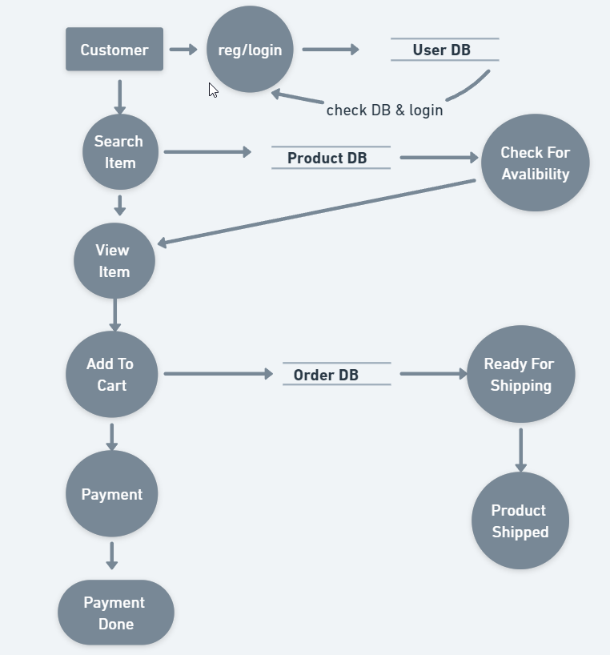

**5 What is flowchart ? Create a flowchart to make addition of two numbers.**

A flowchart is a type of diagram that represents algorithm, workflow or process. The flowchart shows the steps as boxes of various kinds and their order by connecting the boxed with arrows. This diagrammatic representation illustrates a solution model to a given problem.

**---Flowchart on addition of two numbers---**

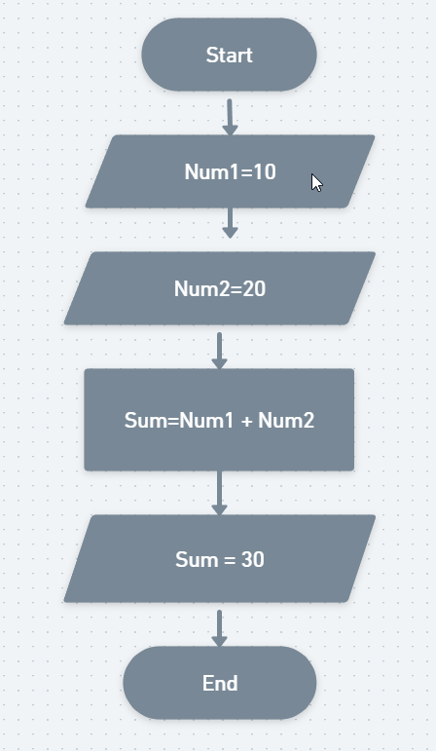

**6 What is use case diagram ? Create a use case on bill payment on paytm.**

A use case digram is a way to summarize details of system and the users within that system. It provides a visual representation of how users interact with a system. It serves as a blueprint for understanding the functional requirements of a system.

The main purpose of use case diagram is to portray the dynamic aspect of a system.

**Use case diagrams can be used for :**

* Requirements analysis and high level design
* Model the context of a system

**Components of Use Case Diagram :**

* **Actors :** They can be individuals, groups or externam system.
* **Use Cases** : These are the specific actions or processes that the actors can perform within the system.
* **System** : It is sometimes represented as a rectangle the encompasses all the use cases, indicating the boundary of the system.
* **Relationships** : These are the connection between actors and use cases.

**USD ON PAYTM**

