Mission and Goals
Our goal is not to provide a stand-alone web portal to use out-of-the box. There is enough of that out there and we will never compete with the given capacity in time and effort.
We would like to:
- Build a platform that developers can use to build their own portal-alike systems.
- Provide a couple of starter applications (currently only an asp.net web forms app) that will serve as a reference in development.

Functionality Layers
In order to facilitate their platform driven development activities we need to define. We
Product Layer | Our customers will have the responsibility to build their products using as a reference our starter applications or even choosing to start from scratch.
Platform Layer | This is what this project delivers to portal developers.
Product Line Layer | What is used selectively by the products.
Common Layer | What is used always by all the products.
Cross-Cutting & 3rd Party | What is not a primary concern of the portal but is needed to support infrastructure.  We aim to use open source 3rd Party like “Unity” instead of developing on our own.
The following layer diagram denotes usage by stacking and containment.
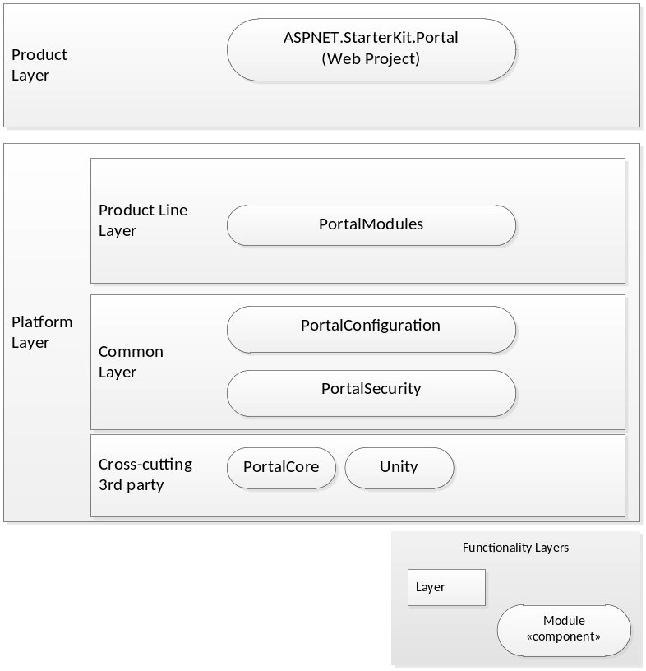

Allocation in namespaces
In order to facilitate easier development and less refactoring we have decided to use a rather flat package (namespace in .net terminology) structure.
We partition namespaces based on the implementations of the data access we provide. Long term this will have to change according to the Layered architecture that we will define.
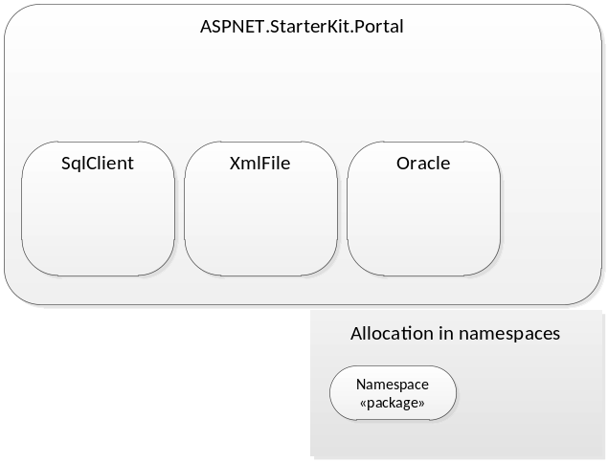

Seperation of Concerns
We currently offer a very simple layered architecture where we simply separate the Presentation from Data Access. This is far from being complete but it allows an easier transition from the legacy “monolithic” portal to a newer more granular design. The drawback of this simple design is that a lot of Business Logic and User Interface Process are being hard coded within the Presentation layer.
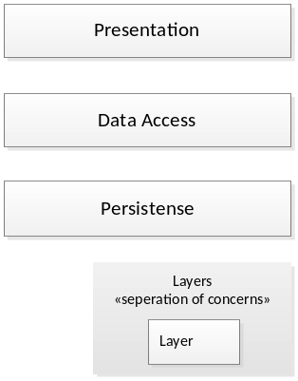
In the long run we will aim for separating the Business Logic and User Interface Process from the Presentation by providing a service layer. We will skip a business layer since there is no need for multiple service layers. The presentation can get access to the Service Layer in-process or via the Service Agent “proxy”.
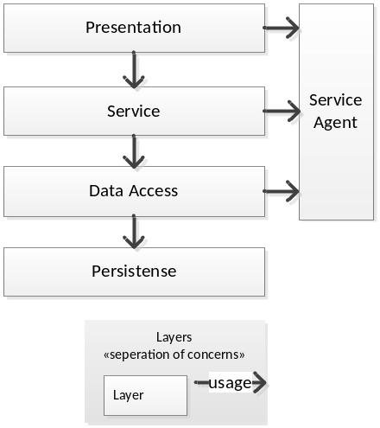

Component Layering
Every component will have its own layering and in order to enforce component orthogonally we will allow access to another component only through well-defined ports. Currently a component has no Presentation to offer. We focus on isolating the persistence (e.g. database schema) and providing well defined and controlled access through the Data Access Layer (according to the usage inferred in the functionality layers chapter).
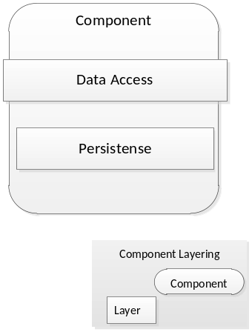
One of the immediate goals is to also include some presentation in the platform. The access offered by the presentation layer will need to adhere to some plugging architecture and will also need to variate per technology we need to support (web forms, mvc, Silverlight, HTML5, etc).
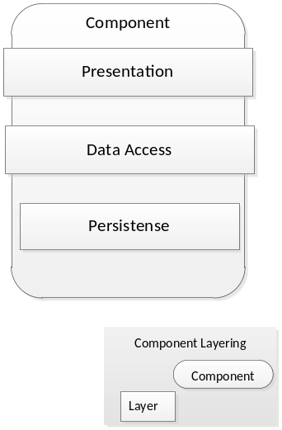
The allowed access between components will be only through the Data Access Layers.
- A Presentation of one component cannot use the Data Access of another. E.g. a View from PortalConfiguration to pull data directly from the Data Access of PortalSecurity. This would break the orthogonally of PortalSecurity.
- A Data Access of one component cannot use Persistence of another. E.g. the data access of PortalConfiguration to use a table or SPROC of PortalSecurity.
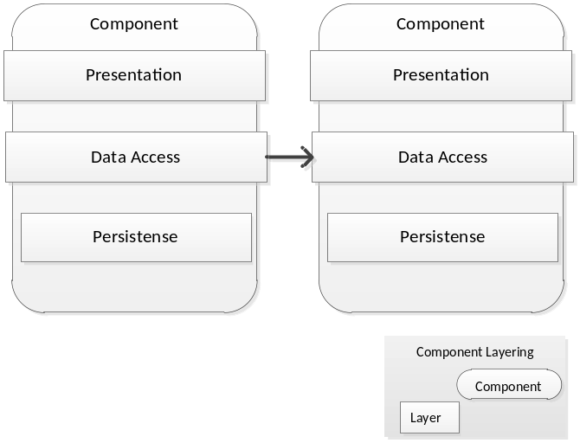
When we finally introduce the Service Layer things get a bit trickier.
- Data Access layers will be internalized.
- A Service can access another component only through the service layer; in-process or invoking a service instance through the Service Agent.
