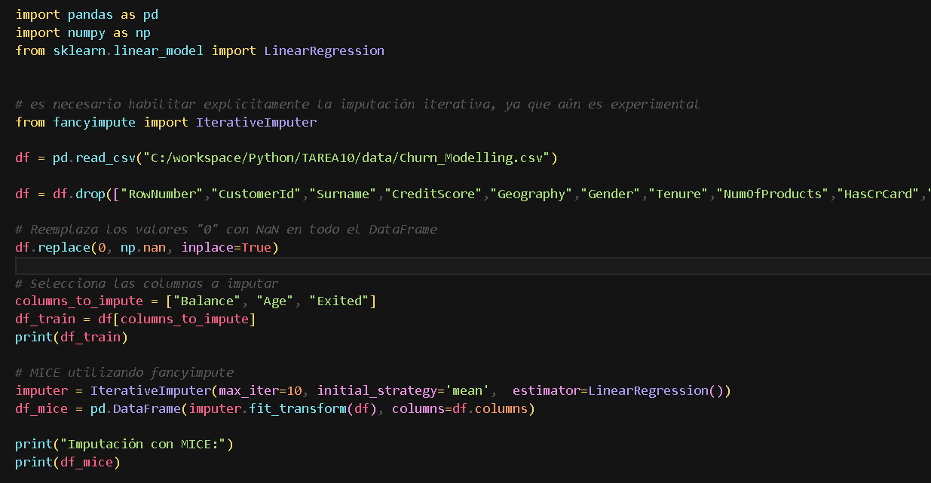

import pandas as pd

import numpy as np

from sklearn.linear_model import LinearRegression

from fancyimpute import IterativeImputer

df = pd.read_csv("C:/workspace/Python/TAREA10/data/Churn_Modelling.csv")

df = df.drop(["RowNumber","CustomerId","Surname","CreditScore","Geography","Gender","Tenure","NumOfProducts","HasCrCard","IsActiveMember","EstimatedSalary"], axis=1)

# Reemplaza los valores "0" con NaN en todo el DataFrame

df.replace(0, np.nan, inplace=True)

# Selecciona las columnas a imputar

columns_to_impute = ["Balance", "Age", "Exited"]

df_train = df[columns_to_impute]

print(df_train)

# MICE utilizando fancyimpute

imputer = IterativeImputer(max_iter=10, initial_strategy='mean', estimator=LinearRegression())

df_mice = pd.DataFrame(imputer.fit_transform(df), columns=df.columns)

print("Imputación con MICE:")

print(df_mice)