ASMi-54L

2W and 4W

Final Test Instructions

Last Updated: 03/02/13

Contents

1 Required Test Equipment 4

11. P/S-AC/48/200 4

12. MPF/DC/120V 4

2 Preparations for Testing 4

3 Visual Inspection 4

4 Basic Operational Tests 4

4.1 Automated BOT 4

4.2 Manual BOT 4

5 Environmental Stress Screening (ESS) 5

6 Automated Final Tests 5

6.1 Complementary Tests (Manual) 5

6.2 Automatic Tester Setup 5

6.3 Running the Test 5

7 Manual Final Tests 5

7.1 Identification Test 5

7.2 Rate/Range Test 6

7.3 E1 Mask test 9

7.4 LEDS Test 9

7.5 Dying Gasp Test 9

7.6 Configuration Memory Test 11

7.7 Tests for Telefonica RPF option 11

7.8 Stickers Attach 12

8 Preparations for Shipment 12

9 Factory Setting 13

9.1 Factory Setting for SLT Option. 13

9.2 Factory Setting for Telefonica RPF option. 13

10 Safety Test 13

Appendix A. ACE 2002 general configuration 14

Appendix B. HW Configuration File 15

Appendix C. License creation 21

# Required Test Equipment

|  |  |  |
| --- | --- | --- |
| Generic Name/Description | Manuf. | Model |
| 1. Counter | Thurlby Thander | TF-830 |
| 1. Line Simulator | Spirent | DLS-6100/ DLS-6300/  DLS-6700 |
| 1. DVM | APPA | 97 |
| 1. PC with asynchronous terminal & LAN | N/A | N/A |
| 1. ACE-2002 Generator | RAD | ACE-2002  ETH/N CARD (*2) |
| 1. ETH cross-cable 100M | RAD | CBL-ETH/UTP/CROSS |
| 1. MP4100 with ASMI-54C/PFH | RAD | ASMI-54C with Power feeding |
| 1. E1 UNBALANCED Cable | RAD | CBL-RJ45/2BNC/E1 |
| 1. DXC-4 Generator | RAD |  |
| 1. Boundary scan Tester (JTAG) | Gopel Electronic GMBH | PSC1149.1-B  Cascon Galaxy(TS) |
| 11. P/S-AC/48/200 | MEPOS |  |
| 12. MPF/DC/120V | RAD |  |

# Preparations for Testing

|  |  |
| --- | --- |
| Jtag  OK |  |
|  |  |

1. Program via JTAG:

a. Product Boot

b. Product Secret Code

1. Program Product HW Word
2. Attach J_TAG O.K. sticker.
3. Erase all partitions on the units Flash.
4. Program product SW via one of the User Ethernet ports (TFTP).
5. Configure the unit to system clock according to the type needed in Environmental Stress Screening (5)

# Visual Inspection

N/A

# Basic Operational Tests

## Automated BOT

N/A

## Manual BOT

### Basic Test

1. For WR PS Option - Connect the unit to 230V AC mains.

For 24VDC PS Option – Connect the unit to 24VDC source.

1. Right after powering the product (during application SW loading), verify Power Led is Light in Green color and ALM Led is Light in Red color.
2. Verify that the product is up (Terminal function well)
3. Attach an OK sticker on the unit.

|  |  |
| --- | --- |
| Jtag  OK | OK |
|  |  |

# Environmental Stress Screening (ESS)

As specified in the GFTI.

# Automated Final Tests

#### The following instructions reflect:

|  |  |
| --- | --- |
| Automatic Tester Version – AT-ASMI-RPF-A | 04/02/2013 |
| Automatic Tester Version – AT-ASMI-54-A | 02/09/2012 |
| Compatible to Final Test Instructions version | 03/02/2013 |

## Complementary Tests (Manual)

. From Section 7, perform the following tests only:

|  |  |
| --- | --- |
| **Test** | **Section** |
| E1 Mask Test | 7.3 |
| Stickers Attach | 7.6 |

## Automatic Tester Setup

1. Connect the UUTs To the Tester AT-ASMI-54-A.
2. Connect “Alarm relay” cables according to existence of these connectors in the UUTs.
3. Press the tester’s icon.
4. On the tester’s GUI choose parameters (“2/4/8 Wire”, “P. Supply”, “Box” and “Alarm relay”) according to the tested modems.
5. Run the automatic tester and verify correct results
6. For RPF Option – Only Connect the UUTs To the Tester AT-ASMI-RPF-A.
7. Press the tester’s icon.
8. Choose the Appropriate parameters according to the UUT Type
9. Run the automatic tester and verify correct results

## Running the Test

1. Run the automatic tester and verify correct results.

For Preparation For Shipment skip to section 8.

# Manual Final Tests

## 

## Identification Test

1. Connect terminal.
2. Via the proper menu, verify that the unit properly identifies:

|  |  |
| --- | --- |
| Feature | Value |
| Unit Type | ASMi-54L  2W/4W  1ETH/4ETH  E1  PS Type WR or 24VDC  BOX TYPE (Via Debug Menu) |
| Revision | H/W Version  S/W Version  Boot Version  Boot Manager |

1. Verify SW Application located at partition 0 of the Flash and partition 1 is empty.
2. Verify on Monitoring>System>Interface status screen that the Ports Description matches the physical hardware.
3. Verify that the product MAC address is on the range of:

0020-D220-0000 to 0020-D2EF-FFFF

## Rate/Range Test

1. For WR PS option - Operate the UUT’S with 48VDC input voltage.

For 24VDC PS option – Operate the UUT’s with 24VDC input voltage.

1. Connect the setup described according to the device type:

 ***Figure 1 – Test Setup***

1. Configure the following parameters and verify data transmission without errors on ACE-2002 and on DXC-4:
   1. Connect the ETH ports of the ACE-2002 to the ETH port of the ASMI-54L (using 100 meter ETH cables) according to the table below. Configure the rate (of each PME in case of EFM) according to the table.

For EFM:

For 2W option configure PME-1.

For 4W option configure PME-1 and PME-2.

|  |  |
| --- | --- |
| Note 1 | For 1 Port ETH unit, perform all the tests in the table below on port 1 include the tests that specified for ports 2-4. |
| Note 2 | Reset might be required when changing clock mode or data rate |
| Note 3 | In some ACE versions In ETH Half Duplex there might be error in FCS. Anyway, no frame loss should be counted. |

* 1. Before any errors testing verify in Monitoring menu that each PME tested is in data status and the line rate is updated according to configuration.
  2. Configure the ACE-2002 generator as specified in Appendix A and according to the tables described below (at n.)
  3. Before SHDSL Synchronization Verify SHDSL SYNC Leds are light in RED color.
  4. Verify Led TST is OFF
  5. Verify the UUT is out of sync and then connect the DSL line.
  6. After synchronization verify that the SHDSL SYNC Led’s are light in Green color.
  7. Verify LINK/ACT corresponding port is green ON when Link connected and no data and yellow blinking when data is transferred.
  8. Verify in the ACE2002 Terminal screens that the line gets configured according to the UUT setting.
  9. Disconnect Ethernet cable from the port and verify LINK & ACT leds are off.
  10. Reconnect Ethernet cable to the unit.
  11. Configure the product to EFM mode.
  12. Configure the Central device to Line Probing disable.

For all options test the test in the following table for 30 seconds:

|  |  |  |  |  |  |  |  |  |  |  |
| --- | --- | --- | --- | --- | --- | --- | --- | --- | --- | --- |
| ETH Port | Local CLK | Remote CLK | ETH mode | | No. Wires | ACE Generator Configuration | | | Rate  (Kbps) | Range  (K  feet) |
| ACE 2002 | UUT | Frame Size | Delay | PPS |
| 1 | INT | RCV | Auto | 100M/FD | 4W | 64 | 1565 | 639 | 192 | 18*** |
| 2W | 3048 | 328 |

***If using DLS6300 for the test, run the test with 2kft less.

For Eth only options add the following tests, each test for 30 seconds:

|  |  |  |  |  |  |  |  |  |  |  |
| --- | --- | --- | --- | --- | --- | --- | --- | --- | --- | --- |
| ETH Port | Local CLK | Remote CLK | ETH mode | | No. Wires | ACE Generator Configuration | | | Rate  (Kbps) | Range  (K  feet) |
| ACE 2002 | UUT | Frame Size | Delay | PPS |
| 2 | INT | RCV | Auto | 10M/FD | 4W | 64 | 131 | 7633 | 2304 | 11* |
| 2W | 254 | 3937 |
| 4 | INT | RCV | Auto | 100M/FD | 4W | 64 | 79 | 12658 | 3840 | 8** |
| 2W | 153 | 6535 |
| 3 | RCV | INT | Auto | 100M/HD | 4W | 1518 | 1200 | 835 | 5696 | 6 |
| 2W | 2178 | 459 |

* If using DLS6300 for the test – since DLS6300 may be set at 2kft resolution, run the test at 10kft.

** If using DLS6700 for the test – run this test at 7kft.

3. For E1 & Eth option add the following tests:

Set ASMi-54L products TC layer to HDLC and E1 line type to G.732N, TS0 transparent and TS1-31 to DATA.

Configure DXC-4 Generator to frame G.732N, all TS’s are activated.

Activate E1 Local Loop and verify that LED TST is ON.

Deactivate the Loop

Perform each test in the following table for 30 seconds

|  |  |  |  |  |  |  |  |  |  |  |  |
| --- | --- | --- | --- | --- | --- | --- | --- | --- | --- | --- | --- |
| ETH Port | Local CLK | Remote CLK | ETH mode | | FIREBERD | No. Wires | ACE Generator Configuration | | | Rate  (Kbps) | Range  (K  feet) |
| ACE 2002 | UUT | Frame Size | Delay | PPS |
| 2 | RCV | INT | Auto | 100M/FD | INTF | 4W | 64 | 100 | 10000 | 7808 | 8** |
| 2W | 319 | 3134 | 3840 |
| 3 | EXT-E1 | RCV | Auto | 100M/FD | SYNTH | 4W | 1518 | 1350 | 740 | 11392 | 6 |
| 2W | 3500 | 285 | 5696 |

** If using DLS6700 for the test – run this test at 7kft.

Connect the DXC-4 Generator to the remote unit and the E1 loop to the local unit.

Set ASMi54 products E1 TS0 looped and TS1 to DATA

h. Set DXC-4 Generator to framed TS1 only.

i. Run the following test for 30 seconds

|  |  |  |  |  |  |  |  |  |  |  |  |  |
| --- | --- | --- | --- | --- | --- | --- | --- | --- | --- | --- | --- | --- |
| ETH Port | Local CLK | Remote CLK | ETH mode | | FIREBERD | No. Wires | ACE Generator Configuration | | | | Rate  (Kbps) | Range  (K  feet) |
| ACE 2002 | UUT | Frame Size | | Delay | PPS |
| 4 | RCV | EXT-E1 | Auto | 100M/FD | SYNTH | 4W | 1518 | 50000 | | 20 | 384 | 18*** |
| 2W | 100000 | | 10 | 192 |

***If using DLS6300 for the test, run the test with 2kft less

## E1 Mask test

For E1 Options Only:

1. Connect the cable with a 120 Ohm (for E1 BAL) / 75 Ohm (for E1 UNBAL) ending to the oscilloscope (according to the ordering option).
2. Connect the oscilloscope cable to E1 port of the UUT and run the proper mask test file as follows:

|  |  |  |
| --- | --- | --- |
| **Mask option** | **Mask file** | **Note** |
| E1 UNBALANCE | 2M_ITU_75.MSK | Use CBL-RJ45/2BNC/E1 |
| E1 BALANCE | 2M_ITU_120.MSK | - |

1. Verify that the signal is not deviating from the mask boundary.
2. For ASMi-54L/E1 test both E1 Balance and E1 Unbalance Masks

## LEDS Test

1. Set factory default

2. Insert in USER NAME: debug and PASSWORD: panic

In the main menu insert to Debug 🡪 LEDs TEST and verify:

* 1. ETH Leds Act- yellow, Link- green.
  2. E1 LED: LOC and REM light in RED color.
  3. Front panel Leds: POWER-Green, Test-Yellow, Sync-Red & Green alternately.

## Dying Gasp Test

|  |  |
| --- | --- |
| *Note* | 1. *The host and management manager IP addresses should be according to the test environment network.* 2. *The dying gasp test can be done only with AC power.* |

1. Configure UUT in order to get full data running and operational MNG-ETH between PC and UUT’s.
2. Run the “WireShark” - Network Protocol Analyzer program on the PC.
3. go to “capture>option>.

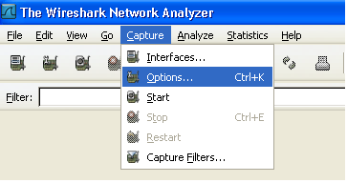

. Under Interface select the right LAN PC card.

. Under Display Option check the 3 boxes.

. Press on the “start” button.

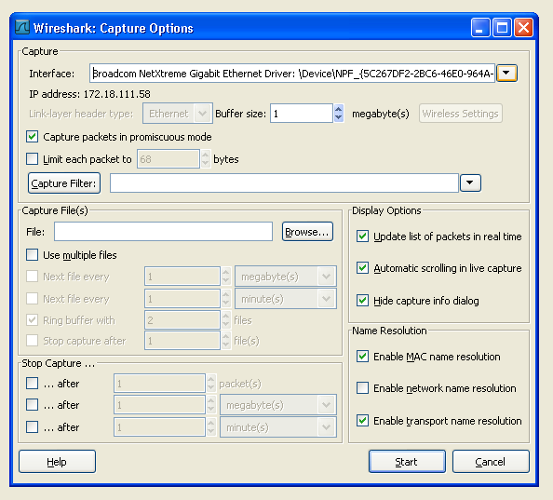

. Define the filter toolbar to “snmp” and press “Apply.

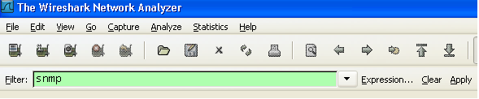

. Disconnect the power cable from PS, and verify that the “wireshark” application gets power fail trap.

. Verify in the trap details that “specific trap” = 36.

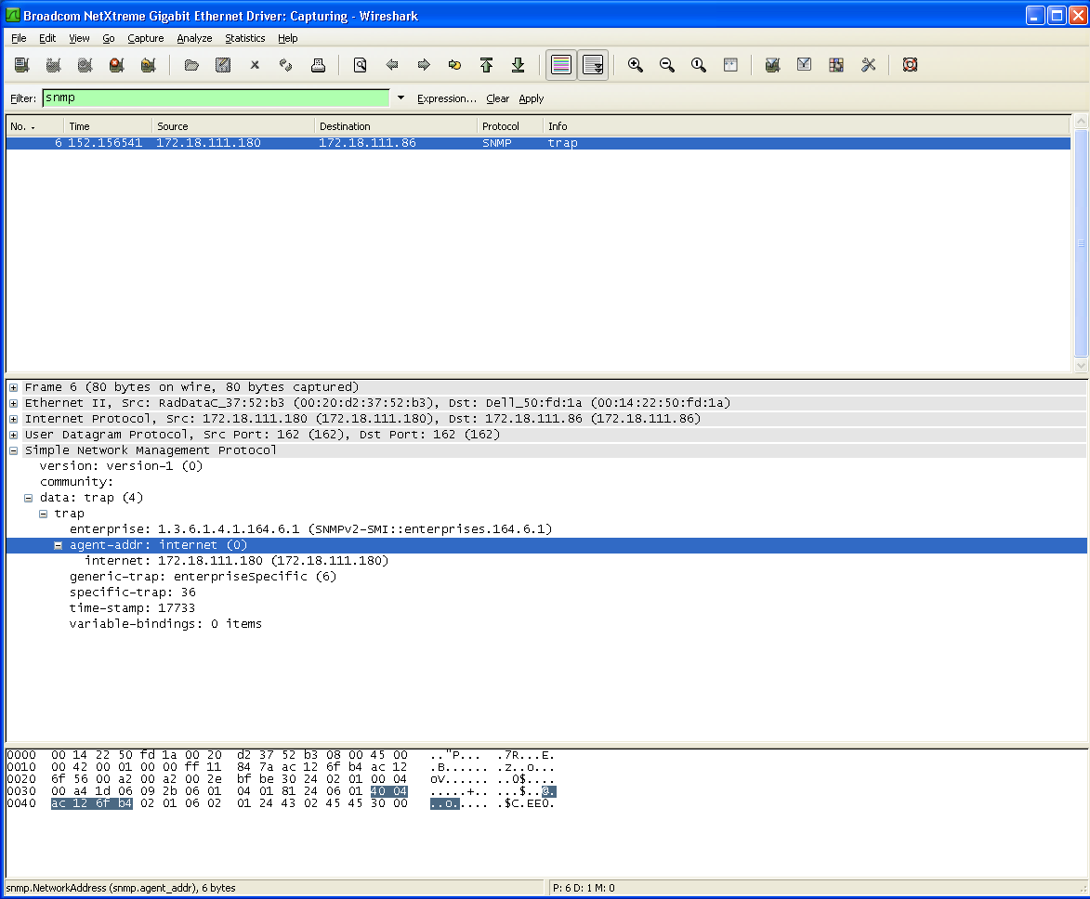

## Configuration Memory Test

* + 1. Change parameters using the terminal the ANNEX type to A.
    2. Turn off then turn on the modem.
    3. Verify that the parameters were saved.
    4. Change ANNEX type to B.

## Tests for Telefonica RPF option

* 1. Perform all the tests from Paragraph 3 -7.6 with ASMI54L-PFED-PS with external power of 48v.
  2. Connect the setup described according to the device type:

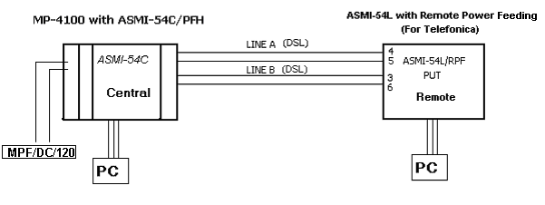

* 1. Verify no external power connected to the PUT.
  2. Set ASMi-54L & ASMI-54C products TC layer to HDLC mode.
  3. Configure the CLK mode of ASMI-54C unit to INT and the PUT to Remote (RCV).
  4. Verify ASMI-54L are sync (Sync A & Sync B).
  5. Verify LED RPF in rear panel of the PUT is light in Green color.
  6. Disconnect line A and verify PUT is up and Terminal function well.
  7. Reconnect line A and disconnect line B and verify PUT is up  and Terminal function well.
  8. Disconnect line A and line B and verify the PUT is off.

## Stickers Attach

1. Attach B.D. sticker and Configuration Status Letter sticker on the unit

|  |  |
| --- | --- |
| Jtag  OK | OK |
| B.D | B.D |

1. Attach B.D sticker and Configuration Status Letter sticker on the interface

(If an interface module exist).

|  |  |  |
| --- | --- | --- |
| OK | B.D | C.S.L |

|  |  |
| --- | --- |
| Note | During normal operation ALM led should be OFF.  All ETH ports should be connected (LINK ON) in order for the ALM led to get OFF. |

# Preparations for Shipment

As specified in the GFTI.

# Factory Setting

As specified in the GFTI.

## Factory Setting for SLT Option.

* 1. Insert User Name: debug , password: panic.
  2. In the Main Menu in section 5 Debug
  3. Change the value (13) SLT Defaults to On.

## Factory Setting for Telefonica RPF option.

Set the values as follow:

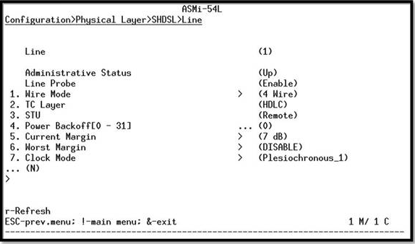

# Safety Test

As specified in the GFTI.

1. ACE 2002 general configuration
2. Set the ACE-2002 generator as follows before using the generator:

|  |  |  |
| --- | --- | --- |
| Parameter | Slot 2 | Slot 3 |
| Auto negotiation | Enable | Enable |
| Default Type | 100baseT Full Duplex | 100baseT Full Duplex |
| Generator mode | Ethernet | Ethernet |
| Generator only | No | No |
| Chain Length | 1 | 1 |
| Base Source MAC Address | 2 | 3 |
| Base Destination MAC Address | 3 | 2 |
| Source MAC Address Increment | 0 | 0 |
| Destination MAC Address Increment | 0 | 0 |
| Ethernet Type, word 1 – word 7 | 0 | 0 |

1. HW Configuration File

* Basically the HW configuration file burning procedure is automatic, “Barcode” dependency.

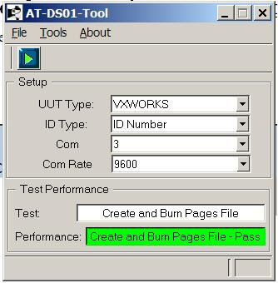

Figure 1 - DS28 GUI for HW configuration file

* If manually burning, set Working Mode to Manual Boot.

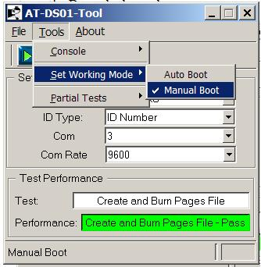

Figure 2 - DS28 GUI - Set Manual Boot

* Open DialogBox for entering the parameters manually by opening the “Create and Burn Page File”.

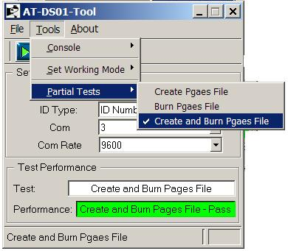

Figure 3 - DS28 GUI -Create and Burn Page File

* Enter the relevant parameters into the DialogBox:
  + CSL REV.
  + PAGE2 – According to options presented below.

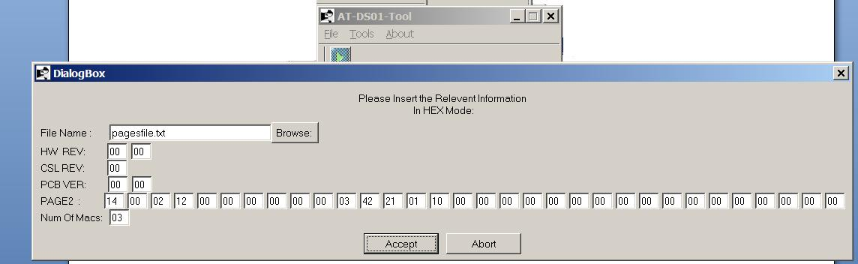

Figure 4 - DialogBox for entering parameters manually

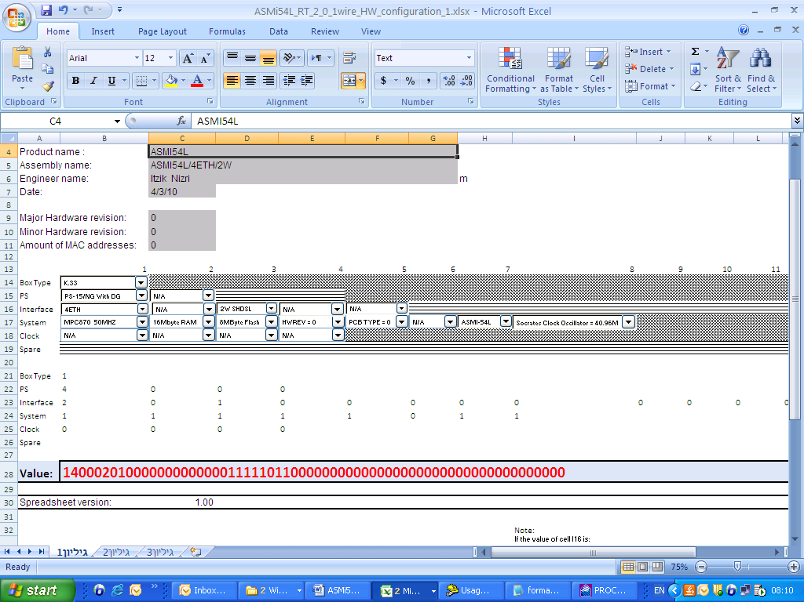

Figure 5 - ASMI-54L /4ETH/2W

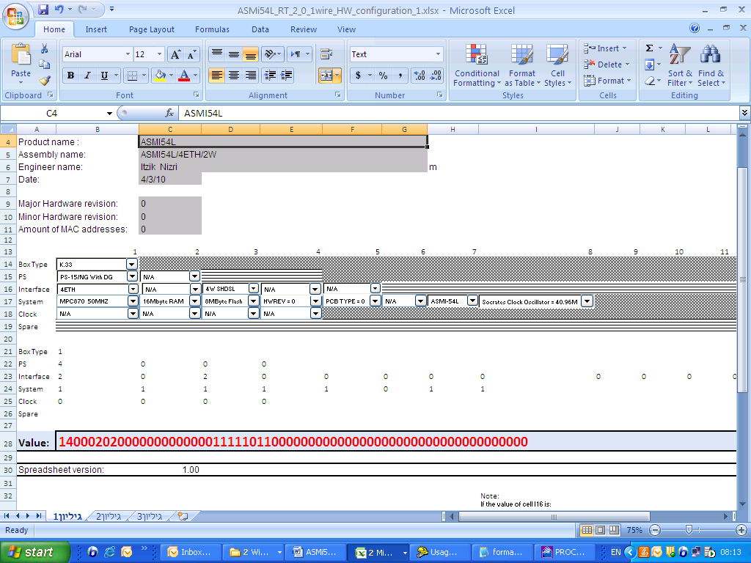

Figure 6 - ASMI-54L /4ETH/4W

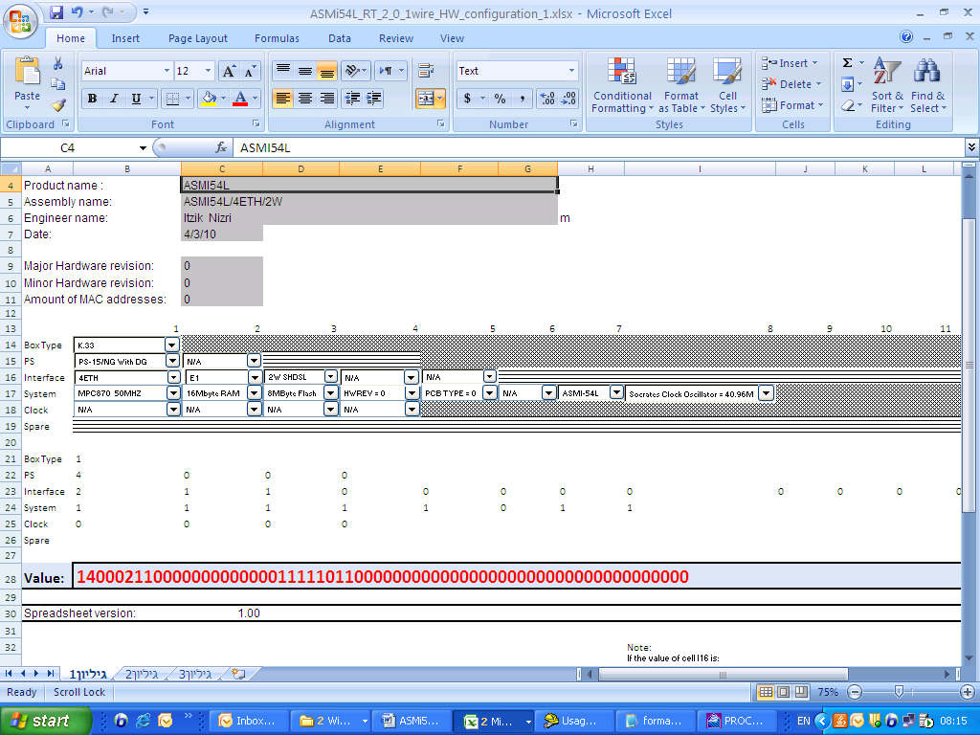

Figure 7 - ASMI-54L /4ETH/E1/2W

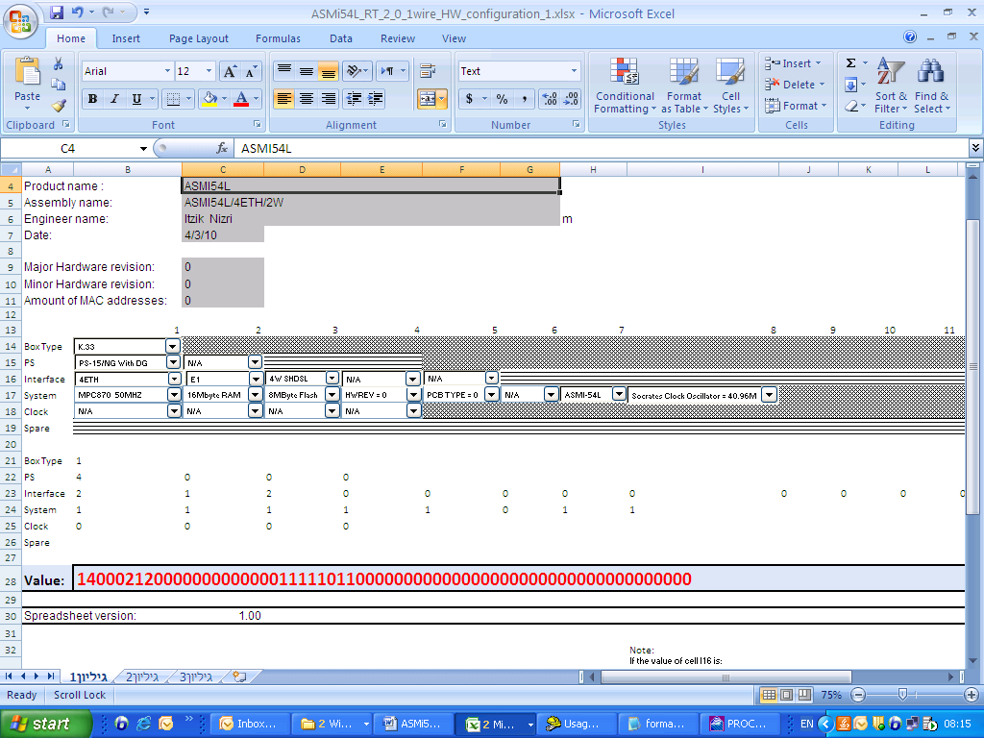

Figure 8 - ASMI-54L /4ETH/E1/4W

1. License creation

1. Open the file License.cfg.

2. Insert the relevant MAC address.

3. Save the file.

4. From the Command Prompt type the command : license license.cfg

(License text file was made)

5. From the main menu of ASMI-54L type:

Utilities>File Transfer>X-Modem>Command>License Download and send the file that was

Made before.

6 .Verify the load of the correct license : Utilities>License Management>Feature Status

SHDSL Extended Rate: Enabled