ETX-2i-64ET1
Final Test Instructions

Revision History:
1
Revision Number | Name | Notes
01 (12.11.17) | Liora_S | Initial Draft
02(14.01.18) | Andrey_G | Was changed picture of wiring for item 2.1.2
03(29.01.18) | Andrey_G | Was added Functional Test Item  Note:Tested in practical only tests up to item 4.7

Contents
1. Required Test Equipment 4
2. Preparations for Testing 4
2.1. 4
2.2. JTAG Test 4
3. Visual Inspection 5
4. Basic Operational Tests (BOT) 5
4.1. Automated BOT 5
4.2. Manual BOT 5
4.3. Functional Tests for ETX-2i/64E1 6
4.4. ETX-2i/64E1 E1 Data Link Test 7
4.5. Ethernet Link Test 10
4.6. Sync-E Slave Clock test 11
4.7. Sync-E Master Clock test 13
5. Environmental Stress Screening (ESS) 14
6. Manual Final Tests 15
6.1. Version Identification Test 15
6.2. Fans & Temperature test 15
6.3. Power supply Identification Test 16
6.4. Dying Gasp Test 16
6.5. DDR Test 16
6.6. DRY Contact Test 17
6.7. TST/ALR Led Test 17
6.8. Connect Mac to ID 17
6.9. Set To Default 18
7. Preparations for Shipment 18
8. Factory Setting 18
9. Safety Test 18

Required Test Equipment

n/n | Generic Name/Description | Manuf. | Model
1. | 1. Counter (1.3 GHz) | TTI | TF-830
2. | 2. Multimeter | APPA | 97
3. | 4. Digital Scope | Lecroy/Tektronix | N/A
5. | 6. PC | N/A | N/A
7. | 8. Asynchronous terminal | N/A | 9600 8-N-1
9. | 10. GIGA ETH cable (2m) | N/A | CBL-ETH/UTP/STR
7. | 7. SFP-5/6/30 | RAD | SFP-5/6/30
8. | 8. Fiber Optic 9µ/62.5µ LC-LC | N/A | N/A
9. | 9. USB 2.0 to 4S Serial Adapter | ST Lab | U-400
11. | 12. Ethernet Generator | RAD | ETX-204A
13. | 14. Communication analyser (*2) | TTC | Fireberd 6000 with E1 interface
12. | 12. E1 source generator | RAD | HTB
15. | 16. Cross-cable for E1/T1 (*64) | RAD | CBL-MP-RJ45/CROSS/0.2M
17. | 18. E1/T1 Physical Loop | RAD
16. | 16. Application | RAD | Decryptor
17. | 17.. Boundary scan Tester (JTAG) | Gopel Electronic GMBH | PSC1149.1-B Cascon Galaxy (TS)

Preparations for Testing

1. Verify that SW2 is in DEBUG & W.D=OFF position.

JTAG Test

Note | The JTAG tests consist with separate hardware tests & also BOOT & ALTERA & FLASH software downloading.

Remove upper cover of ETX2i_64E1T1 system box and connect JTAG station to DUT via Main Board J2 JTAG Connector (left side of system box).
- Turn on the power of the DUT & of the JTAG unit.
- Open the CASCON GALAXY software.
2. Open JTAG software.(USER NAME: ETX-2I-64ET1 ,PASSWORD: rad)
3. In DUT field select the proper name according to the DUT.
4. In Batch field select: All.CBT
5. Press the START BATCH button.
6. Verify that the test has been completed successfully.
7. Turn off the power supply, remove JTAG cable and return
upper cover of system box.
8. Mark on traceability label that the DUT passes JTAG Test.

Visual Inspection
N/A

Basic Operational Tests (BOT)

Automated BOT
N/A

Manual BOT

Dboot Download
1. Connect the MNG-ETH port of the DUT to the PC.
2. Verify that Link led (green) and ACT led (orange) of MNG-ETH port light.
3. Turn on the DUT and wait for “=> “sign.
4. Type: env set ethaddr 00:20:01:02:03:04 <enter>
5. Type: env set netmask 255.255.255.0 <enter>
6. Type: env set gatewayip 10.10.10.1 <enter>
7. Type: env set ipaddr 10.10.10.5<enter>
8. Type: env set serverip 10.10.10.10 <enter>
9. Download vxboot file ver 2.0.0(0.07) or higher according ECO
by typing: run download_vxboot <enter>
10. When the download is finished ( “DOWNLOAD OK? Message is shown
type: reset <enter>
11. Wait to a message “ARE YOU SURE”, type: y <enter> to perform Format to the flash.

H.W Identification Test
Burn the pages (H.W Identification file) by page tool.

Software Download
1. Set on main board SW2 double slides switch to state “DBG”
2. Connect the MNG-ETH port of the DUT to the PC.
3. Verify that Link led (green) and ACT led (orange) of MNG-ETH port light.
4. Open FTP program
5. Type: download 1, FILE NAME1 <enter> to download the application.

Note | “FILE NAME1” is approved application according ECO.

For current time use as FILE NAME1 package sw-pack_2i.bin
3. Type: set-active 1 <enter> to set the application active.
6. Type: run <enter> to restart the BOOT process.

Functional Tests for ETX-2i/64E1

General
The following describe the application needed for testing the ETX-2i/64E1 at BADAS and for Compliance Tests
Functional test performs by using two units of ETX-2i/64E1.
First device is used as reference for supporting the second device that should be tested - DUT (Device under test).
The figure below shows common block diagram of ETX-2i/64E1 test setup.

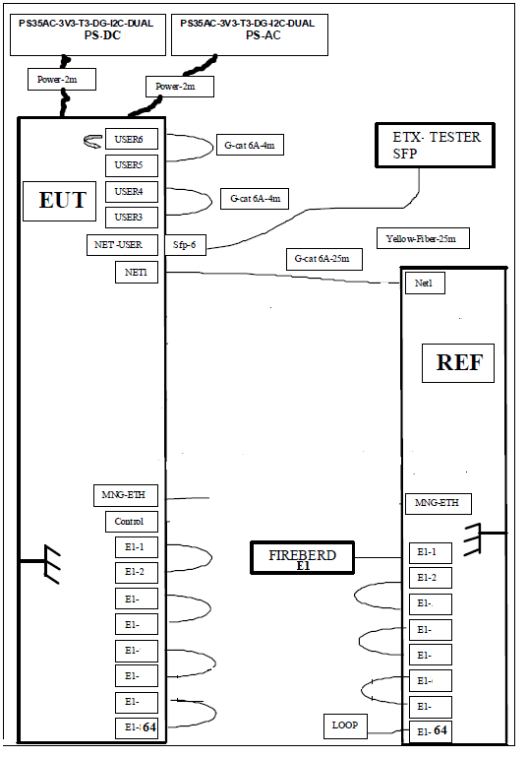

ETX-2i/64E1 test assemble options

1. USE CBL-MP-RJ45/CROSS/0.2M cable to prepare loopbacks for REF ETX-2i/64E1 device between E1 port pairs as shown in picture below:

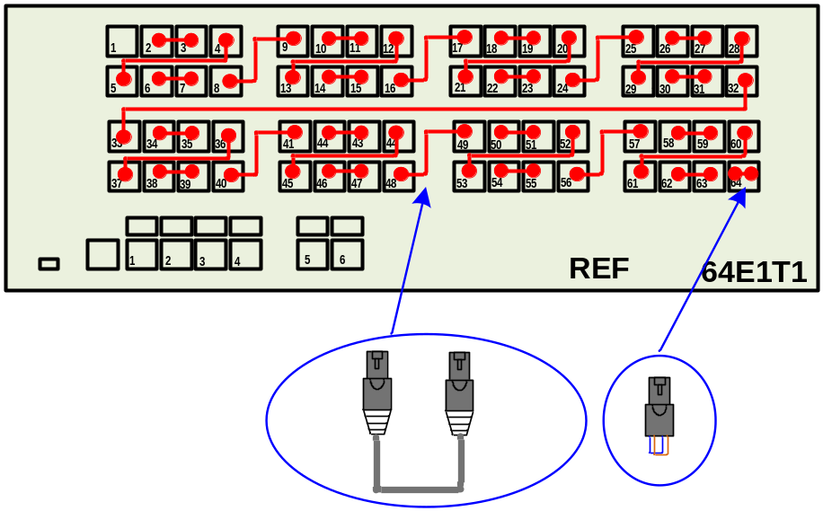

2. Use CBL-MP-RJ45/CROSS/0.2M cable to prepare loopbacks for DUT ETX-2i/64E1 device between E1 port pairs as shown in picture below:

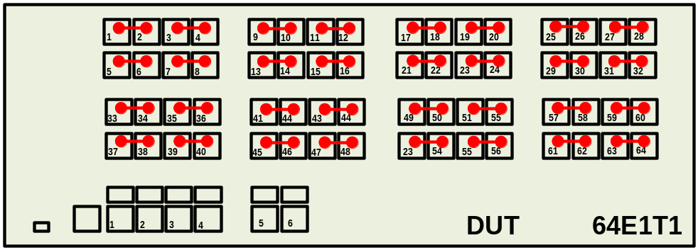

ETX-2i/64E1 E1 Data Link Test
Block diagram below depicts data path test, ETX-2i DUT and ETX-2i REF interconnection and TX/RX data flow.

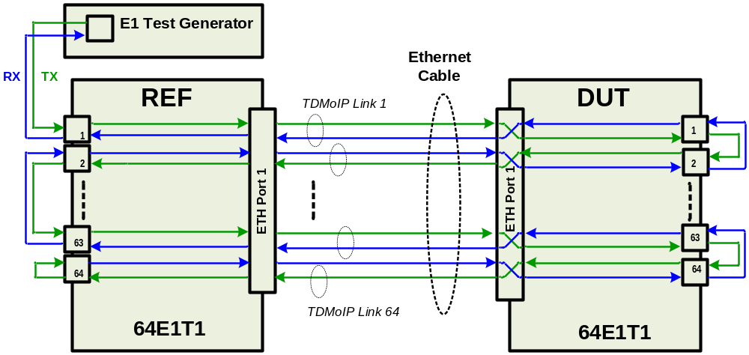
The ETX-2i DUT is configured as SYNC E from REF device, it means that all E1 will be synchronize with the ETH Network .The ETX-2i REF is configured as MASTER clock, it means that the REF unit will synchronize the ETH and all E1 ports. The E1 generator (in this case it is RAD HTB device) is configured unframed E1 with bound rate 2.048MHz. Picture below describes test setup:

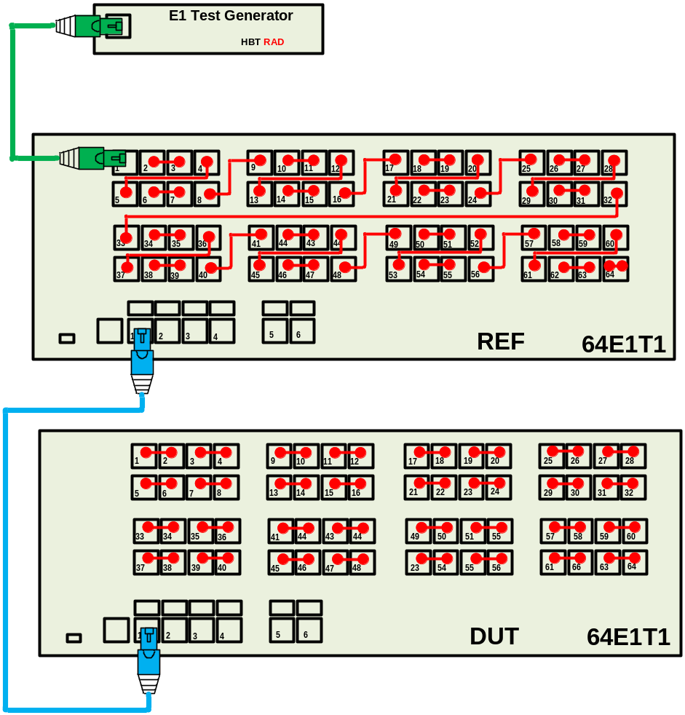

Running the Test
This application will perform a basic test for testing the products.
Since the USER and Network can be Copper or Fiber, the same test can be done with both options
The E1 traffic should run without errors without any reset

- Configure the DUT as specified in Appendix A.A1.
- Configure the REF as specified in Appendix A.A2.
2. Configure the E1 Generator as specified in Appendix B.
3. Verify that the LINK Led of ETH Port1 of DUT and REF blinks (green). (see picture above).
Indication of proper functionality of this test setup should be absence of
active red LEDs on each E1 port of both DUT and REF devices.
Note | It is possible to use ETH/GIGA Ports 2 - 6 on DUT and REF devices as well. For that requires to prepare proper configuration for REF and DUT device respectively.

4. Perform Data Transmission for 2 minutes.
5. Verify no errors in the Generator.
7. Connect the SFP ports instead of the RJ ports by SFP-5/6 and fiber optics.
6. Perform Data Transmission for 2 minutes.
7. Verify no errors in the Generator.

Ethernet Link Test

Test Setup assemble.
Add to previous setup facility for the user internet ports testing as depicted on picture below:

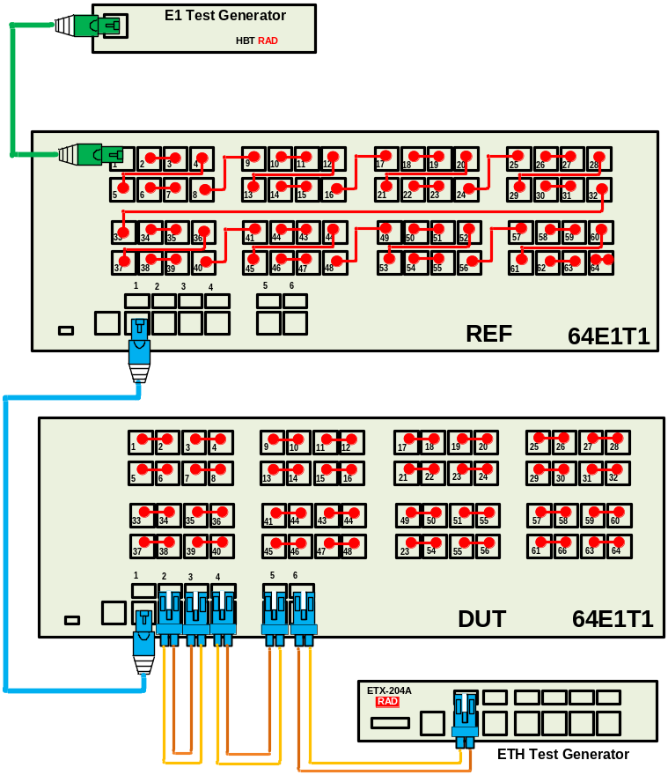

Running the Test

This application will perform a basic test for testing the products.
The Eth traffic should run without errors without any reset

1. Use same configuration for DUT as in previous test.
2. Use same configuration for REF as in previous test.
8. Configure the ETH Generator as specified in Appendix B.
9. Verify that the LINK Led of each Eth port blink (green).
5. Perform Data Transmission for 2 minutes.
6. Verify no errors in the ETH Generator (use terminal screen of Generator).

Sync-E Slave Clock test

Test Setup assemble

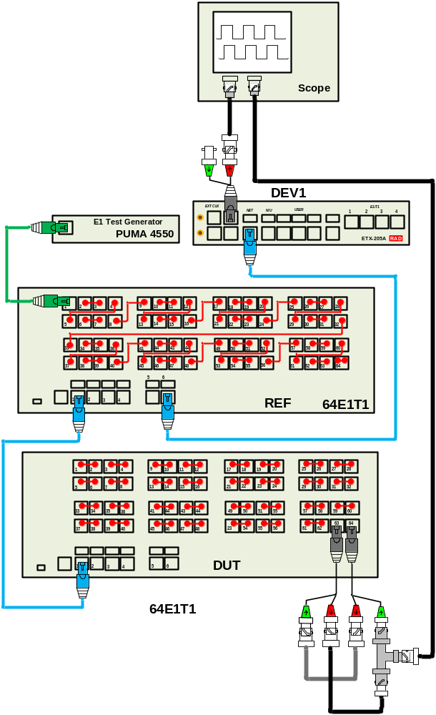

Running the Test

This application will perform a basic test of DUT ability to accept
Master Sync-E Clock and perform internal synchronization of all E1 ports.
As can see in picture above DEV1 (ETX-205A) is used as external Master
clock source. Port “Ext Clk” is connected to first scope channel and
used as source in Trigger Mode. “NET“ ETH port of DEV1 defined as Sync-E
ETH link connected to the ETH Port 6 of REF device and used for the reference
clock extraction for synchronization E1 data link received from external E1
generator. ETH Port1 of REF device is connected to ETH Port 1 of DUT.
Through this port DUT receives E1 data and Sync-E clock from REF device.
Any E1 port of DUT should be synchronized with Master clock.
By using BNC splitter we can "cut" loop and to connect E1 TX/RX signal to
second channel of scope to observe synchronization of this signal relative
to Master Clock (first channel of scope)

1. Use same configuration for DUT as in previous test.
2. Use same configuration for REF as in previous test.
10. Configure the DEV1 Clock Generator as specified in Appendix D.
11. Verify that the LINK Led of ETH Port1 of DUT and REF blinks (green).
Indication of proper functionality of this test setup should be absence of
active red LEDs on each E1 port of both DUT and REF devices
5. Perform Data Transmission for 2 minutes.
6. Verify no errors in the ETH Generator (use terminal screen of Generator).
7. Verify no jitter (wander) between channel 1 and channel 2 of scope (Still image).

Sync-E Master Clock test

Test Setup assemble

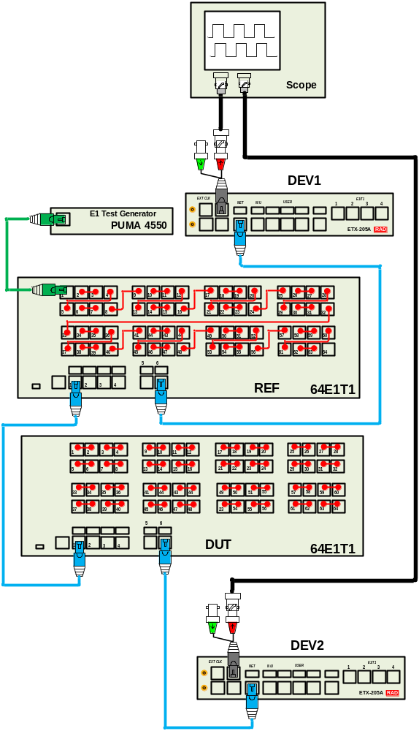

Running the Test

This application will perform a basic test of DUT ability to produce
Sync-E Clock.
As can see in picture above DEV1 (ETX-205A) is used as external Master
clock source. Port “Ext Clk” is connected to first scope channel and
used as source in Trigger Mode. “NET“ ETH port of DEV1 defined as Sync-E
ETH link connected to the ETH Port 6 of REF device and used for the reference
clock extraction for synchronization E1 data link received from external E1
generator. ETH Port1 of REF device is connected to ETH Port 1 of DUT.
Through this port DUT receives E1 data and Sync-E clock from REF device.
ETH Port 6 of DUT is connected to DEV2 Port1. This device configured to
extract Sync-E clock from Ethernet and put it on output through the
“ExtClk” port that is connected to the second channel of scope to observe
synchronization of this signal relative to Master Clock (first channel of scope)

1. Configure DUT configuration as specified in Appendix F (should be added in next version of doc).
2. Use same configuration for REF as in previous test.
12. Configure the DEV1 Clock Generator as specified in Appendix D.
4. Configure the DEV2 as specified in Appendix E.
5. Verify that the LINK Led of ETH Port1 of DUT and REF blinks (green).
Indication of proper functionality of this test setup should be absence of
active red LEDs on each E1 port of both DUT and REF devices
6. Perform Data Transmission for 2 minutes.
7. Verify no errors in the ETH Generator (use terminal screen of Generator).
8. Verify no jitter (wander) between channel 1 and channel 2 of scope (Still image).

Environmental Stress Screening (ESS)
1. As specified in the GFTI.
2. A data transmission can be performed while ESS instead of performing paragraph 4.2.4

Note | - In Case of dual power supplies, turn on only one power supply and perform switching to the other during ESS.  - In Hardened option, the temperature range is -20 to 65 degrees.

Manual Final Tests

Version Identification Test
- Verify BOOT version and SW according ECO.
- Type: su <enter> & Password
3. Type: logon debug <enter>
4. Generate the password from the Key code that appears in the screen.
5. Type the password.
6. Type: debug memory address c0100000 read char length 1
7. Verify CPLD version according ECO. (Should be 0x02)
8. Verify CPLD version of Adapters:
A0 (upper): memory address cc3e0000 read char length 1 (Should be 0x03)
A1 (lower): memory address cd3e0000 read char length 1 (Should be 0x03)

Fans & Temperature test
1. Type: su <enter> & Password
2. Type: logon debug <enter>
3. Generate the password from the Key code that appears in the screen.
4. Type the password.
5. Type: debug thermostat
6. Type: set-point upper 60
set-point lower 55
8. Type: set-point lower 20
set-point upper 30
10. Type: show status and verify that “Current Temperature” is changing during the test.
11. Type: set-point upper 40
set-point lower 32

Power supply Identification Test
1. Turn on the all power supplies.
2. Type: configure chassis
show environment
3. Verify that the type of the power supplies is shown correctly (“AC”, “ACHP” or “DC”)
4. Verify that the LED of the power supplies lights green.
5. Verify that the status of the power supply/supplies is “OK”
6. Turn off power supply 2.
7. Verify that the status of the power supply 2 is “Failed”
8. Verify that the led of the power supply doesn’t light.
9. Remove power supply 2 from DUT.
10. Verify that the status of the power supply 2 is “Not exist”.
11. Assemble power supply 2 and turn it on.
12. Turn off power supply 1.
13. Verify that the status of the power supply 1 is “Failed”.
14. Verify that the led of the power supply doesn’t light.
15. Remove power supply 1 from DUT.
16. Verify that the status of the power supply 1 is “Not exist”.
17. Assemble power supply 1.

Dying Gasp Test

1. Configure the DUT as specified in Appendix C.
2. Connect the DUT to the computer via port 0/1 & perform RESET to the DUT.
3. Open a Network Protocol Analyzer program (like WireShark).
4. Verify that only one power supply is active.
5. Send ping to the DUT.
6. Turn off the power supply and verify that a Dying gasp event was detected.

DDR Test
1. Type: exit all <enter>
2. Type: logon debug <enter>
3. Generate the password from the Key code that appears in the screen.
4. Type the password.
5. Type: debug mea <enter>
6. Type: mea <enter>
7. Type: debug <enter>
8. Type: log <enter>
9. Type: show <enter>
10. Verify that there is no message of ” DDR NOT OK ”.

DRY Contact Test
1. Type: exit all <enter>
2. Type: logon debug <enter>
3. Generate the password from the Key code that appears in the screen.
4. Type the password.
5. Type: debug mea <enter>
6. Type: mea <enter>
7. Type: hw <enter>
8. Type: dry <enter>
9. Type: read 0 <enter>
10. Verify the following message:
[0x0].....................0xf7
11. Type: read 1 <enter>
12. Verify the following message:
[0x1].....................0xff
13. Make a short between pins 2 & 3 & 4 to pin 5 of DRY Contact connector.
14. Type: read 0 <enter>
15. Verify the following message:
[0x0].....................0xf0

TST/ALR Led Test
1. Type: configure reporting
mask-minimum-severity log major
2. Verify that TST/ALR led is off.
3. Type: no mask-minimum-severity log
4. Verify that TST/ALR led lights (red).

Note | If a second P.S was inserted during the test of the DUT, In this test the second P.S must be exist & operated.

Connect Mac to ID
Connect the MAC to ID Number by Key tool.

Note | The MAC is shown in: configure system → show device-information.

Set To Default
1. Type: admin factory-default-all <enter> to perform set to default.
Type: y to approve the action.
2. Mark on traceability label that the DUT passes all testes.

Preparations for Shipment
As specified in the GFTI.

Factory Setting
As specified in the GFTI.

Safety Test
As specified in the GFTI.

Appendix A

A1: DUT Configure for Data Transmission Test

- Open in editor file FTI_dut_config.txt.
- Copy this script into CLI by 2 or 3 chunks (not one)
- Save configuration.

A2: REF Configure for Data Transmission Test

- Open in editor file FTI_ref_config.txt.
- Copy this script into CLI by 2 or 3 chunks (not one)
- Save configuration.

Appendix B

ETX-204A Generator Configure
1. In Main Menu screen choose: Generator.
2. Set the following parameters:
2. Generator mode (GE)
3. Packet type > (MAC)
4. Packet length min [64 - 1600] ... (64)
5. Packet length max [64 - 1600] ... (64)
6. Chain length [1 - 20] ... (1)
7. Stream numbers [1 - 256] ... (8)
8. Packet rate [1 - 1500000] ... (50000)
3. To save the configuration performs save.

Appendix C
E1 Generator Configure
Data Stream: unframed
Bound rate 2.048MHz
PRBS Pattern 1S15

Appendix D
ETX-205A DEV1 Sync-E Clock Generator Configure
- Open in editor file ETX-205_dev1.txt.
- Save configuration.

Appendix E
ETX-205A DEV2 Sync-E Clock Generator Configure
- Open in editor file ETX-205_dev2.txt.
- Save configuration.

Appendix F
DUT Configure for Dying Gasp Test

Type the following commands:
configure port svi 1
no shutdown
exit
exit
flows
classifier-profile u match-any match untagged
flow 10
classifier u
ingress-port svi 1
egress-port ethernet 0/1 queue 0 block 0/1
no shutdown
exit
flow 11
classifier u
no policer
ingress-port ethernet 0/1
egress-port svi 1 queue 0
no shutdown
exit
exit
router 1
interface 1
address 10.10.10.12/24
bind svi 1
no shutdown
exit
exit
management
snmp
target-params 1
message-processing-model snmpv3
version usm
security name initial level no-auth-no-priv
no shutdown
exit
target mypc
target-params 1
address udp-domain 10.10.10.10
no shutdown
tag-list unmasked
trap-sync-group 1
exit all
save

Note | The last field of the IP address can be a number between 2-255 except 10.

