ETX-2i-B/BC
Final Test Instructions

Last Updated: 17/09/2020

Contents
1. Required Test Equipment 3
2. Preparations for Testing 3
3. Visual Inspection 3
4. Basic Operational Tests (BOT) 3
4.1. Automated BOT 3
4.2. Manual BOT 4
5. Environmental Stress Screening (ESS) 5
6. Automated Final Tests 5
6.1. Setup 6
6.2. Running the Test 6
6.3. 1 PPS Test and SYNC E & PTP Test are performed by separate ATE - "ETX-2iB-PTP" 6
7. Manual Final Tests 6
7.1. Version Identification Test 6
7.2. Dying Gasp Test 7
7.3. Data Transmission Test 7
7.4. SFP Identification Test 7
7.5. 1PPS Test 7
7.6. SYNC E & PTP Test 9
7.7. Connect Mac to ID 10
7.8. Set To Default 10
8. Preparations for Shipment 10
9. Factory Setting 10
10. Safety Test 10
Appendix A. UUT Configure for Data Transmission Test 11
Appendix B. ETX-204A Generator Configure 13
Appendix C. UUT & AUX Configure for PTP & SYNC-E Test 14

Required Test Equipment
Generic Name/Description | Manuf. | Model
1. A Giga generator | RAD | ETX-204A
2. Counter (1.3 GHz) | THURLBY THANDAR | TF830
3. DVM | APPA | 93N
4. SFP-5/6/9G/30 | RAD | SFP-5/6/9G/30
5. Cable for Giga | N/A | N/A
6. Fiber Optic 9µ/62.5µ LC-LC | N/A | N/A
7. Network Protocol Analyzer | N/A | N/A
8. Terminal software. | N/A | N/A
9. Boundary Scan Test System | GOEPEL electronic | N/A

Preparations for Testing
1. Connect JTAG station to UUT via JTAG Connector.
2. Supply voltage to UUT by Power Supply.
3. Open JTAG software.(USER NAME: ETX-2I-B ,PASSWORD: rad)
4. In UUT field select the proper name according to the UUT.
5. In Batch field select: All.CBT
6. Press the START BATCH button.
7. Verify that the test has been completed successfully.
8. Turn off the power supply.
9. Mark on traceability label that the UUT passes JTAG Test.

Note | It is possible to check few UUTs in parallel.

Visual Inspection
N/A

Basic Operational Tests (BOT)

Automated BOT
The following instructions reflect:
 | Last Updated
Final Test Instructions | 17/09/2020
Automatic Tester | 17/09/2020

Setup
- Connect the Tester’s cables to the following UUT’s ports: POWER, CONTROL, USB
(If the port exists on the UUT), MNG-ETH, I/O 1 and I/O 2. The rest I/O ports connect
according to Functionality Test.
- Scan the DUT’s ID barcode to configure the Tester accordingly.

Running the Test
- Press to start running the test and follow the Instructions on the screen. If the test
fails, the display will show a red Fail message and the test will be stopped, and you
may resume testing from this point.
2. Verify that the test passed.

Manual BOT

Vxboot Download
1. Connect the MNG-ETH port of the UUT to the PC.
2. Verify that Link led (green) of MNG-ETH port lights.
3. Turn on the UUT and wait for “=> “sign.
4. Type: env set ethaddr 00:20:01:02:03:04 <enter>
5. Type: env set netmask 255.255.255.0 <enter>
6. Type: env set gatewayip 10.10.10.1 <enter>
7. Type: env set ipaddr 10.10.10.5<enter>
8. Type: env set serverip 10.10.10.10 <enter>
9. Download last vxboot file ver according ECO.
by typing: run download_vxboot <enter>
10. When the download is finished (“DOWNLOAD OK? Message is shown
type: reset <enter>
11. Wait to a message “ARE YOU SURE”, type: y <enter> to perform Format to the flash.

H.W Identification Test
Burn the pages (H.W Identification file) by page tool.

Software Download
1. Connect the MNG-ETH port of the UUT to the PC.
2. Verify that Link led (green) and ACT led (orange) of MNG-ETH port light.
3. Open FTP program
4. Type: download 1,FILE NAME1 <enter> to download the application.

Note | “FILE NAME1” is approved application according ECO.

5. Type: set-active 1 <enter> to set the application active.
6. Type: run <enter> to restart the BOOT process.

Functionality Test.
1. Set up the following layout:
- Connect the first port of ETX-204A to port 0/1 of ETX-2I-B.
- Connect the second port of ETX-204A to port 0/2 of ETX-2I-B.
- Connect port 0/3 of ETX-2I-B to port 0/4 of ETX-2I-B.
- Connect port 0/5 of ETX-2I-B to port 0/6 of ETX-2I-B.

Note | It is possible to use ETH/GIGA Ports 5 & 6 in ETX-204A too.

2. Configure the UUT as specified in Appendix A.
3. Configure the Generator as specified in Appendix B.
4. Verify that the 6 LINK Leds blink (green).
5. Perform Data Transmission for 2 minutes.
6. Verify no errors in the Generator.

Environmental Stress Screening (ESS)
1. As specified in the GFTI.
2. A data transmission can be performed while ESS instead of performing paragraph 4.2.4

Automated Final Tests
The following instructions reflect:
 | Last Updated
Final Test Instructions | 17/09/2020
Automatic Tester | 03/11/2022

Setup
- Connect the Tester’s cables to the following UUT’s ports: POWER, CONTROL, USB
(If the port exists on the UUT), MNG-ETH, I/O 1 and I/O 2. The rest I/O ports connect
according to Functionality Test.
- Scan the DUT’s ID barcode to configure the Tester accordingly.

Running the Test
- Press to start running the test and follow the Instructions on the screen. If the test
fails, the display will show a red Fail message and the test will be stopped, and you
may resume testing from this point.
- Verify that the test passed.

1 PPS Test and SYNC E & PTP Test are performed by separate ATE - "ETX-2iB-PTP"

Setup
  - Connect the Tester’s cables to the following UUT’s ports: POWER, CONTROL, 1PPS, I/O 1 I/O 3 and I/O 5.
  - Click on “Scan Scopes” button.
  - Choose a scope for “1PPS” Test and another scope for “SyncE” Test

Running the Test
  - Press to start running the test and follow the Instructions on the screen. If the test fails, the display will show a red Fail message and the test will be stopped, and you may resume testing from this point.
  - Verify that the test passed.

Manual Final Tests

Version Identification Test
- Verify BOOT version and SW according ECO.
- Type: su <enter> & Password
3. Type: logon debug <enter>
4. Generate the password from the Key code that appears in the screen.
5. Type the password.
6. Type: debug memory address c0100000 read char length 1
7. Verify CPLD version according ECO.

Dying Gasp Test
1. Type: configure reporting <enter>
2. Type: clear-alarm-log all-logs <enter>
3. Turn off the power supply.
4. Turn in on and wait till end of boot process.
5. Type: configure reporting<enter>
6. Type: show log<enter> and verify that a Dying gasp event was detected.

Data Transmission Test
- Repeat section 4.2.4.

Note | Perform this test only if data transmission was not tested while ESS.

SFP Identification Test

Note | Perform this test only for SFP ports.

1. Type: configure port ethernet (Port number)
show status
2. Verify that the Connector Type is “SFP In”.
3. Repeat this test on each of SFP port.
4. Verify that the Manufacturer Part Number is “SFP-30”
(or other according the type of the SFP)

1PPS Test
1. Connect 1PPS mBNC Port to scope with 50 ohm termination
2. Type: exit all <enter>
3. Type: logon debug <enter>
4. Generate the password from the Key code that appears in the screen.
5. Type the password.
6. Type: Debug memory address C3100000 write char value E5
7. Check 1PPS pulse exist as the following:

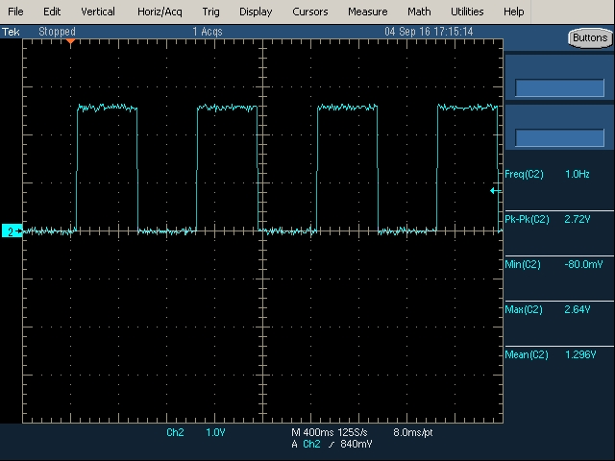

SYNC E & PTP Test
- Set up the following layout :
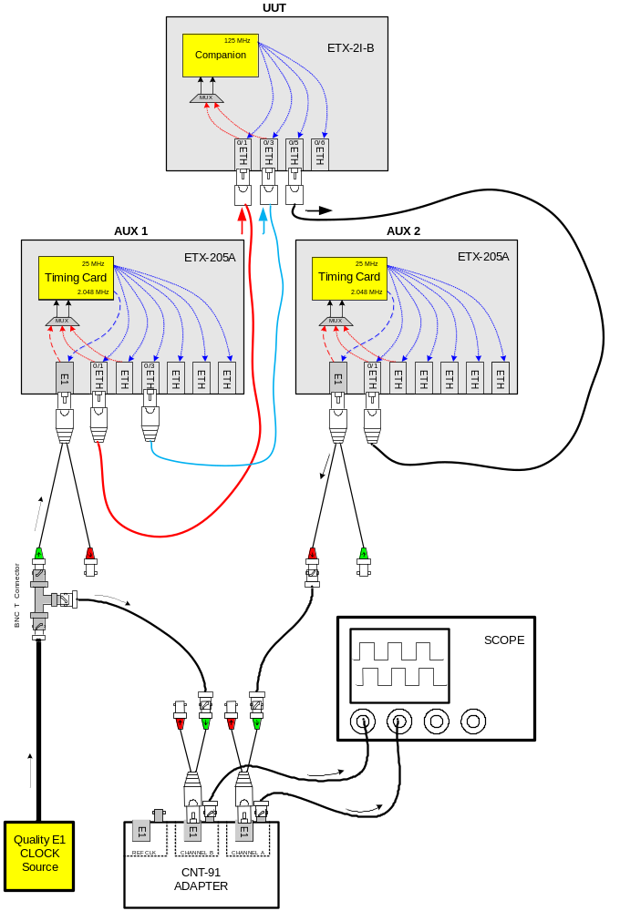
- Configure the UUT and the ETX-205A as specified in Appendix C.
- In UUT type the following commands:
configure system clock
domain 1
show status
- Wait until the following message will appear:
System Clock Source : 2 State : Locked Quality : PRC

- Verify on the digital scope that the 2.048 MHz CLK appears and locked in CH1 & CH2 of the scope in each UUT’s ports test.
- Verify on the digital scope that the jitter of CH2 doesn’t exceed ±30nSec in each UUT’s port test.

Connect Mac to ID
Connect the MAC to ID Number by Key tool.

Note | The MAC is shown in: configure system → show device-information.

Set To Default
1. Type: admin factory-default-all <enter> to perform set to default.
Type: y to approve the action.
2. Mark on traceability label that the UUT passes all testes.

Preparations for Shipment
As specified in the GFTI.

Factory Setting
As specified in the GFTI.

Safety Test
As specified in the GFTI.
- UUT Configure for Data Transmission Test

Type the following commands:
configure
port
ethernet 0/2
shutdown
functional-mode user
no shutdown
exit
exit

flows

classifier-profile "all" match-any
match all
exit

flow "1_3"
classifier "all"
no policer
ingress-port ethernet 0/1
egress-port ethernet 0/3 queue 0 block 0/1
no shutdown
exit

flow "3_1"
classifier "all"
no policer
ingress-port ethernet 0/3
egress-port ethernet 0/1 queue 0 block 0/1
no shutdown
exit

flow "4_5"
classifier "all"
no policer
ingress-port ethernet 0/4
egress-port ethernet 0/5 queue 0 block 0/1
no shutdown
exit

flow "5_4"
classifier "all"
no policer
ingress-port ethernet 0/5
egress-port ethernet 0/4 queue 0 block 0/1
no shutdown
exit

flow "2_6"
classifier "all"
no policer
ingress-port ethernet 0/2
egress-port ethernet 0/6 queue 0 block 0/1
no shutdown
exit

flow "6_2"
classifier "all"
no policer
ingress-port ethernet 0/6
egress-port ethernet 0/2 queue 0 block 0/1
no shutdown
exit

- ETX-204A Generator Configure

1. In Main Menu screen choose: Generator.
2. In Generator mode choose: GE.
3. In Packet rate choose: 1,200,000
4. To save the configuration performs save.

- UUT & AUX Configure for PTP & SYNC-E Test

For AUX1
Type the following commands:
exit all
config
system
clock
master 1 ptp g.8275-1
priority2 0
no shutdown
exit
domain 1
force-t4-as-t0
source 1 rx-port ethernet 6
quality-level prc
wait-to-restore 0
clear-
exit
exit
exit
exit
port
ethernet 1
tx-ssm
exit
ethernet 3
tx-ssm
exit

svi 1
no shutdown
exit
exit
flows
classifier-profile "all" match-any match all
classifier-profile "untagged" match-any match untagged

flow "eth1_svi1"
classifier "untagged"
policer profile "Policer1"
ingress-port ethernet 1
egress-port svi 1
no shutdown
exit
flow "svi1_eth1"
classifier "all"
policer profile "Policer1"
ingress-port svi 1
egress-port ethernet 1 queue 0 block 0/1
no shutdown
exit
exit

system
clock
ptp-port 1 g.8275-1
port 1
bind svi 1
state master
no shutdown
exit
exit
exit
exit

For AUX2
Type the following commands:
exit all
Config
system
clock
domain 1
force-t4-as-t0
source 1 rx-port ethernet 1
quality-level prc
wait-to-restore 0
exit
exit
exit
exit

port
l2cp-profile "ssm"
mac "01-80-c2-00-00-02" peer
exit

ethernet 1
l2cp profile "ssm"
exit
exit

For UUT
Type the following commands:
exit all
Config
system
clock
recovered 0/1 ptp g.8275-1
no shutdown
exit
domain 1
source 2 rx-port ethernet 0/3
quality-level prc
wait-to-restore 0
clear-
exit
exit
exit
exit

port
svi 1 no shutdown
l2cp-profile "ssm"
mac "01-80-c2-00-00-02" peer
exit

ethernet 0/1
l2cp profile "ssm"
exit
ethernet 0/3
l2cp profile "ssm"
exit
ethernet 0/5
tx-ssm
exit

exit

flows
classifier-profile "untagged" match-any match untagged
classifier-profile "all" match-any match all

flow "eth1_svi1"
classifier "untagged"
policer profile "Policer1"
ingress-port ethernet 0/1
egress-port svi 1 queue 1
no shutdown
exit
flow "svi1_eth1"
classifier "all"
policer profile "Policer1"
ingress-port svi 1
egress-port ethernet 0/1 queue 0 block 0/1
no shutdown
exit
exit

system
clock
ptp-port 0/1 g.8275-1
port 1
bind svi 1
no shutdown
exit
exit
exit
exit

