Cable Name: AT-ETX-2i/CBL03

|  |  |
| --- | --- |
| DB25 FEMALE  NBZ-25P TCTC-25 | CONN.TB, 1881396 |
| 1 | 2 |
| 2 | 3 |
| 3 | 4 |
| 25 | 9 |

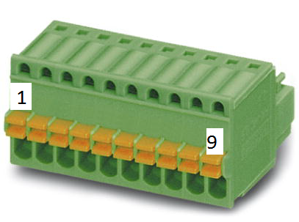

Quantity: 4 units

Length: 220 cm

Cable type: 7291202109

Please attach the label with Cable Name to the cable.