ETX-5300A-MC/4XFP/AT
ETX-5300A-MC/4XFP/AT/H
ETX-5300A_MC/4SFP-P/AT

Final Test Instructions

Last Updated: 14.06.2020

Contents
1. Required Test Equipment 4
2. Preparations for Testing 4
3. Visual Inspection 6
4. Basic Operational Tests (BOT) 6
4.1. Automated BOT 6
4.2. Manual BOT 6
5. Environmental Stress Screening (ESS) 7
6. Automated Final Tests 9
6.1. Setup 9
6.2. Running the Test 9
6.3. Complementary Tests (Manual) 9
‎7.18 Bridge & Freeze Test 9
‎7.19 Sticker Attachment 9
7. Manual Final Tests 9
7.1. Factory default 10
7.2. CPU-PHY RGMII Test 10
7.3. Memory Test 10
7.4. Voltage Test (Reading from register) 11
7.5. Identification Test 11
7.6. Time & Date Test 11
7.7. Temperature Test (Reading from register) 11
7.8. I/O card exist Test 12
7.9. Power controller Test 12
7.10. TDM BUS for I/O Test 12
7.11. Data & I2C Test 14
7.12. Redundancy 15
7.13. External clock 16
7.14. BP Test (J11, J12, J13) 17
7.15. TDM BUS for FAN Test 17
7.16. Led Test 18
7.17. BPN1+2,INA+B,FAN and Barcode setting 18
7.18. Bridge Test 20
7.19. Sticker Attachment 20
8. Preparations for Shipment 20
9. Factory Setting 21
10. Safety Test 21
Appendix A. PAGE Configure for MAIN 22
Appendix B. ETH GEN Configure – ETX220 23
Appendix C. DATA Configure 27
DATA configuration for BURN-IN room and for Final-Test 27
Appendix D. DXC-4 Configure 33
Appendix E. Bridge Configure 35

Required Test Equipment
Generic Name/Description | Manuf. | Model
1. Fireberd+ Interface for FB-E1 OR DXC-4 | TTC | FB6000A
2. Decryptor application
3. PC with 2*COM | N/A
4. ETX5300-ETH-I/O as REF*4 | RAD | ETX-5300A-ETH/2*10XFP
5. ETX5300 chassis as REF | RAD | ETX5300A-AC or DC
6. ETX5300-Main as REF | RAD | ETX-5300A-MC/4XFP/AT
7. Boundary Scan Tester (JTAG) | GOPEL ELECTRONIC  GMBH | PSC1149.1-B  CASCON GALAXY (TS) VERSION 3.44B
8. E1-BAL/UNBAL,ETH,FIBER  OPTIC SM,LOOP Cable | RAD | CBL-ETX5300-KIT
9. ETX5300-FAN | RAD | ETX-5300A-FAN
10. ETX5300-AC or DC inlet*2 | RAD | ETX-5300A-PI-AC or DC
11. ETX5300 power supply*2 | RAD | ETX-5300A-PS-AC
12. Ride 7 S/W + programming
Cable and adaptor.
13. ETH GENERATOR | RAD | ETX-220

Preparations for Testing
- Open as follows:
RIDE7>Project>Close project>Open project>MAIN_POWER_CTRL>REV 0.3>RIDE> project, verify getting stm…code…
- Disconnect Jumper J38 and connect the programming cable
from pin 2 to end (no power connected to UUT).
- Double click on line with stm…code…
- Verify result okay and led D107 GREEN is blinking.
(P.S- near R3115).
- Attached PS CTRL sticker near the leds.
- Reconnect Jumper J38.
- Open s/w RIDE 7 as follows:
RIDE7>Open>Desktop>POWER>POWER SW>ETX5300A-MAIN>MAIN_HVES_CTRL>REV 0.0>Project>RIDE> project
verify getting stm…code…
- Disconnect Jumper J15 and connect the programming cable
from pin 2 to end (no power connected to UUT).
- Double click on line with stm…code…
- Verify result successfully.
- Verify led D39 GREEN and D38 YELLOW are ON
- Attached HP sticker near Q12.
- Reconnect Jumper J15.
- Connect Jumper J16.
- Connect the COMPACT FLASH and DDR3 gently.
- Set SW-2 pins 1-4 to OFF.
- Using the JTAG tester click on icon Cas344i.
- Type: user= ETX-5300A password= RAD.
- Connect the plug from the JTAG tester to the UUT jumper J30.
- Choose the FILE: GMUX5300_JTAG_MUX.PCF.
- Press on START BATCH, verifies result PASS.
- Disconnect JTAG cable from J30 and connect the plug to jumper J33.
- Choose the FILE:
ETX5300_MAIN_MC_4XFP_AT_AREE190_WITH_PIGGY.PCF.
- Verify option mode is ALL status.
- Press on START BATCH.
- Verify result PASS.
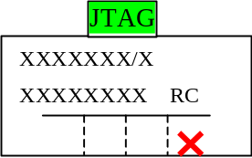
- Disconnect and connect UUT and verify D10 (DBG led) is ON and after few seconds is blinking and OFF.
- Mark the Traceability label as below:
- Disconnect from UUT Jumper J16.
- Send the UUT to assembly dep. to assemble PIGGY and to close CF+MECH cover.
- Set SW-1 pins 1-2 to ON (DBG MODE), Set SW-2 pins 1-4 to OFF.
- Open 3Cdaemon icon.
- Configure FTP server as follows: FTP Profiles>Profile name=gmux>password=gmuxdebug>root+Save Profile.
- Connect UUT to terminal (9600 N-8-1).
- Connect to UUT-MNG inlet ETH cable from PC/SWITCH.
- Press <Enter> to stop the auto-boot.
- After getting [boot (dbg mode)] type <v>+<Enter>
Verify boot version updated as mentioned in the latest ECO.
- Press <c>+<Enter>
- The boot device should be: motetsec2
- Set the name to sw-pack.bin (verify that the sw version updated as mentioned in the latest ECO)
- Insert IP (example): 1.1.1.2, MASK: 255.255.255.0
- Insert SERVER IP: 1.1.1.100,default GW:1.1.1.1
- Type: format+<y>+<Enter>.
- Type at Boot [dbg mode]: download 1
- Verify getting message loading…for example: 60000000 (successfully).
- Verify at 3Cdaemon the Bytes field counter start increasing,
Verify getting reply and verify that led LINK is ON and led ACT is blinking at UUT-MNG inlet.
- Set SW-1 pins 1-2 to OFF (NORMAL MODE), Set SW-2 pins 1-4 to ON insert UUT to rack and after few second type <Enter> several time till you get (boot).
- After getting (boot) Type: set-active 1.
- Insert the PAGE configure as mentioned in Appendix A.
- Disconnect UUT from rack and set SW-1 pin 2 only to OFF.

Visual Inspection
Verify PS2 to PS11 (SIP cards) are soldering straight.

Basic Operational Tests (BOT)

Automated BOT
N/A.

Manual BOT

Functionality Test
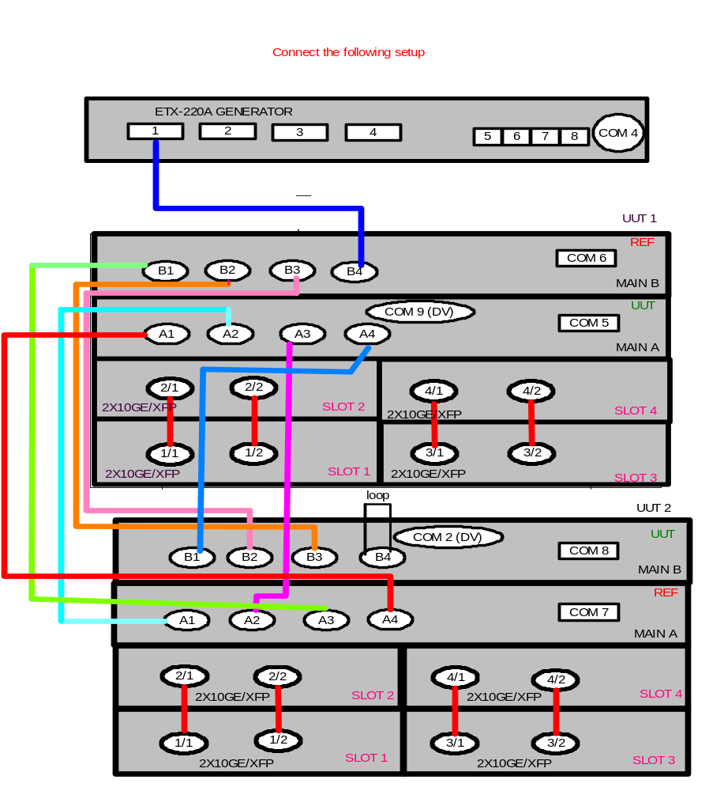
- Connect the following setup:
- While initializing, verify led RMV (blue) turn ON and start blinking.
- Configure the ETX5300 as REF as mentioned in Appendix C.
- Configure the ETX-220 as mentioned in Appendix B.
- Verify no I2C error messages appear.
- Verify DATA running without errors for 2 minutes.
- Mark the Traceability label on main card as below:
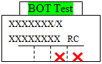

Environmental Stress Screening (ESS)
- Repeat section 4.2.1 steps 1 to 5.
- Type as follows:
ETX-5300A#config port mng-ethernet main-a/0 shutdown
exit
ETX-5300A#config port mng-ethernet main-b/0 shutdown
exit
- Config as follows:
(ETX-5300A#) config reporting clear-alarm-log all-logs
- Capture Terminal
- Run the ESS for 24 hrs with the products passing Data
- Verify DATA running without errors as follows:
(ETX-5300A#)configure reporting
show active-alarm
Total:Critical:0 Major : 0 Minor : 0
• Ignore LOS and Station CLK alarms
- Verify DATA running without errors in the ETX-204 as follows:
PRBS_ERR 0 0 0 0
FRAME_ERR 0 0 0 0
FRAME_NOT_RECOGN 0 0 0 0
SEQ_ERR 0 0 0 0
ERR_CNT 0 0 0 0.
- After 24 hrs Stop Capture Terminal
- Verify in the capture file no I2C error messages appear.
- Verify in the capture file no link down/up messages are appears as follows:
HW-CON - INT_HANDLER_DISP_IRQ3_UNMASK 50001 to 50004
HW-CON - INT_HANDLER_DISP_IRQ3_UNMASK 60001 to 60004
- Type for UUT1 as follows:
>rd8_add 0xf8100067 verify value=24 (Main-A=ACTIVE)
>rd8_add 0xf8100064 verify value=60.
>HW_CONNECTION_DebugOpenMateCardShell
- Type for REF1 as follows:
>rd8_add 0xf8100067 verify value=A0 (Main-B=STANDBY).
>rd8_add 0xf8100064 verify value=A1.
>exit
- Type for UUT2 as follows:
>rd8_add 0xf8100067 verify value=24 (Main-B=ACTIVE)
>rd8_add 0xf8100064 verify value=A0.
>HW_CONNECTION_DebugOpenMateCardShell
- Type for REF2 as follows:
>rd8_add 0xf8100067 verify value=A0 (Main-A=STANDBY).
>rd8_add 0xf8100064 verify value=61.
>exit
- Swap cards between UUT1 and UUT2 as the following setup. Cables and loops remain in the same slots as were before. Configure UUTs to active.
- Type: ETX-5300A#
config protection main-card manual-switch
- Type: ETX-5300A#
config port mng-ethernet main-a/0 shutdown
exit
ETX-5300A#
config port mng-ethernet main-b/0 shutdown
exit
- Config as follows:
(ETX-5300A#) config reporting clear-alarm-log all-logs
- Capture Terminal
- Run the ESS for 24 hrs with the products passing Data
- Verify DATA running without errors as follows:
(ETX-5300A#)configure reporting
show active-alarm
Total: Critical: 0 Major: 0 Minor: 0
- Verify DATA running without errors in the ETX-204 as follows:
PRBS_ERR 0 0 0 0
FRAME_ERR 0 0 0 0
FRAME_NOT_RECOGN 0 0 0 0
SEQ_ERR 0 0 0 0
ERR_CNT 0 0 0 0.
- After 24 hrs Stop Capture Terminal
- Verify in the capture file no I2C error messages appear.
- Verify in the capture file no link down/up messages are appears as follows:
HW-CON - INT_HANDLER_DISP_IRQ3_UNMASK 50001 to 50004
HW-CON - INT_HANDLER_DISP_IRQ3_UNMASK 60001 to 60004
- Type for UUT2 as follows:
>rd8_add 0xf8100067 verify value=24 (Main-A=ACTIVE)
>rd8_add 0xf8100064 verify value=60.
>HW_CONNECTION_DebugOpenMateCardShell
- Type for REF1 as follows:
>rd8_add 0xf8100067 verify value=A0 (Main-B=STANDBY).
>rd8_add 0xf8100064 verify value=A1.
>exit
- Type for UUT1 as follows:
>rd8_add 0xf8100067 verify value=24 (Main-B=ACTIVE)
>rd8_add 0xf8100064 verify value=A0.
>HW_CONNECTION_DebugOpenMateCardShell
- Type for REF2 as follows:
>rd8_add 0xf8100067 verify value=A0 (Main-A=STANDBY).
>rd8_add 0xf8100064 verify value=61.
>exit
- As specified in the GFTI.

Automated Final Tests
The following instructions reflect:
 | Last Updated
Final Test Instructions | 14.06.2020
Automatic Tester | 14.06.2020

Setup
1. Set SW-1 pins 1 to OFF
2. Connect Davicom to the two UUTs
3. Insert the two MAIN cards into the chassis.
4. Connect the cables – power,Davicom, Control, External BAL and UnBAL cables, 10GbEth fiber optic according to Data & I2C Test.
5. Capture the Davicom terminal

Running the Test
1. Press to start running the test and follow the Instructions on the screen. If the test fails, the display will show a red Fail message and the test will be stopped, and you may resume testing from this point.
2. Verify that the test passed.

Complementary Tests (Manual)
From Section 7, perform the following tests only:
Test

7.18 Bridge Test

1 Remove MAIN-B from Chassis UUT1 and MAIN-A from Chassis UUT2.

Manual Final Tests
Notes | 1. For CLI commands insert as follows:  User>su , Password>1234+<Enter> till you get: ETX-5300A#  For MSCEM option (KOREA orders) get: MSCEM#  2. In CLI use the command exit all to start from  ETX-5300A#  3. To activate CLI command press <Enter> in the end.  4. In the following tests when you need to use debug shell  commands perform as follows:  Double click on Decryptor icon verify that rados keys is  active In the rack with the UUT get in User>su ,  Password>1234+<Enter>ETX-5300A#> logon  debug+<Enter>, The number that you get copy to the Key  filed in the Decryptor then click on Change Pass.  The new number that you get at the result filed copy to  the password at the rack and after you get ETX-5300A#  >debug Shell +<Enter> in this point you will get > mark  which means That you can start type shell commands.  5. The following tests regards in both chassis as UUT1 and UUT2 are active as appears at Data & I2C Test.  To activate MAIN that in standby mode use the command in the active MAIN as follows:  configure protection main-card manual-switch

Factory default
- Set SW-1 pin 1 only to OFF.
- Type as follows:
(ETX-5300A#)admin>factory-default+<Y>.
- Using CLI commands type as follows:
(ETX-5300A#) config terminal
timeout forever

CPU-PHY RGMII Test
- Connect Davicom to the two UUTs and start capture
- Using debug shell Config card MAIN A&B as follows:
Use COM1 for Main-A
> tipcConfig "l"
> ifconfig "motetsec0 inet 1.1.1.1/24"
> HW_CONNECTION_DebugOpenMateCardShell
Use COM 2 for Main-B
> tipcConfig "l"
> ifconfig "motetsec0 inet 1.1.1.2/24”
> ping "1.1.1.1",20 (for MAIN-A),verify no packet loss
> exit
Use COM1 for Main-A
> ping "1.1.1.2",20 (for MAIN-B),verify no packet loss
Note | For chassis with UUT2 use COM3 and COM4

Memory Test
Using debug shell commands check mem test as follows:
For checking NETWORK PROCESSOR (U76-87,DDR*12) perform as follows:
>cmd>[Vxworks] rtp>attach ID of rPktProcessing
for example: attach 0xb1f1010
[rPktProcessing] task spawn &SetDefaultTerminal 0
[rPktProcessing] task spawn &ddr_test 2
verify getting message “Test Passed”.
For checking ARRIA FPGA QDR (U92) perform as follows:
[rPktProcessing] task spawn &fpga_mem_test 0
verify getting message “passed”.
For checking ARRIA FPGA RLDRAM1 (U91) perform as follows:
[rPktProcessing] task spawn &fpga_mem_test 1
verify getting message “passed”.
For checking ARRIA FPGA RLDRAM2 (U93) perform as follows:
[rPktProcessing] task spawn &fpga_mem_test 2
verify getting message “passed”.

Voltage Test (Reading from register)
Using debug shell commands check as follows:
> rd8_add 0xf8100069 verify getting data 0xff
> rd8_add 0xf810006A verify getting data 0xff
> rd8_add 0xf810006B verify getting data 0x7

Identification Test
- Type as follows:
ETX-5300A#configure Chassis
Show summary-inventory
Verify the ID of Chassis and UUT’s are according to ECO (H/W, SW, FW version).
- Verify as follows: (ETX-5300A#) file
show sw-pack
verify that the s/w is the updated version and only one s/w appears and Actual filed is active.
- Verify the ID of SFP’s that connect to the UUT are properly (Typical Max Range, Wave length etc.) as follows:
(ETX-5300A#)config port eth main-a/1
show sfp-status
Repeat this command to main-a ports 2 to 4
- Using debug shell commands check as follows:
rd8_add 0xf8100060 (U17) verify value is the updated version.
- Type as follows:
ETX-5300A>config>chassis# show manufacture-info all
Verify Type according to option: Main SFP+x4 or Main 10GEx4
Verify Hard according to option: for Harden option the filed=YES, for Regular = NO

Time & Date Test
- Disconnect REF MAIN cards in both chassis.
- Insert the correct time and date from your PC using CLI commands as follows:
ETX-5300A#configure system date-and-time>
<date>yyyy-mm-dd
<time>hh:mm[:ss] .
ETX-5300A#save
- Disconnect and connect the power from both chassis.
- After both chassis are UP type as follows:
ETX-5300A#configure system
show system date
verify date and time are correct.
- Connect REF MAIN cards in both chassis.

Temperature Test (Reading from register)
- Type by using the SHELL command as follows:
>rd8_add 0xf810006C (PIGGY 10GIGA SENSOR)
verify data is between 78 to A0 (HEX).
>rd8_add 0xf810006D (near U39 SWITCH)
verify data is between 78 to A0 (HEX).
>rd8_add 0xf810006E (near U56 CPU)
verify data is between 78 to A0 (HEX).
>rd8_add 0xf810006F (near U8 NETWORK PROCESSOR)
verify is between 78 to A0 (HEX).
Note | The value that you get is in HEX, so to get the correct value you should convert from HEX to DEC and decrease 100. For example:  81(HEX)=10000001(base 2)>129(DEC)-100=29 degrees.
- Type to test the NETWORK PROCESSOR as follows:
>rtsens 0,0x01 verify value is between 14 to 3C (HEX).
Note | The value that you get you need to convert as the follow example:  Value=0x28=>28(HEX)=>00101000(base 2)=>40(DEC)= 40℃.

I/O card exist Test
By using debug shell commands type as follows:
>malloc 1
Read message value = 253720656 = 0xf1f7850
the value you get (0xf1f7850) insert to the following commands
> IPMC_I2C_Read_data (slot,register,i2cLine, 0xf1f7850,1)
example for slot 1 =>
> IPMC_I2C_Read_data (1,1,0,0xf1f7850,1)
> d 0xf1f7850,1
verify getting message:
0x0f1f7850: 6673 *f...............*
Note: | The 2 first bytes that you get is the value you need to get. For example: 6673 the checked value =66
> IPMC_I2C_Read_data (1,1,1,0xf1f7850,1)
> d 0xf1f7850,1 verify getting message:
0x0f1f7850: 6673 *f...............*

Power controller Test
By using debug shell commands type as follows:
-> wr8_add 0xf810008b,0xe3
-> rd8_add 0xf8100070 verify data filed is the update value as
appears in the latest ECO
for example:4(this value means version 0.4)
-> wr8_add 0xf810008b,0xc5
-> wr8_add 0xf810008b,0x00

TDM BUS for I/O Test
- Setup as appears in DATA & I2C section step 1.
- Type by using the SHELL command as follows:
>wgil(1,0XA0,0XFF)
>rd8_add 0xf8100030 (Main-A) data=0x00
>rd8_add 0xf8100032 (Main-B) data =0x00
>wgil(1,0XA0,0XF3)
Wait 15 seconds
>rd8_add 0xf8100034 (I/O –1) data =0x80
>wgil(1,0XA0,0XFB)
>rd8_add 0xf8100034 (I/O –1) data =0x00
>wgil(1,0XA0,0XF3)
Wait 15 seconds
>rd8_add 0xf8100034 (I/O –1) data =0x80
>wgil(1,0XA0,0XF7)
>rd8_add 0xf8100034 (I/O –1) data =0x00
>wgil(1,0XA0,0XFF)
>wgil(2,0XA0,0XF3)
Wait 15 seconds
>rd8_add 0xf8100036 (I/O –2) data =0x80
>wgil(2,0XA0,0XFB)
>rd8_add 0xf8100036 (I/O –2) data =0x00
>wgil(2,0XA0,0XF3)
Wait 15 seconds
>rd8_add 0xf8100036 (I/O –2) data =0x80
>wgil(2,0XA0,0XF7)
>rd8_add 0xf8100036 (I/O –2) data =0x00
>wgil(2,0XA0,0XFF)
>wgil(3,0XA0,0XF3)
Wait 15 seconds
>rd8_add 0xf8100038 (I/O –3) data =0x80
>wgil(3,0XA0,0XFB)
>rd8_add 0xf8100038 (I/O –3) data =0x00
>wgil(3,0XA0,0XF3)
Wait 15 seconds
>rd8_add 0xf8100038 (I/O –3) data =0x80
>wgil(3,0XA0,0XF7)
>rd8_add 0xf8100038 (I/O –3) data =0x00
>wgil(3,0XA0,0XFF)
>wgil(4,0XA0,0XF3)
Wait 15 seconds
>rd8_add 0xf810003A (I/O –4) data =0x80
>wgil(4,0XA0,0XFB)
>rd8_add 0xf810003A (I/O –4) data =0x00
>wgil(4,0XA0,0XF3)
Wait 15 seconds
>rd8_add 0xf810003A (I/O –4) data =0x80
>wgil(4,0XA0,0XF7)
>rd8_add 0xf810003A (I/O –4) data =0x00
>wgil(4,0XA0,0XFF)

Data & I2C Test
- 
# 4x ETX-5300A-MC/4XFP/AT (2=REF, 2=UUT)
# 8x ETX-5300A-ETH/10X2/XFP (8=REF)
# Configure both ETX5300 as REF as mentioned in Appendix D.
- Configure the ETX-220 as mentioned in Appendix B.
- Config as follows:
configure slot 1 shutdown
configure slot 1 no shutdown
Repeat the commands for slots 2 to 4.
- Type as follows:
ETX-5300A#config port mng-ethernet main-a/0 shutdown
exit
ETX-5300A#config port mng-ethernet main-b/0 shutdown
exit
- Config as follows:
(ETX-5300A#) config reporting clear-alarm-log all-logs
- Verify DATA running without errors for 5 minutes as follows:
(ETX-5300A#) configure reporting
show active-alarm
Total: Critical:0 Major:0 Minor:0
- Ignore LOS and Station CLK alarms
- (ETX-5300A#) config reporting
show log
Last Acknowledge On : -- --
- Start capture by using Davicom to the two UUTs.
- Verify DATA running without errors in the ETX-204 as
follows:
PRBS_ERR 0 0 0 0
FRAME_ERR 0 0 0 0
FRAME_NOT_RECOGN 0 0 0 0
SEQ_ERR 0 0 0 0
ERR_CNT 0 0 0 0.
- Disconnect the power from inlet A.
- Repeat step 10 for DATA running of 10 seconds.
- Reconnect the power to inlet A and after 10 sec
disconnect power from inlet B.
- Repeat step 10.
- Reconnect the power to inlet B.
- Stop Capture Davicom Terminal
- Verify in the capture file no I2C error messages appear.
- Verify in the capture file no link down/up messages are appears as follows:
HW-CON - INT_HANDLER_DISP_IRQ3_UNMASK 50001 to 50004
HW-CON - INT_HANDLER_DISP_IRQ3_UNMASK 60001 to 60004

Redundancy
- Type in both chassis as follows:
(ETX-5300A#) config protection main-card manual-switch
- Verify that REF1 is active as follows:
ETX-5300A# config protection main-card
show status
Primary Card : Main B
Redundancy Status : OK
Verify that REF2 is active as follows:
ETX-5300A# config protection main-card
show status
Primary Card : Main A
Redundancy Status : OK
- Config as follows:
configure slot 1 shutdown
configure slot 1 no shutdown
Repeat the commands for slots 2 to 4.
- Config as follows:
(ETX-5300A#) config reporting clear-alarm-log all-logs
then verify data traffic without errors for 5 minutes via MAIN ref card.
- Type in both chassis as follows:
(ETX-5300A#) config protection main-card manual-switch
Verify that UUT2 is active as follows:
ETX-5300A# config protection main-card
show status
Primary Card : Main B
Redundancy Status : OK
Verify that UUT1 is active as follows:
ETX-5300A# config protection main-card
show status
Primary Card : Main A
Redundancy Status : OK
- Verify data traffic works OK via UUT during 10sec.
- Verify that ACT&LINK leds at UUT are ON (ACT=YELLOW, LINK=GREEN)
- Disconnect all fiber optic cable from ports 1to 4 in UUT.
- Verify that ACT&LINK leds at UUT are OFF.

External clock
Note | Instead of using F.B you can use DXC-4 as mentioned in Appendix D.
- Configure the F.B as follow:
MARK=QRSS CLK=SYNTH
MENU→INTF SETUP→2M/n64→CONFIG→FRAMED, CRC4=OFF, TS16=OFF→
MENU→INTF SETUP→2M/n64→MODE→FULL2M
ERROR←ANALYSIS RESULT→TIME
- Connect from F.B the BAL cable to UUT-BAL inlet then type as follows:
UUT1, ETX-5300A#configure>system clock station main-a/1>
interface-type e1>impedance balanced> tx-clock-source station-rclk>no shutdown
UUT2, ETX-5300A#configure>system clock station main-b/1>
interface-type e1>impedance balanced> tx-clock-source station-rclk>no shutdown
- Verify no errors at F.B for UUT data running for 10 seconds.
- Connect from F.B the UNBAL cables to UUT-UNBAL inlet then type as follows:
UUT1, ETX-5300A#configure>system clock station main-a/1> shutdown impedance unbalanced>no shutdown.
UUT2, ETX-5300A#configure>system clock station main-b/1> shutdown impedance unbalanced>no shutdown.
- Verify no errors at F.B for UUT data running for 10 seconds.
- Disconnect from UUT-UNBAL inlet the cables.

BP Test (J11, J12, J13)
- By using shell commands check as follows:
AC option
disconnect FAN unit
>rd8_add 0xf8100062 verify value is D7
disconnect ETX5300-INLET A.
>rd8_add 0xf8100062 verify value is F7
Reconnect INLET-A and the FAN
and after few seconds disconnect INLET-B
>rd8_add 0xf8100062 verify value is DC
Reconnect INLET-B
>rd8_add 0xf8100062 verify value is D4
disconnect only the power from INLET-A unit
>rd8_add 0xf8100065 verify value=AF
Reconnect the power to INLET-A after few seconds disconnect
only the power from INLET-B
>rd8_add 0xf8100065 verify value=5F
Reconnect the power to INLET-B
>rd8_add 0xf8100065 verify value is F
(INLET A+B voltage okay)
DC option
disconnect FAN unit
>rd8_add 0xf8100062 verify value is C3
Reconnect the FAN unit
>rd8_add 0xf8100062 verify value is C0
disconnect INLET A.
>rd8_add 0xf8100062 verify value is F0
Reconnect INLET-A and after few seconds disconnect INLET-B
>rd8_add 0xf8100062 verify value is CC
Reconnect INLET-B.
Disconnect only the power from INLET-A unit
>rd8_add 0xf8100065 verify value=AB
Reconnect the power to INLET-A and after few seconds disconnects
only the power from INLET-B
>rd8_add 0xf8100065 verify value=57
Reconnect the power to INLET-B
>rd8_add 0xf8100065 verify value is 3
(INLET A+B voltage okay)

TDM BUS for FAN Test
- By using shell commands check as follows:
For UUT1 perform as follows:
>diconnect Main B
>rfan(1,1) – value should be 0x66
>wr8_add(0xf8100020,0x3f)
>rfan(1,1) – value should be 0xff
>wr8_add(0xf8100020,0x1f)
>rfan(1,1) – value should be 0x66
>reconnect Main B
For UUT2 perform as follows:
>disconnect Main A
>rfan(1,1) – value should be 0x66
>wr8_add(0xf8100020,0x3f)
>rfan(1,1) – value should be 0xff
>wr8_add(0xf8100020,0x1f)
>rfan(1,1) – value should be 0x66
>reconnect Main A

Led Test
- By using shell commands check as follows:
checking leds PRI+FLT+RMV type as follows:
>wr8_add 0xf8100083,0xff
Verify PRI+FLT+RMV leds turn OFF.
>wr8_add 0xf8100083,0xef
Verify PRI+FLT+RMV leds turn ON.
>wr8_add 0xf8100083,0xbf
Verify only PRI led is turn ON.
- For checking led CLK type as follows:
cmd>[Vxworks]> rtp>attach ID of ClockSelection.VXE
for example: attach 0xa53b010>
- [rClockSelection] task spawn &SetDefaultTerminal 0
- [rClockSelection]
Verify that CLK led turn ON.
[rClockSelection] task spawn &SYNCLOCK_WR16 0X20 0X8FFF
Verify that CLK led turn OFF.
- Type on UUT-1: (ETX-5300A#(config/port/mng-ethernet main-a/0
(ETX-5300A#(no shutdown
- Type on UUT-2: (ETX-5300A#(config/port/mng-ethernet main-b/0
(ETX-5300A#(no shutdown
- Run Generator’s ports 5 and 6.
- Verify that green leds LINK are ON and orange leds ACT are blinking at both MNG-ETH ports.

BPN1+2,INA+B,FAN and Barcode setting
- Set the BARCODE value as for MAIN-A as mentioned in Appendix A/BARCODE.
Note | After each following C2 command type y0a02+<Y>.
- Program UUT of 2 BPNs, 2 AC/DC Inlets and FAN as follows: boot(debug-mode)]:shelfmac bpn1
Type as follows:
C2 0,0,0,” 00 00 00 00 00 00 00 00 00 00 00 00 00 00 00 00”,FF
C2 0,1,0,” 00 00 00 00 00 00 00 00 00 00 00 00 00 00 00 00”,FF
C2 0,2,0,” 00 00 00 00 00 00 00 00 00 00 00 00 00 00 00 00”,FF
C2 0,3,0,” 00 00 00 00 00 00 00 00 00 00 00 00 00 00 00 00”,FF
type: d2 00+<Enter> verify PAGE 0 to 3 is all 00.
Type as follows:
C2 0,0,0,” 01 02 03 04 05 06 07 08 09 0A 0B 0C 0D 0E 0F 0G 0H”,FF
C2 0,1,0,” 01 02 03 04 05 06 07 08 09 0A 0B 0C 0D 0E 0F 0G 0H”,FF
C2 0,2,0,” 01 02 03 04 05 06 07 08 09 0A 0B 0C 0D 0E 0F 0G 0H”,FF
C2 0,3,0,” 01 02 03 04 05 06 07 08 09 0A 0B 0C 0D 0E 0F 0G 0H”,FF
type: d2 00+<Enter> verify PAGE 0 to 3 were change.
boot(debug-mode)]:shelfmac bpn2
Type as follows:
C2 0,0,0,” 00 00 00 00 00 00 00 00 00 00 00 00 00 00 00 00”,FF
C2 0,1,0,” 00 00 00 00 00 00 00 00 00 00 00 00 00 00 00 00”,FF
C2 0,2,0,” 00 00 00 00 00 00 00 00 00 00 00 00 00 00 00 00”,FF
C2 0,3,0,” 00 00 00 00 00 00 00 00 00 00 00 00 00 00 00 00”,FF
type: d2 00+<Enter> verify PAGE 0 to 3 is all 00.
Type as follows:
C2 0,0,0,” 01 02 03 04 05 06 07 08 09 0A 0B 0C 0D 0E 0F 0G 0H”,FF
C2 0,1,0,” 01 02 03 04 05 06 07 08 09 0A 0B 0C 0D 0E 0F 0G 0H”,FF
C2 0,2,0,” 01 02 03 04 05 06 07 08 09 0A 0B 0C 0D 0E 0F 0G 0H”,FF
C2 0,3,0,” 01 02 03 04 05 06 07 08 09 0A 0B 0C 0D 0E 0F 0G 0H”,FF
type: d2 00+<Enter> verify PAGE 0 to 3 were change.
boot(debug-mode)]:shelfmac ina
Type as follows:
C2 0,0,0,” 00 00 00 00 00 00 00 00 00 00 00 00 00 00 00 00”,FF
C2 0,1,0,” 00 00 00 00 00 00 00 00 00 00 00 00 00 00 00 00”,FF
C2 0,2,0,” 00 00 00 00 00 00 00 00 00 00 00 00 00 00 00 00”,FF
C2 0,3,0,” 00 00 00 00 00 00 00 00 00 00 00 00 00 00 00 00”,FF
type: d2 00+<Enter> verify PAGE 0 to 3 is all 00.
Type as follows:
C2 0,0,0,” 01 02 03 04 05 06 07 08 09 0A 0B 0C 0D 0E 0F 0G 0H”,FF
C2 0,1,0,” 01 02 03 04 05 06 07 08 09 0A 0B 0C 0D 0E 0F 0G 0H”,FF
C2 0,2,0,” 01 02 03 04 05 06 07 08 09 0A 0B 0C 0D 0E 0F 0G 0H”,FF
C2 0,3,0,” 01 02 03 04 05 06 07 08 09 0A 0B 0C 0D 0E 0F 0G 0H”,FF
type: d2 00+<Enter> verify PAGE 0 to 3 were change.
boot(debug-mode)]:shelfmac inb
Type as follows:
C2 0,0,0,” 00 00 00 00 00 00 00 00 00 00 00 00 00 00 00 00”,FF
C2 0,1,0,” 00 00 00 00 00 00 00 00 00 00 00 00 00 00 00 00”,FF
C2 0,2,0,” 00 00 00 00 00 00 00 00 00 00 00 00 00 00 00 00”,FF
C2 0,3,0,” 00 00 00 00 00 00 00 00 00 00 00 00 00 00 00 00”,FF
type: d2 00+<Enter> verify PAGE 0 to 3 is all 00.
Type as follows:
C2 0,0,0,” 01 02 03 04 05 06 07 08 09 0A 0B 0C 0D 0E 0F 0G 0H”,FF
C2 0,1,0,” 01 02 03 04 05 06 07 08 09 0A 0B 0C 0D 0E 0F 0G 0H”,FF
C2 0,2,0,” 01 02 03 04 05 06 07 08 09 0A 0B 0C 0D 0E 0F 0G 0H”,FF
C2 0,3,0,” 01 02 03 04 05 06 07 08 09 0A 0B 0C 0D 0E 0F 0G 0H”,FF
type: d2 00+<Enter> verify PAGE 0 to 3 were change.
boot(debug-mode)]:shelfmac fan
Type as follows:
C2 0,0,0,” 00 00 00 00 00 00 00 00 00 00 00 00 00 00 00 00”,FF
C2 0,1,0,” 00 00 00 00 00 00 00 00 00 00 00 00 00 00 00 00”,FF
C2 0,2,0,” 00 00 00 00 00 00 00 00 00 00 00 00 00 00 00 00”,FF
C2 0,3,0,” 00 00 00 00 00 00 00 00 00 00 00 00 00 00 00 00”,FF
type: d2 00+<Enter> verify PAGE 0 to 3 is all 00.
Type as follows:
C2 0,0,0,” 01 02 03 04 05 06 07 08 09 0A 0B 0C 0D 0E 0F 0G 0H”,FF
C2 0,1,0,” 01 02 03 04 05 06 07 08 09 0A 0B 0C 0D 0E 0F 0G 0H”,FF
C2 0,2,0,” 01 02 03 04 05 06 07 08 09 0A 0B 0C 0D 0E 0F 0G 0H”,FF
C2 0,3,0,” 01 02 03 04 05 06 07 08 09 0A 0B 0C 0D 0E 0F 0G 0H”,FF
type: d2 00+<Enter> verify PAGE 0 to 3 were change.
- Disconnect UUT then set SW-1 pins 1-2 to OFF (normal)

Bridge Test
- Remove MAIN-B from Chassis UUT1 and MAIN-A from Chassis UUT2.
- Connect the following setup:
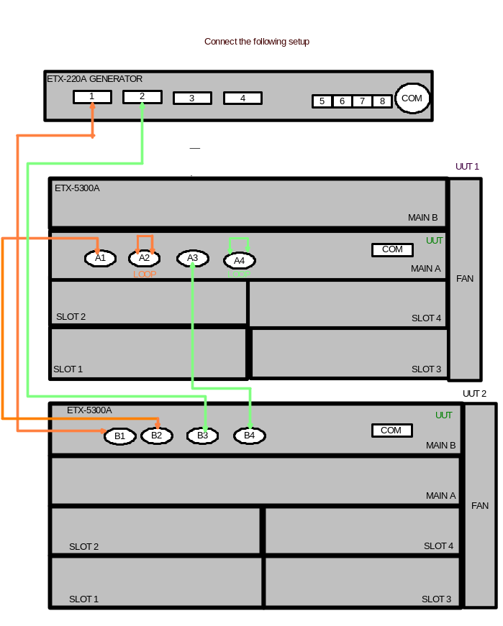
- Type as follows:
(ETX-5300A#)admin>factory-default+<Y>.
- Configure UUT as mentioned in Appendix E.
- Verify no errors appear for 2 minutes of DATA running.
- Type as follows:
(ETX-5300A#)admin>factory-default+<Y>.

Sticker Attachment
- Mark the Traceability label on main card and “CSL” (Configuration Status Label) as follows:
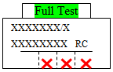

Preparations for Shipment
1. As specified in the GFTI.
2. Integration test - Connect the UUT to setup as customer order and run DATA

Factory Setting
As specified in the GFTI.

Safety Test
As specified in the GFTI.
- PAGE Configure for MAIN
BOT
- Set SW1 to DBG mode ON (pins 1+2).
- Type<C> and verify IP is=10.10.10.2(default) and baud rate is 9600(default),
if IP and baud rate not as mentioned then set IP to 10.10.10.2 and baud rate to 9600 by in pass the line after line by type
<Enter> until getting IP line and baud rate.
- After getting [boot (dbg mode)] type as follow: <Ctrl>+<P>+<Enter> then type d2 00
- Configure as follows:
Page 0 - 00 00 00 00 00 00 00 00 00 00 00 00 00 00 00 00
00 00 00 00 00 00 00 00 00 00 00 00 00 00 00 00
For setting Page 1 type as follows:
C2 0,1,0,” 00 00 00 48 00 00 00 00 00 00 00 00 00 00 01 F5”,FF
Then type y0a02+<Y>.
Page 1 - 00 00 00 4B 00 00 00 00 00 00 00 00 00 00 01 F5
00 00 00 00 00 00 00 00 00 00 00 00 00 00 00 00
For setting Page 2 type as follows:
C2 0,2,0,” 00 00 00 00 00 00 00 00 00 00 00 00 00 00 00 00
00 00 00 00 02 00”,FF then type y0a02+<Y>.
Page 2 - 00 00 00 00 00 00 00 00 00 00 00 00 00 00 00 00
00 00 00 00 02 00 00 00 00 00 00 00 00 00 00 00

Page 2 setting for Harden: c2 0,2,23,"0x48",ff
Page 2 (for Harden option) - 00 00 00 00 00 00 00 00 00 00 00 00 00 00 00 00
00 00 00 00 02 00 00 48 00 00 00 00 00 00 00 00

Barcode
- Repeat BOT part steps 1 to 2.
- After getting [boot (dbg mode)] type <V>
Verify boot version updated as mentioned in the latest ECO.
- After getting [boot (dbg mode)] type as follow: <Ctrl>+<P>+<Enter> then type d2 00
- Configure as follows:
Page 3- 00 02 44 41 32 30 30 30 31 32 33 34 35 00 00 00
00 00 00 00 00 00 00 00 00 00 00 00 00 00 00 00
For setting Page 3 type as follows (example of barcode DA200012345 in ASCII):
C2 0,3,0,” 00 02 44 41 32 30 30 30 31 32 33 34 35”,FF
Then type y0a02+<Y>.
- ETH GEN Configure – ETX220
- Double click on the icon 10GbGen.exe
- Config as attached in the following pictures:
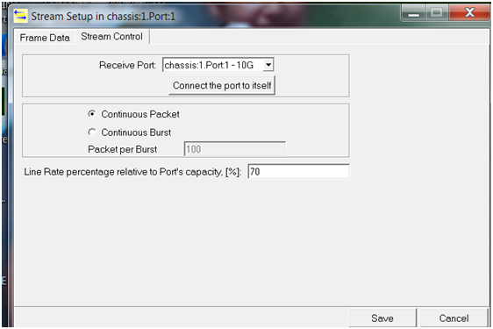

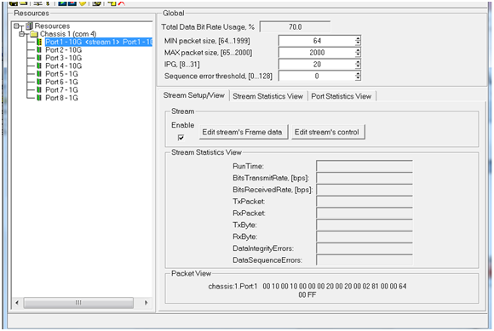

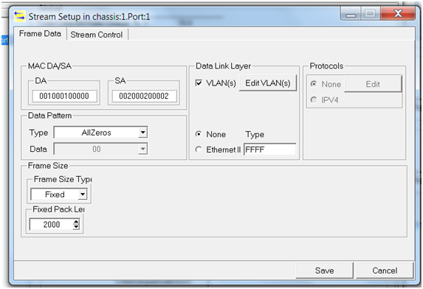

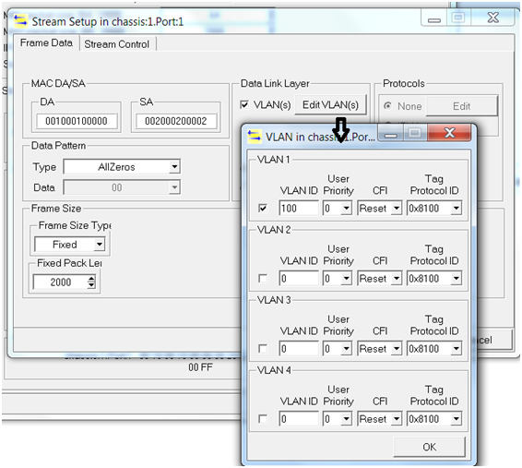

Press on run icon, verify data running.
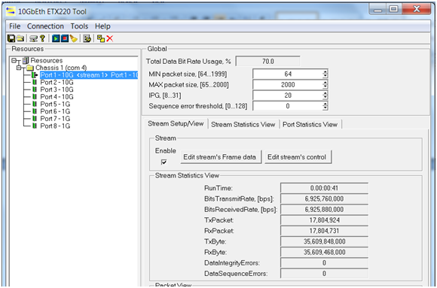

Press on stop icon
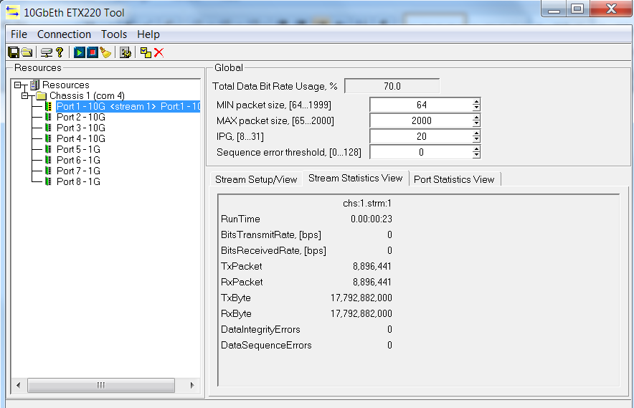

Verify TX=RX and no errors

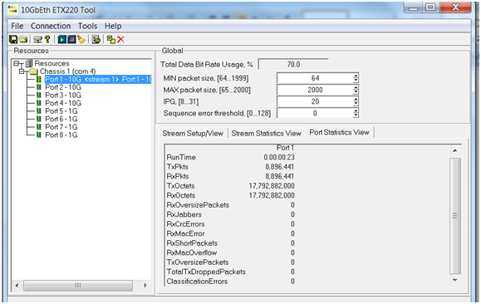

Verify TX=RX and no errors

- DATA Configure

DATA configuration for BURN-IN room and for Final-Test
- Download script DATA_RUNNING.txt
- Verify no CLI errors messages.
- Verify that DATA running okay.

DATA RUNNING SCRIPT
#********************card type****************************************
configure slot 1
card-type eth 10g-2-xfp
no shutdown
exit all
configure slot 2
card-type eth 10g-2-xfp
no shutdown
exit all
configure slot 3
card-type eth 10g-2-xfp
no shutdown
exit all
configure slot 4
card-type eth 10g-2-xfp
no shutdown
exit all
#************************************************************************
#****************************IO-1_to_MC-A/1******************************
#***************************General_Traffic******************************
#************************************************************************
exit all
#***************************TM_QUEUE_GROUP*******************************
config port ethernet main-a/1 queue-group profile q_group_2_level_default
config port ethernet main-a/2 queue-group profile q_group_2_level_default
config port ethernet main-a/3 queue-group profile q_group_2_level_default
config port ethernet main-a/4 queue-group profile q_group_2_level_default
config port ethernet main-b/1 queue-group profile q_group_2_level_default
config port ethernet main-b/2 queue-group profile q_group_2_level_default
config port ethernet main-b/3 queue-group profile q_group_2_level_default
config port ethernet main-b/4 queue-group profile q_group_2_level_default
config port ethernet 1/1 queue-group profile q_group_2_level_default
config port ethernet 1/2 queue-group profile q_group_2_level_default
config port ethernet 3/2 queue-group profile q_group_2_level_default
config port ethernet 4/1 queue-group profile q_group_2_level_default
config port ethernet 2/1 queue-group profile q_group_2_level_default
config port ethernet 2/2 queue-group profile q_group_2_level_default
config port ethernet 3/1 queue-group profile q_group_2_level_default
config port ethernet 4/2 queue-group profile q_group_2_level_default
config port sag 1/1 queue-group profile q_group_SAG_2_level_default
config port sag 1/2 queue-group profile q_group_SAG_2_level_default
config port sag 2/1 queue-group profile q_group_SAG_2_level_default
config port sag 2/2 queue-group profile q_group_SAG_2_level_default
config port sag 3/1 queue-group profile q_group_SAG_2_level_default
config port sag 3/2 queue-group profile q_group_SAG_2_level_default
config port sag 4/1 queue-group profile q_group_SAG_2_level_default
config port sag 4/2 queue-group profile q_group_SAG_2_level_default
exit all
config port ethernet main-a/1 no shutdown
config port ethernet main-a/2 no shutdown
config port ethernet main-a/3 no shutdown
config port ethernet main-a/4 no shutdown
config port ethernet main-b/1 no shutdown
config port ethernet main-b/2 no shutdown
config port ethernet main-b/3 no shutdown
config port ethernet main-b/4 no shutdown
exit all
config port ethernet 1/1 no shutdown
config port ethernet 1/2 no shutdown
config port ethernet 3/1 no shutdown
config port ethernet 4/1 no shutdown
config port ethernet 2/1 no shutdown
config port ethernet 2/2 no shutdown
config port ethernet 3/2 no shutdown
config port ethernet 4/2 no shutdown
exit all
#***************************CLASSIFIER_PROFILE for TM tests *************
config flows classifier-profile classall match-any
match all
exit all
config flows classifier-profile slot1 match-any
match vlan 100
exit all

#*********************************END************************************

#***************************FLOW_CONFIGURATION***************************

#**********Traffic from PORT main-1 to main-2 via eth 1/1 to 2/1**************
configure flows flow 1
classifier slot1
ingress-port ethernet main-a/1
egress-port ethernet 1/1 queue-map-profile QueueMapDefaultProfile block 0/1
no shutdown
exit all
configure flows flow 2
classifier slot1
ingress-port ethernet 2/1
egress-port sap 2/1/1 queue-map-profile QueueMapDefaultProfile block 0/1
no shutdown
exit all
configure flows flow 3
classifier classall
ingress-port sap 2/1/1
egress-port ethernet main-a/2 queue-map-profile QueueMapDefaultProfile block 0/1
no shutdown
exit all

#***************Traffic from PORT main-2 to main-1 via eth 2/1 to 1/1*******
configure flows flow 4
classifier slot1
ingress-port ethernet main-a/2
egress-port ethernet 2/1 queue-map-profile QueueMapDefaultProfile block 0/1
no shutdown
exit all
configure flows flow 5
classifier slot1
ingress-port ethernet 1/1
egress-port sap 1/1/1 queue-map-profile QueueMapDefaultProfile block 0/1
no shutdown
exit all
configure flows flow 6
classifier classall
ingress-port sap 1/1/1
egress-port ethernet main-a/1 queue-map-profile QueueMapDefaultProfile block 0/1
no shutdown
exit all
#***************Traffic from PORT main-1 to main-2 via eth 1/2 to 2/2********
configure flows flow 7
classifier slot1
ingress-port ethernet main-a/3
egress-port ethernet 1/2 queue-map-profile QueueMapDefaultProfile block 0/1
no shutdown
exit all
configure flows flow 8
classifier slot1
ingress-port ethernet 2/2
egress-port sap 2/2/2 queue-map-profile QueueMapDefaultProfile block 0/1
no shutdown
exit all
configure flows flow 9
classifier classall
ingress-port sap 2/2/2
egress-port ethernet main-a/4 queue-map-profile QueueMapDefaultProfile block 0/1
no shutdown
exit all

#***************Traffic from PORT main-2 to main-1 via eth 2/2 to 1/2*********
configure flows flow 10
classifier slot1
ingress-port ethernet main-a/4
egress-port ethernet 2/2 queue-map-profile QueueMapDefaultProfile block 0/1
no shutdown
exit all
configure flows flow 11
classifier slot1
ingress-port ethernet 1/2
egress-port sap 1/2/2 queue-map-profile QueueMapDefaultProfile block 0/1
no shutdown
exit all
configure flows flow 12
classifier classall
ingress-port sap 1/2/2
egress-port ethernet main-a/3 queue-map-profile QueueMapDefaultProfile block 0/1
no shutdown
exit all
#***************Traffic from PORT main-1 to main-2 via eth 1/3 to 2/3******
configure flows flow 13
classifier slot1
ingress-port ethernet main-b/1
egress-port ethernet 3/1 queue-map-profile QueueMapDefaultProfile block 0/1
no shutdown
exit all
configure flows flow 14
classifier slot1
ingress-port ethernet 4/1
egress-port sap 4/1/1 queue-map-profile QueueMapDefaultProfile block 0/1
no shutdown
exit all
configure flows flow 15
classifier classall
ingress-port sap 4/1/1
egress-port ethernet main-b/2 queue-map-profile QueueMapDefaultProfile block 0/1
no shutdown
exit all

#***************Traffic from PORT main-2 to main-1 via eth 2/3 to 1/3*******
configure flows flow 16
classifier slot1
ingress-port ethernet main-b/2
egress-port ethernet 4/1 queue-map-profile QueueMapDefaultProfile block 0/1
no shutdown
exit all
configure flows flow 17
classifier slot1
ingress-port ethernet 3/1
egress-port sap 3/1/1 queue-map-profile QueueMapDefaultProfile block 0/1
no shutdown
exit all
configure flows flow 18
classifier classall
ingress-port sap 3/1/1
egress-port ethernet main-b/1 queue-map-profile QueueMapDefaultProfile block 0/1
no shutdown
exit all

#***************Traffic from PORT main-1 to main-2 via eth 1/4 to 2/4*******
configure flows flow 19
classifier slot1
ingress-port ethernet main-b/3
egress-port ethernet 3/2 queue-map-profile QueueMapDefaultProfile block 0/1
no shutdown
exit all
configure flows flow 20
classifier slot1
ingress-port ethernet 4/2
egress-port sap 4/2/2 queue-map-profile QueueMapDefaultProfile block 0/1
no shutdown
exit all
configure flows flow 21
classifier classall
ingress-port sap 4/2/2
egress-port ethernet main-b/4 queue-map-profile QueueMapDefaultProfile block 0/1
no shutdown
exit all

#***************Traffic from PORT main-2 to main-1 via eth 2/4 to 1/4*******
configure flows flow 22
classifier slot1
ingress-port ethernet main-b/4
egress-port ethernet 4/2 queue-map-profile QueueMapDefaultProfile block 0/1
no shutdown
exit all
configure flows flow 23
classifier slot1
ingress-port ethernet 3/2
egress-port sap 3/2/2 queue-map-profile QueueMapDefaultProfile block 0/1
no shutdown
exit all
configure flows flow 24
classifier classall
ingress-port sap 3/2/2
egress-port ethernet main-b/3 queue-map-profile QueueMapDefaultProfile block 0/1
no shutdown
exit all
save
#***************end**********************************steup test****************

- DXC-4 Configure

DXC-4 ( 8 PORTS ) STAT
System
1. Source Clock > (Internal)
2. Management >
3. Control Port >
4. Date/Time >
5. Factory Default
6. Reset
DXC-4 ( 8 PORTS ) STAT
Link channel port
1. Link channel port type[E1,T1] (E1)
2. Port parameters >
DXC-4 ( 8 PORTS ) STAT
Port parameters
1. Update channel number > (Port 1)
2. Frame > (G.732N)
3. Restoration time > (1 Second (Fast))
4. Interface type[LTU,DSU] (DSU)
5. Idle code ... (7F)
6. Line code[AMI,HDB3] (HDB3)
7. Balanced[Yes,No] (Yes)
8. Out of service code ... (7F)
DXC-4 ( 8 PORTS )

1. Update channel number > (Port 2)
2. Frame > (G.732N)
3. Restoration time > (1 Second (Fast))
4. Interface type[LTU,DSU] (DSU)
5. Idle code ... (7F)
6. Line code[AMI,HDB3] (HDB3)
7. Balanced[Yes,No] (No)
8. Out of service code ... (7F)
DXC-4 ( 8 PORTS )
ATAT
Bert Generators
1. Link channel port type[E1,T1] (E1)
2. Configured channel number > (Port 1)
3. Berts enabled assignment ... (1,2)
4. Bert pattern > (QRSS)
5. TSs bert assignment ... (all)
6. Bert State [Run,Stop] (Run)
7. Berts statistics []
8. Insert error rate > (SINGLE)
9. Insert error berts assignment ... (all)
10. Insert error (OFF)
11. Clear Statistics
12. Insert BPV error
DXC-4 ( 8 PORTS ) STAT
Berts statistics

Bert Run time Sync loss Error seconds Error bits
Bert1 2 0 0 0
Bert2 2 2 0 0

- Bridge Configure
Config for MAIN-A
config port ethernet main-a/1 queue-group profile q_group_2_level_default
config port ethernet main-a/2 queue-group profile q_group_2_level_default
config port ethernet main-a/3 queue-group profile q_group_2_level_default
config port ethernet main-a/4 queue-group profile q_group_2_level_default
exit all
configure terminal timeout forever
exit all
config port mng-ethernet main-a/0
shutdown
exit all
config port mng-ethernet main-b/0
shutdown
exit all
config port
ethernet main-a/1
no shutdown
exit
ethernet main-a/2
no shutdown
exit
ethernet main-a/3
no shutdown
exit
ethernet main-a/4
no shutdown
exit all
config flows classifier-profile 10 match-any
match vlan 10
exit all
config flows classifier-profile 11 match-any
match vlan 11
exit all

config port svi 1 bridge
exit all
config port svi 2 bridge
exit all
config port svi 3 bridge
exit all
config port svi 4 bridge
exit all
config bridge 1 port 1
bind svi 1
no shutdown
exit all
config bridge 1 port 2
bind svi 2
no shutdown
exit all
config bridge 1 port 3
bind svi 3
no shutdown
exit all
config bridge 1 port 4
bind svi 4
no shutdown
exit all
config bridge 1
vlan 10
tagged-egress 1..2
exit
vlan 11
tagged-egress 3..4
exit all
config flows flow 4000
classifier "10"
ingress-port ethernet main-a/1
egress-port svi 1
no shutdown
exit
flow "4001"
classifier "10"
ingress-port ethernet main-a/2
egress-port svi 2
no shutdown
exit
flow "4002"
classifier "11"
ingress-port ethernet main-a/3
egress-port svi 3
no shutdown
exit
flow "4003"
classifier "11"
ingress-port ethernet main-a/4
egress-port svi 4
no shutdown
exit
flow 4004
classifier "10"
ingress-port svi 1
egress-port ethernet main-a/1 queue-map-profile "QueueMapDefaultProfile"block 0/1
no shutdown
exit
flow 4005
classifier "10"
ingress-port svi 2
egress-port ethernet main-a/2 queue-map-profile "QueueMapDefaultProfile"block 0/1
no shutdown
exit
flow 4006
classifier "11"
ingress-port svi 3
egress-port ethernet main-a/3 queue-map-profile "QueueMapDefaultProfile"block 0/1
no shutdown
exit
flow 4007
classifier "11"
ingress-port svi 4
egress-port ethernet main-a/4 queue-map-profile "QueueMapDefaultProfile"block 0/1
no shutdown
exit
save
Config for MAIN-B
config port ethernet main-b/1 queue-group profile q_group_2_level_default
config port ethernet main-b/2 queue-group profile q_group_2_level_default
config port ethernet main-b/3 queue-group profile q_group_2_level_default
config port ethernet main-b/4 queue-group profile q_group_2_level_default
exit all
configure terminal timeout forever
exit all
config port mng-ethernet main-a/0
shutdown
exit all
config port mng-ethernet main-b/0
shutdown
exit all
config port
ethernet main-b/1
no shutdown
exit
ethernet main-b/2
no shutdown
exit
ethernet main-b/3
no shutdown
exit
ethernet main-b/4
no shutdown
exit all
config flows classifier-profile 10 match-any
match vlan 10
exit all
config flows classifier-profile 11 match-any
match vlan 11
exit all
config port svi 1 bridge
exit all
config port svi 2 bridge
exit all
config port svi 3 bridge
exit all
config port svi 4 bridge
exit all
config bridge 1 port 1
bind svi 1
no shutdown
exit all
config bridge 1 port 2
bind svi 2
no shutdown
exit all
config bridge 1 port 3
bind svi 3
no shutdown
exit all
config bridge 1 port 4
bind svi 4
no shutdown
exit all
config bridge 1
vlan 10
tagged-egress 1..2
exit
vlan 11
tagged-egress 3..4
exit all
config flows flow 4000
classifier "10"
ingress-port ethernet main-b/1
egress-port svi 1
no shutdown
exit
flow "4001"
classifier "10"
ingress-port ethernet main-b/2
egress-port svi 2
no shutdown
exit
flow "4002"
classifier "11"
ingress-port ethernet main-b/3
egress-port svi 3
no shutdown
exit
flow "4003"
classifier "11"
ingress-port ethernet main-b/4
egress-port svi 4
no shutdown
exit
flow 4004
classifier "10"
ingress-port svi 1
egress-port ethernet main-b/1 queue-map-profile "QueueMapDefaultProfile"block 0/1
no shutdown
exit
flow 4005
classifier "10"
ingress-port svi 2
egress-port ethernet main-b/2 queue-map-profile "QueueMapDefaultProfile"block 0/1
no shutdown
exit
flow 4006
classifier "11"
ingress-port svi 3
egress-port ethernet main-b/3 queue-map-profile "QueueMapDefaultProfile"block 0/1
no shutdown
exit

flow 4007
classifier "11"
ingress-port svi 4
egress-port ethernet main-b/4 queue-map-profile "QueueMapDefaultProfile"block 0/1
no shutdown
exit
save

Config for ETX-220A GENERATOR
Set according to parameters in pictures
NOTE: Change IPG (GLOBAL) to 31
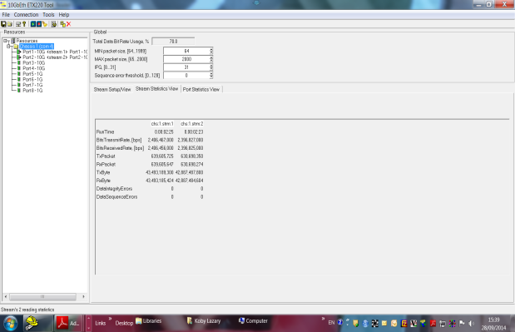

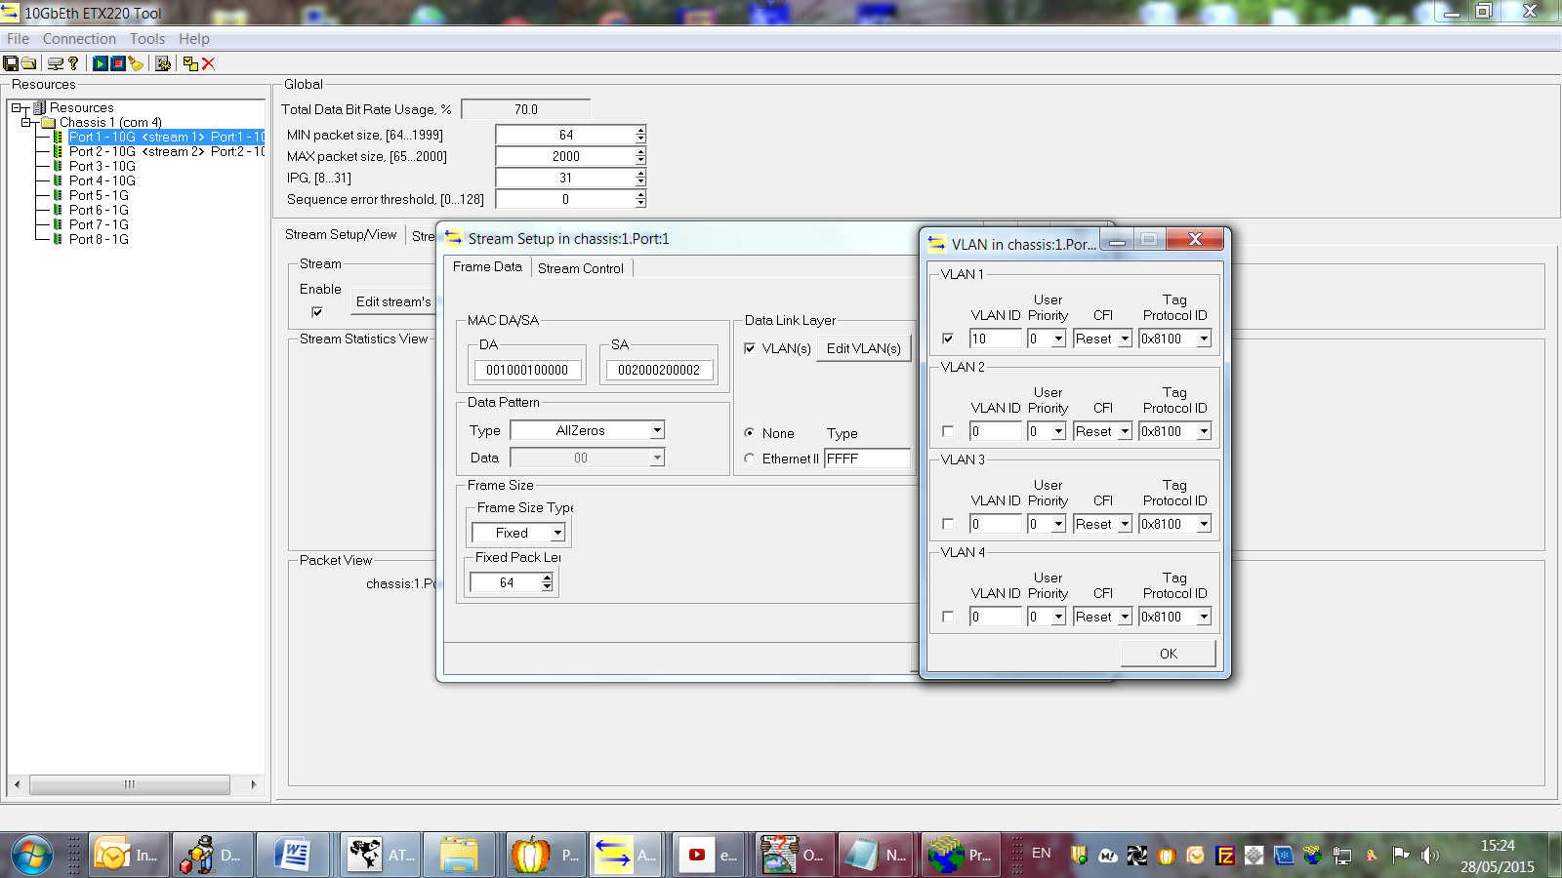

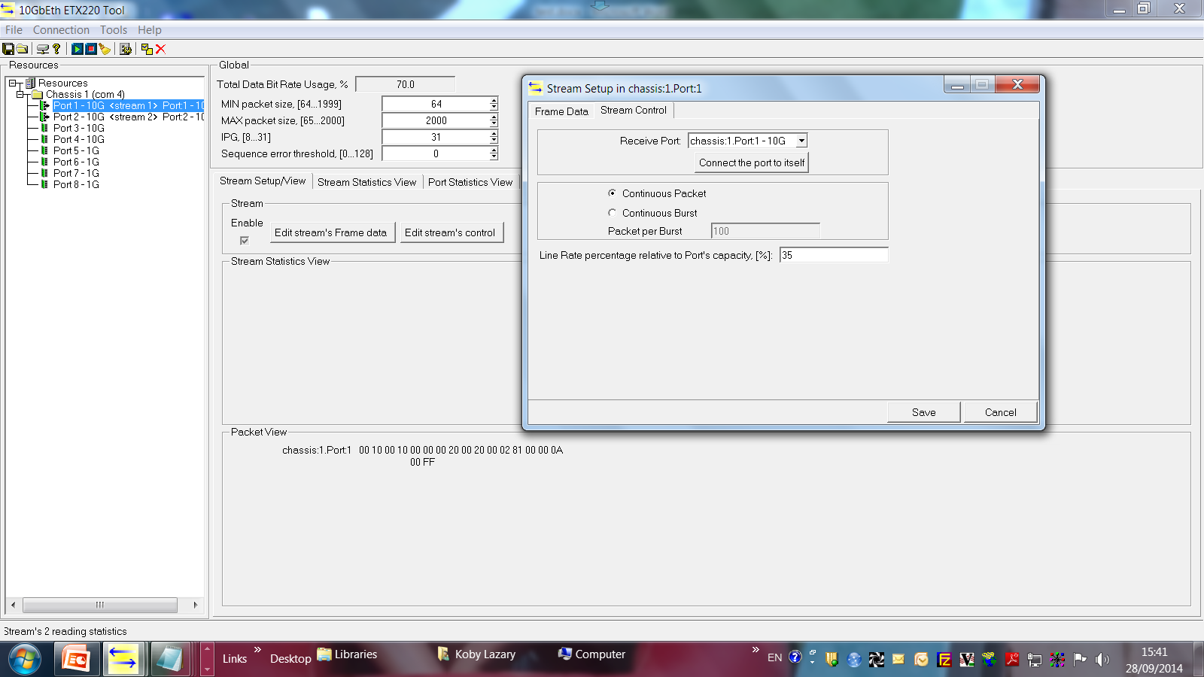
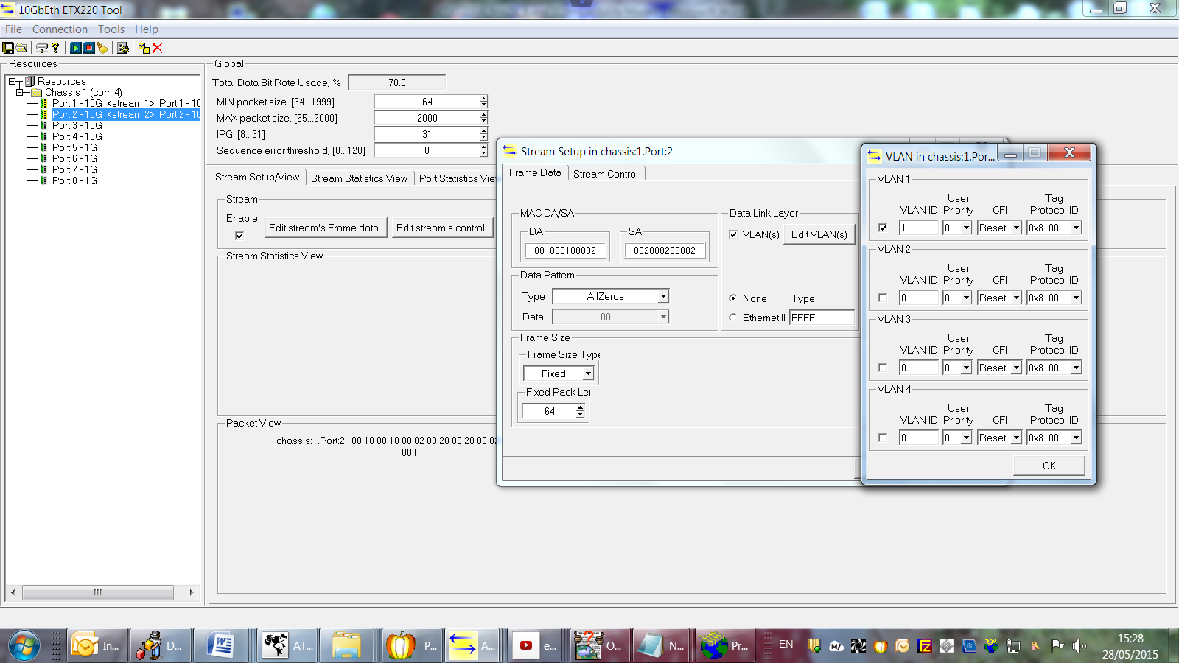

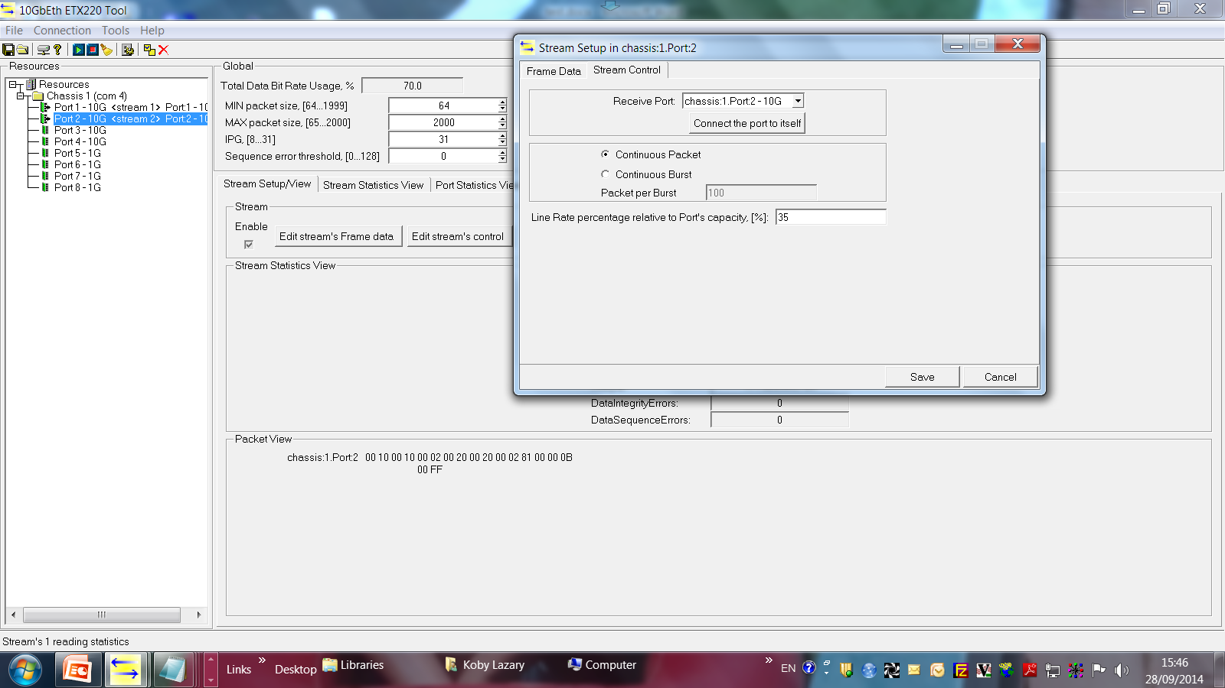

After Stop verify Tx=Rx
