ETX-5300A-MC/4XFP/AT
Final Test Instructions

Last Updated: 18.02.2013

Contents
1. Required Test Equipment 3
2. Preparations for Testing 3
3. Visual Inspection 5
4. Basic Operational Tests (BOT) 5
4.1. Automated BOT 5
4.2. Manual BOT 5
5. Environmental Stress Screening (ESS) 6
6. Automated Final Tests 6
6.1. Complementary Tests (Manual) 6
6.2. Setup 6
6.3. Running the Test 6
6.4. Complementary Tests (Manual) 7
7. Manual Final Tests 7
7.1. Memory Test 7
7.2. Voltage Test (Reading from register) 7
7.3. Identification Test 7
7.4. Time & Date Test 8
7.5. External clock 8
7.6. Temperature Test (Reading from register) 9
7.7. Data Test 10
7.8. Redundancy 11
7.9. BP Test (J11, J12, J13) 11
7.10. Led Test 13
7.11. Barcode setting 13
7.12. Sticker Attachment 13
8. Preparations for Shipment 13
9. Factory Setting 13
10. Safety Test 13
11. Integration Test 13
Appendix A-PAGE Configure for MAIN 14
Appendix B- ETH GEN Configure – ETX204 15
Appendix C- 1-10 GIGA CONVERTER Configure – ETX220 18
Appendix D- DATA Configure 19
DATA configuration for BURN-IN room and for Final-Test 19
Appendix E- DXC-4 Configure 25

Required Test Equipment
Generic Name/Description | Manuf. | Model
1. Fireberd+ Interface for FB-E1  OR DXC-4 | TTC | FB6000A
2. 1 to 10 GIGA CONVERTOR | RAD | ETX-220
3. PC with 2*COM | N/A
4. ETX5300-ETH-I/O as REF*4 | RAD | ETX-5300A-ETH/2*10XFP
5. ETX5300 chassis as REF | RAD | ETX5300A-AC or DC
6. ETX5300-Main as REF | RAD | ETX-5300A-MC/4XFP/AT
7. Boundary Scan Tester (JTAG) | GOPEL ELECTRONIC  GMBH | PSC1149.1-B  CASCON GALAXY (TS) VERSION 3.44B
8. E1-BAL/UNBAL,ETH,FIBER  OPTIC SM,LOOP Cable | RAD | CBL-ETX5300-KIT
9. ETX5300-FAN | RAD | ETX-5300A-FAN
10. ETX5300-AC or DC inlet*2 | RAD | ETX-5300A-PI-AC or DC
11. ETX5300 power supply*2 | RAD | ETX-5300A-PS-AC
12. Ride 7 S/W + programming
Cable and adaptor.
13. ETH GENERATOR | RAD | ETX-204
14. ETX-GEN BERT | RAD

Preparations for Testing
- Perform short at R280 location.
- Open s/w RIDE 7 as follows:
RIDE7>Open>Desktop>POWER>POWER SW>ETX5300A-MAIN>MAIN_HVES_CTRL>REV 0.0>Project>RIDE> project
verify getting stm…code…
- Disconnect Jumper J15 and connect the programming cable
from pin 2 to end (no power connected to UUT).
- Double click on line with stm…code…
- Verify result successfully.
- Verify led D39 GREEN is ON.
- Attached HP sticker near Q12.
- Reconnect Jumper J15.
- Open as follows:
RIDE7>Project>Close project>Open project>MAIN_POWER_CTRL>REV 0.3>RIDE> project, verify getting stm…code…
- Disconnect Jumper J38 and connect the programming cable
from pin 2 to end (no power connected to UUT).
- Double click on line with stm…code…
- Verify result okay and leds RED+ YELLOW are ON (P.S- near R3114-5).
- Attached PS CTRL sticker near the leds.
- Reconnect Jumper J38.
- Connect Jumper J16.
- Connect the COMPACT FLASH and DDR3 gently.
- Using the JTAG tester click on icon Cas344i.
- Type: user= ETX-5300A password= RAD.
- Connect the plug from the JTAG tester to the UUT jumper J30.
- Choose the FILE: GMUX5300_JTAG_MUX.PCF.
- Press on START BATCH.
- Verify result PASS.
- Disconnect JTAG cable from J30 and connect the plug to jumper J33.
- Choose the FILE:
ETX5300_MAIN_MC_4XFP_AT_AREE190_WITHOUT_PIGGY.PCF.
- Verify option mode is ALL status.
- Press on START BATCH.
- Verify result PASS.
- Disconnect and connect UUT and verify D10 (DBG led) is ON and after few seconds is blinking and OFF.
- Attach JTAG-OK sticker in the proper location.
- Send the UUT to assembly dep. to assemble PIGGY and to close CF+MECH cover.
- Set SW-1 pins 1-2 to ON (DBG MODE).
- Set SW-2 pins 1-4 to ON.
- Open 3Cdaemon icon.
- Configure FTP server as follows:
FTP Profiles>Profile name=gmux>password=gmuxdebug>root+Save Profile.
- Connect UUT to terminal (9600 N-8-1).
- Connect to UUT-MNG inlet ETH cable from PC/SWITCH.
- Press <Enter> to stop the auto-boot.
- After getting [boot (dbg mode)] type <v>+<Enter>
Verify boot version updated as mentioned in the latest ECO.
- Press <c>+<Enter>
- The boot device should be: motetsec2
- Set the name to sw-pack.bin (verify that the sw version updated as mentioned in the latest ECO)
- Insert IP (example): 1.1.1.50, MASK: 255.255.255.0
- Insert SERVER IP: 1.1.1.100,default GW:1.1.1.2
- Type: format+<y>+<Enter>.
- Type at Boot [dbg mode]: download 1
- Verify getting message loading…for example: 60000000 (successfully).
- Verify at 3Cdaemon the Bytes field counter start increasing,
Verify getting reply and verify that led LINK is ON and led ACT is blinking
at UUT-MNG inlet.
- Type: set-active 1.
- Insert the PAGE configure as mentioned in Appendix A-BOT part
- Disconnect UUT from rack and set SW-1 pins 1-2 to OFF(normal).
- Disconnect from UUT Jumper J16.

Visual Inspection
N/A

Basic Operational Tests (BOT)

Automated BOT
N/A.

Manual BOT

Functionality Test
- 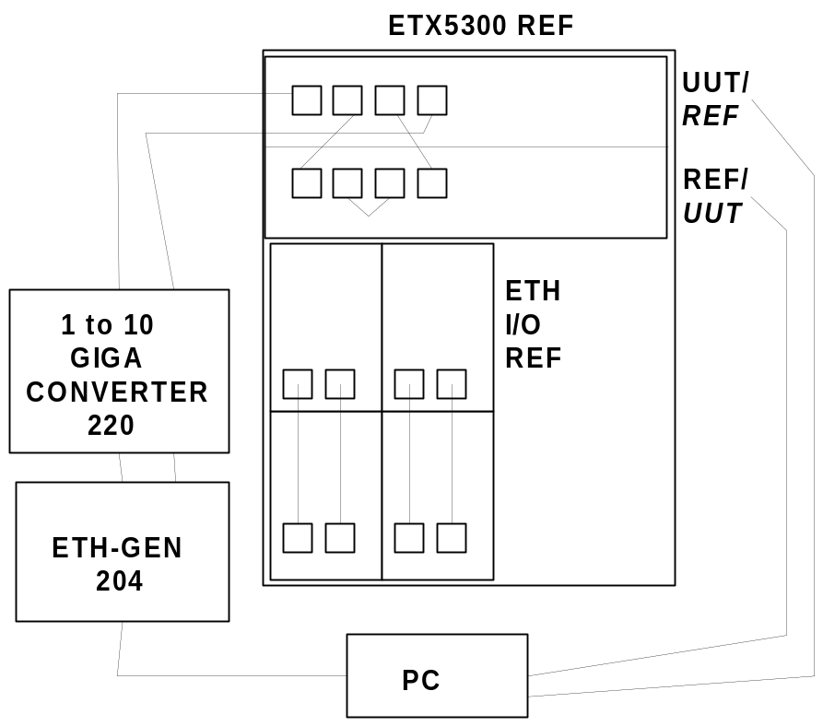Connect the following setup:
- While initializing, verify led RMV (blue) turn ON and start blinking.
- Configure the ETX5300 as REF as mentioned in Appendix D
- Configure the ETX-220 as mentioned in Appendix C
- Configure the ETX-204 as mentioned in Appendix B
- Verify DATA running without errors for 2 minutes.
- Attached “OK” sticker as follows:
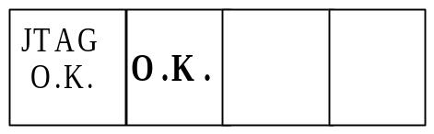

Environmental Stress Screening (ESS)
- Repeat section 4.2.1 steps 1 to 5.
- Verify DATA running without errors.
- If the setup is with 2 UUT cards then after 24h of DATA running swap between the cards as follows:
Type: )ETX-5300A#(config>protection main-card manual-switch+<Enter>.
- As specified in the GFTI.

Automated Final Tests
The following instructions reflect:
 | Last Updated
Final Test Instructions | 18.02.2013
Automatic Tester | 18.02.2013

Complementary Tests (Manual)
From Section 7,perform the following tests only:
Test | Section
Memory Test | 7.1

Setup
1. Insert the two MAIN cards into the chassis.
2. Connect the cables – power, Control, External BAL and UnBAL cables, 10GbEth fiber optic according to 7.7.

Running the Test
1. Press to start running the test and follow the Instructions on the screen.
If the test fails, the display will show a red Fail message and the test will be stopped, and you may resume testing from this point.
2. Verify that the test passed.

Complementary Tests (Manual)
From Section 7,perform the following tests only:
Test | Section
Sticker Attachment | 7.12

Manual Final Tests

Memory Test
- Set SW-1 pin 1 only to ON.
- Connect UUT to rack and after initializing type as follows:
User>su
Password>1234+<Enter>
ETX-5300A#configure>system>date-and-time>
<date>yyyy-mm-dd>+<Enter>
<time>hh:mm[:ss]>+<Enter>
type exit all.
- Type as follows:
ETX-5300A#admin>factory-default+<Enter>+<Y>.
- After initializing type as follows:
User>debug
Password>1234+<Enter>
ETX-5300A#debug shell
- For checking NETWORK PROCESSOR (U76-87,DDR*12) perform as follows:
>cmd>[Vxworks] rtp>attach ID(NAME.VXE)
for example: attach 0xb1f1010
[rPktProcessing] task spawn &ddr_test 2
verify getting massage “Test Passed”.
- Set SW-1 pin 1 only to OFF.

Voltage Test (Reading from register)
- Type as follows:
User>debug
Password>1234+<Enter>
ETX-5300A#debug shell
> rd8_add 0xf8100069 verify getting data 0xff
> rd8_add 0xf810006A verify getting data 0xff
> rd8_add 0xf810006B verify getting data 0x7
> type exit +<Enter>*2

Identification Test
- Type as follows:
User>debug
Password>1234+<Enter>
ETX-5300A#configure>Show chassis inventory
Verify the ID of Chassis and UUT’s are according to ECO (H/W, SW, FW version).
- Verify as follows:
ETX-5300A#file>show sw-pack
verify that the s/w is the updated version for example(1.0050).
- Verify the ID of SFP’s that connect to the UUT are properly (Typical Max Range, Wave length etc.) as follows:
ETX-5300A#configure>port> eth(main-a/1-4>show sfp-status
ETX-5300A#configure>port> eth(main-b/1-4>show sfp-status
Types: exit all.
- User>debug
Password>1234+<Enter>
ETX-5300A#debug shell
rd8_add 0xf8100060 (U17) verify value is the updated version.

Time & Date Test
Type as follows: ETX-5300A#configure>system>show date-and-time refresh verify time second counter increasing type: exit all.

External clock
- Connect the following setup:
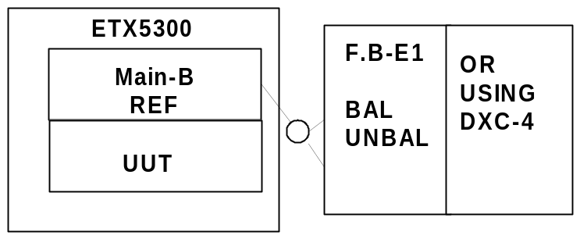
- Configure the F.B-BAL/UNBAL as follow:
MARK=QRSS CLK=SYNTH
MENU→INTF SETUP→2M/n64→CONFIG→FRAMED, CRC4=OFF, TS16=OFF→
MENU→INTF SETUP→2M/n64→MODE→FULL2M
ERROR←ANALYSIS RESULT→TIME
Note | Instead of using F.B you can use DXC-4 as mentioned in Appendix E
- Connect from F.B the BAL cable to UUT-BAL inlet then type as follows:
ETX-5300A#configure>system clock station main-a/1>
interface-type e1>impedance balanced> tx-clock-source station-rclk>
no shutdown
ETX-5300A#configure>system clock station main-b/1>
interface-type e1>impedance balanced> tx-clock-source station-rclk>
no shutdown
- Verify no errors at F.B for data running MAIN A+B for 10 seconds.
- Disconnect from UUT-BAL inlet the cable.
- Connect from F.B the UNBAL cables to UUT-UNBAL inlet then type as follows:
ETX-5300A#configure>system clock station main-a/1> shutdown
impedance unbalanced>no shutdown.
Connect from F.B the UNBAL cables to UUT-UNBAL inlet then type as follows:
ETX-5300A#configure>system clock station main-b/1> shutdown
impedance unbalanced>no shutdown.
- Verify no errors at F.B for data running MAIN A+B for 10 seconds.
- Disconnect from UUT-UNBAL inlet the cables.
Note | Instead of using F.B you can use DXC-4 as mentioned in Appendix E

Temperature Test (Reading from register)
- Type by using the SHELL command as follows:
>rd8_add 0xf810006C (PIGGY 10GIGA SENSOR)
verify data is between 20 to 60℃.
>rd8_add 0xf810006D (near U39 SWITCH)
verify data is between 20 to 60℃.
>rd8_add 0xf810006E (near U56 CPU)
verify data is between 20 to 60℃.
>rd8_add 0xf810006F (near U8 NETWORK PROCESSOR)
verify data is between 20 to 60℃.
Note | The value that you get is in HEX so to get the correct value you should convert from HEX to DEC and decrease 100 for example:  81(HEX)=10000001(base 2)>129(DEC)-100=29 degrees.
- Type to test the NETWORK PROCESSOR as follows:
>rtsens 0,0x01 verify value is between 20 to 60℃.
Note | The value that you get you need to convert as the follow example:  Value=0x28=>28(HEX)=>00101000(base 2)=>40(DEC)= 40℃.

Data Test
- Connect the following setup:
- Configure the ETX5300 as REF as mentioned in Appendix D
- Configure the ETX-220 as mentioned in Appendix C
- Configure the ETX-204 as mentioned in Appendix B
- Type as follows:
ETX-5300A>config# port mng-ethernet main-a/0
ETX-5300A>config>port>mng-eth(main-a/0)# shutdown
ETX-5300A>config>port>mng-eth(main-a/0)# exit
ETX-5300A>config>port# mng-ethernet main-b/0
ETX-5300A>config>port>mng-eth(main-b/0)# shutdown
ETX-5300A>config>port>mng-eth(main-b/0)#
ETX-5300A>config>system>clock>domain(1)# sync-network-type 1
- Verify DATA running without errors for 5 minutes as follows:
ETX-5300A#configure>reporting>show active-alarm
Total : Critical : 0 Major : 0 Minor : 0
- Verify DATA running without errors in the ETX-204 as follows:
PRBS_ERR 0 0 0 0
FRAME_ERR 0 0 0 0
FRAME_NOT_RECOGN 0 0 0 0
SEQ_ERR 0 0 0 0
ERR_CNT 0 0 0 0.
- Disconnect power inlet A.
- Repeat step 7 for DATA running for 10 seconds.
- Reconnect power inlet A and disconnect power inlet B.
- Repeat step 9.
- Reconnect power inlet B.

Redundancy
- Type: Config>protection main-card manual-switch+<Enter>
Verify that MAIN-B is active as follows:
ETX-5300A>config>protection>main-card# show status
Primary Card : Main B
Last Switchover Time : 0000-00-00 00:00:00.00
Last Switchover Reason : None
Redundancy Status : OK
- After clear alarms Verify data traffic without errors for 5 minutes via MAIN ref card.
- Type: )ETX-5300A#(config>protection main-card manual-switch+<Enter>
Verify that MAIN-A is active as follows:
ETX-5300A>config>protection>main-card# show status
Primary Card : Main A
Last Switchover Time : 0000-00-00 00:00:00.00
Last Switchover Reason : None
Redundancy Status : OK
- Verify data traffic works okay via UUT.
- Verify that ACT&LINK leds at MAIN-A&B are ON (ACT=YELLOW, LINK=GREEN)
- Disconnect all fiber optic cable from ports 1to 4 in MAIN-A&B.
- Verify that ACT&LINK leds at MAIN-A&B are OFF.

BP Test (J11, J12, J13)
- 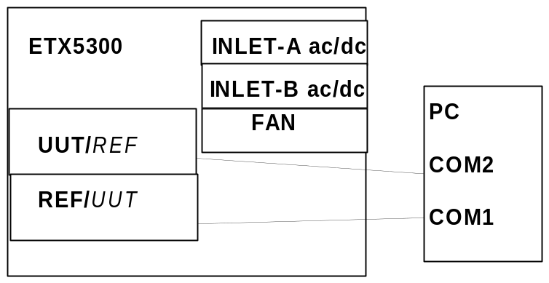Connect the following setup:
- Turn the rack ON.
- User>debug
Password>1234+<Enter>
ETX-5300A#debug shell
AC option
>rd8_add 0xf8100062 verify value is D4
disconnect FAN unit
>rd8_add 0xf8100062 verify value is D7
disconnect ETX5300-INLET A.
>rd8_add 0xf8100062 verify value is F7
Reconnect INLET-A and Reconnect FAN after few seconds
disconnect INLET-B
>rd8_add 0xf8100062 verify value is DC
Reconnect INLET-B and after 2 seconds
>rd8_add 0xf8100065 verify value is f
(INLET A+B voltage okay)
disconnect only the power from INLET-A unit
>rd8_add 0xf8100065 verify value=AF
Reconnect the power to INLET-A after few seconds disconnect
only the power from INLET-B
>rd8_add 0xf8100065 verify value=5f
Reconnect the power to INLET-B
DC option
>rd8_add 0xf8100062 verify value is C0
disconnect FAN unit
>rd8_add 0xf8100062 verify value is C3
Reconnect the FAN unit
disconnect ETX-INLET A.
>rd8_add 0xf8100062 verify value is F0
Reconnect INLET-A and after few seconds disconnect INLET-B
>rd8_add 0xf8100062 verify value is CC
Reconnect INLET-B
>rd8_add 0xf8100065 verify value is 03
(INLET A+B voltage okay)
disconnect only the power from INLET-A unit
>rd8_add 0xf8100065 verify value=AB
Reconnect the power to INLET-A after few seconds disconnect
only the power from INLET-B
>rd8_add 0xf8100065 verify value=57
Reconnect the power to INLET-B
- Type by using COM1
>rd8_add 0xf8100067 verify value=24 (Main-A=ACTIVE)
>rd8_add 0xf8100064 verify value=60.
- Type by using COM2
>rd8_add 0xf8100067 verify value=A0 (Main-B=STANDBY).
>rd8_add 0xf8100064 verify value=A1.

Led Test
- User>debug
Password>1234+<Enter>
ETX-5300A#debug shell.
- For checking leds PRI+FLT+RMV type as follows:
>wr8_add 0xf8100083,0xff
Verify PRI+FLT+RMV leds turn OFF.
>wr8_add 0xf8100083,0xef
Verify PRI+FLT+RMV leds turn ON.
>wr8_add 0xf8100083,0xbf
Verify only PRI led is turn ON.
- For checking led CLK type as follows:
cmd>[Vxworks]> rtp>attach ID of ClockSelection.VXE
for example: attach 0xa53b010>
[rClockSelection] task spawn &SYNCLOCK_WR16 0X20 0X8FFF
Verify that CLK led turn OFF.
[rClockSelection] task spawn &SYNCLOCK_WR16 0X20 0X8FFE
Verify that CLK led turn ON.
- Type in primary UUT: )ETX-5300A#(admin factory-default+<Enter>.
- Verify after few seconds that RMV leds are blinking in both UUTs.

Barcode setting
- By using COM insert to the PAGE configure the BARCODE value as mentioned in Appendix A-Barcode part.
- Disconnect UUT from rack and set SW-1 pins 1-2 to OFF(normal).

Sticker Attachment
- Attached “BD” and “CSL” (Configuration Status Label) stickers as follows:
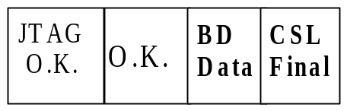

Preparations for Shipment
As specified in the GFTI.

Factory Setting
As specified in the GFTI.

Safety Test
As specified in the GFTI.

Integration Test
Connect the UUT to setup as customer order and run DATA for 24H.

Appendix A-PAGE Configure for MAIN
BOT
- Set SW1 to DBG mode ON (pins 1+2).
- Verify IP is=10.10.10.2(default) and baud rate is 9600(default),
if IP and baud rate not as mentioned then set IP to 10.10.10.2 and baud rate to 9600 by type<C> in pass the line after line by type
<Enter> until getting IP line and baud rate.
- After getting [boot (dbg mode)] type as follow: <Ctrl>+<P>+d2 00+<Enter>.
- Configure as follows:
Page 0 - 00 00 00 00 00 00 00 00 00 00 00 00 00 00 00 00
00 00 00 00 00 00 00 00 00 00 00 00 00 00 00 00
Page 1 - 00 00 00 48 00 00 00 00 00 00 00 00 00 00 01 F5
00 00 00 00 00 00 00 00 00 00 00 00 00 00 00 00
Page 2 - 00 00 00 00 00 00 00 00 00 00 00 00 00 00 00 00
00 00 00 00 02 00 00 00 00 00 00 00 00 00 00 00
For setting Page 1 type as follows:
C2 0,1,0,” 00 00 00 48 00 00 00 00 00 00 00 00 00 00 01 F5”,FF
Then type y0a02+<Y>.
For setting Page 2 type as follows:
C2 0,2,0,” 00 00 00 00 00 00 00 00 00 00 00 00 00 00 00 00
00 00 00 00 02 00”,FF then type y0a02+<Y>.
- Page 1:
  - CSL (48) =(H) Index (03)
  - HW Rev. (00 00) index (01-02)
  - PCB Rev. (00 00) index (04-05)
  - CARD TYPE (01 F5) index (14-15)
- Page 2:
CPLD index (20)
Barcode
- Repeat BOT part steps 1 to 3.
- Configure as follows:
Page 3- 00 02 44 41 32 30 30 30 31 32 33 34 35 00 00 00
00 00 00 00 00 00 00 00 00 00 00 00 00 00 00 00
For setting Page 3 type as follows (example of barcode DA200012345 in ASCII):
C2 0,3,0,” 00 02 44 41 32 30 30 30 31 32 33 34 35”,FF
Then type y0a02+<Y>.
- Page 3:
  - Constant (XX) index (00)
  - Id Type (XX) index (01)
  - Id Num (Need Pleace to feed our Bar code) index (02-12)
BARCODE no. need to convert from HEX to ASCII.
  - Mac Quantity (00) index (14)

Appendix B- ETH GEN Configure – ETX204
- Double click on the icon EtxGen.exe
- 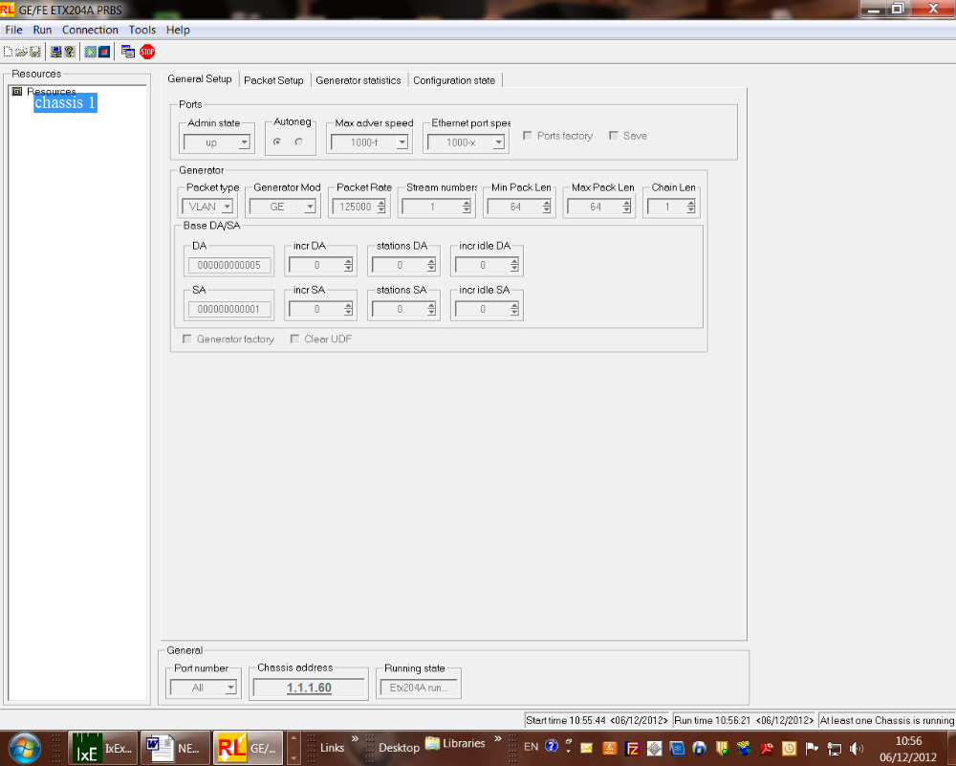Config as attached in the following pictures:
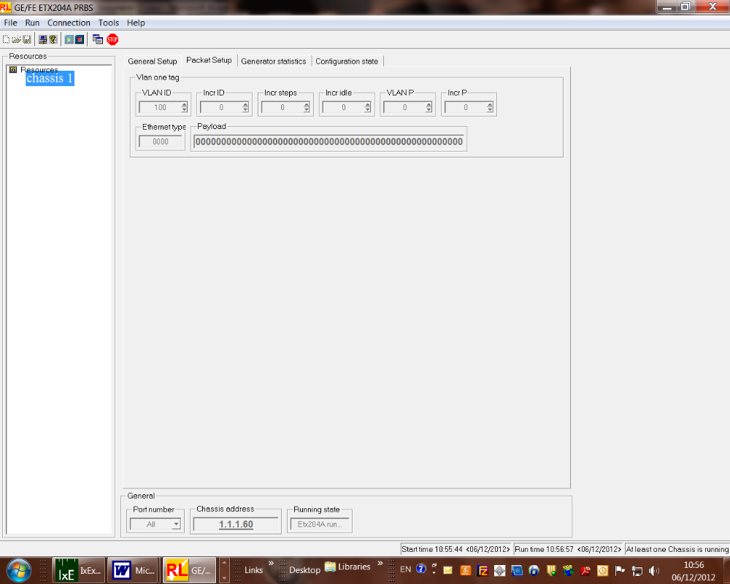
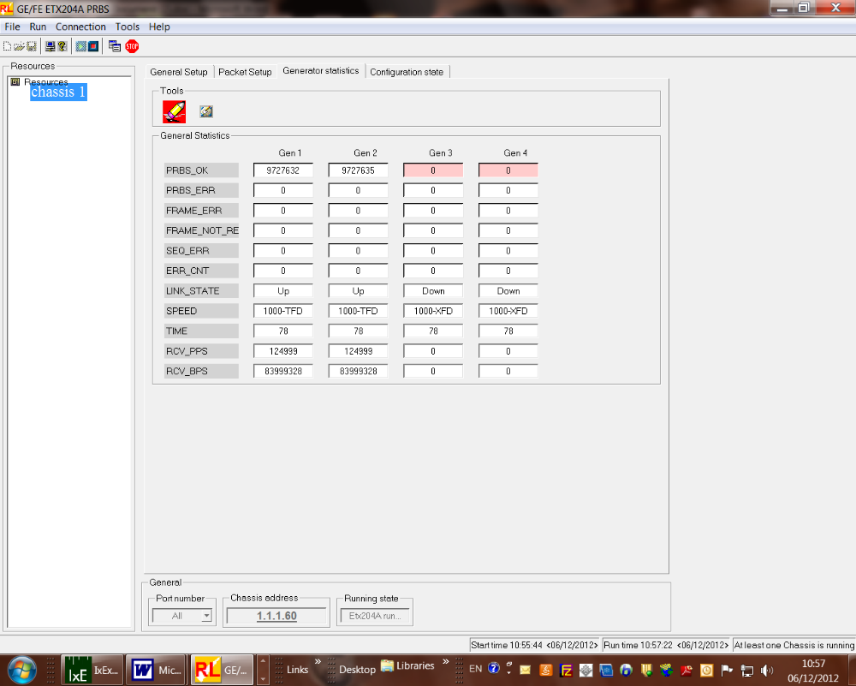

Appendix C- 1-10 GIGA CONVERTER Configure – ETX220
- Download script GIGA_CONVERTER.txt
- Verify no CLI errors messages.

GIGA CONVERTER SCRIPT
# Classifier Profile Configuration
classifier-profile "all" match-any
match all
exit
echo "Flow Configuration"
# Flow Configuration
flow "1"
classifier "all"
ingress-port ethernet 1
egress-port ethernet 5 queue 0 block 0/1
no shutdown
exit
flow "2"
classifier "all"
ingress-port ethernet 5
egress-port ethernet 1 queue 0 block 0/1
no shutdown

exit
flow "3"
classifier "all"
ingress-port ethernet 3
egress-port ethernet 8 queue 0 block 0/1
no shutdown
exit
flow "4"
classifier "all"
ingress-port ethernet 8
egress-port ethernet 3 queue 0 block 0/1
no shutdown
exit

Appendix D- DATA Configure

DATA configuration for BURN-IN room and for Final-Test
- Download script DATA_RUNNING.txt
- Verify no CLI errors messages.
- Verify that DATA running okay.

DATA RUNNING SCRIPT

#********************card type****************************************
configure slot 1-4
card-type eth 10g-2-xfp
no shutdown
exit all
#************************************************************************
#****************************IO-1_to_MC-A/1******************************
#***************************General_Traffic******************************
#************************************************************************
exit all
#***************************TM_QUEUE_GROUP*******************************
config port ethernet main-a/1-4 queue-group profile q_group_2_level_default
config port ethernet main-b/1-4 queue-group profile q_group_2_level_default
config port ethernet 1-4/1-2 queue-group profile q_group_2_level_default
config port sag 1-4/1-2 queue-group profile q_group_SAG_2_level_default
exit all
config port ethernet main-a/1-4 no shutdown
config port ethernet main-b/1-4 no shutdown
exit all
config port ethernet 1-4/1-2 no shutdown
exit all
#***************************CLASSIFIER_PROFILE for TM tests *************
config flows classifier-profile classall match-any
match all
exit all
config flows classifier-profile slot1 match-any
match vlan 100
exit all
#*********************************END************************************

#***************************FLOW_CONFIGURATION***************************
#**********Traffic from PORT main-1 to main-2 via eth 1/1 to 2/1**************
configure flows flow 1
classifier slot1
ingress-port ethernet main-a/1
egress-port ethernet 1/1 queue-map-profile QueueMapDefaultProfile block 0/1
no shutdown
exit all
configure flows flow 2
classifier slot1
ingress-port ethernet 2/1
egress-port sap 2/1/1 queue-map-profile QueueMapDefaultProfile block 0/1
no shutdown
exit all
configure flows flow 3
classifier classall
ingress-port sap 2/1/1
egress-port ethernet main-a/2 queue-map-profile QueueMapDefaultProfile
block 0/1
no shutdown
exit all
#*********Traffic from PORT main-2 to main-1 via eth 2/1 to 1/1**************
configure flows flow 4
classifier slot1
ingress-port ethernet main-a/2
egress-port ethernet 2/1 queue-map-profile QueueMapDefaultProfile block 0/1
no shutdown
exit all
configure flows flow 5
classifier slot1
ingress-port ethernet 1/1
egress-port sap 1/1/1 queue-map-profile QueueMapDefaultProfile block 0/1
no shutdown
exit all
configure flows flow 6
classifier classall
ingress-port sap 1/1/1
egress-port ethernet main-a/1 queue-map-profile QueueMapDefaultProfile
block 0/1
no shutdown
exit all
#********Traffic from PORT main-1 to main-2 via eth 1/2 to 2/2**************
configure flows flow 7
classifier slot1
ingress-port ethernet main-a/3
egress-port ethernet 1/2 queue-map-profile QueueMapDefaultProfile block 0/1
no shutdown
exit all
configure flows flow 8
classifier slot1
ingress-port ethernet 2/2
egress-port sap 2/2/2 queue-map-profile QueueMapDefaultProfile block 0/1
no shutdown
exit all
configure flows flow 9
classifier classall
ingress-port sap 2/2/2
egress-port ethernet main-a/4 queue-map-profile QueueMapDefaultProfile
block 0/1
no shutdown
exit all
#*********Traffic from PORT main-2 to main-1 via eth 2/2 to 1/2**************
configure flows flow 10
classifier slot1
ingress-port ethernet main-a/4
egress-port ethernet 2/2 queue-map-profile QueueMapDefaultProfile block 0/1
no shutdown
exit all
configure flows flow 11
classifier slot1
ingress-port ethernet 1/2
egress-port sap 1/2/2 queue-map-profile QueueMapDefaultProfile block 0/1
no shutdown
exit all
configure flows flow 12
classifier classall
ingress-port sap 1/2/2
egress-port ethernet main-a/3 queue-map-profile QueueMapDefaultProfile
block 0/1
no shutdown
exit all

#*********Traffic from PORT main-1 to main-2 via eth 1/3 to 2/3**************
configure flows flow 13
classifier slot1
ingress-port ethernet main-b/1
egress-port ethernet 3/1 queue-map-profile QueueMapDefaultProfile block 0/1
no shutdown
exit all
configure flows flow 14
classifier slot1
ingress-port ethernet 4/1
egress-port sap 4/1/1 queue-map-profile QueueMapDefaultProfile block 0/1
no shutdown
exit all
configure flows flow 15
classifier classall
ingress-port sap 4/1/1
egress-port ethernet main-b/2 queue-map-profile QueueMapDefaultProfile
block 0/1
no shutdown
exit all
#*********Traffic from PORT main-2 to main-1 via eth 2/3 to 1/3**************
configure flows flow 16
classifier slot1
ingress-port ethernet main-b/2
egress-port ethernet 4/1 queue-map-profile QueueMapDefaultProfile block 0/1
no shutdown
exit all
configure flows flow 17
classifier slot1
ingress-port ethernet 3/1
egress-port sap 3/1/1 queue-map-profile QueueMapDefaultProfile block 0/1
no shutdown
exit all
configure flows flow 18
classifier classall
ingress-port sap 3/1/1
egress-port ethernet main-b/1 queue-map-profile QueueMapDefaultProfile
block 0/1
no shutdown
exit all

#**********Traffic from PORT main-1 to main-2 via eth 1/4 to 2/4**************
configure flows flow 19
classifier slot1
ingress-port ethernet main-b/3
egress-port ethernet 3/2 queue-map-profile QueueMapDefaultProfile block 0/1
no shutdown
exit all
configure flows flow 20
classifier slot1
ingress-port ethernet 4/2
egress-port sap 4/2/2 queue-map-profile QueueMapDefaultProfile block 0/1
no shutdown
exit all
configure flows flow 21
classifier classall
ingress-port sap 4/2/2
egress-port ethernet main-b/4 queue-map-profile QueueMapDefaultProfile
block 0/1
no shutdown
exit all
#**********Traffic from PORT main-2 to main-1 via eth 2/4 to 1/4**************
configure flows flow 22
classifier slot1
ingress-port ethernet main-b/4
egress-port ethernet 4/2 queue-map-profile QueueMapDefaultProfile block 0/1
no shutdown
exit all
configure flows flow 23
classifier slot1
ingress-port ethernet 3/2
egress-port sap 3/2/2 queue-map-profile QueueMapDefaultProfile block 0/1
no shutdown
exit all
configure flows flow 24
classifier classall
ingress-port sap 3/2/2
egress-port ethernet main-b/3 queue-map-profile QueueMapDefaultProfile
block 0/1
no shutdown exit all
#*******************************end******************************************

#****************************Setup test***************************************
# 2x main
# 4x 2x10
# loop 1/1 & 2/1
# loop 1/2 & 2/2
# loop 3/1 & 4/1
# loop 3/2 & 4/2
# loop a/1 & b2
# loop a/2 & a3
# loop a/4 & b3
# b/1 gen
# b/4 gen
#**************************End setup*****************************************

Appendix E- DXC-4 Configure

DXC-4 ( 8 PORTS ) STAT
System
1. Source Clock > (Internal)
2. Management >
3. Control Port >
4. Date/Time >
5. Factory Default
6. Reset
DXC-4 ( 8 PORTS ) STAT
Link channel port
1. Link channel port type[E1,T1] (E1)
2. Port parameters >
DXC-4 ( 8 PORTS ) STAT
Port parameters
1. Update channel number > (Port 1)
2. Frame > (G.732N)
3. Restoration time > (1 Second (Fast))
4. Interface type[LTU,DSU] (DSU)
5. Idle code ... (7F)
6. Line code[AMI,HDB3] (HDB3)
7. Balanced[Yes,No] (Yes)
8. Out of service code ... (7F)
DXC-4 ( 8 PORTS )

1. Update channel number > (Port 2)
2. Frame > (G.732N)
3. Restoration time > (1 Second (Fast))
4. Interface type[LTU,DSU] (DSU)
5. Idle code ... (7F)
6. Line code[AMI,HDB3] (HDB3)
7. Balanced[Yes,No] (No)
8. Out of service code ... (7F)

DXC-4 ( 8 PORTS ) STAT
Bert Generators
1. Link channel port type[E1,T1] (E1)
2. Configured channel number > (Port 1)
3. Berts enabled assignment ... (1,2)
4. Bert pattern > (QRSS)
5. TSs bert assignment ... (all)
6. Bert State [Run,Stop] (Run)
7. Berts statistics []
8. Insert error rate > (SINGLE)
9. Insert error berts assignment ... (all)
10. Insert error (OFF)
11. Clear Statistics
12. Insert BPV error
DXC-4 ( 8 PORTS ) STAT
Berts statistics

Bert Run time Sync loss Error seconds Error bits
Bert1 2 0 0 0
Bert2 2 2 0 0

