OP-108L /B-U
OP-108L/B-U/ETH
Final Test Instructions

Last Updated: 09.06.2020

Contents
1. Required Test Equipment 3
2. Preparations for Testing 4
2.1. JTAG 4
2.2. Software Download 4
3. Visual Inspection 4
4. Basic Operational Tests (BOT) 5
4.1. Voltage Test 5
4.2. Frequency Test 5
4.3. DATA Running 5
5. Environmental Stress Screening (ESS) 5
6. Automated Final Tests 6
6.1. Setup 6
6.2. Complementary Tests (Manual) 6
7. Manual Final Tests 6
7.1. Voltage Test 6
7.2. Frequency Test 6
7.3. Software Download 6
7.4. ID & MAC test 7
7.5. TX Level Test 7
7.6. Mask Test 8
7.7. Data Transmission test 9
7.8. Loop test 10
7.9. Alarm Test 13
7.10. USER – Ethernet Data Port Test 15
7.11. Checking Set. Def Button 18
7.12. LED Test 18
7.13. MAC Registry 18
8. Preparations for Shipment 19
9. Factory setting 19
10. Safety Test 19
Appendix A. HBT Configuration 20
Appendix B. Masks with Digital Scope 21
Appendix C. ACE-2002 Configuration 22

Required Test Equipment

Generic Name/Description | Manufacture | Model
- Oscilloscope 500 MHz with mask measurement option | Tektronix | TDS 580D/3032B
- Counter (Frequency meter 1.3GHz) | TTI | TF-830 (3 GHz)
- Multi-meter | N/A | N/A
- PC with NIC 10/100 with Windows 98 or higher | N/A | N/A
- Short UTP CAT5 Ethernet cable (*2) | N/A | According to standard
- UTP loop connections | N/A | N/A
- HBT E1 | RAD | H.W. 0.0 S.W. 1.0
- Optimux-108L reference device | RAD
- OPTIC link reference module | RAD
- SC/APC fiber  (For SF3 FO module only) | AVDOR | According to standard
- BNC short cable (*8) | N/A | CBL-BNC/BNC
- Short FO cables  SM – 9/125 µm  MM – 65/125 µm | N/A | According to standard
- ACE – 2002 | RAD | 2002 (ETH port Option ONLY)
- ACE - /ETH-N (*2) | RAD | Ethernet Modules for Ace – 2002 (ETH port Option ONLY)
- CASCON for JTAG | 4.1
- Procomm Plus | N/A
- PUMPKIN | N/A
- Barcode scanner | N/A
- Optical power meter (option) | EXFO | FOT-10A
- Adaptors (ST, FC, SC) | EXFO | FOA-22  FOA-32  FOA-54

Preparations for Testing

JTAG
- Type: user= OP108 password= RAD.
- Connect the plug from the JTAG tester to the UUT jumper J5.
- Choose the FILE:
OP_108L_BLIU_CPU-WRPS_N.PCF.
OP_108L_UNBLIU_CPU-WRPS_N.PCF.
OP_108L_BLIU_CPU-WRPS_USER_N.PCF.(ETH OPTION)
OP_108L_UNBLIU_CPU-WRPS_USER_N.PCF.(ETH OPTION)
- Press on START BATCH, verifies result PASS.
- Disconnect JTAG cable from J5.
- Mark point on the procedure trace sticker.
- Solder the relevant optical led due to order + nomex.
- Send the UUT for basic mechanical assembly.

Software Download
- Connect ETH cable from PC to UUT MNG-ETH inlet.
- Connect COM cable from PC to UUT via J8 (TRM).
- Set ProComm to: N-8-1,9600
- Turn ON the device.
- While UUT start booting up press any KEY till you get [boot]:
- By typing <C> command set: application SW, IP device, IP server, default
getaway Baud rate.
- By typing <DL> command twice download S/W application to UUT
partitions.
- By typing <@> command UUT S/W start initialize, verify:
LED | Status
Channels LEDs | Blinking (Red + Yellow)
Link Interfaces LEDs | Blinking (Red + Yellow)
SD led (back Panel) | Light (Green)
PWR led | Light (Green)

Visual Inspection
N/A

Basic Operational Tests (BOT)

Voltage Test
- Connect the plug from the Main Board to the PS connector.
- Using Multi-meter measured as follows:
Measuring point | Value
3.3V (U25-1), [V] | 3.30 ± 0.165
2.5V (U3-24), [V] | 2.50 ± 0.125 (MNG)
2.5V (U4-24), [V] | 2.50 ± 0.125 (USER Port)
1.2V (U25-5), [V] | 1.20 ± 0.06

Frequency Test
- Using counter measured as follows:
Reference | Test point | Required Freq (MHz) | Deviation (ppm) | Min – Max  (MHz)
 | R433 | 50.0000 | ±50 | 49.9975 – 50.0025
 | R357 | 33.7920 | ±20 | 33.7913 – 33.7926
 | R439 | 2.0480 | ±25 | 2.0479 – 2.0480
U3/U4 | Pin 32 | 25.000 | ±20 | 25.0005 – 19.9995

DATA Running
1. Set the next Application:
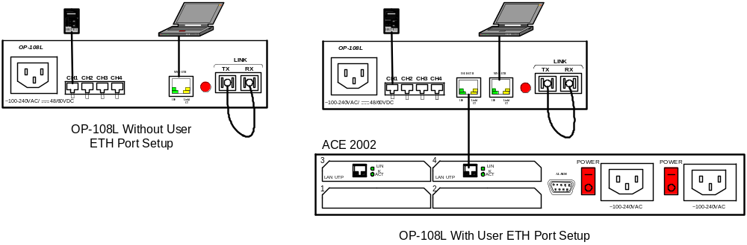
- Run data on all E1 channels (10 seconds).
- Verify no errors on HBT.
- Verify Lost=0 on ACE-2002 (configuration of ACE-2002 on Appendix C) [Only on OP-108L Full with User ETH port]
- Mark point on the procedure trace sticker.

Environmental Stress Screening (ESS)
As specified in the GFTI.

Automated Final Tests

The following instructions reflect:
Automatic Tester Version
Compatible to Final Test Instructions version | 09.06.2020

Setup
1. Connect the UUTs to the tester with the appropriate cables needed for the UUTs configuration.
2. Double click the icon in the window that will open the program, set the correct configuration of the UUTs, and press the PLAY button to start the test.
3. Follow the instruction on the screen.

Complementary Tests (Manual)
1. From Section 7, perform the following tests only:
Test | Section
Voltage Test | 7.1
Voltage Test | 7.2
TX level Test | 7.5
TX Level Test | 7.6
2. Skip to Section 8.

Manual Final Tests

Voltage Test
Repeat section 4.1

Frequency Test
Repeat section 4.2

Software Download
- Connect ETH cable from PC to UUT MNG-ETH inlet.
- Connect COM cable from PC to UUT via J8 (TRM).
- Set ProComm to: N-8-1,9600
- Turn ON the device.
- While UUT start booting up press any KEY till you get [boot]:
- By typing <C> command set: application SW, IP device, IP server, default
getaway Baud rate.
- By typing <DL> command twice download S/W application to UUT
- By typing <@> command UUT S/W start initialize.

ID & MAC test
- Set SW5 dipswitch according order and as follows:
SWITCH pin Number | Operation
pin1 | FO Type: “0”=9Row; “1”=SFP
pin2 (Inventory) | Length Type: “0”=Short Haul; “1”=Long Haul
pin3+pin4 (Inventory)  [0=OFF & 1=ON] | Wavelength: 850nm = “00”
pin3+pin4 (Inventory)  [0=OFF & 1=ON] | Wavelength: 1310nm = “01”
pin3+pin4 (Inventory)  [0=OFF & 1=ON] | Wavelength: 1550nm = “10”
pin3+pin4 (Inventory)  [0=OFF & 1=ON] | Wavelength: Not Used = “11”
pin5 (Inventory) | FO Type: “0”=Single Mode; “1”=Multi-Mode
Pin6 (only Vs. LRS-102) | FO Connection:  “0”=Duplex (ST, FC, SC);  “1”=Single Fiber (SF1 Or SF2 Or SF3)
pin7+pin8 (Inventory)  [0=OFF & 1=ON] | Define The FO Connection Type:
pin7+pin8 (Inventory)  [0=OFF & 1=ON] | “00”=SC/APS Type (SF3)
pin7+pin8 (Inventory)  [0=OFF & 1=ON] | “01”=ST Type
pin7+pin8 (Inventory)  [0=OFF & 1=ON] | “10”=FC Type
pin7+pin8 (Inventory)  [0=OFF & 1=ON] | “11”=SC Type (Include SF1 & SF2)
pin9+pin10  [0=OFF & 1=ON] | Define The Mechanical Box Type:
pin9+pin10  [0=OFF & 1=ON] | “00”=K33 Box (Plastic Blue & White)
pin9+pin10  [0=OFF & 1=ON] | “01”=Metal Box (Type4)
pin9+pin10  [0=OFF & 1=ON] | “10”=Metal Box (Type1)
pin9+pin10  [0=OFF & 1=ON] | “11”=Not Used
- Connect to the UUT MNG-ETH inlet ETH cable from PC.
Attention! | The Default IP Address for the OP-108L is 192.168.205.1
- Verify communication with the UUT (Telnet) by PING command.
- Use following USER and PASSWORD to enter into Main Menu:
 | USER | PASSWORD
SUPER USER- can do all. R/W access including administrator privileges (allowed to add/remove users and change passwords of existing users | SU | 1234
- Verify, on Inventory screen that the HW&SW version and Firmware of the UUT Are updated version according to corresponding ECO and according to ORDER.

TX Level Test
- Insert the correct fiber optic into the UUT optical TX inlet
- Connect the other side on the Optical Power Meter and set
the right Wavelength.

- Verify TX level according to the following table:
Interface Type | Wave Length | TX Level Value  Typical  (dBm)
Interface Type | Wave Length | MIN | MAX
850 nm Led MM | 850 nm | -10 | -4
1310 nm Led MM | 1310 nm | -20 | -14
1310 nm Laser SM  (Short haul) | 1310 nm | -15 | -8
1310 nm Laser SM  (Long haul) | 1310 nm | -5 | 0
1550 nm Laser SM  (Short haul) | 1550 nm | -15 | -8
1550 nm Laser SM  (Long haul) | 1550 nm | -5 | 0
SF1  1310 nm Laser SM  (Short haul) | 1310 nm | -15 | -8
SF2  1550 nm Laser SM  (Short haul) | 1550 nm | -15 | -8
SF3 1310 nm Laser SM  (Short haul) | 1310 nm | -15 | -8
SF4  1310 nm Laser SM  (Long haul) | 1310 nm | -5 | 0
SF5  1550 nm Laser SM  (Long haul) | 1550 nm | -5 | 0

Mask Test

E1 UBALANCE Mask Test
Using digital scope Perform the E1 Unbalanced musk test as follows:
1. Perform the test according to Appendix B
2. Verify that the signal does not exceed the E1 Unbalanced mask boundary.
3. Perform the test for all the Channels.
4. Mark point on the procedure trace sticker.

E1 BALANCE Mask Test
Using digital scope Perform the E1 Balanced musk test as follows:
1. Perform the test according to Appendix B.
2. Verify that the signal does not exceed the E1 Balanced mask boundary.
3. Perform the test for all the Channels.
4. Mark point on the procedure trace sticker.

Data Transmission test
1. Connect the following configuration (As described on Figure 2):
(E1 channels are connected in the chain for all channels simultaneous test)

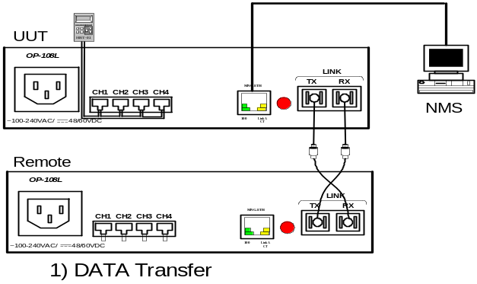

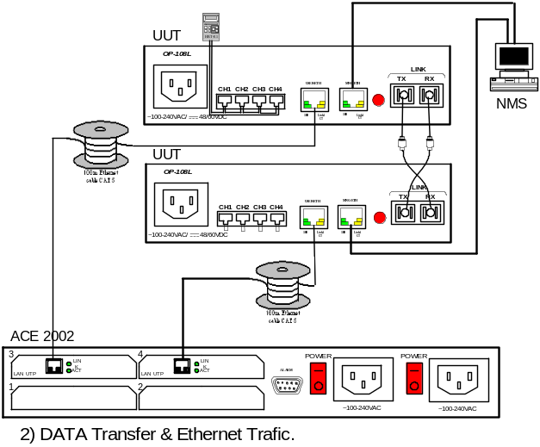
Figure 2 – Data transmission test
2. Verify that both uplinks are identical to the ordered from the Inventory menu.
3. Verify that Link Status is normal: no link Alarms appeared in Active Alarms menu.
- Initialize the E1 HBT (according to Appendix A).
- Check DATA Transfer for 60 seconds.
Verify: HBT:
Check | Value/Status
ERROR BITS | 0
SYNC LOSS | 0

Note | Tests 6 to 8 (ACE – 2002) for Ethernet Option Only

6. Configure the UUT, REF and ACE the following configuration
UUT & REF | USER-ETH: Auto negotiation: Enable
ACE – 2002 | Both ports: Auto negotiation: Enable  And Max Capability advertised:  100baseT Full Duplex | Frame Length: 1518  Chain Length: 1  Delay: 125
7. Run the HBT and ACE-2002 Data transmit for 60 seconds and verify:
HBT:
Check | Value/Status
ERROR BITS | 0
SYNC LOSS | 0
ACE – 2002:
Check | Value/Status
Rate & Mode | 100 Full Duplex
Status | Connected
Lost | 0
Loss Indicator | 0
Flow Control | 0
Tester, Global and Generator PPS | 8000
8. Verify on the Active Alarms screen, for all CH’s as follows:
Monitoring>System>Active Alarms
Indication | Status
Signal loss | No alarm appears
AIS | No alarm appears

Loop test
Connect the following configuration:

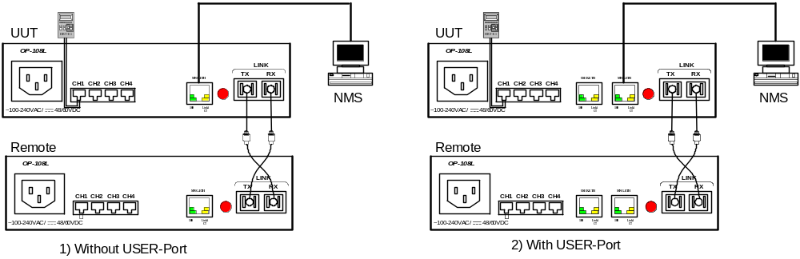Figure 4 – Loop test

E1 local loop
1. Perform on UUT - E1 LLB through the Telnet (Web) in CH1.
2. Verify:
No errors in HBT | 10 seconds
AIS CH1 LED ON | Reference device
AIS CH1 ON | Reference-> Monitoring>Active Alarms screen
TST Indication ON | UUT->Monitoring>System> Status screen
3. Remove the physical LOOP on Reference device.
4. Verify:
HBT | No errors
5. Deactivate the LLB through the Telnet (Web).
Diagnostics>Channel’s Loops.
6. Verify:
HBT | SYNC LOSS
7. Connect the physical LOOP on Reference device.
8. Verify:
HBT | No errors
9. Repeat Sections 1 to 8 for all channels.

Uplink Local Loop
- Connect the configuration according to Figure 2.
- Verify that Uplink LLB not exist (UUT) through the Telnet (Web).
Diagnostics>Link Loop Type = (No loop)
- Disconnect optical cable from the device.
4. Verify:
HBT | SYNC LOSS
- Perform an Uplink local loop through the Telnet (Web) on UUT.
Diagnostics>Link Loop Type = (LLB)
- Connect HBT to every channel for 10 Sec and Verify
Check | Value/Status
ERROR BITS | 0
SYNC LOSS | 0
7. Return to Configuration according Figure 2.
8. Verify:
No errors | 10 sec.
E1’s AIS LEDs ON | Reference device
E1’s AIS alarms | Ref-> Monitoring>Active Alarms screen
Frame Loss on Uplink | ReF-> Monitoring>Active Alarms screen
TST Indication ON | UUT->Monitoring>System> Status screen

E1 Remote Loop
- Connect the configuration according to Figure 4.
And disconnect the physical LOOP from REF device.
2. Verify:
HBT | SYNC LOSS
3. Perform on UUT - E1 RLB on CH1.
Diagnostics>Channel’s Loops.
4. Verify:
HBT | No Errors (10 seconds)
TST Indication ON | UUT->Monitoring>System> Status screen
- Connect physical LOOP to CH1 on REF device.

6. Verify:
HBT | No Errors
CH1 AIS LED on REF Device | ON
Remote CH1 AIS Alarm | UUT->Monitoring>System>Active Alarms screen
7. Deactivate CH1 RLB on UUT device
Diagnostics>Channel’s Loops.
8. Verify:
HBT | No Errors (15 sec)
9. Repeat the sections 1 – 8 for all the channels.

Uplink Remote Loop
1. Connect the configuration according to Figure 2.
- Remove all physical LOOPs from the REF device.
3. Verify:
HBT | SYNC LOSS
4. Perform an Uplink RLB in the UUT.
Diagnostics>Link Loop Type = (RLB)
5. Verify:
HBT | No Errors (10 seconds) On all Channels
6. Connect physical LOOPs to all E1 channels on REF device.
7. Verify:
HBT | No Errors (10 seconds)
E1’s AIS Alarms | Ref-> Monitoring>Active Alarms screen
E1’s AIS LEDs ON | REMOTE Device
TST Indication ON | UUT->Monitoring>System> Status screen
7. Disconnect all physical LOOPs.
8. Verify:
HBT | No Errors (10 seconds)
9. Release Uplink RLB
Diagnostics>Link Loop Type = (No loop)
Verify:
HBT | SYNC LOSS
- Repeat the UPLINK RLB test, Steps: 1–9, on the Remote Reference
Device.

Alarm Test
1. Connect the configuration according to Figure 5.

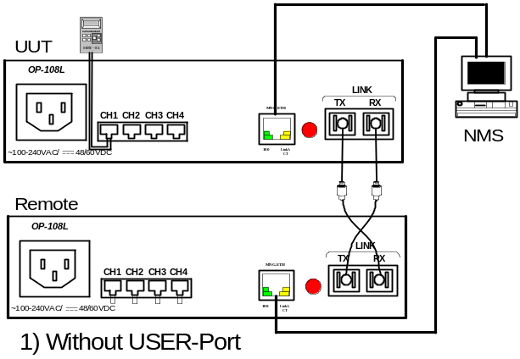

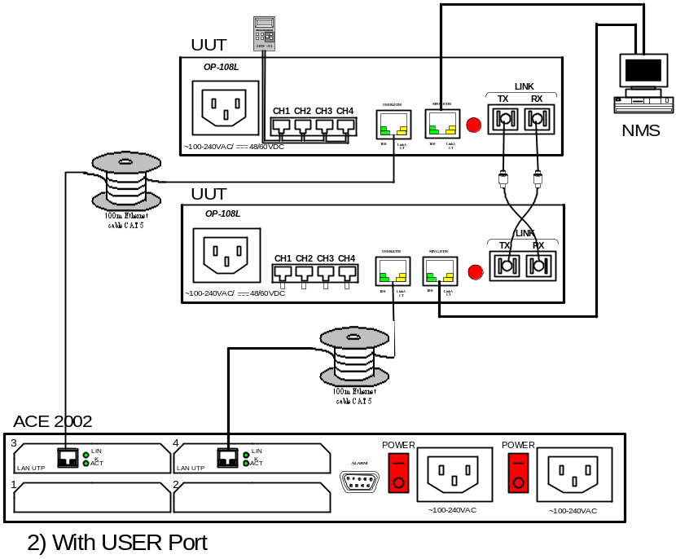

Figure 5 – Major and Minor Alarm Test

1. Disconnect all the physical LOOPs, HBT, FO uplink cables, MNG - ETH and
USER-ETH cable.
2. Perform masking to system alarms, all Channels, Uplinks,
MNG – ETH, and USER – ETH port (In OP-108L with User-Port
Only). Main menu>Config>System>Alarms
Main menu>Config>Physical Layer>Ethernet/Link/E1
3. Clear Event Log screen (by connecting to telnet)
Main Menu>Monitoring>System> Event Log +<C>
4. Change status on Ch1 (UUT) by connecting Loop to ch1 and
Disconnect the loop
5. Verify:
No Alarms | Event Log Screen
- Perform unmasking to Channel 1
Main menu>Config>Physical Layer>E1
- Change status on Ch1 (UUT) by connecting Loop to ch1 and Disconnect it and Verify on Event Log screen:
Local ch-1 AIS = ON & Signal Loss = OFF | Monitoring>System> Event Log
Local ch-1 Signal Loss = ON & AIS = OFF | Monitoring>System> Event Log
- Clear Event Log screen
Main Menu>Monitoring>System> Event Log +<C>
- Perform masking to channel 1.
Main menu>Config>Physical Layer>E1
- Change status on Ch1 (UUT) by connecting Loop to ch1 and Disconnect it and Verify on Event Log screen:
No Alarms | Monitoring>System> Event Log
- Repeat the section 1-6 for all channels (2 to 4).
- Connect ETH loop to User ETH port and disconnect it.
- Verify:
No Alarms | Monitoring>System> Event Log
- Perform Unmasking to User ETH port.
Main menu>Config>Physical Layer>Ethernet
- Connect ETH loop to User ETH port and disconnect it.
- Verify:
Local USER-ETH – ETH integrity Fail= ON | Monitoring>System> Event Log
Local USER-ETH – ETH integrity Fail= OFF | Monitoring>System> Event Log
- Connect FO cable between 2 Units and disconnect it.
- Verify:
No Alarms | Monitoring>System> Event Log
- Perform Unmasking to Uplink.
Main menu>Config>Physical Layer>Link
- Verify:
Local Link – Signal Loss = OFF | Monitoring>System> Event Log
Local Link - Signal Loss = ON | Monitoring>System> Event Log
- Connect FO cable Between 2 Units Verify Synchronization.
- Connect by Telnet to UUT.
- Clear Event Log screen and Verify No Alarms for Uplink are Active. Main Menu>Monitoring>System> Event Log +<C>
Main Menu>Monitoring>System> Event Log +<C>
- Disconnect & Reconnect MNG cable on Remote unit and verify:
No Uplink Alarms | Monitoring>System> Event Log
- Perform Unmasking on MNG-ETH port.
Main menu>Config>Physical Layer>Ethernet
- Disconnect & Reconnect MNG cable on Remote unit and Verify On UUT:
Remote MNG-ETH – ETH integrity fail = ON | Monitoring>System> Event Log
Remote MNG-ETH – ETH integrity fail = OFF | Monitoring>System> Event Log
- Main Menu>Monitoring>System> Event Log +<C>
Verify No alarms are active:
Monitoring>System> Event Log
Monitoring>Active Alarms screen
Verify DATA Transfer without any Error (Channels + User Port).

USER – Ethernet Data Port Test

General Function Test
- Connect the devices according to the Figure 2.
- Configure UUT and REF port parameters:
Parameter | Value
Auto negotiation | Enabled
MDIX Auto cross over | Enabled
Fault Propagation | Off
Administrative Status | Up
- Configure the ACE – 2002:
Parameter | Value
Max Capability Advertised | 100BaseT Full Duplex
Auto negotiation | Enabled
- Use following configuration of the UUT and Ref for Data Ethernet Test according to the table bellow:
Test Number | Speed and Duplex
1 | Auto negotiation
2 | 100Mbps Full Duplex
3 | 10Mbps Full Duplex

Note | Ethernet Rate limit should be match to the Mode has been chosen.
- Use following configuration of the ACE – 2002 Generator for Data Ethernet Test:
Test Number | Frame Length | Chain Length | Delay | PPS | Speed and Duplex
1 | 1518 | 1 | 125 | 8000 | Auto negotiation

- Run the Test number 1 for 60 seconds and verify on the ACE – 2002 and UUT the following:
Device | Slot | Parameter | Value/Status
ACE 2002 | Slot 2 & Slot 4  (Statistic screen) | Received O.K. | Counting
ACE 2002 | Slot 2 & Slot 4  (Statistic screen) | Lost | 0
ACE 2002 | Slot 2 & Slot 4  (Statistic screen) | Lost Indicator | 0
ACE 2002 | Slot 2 & Slot 4  (Statistic screen) | Tester PPS | 8000
UUT | Ethernet Physical Layer  USER-ETH | Administrative Status  (Monitoring) | Up
UUT | Ethernet Physical Layer  USER-ETH | Operation (Monitoring) | Up
UUT | Ethernet Physical Layer  USER-ETH | Auto negotiation Status  (Configuration) | Enable
UUT | Ethernet Physical Layer  USER-ETH | Speed and Duplex  (Monitoring) | 100base-TX Full Duplex
UUT | LEDs | LINK/ACT | Orange Blinking
UUT | LEDs | 100 | Green ON

Fault Propagation and Alarms Test
- Connect the devices according to the Figure 5.
- Configure UUT and REF:
Fault Propagation | On
- Configure ACE – 2002 physical layer the following:

Device | Slot | Parameter | Value
ACE 2002  Slot 2 & Slot 4 | (Physical Layer Configuration) | Max Capability Advertised | 100BaseT Full Duplex
ACE 2002  Slot 2 & Slot 4 | (Physical Layer Configuration) | Auto negotiation | Enable
ACE 2002  Slot 2 & Slot 4 | (Physical Layer Configuration) | Frame Length | 1518
ACE 2002  Slot 2 & Slot 4 | (Physical Layer Configuration) | PPS | 8000
ACE 2002  Slot 2 & Slot 4 | (Physical Layer Configuration) | Delay | 125

- Verify:
Device |  | Slot | Parameter | Value/Status
ACE 2002 | Slot 2 & Slot 4 (Statistic screen) |  | Received O.K. | Counting
ACE 2002 |  |  | Lost | 0
ACE 2002 |  |  | Lost Indicator | 0
ACE 2002 |  |  | Tester PPS | 8000
ACE 2002 |  |  | Generator Only | No
ACE 2002 |  |  | Mode | Full Duplex
ACE 2002 |  |  | Rate (Mbps) | 100
ACE 2002 |  |  | Status | Connected
UUT |  | Ethernet Physical Layer (Monitoring & Configuration screen) | Administrative Status | Up
 |  | Ethernet Physical Layer (Monitoring & Configuration screen) | Operation | Up
 |  | Ethernet Physical Layer (Monitoring & Configuration screen) | Auto negotiation Status | Enable
 |  | Ethernet Physical Layer (Monitoring & Configuration screen) | Speed and Duplex | 100base-TX Full Duplex
 |  | LEDs | LINK/ACT | Orange Blinking
 |  | LEDs | 100 | Green ON
 |  | Active Alarm Screen | USER – ETH Integrity Loss | No Alarm
- Disconnect Uplinks on UUT and verify:
Device |  | Slot | Parameter | Value/Status
ACE 2002 | Slot 2 & Slot 4 (Statistic screen) |  | Received O.K. | 0
ACE 2002 |  |  | Lost | 0
ACE 2002 |  |  | Lost Indicator | 0
ACE 2002 |  |  | Tester PPS | 8000
ACE 2002 |  |  | Generator Only | No
ACE 2002 |  |  | Mode | Half Duplex
ACE 2002 |  |  | Rate (Mbps) | 10
ACE 2002 |  |  | Status | Not Connected
UUT  &  REF |  | LEDs | LINK/ACT | Off
 |  | LEDs | 100 | Off
- Reconnect Uplinks and verify as specified in step 4.

- Disconnect Ethernet cable on the UUT and verify:
Device |  | Slot | Parameter | Value/Status
ACE 2002 | Slot 2 & Slot 4 (Statistic screen) |  | Received O.K. | 0
ACE 2002 |  |  | Lost | 0
ACE 2002 |  |  | Lost Indicator | 0
ACE 2002 |  |  | Tester PPS | 8000
ACE 2002 |  |  | Generator Only | No
ACE 2002 |  |  | Mode | Half Duplex
ACE 2002 |  |  | Rate (Mbps) | 10
ACE 2002 |  |  | Status | Not Connected
UUT  &  REF |  | LEDs | LINK/ACT | Off
 |  | LEDs | 100 | Off
 |  | Active Alarm Screen | USER – ETH Integrity fail | On (Major)
- Reconnect the cable and verify as specified in step 4.

Checking Set. Def Button
On the Rear Panel You will find a RED Push Button.
This Button is setting to default all the Parameters that has been changed.
    - Please Change any Parameter Using The Telnet (Web) Connection.
    - Press the Set. Def Button.
    - Verify that the parameters changed back to default Setting’s.

Note | IP address changes Back to 192.168.205.1

LED Test
- Perform Reset to UUT Main Menu>Utilities>Reset Device+<Y>
and after approximately 30 sec Led test is being
performed
- Verify:
LED | Status
Channels LEDs | Blinking (Red + Yellow)
Link Interfaces LEDs | Blinking (Red + Yellow)
SD led (back Panel) | Light (Green)
PWR led | Light (Green)

MAC Registry
- By using Barcode scanner or DBR application insert to the Barcode the
UUT MAC and Verify on Monitoring System screen that the MAC address
appears is in the legal RAD MAC address range.
- Mark point on the procedure trace sticker and attach updated CSL sticker.

Preparations for Shipment
As specified in the GFTI.

Factory setting
As specified in the GFTI.

Safety Test
As specified in the GFTI.
- HBT Configuration

CLK | INT
PATTERN | 511
MODE | X64
BAUD RATE | 2.048
- Masks with Digital Scope
  - Infinium
  - Connect the scope probe to the appropriate E1connector (via RJ/BNC patch tributary cable in the case of UNBALANCE test) and verify the switch directed to 75/120Ω impedance (according to the signal type).
  - For E1 load the 2M_Bal/2M_Unbal mask
(According to the tested signal type).
  - Perform Align to the signal.
  - Press the run icon.

  - Tektronix
- Connect the scope probe to the appropriate E1connector (via RJ/BNC patch tributary cable in the case of UNBALANCE test) and verify the switch directed to 75/120Ω impedance (according to the signal type).
- Configuring the scope:
  - For Factory Setup use following configuration:
- Press SAVE/RECALL button
- Press Recall Factory Setup
- Press OK Confirm Factory Init
  - Press Quick Menu
  - Choose from the MENU: TELECOM
  - Listing up and down choose the STANDARD:
    - E1 Coax (ITU-T) 2.048 Mb/s – for UNBALANCE
    - E1 Sym (ITU-T) 2.048 Mb/s – for BALANCE
  - Press AutoSet.
  - Select Boundary of Waveforms to 500.
  - Select Average to 16.
  - Choose RUN TEST.

- ACE-2002 Configuration

The menus are refers to ACE-2002 with:
- Software Versions:
Boot: 1.1 1-29-2001 13:07
Application: 3.1-B2 3-7-2005 11:24
- Hardware Version: 0.2-J/0.1-A
ACE-2002 Configuration:
1. After ACE-2002 finish its initialization and configuration press ESC.
2. Press 2 (Configuration)
3. Press 2 (Physical Layer Configuration) and select the slot number for configuration (3 or 4).
4. Select the following and by pressing SPACE change the configuration, then press ENTER and S to Save:
- For auto-negotiation setting select 3.
- For determining the max rate in A.N select 4 (set always on 100BaseT Full Duplex).
- For Rate and Duplex setting select 5.
5. Press ESC to return to previous screen and perform steps 3, 4 to the next slot.
6. Press ESC until Configuration screen.
- Press 7 (Generator Configuration).
- Configure Generator Mode to the Ethernet mode.
- Configure Generator only to No.
8. Select the following and press S for saving the configuration:
- For Frame Length setting select 4.
- For Chain Length setting select 5.
- For Delay setting select 6.
9. Press N to configure the next slot and perform step 8.
10. Press 9 to see the statistics:
Slot | Parameter | Value
Slot 3 & Slot 4 | Received O.K. | Advancing
Slot 3 & Slot 4 | Lost | 0
Slot 3 & Slot 4 | Loss Indicator | 0
11. To reset counters press R.
12. To see the next slot statistics press ESC, N, 9.

