Cable Name: AT-SF1P/CBL03

|  |  |
| --- | --- |
| DCJ20-0442SVB-L  CONN.PWR,DC,JACK,2.0MM PIN,LOCK | 395040003  CONN.TB,WR,3PIN,(F),8A |
| 1 | 1 |
| 2 | 2 |

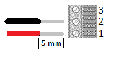



Please attach a label the with Cable Name and label to the cable