Alpha testing of O3_Input
Thank you for helping test O3_Input! This first stage is to check that individuals at other institutions can use the encryption process to connect to ARIA and pull data into O3.
O3_Input will allow 1) fully manual input, 2) partial input from a spreadsheet or 3) Input from ARIA. The spread sheet input supports clinics that are not allowed to connect to their ARIA database. It also provides a means for users to develop queries to pull data from other systems (e.g. Mosaiq) to test their queries by saving results as a tab delimited text file, to confirm proper ingestion. Options 2 and 3 use the same code for processing the data tables read in either from the tsv spreadsheet or the SQL query.

- Get the files
You have been given access to a private git hub repository. The first step is to down load the code from the repository. There are two programs that you will use. Down load the code into separate folders

- EncryptDecryptWPF
CSMayoLab/EncryptDecrypt: EncryptDecrypt

- O3_Input
https://github.com/CSMayoLab/O3_Input

If you are pulling data from AIRA you will first need to encrypt the connection string to connect to ARIA, and then copy the encrypted string into the configuration file.

- Run the executable
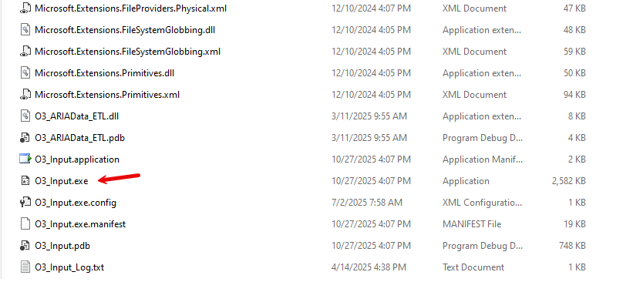

- First test fully manual entry.
Create a new data set, then navigate the tabs to enter information for patients
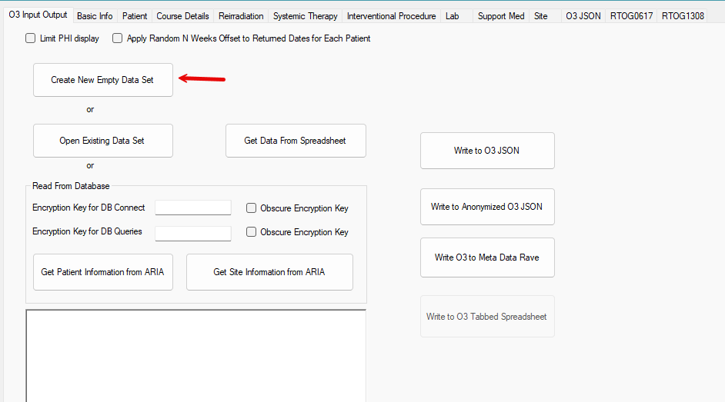

- Next test ability to import an existing O3 formatted JSON file, by clicking the open Existing Data Set button.
Select the O3RecordSet20251024_NoPHI.json file. On the Basic Info tab you will see three anonymized patients. (Note domicile addresses in the NoPHI file were set to local libraries) You can add and update information for those patients.
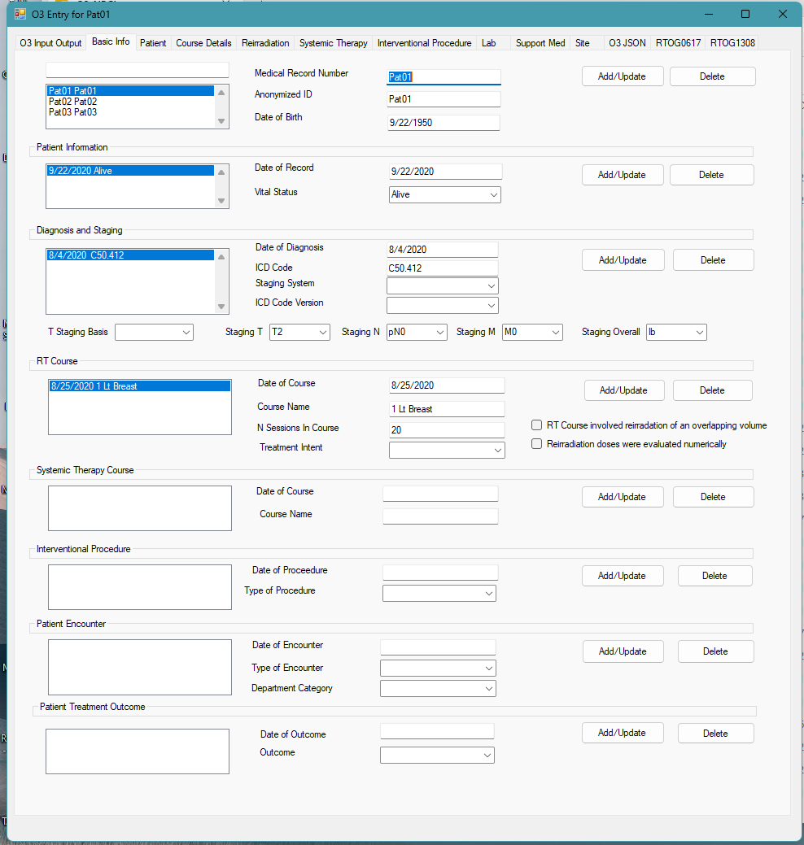

- Click on the O3 JSON tab and you will be able to see the underlying data file.
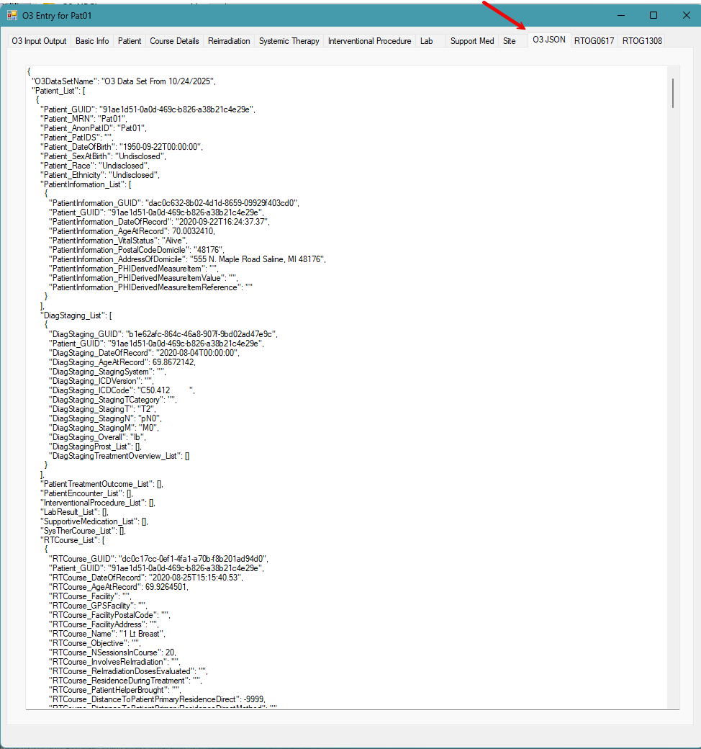

- Randomize dates.
Under the O3 Input Output tab, clicking on the “Apply Random N Weeks Offset to Returned Dates for Each Patient” check box will anonymize dates. Unchecking will take you back to the original dates.
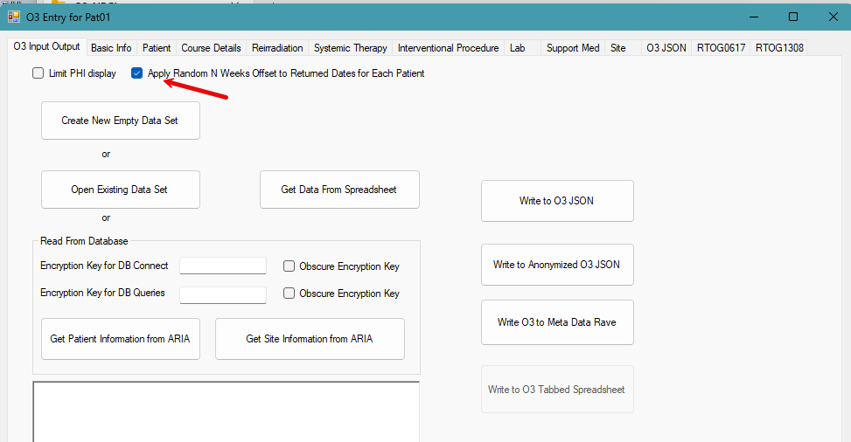

- Write to JSON file.
The first button writes the current stored data as is into the directory you choose, with the name that you choose. The second button will 1) Replace MRN with the Anonymized ID you’ve selected for the patient, 2) apply per patient random offset of dates, 3) replace patient domicile address with address of a library, 4) replace DICOM UID’s with “x.x.x.x” . This preserves relative times between events.
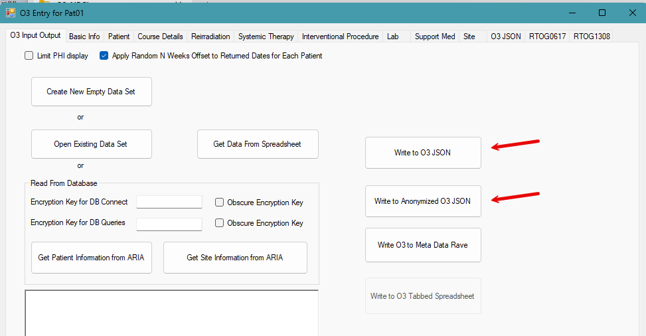

You are entirely in control of where your data files are stored and who has permissions to access them.

- Read data from spreadsheets.

For developing connections to new vendor systems, or when you cannot connect directly to the database of the vendor system, spreadsheet input is a convenient way to pull in data for groups of patients. You can have your IT group export results of a query pulling the needed information in to a set of tab delimited text files. When you click the “Get Data from Spreadsheet” button navigate to the directory that contains the files and select the “PatCourseToGet.txt” file. It will read the data for the other files using standard formatting into O3_Input. The files included with the down load are anonymized. If you want to create your own versions just follow the column types.

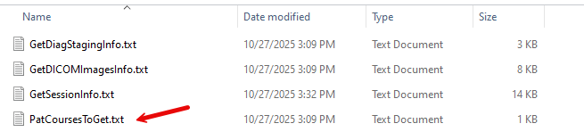

The first row specifies the data type of the column, and the second row the column header.
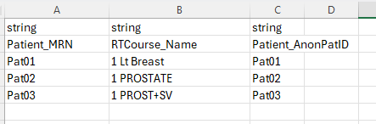

Below is an image of the first few rows and columns of the GetSessionInfo.txt file
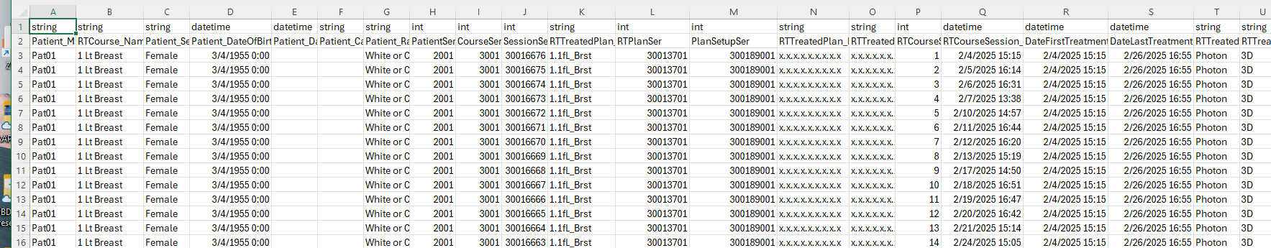

- Encrypt Connection String
Only try the remaining steps, if you are going to connect to the ARIA database or a reporting copy of the database to pull data. Your IT group may not allow this connection. This is the connection string format. Replace the red italicized text with your value
Server = servername; Database = databasename; User Id = username; Password = password;
Use the program EncryptDecryptWPF to encrypt the connection string.
If you leave the encryption key blank it will use a standard secret value. This is recommended for less typing and remembering.
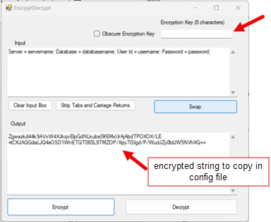
You can enter an 8 character string to use as the encryption key. In this example we used fourfour
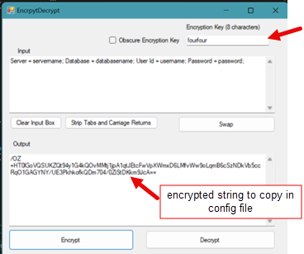

- Copy into the json query file
The O3_Input_QuerySet.json file is in the directory with the O3_Input program files that you downloaded from GitHub. Open the file.
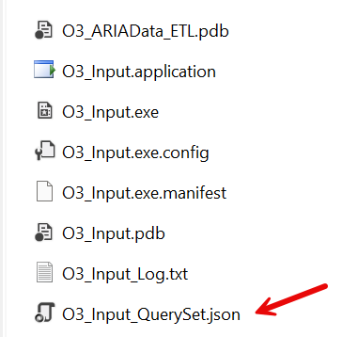
There are two groups: PatCourseInfo and SiteInfo. Each of these groups define a connection string to be used with all of the queries in the respective group.
Paste the encrypted connection string into the value for the ConnectionString key in each group. Save the file, then you are ready to run the program.
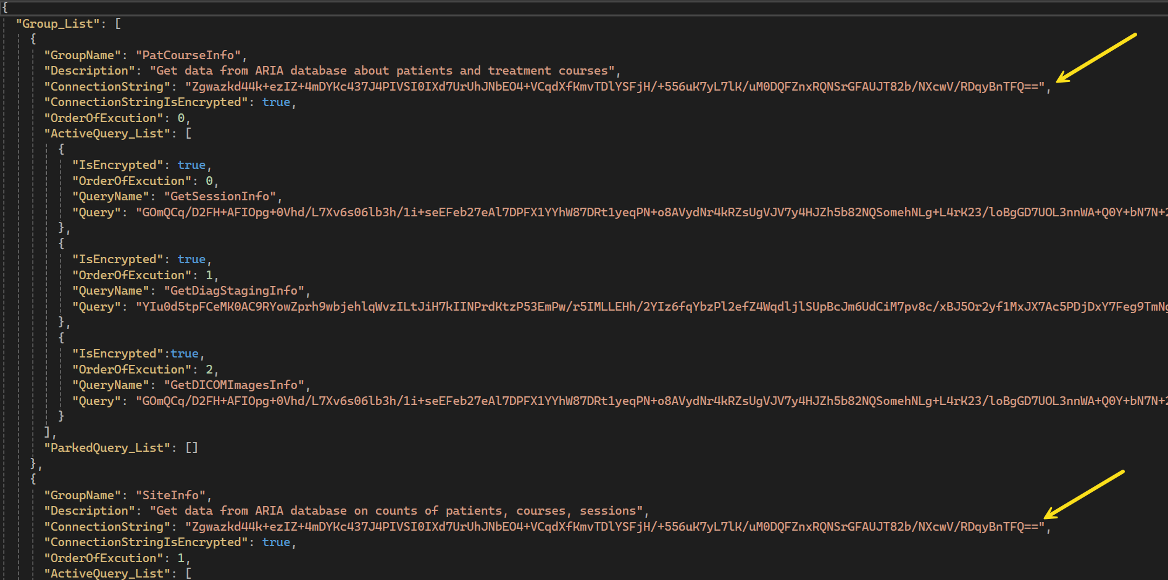
Within each group there is an ActiveQuery_List and at ParkedQuery_List. The program will only run the encrypted queries inside of the ActiveQuery_List. If you want to keep a query item ({…}), but not run it, move it into the ParkedQuery_List.
This functionality is helpful if you are debugging set of queries, one-by-one. It is also useful if you are developing a new query.
- Modify patient list file to check that it runs with ARIA
You have to modify the tab delimited file to include MRNs, CourseIds and Anonymization names, to match a couple of patients in your ARIA database.
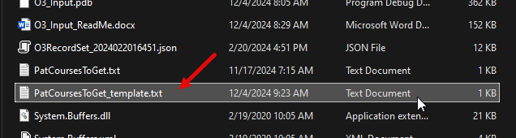

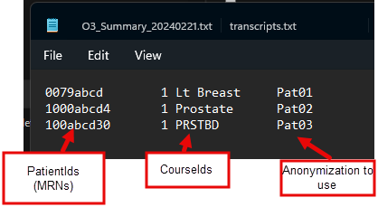

- Check that it runs pulling data from ARIA
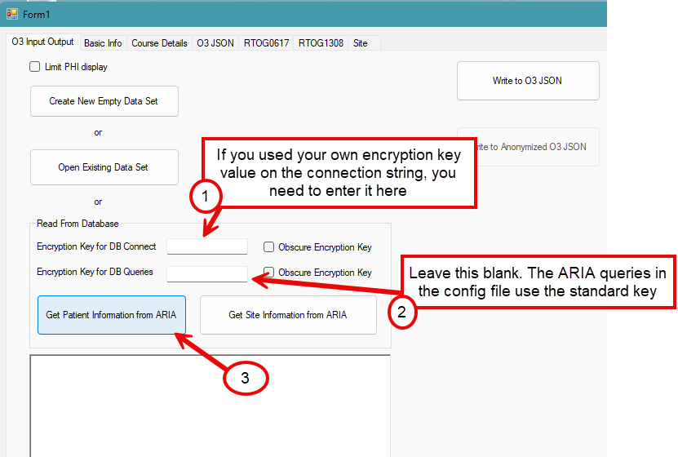
Leave the db connection encryption key blank if you used the standard value or enter the custom one if that is how you encrypted the connection string. Leave the key for queries blank. Click the Get Patient Information from ARIA button. Select the patient list file you just modified to contain your patients.

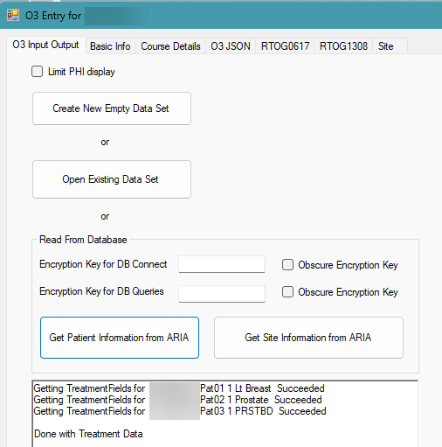
It will keep you posted as it works through the patients and let you know when done.

- Get the site summary data
Click on the Get Site Information from ARIA. It will keep you updated as it progresses through
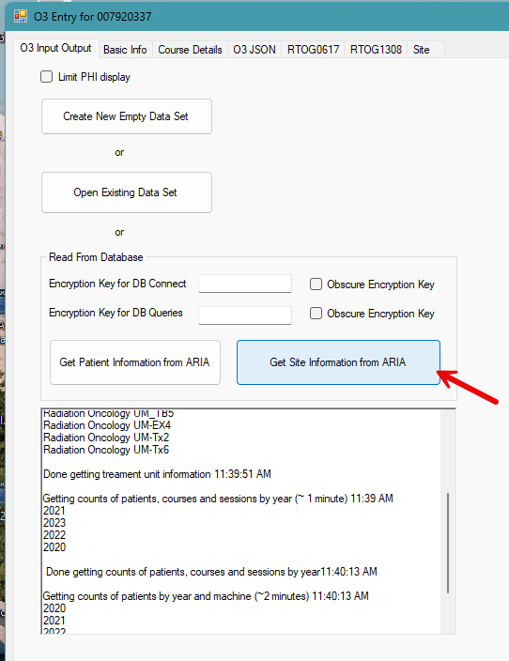
It takes a bit longer (~3-4) min to get all of this summary information on all patients and courses over the last 4 years.

Log File
A log file is used to record progress through extraction of data from queries. The tables returned by the queries are also written as tab delimited text into the log file.
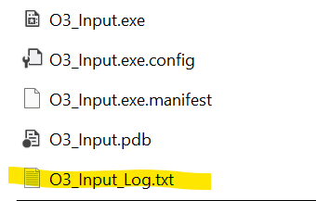

The pages following show the data elements returned by the queries in the configuration file.
No data is automatically sent or saved.
The only data retained is in the O3 JSON file if the user chooses to write the file to a local folder.
The contents of the O3 JSON file are fully visible in the O3_Input application.

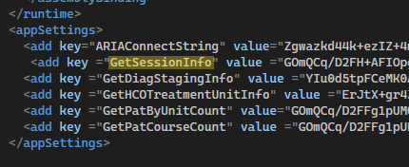

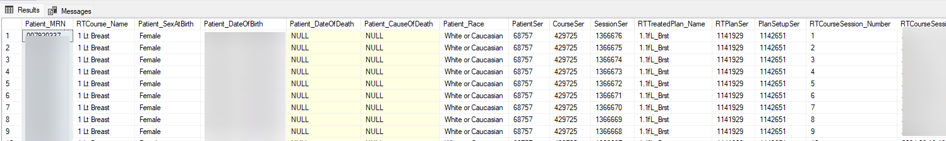
Patient_MRN
RTCourse_Name
Patient_SexAtBirth
Patient_DateOfBirth
Patient_DateOfDeath
Patient_CauseOfDeath
Patient_Race
PatientSer
CourseSer
SessionSer
RTTreatedPlan_Name
RTPlanSer
PlanSetupSer
RTCourseSession_Number
RTCourseSession_DateOfRecord
DateFirstTreatmentOfPlan
DateLastTreatmentOfPlan
RTTreatedPlan_Modality
RTTreatedPlanDetailsXRT_Technique
RTTreatedPlanDetailsXRT_Energy
RTCourseSession_NCBCTInSession
RTCourseSession_NkVInSession
RTCourseSession_NMVInSession

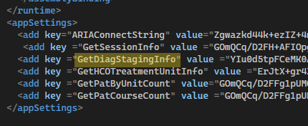

Patient_MRN
RTCourse_Name
DiagStaging_DateOfRecord
DiagStaging_ICDCode
DiagStaging_Overall
StageComponents
DiagnosisDescription
DiagnosisName
PatientSer
CourseSer

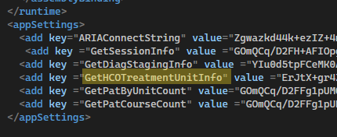

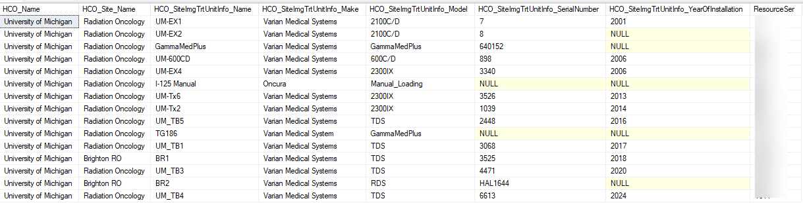

HCO_Name
HCO_Site_Name
HCO_SiteImgTrtUnitInfo_Name
HCO_SiteImgTrtUnitInfo_Make
HCO_SiteImgTrtUnitInfo_Model
HCO_SiteImgTrtUnitInfo_SerialNumber
HCO_SiteImgTrtUnitInfo_YearOfInstallation
ResourceSer

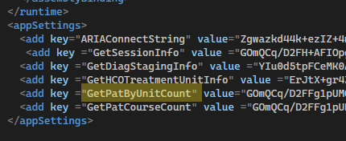

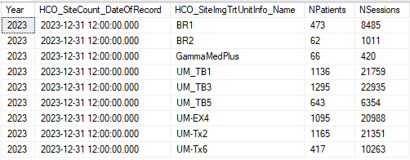

Year
HCO_SiteCount_DateOfRecord
HCO_SiteImgTrtUnitInfo_Name
NPatients
NSessions

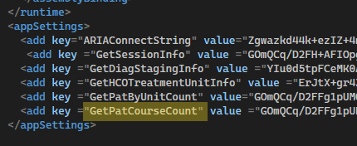

Year
HCO_SiteCount_DateOfRecord
NumberofPatients
ARIACourseCount
NumberofRadiationTherapyTreatmentCourses
NumberofRadiationTherapyTreatmentSessions

