DPNR · THE HUMAN OPERATING SYSTEM
MVP BUILD
SPECIFICATION
A build-ready specification for the first usable DPNR Beta product
Product promise
DPNR helps a person understand what is happening inside them, identify patterns, make more aligned choices, and see how they are evolving over time — without turning self-development into another task list.

BETA PRODUCT · EARLY USER RELEASE
User-facing personal layer: My Evolution Map
Technology layer: Digital Twin

1. What We Are Building
The MVP is a working personal operating and navigation product, not a collection of AI chats and not a static Figma prototype. A first-time user must be able to enter, understand the product, form an initial personal orientation, use the Companion or Dashboard as two connected views of Gate 1, enter at least one guided workspace, receive a meaningful insight, and return later to a system that remembers relevant context. This release is explicitly a Beta product: real users can use the core experience, while interaction details, the visual expression of the Digital Twin / My Evolution Map, recommendations and commercial packaging continue to be refined through product discovery and early-user feedback.

Core Experience Principle — Gate 1 First
The system works for the user — the user should not have to operate the system. Gate 1 is the user’s Personal Operating System. Its default interaction surface is the Main Chat: a persistent, conversational home base inspired by the simplicity of ChatGPT, where the user can arrive, share what is happening, ask a question, continue previous work, or be guided into the right DPNR experience. From the Main Chat, the user can open the Dashboard, enter a Room, pull a card, learn, continue a commitment, or return to a previous process. The Dashboard remains the visual system hub / data room, but the user should never need to leave the Main Chat just to understand what to do next. DPNR carries the organizational burden.
Experience rule: Main Chat first → contextual guidance → Dashboard or deeper workspace on demand → return to Main Chat with continuity.
Surface | User meaning | Primary role | Navigation behavior
Main Chat | “Talk to my system” | Default interaction surface and intelligent router | Can open Dashboard, Rooms, Library, Daily Card, commitments and prior sessions inline or by transition.
Dashboard | “See my system” | System hub / data room / operating overview | Shows Roadmap, My Evolution Map, progress and direct access to the wider platform; always returns cleanly to Main Chat.
Rooms & Library | “Work on it” | Focused training, reflection, decision-making and learning | Entered directly or contextually from Main Chat/Dashboard; outputs flow back into Gate 1 and the Digital Twin.
Digital Twin | “System learns in the background” | Shared structured intelligence layer | Supports both Main Chat and Dashboard; user-facing visualization can evolve during product characterization.
Core product loop
Talk → Understand → Practice → Insight → Update My Evolution Map → Adjust Roadmap → Return with continuity.

The product system
Core element | Role in MVP | User relationship
DPNR — The Human Operating System | the complete product experience. | Complete system
Companion | the conversational interface of Gate 1 — understands, guides and routes. | Default Main Chat / guide
My Evolution Map | the user-facing living representation of their evolving context. | User-facing personal view
Digital Twin | the underlying structured technology layer that stores confirmed and candidate signals. | Invisible structured intelligence layer
Roadmap | the current focus, theme and direction that orient the user. | Current direction / compass
Training Rooms | guided practice spaces such as Mirror Room and Decision Room. | Focused work environments
Content Library | interactive learning organized by DPNR taxonomy and personalized recommendations. | Learning and explanation layer
Dashboard | the Gate 1 system hub / data room — Roadmap, My Evolution Map, continuity, progress, recommended actions, reminders, daily card, weekly recap and direct navigation to the wider platform. | Visual system hub / data room
Beta Product | the first live release for early users. Core flows, privacy and continuity must be real; selected UX details, Digital Twin visualization and commercial packages may evolve during beta. | Release state / expectation setting

Source of truth
Source | Owns | Rule
Figma | Visual design, screen hierarchy, components, layout and interaction states | Implement, do not redesign unless a required state is missing.
This specification | Product behavior, flow, outputs, data and intelligence rules | Use this document to decide what happens and why.
Technical architecture | Security, APIs, storage, AI and deployment | Keep UI independent from infrastructure and AI provider.

Reference hierarchy & provenance
Primary product source-of-truth: DPNR’s approved product work — Figma, FigJam, user journeys, room models, taxonomy, Roadmap logic, and the Two Gates experience concept. The Two Gates / system overview visual referenced in this specification is attributed to Dafna and is used as a product-experience reference.
Architecture and research references: selected materials created by Sergei may be used to inform technical thinking around structured personal memory, graph-based data, hypothesis handling, privacy, portability and an orchestration/harness layer around the LLM. These materials are reference inputs only. They are not automatically product requirements, and DPNR should not depend on unique concepts from those materials unless the team explicitly evaluates and adopts them.
Implementation rule: build the product DPNR has defined. Use external or consultant reference material to strengthen implementation choices, not to redefine the product, its user experience, or its intellectual architecture by default.
The user should experience one coherent system: talk to it, see it, and move into deeper work when useful. The platform should organize itself around the person — not require the person to organize the platform.

Product rule
Digital Twin is the technology layer underneath Gate 1 and Gate 2. My Evolution Map is its user-facing expression. The Digital Twin data structure should be designed deliberately; however, the exact visual representation of My Evolution Map / the “digital twin” is intentionally open and will evolve during product characterization, Figma iteration and testing with first users. The MVP should therefore avoid coupling the data model to one fixed avatar, map, graphic or visualization. The exact visual form of My Evolution Map / Digital Twin is intentionally not locked for the MVP. Its representation — map, presence, data view, visual metaphor or combination — will be defined iteratively during UX/product specification and beta learning, without changing the underlying structured data model.

1.1 Experience Architecture — Two Gates, One System
Gate 1 is the operating layer the user lives in. Main Chat is the default interaction surface; Dashboard is the visual operating hub. Gate 2 contains deeper workspaces. All layers share the same Digital Twin context.
Layer | What the user experiences | System role | Navigation rule
Gate 1 · Main Chat | Talk to my system | Default conversational home, continuity, intent understanding and intelligent routing | Primary place to arrive and navigate. Can open Dashboard or any relevant experience without making the user choose the “right tool.”
Gate 1 · Dashboard | See my system | System hub / data room showing Roadmap, My Evolution Map, progress, current focus and direct platform access | One tap from Main Chat; supports direct navigation to the wider platform and a clear return to Main Chat.
Gate 2 · Deep Work | Work on it | Mirror Room, Decision Room and other focused training / intervention experiences | Entered by user choice or contextual guidance from Gate 1; outcomes return to Gate 1 and update the shared context when justified.
Shared Digital Twin | System learns in the background | Structured memory, signals, summaries, context and personalization across Gate 1 and Gate 2 | Technology layer is stable; the exact user-facing visual form of My Evolution Map remains intentionally iterative.

Digital Twin definition is intentionally iterative
The MVP must define the Digital Twin data contract and learning rules, but not freeze a single visual metaphor for what the Digital Twin “looks like.” Its user-facing expression through My Evolution Map may evolve during product specification, Figma iteration and early-user testing. The implementation should therefore separate structured Digital Twin data from its visual representation so that avatar, map, graph, score, timeline or other views can change without redesigning the underlying intelligence layer.

2. Golden Paths
These are the two journeys that must work end-to-end before the MVP is considered usable.

A. First-time user
Step | User experience | System responsibility
1 | Welcome / short product explanation | Explain Beta simply; do not overload.
2 | Create account or sign in | Create secure identity.
3 | Consent and privacy acknowledgement | Capture explicit consent before personal processing.
4 | Activate Beta Trial with starter credits — no payment method required. | Grant starter credits without payment method.
5 | Companion-led conversational onboarding | Use Main Chat as the onboarding interface; ask one useful question at a time.
6 | Initial orientation: focus, theme, direction | Infer only a useful first orientation.
7 | Generate My Evolution Map v1 | Create My Evolution Map v1 from structured, traceable signals.
8 | Generate initial Roadmap | Create initial Roadmap and one clear next direction.
9 | Enter Gate 1. The Companion can welcome and orient the user conversationally, while the Dashboard is available as the user’s living system hub showing the initial Roadmap, My Evolution Map and one clear next step. | Keep user in Main Chat by default; make Dashboard one tap away as the visual system hub.
10 | If useful, the Companion recommends or opens one relevant next action, learning experience or Training Room. | Route contextually; do not force a Room.
11 | Complete a meaningful session in a Training Room or Companion | Preserve room logic behind a natural experience.
12 | Receive a reflection / insight | Return a concise, useful reflection.
13 | Update Digital Twin signals and My Evolution Map | Write only justified Digital Twin updates.
14 | Return later to Gate 1 and experience continuity across both Companion and Dashboard without having to reconstruct context. | Restore context on next return across Main Chat and Dashboard.
Onboarding principle
The user should not feel that they are filling a profile for DPNR. DPNR learns through natural conversation, small choices and actual use. Ask only what is needed to create a useful first orientation.

Beta trial principle
The first experience must be low-friction. A new user receives a configurable amount of starter credits and can experience DPNR without entering a card or other payment method. The product should demonstrate value before asking for payment. No automatic charge is permitted at the end of the starter-credit experience.

B. Returning user
Step | User experience | System responsibility
1 | Authenticate and restore the user’s safe context. | Restore secure context and active session state.
2 | Gate 1 restores safe context. The Companion opens with a relevant continuation, while the Dashboard reflects the user’s current state, active focus and available pathways — not a generic feature menu. | Open the Main Chat as the default conversational home; preload only relevant context. Dashboard remains directly available.
3 | Across Gate 1, surface a Daily Card, relevant continuation, upcoming commitment, Roadmap cue or recommended space only when useful. | Surface only useful cues; avoid feature dumping.
4 | Keep Companion, Dashboard, My Evolution Map, Mirror Room, Decision Room and Library directly accessible. Dashboard is the primary navigation hub into the wider platform. | Preserve direct access and user agency across the platform.
5 | After meaningful use, update the user model and Roadmap only when evidence justifies it. | Update personalization only with sufficient evidence.
6 | Preserve continuity: do not re-ask what is already known unless reconfirmation is useful. | Never make the user reconstruct what DPNR already knows.

3. Core MVP Scope
The following capabilities define the first usable product. Everything else is secondary unless required for safety, privacy or continuity.
Capability | MVP status | Primary surface | Build note
Account, authentication, consent and account deletion. | Required | Platform layer | Required for first usable Beta.
First-entry welcome and conversational onboarding. | Required | Gate 1 | Required for first usable Beta.
Gate 1 as the primary operating layer, combining Companion (conversation/routing) and Dashboard (system hub/data room/navigation). | Required | Gate 1 | Main Chat is default interaction surface; Dashboard is visual hub.
Dashboard / Roadmap as the user’s living system hub: a calm data room that shows current orientation, continuity and direct access to the wider platform without requiring manual maintenance. | Required | Gate 1 | User should not manually maintain this data room.
My Evolution Map v1 backed by structured Digital Twin data. | Required | Dashboard / Digital Twin | Required for first usable Beta.
Mirror Room v1. | Required | Gate 2 | Required for first usable Beta.
Decision Room v1. | Required | Gate 2 | Required for first usable Beta.
Content Library with DPNR taxonomy, AI-generated learning experiences and personalized recommendations. | Required | Learning layer | Required for first usable Beta.
Daily Card: one short, relevant, positive or reflective prompt linked to current context. | Required | Dashboard + Main Chat | Required for first usable Beta.
Weekly Recap: short summary of meaningful movement, not a scorecard of engagement. | Required | Dashboard + Main Chat | Required for first usable Beta.
Growth / continuity indicators on Dashboard. | Required | Dashboard + Main Chat | Required for first usable Beta.
In-app session timer, soft stopping cues and anti-addiction rules. | Required | Gate 1 | Required for first usable Beta.
Reminders for user-chosen commitments and review dates. | Required | Gate 1 | Required for first usable Beta.
Privacy-first storage, safe logs and an encryption path compatible with the stronger AWS architecture. | Required | Platform layer | Required for first usable Beta.
Beta Trial + Credits: starter credits at signup with no payment method; visible remaining-credit status; clear low-credit/exhausted state; upgrade path to paid credit packs and/or plans. | Required | Signup / Account | Required for first usable Beta.
Beta labeling and expectation setting across Welcome/Trial and Account/Profile surfaces. | Required | Signup / Account | Required for first usable Beta.

Not required to prove the MVP
- Full read/write calendar integration. Keep the product integration-ready; add opt-in access only when the use case is proven.
- Predictive personality labeling or autonomous psychological conclusions.
- Hundreds of manually authored content items. The taxonomy and learning format are owned by DPNR; AI may generate the explanation layer in the MVP.
- Complex gamification, streaks or engagement mechanics designed to maximize time in app.
- Every future room or every Figma concept.

4. Feature Contracts
Each feature is defined by what brings the user in, what happens, what the system learns, what comes out, and where the user goes next.

Companion
Contract | Definition
Purpose | Main Chat is the default interaction surface of Gate 1: a persistent conversational home base and intelligent router for the entire DPNR system.
Entry points | Default after successful first-entry onboarding and default on return, unless the user explicitly chooses Dashboard or a specific deep-work destination.
User experience | Chat-first, low-friction and familiar. The user can simply speak or type what is happening. DPNR responds, remembers relevant context, and can surface cards, actions, room transitions, learning or Dashboard access without making the user manage the platform.
AI / system behavior | Restore relevant safe context; ask one meaningful question at a time; do not repeat known information; infer intent and appropriate depth; offer Dashboard or deeper work when useful; preserve a clear return path to Main Chat after every experience.
Data captured | Current concern, stated goal, context, explicit preferences, candidate signals that naturally emerge.
Primary output | Useful response, clarified intent, recommendation, or a transition into a deeper flow.
Next step | Stay in conversation, open Dashboard, enter a Training Room, learn in Library, update Roadmap, or close with a real-world next step.

Home / Dashboard + Roadmap
Contract | Definition
Purpose | The visual operating environment of Gate 1: system hub / data room / navigation center. It complements Main Chat rather than replacing it.
Entry points | One tap from Main Chat, direct navigation, after onboarding, after a meaningful update, or when the user explicitly wants the full picture.
User experience | A calm data room that visualizes what DPNR has organized for the user. It should feel like “see my system,” while Main Chat remains “talk to my system.” Every Dashboard path should return cleanly to Main Chat.
AI / system behavior | Compose the view from Digital Twin signals and product state. Prioritize what matters now, show “continue where you left off,” and route directly to Companion, Mirror Room, Decision Room, Content Library and other enabled spaces. Do not overload the user with every available feature.
Data captured | Primarily a read/interaction surface. Capture clicks, confirmations, corrections and explicit choices as product signals; do not infer deep personal meaning from passive browsing alone.
Primary output | Personal orientation, continuity and clear navigation across the user’s DPNR system.
Next step | Talk to Companion, continue current focus, open My Evolution Map, enter a Room, explore Library, review a commitment, pull a Daily Card or close the app.

Roadmap example
Current Focus: Work
Theme: Boundaries & Energy
Direction: From over-giving → clearer choices
Suggested Spaces: Mirror Room · Content Library · Growth Tracker
“A roadmap isn’t about locking the future, it’s about staying aligned as you move.”

My Evolution Map
Contract | Definition
Purpose | Give the user a living, understandable representation of what DPNR is learning over time. The exact visual form of this representation is not fixed at MVP specification stage and should evolve through product characterization, Figma iteration and early-user testing.
Entry points | Generated after onboarding; revisited from Dashboard and after meaningful updates.
User experience | Readable, revisable and intentionally non-final in visual form. The user can confirm, reject or explore meaningful interpretations. The representation may evolve from cards/sections into a richer map or other visual model as the product is characterized.
AI / system behavior | Maintain structured Digital Twin signals with source, timestamp, confidence and confirmation state. Keep the underlying data model stable even if the user-facing visualization changes. Propose major Roadmap changes rather than silently rewriting them.
Data captured | Focus, themes, confirmed/candidate patterns, triggers, values, needs, decision tendencies, goals, commitments, relevant learning themes and change over time.
Primary output | A living view of current orientation and emerging patterns; never a fixed diagnosis or identity label. Its visual language should be treated as a product-design decision that can evolve during MVP characterization.
Next step | Roadmap update, recommended space, reflection, or no change when evidence is weak.

Mirror Room
Contract | Definition
Purpose | Train awareness of recurring patterns, emotional loops, trigger people/characters, trigger situations and protective responses.
Entry points | Direct entry, Companion recommendation, Roadmap recommendation or after a relevant Library topic.
User experience | Conversational guided reflection; the model stays structured behind the scenes.
AI / system behavior | Use the Mirror model flexibly. Do not expose every question as a checklist. Skip questions already answered and stop when enough evidence exists.
Data captured | Situation, trigger, thought, emotion, body response, automatic reaction, coping/protective response, recurring pattern, energy/mood effect, life domain.
Primary output | Reflection: what repeats, what activated me, what I did, what may be protected, what to notice next time.
Next step | Update candidate/confirmed signals; return to Roadmap, Library, Companion or a real-world observation task.

Mirror Room model — prompt logic
Identify Your Patterns
- What situation or feeling seems to repeat itself in your life, even when you try to change it?
- When things don’t go as planned, what is your first automatic reaction?
- What do you know would be good for you — but still find yourself avoiding or postponing?
Trigger Characters — Identify Trigger People
- Is there a type of person in your life who tends to activate you emotionally?
- What do they usually do that triggers you?
- What do you usually feel around them?
- How do you tend to respond in those moments?
Trigger Situations
- Which situations tend to trigger you the most?
- What is usually happening right before you feel triggered?
- After these situations, what happens to your energy or mood?
Shape the Character
- How would you describe this character in your life?
- What does this character tend to activate in you?
- What do you usually do when this character shows up?

Decision Room
Contract | Definition
Purpose | Help the user move from inner conflict to a more aligned decision by integrating thought, emotion, body, desire, fear, values, needs and practical evaluation.
Entry points | Direct entry, Companion recommendation, Roadmap recommendation or decision-related Library topic.
User experience | A guided process that feels conversational and responsive, not like a 14-page form.
AI / system behavior | Use the DPNR decision model as hidden structure. Adapt sequence to what is already known while preserving the core decision logic and final integration.
Data captured | Decision, options, thoughts, emotions, body signals, past-conflict learning, desire, fear, pros/cons, values, needs, future projection, chosen micro-step and commitment.
Primary output | Inner Alignment reflection plus one safe, concrete next step.
Next step | Update relevant decision signals, set a review date/reminder if chosen, and return to Roadmap/Home.

Decision Room model — hidden structure
- Define the conflict.
- Map the options.
- Notice initial thoughts and what they are trying to achieve or protect.
- Check emotional response.
- Check body response.
- Reflect on similar previous conflicts.
- Clarify desire beneath expectation and fear.
- Meet the fear and understand what it protects.
- Separate desire from fear.
- Evaluate pros and cons consciously.
- Check values and needs alignment.
- Project each path into the future.
- Integrate the choice with identity.
- Reflection + action: aligned / protective / avoidant, then define a safe 1% micro-step and optional commitment.

Content Library
Contract | Definition
Purpose | Turn DPNR’s knowledge taxonomy into short, interactive learning that can be browsed or personalized.
Entry points | Direct Library entry, recommendation from Home/Companion/Room, or link from a Daily Card.
User experience | Topic browsing plus a “Recommended for You” layer similar to content discovery products, without endless-scroll mechanics.
AI / system behavior | Generate explanations within DPNR’s taxonomy, tone and learning format. Personalize examples and recommendations from relevant confirmed context, not from unsupported assumptions.
Data captured | Topics opened, optional saves, explicit relevance feedback, reflections that naturally emerge.
Primary output | Understand → Recognize → Visualize → Examples → Reflect → Next Step.
Next step | Mirror Room, Decision Room, Companion, another topic, or close and apply in real life.

Library taxonomy
Inner World: Fear · Emotional Triggers · Pain & Healing · Inner Child
Values & Needs: Core Values · Emotional Needs · Boundaries · Self-Worth
Energy & Motivation: Energy & Vitality · Motivation & Drive · Desire & Passion · Comfort Zone
Patterns & Beliefs: Beliefs · Limiting Beliefs · Inner Conflict · Awareness Patterns
Relationships: Relationships · Attachment & Intimacy · Communication · Trust · Letting Go
Direction & Creation: Decision Making · Change & Transition · Purpose & Meaning · Freedom & Choice · Manifestation & Creation

Daily Card
Contract | Definition
Purpose | Create one short, useful daily touchpoint connected to the person’s current context.
Entry points | Home or optional notification.
User experience | A single card. No feed, no streak pressure.
AI / system behavior | Select from the user’s current focus, recent insight, value, pattern, commitment or relevant learning theme. Keep it positive, grounded and brief.
Data captured | Open/dismiss/save response; explicit relevance feedback if provided.
Primary output | One thought, question, reminder or micro-practice.
Next step | Close app, reflect, or open one directly relevant space.

Weekly Recap
Contract | Definition
Purpose | Show meaningful movement across the week without turning personal growth into performance metrics.
Entry points | Home and optional weekly notification.
User experience | Short summary that can be read quickly.
AI / system behavior | Summarize only meaningful sessions, commitments and confirmed changes; avoid engagement statistics such as “you spent X hours”.
Data captured | Session summaries, confirmed insights, commitments and user corrections.
Primary output | What stood out · what shifted · what remains active · one gentle suggestion for the coming week.
Next step | Continue focus, adjust Roadmap, revisit a commitment, or do nothing.

Beta Trial, Credits & Upgrade
Contract | Definition
Purpose | Let early users experience meaningful DPNR value before payment, while creating a transparent path from free beta use to paid continuation.
Entry points | Signup / first activation, Account / Profile, credit indicator, low-credit state, exhausted-credit state, and explicit user request to see plans.
User experience | Beta user receives starter credits immediately. No payment method is requested to begin. Credit balance is visible but should not dominate the experience. When credits become low, DPNR gives a calm heads-up; when exhausted, the user can review packages and choose whether to continue.
System behavior | Maintain an auditable credit ledger. Deduct only for defined billable actions. Do not create dark patterns, forced countdowns, surprise charges, or automatic conversion from free to paid. Preserve access to account, privacy controls and user data even when credits are exhausted.
Commercial model | Initial package structure may include credit packs and/or subscription plans. Exact prices, included credits, renewal rules and package names are Beta variables and should remain configurable rather than hard-coded into product logic.
Payment rule | No card/payment method required for starter Beta credits. Payment details are collected only when the user explicitly chooses a paid package. The confirmation screen must show price, included credits/benefits, billing frequency if applicable, and renewal/cancellation terms.
Data captured | Trial activation, credits granted, credits consumed by action type, current balance, package/plan selection, payment status, renewal/cancellation state. Do not expose sensitive payment data to DPNR application storage; use payment-provider tokens/references.
Primary output | A frictionless Beta trial, transparent credit balance, and an explicit upgrade choice after the user has experienced product value.
Next step | Continue using DPNR while credits remain; purchase a credit pack/plan when desired; or remain inactive without losing access to account/data controls.

Beta commercial flow
Signup → Consent → Starter Credits (no payment method) → Experience DPNR → Low-credit notice → Credits exhausted / user chooses upgrade → Packages & Credits screen → Explicit purchase → Continue with updated balance.

5. My Evolution Map / Digital Twin
My Evolution Map is what the user experiences. The Digital Twin is the structured technology layer behind it. The map should become more useful over time, not more absolute.

How it develops
- Orientation — current area, challenge, desired direction and initial theme.
- Pattern recognition — recurring reactions, triggers and loops.
- Inner logic — what the person appears to seek, avoid, protect or need.
- Context — where patterns appear across work, relationships and other domains.
- Decision signature — how desire, fear, values, needs and body signals interact in choices.
- Action & outcomes — commitments, follow-up and what actually happened.
- Evolution tracking — what is becoming less active, more stable or newly important.
- Anticipatory guidance — relevant next suggestions based on strong context, never deterministic prediction.

Signal model
Signal | Source | Confidence | Status | Example
pattern | Mirror Room | 0–1 | candidate / confirmed / rejected | over-giving when approval feels at risk
trigger | Mirror Room / Companion | 0–1 | candidate / confirmed | dismissive authority figure
value | Decision Room / explicit user input | 0–1 | candidate / confirmed | freedom
current_focus | Onboarding / Roadmap | 0–1 | active / changed | work
direction | Roadmap | 0–1 | active / changed | clearer choices
commitment | Decision Room | n/a | open / completed / dropped | send boundary-setting message

Trust rules
- Never convert one answer into a fixed trait.
- Distinguish facts explicitly stated by the user from AI inferences.
- Use “may be emerging” language for interpretations.
- Expose meaningful inferences to Confirm · Not quite · Explore this.
- Rejected signals should not continue shaping personalization.
- Not every chat turn updates the Digital Twin.
- Prefer structured summaries and signals over repeatedly loading raw conversation history.
- Meaningful Roadmap changes should be proposed to the user.

6. DPNR Intelligence Rules
- Ask one meaningful question at a time.
- Do not repeat questions when the answer already exists in relevant context.
- Do not turn onboarding or a Training Room into a questionnaire.
- Use the minimum context required for the current task.
- Distinguish observation from inference.
- Never diagnose, label or define the user as a fixed type.
- Allow correction of meaningful interpretations.
- Recommend a Room only when deeper structured work adds value.
- Learning content should explain first and personalize second.
- Every meaningful session should produce a structured summary; only strong signals should update the Digital Twin.
- Prefer completion and real-world action over continued screen time.
- If a user appears finished, help them close the loop instead of generating another prompt merely to prolong engagement.
Anti-addiction principle
DPNR should optimize for useful completion, not time spent. No infinite feed, no streak pressure, no variable-reward loops, and no unnecessary notifications.

Session boundaries
- Use a calm visible session timer in guided rooms.
- After sustained intensive reflection, offer to integrate, stop, or continue later.
- Never lock a user out abruptly; the boundary is supportive, not punitive.
- Notifications are opt-in, configurable and easy to silence.
- Daily Card and Weekly Recap should be brief and valuable enough that the user can benefit without opening a long session.

7. Data & AI Flow
The frontend should never contain the core DPNR intelligence or call the model directly. All AI and personal-data operations pass through the DPNR API / orchestration layer.
Request path
Figma UI → Next.js client → DPNR API → context builder → prompt registry → Claude via Amazon Bedrock → structured validation → encrypted persistence → response to UI

Session lifecycle
- Authenticate user and establish permitted session context.
- Load only the relevant profile summary, confirmed signals, active Roadmap and required session history.
- Compose a versioned prompt for the current feature.
- Call Claude through Bedrock.
- Validate structured output before using it as product state.
- Return the user-facing response.
- At meaningful session completion, generate a session summary and candidate Digital Twin updates.
- Apply updates only according to confidence and confirmation rules.
- Persist sensitive content encrypted; keep operational logs payload-free.

Core data objects
- User / account metadata
- Consent record
- Roadmap
- Digital Twin profile / signals
- Session
- Session messages
- Session summary
- Insight
- Commitment / review date
- Daily Card
- Weekly Recap
- Prompt reference / model version

8. Privacy & Security Baseline
DPNR handles highly personal reflective data. Privacy is a product requirement, not a later infrastructure task. The MVP should preserve the architectural direction already defined for stronger user-controlled encryption and bounded server-side processing.

Launch blockers
- Explicit consent before personal reflective processing.
- No model API keys or secrets in the browser.
- No raw personal payloads in application logs, analytics events or error traces.
- Personal content encrypted at rest; sensitive derived profile data is treated as personal content.
- Role-separated backend access and least privilege.
- Secure account deletion and sign-out behavior.
- AI provider calls routed through the controlled backend; for the AWS path use Claude through Amazon Bedrock.
- Prompt outputs validated before being persisted as structured user state.
- Recovery / key-custody UX must be clear before enabling a zero-knowledge mode where lost credentials can mean unrecoverable data.
- Payment data minimization: DPNR stores provider/customer/transaction references and entitlement state, not raw card numbers or security codes. Payment processing must be delegated to a compliant payment provider.
- Trial and credit events must be auditable without logging personal reflection content or AI payloads.

Target privacy architecture
- AWS Cognito for identity.
- API Gateway + Lambda for the standalone API.
- Amazon Bedrock for Claude.
- Encrypted personal content with a defined encrypted/plaintext field split.
- KMS-backed session-ticket model for bounded server-side decryption during an active and short post-session window.
- CloudTrail / monitoring for key and sensitive access, with payload-free logs.
- Client-held or client-derived key custody as the stronger end-state for user personal content.

9. Recommended Build Stack
Layer | Recommendation | Implementation note
Design | Figma | Visual source of truth.
Frontend | Next.js + React + TypeScript | Reusable component system mapped to Figma.
Styling | Existing Figma design tokens / CSS system | Do not let the coding agent invent a new visual language.
Hosting | AWS deployment path for production; local/preview environments as needed | Keep deployment separate from product logic.
API | Standalone /v1 contract | Frontend never talks directly to the DB or AI provider.
Auth | Amazon Cognito | Consent state included in access enforcement.
Database | DynamoDB target architecture; preserve explicit encrypted/plaintext split | Use stable IDs and structured objects that support future mobile clients.
AI | Claude through Amazon Bedrock Converse API | Single controlled backend trust chain.
Prompt management | Versioned Prompt Registry | Pin prompt versions per session and store prompt_ref with AI outputs.
Async processing | Lambda first; EventBridge / Step Functions as needed | Session summary, profile update, weekly recap and reminders.
Secrets / crypto | AWS KMS + Secrets Manager / SSM | Never expose provider or encryption secrets to the client.
Observability | CloudWatch + CloudTrail | No personal payloads in logs.
Coding workflow | Claude Code / Cursor or equivalent coding agent | Agent implements this spec and the Figma source of truth; human review remains mandatory.
Payments / Billing: use a compliant hosted payment provider or payment SDK; keep credit/entitlement logic in the DPNR backend and payment instruments outside DPNR storage.

10. Time, Reminders & Calendar
Time-awareness should support real-life action without turning DPNR into a productivity system.
- Allow the user to attach a reminder or review date to a commitment.
- Surface upcoming commitments on Home and in the Weekly Recap.
- Daily Card and Weekly Recap notifications are optional and user-controlled.
- Calendar integration should be opt-in and permission-minimized. Do not request full calendar access merely to create a reminder.
- If calendar integration is added, prefer creating or reading only the data required for the specific user-approved use case.
- DPNR should never imply awareness of external calendar events it has not been explicitly authorized to access.

11. Build Sequence
Build complete vertical slices. Do not implement all Figma screens before connecting product behavior and persistence.
Slice 1 — Product spine
Account → consent → onboarding → My Evolution Map v1 → Roadmap → Home → Companion → session summary → return with continuity.
Slice 2 — Mirror Room
Entry → guided reflection → structured output → candidate Digital Twin update → Dashboard continuity.
Slice 3 — Content Library
Browse taxonomy → open topic → AI-generated learning experience → personalized recommendation → route into practice.
Slice 4 — Decision Room
Decision conflict → guided model → Inner Alignment → micro-step / commitment → review date → Digital Twin update.
Slice 5 — Continuity layer
Daily Card → Weekly Recap → reminders → Growth / Dashboard signals → returning-user polish.
Slice 6 — Production hardening
Security review, encryption completion, failure states, recovery, telemetry hygiene, deletion/export, responsive QA and accessibility.

Screen implementation rule
- Identify the Figma frame and the reusable components.
- List every user action and every state: loading, empty, success, error, permission and return state.
- Define required data and API calls.
- Implement visual fidelity first, then connect real product behavior.
- Compare the implemented screen against Figma before moving on.
- Never hardcode a Figma page as a one-off if it is made from reusable product components.

12. MVP Acceptance Criteria
The MVP is ready for first users only when these scenarios work end-to-end.
- A new user understands what DPNR does before being asked for meaningful personal information.
- The user can create an account, consent and complete onboarding without a long form.
- DPNR creates a useful My Evolution Map v1 and Roadmap from onboarding.
- Home gives a clear current orientation and next action.
- The Companion remembers relevant context and does not start from zero on every visit.
- The user can complete one Mirror Room session and receive a coherent reflection.
- The user can complete one Decision Room flow and end with an Inner Alignment view plus a safe micro-step.
- The user can browse the Library by topic and receive a personalized recommendation.
- A meaningful session updates the Digital Twin only through structured, reviewable rules.
- The user can correct a meaningful inference.
- On return, the user sees continuity in Roadmap / Dashboard rather than a reset experience.
- Daily Card and Weekly Recap can be generated without encouraging compulsive engagement.
- The system supports a calm session boundary and respects user notification preferences.
- Personal payloads do not appear in logs; secrets are server-side; consent and deletion work.
- The UI matches the approved Figma closely across the key flows and is usable on target screen sizes.
- The product is visibly identified as Beta in appropriate onboarding/account surfaces without making the experience feel unfinished.
- A first-time user can activate the Beta trial and receive starter credits without entering a payment method.
- The user can see remaining credits and receives a clear, non-coercive low-credit/exhausted state.
- No automatic charge occurs when starter credits end.
- The Packages & Credits screen appears only when relevant or explicitly opened, and a paid purchase requires affirmative user action.
- Payment instruments are not stored in DPNR application data; only provider references and entitlement/credit state are retained.

Release test — one person, one complete loop
The test
A person who has never seen DPNR can enter → understand → onboard → receive a personal orientation → complete a meaningful guided experience → see that the system learned something useful → leave → return later → continue without starting over.

13. Builder Instruction
Implementation directive
Use the existing DPNR Figma as the visual source of truth and this specification as the product-behavior source of truth. Implement the product in reusable Next.js / React components. Do not redesign approved UX unless a required state is missing. Keep all personal data and AI calls behind a standalone DPNR API. Use Claude through Amazon Bedrock for AI execution. Maintain versioned prompts and structured output schemas. Treat My Evolution Map as a user-facing view of a structured Digital Twin, not as unrestricted LLM memory. Keep its user-facing visual representation flexible: the exact form of the “digital twin” will evolve through product characterization and early-user testing, so do not bind the underlying data model to one fixed visual metaphor. Every meaningful session may generate a summary and candidate profile updates; only strong, traceable signals should change personalization. Do not repeat known questions, do not expose room models as long questionnaires, and do not optimize for time spent. Preserve the privacy architecture: no personal payloads in logs, no client-side provider secrets, encrypted personal content, explicit consent, secure deletion, and a clear path to bounded server-side decryption / user-controlled key custody. Treat Gate 1 as one operating layer with two connected primary experiences: Companion and Dashboard. Dashboard is the system hub/data room and direct navigation surface into the wider platform; Companion is the conversational guide and router. Build vertical slices and verify the complete first-time and returning-user Golden Paths before expanding the product.
Beta commercialization rule: ship starter credits without a payment method; treat pricing and package design as configurable beta variables; never trade user trust for conversion.

Final principle
Figma defines what the user sees.
This specification defines what the product does.
The architecture defines how it happens safely.

Appendices — Product & Architecture References
These appendices preserve useful visual and architectural references without changing the product source-of-truth. DPNR product behavior, user experience and MVP priorities remain governed by the specification above and the approved DPNR design work.

Appendix A — Dafna / DPNR Two Gates Experience Reference
Product-experience inspiration: the Two Gates visual by Dafna is used here as a reference for the relationship between Main Chat, Dashboard/system overview and deeper workspaces. The MVP keeps the same principle while clarifying that Main Chat is the default interaction surface and Dashboard is the visual operating hub.
Reference role: product-experience framing. The visual supports the “Two Gates. One System.” model and the relationship between conversational guidance, deeper workspaces, contextual learning, daily guidance, an evolving personal model and the wider Dashboard. For the MVP, Gate 1 is interpreted as the user’s Personal Operating System: Companion + Dashboard. Gate 2 contains focused training / intervention spaces.
Important: the image is a reference for experience architecture and intent; approved Figma screens remain the visual source-of-truth for implementation.
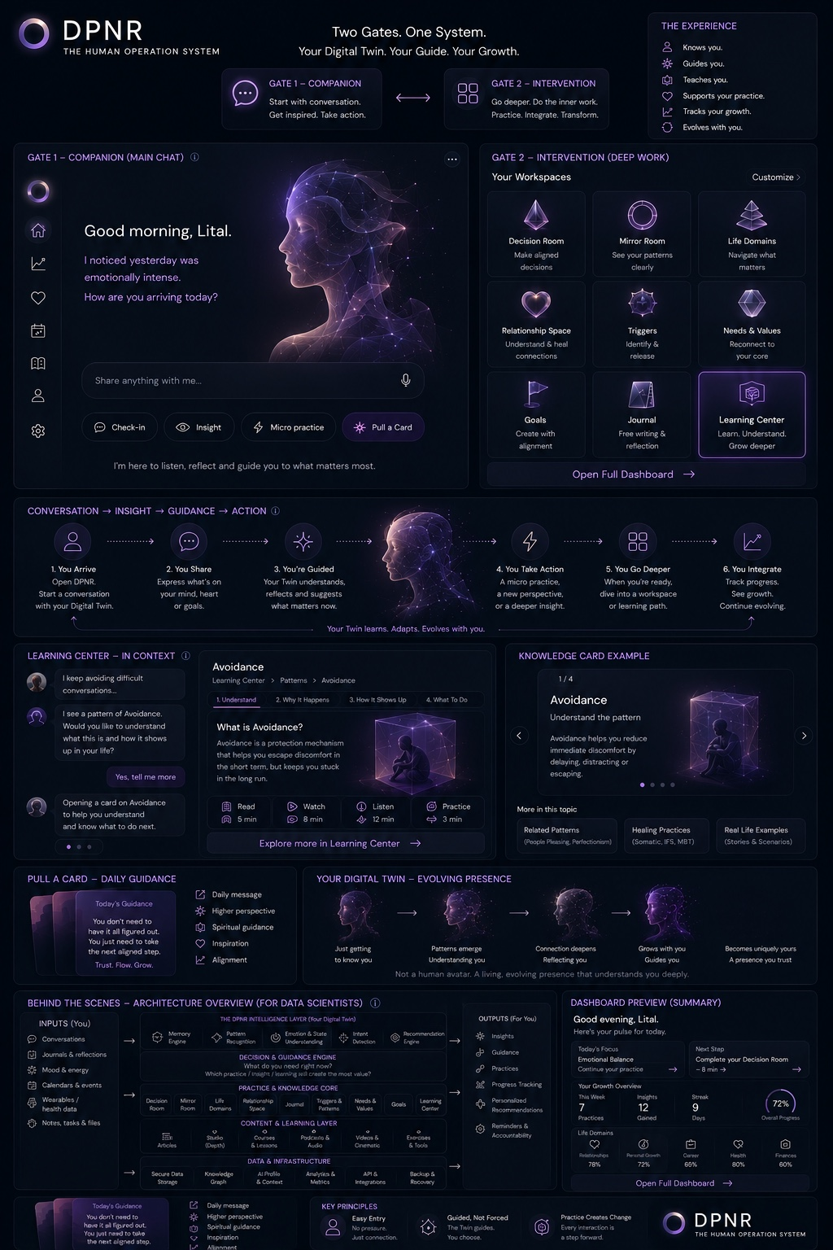

Appendix B — Sergei Digital Personality / Architecture References
Reference role: technical and methodological inspiration only. These materials may inform implementation discussions around a personal graph/data model, encrypted user-owned data, hypothesis formation and verification, structured extraction, knowledge graphs, and an orchestration / “harness” layer around the LLM.
Useful as reference | DPNR MVP interpretation
Personal graph / structured person model | Use structured Digital Twin signals, provenance, confidence, timestamps and confirmation state. Graph storage is optional; the product contract matters more than the database technology.
Hypothesis formation / verification | Use candidate signals and explicit confirmation rules. Do not infer fixed psychological identities or diagnoses.
LLM Harness / orchestration layer | Keep context assembly, prompt registry, tools, validation and memory outside the raw model call. This aligns with the DPNR API/orchestration approach.
Encrypted / portable personal data concept | Maintain privacy-first architecture and user control. Portability is a future capability unless required for the Beta MVP.
Psychological knowledge graph | Treat as a future knowledge architecture option. MVP learning content may be generated through DPNR taxonomy + controlled AI prompts without requiring a full scientific graph database.
Virtual personalities / synthetic training data | Potential R&D / testing approach only; not required for MVP and not a dependency for first-user launch.
Adoption rule: if a concept appears only in Sergei’s reference materials and is not already part of DPNR’s product definition, it must be treated as optional until the DPNR team explicitly decides to adopt it. The MVP should favor the simplest architecture that preserves DPNR’s product behavior, privacy commitments and future extensibility.

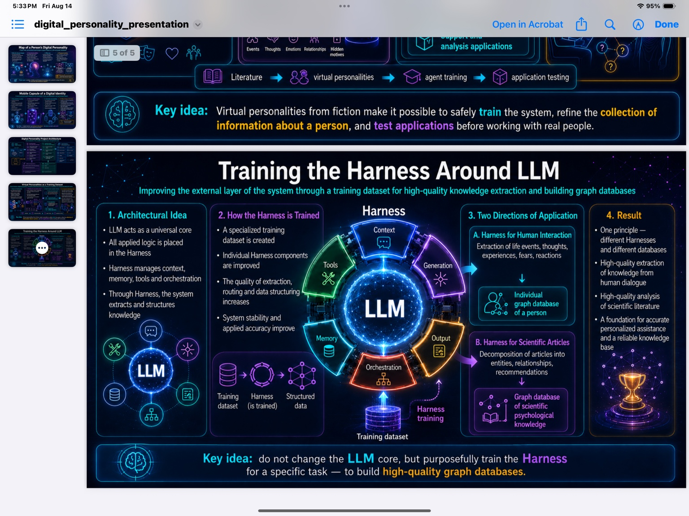
Figure B1. Virtual Personalities as a Training Dataset — R&D / synthetic-testing reference.

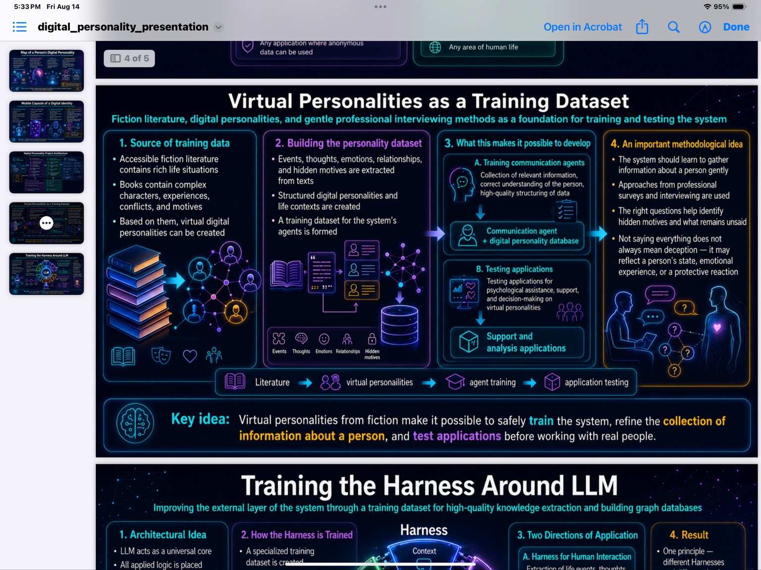
Figure B2. Digital Personality Project Architecture — graph / hypothesis-agent reference.

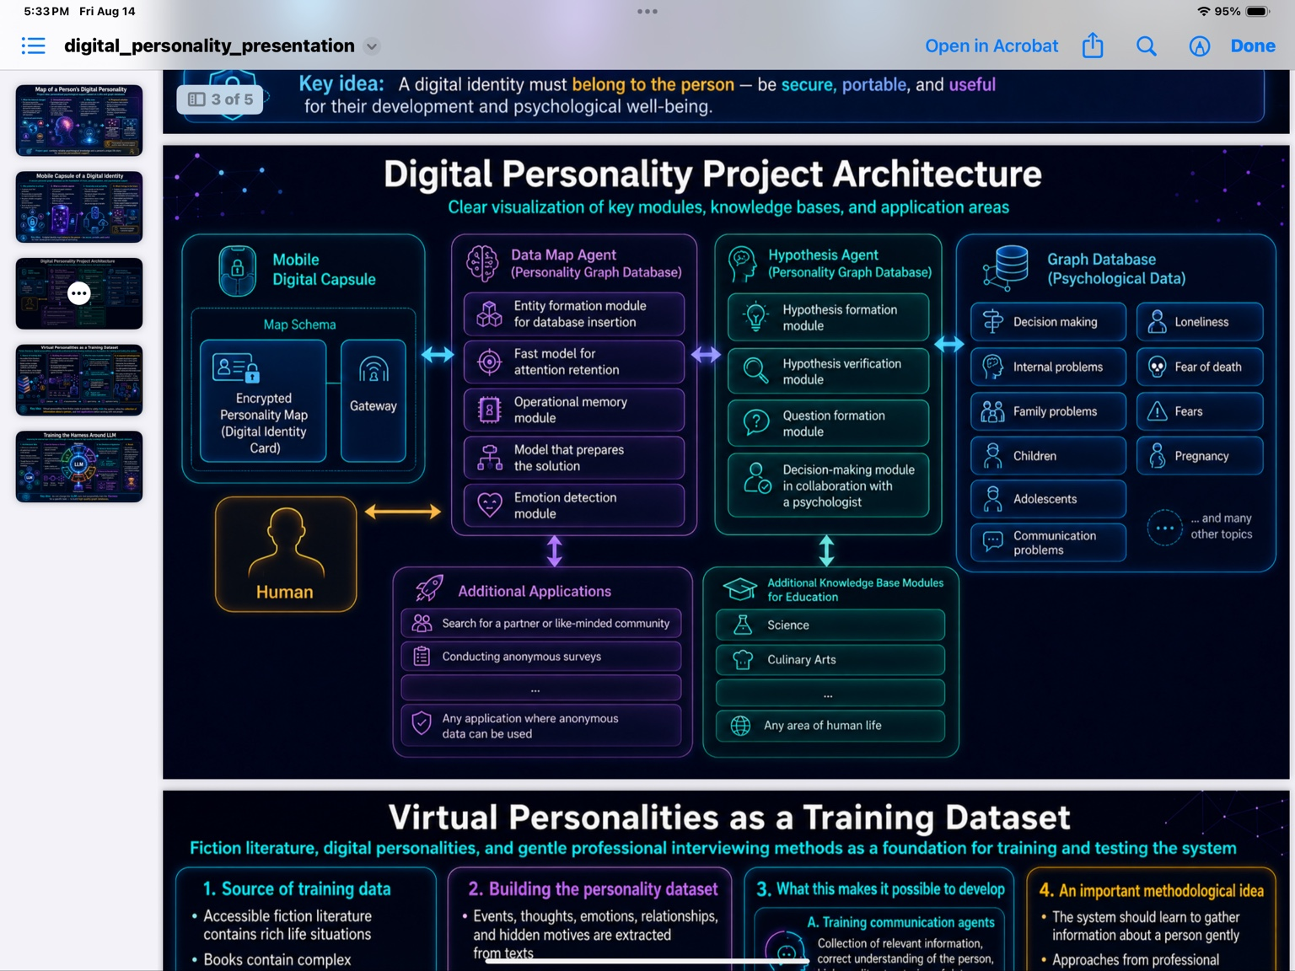
Figure B3. Mobile Capsule of a Digital Identity — privacy, ownership and portability reference.

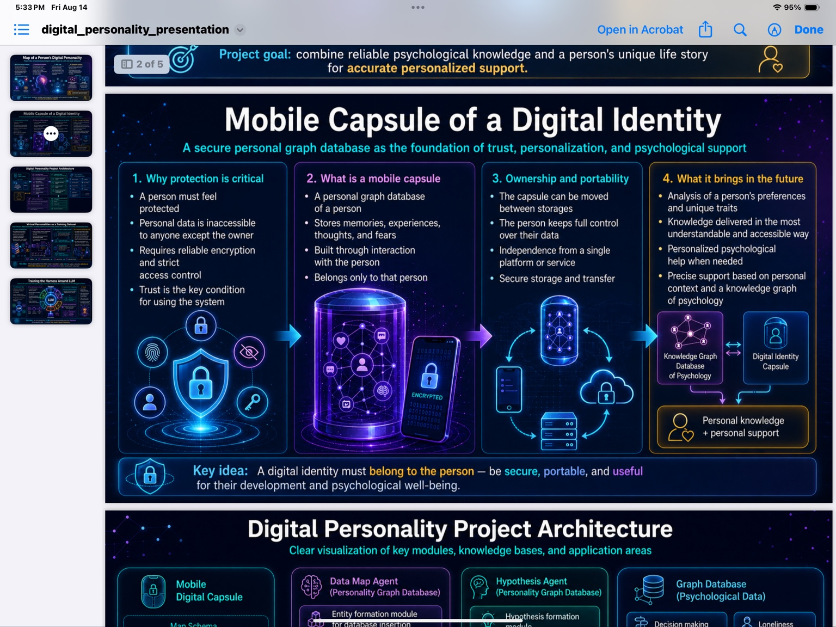
Figure B4. Map of a Person’s Digital Personality — personal + scientific knowledge graph reference.

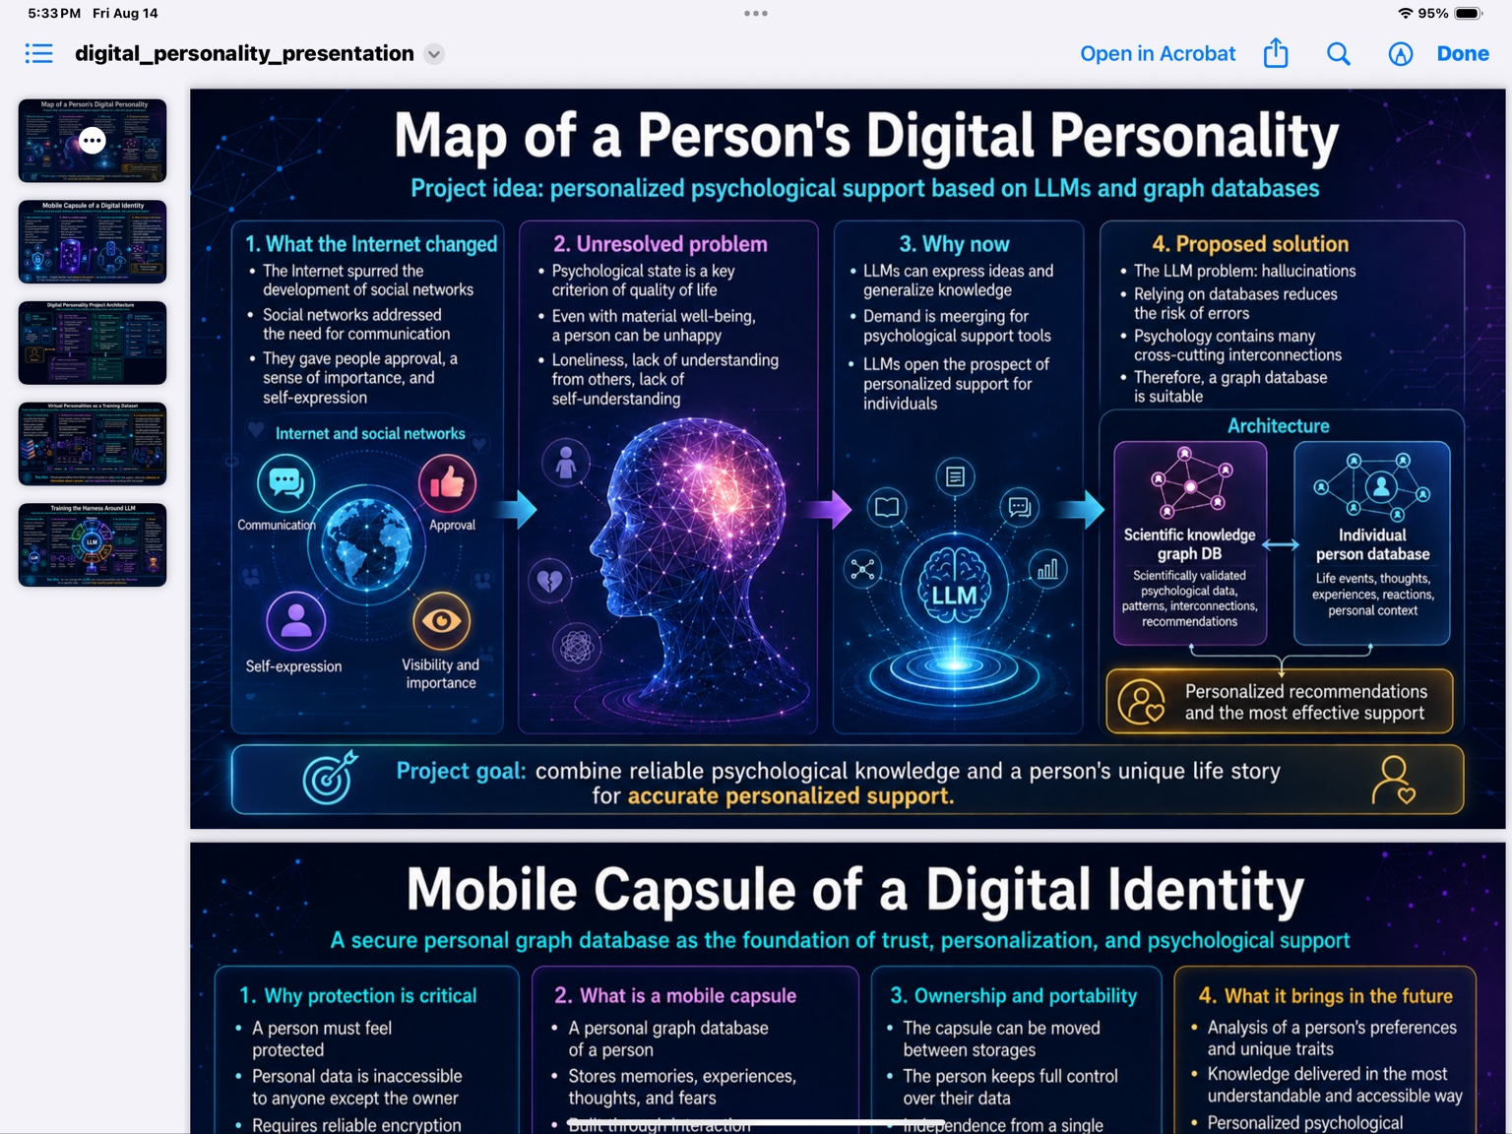
Figure B5. Digital personality / system overview — broader research reference.

Appendix C — Sergei AWS Migration, Security & Cost References
Reference role: implementation and security architecture. These materials document an AWS-oriented path for identity, protected APIs, session-key handling, encrypted data storage, registration, trusted processing and operating-cost assumptions. DPNR may reuse implemented components and proven privacy patterns where they fit the current MVP, while keeping product behavior and user experience independent from any one infrastructure choice.
Source / provenance: DPNR’s saved evidence materials identify the email “AWS Migration for Decision Room” dated 20 July 2026, together with the related architecture workstream and saved email communications. The architecture and cost references in this appendix are attributed to Sergei Merson and should be cross-checked against the archived email chain, attachments and repository materials when implementation details are needed.
Use rule: preserve the strongest relevant privacy properties — user control, encryption of personal content, separation of identity from sensitive content, short-lived / bounded processing access, safe logging and auditable key use. Do not adopt infrastructure complexity solely because it appears in the reference. The MVP team should reuse what is already implemented and valuable, and phase the rest according to product need and launch risk.
Reference area | How to use it in the MVP
Cognito + JWT + API Gateway | Strong candidate for production identity and protected API access if the existing implementation is reusable without blocking product delivery.
Client key material / KEK / DEK | Preserve the design principle that long-lived user secrets are not stored as plaintext on the backend. Final UX for key setup and recovery must be specified carefully.
KMS-wrapped session access | Useful pattern for bounded server-side processing during an authorized session or post-session task; keep access time-limited and auditable.
DynamoDB encrypted records | Valid implementation path for encrypted structured records. Storage technology may evolve, but the encrypted/plaintext data contract should be explicit.
Trusted processing / LLM decrypt flow | Reference for future secure AI processing. Use only when the backend legitimately needs decrypted context; minimize scope, duration and logs.
Cost model | Planning reference only. Recalculate against the actual Beta architecture, region, traffic and current AWS pricing before financial decisions.
Implementation roadmap | Reuse completed foundation where sound. Treat “near term” and “later” items as technical backlog, not as the product roadmap.

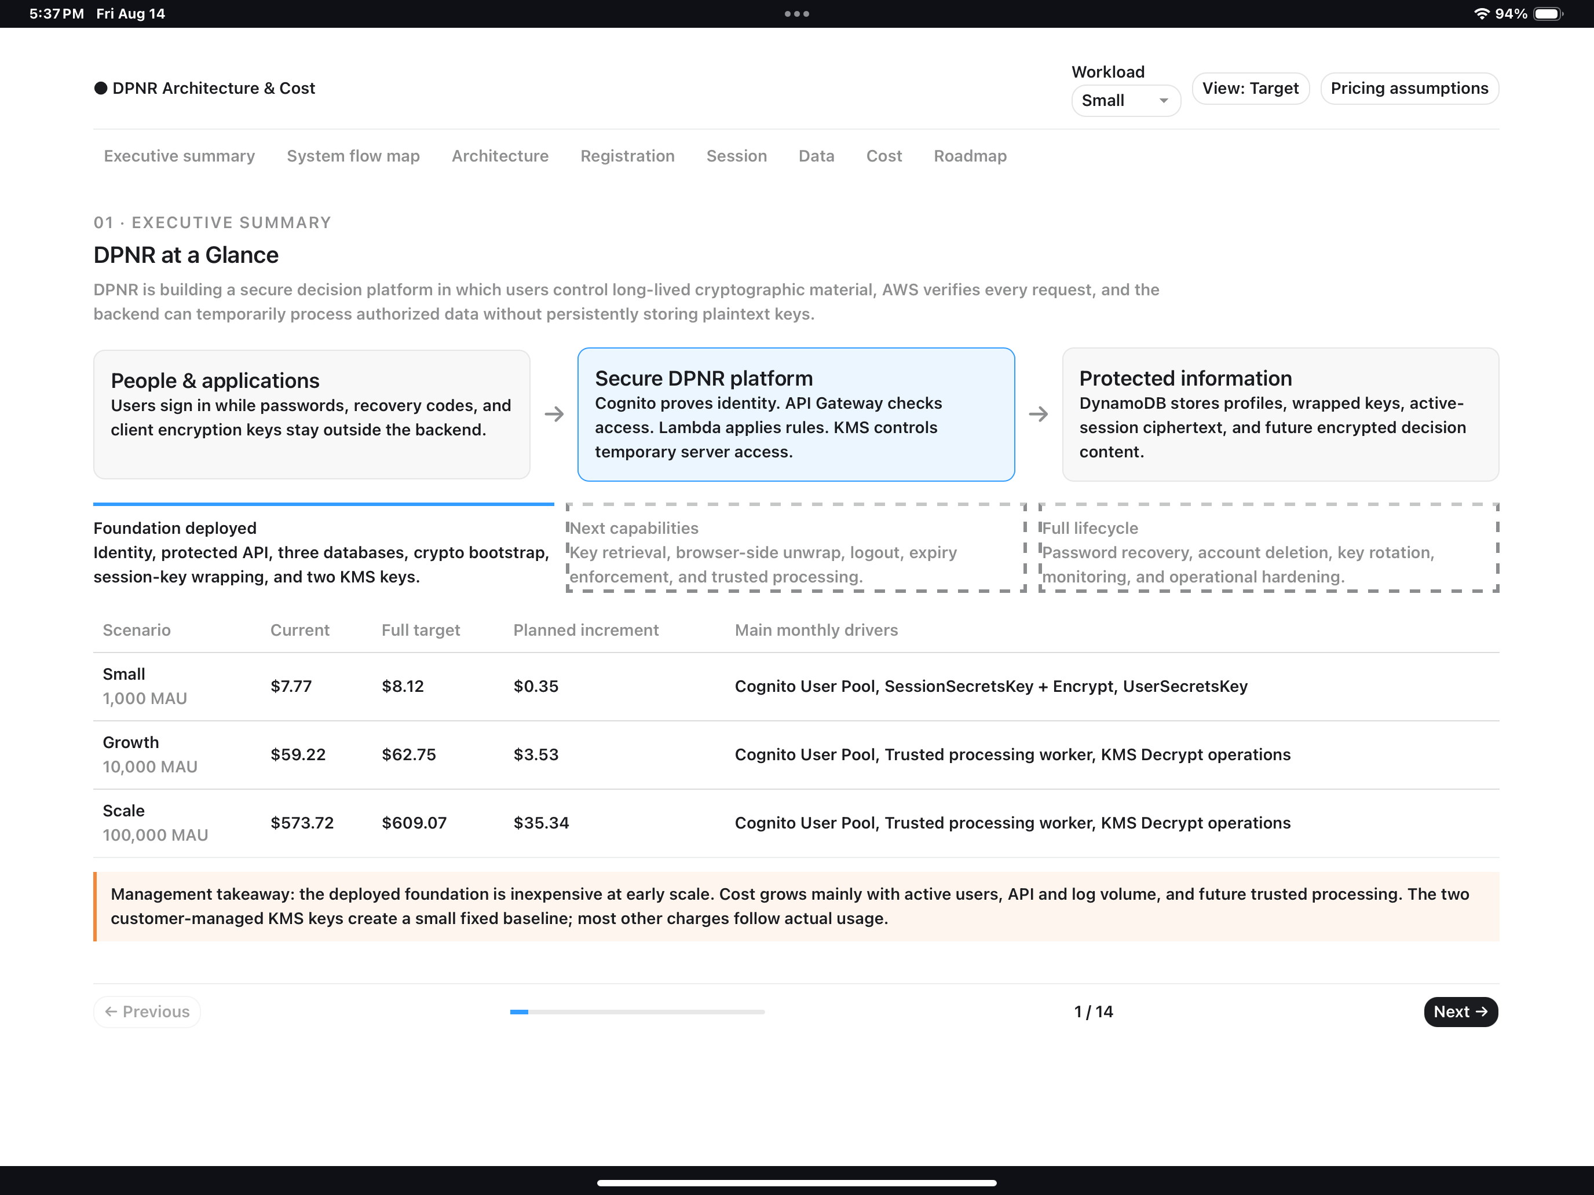
Figure C1. DPNR Architecture & Cost — executive summary / protected platform reference.

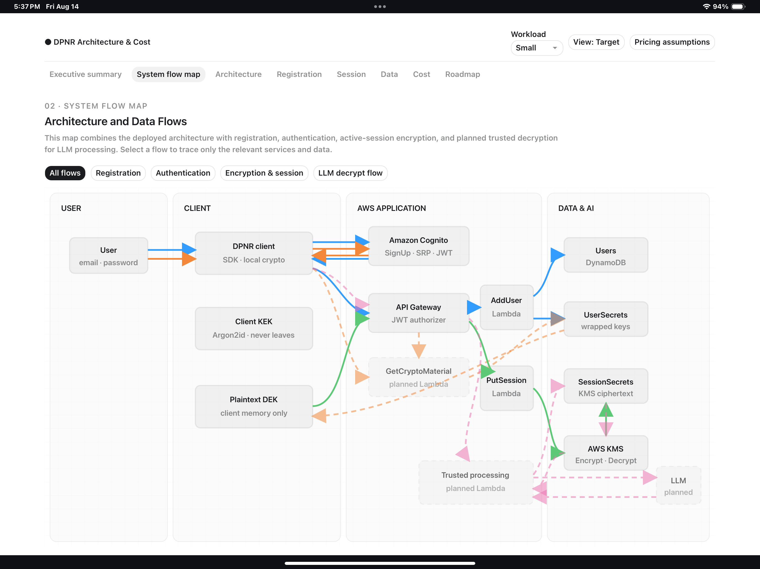
Figure C2. Architecture and Data Flows — registration, authentication, encryption/session and planned LLM processing.

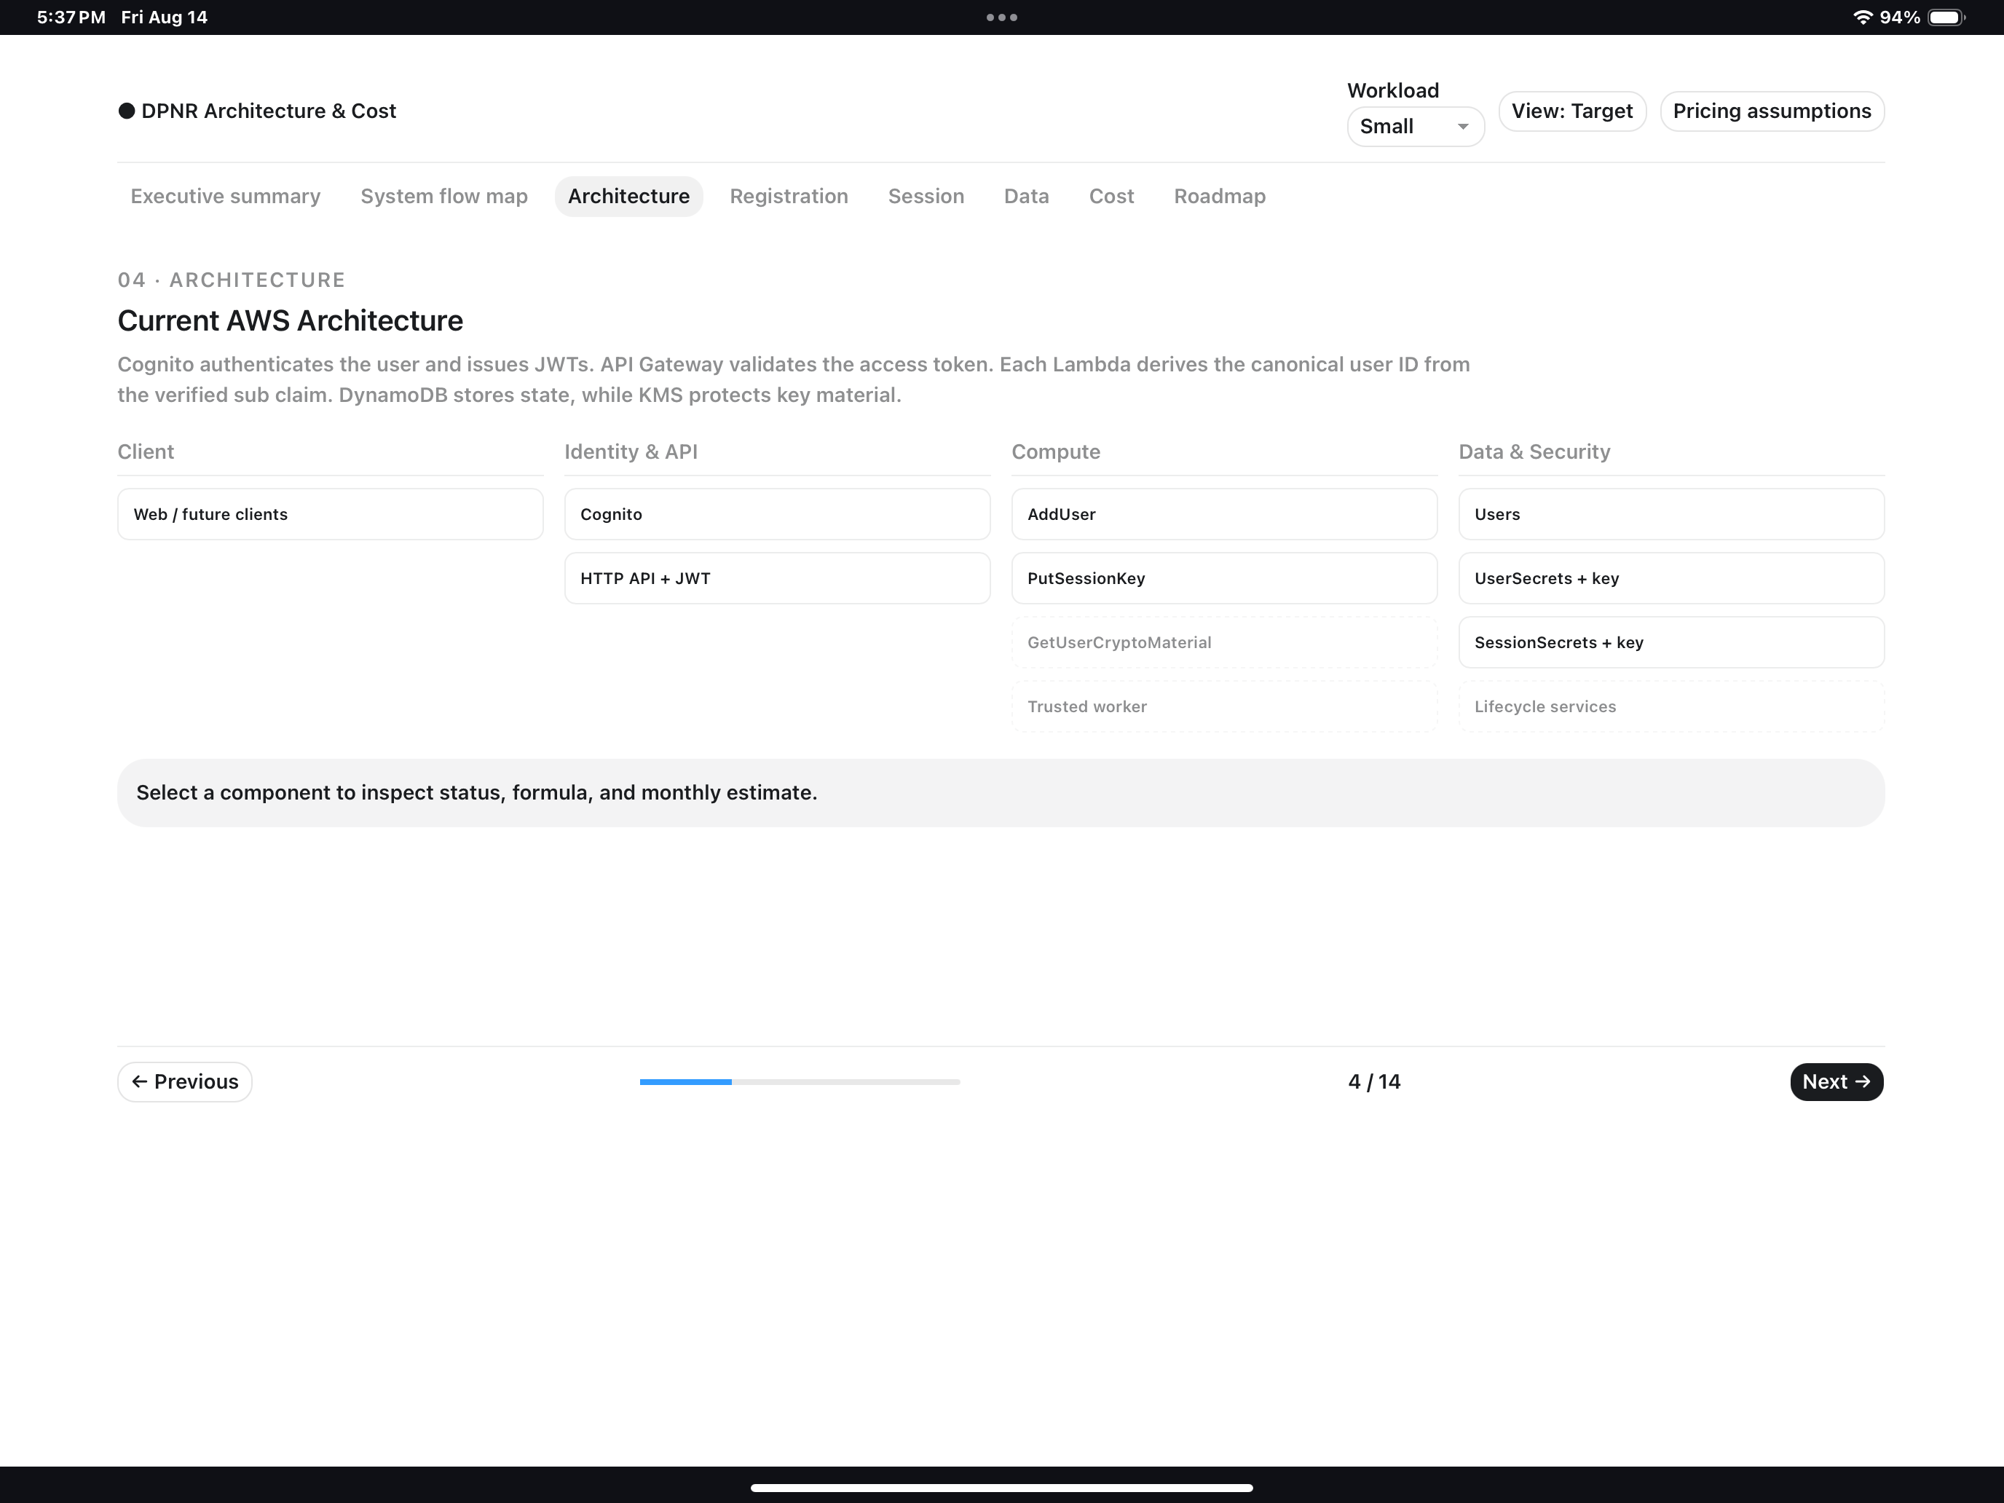
Figure C3. Current AWS Architecture — client, Cognito/API, compute and data/security components.

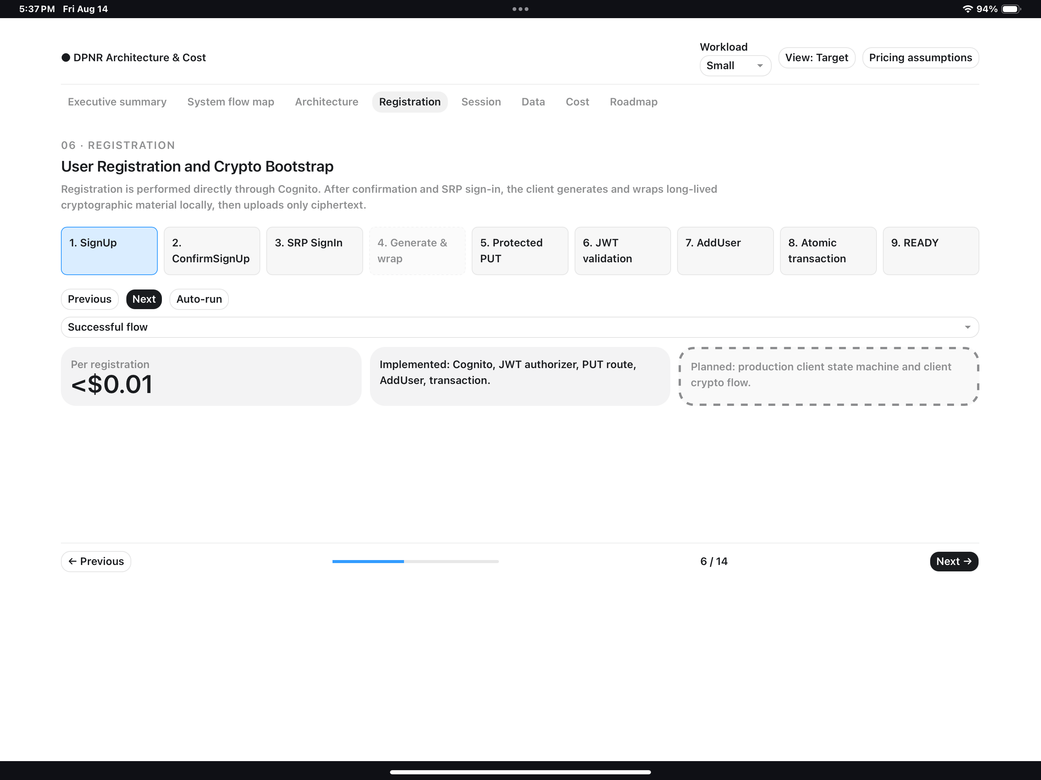
Figure C4. User Registration and Crypto Bootstrap — registration flow reference.

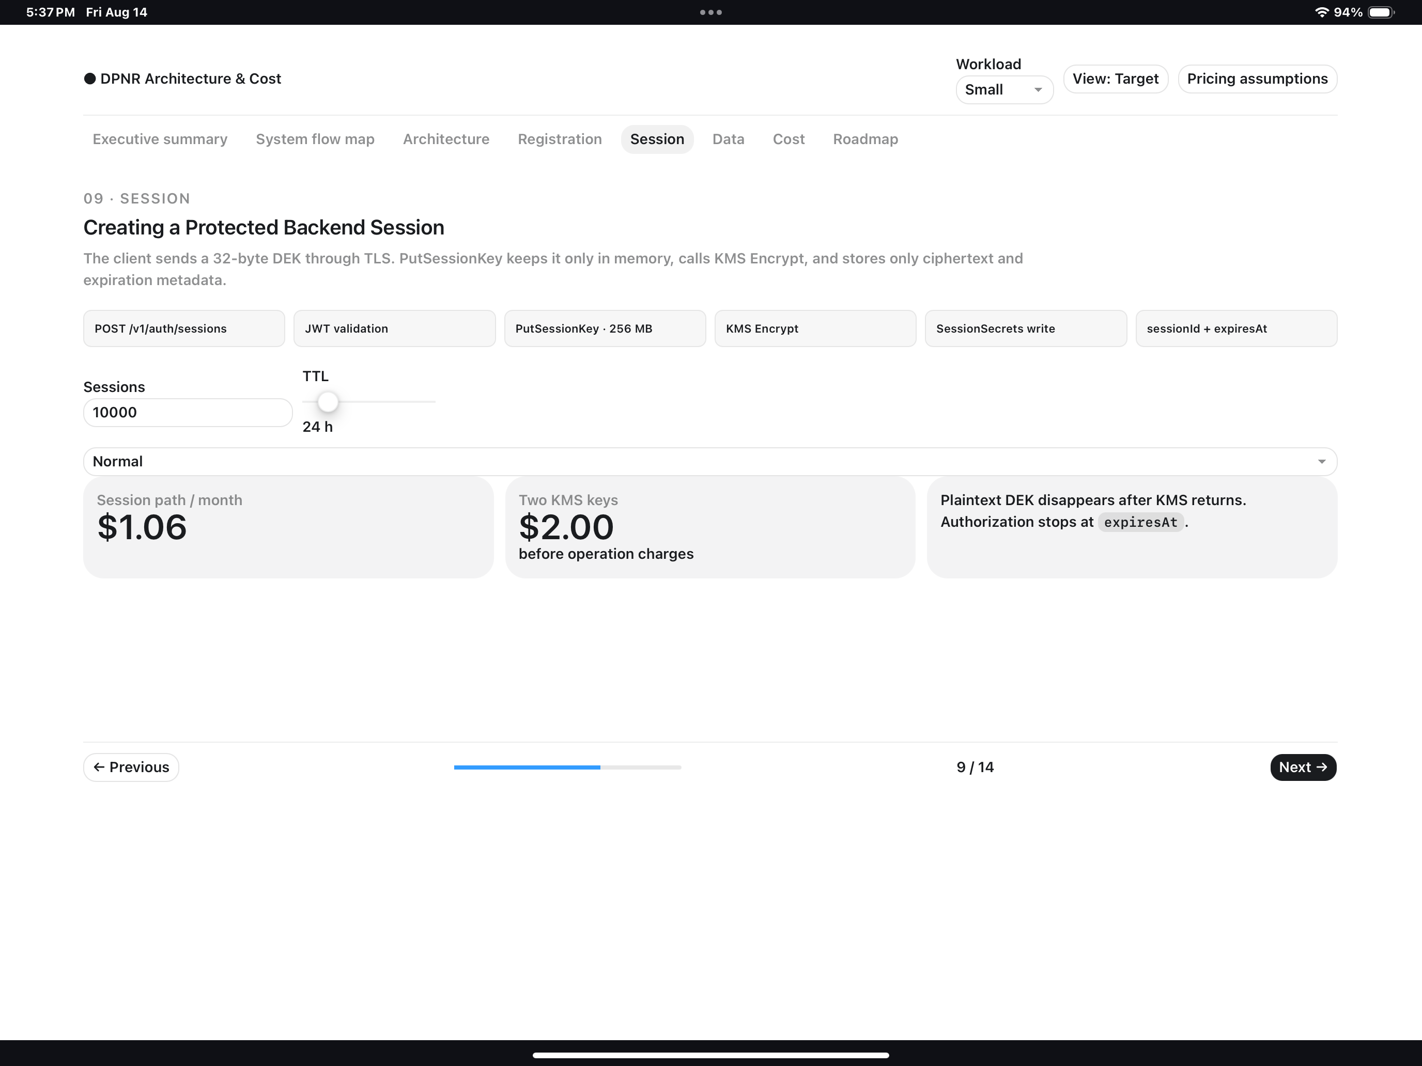
Figure C5. Protected Backend Session — session-key and KMS reference.

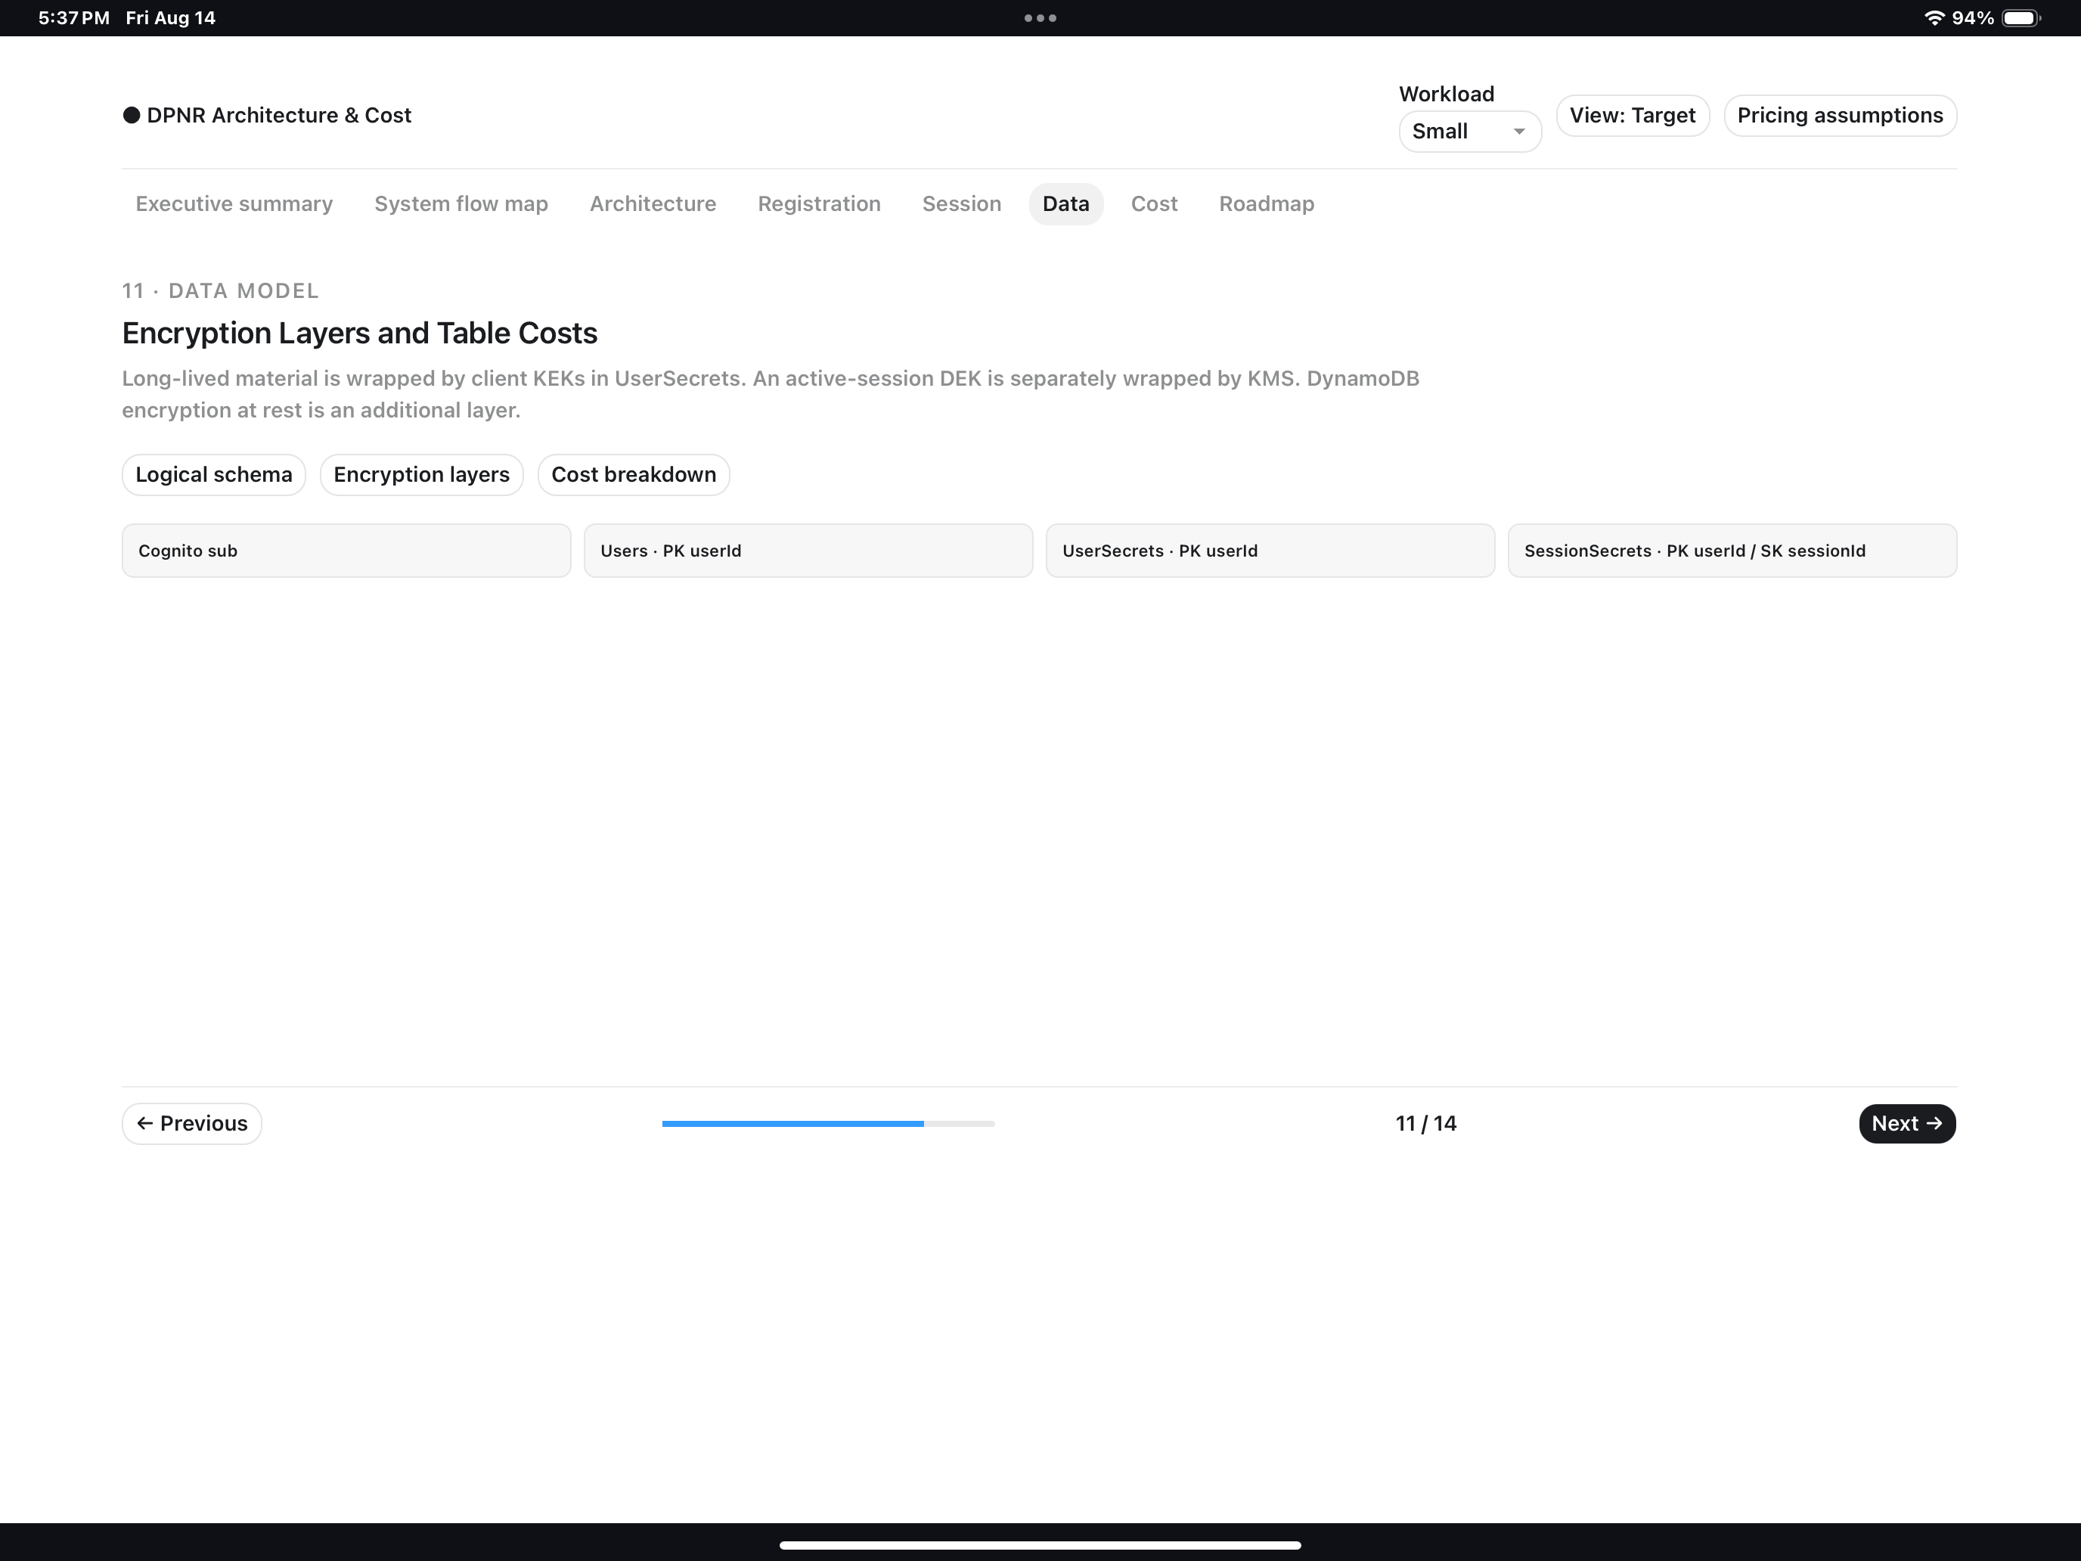
Figure C6. Encryption Layers and Data Model — user, secret and session storage reference.

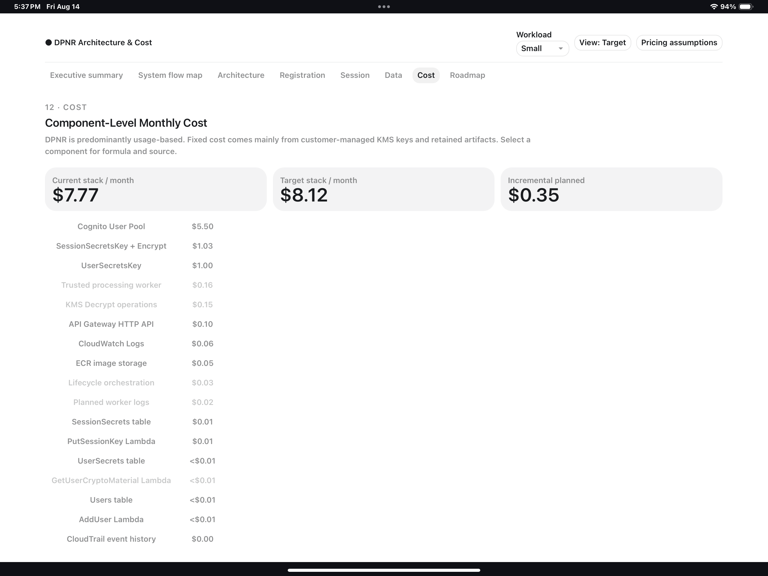
Figure C7. Component-level AWS Cost — planning reference; prices must be revalidated.

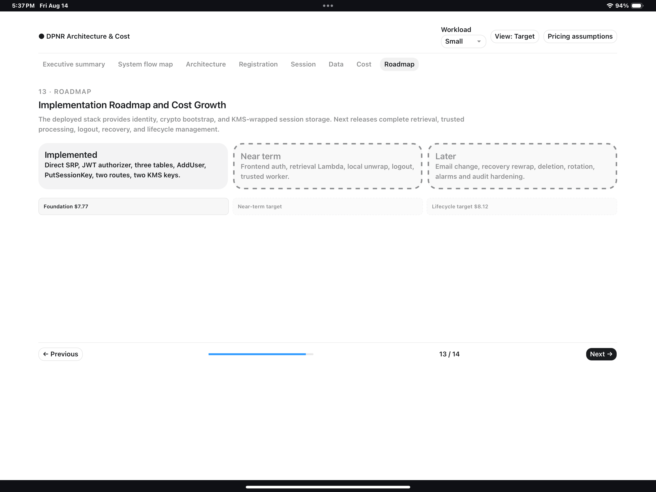
Figure C8. AWS Implementation Roadmap — technical backlog reference, not product roadmap.

