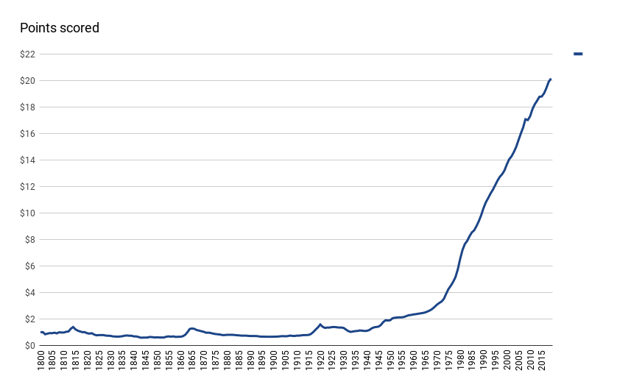

WWII 1939-45

WWI 1914-19

Civil war 1861-65

War of 1812-15

Fiat system born 1971

Out of Gold Standard 1933

Fed 1913