Dokumentacja Jakub Radaszkiewicz
1.
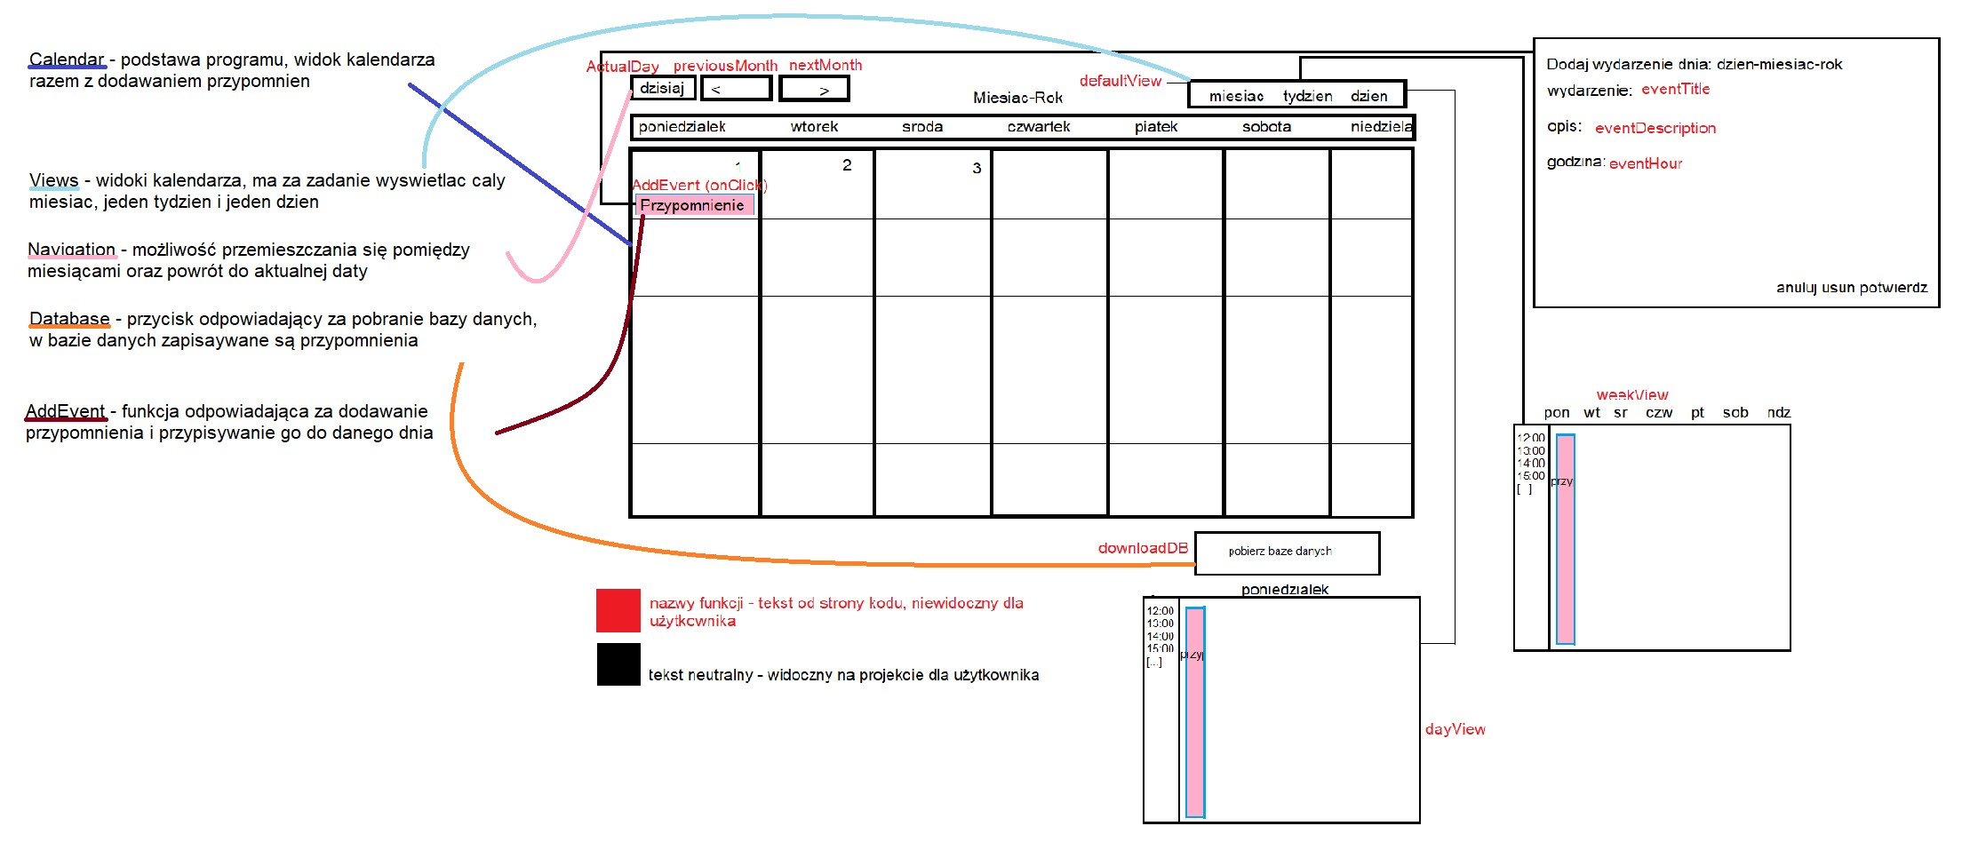
2.
https://github.com/Rada777/Kalendarz-Radaszkiewicz/commit/39f45f2f7c08f40721ab0770bafd8fa1e2a77e7f
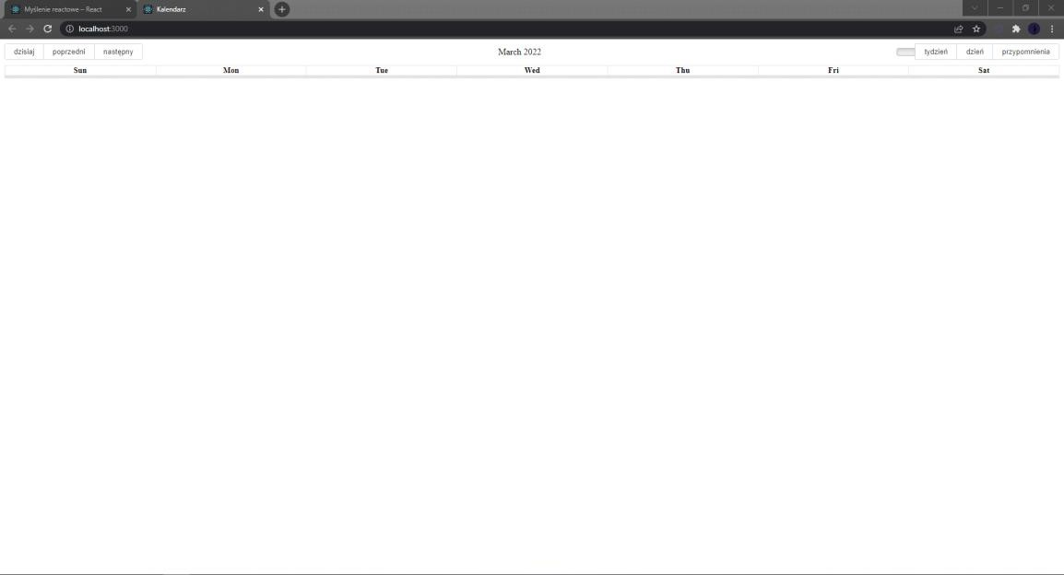
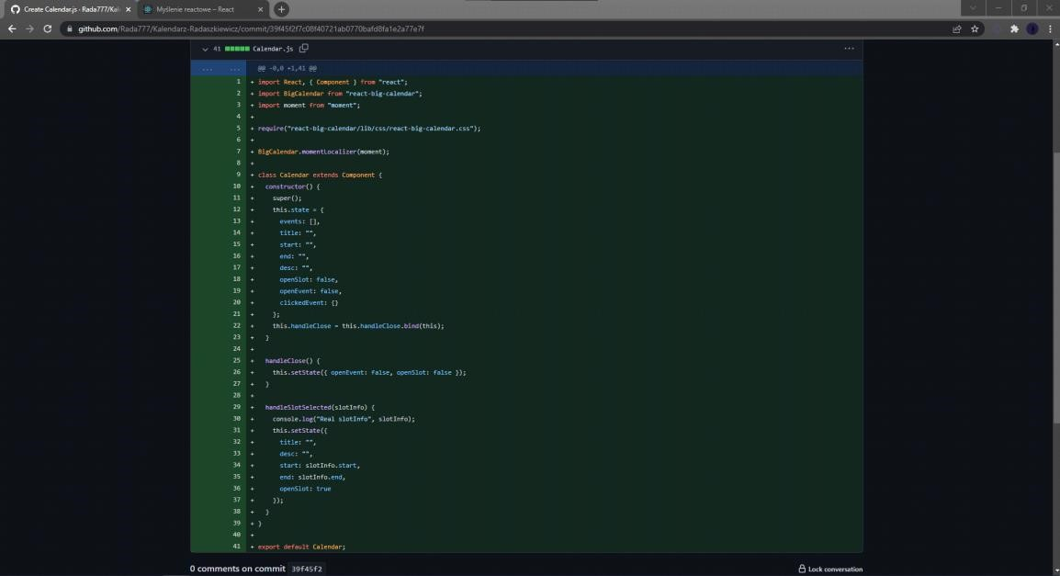
3.
https://github.com/Rada777/Kalendarz-Radaszkiewicz/commit/5923a2ac67cf687954d5b3d5545e635a74d12142
https://github.com/Rada777/Kalendarz-Radaszkiewicz/commit/4fcfa67ea40c9c162be6df45280dae354fe3cae6
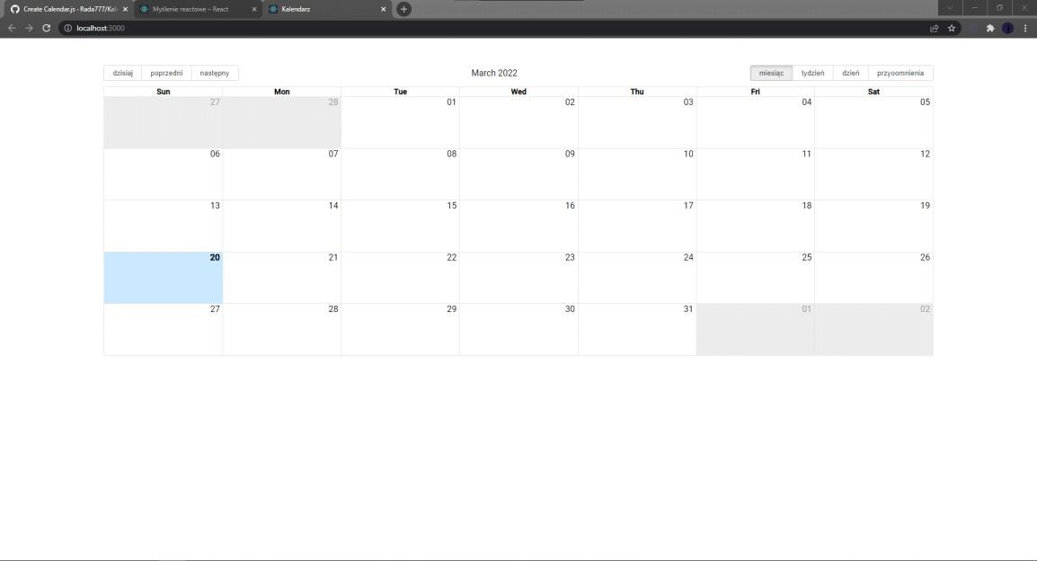
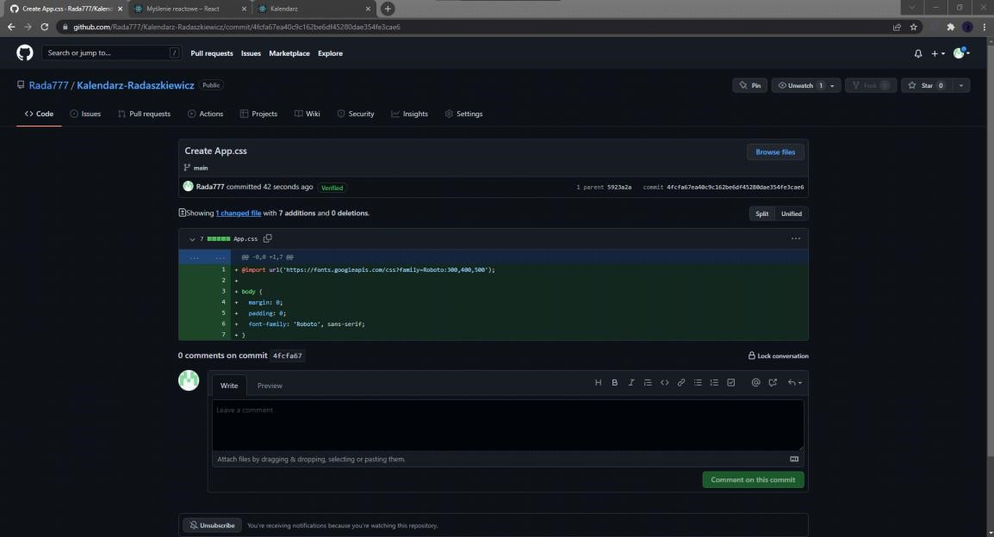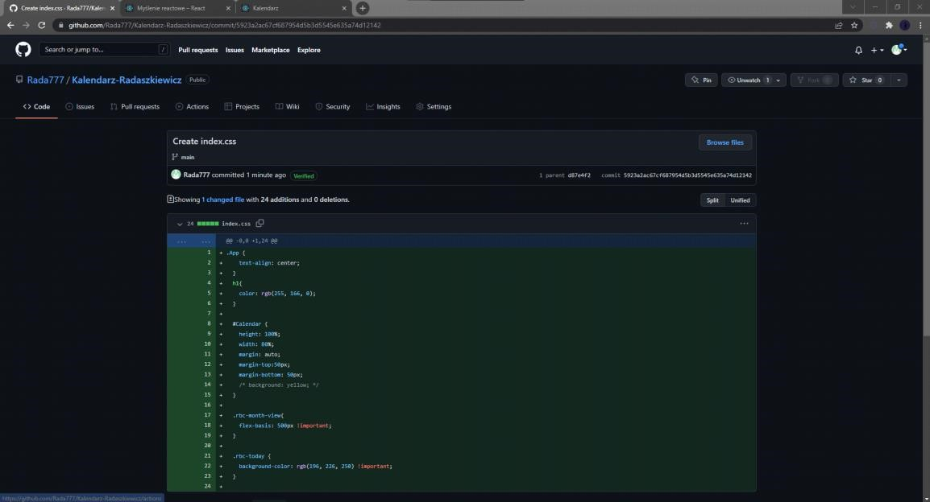
4.
https://github.com/Rada777/Kalendarz-Radaszkiewicz/commit/c57a8d63bf4077eca65e81a341530b4f478fa4f4
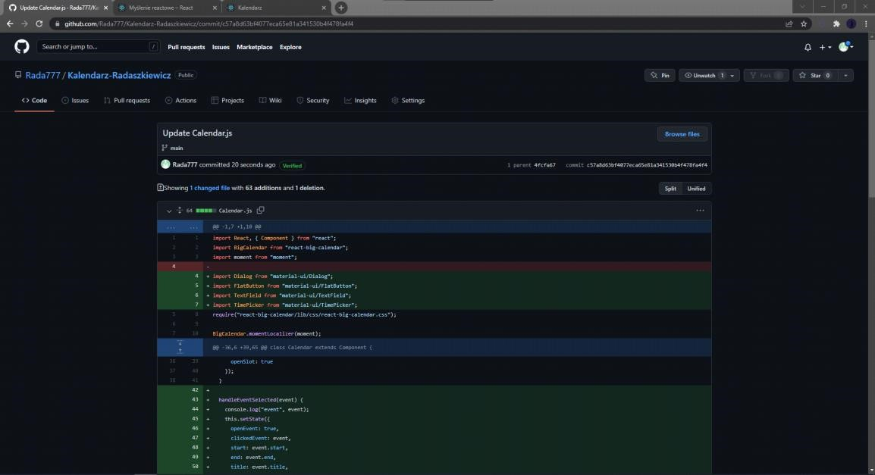
5.
https://github.com/Rada777/Kalendarz-Radaszkiewicz/commit/b2327589973f317960adbe69b41cbe624e4212f0
