Architecture & Justification

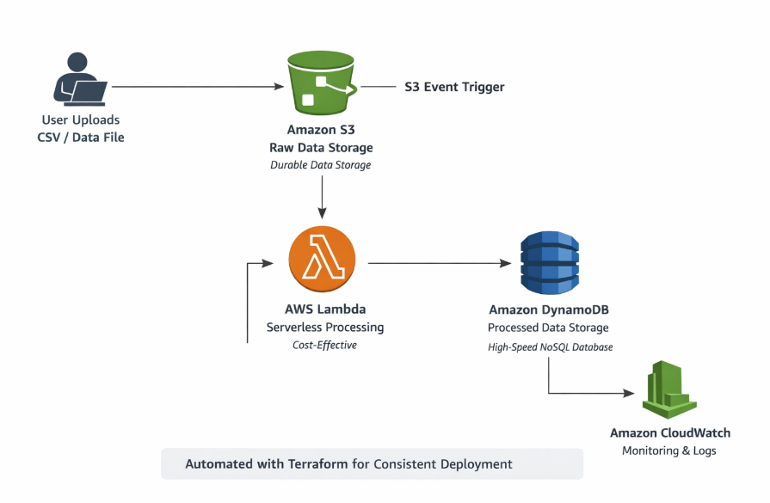

- The above diagram represents a high-level architecture of an event-driven data processing pipeline implemented on AWS.
- The system is designed to automatically process incoming data files and generate structured outputs without manual intervention.

- Architecture Explanation

- In this architecture, users upload CSV or data files to an Amazon S3 bucket, which acts as the raw data storage layer.
- An S3 ObjectCreated event automatically triggers an AWS Lambda function.
- The Lambda function processes the data and stores the processed results in Amazon DynamoDB.
- Amazon CloudWatch is used to capture logs and monitor the execution of the Lambda function.
- The entire infrastructure is automated using Terraform for consistent deployment.

- Justification of Design Choices

- Amazon S3 is used for raw data storage because it provides high durability, scalability, and low cost.
- AWS Lambda is chosen for processing as it is a serverless service, eliminating the need for server management and reducing operational cost.
- Amazon DynamoDB is selected due to its high performance and ability to handle large-scale data with low latency.
- Terraform is used to automate infrastructure creation and ensure consistency across environments.

- Automation, Deployment, and Reporting Flow

- The system is fully automated.
- Whenever a new file is uploaded to the S3 bucket, it automatically triggers the Lambda function.
- The Lambda function processes the data and generates a summary output, which is stored in DynamoDB.
- Infrastructure deployment and updates are managed through Infrastructure as Code using Terraform.

- Fault Tolerance and Scalability

- The architecture is fault-tolerant because AWS Lambda automatically retries execution in case of failure.
- Amazon S3 stores data across multiple availability zones, ensuring high durability.
- The system is highly scalable, as AWS managed services like S3, Lambda, and DynamoDB automatically scale based on workload.

