Beyond the Price Tag: An Explainable AI Decision-Support System for Identifying Undervalued Talent and Optimizing Football Transfer Budgets

Project Submitted to the
Indian Institute of Management Ranchi

Masters of Business Administration
in
Marketing

submitted by
Gudladona Venkata Rahul, M13A-25

Under the Guidance of
Prof. Yelleti Vivek

Area of Information Systems and Business Analytics
Indian Institute of Management Ranchi,
Ranchi, Jharkhand - 835 303

September 2026
DECLARATION
I undersigned hereby declare that the project report entitled "Beyond the Price Tag: An Explainable AI Decision-Support System for Identifying Undervalued Talent and Optimizing Football Transfer Budgets" submitted as part of the requirements for the Sports Analytics subject at IIM Ranchi, is a bonafide work carried out by me under the supervision of Dr. Vivek Yelleti.
In the preparation of this report, I have responsibly leveraged Artificial Intelligence tools and techniques to support analysis, modeling, and drafting. The use of AI was restricted to augmenting my own effort, and the intellectual contributions, interpretations, and conclusions presented herein are my own. Where ideas, words, or outputs generated by AI or other sources have been included, I have adequately and accurately cited and referenced the original sources.
I further declare that I have adhered to the ethics of academic honesty and integrity, and have not misrepresented or fabricated any data, idea, fact, or source in my submission. I understand that any violation of the above will be a cause for disciplinary action by the Institute, and may also evoke penal action from the sources which have not been properly cited or from whom proper permission has not been obtained.
This report has not previously formed the basis for the completion of any other subject or project in any other institution.

Place : Ranchi Date : 5th September 2026
Name of student : Gudladona Venkata Rahul Signature : Rahul


Area of Information Systems and Business Analytics
Indian Institute of Management Ranchi,
Ranchi, Jharkhand - 835 303

CERTIFICATE
This is to certify that the report entitled "Beyond the Price Tag: An Explainable AI Decision-Support System for Identifying Undervalued Talent and Optimizing Football Transfer Budgets" submitted by Gudladona Venkata Rahul for the Sports Analytics Subject to the Indian Institute of Management Ranchi is a bonafide record of the project work carried out under my/our guidance and supervision. This report in any form has not been submitted to any other University or Institute for any purpose.

Subject Guide
Name: Dr. Vivek Yelleti
Signature: .......................

ABSTRACT
Football clubs commit substantial and largely irreversible capital to the transfer market under conditions of imperfect information. This project asked whether observable performance data could support a defensible valuation framework, and whether the gap between a fundamentals-based valuation and the market's own price could identify recruitment opportunities a club could act on. That question was treated as a hypothesis to be tested rather than a premise to be assumed.
Using 15,925 player-seasons across five major European leagues from 2015/16 to 2024/25, a valuation model combining performance, age, position, league and career trajectory achieved an R-squared of 0.678 on a held-out season in a season-normalised framework, against 0.383 for a context-only benchmark. Observable football carries substantial valuation signal. However, the study did not find sufficient out-of-sample evidence to support the hypothesis that the resulting valuation residual represents systematically exploitable market mispricing: two pre-specified signal definitions were tested under strict time-based discipline and neither produced a significant subsequent appreciation advantage.
The same residual instead proved strongly associated with subsequent exit from top-five football. Flagged players left at 3.7 times the benchmark rate, and a dedicated exit-risk model achieved an out-of-sample AUC of 0.732 with strong calibration. The system was accordingly redesigned around this evidence: a risk-aware constrained optimizer allocates a transfer budget on position-appropriate quality, development potential and value efficiency, penalised by validated exit risk and model uncertainty. Explainability separates why the model produced a valuation from why the optimizer selected a player, and a guarded generative-AI layer converts validated outputs into committee briefs subject to automated fidelity checks.
The contribution is the evidence-driven transition from player valuation to risk-aware recruitment decision support. The residual proved to be a warning signal rather than an arbitrage signal: a model's disagreement with the market is shown to be a question warranting investigation rather than an opportunity to exploit, and the resulting system is positioned as a screening and investigation tool rather than an autonomous decision-maker.

Keywords: player valuation, transfer market, explainable AI, SHAP, constrained optimisation, decision support, market efficiency, sports analytics

CONTENTS
1. Introduction 8
1.1 Transfer spending as a capital-allocation decision 8
1.2 Why conventional valuation is difficult 8
1.3 What observable performance data can offer 8
1.4 Why explainability is a requirement, not a feature 9
1.5 The research question 9
2. Problem Statement 10
3. Motivation 11
4. Novelty of the Project 12
5. Dataset Description & Details 14
Construction and scope 14
Data-quality accounting 14
The transfer-fee limitation 15
6. Design and Methodology 16
6.1 Decision context and information set 16
6.2 Target definition and market-level normalisation 16
Target timing 16
Market-level normalisation 16
6.3 Feature engineering 17
Missing trajectory history 18
6.4 Valuation models 18
6.5 Time-based validation 18
6.6 Mispricing hypothesis and back-test 19
Sequencing discipline 19
Outcome definitions, fixed in advance 19
6.7 Exit-risk model 19
6.8 Risk-aware portfolio optimisation 20
Withdrawal of the original objective 20
Objective function 20
Constraints 20
Leakage correction 21
Guards against arbitrary scoring 21
6.9 Explainable AI 21
6.9.1 Purpose and scope 21
6.9.2 Method 22
6.9.3 Two kinds of explanation, deliberately separated 22
6.9.4 Reading league contributions under baseline encoding 22
6.9.5 Residual-bias audit 23
6.9.6 What the explainability layer must not be used to claim 23
6.10 Generative-AI recruitment briefs 23
6.10.1 Role of the generative layer 23
6.10.2 Input contract 24
6.10.3 Output specification and prohibitions 24
6.10.4 The fidelity validator 24
6.10.5 Execution environment 25
6.10.6 Three-arm evaluation design 25
6.11 Ethical, data and modelling safeguards 26
7. Results and Discussion 27
7.1 Result 1: Football market valuation is highly structured 27
7.2 Result 2: Observable fundamentals explain a substantial share of valuation 27
Error is not uniformly distributed 28
7.3 Result 3: Prior market beliefs explain considerably more 28
7.4 Result 4: The mispricing hypothesis fails out of sample 29
Why the raw signal failed 29
7.5 Result 5: The residual instead carries recruitment-risk information 29
An exploratory conditional observation 30
7.6 Result 6: Exit risk is itself predictable 30
7.7 Result 7: Risk-aware allocation changes the recommendation 31
Comparison against naive strategies 31
What this comparison does and does not establish 32
Sensitivity 32
7.8 Synthesis 32
7.8.1 What drives model-implied valuation 32
7.8.2 Player-level explanation for the recommended portfolio 34
Lucas Stassin: Attack, Ligue 1, age 20.1 34
Diego Coppola: Defender, Serie A, age 21.0 34
Facundo Buonanotte: Midfield, Premier League, age 20.0 35
7.8.3 Systematic residual heterogeneity 35
7.8.4 Robustness: does the gradient replicate? 36
7.8.5 Why this connects directly to the failure of the mispricing hypothesis 37
7.9.1 Headline result 38
7.9.2 The generation failure 38
7.9.3 Cross-model arm 39
7.9.4 Content fidelity: which framework did the briefs communicate? 39
7.9.5 What these results do not establish 40
7.9.6 Managerial implication 40
8. Analysis 42
8.1 From valuation to decision support 42
8.2 Why the original "bargain" logic fails 42
8.3 The recruitment decision framework 43
8.4 Implications for recruitment teams 43
8.5 Implications for finance and sporting directors 44
8.6 Explainability and governance 45
8.7 Model risk and systematic residual heterogeneity 45
8.8 Sensitivity and robustness 46
8.9 A practical operating model 47
9. Conclusion 48
9.1 What this project set out to ask 48
9.2 What the study found 48
9.3 What was built as a result 49
9.4 What a club should do differently 49
9.5 Contribution 50
10. Limitations and Future Work 51
Limitations 51
Future work 51

1. Introduction

1.1 Transfer spending as a capital-allocation decision
A football club's transfer budget is finite, committed under time pressure, and largely irreversible once spent. A signing that does not work out cannot be unwound at cost: the fee is sunk, the wage commitment persists for years, and the squad slot the player occupies is unavailable to anyone else. In this respect recruitment resembles capital budgeting more closely than it resembles shopping: a set of interdependent, constrained, long-horizon commitments made with incomplete information about their eventual return.
Clubs nonetheless approach the decision one player at a time. A target is identified, negotiated for, and signed; attention then moves to the next. The budget functions as a running balance rather than a portfolio to be allocated, and the question "is this player worth the fee?" is asked far more often than "is this combination of players the best use of what we have?"

1.2 Why conventional valuation is difficult
The natural response is to establish what a player is worth and compare it to the asking price. This turns out to be harder than it sounds, for three reasons.
First, there is no observable price for most players. A transfer fee exists only when a transfer occurs, and most players in any season do not move. In the dataset underlying this study, only a tenth of transfer records carry a positive fee at all. The remainder are free transfers, loans and youth movements. Any valuation framework covering a full player population must therefore work against an estimated valuation rather than a transacted price, and that estimate is itself a construct, not a fact.
Second, valuation is heavily confounded by context. The same performance commands materially different valuations depending on the player's age, position and competition. A striker's goal contribution and a goalkeeper's are not comparable quantities, and a season in one league is not priced like the same season in another.
Third, and most importantly, much of what determines a player's price is not publicly observable. Contract length, injury history, tactical role, relationship with the coaching staff, agent situation and willingness to move are all material to a valuation and none appears in public match data. Any model built on performance statistics is working with a partial view, and the gap between what it can see and what the market can see is precisely where its errors will live.

1.3 What observable performance data can offer
Public data has nonetheless improved substantially. Match-level records for Europe's major leagues now provide minutes, appearances, goals, assists and disciplinary records for tens of thousands of player-seasons, linked to valuation histories that extend over a decade. This supports a specific and useful question: how much of a player's market valuation is explained by what is publicly observable about their football?
That question is answerable, and its answer is informative in both directions. A high proportion suggests valuation is broadly grounded in performance. A large unexplained remainder is more ambiguous; it might indicate that the market is mispricing players, or that the model is missing information the market possesses. Distinguishing between those two interpretations is not a technical detail. It is the entire question on which a recruitment decision turns.

1.4 Why explainability is a requirement, not a feature
A recruitment committee cannot act on a number it cannot interrogate. If a system asserts that a player is worth substantially more than his price, the immediate and correct response is why does it think so, and how confident should we be?
This makes explainability a functional requirement of the system rather than a presentational addition. It also imposes a second obligation that is easier to overlook: a decision-support tool must be able to communicate what it does not know. A model that explains its reasoning persuasively while remaining silent about its blind spots is more dangerous than one that offers no explanation at all, because the explanation lends unearned confidence to an estimate built on partial information.

1.5 The research question
This project therefore treats market inefficiency as something to be tested rather than assumed. It does not begin from the position that clubs systematically misprice players and that a model can exploit this. It begins from a narrower and more answerable question:
Can observable football fundamentals support a useful valuation and recruitment-decision framework, without assuming that every unexplained valuation gap represents a market inefficiency?
The distinction matters because the two most plausible explanations for a model-market disagreement have opposite managerial implications. If the market is wrong, the discrepancy is an opportunity. If the model is missing something, the same discrepancy is a warning. A system that cannot tell these apart, or that assumes the first by default, will systematically recommend the players a club should most carefully avoid.
Whether the framework built here can distinguish between them, and what happens when that capability is subjected to out-of-sample testing, is the subject of the remainder of this report.

2. Problem Statement
A club must allocate finite transfer capital across players who differ in position, age, performance level, valuation uncertainty and the risk that they will not deliver the playing time expected of them, while satisfying specific positional requirements and working from information that is materially incomplete.
The decision has four properties that shape any system intended to support it:
It is constrained, not open-ended. A budget cannot be exceeded, positional gaps must actually be filled, and a portfolio of five wingers does not solve a defensive problem regardless of how favourably each is priced.
It is made under partial observability. The information available publicly is a strict subset of the information available to the market. Contract, medical, tactical and personal circumstances are absent.
It is heterogeneous across the player population. Performance means different things in different positions, valuations scale differently across leagues, and the reliability of any estimate varies systematically by segment.
It is irreversible and long-horizon. Consequences persist for years, which makes the cost of a confidently wrong recommendation considerably higher than the cost of a cautious one.
A useful system must therefore do more than rank players by apparent value. It must indicate how confident it is, what it cannot see, and how a given candidate fits alongside the others a club might sign.

3. Motivation
The project's founding hypothesis was straightforward and widely held: that a valuation model built from observable performance, age, position and career trajectory could identify players whose market valuations appear disconnected from their fundamentals, and that such players would represent recruitment opportunities.
The hypothesis is plausible. If performance drives value, then players whose performance exceeds what their valuation implies are, on the face of it, underpriced.
This project treats that proposition as a hypothesis to be tested rather than a premise to be built upon. That decision determined the structure of the entire study. The mispricing claim was formalised as a falsifiable statement, a testing procedure was specified in writing before any outcome was examined, thresholds were fixed on validation data and applied once to a held-out season, and the result, whatever it turned out to be, was accepted rather than iterated upon.
The motivation for this discipline is practical rather than academic. A recruitment system that recommends players on the basis of an untested assumption does not only fail to add value; it directs scarce scouting resources and irreversible capital toward whichever players the model happens to misjudge most severely. The cost of an unvalidated recruitment signal is borne in real transfers.

4. Novelty of the Project
The novelty of this project does not lie in applying machine learning to football valuation, which is well-established, nor in any individual algorithm used. Gradient boosting, logistic regression, integer programming and SHAP are all standard tools.
The contribution is the integrated decision framework and the managerial logic that governs it, specifically, a framework whose design was determined by empirical evidence rather than by initial intent. Seven elements constitute that contribution:
1. A fundamental valuation model with strict time-consistency. Market value is modelled from performance, age, position, league and performance trajectory. Career trajectory is deliberately defined through performance history rather than valuation history, so that the model explains value from football rather than reproducing the market's own persistence.
2. A formally tested, and unsupported, market-mispricing hypothesis. The central claim was subjected to a pre-registered out-of-sample test with the selection rule fixed in advance. Two specifications were tested and the investigation stopped, rather than continuing until a specification reached significance. The negative result is a finding of the study, not a failure of it.
3. Discovery of a strong exit-risk relationship within the residual. The diagnostic that invalidated the mispricing interpretation revealed a substantially stronger relationship running the opposite way: unexplained valuation gaps predict subsequent departure from top-flight football rather than appreciation.
4. An independently validated exit-risk model. That relationship was converted from a back-test observation into a calibrated predictive component, validated under the same time-based discipline as the valuation model.
5. A risk-aware constrained transfer-budget optimizer. The original objective, maximise the valuation gap, was withdrawn on evidence and replaced with a formulation combining position-appropriate quality, development potential and value efficiency against validated exit risk and model uncertainty, under budget, positional, quality, age and confidence constraints. Weights and constraints were declared in a written specification before execution.
6. Explainability separating prediction explanations from selection explanations. Two distinct questions receive two distinct answers: SHAP accounts for why the model produced a given valuation, while the optimizer separately accounts for why a player was selected. Conflating them would allow a persuasive valuation explanation to substitute for a selection rationale.
7. A guarded generative-AI layer for committee communication. The language model receives only validated structured outputs and performs no analysis. Every brief is machine-audited for numerical fidelity, unsupported claims, speculative causal inference, decision consistency and uncertainty disclosure, with the auditor itself verified against deliberately planted violations.
Taken together, these describe a system that does something different from what the project set out to build. It does not identify undervalued players. It helps a recruitment committee distinguish candidates worth investigating from apparent bargains that more likely reflect model error or hidden risk, and, for each candidate, states which of those it cannot tell apart.
That is a narrower claim than the project began with, and it is the claim the evidence supports.

5. Dataset Description & Details
The analysis is built on davidcariboo/player-scores, a maintained export of Transfermarkt covering players, clubs, competitions, appearances, historical valuations and transfers. The dataset was downloaded once and frozen locally; because the public version refreshes weekly, working from a frozen copy is necessary for reproducibility.
The architectural constraint governing all data assembly is that every join uses an integer identifier (player_id, club_id). No step at any point matches players by name. This eliminates entity-resolution error as a source of silent corruption.
Two further public datasets were evaluated and excluded on data-integrity grounds. A pre-joined Transfermarkt + WhoScored dataset (atakanakn, 1,533 players × 32 variables) offers advanced metrics such as expected goals and key passes, but its only join key is player name; incorporating it would have required exactly the fuzzy matching the architecture is designed to avoid. A second Transfermarkt compilation (kberkek00) was retained as a contingency source but never entered the pipeline. Excluding both is a deliberate methodological choice, not an oversight.

Construction and scope
The analysis table is at player-season grain, built by aggregating match-level appearances and attaching player, club and valuation attributes by ID. The frozen scope is:
Parameter | Value
Leagues | England, Spain, Germany, Italy, France
Seasons | 2015/16 – 2024/25
Playing-time floor | ≥ 900 league minutes per player-season
Information cutoff | 26 August 2026

Data-quality accounting
Every filter is logged; nothing is dropped silently. The material steps:
Step | Rule | Before | After | Dropped
1b | Top-5 European leagues only | 1,894,350 | 726,823 | 1,167,527
1c | Seasons 2015/16 – 2024/25 | 726,823 | 523,349 | 203,474
1d | ≥ 900 league minutes | 26,493 | 16,045 | 10,448
2b–2c | Plausible age; known position | 16,045 | 16,035 | 10
4a | Post-season market value exists | 16,035 | 15,927 | 108
4b | Valuation strictly after last match | 15,927 | 15,925 | 2

Final analysis table: 15,925 player-seasons covering 4,961 unique players.
A separate note concerns 492 transfer records dated after the information cutoff, extending to 2030. Inspection showed these are not corrupt: they are largely pre-announced scheduled returns, a substantial block relating to a club whose players' return dates are known years in advance. They are correctly characterised as observations outside the project's information set and are excluded and logged, not deleted as errors.

The transfer-fee limitation
Of 174,673 in-scope transfer records, only 10.0% carry a positive fee (35.1% are missing, 54.9% record €0 for free transfers, loans and youth moves). Within the analysis table, 2,487 of 15,925 player-seasons (15.6%) have an observed positive fee.
This materially shapes the design. Market value, not fee, is the primary acquisition-cost benchmark, with observed fees used only as a secondary check. The positive-fee subset is a selective, non-representative sample of player movement and is reported as such.
An early exploratory finding reinforces the caution: across observed fees, the median fee is 0.86× the listed market value, and only 36% of transfers exceed the valuation. Transfermarkt valuations are therefore not a floor over which clubs bid; they sit above typical realised prices. Any definition of "overpayment" must be relative to a model benchmark, not to the listed valuation.

6. Design and Methodology

6.1 Decision context and information set
The system supports one decision, made by one identifiable group of people:
Given a fixed transfer budget and a set of positional requirements, which players should a club's recruitment and finance functions investigate as acquisition targets?
Fixing the moment at which that decision is taken governs every methodological choice that follows. The decision point is the end of the 2024/25 season. Everything the system uses, performance, age, position, league, valuation, trajectory, is observable at that moment. Everything used to evaluate the system belongs to 2025/26 and is withheld from every fitting, tuning and threshold decision.
This is a stricter standard than a train/test split. It applies to feature selection, hyperparameter choice, threshold selection, normalisation constants and eligibility screens alike. Three separate leakage defects were identified and corrected during development under this rule, each documented at the relevant subsection below.
The system is therefore an end-of-season transfer-window valuation tool, not a mid-season scouting model. Features are drawn from a completed season and the valuation being modelled is recorded after that season concludes.

6.2 Target definition and market-level normalisation
The modelling target is the logarithm of market value. Exploratory analysis found raw values heavily right-skewed (skew 3.90) against an approximately symmetric log distribution (skew 0.06), with a median of €7.0M against a mean of €13.3M.
Extreme values were deliberately not winsorised. Inspection confirmed the highest observations are recognisable elite players, and €200M is a genuine price in the modern market. Capping would remove precisely the cases a valuation model must handle; the log transform addresses the scale.

Target timing
The target is the first valuation recorded strictly after the player's final match of the season, within a 240-day window.
An earlier specification anchored the target to a fixed 1 July date. This proved to be an artefact-generating choice: Transfermarkt's bulk refreshes occur at irregular times, and the June 2017 refresh fell immediately before the window opened, collapsing 2016/17 coverage to 46% against roughly 95% elsewhere. Anchoring instead to each player's own last match raises coverage to 99.3%, stable across every season, with a median lag of 22 days.

Market-level normalisation
Season cannot enter the model as a dummy variable. The test season never appears in training, so every test observation silently defaults to the baseline season, against a market that inflated approximately 2.6× across the study period. This produces a severe and invisible downward bias.
Two alternatives were evaluated. A log-linear market trend fitted on training seasons overshot the true 2024/25 level by roughly 46%, because training-period growth was rapid early and then plateaued. The adopted approach demeans each training season by its own median and carries the final training season's level forward to validation and test. No realised post-training outcome enters the calibration.
Two claims are consequently reported separately:
- R²_relative (primary), level-invariant: how well the model values players relative to peers within a season. The market-level constant cancels exactly.
- R² and euro-denominated error (deployable), performance under the carried-forward level, representing genuine out-of-sample forecasting.
Critically, the mispricing residual is invariant to this choice, being a within-season quantity from which the level term cancels.

6.3 Feature engineering
Features fall into five groups, each documented in a feature dictionary classifying all 48 entries by leakage status (34 ALLOWED, 3 ROBUSTNESS, 7 EXCLUDED, 2 ALLOWED-but-unused, 2 TARGET).
Player characteristics, age, age², position, height, preferred foot. Age² is included on empirical grounds: median value peaks at 21 among ages with adequate sample and declines to roughly €1M by 34.
Current-season performance, minutes, appearances, goals per 90, assists per 90, combined contributions per 90, cards per 90, minutes per appearance, availability.
Performance trajectory, prior-season levels and changes in minutes and output, three-season rolling means and volatilities, and a young_and_improving indicator. Career trajectory is deliberately defined as performance trajectory, not valuation trajectory: a model given the market's own prior valuation largely reproduces the market's persistence rather than challenging it, which would render the residual uninterpretable as mispricing.
Market context, league and season. Justified empirically: league medians differ 3.3× (Premier League €15M against Ligue 1 €4.5M) and season medians shift 2.6× across the period.
Club context, squad size in that season, derived from appearances.
Two decisions in this group required correction during development:
Anachronistic club variables. The squad_size, average_age and stadium_seats fields in clubs.csv describe each club as of the 2026 export, not as of the observed season. Attaching them to a 2015/16 row injects information from a decade later. All three are formally excluded; season-specific equivalents were derived from appearances instead.
Target-informed selection. Club variables were initially chosen by correlating them against a full-sample residual from the target: a subtle form of outcome-influenced feature selection. Club squad size is now pre-specified on managerial grounds (a proxy for squad depth and rotation environment), with a training-period-only diagnostic reported for transparency but not used to select.

Missing trajectory history
4,961 player-seasons (31.2%) are a player's first observed season and have no prior history. These are retained, with trajectory features zero-filled and four explicit indicator flags carried so the model can learn "no history available" as a state. Dropping them would have cost 31% of the sample and biased it toward established players, removing precisely the young talent the system exists to surface.

6.4 Valuation models
Three nested specifications are estimated as a research experiment rather than an algorithm contest.
Model | Raw variables | Encoded columns | Question
Model 0: context benchmark | 4 | 18 | How much does age, position and league alone explain?
Model 1: fundamental valuation (primary) | 33 | 47 | What does observable performance and trajectory add?
Model 2: market-informed benchmark | 35 | 49 | How much easier is it when the model sees prior market value?

Model 1 is the primary specification. Model 2 exists to quantify the difference between explaining value from fundamentals and predicting the market from its own history; its residual is not economically interpretable as mispricing.
Two algorithms are reported: Ridge regression as the interpretable baseline, and scikit-learn's `HistGradientBoostingRegressor` as the primary non-linear model. This is a histogram-based gradient-boosting implementation in the same family as LightGBM and XGBoost; it was used throughout, and all reported results derive from it. Several features are mechanically related (contributions per 90 is the sum of goals and assists per 90; minutes, appearances and minutes-per-appearance are algebraically linked), so Ridge guards against multicollinearity distorting the linear conclusion. The ridge penalty is chosen by cross-validation within the training period only.

6.5 Time-based validation
Split | Seasons | n
Train | 2015/16 – 2021/22 | 11,173
Validation | 2022/23 – 2023/24 | 3,244
Test | 2024/25 | 1,508

All three models are scored on identical test observations. Categorical encodings and scaling are fitted on training data alone. The test season is examined once, after all specification decisions are fixed.

6.6 Mispricing hypothesis and back-test
The mispricing hypothesis is treated as a falsifiable claim subjected to out-of-sample test, not an assumed property of the system.
The residual is defined as observed log market value minus model-implied log value; a negative residual indicates the market values a player below what fundamentals imply. The back-test asks whether players flagged undervalued using only end-of-2024/25 information subsequently showed evidence of value in 2025/26.

Sequencing discipline
1. The selection criterion was declared in writing before any computation: candidate thresholds of bottom 10%, 15% and 20%; selection by largest median relative-appreciation differential in the validation window; minimum 50 candidates; tie-break toward the larger threshold.
2. The threshold was chosen using validation seasons only (flag 2022/23 → outcome 2023/24).
3. The threshold was applied once to 2024/25 and the candidate list frozen.
4. Only then were 2025/26 outcomes examined.

Outcome definitions, fixed in advance
Market-value outcome, change in log valuation, measured relative to a position × league peer benchmark so that market-wide inflation and positional differences are controlled. A Ligue 1 midfielder and a Premier League forward are not comparable in raw terms.
Performance outcome, position-appropriate metrics, requiring ≥900 minutes in 2025/26. Goal contributions are used for attackers and midfielders; availability and minutes for defenders and goalkeepers, since exploratory analysis found goal contributions correlate 0.540 with value for attackers but only 0.069 for goalkeepers.
Candidate accounting, every flagged player is accounted for as outcome-available, outcome-unavailable, or without top-5 minutes. No candidate is silently dropped.

6.7 Exit-risk model
The back-test result (Section 7.4) redirected the project toward a second modelling task: predicting whether a player records fewer than 900 top-5 league minutes in the following season.
This threshold is recruitment-relevant: a signing managing 200 minutes delivers no more than one who departs. The base rate is 33.5%. This definition is deliberately broader than the stricter "no top-5 minutes at all" measure used in the back-test diagnostic, and the two must not be conflated.
The specification uses player characteristics, current performance, trajectory, market value and the calibrated mispricing residual. Including the residual here is not recycling a failed signal: it uses the one relationship the back-test actually validated, namely that unexplained valuation gaps predict exit rather than appreciation.
Both a logistic regression and a boosted classifier were estimated under the same time-based split. The logistic model is the production model, on evidence rather than preference, it marginally outperformed the boosted challenger out of sample, so no transparency-for-accuracy trade-off was required. The boosted model is retained as a challenger.

6.8 Risk-aware portfolio optimisation

Withdrawal of the original objective
The optimizer was originally specified to maximise performance-per-euro, later revised to maximise model-implied value minus acquisition cost. The back-test rejected that objective empirically. Maximising the residual maximises model error, and demonstrably loads the portfolio with exit risk. The objective was replaced before any optimizer was built.

Objective function
For each eligible player i, with all components normalised to [0,1] within position:
RecruitmentScore_i = w₁·Quality_i + w₂·Potential_i + w₃·ValueEfficiency_i − w₄·Risk_i

maximising Σ RecruitmentScore_i · x_i over binary selection variables.
Component | Definition
Quality | Position-appropriate performance percentile (output for attackers and midfielders; availability for defenders and goalkeepers)
Potential | Remaining development runway, declining linearly to zero at age 30, three years beyond the hard recruitment ceiling of 27, so a 26-year-old retains some runway rather than scoring zero
ValueEfficiency | Model-implied value ÷ market value, capped at the 90th percentile of the pre-test distribution
Risk | Validated exit probability combined with segment-level model uncertainty

Declared weights: Quality 0.35, Potential 0.25, ValueEfficiency 0.20, Risk penalty 0.20. These are managerial assumptions fixed in a written specification before execution, not fitted parameters. Value efficiency is deliberately not dominant, and the risk penalty is sized to match it, encoding the project's central finding that a valuation gap and its attendant risk approximately offset.

Constraints
Constraint | Default | Managerial meaning
Budget | €50M | Acquisition cost cannot exceed the transfer budget
Positional requirements | 1 defender, 1 midfielder, 1 attacker | The squad has specific holes
Performance floor | 40th percentile within position | Prevents buying cheap players merely because they are cheap
Exit-risk ceiling | 0.40 | Excludes players likely to leave top-5 football
Age ceiling | 27 | Recruitment horizon requires resale runway
Minimum market value | €1M | Below this is not a strategic capital decision
Uncertainty ceiling | 80th percentile of segment error | Prevents treating noisy estimates as confident ones

Solved as an integer linear program via PuLP, with a greedy heuristic reported alongside so that the value added by exact optimisation is visible rather than assumed.

Leakage correction
An initial implementation derived segment uncertainty and the value-efficiency cap from the 2024/25 sample, both requiring the realised 2024/25 valuations a club cannot observe at the decision point. Both are now fitted on training and validation seasons only and passed to the optimizer as fixed constants.

Guards against arbitrary scoring
Weights declared in advance with written justification; mandatory sensitivity analysis across weight and budget grids; naive baseline portfolios reported alongside; greedy solution reported alongside the ILP; and every recommendation carrying its exit probability and confidence. All optimizer artifacts are regenerated in a single verified execution, with cross-file consistency checked before any figure is quoted.

6.9 Explainable AI

6.9.1 Purpose and scope
The valuation model is a histogram-based gradient-boosted ensemble (HistGradientBoostingRegressor), which is not directly readable. For a system whose stated purpose is to support recruitment and finance decisions, an unreadable model is not simply inelegant; it is unusable, because a committee cannot act on a number it cannot interrogate.
SHAP (SHapley Additive exPlanations) is applied to Model 1 for two distinct purposes:
1. Model explainability, establishing what generally drives model-implied valuation, and why a specific player receives a specific figure.
2. Recruitment decision support, presenting each shortlisted player's positive drivers, negative drivers, and, critically, what the model does not know.
The second purpose exists because of the Phase 7 result. A model explanation that persuasively accounts for a high implied value could easily be mistaken for evidence that a player is underpriced. Section 7.4 established that this inference is unsafe. The explainability layer is therefore designed to constrain interpretation, not merely to justify predictions.

6.9.2 Method
SHAP values are computed with a tree-path-dependent explainer on the held-out 2024/25 season (n = 1,508), using the frozen Model 1 refitted on training seasons only. Values are expressed in the deflated log-valuation units in which the model is estimated, and are additive: each player's prediction equals the base value plus the sum of that player's SHAP contributions.
Two levels of aggregation are reported. Global importance is the mean absolute SHAP value per encoded feature, which measures how much a feature moves predictions overall irrespective of direction. Family importance sums those values across the feature groups defined in the feature dictionary, giving a reading at the level a manager can actually reason about.

6.9.3 Two kinds of explanation, deliberately separated
The system answers two different questions, and conflating them would misrepresent how a recommendation was produced.
 | Question answered | Mechanism | Example
Prediction explanation | Why did the model value this player at this figure? | SHAP decomposition of Model 1 | Age and minutes raise Coppola's implied value; Serie A and squad rotation lower it
Selection explanation | Why did the system recommend this player for the portfolio? | Optimizer score components and binding constraints | Coppola was selected on quality percentile 89, potential 0.691, value efficiency 0.931, against risk 0.327

SHAP explains a number. The optimizer explains a choice. A player may have a fully explicable valuation and still not be selected, because the portfolio is constrained by budget, positional requirements, exit risk and model uncertainty. Both explanations are reported for every shortlisted player, and the dashboard presents them as separate panels.

6.9.4 Reading league contributions under baseline encoding
One presentational caveat requires explicit statement, since the raw output is otherwise easy to misread.
Categorical variables are one-hot encoded with the first level dropped, so England (Premier League) is the omitted baseline. For a Premier League player, every other league indicator takes the value zero, and SHAP correctly assigns a contribution to those zeros. The output therefore shows entries such as "plays in Spain – LaLiga: +0.120" for a player who plays in England.
*These are to be read as the contribution of not playing in that league.* For a Premier League player, the combined positive contributions across the omitted league indicators represent the Premier League valuation premium identified in Section 7.1, where league medians differ 3.3×. In the dashboard and in generated briefs, these terms are consolidated into a single readable "league context" line rather than presented as separate indicators, to avoid the misreading.

6.9.5 Residual-bias audit
SHAP describes what drives the model. It does not reveal where the model is systematically wrong. These are different questions, and the second is more consequential for this project.
A separate audit therefore examines the mean signed residual (observed minus model-implied log value) by position, league and age band on the held-out season. A mean residual materially above zero indicates the model systematically under-values that group; materially below zero, that it over-values them. A threshold of ±0.05 log units is used to distinguish material from immaterial patterns.
This audit is reported in Section 7.8 and its managerial implications in Section 8.7. It is described throughout as systematic residual heterogeneity, not as "fairness bias," since no formal fairness criterion is defined in this project and the groups examined are competitive rather than protected characteristics.

6.9.6 What the explainability layer must not be used to claim
Three constraints are imposed on how SHAP output may be interpreted, each traceable to an earlier finding:
1. A SHAP explanation of a high implied value is not evidence of undervaluation. Section 7.4 found no relationship between valuation residuals and subsequent relative appreciation.
2. Feature importance is not causal. SHAP attributes a model's behaviour, not the world's. Age dominating the explanation means the model relies on age, not that age causes market value.
3. Explanations cannot cover omitted information. The model observes no contract length, injury history, disciplinary record beyond cards, scouting assessment or off-field circumstance. Section 7.5 established that unexplained valuation gaps predict exit rather than appreciation, which is consistent with these omissions carrying real information. Every shortlist explanation therefore carries an explicit "what the model does not know" statement alongside the player's validated exit probability.

6.10 Generative-AI recruitment briefs

6.10.1 Role of the generative layer
The generative-AI component is a downstream communication layer, not a source of analytical estimates. The valuation model, exit-risk model, explainability analysis and portfolio optimizer provide the quantitative evidence used by the system; the language model converts those validated outputs into a recruitment-committee brief. This separation is architectural rather than stylistic: it prevents the language model from computing, adjusting or reinterpreting any analytical result.
The design responds directly to Section 7.4. Because the study found no support for exploitable mispricing, a brief that reads persuasively must not thereby lend confidence to a recommendation the evidence does not support. The generative layer is therefore constrained to translate, and constrained to disclose what the analytical system cannot see.

6.10.2 Input contract
Each brief is generated from a structured player-facts payload containing position, club, league, age, market value, model-implied value, valuation gap, minutes, goal contributions per 90, quality percentile, development potential, value efficiency, predicted exit risk, model uncertainty, SHAP positive and negative drivers, and the optimizer's selection rationale. A shared model-context block supplies the valuation model's held-out error, the exit model's AUC, the back-test result, the known age-related model bias, and the list of variables the system cannot observe.
Nothing outside this payload may appear as a factual claim. The payload is treated as a project artifact under the same control rules as the model outputs and is verified against the canonical figure table during the final audit: a control introduced after a superseded figure was found in a delivered copy of the payload, where it would have propagated into every subsequent generation as an allowed fact.

6.10.3 Output specification and prohibitions
The prompt requires a fixed seven-section structure: recommendation, why the player merits consideration, performance and valuation evidence, why the optimizer selected him, key risks and uncertainties, what the model does not know, and recommended human due diligence.
Four prohibitions apply:
1. No unsupported numbers. Only figures present in the payload may appear.
2. No invented attributes. Injuries, contracts, personality, tactical fit, scouting assessment and willingness to move are unobservable and may not be asserted.
3. No transaction recommendation. The brief recommends investigation. Section 7.4 established that valuation gaps do not identify exploitable opportunities.
4. No speculative causation, hedged or otherwise. May, might, possibly, likely, suggests do not make an unsupported causal claim acceptable. The permitted form states the observation and then states that the cause is unknown.
The fourth prohibition was added after review identified hedged inference, "his limited minutes may indicate fitness problems", as a more probable failure mode than outright fabrication, because such phrasing reads as helpfulness rather than invention.

6.10.4 The fidelity validator
Generated briefs pass through a frozen validator applying six checks:
Check | Tests
Numerical fidelity | Every number traces to the payload
Unsupported claims | No invented injury, contract, personality, tactical or scouting assertion
Speculation control | No hedged causal claim about an unobservable
Structural completeness | All seven sections present
Decision consistency + uncertainty disclosure | Recommends investigation, never a transaction; states exit risk and model limitations

The validator is negative-control tested: a checker that passes every document demonstrates nothing. Deliberately fabricated numerical and qualitative claims are inserted into otherwise compliant briefs, and the validator must detect them. This testing exposed a genuine defect during development, markdown ordered-list markers were being parsed as numeric claims, which was corrected before evaluation.

6.10.5 Execution environment
The original implementation called the Anthropic API from a scripted harness. That path was not used. The evaluation was instead conducted through conversational language-model invocation, using the identical structured payload, the identical prompt specification and the identical frozen validator.
This is stated plainly because the distinction matters for reproducibility: the briefs were not produced by an authenticated API call, and the report makes no claim that they were. The provider is not the research object. The object is whether a constrained generative layer can translate validated analytical output without introducing unsupported content, and that question is unaffected by which interface performed the inference.

6.10.6 Three-arm evaluation design
Arm | Generator | Independence from validator authorship
A | Deterministic template, no language model | Full
B | Claude, conversational | None: the same model family authored the validator
C | GPT, conversational | Partial, different model family, but with visibility of the validator design through the project interaction

Arm A establishes that the validator does not falsely reject compliant structured output. Arm B is a live generation but carries no independence: a model evaluated against checks it designed demonstrates little. Arm C was added specifically to reduce that shared-origin limitation.
Arm C's independence is partial, not full, and the report does not describe it otherwise. The generating model had visibility of the check design through the project conversation, so procedural coupling remains.
Two provenance controls were applied before Arm C was evaluated, both prompted by earlier defects:
- Payload provenance. The payload used for Arm C was verified byte-identical to the canonical file. Had the generator amended the facts, the arms would not have been comparable.
- Validator provenance. The validator's checksum was verified unchanged against the delivered copy, establishing that no check was adjusted for this run.
A result reported by a generator is not evidence. Only the frozen validator's output on the delivered artifacts is treated as an Arm C result.

6.11 Ethical, data and modelling safeguards
See Section 8.7 for the managerial treatment of model risk and systematic residual heterogeneity, and Appendix F for the statement on the use of artificial intelligence.

7. Results and Discussion

7.1 Result 1: Football market valuation is highly structured
Before any model was fitted, exploratory analysis established that market value varies systematically along four dimensions. Each finding determined a specific modelling decision rather than merely describing the data.
Distribution. Raw market value is heavily right-skewed (skew 3.90); the log transform is approximately symmetric (skew 0.06). Median €7.0M against mean €13.3M confirms a long right tail that would otherwise dominate squared-error loss. Decision: model log value.
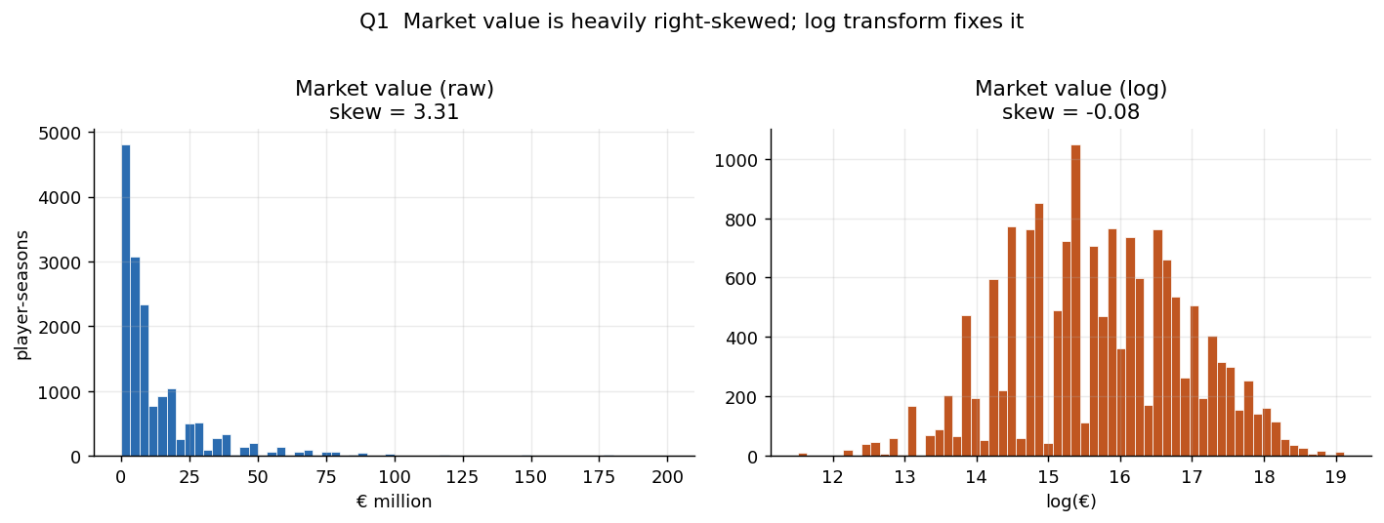
Figure 1 Market value distribution, raw and log transformed
Age. Median value peaks at 21 (€12.0M, n=798) and declines to approximately €1.0M by 34. The relationship is markedly non-linear. Decision: include age².
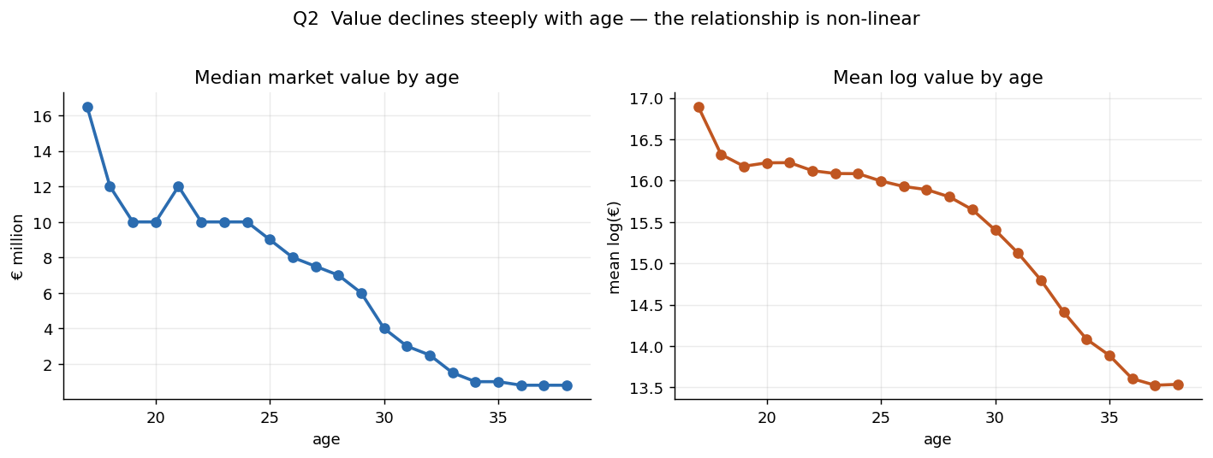
Figure 2 Median market value by age, showing the non-linear decline
An instructive detail: an initial reading placed the peak at 17. That figure rested on 22 observations: the only players young enough and good enough to accumulate 900 top-5 minutes. Restricting attention to ages with adequate sample corrects the peak to 21. The episode illustrates why sample size must be inspected alongside any summary statistic.
The peak nonetheless sits younger than the conventional 25–27 performance peak. This is not an error but a substantive finding: market value prices future resale potential, not only current output.
Position. Median values differ 1.8× across positions. Decision: position controls are mandatory.
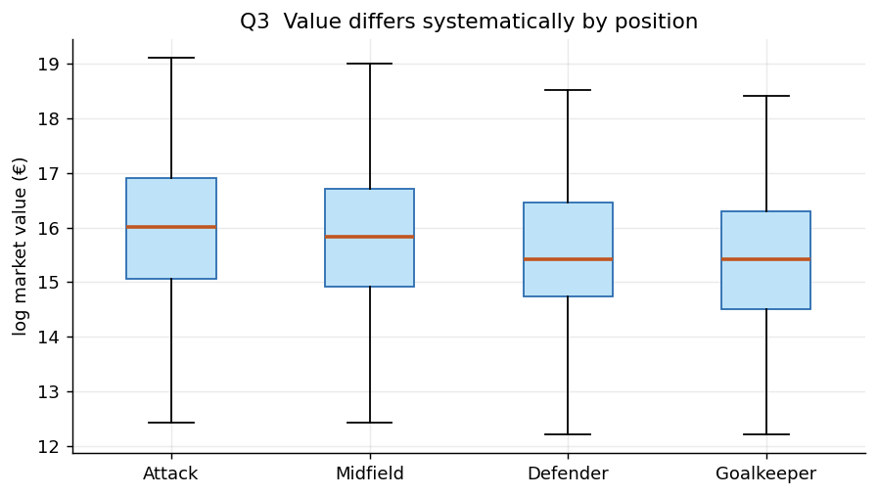
Figure 3 Value distribution by position
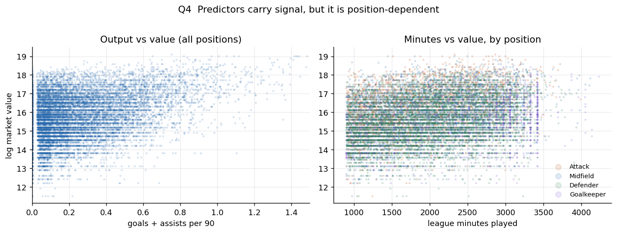
Figure 4 Performance signal by position
League and season. League medians differ 3.3× (Premier League €15.0M against Ligue 1 €4.5M); season medians shift 2.6× across the period. Decision: both are mandatory controls, and validation must be strictly time-based.
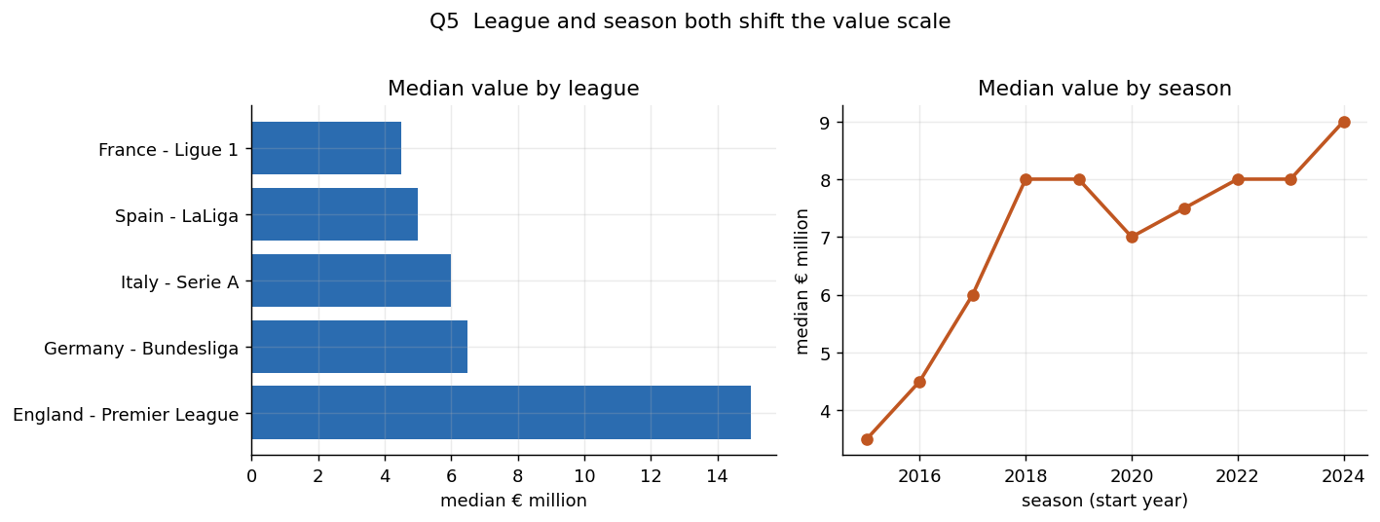
Figure 5 League and season effects on market value

7.2 Result 2: Observable fundamentals explain a substantial share of valuation
Model | Raw variables | R²_relative | R² (deployable) | Median % error | MAE
Model 0: context benchmark | 4 | 0.383 | 0.375 | 57.5% | €10.72M
Model 1: fundamental (HistGradientBoosting) | 33 | 0.678 | 0.677 | 43.9% | €7.60M
Model 1: fundamental (Ridge) | 33 | 0.672 | 0.671 | 44.2% | €7.64M

Held-out 2024/25 season, n = 1,508, identical observations across all models.
Adding observable performance and trajectory raises explanatory power from 0.383 to 0.678: the project's substantive positive finding. Observable football information carries real valuation signal.
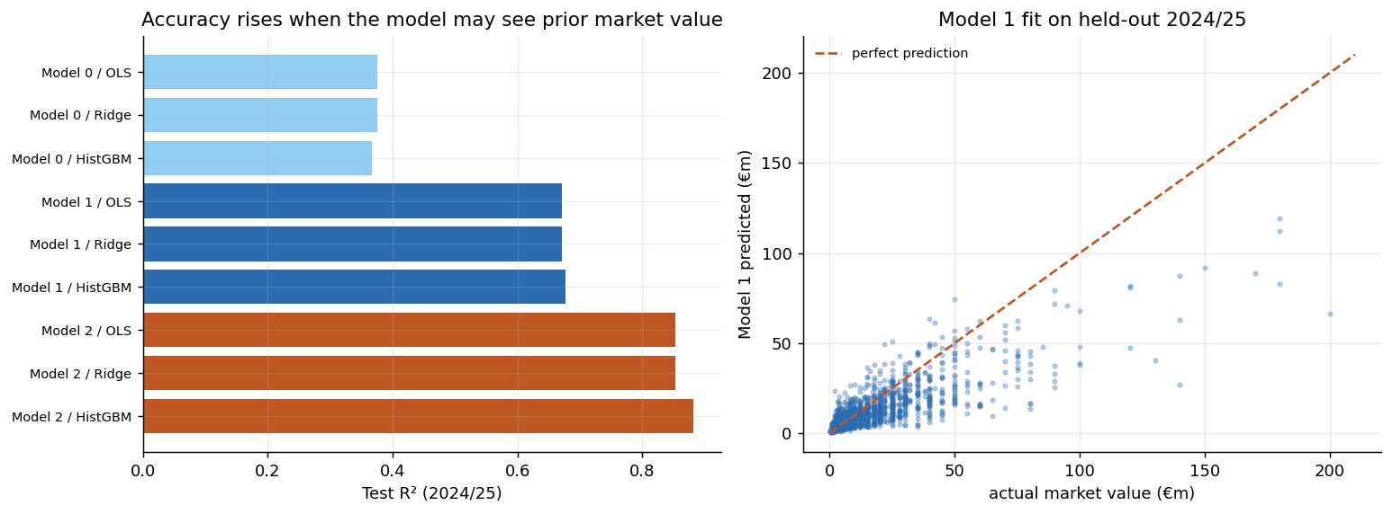
Figure 6 Model comparison on the held-out 2024/25 season
The correct formulation is: on the held-out 2024/25 sample, Model 1 achieves R² = 0.678 in the season-normalised valuation framework. The stronger claim that the model "explains 67.8% of player value" is not supported, since Transfermarkt market value is itself an estimate rather than an objective price.
Ridge and OLS agree to three decimal places, confirming that the mechanical relationships among per-90 and minutes-based features do not materially alter the linear conclusion.

Error is not uniformly distributed
Dimension | Segment | n | Median % error | R²
Position | Attack | 379 | 37.3% | 0.768
 | Goalkeeper | 114 | 40.5% | 0.588
League | England | 315 | 35.1% | 0.637
 | Spain | 329 | 55.9% | 0.615
Age | ≤21 | 98 | 52.3% | 0.104
 | 25–27 | 417 | 40.4% | 0.621

Two segments deserve emphasis. Spanish valuations are markedly harder to model than English ones. More consequentially, the model performs worst on players aged 21 and under (R² = 0.104), the segment in which the system therefore provides the least reliable valuation signal. This heterogeneity is the direct justification for the uncertainty constraint in the optimizer, and it is reported rather than concealed.

7.3 Result 3: Prior market beliefs explain considerably more
Model | R²_relative | Median % error | MAE
Model 1: fundamentals only | 0.678 | 43.9% | €7.60M
Model 2: plus prior market value | 0.884 | 23.7% | €4.47M

Adding a single market-derived variable, the player's own prior valuation, raises R² by 0.206. Twenty-nine performance and trajectory features contributed 0.295; two market-derived features contribute more than two-thirds of that. Prior log market value correlates 0.835 with the target, nearly double the strongest legitimate fundamental feature (age², 0.451).
The interpretation is the project's first major insight:
Predicting the market is substantially easier than explaining it. Transfermarkt valuations are highly persistent, and a model permitted to observe prior valuations largely reproduces that persistence.
This is why Model 1 remains the primary specification despite lower accuracy. Model 2's residual measures deviation from Transfermarkt's own trend, which carries no economic interpretation as mispricing. Accuracy and economic usefulness are different objectives, and a project optimising the former would have selected the wrong model.

7.4 Result 4: The mispricing hypothesis fails out of sample
This is a core research finding and is reported as such rather than minimised.
Signal | Candidates with outcome | Median relative appreciation | Difference vs benchmark | p (one-sided)
Raw residual (pre-registered) | 110 | +0.034 | +0.034 | 0.094
Calibrated + screened | 128 | +0.154 | 0.000 | 0.307
Eligible benchmark | 591 | +0.154 | N/A | N/A

Neither specification produced a statistically significant subsequent appreciation advantage. The validation window had shown a small positive differential (+0.042) that did not replicate on the test season: the characteristic signature of a signal that was noise.
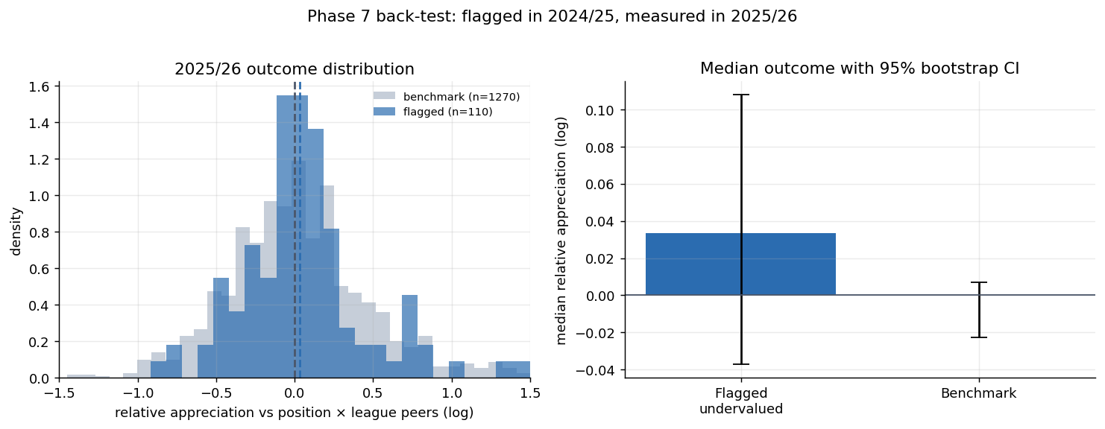
Figure 7 Back-test outcome distribution, pre-registered signal
The out-of-sample evidence does not support the hypothesis that the model residual identifies systematically exploitable transfer-market mispricing.
Deliberately, no third signal was constructed. Iterating specifications until one reached significance would have invalidated the entire testing procedure; the discipline that makes a negative result meaningful is the willingness to accept it.

Why the raw signal failed
Diagnosis was unambiguous. The residual correlates +0.667 with log market value: it is substantially a function of how cheap a player already is. Because the model regresses toward the mean in log space, it over-predicts low-valued players, who are then flagged as "undervalued."
 | Flagged | Benchmark
Median market value | €2.0M | €11.0M
Median age | 28.8 | 26.0
No top-5 minutes following season | 39.7% | 13.6%

The raw signal identified cheap, ageing players departing top-flight football, players who are inexpensive for reasons the model cannot observe.
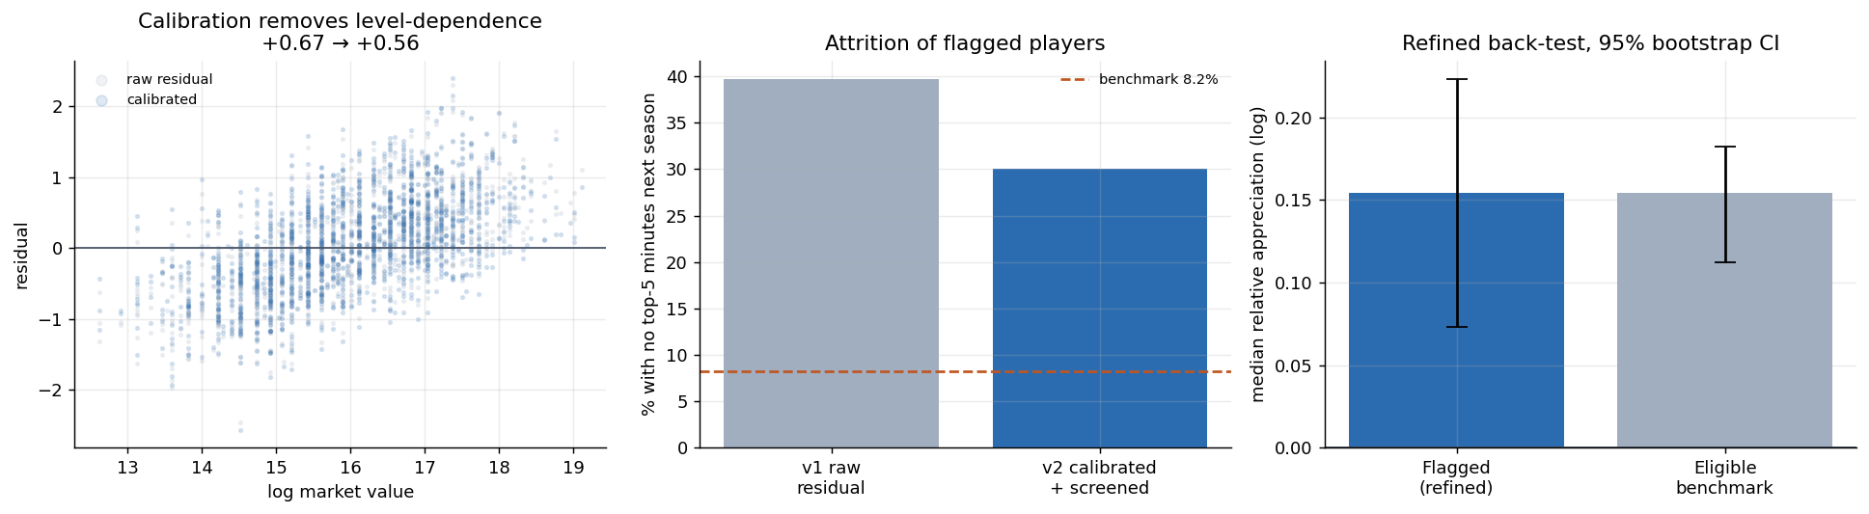
Figure 8 Refined signal back-test after calibration and screening

7.5 Result 5: The residual instead carries recruitment-risk information
The same diagnostic that invalidated the appreciation hypothesis revealed a far stronger relationship in the opposite direction.
Players flagged by the refined signal left top-5 football entirely at 3.7× the rate of the eligible benchmark the following season, 30.1% against 8.2% (Fisher exact, odds ratio 4.82, p = 2.6 × 10⁻¹¹). This relationship provides substantially stronger statistical evidence than either appreciation test, and it survived both signal specifications.
The managerial interpretation:
When a player's observed valuation sits substantially below what observable performance fundamentals imply, the discrepancy more often reflects information the market holds and public match statistics do not, than an exploitable error.
Contract situation, injury history, role change, off-field circumstances and impending movement below top-flight level are plausible hypotheses, not findings from this data, and are labelled accordingly.
The practical consequence reframes the entire system:
A large unexplained valuation gap should trigger investigation, not an automatic bid.

An exploratory conditional observation
Among flagged players who remained in top-5 football with ≥900 minutes, the flagged group did appreciate more strongly than the benchmark (+0.242 against +0.182, p = 0.048).
This is reported as exploratory only. Conditioning on survival is post-outcome selection: a club cannot know at the decision point which players will still be playing a year later. It is not evidence of an investable strategy and does not enter the optimizer.

7.6 Result 6: Exit risk is itself predictable
The negative result becomes a validated decision-support component.
Model | Split | n | AUC | Brier
Logistic (production) | Validation | 3,244 | 0.7362 | 0.1932
Logistic (production) | Test | 1,508 | 0.7323 | 0.1861
HistGradientBoosting (challenger) | Test | 1,508 | 0.7283 | 0.1864

The interpretable model marginally outperformed the non-linear challenger out of sample, so the project faced no transparency-versus-accuracy trade-off in this task: a point worth stating explicitly, since such trade-offs are usually assumed.
Calibration is strong across the risk distribution:
Risk decile | Predicted exit | Actual exit
0 (lowest) | 5.2% | 7.3%
4 | 23.0% | 30.5%
9 (highest) | 69.6% | 69.5%

A 9.5× spread between lowest and highest decile, with predicted and actual converging closely at the extremes. The model both discriminates and is calibrated well enough for its outputs to be used as probabilities in a decision rule.
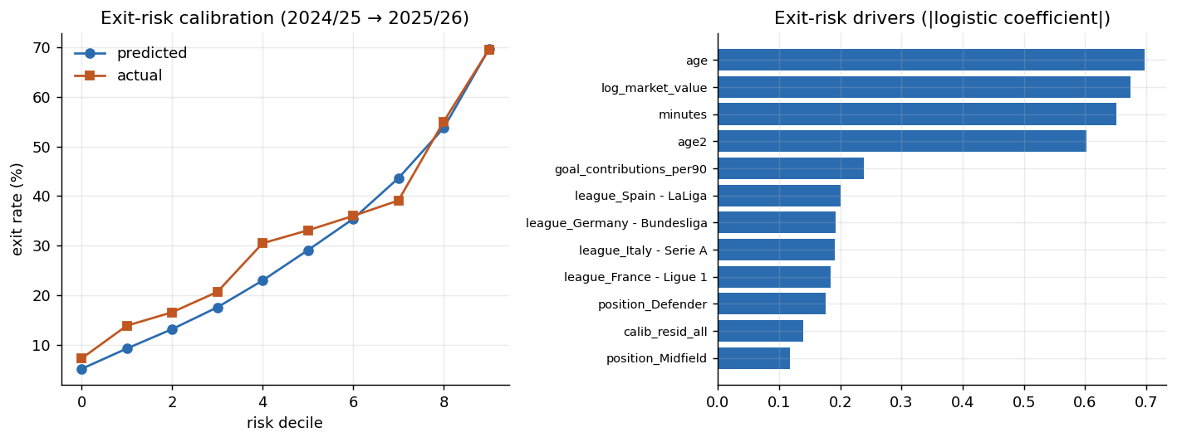
Figure 9 Exit-risk calibration and principal drivers

7.7 Result 7: Risk-aware allocation changes the recommendation
Applying the optimizer under a €50M budget with one defender, one midfielder and one attacker required:
Player | Position | League | Age | Market | Model-implied | Exit risk
Lucas Stassin | Attack | Ligue 1 | 20.1 | €18M | €31.1M | 14%
Diego Coppola | Defender | Serie A | 21.0 | €10M | €27.1M | 13%
Facundo Buonanotte | Midfield | Premier League | 20.0 | €20M | €20.3M | 25%

€48M of €50M · mean quality percentile 88.3 · mean predicted exit risk 17.1%

Comparison against naive strategies
Portfolio | Spend | Mean quality percentile | Predicted exit risk | Mean age
Risk-aware (recommended) | €48M | 88.3 | 17.1% | 20.4
Largest valuation gap (rejected objective) | €7M | 69 | 49.3% | 26.5
Cheapest meeting positional needs | €3M | 70 | 66.4% | 35.5

The contrast is instructive. The cheapest feasible portfolio has a mean age of 35.5 and a predicted exit risk of 66.4%; it is not a recruitment strategy but a demonstration of what naive value-hunting selects. The rejected valuation-gap objective performs better but still carries nearly three times the exit risk of the risk-aware portfolio at materially lower quality.

What this comparison does and does not establish
The illustration must not be overstated. Realised 2025/26 outcomes for these three-player portfolios involve two players versus one and cannot establish effectiveness at n = 3.
The exit-risk model is validated at the population level (AUC 0.732, n = 1,508). The portfolio is an illustrative application of that validated model, not an out-of-sample validation sample for the optimizer.

Sensitivity
Across six weight configurations, Lucas Stassin appears in all six, Diego Coppola in four, and Facundo Buonanotte in three. The honest characterisation is meaningful stability rather than complete invariance: the core recommendation persists while the remainder of the portfolio shifts with the relative emphasis placed on quality, potential, affordability and risk.
Budget sensitivity reveals a further property. Recommended spend plateaus at approximately €52M, with identical portfolios returned at €75M and €100M:
Under the model's eligibility constraints, increasing the nominal budget beyond roughly €75M does not translate into a larger or higher-scoring recommended portfolio.
This is a property of the model and its eligibility universe, not evidence that real clubs face a €52M optimal ceiling.

7.8 Synthesis
The evidence chain runs:
1. Market valuation is highly structured along age, position, league and time.
2. Observable fundamentals explain a substantial share of it (R² = 0.678).
3. Prior market beliefs explain considerably more (R² = 0.884): the market is highly persistent.
4. The unexplained residual does not identify exploitable mispricing.
5. It does identify elevated exit risk (30.1% vs 8.2% exit, odds ratio 4.82, p = 2.6 × 10⁻¹¹).
6. Exit risk is independently predictable (AUC 0.732) and well calibrated.
7. A risk-aware optimizer built on that validated component produces materially different, and more defensible, recommendations than naive value-hunting.
The project therefore concludes something more useful than its original hypothesis. A high-accuracy valuation model does not license the inference that its residual represents market error. In this market, over this period, the residual was better understood as a signal of information the model lacked. The appropriate managerial response is not to abandon quantitative recruitment support, but to redesign it: from a bargain-finder into a system that tells a recruitment committee where to look, how confident to be, and what to investigate before committing capital.

7.8.1 What drives model-implied valuation
SHAP values computed on the held-out 2024/25 season (n = 1,508) decompose Model 1's behaviour. The fifteen strongest individual drivers are led by a single dominant feature:
Rank | Feature | Mean \ | SHAP\ |  | Share
1 | Age | 0.4726 | 21.10%
2 | Goal contributions per 90 | 0.2156 | 9.63%
3 | League minutes played | 0.2020 | 9.02%
4 | League: Ligue 1 | 0.1433 | 6.40%
5 | League: Bundesliga | 0.1212 | 5.41%
6 | Seasons of top-5 history | 0.1092 | 4.88%
7 | Minutes last season | 0.0896 | 4.00%
8 | League: Serie A | 0.0884 | 3.95%
9 | Minutes per appearance | 0.0861 | 3.84%
10 | Three-season average minutes | 0.0843 | 3.76%

Aggregated into the families defined in the feature dictionary, the explanation is well distributed rather than concentrated:
Feature family | Mean \ | SHAP\ |  | Share
Current-season performance | 0.6261 | 28.0%
Performance trajectory | 0.4886 | 21.8%
Age | 0.4726 | 21.1%
League context | 0.4240 | 18.9%
Position | 0.0896 | 4.0%
Club context | 0.0748 | 3.3%
Physical (height) | 0.0593 | 2.6%
Preferred foot | 0.0046 | 0.2%

Three observations follow.
No single feature dominates the model. Age is the largest individual contributor at 21.1%, but current-season performance collectively contributes more (28.0%), and no family exceeds three-tenths of the explanation. A valuation model in which one variable overwhelmed the rest would be difficult to defend as a fundamentals-based system.
Performance trajectory earns its place. At 21.8%, trajectory features contribute more than the league context and almost as much as age. This vindicates the methodological decision in Section 6.3 to define career trajectory as performance history rather than valuation history. Had prior market value been admitted, it would have absorbed much of this explanatory mass while rendering the residual uninterpretable.
League context is substantial at 18.9%. Nearly a fifth of the model's behaviour reflects which competition a player appears in rather than what he does in it. This is consistent with the 3.3× league median differences in Section 7.1, and it is a finding a recruitment committee should register: the model prices the shirt as well as the performance.
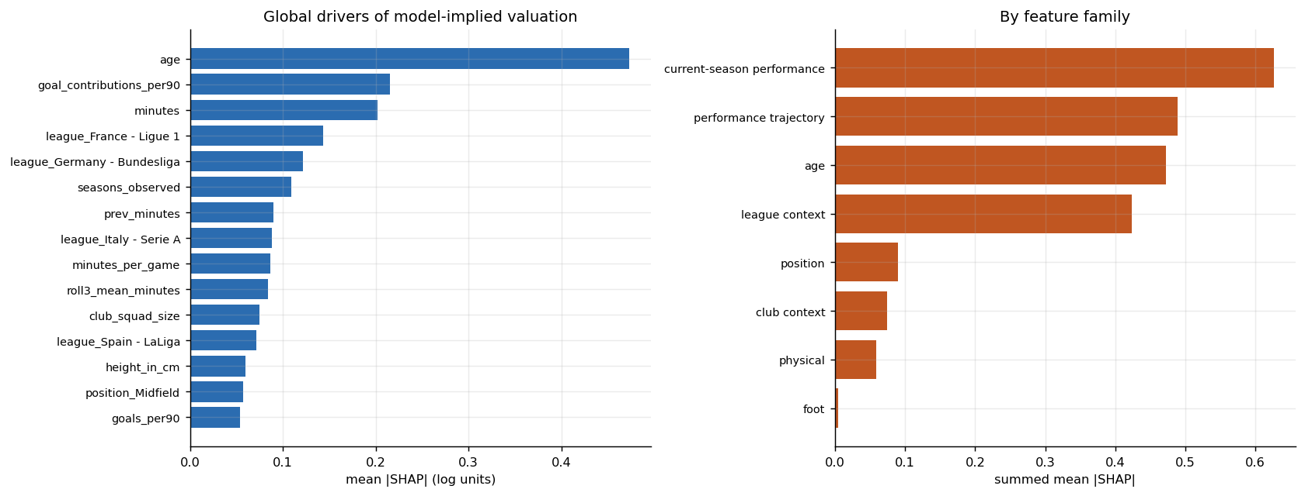
Figure 10 SHAP global importance and contribution by feature family

7.8.2 Player-level explanation for the recommended portfolio
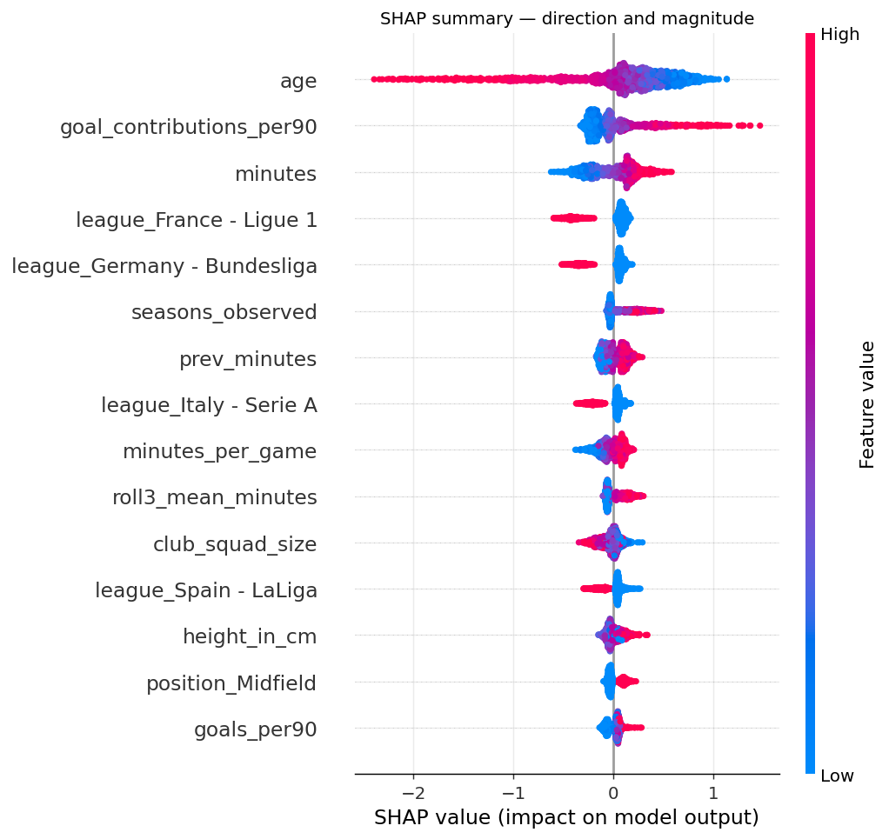
Figure 11 SHAP summary: direction and magnitude of each driver
Each recommended player carries both a prediction explanation and a selection explanation.

Lucas Stassin: Attack, Ligue 1, age 20.1
Market value €18.0M · model-implied €31.1M
Prediction explanation. Raised by goal contributions per 90 (+1.028), age (+0.740), goals per 90 (+0.104), assists per 90 (+0.073) and minutes played (+0.042). Lowered by playing in Ligue 1 (−0.372), minutes last season (−0.091), minutes per appearance (−0.045), prior-season contributions (−0.040) and three-season average minutes (−0.031).
Selection explanation. Quality percentile 90, potential 0.762, value efficiency 0.818, risk component 0.117.
What the model does not know. Validated exit probability 13.5%. No contract, injury, scouting or off-field information.
Stassin is the clearest case in the portfolio: output is the dominant positive driver, and the principal drag is the league discount rather than anything about the player.
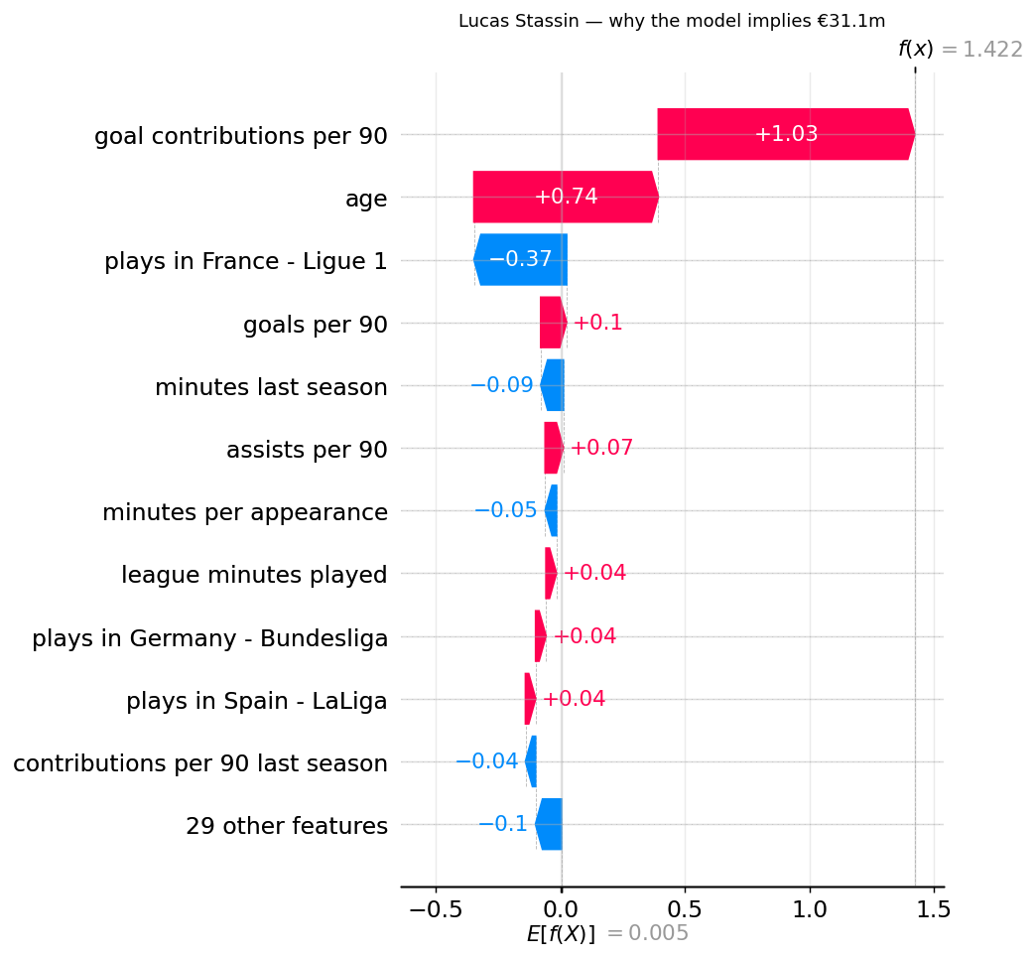
Figure 12 SHAP decomposition: Lucas Stassin

Diego Coppola: Defender, Serie A, age 21.0
Market value €10.0M · model-implied €27.1M
Prediction explanation. Raised by age (+0.955), league minutes played (+0.336), height (+0.138), minutes per appearance (+0.114) and league context (+0.081). Lowered by goal contributions per 90 (−0.179), playing in Serie A (−0.155), club squad size and rotation (−0.140), three-season average minutes (−0.053) and assists per 90 (−0.026).
Selection explanation. Quality percentile 89, potential 0.691, value efficiency 0.931, risk component 0.327.
What the model does not know. Validated exit probability 12.9%.
Coppola illustrates why position-appropriate reasoning matters. Goal contributions reduce his implied value, appropriate for a defender, whose value the model derives from availability and minutes rather than attacking output, consistent with the correlation of 0.069 between contributions and value for non-attacking roles reported in Section 7.1.
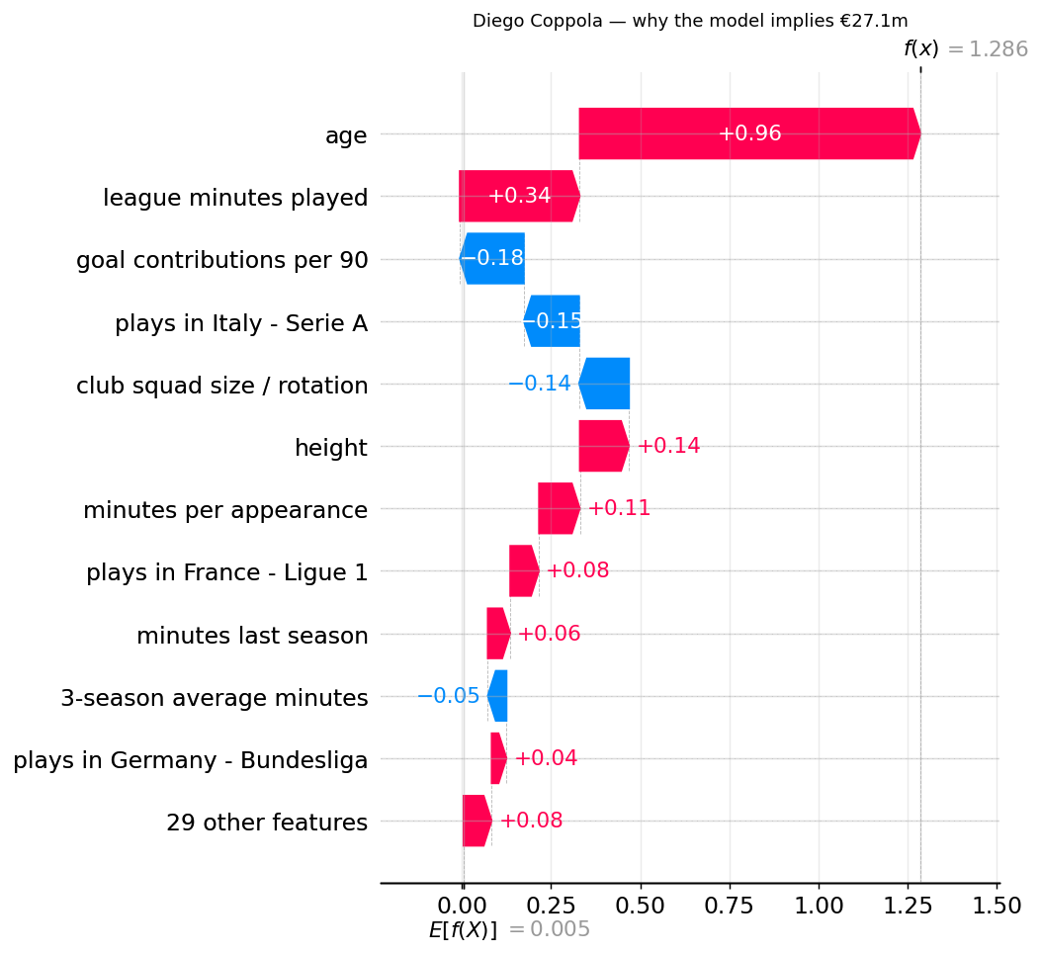
Figure 13 SHAP decomposition: Diego Coppola

Facundo Buonanotte: Midfield, Premier League, age 20.0
Market value €20.0M · model-implied €20.3M
Prediction explanation. Raised by age (+0.764), goal contributions per 90 (+0.137) and league context (+0.344 across the omitted league indicators, representing the Premier League premium). Lowered by league minutes played (−0.143), minutes per appearance (−0.099), club squad size and rotation (−0.082), disciplinary record (−0.055) and three-season average minutes (−0.051).
Selection explanation. Quality percentile 86, potential 0.767, value efficiency 0.567, risk component 0.240.
What the model does not know. Validated exit probability 24.9%: the highest in the portfolio.
Buonanotte is instructive precisely because his model-implied value (€20.3M) sits almost exactly at his market value (€20.0M). He was not selected because of a valuation gap; value efficiency is his weakest component at 0.567. He was selected on quality and development potential. This is the clearest demonstration in the project that the system is no longer a bargain-finder.
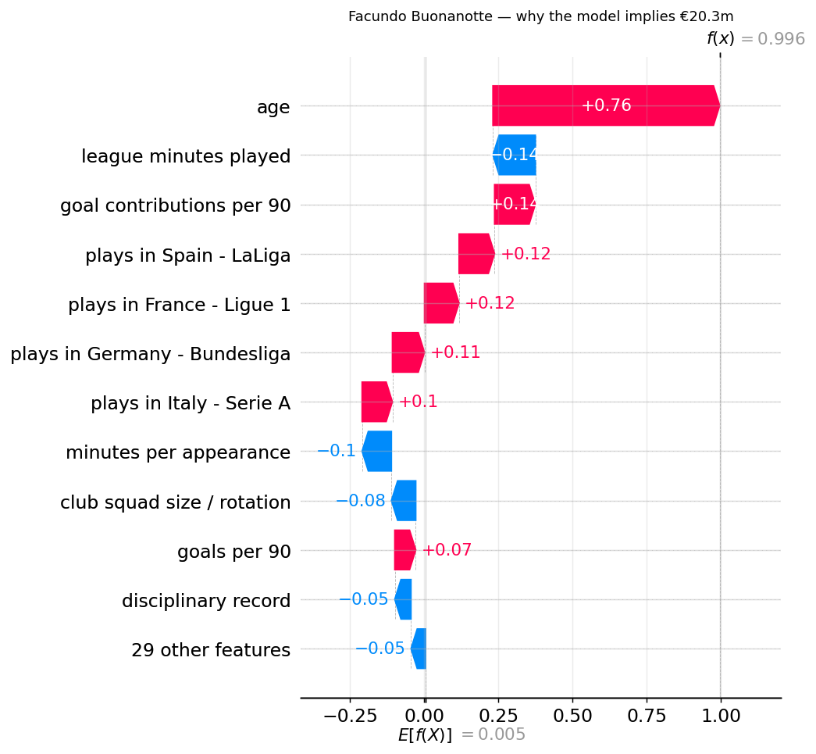
Figure 14 SHAP decomposition: Facundo Buonanotte

7.8.3 Systematic residual heterogeneity
SHAP explains what drives the model. A separate audit of mean signed residuals on the held-out season reveals where the model systematically misses, and the pattern is not random.
Dimension | Segment | n | Mean residual | Direction
Age | ≤21 | 98 | +0.553 | Model under-values
 | 22–24 | 329 | +0.164 | Model under-values
 | 25–27 | 417 | +0.116 | Model under-values
 | 28–30 | 345 | −0.100 | Model over-values
 | 31+ | 319 | −0.144 | Model over-values
League | England | 315 | +0.304 | Model under-values
 | Italy | 326 | +0.047 | No material pattern
 | France | 267 | +0.047 | No material pattern
 | Germany | 271 | −0.045 | No material pattern
 | Spain | 329 | −0.107 | Model over-values
Position | Midfield | 446 | +0.090 | Model under-values
 | Defender | 569 | +0.047 | No material pattern
 | Goalkeeper | 114 | +0.030 | No material pattern
 | Attack | 379 | +0.016 | No material pattern

Three patterns emerge, in descending order of importance.
The age gradient is monotonic and large. The mean residual falls steadily from +0.553 at age ≤21 to −0.144 at 31+, crossing zero between 27 and 28. The model systematically under-values young players and over-values old ones. The ≤21 magnitude should be read directionally rather than precisely: n = 98, and that segment also records the project's weakest predictive performance (R² = 0.104, Section 7.2).
The Premier League is systematically under-valued (+0.304), while LaLiga is modestly over-valued (−0.107): a spread of roughly 0.41 log units between the two.
Position effects are comparatively small. Only midfield (+0.090) shows a material directional pattern; the remaining three positions sit within the immaterial band.

7.8.4 Robustness: does the gradient replicate?
A pattern observed in a single held-out season could be season-specific noise rather than a property of the model. A pre-specified replication check was therefore run on the two validation seasons, using the identical frozen Model 1, the identical five age bands, and the identical ±0.05 materiality threshold. No band was redrawn and no threshold was tuned after seeing results.
Mean signed residual by age band and season:
Age band | 2022/23 | 2023/24 | 2024/25 (test)
≤21 | +0.191 | +0.314 | +0.553
22–24 | +0.092 | +0.114 | +0.164
25–27 | +0.012 | +0.074 | +0.116
28–30 | −0.074 | −0.119 | −0.100
31+ | −0.094 | −0.085 | −0.144

(n per band ranges from 92 to 444; the ≤21 band holds 92–103 observations per season.)
The pattern replicates in every season examined. In all three, the youngest band carries a materially positive residual and the oldest a materially negative one. The decline is strictly monotonic in 2022/23 and 2024/25; in 2023/24 it breaks only at the final step, where the 31+ band (−0.085) sits marginally above 28–30 (−0.119): a departure well inside sampling variation and one that does not affect the direction of the gradient.
The magnitude widens over time: the spread between youngest and oldest bands rises from 0.285 (2022/23) to 0.400 (2023/24) to 0.697 (2024/25). The direction is a stable model property; the size is not, and should not be quoted as a fixed quantity.
League effects replicate less symmetrically. England carries a materially positive residual in all three seasons (+0.249, +0.204, +0.304). Spain is directionally negative in all three (−0.032, −0.058, −0.107) but crosses the materiality threshold in only two: the 2022/23 figure sits inside the immaterial band. The under-valuation of Premier League players is therefore the better-supported league finding; the over-valuation of LaLiga players is directionally consistent but weaker.
This check materially strengthens the argument that follows. The age gradient is not an artefact of the test season but a persistent characteristic of the model across three consecutive seasons.
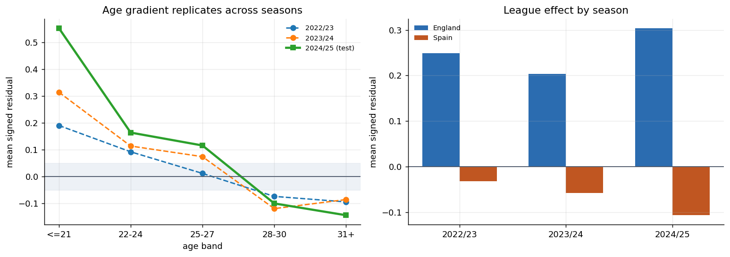
Figure 15 Residual gradient replication across three seasons

7.8.5 Why this connects directly to the failure of the mispricing hypothesis
The residual audit is not an incidental limitation. It supplies a mechanism for the central negative result of Section 7.4.
If the model systematically over-values players aged 28 and above, then those players will exhibit large negative residuals, observed value below model-implied value, and will be flagged as undervalued. But their market price is not wrong; the model is. This is precisely the population the raw signal selected: median flagged age 28.8, median flagged value €2.0M, with 39.7% subsequently departing top-5 football.
The residual/value correlation of +0.667 reported in Section 7.4 and the monotonic age gradient reported here are two views of the same defect.
The residual cannot be safely interpreted as market inefficiency, because the residual is itself systematically structured by age and league. A discrepancy between model and market is at least as likely to locate a weakness in the model as an error in the market.
This is the point at which explainability stops being a presentational layer and becomes a substantive result. Had the project reported SHAP importance alone, age matters most, performance matters second, it would have produced a plausible-looking explanation of a model whose residuals were not fit for the purpose originally intended for them. The audit is what exposes that, and it is the reason the system was redesigned around validated exit risk rather than assumed mispricing.
Managerial implications are developed in Section 8.7.

7.9 Generative-AI recruitment briefs

7.9.1 Headline result
Arm | Generator | Result | Interpretation
A | Deterministic template | 3/3 | Control: the validator does not falsely reject compliant output
B | Claude, conversational | 1/3 → 3/3 | A real generation failure, detected and corrected
C | GPT, conversational | 3/3 | Cross-model arm; partial validator independence

The result of interest is Arm B's initial failure, not any of the pass rates.
In summary: the evaluation demonstrated that fluency alone was insufficient to guarantee factual fidelity. The initial Claude generation contained three plausible numerical fabrications that were detected by the frozen validator, after which the corrected Claude and GPT generations passed all prescribed checks. This demonstrates the utility of the generation-and-validation architecture; it does not establish general language-model reliability, nor superiority of one model family over another.

7.9.2 The generation failure
The first conversational generation produced one passing brief of three. The Stassin brief contained three numerical claims inconsistent with the supplied payload:
Stated in the brief | Value in the payload
2,079 league minutes | 1,868
0.606 goal contributions per 90 | 0.819
0.560 model uncertainty | 0.074

The validator detected all three.
Two features of this failure matter more than its existence. First, the brief was otherwise professionally written and structurally complete, it passed the claim, speculation, structure, decision-consistency and uncertainty checks. Nothing in its prose signalled that three of its figures were wrong. Second, the fabrications were plausible: 2,079 minutes is a credible season for a regular starter, and 0.606 goal contributions per 90 is a credible attacking return. A reader without the source data beside them would have no basis for suspicion.
The failure arose from the model drawing figures from surrounding context rather than reading them from the payload. After the figures were re-taken verbatim from the payload, all three briefs passed.
This is the project's principal generative-AI finding:
A fluent, well-structured and apparently authoritative recruitment brief contained three fabricated quantitative claims. Fluency carried no information about factual accuracy, and only automated verification against the source payload exposed the discrepancy.

7.9.3 Cross-model arm
The GPT conversational arm achieved 3/3 under the frozen validator, passing all six recorded dimensions for each of Lucas Stassin, Diego Coppola and Facundo Buonanotte on first generation, without correction.
Two additional checks establish that this pass is substantive rather than an artefact of the evaluation.
Numerical density. A brief can pass a numerical-fidelity check trivially by making few numerical claims. The GPT briefs recorded 74.3 numeric claims per 1,000 words, higher than the initial Claude arm at 69.9 and comparable to the deterministic template at 91.1. The arm passed by stating figures correctly, not by avoiding them.
Negative control on the generated text itself. Six violations were planted directly into a GPT-authored brief: a fabricated euro figure, invented injury, contract and tactical claims, an explicit signing recommendation, and a hedged causal claim. The validator detected 6/6. It was therefore actively evaluating that text rather than passing it because it was structurally complete.
Control | Result
Synthetic negative control (planted into template text) | 7/7 detected
Negative control planted into GPT-authored text | 6/6 detected
Arm C payload vs canonical payload | byte-identical
Validator checksum vs delivered copy | unchanged

7.9.4 Content fidelity: which framework did the briefs communicate?
The six automated checks test whether a brief states the supplied facts correctly. They cannot test whether it communicates the right analytical framework: a brief could be numerically flawless while reverting to the bargain-finding framing this study rejected.
Manual inspection of the nine generated briefs across both conversational arms found that framework fidelity held in every case, and the three players happen to constitute a useful test:
Stassin carries a substantial model-market gap (+72.6%). The briefs present it as a discrepancy warranting investigation and pair it with the back-test result, rather than as evidence of underpricing.
Coppola carries the largest gap in the portfolio (+171.4%) together with the highest model uncertainty (0.788). The briefs disclose both, and treat the size of the gap as a reason for closer scrutiny rather than greater confidence.
Buonanotte is the decisive case. His model-implied value (€20.3M) is within 1.5% of his market value, and his value efficiency (0.567) is the weakest in the portfolio. Under the project's original objective he would never have been surfaced. The briefs state explicitly that no valuation discrepancy supports the recommendation and that the case rests on quality and development potential.
That last result matters because it could not have been produced by a system still optimising for apparent bargains. The generative layer is faithfully communicating the framework the evidence produced, not the one the project began with.
This is reported as manual inspection rather than as an automated check, and it is not claimed as a validated property. It is an observation about nine documents.

7.9.5 What these results do not establish
Three claims are not supported and are not made anywhere in this report.
This is not evidence that GPT is more reliable than Claude. Each arm contains three briefs. The design was not constructed or powered for model comparison, and a single failed generation in one arm cannot support an inference about relative reliability.
This is not a claim of factual reliability. The corrected Claude result and the GPT result are both 3/3, but the first Claude generation was not. The system's demonstrated property is that fabrication can be detected, not that it does not occur.
Arm C is not a fully independent validation. The generating model had visibility of the validator design through the project interaction. The independence is partial, and Section 6.10.6 records it as such.
The defensible conclusion is narrower than any of these:
The constrained generation-and-validation architecture detected fabricated content in an initial language-model generation and produced compliant output after factual grounding and correction. It was applied without modification across two model families.

7.9.6 Managerial implication
The finding has a direct consequence for how a committee should treat a generated document.
A recruitment brief produced by this system is a verified translation of analytical evidence, not an additional source of football intelligence. It contains no information the analytical layer did not supply, and the fidelity check confirms that it contains nothing more.
That framing carries practical weight because the failure mode observed here is not detectable by reading. The three fabricated figures in the Stassin brief were caught by comparison against a source file, not by review of the prose. A committee that treated fluency as evidence of accuracy would have accepted them.
Every brief therefore closes with two sections that exist for this reason: an explicit statement of what the model cannot observe, contract, medical, scouting and willingness-to-move considerations, and a list of due-diligence questions directed back to human judgement. The generative layer reduces the burden of translating multiple quantitative outputs into a consistent decision document. It does not reduce the burden of verification, and the architecture is designed so that verification happens automatically before the document reaches a decision-maker rather than depending on a reader noticing.

8. Analysis
Section 7 reports what the analysis found. This section addresses what a football club should do about it.

8.1 From valuation to decision support
The project set out to build a system that identified undervalued players. It ended by building something different, and the reason is the single most important managerial lesson it produced.
The valuation model works. On the held-out 2024/25 season it achieves R² = 0.678 in the season-normalised framework, against 0.383 for a benchmark using age, position and league alone. Observable football performance explains a substantial share of what the market pays.
But a model that explains valuation well does not thereby identify where valuation is wrong. When the residual from that model was tested out-of-sample as a mispricing signal, it produced no subsequent relative appreciation advantage (median differential 0.0000, p = 0.307). The gap between model and market was not an exploitable error.
A valuation model can identify a discrepancy without establishing that the market is mistaken.
This is why the system is positioned as a screening and investigation tool. It narrows 1,508 players to a handful worth a scout's time, attaches an explanation and a risk estimate to each, and states plainly what it cannot see. It does not decide, and the interface never labels a player "undervalued" because the evidence does not support that word.

8.2 Why the original "bargain" logic fails
The intuitive recruitment heuristic, pursue players whose model-implied value exceeds their market price, failed in a specific and instructive way.
The residual correlates +0.667 with log market value. Because the model regresses toward the mean in log space, it over-predicts cheap players, and those players are then flagged as bargains. The result was a candidate list with a median market value of €2.0M and a median age of 28.8, of whom 39.7% left top-5 football entirely within a season, against 13.6% of the benchmark.
The refined signal, with level calibration and eligibility screening applied, produced a far more sensible candidate list, but still no appreciation advantage (p = 0.307) and still 30.1% attrition against 8.2%.
For a recruitment committee, the practical translation is:
A large unexplained valuation gap is more often a sign that the market knows something the model does not than an error waiting to be exploited.
Contract situation, injury history, role change, attitude, and impending movement below top-flight level are plausible candidates for that missing information. None of them is observable in this data, and none is claimed as a finding.

8.3 The recruitment decision framework
The system's outputs sequence into six questions a committee can actually work through. This is the dashboard expressed as a process.
Step | Question | Evidence used | Fails if
1 | Is observable performance strong enough? | Position-appropriate quality percentile | Below the 40th percentile in position
2 | Does the model imply meaningful valuation upside? | Model-implied value against market value | Gap within ±5%, model and market agree
3 | How uncertain is that estimate? | Segment-level model error | Segment in the least reliable quintile
4 | What is the predicted exit risk? | Validated exit model (AUC 0.732) | Above the club's risk tolerance
5 | Does he fit positional and budget requirements? | Constrained optimizer | No feasible portfolio includes him
6 | What human due diligence is required? | Generated brief | , always required

Step 6 never resolves to "no further work needed." The system's own back-test is the reason.
Note the ordering. Quality is asked before value. A framework that asked about the valuation gap first would reproduce the failure documented in 5.2.

8.4 Implications for recruitment teams
Scouting capacity is the binding constraint in most recruitment operations, not analytical capacity. A club cannot send analysts to watch 1,508 players.
The system is therefore best understood as a way of allocating scouting attention. It supports:
- Candidate screening, reducing a league-wide pool to a reviewable shortlist
- Shortlist construction under explicit positional and budget requirements
- Prioritising scouting resource toward players where the model is confident and the risk is low
- Flagging players who require deeper investigation: a large gap paired with high exit risk is a question for a scout, not a recommendation
- Balancing youth and upside against retention risk, which the exit model now quantifies per player
It does not support autonomous signing decisions, and the briefs it generates are written to make that impossible to misread: each one states that the player is "put forward for further investigation, not for an immediate approach."
There is one specific caution for recruitment teams. The model is weakest for players aged 21 and under: for players aged 21 and under it achieves R² of only 0.104 with a median error of 52.3%. Its outputs for that group should therefore carry more human scrutiny and less analytical confidence than the headline accuracy figures imply.

8.5 Implications for finance and sporting directors
This is where the project's managerial contribution is strongest, because the optimizer changes the shape of the decision rather than merely informing it.
Recruitment is conventionally executed as a sequence of isolated player decisions: identify a target, negotiate, sign, move to the next. The optimizer reframes it as portfolio allocation under constraint. The question shifts from
Which player is cheapest relative to estimated value?
to
Given €50M and three positional requirements, which combination delivers the strongest risk-adjusted recruitment profile?
Under the declared weights, the recommended €50M portfolio commits €48.0M across three players at a mean quality percentile of 88.3 and a mean predicted exit risk of 17.1%. Set against two naive alternatives:
Strategy | Spend | Mean quality pctl | Predicted exit risk | Mean age
Risk-aware allocation | €48.0M | 88.3 | 17.1% | 20.4
Largest valuation gap | €7.0M | 69 | 49.3% | 26.5
Cheapest meeting needs | €3.0M | 70 | 66.4% | 35.5

The cheapest feasible portfolio is not a recruitment strategy at all: a mean age of 35.5 and a two-in-three probability of the squad falling below meaningful minutes. It demonstrates what unconstrained value-hunting selects when nothing restrains it.
Two further findings matter at director level.
Budget is not the binding constraint beyond a point. Recommended spend plateaus at €52.0M: identical portfolios are returned at €75M and €100M. Under this model's eligibility rules, additional budget stops buying a better shortlist because the constraints, quality floor, age ceiling, exit-risk ceiling, uncertainty ceiling, bind before the money does. This is a property of the model's eligible universe, not evidence that clubs face a €52M optimal ceiling in reality. But it makes a real managerial point: relaxing a constraint may be worth more than raising a budget.
Risk tolerance is a real lever, and it is expensive. Moving from a €20M to a €35M budget raises mean quality from 88 to 92 while cutting mean exit risk from 30.9% to 19.2%. The marginal €15M buys risk reduction more than it buys quality.

8.6 Explainability and governance
For a system whose recommendations concern individual professionals and substantial capital, three governance properties matter.
Explanations are separated by question. SHAP explains why the model produced a valuation; the optimizer separately explains why a player was selected. Conflating them would let a persuasive valuation explanation stand in for a selection rationale. In the Coppola case, the valuation is driven by age (+0.955) and minutes (+0.336), while the selection is driven by quality percentile 89 and value efficiency 0.931 against a risk component of 0.327, related but distinct accounts.
Uncertainty travels with every recommendation. No player appears without an exit probability and a confidence indication. The briefs state the model's 43.9% median error explicitly rather than presenting point estimates as precise.
The generative layer is constrained by construction. It receives structured, already-validated numbers and converts them to prose. It performs no analysis. Every brief is machine-checked for numerical fidelity, unsupported claims, speculative causal inference, decision consistency and uncertainty disclosure, and the checker is verified against deliberately planted violations. Generative AI here adds communication efficiency, not analytical authority.
Public data has limits that governance cannot fix. The model observes match statistics, age, position, league and valuation history. Contract, medical, tactical and personal information are absent, and Section 7.5 suggests that absence is doing real work in the residual.

8.7 Model risk and systematic residual heterogeneity
The model's errors are not random with respect to who a player is, and the pattern replicates.
Age band | 2022/23 | 2023/24 | 2024/25
≤21 | +0.191 | +0.314 | +0.553
22–24 | +0.092 | +0.114 | +0.164
25–27 | +0.012 | +0.074 | +0.116
28–30 | −0.074 | −0.119 | −0.100
31+ | −0.094 | −0.085 | −0.144

The direction of the gradient replicated across all three examined seasons, although its magnitude varied materially over time. The model systematically under-values young players and over-values older ones. A parallel league pattern shows the Premier League under-valued in all three seasons (+0.249, +0.204, +0.304); LaLiga is directionally over-valued but crosses the materiality threshold in only two of three.
This is not an incidental limitation. It is the mechanism behind the failed mispricing hypothesis. If the model over-values players aged 28 and above, those players show negative residuals and get flagged as bargains, but their market price is not wrong; the model is. The residual/value correlation of +0.667 and this age gradient are two views of one defect.
A model's disagreement with the market cannot automatically be interpreted as evidence that the market is wrong. The disagreement may equally locate a weakness in the model.
For a club, this converts into a concrete operating rule: discrepancies concentrated in a segment where the model is known to be biased carry less weight than discrepancies elsewhere. All else equal, a large gap on a 30-year-old in LaLiga deserves more scepticism than the same gap on a 24-year-old in Serie A, because the first sits where the model is known to err in that direction.

8.8 Sensitivity and robustness
The conclusions do not rest on a single modelling choice.
Time-based validation throughout. Train 2015/16–2021/22, validate 2022/23–2023/24, test 2024/25 once. No feature selection, threshold or normalisation constant was ever fitted using validation or test information. Three separate leakage defects were found and corrected under this rule.
The nested model comparison is consistent across algorithms. Model 0 → 1 → 2 R² runs 0.375 → 0.678 → 0.884 under gradient boosting, and 0.383 → 0.672 → 0.855 under Ridge. The ordering and the interpretation hold regardless of estimator. Ridge and OLS agree to three decimal places, confirming multicollinearity is not distorting the linear conclusion.
The bias gradient replicates across three seasons (5.7).
The exit model is calibrated, not merely discriminating. Predicted and actual exit rates converge closely at the extremes: 5.2% predicted against 7.3% actual in the lowest decile, 69.6% against 69.5% in the highest: a 9.5× spread. The interpretable logistic model marginally outperformed the boosted challenger out of sample (AUC 0.7323 against 0.7283), so no transparency-for-accuracy trade-off was required.
The optimizer's recommendation is stable but not invariant. Across six weight configurations, Lucas Stassin appears in all six, Diego Coppola in four and Facundo Buonanotte in three. The honest characterisation is meaningful stability rather than complete invariance: the core recommendation persists while the remainder shifts with the emphasis placed on quality, potential, affordability and risk.
Budget sensitivity shows a plateau at €52.0M (5.5).
One robustness limit must be stated plainly. The three-player portfolio is an illustration of a validated method, not a validation sample. Realised 2025/26 outcomes for three players cannot establish effectiveness. The exit-risk model is validated at the population level, n = 1,508; the portfolio is not.

8.9 A practical operating model
The system fits into an existing recruitment process at a specific point, and stops at a specific point.
ANALYTICS SCREENING model-implied value, quality percentile
↓ across the eligible player universe
MODEL EXPLANATION SHAP drivers, prediction vs selection
↓ rationale separated
RISK ASSESSMENT exit probability, segment uncertainty,
↓ known model bias for that profile
PORTFOLIO OPTIMISATION budget, positional needs, risk tolerance
↓ → shortlist for investigation
─────────────── analytics ends here ───────────────
↓
HUMAN SCOUTING live assessment, tactical fit, style
↓
DUE DILIGENCE medical, contract, agent, willingness
↓
TRANSFER COMMITTEE decision, with analytics as one input

The line matters as much as the steps. Everything above it is reproducible, auditable and explicitly uncertain. Everything below it requires information the system does not have and cannot acquire from public data.
The project's proposition is therefore not that artificial intelligence discovers undervalued footballers. It is that:
AI can help a recruitment committee distinguish between an apparent value opportunity and an apparent value opportunity that is more likely to be model error or recruitment risk, and can say, for each candidate, which of those it cannot tell apart.
That is a narrower claim than the project began with. It is also one the evidence supports.

9. Conclusion

9.1 What this project set out to ask
Football clubs commit substantial capital to the transfer market under conditions of imperfect information. This project asked whether observable performance data could support a defensible valuation framework, and whether the gap between a fundamentals-based valuation and the market's own price could identify recruitment opportunities a club could act on.
That question was treated as a hypothesis to be tested rather than a premise to be assumed. The distinction determined the shape of everything that followed.

9.2 What the study found
Observable football fundamentals explain a substantial proportion of market valuation. A model using age, position, league, current-season performance and performance trajectory achieved R² = 0.678 on a held-out season in the season-normalised framework, against 0.383 for a benchmark using contextual variables alone. Performance data carries real valuation signal.
A model permitted to observe prior market valuations performs considerably better still, R² = 0.884, but its residual is no longer economically interpretable. That contrast produced the project's first substantive insight: predicting the market is easier than explaining it, and the two objectives are not interchangeable. A project optimising for accuracy alone would have selected the wrong model.
The study did not find sufficient out-of-sample evidence to support the hypothesis that the model-implied valuation residual represents systematically exploitable market mispricing. Two pre-specified signal definitions were tested under strict time-based discipline, with thresholds fixed on validation data and applied once to the held-out season. Neither produced a statistically significant subsequent appreciation advantage over a matched benchmark (p = 0.094 and p = 0.307 respectively). A promising validation-period differential did not replicate on test.
However, the analysis revealed that large unexplained valuation gaps were strongly associated with subsequent exit from top-five football, indicating that disagreement between model and market may contain information about variables not captured in publicly observable performance data. Players flagged by the residual recorded no top-five minutes in the following season at 3.7 times the rate of a matched benchmark, 30.1% against 8.2%, Fisher exact odds ratio 4.82, p = 2.6 × 10⁻¹¹. This relationship was substantially stronger statistical evidence than either appreciation test.
Investigation of the residual's structure supplied a mechanism. The residual correlates +0.667 with log market value, and the model's signed errors follow a monotonic age gradient, systematically under-valuing younger players and over-valuing older ones, whose direction replicated across all three seasons examined, though its magnitude varied materially. A discrepancy between model and market is therefore at least as likely to locate a weakness in the model as an error in the market.
Exit risk itself proved predictable. A logistic model achieved AUC = 0.732 on the held-out season with strong calibration across the risk distribution, from 7.3% realised exit in the lowest decile to 69.5% in the highest. The interpretable model marginally outperformed a gradient-boosted challenger, so no transparency-for-accuracy trade-off was required.

9.3 What was built as a result
The evidence redirected the system's design. The original objective, maximise the gap between model-implied value and acquisition cost, was withdrawn, because maximising a residual that had failed validation would have optimised model error and loaded the portfolio with exit risk.
In its place, a risk-aware recruitment framework selects players on position-appropriate quality, development potential and value efficiency, penalised by validated exit risk and model uncertainty, subject to budget, positional, performance-floor, age and confidence constraints. Explanations are separated by question: SHAP accounts for why the model produced a valuation, while the optimizer separately accounts for why a player was selected. A constrained generative layer converts validated outputs into committee-readable briefs, machine-checked for numerical fidelity, unsupported claims, speculative causal inference, decision consistency and uncertainty disclosure.
The interface never labels a player "undervalued." It says potential valuation discrepancy, investigate, and where a large gap coincides with high exit risk, it says treat as a warning. That wording is not caution for its own sake; it is the most the evidence supports.

9.4 What a club should do differently
Do not treat a valuation gap as a buy signal. The intuitive heuristic, pursue players whose model-implied value exceeds their price, was tested and not supported. Such gaps are generated by omitted variables and by systematic model error at least as often as by market error.
Ask quality before value. The decision sequence should establish that a player is good enough, then how confident the estimate is, then what the exit risk is, and only then whether the price looks favourable. A framework that leads with the valuation gap reproduces the failure this study documented.
Treat the transfer budget as a portfolio, not a queue. The relevant question is not which single player is cheapest relative to estimate, but which combination of signings delivers the strongest risk-adjusted profile within budget and positional requirements. Analysis of the model's eligible universe further suggests that relaxing a recruitment constraint can be worth more than increasing the budget: a decision a sporting director can act on directly.
Apply more human scrutiny where the model is least confident. The system is weakest for players aged 21 and under, achieving R² of only 0.104 in that segment. Its outputs there warrant proportionally more scouting weight and less analytical weight.
Use the system to allocate attention, not to make decisions. Its function is to reduce a league-wide pool to a shortlist worth a scout's time, with an explanation, a risk estimate and an explicit statement of what it cannot see attached to each name.

9.5 Contribution
The project's contribution is the transition it documents: from player valuation to risk-aware recruitment decision support. That transition was driven by evidence rather than design preference.
Its methodological contribution is the discipline of the test itself. Two pre-specified signal definitions produced null results, and the investigation stopped there rather than iterating until a specification reached significance. The negative result is informative precisely because the procedure that produced it was fixed in advance, and the willingness to accept it is what distinguishes a hypothesis test from a search.
Its managerial contribution is a defensible answer to a question clubs actually face. Not "which players are undervalued?", a question this study suggests public performance data cannot reliably answer, but:
Which apparent value opportunities are worth a scout's time, how much confidence should we place in each estimate, and which apparent bargains are more likely to be hidden risk?

10. Limitations and Future Work

Limitations
The target is an estimate, not an observed price. Transfermarkt market value is a community-informed valuation, not a transaction record. The model is therefore calibrated against a construct, and "fair value" throughout this report means model-implied value under that construct.
Observed transfer fees are sparse and selectively observed. Only 10.0% of in-scope transfer records carry a positive fee, and 15.6% of player-seasons in the analysis table. The fee-based analysis is a secondary check on a non-representative subset.
A single test season and one market cycle. All headline out-of-sample claims rest on 2024/25 with outcomes measured in 2025/26. The residual bias gradient was replicated across three seasons; the back-test was not.
The optimizer portfolio is illustrative, not validated. The exit-risk model is validated at population level (n = 1,508). The three-player portfolio is an application of that validated component under declared constraints, with sensitivity analysis showing meaningful but incomplete stability. Realised outcomes for three players cannot establish effectiveness, and no claim of superior transfer returns is made or supported.
Segment heterogeneity is material. Median error ranges from 35.1% (England) to 55.9% (Spain), and R² from 0.104 (aged ≤21) to 0.768 (attackers).
The most likely contents of the residual are unobserved. Contract length, injury history, tactical role, scouting assessment and player willingness are absent from the data. Section 7.5 suggests this absence is doing real work.
The generative layer was evaluated under both deterministic and conversational conditions. The deterministic control passed all three briefs; the initial conversational generation contained three plausible numerical fabrications that were detected by the frozen fidelity validator and subsequently corrected; a second conversational arm using a different model family passed all prescribed checks. The evaluation demonstrates the utility of the generation-and-validation architecture, but comprises nine briefs in total and does not establish general language-model reliability or comparative superiority between models. The cross-model arm carries only partial independence, since the generating model had visibility of the validator design.

Future work
Contract and injury data would test directly whether the residual's association with exit risk is explained by these unobserved variables. This is the single highest-value extension.
Multi-season back-testing would establish whether the null mispricing result holds across market cycles, or is specific to this period.
Segment-specific models, particularly for players aged 21 and under, where a general model performs poorly, might improve precisely where recruitment value is highest.
An anchoring-bias event study, testing whether past transfer fees inflate subsequent valuations after controlling for performance, would examine a specific behavioural mechanism for the persistence documented in Model 2.
Transfer-market network analysis would extend the question from player-level mispricing to market structure: whether particular clubs are systematic over- or under-payers.
The project began by asking whether artificial intelligence could find undervalued footballers. It ends with a more useful answer than the one it sought: that a valuation model's disagreement with the market is a question to investigate rather than an opportunity to exploit, and that a system honest about what it cannot see is more valuable to a recruitment committee than one that conceals it.

