My Test document
25,00 | 5,50 | 22,27 ₽ | 0001-01-01 | 02:48:05 | 25,55 | 7,80 | False | Test | Test
-25,00 | -5,50 | -22,27 ₽ | 2024-03-25 | 00:00:00 | -25,55 | -7,80 | True
1000,00 | 5000,00 | 22 000,00 ₽ | 9999-12-31 | 02:48:05 | 25,55 | 7,80 | False | TestASSASSAAS | TestASDSDDASDS
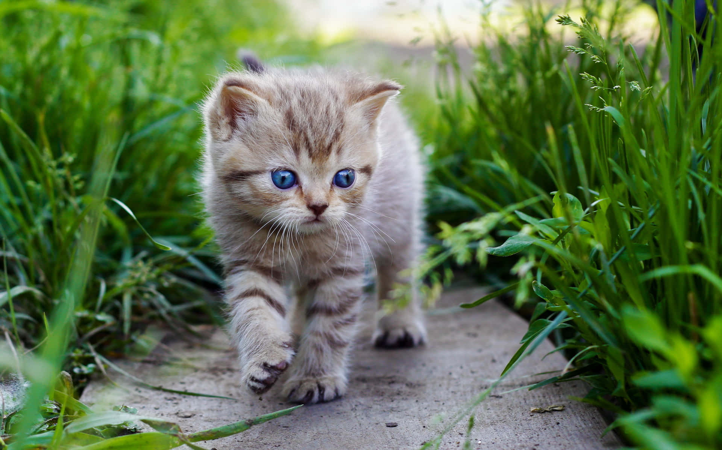

Unformatted

255

4294967295

не число
This is a text
This is a text a very very very long textThis is a text a very very very long textThis is a text a very very very long textThis is a text a very very very long text
25,00 | 5,50 | 22,27 ₽ | 0001-01-01 | 02:48:05 | 25,55 | 7,80 | False | Test | Test
-25,00 | -5,50 | -22,27 ₽ | 2024-03-25 | 00:00:00 | -25,55 | -7,80 | True
1000,00 | 5000,00 | 22 000,00 ₽ | 9999-12-31 | 02:48:05 | 25,55 | 7,80 | False | TestASSASSAAS | TestASDSDDASDS

Formatted
-9223372036854775808
₂₅₅
⁴²⁹⁴⁹⁶⁷²⁹⁵
не число
^{This}

^{is}

ª

^{text}
This is a text a very very very long textThis is a text a very very very long textThis is a text a very very very long textThis is a text a very very very long textThis is a text a
_{very}

_{very very}

_{long text}
sub-sub-sub-sub
Fill me | Fill me | Fill me
Fill me | Fill me | Fill me
Fill me | Fill me | Fill me
0,00 | 0,00 | 0,00
0,00 | 0,00 | 0,00
0,00 | 0,00 | 0,00

