Requirement:

Entire section (shown below) to be printed/ saved as PDF by clicking on Print button. While printing section on the left side should be on top. And entire content present in all the tabs which will generate dynamically based on selection should be printed.

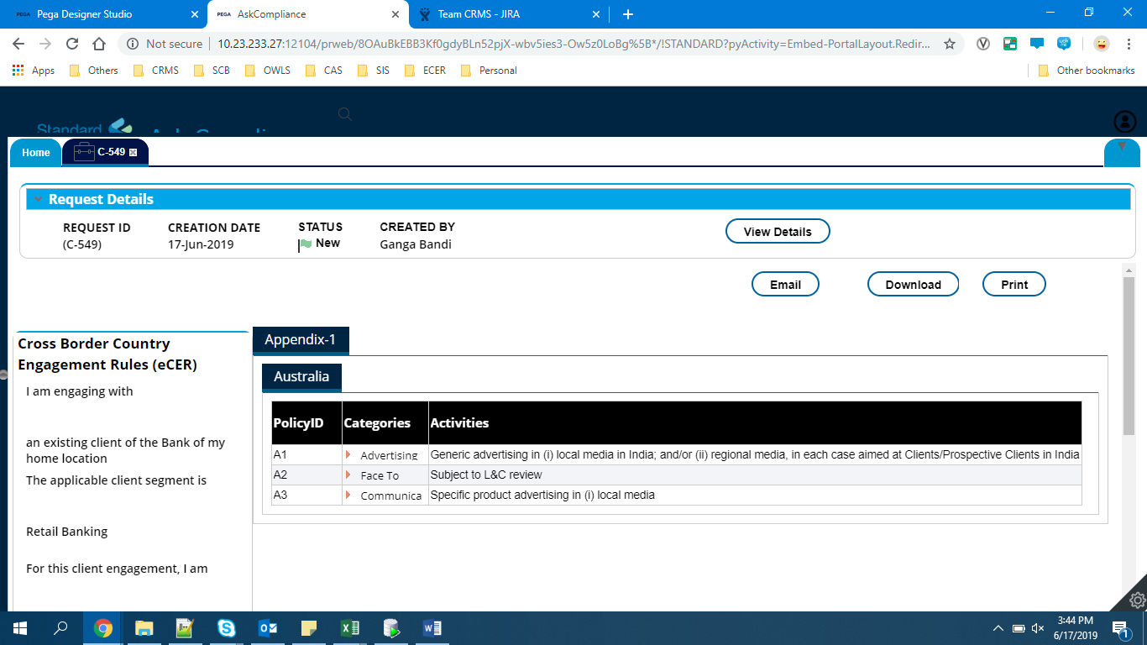

Solution:

Create a **PolicyDetails** section in the work class and add **Print** button

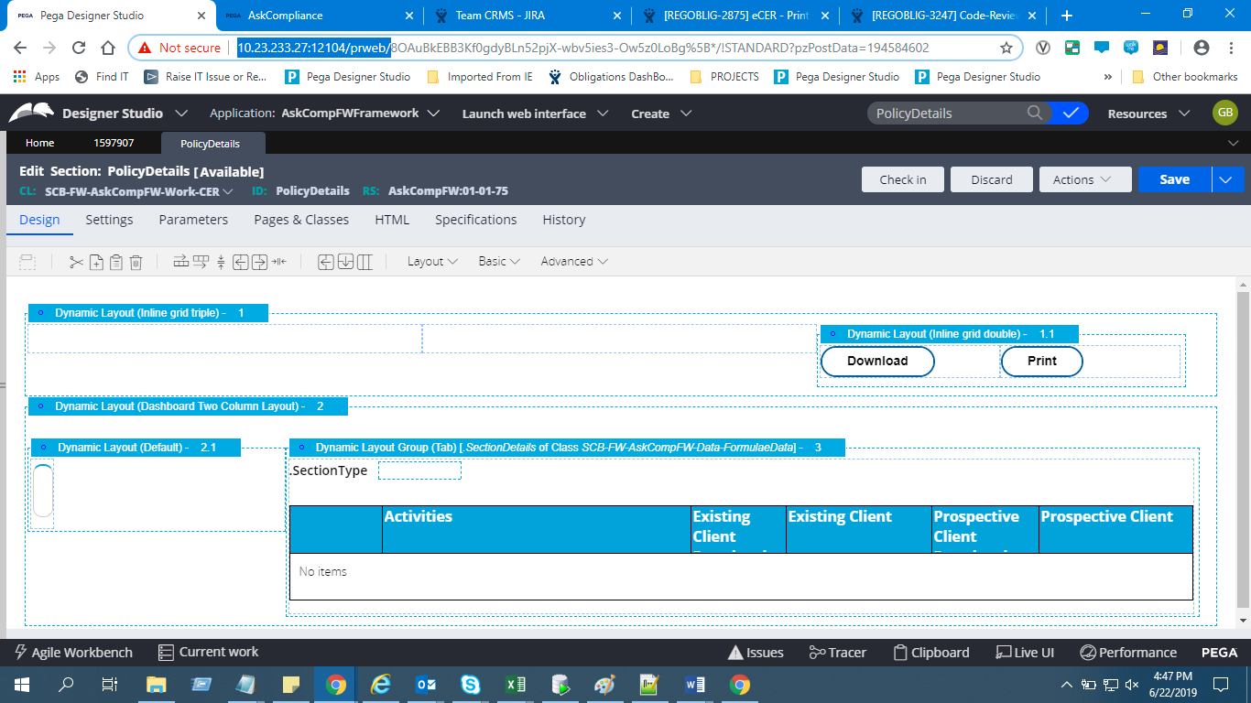

Under actions tab of **Print Button** call **PrintView** **Harness**.

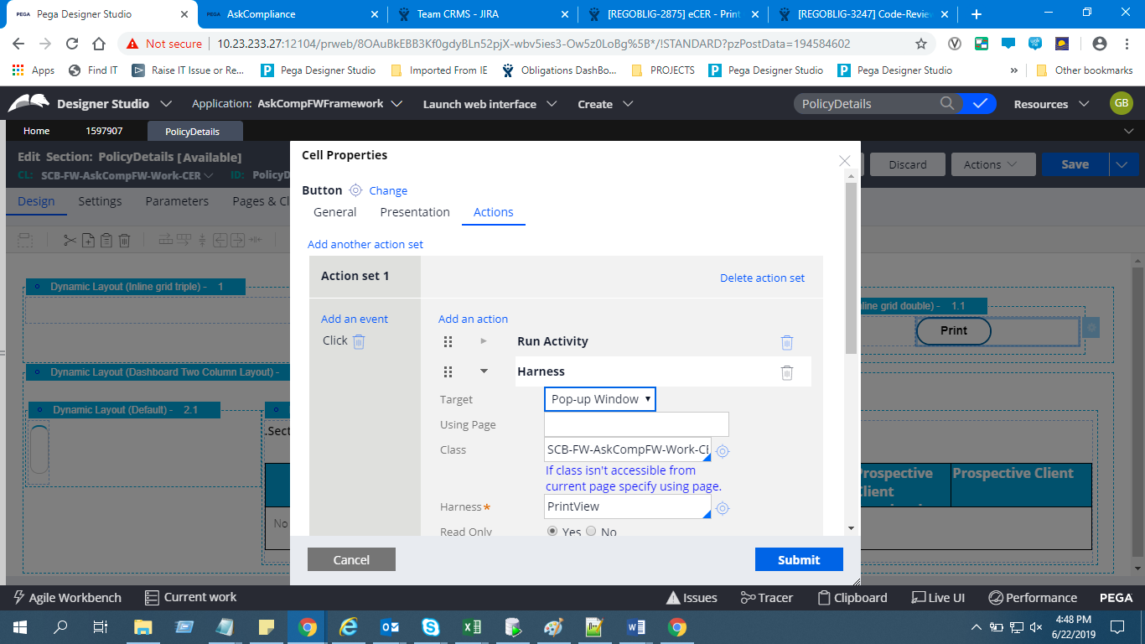

Clipboard structure: CountryReference-->SectionReference--->CategoryReference

CountryReference is a pagelist.Inside CountryReference we will have SectionReference pagelist and inside SectionReference we will have CategoryReference pagelist.

As we have CountryReference is a pagelist Inside CountryReference we will have SectionReference pagelist and inside SectionReference we will have CategoryReference pagelist we need to build the section that should display entire content present in all the pagelists in country wise.

(**Example**: CountryReference Pagelist contains two Pages Bangladesh and Australia. For Australia we will have one Page in SectionReference Pagelist and Bangladesh have Zero pages. Inside Australia SectionReference Pagelist we may have three pages for inside CategoryReference pagelist.)

We need to display 1st Bangladesh content and after that Australia content.

Steps to Create **PrintView Harness:**

Create a Harness rule in work class

Under Scripts and Styles tab give **harness_print** JS script (OOTB)

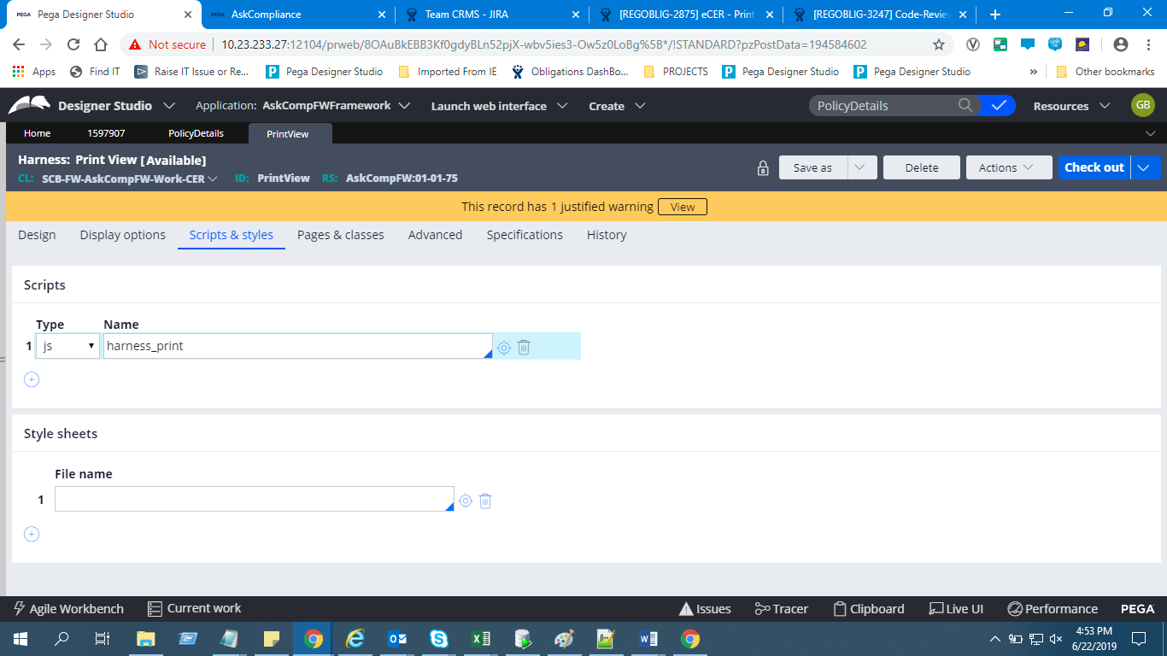

Add a container and inside it include a section that is to be printed

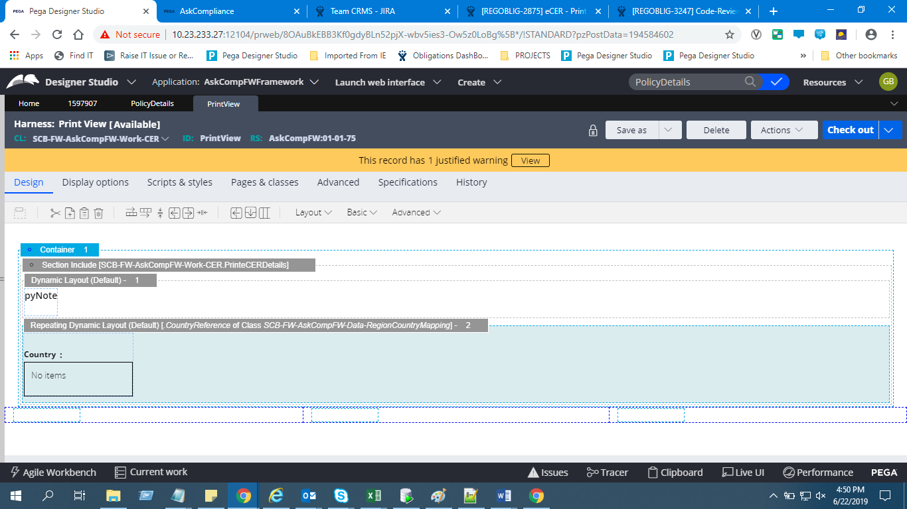

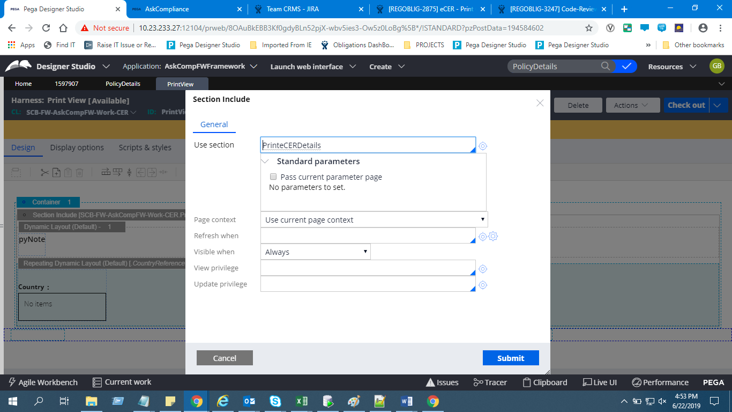

Include a Repeating Dynamic Layout with source as **CountryReference.**

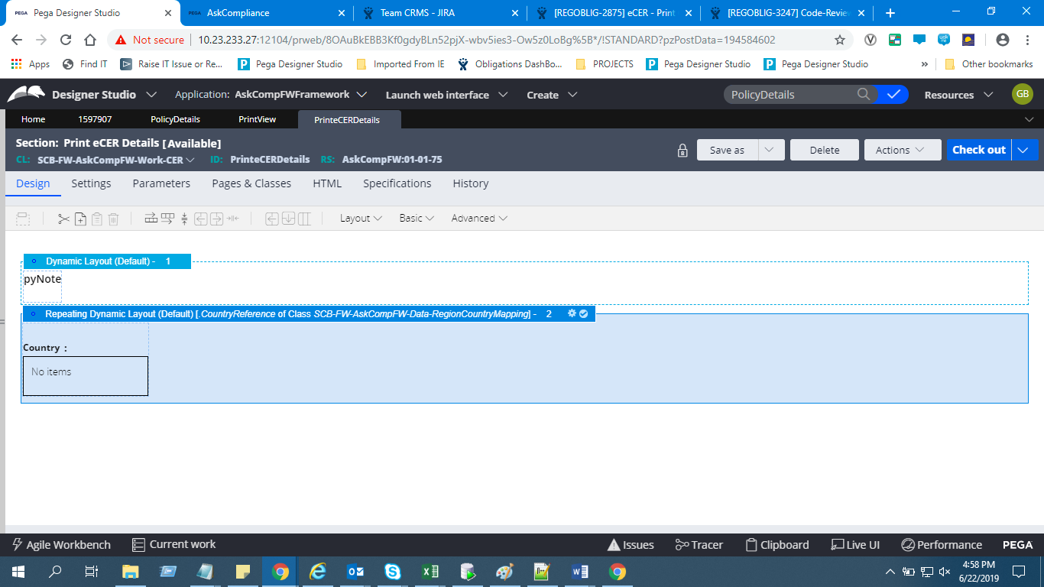

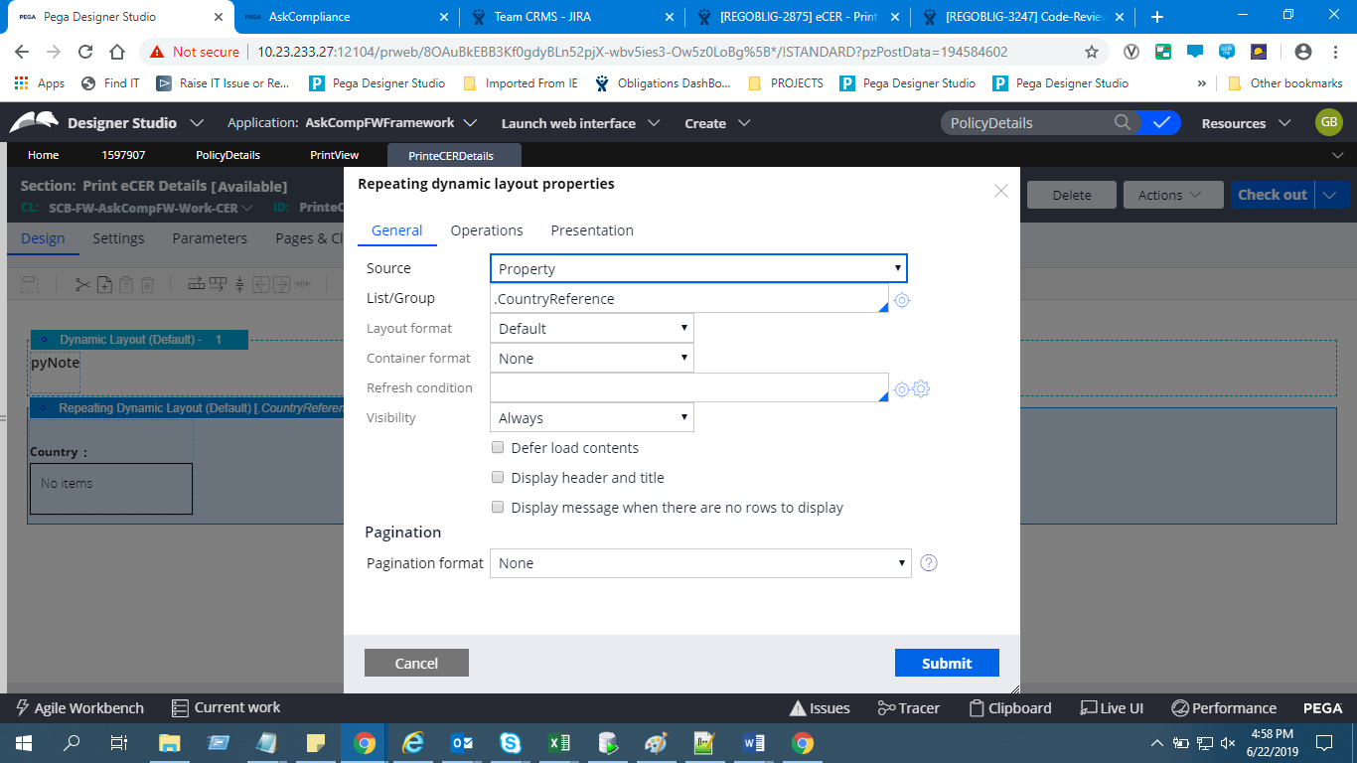

Include a Section in Repeating Dynamic Layout to display country details.

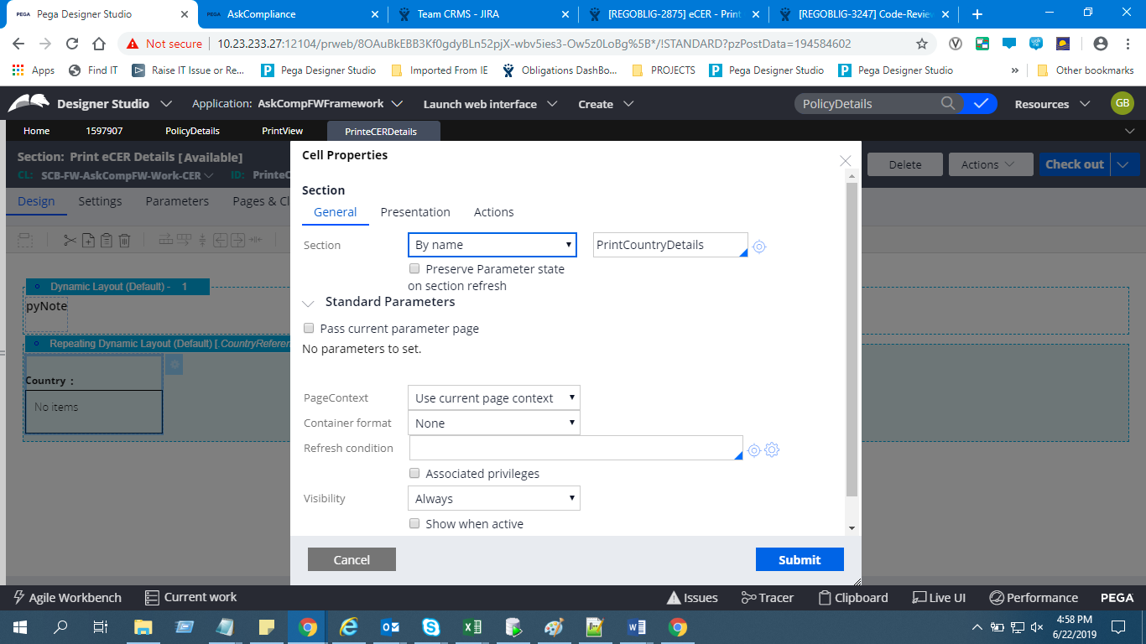

To avoid formatting issues in PDF Use Free form layout to display **CountryName**

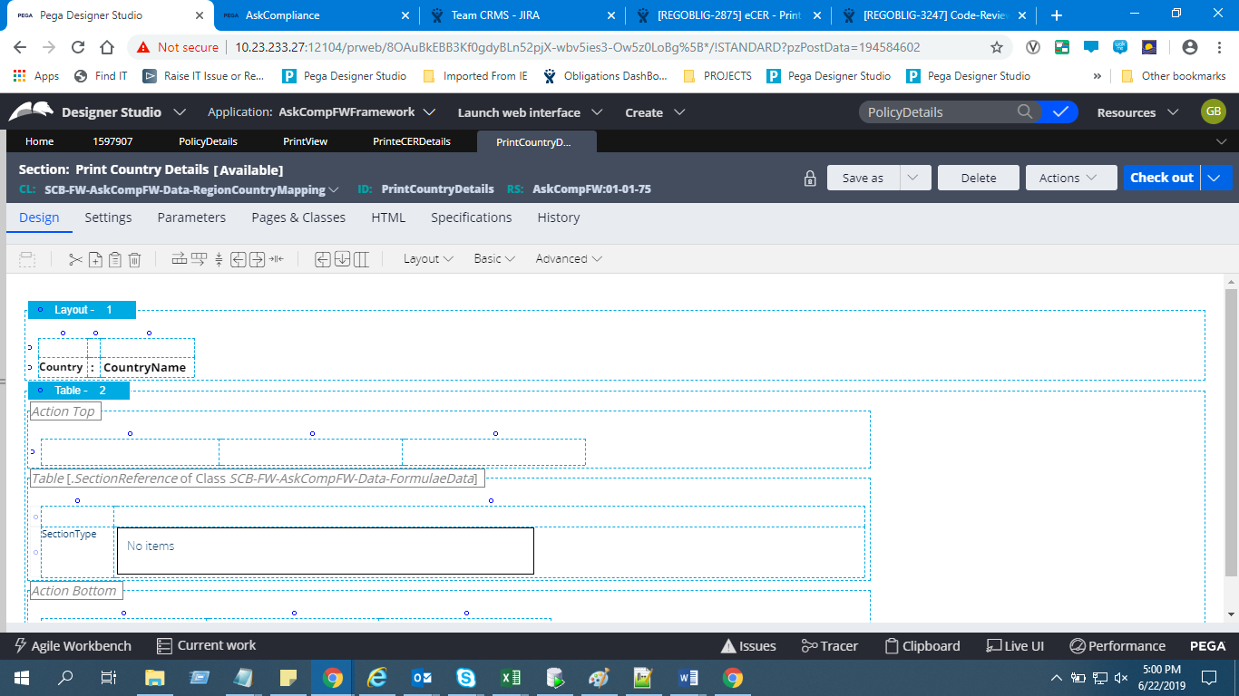

Include a Repeating Grid layout to display Section Details and category Details with source as **SectionReference**

In 1st column of the grid give Section Name in the Second Column Include another section to display Category Details.

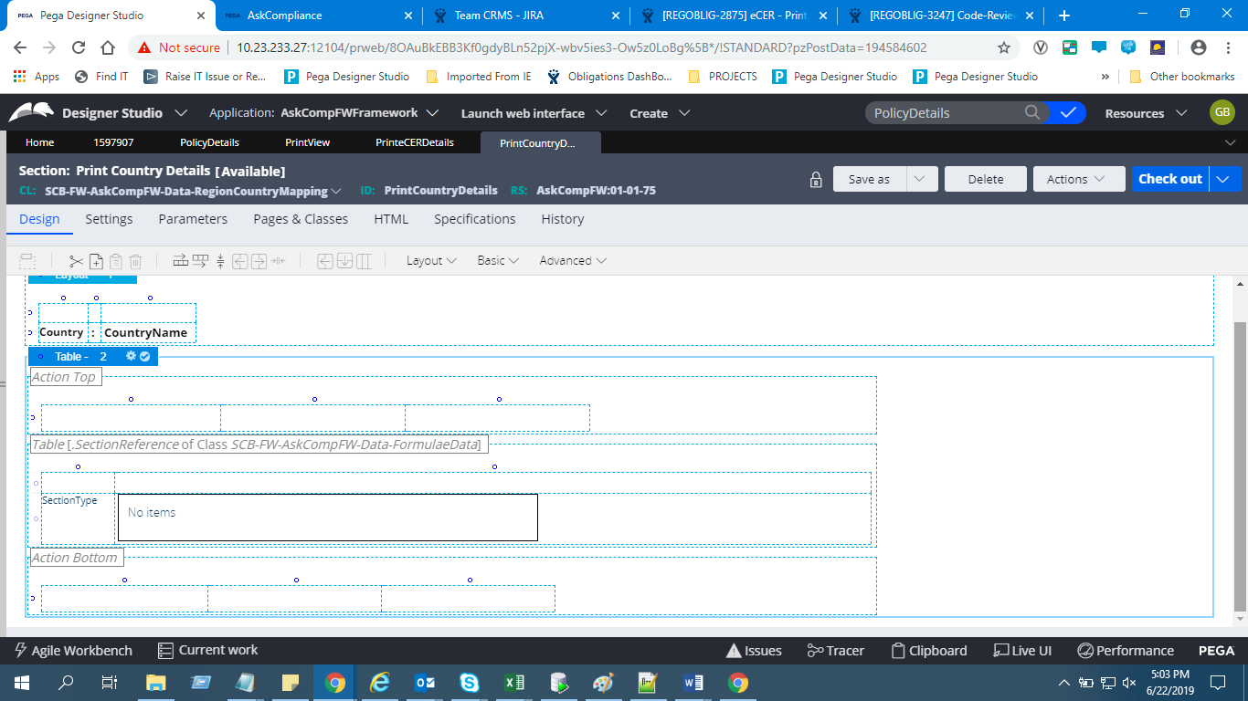

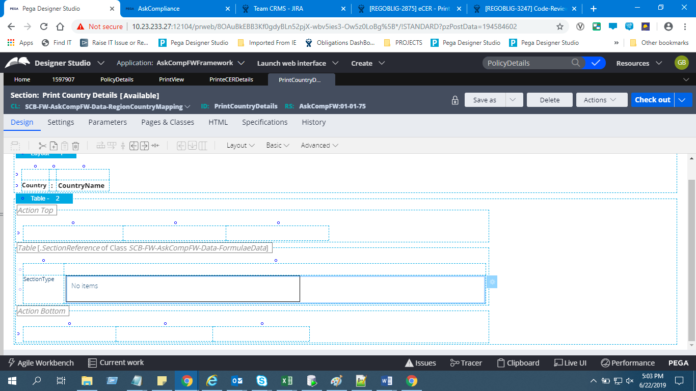

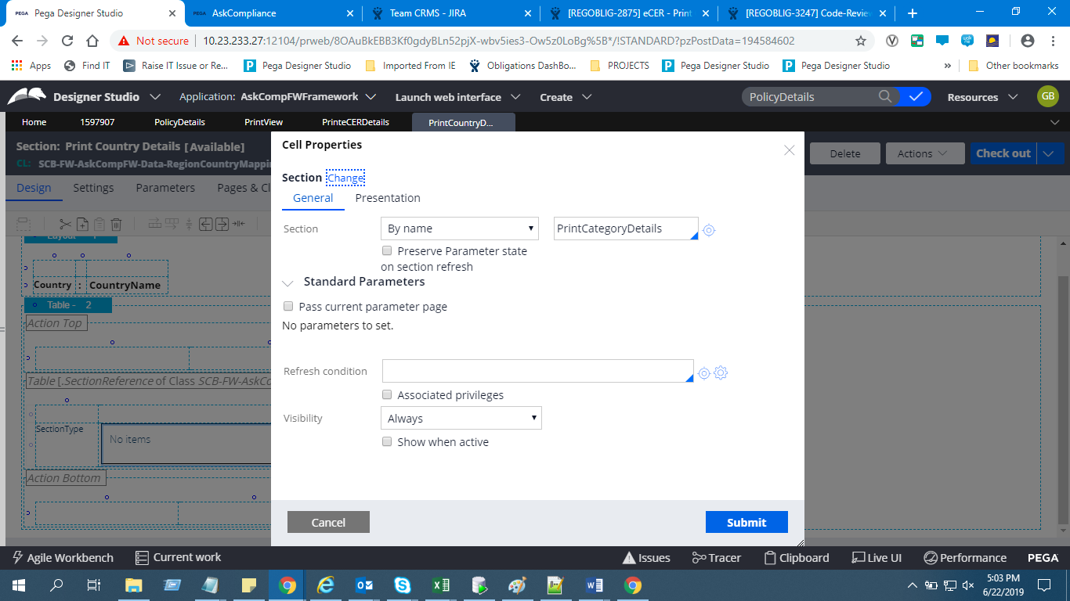

In PrintCategoryDetais Section include a repeating Grid with source as **CategoryReference.** This section is used to display Category Details.

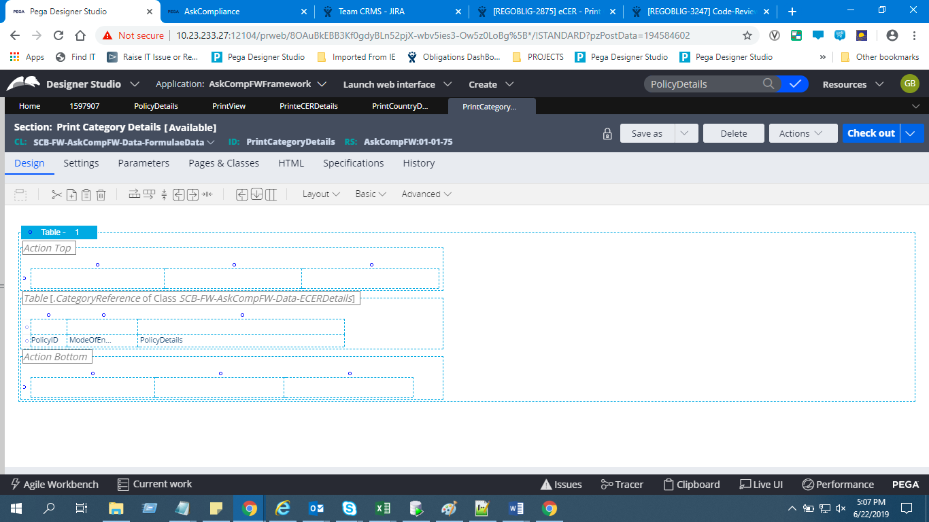

**OUTPUT**:

By clicking on the Print button in the below section PrintView harness will run.



