**Assignment on Multi-Select**

**Method-1**

Open a section. Navigate to Advanced tab. In the advanced tab, drag the Multi-Select List.

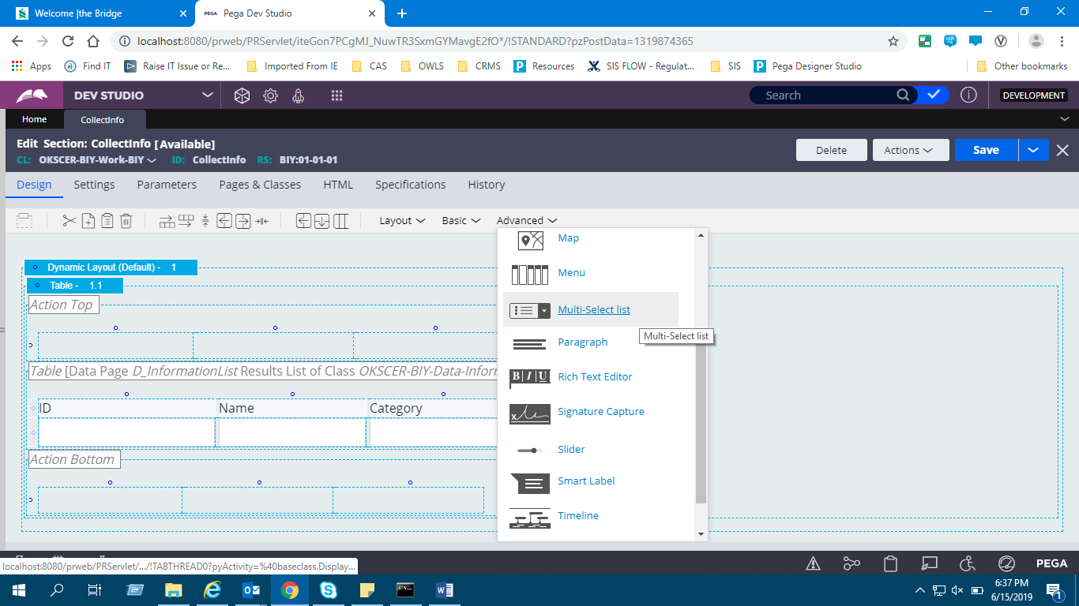

Drag a multiselect list.

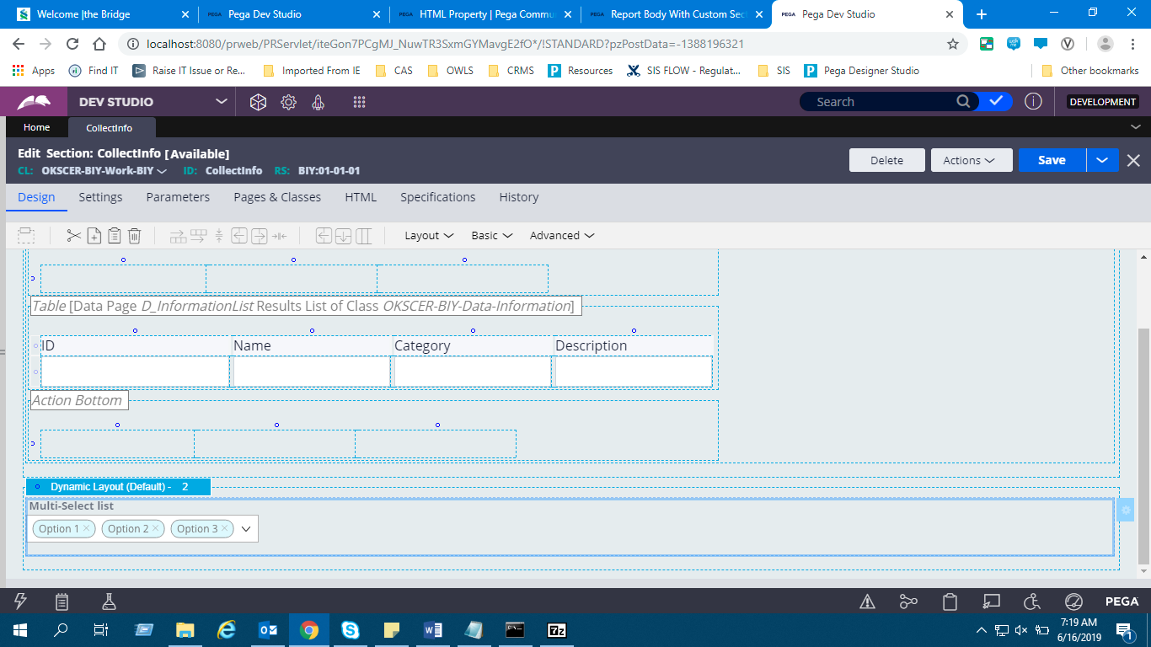

Open the multi select list and give the property. Create a property of type list.

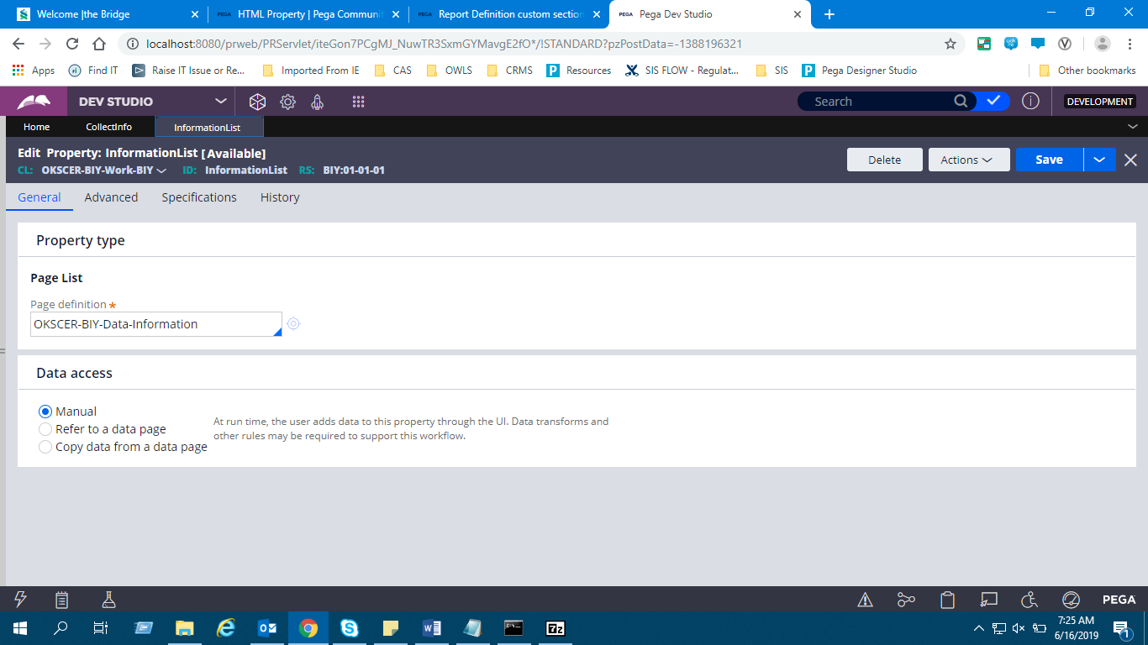

Refer the property in the multi-select list.

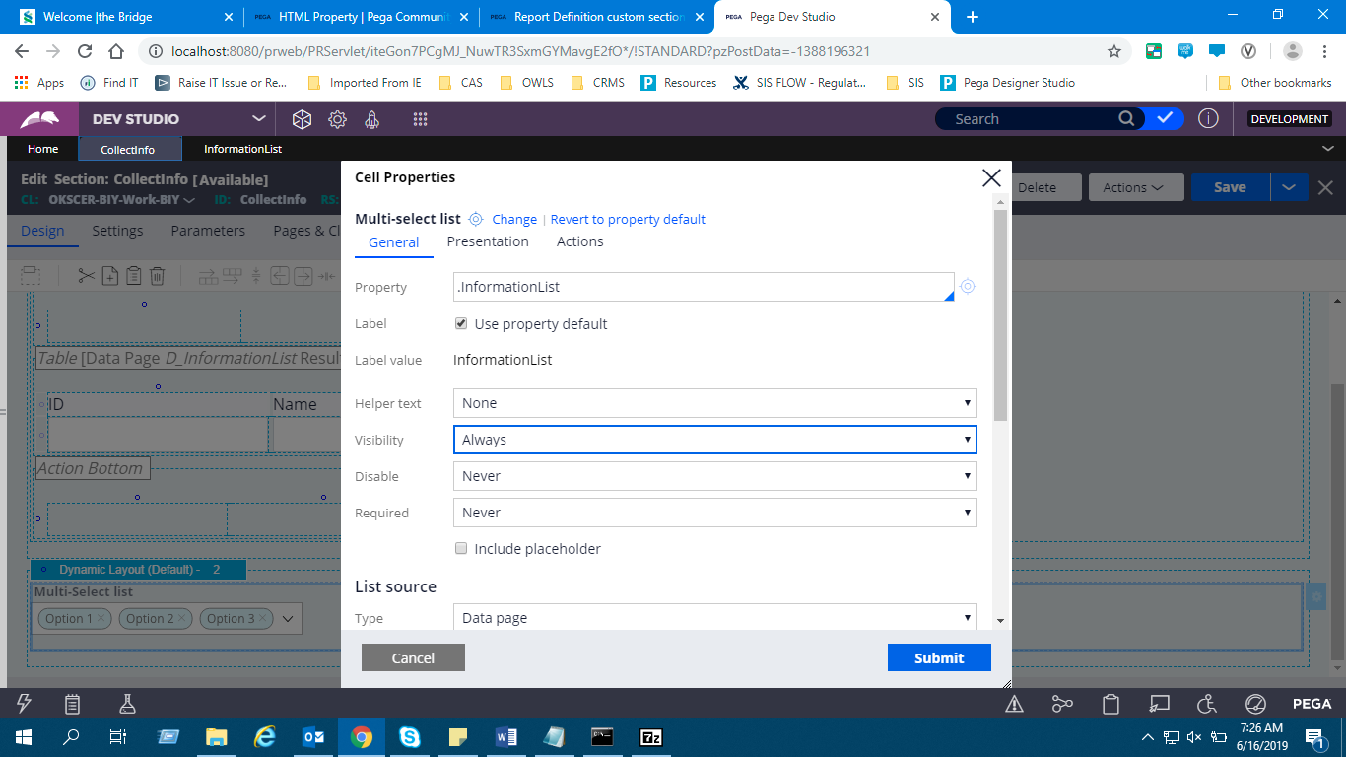

Select the source as Datapage/Report Def/any clipboard page.

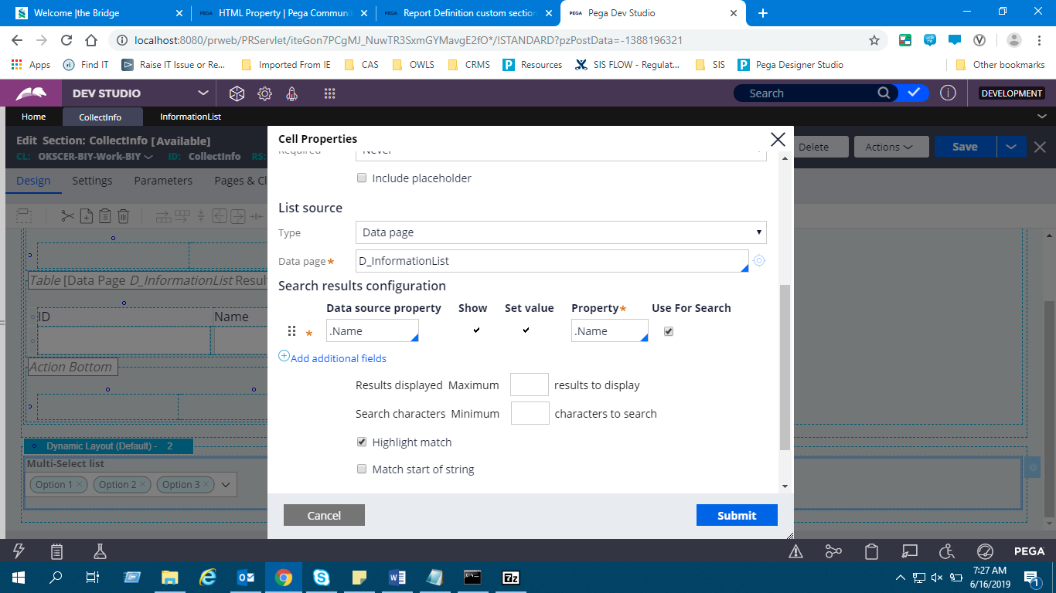

To get the value posted to clipboard add post value.

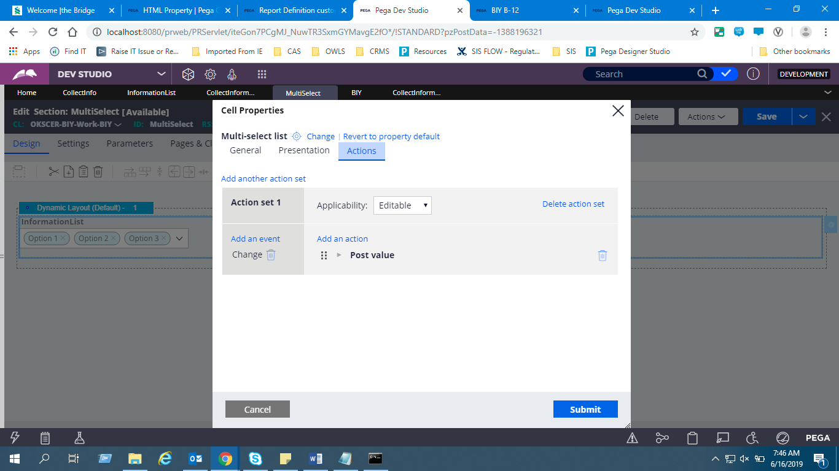

Now launch the portal. There click on the dropdown.

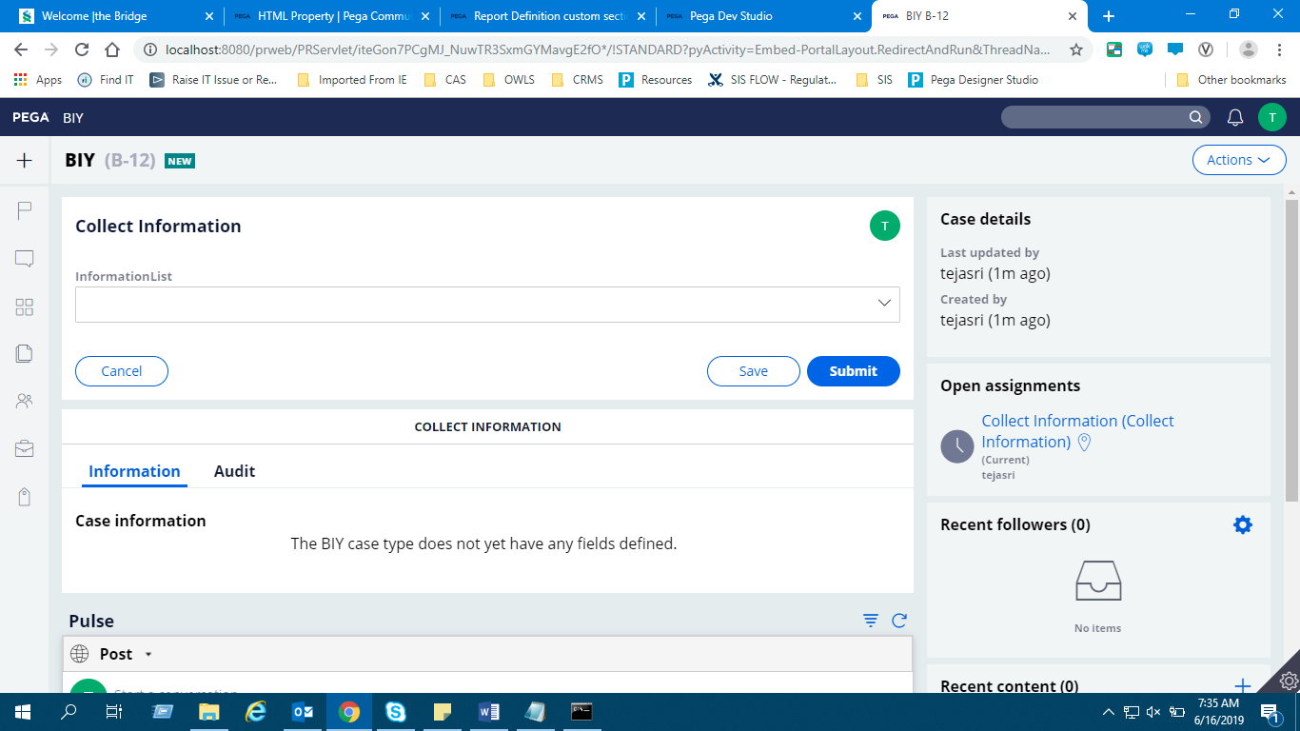

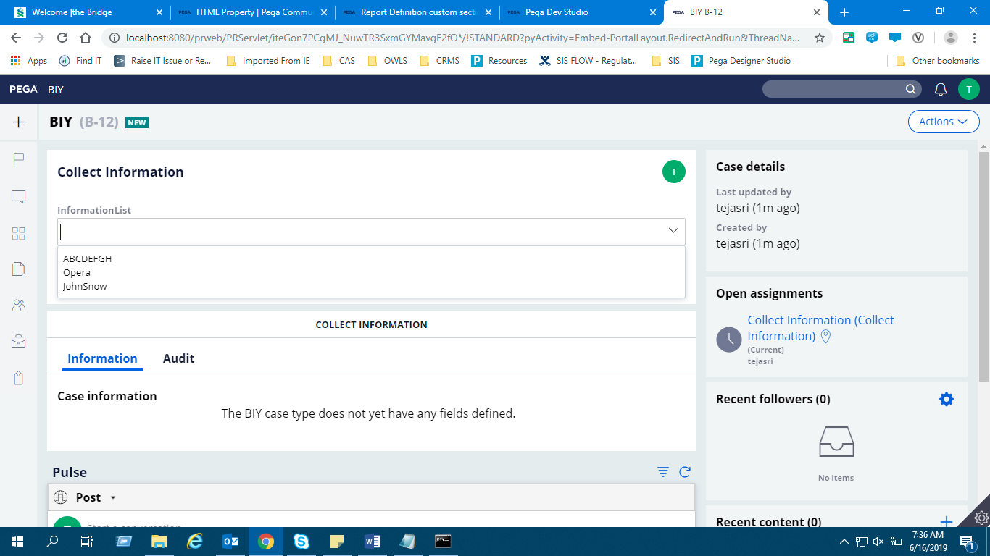

From the dropdown we can select multiple items.

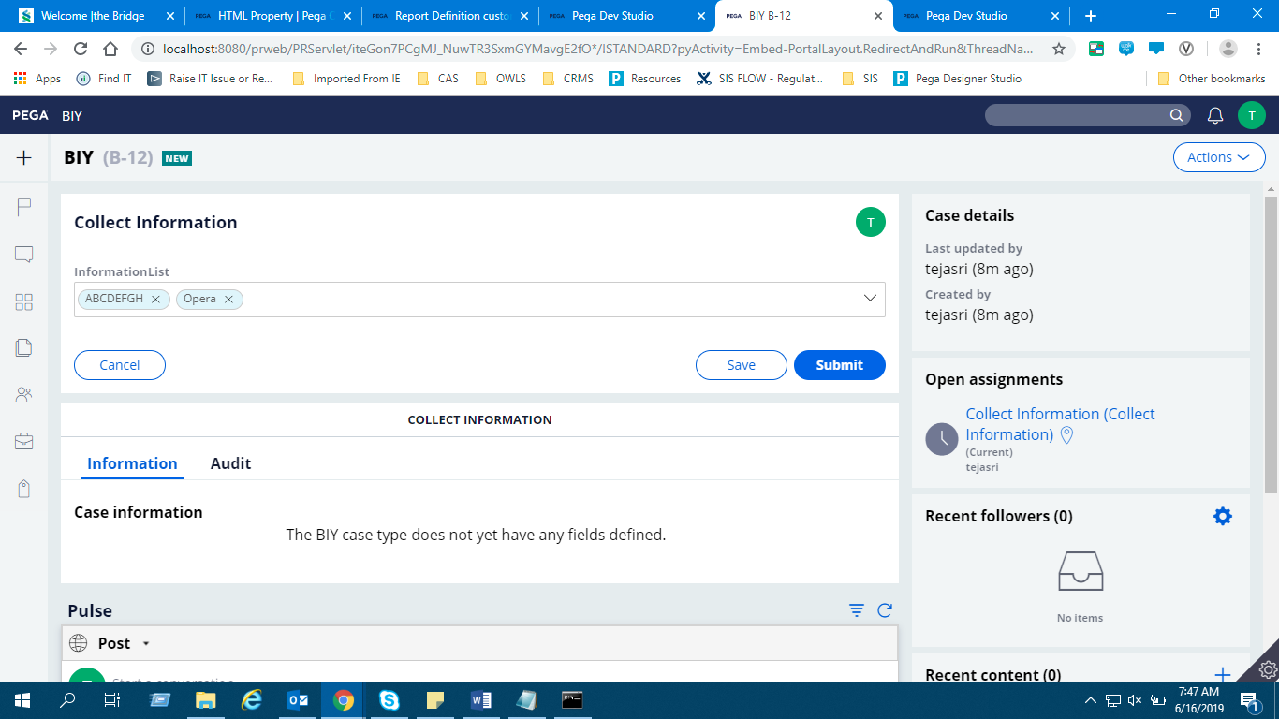

Now open clipboard and select the thread. Open Information List and check the results.

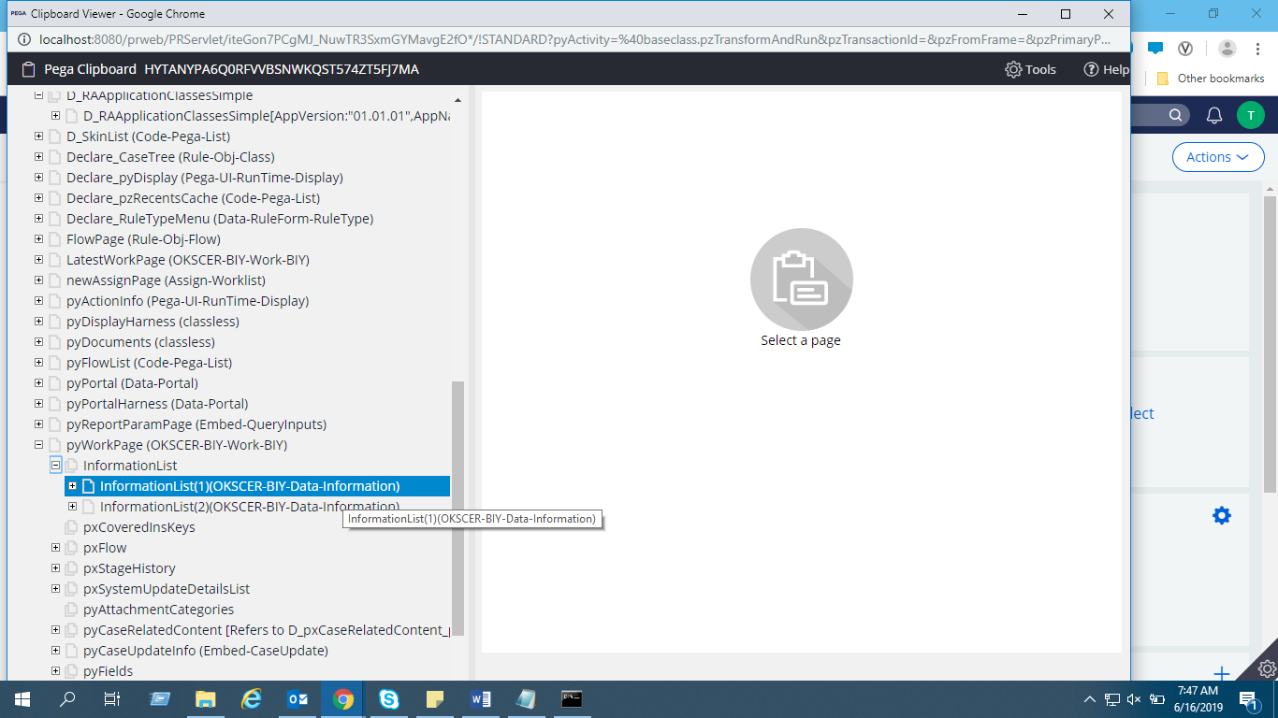

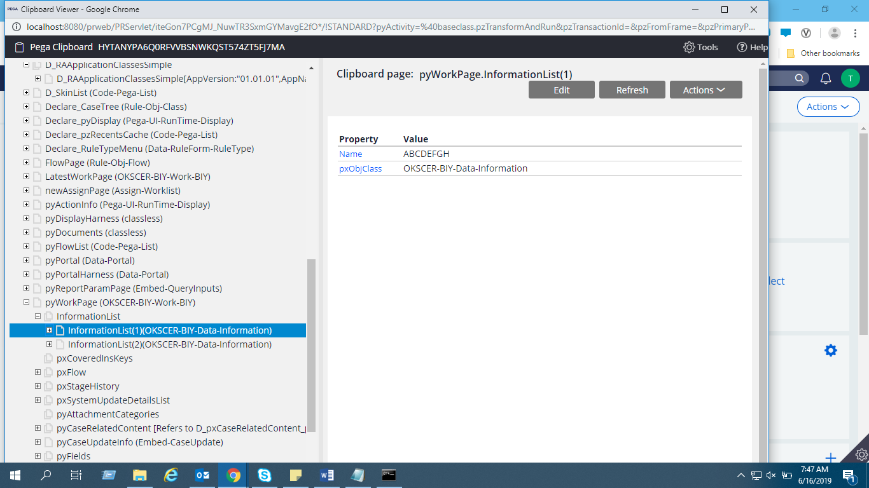

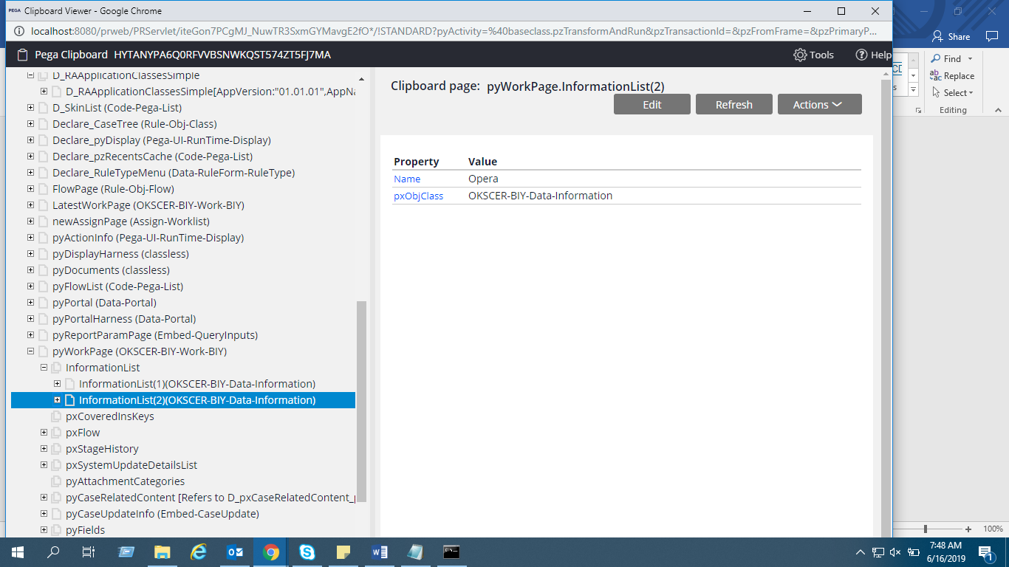

**Method -2**

Drag a table to section. Give the source as Datapage.

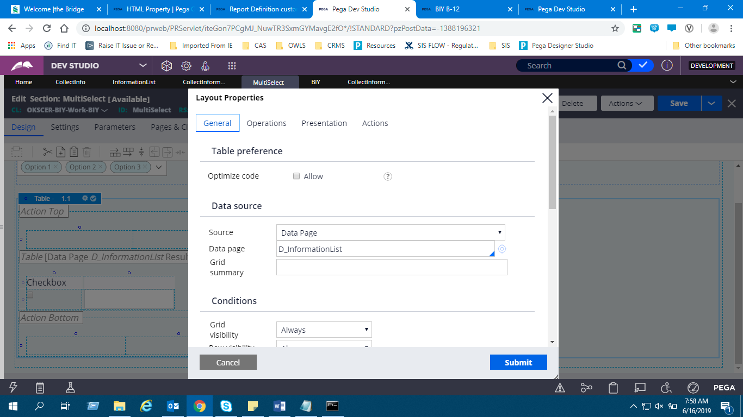

In the row, add a property ‘pySelected’ for displaying the checkbox. Or drag a checkbox and add in the row.

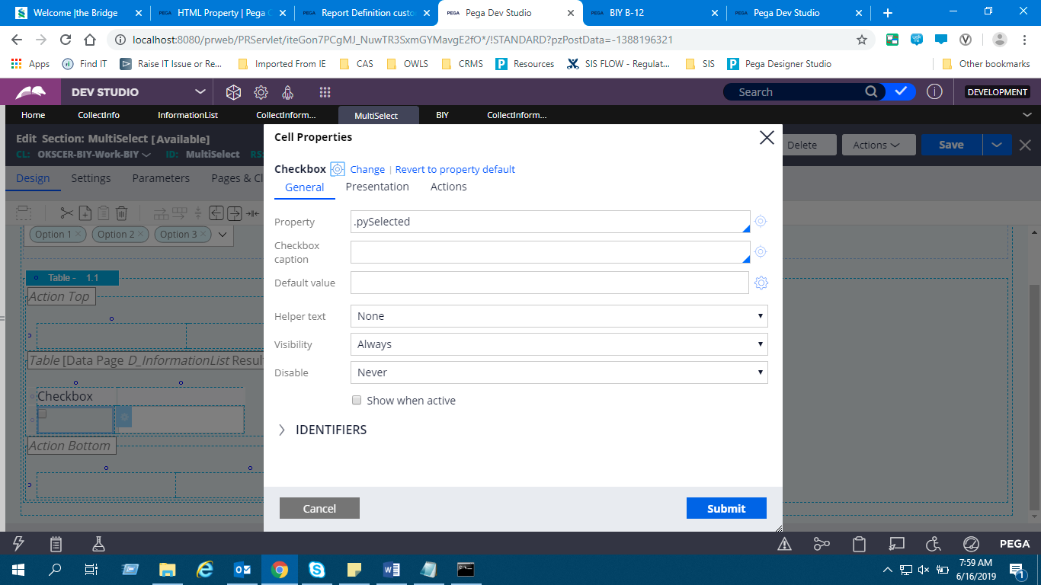

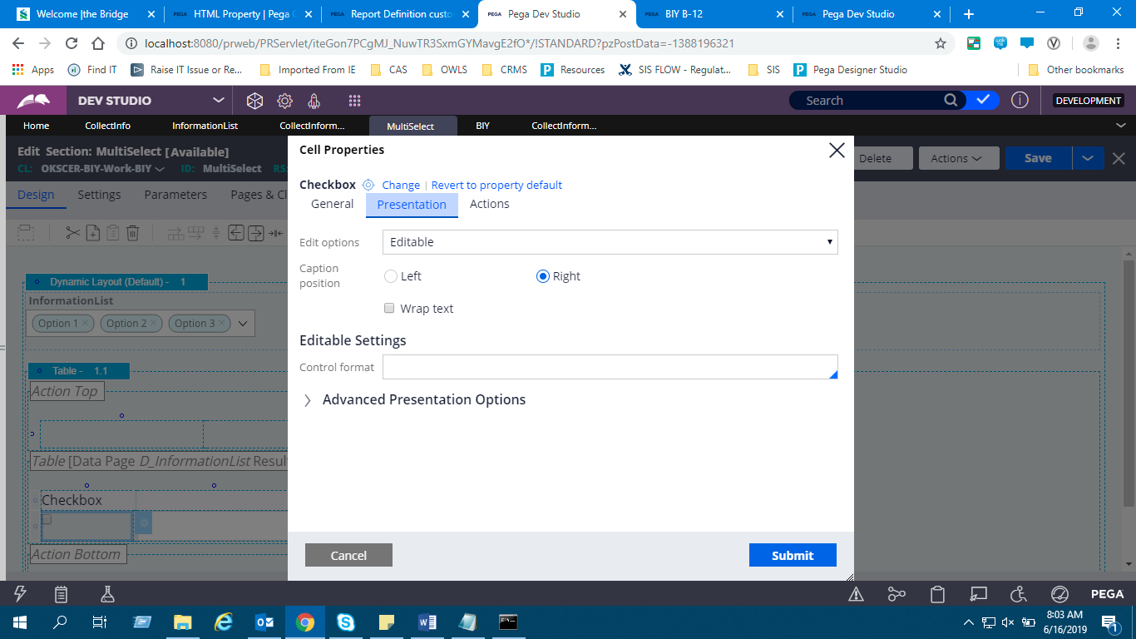

Add the property to be selected under multi select.

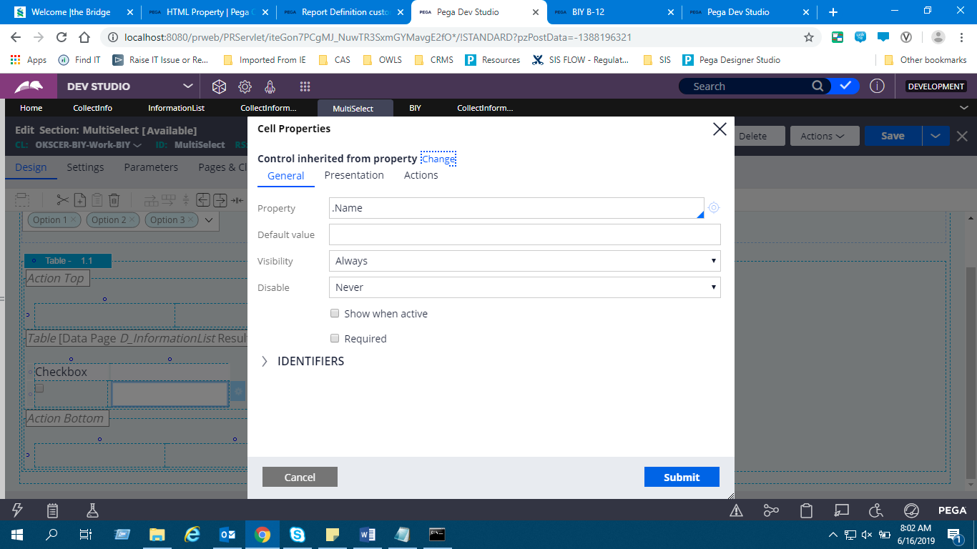

Now the table looks as follows.

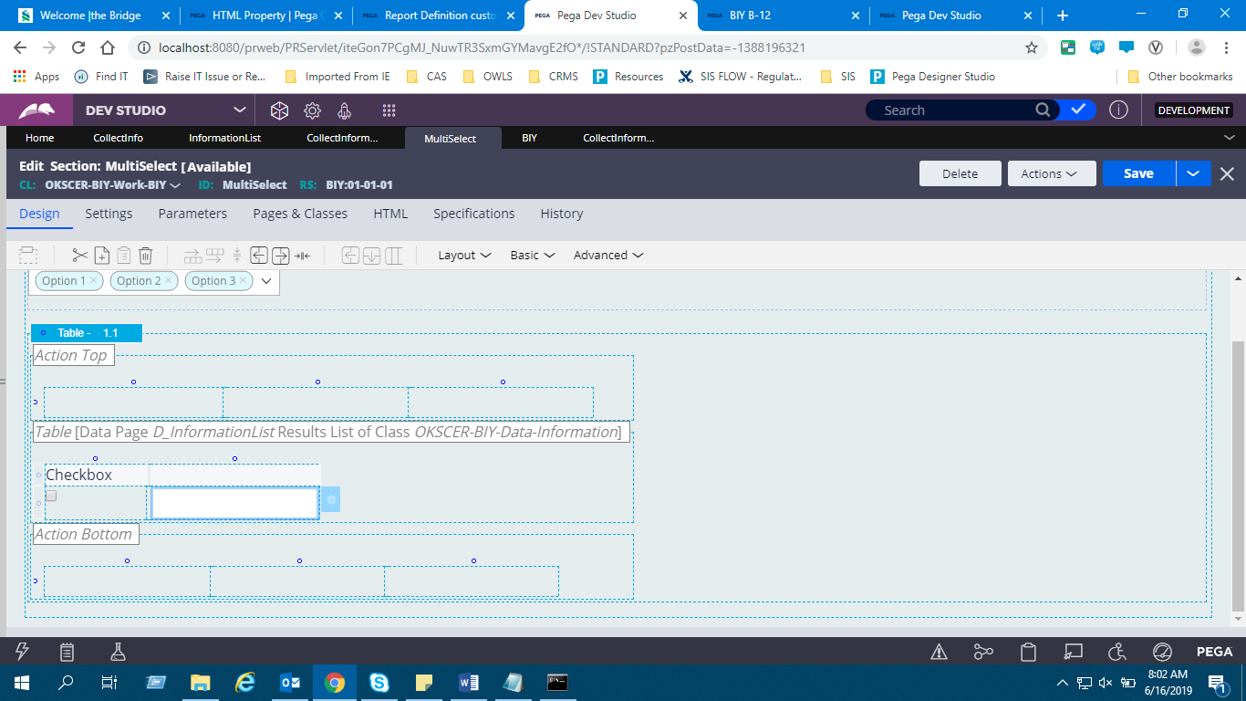

Launch the portal.

