**ASSIGNMENT**

**Setting Case Status at each stage:**

Decision table for setting status to each stage:

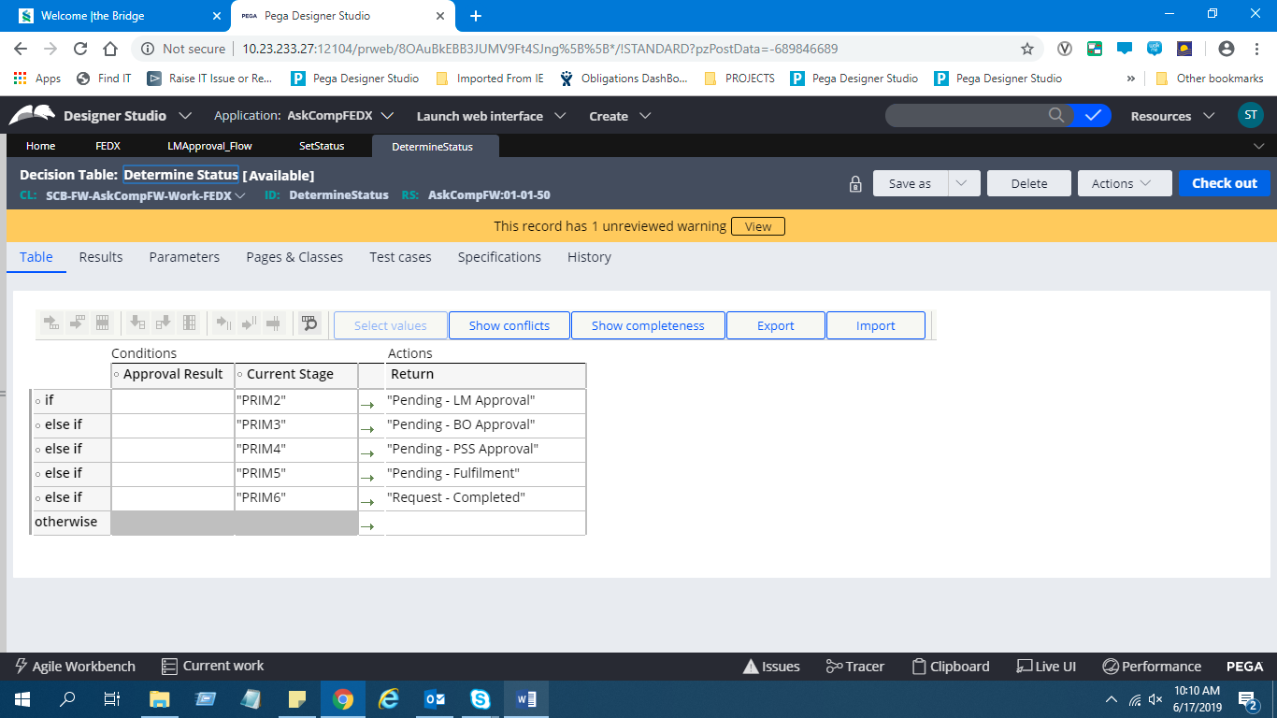

Calling the decision table in an Activity to update status:

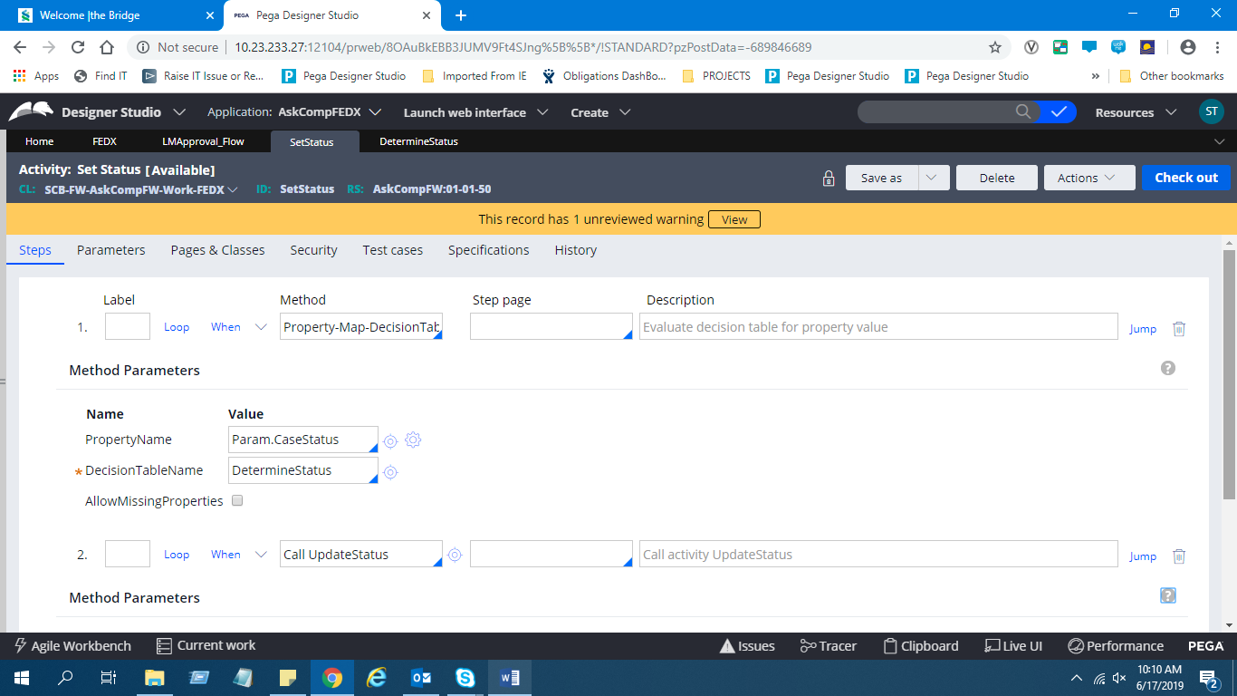

Calling an Utility shape and calling an Activity in that:

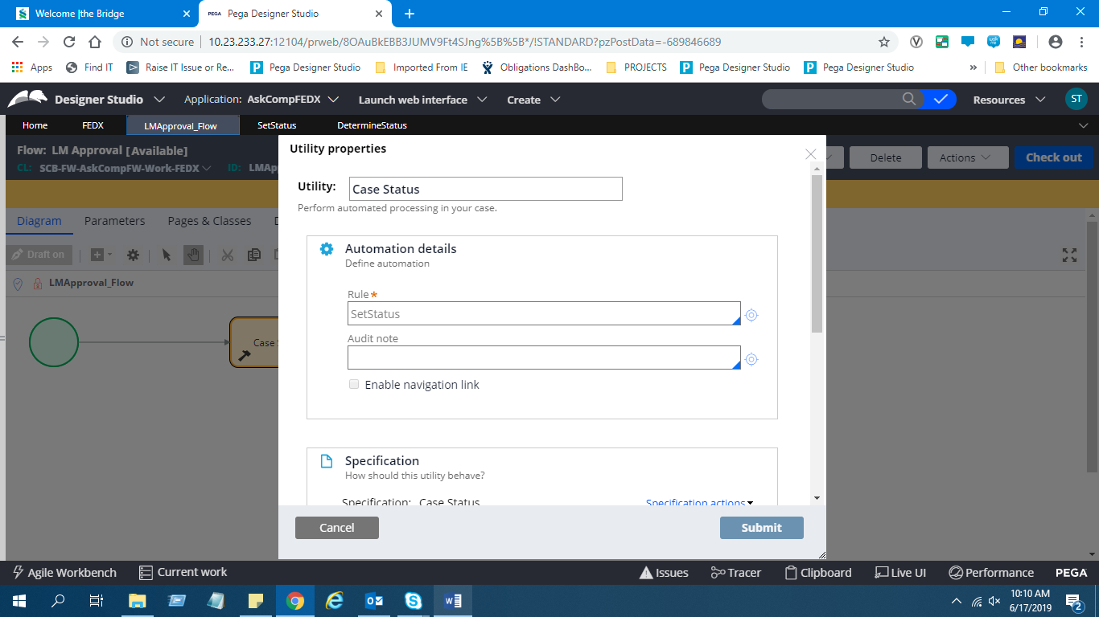

Configuring the Utility shape in the flow:

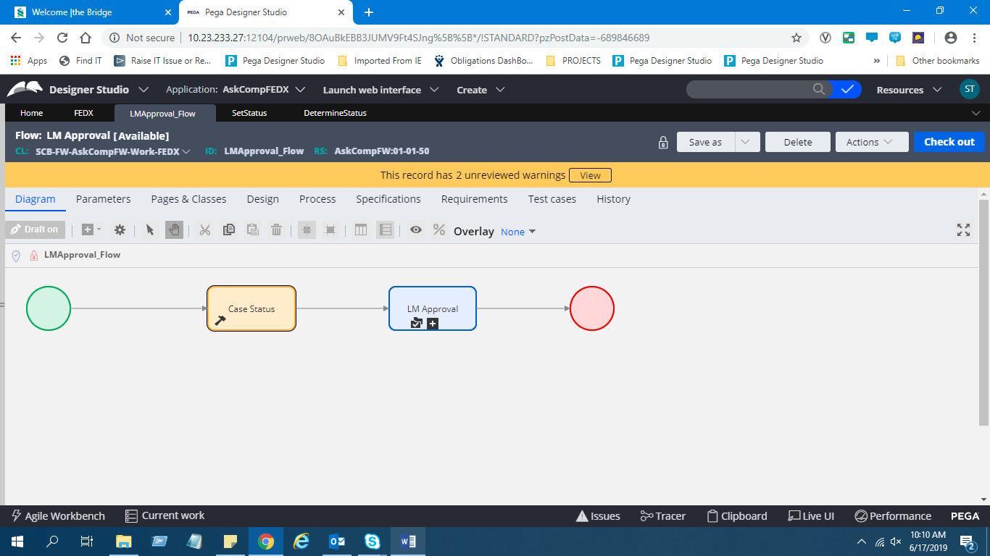

Status displayed at each stage:

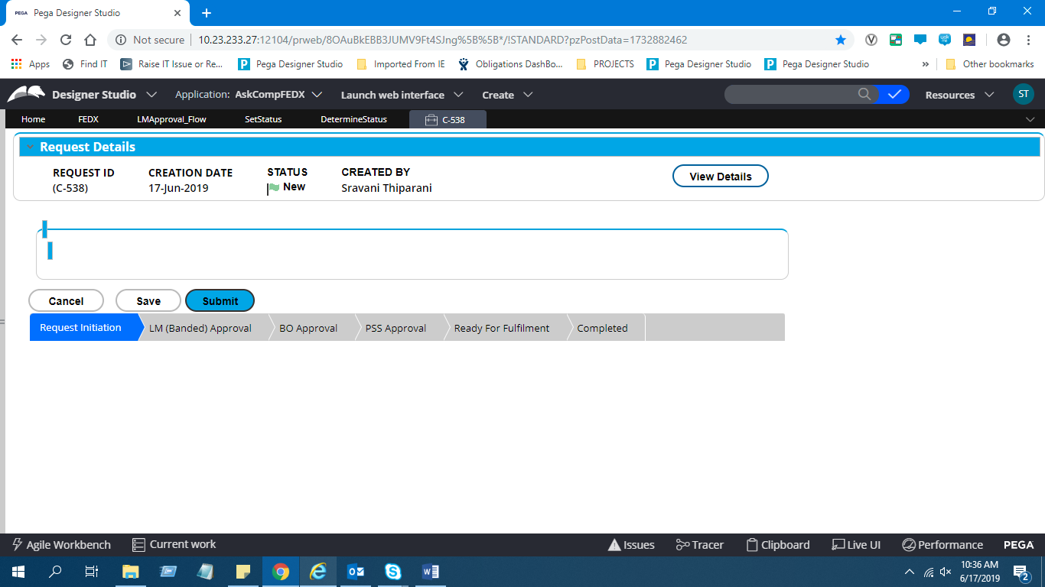

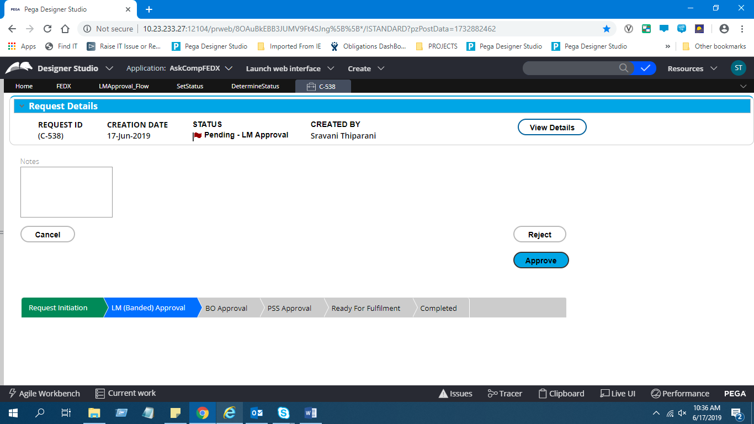

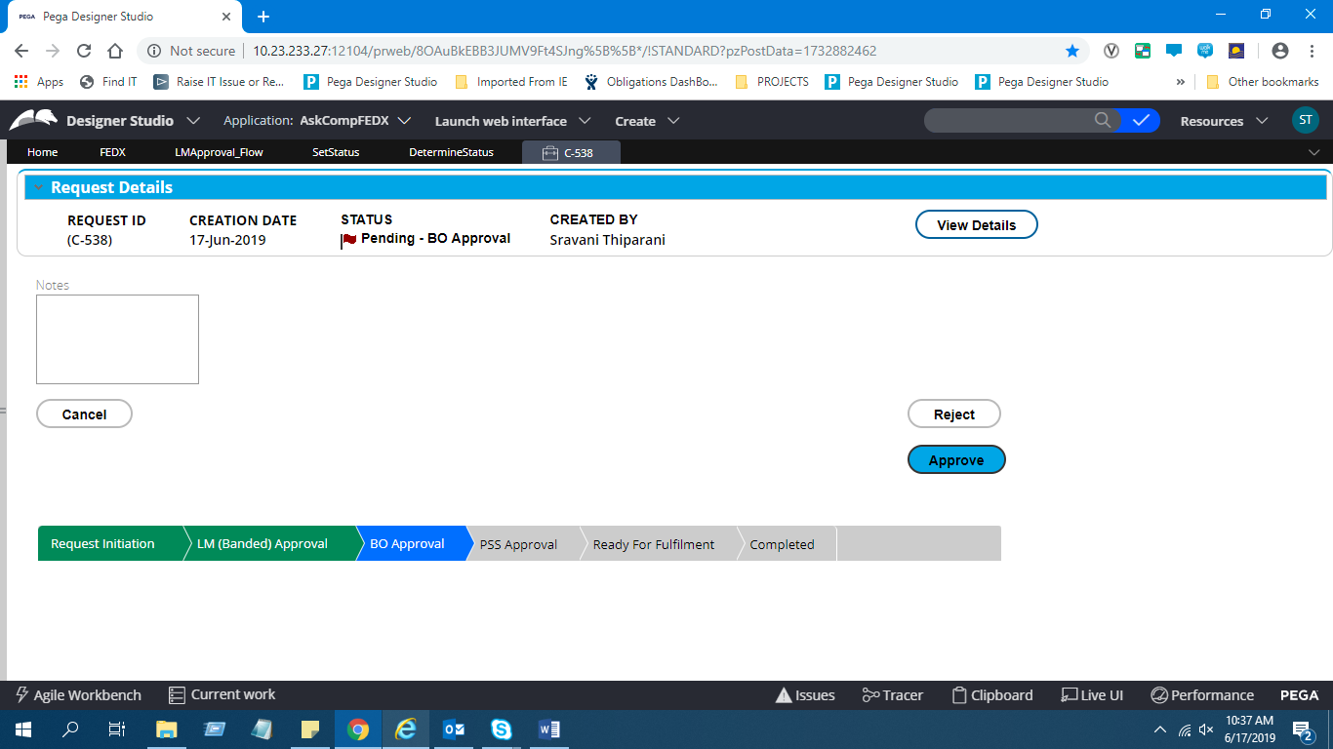

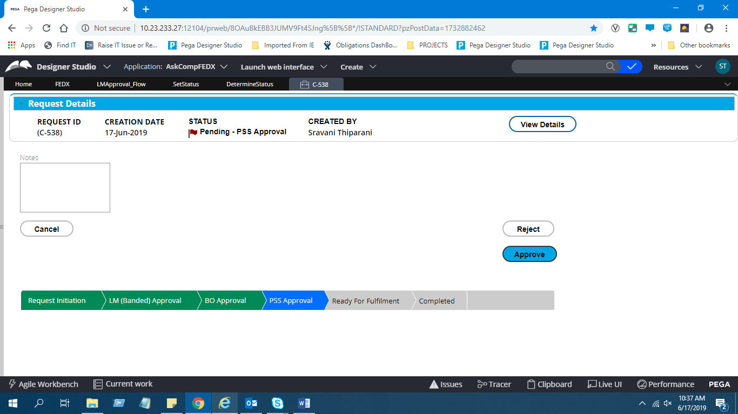

**Name** : T.Sravani

**ID** : 51749603.