**GEHC RPA**

**Tollgate 2**

**HC_FIN_19002.1**

**Weekly Pacing Bot #1**

**Revision History**

|  |  |  |  |
| --- | --- | --- | --- |
| Date | Revision | Author | Description |
| 14/11/2019 | 1.0 | Amit Chaudhari | Basic Template |
|  |  |  |  |
|  |  |  |  |

# Contents

Contents 4

Introduction 5

Intended Audience 5

Functional Design 6

Process Description 6

Current Process 6

Robotic Process 7

Connected Systems/Components 11

Connected Systems 11

Schedule 12

Technical Design 13

Logging 13

Assets 14

Exception handling 14

Workflows 15

Custom Code Requirements 16

Breakdown of Process Steps 16

# Introduction

This document outlines the design and goals for the automation of the ***Weekly Pacing Bot #1 HC_FIN_19002.1.*** This is a considered a living document that will grow and change as the project is actively developed or modified.

This ***Weekly Pacing Bot #1*** consists of 4 sub processes:

* 1. Commercial Pacing
  2. Headcount Pacing
  3. T&L Pacing
  4. Operational Linearity

## Intended Audience

This document is intended for RPA Developers and those involved in the project management of the RPA Project ***HC_FIN_19002.1***. For this document, assumption is made that the reader has knowledge of RPA, and the processes up to this point.

* Developer: Amit Chaudhari
* Project Manager: Nikhil Shinde

# Functional Design

## Process Description

This document describes bot processes designed to automate the manual task of updating GEHC Pacing Qxmonth.day.year.pptx with all required special data from Spotfire dashboard.

Bot will connect to GE box location, Spotfire & Tableau URL to download the required data and then will update the excel sheets and GEHC Pacing Qxmonth.day.year.pptx with extracted data.

## Current Process

For the current process, user manually access GE Box and get Order & Sales Pacing template Excel. Login to Spotfire and extract data from Operational Pacing and Sales Triangulating dashboard & update it into excel. Login to Qliksense and extract data from BioPharma Financials and QTD Trending tab & update it to excel template. Go back to GE Box and get HeadCount Pacing template excel. Login to Spotfire and extract data from Weekly Trends detailed, Contractors and Raw data tab and update it into excel. Connect to Headcount DB.accdb database & update the data into database. Again, go back to GE Box and get TL Pacing FWxx.xlsb template file. Login to Spotfire and apply some filter then extract data from T&L Dashboard and update it into excel. Download the GEHC Pacing Qxmonth.day.year.pptx from GE Box. Login to Tableau Operational Linearity dashboard and take screenshot of various tabs. Open the PPT template file & update the PPT slides with extracted data from Commercial, Headcount, T&L and Operational pacing process. Save and upload the PPT in GE Box.

## Robotic Process

* 1. Commercial Pacing Process

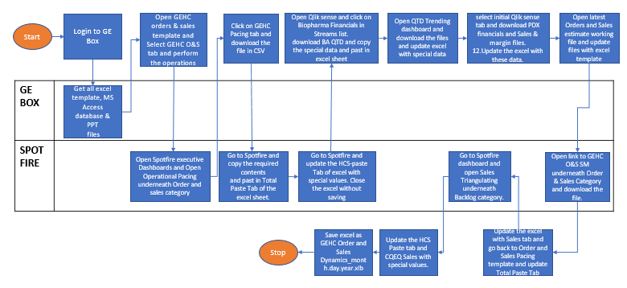

* 1. Headcount Pacing Process

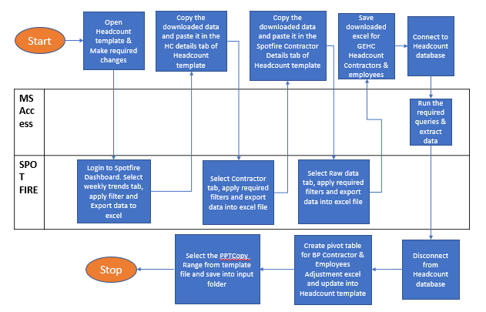

* 1. T&L Pacing Process

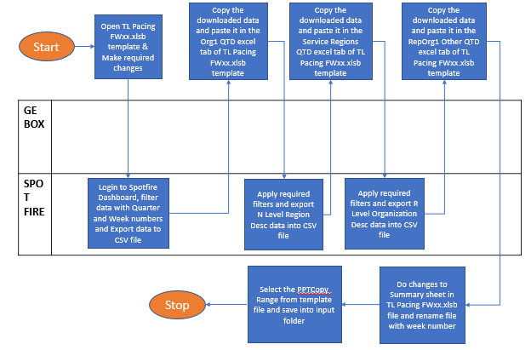

* 1. Operational Linearity Process

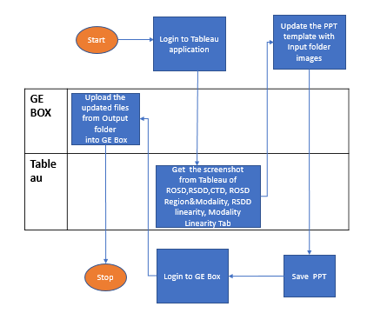

# Connected Systems/Components

## Connected Systems

|  |  |  |  |  |  |
| --- | --- | --- | --- | --- | --- |
| System Name | Usage | Path | Contact/Method for Requesting Access | Access? | ID |
| GE Box URL to Download Orders and Sales Pacing excel template | To download Orders and Sales Pacing excel template | <https://ge.ent.box.com/folder/87948015337> | Request through the email. | Yes | 503155107 |
| Spotfire | Getting Required data | [http://sc.ge.com/*execdash](http://sc.ge.com/*execdash) | Request through link | Yes | 503155107 |
| Qliksense | Getting Required data | <https://qliksense.health.ge.com/> | Request through link | Yes | 503155107 |
| Tableau | Getting Required data | https://tableau.idc.ge.com/ | Request through link | Yes | 503155107 |

|  |  |  |
| --- | --- | --- |
| Name | Version | Source |
| Chrome | Version 72.0.3626.119 (Official Build) (32-bit) | Desktop Experience |
| Microsoft Excel | Office 365 | Installed |
| Power Point | Office 365 | Installed |
| MS Access database | Office 365 | GE Mytech website |
| MSAccessDatabaseEngine | Version x64 bit | IT team |

Software

Process Considerations

|  |  |
| --- | --- |
| Expected volume of output | ~ 4 files per run |
| Transaction Run Time | ~20 min per transaction |
| Total Run Time | ~90 min |
| Number of Bots | 1 |
| Use of Queue | No |
| Bulk Process | Yes |
| Ad-Hoc Request Support | No |

## Schedule

Weekly – Once in a week

# Technical Design

## Logging

* Process logs
  + Start/finish of process
    - Name: Weekly Pacing Bot # 1
    - Project ID: HC_FIN_19002.1
* Transaction logs
  + Unit of Work: Weekly Status Reports
  + Transaction Name: Weekly Status Reports
  + Transaction ID: *Report_CurrentDate*
* Task logs
  + *Initialization for the process*
  + *Logging to the Box Folder*
  + *Downloading file from Box*
  + *Excel manipulation logs*
  1. ***Commercial Pacing***
  + *Spotfire login logs*
  + *Spotfire dashboard data extraction logs*
  + *Qliksense login logs*
  + *Qliksense dashboard data extraction logs*
  + *Updating edit link in excel logs*
  + *Logs for storing images in input folder for PPT*
  1. ***Headcount Pacing***
  + *Spotfire login logs*
  + *Spotfire dashboard data extraction logs*
  + MS Access Database *Initialization logs*
  + Logs for Executing queries
  + *Logs for storing images in input folder for PPT*

***1.3 T&L Pacing***

* + *Spotfire login logs*
  + *Spotfire dashboard data extraction logs*
  + *Logs for storing images in input folder for PPT*

***1.4 Operational Linearity***

* + *Tableau login logs*
  + *Tableau dashboard data extraction logs*
  + *Logs for storing images in input folder for PPT*
  + *Power point operations logs*

## Assets

|  |  |
| --- | --- |
| **Asset Name** | **Description** |
| **HC_FIN_19002_1_Box_Credentials** | Bot Credentials |
| HC_FIN_19002_1_BOX_Upload_Url | Box URL to upload the excel containing processed data |
| **HC_FIN_19002_1_**Spotfire**_URL** | Spotfire URL |
| **HC_FIN_19002_1_** **Qliksense** **_URL** | Qliksense URL |
| **HC_FIN_19002_1_Tableau_URL** | Tableau URL |

## Exception handling

* Operational Exceptions
  + *Login to the Box Faults*
  + *Login to Spotfire login faults*
  + *Login to Qliksense Login faults*
  + *Login to Tableau login faults*
    - *Retry for standard attempts*
* Functional Exceptions
  + *File Missing in the box or inaccessible- Log message in status file*
  + *Spotfire data not found-Log message in status file.*
  + *Qliksense data not found-Log message in status file.*
  + *Tableau data not found-Log message in status file.*
  + *MS Access database not found-Log message in status file.*
  + *Power point file not found-Log message in status file.*
* Coding Exceptions
  + Not able to connect to MS Access database.
  + Executing queries into MS Access database.
  + All other exception will be covered under the framework level.
    - Reported to the team either through mail or status report.

## Workflows

|  |  |  |  |  |
| --- | --- | --- | --- | --- |
| Workflow Name | Description | Input | Output | Reusability? |
| BoxLogin | Login to the box folder | Robot SSO and url | Login to box | Yes |
| BoxUpload | Upload the report | File path | New file | Yes |
| Spotfire_Login | Login to Spotfire Application | Login Credentials | Login to Spotfire | Yes |
| Extracting_data_from_Spotfire | Extracting the required data from Spotfire | Bot credentials | Success/Failure | Yes |
| Qliksense_Login | Login to Qliksense Application | Login Credentials | Login to Qliksense | Yes |
| Extracting_data_from_Qliksense | Extracting the required data from Qliksense | Bot credentials | Success/Failure | No |
| Tableau_Login | Login to Tableau Application | Login Credentials | Login to Tableau | Yes |
| Extracting_data_from_Tableau | Extracting the required data from Tableau | Bot credentials | Success/Failure | No |
| MSAccess_database_operation | Run multiple queries into MS Access database | Connection string | Success/Failure | Yes |
| Powerpoint_Operations | Add screenshot inside ppt slide | File path | New updated file | Yes |

## Custom Code Requirements

*Added the below package to perform power point operations.*

*PPT.Activities.4.0.1.nupkg*

## Breakdown of Process Steps

*Refer the below GE Box link for step by step list per subprocess*

<https://ge.ent.box.com/folder/89662572919> (HC_FIN_19002_processsteps_WeeklyPacingBot#1.xlsx)