**Videojet RPA Design- Service Report Automation**

**Revision History**

|  |  |  |  |
| --- | --- | --- | --- |
| Date | Revision | Author | Description |
| 25-10-2020 | 1.0 | Radha vennapusa | Initial Version |
|  |  |  |  |
|  |  |  |  |

# Contents

Contents..……………………………………………………………………………………………………………………….2

Introduction……………………………………………………………………………………………………………………3

Intended Audience 3

Accompanying Material 3

Functional design 4

Process Description 4

Current Process 4

Robotic Process 4

Process Videos 5

Connected Systems/Components 6

Connected Systems 6

Software 6

Bot Schedule 7

Bot Sample Weekly/Monthly Reports 7

Technical Design 8

Logging Bot 8

Assets.... 8

Exception handling 10

Workflows 11

Custom Code Requirements 13

Breakdown of Process Steps 13

Challenges 13

Assumptions………………………………………………………………………………..14

Change Requests 15

# Introduction

This document outlines the design and goals for the automation of the *Service_Report.* This is a considered a living document that will grow and change as the project is actively developed or modified.

## Intended Audience

This document is intended for RPA Developers and those involved in the project management of the Videojet Service_Report. For this document, assumption is made that the reader has knowledge of RPA, and the processes up to this point.

|  |  |  |  |  |  |
| --- | --- | --- | --- | --- | --- |
| Role | Name | Level of Impact / Influence | Key Concerns / Issues / Needs | Will person require training? | Contact Info |
| Functional Owner | Ram Devineni |  |  |  | ram.devineni@videojet.com |
| Process SME | Nick Blasing |  |  |  | nick.blasing@videojet.com |
| Technical Lead | Priyanka Kamble |  |  |  | priyanka.kamble@capgemini.com |
| RPA COE manager | Steve Flaker |  |  |  | steve.flaker@dhbsllc.com |
| Developer | Radha vennapusa |  |  |  | [vennapusa.radha@videojet.com](mailto:vennapusa.radha@videojet.com) |

## Accompanying Material

* Functional Documentation folder:

[https://teams.microsoft.com/_#/files/General?threadId=19%3A5ff895cb434849739dd4bb4069b35628%40thread.tacv2&ctx=channel&context=RPA%2520-%2520Service%2520Reports&rootfolder=%252Fsites%252FVideojetUiPathRPADevelopment%252FShared%2520Documents%252FGeneral%252FRPA%2520-%2520Service%2520Reports](https://teams.microsoft.com/_#/files/General?threadId=19%3A5ff895cb434849739dd4bb4069b35628%40thread.tacv2&ctx=channel&context=RPA%2520-%2520Service%2520Reports&rootfolder=%252Fsites%252FVideojetUiPathRPADevelopment%252FShared%2520Documents%252FGeneral%252FRPA%2520-%2520Service%2520Re)

* UAT Plan & Scenarios: TBD

# Functional design

## Process Description

Service Revenue Dashboard Reports is received in functional Shared Email box with Service attachment in form of Excel template. Running the Macro code in Service Revenue Dashboard reports and Processed the Macro result to NA Service Revenue Run Charts It will automatically populate the resulted values in Forecast excel. Final 2020 Forecast report is shared via email to the User by BOT as Output.

## Current Process(As-Is)

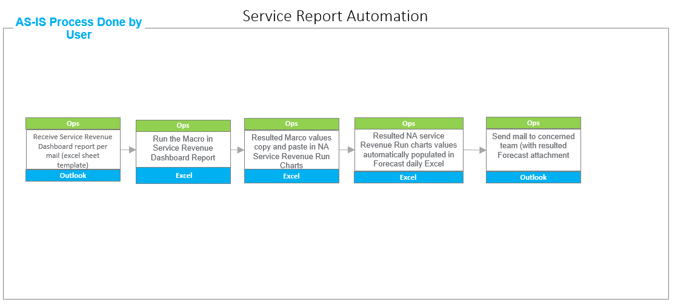

## 

## Robotic Process (To-Be)

## 

## Process Videos

[Folder](https://ge.ent.box.com/folder/111882383103) Location for any Process Videos from Functional team

## [https://teams.microsoft.com/_#/files/General?threadId=19%3A5ff895cb434849739dd4bb4069b35628%40thread.tacv2&ctx=channel&context=RPA%2520-%2520Service%2520Reports&rootfolder=%252Fsites%252FVideojetUiPathRPADevelopment%252FShared%2520Documents%252FGeneral%252FRPA%2520-%2520Service%2520Reports](https://teams.microsoft.com/_#/files/General?threadId=19%3A5ff895cb434849739dd4bb4069b35628%40thread.tacv2&ctx=channel&context=RPA%2520-%2520Service%2520Reports&rootfolder=%252Fsites%252FVideojetUiPathRPADevelopment%252FShared%2520Documents%252FGeneral%252FRPA%2520-%2520Service%2520Re)

## Connected Systems/Components

|  |  |  |  |  |  |
| --- | --- | --- | --- | --- | --- |
| System Name | Usage | Path | Contact/Method for Requesting Access | Access? | ID |
| Email | To get the Service Revenue report received and send final report | Need an Email account for Bot | Requested Through email | Required | Developer ID: [vennapusa.radha@videojet.com](mailto:vennapusa.radha@videojet.com)  Production ID TBD |
| SharedFolder | To get the reports from SharedFolder | Need an shared Folder path | Requested through email | Required | Developer ID:  [vennapusa.radha@videojet.com](mailto:vennapusa.radha@videojet.com)  Production ID TBD |

|  |  |  |
| --- | --- | --- |
| Name | Version | Source |
| UiPath Studio | 20.4.3 | VM |
| Orchestrator | <https://dhr-rpa.danaher.org/> | Orchestrator Website |
| Excel | Office 365 | Installed |

## Software

Bot Process Considerations

|  |  |
| --- | --- |
| Expected volume of output per Run | 1 |
| Transaction Run Time | ~ 5 to 10 min |
| Total Run Time | ~ 5 to 10 min |
| Number of Bots | 1 |
| Use of Queue | No |
| Bulk Process | Yes |
| Ad-Hoc Request Support | No |
| Use of Database | No |

## Bot Schedule

|  |  |
| --- | --- |
| Bot Schedule | Monday to Friday (To check whether we can Skynet) |
| Frequency | once |
| Blackout Start and End time (if any) | NA |
| Run time (24hrs – blackout duration) | NA |

## Bot Sample Weekly/Monthly Reports

Daily status reports will provide the following fields:

|  |  |
| --- | --- |
| Delivery Method | Outlook |
| Recipient | Business User Email Id |
| Format | Hi <User>  Bot has successfully completed Service Report Automation. NA Finance,  The service revenue total for today is,  Forecast image screenshot  Regards  ServiceReport_Dispatcher_VTI |
| Notification | Through Email |

# Technical Design

## Logging Bot

* Process logs
* Start/finish of process
* Name:  *Videojet Service Report Automation*
* Project ID: FieldServices_ServiceReport_Dispatcher_VTI
* Transaction logs
* Unit of Work: *Forecast Report*
* Transaction Name: Forecast_Report
* Transaction ID: Forecast_Report
* Task logs (Examples below)
* Getting NA Service Revenue Run charts and Forecast(Daily) reports from ShareDrive.
* Reading Service report email.
* Checking read email is Month end report or Daily Report.
* Downloading Service Revenue files from email based on month end and daily reports condition.
* Validating Service Report Template.
* Starting Macro Process to update template.
* Based on Current date Copying macro resulted data to NA Service Revenue Run Chart Report in previous business day column.
* Resulted NA Service Revenue Run Chart Values Populating to Forecast Report.
* Sending Mail to business users.

## Assets

|  |  |
| --- | --- |
| **Asset Name** | **Description** |
| FieldServices_ServiceReport_Bot_Cred | This credentials for Bot email |
| FieldServices_ServiceReport_Bot_SuccessDL | This is for sending success status to the DL |
| FieldServices_ServiceReport_Bot_ErrorDL | This is for sending Error screenshots to the DL |
| FieldServices_ServiceReport_Bot_Mail | This is for receiving files in email and sending mails |
| FieldServices_ServiceReport_ForeCastSharePath | This is for SharedFolderPath to access forecast daily report |
| FieldServices_ServiceReport_ServiceRevenueRunCharts_SharePath | This is for SharedFolderPath to access Run charts file |
| FieldServices_ServiceReport_Bot_MailFolder | This is for getting mail folder |
| FiledServices_ServiceReport_ServiceRevenueFile | Service Revenue Dashboard File Name |
| FiledServices_ServiceReport_MacroFile | Service Macro code File Name |
| FiledServices_ServiceReport_RunChartsFile | NA Service Revenue Run charts File Name |
| FieldServices_ServiceReport_ForeCastFile | 2020 Forecast Daily file name |
| ServiceReports_JDrive_RunchartsBotFolder | Share drive automation folder Run Charts File path |
| ServiceReports_JDrive_ForeCastBotFolder | Share drive automation folder forecast file path |
| SMTP_Server | SMTP Server |
| ServiceReports_FiscalFilePath | Fiscal lookup file share drive path |
| ServiceReports_FiscalFileName | Fiscal lookup file name |
| ServiceReport_ContractZero_Mail | This one for Sending Data sync issues |
| ExchangeMailDomain | Exchange Mail Domain |
| ExchangeMailServer | Exchange Mail Server |
| ServiceReport_SharedMail_Account | Shared mail Account |
| SMTP_Port | SMTP Port |
| RPA_Robot001_Dev | Shared account Robot connect |

## Exception handling

* Operational Exceptions

|  |  |  |
| --- | --- | --- |
| Exception No. | Exception Description | Exception Resolution |
| 1. | Email not accessible | Notify Support Team via Email with Proper Exception message and Screenshot |
| 2. | Share Folder not accessible | Send Exception notification after 3 retries |

* Functional Exceptions

|  |  |  |
| --- | --- | --- |
| Exception No. | Exception Description | Exception Resolution |
| 1. | No email for Service Revenue dashboard | Send email to Functional team |
| 2 | If Service Revenue report attachment not present in Service Revenue Dashboard email. | Log same in status file and send email to Functional Team. |
| 3 | If template file has error | Send email to Functional Team. |
| 4 | If Macro resulted template wrong | Send email to Functional Team. |
| 5 | If Run charts tab name not present | Send email to Functional Team. |
| 6 | If Current business day not Present in Run charts file | Send email to Functional Team. |
| 7 | If US Contract value is Zero | Send email to Functional team |
| 8 | If CAN Contract Value is Zero | Send email to Functional team |

* Coding Exceptions

Any errors not handled explicitly above will be captured at the framework level and would be notified through mail as generic failure.

## Workflows

|  |  |  |  |  |
| --- | --- | --- | --- | --- |
| Workflow Name | Description | Input | Output | Reusability? |
| CleanUpFolders.xaml | Workflow to clean up input/output folders before every run | Folder path |  |  |
| Email_Screenshot_And_Attachments.xaml | Workflow to email with screenshot | To Email  Email Cred  Subject  Email Body |  |  |
| Main.xaml | Main workflow which defines state transitions and invokes other workflows |  |  |  |
| Process.xaml | Process workflow which defines business process for each transaction | Transaction Item |  |  |
| CloseAllApplications.xaml | Framework Workflow to close all applications |  |  |  |
| GetTransactionData.xaml | Framework Workflow to get transaction data | Transaction Number  Config | Transaction Item |  |
| InitAllApplications.xaml | Framework Workflow to initialize all the required applications for process | Config  Passwords  DataLoaded |  |  |
| InitAllSettings.xaml | Framework Workflow to initialize settings required for the process | Config  Config_Sheets | Config  Passwords |  |
| KillAllProcesses.xaml | Framework Workflow to kill all the required processes | Process list |  |  |
| ProcessFinished.xaml | Framework Workflow to log process finish | Process Name  Process Error  ProcessSummary |  |  |
| ProcessStartLog.xaml | Framework Workflow to log process start | Process Name  ProcessStartTime  ProjectId |  |  |
| TakeScreenshot.xaml | Framework Workflow to take screen shot and save | Folder  FilePath |  |  |
| TransactionFinishLog.xaml | Framework Workflow to log transaction finish | Transaction Id  Transaction Name  Transaction End Time |  |  |
| TransactionStartLog.xaml | Framework Workflow to log transaction start | Transaction Id  Transaction Name  Transaction Start time  ProjectId  ProjectName |  |  |
| GettingFilesFrom_ShareDrive.xaml | Getting Run charts and Forecast files from share drive |  |  |  |
| Reading_ServiceReport_Mail.xaml | Read and download Service Revenue Dashboard from Email |  |  |  |
| ExecuteMacro.xaml | Run the Macro in Service Revenue Report |  |  |  |
| PopulateRunChartsAndForecast.xaml | Resulted macro values populate to NA service Revenue Run Chart and run charts Values populating in Forecast report daily. |  |  |  |
| MovingForeCastFilesToShareDrive.xaml | Resulted Run charts and forecast files moving from bot output folder to share drive automation folder |  |  |  |
| SendingForeCastReport.xaml | Send Forecast daily Report to concern team. |  |  |  |

## Custom Code Requirements

Macro Name: Daily_Dashboard_4

## Breakdown of Process Steps



## 

## Challenges

# Assumptions

Required templates should be available in Excel templates of Reports would be as Provided and for any other format business exception will be raised.

# Change Requests

*All change requests after functional design is signed off as a change request.*

|  |  |  |  |
| --- | --- | --- | --- |
| Change Request Log | | | |
| Request # | **Change Requested** | **Impact to Overall Timeline** | **Approved/Unapproved** |
| [#] | [Change Request] | [Impact to timeline in days] | [Decision] |
|  |  |  |  |