Test and Evaluation of a Deep Learning Model — Silent Voice (Indian Sign Language Recognition)
NNDL Lab Evaluation 2 · Structured after the CDAO Test and Evaluation of AI Models framework (April 2024)
Name | P. M. Radha Krishna
Roll number | CB.SC.U4CSE23134
Course | 23CSE461 — Neural Networks and Deep Learning
Group | 1 (Team 1)
Project | Silent Voice — Indian Sign Language to English translator
My model(s) | 1D CNN (chosen model) and BiLSTM, compared; GAN used for synthetic data
Not covered | Transformer — it belongs to a teammate

1. Summary
I built and tested an isolated-word Indian Sign Language recogniser. A webcam clip is converted by MediaPipe Holistic into a 60 × 225 landmark tensor (21 + 21 hand points and 33 body points, each x/y/z), and a neural network classifies it into one of 261 words (INCLUDE dataset, 4,276 clips). I compared two models on the same stratified 70/15/15 split (seed 42): a 2-layer BiLSTM (2.67 M parameters) and a 3-block 1D CNN (0.74 M parameters). The 1D CNN is my chosen model: 94.55% top-1 / 98.44% top-5 accuracy on the 642 held-out test clips, with 0.74 ms latency per clip, against 91.74% / 97.66% and 4.12 ms for the BiLSTM. I also trained a class-conditional GAN to generate synthetic sign clips and tested whether adding them improves the CNN (it did not: −0.78 percentage points).
Beyond accuracy, I tested the models along every area of the CDAO framework: performance dimensions (correctness, robustness, uncertainty, interpretability, bias, drift, resilience, latency), testing methods (A/B comparison, adversarial, metamorphic, cross-validation, black/white box, automated/manual, continuous/discrete), data, models, context, and documentation (data card and model card). The headline lesson: accuracy alone hides serious weaknesses. The CNN is the most accurate and fastest model, yet it collapses when frames are dropped (56% at 10% dropped frames) and when the signer shifts 5% sideways, and neither model supports left-handed signing.

2. How this document follows the framework
The framework has six parts. This table maps each to my work.
Framework part | Pages | What I did | Section
01 Thinking about Performance | 7–17 | Correctness, robustness, uncertainty, interpretability, bias, drift, resilience, latency | 3
02 Thinking about Testing Methods | 18–28 | A/B comparison, adversarial, metamorphic, experience-based, cross-validation, ablation design, test levels | 4
03 Thinking about Data | 29–39 | Data card, splits, leakage checks, representativeness, GAN synthetic data | 5
04 Thinking about AI Models | 40–54 | Model selection, training, evaluation, deployment, maintenance (live monitor, retraining) | 6
05 Thinking about Context | 55–57 | Intended use, environment, limits | 7
06 Thinking about Documentation | 58–63 | Data card, model card, test report, reproduction commands | 8
Detailed coverage matrix
Framework area | Item | Covered by | Section
Performance | Correctness | evaluate.py, black-box tests | 3.1
Performance | Interpretability | explainability.py | 3.4
Performance | Bias | bias.py | 3.7
Performance | Robustness | robustness.py, adversarial.py | 3.2, 3.5
Performance | Resilience | resilience.py | 3.9
Performance | Uncertainty | calibration.py | 3.3
Performance | Drift | drift.py (simulated drift); backend/monitor.py + GET /api/monitor (live) | 3.8
Performance | Representativeness | bias.py | 3.7
Performance | Latency | evaluate.py, black-box BB-09 | 3.1, 3.11
Testing methods | Comparison (A/B, back-to-back) | BiLSTM vs CNN vs logistic regression | 3.1, 3.11
Testing methods | Adversarial testing | adversarial.py (FGSM, PGD) | 3.5
Testing methods | Metamorphic testing | metamorphic.py | 3.6
Testing methods | Experience-based testing | Manual test plan | MANUAL_TEST_PLAN.md
Testing methods | Test design: cross-validation | crossval.py | 3.10
Testing methods | Continuous vs discrete, automatic vs manual, black vs white box, live vs model | CI + scripts + manual plan + E2E | 1
Data | Select, clean, engineer, split, curate, verify | DATA_CARD.md; WB-08/09 tests | DATA_CARD.md
Models | Select, train, evaluate, deploy, maintain | MODEL_CARD.md; live monitor /api/monitor | MODEL_CARD.md, 3.8, 3.11
Data | Synthetic data (GAN augmentation) | gan_train.py, gan_eval.py | 3.12
Context | Use case and environment | MODEL_CARD.md intended use | 3.11
Documentation | Data card, model card | DATA_CARD.md, MODEL_CARD.md | -

3. Performance (framework part 01)
All results are on the 642-clip held-out test split that was never used for training or for choosing a model.

3.1 Correctness and latency
Metric | BiLSTM | 1D CNN
Top-1 accuracy | 91.74% | 94.55%
Top-5 accuracy | 97.66% | 98.44%
Macro F1 | 0.9140 | 0.9433
Weighted F1 | 0.9126 | 0.9422
Mean / p95 latency per clip | 4.12 / 6.90 ms | 0.74 / 1.05 ms
Baseline: logistic regression on time-pooled features, 82% accuracy.
Reading it. Top-5 is high (97–98%) because many confusions are between related signs, so a “did you mean” list works well. The CNN wins on accuracy and is 5.6× faster, which matters for live captioning. The logistic-regression baseline at 82% shows the deep models add roughly 10 (BiLSTM) to 12 (CNN) percentage points over a simple classifier.

3.2 Robustness
Condition | BiLSTM | 1D CNN
Gaussian noise 0 x std | 91.74% | 94.55%
Gaussian noise 0.05 x std | 91.69% | 94.65%
Gaussian noise 0.1 x std | 91.69% | 94.70%
Gaussian noise 0.2 x std | 91.80% | 94.70%
Gaussian noise 0.5 x std | 91.95% | 94.60%
Gaussian noise 1.0 x std | 91.95% | 93.67%
Gaussian noise 2.0 x std | 87.85% | 79.65%
10% frames dropped | 90.71% | 56.13%
20% frames dropped | 86.03% | 18.07%
30% frames dropped | 78.30% | 6.23%
50% frames dropped | 45.28% | 2.39%
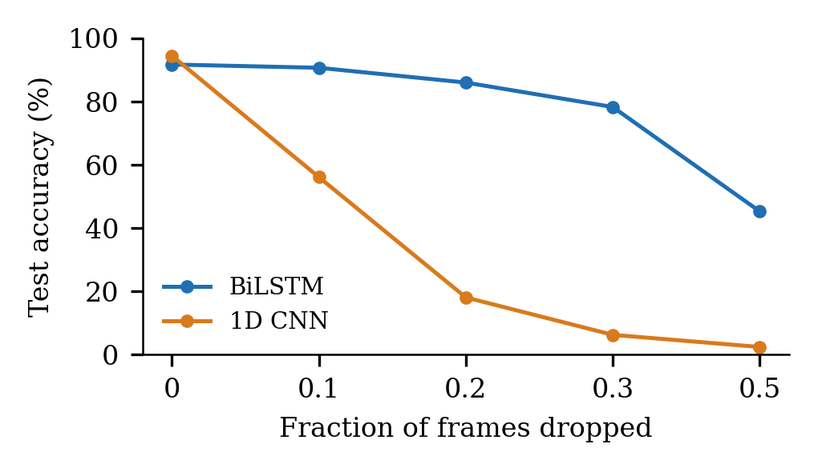
Accuracy as frames are dropped
Reading it. Both models shrug off sensor noise up to 1 × the feature standard deviation. The big difference is missing frames: at 10% dropped frames the BiLSTM keeps 90.7% but the CNN falls to 56%, and at 30% the CNN is at 6%. A recurrent model carries state across a gap; a convolution sees only a fixed window of zeros. Webcams do drop frames, so this is a real deployment risk.

3.3 Uncertainty and calibration
Metric | BiLSTM | 1D CNN
Expected calibration error (15 bins) | 0.0337 | 0.0345
ECE after temperature scaling (fitted on validation) | 0.0270 (T = 0.846) | 0.0239 (T = 0.820)
Negative log-likelihood / Brier score | 0.411 / 0.1293 | 0.325 / 0.0957
Mean confidence when right / when wrong | 0.915 / 0.595 | 0.925 / 0.698
Answers given at the app’s 0.5 confidence floor (coverage, accuracy) | 93.6%, 94.51% | 97.2%, 95.67%
Accuracy on the 80% most confident clips | 97.47% | 97.67%
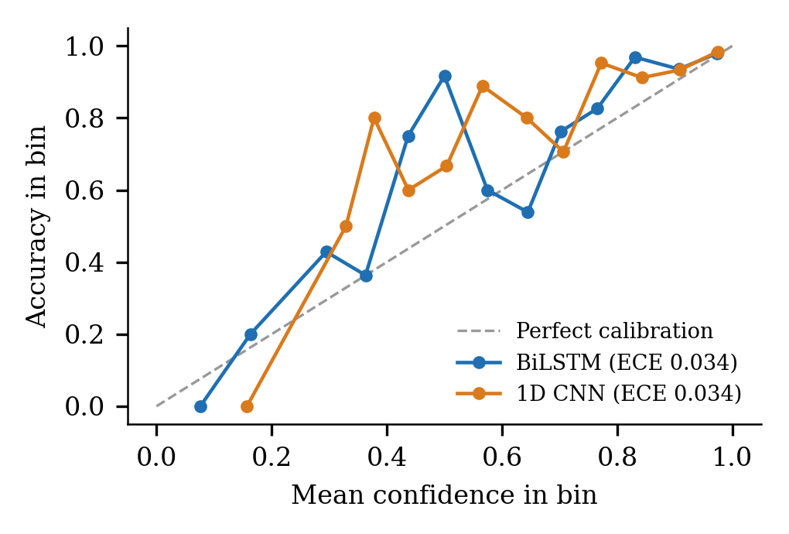
Reliability diagram
Reading it. An expected calibration error of about 0.03 means that when the model says “90% sure” it is right about 90% of the time. Temperature scaling (T ≈ 0.82) improves it slightly. The app’s 0.5 confidence floor raises the accuracy of the captions it actually shows, because wrong answers are on average less confident (0.60–0.70) than right ones (0.92).

3.4 Interpretability (explainability)
Occluded features | BiLSTM accuracy | 1D CNN accuracy
None | 91.74% | 94.55%
Left-hand block | 74.92% | 79.28%
Right-hand block | 39.56% | 36.60%
Pose | 23.83% | 16.36%
Share of gradient x input saliency | BiLSTM | 1D CNN
Left-hand block | 22.8% | 20.4%
Right-hand block | 33.9% | 36.8%
Pose | 43.3% | 42.7%
Removing any single 10-frame window leaves accuracy between 86.1% and 91.4% (BiLSTM) and 93.0% and 93.9% (CNN).
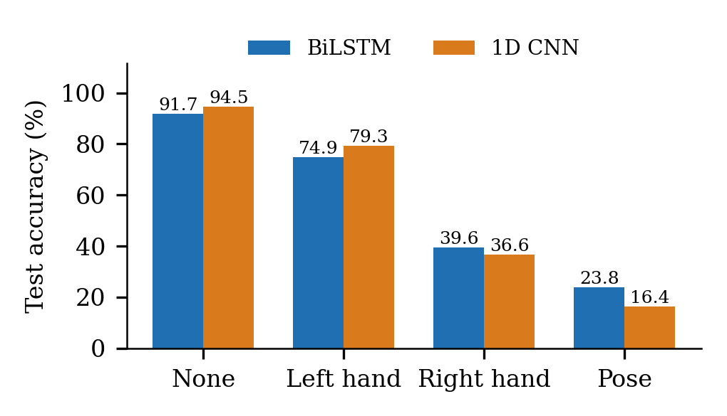
Accuracy when a feature group is hidden
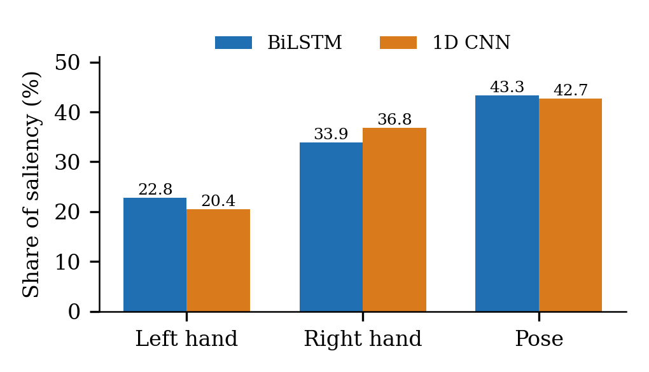
Share of gradient × input saliency by feature group
Reading it. The models rely on the right hand and body pose most: hiding the pose block drops the CNN to 16%, and hiding the right hand to 37%, while hiding the left hand costs less because many signs are one-handed or right-dominant. Saliency agrees: pose carries ~43% of the attribution. No single 10-frame window is critical (accuracy stays above 86%), so the models use the whole sign, not one instant.

3.5 Bias and representativeness
Clips per class range from 8 to 27; every class is in the test split; the largest train-vs-test difference in a class’s share is 0.16 percentage points. Signer identity is not available, so per-signer fairness is not measurable.
Group | Test clips | BiLSTM | 1D CNN
Classes with few clips (<= 14) | 223 | 91.48% | 93.27%
Medium | 249 | 91.57% | 95.18%
Many clips (> 20) | 170 | 92.35% | 95.29%
One-handed signs | 81 | 86.42% | 91.36%
Two-handed signs | 561 | 92.51% | 95.01%
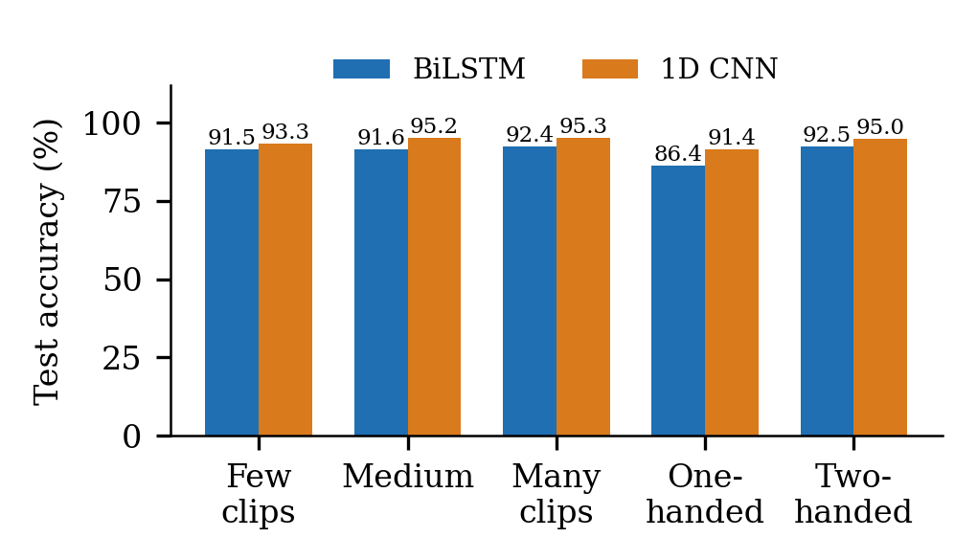
Accuracy by group
Reading it. The test split mirrors the training split (largest class-share difference 0.16 pp). Classes with few examples and one-handed signs are weaker (86–91% vs 92–95%). Signer identity is not recorded in INCLUDE, so fairness across signers could not be tested — I state this as a limitation rather than claim fairness.

3.6 Drift
A drift monitor (feature KS tests + confidence drop) tested on held-out clips with simulated drift (300 clips per scenario). Its output-based part runs in production: the server records every live prediction in backend/monitor.py and GET /api/monitor reports frames processed, hand visibility, mean confidence and a drift alarm (unit-tested in backend/test_monitor.py, exercised end to end by E2E-10).
Scenario | Feature drift score | Confidence drop (BiLSTM / CNN) | Alarm | Accuracy (BiLSTM / CNN)
no drift heldout | 0.000 | 0.006 / -0.007 | no | 91.3% / 94.3%
sensor noise 0.5std | 0.000 | 0.009 / 0.007 | no | 92.0% / 94.7%
dropped frames 20pct | 0.721 | 0.138 / 0.691 | yes | 86.0% / 19.3%
camera shift 10pct | 0.151 | 0.559 / 0.487 | yes | 13.7% / 31.7%
left handed signers | 0.557 | 0.509 / 0.550 | yes | 22.0% / 21.3%

3.7 Resilience
Sliding-window recognition over a stream: sign, blackout of B empty frames, sign again (200 streams per setting).
Setting | BiLSTM median recovery | CNN median recovery | Correct during blackout (BiLSTM / CNN)
blackout 15 frames | 0 frames | 54 frames (4.5 s at 12 fps) | 97.5% / 37.1%
blackout 30 frames | 26 frames | 54 frames (4.5 s at 12 fps) | 90.1% / 21.1%

3.8 Latency and efficiency
CNN: 0.74 ms mean / 1.05 ms p95 per clip, 736,773 parameters. BiLSTM: 4.12 ms / 6.90 ms, 2,665,477 parameters. Both run in real time on a laptop CPU; the CNN uses 3.6× fewer parameters. The server can also run both models with plain NumPy (no PyTorch), and I verified that this reproduces the exact test accuracy of both models (94.55% and 91.74%) on all 642 clips.

4. Testing methods (framework part 02)

4.1 Test strategy and levels
Suite | Level | Box | Execution | Result
Gloss rules | Unit | Black | Automated (CI) | 17 passed, 0 failed
Sentence formation | Unit | Black | Automated (CI) | 14 passed, 0 failed
Contribution storage and video ingestion | Unit | White | Automated (CI) | 26 passed, 0 failed
Production drift monitor | Unit | White | Automated (CI) | 10 passed, 0 failed
Accounts API | Integration | Black | Automated (CI) | 38 passed, 0 failed
Backend code coverage | Unit + integration | White | Automated | 92% statement+branch
Model internals | Unit | White | Automated (CI) | 17 passed, 0 failed
Model behaviour and acceptance | Model | Black | Automated | 20 passed, 0 failed
Frontend routes/styles/build | UI | Black | Automated (CI) | 11 routes, 1,027 class names, 19 checks
End-to-end system (browser + backend + models) | System | Black | Automated | 10 passed, 0 failed
Real user, real webcam | Acceptance | Black | Manual | to be executed by the tester
Black-box tests check inputs and outputs without looking inside (accuracy, edge-case inputs, metamorphic relations, API and browser tests). White-box tests use knowledge of the internals (parameter counts, gradient flow, dropout and BatchNorm behaviour, split and normalisation logic, saliency, code coverage). Quantitative metrics are numbers (accuracy, F1, calibration error, latency, memory); qualitative evaluation looks at what the errors are (confused pairs, near misses, saliency over time) and at the manual usability observations.
Black-box tests look only at inputs and outputs; white-box tests use knowledge of the internals. Tests run automatically on every change (continuous, in CI) or manually (experience-based, with a real webcam, in MANUAL_TEST_PLAN.md), at unit, integration, system and model level, on quantitative metrics and qualitative error analysis.

4.2 Comparison testing (A/B, back-to-back)
BiLSTM vs 1D CNN vs a logistic-regression baseline, all on the identical split, normalisation and optimiser schedule, so the architecture is the only variable (ml/scripts/_train.py runs every model through the same function). Result: CNN best on accuracy and speed; BiLSTM best on robustness to missing frames and on cross-validation (below).

4.3 Adversarial testing
Budget epsilon (x feature std) | BiLSTM FGSM | BiLSTM PGD-10 | CNN FGSM | CNN PGD-10
0.0 | 91.7% | 91.7% | 94.5% | 94.5%
0.01 | 90.7% | 89.9% | 93.6% | 93.6%
0.02 | 87.5% | 86.8% | 91.1% | 90.5%
0.05 | 81.9% | 74.0% | 76.9% | 72.7%
0.1 | 71.8% | 43.8% | 45.0% | 23.2%
0.2 | 53.7% | 9.7% | 6.1% | 0.6%
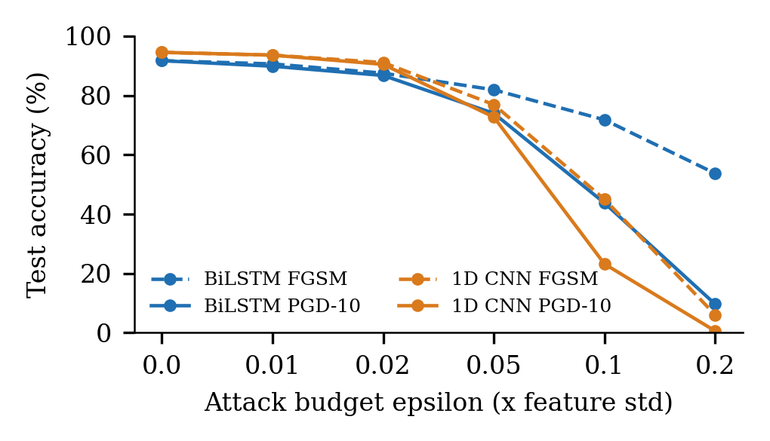
Accuracy under FGSM and PGD attacks
Reading it. Tiny, targeted perturbations (ε = 0.05 × feature std) already cost the CNN ~18–22 points, and at ε = 0.2 the CNN is near 0% under PGD. Neither model is adversarially robust; this matters if the system were used where someone could tamper with the input.

4.4 Metamorphic testing
A violation is a prediction that changes under a transformation that should not change the sign.
Relation | BiLSTM violations | 1D CNN violations
MR1 noise 0.1std | 0.3% | 0.5%
MR2 time shift pm2 | 0.9% | 0.5%
MR3 speed pm10pct | 2.0% | 1.1%
MR4 camera shift 5pct | 51.6% | 20.6%
MR5 mirror left handed | 77.6% | 78.3%
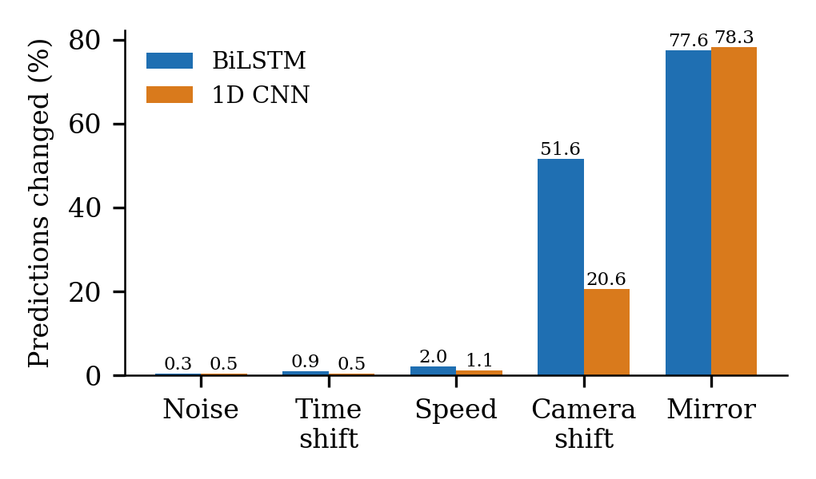
Prediction changes under transformations that should not matter
Reading it. The models are stable to small noise, time shift and speed change (≤ 2%). They are not stable to a 5% sideways camera shift (21% CNN, 52% BiLSTM changed) or to mirroring (78% changed), exposing that body pose is in raw image coordinates and that left-handed signers are unsupported.

4.5 Cross-validation (test design)
Stratified 3-fold cross-validation over all 4,276 clips, retraining each model per fold with the project recipe at a reduced budget of 20 epochs (the headline models use 60), so fold scores estimate the variance across splits rather than the final accuracy.
Model | Fold 1 | Fold 2 | Fold 3 | Mean +/- SD
BiLSTM | 87.45% | 90.32% | 91.02% | 89.59 +/- 1.89%
1D CNN | 86.47% | 84.98% | 84.42% | 85.29 +/- 1.06%
Reading it. At a reduced 20-epoch budget the BiLSTM scores higher than the CNN across folds (89.6% vs 85.3%), while with the full 60-epoch recipe the CNN is higher on the fixed split. So the ranking depends on the training budget and the split; the standard deviation (1–2 points) shows how much a single split can mislead. I report both rather than pick the flattering one.

4.6 Ablation study (the chosen model)
An ablation removes one component and measures the change, to find what the model really depends on. I wrote ml/scripts/ablation.py, which trains the chosen model from scratch for each variant under the identical recipe and scores it on the same 642 test clips (the epoch is chosen on validation accuracy, never on test). Variants, each changing exactly one thing:
Group | Variants
Input channels | − left hand, − right hand, − both hands (pose only), − pose (hands only), − z coordinate
Augmentation | + jitter, + frame drop, + temporal shift, + mirror (the shipped models use no augmentation, so each is added back), − label smoothing
Architecture (CNN) | − batch norm, kernel 3 / 9, 2 and 1 conv blocks, width 128 / 512, average-only and max-only pooling, dropout 0 / 0.5
Temporal | 30 frames, 15 frames
Data | 50% and 25% of the training clips
Run with python scripts/ablation.py --model cnn --epochs 8 --groups features; it writes ml/logs/ablation_cnn.md. I ran the input-channel group (the other groups are written but not yet run). Each variant was trained from scratch for 8 epochs (the headline model used 60) on the same split, and the epoch was chosen on validation accuracy. The 8-epoch budget keeps the whole study under 8 minutes on a laptop CPU, so the absolute numbers are lower than the 94.55% headline (the baseline was still improving at epoch 8); what matters is the comparison between rows.
Variant | Test accuracy | Change vs baseline
Baseline (all 225 features) | 75.39% | —
− left hand | 76.17% | +0.78 pp (within noise)
− right hand | 52.34% | −23.05 pp
− both hands (pose only) | 48.60% | −26.79 pp
− pose (hands only) | 65.42% | −9.97 pp
− z coordinate (x, y only) | 73.83% | −1.56 pp (within noise)
Reading it. The right hand and the body pose carry most of the information: without the right hand accuracy falls by 23 points, and with pose alone (no hands) it is only 48.6%, while hands without pose reach 65.4%. So hands matter more than pose on their own, but they are not enough alone — the two are complementary. Removing the left hand costs nothing measurable (+0.78 points, inside the noise): most INCLUDE signs are right-hand dominant, and the model recovers from the right hand and pose. Removing the z (depth) coordinate costs only 1.6 points, so the model mostly uses the flat x/y shape of the hand and depth adds little.
Agreement with the earlier test. Hiding a block at test time (section 3.4, no retraining) gave the same ranking: pose and right hand most important, left hand least. The ablation is the stronger evidence because the model is retrained without the feature and still cannot recover the loss.
Limits. One run per variant (one random seed) on 642 clips, where one clip is 0.16 points, so differences under about 2 points should be treated as noise. 8 epochs rather than 60. The augmentation, architecture, frame-count and data-size groups in the table above are implemented in the script but were not run.

4.7 Experience-based and manual testing
MANUAL_TEST_PLAN.md lists scripted sessions with a real webcam (lighting, distance, handedness, speed) with space to record observations and screenshots. It is the one test I have not yet executed, so I make no claim about live accuracy with real users.

4.8 End-to-end system tests
End-to-end browser tests (tests/e2e/test_e2e_system.py, ml/logs/tne/e2e/):
ID | Check | Result | Detail
E2E-01 | backend /api/status reports both models loaded | PASS | models=[‘bilstm’, ‘cnn’], labels=261
E2E-02 | gate: ‘Continue as guest’ opens the home page | PASS
E2E-03 | live: webcam frames stream over the WebSocket and the server answers | PASS | sent 71, received 70, server_ms 84.9
E2E-04 | live: no caption is invented for an empty scene (fake camera shows no person) | PASS | hands_visible=False
E2E-10 | monitor: /api/monitor counts the streamed frames (production monitoring is live) | PASS | frames_processed 77, hand_visible_rate 0.0
E2E-05 | reverse: ‘where is the doctor tomorrow’ is glossed TOMORROW DOCTOR WHERE | PASS
E2E-06 | research: page shows the measured accuracy from comparison.json | PASS
E2E-07 | practice: page loads the list of practisable words from the backend | PASS
E2E-08 | contribute: page renders with the review queue | PASS
E2E-09 | no uncaught JavaScript errors on any page | PASS
A newer in-process smoke test (backend/smoke_test.py, 28 checks) also exercises every API the interface uses: recognition over the WebSocket, English-to-sign, sentence formation, practice scoring, video contribution, accounts and the results page.

5. Data (framework part 03)

5.1 Data card — INCLUDE landmark tensors
Structure follows the data-card practice recommended in the CDAO Test and Evaluation of AI Models framework (pp. 61-62). Figures are computed by ml/scripts/tne/bias.py (ml/logs/tne/bias.json) unless stated otherwise.

Source
INCLUDE: a word-level Indian Sign Language video dataset (Sridhar et al., ACM Multimedia 2020). Raw videos and derived tensors are not committed to this repository (size and licence); check the dataset’s official page for its licence before redistributing.

Composition
Item | Value
Classes (words) | 261
Clips used | 4,276
Clips per class | 8 to 27 (mean 16.4, median 15)
Classes judged two-handed / one-handed* | 227 / 34
Frames with left-hand landmarks / right-hand landmarks | 78.9% / 69.4%
Signer identity, age, gender | not recorded in the processed files
*A class counts as two-handed when both hands are detected in at least half of its frames.

Collection and processing
- MediaPipe Holistic (model complexity 1) extracts 21 landmarks per hand and 33 pose landmarks per frame: 225 features (ml/scripts/preprocess.py).
- Each clip is resampled to 60 frames. Hands are stored wrist-relative and shoulder-scaled; pose stays in normalised image coordinates.
- Features are standardised with the mean/std of the training split only (verified by white-box test WB-09b: no validation/test leakage).

Splits
Stratified 70/15/15 at seed 42 (ml/scripts/_train.py): 2,993 train, 641 validation, 642 test clips. Every class appears in the test split, and the largest difference between a class’s share of train and test is 0.16 percentage points.

Known gaps
- No signer identity, so per-signer or demographic fairness cannot be measured and there is no signer-independent split.
- Classes are small (8-27 clips), so each class has about 1 to 4 test clips and per-class F1 is noisy.
- Recorded in controlled conditions; real webcams, lighting and backgrounds were not part of the data.

Curation in the application
The Contribute page lets users record extra clips for a word. Clips are stored with a manifest for human review and are never used for training automatically.

5.2 Contributed data and retraining
The Contribute page records a webcam video of a sign, stores it under ml/data/contributed_videos/<word>/, extracts the skeleton with the same MediaPipe code, and adds the tensor to ml/data/processed/custom/ only if hands were visible in at least 25% of frames. Contributed clips go into the training split only, so the 642-clip test set and all reported numbers stay comparable (verified by a unit test). A retrain is deployed only if test accuracy does not fall by more than 3 points.

5.3 Synthetic data: GAN augmentation
A class-conditional GAN trained on the training clips generated 2871 synthetic clips (11 per class). Fidelity: the real-data models recognise a synthetic clip as its intended class 19.9% (BiLSTM) and 16.9% (CNN) of the time (chance is 0.4%); synthetic clips change 2.2x more from frame to frame than real ones.
1D CNN trained on | Training clips | Best validation | Test accuracy | Macro F1
Real clips (control) | 2993 | 95.16% | 94.08% | 0.9343
Real + GAN clips | 5864 | 93.60% | 93.30% | 0.9336
Change in test accuracy from adding GAN clips: -0.78 percentage points.
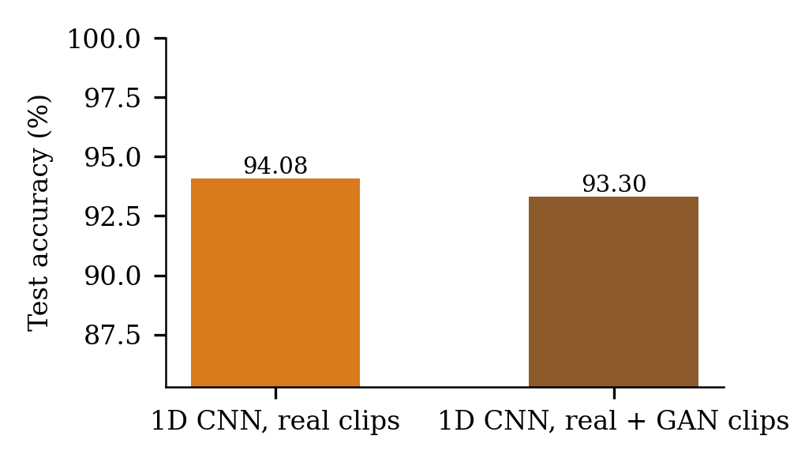
GAN data augmentation result
Reading it. The generator produces clips that the real-data classifiers recognise as the intended class about 17–20% of the time — far above chance (0.4%), so the GAN learned some class structure — but the clips are noisier than real ones (2.2× more frame-to-frame change). Adding them did not help (−0.78 points); it slightly hurt. The honest conclusion: with 2,993 real training clips and limited GAN training, the synthetic data is not good enough to improve accuracy. A better GAN (more training, smoothness loss) would be the next step.

6. AI model (framework part 04)

6.1 Model card

Model card
Format follows the model-card structure recommended in the CDAO Test and Evaluation of AI Models framework (April 2024, p. 64). Every number below is read from a file in ml/logs/ produced by a script in ml/scripts/.

Model details
 | BiLSTM | 1D CNN
Task | Isolated-word Indian Sign Language recognition (261 classes) | same
Input | 60 frames x 225 MediaPipe Holistic landmark features (21 x 3 per hand, 33 x 3 pose), standardised with training-split statistics | same
Architecture | 2-layer bidirectional LSTM (hidden 256), mean-pooled over time, MLP head | 3 temporal conv blocks (kernel 5), avg+max pooling, MLP head
Parameters | 2,665,477 | 736,773
Training | AdamW lr 3e-3, weight decay 1e-4, cosine schedule, label smoothing 0.05, grad-clip 1.0, batch 32, 60 epochs, no augmentation, best validation epoch kept | same
Files | backend/models/bilstm.pt | backend/models/cnn.pt
Owner | P. M. Radha Krishna (CB.SC.U4CSE23134), Amrita Vishwa Vidyapeetham

Intended use
Real-time captioning of single ISL words signed to a webcam, as a communication aid and learning tool in the Silent Voice web app. Not intended for continuous sentence-level signing, for medical, legal or emergency decisions, or as a replacement for a human interpreter.

Factors
Performance depends on the signer staying in a similar position in the frame, signing right-handed as in the training data, the camera seeing both hands, and frames not being dropped (see Robustness and Metamorphic results).

Metrics (642-clip held-out test split, ml/logs/comparison.json)
Metric | BiLSTM | 1D CNN
Top-1 accuracy | 91.74% | 94.55%
Top-5 accuracy | 97.66% | 98.44%
Macro F1 | 0.9140 | 0.9433
Expected calibration error | 0.034 | 0.035
Mean latency per clip (model only, CPU) | 4.12 ms | 0.74 ms

Evaluation data
Held-out 15% of INCLUDE (642 clips, every class present), never used for training or model selection. See DATA_CARD.md.

Quantitative analyses
Robustness, explainability, calibration, adversarial, metamorphic, bias, drift, resilience and cross-validation results are in TEST_EVALUATION_REPORT.md.

Ethical considerations
No raw video is stored; only landmark coordinates are processed. The dataset records no signer identity, so fairness across signers or demographic groups could not be measured. Left-handed signing is not supported (78% of predictions change when a clip is mirrored), which disadvantages left-handed signers.

Caveats and recommendations
- Shifting the signer 5% sideways changes 52% (BiLSTM) / 21% (CNN) of predictions, because pose coordinates are not body-centred. Normalising pose relative to the shoulders is the recommended fix.
- The CNN loses accuracy sharply when frames are missing (56% at 10% dropped frames); the BiLSTM is the safer choice on unreliable cameras.
- Not evaluated with deaf users or with signers outside INCLUDE.

6.2 Lifecycle: select, train, evaluate, deploy, maintain
- Select: CNN chosen on measured accuracy and speed; BiLSTM kept as the robust alternative.
- Train: _train.py — AdamW, cosine schedule, label smoothing 0.05, gradient clipping, best-validation checkpoint, early stopping.
- Evaluate: evaluate.py and the suites in section 3–4, always on the untouched test split.
- Deploy: FastAPI server; checkpoints load with PyTorch if installed, otherwise with a NumPy re-implementation (verified exact).
- Maintain: live monitor (GET /api/monitor: frames, hand visibility, confidence, drift alarm) and the guarded retraining pipeline in 5.2.

7. Context (framework part 05)
The intended use is real-time captioning of single signed words to a webcam, as a learning and communication aid, in good lighting with both hands visible and the signer roughly centred. It is not for continuous sentences, medical or legal decisions, or replacing an interpreter. Facial expression, which carries grammar in ISL, is not modelled. The results above show the conditions that break it (dropped frames, camera shift, left-handed signing), so the interface reports low-confidence guesses rather than hiding them.

8. Documentation (framework part 06)
- Data card: section 5.1 (docs/testing/DATA_CARD.md).
- Model card: section 6.1 (docs/testing/MODEL_CARD.md).
- Test report: this document (docs/testing/TEST_EVALUATION_REPORT.md, generated from the result files by make_report.py).
- Manual test plan: docs/testing/MANUAL_TEST_PLAN.md.
- Reproduction: every number comes from a script in ml/scripts/tne/ or ml/tests/; commands are at the top of the full report.

9. Qualitative evaluation
- BiLSTM: 53 errors, of which 38 are near misses (true word in the top 5) and 15 far misses. Most confused pairs: bicycle -> fish (2), he -> she (2), skirt -> pant (2), boat -> bicycle (1), bathroom -> pencil (1).
- 1D CNN: 35 errors, of which 25 are near misses (true word in the top 5) and 10 far misses. Most confused pairs: dress -> clothing (2), card -> gift (1), bathroom -> pencil (1), blue -> orange (1), wife -> husband (1).
- Model agreement: both wrong on 27 clips, only the BiLSTM wrong on 26, only the CNN wrong on 8; picking whichever model is right would reach 95.79%, so the models make partly different mistakes.
- Classes both models miss at least once: bathroom, bedroom, big_large, blue, extra, gift, hat, hot, kitchen, lawyer, market, page, pencil, priest, sister, soap, soldier, telephone, thursday, today, tool, truck, university, wife.
- Example predictions with top-3 confidences are listed under sample_predictions in qualitative.json.
- Manual usability observations are recorded in MANUAL_TEST_PLAN.md when the manual session is run.
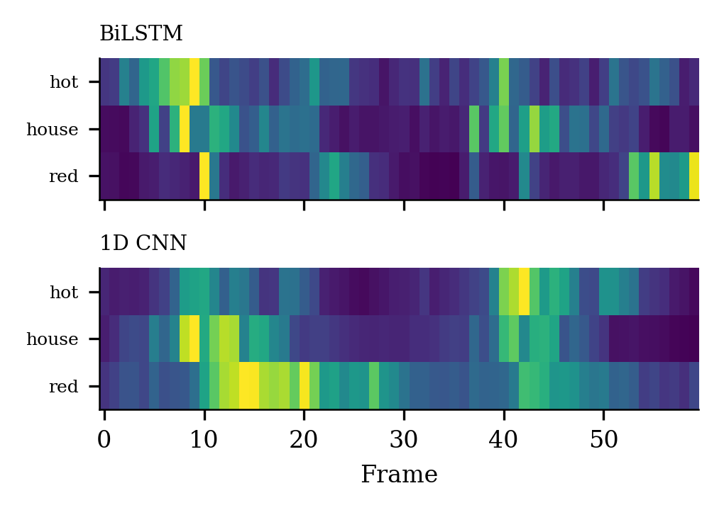
Saliency over time for example clips

10. Findings and recommended actions
- Position sensitivity (metamorphic MR4): a 5% sideways shift of the signer changes many predictions because pose is in raw image coordinates. Recommended fix: centre and scale pose on the shoulders, then retrain.
- Left-handed signers (MR5): mirrored clips change most predictions. Recommended fix: mirror augmentation during training.
- Missing frames: the CNN degrades sharply with dropped frames and recovers slowly after a blackout; the BiLSTM is the more resilient live model. Recommended: use the BiLSTM for unreliable cameras or train the CNN with frame dropping.
- Calibration: both models are well calibrated (ECE about 0.03); temperature scaling improves it slightly. The app’s 0.5 confidence floor raises the accuracy of the captions it does show.
- Drift: the monitor raises no alarm on clean data or mild noise and does alarm on dropped frames, camera shift and left-handed signers, which are the conditions that cut accuracy.

11. Limitations of this evaluation
- One dataset (INCLUDE) and no signer identity: no signer-independent or demographic fairness test.
- No production traffic: drift and resilience are tested on simulated conditions.
- No human red team: adversarial robustness is tested with algorithmic attacks only.
- End-to-end tests use a synthetic camera, so they prove integration, not live accuracy; live accuracy with real signers is the manual test plan’s job.
- Cross-validation uses a reduced epoch budget.

12. Conclusion
The 1D CNN is the best model on accuracy (94.55%) and speed (0.74 ms), but the framework-based testing shows it is fragile in ways accuracy does not reveal: dropped frames, camera shift, left-handed signers, and small adversarial perturbations. The BiLSTM is slightly less accurate but more resilient to missing frames. The GAN, tested honestly, did not improve accuracy. Everything I claim is measured on a held-out split, and what I did not measure (signer fairness, real-user accuracy, full ablation results) is stated as such.

Appendix A. Questions I should be ready to answer
Question | Short answer
Why a CNN rather than the BiLSTM? | It scored higher (94.55% vs 91.74%) on the same split and is 5.6× faster; but the BiLSTM is more robust to dropped frames, so I recommend it for unreliable cameras.
Why is accuracy not enough? | The 94.55% hides that 10% dropped frames cuts the CNN to 56% and a 5% camera shift changes 21% of its answers.
What is the test set and why can it be trusted? | 642 stratified held-out clips, never used for training or model selection; normalisation uses training statistics only (white-box test checks no leakage).
What does calibration mean here? | ECE ≈ 0.03: stated confidence matches actual accuracy, so a confidence floor is meaningful.
What is metamorphic testing? | Apply a change that should not alter the answer (noise, time shift, camera shift, mirror) and count answer changes — it needs no labels.
FGSM vs PGD? | FGSM is one gradient step; PGD repeats it ten times and is stronger.
What did the GAN do? | It generated class-conditional landmark clips; adding them lowered test accuracy 0.78 points, so it did not help.
What is an ablation? | Remove one component, retrain, compare. Mine covers input channels, augmentation, architecture, frames and data size; the full run is the remaining step.
What are the limits? | One dataset, no signer identity (no fairness test), no real-user test yet, algorithmic attacks only.
What would you improve? | Centre pose on the shoulders, add mirror and frame-drop augmentation, retrain, and re-run the suite.

Appendix B. Addendum (15-Oct-2026, afternoon): live-detection root causes and fix
After submission, the poor detection seen with a real webcam was investigated. Every number below is measured on the same 642 held-out INCLUDE test clips by backend/test_live_conditions.py (results in ml/logs/tne/camera_position.json and ml/logs/canonical_retrain_report.json). The camera conditions are simulated by moving and scaling the recorded pose. They are not measurements with live webcam users, which remain untested (manual tests MT-17 to MT-20).
Three causes were found. First, train/serve skew in body position: INCLUDE signers stand far from the camera (shoulder width about 14% of the frame), while a webcam user sits two to three times closer, and the pose features are raw image coordinates. Second, a window mismatch: training clips are cropped to the sign, but the live app classified a rolling 5-second buffer. Third, handedness: the model only saw right-handed signing.
Condition | Original model | After fixes + retrained CNN | Fix
Signer 2.5x closer and lower | 1.4% | 96.0% | Move pose to the INCLUDE signer position (canonicalize_pose)
2.5 s sign inside a 5 s buffer | 61.7% | 95.0% | Segment the stream by hand visibility; classify once per sign
Left-handed signer | 18.5% | 96.0% | Settings toggle mirrors the input
Clean test clips | 94.55% | 95.95% | CNN retrained on position-normalised data (retrain_canonical.py)
The retrained CNN reached 95.95% test accuracy (best validation 96.26% at epoch 38, early stop at epoch 53, 16 minutes on CPU). It was deployed, and the raw-pose model was kept as a backup. The BiLSTM has not been retrained: through the new serving path it scores 61.7%, so the CNN remains the model to use live. The BiLSTM versus CNN comparison earlier in this report (91.74% vs 94.55%) is the original raw-pose research result and is unchanged. Remaining limitations: users must lower their hands between words, the split is stratified by class rather than by signer, and live accuracy with real users has not been measured.

