Silent Voice: A Real-Time Bidirectional Indian Sign Language Translation System Using Landmark-Based Deep Learning
P. M. Radha Krishna (CB.SC.U4CSE23134)
Department of Computer Science and Engineering, Amrita School of Computing, Amrita Vishwa Vidyapeetham, Coimbatore, Tamil Nadu, India
Corresponding author: P. M. Radha Krishna (e-mail: pradhakrishna594@gmail.com).
ABSTRACT Communication between India's deaf and hard-of-hearing community and the hearing population remains limited by the scarcity of accessible, low-cost sign-language translation tools. Most existing systems translate in only one direction and rely either on costly per-space sensor hardware or on raw-video deep models that are heavy and sensitive to background and lighting. This paper presents Silent Voice, a bidirectional Indian Sign Language (ISL) to English translation system that performs recognition and generation in real time from a single webcam. Rather than operating on raw video, the system extracts MediaPipe landmark coordinates (21 points per hand, 33 body-pose points) from each frame, reducing every clip to a compact (60, 225) tensor that is invariant to skin tone, clothing, lighting and background. Two sequence models — a Bidirectional Long Short-Term Memory network (BiLSTM) and a one-dimensional Convolutional Neural Network (1D CNN) — were trained on the full INCLUDE corpus (261 classes, 4,276 clips, stratified 70/15/15 split) under an identical protocol and evaluated on a 642-clip held-out test set. The 1D CNN reached 94.55% test accuracy (98.44% top-5, macro F1 0.9433) at 0.74 ms mean inference latency, exceeding the BiLSTM (91.74% accuracy, 4.12 ms latency) on every measured axis while using 3.6 times fewer parameters. For the reverse direction, English text is parsed into ISL gloss order and replayed using real recorded landmark trajectories rather than a rigged three-dimensional avatar, giving a lightweight and anatomically faithful sign animation drawn from the same data the recognizer was trained on. The complete system is served through a FastAPI backend over a persistent WebSocket connection to a React frontend, with scrypt-hashed session authentication and no raw video ever persisted to disk. The models were further evaluated against the U.S. Chief Digital and Artificial Intelligence Office test-and-evaluation framework for AI models, covering calibration, adversarial and metamorphic testing, bias, drift, resilience, cross-validation and GAN-based data augmentation, alongside black-box, white-box, end-to-end and manual tests.
INDEX TERMS Indian Sign Language, sign language recognition, deep learning, bidirectional LSTM, convolutional neural network, human-computer interaction.

I. INTRODUCTION
India is home to one of the largest deaf and hard-of-hearing populations in the world, yet Indian Sign Language (ISL) has comparatively little technological support relative to spoken-language translation tools or to American Sign Language (ASL), for which large public datasets and mature recognition systems already exist. The result is a persistent communication gap between ISL signers and the hearing population in everyday settings such as classrooms, hospitals and public services, where a human interpreter is rarely available on demand.
Existing automated approaches to sign-language translation fall short in three recurring ways. First, several commercial systems depend on per-space or wearable sensor hardware (e.g., instrumented gloves), which is expensive to deploy and does not scale to ordinary users with only a webcam. Second, most published recognition systems are one-directional: they recognize signs into text but offer no way to translate text back into sign, which is only half of a genuine two-way conversation. Third, many recognition pipelines operate directly on raw video pixels, which ties model accuracy to incidental factors such as background clutter, lighting and the signer's clothing, and increases both model size and inference latency.
This paper presents Silent Voice, a system designed to address all three gaps. It operates on MediaPipe-extracted body and hand landmarks rather than raw pixels, which removes the dependence on expensive hardware and makes recognition largely invariant to background and lighting. It is genuinely bidirectional: a webcam-to-English recognition path and an English-to-sign generation path that replays real recorded landmark trajectories rather than requiring a rigged three-dimensional avatar. Finally, it provides a systematic, controlled comparison between a temporal sequence model (BiLSTM) and a spatial sequence model (1D CNN) on identical landmark features, trained under one protocol on the full 261-class INCLUDE corpus, to establish which architecture is better suited to isolated-word ISL recognition under real-time latency constraints.
The work is relevant to three United Nations Sustainable Development Goals. It supports SDG 10 (Reduced Inequalities) by giving deaf and hard-of-hearing ISL users a two-way communication aid that needs only a webcam; SDG 4 (Quality Education) through a practice mode that scores a learner's attempt against a recorded reference sign, which can support learning ISL; and SDG 3 (Good Health and Well-Being) by lowering one barrier to understanding in settings such as clinics, where an interpreter is rarely on hand. The system is a prototype and has not been evaluated with deaf users, so these are intended contributions, not measured outcomes.
The remainder of this paper reviews related work (Section II), describes the dataset, architecture, models, design and testing (Section III), presents the measured results (Section IV) and discusses them (Section V).
II. RELATED WORK
Pose- and landmark-based representations have become a common alternative to raw-video input for gesture and sign-language recognition, since they discard background and appearance variation while retaining the geometric information that actually distinguishes one gesture from another. MediaPipe [2] popularized a lightweight, CPU-friendly framework for extracting hand, face and body landmarks in real time, and is the extraction framework used in this work.
Large labeled datasets for ISL have historically been far scarcer than for ASL, which has constrained the scale at which ISL recognition systems could be trained and evaluated. The INCLUDE dataset [1], introduced by Sridhar et al., addressed this gap by releasing a word-level ISL corpus of 261 classes recorded by multiple signers, and remains, to the authors' knowledge, the largest publicly available word-level ISL dataset; it is the dataset used for all training and evaluation in this work.
For the temporal modelling of landmark sequences, recurrent architectures such as the Long Short-Term Memory network (LSTM) [3] and its bidirectional extension [4] are widely used because they can model long-range dependencies across a gesture's duration. Convolutional architectures applied along the time axis, originally popularized for sequence classification in natural language processing [5], offer an alternative that models local temporal motion primitives rather than long-range dependencies, typically at lower computational cost. Head-to-head comparisons of a recurrent and a purely convolutional model on the same landmark representation, with measured latency, are uncommon for ISL; Silent Voice provides one on the full INCLUDE corpus and pairs it with a reverse English-to-ISL pipeline built from the same recorded data.
III. METHODOLOGY
All models in this work are trained and evaluated on the INCLUDE dataset [1], a word-level Indian Sign Language corpus comprising 261 sign classes performed by multiple signers. For this study, the full corpus of 4,276 clips was used, split in a stratified 70/15/15 ratio (train/validation/test) at a fixed random seed of 42, yielding a held-out test set of 642 clips that was not used for any training or model-selection decision. Each class contains between 8 and 27 clips, which produces a modest degree of class imbalance that is reflected in the evaluation by reporting macro-averaged F1 alongside overall accuracy. All reported results are computed on this INCLUDE test split.
TABLE I. INCLUDE dataset and split used in this work
Item | Value
Sign classes | 261
Total clips | 4,276
Clips per class | 8 to 27
Split (train / val / test) | 70 / 15 / 15 % (stratified, seed 42)
Held-out test clips | 642
Input tensor per clip | 60 frames x 225 features

Silent Voice operates in two directions. In the forward direction, frames captured from a webcam are streamed over a persistent WebSocket connection to a backend server, which extracts landmarks from each frame, assembles a rolling window of landmark vectors, and passes the resulting tensor to a trained classifier to predict the signed word; once signing pauses, the sequence of recognized words is stitched into one fluent English sentence. In the reverse direction, English text is parsed into ISL gloss order and each gloss word is replayed on screen using real recorded landmark trajectories drawn from the training data, rather than being synthesized by a rigged avatar.
Each video clip is converted into a landmark tensor rather than being consumed as raw pixels. MediaPipe Holistic is run once per frame to extract 21 landmark points per hand and 33 body-pose landmark points, each with (x, y, z) coordinates, giving 63 + 63 + 99 = 225 features per frame; a clip is represented as a fixed 60-frame sequence, yielding a (60, 225) tensor of roughly 54 kilobytes, compared to approximately 12 megabytes for the equivalent raw video clip. Hand coordinates are stored wrist-relative and shoulder-scaled, while pose coordinates are kept in raw normalized image space, which keeps the representation consistent across signers of different sizes and positions relative to the camera. Because MediaPipe is run server-side using the same extraction code at both training and inference time, train/serve skew between the two is eliminated by construction.
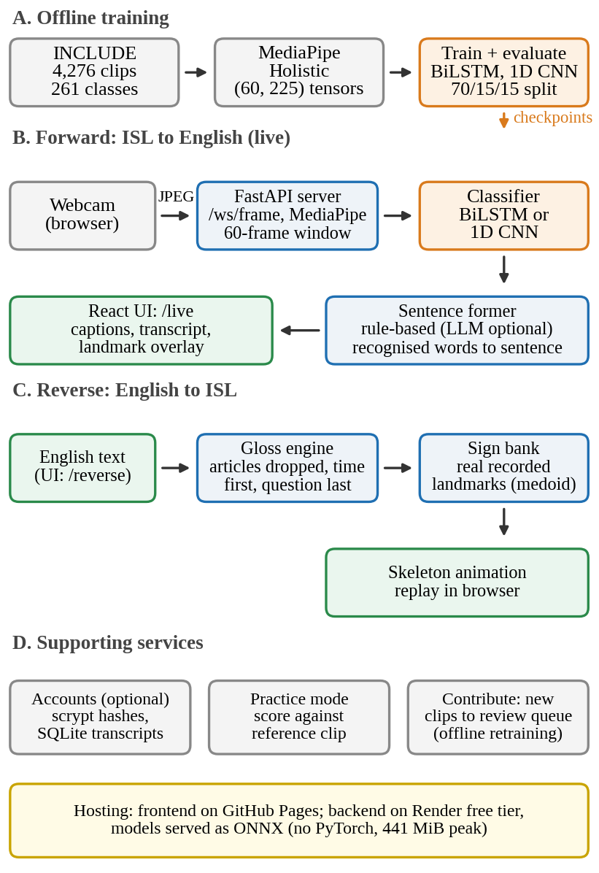
Fig. 1. Architecture of the complete system: offline training, the two translation directions and the supporting services.
Clips in the source corpus begin and end with the signer's arm at rest, so a trimming step identifies the active signing window within each 60-frame sequence by locating the span of frames that maximizes wrist-relative fingertip movement, weighted by wrist elevation; this window is used consistently both for model training and for the reverse-translation playback described above.
Two architectures were trained on the identical (60, 225) landmark tensors under an identical protocol, differing only in how they model the temporal dimension. The first is a Bidirectional LSTM (2,665,477 parameters), which processes the frame sequence in both temporal directions to capture long-range dependencies across the full gesture. The second is a one-dimensional Convolutional Neural Network (736,773 parameters), which instead applies convolutions along the time axis to capture local temporal motion primitives. Both models were trained for up to 60 epochs with a learning rate of 3 × 10⁻³, found empirically to converge substantially faster than the common default of 1 × 10⁻³ on this dataset size. Data augmentation (temporal jitter, frame dropping, temporal shifting and mirroring) was evaluated and found to be actively harmful at this dataset scale — with augmentation enabled, the BiLSTM reached only 0.94% validation accuracy after 16 epochs (against a 0.38% chance baseline), whereas disabling augmentation reached 58.97% accuracy within 5 epochs — and augmentation was therefore disabled for both models in the results reported here, so that the comparison between architectures remains controlled on every other setting. As a sanity baseline, a logistic regression classifier trained on time-pooled features of the same tensors was evaluated and reached 82% accuracy across all 261 classes, confirming that both deep models are capturing structure beyond what is available to a simple linear baseline on pooled features.
The reverse direction reuses the same recorded landmark data rather than requiring a separately produced video library or a rigged three-dimensional avatar, on the basis that each training tensor is already a recording of a real signer performing one sign and can be replayed. Input English text is first converted to ISL gloss order using a rule-based engine that removes articles and the copula, reorders the sentence into subject-object-verb order, moves temporal expressions to the front and question words to the end, and applies a synonym and morphology mapping — structural differences documented for ISL relative to English. For each gloss word, a single representative recording is selected from the available takes of that sign by filtering to takes where MediaPipe reliably detected the signing hand or hands, then choosing the medoid (the take closest to the class average) among the qualifying takes, which yields a real, representative performance rather than an averaged and potentially anatomically invalid blend of several takes. Hand and pose coordinates are reconstructed from the stored wrist-relative, shoulder-scaled representation back into image space for playback, trimmed to the active signing window identified above.
The system is implemented as a FastAPI backend and a React frontend. Live recognition is served over a persistent WebSocket endpoint that streams webcam frames from the client, returns per-frame landmark and prediction data, and maintains per-connection recognition state so that concurrent users do not interfere with one another's in-progress recognition. Once a sequence of isolated words has been recognized, a sentence-formation endpoint stitches them into one fluent English sentence, using a deterministic rule-based reordering pass by default or a large language model fallback when configured. User accounts are optional: signed-in users have transcripts and practice history persisted server-side in SQLite, with passwords stored as scrypt hashes under a per-user random salt and session tokens stored hashed rather than in plaintext, while guest users have nothing written to the server at all. Raw video is never stored or transmitted beyond the per-frame landmark extraction step, which is a direct consequence of operating on landmarks rather than pixels. The frontend is deployed continuously to GitHub Pages. The original backend, which loaded MediaPipe, PyTorch and OpenCV in one process, used roughly 500-700 MB and did not fit a 512 MB free hosting tier; for hosting, the two models are therefore exported to ONNX and served with ONNX Runtime, without PyTorch, which brings the measured footprint to 188 MiB idle and 441 MiB at peak with two concurrent camera streams. The server also records each live prediction and reports frames processed, hand visibility, mean confidence and a drift alarm on a monitoring endpoint.
Both models were evaluated on the same 642-clip held-out test split, which was not used during training or model selection. The reported metrics are overall accuracy, top-5 accuracy, macro-averaged F1 (which weights every class equally and is therefore sensitive to the dataset's class imbalance), weighted F1, mean and 95th-percentile inference latency per clip, parameter count and wall-clock training time. The 1D CNN outperformed the BiLSTM on every measured axis: 94.55% versus 91.74% test accuracy, 98.44% versus 97.66% top-5 accuracy, 0.9433 versus 0.9140 macro F1, and 0.74 ms versus 4.12 ms mean inference latency, while using 3.6 times fewer parameters (736,773 versus 2,665,477) and completing training roughly 6.8 times faster (287 versus 1,953 seconds on CPU). The consistent advantage of the convolutional model across accuracy, latency and model size suggests that isolated ISL signs in this dataset are separable primarily from short, local motion primitives, so that the additional long-range temporal modelling capacity of the BiLSTM does not pay for itself at this vocabulary size; this may not generalize to continuous, multi-sign ISL, where context spans a longer temporal range, and is left as a direction for future work.
Test and evaluation protocol. The models were evaluated against the AI-model test-and-evaluation framework of the U.S. Chief Digital and Artificial Intelligence Office [6], which asks for evidence on correctness, interpretability, bias, robustness, resilience, uncertainty, drift, representativeness and latency, using comparison, adversarial and metamorphic test types, sound test design, and data and model documentation. Every analysis below uses the trained checkpoints and the same 642 test clips unless stated, and is produced by a script whose results are saved to file. Noise: zero-mean Gaussian noise is added to the raw landmark features before normalisation, at 0.05 to 2.0 times each feature's own standard deviation, averaged over three seeds; the six wrist-origin features, which are exactly zero by construction, are left unperturbed. Dropped frames are set to all zeros, as when MediaPipe finds nobody. Interpretability: occlusion replaces a block of normalised features with the training mean (left-hand, right-hand or pose features, or a 10-frame window), and gradient-times-input saliency measures the share of the true-class logit's sensitivity carried by each feature group, with the model in evaluation mode. Clustering: k-means with k = 261 is fitted on the training clips in three feature spaces (time-pooled raw landmarks, and the 512-dimensional embedding before each model's classifier head); each cluster takes the majority label of its training clips. Uncertainty: expected calibration error over 15 bins, negative log-likelihood and Brier score, temperature scaling fitted on the validation split [7], and selective accuracy at confidence thresholds. Adversarial testing: white-box FGSM [8] and 10-step PGD [9] attacks bounded in the L-infinity norm. Metamorphic testing [11]: five transformations that should not change the sign (small noise, a two-frame time shift, a 10% speed change, a 5% sideways shift of the signer, and left-right mirroring), scored by how often the prediction changes. Bias and representativeness: accuracy by class size and for one- versus two-handed signs, and class shares in train versus test. Drift: a monitor combining per-feature Kolmogorov-Smirnov tests against the validation data with the drop in mean confidence, tested on simulated drift. Resilience: recovery of a sliding-window recogniser after a blackout of empty frames. Test design: stratified k-fold cross-validation with retraining. Documentation: a model card [10] and a data card are kept with the code.
Software design and testing. The software is organized in layers so that each can be tested without the others: a deterministic gloss engine, a rule-based sentence former, an account module, a contribution store, the model code, an evaluation suite and a React frontend, with MediaPipe and the model runtime confined to the server process. Tests were designed requirement-first and are listed in Table II by level, by whether they look inside the code (white-box) or only at inputs and outputs (black-box), and by whether they are automated or manual. Black-box unit and integration tests check the ISL grammar rules (17), sentence formation (14) and the accounts API (38); white-box unit tests check contribution storage (12) and, for the models, parameter counts, output shapes, gradient flow to every parameter, dropout and BatchNorm behaviour, mirror augmentation, deterministic disjoint stratified splits and, against the saved statistics, that normalisation used the training split only (17). A production monitor that tracks live prediction confidence and raises a drift alarm is unit-tested separately (10). Statement-and-branch coverage of the backend modules under these tests is 92%. Black-box model tests (20) check the output contract, the acceptance criteria (top-1 at least 90%, top-5 at least 95%, latency under 100 ms), boundary inputs such as an empty scene, a missing hand and 30- or 90-frame sequences, rejection of malformed input, and determinism; an empty scene gets a top confidence below the 0.5 floor the application uses, so nothing is captioned. Frontend checks confirm that all 11 routes render, that 1,027 class names across 94 files resolve, that 19 trail-data assertions hold and that the production build compiles. An automated end-to-end test drives the built application in a headless browser against the running backend (10 checks), and a manual test plan of 16 cases covers what automation cannot judge: a real person signing to a real webcam, lighting, and usability. All automated suites pass; those that need no dataset run on every push in continuous integration. Testing exposed real defects, each fixed: inflected verbs such as "going" were not reduced to their base sign, a second clip saved within one second overwrote the first, and a missing export would have broken the production build.
TABLE II. Test suites by level, box and execution
Suite | Type | Checks | Result
Gloss rules | Unit, black-box, auto | 17 | pass
Sentence formation | Unit, black-box, auto | 14 | pass
Contribution storage | Unit, white-box, auto | 12 | pass
Accounts API | Integration, black-box, auto | 38 | pass
Live monitor | Unit, white-box, auto | 10 | pass
Backend coverage | White-box metric | 412 stmts | 92%
Model internals | Unit, white-box, auto | 17 | pass
Model behaviour | Model, black-box, auto | 20 | pass
Frontend checks | UI, black-box, auto | 11 / 1,027 / 19 | pass
End-to-end browser | System, black-box, auto | 10 | pass
Real user, webcam | Acceptance, manual | 16 cases | planned

The user interface is integrated with the backend through eleven routes: a gate (sign in or guest), a home page, Live (webcam captions over the WebSocket), Reverse (text to sign animation), Practice (scored attempts), Contribute (new clips), Transcripts, Settings, About, Research (which reads the measured comparison file on each request, so the displayed figures are not hard-coded) and a rubric page. When the backend is unreachable the interface reports that state instead of showing invented output.
IV. RESULTS AND ANALYSIS
All figures in this section are produced from the measured evaluation files of the project (the comparison, training-history and complexity logs), on the 642-clip held-out test set. The reference points are a logistic-regression classifier on time-pooled features (82% accuracy) and, between the two deep models, the 1D CNN, which the project treats as the baseline for the BiLSTM.
Accuracy. Fig. 2 compares top-1 accuracy with the logistic-regression baseline: the BiLSTM (91.74%) and the 1D CNN (94.55%) are 9.74 and 12.55 percentage points above it. Fig. 3 shows that the gap between the models narrows at top-5 (97.66% against 98.44%), so most of the BiLSTM's extra errors are near misses rather than wild guesses. Fig. 4 shows the same ordering for macro F1 (0.9140 against 0.9433) and weighted F1 (0.9126 against 0.9422).
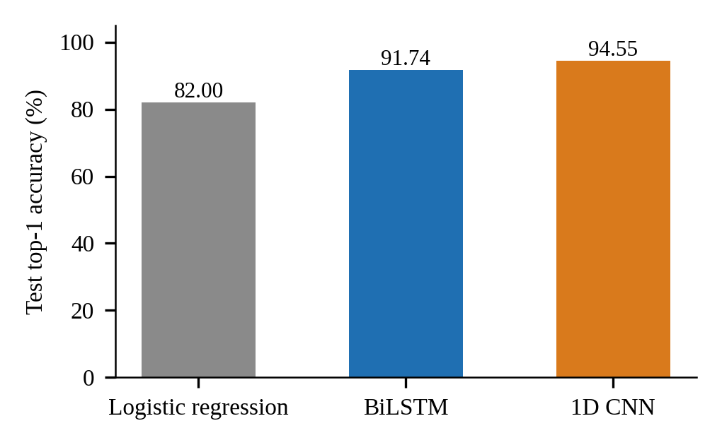
Fig. 2. Top-1 test accuracy against the logistic-regression baseline.
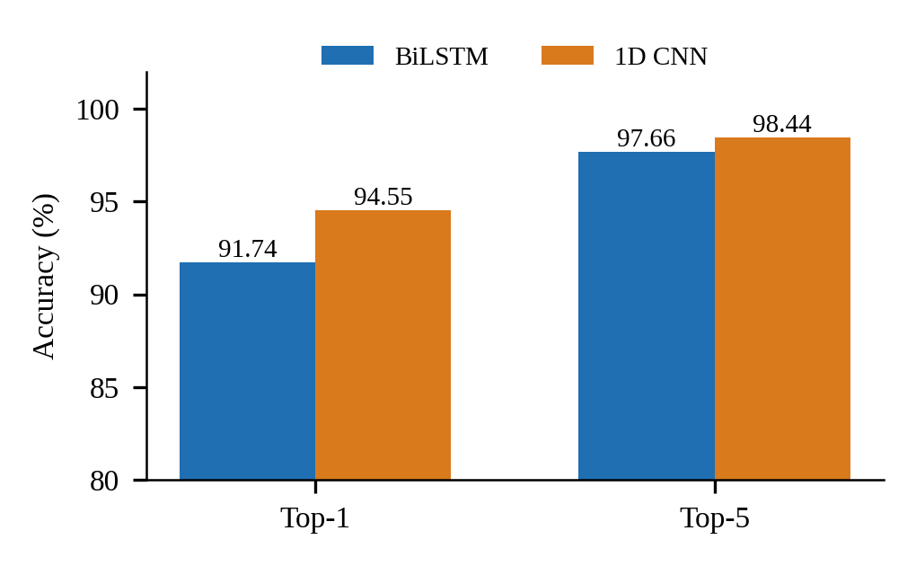
Fig. 3. Top-1 and top-5 test accuracy of the two models.
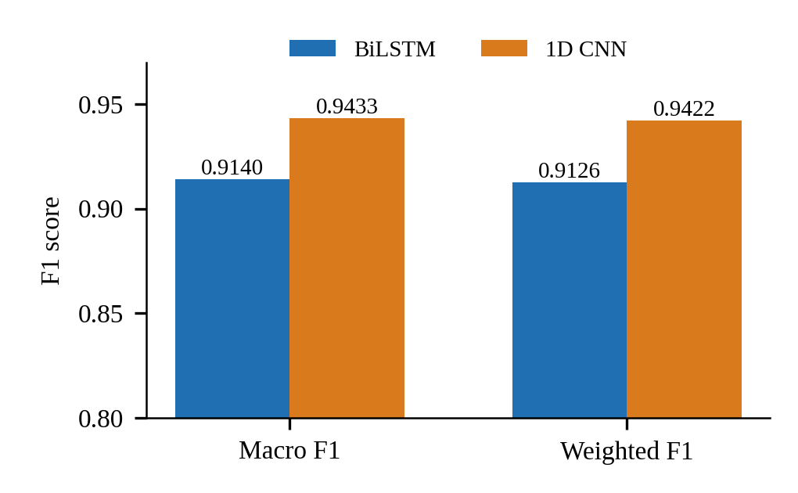
Fig. 4. Macro and weighted F1 on the 642 test clips.
TABLE III. Complete comparison on the held-out test set
Metric | Logistic reg. | BiLSTM | 1D CNN
Top-1 accuracy | 82% | 91.74% | 94.55%
Top-5 accuracy | n/a | 97.66% | 98.44%
Macro F1 | n/a | 0.9140 | 0.9433
Weighted F1 | n/a | 0.9126 | 0.9422
Best val. accuracy | n/a | 93.76% | 95.32%
Parameters | n/a | 2,665,477 | 736,773
MACs per clip | n/a | 153.6 M | 18.6 M
Latency mean (ms) | n/a | 4.12 | 0.74
Latency p95 (ms) | n/a | 6.90 | 1.05
Training time | n/a | 32.5 min | 4.8 min
Best epoch (of 60) | n/a | 41 | 45

Efficiency. Figs. 5 to 8 and Table III show that the 1D CNN is cheaper on every cost axis: mean latency of 0.74 ms against 4.12 ms (5.6 times lower), 3.62 times fewer parameters, 8.27 times fewer multiply-accumulates per clip and a training time of 4.8 minutes against 32.5 minutes on CPU. These latencies are for the model alone; the end-to-end delay of the live system also includes landmark extraction, which was not separately timed in this study.
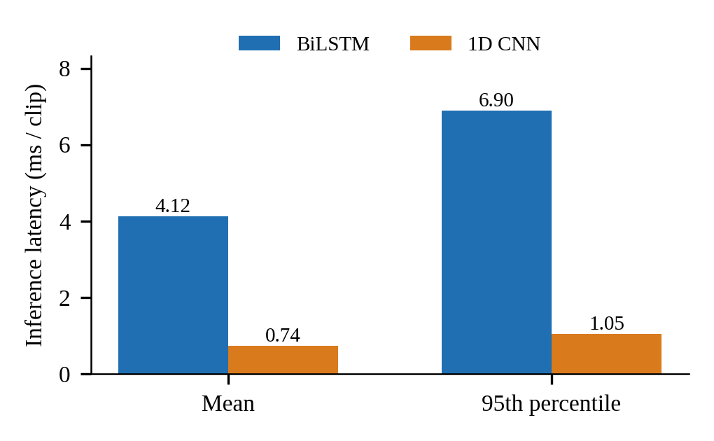
Fig. 5. Mean and 95th-percentile inference latency per clip.
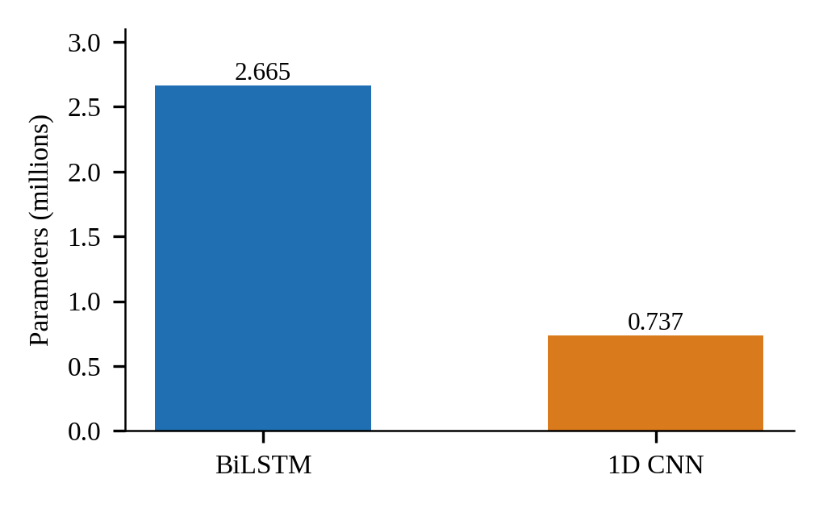
Fig. 6. Trainable parameters of each model.
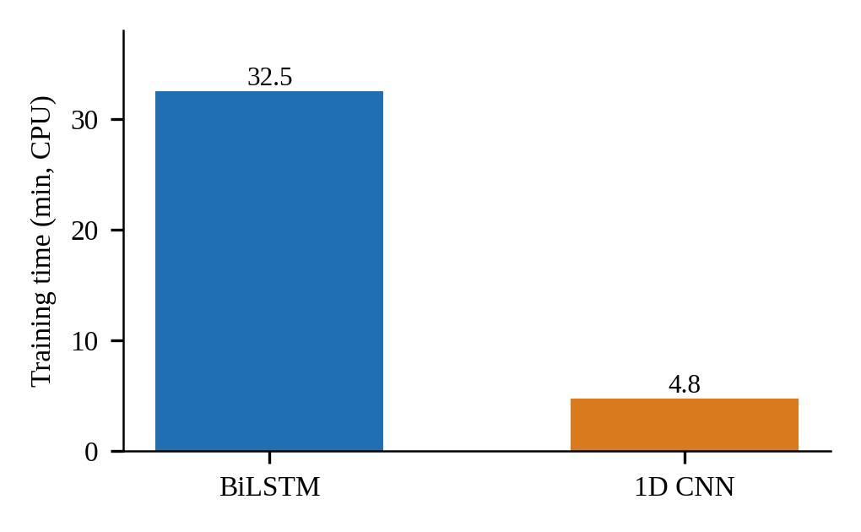
Fig. 7. Wall-clock training time on CPU.
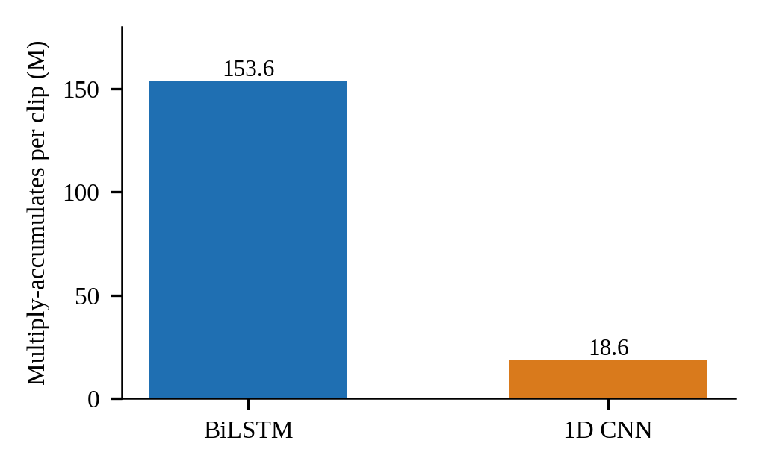
Fig. 8. Multiply-accumulate operations per clip.
Training behaviour. Fig. 9 shows that the BiLSTM learns faster at first (79.1% validation accuracy at epoch 10 against 66.0% for the CNN, and 90% reached at epoch 22 against epoch 23) but the CNN overtakes it later and finishes higher. In Fig. 10 the BiLSTM's final training loss (0.583) sits well below its validation loss (0.815), a gap of 0.232, whereas the CNN's two losses are close (0.752 and 0.805, a gap of 0.053), which suggests the BiLSTM fits the training clips more tightly.
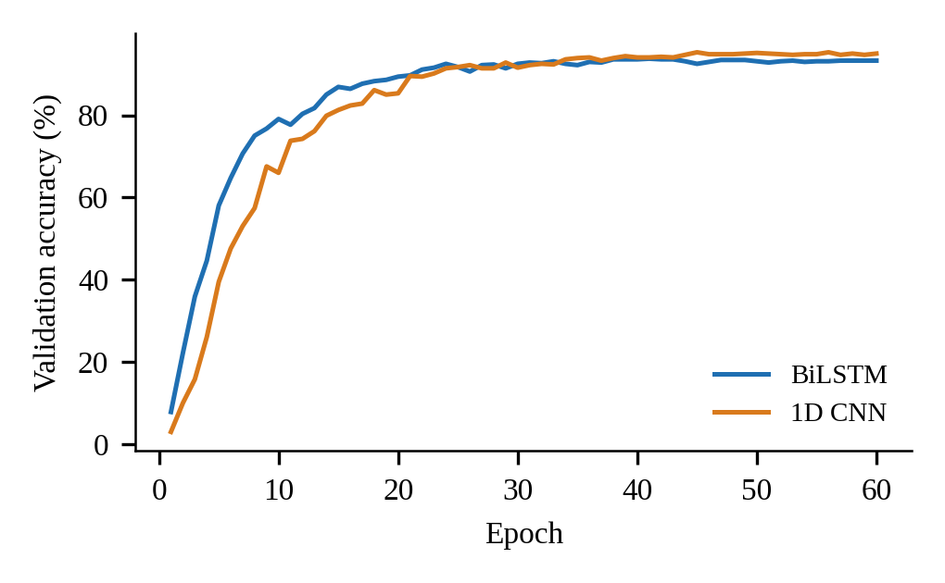
Fig. 9. Validation accuracy per epoch.
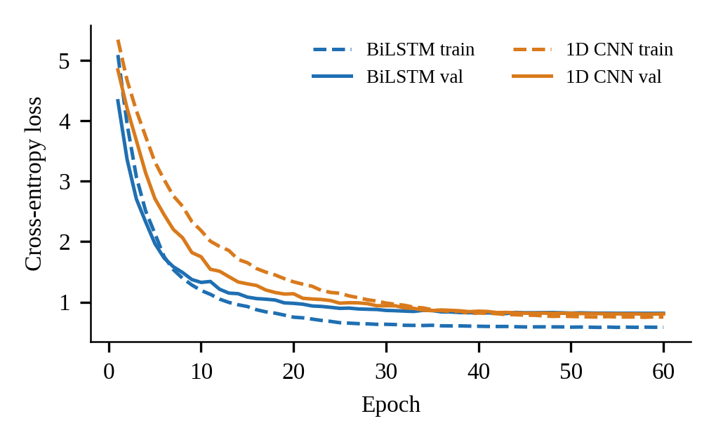
Fig. 10. Training and validation loss per epoch.
Class-level results. Fig. 11 and Table IV show how the errors are distributed. The CNN scores an F1 of at least 0.9 on 207 of the 261 classes and below 0.5 on only 2, while the BiLSTM manages 187 and 5. The classes with F1 of exactly 0 are extra, soldier, thursday and ugly for the BiLSTM and extra for the CNN.
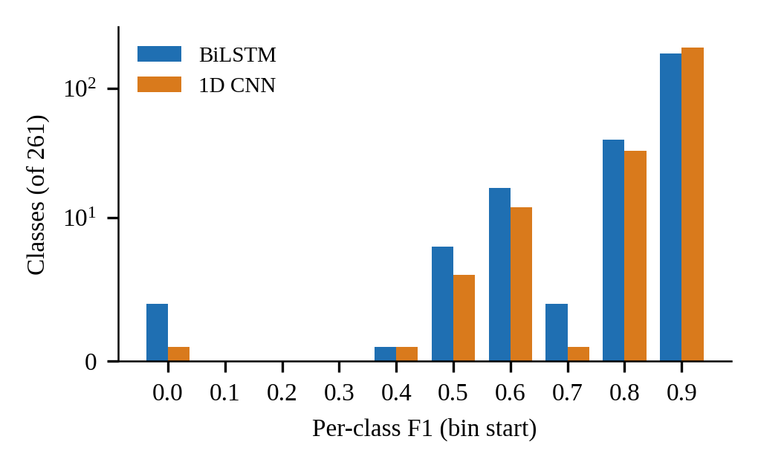
Fig. 11. Distribution of per-class F1 (count axis is symmetric-log).
TABLE IV. Per-class outcome summary
Per-class F1 | BiLSTM | 1D CNN
Classes with F1 >= 0.9 | 187 | 207
Classes with F1 < 0.5 | 5 | 2
Classes with F1 = 0 | 4 | 1
Weakest classes | extra, soldier, thursday, ugly | extra

Robustness to noise. Fig. 12 and Table V show that both models are almost unaffected by Gaussian landmark noise: the BiLSTM stays between 91.7% and 92.0% and the CNN between 94.5% and 94.7% up to noise equal to half of each feature's standard deviation, and the CNN loses only about one point (93.67%) at one full standard deviation. Dropping whole frames is very different (Fig. 13). At 10% of frames dropped the BiLSTM keeps 90.71% but the CNN falls to 56.13%; at 30% the figures are 78.30% and 6.23%, and at 50% the BiLSTM is at 45.28% and the CNN at 2.39%.
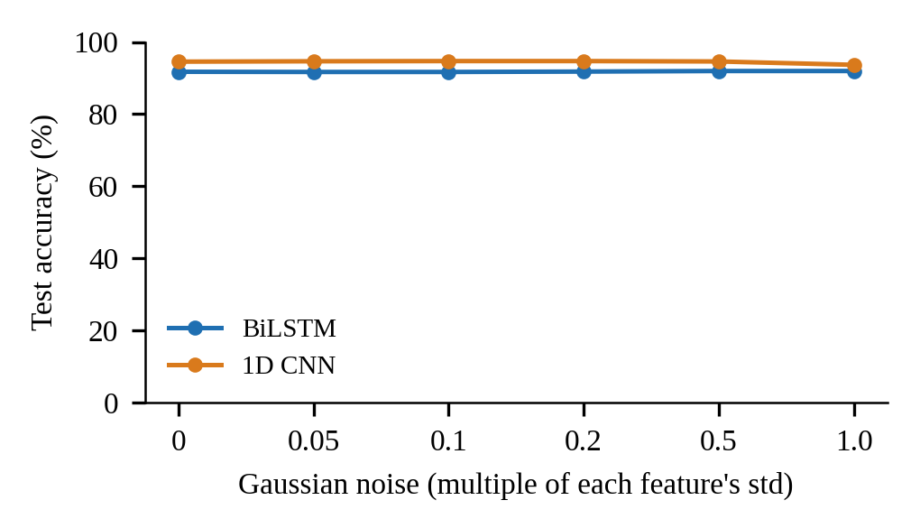
Fig. 12. Test accuracy under Gaussian landmark noise.
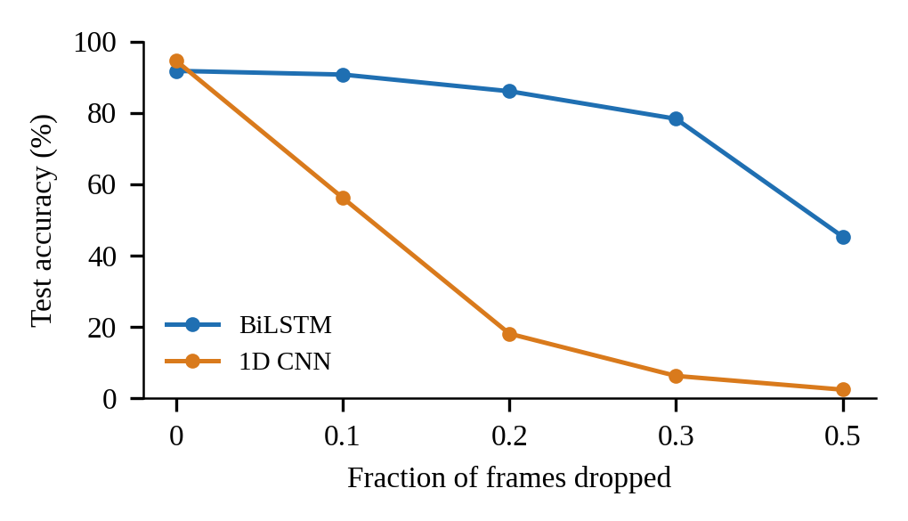
Fig. 13. Test accuracy when a fraction of frames is dropped.
TABLE V. Accuracy (%) under noise and frame dropping
Condition | BiLSTM | 1D CNN
Clean | 91.74 | 94.55
Noise 0.2 x feature std | 91.80 | 94.70
Noise 1.0 x feature std | 91.95 | 93.67
10% frames dropped | 90.71 | 56.13
30% frames dropped | 78.30 | 6.23
50% frames dropped | 45.28 | 2.39

Explainability. Fig. 14 and Table VI show what happens when a block of features is removed. Without the pose features accuracy falls to 23.8% (BiLSTM) and 16.4% (CNN); without the right-hand features it falls to 39.6% and 36.6%; without the left-hand features it falls less, to 74.9% and 79.3%. The gradient-times-input analysis in Fig. 16 agrees on the ordering: pose carries 43.3% and 42.7% of the sensitivity, the right-hand features 33.9% and 36.8%, and the left-hand features 22.8% and 20.4%. Fig. 15 shows that no single 10-frame window is critical: removing any one of the six windows leaves accuracy between 86.1% and 91.4% for the BiLSTM and between 93.0% and 93.9% for the CNN.
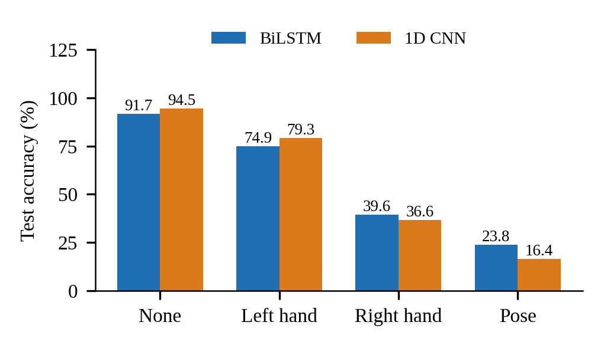
Fig. 14. Test accuracy when one feature group is occluded.
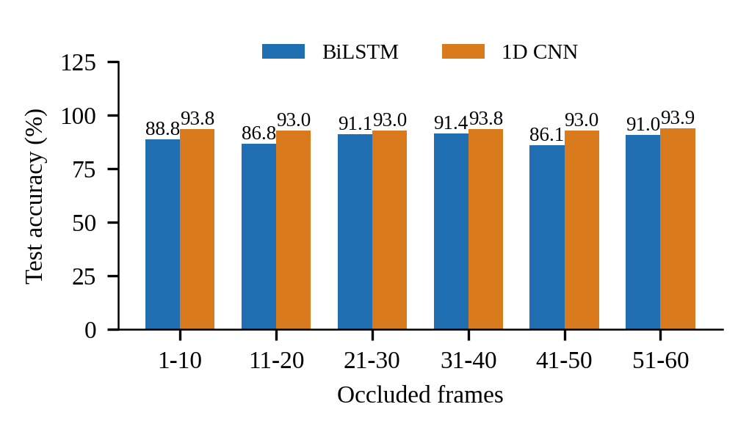
Fig. 15. Test accuracy when one 10-frame window is occluded.
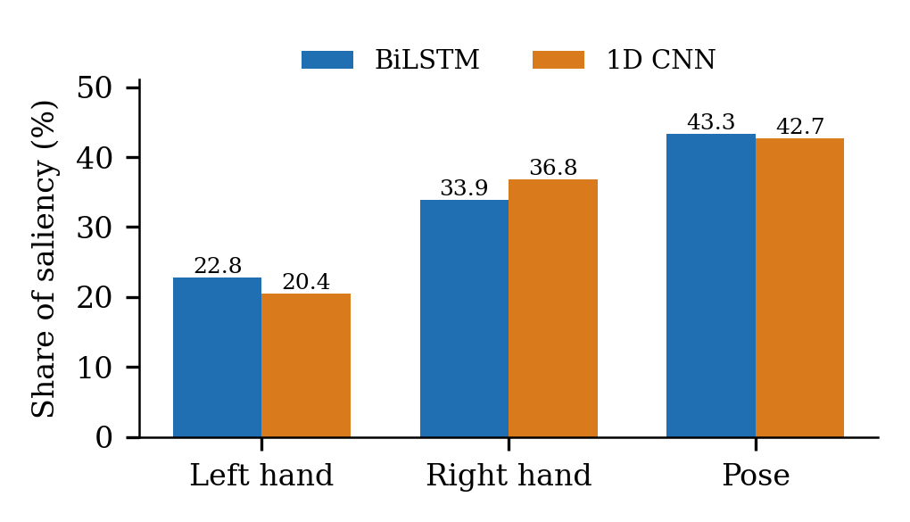
Fig. 16. Share of gradient-times-input saliency by feature group.
TABLE VI. Occlusion analysis (test accuracy %, mean true-class probability)
Occluded | BiLSTM | 1D CNN
None | 91.74, 0.848 | 94.55, 0.880
Left hand | 74.92, 0.590 | 79.28, 0.621
Right hand | 39.56, 0.288 | 36.60, 0.245
Pose | 23.83, 0.134 | 16.36, 0.081

Clustering. Fig. 17 and Table VII show that k-means separates the signs well only in the learned embedding space. Cluster-vote accuracy is 9.7% on time-pooled raw landmarks, against 88.2% on the BiLSTM embedding and 85.2% on the CNN embedding; the adjusted Rand index is 0.078, 0.784 and 0.703 respectively.
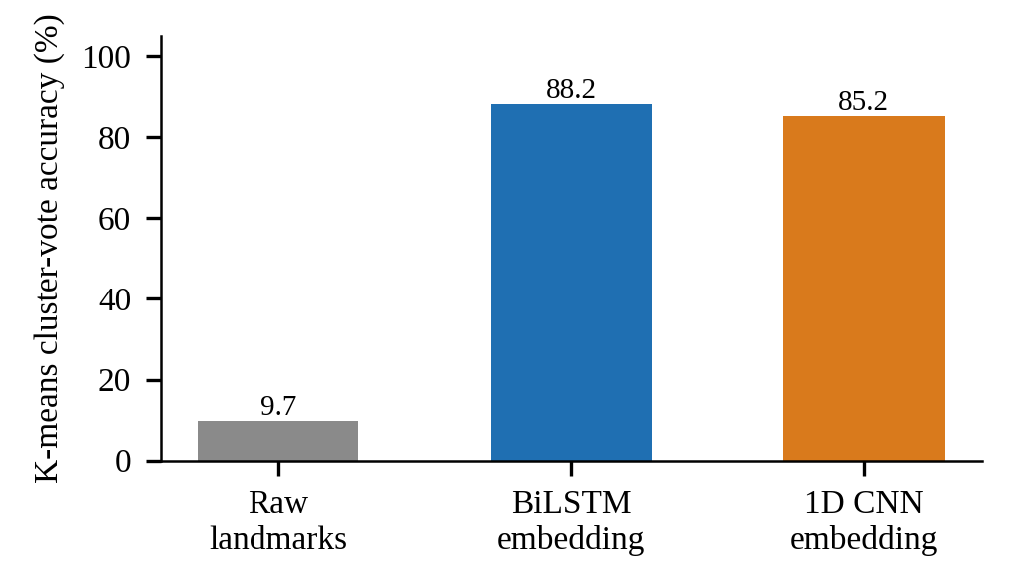
Fig. 17. K-means (k = 261) cluster-vote accuracy by feature space.
TABLE VII. K-means (k = 261) in three feature spaces
Feature space | Vote acc. | NMI | ARI
Raw pooled (450-d) | 9.7% | 0.817 | 0.078
BiLSTM embed. (512-d) | 88.2% | 0.967 | 0.784
CNN embed. (512-d) | 85.2% | 0.961 | 0.703

Uncertainty and calibration. Both models are well calibrated: expected calibration error (ECE, 15 bins) is 0.034 for the BiLSTM and 0.034 for the CNN (Fig. 18, Table VIII). Temperature scaling fitted on the validation split, never on test, lowers it to 0.027 and 0.024. Confidence separates right from wrong answers: mean confidence is 0.91 on correct and 0.59 on wrong BiLSTM predictions, and 0.92 and 0.70 for the CNN. At the 0.5 confidence floor the live application uses, the BiLSTM answers 93.6% of clips with 94.51% accuracy and the CNN answers 97.2% with 95.67%.
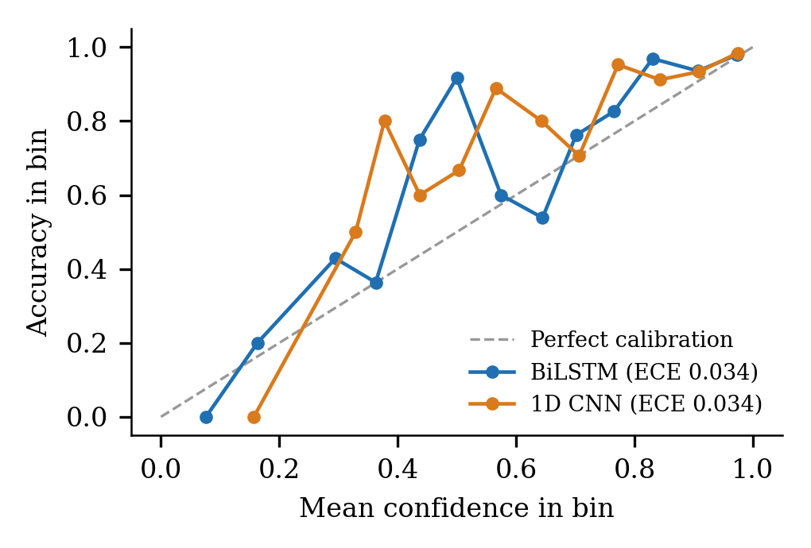
Fig. 18. Reliability diagram: accuracy against confidence (15 bins).
TABLE VIII. Calibration and selective prediction
Metric | BiLSTM | 1D CNN
ECE | 0.0337 | 0.0345
ECE, temperature-scaled | 0.0270 | 0.0239
NLL / Brier | 0.411 / 0.129 | 0.325 / 0.096
Coverage, acc. at conf. >= 0.5 | 93.6%, 94.5% | 97.2%, 95.7%
Acc. on 80% most confident | 97.5% | 97.7%

Adversarial robustness. Worst-case perturbations are far more damaging than random noise (Fig. 19). Under a 10-step projected-gradient (PGD) attack bounded at 0.05 feature standard deviations, accuracy falls to 74.0% for the BiLSTM and 72.7% for the CNN; at 0.1 it falls to 43.8% and 23.2%, whereas random noise of a full standard deviation costs at most about one point. The CNN, the more accurate model on clean data, is the more fragile one under attack at every budget from 0.05 upward.
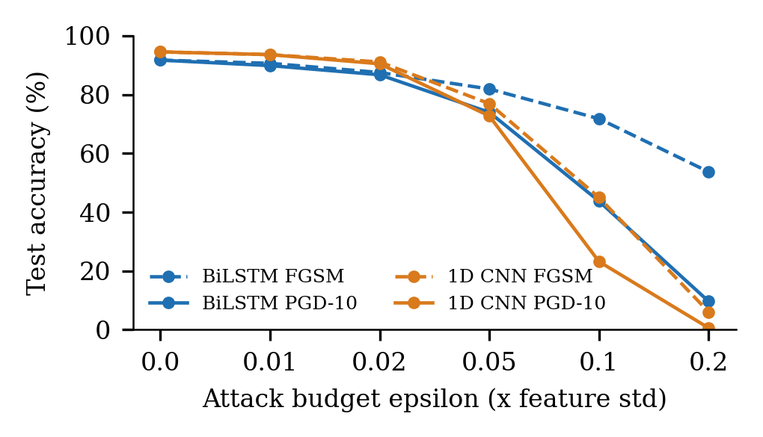
Fig. 19. Test accuracy under FGSM and PGD-10 attacks of increasing budget.
Metamorphic testing. Table IX lists five relations that should leave the predicted sign unchanged. Small noise, a two-frame time shift and a 10% change of signing speed change at most 2.0% of predictions. Two relations expose real weaknesses (Fig. 20): moving the signer 5% sideways in the image changes 51.6% of BiLSTM and 20.6% of CNN predictions, and mirroring the clip, as for a left-handed signer, changes 77.6% and 78.3%.
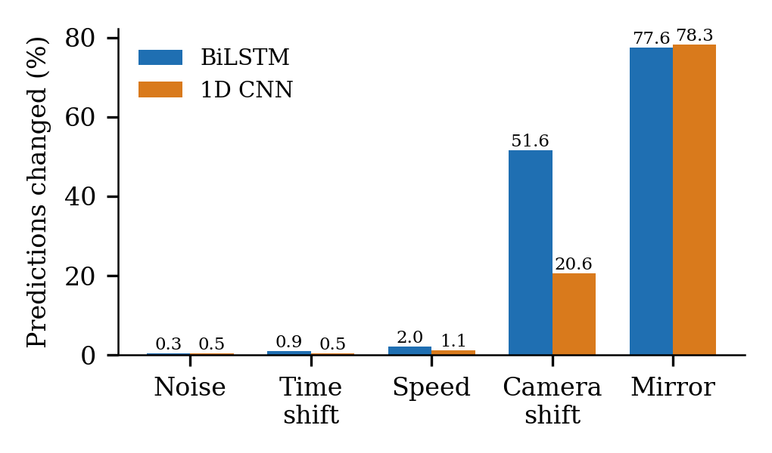
Fig. 20. Share of predictions changed by each metamorphic transformation.
TABLE IX. Metamorphic relations: predictions changed
Relation | BiLSTM | 1D CNN
Noise, 0.1 x std | 0.3% | 0.5%
Time shift, +/-2 frames | 0.9% | 0.5%
Speed, +/-10% | 2.0% | 1.1%
Signer shifted 5% | 51.6% | 20.6%
Mirrored (left-handed) | 77.6% | 78.3%

Bias and representativeness. The split is representative by construction: every class appears in the test set and no class's share differs between train and test by more than 0.16 percentage points. Accuracy is lower on one-handed signs (86.4% BiLSTM, 91.4% CNN, 81 test clips) than on two-handed signs (92.5% and 95.0%), and for the CNN on classes with the fewest training clips (93.3%) than on those with the most (95.3%) (Fig. 21, Table X). The data carry no signer identity, so fairness across signers or demographic groups could not be measured.
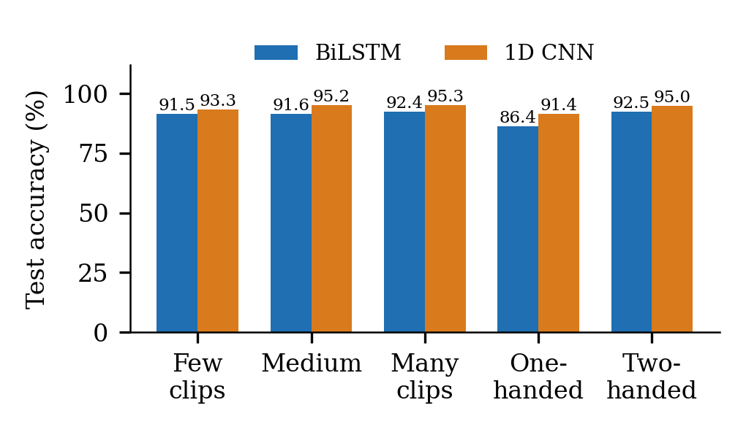
Fig. 21. Test accuracy by class size and by one- or two-handed signs.
TABLE X. Accuracy by group
Group | Clips | BiLSTM | 1D CNN
Few-clip classes | 223 | 91.5% | 93.3%
Medium classes | 249 | 91.6% | 95.2%
Many-clip classes | 170 | 92.4% | 95.3%
One-handed signs | 81 | 86.4% | 91.4%
Two-handed signs | 561 | 92.5% | 95.0%

Drift monitoring. A drift monitor was built that compares each batch of incoming clips with the validation data, using Kolmogorov-Smirnov tests on the per-clip feature averages and the drop in mean model confidence. On simulated drift (Table XI) it stays silent on clean data and on mild sensor noise, which do not hurt accuracy, and raises an alarm in all three conditions that do: dropped frames, a shifted camera and left-handed signers.
TABLE XI. Drift monitor on simulated drift (300 clips each)
Scenario | Feature score | Alarm | Accuracy (BiLSTM / CNN)
No drift | 0.000 | no | 91.3% / 94.3%
Sensor noise 0.5 std | 0.000 | no | 92.0% / 94.7%
20% frames dropped | 0.721 | yes | 86.0% / 19.3%
Camera shift 10% | 0.151 | yes | 13.7% / 31.7%
Left-handed signers | 0.557 | yes | 22.0% / 21.3%

Resilience. In a simulated live stream (a sign, a blackout of empty frames, the sign again, with a 60-frame window sliding one frame at a time), the BiLSTM keeps answering correctly through a 15-frame blackout in 97.5% of windows and recovers a median 26 frames after a 30-frame blackout. The CNN answers correctly in only 37.1% of windows during a 15-frame blackout and needs a median 54 frames, about 4.5 seconds at the application's 12 frames per second, to recover (Table XII).
TABLE XII. Recovery after a blackout (200 streams each)
Blackout | BiLSTM | 1D CNN
15 frames | 0 frames; 97.5% correct during | 54 frames; 37.1% correct during
30 frames | 26 frames; 90.1% correct during | 54 frames; 21.1% correct during

Cross-validation. To estimate how much the results depend on the particular split, both models were retrained with stratified 3-fold cross-validation over all 4,276 clips (Fig. 22, Table XIII). To keep CPU time practical each fold used 20 epochs instead of 60, so the fold scores are lower than the headline results and measure variation across splits, not final accuracy. Mean fold accuracy is 89.59% (standard deviation 1.89) for the BiLSTM and 85.29% (1.06) for the CNN.
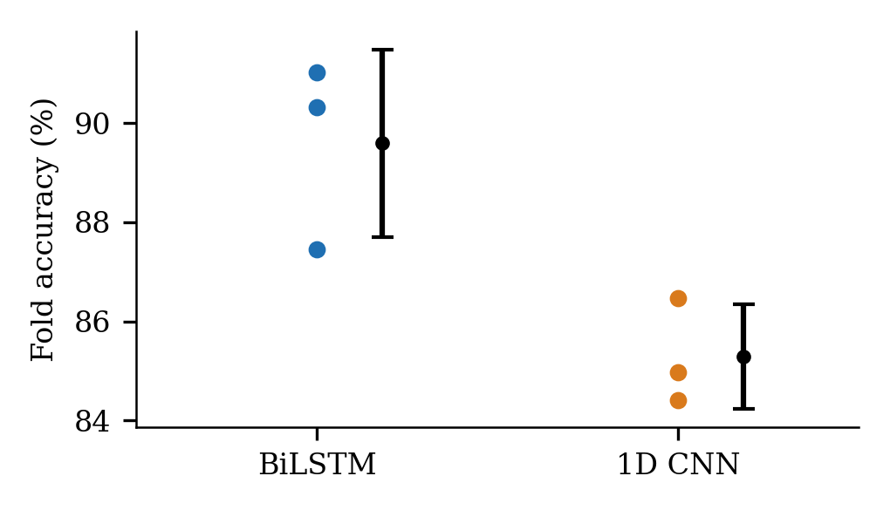
Fig. 22. Accuracy of each cross-validation fold (dots) with mean and standard deviation.
TABLE XIII. Stratified cross-validation (reduced budget)
Model | Fold 1 | Fold 2 | Fold 3 | Mean +/- SD
BiLSTM | 87.4% | 90.3% | 91.0% | 89.6 +/- 1.9
1D CNN | 86.5% | 85.0% | 84.4% | 85.3 +/- 1.1

Qualitative error analysis. Most errors are near misses: for the BiLSTM 38 of 53 wrong answers, and for the CNN 25 of 35, still have the correct word in the top five. The confusions are often between related signs, for example he and she, skirt and pant (BiLSTM) and dress and clothing, wife and husband (CNN). The two models fail on partly different clips: both are wrong on 27 clips, only the BiLSTM on 26 and only the CNN on 8, so choosing whichever is right would reach 95.79%. Per-frame saliency for three example signs (Fig. 24) shows each model drawing on several moments of the sign rather than one frame.
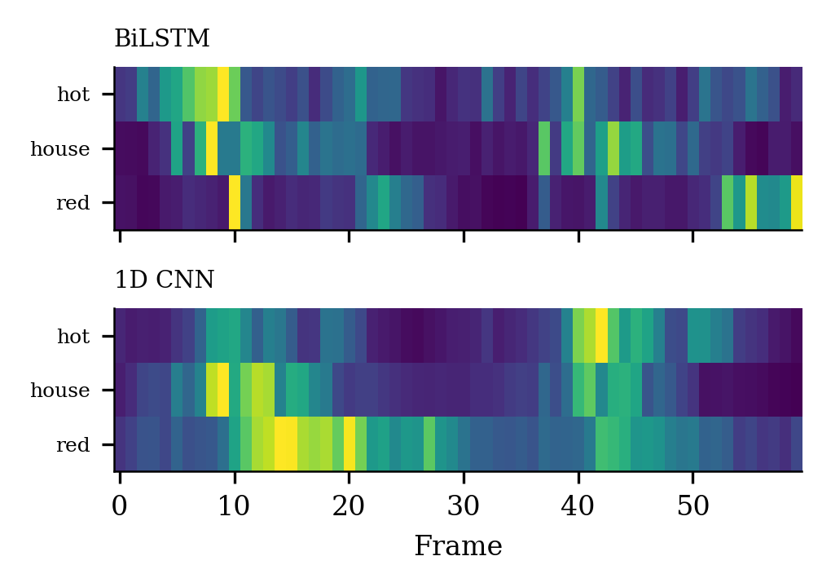
Fig. 24. Per-frame saliency (gradient x input, normalised per clip) for three test signs.
Deployment and end-to-end tests. The served models were exported to ONNX; ONNX Runtime gives the same top-1 prediction as PyTorch on all 642 test clips. Without PyTorch, the server measured 188 MiB idle and 441 MiB at peak with 2 concurrent camera streams, inside a 512 MiB free hosting limit. An automated end-to-end test drove the built web application in a headless browser against this server with a synthetic camera: all 10 checks passed, including frames streaming over the WebSocket, no caption being invented for an empty scene, reverse translation, and the Research, Practice and Contribute pages loading data from the backend.
V. DISCUSSION
Which model, and why. The convolutional model wins on accuracy and on every cost measure, which is a stronger result than a simple trade-off between accuracy and speed. A plausible reading, consistent with the training curves, is that an isolated sign in a 60-frame window is identified by short local motion patterns, which convolutions along time capture directly, so the BiLSTM's ability to carry information across the whole clip is not what limits accuracy here. The complexity analysis adds a structural reason for the latency gap: the recurrent layers must process the 60 time steps one after another, so the critical path is sequential however many cores are available, whereas the convolutions can be computed across time in parallel. We did not run an ablation that isolates these causes, so they remain explanations, not tested findings.
Fast start against better finish. The BiLSTM's early lead (Fig. 9) and larger train-validation gap (Fig. 10) point to different behaviour rather than a better or worse optimiser: it fits the training data quickly and then stops improving on unseen clips, whereas the CNN improves more slowly but generalises slightly better. Both models were trained with the same schedule for 60 epochs and with augmentation off, so neither result reflects tuning for one model. A different schedule or regularisation might change the BiLSTM's finish, and we did not search for one.
Reading the weak classes. With 8 to 27 clips per class and a 15% test share, each class has roughly one to four test clips, so a single wrong prediction moves its F1 sharply. The zero-F1 classes should therefore be read as signs to collect more clips for, not as proof that those signs are unlearnable, and the small difference between the models on a few classes (for example ugly and soldier) is within what one clip can change. The Contribute feature in the application was built for exactly this case: users can record more clips for a word, which are queued for human review and offline retraining.
Top-5 against top-1. Top-5 accuracy of 97.66% and 98.44% means the correct word is almost always among the five most likely answers. For the application this matters because the recognised word stream is passed to a sentence former, so a future interface could show the next-best candidates for the user to confirm; the current system uses the top prediction only.
Robustness: noise is not the weakness, missing frames are. The flat curves in Fig. 12 mean that small coordinate jitter, the kind of error a landmark detector makes on a clear frame, is not a practical risk for either model. Missing frames are a different matter (Fig. 13): the CNN is far more fragile than the BiLSTM, losing 38 points at 10% dropped frames where the BiLSTM loses about one. A dropped frame sets every feature to zero, which is unlike any frame seen in training, and the CNN's pooled convolutional features appear to be disturbed by such frames much more than the BiLSTM's recurrent state, although we did not isolate the mechanism. In deployment this matters, because a webcam that skips frames or a landmark detector that loses the signer for a moment produces exactly this condition. The 1D CNN is therefore the better model on a clean test set and the BiLSTM the safer model when frames can be missing, and a deployment that accepts a small accuracy loss for resilience might prefer the BiLSTM or train the CNN with frame dropping.
Explainability: where the models look. Both explanation methods agree that body pose carries the most information, followed by the right-hand and then the left-hand features (Figs. 14 and 16). That the pose features matter more than either hand is plausible, because they place the hands relative to the face and body and so encode where a sign is made, which separates signs with similar handshapes. The occlusion test also shows that the evidence is spread across time: no single 10-frame window is critical (Fig. 15), so the models do not depend on one key moment. These are measurements of model sensitivity to removed or perturbed inputs, not proof of how a signer would explain a sign, and occluding a block with the mean is itself an out-of-distribution input.
Clustering: the learned features carry the structure. K-means on raw pooled landmarks recovers almost nothing (9.7%), while the same algorithm on the models' embeddings recovers 85 to 88% of the labels, so nearly all of the class structure is created by the networks rather than present in simple pooled statistics. It is notable that the BiLSTM embedding clusters better than the CNN embedding (adjusted Rand index 0.784 against 0.703) even though the CNN classifies better, which shows that clusterability and classification accuracy are not the same property. K-means with a vote is also a usable lightweight alternative to the classifier head: it reaches 88.2% without the head, which could support adding new signs by clustering before retraining, although we did not build or test that.
Confidence can be trusted, and used. Because both models are well calibrated, a confidence floor is a meaningful control rather than a cosmetic one: at the application's 0.5 floor the CNN withholds 2.8% of clips and is right on 95.67% of the rest, and an empty scene stays below the floor so nothing is captioned. Temperatures below one (0.85 and 0.82) mean both models are, if anything, slightly under-confident on the validation data, the opposite of the over-confidence often reported for deep classifiers [7].
Robust to noise is not robust to attack. The models shrug off random jitter but not perturbations chosen against them, and the more accurate CNN is the more fragile under attack. A Silent Voice user has no reason to attack their own captions, so this is not an operational threat for the application as built; it would matter if recognition were ever used where someone gains from a wrong answer, and it shows that clean accuracy alone says little about the decision boundary.
Where the system will fail first. The metamorphic tests point to the two most likely real-world failures. Position: pose coordinates are kept in image space, so a signer who stands slightly to one side changes 51.6% of BiLSTM and 20.6% of CNN predictions; centring and scaling the pose on the shoulders, as is already done for the hands, should remove most of this. Handedness: mirrored clips change about 78% of predictions, so left-handed signers are effectively unsupported, a fairness problem that mirror augmentation during training could address. The drift monitor raises an alarm in exactly these conditions, so in deployment it would flag them before users lose trust.
Choosing a model for the live stream. The clean-test ranking (CNN first) reverses under the conditions a live camera creates. The BiLSTM keeps 97.5% of windows correct through a short blackout and recovers quickly, while the CNN drops to 37.1% and needs about 4.5 seconds to recover, consistent with its sharp loss under dropped frames. For a webcam that occasionally loses the signer, the BiLSTM is the safer default, and the application lets the user switch.
Groups the models serve less well. One-handed signs are recognised less accurately than two-handed ones by both models, and the CNN is weaker on classes with few training clips. Both gaps are small next to the handedness and position effects above, but they identify where additional recordings, collected through the Contribute page, would help most.
How stable the comparison is. Cross-validation with a reduced training budget gives fold-to-fold standard deviations of 1.9 and 1.1 percentage points, so differences of that size between the two models on a single split should not be over-read. The headline comparison on the fixed split, with full training, remains the primary result.
Software quality as part of the result. Automated testing found real defects in the gloss rules and in contribution storage, and a build check caught a missing export that would have broken the deployed interface (Section III). We treat this as evidence that testing the supporting software, not only the model, changes what ships.
Limitations. The results come from one dataset (INCLUDE) with no signer identity, so there is no signer-independent test and no fairness measurement across signers or demographic groups; real-world accuracy with new signers, cameras and lighting is assessed only through the manual test plan, not a user study with deaf signers. The only classical baseline is logistic regression on pooled features, with a single accuracy value. Drift and resilience were tested on simulated conditions, not production traffic, and adversarial robustness with algorithmic attacks, not a human red team. Cross-validation used a reduced training budget. End-to-end tests used a synthetic camera, so they show that the system works as a whole, not how well it recognises a real signer. The GAN augmentation was evaluated with one generator and one retraining run per condition. The latency figures in Table III exclude landmark extraction. These gaps bound what the paper can claim.
REFERENCES
[1] A. Sridhar, R. G. Ganesan, P. Kumar, and M. Khapra, "INCLUDE: A Large Scale Dataset for Indian Sign Language Recognition," in Proc. 28th ACM Int. Conf. Multimedia (ACM MM), 2020, pp. 1366–1375.
[2] C. Lugaresi et al., "MediaPipe: A Framework for Building Perception Pipelines," arXiv:1906.08172, 2019.
[3] S. Hochreiter and J. Schmidhuber, "Long Short-Term Memory," Neural Computation, vol. 9, no. 8, pp. 1735–1780, 1997.
[4] M. Schuster and K. K. Paliwal, "Bidirectional Recurrent Neural Networks," IEEE Trans. Signal Processing, vol. 45, no. 11, pp. 2673–2681, 1997.
[5] Y. Kim, "Convolutional Neural Networks for Sentence Classification," in Proc. 2014 Conf. Empirical Methods in Natural Language Processing (EMNLP), 2014, pp. 1746–1751.
[6] Chief Digital and Artificial Intelligence Office (CDAO), U.S. Department of Defense, "Test and Evaluation of Artificial Intelligence Models: What to Consider in a Test & Evaluation Strategy," Apr. 2024.
[7] C. Guo, G. Pleiss, Y. Sun, and K. Q. Weinberger, "On Calibration of Modern Neural Networks," in Proc. 34th Int. Conf. Machine Learning (ICML), 2017, pp. 1321–1330.
[8] I. J. Goodfellow, J. Shlens, and C. Szegedy, "Explaining and Harnessing Adversarial Examples," in Proc. Int. Conf. Learning Representations (ICLR), 2015.
[9] A. Madry, A. Makelov, L. Schmidt, D. Tsipras, and A. Vladu, "Towards Deep Learning Models Resistant to Adversarial Attacks," in Proc. Int. Conf. Learning Representations (ICLR), 2018.
[10] M. Mitchell et al., "Model Cards for Model Reporting," in Proc. Conf. Fairness, Accountability, and Transparency (FAT*), 2019, pp. 220–229.
[11] T. Y. Chen et al., "Metamorphic Testing: A Review of Challenges and Opportunities," ACM Computing Surveys, vol. 51, no. 1, pp. 1–27, 2018.

