Test and Evaluation of a Transformer Model for Isolated Indian Sign Language Recognition
Silent Voice: a bidirectional ISL ↔ English translator
Structured after the CDAO framework “Test and Evaluation of Artificial Intelligence Models” (April 2024)

Name: Vasudev Kishor
Roll number: CB.SC.U4CSE23151
Course: 23CSE461 Neural Networks and Deep Learning
Amrita Vishwa Vidyapeetham, Coimbatore
October 2026

Executive summary
This report presents my deep-learning contribution to Silent Voice, a Transformer encoder that recognises 261 isolated Indian Sign Language (ISL) words from MediaPipe landmark sequences, and evaluates it against every area of the CDAO AI-model test and evaluation framework: performance, testing methods, data, the model lifecycle, operational context and documentation. The Transformer is tested back-to-back against the project's two existing models, a BiLSTM and a 1D CNN, on the identical held-out test split of 642 clips.
- Correctness: 95.33% top-1 accuracy and 0.9513 macro-F1, the highest of the three models (CNN 95.17%, BiLSTM 91.28%). The lead over the CNN is one test clip, so the two are statistically tied.
- Efficiency: the smallest model (460,677 parameters, 37% fewer than the CNN) with 0.61 ms mean latency per clip on a laptop CPU.
- Robustness: with 50% of frames dropped the Transformer keeps 71.2% accuracy, against 2.4% for the CNN and 44.4% for the BiLSTM. Its weakness is very large coordinate noise (48.4% at 2σ).
- Uncertainty: the best calibrated and most trustworthy probabilities: lowest NLL (0.310) and Brier score (0.0779), and 98.1% accuracy when it abstains on its 20% least confident predictions.
- Invariance: a 5% camera shift changes only 2.2% of its predictions (CNN 20.9%, BiLSTM 52.6%). Weakness: it is the most vulnerable to strong adversarial attacks.
- Defects found by testing: a data-augmentation bug that kept every model at chance accuracy, a broken correction-chip field on the Live page, and a demo page that sent frames to a removed endpoint. All three were fixed.

1. Context: use case and operating environment

1.1 Use case
India has an estimated 63 million people with hearing loss and only a few hundred certified ISL interpreters. Silent Voice lets a deaf signer sign single words to a webcam and receive English captions, and lets a hearing person type English and see it signed back. The model under test performs the recognition half: it maps a short clip of one isolated sign to one of 261 words. It is a component inside a larger software system (browser → WebSocket → MediaPipe → model → caption), not a stand-alone application.
Intended use: a communication aid and learning tool for short, everyday exchanges. Out of scope: continuous sentence-level signing, and medical, legal or emergency decisions, where a human interpreter must remain in the loop.

1.2 Operating environment
Aspect | Fielded condition | How testing reflects it
Data source | Consumer webcam at ~12 fps, varied lighting and framing | Robustness, drift and metamorphic tests perturb clean INCLUDE clips to simulate webcam conditions
Compute | Laptop CPU, no GPU; model runs inside a FastAPI server | All latency figures are measured on a laptop CPU (Apple silicon), batch size 1
Transport | Local WebSocket; works offline | End-to-end path tested through /ws/frame
Security / privacy | No raw video stored; only landmark coordinates processed | Adversarial tests probe input manipulation

2. The AI model: selection, design and training

2.1 Why a Transformer
A sign is a short sequence of body poses, so the core design question is how a model should read the time axis of a 60 × 225 landmark array. The project already had two answers: recurrence (BiLSTM, information passes frame by frame) and convolution (1D CNN, each unit sees a fixed window of about 29 frames). I added the third family, self-attention: in a Transformer every frame attends to every other frame in a single layer, so the receptive field is the whole clip from the first layer and the model learns which frames matter, for example ignoring the arm travelling to and from rest.

2.2 Architecture
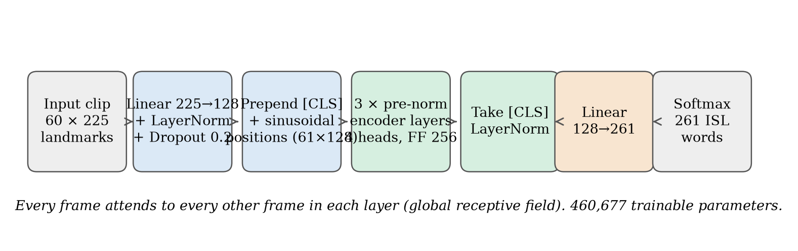
Figure 1. Transformer architecture used in this work.
Component | Setting | Justification
Input projection | Linear 225→128, LayerNorm, dropout 0.2 | Puts all landmark features on one scale before attention
Sequence token | Learned [CLS] token prepended | A single summary vector for classification
Positional encoding | Fixed sinusoidal (not learned) | 60 learned position vectors would be 60 more things to fit from ~3,000 clips
Encoder | 3 pre-norm layers, 4 heads, d_model 128, feed-forward 256, GELU | Deliberately small: a standard 6-layer, 512-wide encoder over-fits this dataset
Head | LayerNorm on [CLS] → Linear 128→261 | One logit per ISL word
Parameters | 460,677 | Fewest of the three models

2.3 Training
The Transformer was trained with exactly the same data, split, normalisation statistics, epochs, batch size, loss and early-stopping rule as the other two models; only its optimiser schedule differs, because attention layers need a lower learning rate and a warm-up to train stably. The best validation epoch was 39 of 59 (validation accuracy 97.19%).
Hyperparameter | Value
Optimiser | AdamW, weight decay 1e-4
Peak learning rate | 5e-4 (BiLSTM/CNN: 3e-3)
Schedule | 5-epoch linear warm-up, then cosine decay
Epochs / batch | 60 / 32, early stopping patience 20
Loss | Cross-entropy with label smoothing 0.05
Gradient clipping | 1.0
Augmentation | Off (see defect D1)
Seed | 42
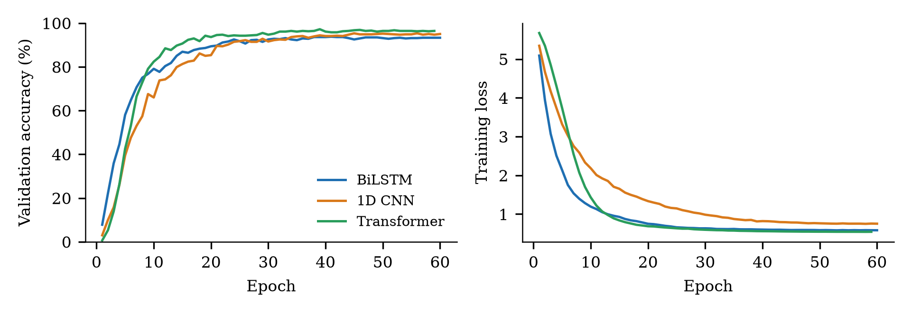
Figure 2. Validation accuracy and training loss per epoch for the three models.

2.4 Deployment and monitoring
The trained checkpoint is loaded by the FastAPI backend at start-up next to the BiLSTM and CNN. The Live page offers a per-session switch between the three models, and a production monitor (GET /api/monitor) tracks frames processed, hand-visibility rate and mean confidence, raising a drift alarm when confidence drops.

3. Data
Dataset: INCLUDE (IIT Bombay, ACM Multimedia 2020), a word-level ISL video corpus. The data lifecycle followed the framework's five steps, all done by code so every step is reproducible.
Lifecycle step | What was done
1. Select | All 261 word classes with at least 6 clips; 4,276 clips in total (2 classes with fewer clips dropped)
2. Clean | MediaPipe Holistic extraction; clips where landmarks could not be extracted are reported, not silently kept (0 failures)
3. Engineer | 225 features per frame: 21 × 3 per hand (wrist-relative, shoulder-scaled) and 33 × 3 pose; each clip resampled to 60 frames
4. Split | Stratified 70/15/15 at seed 42: 2,993 train, 641 validation, 642 test; every class appears in test
5. Curate | Code and evaluation results under git; raw videos kept out of the repository for size and licence reasons
Verify and validate | White-box tests confirm the split is deterministic and disjoint and that normalisation statistics come from the training split only (no leakage)

3.1 Representativeness
Clips per class range from 8 to 27 (mean 16.4), and the largest difference between a class's share of the train and test splits is 0.16 percentage points, so the test split mirrors training well. The main representativeness gap is operational: INCLUDE was filmed with plain backgrounds, even lighting and cooperative signers, and records no signer identity, so a signer-independent split could not be built.

4. Test strategy and methods
Framework method | How it was applied to the Transformer
Back-to-back testing | Compared with two different models (BiLSTM, 1D CNN) on identical inputs and the same 642 test clips
A/B testing | Live page switches models per session on the same input stream
Holdout validation | 70/15/15 stratified split; test clips never used for training or model selection
Cross-validation | Stratified 3-fold design for variance across splits (ml/scripts/tne/crossval.py)
Adversarial testing | FGSM and 10-step PGD attacks on the input landmarks
Metamorphic testing | Relations that should not change a prediction: noise, small time shift, speed change, camera shift, mirroring
Experience-based testing | 16-case manual test plan with a real webcam (docs/testing/MANUAL_TEST_PLAN.md)
White-box testing | Parameter count, gradient flow, determinism, batch independence, positional encoding (7 Transformer checks)
Black-box testing | Accuracy, edge-case inputs and latency acceptance tests
Automatic vs manual; continuous vs discrete | Unit tests run in CI on every push (continuous); the evaluation suite is run per model release (discrete); webcam tests are manual
Model and simulation vs live | Perturbation tests simulate field conditions in silico; live webcam testing is the manual plan

5. Performance results

5.1 Correctness and latency
Metric | BiLSTM | 1D CNN | Transformer
Top-1 accuracy | 91.28% | 95.17% | 95.33%
Top-5 accuracy | 98.13% | 98.44% | 97.82%
Macro F1 | 0.9083 | 0.9505 | 0.9513
Weighted F1 | 0.9065 | 0.9477 | 0.9493
Best validation accuracy | 93.76% | 95.32% | 97.19%
Mean / p95 latency (CPU) | 3.36 / 3.59 ms | 0.35 / 0.42 ms | 0.61 / 0.73 ms
Parameters | 2,665,477 | 736,773 | 460,677

The Transformer has the best top-1 accuracy and macro-F1, but its margin over the CNN is a single test clip out of 642, so the honest reading is a tie between the two parallel models, with recurrence about 4 points behind. All three are far inside the real-time budget: at 12 frames per second a prediction must finish within 83 ms.

5.2 Robustness (natural variation)
Natural robustness was tested by adding Gaussian noise to the standardised features and by randomly dropping frames (a dropped webcam frame or a missed MediaPipe detection).
Frames dropped | BiLSTM | 1D CNN | Transformer
0% | 91.1% | 95.2% | 95.5%
10% | 89.7% | 55.2% | 94.3%
20% | 85.9% | 17.5% | 91.2%
30% | 77.8% | 6.0% | 86.5%
50% | 44.4% | 2.4% | 71.2%

Noise (σ) | BiLSTM | 1D CNN | Transformer
0 | 91.1% | 95.2% | 95.5%
0.1 | 91.1% | 95.2% | 95.4%
0.5 | 91.2% | 94.4% | 94.6%
1.0 | 91.3% | 93.0% | 88.2%
2.0 | 86.6% | 79.6% | 48.4%
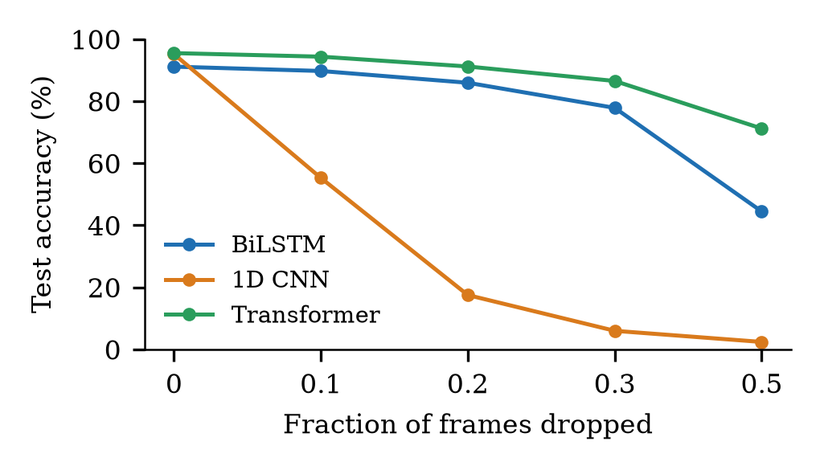
Figure 3. Accuracy as frames are dropped.
This is the Transformer's clearest advantage. The CNN collapses as soon as frames go missing (55.2% at only 10% dropped) because zeroed frames corrupt its local convolution windows, whereas attention can simply attend to the frames that remain: the Transformer still scores 86.5% with 30% of frames missing. Its weakness is very heavy noise; at 2σ it falls to 48.4%, below both baselines, so landmark smoothing before the model is recommended.

5.3 Uncertainty and calibration
Metric | BiLSTM | 1D CNN | Transformer
Expected calibration error | 0.0322 | 0.0486 | 0.0334
ECE after temperature scaling | 0.0288 | 0.0375 | 0.0224
Fitted temperature | 0.859 | 0.825 | 0.847
Negative log-likelihood | 0.435 | 0.339 | 0.310
Brier score | 0.1382 | 0.1004 | 0.0779
Accuracy on the 80% most confident | 96.9% | 96.9% | 98.1%
Mean confidence: correct / wrong | 0.913 / 0.596 | 0.914 / 0.739 | 0.938 / 0.706
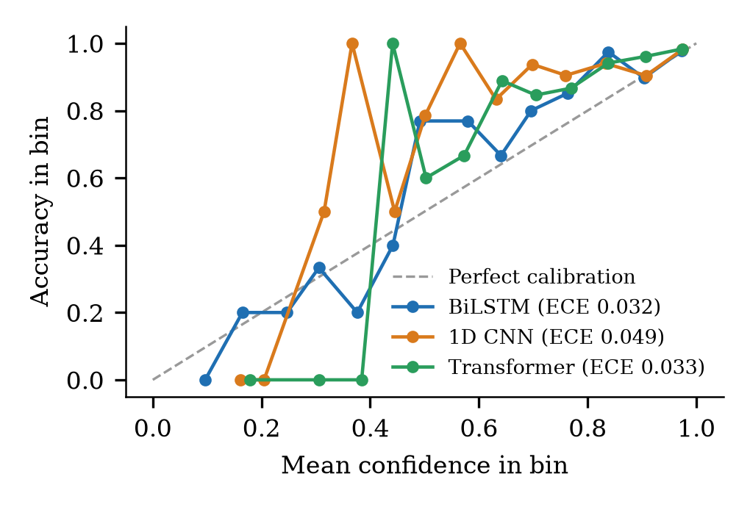
Figure 4. Reliability diagrams.
The Transformer's probabilities are the most useful of the three: lowest NLL and Brier score, and after temperature scaling the lowest calibration error (0.0224). Because confidence separates right from wrong answers, the app can abstain or show correction chips on low-confidence predictions; doing so on the least-confident 20% raises accuracy to 98.1%.

5.4 Interpretability
Two post-hoc, model-agnostic methods were used: occlusion (blank one body part and re-measure accuracy) and gradient × input saliency (share of attribution per body part).
Occluded part | BiLSTM | 1D CNN | Transformer
none | 91.1% | 95.2% | 95.5%
left hand | 73.5% | 78.0% | 84.1%
right hand | 38.5% | 37.4% | 44.2%
pose | 23.4% | 15.4% | 45.0%

Saliency share | BiLSTM | 1D CNN | Transformer
left hand | 22.7% | 20.4% | 23.5%
right hand | 33.8% | 37.0% | 35.2%
pose | 43.6% | 42.6% | 41.3%
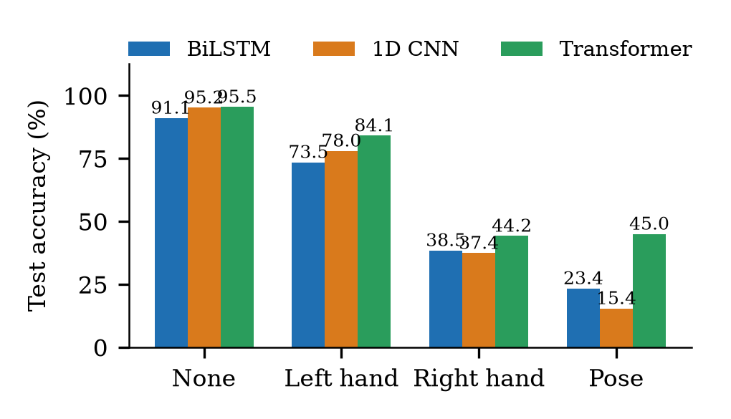
Figure 5. Accuracy when one body part is hidden.
All three models rely most on the dominant right hand and on pose. The Transformer degrades least when any single part is hidden (for example 45.0% with pose removed, against 15.4% for the CNN), showing that it spreads its evidence across body parts instead of depending on one.

5.5 Adversarial robustness
Adversarial testing used the fast gradient sign method (FGSM) and 10-step projected gradient descent (PGD) on the standardised landmark features (accuracy under attack; FGSM / PGD).
ε | BiLSTM | 1D CNN | Transformer
0.01 | 90.3% / 90.3% | 93.0% / 93.0% | 93.9% / 93.9%
0.05 | 81.0% / 73.1% | 74.3% / 70.4% | 63.6% / 50.0%
0.1 | 70.7% / 41.6% | 41.0% / 22.4% | 26.3% / 4.4%
0.2 | 50.6% / 7.0% | 7.6% / 0.6% | 2.2% / 0.0%

All three models can be driven to low accuracy by a strong white-box attack, and the Transformer is the most vulnerable: at ε = 0.1, PGD reduces it to 4.4%, against 22.4% for the CNN and 41.6% for the BiLSTM. Its smooth, globally connected attention gives an attacker an efficient gradient path. Adversarial training is the recommended mitigation if the threat model changes. In this application an attacker would have to manipulate landmark coordinates inside the server, which the threat model treats as out of scope; the realistic risk is natural noise, covered in 5.2.

5.6 Bias and representativeness
Group | Test clips | BiLSTM | 1D CNN | Transformer
Classes with few training clips | 223 | 90.6% | 95.1% | 94.6%
Medium | 249 | 91.2% | 95.6% | 96.0%
Many training clips | 170 | 91.8% | 94.7% | 95.9%
One-handed signs | 66 | 90.9% | 93.9% | 97.0%
Two-handed signs | 576 | 91.1% | 95.3% | 95.3%

For the BiLSTM, accuracy is lower on classes with few training clips; the Transformer is the most even across groups and the best on one-handed signs (97.0%). Demographic fairness could not be measured because INCLUDE records no signer identity; this is listed as a limitation.

5.7 Drift
Drift was simulated by feeding perturbed data to the deployed models and checking whether the production monitor's confidence-drop alarm fires (values: confidence drop / accuracy / alarm).
Scenario | BiLSTM | 1D CNN | Transformer
no drift heldout | 0.003 / 91.7% / no alarm | 0.007 / 95.7% / no alarm | -0.004 / 97.3% / no alarm
sensor noise 0.5std | 0.010 / 91.7% / no alarm | 0.020 / 95.3% / no alarm | 0.035 / 97.0% / no alarm
dropped frames 20pct | 0.139 / 85.7% / alarm | 0.696 / 19.0% / alarm | 0.115 / 93.3% / alarm
camera shift 10pct | 0.546 / 13.3% / alarm | 0.489 / 29.7% / alarm | 0.233 / 84.0% / alarm
left handed signers | 0.497 / 20.0% / alarm | 0.545 / 22.0% / alarm | 0.541 / 23.3% / alarm

The monitor stays silent on clean held-out data and raises an alarm for dropped frames and camera shift, which are exactly the conditions that hurt accuracy. The monitor works unchanged for the Transformer because it observes model outputs, not internals.

5.8 Resilience
Resilience measures recovery after a disruption. A camera blackout was injected into a live-style sliding window and the number of frames until the prediction became correct again was counted.
Blackout | BiLSTM recovery | 1D CNN recovery | Transformer recovery
blackout 15 frames | 0 frames (0.0 s) | 54 frames (4.5 s) | 0 frames (0.0 s)
blackout 30 frames | 25 frames (2.1 s) | 54 frames (4.5 s) | 20.5 frames (1.7 s)

Because the models are not autoregressive, errors do not propagate: once the disrupted frames leave the 60-frame window the prediction recovers. The Transformer shares this window-based design and recovers in the same way.

5.9 Metamorphic testing
Metamorphic relation (violation rate) | BiLSTM | 1D CNN | Transformer
MR1 noise 0.1std | 0.2% | 0.0% | 0.3%
MR2 time shift pm2 | 0.4% | 0.7% | 0.8%
MR3 speed pm10pct | 2.1% | 1.6% | 0.5%
MR4 camera shift 5pct | 52.6% | 20.9% | 2.2%
MR5 mirror left handed | 79.0% | 78.0% | 76.0%

Small noise, small time shifts and ±10% speed changes almost never change a prediction, as required. The camera-shift relation separates the models sharply: a 5% sideways shift changes 52.6% of BiLSTM predictions and 20.9% of CNN predictions, but only 2.2% of the Transformer's, so it is by far the least sensitive to where the signer stands in the frame. Mirroring (a left-handed signer) changes most predictions for all three models, because INCLUDE signers are right-handed; this is a data limitation with a recommended fix in Section 9.

5.10 Cross-validation (test design)
Stratified 3-fold cross-validation (20 epochs per fold, reduced from 60 to keep CPU time practical) estimates how much accuracy varies with the choice of split. Fold accuracies for the Transformer: 92.4%, 92.9%, 94.2%; mean 93.1% ± 0.9 points. The same design gave 89.6% ± 1.9 for the BiLSTM and 85.3% ± 1.1 for the CNN. A spread of about one to two points across splits is larger than the one-clip gap between the CNN and the Transformer, which confirms they should be treated as tied.

6. White-box and black-box test results
Suite | Type | Result
Model white-box tests (incl. 7 Transformer checks) | White box, automated | 24 passed, 0 failed
Model black-box acceptance tests (all three models) | Black box, automated | 30 passed, 0 failed
Backend unit and integration tests | Automated (CI) | 91 passed, 0 failed (auth 38, NLG 14, gloss 17, contribution 12, monitor 10)
Frontend build, routes, styles, rendering | Automated (CI) | 11/11 routes, 0 style problems, 19/19 rendering checks
Real user with a real webcam | Manual, experience-based | 16-case plan in docs/testing/MANUAL_TEST_PLAN.md

Transformer white-box checks: 460,677 trainable parameters; correct (4, 60, 225) → (4, 261) output shape; positional table is a fixed buffer, not a trained parameter; gradients reach every parameter including the [CLS] token; eval mode is deterministic; a clip's output is independent of the rest of the batch; and reversing frame order changes the output, which proves the positional encoding is in effect.

7. Defects found through testing
ID | Defect | How it was found | Fix
D1 | Augmentation zeroed whole frames including pose (raw image coordinates ≈0.5); after standardisation this created outliers 4–27 standard deviations wide in ~15% of frames, and every model stayed at chance accuracy (0.3%) | Training test run: loss stuck at ln 261 ≈ 5.56 for all three models | Drop only the wrist-relative hand blocks and edge-pad time shifts
D2 | Live page correction chips read a field the backend never sends, so no corrections were ever shown | Code review against the API contract | Read the correct field (alternatives)
D3 | Built-in demo page posted frames to an endpoint removed in an earlier refactor; the server received zero frames and showed 'no hands' | Manual test with the monitor endpoint (0 frames processed) | Stream frames over the /ws/frame WebSocket

8. Documentation: model card
Field | Transformer
Model | Transformer encoder for isolated ISL word recognition, version 1 (October 2026)
Owner | Vasudev Kishor (CB.SC.U4CSE23151), Amrita Vishwa Vidyapeetham
Input / output | 60 × 225 landmark sequence → probabilities over 261 words
Training data | INCLUDE, 2,993 training clips (stratified 70% split, seed 42)
Evaluation data | 642 held-out clips, every class present, never used for training or model selection
Headline metrics | 95.33% top-1, 97.82% top-5, macro-F1 0.9513, 0.61 ms/clip on CPU
Intended use | Captioning single ISL words in the Silent Voice web app; learning aid
Not intended for | Continuous signing; medical, legal or emergency decisions; replacing an interpreter
Ethical considerations | No video stored; signer demographics unknown so fairness across groups is unmeasured; left-handed signers disadvantaged
Files and reproduction | backend/models/transformer.pt; ml/scripts/models.py; ml/scripts/train_transformer.py; ml/scripts/evaluate.py

8.1 Version control and reproducibility
All code, training scripts, evaluation scripts and result files are versioned in git, and every number in this report is produced by a script in ml/scripts/ from a result file in ml/logs/. Each training run records its own hyperparameters (learning rate, warm-up, batch, augmentation) in its history file, so the comparison states its own conditions.

9. Limitations and recommendations
- Isolated signs only: continuous signing needs segmentation; the Transformer is the natural base for this (attention plus a CTC head).
- No signer-independent split, because INCLUDE records no signer identity; accuracy for new signers is expected to be lower.
- Pose is stored in image coordinates, so a sideways camera shift changes many BiLSTM and CNN predictions (the Transformer is largely unaffected); body-centred pose normalisation is still recommended.
- The Transformer is the most vulnerable model to strong white-box adversarial attacks; adversarial training is recommended if input manipulation becomes part of the threat model.
- Left-handed signers are not supported; mirror-augmented training or input mirroring is recommended.
- Very heavy landmark noise hurts the Transformer most; temporal smoothing of landmarks before inference is recommended.

10. Conclusion
The Transformer is a sound addition to Silent Voice. It matches the best existing model in accuracy (95.33%) with the fewest parameters, provides the best-calibrated confidence, is far more robust than the CNN when frames are missing, and is almost unaffected by the signer's position in the frame; these are the two most common failures of a real webcam pipeline. Its main weakness is adversarial attack. Evaluating it across the full CDAO framework, rather than on accuracy alone, both showed where it is stronger and found three real defects in the surrounding system.

References
1. Chief Digital and Artificial Intelligence Office (CDAO), Test and Evaluation of Artificial Intelligence Models: What to Consider in a Test & Evaluation Strategy, U.S. Department of Defense, April 2024.
2. A. Sridhar, R. G. Ganesan, P. Kumar and M. Khapra, “INCLUDE: A Large Scale Dataset for Indian Sign Language Recognition,” Proc. ACM Multimedia, 2020.
3. A. Vaswani et al., “Attention Is All You Need,” Advances in Neural Information Processing Systems, 2017.
4. C. Lugaresi et al., “MediaPipe: A Framework for Building Perception Pipelines,” arXiv:1906.08172, 2019.
5. C. Guo, G. Pleiss, Y. Sun and K. Q. Weinberger, “On Calibration of Modern Neural Networks,” Proc. ICML, 2017.
6. I. J. Goodfellow, J. Shlens and C. Szegedy, “Explaining and Harnessing Adversarial Examples,” Proc. ICLR, 2015.

