SMART TRAFFIC MANAGEMENT SYSTEM
A Multi-Agent AI System with Max-Pressure Signal Control, A* Routing, Ambulance Preemption, Accident Re-routing and Hill-Climbing Policy Tuning
AI Case Study Report | Review 1 and Review 2
Department of Computer Science and Engineering, Amrita School of Computing, Amrita Vishwa Vidyapeetham, Coimbatore
# | Team member | Role
M1 | P.M. Radha Krishna | CB.SC.U4CSE23134 | Task environment and simulation (PEAS, stochastic demand)
M2 | Member 2 | (Name, Roll No.) | Junction agent: Max-Pressure signal control
M3 | Member 3 | (Name, Roll No.) | Vehicle agent: A* search and re-planning
M4 | Member 4 | (Name, Roll No.) | Ambulance agent and FIPA-ACL protocol
M5 | Member 5 | (Name, Roll No.) | Traffic centre agent: hill climbing; testing

Batch 2027, Section B

Abstract
Fixed-time traffic signals cannot react to real demand, they make ambulances wait at red lights, and they give drivers no warning of accidents. This project models a city grid as a multi-agent system of four cooperating agent types. Intersection agents switch signals with the decentralised Max-Pressure algorithm plus an anti-starvation term. Vehicle agents plan routes with A* search over their own beliefs about the road network. Ambulance agents preempt signals ahead of them. A Coordinator (Traffic Management Centre) broadcasts incidents and tunes every controller with hill climbing. All interaction goes through FIPA-ACL messages.
Every vehicle is simulated to completion and results are averaged over several random seeds. Compared with a 20-second fixed-time plan, Max-Pressure cuts average waiting time by 47.5% (15.45 s to 8.11 s). Ambulance preemption makes the ambulance 29.6% faster with zero red-light delay. A* finds the optimal route every time while expanding 14.1 nodes against 36 for Uniform-Cost Search. Hill climbing lowers waiting time on unseen traffic by a further 20%. The system scales to an 8x8 grid with 461 agents. All 47 automated tests pass. Negative results are reported alongside the positive ones.

1. Problem Statement and Objectives
Urban intersections are the bottleneck of city traffic. Three failures of conventional control motivate this work:
- Static timing. A fixed cycle gives the same green to an empty side street as to a rush-hour arterial.
- Emergency delay. An ambulance crossing a signalised corridor loses tens of seconds at red lights.
- Information lag. Drivers learn about an accident only when they reach the queue behind it.
Objectives. Build a working multi-agent system that (1) adapts signals to live queues without a central controller, (2) guarantees that no approach is starved, (3) gives emergency vehicles a green corridor safely, (4) lets public transport request priority without overriding everyone else, (5) spreads incident information so vehicles re-plan early, and (6) improves its own control parameters. Each objective is backed by a measured, repeatable test.

1.1 Team and work division
The system is split so that every member owns one agent or algorithm end to end: code, scenario, tests, slides and viva questions.
# | Member | Owns | Code | Evaluation
M1 | P.M. Radha Krishna  CB.SC.U4CSE23134 | Task environment and simulation (PEAS, stochastic demand) | stms/environment/ | S8 Scalability
M2 | Member 2  (Name, Roll No.) | Junction agent: Max-Pressure signal control | intersection_agent.py, max_pressure.py | S1, S2
M3 | Member 3  (Name, Roll No.) | Vehicle agent: A* search and re-planning | vehicle_agent.py, search_astar.py | S4, S7, A* trace
M4 | Member 4  (Name, Roll No.) | Ambulance agent and FIPA-ACL protocol | emergency_agent.py, message.py | S3, S5
M5 | Member 5  (Name, Roll No.) | Traffic centre agent: hill climbing; testing | coordinator_agent.py, hill_climbing.py, tests/ | S6, test suite

2. Review 1: PEAS Formulation
PEAS (Performance, Environment, Actuators, Sensors) is written for each of the five agent types. The performance measure is what the agent's decision procedure actually optimises in the code, not just a wish list.
Agent | Performance measure | Environment | Actuators | Sensors
Intersection  (M2) | Min. average vehicle delay; max. throughput; no starvation (bounded red while cars wait); safe clearance (3 s yellow) | 4-leg junction, 2 incoming + 2 outgoing roads per axis, stochastic arrivals, neighbouring junctions | Signal phase: NS green / EW green / yellow; messages AGREE, INFORM | Queue detectors on all 8 roads (loop counts); message inbox (preemption, platoons, parameter updates)
Vehicle  (M3) | Min. travel time to destination; min. stops; never enter a closed road | Directed road graph, signals, other cars ahead, incidents | Accelerate / stop, cross stop line, choose next road (route) | Own position & speed; signal state at stop line; gap to car ahead; TMC broadcasts; sees blocked road at junction
Ambulance  (M4) | Min. response time; zero red-light delay; no unsafe signal switch | Same roads with background traffic | Drive at 60 km/h; PREEMPT_OVERRIDE, CANCEL | Route look-ahead (next 2 junctions, ETA); AGREE replies
Coordinator  (M5) | Network-wide average delay; incident awareness latency; delay on unseen traffic after tuning | Whole network (aggregate densities), incident reports | BROADCAST INCIDENT_ALERT, INFORM CONGESTION_WARNING, INFORM PARAMETER_UPDATE | Density of every road; incident reports; simulated evaluation of candidate parameters

3. Review 1: Environment and Agent Analysis

3.1 Task-environment properties
Property | Classification | Justification in this system
Observable | Partially | An intersection sees only its own 8 roads. A vehicle sees the signal and the car ahead. Incidents elsewhere are known only through messages (vehicles keep explicit known_blocked / known_speed beliefs).
Agents | Multi-agent: cooperative and competitive | Intersections cooperate (green-wave hand-off). Vehicles compete for road space and green time. The ambulance asks the intersection to override the normal signal order.
Deterministic | Stochastic | Poisson arrivals, random origin-destination pairs, unplanned incidents. Seeded for reproducibility.
Episodic | Sequential | Holding a green now changes every queue later. Routing choices commit a vehicle to a road.
Static | Dynamic | Queues grow while agents deliberate. A decision must be made every 1 s tick.
Discrete | Continuous (discretised) | Positions and speeds are continuous. Time is discretised to 1 s, and routes to a graph of junctions.
Known | Known physics, unknown demand | Agents know road lengths, speed limits and the BPR model, but not future arrivals or incidents.

3.2 Agent architectures
Agent | Architecture (Russell & Norvig) | Why
Intersection | Utility-based agent with internal state | Keeps timers (phase duration, red time per axis) and pending requests, and picks the phase with the highest pressure score (its utility).
Vehicle | Goal-based, model-based agent | Has a goal (destination) and a model (beliefs about road costs), and uses search (A*) to find an action sequence. Re-plans when its model changes.
Ambulance | Goal-based agent with communication | Same goal-based core, plus a proactive protocol that changes other agents' behaviour ahead of time.
Coordinator | Learning agent | Performance element = the intersections' controllers; critic = simulated average delay; learning element = hill climbing; problem generator = random restarts.

3.3 Architecture of the multi-agent system
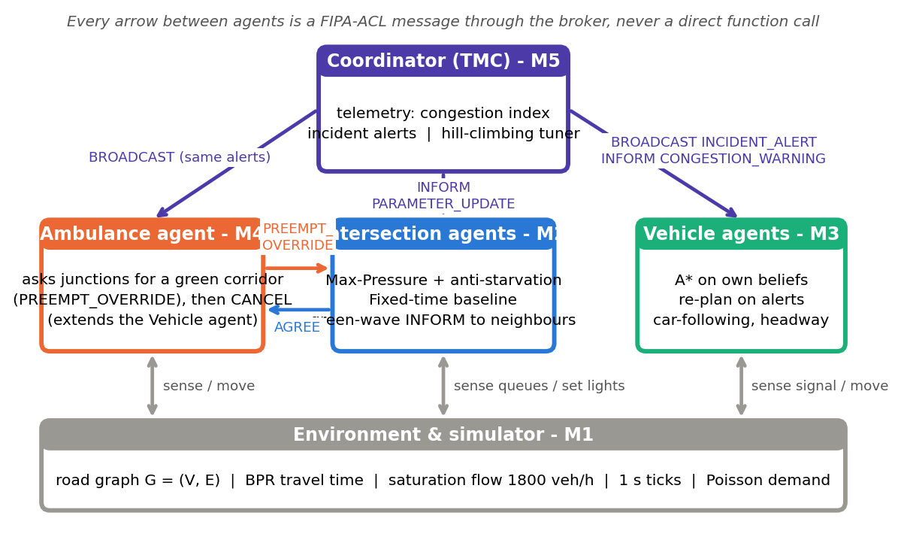
Figure 1. Agents, owners and the messages that connect them

4. Review 1: Algorithmic Modelling and Search Strategy
Four algorithms are at the centre of the system. The first, A*, is the core search strategy and is covered in the most depth.

4.1 Route search as a state-space problem (Vehicle agent, M3)
Component | Definition
State | The intersection node the vehicle is at, s in V
Initial state | Origin node (or the end of the road it is currently driving on, when re-planning)
Actions | Drive along any outgoing road u -> v that the vehicle believes is open
Transition model | RESULT(u, drive(u->v)) = v
Goal test | s == destination
Step cost | c(u,v) = BPR travel time = t0 (1 + 0.15 (V/C)^4), where t0 = length / believed speed
Heuristic | h(n) = straight-line distance(n, goal) / v_max, with v_max = the highest speed limit in the network (13.88 m/s)

A* algorithm
A*(start, goal):
frontier <- priority queue ordered by f(n) = g(n) + h(n); push(start, f = h(start))
g[start] <- 0; closed <- {}
while frontier not empty:
n <- pop lowest f
if n in closed: continue # stale entry
if n == goal: return path(n) # optimal: h is consistent
closed.add(n)
for each road n -> m believed open:
g' <- g[n] + c(n, m) # BPR congested travel time
if g' < g[m]: g[m] <- g'; parent[m] <- n; push(m, g' + h(m))
return failure # goal unreachable

Why the heuristic is admissible and consistent
- Admissible (h(n) <= h*(n)). Any route from n to the goal is at least the straight-line distance long, and no road is faster than v_max. So the true remaining time is at least d(n, goal) / v_max = h(n). Congestion only increases travel time above free flow, so admissibility holds under any load. Test UT-01 checks this for every node.
- Consistent (h(u) <= c(u,v) + h(v)). Triangle inequality: d(u,g) <= d(u,v) + d(v,g). Also, c(u,v) >= length(u,v) / v_max >= d(u,v) / v_max. Dividing by v_max gives the inequality. So f never decreases along a path, the first time the goal is popped it is optimal, and no node is re-expanded. Test UT-02 checks every edge.
- Manhattan variant. On this grid every road is axis-aligned, so Manhattan distance / v_max is also admissible, and tighter. It is used only as an experiment, because on a general map it could over-estimate.

Worked example: A* step by step
A congested 3x3 grid with road INT_10->INT_11 closed; trip W0 -> E2. Each row is one expansion. Notice that f(n) never decreases, and nodes with a high h (N0, W1) are never expanded.
A* trace on a congested 3x3 grid, W0 -> E2 (v_max = 13.88 m/s, h = Euclidean/v_max)
Blocked road(s): INT_10->INT_11

step expand g(n) h(n) f(n) frontier (f, node) after pop
1 W0 0.0 64.44 64.44
2 INT_00 14.41 51.95 66.37
3 INT_01 28.82 40.76 69.58 (74.5,INT_10), (90.3,N0)
4 INT_10 28.96 45.57 74.52 (75.5,INT_02), (77.2,INT_11), (90.3,N0), (95.2,N1)
5 INT_02 43.23 32.22 75.45 (77.2,INT_11), (87.5,INT_20), (90.3,N0), (95.2,N1), (102.8,W1)
6 INT_11 44.99 32.22 77.21 (78.0,INT_12), (86.8,E0), (87.5,INT_20), (90.3,N0), (95.2,N1) ...
7 INT_12 57.64 20.38 78.02 (86.8,E0), (87.5,INT_20), (89.1,INT_21), (90.3,N0), (95.2,N1) ...
8 INT_22 72.05 14.41 86.46 (86.5,E1), (86.8,E0), (87.5,INT_20), (89.1,INT_21), (90.3,N0) ...
9 E2 86.46 0.0 86.46 (86.5,E1), (86.8,E0), (87.5,INT_20), (89.1,INT_21), (90.3,N0) ...

A* path: W0 -> INT_00 -> INT_01 -> INT_02 -> INT_12 -> INT_22 -> E2
cost = 86.46 s, nodes expanded = 9
UCS path: W0 -> INT_00 -> INT_01 -> INT_02 -> INT_12 -> INT_22 -> E2
cost = 86.46 s, nodes expanded = 20
Same optimal cost; A* expands fewer nodes because h(n) steers it toward the goal.

Comparison of search strategies (Scenario S7)
Measured on a 6x6 (60 nodes, 168 roads) with random congestion and one closed road, over 200 random trips. Optimality is checked against Uniform-Cost Search.
Algorithm | Nodes expanded | Max frontier | Optimal routes | Avg extra cost | Complete / optimal?
BFS | 35.5 | 9.9 | 56.5% | 0.67% | yes / only for equal costs
UCS (Dijkstra) | 36.0 | 11.4 | 100% | 0% | yes / yes
Greedy Best-First | 7.7 | 10.7 | 51.5% | 0.7% | yes (finite graph) / no
A* (Euclidean h) | 14.1 | 12.3 | 100% | 0% | yes / yes
A* (Manhattan h) | 11.3 | 11.9 | 100% | 0% | yes / yes (grid only)
Weighted A* (w=2) | 8.0 | 10.4 | 57% | 0.51% | yes / within factor 2

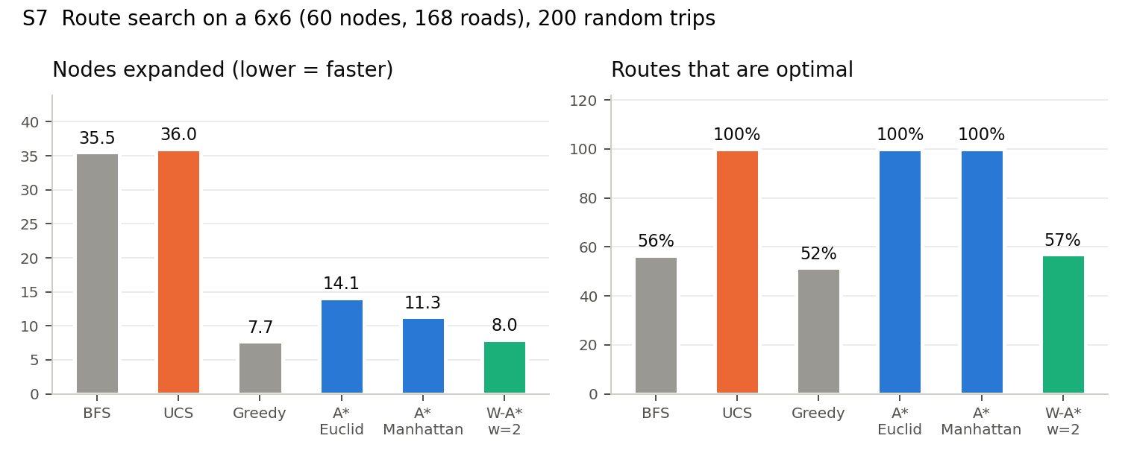
Figure 2. A* is the only strategy that is both optimal and cheap
Take-away. A* expands 61% fewer nodes than UCS and never loses optimality. Greedy and Weighted A* are cheaper still, but choose a worse route in about half of the trips.

4.2 Max-Pressure signal control (Intersection agent, M2)
Each intersection has two phases: North-South green and East-West green. A movement l -> m carries traffic from incoming road l to outgoing road m. Max-Pressure (Varaiya, 2013) serves the phase whose movements have the largest queue differential. It needs only local queues, and it is proven to stabilise every demand that any controller can stabilise.
w(l, m) = Q_l - Q_m movement pressure
P(p) = sum over movements of p of max(0, Q_l - Q_m) phase pressure
S(p) = P(p) + beta * T_red(p) + anti-starvation (beta = 0.5 /s)

every second, after min_green (5 s):
if the red approach has no waiting car: keep current green
elif phase duration >= max_green (30 s): switch (via 3 s YELLOW)
elif S(red) > S(green) + theta (1.0): switch (via 3 s YELLOW)
else keep current green

Worked example (INT_00, NS currently green for 12 s)
Movement | Q_in | Q_out | max(0, Q_in - Q_out)
N0 -> INT_00 -> INT_10 (southbound) | 8 | 2 | 6
INT_10 -> INT_00 -> N0 (northbound) | 3 | 5 | 0
W0 -> INT_00 -> INT_01 (eastbound) | 2 | 1 | 1
INT_01 -> INT_00 -> W0 (westbound) | 4 | 0 | 4

P(NS) = 6 + 0 = 6 and P(EW) = 1 + 4 = 5, so pure Max-Pressure would keep NS green. With anti-starvation, S(NS) = 6 + 0.5 x 0 = 6 and S(EW) = 5 + 0.5 x 12 = 11. Since 11 > 6 + 1, the agent starts a yellow and then serves East-West. Test UT-18 reproduces this arithmetic.
Why the starvation term matters (S2). Without it, a lone side-street car can wait forever. The heavy axis always has more pressure, and 1 car vs 0 cars never beats the switching threshold. In the rush-hour test, 14 of 108 East-West cars were never served without the term, and 0 with it.

Green-wave hand-off (peer cooperation)
When a new green releases 4 or more queued vehicles, the intersection sends INFORM PLATOON_INCOMING to its neighbour on the same axis. For 25 s the neighbour adds 1.0 x (expected vehicles) to that axis' pressure, but only to extend a green it is already showing. It never forces a switch, because an earlier version that did made things worse.

4.3 Hill climbing policy tuning (Coordinator agent, M5)
Component | Definition
State | x = (min_green, max_green, beta, theta) on a discrete grid of 7 x 7 x 7 x 6 = 2,058 settings
Neighbours | Change one parameter by one grid step up or down (at most 8 neighbours)
Objective J(x) | Average vehicle delay in a simulation of asymmetric rush-hour demand (3 training seeds); lower is better
Move rule | Steepest descent: go to the best neighbour if it improves J; otherwise stop at a local optimum
Escaping local optima | 2 random restarts; keep the global best. Results are memoised, so revisited states cost nothing.
Deployment | Best parameters are sent to every intersection with INFORM PARAMETER_UPDATE (test IT-06)

HILL-CLIMB(start):
for s in [start] + random_states(restarts):
current <- s
loop:
best <- argmin over n in NEIGHBOURS(current) of J(n)
if J(best) >= J(current): break # local optimum
current <- best
keep the best local optimum seen

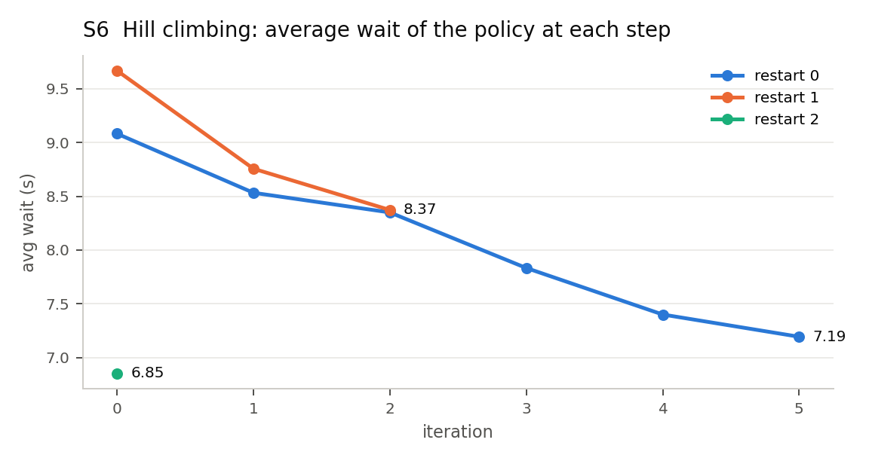
Figure 3. Hill-climbing trace: restart 1 stops at a worse local optimum; restarts matter

4.4 Interaction protocols (Priority vehicles, M4)
- Emergency preemption (fipa-request). When the ETA to a junction is 15 s or less, the ambulance sends PREEMPT_OVERRIDE with its axis. The intersection replies AGREE, and if the conflicting phase is green it goes through the full 3 s yellow before giving green. It holds the green until the ambulance sends CANCEL after crossing (safety timeout 40 s).

5. Review 2: Tool and Package Selection and Setup
Tool | Used for | Why this and not an alternative
Python 3.10+ | All agents, algorithms, simulator | Readable enough for a 5-person team; standard in AI courses; dataclasses and typing keep interfaces clear
Python standard library only (core) | Road graph (adjacency lists), search, broker, simulator | No third-party package is needed to run the agents, so the same code also runs inside a browser. The search algorithms are written by hand so every step can be explained and instrumented.
Pyodide (WebAssembly Python) | The website when no local server is running | Runs the unchanged stms package in the browser, so the published page uses the real agents instead of a JavaScript copy
rich | Console tables for the scenarios | Readable output during the review without building a GUI
HTML + JavaScript canvas | The website (index.html): two cities side by side | Opens in any browser; with run_demo.py it uses local Python and works offline
http.server (standard library) | run_demo.py: serves the page and the /api/run endpoint | No web framework needed for one page and one endpoint
matplotlib | Report charts | Available everywhere
unittest | 47 automated tests with IDs | Part of the standard library, so there is nothing extra to install on lab machines
Not used: SUMO, Mesa, JADE | - | SUMO would hide the vehicle model we want to explain; Mesa/JADE add framework code without adding AI content. We implemented the message broker ourselves (about 150 lines) so every protocol step is visible.

Setup and run
python run_demo.py # the website on http://localhost:8000
python tests/run_tests.py # 47 tests -> results/test_report.json
pip install -r requirements.txt # matplotlib, rich (charts and tables only)
python scripts/run_simulation.py --all # every experiment as a table
python scripts/run_simulation.py --scenario 3 # one scenario: 1, 2 ... 8
python scripts/run_simulation.py --astar-trace # A* expansion table
python scripts/run_simulation.py --protocol # message log
python scripts/generate_results.py # regenerate every number, chart and index.html

6. Review 2: Multi-Agent Execution and Interaction

6.1 Execution cycle
The simulator is synchronous and deterministic for a given seed (test IT-09). Each 1-second tick runs: (1) the Coordinator (telemetry, advisories), (2) every Intersection agent, (3) every Vehicle and Ambulance agent, (4) metrics. Every agent runs the same cycle in BaseAgent.step(): receive messages -> perceive -> reason -> act, and reason() runs exactly once per tick. The original code called it twice, which made signal timers run at double speed; this was fixed and is now covered by test IT-02.

6.2 Message catalogue
Performative | From -> To | Content | Effect
PREEMPT_OVERRIDE | Ambulance -> Intersection | axis, ETA | Intersection clears the conflicting phase (via yellow) and holds green
AGREE | Intersection -> Ambulance | status, axis | Confirms the corridor
CANCEL | Ambulance -> Intersection | cleared | Release priority; Max-Pressure resumes
INFORM (green-wave) | Intersection -> neighbour | axis, vehicles | Neighbour extends green for the arriving platoon
BROADCAST INCIDENT_ALERT | Coordinator -> all | road, BLOCKED / SLOWED / CLEARED | Vehicles update beliefs and re-plan with A*
INFORM CONGESTION_WARNING | Coordinator -> all | index, hotspots | Vehicles re-plan if they find a route at least 15% faster
INFORM PARAMETER_UPDATE | Coordinator -> Intersections | tuned parameters | Controllers adopt the hill-climbing result

6.3 A real interaction from the demo run
In the demo run the ambulance drives S0 to N2 while an accident closes road J01-J11. In our system the ambulance sends PREEMPT_OVERRIDE to each junction on its route (about 12 to 15 s before it arrives), the junction replies AGREE and turns green through a 3 s yellow, and the ambulance sends CANCEL once it has crossed so that Max-Pressure resumes. The accident alert is a single broadcast from the traffic centre.
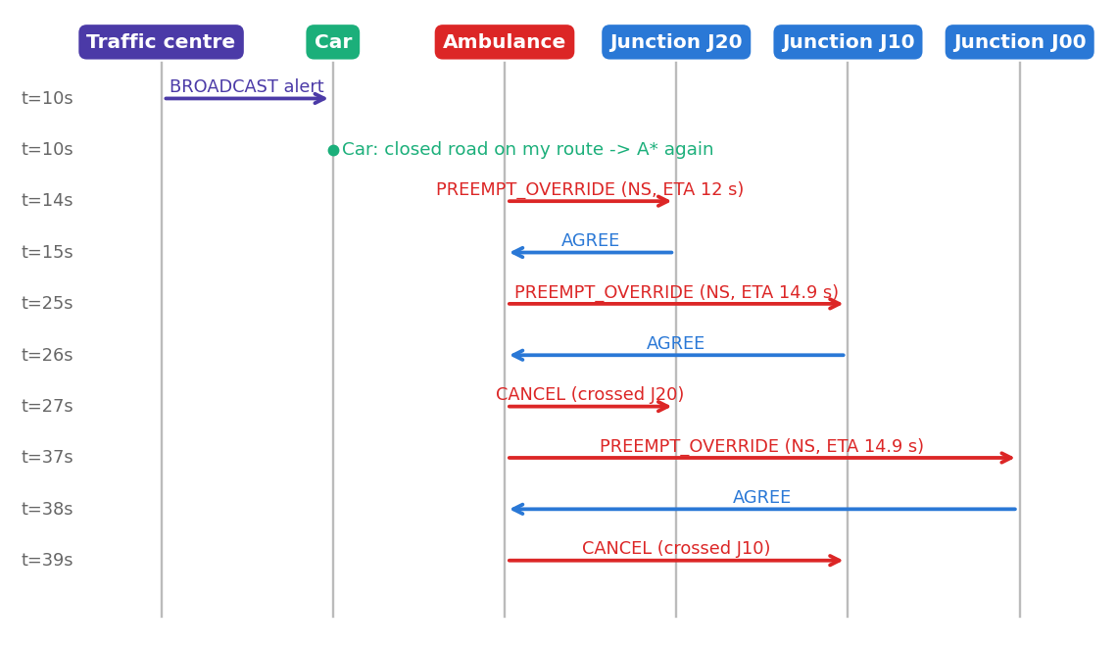
Figure 4. Message sequence recorded from the demo (results/protocol_trace.txt)
The website (index.html, or python run_demo.py) runs the same 3x3 city twice with about 160 random vehicles and identical accidents. Fixed-time city (left): signals change every 20 s, there is no traffic centre, drivers find a closed road only at the junction, and the ambulance waits at red lights. STMS city (right): Max-Pressure junctions with hill-climbing-tuned parameters, accident alerts with A* re-planning, and a green corridor for the ambulance. The user sends a car or an ambulance (random origin and destination; the A* route is drawn), clicks roads to close or reopen them, and both cities are re-simulated. Each junction signal is drawn as a plus sign whose arms are the four approaches. The page also shows the live agent messages and one panel for each algorithm: the car's A* plan, a junction's Max-Pressure scores and decision, and the hill-climbing parameters.
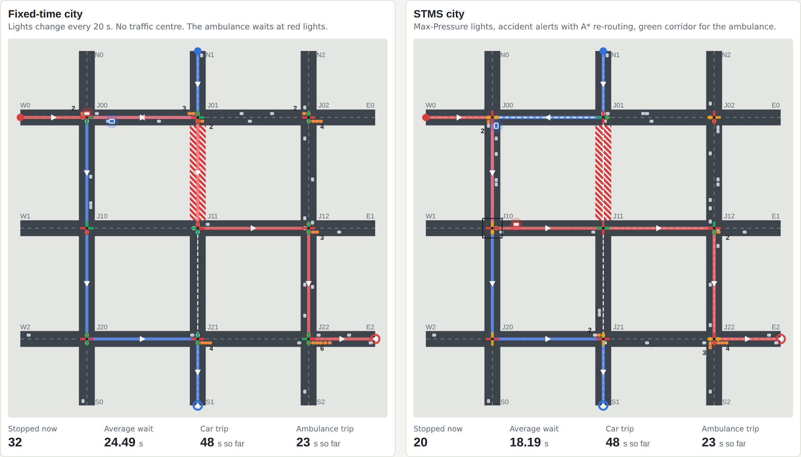
Figure 5a. The website: both cities with the same traffic, the car and ambulance routes, plus-shaped signals and queues
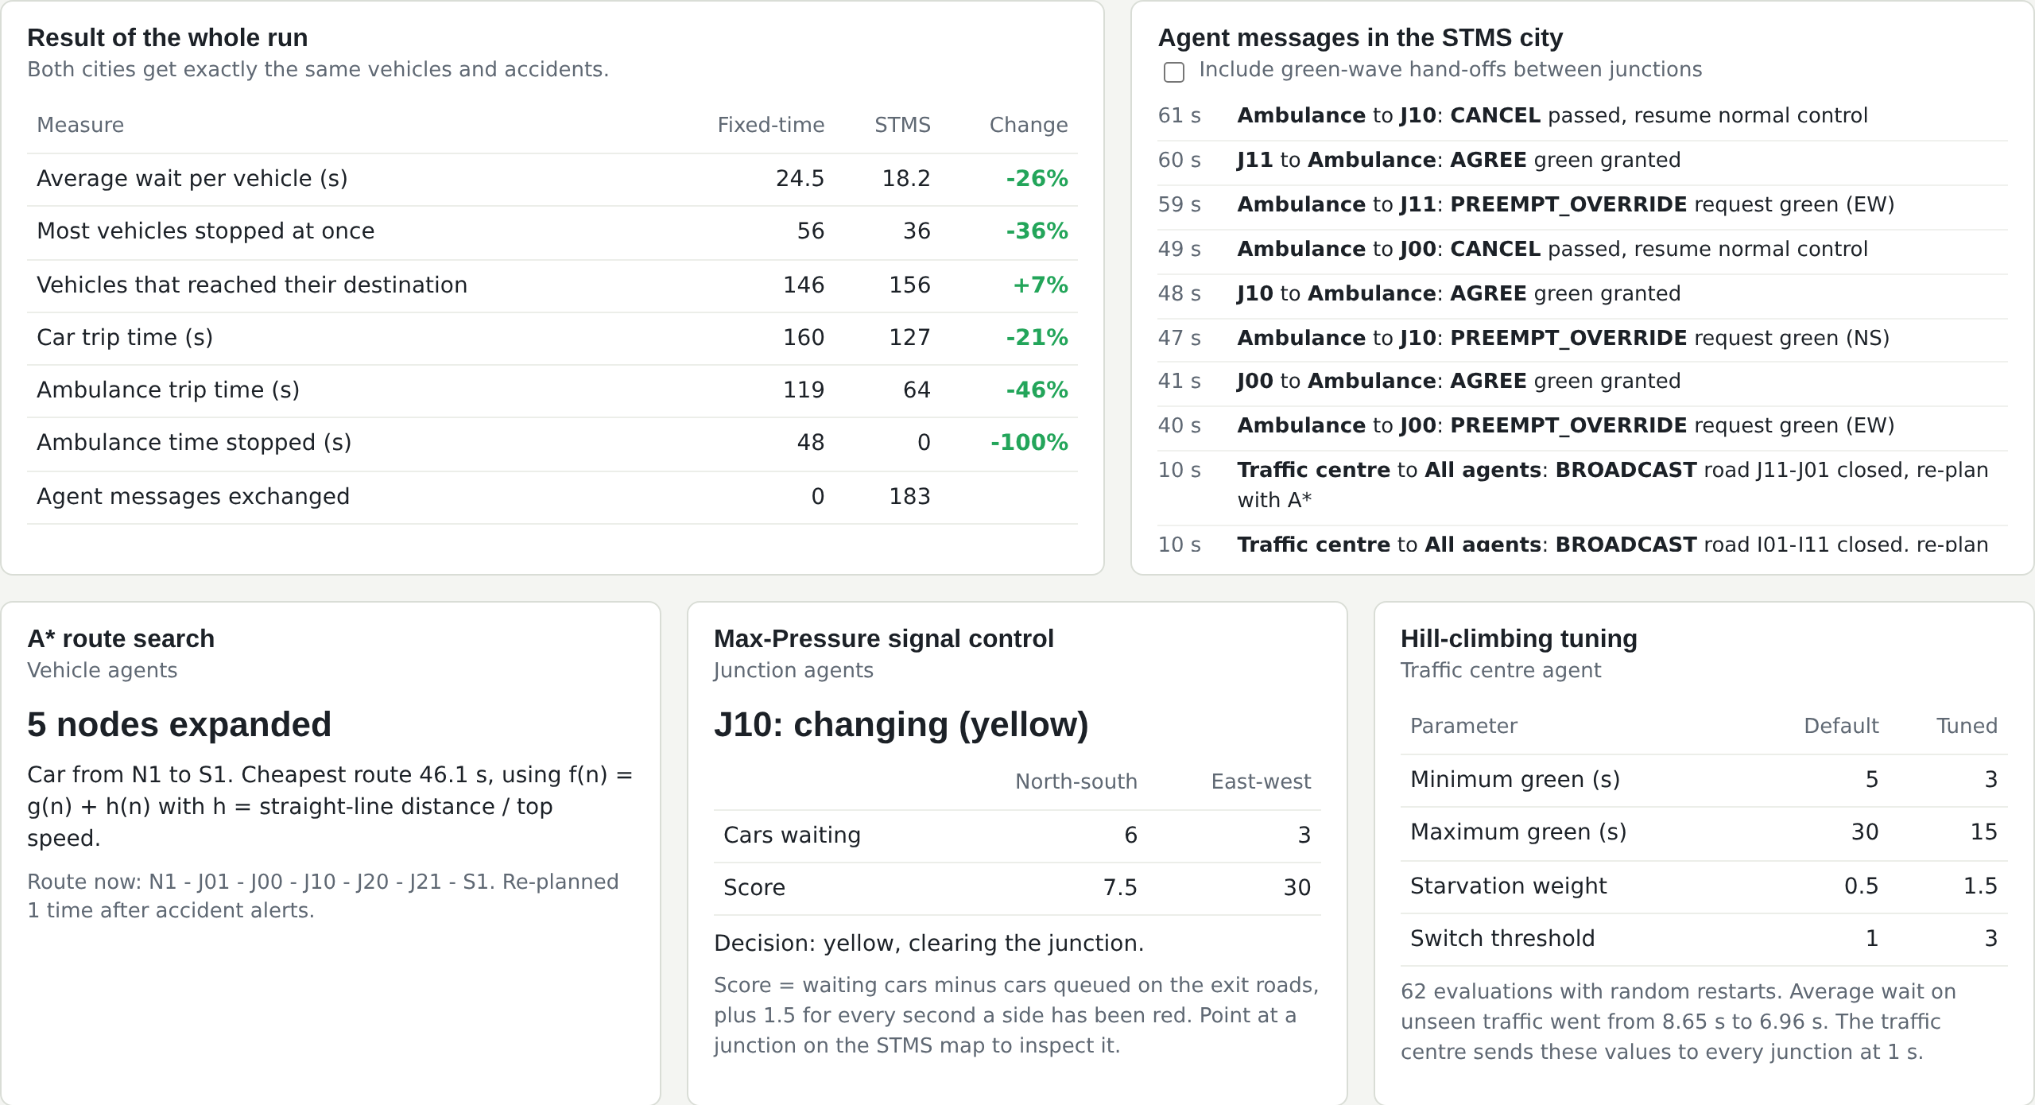
Figure 5b. Results, agent messages and the three algorithm panels (A*, Max-Pressure, hill climbing)

7. Review 2: Demo Quality and Testing Scenarios
Method. Vehicles arrive as Poisson processes with random origin-destination pairs. Every run continues until the last vehicle arrives, so no slow vehicle is silently dropped from the averages. Controller comparisons use identical demand (same seed) and are averaged over 5 to 10 seeds. Standard deviations are shown where relevant. Every number below comes from results/results.json and can be regenerated with python scripts/generate_results.py.

S1. Fixed-Time vs Max-Pressure (2x2 grid, 10 seeds)
Controller | Avg wait (s) | 95th pct wait (s) | Avg travel (s) | Stops / veh | Fuel (L)
Fixed-Time (20s green) | 15.45 +/- 0.75 | 33.0 | 71.4 | 1.80 | 5.56
Max-Pressure, no green-wave | 8.11 +/- 0.79 | 17.7 | 63.7 | 1.65 | 5.28
Max-Pressure + green-wave | 9.26 +/- 1.02 | 21.3 | 64.8 | 1.66 | 5.33

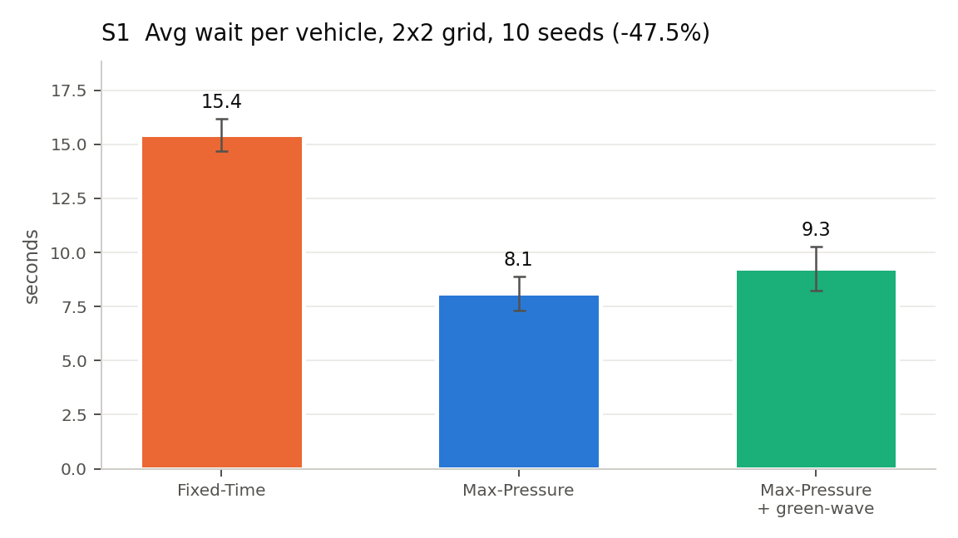
Figure 6. Average wait with standard deviation over 10 seeds
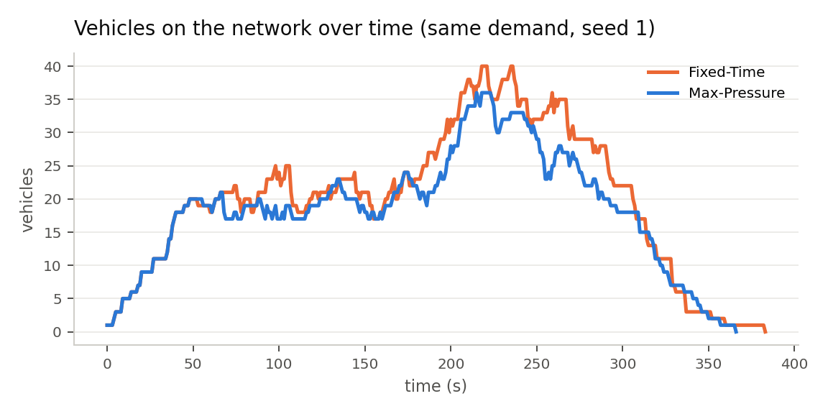
Figure 7. Vehicles on the network over time: Max-Pressure clears the same demand with shorter queues

S2. Rush hour and anti-starvation
Controller | Wait N-S (s) | Wait E-W (s) | Worst E-W wait (s) | E-W cars never served
Fixed-Time | 21.88 | 12.35 | 25.0 | 0 / 108
Max-Pressure WITHOUT anti-starvation | 2.93 | 44.27 | 130.0 | 14 / 108
Max-Pressure WITH anti-starvation | 5.94 | 12.79 | 40.0 | 0 / 108

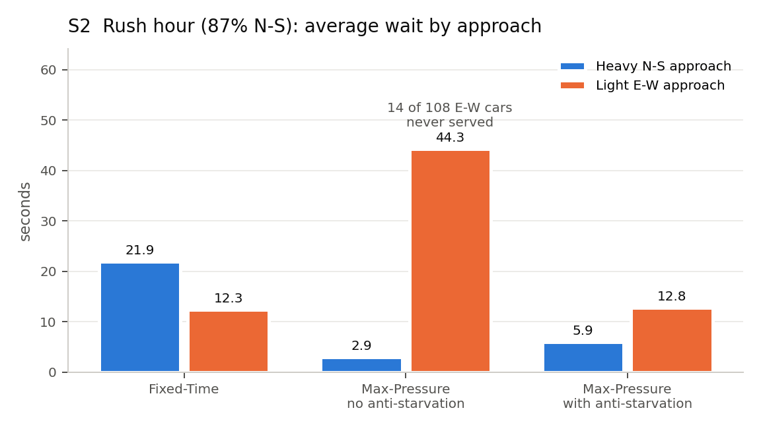
Figure 8. 86.5% of demand on the N-S axis (5 seeds)

S3. Ambulance green corridor
Both runs use the same Max-Pressure controller and the same background traffic; only preemption is switched on or off. (The original project compared fixed-time without preemption against Max-Pressure with preemption, which mixed two effects.)
Mode | Ambulance travel (s) | Wait at red (s) | Worst case (s) | Other cars' avg wait (s)
No preemption | 54.0 | 12.2 | 57.0 | 5.58
Preemption (MAS) | 38.0 | 0.0 | 38.0 | 5.46

Result: 16 s faster (29.6%), zero seconds at red lights in all 10 seeds, and no measurable cost to other traffic (-0.12 s).

S4. Accident: static vs local sensing vs TMC broadcast
Policy | Closure: arrived | Slowdown: drove through incident | Slowdown: avg travel (s)
static | 0% | 12 / 12 | 144.9
local | 100% | 12 / 12 | 144.9
broadcast | 100% | 0 / 12 | 95.5

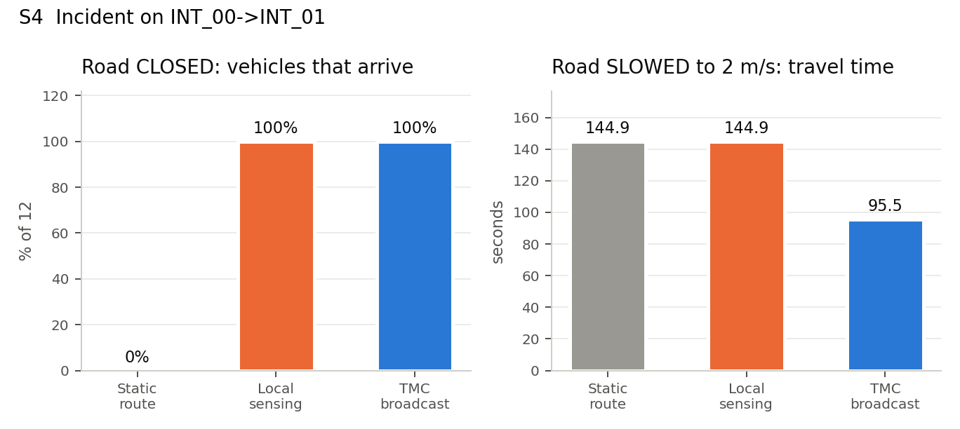
Figure 9. A full closure strands vehicles that never re-plan; for a slowdown only the broadcast helps
With a full closure, the local and broadcast policies give identical results. On a grid, every detour around a single closed road is the same length, and the decision point (INT_00) is the same either way. The broadcast pays off for a slowdown: a vehicle cannot see that a road is slow until it is already driving on it.

S5. Conventional city vs our system (accident + ambulance)
The website's 3x3 city with dense random traffic (about 160 vehicles, 5 seeds), the same accident (J01-J11 closed at t = 10 s), one car and one ambulance (W0 to E2). Conventional = fixed-time signals, no traffic centre, drivers find the closed road only at the junction, no preemption. Ours (STMS) = Max-Pressure with hill-climbing-tuned parameters, accident broadcast with A* re-planning, ambulance preemption.
System | Ambulance trip (s) | Ambulance wait at red (s) | Avg wait per car (s) | Cars arrived (%)
Conventional | 119.0 | 48.0 | 24.31 | 91.8
Ours (STMS) | 64.0 | 0.0 | 16.74 | 97.9

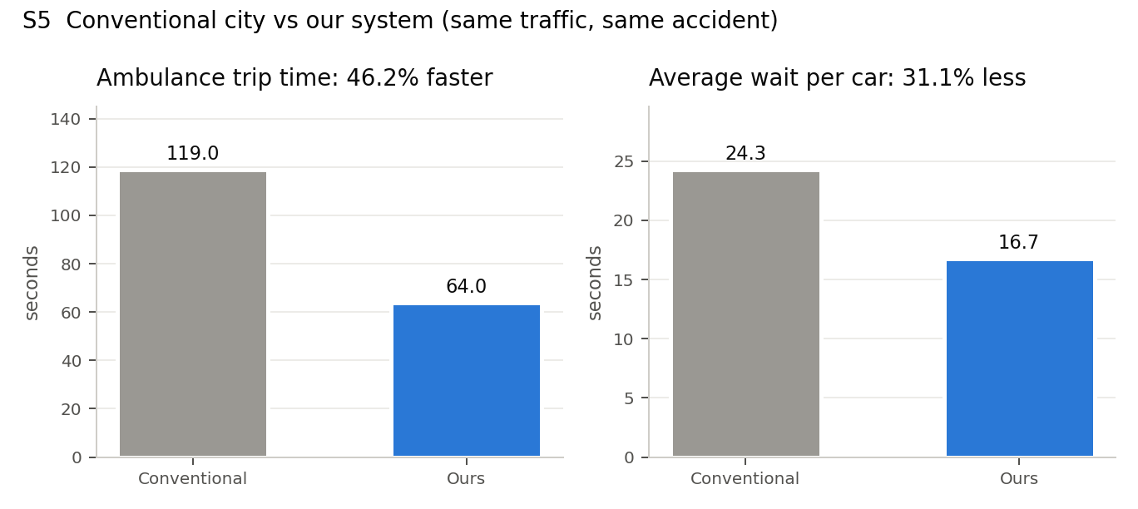
Figure 10. Conventional city vs our system
Result. The ambulance is 46.2% faster and never waits at a red light; the average car waits 31.1% less. Honest note: the ambulance trip is the same in every seed because it depends on the signal timings, not the random cars. Individual cars can occasionally be slower in our system; the gain is in the average.

S6. Hill-climbing tuning
Policy | Training traffic avg wait (s) | Unseen validation traffic avg wait (s)
Fixed-Time | - | 17.02
Max-Pressure, default parameters | 9.08 | 8.65
Max-Pressure, tuned by hill climbing | 6.85 | 6.96

Tuned parameters: min green 3 s, max green 15 s, beta 1.5, theta 3. Defaults were 5 s, 30 s, 0.5 and 1.0. The search used 62 simulated evaluations (16.2 s). The improvement carries over to validation seeds that were never used in the search, so it is not over-fitting. Note that the 3 s minimum green sits at the edge of the grid. A real deployment would enforce a pedestrian-safe minimum instead.

S8. Scalability
Grid | Intersections | Vehicles | Agents | Fixed wait (s) | Max-P wait (s) | Reduction | ms / sim-second
2x2 | 4 | 90 | 95 | 14.1 | 7.7 | 45.4% | 0.25
3x3 | 9 | 143 | 153 | 20.7 | 11.5 | 44.5% | 0.48
4x4 | 16 | 190 | 207 | 25.7 | 14.8 | 42.4% | 0.71
5x5 | 25 | 234 | 260 | 35.7 | 19.9 | 44.4% | 0.78
6x6 | 36 | 296 | 333 | 44.6 | 24.9 | 44.3% | 1.11
8x8 | 64 | 396 | 461 | 56.8 | 30.3 | 46.6% | 1.49

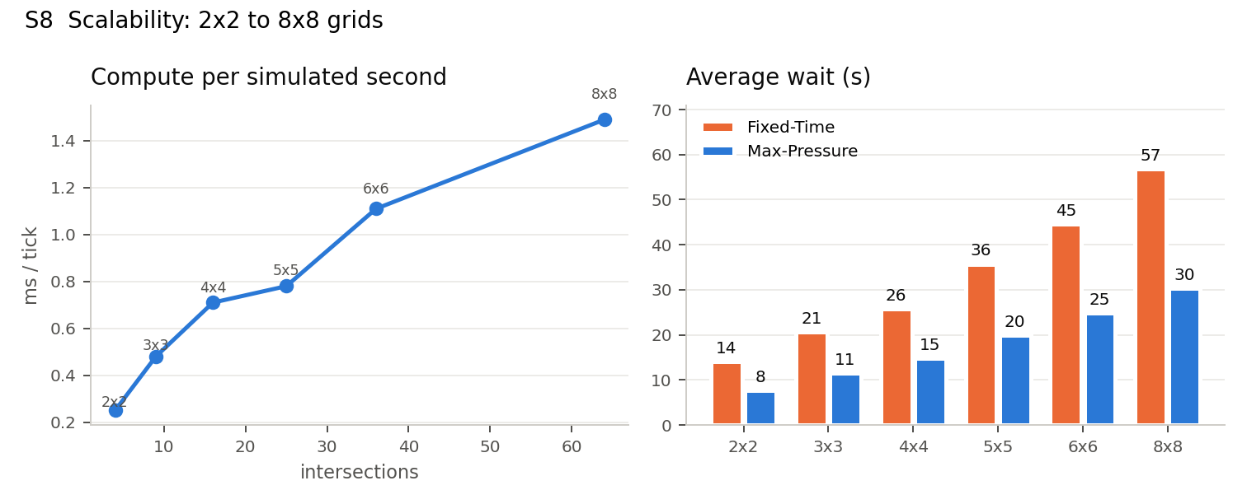
Figure 11. Cost grows linearly with the number of intersections; the benefit holds at every size

7.1 Test summary
47 of 47 automated tests pass (28.2 s): 23 unit tests, 7 integration tests (agent interaction and safety invariants), 8 system acceptance tests (one per scenario) and 9 demo tests. The full test cases, expected and actual values, and the defects found during testing are in the separate Testing Document.

8. Review 2: Code Structure and Scalability
stms/
protocols/message.py FIPA-ACL message + broker (history, counts) M4
agents/base_agent.py receive -> perceive -> reason -> act shared
agents/intersection_agent.py Max-Pressure, preemption, green-wave M2
agents/vehicle_agent.py beliefs, A* planning, re-planning, car-following M3
agents/emergency_agent.py look-ahead preemption M4
agents/coordinator_agent.py telemetry, incidents, hill-climbing tuner M5
algorithms/search_astar.py A* (BFS, UCS, Greedy kept as baselines) M3
algorithms/max_pressure.py controller + decision explanation M2
algorithms/hill_climbing.py parameter space, steepest descent, restarts M5
environment/ road network (BPR, headway), R x C grids, simulator M1
scenarios.py S1 ... S8
demo.py records the two-city run for the website
site.py builds index.html from web/template.html
visualization/ report charts and diagrams
scripts/ generate_results.py, run_simulation.py, build_site.py
tests/ 47 tests + run_tests.py (JSON report)
docs/ report, testing document, presentation, team split

Component | Cost per decision | Why it scales
Intersection decision | O(1): 8 road counts, 2 scores | Purely local, so adding junctions adds no work to existing ones
A* route plan | O(E log V) worst case; 14 expansions on average at 6x6 | Runs inside each vehicle (distributed), only at departure or re-plan
Messages | O(1) point-to-point; O(N) per broadcast | Broadcasts are rare (incidents) and congestion warnings are rate-limited (20 s)
Hill climbing | at most 8 simulations per iteration, memoised | Offline; tuned parameters are pushed once

Measured. Going from 4 to 64 intersections (461 agents), compute time rises from 0.14 to 1.53 ms per simulated second. That is roughly linear and about 650 times faster than real time at 8x8.

9. Limitations and Future Work

9.1 Limitations (stated honestly)
- Two-phase signals: a green phase serves through and turning traffic of one axis together. Separate turn phases and pedestrian phases are not modelled.
- Single-lane roads; vehicles queued in front of an ambulance are assumed to pull aside.
- Synthetic Poisson demand on a regular grid, not calibrated to a real city's counts.
- Messages are delivered instantly and never lost; there is no communication delay or failure model.
- The green-wave hand-off helps only on corridors, and it assumes the ambulance can always ask junctions for priority (Section 7).

9.2 Ideas for extension
- Reinforcement learning intersections (Q-learning or DQN on queue states), compared directly against Max-Pressure.
- Contract-Net for multiple ambulances so that conflicting corridor requests are resolved by bidding on urgency.
- Pedestrian agents with push-button requests and a pedestrian-safe minimum green.
- Real map import from OpenStreetMap (osmnx) and calibration against Coimbatore junction counts.
- Message loss and delay to test how robust the protocols are when V2I communication is unreliable.
- Simulated annealing or a genetic algorithm for the coordinator, compared with hill climbing on the same objective.

10. Conclusion
A decentralised multi-agent design meets every objective. Local Max-Pressure control with an anti-starvation term cuts waiting by 47.5% and never leaves a car unserved. A* over each vehicle's own beliefs gives optimal routes at a fraction of UCS's search effort. Explicit protocols let an ambulance cross without stopping, show a conventional city next to ours (S5), and let one broadcast about an incident save vehicles about a third of their travel time. The coordinator improves every controller by hill climbing without taking control away from them. Because every claim is tied to a regenerable result and an automated test, the system can be checked rather than taken on trust.

References
[1] S. Russell and P. Norvig, Artificial Intelligence: A Modern Approach, 4th ed., Pearson, 2021 (agents, PEAS, A*, local search).
[2] P. Varaiya, "Max pressure control of a network of signalized intersections," Transportation Research Part C, vol. 36, pp. 177-195, 2013.
[3] Bureau of Public Roads, Traffic Assignment Manual, U.S. Dept. of Commerce, 1964 (BPR travel-time function).
[4] Transportation Research Board, Highway Capacity Manual, 7th ed., 2022 (saturation flow, 1800 veh/h/lane).
[5] FIPA, "FIPA ACL Message Structure Specification (SC00061G)" and "FIPA Request / Propose Interaction Protocols," 2002.
[6] P. E. Hart, N. J. Nilsson and B. Raphael, "A formal basis for the heuristic determination of minimum cost paths," IEEE Trans. SSC, vol. 4, no. 2, 1968.

Appendix A. Viva Question Bank (by owner)

M1 - Task environment & simulation
Question | Answer
Why a 2 s discharge headway? | It is the Highway Capacity Manual saturation flow of 1800 vehicles per hour per lane. Without it, a whole queue could cross in one second and signal control would barely matter.
Why is the environment called continuous if you use 1 s ticks? | Positions and speeds are real-valued. Only time is discretised, for tractability, and 1 s is finer than any signal decision.
How do you know results are not luck? | Runs are seeded (IT-09 checks determinism), averaged over 5-10 seeds with standard deviations, and every vehicle runs to completion.

M2 - Junction agent (Max-Pressure)
Question | Answer
Why Max-Pressure instead of 'longest queue first'? | It subtracts the downstream queue, so it will not push cars into a full road (spillback). Varaiya proved it stabilises any demand that can be stabilised.
What happens without the starvation term? | In S2, 14 side-street cars were never served. One car against zero never beats the switching threshold.
Can preemption cause a crash? | No. Every switch, including an emergency one, goes through a 3 s yellow. IT-02 checks over 400 s with ambulances that no green ever changes directly to the other green.
Why does the green-wave not help on the grid? | Random origin-destination pairs create no platoons, so extending a green for predicted arrivals delays the other axis. It helps on a corridor (-32%).

M3 - Vehicle agent (A*)
Question | Answer
Is your heuristic admissible under congestion? | Yes. Congestion only increases true cost, and h uses the fastest possible speed and the straight-line distance, so h stays a lower bound (UT-01).
Why not Greedy? It expands fewer nodes. | It is optimal in only 51.5% of trips. A* costs a few more expansions and is optimal every time.
What does the vehicle know? | Only its beliefs: roads it was told about or saw itself. That is why the broadcast matters for slowdowns (S4).
What if the destination becomes unreachable? | Search returns failure (UT-07). The vehicle keeps its route and waits, and re-plans when a ROAD_CLEARED broadcast arrives.

M4 - Ambulance agent & protocol
Question | Answer
Why is the ambulance's preemption not a pure override? | It still respects the yellow clearance, and it releases the junction with CANCEL so Max-Pressure resumes immediately (IT-01).
Does preemption hurt other traffic? | Measured change in other cars' average wait: -0.12 s, which is negligible.

M5 - Traffic centre (hill climbing) & testing
Question | Answer
Why hill climbing and not exhaustive search? | 2,058 settings x 3 simulations is about 6,000 runs. Hill climbing needed 62, and restarts reduce the risk of a poor local optimum.
How do you know tuning did not over-fit? | It was evaluated on 5 validation seeds never seen during search: 8.65 s to 6.96 s.
Is the coordinator a single point of failure? | No. Signals keep running Max-Pressure locally if it disappears. It only adds information (alerts) and tuning.
What did testing find? | Five defects in the original code, including double reasoning per tick, ignored departure times and an unfair ambulance baseline. See the Testing Document.

