From a CIF File to a Crystal Shape
The mathematics, one step at a time, with every number worked out
G070 Final Year Project, Phase II · 23CSE498 · Amrita Vishwa Vidyapeetham, Coimbatore
Explanatory note for the project guide · 13 November 2026
How to read this note
Part A follows one real file, MOF5.cif, from the first line of the file to the finished crystal shape. Every number is calculated in front of you; nothing is skipped. If you understand Part A you understand the method.
Part B repeats the method on a crystal that is not cubic (Mg-MOF-74) and shows why that one grows as a rod.
Part C says how we know the numbers are right. Part D explains how the 3D pictures on the website are made, and what was written by us. Part E lists what the method does not do.
All numbers come from the project's own programs: code/morphology/run_cif_to_shape.py and run_general_shape.py (Python), and the same steps written again in the browser (website/mof_cif_shape.js, mof_general_shape.js).

Contents
0. The one idea behind everything, and the words used
A. MOF-5, from the file to the shape (Steps 1–11, every number worked out)
B. A crystal that is not cubic: Mg-MOF-74 grows as a rod
C. How we know the numbers are right
D. How the 3D pictures on the website are made, and what is our own work
E. What the method does not do

0. The one idea behind everything
A crystal grows by adding one flat layer of molecules after another onto its faces. A crystal is made of many parallel planes of atoms, in many directions. The rule we use, called BFDH after Bravais, Friedel, Donnay and Harker, says:
The BFDH rule
Planes that are far apart grow slowly, and slow faces become the big faces of the crystal.
So: find the spacing d between the planes in every direction; the directions with the largest spacing give the largest faces. Fast-growing faces grow themselves out of existence and disappear.
Why should wide spacing mean slow growth? A wide spacing means many atoms packed flat in each layer, held strongly inside the layer; a new layer adds little extra binding, so it attaches slowly. This is a rule of thumb from geometry only. It ignores solvent, temperature and additives (Part E).
The whole task is therefore: (1) read the crystal from the file, (2) find the spacings of its planes, (3) remove the spacings that cancel because of symmetry, (4) place a flat wall for each direction at a distance proportional to how fast it grows, and (5) see what solid is left inside all the walls.

Words used in this note
Word | Meaning in plain terms
Unit cell | The smallest box that, repeated in all directions like bricks, builds the whole crystal. Its edges are a, b, c (in Å, 1 Å = 10⁻¹⁰ m) and the angles between them α, β, γ.
Fractional coordinates (x, y, z) | Where an atom sits inside the box, as fractions of the edges. (0.5, 0.5, 0.5) is the centre of the box.
Plane family {hkl} | A set of parallel, equally spaced planes. The three whole numbers h, k, l (Miller indices) say how the planes cut the box edges: (100) planes cut the a edge once and run parallel to b and c. A bar over a number (or a minus sign) means negative.
Spacing d_{hkl} | The distance between two neighbouring planes of the family, in Å.
Centring | Extra copies of the whole pattern inside the box, shifted by half an edge. F = face-centred (copies at the centre of each face), I = body-centred (copy at the centre of the box).
Cancelled (absent) planes | Planes whose layers are exactly matched by another layer halfway between them, so the true repeat is half (or a third) of the spacing. Symmetry decides which.
d_{eff} | The effective spacing, after cancellations: d_{eff} = d / n, where n is 1, 2, 3, …
Habit | The overall look of the crystal: compact (all directions similar), rod (needle), plate, or lath (flat rod).

Part A. MOF-5, from the file to the shape
MOF-5 is zinc oxide clusters (Zn₄O) joined by terephthalate (benzene dicarboxylate, BDC) linkers. The file used is website/MOF5.cif.

Step 1. Read the file
A CIF file is plain text. The lines we need are the cell and the list of atoms:
_cell_length_a 25.86584 _cell_angle_alpha 90
_cell_length_b 25.86584 _cell_angle_beta 90
_cell_length_c 25.86584 _cell_angle_gamma 90
Zn1 0.293367 0.293367 0.206633
O1 0.250000 0.250000 0.250000 … and so on
Counting every atom line gives 424 atoms: 32 Zn, 104 O, 192 C and 96 H. The three edges are equal and all angles are 90°: a cube of side a = 25.86584 Å.

Step 2. Turn the cell into vectors and measure them
Put the three edges along the x, y, z directions:
a = (25.866, 0, 0), b = (0, 25.866, 0), c = (0, 0, 25.866) Å
The metric is the table of all dot products of these edges. It holds every length and angle of the cell, and every later distance is computed from it:
G = [ a·a a·b a·c ; b·a b·b b·c ; c·a c·b c·c ]
a·a = 25.86584 × 25.86584 = 669.042 Å² (same for b·b and c·c)
a·b = |a||b| cos 90° = 0 (same for the other off-diagonal entries)
Volume of the cell = a³ = 25.86584³ = 17 305.3 Å³

Step 3. Is the cell cubic?
A cell is cubic if its metric equals a² times the identity table: equal diagonal entries and zeros elsewhere. Here G = 669.042 × I, so yes, cubic, with a = √669.042 = 25.866 Å. (A file can describe a cubic crystal with a slanted, smaller box; the program also tries small whole-number rewrites M of the box, M G M^{T} = a² I. Here no rewrite was needed, M = identity.)
Why it matters: in a cubic cell the spacing formula is the simplest one (Step 6), and the faces come in the familiar cube, octahedron and dodecahedron directions.

Step 4. Find the centring: test half-cell shifts
Take every atom, move it by a test shift t, and check whether an atom of the same element is already sitting at the new place. If all atoms land on matching atoms, the shift is a true symmetry of the crystal.
Example with one atom. Zn1 is at (0.293367, 0.293367, 0.206633). Try the face-centring shift t = (½, ½, 0):
(0.293367 + 0.5, 0.293367 + 0.5, 0.206633 + 0) = (0.793367, 0.793367, 0.206633)
The file has an atom Zn31 at exactly (0.793367, 0.793367, 0.206633). It matches. Now try the body-centring shift t = (½, ½, ½):
(0.793367, 0.793367, 0.706633) → no Zn atom there
Doing this for all 424 atoms:
Test shift | Atoms that land on a matching atom | Result
(½, ½, 0) | 424 of 424 | symmetry
(½, 0, ½) | 424 of 424 | symmetry
(0, ½, ½) | 424 of 424 | symmetry
(½, ½, ½) | 104 of 424 | not a symmetry
All three face shifts work, the body shift does not: MOF-5 is face-centred, F. The box therefore holds 4 copies of one basic pattern (the corner one and three face copies), 424 / 4 = 106 atoms each.

Step 5. Find the rotations (point group)
The same "move every atom and compare" test is used with rotations instead of shifts. Four checks are enough to identify the cubic group:
Operation tried | Atoms matched | Present?
Inversion through the centre: (x, y, z) → (−x, −y, −z) | 424 of 424 | yes
3-fold rotation about the body diagonal [111]: (x, y, z) → (z, x, y) | 424 of 424 | yes
4-fold rotation about the c axis [001]: (x, y, z) → (−y, x, z) | 424 of 424 | yes
4-bar (rotate 90° and invert) about [001] | 424 of 424 | yes
All four present means the full cubic group m-3m, with 48 rotations and reflections. (Combined with the F centring this is space group Fm-3m, No. 225; the standard program spglib finds the same.)
Why it matters: rotations make faces equivalent. Every face in one family, for example all 8 faces of {111}, is turned into the others by these 48 operations, so they must grow at the same rate and have the same size.

Step 6. The spacing of each plane family
For a cubic cell the distance between neighbouring (hkl) planes is
d_{hkl} = a / √(h² + k² + l²)
With a = 25.86584 Å:
Family | h² + k² + l² | Square root | d = a ÷ root (Å) | Faces in family
{100} | 1 + 0 + 0 = 1 | 1 | 25.866 ÷ 1 = 25.866 | 6 (the cube directions)
{110} | 1 + 1 + 0 = 2 | 1.41421 | 25.866 ÷ 1.41421 = 18.290 | 12 (the dodecahedron)
{111} | 1 + 1 + 1 = 3 | 1.73205 | 25.866 ÷ 1.73205 = 14.934 | 8 (the octahedron)
{210} | 4 + 1 + 0 = 5 | 2.23607 | 25.866 ÷ 2.23607 = 11.568 | 24
{211} | 4 + 1 + 1 = 6 | 2.44949 | 25.866 ÷ 2.44949 = 10.560 | 24
{311} | 9 + 1 + 1 = 11 | 3.31662 | 25.866 ÷ 3.31662 = 7.799 | 24
By spacing alone, {100} (25.9 Å) would win and MOF-5 would be a cube. Step 7 shows why that is wrong.

Step 7. Which planes cancel
Think of the (100) planes: they are the faces of the box, 25.866 Å apart, perpendicular to x. Because MOF-5 is face-centred, the shift (½, ½, 0) puts an identical copy of every atom exactly halfway between two of these planes (½ of the way along x). So there is an identical layer every 12.933 Å, not every 25.866 Å. The true repeat in this direction is half the box.
Proof with waves. In X-ray language, each plane family has a "strength" called the structure factor. For the (hkl) direction every atom adds a wave with phase angle 2π(hx + ky + lz):
F(hkl) = Σ over atoms of Z × [cos 2π(hx+ky+lz) + i sin 2π(hx+ky+lz)] (Z = atomic number)
Take Zn1 and its copy Zn31, shifted by (½, ½, 0), and compute the phases for (100), where h = 1, k = 0, l = 0:
Zn1: 2π(1 × 0.293367) = 2π × 0.293367
Zn31: 2π(1 × 0.793367) = 2π × 0.293367 + 2π × 0.5 = (phase of Zn1) + π
A phase difference of π means the two waves are exactly opposite: cos(θ + π) = −cos θ, sin(θ + π) = −sin θ. They add to zero. Every atom in the crystal has such a partner, so F(100) = 0: the (100) planes cancel. For (200), h = 2, the difference becomes 2π × 2 × 0.5 = 2π, a full turn, so the waves add instead of cancelling: (200) survives.
Repeating this for the other shifts gives the simple rule for any face-centred crystal:
Rule for F-centred crystals
(hkl) survives only if h, k, l are all even or all odd. Mixed even and odd: cancelled.
(100): 1 odd, 0 even, 0 even → mixed → cancelled. (200): all even → survives.
(110): mixed → cancelled. (220): all even → survives.
(111): all odd → survives already at the first order.
The program checks this rule numerically on the real atoms (Z-weighted, 3040 electrons in total):
Reflection | |F| (electrons) | |F| ÷ 3040 | Verdict
(100) | 0.0 | 0 | cancelled
(200) | 1870.2 | 0.615 | present
(110) | 0.0 | 0 | cancelled
(220) | 853.9 | 0.281 | present
(111) | 74.2 | 0.024 | present
(210) | 0.0 | 0 | cancelled
(420) | 572.8 | 0.188 | present

Step 8. Effective spacings and the BFDH distances
The effective spacing is the spacing of the first order that survives: d_{eff} = d / n.
Family | d (Å) | First surviving order n | d_{eff} = d ÷ n (Å) | Rank
{111} | 14.934 | 1 (all odd) | 14.934 ÷ 1 = 14.934 | 1st
{100} | 25.866 | 2 → (200) | 25.866 ÷ 2 = 12.933 | 2nd
{110} | 18.290 | 2 → (220) | 18.290 ÷ 2 = 9.145 | 3rd
{311} | 7.799 | 1 (all odd) | 7.799 | 4th
{210} | 11.568 | 2 → (420) | 11.568 ÷ 2 = 5.784 | 6th
Now {111} has the largest effective spacing, not {100}. BFDH sets the growth rate proportional to 1 / d_{eff}. We place a flat wall for every face at a distance R from the centre proportional to its growth rate, scaled so the slowest family sits at R = 1:
R = d_{eff, largest} ÷ d_{eff}
{111}: R = 14.934 ÷ 14.934 = 1.000
{100}: R = 14.934 ÷ 12.933 = 1.1547
{110}: R = 14.934 ÷ 9.145 = 1.6330
A useful check: the answer does not depend on the size of the cell
R₁₀₀ = (a/√3) ÷ (a/2) = 2/√3 = 1.1547 exactly. The edge a cancels, so every F-centred cubic crystal gets the same two numbers. This is why MOF-5 and UiO-66, very different chemically, get the same BFDH shape.

Step 9. Build the crystal by cutting
Each face is a flat wall. A wall with outward direction n (a unit vector) at distance R keeps the points x with n · x ≤ R. The crystal is the region kept by all walls at once.
The 8 {111} walls. Their directions are (±1, ±1, ±1)/√3. For the wall in direction (1, 1, 1)/√3:
(x + y + z)/√3 ≤ 1 ⇔ x + y + z ≤ √3 = 1.732
All 8 together give |x| + |y| + |z| ≤ 1.732: a regular octahedron whose corners are at distance 1.732 on each axis, e.g. (1.732, 0, 0).
The 6 {100} walls. Directions (±1, 0, 0), (0, ±1, 0), (0, 0, ±1), at R = 1.1547:
|x| ≤ 1.1547, |y| ≤ 1.1547, |z| ≤ 1.1547 (a cube)
The octahedron reaches 1.732 along each axis but the cube walls stop at 1.1547, so the cube walls cut off the 6 corners of the octahedron. Each cut is a square.
The 12 {110} walls, at R = 1.6330, give |x| + |y| ≤ 1.6330 × √2 = 2.309 (and the same for the other pairs). On what is left after the first two cuts, the largest value of |x| + |y| is at a corner such as (1.1547, 0.5774, 0): 1.1547 + 0.5774 = 1.732. Since 1.732 < 2.309, these walls never touch the crystal. The program checks the 45 further families the same way; none of them touches the crystal either.
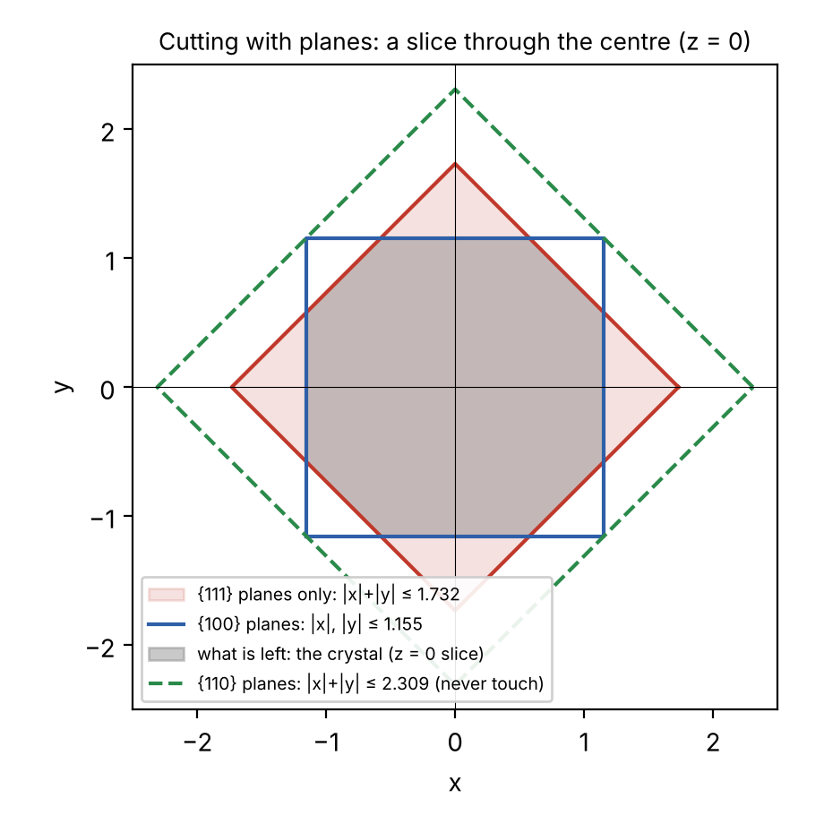
Figure 1. A slice through the centre (z = 0). Red: the {111} walls alone (a square standing on its corner). Blue: the {100} walls. Grey: what both keep, the crystal. Green dashed: the {110} walls, which never touch it.
Finding the corners. A corner sits where a cube wall meets two octahedron walls. On the cube face x = 1.1547, the octahedron wall gives y + z ≤ 1.732 − 1.1547 = 0.5774. So that square face has corners
(1.1547, ±0.5774, 0) and (1.1547, 0, ±0.5774)
and by symmetry there are 4 such corners on each of the 6 cube faces: 6 × 4 = 24 corners in total.

Step 10. Name the shape and measure it
Edge lengths. Edge of a square face, from (1.1547, 0.5774, 0) to (1.1547, 0, 0.5774):
√(0² + 0.5774² + 0.5774²) = 0.5774 × √2 = 0.8165
Edge between a square and a hexagon, from (1.1547, 0.5774, 0) to (0.5774, 1.1547, 0):
√(0.5774² + 0.5774² + 0²) = 0.8165
All edges are equal: 6 squares and 8 regular hexagons. This is the truncated octahedron, 14 faces, 24 corners, 36 edges (check with Euler: 24 − 36 + 14 = 2 ✓).
Areas, with edge s = 0.8165, s² = 0.6667:
one square = s² = 0.6667 6 squares = 4.000
one hexagon = (3√3/2) s² = 2.598 × 0.6667 = 1.732 8 hexagons = 13.856
total surface = 4.000 + 13.856 = 17.856
{111} share = 13.856 ÷ 17.856 = 77.6 % {100} share = 4.000 ÷ 17.856 = 22.4 %
Volume of a truncated octahedron with edge s: V = 8√2 s³ = 11.314 × 0.5443 = 6.158.
Sphericity Ψ compares the surface with that of a ball of the same volume (Ψ = 1 for a ball):
Ψ = π^{1/3} (6V)^{2/3} ÷ A
6V = 36.95; 36.95^{2/3} = 11.09; π^{1/3} = 1.4646; 1.4646 × 11.09 ÷ 17.856 = 0.910
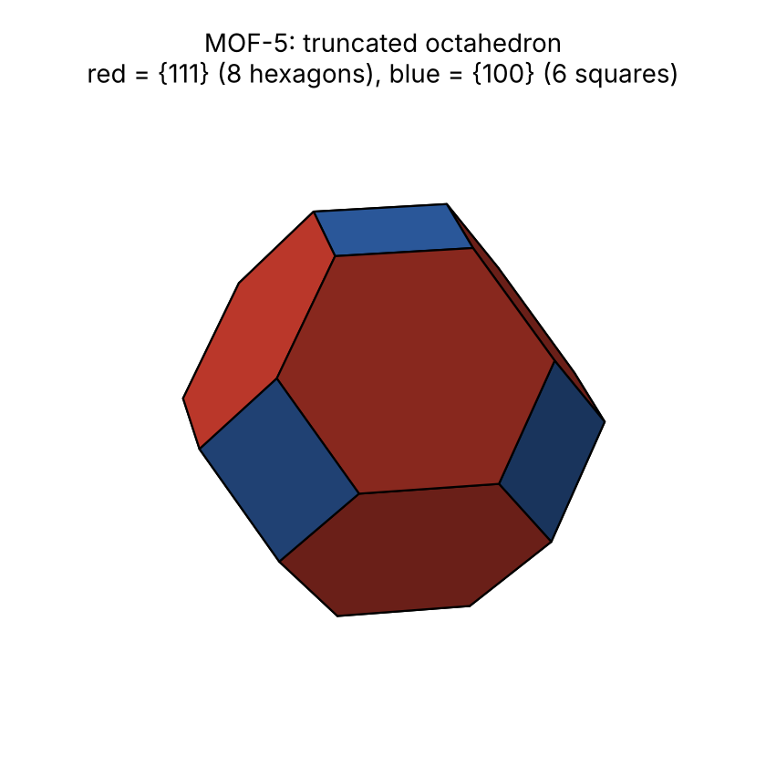
Figure 2. The BFDH crystal of MOF-5: a truncated octahedron. Red: the 8 {111} faces (77.6 % of the surface). Blue: the 6 {100} faces (22.4 %).
Quantity | Worked out above | Program output
Shape | truncated octahedron | truncated octahedron
Faces / corners | 14 / 24 | 14 / 24
{111} : {100} surface | 77.6 % : 22.4 % | 77.6 % : 22.4 %
Volume | 6.158 | 6.1584
Surface | 17.856 | 17.8564
Sphericity | 0.910 | 0.9099

Step 11. What would make it a cube or an octahedron?
The shape depends only on the ratio of the two distances, R₁₁₁ ÷ R₁₀₀:
R₁₁₁ ÷ R₁₀₀ | What happens | Shape
≤ 1/√3 = 0.577 | the octahedron walls are so close that the cube walls never touch | octahedron
between 0.577 and 1.155 | cube walls cut the octahedron corners | truncated octahedron
= 2/√3 = 1.155 | the octahedron walls pass exactly through the cube edge midpoints, e.g. (1, 1, 0): (1+1+0)/√3 = 1.155 | cuboctahedron
between 1.155 and 1.732 | octahedron walls cut the cube corners | truncated cube
≥ √3 = 1.732 | octahedron walls never touch the cube | cube
MOF-5 has R₁₁₁ ÷ R₁₀₀ = 1 ÷ 1.1547 = 0.866, inside the second row: truncated octahedron. A real additive that slows the {100} faces lowers R₁₀₀ and moves the crystal down this table towards the cube. This is the "morphology map" on the website.

Part B. A crystal that is not cubic: Mg-MOF-74
Mg-MOF-74 has chains of magnesium and oxygen running through the crystal, joined by dobdc linkers into hexagonal channels. File: data/structures/general_lattice/MgMOF-74.cif (from the RASPA2 structure library).

Steps 1–3. The cell
a = b = 26.136 Å, c = 6.942 Å, α = β = 90°, γ = 120°
Two equal edges at 120° and a third, much shorter, at right angles: hexagonal axes. Not cubic, so the cubic formula of Step 6 does not apply. The file lists 9 atoms and 18 symmetry operations; applying the operations gives 162 atoms in the cell. The symmetry search (same method as Steps 4–5, tolerance 0.05 Å) finds all 18 operations of space group R-3: a 3-fold axis along c, inversion, and the rhombohedral centring shifts (⅔, ⅓, ⅓) and (⅓, ⅔, ⅔).

Step 6. Spacings in a hexagonal cell
For hexagonal axes the spacing formula comes from the same metric idea; it becomes
1 / d² = (4/3) (h² + hk + k²) / a² + l² / c²
With a² = 683.09 and c² = 48.19:
(2, −1, 0): h²+hk+k² = 4 − 2 + 1 = 3; 1/d² = (4/3)(3)/683.09 = 0.005856; d = 13.068 Å ( = a/2 )
(1, 0, 0): h²+hk+k² = 1; 1/d² = (4/3)/683.09 = 0.001952; d = 22.634 Å
(1, 0, 1): 1/d² = 0.001952 + 1/48.19 = 0.001952 + 0.020750 = 0.022702; d = 6.637 Å
(0, 0, 1): 1/d² = 1/48.19; d = c = 6.942 Å

Step 7. Which planes cancel (rhombohedral centring)
Rule for R-centred crystals (hexagonal axes)
(hkl) survives only if −h + k + l is a multiple of 3.
(2, −1, 0): −2 − 1 + 0 = −3 ✓ survives. (1, 0, 1): −1 + 0 + 1 = 0 ✓ survives.
(1, 0, 0): −1 ✗; (2, 0, 0): −2 ✗; (3, 0, 0): −3 ✓ → n = 3, d_{eff} = 22.634 ÷ 3 = 7.545 Å.
(0, 0, 1): 1 ✗; (0, 0, 2): 2 ✗; (0, 0, 3): 3 ✓ → n = 3, d_{eff} = 6.942 ÷ 3 = 2.314 Å only.
The reason is the same as in Part A: the centring shifts put copies of every atom ⅓ and ⅔ of the way between the (001) planes, so the true repeat along c is c/3.

Step 8. Effective spacings and distances
Family (3 and 4 indices) | d (Å) | n | d_{eff} (Å) | R = 13.068 ÷ d_{eff} | Surface share
{2-10} = {2-1-10}, the 6 sides | 13.068 | 1 | 13.068 | 1.000 | 77.4 %
{100} = {10-10} | 22.634 | 3 | 7.545 | 1.732 | 0 (cut away)
{101} = {10-11}, the 6 end faces | 6.637 | 1 | 6.637 | 1.969 | 22.6 %
{001}, flat ends | 6.942 | 3 | 2.314 | 5.65 | not in the 40 widest

Step 9. The shape, and why it is a rod
The six side walls {2-1-10} sit at R = 1 all round the c axis: a hexagonal tube of half-width 1 (1.155 to its edges). Nothing nearby closes the tube along c: the flat (001) wall is at R = 5.65 because its spacing is only 2.314 Å, so fast-growing that it never appears. The tube is closed instead by the six sloping {10-11} walls at R = 1.969. Their unit normal is (0.254, 0.147, 0.956), nearly along c, so they meet the axis at
z = R ÷ n_{z} = 1.969 ÷ 0.956 = 2.060
The crystal therefore runs from z = −2.06 to +2.06 (length 4.12) but is only about 2.0 wide: a hexagonal rod about twice as long as it is wide, with pointed three-faced ends.
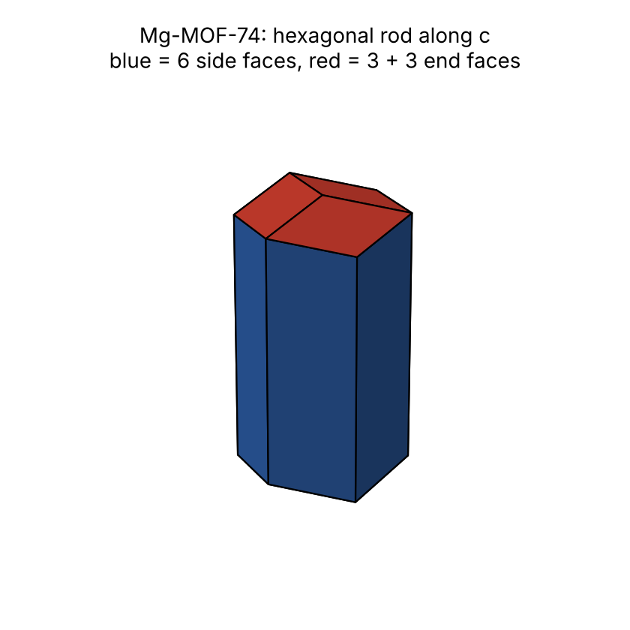
Figure 3. The BFDH crystal of Mg-MOF-74: a hexagonal rod along c. Blue: the six {2-1-10} sides (77.4 %). Red: the three-faced ends {10-11} (22.6 %).

Step 10. Compact, rod or plate? (Zingg ratios)
To classify any shape we measure how far its volume spreads in each direction (the gyration tensor). Its three principal "radii" are written a ≥ b ≥ c (largest first):
Mg-MOF-74: a : b : c = 1 : 0.479 : 0.479
Test (Zingg, 1935) | Mg-MOF-74 | Meaning
b / a < 2/3 ? | 0.479 < 0.667 → yes | one direction is much longer
c / b < 2/3 ? | 1.000 → no | not flattened
Result | rod | long axis [001] = the c axis
The same test gives compact if neither ratio is below 2/3 (MOF-5: 1 : 1 : 1), plate if only c/b is, and lath if both are.
Why this is physically sensible
The rod lies along the Mg–O chains. Along the chain the true repeat is very short (c/3 = 2.3 Å), so in BFDH those layers grow fastest and the crystal shoots out along c. MIL-53, another chain MOF, is reported in the laboratory as needles grown along its metal–oxide chain (Joshi et al., CrystEngComm 2022), which agrees in kind. This is a qualitative agreement; the project does not yet have a measured data set of non-cubic MOF shapes to test against.

Part C. How we know the numbers are right
- Two independent programs. Every step is written twice: in Python (using the standard symmetry library spglib) and again in JavaScript for the website (with its own symmetry search). They must give the same numbers. The automatic test website/tests/test_general_shape.js compares them on 10 MOF files and 3 stretched cells: atom count, number of symmetry operations, habit, b/a and c/b to 0.002, the first 12 spacings and every face family's share of the surface. All 249 checks pass.
- Hand checks. The numbers in Part A were worked out by hand in this note and agree with the program output to the last digit shown (table in Step 10).
- Exact results as checks. R₁₀₀ = 2/√3 for every F-centred cube (Step 8), and the Euler count 24 − 36 + 14 = 2 for the solid (Step 10).
- A survey. The browser engine was run on all 94 MOF files of the RASPA2 library: 27 rods, 65 compact, 1 plate (and one unreadable file). The plate and 15 others are files stored without exact symmetry; the website flags such files instead of trusting them.

Part D. How the 3D pictures on the website are made
Short answer: we wrote the 3D viewers ourselves. We did not take them from another website. The only outside piece is three.js (version r128), a free, open-source JavaScript library (MIT licence) that draws 3D objects in a web browser using the graphics card (WebGL). It is a general drawing tool, like a pen; it knows nothing about atoms or crystals. Everything chemical is our own code.

D1. The atom viewers (Decomposition, Network and other pages)
What you see | How it is computed (our code, website/mof_render.js and mof_decompose.js)
Atom positions | Cartesian position = x·a + y·b + z·c, from the fractional coordinates in the CIF and the cell vectors of Step 2.
Atom size and colour | Each atom is a shaded sphere. Radius = 0.42 × its covalent radius (smallest 0.26 Å), so heavier atoms look larger; colours follow the usual chemistry convention (C grey, O red, N blue, metals by element).
Which atoms are bonded | Two atoms are bonded if their distance is less than (r₁ + r₂) × 1.15, or × 1.30 if one is a metal, where r is the covalent radius. Example, MOF-5: Zn–O cutoff (1.22 + 0.66) × 1.30 = 2.44 Å; the actual Zn1–O1 distance is 0.043367 × 25.866 × √3 = 1.943 Å, so they are bonded. Bonds that cross the box wall are found by also checking the neighbouring boxes.
Cloud bonds | Each bond is a smooth tube, each half in the colour of its own atom, wider at the atoms and narrower in the middle like a stretched rubber band. Around it sits a translucent, elongated cloud (an ellipsoid along the bond, blended in the two atoms' colours and drawn so that it adds a soft glow to what is behind it), suggesting the shared electrons. A switch in the corner of every viewer changes back to plain sticks.
Lighting | A sky-and-ground fill light, a main light from the upper right and a weak rim light from behind, so spheres look round and glossy.
Click an atom | The computer finds which sphere is under the mouse (ray casting) and shows a card: element name, atomic number, standard atomic mass (IUPAC), Pauling electronegativity, the covalent radius used for bonds, position in Å and as fractions of the cell, the number of bonds with each neighbour and its distance, and which building block (metal node or linker) the atom belongs to.
Rotate, zoom | Dragging turns the camera around the structure; the wheel zooms. The picture is redrawn only when something changes, to save battery.
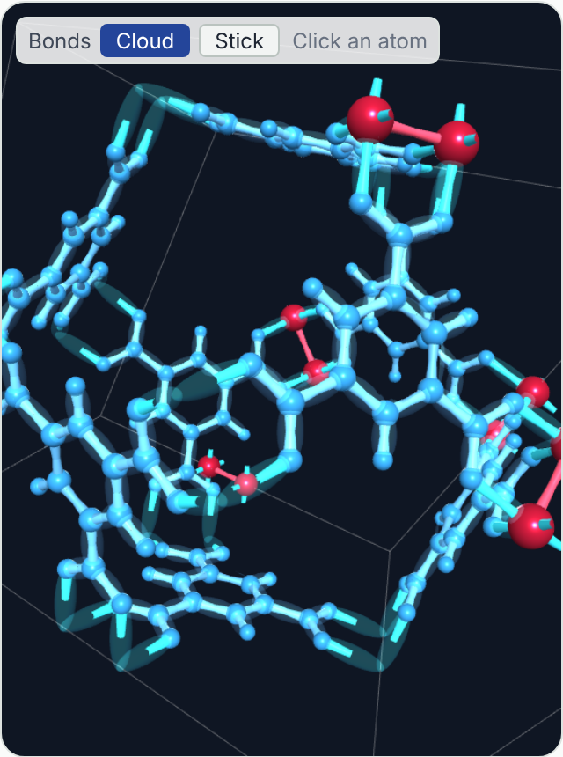
Figure 4. Cloud bonds on the Network page (HKUST-1, zoomed in): atom-coloured bands, each inside a translucent cloud.
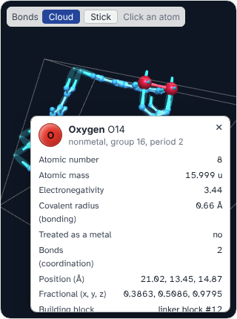
Figure 5. The card shown when an atom is clicked (an oxygen atom of HKUST-1).

D2. The crystal-shape drawings (CIF to Shape, Morphology, Cell Deform)
These do not use three.js at all. They are drawn as flat SVG polygons by our own code:
- Each face from Step 9 is a list of corner points in 3D.
- Turning the crystal multiplies every corner by a 3 × 3 rotation matrix (updated as you drag).
- Faces pointing away from the viewer are skipped; the rest are drawn from the back to the front, so nearer faces cover farther ones.
- Each face is shaded by how directly it faces a fixed light: brightness depends on the dot product of the face normal and the light direction.
- Clicking a face shows its Miller index, its family, its share of the surface and, on the any-lattice view, d, d_{eff} and R.
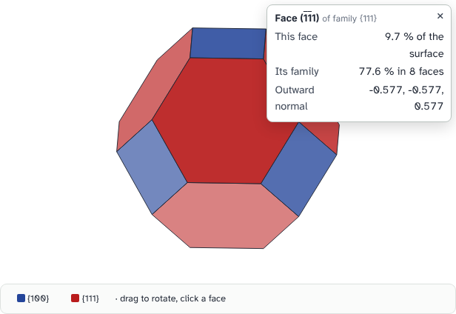
Figure 6. Clicking a face of a crystal drawing (Morphology page).

D3. Existing tools that do similar things
Crystal viewers already exist, and chemists use them every day. We did not use or copy them; they are listed so the panel can see where our viewer stands:
Tool | What it is | Relation to our work
VESTA | Desktop program for crystal structures and electron density (K. Momma and F. Izumi) | Standard for publication pictures. Our MOF5.cif was written by VESTA. Not used for the website.
Mercury (CCDC) | Desktop viewer from the Cambridge Crystallographic Data Centre; it can also draw BFDH crystal shapes | Its BFDH tool computes the same kind of shape as Part A; a useful independent cross-check for the panel.
Jmol / JSmol, 3Dmol.js, NGL | Molecule viewers for web pages | Could have been embedded. We wrote our own so that each pipeline stage (bonds cut, blocks, network) can be coloured and explained step by step, which these viewers do not do.

Part E. What the method does not do
- Geometry only. BFDH uses plane spacings. It ignores the solvent, temperature, supersaturation, additives (modulators) and the actual bond strengths across each face.
- Layered frameworks. If layers are held together only weakly, the stacking direction grows slowly in reality, giving plates; BFDH cannot see this and may predict the opposite.
- Kinetic shapes. Spheres, intergrown crystals and shapes controlled by diffusion are outside BFDH and outside Wulff constructions in general.
- Files without exact symmetry. If the atoms in a file are slightly out of place, the program finds fewer symmetry operations, misses cancellations and can give the wrong shape. The website warns when this happens.
- Comparison with experiment. For the cubic MOFs the project compares against 134 laboratory records (the Morphology map page). For non-cubic MOFs the agreement in Part B is qualitative only.

In one sentence
From the CIF we find the cell, its centring and rotations; from these the spacing of every plane family and which ones cancel; the widest effective spacings become the slowest, largest faces; cutting space with one wall per face gives the crystal, and its proportions tell us whether it is compact, a rod or a plate.

