MOF Graphs and Crystal Morphology: Complete Project Report (G070)
Nov 12, 2026 · @Radha Krishna

1. Executive summary
The project built a complete, tested pipeline from a MOF crystal file to (a) a graph-based structural descriptor and (b) predicted crystal shapes, and found that the descriptor does not carry shape information in the form first proposed, but that a related scaling measure does.
Part 1 (spectrum). A MOF structure is decomposed into metal-oxo nodes and organic linkers, collapsed to a labelled quotient graph, and described by the width Δα of its multifractal spectrum. On 77 hypothetical (hMOF) and 61 synthesised (CoRE MOF 2019) frameworks the project showed that Δα grows with graph size (slope of Δα against ln D between 0.69 and 0.89 per net), and that the proposed Narrow / Medium / Wide classes follow size (correlation +0.69 for hMOF, +0.72 for CoRE MOF). The proposed reference band 1.11–1.25 was therefore withdrawn. The team paper (G070) reports the method and these limits.
Goal change. The guide and the review panel asked whether the unit cell of an established MOF can generate its crystal morphologies, and whether anything about morphology follows from the spectra.
Part 2 (morphology). A Python package (mofmorph) predicts crystal shape with seven models: BFDH, a graph attachment rule, two graph-energy Wulff models, a force-field (UFF) Wulff model, a BFDH × Wulff blend and a CHGNet cleavage-energy model. Scored against 134 laboratory records from 35 papers, no model reproduces all four benchmark MOFs. ZIF-8 is reproduced by every model applied to it, MOF-5 by three, HKUST-1 only through its dominant {111} face, and additive-free UiO-66 by none.
Linking the parts. The periodic Δα is unrelated to predicted shape once size is controlled (ρ = +0.001, p = 0.99, 55 CoRE MOFs). On finite particles Δα separates plates and rods but not compact shapes. The mass–radius dimension profile separates both: the MOF-5 cube, plate and rod have the local dimension of a 3D, 2D and nearly 1D lattice, and the half-mass radius over diameter separates the cube, truncated cube and truncated octahedron predicted for MOF-5.
Update of 10 November. Kshitij's steps 1–8 pipeline (CIF to surface energies to Wulff shape) was run on four MOFs and checked; five mistakes that change results were found and the worst was fixed (Sections 11.8 and 13.8). Keerthi's proposal that shape classes are regions in a space was given an exact form, the morphology map: for a cubic MOF the shape depends only on γ110/γ100 and γ111/γ100, and every shape name is a region with closed-form boundaries (Section 11.9). In the lab dataset all six series whose shape changes on the map move toward one face only, a label-only conditions model does worse than ignoring the additive, and lowering one face energy at a time from a CIF's point lists 15 of the 16 polyhedral lab shapes for four MOFs (Section 11.10). The dimension-profile number r½/D moves steadily along the map, so the spectrum work becomes the measurement side of the same map (Section 12.6). No existing dataset lists the possible morphologies of a given CIF; the hand-built one covers about 12 MOFs, and the guide's help is being sought on how to proceed (Section 17.4).
Verdict. The direction is sound: every claim is now generated from scripts, checked by tests, and corrected in public when wrong. The main gaps are physical, not computational: surface energies without solvent, modulators or DFT validation, and a benchmark of only four MOFs.
The repository is github.com/Radha-Krishna-19/fyp and the website is radha-krishna-19.github.io/fyp. The latest versions described here become public once the final push is made (section 17).

2. Problem statement and objectives
The project asks whether a MOF's connectivity alone, read as a graph, can describe its structure well enough to (1) group frameworks without molecular simulation and (2) say something about the shape of its crystals.
Course and team. 23CSE498 Final Year Project, Phase II, Department of Computer Science and Engineering, Amrita Vishwa Vidyapeetham, Coimbatore. Guide: Dr. T. Ramraj. Team G070: Pasupuleti Meena Radha Krishna (CB.SC.U4CSE23134), Keerthi Sree Jonnakuti (CB.SC.U4CSE23031), Kshitij Varma Pinnamaraju (CB.SC.U4CSE23122), Rohith Abhinav Sai Komal Gullolla (CB.SC.U4CSE23141), Isha Sri Prakash (CB.SC.U4CSE23029).

2.1 The situation
Metal-organic frameworks (MOFs) are crystals built from metal clusters joined by organic linkers. Hundreds of thousands exist, synthesised or generated by computer. Their use (gas storage, separation, catalysis) depends on the pore network. The standard way to test a MOF for adsorption is grand canonical Monte Carlo (GCMC) simulation, which takes hours per structure. At 100,000 candidates that is decades of computing time, so the bottleneck is computational cost, not chemistry.

2.2 The first question (Part 1)
Can a purely structural descriptor, computed from a framework's connectivity in seconds, group MOFs into meaningful families, so that a new candidate can be triaged before any expensive calculation? The descriptor was never meant to replace simulation. Its value would be as a filter that decides what to simulate.
The brief from the guide was: highlight the influential nodes, find the multifractal spectrum, and deduce statements such as "all zirconium MOFs fall under this spectrum". Each of the three tasks met a specific obstacle:
Task in the brief | Obstacle found | Outcome
Highlight the influential nodes | In a perfect crystal every node of a kind is symmetry-equivalent, so influence cannot be ranked from centrality alone | Reported as a property of crystals; the spectrum uses degree to pick influential nodes
Find the spectrum | The first implementation fitted τ(q) with a free intercept, which flattened every spectrum's apex | Fixed (fit through the origin); 77 of 77 spectra valid afterwards
Deduce a family band | A band exists, but its position and width follow graph size | Band withdrawn; the size dependence was quantified instead
Why connectivity. A MOF is a repeating framework; what distinguishes two MOFs is how their parts are wired. Wiring is exactly what a graph describes. Gas moves through the pore network, which is the space the wiring leaves. Once the framework is a graph, established measures apply: coordination number, centrality, the Laplacian, fractal and multifractal measures.
What is given up. The graph is unweighted: it does not know elements, charges or binding energies. A copper node and a zinc node are the same vertex. This is stated wherever results are quoted. It is also the point: what survives is architecture, which transfers across chemistries.

2.3 The second question (Part 2)
After Panel Review 1 the panel asked: given the unit cell of an established MOF, can its crystal morphologies be generated, mathematically and computationally? The guide added: can anything about morphology be concluded from the spectra already computed, or by other routes?
Crystal shape matters in practice. The exposed faces control which pore openings face the gas, diffusion lengths, packing in a column and catalytic activity. Shape is decided by symmetry (which faces are allowed) and by growth rates or surface energies (which faces survive).

2.4 Objectives
- Build a reproducible pipeline from a CIF file to a labelled quotient graph of building blocks.
- Compute the influential-node multifractal spectrum and test whether its width Δα is a structural descriptor (hMOF and CoRE MOF 2019 datasets).
- From the unit cell, derive the allowed crystal faces (symmetry and systematic absences) and predict crystal shapes with several growth models of increasing physical detail.
- Build an experimental benchmark from the literature and score every model against it.
- Test the link between the two parts: what the spectrum, or related scaling measures, can say about crystal shape.
- Document everything so that each number traces to the script that made it: website, open repository, dataset, paper.

2.5 Scope
In scope | Out of scope
Graph construction, multifractal analysis, size scaling | Adsorption isotherms, GCMC simulation
Crystal shape from symmetry, lattice, graph energies, force field, CHGNet | Growth kinetics in solution, nucleation, solvent and modulator chemistry (planned)
Four benchmark MOFs: MOF-5, HKUST-1, UiO-66, ZIF-8 | Ranking models statistically (four MOFs are too few)
Validation against published crystal habits | Laboratory synthesis

3. Theory I: MOFs, crystals and CIF files
Every result in this project starts from a CIF file, which stores atom positions and symmetry but no bonds, so every bond, block and graph used later is inferred from geometry.

3.1 What a MOF is
A MOF has two kinds of building block, joined over and over in three dimensions:
- Node (secondary building unit, SBU): a small cluster of metal atoms, usually held together by oxygen. It is rigid and points in fixed directions; it is the joint of the structure.
- Linker: an organic molecule, typically a rigid ring with binding groups (often carboxylates, –COO⁻) at its ends; it is the strut.
Because both parts are rigid and bind in predictable directions, frameworks can be designed like construction kits (reticular chemistry): a node with four connection points and a linker of a given length predict the framework, and a longer linker gives the same architecture with larger pores. Internal surface areas above 3000 m²/g are common. Uses include gas storage (H₂, CH₄), carbon capture, separations (Xe/Kr, O₂/N₂) and catalysis at exposed metal sites. All of these depend on the pore network, which is the space left by how the blocks are wired.

3.2 The four benchmark structures
The same four MOFs are used throughout as known answers. The numbers below are the project's own computed values; they agree with the published structures.
MOF | Metal | Atoms in cell | Bonds found | Blocks (nodes + linkers) | Node connectivity | Net | Role in the project
HKUST-1 | Cu | 156 | 198 | 14 (6 + 8) | 4 | tbo | Copper paddlewheel; the most cited node
MOF-5 | Zn | 424 | 512 | 32 (8 + 24) | 6 | pcu | Simple cubic; easy to sanity-check
ZIF-8 | Zn | 276 | 312 | 36 (12 + 24) | 4 | sod | Control: binds through nitrogen, contains no oxygen
UiO-66 | Zr | 114 | 184 | 7 (1 + 6) | 12 | fcu | Stress test: one 12-connected cluster per cell
ZIF-8 tests any method that silently assumes metals bind to oxygen. UiO-66 tests periodicity: its single Zr₆ cluster has twelve connections, almost all of which leave the cell and return from a neighbouring copy.

3.3 Crystals and the unit cell
A crystal is a unit cell of atoms repeated without end in three directions. It has no boundary: an atom near a cell wall is bonded to an atom in the next cell. Software that looks inside one cell only misses those bonds. This fact causes the most important failure mode found in Part 1 (section 13).
The cell is given by three edge lengths a, b, c (Å) and three angles α, β, γ. Atom positions are stored as fractional coordinates (fractions of each edge, between 0 and 1). Real positions follow from the lower-triangular cell matrix:
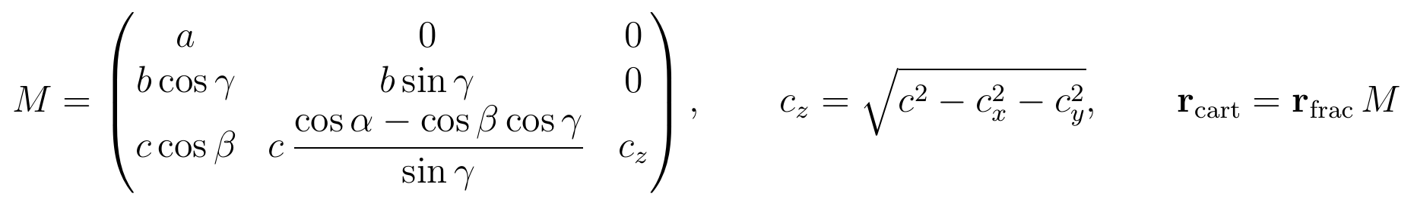

3.4 The CIF file
A Crystallographic Information File (CIF) holds exactly three things: the six cell parameters, the atoms (element and fractional coordinates), and the symmetry operations that generate all atoms from a small asymmetric unit. It holds no bonds. X-ray diffraction measures electron density, hence positions; it does not say which atoms are bonded. Every bond any MOF software uses is therefore inferred from distances, and every later stage of the pipeline rests on that inference.

3.5 Bond perception with periodic boundaries
Two atoms are bonded when their distance is below the sum of their covalent radii (Cordero et al., 2008) times a tolerance: 1.30 if either atom is a metal (coordination bonds are longer and more variable), 1.15 otherwise.
The minimum is taken over the home cell and its 26 neighbours (27 images), the minimum-image convention. The winning shift t, three integers, records which copy of the cell the bond reaches into. It is kept with every bond; discarding it makes the crystal fall apart (section 4).
Example radii: H 0.31, C 0.76, N 0.71, O 0.66, Cu 1.32, Zn 1.22, Fe 1.32, Zr 1.75 Å. The threshold is a cut on a continuum: a Zr–O contact 2% under the cutoff and one 2% over are chemically similar, but only one is called a bond. The code reports borderline pairs (within 10% of the cutoff) instead of pretending the cut is sharp.

3.6 Symmetry and space groups
A crystal's symmetry is described by its space group: the set of rotations, reflections, inversions, screw axes, glide planes and lattice centrings that map the crystal onto itself. The project finds it with spglib from the atom positions. Results for the four benchmark files:
MOF | Space group found | a (Å) | Note
MOF-5 | Fm-3m | 25.866 | Face-centred cubic
HKUST-1 | Fm-3m | 26.297 | The file stores the primitive cell
UiO-66 | F-43m | 20.518 | Ordered μ₃-OH groups lower the symmetry; the literature reports Fm-3m
ZIF-8 | I-43m | 16.991 | Found only without hydrogen; with hydrogen the file reads as P1
Two of these are traps. UiO-66 in F-43m lacks inversion, so its {111} faces split into two families, {111}+ and {111}−, which permits a tetrahedral shape that Fm-3m forbids; the project reports that shape as "allowed by the ordered structure", never as a prediction. ZIF-8 needs symmetry found without hydrogen; energies must still be computed with all atoms (a defect of this kind was found and fixed; section 13).
Symmetry enters morphology twice: equivalent faces form families ({100} = all six cube faces in a cubic crystal), and lattice centring and screw or glide operations cause systematic absences, which remove faces from the list of candidates (section 6).

4. Theory II: building blocks, graphs and periodic nets
A MOF becomes a graph by cutting it into building blocks and keeping, for every bond between blocks, the lattice translation it crosses; without that translation the coordination numbers come out wrong.

4.1 Decomposition into building blocks
A MOF is one continuous covalent network; the boundary between node and linker is a decision made by an algorithm. The ambiguous case is the carboxylate group: its carbon is bonded to the organic ring (linker side) and its two oxygens to metal atoms (node side). Assigning it to the node, the linker, or splitting it are all defensible, which is why the field has several decomposition rules.
The project uses the MOFid decomposition (Bucior et al., Crystal Growth & Design, 2019; software snurr-group/mofid, C++ on Open Babel), translated into standalone Python, one module per stage, and used without modification.
Metal classification. MOFid treats as a metal every element not on a list of 23 non-metals (H, He, B, C, N, O, F, Ne, Si, P, S, Cl, Ar, Ge, As, Se, Br, Kr, Sb, Te, I, Xe, At, Rn). This exclusion design is deliberate. A whitelist of eight common MOF metals (Zn, Cu, Ni, Co, Fe, Al, Cr, Mn) looks reasonable, but on UiO-66 it recognises no atom as a metal (zirconium is absent), produces no nodes and raises no error.
The metal-oxo rule (default). Cut every bond that has a metal at one end; each remaining connected component is a building block; blocks containing a metal are nodes, the rest are linkers.
MOF | Node reported | Chemical node
HKUST-1 | Cu₂ | Cu₂(COO)₄ paddlewheel
MOF-5 | Zn₄O | Zn₄O(COO)₆
ZIF-8 | Zn | single Zn²⁺ (correct)
UiO-66 | Zr₆O₈H₄ | Zr₆O₄(OH)₄(COO)₁₂
Because both carboxylate oxygens touch metal, the carboxylate goes to the linker. The reported node is the cluster with its binding groups stripped. This changes block composition, not connectivity, so the coordination numbers are unaffected. The rule trades chemical fidelity for universality: deterministic, needs only is_metal(), works on any chemistry.
Alternative rules. Single-node keeps the bridging carboxylate with the metal (the chemically complete cluster). All-node additionally splits branched linkers at their branch points. All three are implemented; Part 1 uses metal-oxo.
After the split. Each block is collapsed to its centroid, computed periodically so a block straddling a cell wall is not averaged into the middle of the cell. The simplified net is written as a .cgd file for Systre (Delgado-Friedrichs and O'Keeffe), which names the net (RCSR symbols such as tbo, pcu, sod, fcu). Systre itself is external Java software and was not reimplemented; the net names quoted are the published ones. MOFid and MOFkey strings are assembled; the InChIKey part is a placeholder of the correct shape, and nothing downstream uses it.

4.2 Graphs
A graph is a set of vertices (things) and edges (connections). It has no notion of distance, angle or chemistry. In this report "vertex" is the graph sense and "node" the chemical sense. Each building block becomes a vertex and each bond between two blocks an edge: a 14-atom copper paddlewheel becomes one vertex.
The degree of a vertex is the number of edges touching it. For a node vertex this is the coordination number, which is published for every benchmark MOF. That gives an independent ground truth: if the literature says the Zr₆ cluster is 12-connected and the graph says otherwise, the graph is wrong.

4.3 The labelled quotient graph
A crystal is infinite; a CIF stores one cell. The correct finite description keeps one vertex per block and labels every edge with the translation it crosses:
This is the labelled quotient graph (Chung, Hahn and Klee, 1984; Delgado-Friedrichs). Two blocks are often joined by several bonds in different directions; without labels they collapse to one edge and the degree is too low. Measured on the benchmark set by docs/report_figures/make_figures.py (through code_09); the dropped-bond column gives the range over the node vertices of one cell:
MOF | Node degree, cell-crossing bonds dropped | Degree, labelled quotient graph | Published
HKUST-1 | 0–2 | 4 | 4
MOF-5 | 3–5 | 6 | 6
ZIF-8 | 2 | 4 | 4
UiO-66 | 1 | 12 | 12
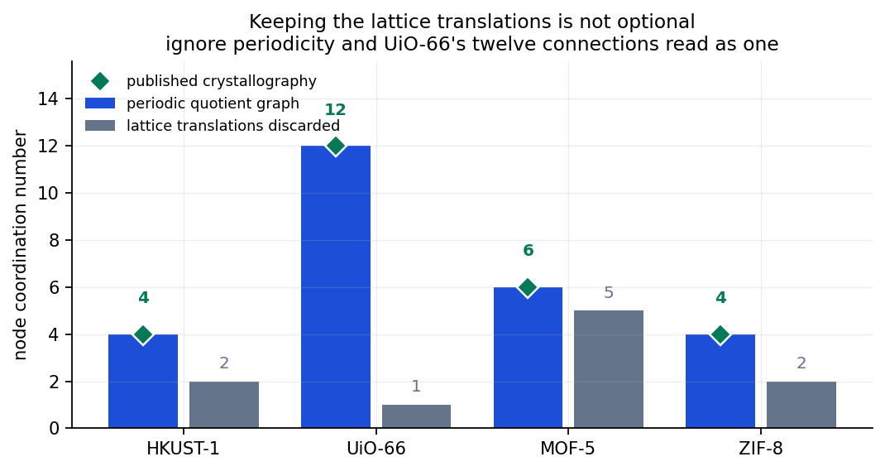
Figure 1. Keeping the lattice translations is not optional. What it shows: the node coordination number of the four benchmark MOFs from the labelled quotient graph (blue), the published crystallographic value (green diamond) and the largest value when cell-crossing bonds are dropped (grey). What it says: the quotient graph reproduces every published value; without translations UiO-66's twelve connections read as one. How it was made: docs/report_figures/make_figures.py, which calls code/spectrum_pipeline/code_09_network_analysis.py on the four demonstration CIFs.
UiO-66 is the extreme case: its one cluster's twelve connections nearly all leave the cell. A worse failure is a star (one hub joined to everything, all other vertices of degree 1), which is not a framework; every centrality computed on it is meaningless and the failure is silent.

4.4 Supercells and finite particles
One cell is too small to measure scaling on (UiO-66's cell graph has 7 vertices and diameter about 2). A periodic supercell of n×n×n cells is built exactly from the quotient graph: block i in cell c is joined to block j in cell (c + t) mod n. HKUST-1 goes from 14 vertices to 112 at n = 2. The supercell size is a choice made by the analyst, not a property of the material; this becomes the central problem of Part 1.
Without the wrap-around (no mod n), the same construction gives a finite particle: a box, slab, plate, rod or any polyhedron cut from the infinite net. Part 2 and the link study use finite particles.
Coarse-graining first and then replicating gives the same graph as replicating every atom first and then decomposing. This was proved empirically on five cases by full isomorphism test (section 8), with Route B 48 to 675 times slower.

4.5 Centrality, the Laplacian and defects
- Degree: number of neighbours (coordination number).
- Eigenvector centrality: importance by association with important neighbours (power iteration on the adjacency matrix).
- Betweenness: share of shortest paths passing through a vertex (Brandes' algorithm).
Finding: influence cannot be ranked in a perfect crystal. Every benchmark structure has exactly two distinct degree values, one for nodes and one for linkers. Symmetry-equivalent blocks are identical, so a "top-12 influential" list is the first twelve entries of a tie, ordered by indexing.
The Laplacian is L = D − A (degree matrix minus adjacency matrix). The number of zero eigenvalues equals the number of connected pieces (an automatic alarm if the framework falls apart). The second-smallest eigenvalue λ₂, the algebraic connectivity (Fiedler, 1973), measures how hard the network is to cut in two.
Breaking symmetry with a missing-linker defect (real chemistry: UiO-66 tolerates many, and they are engineered on purpose) makes influence measurable:
Graph | λ₂ perfect | λ₂ one linker removed | Change | Distinct centrality values
HKUST-1 unit cell (14 blocks) | 1.438 | 1.186 | −18% | 2 → 4
HKUST-1 2×2×2 supercell (112 blocks) | 0.628 | 0.551 | −12% | 2 → 15
The question "which block matters most?" has no answer in a perfect crystal, but "how much does the framework suffer when this block is removed?" always does.

5. Theory III: fractals, scaling and the multifractal spectrum
The spectrum width Δα measures how unevenly a network fills space around its influential vertices; it is only a property of the material if it does not change with the size of the graph analysed, and that is the condition Part 1 tested.

5.1 Dimension as a scaling exponent
The dimension of an object can be read from how its content grows with scale. For a solid ball of radius r in three dimensions the mass grows as r³; for a disc as r²; for a line as r. In general
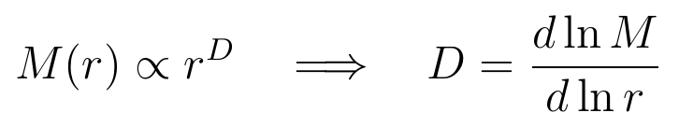
The exponent D need not be an integer. For a fractal (a Sierpinski triangle, a coastline, a diffusion-limited aggregate) it is fractional. Two standard ways of measuring it are box counting (cover the object with boxes of size ℓ and count how many N(ℓ) are needed; N ∝ ℓ^−D) and mass–radius or cluster growing (count the mass M(r) within distance r of a point; M ∝ r^D). On a network the distance is the number of steps along edges (graph distance), and both methods carry over (Song, Havlin and Makse, Nature 433, 392, 2005; Song et al., J. Stat. Mech. 2007).
A finite object never shows a clean power law. At small r the count is dominated by the discreteness of the lattice; at large r the ball reaches the edge and M(r) saturates at the total size N. The scaling region lies between, and a fit outside it measures the finite size, not the object. This is the single most important practical lesson of the Fractals and Scaling course for this project, and it was learned in Part 1 the hard way.
Fitting a power law correctly means: plot ln M against ln r, check that a straight line fits over at least a decade of scale, report the fitted range, and test the slope against system size. A straight line over less than a decade, or one that drifts with size, is not a dimension.

5.2 Why one number is not enough: multifractals
If a network were uniform, every vertex would see the same growth rate and one dimension would describe it. Real frameworks have dense knots and open voids, so different vertices grow at different rates. A multifractal is an object described by a distribution of local scaling exponents instead of one. The multifractal spectrum f(α) gives, for each local exponent α, how much of the object scales with it.

5.3 The influential-node multifractal analysis (iNMFA)
The method is from Xiao, Wang and Li (2021). Four steps:
Step 1, the measure. For each influential vertex i (top fraction by degree) and each radius r, count Mᵢ(r), the vertices within r steps, and normalise:
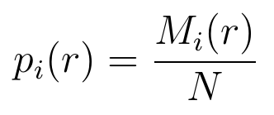
Step 2, the partition function. Sum the measures raised to a power q:
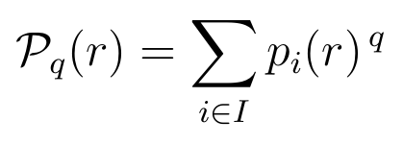
q acts as a zoom: large positive q emphasises vertices with the most network around them (dense regions), q = 0 counts all equally, large negative q emphasises the sparsest. The project sweeps q from −10 to +10.
Step 3, the mass exponent. The partition function scales as a power of the radius scaled by the diameter r_N:
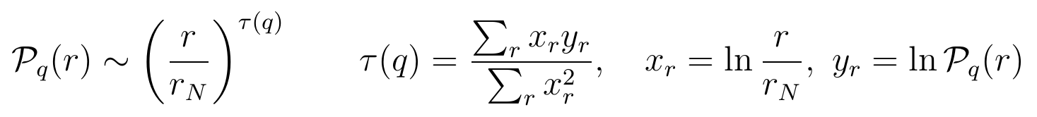
Because the definition is a ratio, the fit over several radii is a line through the origin. An ordinary least-squares slope with a free intercept is a different estimator; using it was the project's worst defect (section 13).
Step 4, the Legendre transform.
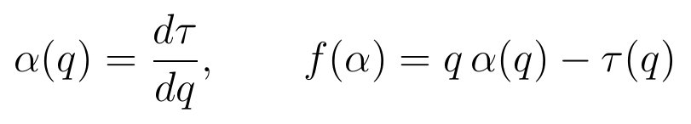

5.4 Reading the spectrum
Quantity | Definition | Meaning
α | dτ/dq | Local growth rate around one vertex (a local dimension)
f(α) | qα − τ | How much of the framework shares that growth rate
α₀ | α at the peak of f | Typical growth rate
Δα | α_max − α_min | Heterogeneity: narrow means uniform, wide means a mix of dense and open regions
A | ln[(α₀ − α_min)/(α_max − α₀)] | Asymmetry of the spectrum
A built-in correctness test. At q = 0 the transform gives f = −τ(0) = D₀, the box dimension, which is the maximum. So a valid spectrum is an inverted parabola (∩) with its peak at q = 0. A spectrum without that shape means the code is wrong, not the material. The project ran this test, it failed, and the failure exposed the intercept defect.
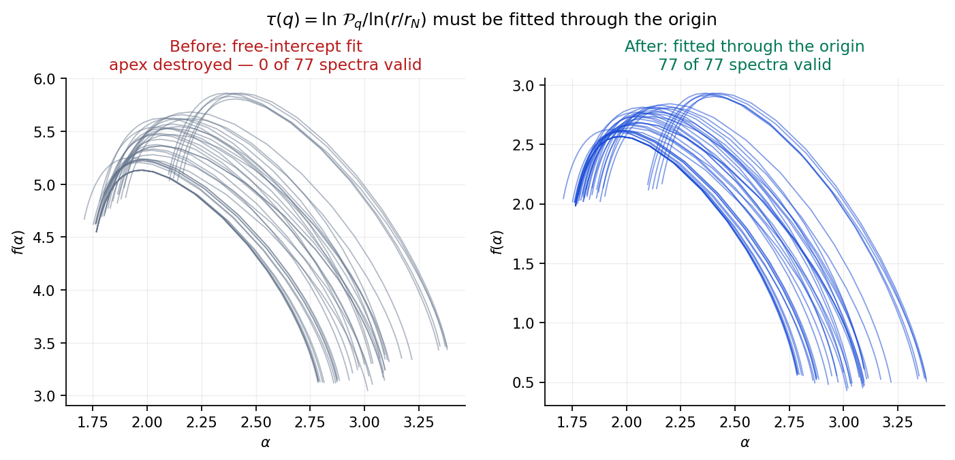
Figure 2. The τ(q) fit must pass through the origin. What it shows: the spectra f(α) of the 77 hMOF frameworks computed two ways from the same coverings. What it says: with a free intercept (left) the apex is destroyed and no spectrum is valid; fitted through the origin as the paper defines τ (right) all 77 are inverted parabolas. How it was made: docs/report_figures/make_figures.py (fig07) from notebooks/spectrum/results.json.

5.5 Box growing and box covering
Method | How the measure is obtained | Random?
Box growing | A ball of radius r around vertex i; count what is inside | No, deterministic
Box covering | Tile the network with randomly seeded boxes; a vertex's measure is the size of the box covering it | Yes, needs many trials
The paper specifies box growing; the project implements both (box covering in code_10 and code_12, box growing in code_11) and uses their agreement as a check. With random trials the order of averaging matters: Z is built per trial, logarithms taken, and ln Z averaged. Averaging pᵢ(r) first biases the spectrum narrow by more than a factor of ten.

5.6 Why Δα depends on size
Over q ∈ [−10, 10], at |q| = 10 the partition function is dominated by one box. The smallest box holds one vertex, p = 1/N, so α at the negative-q end carries a ln N term and moves with system size. At extreme q the spectrum measures the extreme-value statistics of a single box, not scaling. Section 9 shows the measured consequence: Δα grows linearly in ln D on every net.

5.7 Complexity
Step | Cost
Bond perception | O(N²) pair checks over 27 images (a cell list reduces this)
All-pairs shortest paths | O(N²) memory
Box growing | O(N·E) by breadth-first search from each centre
The O(N²) memory is why atomic graphs were capped at 7000 atoms, and that cap in turn fixed the graph size the published bands were measured at.

6. Theory IV: crystal morphology
Every shape model in the project is the same convex construction, P = {x : n_f · x ≤ R_f}; the models differ only in how the face distances R_f are estimated (from the lattice, the periodic graph, a force field, or a machine-learned potential).

6.1 Three meanings of "shape"
Shape is used at three scales: (a) the shape of one building unit (a square paddlewheel, an octahedral Zr₆ cluster); (b) the shape of the network in one unit cell; (c) the outer shape of the whole crystal, its morphology or habit. The panel's question is about (c), starting from (b). One crystal contains billions of identical cells, and the same cell can be stacked into an octahedron, a cube, a plate or a rod. Which appears depends on how fast each face grows.

6.2 Lattices, Miller indices and spacings
A lattice is the set of points r = ua + vb + wc with integer u, v, w. Put the lattice vectors as rows of L; the metric tensor is G = L Lᵀ. HKUST-1 and UiO-66 files store primitive cells (18.59 Å and 14.51 Å, 60° angles); their conventional cubic cells are 26.30 Å and 20.52 Å (a_conv = √2 a_prim for an F lattice). Faces must be named in the conventional cell.
A plane cutting the axes at a/h, b/k, c/l has Miller indices (hkl); {hkl} is its symmetry family. A cube is bounded by {100} (6 faces), an octahedron by {111} (8), a rhombic dodecahedron by {110} (12). The spacing of a family is
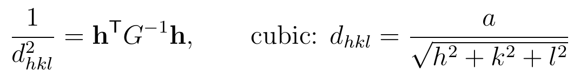
Example, MOF-5 (a = 25.866 Å): d₁₁₁ = 14.93 Å, d₂₀₀ = 12.93 Å, d₂₂₀ = 9.15 Å.

6.3 Systematic absences
A symmetry operation acts as x → Rx + t. Proposition 1 (proved on the Maths page from the structure factor F(h) = Σ_j f_j e^{2πi h·x_j}): if the space group contains (R, t) with hR = h and h·t not an integer, then F(h) = 0 and the family (hkl) is systematically absent. Its true repeat is then d_eff = d_hkl / n, with n(hkl) the first allowed multiple.
Lattice | Allowed reflections | d_eff(100) | d_eff(110) | d_eff(111)
F-centred cubic (MOF-5, HKUST-1, UiO-66) | h, k, l all even or all odd | a/2 | a/(2√2) | a/√3
I-centred cubic (ZIF-8) | h + k + l even | a/2 | a/√2 | a/(2√3)
The code applies the rule with every operation of the space group, so screw axes and glide planes are handled too. It is tested on diamond silicon (Fd-3m), where a glide makes (400) the first allowed reflection along (100).

6.4 Growth: the slowest faces win
Each face moves outward at its normal growth rate R_f. Fast faces shrink and vanish; after long growth each face's distance from the centre is proportional to its rate, so the crystal is the convex polytope
Propositions 3–5: P is a bounded convex polytope if the normals positively span space; it has the crystal's point symmetry if rates are equal within each family; and any bounded seed growing at constant rates tends to P(R).

6.5 BFDH: shape from the lattice alone
The Bravais–Friedel–Donnay–Harker rule: widely spaced planes are densely packed and strongly bonded within themselves, so they grow slowly.
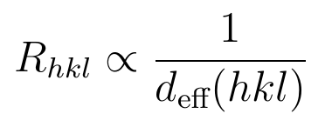
For F-centred cubic lattices this gives an octahedron truncated by small cube faces (a truncated octahedron); for I-centred cubic (ZIF-8) a rhombic dodecahedron. In the laboratory ZIF-8 forms rhombic dodecahedra and HKUST-1 octahedra; UiO-66 forms octahedra only with a modulator (acetic or benzoic acid) and is otherwise poorly faceted; MOF-5 forms cubes, which BFDH does not predict. BFDH uses only the input the panel specified (the unit cell), which is why it was Phase 1.

6.6 Energy rules: Wulff and attachment energy
The surface energy γ_hkl is the cost per unit area of creating a face (J/m²). A crystal at equilibrium minimises total surface energy at fixed volume; Wulff's theorem (Wulff 1901; Taylor 1970s) gives the shape as P with R_f = γ_f. For growth instead of equilibrium, Hartman and Bennema (1980) set R_hkl ∝ E_att, the energy released when a slice of thickness d_hkl attaches.
Hartman–Perdok face classes. A periodic bond chain (PBC) is an unbroken chain of strong bonds repeating with a lattice translation. In a slice parallel to a face: chains in two or more directions give an F (flat) face, which grows slowly and dominates shapes; one direction gives an S (stepped) face; none gives a K (kinked) face, which grows fastest and usually disappears.
Faces from the periodic graph (Propositions 11–13). A closed walk in the quotient graph whose edge translations sum to τ ≠ 0 lifts to an infinite chain with period τ; it lies in face (hkl) if hτ₁ + kτ₂ + lτ₃ = 0. The number of independent such directions in a slice (its periodicity rank) is the face class: 2 is F, 1 is S, 0 is K. In a lattice net a new-layer vertex forms E_att = (deg − c₀)/2 links with the layer below (c₀ = in-layer neighbours). For pcu this gives 1, 2, 3 on (100), (110), (111), hence a cube; for fcu 4, 5, 3, hence an octahedron (in agreement with Chen et al., Matter, 2020). Proposition 13 lets counts per unit area be computed exactly from one cell, with no finite cluster; on a nearest-neighbour fcc crystal it reproduces γ₁₀₀/γ₁₁₁ = 2/√3.

6.7 One cell, many shapes: the morph
With {100} at distance 1 and {111} at distance t (Proposition 7, proved):
t | Shape
t ≥ √3 | Cube
2/√3 < t < √3 | Truncated cube
t = 2/√3 | Cuboctahedron
1/√3 < t < 2/√3 | Truncated octahedron
t ≤ 1/√3 | Octahedron
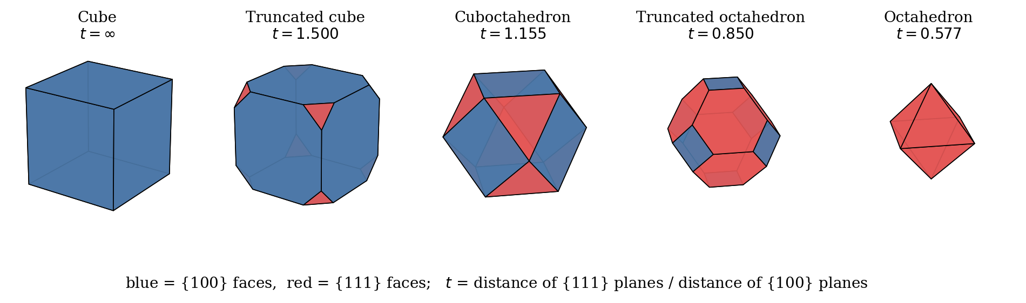
Figure 3. One unit cell, one continuous family of shapes. What it shows: the polytope P with {100} faces (blue) at distance 1 and {111} faces (red) at distance t, at t = ∞, 1.5, 1.155, 0.85 and 0.577. What it says: the named shapes appear at the exact thresholds of Proposition 7, and every shape between them is reachable by a continuous change of one growth-rate ratio. How it was made: docs/reports/morphology_primer_source/figs1.py with the mofmorph polytope code.
Proposition 6: the shape changes continuously with the rates (Hausdorff distance at most (ε/m) max|x|), so between any two morphologies of one cell there is a continuous path. Proposition 8: in point group −43m the {111} faces split into {111}+ and {111}−, and the shape is a regular tetrahedron exactly when r₊ ≤ r₋/3. Slowing or speeding growth along one axis by λ gives plates (λ < 1) or rods (λ > 1).

6.8 Changing the unit cell (Propositions 14–16)
Keeping atoms at fixed fractional coordinates and straining the lattice, L′ = L(I + ε)ᵀ, gives a hypothetical framework. Proposition 14: the forbidden reflections and the order n(hkl) of every face are unchanged by any deformation (the phase h·x_j does not change). Proposition 15: face families come from the subgroup H of operations that preserve the new metric; stretching one cubic axis reduces m-3m (48 operations) to 4/mmm (16) and splits {100} into {100} (4 faces) and {001} (2). Proposition 16: in an orthogonal cell the BFDH shape is exactly a box with half-widths R_i = d_max n_i / a_i unless some plane has order n_f < Σ w_i n_i; for a primitive cell every stretch gives a box flattened by exactly 1/λ. For F-centred parents {111} (order 1) always cuts the box; for I-centred ZIF-8 {110} cuts instead. A lattice-only rule cannot tell MOF-5, HKUST-1 and UiO-66 apart. Checked on 75 random cells (25 boxes, 50 cut shapes).

6.9 Measuring shape
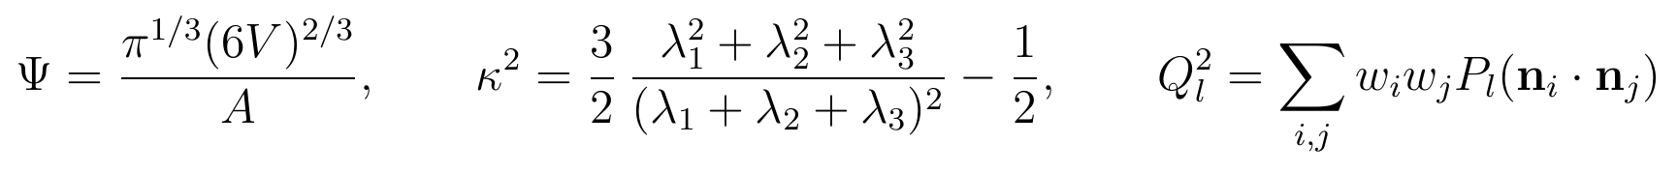
Sphericity Ψ is 1 for a sphere, 0.806 for a cube, 0.846 for an octahedron. Asphericity κ² (from the gyration tensor eigenvalues) is 0 for an isotropic body and 1 for a line; it is good for plates and rods. Q₄, Q₆ tell cube (0.764, 0.354) from octahedron (0.509, 0.629); Q₃ is non-zero only without an inversion centre (tetrahedron 0.745). Proposition 9 proves κ² = 0 for every shape with cubic or tetrahedral rotational symmetry, so it cannot tell a cube from an octahedron. The earlier work used it that way (a mistake; section 13); the morphology work uses Ψ and Q_l.

6.10 Where energies come from
Cutting a crystal makes two faces: E_cut/A = γ_top + γ_bottom. Half the cheapest cut is the cleavage energy; with an inversion centre (MOF-5, HKUST-1) it equals the surface energy, otherwise it is an upper bound on the cheaper face. One direction can be cut at many depths (terminations); a cut through linkers is cheap, one through metal clusters expensive. Energies are computed on slabs: a layer a few nanometres thick, periodic sideways, with vacuum (20 Å in the CHGNet runs) above and below; stoichiometric slabs have the bulk formula. 1 eV/Å² = 16.02 J/m².
Level | What it is | Cost per MOF slab | Used here
Force field (UFF) | A fixed formula per atom pair: a bond cost plus Lennard-Jones E(r) = D[(x/r)¹² − 2(x/r)⁶] | Seconds | Phase 4, every face (unrelaxed)
Machine-learned potential (CHGNet) | A graph neural network trained on quantum calculations; predicts energies and forces | Minutes to hours on a GPU | MorphoGraph-MOF notebooks (relaxed until forces < 0.05 eV/Å)
Density functional theory (DFT) | Quantum-mechanical calculation of the electrons; the reference | Hours to days | Planned check of six slabs
MOF faces are cheap compared with metals (about 1–2 J/m²): MOF-5 {100} is 0.148 J/m² with the force field and 0.127 J/m² from CHGNet, because a MOF is mostly empty space.
Equilibrium versus growth. Wulff shapes are equilibrium shapes; real crystals usually stop growing before equilibrium, when the slowest faces win. Solvent molecules and modulators stick to some faces and slow them. None of the project's models contains solvent or modulators, so they are compared only with crystals grown without additives.

7. Timeline: from the first day to now
The project ran in fourteen stages from August to 12 November 2026: four on the spectrum, a change of question at Panel Review 1, five on morphology, one joining the halves, an audit with a new result, a check of the team's next-phase pipeline that produced the morphology map, and a final stage that shows every step from a CIF to a shape and makes the record reproducible from any computer.
Stage | When | What happened
1 | August 2026 | The question; MOFid decomposition and the multifractal spectrum implemented; first spectra on 8 frameworks
2 | 1 September | Formulas matched to the paper line by line; band of 77 frameworks; four defects found
3 | 2–7 September | Labelled quotient graph; correct coordination on all four nets; website, textbook, panel deck; 61 real CoRE MOF structures
4 | 14–16 September | Size scaling: Δα grows with ln D on every net; both bands withdrawn; ordering equivalence proved
5 | After Panel Review 1 | Panel asks for morphologies from the unit cell; Phase 1 (symmetry, absences, BFDH) built
6 | October | Sixteen propositions proved; cell deformation (Phase 1b); faces from the periodic graph (Phase 3)
7 | October | Face energies from atoms with UFF; Wulff shapes (Phase 4)
8 | 12–14 October | Team tasks: BFDH × Wulff blend, CHGNet slab energies, experimental dataset
9 | 14–15 October | Independent review of code and chemistry; benchmark scoring; ZIF-8 hydrogen defect found
10 | 16 October | Spectrum ↔ shape tests 1–3 run in Colab; 15/15 checks pass
11 | 23–25 October | Audit, repository reorganisation, certificates, Resources page, provenance on every figure
12 | 25 October – 6 November | Test 4, the dimension profile; 21/21 checks; history cleaned; final bundle prepared for push
13 | 10 November | Kshitij's steps 1–8 notebook run and checked (five mistakes, K11 fixed); morphology map; conditions tested on the lab dataset; possible morphologies per CIF; dimension profile along the map
14 | 11–12 November | Every step from a CIF to a shape shown on one page; every script runs from any folder; 10 November work added to the repository and site; audit of every quoted number

Stage 1. The question and the first two papers (August 2026)
Purpose. Screening MOFs for gas separation (Xe/Kr, then CO₂) by simulation costs hours per framework. A number computed from connectivity in seconds could decide which frameworks deserve simulation.
Read. Bucior et al. 2019 (MOFid, MOFkey, the metal-oxo decomposition); Xiao, Wang and Li 2021 (NMFA and iNMFA); Song, Havlin and Makse 2005 (box covering).
Done. Translated the published decomposition into Python (code_01 to code_07: CIF reading, bond perception with Cordero radii, element classification, the three decompositions, centroids, Systre export, MOFid/MOFkey), built the building-block graph (code_09) and computed the spectrum (code_10). First notebook on 8 frameworks.
Mistake and fix. Probabilities were averaged over random box-covering trials before taking logarithms, making every spectrum more than ten times too narrow. Corrected on 31 August: build Z per trial, take ln Z, then average.
Why this method. Metal-oxo is the published MOFid rule and keeps each metal cluster as one node, the unit that decides connectivity; single-node and all-node are implemented for comparison. The spectrum was chosen because it summarises mass distribution across all scales in one curve, whereas degree, clustering and diameter describe one scale. Whether it adds anything over simple statistics is what the later stages tested.

Stage 2. Matching the paper exactly, and the data received (1 September)
Purpose. A result is meaningful only if it uses the published method exactly and if the data are known.
Done. Compared every formula with the paper; rebuilt the Δα band on 77 frameworks from MOFX-DB (notebooks/spectrum/mof_band_analysis.ipynb).
Mistakes found. (1) τ(q) had been fitted with a free intercept; the paper fits through the origin; 0 of 77 spectra had the required ∩ shape. (2) The influential nodes were analysed on their own induced subgraph, which has no edges in a MOF (metal clusters touch only through linkers). (3) A request for CoRE MOF 2019 returned 150/150 hMOF records (hypothetical, all Zn₄O) unnoticed: MOFX-DB's database= parameter is advisory and loses to the gas filter. (4) A claim that Δα tracks pore size.
Fixes. τ = Σxy/Σx² (77 of 77 valid); cover the full graph and read the measure at influential nodes; dataset relabelled as hMOF; pore-size claim retracted the same day.

Stage 3. Making it periodic and teachable (2–7 September)
Purpose. A crystal is periodic; a one-cell graph is not. Without periodicity the connectivity of real MOFs is wrong.
Done. Built the labelled quotient graph (code_09, build_periodic_block_graph); checked it on tbo, pcu, sod and fcu (UiO-66 12-connected). Wrote a second, independent implementation in JavaScript for the website (website/mof_*.js), the eleven-chapter textbook and the panel deck. Obtained 61 real CoRE MOF 2019 structures and ran their band (notebooks/spectrum/real_mof_band.ipynb).
Mistakes and fixes. Without translation labels UiO-66's cluster got the wrong neighbour count (fixed everywhere with the quotient graph). A claim built on four real structures was withdrawn on 7 September.

Stage 4. Is the number about the MOF or about the graph size? (14–16 September)
Purpose. Before ranking MOFs by a number, the number must describe the MOF, not the size of the computer model.
Done. Swept Δα over supercell sizes on four nets (_run_size_scaling.py); re-ran full bands on the correct coarse-grained graph (72/77 hMOF, 55/61 CoRE MOF; code_17); proved coarse-graining first and replicating first give identical graphs (_prove_ordering_equivalence.py); analysed classes (code_13 to code_18).
Result. Δα grows linearly in ln(diameter) on every net (R² ≥ 0.998, slope 0.69–0.89) and never converges; class tracks graph size (r = +0.69 hMOF, +0.72 CoRE MOF).
Mistakes and fixes. Classes narrower than their error bars; published bands computed on the atomic graph while the text described the coarse-grained graph; graphs capped too small to measure scaling; 48 of 76 hMOF structures the same graph; the size effect itself. Both bands withdrawn but kept visible with reasons; assign_classes() now refuses classes narrower than their error; coarse-grain first (48–675× cheaper); a diversity guard on samples.
Why withdraw rather than tune. A number that changes with graph size cannot be compared between MOFs of different size; tuning until it looks stable would hide the problem.

Stage 5. The panel changes the question (after Panel Review 1)
Purpose. The panel asked for several crystal shapes from one established unit cell. Shape matters to the original aim: it decides exposed faces, diffusion lengths and packing.
Read. Chen et al. 2020 (one MOF chemistry, many shapes; link counting), Hartman–Perdok theory, the Wulff construction, spglib.
Done. CIF → symmetry → allowed faces (absences removed) → BFDH shape → shape descriptors, in code/morphology/ (mofmorph/structure.py, faces.py, shape.py, models.py, run_phase1.py, 14 checks in tests.py) and the browser engine mof_morphology.js.
Result. BFDH: truncated octahedron for MOF-5, HKUST-1 and UiO-66; rhombic dodecahedron for ZIF-8. Cube, cuboctahedron and octahedron are reached by varying R₁₁₁/R₁₀₀.
Mistake and fix. Self-referencing CSS colour tokens (--node:var(--node)) blanked colours on every page; fixed 9 October.
Why BFDH first. It needs only the lattice and space group, so it gives a shape for any CIF in seconds. Molecular dynamics of MOF growth in solvent was beyond the project and would not answer the mathematical question asked.

Stage 6. Proofs, cell deformation, and faces from the graph (October)
Done. Sixteen propositions with proofs, each checked numerically in the browser (morph_math_page.js). Cell deformation (mofmorph/deform.py, run_deform.py, 9 checks) gives plates, equant shapes and rods. Phase 3 counts the links each face cuts on the MOF's own periodic graph (mofmorph/graphfaces.py, run_phase3.py, 11 checks).
Result. Attachment numbers pcu 1/2/3 (cube) and fcu 4/5/3 (octahedron, matching Chen et al.). No mistakes recorded at this stage.

Stage 7. Face energies from atoms (October)
Done. Cleavage energy of every face from the atoms with UFF (mofmorph/forcefield.py, run_phase4.py, 4 checks); Wulff shapes.
Result. UFF Wulff: cube for MOF-5, octahedron for UiO-66, rhombic dodecahedron for ZIF-8, truncated octahedron for HKUST-1.
Mistake and fix. HKUST-1 was first described as a cube with cut corners; it is a truncated octahedron. Shapes are now named only from the computed face fractions.
Why UFF. It covers every element and costs seconds per face; DFT costs hours per slab. Unrelaxed energies are stated as such.

Stage 8. Team tasks (12–14 October)
Done. BFDH × Wulff blend with weight w (mofmorph/hybrid.py, run_hybrid.py, MorphoGraph_hybrid.ipynb, any crystal system). Keerthi's CHGNet slab notebook, run by Rohith for MOF-5, HKUST-1 and UiO-66, post-processed (chgnet_post.py, run_chgnet_cleavage.py, slab_check.py). Rohith's experimental dataset with growth conditions.
Result. The blend changes the shape only for MOF-5 and UiO-66. CHGNet slabs give only γ_top + γ_bottom, too few equations for individual faces; the cleavage-energy shapes disagree with experiment for MOF-5 and UiO-66.
Mistakes and fixes. The first hybrid notebook assumed every crystal is cubic (a general version written). A statement that CHGNet "will never" give a shape was too strong (the cleavage-energy route stated with its limits). Loose pieces in slabs were first read as split metal clusters; they were linker fragments.

Stage 9. Independent review (14–15 October)
Done. A second reviewer re-ran every script; built the experimental dataset (134 records, 35 papers, 12 MOFs); confirmed from two primary papers that UiO-66 octahedra grow with modulators; tested the force field's sensitivity to the bond cost (run_bond_sensitivity.py); ran the pipeline on 8 CoRE MOFs of six crystal systems (run_core.py); added tests_review.py.
Mistakes and fixes. Hydrogens dropped from the ZIF-8 energy cell ({111}: 0.312 instead of 0.619 J/m²; energies rebuilt with all atoms). The MOF-5 cube trusted because it matched experiment, though it depends on the flat bond cost (now quoted with its caveat). One "correct" shape per MOF, although shapes depend on solvent, additive and time (conditions recorded for every record). The hybrid weight could be tuned to the four test MOFs (shown fixed at w = 0.5).

Stage 10. Joining the two halves (16 October)
Done. Finite crystal particles (no wrap-around) of chosen shapes; Δα measured on them; Δα compared with BFDH shape on 55 CoRE MOFs. Spectrum_Shape_Relation.ipynb run by Radha Krishna in Colab, 15/15 checks.
Result. Δα of a finite MOF-5 particle separates flat and long particles from compact ones but not compact shapes from each other; the periodic Δα carries no shape information once graph size is fixed.

Stage 11. Audit, reorganisation, certifications (23–25 October)
Done. Local work compared file by file with GitHub and merged; repository reorganised into code/, data/, notebooks/, docs/, website/; every page compared with the result files; a source line under every figure; Resources page; five certificates added.
Mistakes and fixes. UiO-66 called a match although additive-free crystals are cubes; status tables behind the work; figures without a source; a footer claiming every number is computed in the browser; work in several copies (section 13).

Stage 12. The dimension profile (25 October to 6 November)
Done. Mass–radius curve and local dimension of MOF-5 boxes (about 1000 cells) and of the seven polyhedra at two sizes, calibrated on a path, a square grid and a cubic grid (run_04_dimension_profile_of_crystal_particles.py; six new checks, 21 in all; notebook step 4; website Test 4). The ZIF-8 statement corrected. Git history cleaned of tool references, branch kept, final bundle delivered for push.
Mistake and fix. The first draft explained the local dimension staying below 3 by the linkers; the cubic grid, which has no linkers, also peaks at 2.64, so the cause is finite size and the lattice. Reference lattices were added.

Stage 13. Checking the new pipeline and building the morphology map (10 November)
Purpose. After the guide's question, two teammates proposed the next phase: Kshitij a CIF-to-Wulff pipeline with whole-block slabs, water capping and DFT validation (steps 1–8), and Keerthi a condition-aware model in which shape classes are regions of a space (steps 9–10). The question was whether these work and whether they fit the earlier work.
Done. Kshitij's notebook MOF_Wulff_steps1-8.ipynb run unchanged on ZIF-8, HKUST-1, UiO-66 and Mg-MOF-74 in quick (static) and full (relaxed) modes (run/run_nb.py); its module read line by line; checks written for each problem found (checks/naming.py, checks/open_shape.py, run/k11.py). The exact cubic Wulff map built (keerthi/cubic_wulff.py, phase_grid.py); every model of the project placed on it (model_points.py); the lab dataset tested against it (series_test.py, condition_model.py); a first modulator-cap calculation (modulator_caps.py); possible morphologies generated per CIF (possible_morphs.py); the dimension profile measured along the map (dimension_along_map.py). All in the folder morphology_map_2026-11-10.
Result. Static mode: ZIF-8 agrees with the lab, HKUST-1 gets the lab's largest face, UiO-66 and Mg-MOF-74 do not agree. Relaxed mode (after the fix): ZIF-8 still a rhombic dodecahedron; HKUST-1 a truncated octahedron. All six lab series that change shape on the map move monotonically; a label-only conditions model is worse than ignoring the additive; r½/D is monotone along both map axes.
Mistakes and how they were found. Running the full mode on HKUST-1 ran out of memory on a 336-atom slab, while the same slab's forces needed only 2 GB in a direct test. Rebuilding the slab showed it was four times larger than in static mode, which led to K11: the relaxed cell is re-oriented by a CIF round trip, so faces are converted to the wrong primitive planes. A one-line fix restored the correct planes (Section 13.8). The shape-naming error K1 was found by comparing name_habit() with the exact ratio limits; K2 by reading the Step 2 output for Mg-MOF-74 (each Mg its own node); K3 by noticing that some slabs come from the unrelaxed cell. Two of my own runs were also killed for memory because a second CHGNet or MACE job was started beside them; heavy jobs are now run one at a time.
Why this matters. It answers the panel's request directly: from a unit cell, the map generates a set of morphologies in a predicted order, and the lab data support that order. It also shows where the method stops: shapes set by growth kinetics (plates, rods, intergrown crystals) are outside any Wulff model.

Stage 14. Every step shown, and a record anyone can run (11–12 November)
Purpose. The guide asked to see every step from a CIF to a shape, and the record had to be usable by anyone in the team on any computer.
Done. The page From a CIF to a shape shows the lattice, the centring and point group found from the atoms, the structure factors, the BFDH distances, the shape cut plane by plane (with the cutting plane, its distance and the removed piece drawn for every cut, and the reason each plane cuts) and the morphology map; the Python reference is code/morphology/run_cif_to_shape.py. Every analysis script was made independent of the folder it is started from; the repository gained PROJECT_MAP.md and a README in every folder; the 10 November work was added to the repository and to the website (Morphology map page). An audit then re-ran every script from another folder and checked the quoted numbers against their result files.
Result. The browser and Python agree on every number for the four MOFs; all 13 website test suites and every Python test pass from any folder; every headline number checked reproduces from its result file. The audit's corrections are listed in section 13.9.
Mistakes and how they were found. Several Phase 1 scripts opened files relative to the folder they were started in (found by running them from the file-system root); the step-by-step view named a half-built shape by its proportions (an octahedron with two corners cut was called a cuboctahedron); and its 3D view lost the drag after one step because every redraw replaced the picture. All three are fixed.

8. Part 1 code: every script, what it does and what it produced
Part 1 is 20 numbered modules and 5 helper scripts in code/spectrum_pipeline/, three notebooks in notebooks/spectrum/, and a second, independent implementation in JavaScript on the website; modules 00–07 translate the published MOFid pipeline, 09–19 are the project's own analysis.
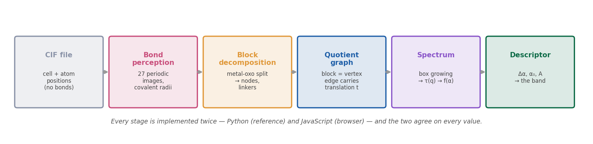
Figure 4. The Part 1 pipeline. What it shows: the six stages from a CIF file (positions only, no bonds) to the descriptor Δα, with what each stage adds. What it says: every later number rests on the bonds inferred in stage 2 and on the translation labels kept in stage 4. How it was made: drawn for the textbook (docs/textbook/figures/fig02_pipeline.png); a schematic, not data.

8.1 The published decomposition (translated, unmodified)
The original MOFid is C++ built on a patched Open Babel (github.com/snurr-group/mofid). Each module names the real source file it translates.
Module | Translates | What it does | Output
code_00_pipeline_driver.py | src/sbu.cpp main(), analyzeMOF() | Runs the whole chain for one CIF: python code_00_pipeline_driver.py HKUST-1.cif | All artefacts below, and the metal-oxo MOFid string
code_01_cif_input.py | Open Babel importCIF() (contract) | Pure-Python CIF reader: cell parameters to the lower-triangular matrix, symmetry operations parsed and applied, fractional coordinates wrapped, duplicates merged | Atoms with fractional and Cartesian positions; no bonds
code_02_bond_assignment_pbc.py | src/periodic.cpp + the missing ConnectTheDots patch | Minimum-image search over 27 images; covalent-radius cutoffs (tolerance 1.30 for metal pairs, 1.15 otherwise); keeps the shift t of every bond | Bond list (i, j, t); borderline pairs reported
code_03_element_classification.py | src/obdetails.cpp isMetal, deleteBonds | Metal = any element not in the 23 InChI non-metals | is_metal() used everywhere
code_04a_metal_oxo_algorithm.py | src/deconstructor.cpp base Deconstructor | Cut every metal bond, connected components = blocks. Finding while tracing the source: MetalOxoDeconstructor overrides none of the base methods, so "metal-oxo" is the base algorithm | Nodes and linkers
code_04b_single_node_algorithm.py | SingleNodeDeconstructor | Walks out from each metal with rules for oxygen environments; keeps the carboxylate with the node | Chemically complete clusters
code_04c_all_node_algorithm.py | AllNodeDeconstructor | As 04b, plus splits linkers at heavy-atom branch points (degree ≥ 3) | Linker centres and arms
code_05_centroid_simplification.py | src/topology.cpp CollapseFragment | Each block to one pseudo-atom at its periodically unwrapped centroid; duplicate edges removed | Simplified net
code_06_systre_topology_export.py | Topology::WriteSystre | Writes a valid Systre .cgd file (Systre itself not reimplemented) | topology_exports/*.cgd
code_07a_mofid_assembly.py | Python/run_mofid.py | Assembles the MOFid string from the artefacts | <linker SMILES>.<node SMILES> MOFid-v1.<net>.<cat>
code_07b_mofkey_assembly.py | GetMOFkey, PAsToUniqueInChIs | Metal symbols and string assembly; the InChIKey is a placeholder of the correct shape | MOFkey string (not used downstream)
Measured on the four demonstration CIFs (in the same folder): HKUST-1 156 atoms, 198 bonds, 14 blocks; MOF-5 424, 512, 32; ZIF-8 276, 312, 36; UiO-66 114, 184, 7.

8.2 The project's analysis
Module | Question it answers | What it found | Output
code_09_network_analysis.py | Which blocks are influential; is there a spectral signature? | Labelled quotient graph (build_periodic_block_graph) gives coordination 4, 6, 4, 12 for HKUST-1, MOF-5, ZIF-8, UiO-66 (with cell-crossing bonds dropped: 0–2, 3–5, 2, 1). Two distinct degree values per structure: influence cannot be ranked. One missing linker lowers λ₂ of HKUST-1 from 1.438 to 1.186 (−18%) | Printed; website Network page
code_10_multifractal_spectrum.py | The guide's brief: influential nodes, spectrum, family band | iNMFA with box covering on the replicated quotient graph (top 30% by degree, radii 1 to D); Legendre transform; asymmetry; band builder; candidate scoring; defect families; _compute_tau_wrong kept to demonstrate the intercept defect | Printed; browser twin mof_multifractal.js
code_11_nmfa_paper.py | The method exactly as published (Xiao et al. 2021, Sci. Rep. 11, 22964) | Deterministic box growing; per-node fractal dimension; used to cross-check code_10 | Printed
code_12_converged_band.py (929 lines) | Does Δα converge with graph size? Are the classes real? | Quotient graph replicated without atoms; finite-size sweep and q-range convergence; fast_diameter (double sweep); assign_classes() refuses classes narrower than the error bar; require_topological_diversity(); partial correlation. No plateau at any q cap | Used by modules 13–19
code_13_scaling_regimes.py | Does the atomic graph have two scaling regimes? | Yes, on all four: mass–radius slope about 1.4 (1.85 for UiO-66) inside one linker, 2.4–2.9 at framework scale, split at r = 5–7 bonds; a single power law across the crossover is invalid | size_scaling/scaling_regimes.json
code_14_size_strata.py | Are Narrow/Medium/Wide chemistry or size? | Of 14 distinct graph signatures among 76 structures, 13 are entirely one class; the 14th (256 nodes, 384 edges, D = 12; a 4×4×4 pcu net) holds 48 of 76 structures and spans all three classes | size_scaling/size_strata.json
code_15_dataset_sweeps.py | Does the slope of Δα vs ln D differ between frameworks? | hMOF (19 usable): mean 0.594, sd 0.134; CoRE MOF (15 usable): mean 0.871, sd 0.333. Not established either way (capped, one seed) | size_scaling/slope_sweep_*.json
code_16_topological_diversity.py | How diverse are the nets in the datasets? | Coordination-signature heuristic resolves only pcu, tbo, sod, fcu; the extra 34 hMOF CIFs are all pcu or unclassifiable; rht not found | size_scaling/topological_diversity.json
code_17_full_correct_band.py | The band on all structures, correct graph | 72/77 hMOF, 55/61 CoRE MOF usable; r(Δα, node count) = +0.69 and +0.72 | size_scaling/full_band_*_cg.json
code_18_subband_explain.py | What distinguishes the classes, on nine categories? | hMOF Narrow and Medium (63 of 72) are the same metal (Zn), net (pcu), block count (4), node count (~255); CoRE MOF classes differ on chemistry and graph features, all in step with size. Some classes average more than one connected component (guest or solvent fragments kept as linkers) | size_scaling/subband_explain_*.json
code_19_spectrum_vs_shape.py | Does Δα see crystal shape on finite particles? | MOF-5 at 64 cells (2048 blocks): cube 1.722, slab 8×4×2 1.626, plate 8×8×1 1.591, rod 16×2×2 1.410 (seed sd ≤ 0.009). ZIF-8 not usable: its block graph is disconnected (34–238 components) | size_scaling/spectrum_vs_shape_*.json

8.3 Checks and drivers
Script | Purpose | Result
_ci_smoke_test.py | Coordination numbers of the four nets, run by GitHub Actions on every push | Pass
_prove_ordering_equivalence.py | Coarse-grain-then-replicate vs replicate-then-coarse-grain, five cases | Identical graphs by full isomorphism (HKUST-1 n=2, MOF-5 n=2, ZIF-8 n=2, UiO-66 n=2 and 3); Route B 48–675× slower
_run_size_scaling.py | Finite-size and q-range sweep on four nets | Slopes 0.782 (tbo), 0.732 (pcu), 0.886 (sod), 0.692 (fcu); R² ≥ 0.998
_test_window_frac.py | Effect of fitting radii up to half the diameter | Slope 0.63–0.79 instead of 0.73–0.91; gentler, but still grows
_make_strata_figure.py | Size-strata figure | size_strata_figure.png

8.4 Notebooks
Notebook | Purpose | Result | Status
pipeline_walkthrough_full.ipynb | Teach every MOFid module with its real code beside a 3D model | Worked example with outputs | Current, teaching
mof_band_analysis.ipynb | Band on 77 database MOFs (requested as CoRE MOF, received as hMOF) | Interquartile band 1.11–1.25, median 1.197; r(Δα, pore size) = −0.497, r(Δα, size) = +0.62 | Withdrawn result, kept for the record
real_mof_band.ipynb | Same band on 61 real CoRE MOF 2019 structures | Interquartile band 1.10–1.29, median 1.214; r(pore) = −0.198, r(atom count) = +0.511; controlling size drops pore correlation to +0.10 | Withdrawn result, kept for the record
Both notebook bands were computed on the atomic supercell graph (capped at 7000 atoms), although the text described the coarse-grained graph; the CSV columns graph_diameter and n_influential describe the atomic graph.

8.5 The four spectrum estimators
Four estimators exist in the project and must not be confused:
Run | Graph | Influential set | Radii fitted
hMOF-77 and CoRE-61 bands (CSV files) | Atomic supercell, capped at 7000 atoms | Top 10% of atoms by degree, then closeness | 1 to round(0.34 D)
Independent Narrow/Medium/Wide run (team paper) | Coarse graph cut from the atomic supercell | Top 20% by degree, then closeness | 1 to min(round(0.5 D), D − 1)
code_10, code_12, browser engine | Coarse-grained quotient graph, replicated | Top 30% by degree (20% from 16 September) | 1 to D (D/2 from 16 September)
Paper-faithful box growing (code_11) | Coarse-grained quotient supercell | Top 10% | Deterministic box growing

8.6 The browser implementation
website/mof_decompose.js, mof_network.js and mof_multifractal.js were written independently from the same specification as the Python. Every decomposition, network and spectrum page computes its numbers in the reader's browser from the four CIFs. Where the two implementations disagree, one is wrong; both are kept, and the website test suites compare them.

9. Part 1 results, and why the band was withdrawn
The spectrum width Δα is a function of the size of the graph it is measured on, not of the framework, so the proposed reference band (1.11–1.25) and the Narrow/Medium/Wide classes were withdrawn; what survives from Part 1 is the verified graph pipeline and a quantified account of why the descriptor fails.

9.1 What was claimed
The 77-framework band from mof_band_analysis.ipynb and the 61-framework band from real_mof_band.ipynb, as computed:
Dataset | n | Full range | Interquartile band | Mean ± sd | Median | Mean asymmetry A
hMOF (hypothetical) | 77 | 1.016–1.410 | 1.11–1.25 | 1.180 ± 0.095 | 1.197 | −1.31
CoRE MOF 2019 (synthesised) | 61 | 0.951–1.475 | 1.10–1.29 | 1.198 ± 0.132 | 1.214 | −1.31
Combined | 138 | 0.951–1.475 | 1.10–1.26 | 1.188 ± 0.113 | 1.203 | −1.31
The centres agree (Welch test p = 0.38); the spreads differ (Levene p = 0.010), with real frameworks more varied. Before the real structures arrived, the project wrote down two predictions; the one that came true was "four is not enough": the 61 real frameworks landed at 0.95–1.47, centred on 1.20, not at the 1.7–2.3 an earlier four-structure comparison had suggested.

9.2 Reason 1: the wrong graph was measured
Both bands ran the analysis on the atomic supercell bond graph; coarse-graining only supplied node and linker counts. The saved outputs prove it: analysed vertex counts 3024–6592 (hMOF) and 1160–7000 (CoRE) are atom counts, against 97–432 and 1–1297 building blocks; the number of influential vertices exceeds the block count in 77/77 and 47/61 structures. An atomic MOF graph has two length scales (code_13): inside one linker the mass–radius slope is about 1.4, at framework scale 2.4–2.9, with the crossover at 5–7 bonds. One power law fitted across that crossover is not a scaling measurement.

9.3 Reason 2: on the correct graph Δα still does not converge
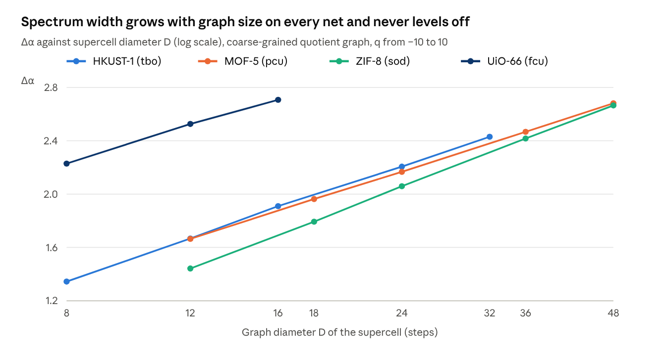
data/spectrum_descriptors/size_scaling/convergence_sweep.json (code/spectrum_pipeline/_run_size_scaling.py) · four demonstration MOFs, supercells n = 2 to 6
On the coarse-grained quotient graph, Δα rises by 1.0–1.1 as D grows six-fold on HKUST-1, MOF-5 and ZIF-8, with no sign of a plateau. Fitted lines in ln D have R² ≥ 0.998 on every net, with slopes 0.782 (tbo), 0.732 (pcu), 0.886 (sod) and 0.692 (fcu). Capping q does not help: the drift between the two largest supercells exceeds 5% at every cap from |q| ≤ 10 down to |q| ≤ 2.
Mechanism. At extreme q the partition function is dominated by one box; the smallest box holds one vertex (p = 1/N), so the negative-q end of the spectrum carries a ln N term. The spectrum's width at extreme q is the extreme-value statistics of one box, not a scaling exponent. Fitting radii only to half the diameter makes the growth gentler (slope 0.63–0.79) but does not stop it.

9.4 What the classes and correlations really were
- Pore size. On hMOF, r(Δα, largest cavity) = −0.497 looked like a structural result; r(Δα, graph size) = +0.62. On CoRE MOF, pore r = −0.198, size r = +0.511, and controlling for size moves the pore correlation to +0.10 while size stays at +0.49. The claim was retracted the day it was made.
- Classes are size strata. Of 14 distinct coarse-grained graphs among the 76 structures of the independent run, 13 fall entirely in one class; the 14th (a 4×4×4 pcu net, 256 vertices, 384 edges, D = 12) holds 48 structures (63%) and spans all three classes with Δα 1.171–1.235 on an identical graph. That spread is box-covering noise.
- Classes narrower than the error bar. The Medium class was 0.032 wide against per-structure error bars of 0.013–0.098; two structures confirmed isomorphic (hMOF-94 and hMOF-96) fell in different classes.
- Full datasets, correct graph (code_17): hMOF 72 usable, Δα 1.118–1.716 (median 1.246, interquartile 1.241–1.259); CoRE MOF 55 usable, 0.892–2.536 (median 1.512, interquartile 1.376–1.760). Correlation with coarse-grained node count +0.69 and +0.72.
- Topological degeneracy. The hMOF sample is essentially one net (pcu Zn₄O); differences are in linker chemistry, which coarse-graining removes by design.

9.5 What survives from Part 1
- A verified CIF-to-graph pipeline: coordination numbers of all four nets correct, two independent implementations, ordering equivalence proved.
- The labelled quotient graph, reused by Part 2 for face counting (Phase 3) and by the link study for finite particles.
- Two citable negative results: influence cannot be ranked in a defect-free crystal; Δα of a periodic MOF graph grows linearly in ln D on every net tested.
- A proposal, not a finding: the slope of Δα against ln D might itself be a size-independent descriptor (code_15); the capped sample cannot decide it.
- The habit of controlling for size, which prevented the same error in the link study (section 12).
The team paper (docs/paper/G070_Paper.pdf) reports the coarse-grained run on 76 hMOF structures (Δα 1.032–1.582) with these limitations stated. Its estimator is the second row of the table in section 8.5, so its numbers are not directly comparable with the withdrawn atomic band.

10. Part 2 code: the morphology package, its phases and results
The panel's question is answered under both readings: one unit cell gives a continuous family of shapes by changing growth-rate ratios (Phases 1–4), and changing the cell parameters of the same CIF gives plates, equant crystals and rods (Phase 1b); each rule is proved and each code path is tested.
The panel's handwritten task read: "We have a MOF (established) with a specified unit cell dimension which gives a unit cell structure. Is it possible to generate at least a few morphologies from the given unit cell structure?" They noted the result is known chemically (laboratories grow one MOF in several shapes) but that a mathematical and computational demonstration was missing.

10.1 The package code/morphology/mofmorph/ (1265 lines)
Module | What it does
structure.py | Reads a CIF with ASE; finds the space group with spglib with and without hydrogen, at tolerances 0.001–0.1 Å; returns the conventional cell and symmetry operations
faces.py | Absence rule with every symmetry operation; effective spacings d_eff; symmetry families (including {111}± in −43m)
shape.py | Shape as a convex polytope (half-space intersection): exact volume, area, sphericity, gyration tensor, κ², Q₃/Q₄/Q₆
models.py | Growth-rate models: BFDH, user rates (morph families), graph rule R = e^{βc}, growth in time from a seed
graphrule.py | Attachment numbers on the ideal pcu and fcu nets
graphfaces.py | Phase 3: slices of the real periodic net, exact attachment and broken-bond counts (Proposition 13), F/S/K classes
forcefield.py | Phase 4: UFF cleavage energy of every face from the atoms (unrelaxed, no electrostatics)
deform.py | Phase 1b: changed cell parameters, original operations kept for the absence test
hybrid.py | UFF face energies for any crystal system (all atoms) and the BFDH × Wulff blend
chgnet_post.py | CHGNet slab energies to cleavage-energy upper bounds and Wulff shapes
chgnet_runs.py | Uniform access to the CHGNet result folders in data/chgnet_morphograph_runs/
render.py | Drawing of shapes for figures
Checks. tests.py 14 checks (lattice absences, exact shape thresholds, known solids, diamond silicon glide); tests_phase3.py 11 (textbook nets); tests_phase4.py 4 (exact surface energies); tests_deform.py 11 (subgroup symmetry, the box criterion on 75 random cells); tests_review.py 28 (the fixes of the 14 October review). All pass. The browser engines mof_morphology.js and mof_deform.js are independent second implementations, checked number by number against the Python JSON files.

10.2 Phase 1: symmetry, allowed faces, BFDH and morph families (run_phase1.py)
Method. Find the true symmetry (all four CIFs are stored in P1) → remove systematically absent faces → build the polytope → measure it.
Results.
- BFDH gives a truncated octahedron for MOF-5, HKUST-1 and UiO-66 (all F-centred cubic) and a rhombic dodecahedron for ZIF-8 (I-centred).
- Varying R₁₁₁/R₁₀₀ moves MOF-5 continuously from cube to octahedron at the exact thresholds √3, 2/√3 and 1/√3; varying R₁₁₀/R₁₀₀ moves ZIF-8 from cube to rhombic dodecahedron.
- In the ordered UiO-66 file (F-43m) the {111}+ and {111}− halves may grow at different rates, giving truncated tetrahedra and tetrahedra. Reported as allowed by the ordered structure, not as a prediction; forbidden in the averaged Fm-3m structure.
- Graph rule. Attachment number c_hkl = links a new-layer node forms with the crystal below; R = e^{βc} (β = link energy / kT). pcu (MOF-5) 1, 2, 3 on (100), (110), (111) gives a cube; fcu (UiO-66) 4, 5, 3 gives an octahedron. Growing UiO-66 from a spherical seed (β = 0.6) passes ball → cuboctahedron → octahedron, the sequence Chen et al. observed for Hf-UiO-67 (cuboctahedra after 1.5 h, octahedra after a day). The rule cannot resolve ZIF-8 (sod: one or two links on every face) or HKUST-1 (two node types); Phase 3 does.
- Against the literature. MOF-5 cubes as synthesised, octahedra by changing the Zn : H₂bdc ratio (Cubillas et al., Chem. Eur. J. 2012); HKUST-1 cube → cuboctahedron → octahedron with salt concentration (Liu et al., CrystEngComm 2016); ZIF-8 cube → rhombic dodecahedron with CTAB (Liu et al., Nano Lett. 2020; Pan et al. 2011). All are inside the generated families.
- Prior work. A literature search found one direct precedent (Pan et al. 2011, ZIF-8 shapes from attachment energies in Materials Studio). It did not find BFDH applied across several MOFs, shape descriptors across several MOFs, link counting across several nets, or a link from the periodic graph to Hartman–Perdok classes. That is a search result, not proof of novelty; a Scopus or Google Scholar check is still needed.

10.3 Phase 2: the mathematics (morph_math_page.js)
Sixteen propositions with proofs (section 6), each checked numerically in the browser when the Maths page loads. Classical results used without proof are cited: Wulff's theorem (Wulff 1901; Taylor), the BFDH and Hartman–Bennema laws (empirical inputs), continuity of volume under Hausdorff convergence.

10.4 Phase 1b: changing the unit cell (run_deform.py, figs_deform.py)
52 deformed cells. Stretching c of an F-centred cell by λ: rod (truncated cube, height/width 2.70, κ² = 0.413) at λ = 0.2; equant from 0.4 to 1.5; plate (truncated octahedron, height/width 0.333, κ² = 0.128) at λ = 3. MOF-5, HKUST-1 and UiO-66 give identical rows, because a lattice-only rule cannot tell them apart. ZIF-8 goes rod (λ ≤ 0.4) → equant rhombic dodecahedron → plate at λ = 3. Shearing γ to 60–120° lowers the symmetry to 32, 16 or 8 operations and leans the crystal. Habit follows the Zingg classification from the principal radii of gyration. Plates are easy (stretch 2–3×); rods are harder (compress to 0.3–0.4) because slanted planes cap the height. The deformed framework is hypothetical; nothing claims a real MOF can reach those cells.

10.5 Phase 3: faces from the periodic graph (run_phase3.py, figs_phase3.py)
Method. Build the graph from the CIF with the project's own pipeline (code_12.quotient_graph_from_cif); contract two-connected linkers (BDC, imidazolate) into single links (three-connected BTC stays a vertex). The nets come out as pcu (6-c), tbo (3,4-c), fcu (12-c), sod (4-c). Cut slices of thickness d_eff; try every slice boundary and keep the one cutting fewest links. Count exactly: E_att = links from a slice to the crystal below per vertex; γ = links cut per unit area; rank = dimension of translations carried inside a slice (F, S, K).
Validation. Simple cubic (Kossel) 1, 2, 3 and F, S, K; fcc 4, 5, 3 and F, S, F; bcc (110), (100) 2, 4 and F, K; fcc broken bonds γ₁₀₀/γ₁₁₁ = 1.1547 = 2/√3; decorated pcu contracts to pcu. All 11 pass.
Result. From connectivity alone the dominant face matches the additive-free benchmark for three of four: {100} for MOF-5 (broken-bond Wulff gives a cube), {111} for HKUST-1, {110} for ZIF-8 (rhombic dodecahedron by both rules). UiO-66 gives {111}, the modulated habit, so it is not a test. Counting whole slices resolves ZIF-8, which Phase 1's single-node count could not.

10.6 Phase 4: surface energies from a force field (run_phase4.py, figs_phase4.py)
Method. Each atom pair across a cleaving plane costs ε: a flat 70 kcal/mol for a bond (UFF default), −E_vdW for a non-bonded pair (UFF Lennard-Jones, geometric-mean well depths; pairs two bonds apart or closer excluded). γ(s) = ½ (d/V) Σ ε_pair c_pair(s); the plane offset s is scanned over one period and the lowest γ kept. Validated on simple cubic (exact to 9 digits) and an fcc Lennard-Jones crystal (periodic formula 0.00108 J/m² against a brute-force slab 0.00108; ordering γ₁₁₁ < γ₁₀₀ < γ₁₁₀).
MOF | Lowest face (γ, J/m²) | Other faces (J/m²) | Phase 4 shape | Phase 3 broken-bond shape
MOF-5 | {100} 0.148 | {111} 0.255, {310} 0.374, {110} 0.416 | Cube | Cube
HKUST-1 | {111} 0.251 | {100} 0.288, {110} 0.307 | Truncated octahedron | Truncated octahedron
UiO-66 | {111}± 0.421 | {100} 0.947, {110} 1.005 | Octahedron | Truncated octahedron
ZIF-8 | {110} 0.269 | {100} 0.364, {211} 0.585, {111} 0.619 | Rhombic dodecahedron | Rhombic dodecahedron
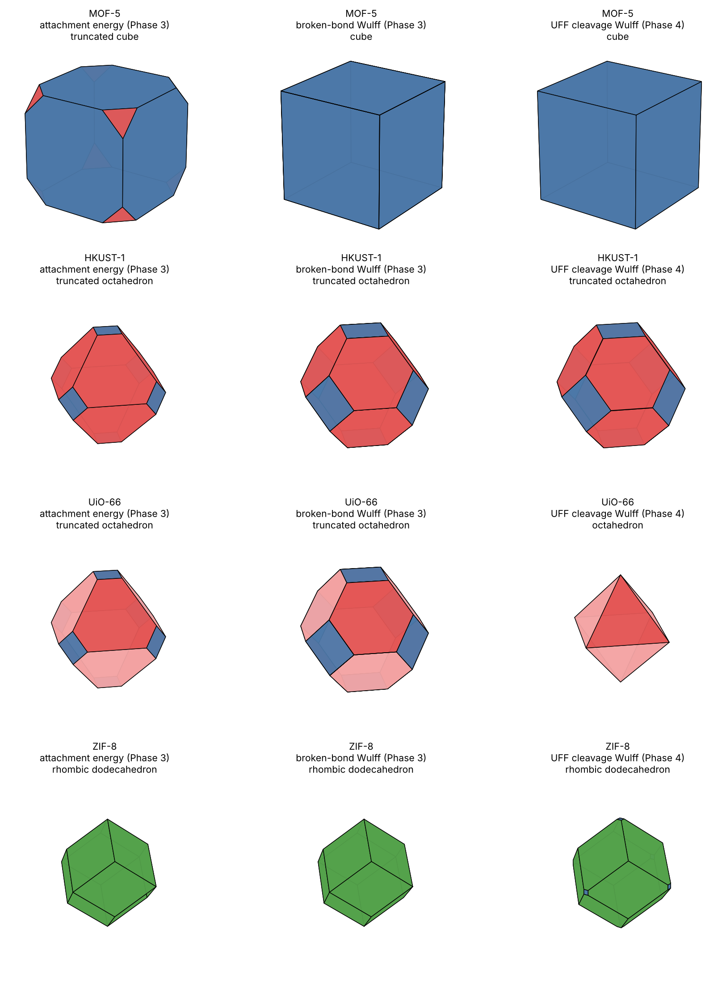
Figure 5. Shapes from the graph (Phase 3) and from the atoms (Phase 4). What it shows: for each MOF, the attachment-energy growth shape and the broken-bond Wulff shape from the periodic graph, and the UFF cleavage-energy Wulff shape from the atoms. Colours: blue {100}, red {111} (pink {111}−), green {110}. What it says: the three models agree on the dominant face of every MOF; they differ in truncation, most for MOF-5 and UiO-66. How it was made: code/morphology/figs_phase4.py from results/phase3_results.json and phase4_results.json.
The bond part is 91–99% of every value (MOFs are mostly empty, so few van der Waals contacts are cut). Scaling the van der Waals part by 0, 1, 5, 20 and 100 never changes the dominant face; only minor-face shares move (HKUST-1 {100} from 22% to 44% of the area at ×100). Limits: no relaxation, no electrostatics (probably understates UiO-66's cut cost), flat bond energy, no solvent, {111}+ and {111}− come out equal.

10.7 The BFDH × Wulff blend (hybrid.py, run_hybrid.py, MorphoGraph_hybrid.ipynb)
Both distance sets are scaled so their smallest value is 1. Worked example, MOF-5: {100} 1.155 (BFDH), 1.000 (Wulff), 1.075 (w = 0.5); {111} 1.000, 1.727, 1.314.
MOF | w = 0 | 0.25 | 0.5 | 0.75 | w = 1 | Additive-free crystals
MOF-5 | Truncated octahedron | Truncated octahedron | Truncated cube | Truncated cube | Cube | Cube (8 records)
HKUST-1 | Truncated octahedron | same | same | same | same | Octahedron (5 records)
UiO-66 | Truncated octahedron | Truncated octahedron | Octahedron | Octahedron | Octahedron | Cube (2 records); octahedra only with modulators
ZIF-8 | Rhombic dodecahedron | same | same | same | same | Rhombic dodecahedron (10 records)
The blend adds nothing where the two methods agree (HKUST-1, ZIF-8) and passes through intermediate shapes where they disagree. w is a free parameter with four test MOFs, so no best value is claimed; it must be chosen on some MOFs and tested on others. The notebook runs the chain on any CIF in seconds without a GPU, with an optional cell for external (CHGNet or DFT) energies.

11. Experimental benchmark, CHGNet and scoring
Against additive-free laboratory crystals no model reproduces all four MOFs: ZIF-8 validates every model but distinguishes none, MOF-5 separates the bond-counting models (cube) from BFDH and CHGNet (truncated octahedron), HKUST-1 is right only in its dominant {111} face, and UiO-66 has no reliable additive-free benchmark.

11.1 The experimental dataset (data/experimental_morphology/, Rohith)
134 crystal-shape records from 35 open-access papers covering 12 MOFs. Each record states the MOF, the shape as written by the authors, exposed faces where given, and every reported synthesis condition (metal salt, linker ratio, solvent, additive and its role, temperature, time, heating, stirring), the evidence (SEM, TEM) and the exact figure or table. Records from an abstract alone are marked. Eleven records whose source could not be confirmed are held in experimental_morphology_unverified.csv and kept out of every comparison. Built by dataset/build_dataset.py.
MOF | Records | Papers | Shapes reported (count) | Temperature | With additive
ZIF-8 | 35 | 8 | Rhombic dodecahedron 13, other 5, plate 4, cube 4 | 22–140 °C | 16
HKUST-1 | 29 | 11 | Octahedron 13, cuboctahedron 4, cube 3, irregular 3 | 25–140 °C | 16
Mg-MOF-74 | 18 | 3 | Intergrown 4, other 4, spindle 4, hexagonal rod 3 | 125 °C | 16
MOF-5 | 18 | 3 | Cube 10, rhombic dodecahedron 3, cuboctahedron 2, octahedron 2 | 100–140 °C | 9
UiO-66 | 14 | 8 | Octahedron 4, cube 4, irregular 2, intergrown 1 | 120–140 °C | 11
IRMOF-3 | 5 | 1 | Truncated octahedron 2, cube, rhombic dodecahedron, octahedron | 100 °C | 4
Six others (MIL-53(Fe), ZIF-67, SNU-70, IRMOF-8, Zn₄O(FMA)₃, UiO-66-NH₂) | 15 | 6 | Rods, plates, cubes, others | 85–170 °C | 10
Two series show why conditions matter: ZIF-8 with sodium formate passes from edge-truncated cubes to rhombic dodecahedra over about four hours (Cravillon et al. 2012); HKUST-1 goes octahedron → cuboctahedron → cube as a monocarboxylic acid modulator increases (Umemura et al. 2011). A single "experimental shape" per MOF is a simplification. Because no model contains an additive, the benchmark uses only additive-free crystals.
Benchmark shapes (single source of truth: data/experimental_morphology/compare/comparison.csv): MOF-5 cube (8 records, two laboratories); HKUST-1 octahedron (5); UiO-66 cube (2 records, cao2018 and rahmawati2014, poorly faceted "clusters of square morphology"); ZIF-8 rhombic dodecahedron (10). UiO-66 octahedra appear only with modulators, confirmed from two primary papers: Butova et al. 2023 (benzoic acid, DMF, 120 °C, TEM) and Morelli Venturi et al. 2020 (acetic acid in green solvents, 120 °C, SEM).

11.2 Scores
"Name": the predicted shape has the experimental name. "Facet": the predicted largest face family is the one the crystals expose. Scored by compare/compare_with_project.py.
Model | Name matches | Facet matches | MOF-5 | HKUST-1 | UiO-66 | ZIF-8
BFDH (Phase 1) | 1/4 | 2/4 | Truncated octahedron, {111} | Truncated octahedron, {111} | Truncated octahedron | Rhombic dodecahedron
Graph attachment rule (Phase 1) | 1/2 | 1/2 | Cube | not applicable (tbo) | Octahedron | not applicable (sod)
Attachment-energy Wulff (Phase 3) | 1/4 | 3/4 | Truncated cube, {100} | Truncated octahedron, {111} | Truncated octahedron | Rhombic dodecahedron
Broken-bond Wulff (Phase 3) | 2/4 | 3/4 | Cube | Truncated octahedron, {111} | Truncated octahedron | Rhombic dodecahedron
UFF Wulff (Phase 4) | 2/4 | 3/4 | Cube | Truncated octahedron, {111} | Octahedron | Rhombic dodecahedron
Hybrid, w = 0.5 | 1/4 | 3/4 | Truncated cube, {100} | Truncated octahedron, {111} | Octahedron | Rhombic dodecahedron
CHGNet cleavage (intact slabs) | 0/3 | 2/3 | Truncated octahedron, {111} | Truncated octahedron, {111} | Truncated cube, {100} | not run
Reading. ZIF-8 is the one clean validation, and Cravillon et al. identify the rhombic dodecahedron as the equilibrium shape; since geometry alone (BFDH) gives it, it does not distinguish energy models. MOF-5 separates the methods, but the UFF cube depends on charging a Zn–O bond the same as a C–C bond (11.5) and CHGNet disagrees. Every method keeps {100} faces on HKUST-1 that octahedral crystals do not show. UiO-66 scores should count for or against no method. Four MOFs cannot rank models.
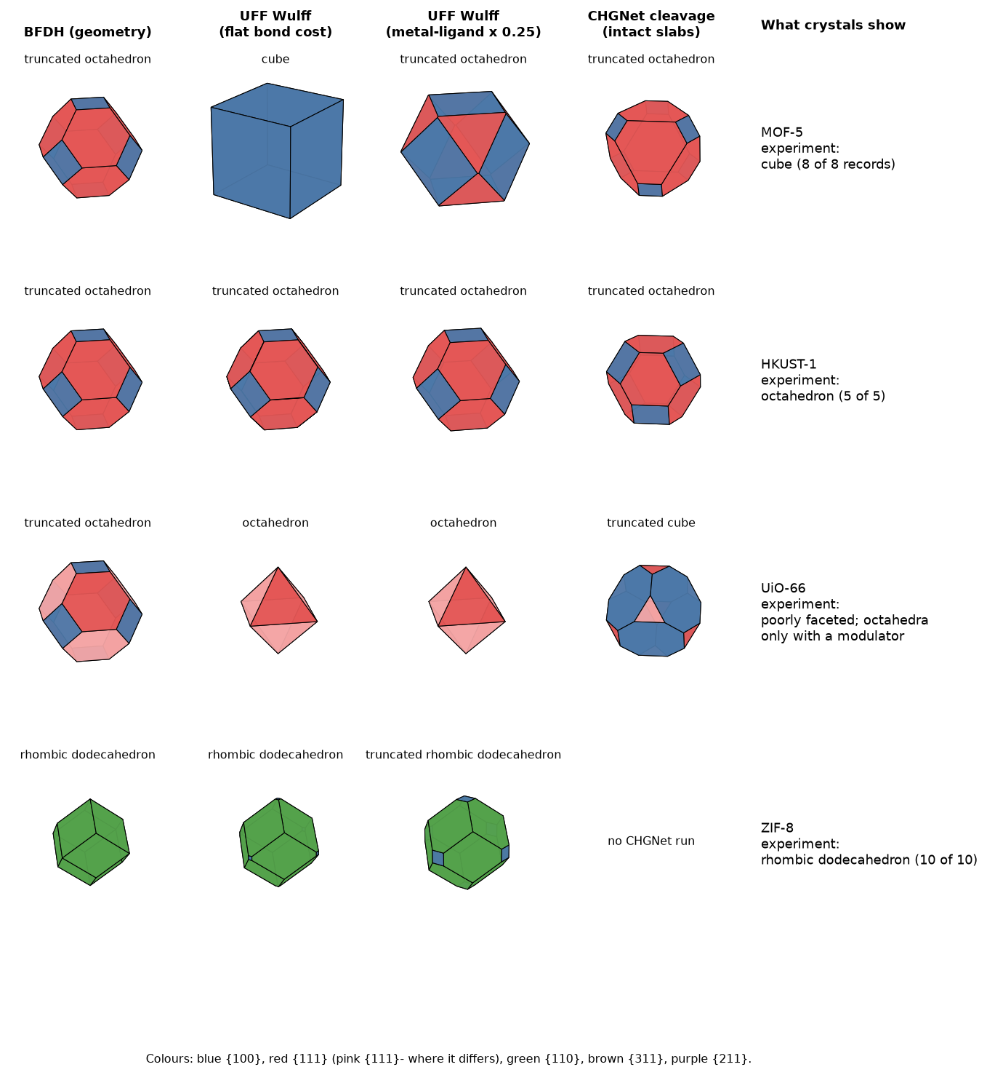
Figure 6. Every method against what the crystals show. What it shows: for each MOF, the BFDH shape, the UFF Wulff shape at the flat bond cost and with metal–ligand bonds at 0.25×, the CHGNet cleavage-energy shape (intact slabs), and the additive-free laboratory habit with its record count. What it says: ZIF-8 is matched by every method applied to it; MOF-5's cube appears only with the flat bond cost; HKUST-1 is right in its dominant face only; no method gives poorly faceted UiO-66. How it was made: code/morphology/figs_experiment.py from the result files and data/experimental_morphology/compare/comparison.csv. CHGNet shapes are drawn in the notebook's primitive-cell orientation, so they appear rotated.

11.3 CHGNet slab energies (MorphoGraph-MOF notebooks)
What the notebook does (Keerthi; run by Rohith on a Colab T4 GPU for MOF-5, HKUST-1 and UiO-66, and earlier for hMOF-0). CHGNet (Deng et al. 2023), a graph neural network potential trained on DFT data, relaxes the bulk and then slabs about 15 Å thick with 20 Å vacuum, cut parallel to each face with Miller indices up to 1; pymatgen generates every termination. ZIF-8 was left out because its CIF has no symmetry with hydrogens kept.
Why it produced no shape. A slab gives only the sum of its two faces:
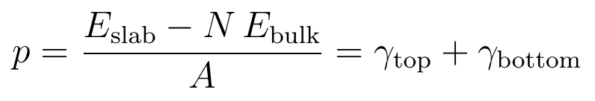
Every slab had different terminations on its two sides, and each appeared twice (once flipped), so the equations had about half as many independent rows as unknowns (rank/unknowns per face class: HKUST-1 15/28 to 23/46; MOF-5 8/15 to 35/67; UiO-66 15/30 to 21/42). The notebook correctly refused to guess. The hMOF-0 run produced no valid pair energies.
The cleavage energy. γ_cl(hkl) = min over terminations of p/2, computed by chgnet_post.py. Since p/2 ≥ min(γ_top, γ_bottom), it is an upper bound on the lowest termination energy. With an inversion centre (MOF-5, HKUST-1) it is the usual cleavage surface energy; for F-43m UiO-66 the {111}+/− and {311}+/− halves cannot be separated (both get p/2).
MOF | {100} | {110} | {111} | {311} | Wulff, all slabs | Wulff, intact slabs only
HKUST-1 (J/m², all / intact) | 0.163 / 0.163 | 0.181 / 0.476 | 0.151 / 0.152 | 0.210 / – | Rhombicuboctahedron-like (88 slabs) | Truncated octahedron (25)
MOF-5 | 0.127 / 0.127 | 0.184 / 0.238 | 0.098 / 0.098 | 0.222 / 0.539 | Truncated octahedron (94) | Truncated octahedron (30)
UiO-66 | 0.210 / 0.210 | 0.551 / 1.161 | 0.287* / 0.287* | 0.533* / 1.069* | Truncated cube (113) | Truncated cube (24)

11.4 Chemistry checks on the slabs
- Most slabs cut through linkers (slab_check.py). pymatgen places cuts by atom position, not by molecule. Loose pieces as cut: HKUST-1 51 of 88 slabs (H ×130, O ×48, CH ×30, CuO₄ ×2); MOF-5 62 of 94 (H ×162, O ×28, CH ×28, C₂H₂ ×8); UiO-66 87 of 113 (H ×249, CH ×36, C₂H₂ ×35, O ×28). On relaxation CHGNet released CO₂ from broken carboxylates. The lowest-energy slabs of MOF-5 and UiO-66 are intact; HKUST-1 {111} moves from 0.151 to 0.152 J/m² on intact slabs only. No shape changes.
- Slabs are thin. Bulk-equivalent thickness 15–30 Å (one or two block layers). Thickness convergence has not been tested.
- Better slabs? A pymatgen dry run (slab_options_check.py) shows the symmetrize option returns the same slabs as the plain cut, and keeping linkers whole leaves few terminations, none symmetric.
- Symmetric slabs that exist give exact termination energies but are expensive terminations: 1.4× (HKUST-1 {100}) to 9.1× (MOF-5 {111}) the cleavage bound. Cheap cuts in these frameworks are asymmetric, so symmetric slabs cannot recover the faces that set the shape.

11.5 Is the flat bond cost safe? (run_bond_sensitivity.py)
Organic bonds kept at 70 kcal/mol; every metal bond multiplied by f.
MOF | f = 1 | f = 0.5 | f = 0.25 | Lowest face
MOF-5 | Cube | Truncated cube | Truncated octahedron | {100} throughout
HKUST-1 | Truncated octahedron | same | same | {111}
UiO-66 | Octahedron | same | same | {111}+
ZIF-8 | Rhombic dodecahedron | Truncated rhombic dodecahedron | same | {110}
The MOF-5 cube is a consequence of the flat bond cost; a bond-type-specific cost or a DFT check is needed before it is quoted as a prediction.

11.6 Any framework: eight CoRE MOF structures (run_core.py)
Six crystal systems and six metals: ABAVIJ (Cc, Co), ACIBIY (P-1, Co), ACOLOV (P2₁/c, Cd), ACIBOE (I4cm, Zn), ABETIN (I4₁/acd, Cu), ABEXEN (P6/mcc, In), ACAJIY (R3, Zn), ADATAC (Fm-3, Zn). Aspect ratios reach about 2 for the non-cubic frameworks, and UFF energies change the dominant faces in most (trigonal ACAJIY goes from a nearly isometric BFDH rhombohedron to a plate). No experimental shapes are known for them, so this shows only that the method runs on any framework.

11.7 The CHGNet run folders (data/chgnet_morphograph_runs/)
Folder | Content
hMOF-0_2026-10-12 | First run, interactive notebook; initial slabs only
HKUST-1_2026-10-14, MOF-5_2026-10-14, UiO-66_2026-10-14 | Four-MOF notebook: cells, initial and relaxed slabs, slab energies, pair fits, metadata, particles
They were verified identical (1118 files) to the zip archives on the team's computer and are read through mofmorph/chgnet_runs.py.

11.8 Kshitij's steps 1–8 pipeline, run and checked (run/run_nb.py)
Kshitij's notebook MOF_Wulff_steps1-8.ipynb writes one module, mofwulff.py (about 840 lines), that goes from a CIF to a Wulff shape in eight steps: (1) standardise the structure (disorder policy, guest removal, space group from the full structure or from an H-free or metal + C skeleton); (2) split it into building blocks; (3) list symmetry-unique face families and their distinct terminations; (4) cut slabs that contain only whole blocks, with the stoichiometry asserted; (5) heal every broken metal–linker bond with a dissociated water (OH⁻ on the metal, H⁺ on the linker donor); (6) compute CHGNet energies, static for every termination and relaxed for the lowest; (7) validate with MACE-MP-0 and write CP2K PBE-D3 inputs; (8) build the Wulff shape from the point-group symmetry and name it. The surface energy is
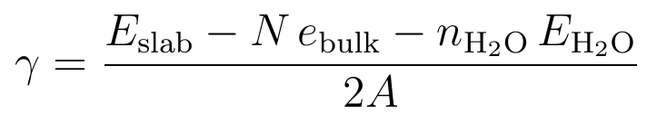
This design answers the three weaknesses of our October CHGNet run (Section 11.3): slabs no longer cut through building blocks, broken bonds are capped, and a DFT check is planned. The module was run unchanged with the notebook's own settings on the four RASPA2 CIFs it downloads, on a 2-core CPU with 8 GB of memory.
Quick mode (static energies), all four MOFs.
MOF | Space group used | Slab sizes (atoms) | γ static, J/m² | Notebook's name | Exact shape | Lab
ZIF-8 | I-43m (H-free skeleton) | 288–576 | {100} 0.120, {110} 0.095, {111} 0.132 | rhombic dodecahedron | truncated rhombic dodecahedron (3 % {100}) | rhombic dodecahedron
HKUST-1 | Fm-3m | 174–720 | {100} 0.534, {110} 0.557, {111} 0.445 | truncated octahedron | truncated octahedron | octahedron
UiO-66 | Fm-3m (metal + C skeleton) | 480–936 | {100} 0.757, {110} 0.842, {111} 0.661 | cuboctahedron | truncated octahedron | cube (no additive)
Mg-MOF-74 | R-3 | 123–567 | {100} 1.22, {2̅1 0} 1.16, {001} 0.63, {101} 0.61 | block/prism | not cubic | intergrown or spindle (no additive); rods with additives
Full mode (relaxed), with the K3 and K11 fixes. Lowest static termination of each face relaxed to fmax ≤ 0.05 eV/Å (RELAX_TOP_K lowered from 2 to 1 for time).
MOF | Face | γ static → relaxed, J/m² | Steps | Shape
ZIF-8 | {100}, {110}, {111} | 0.113 → 0.020; 0.088 → 0.012; 0.096 → 0.016 | 127, 92, 105 | rhombic dodecahedron, 100 % {110}
HKUST-1 | {100}, {111} | 0.548 → 0.190; 0.444 → 0.170 | 369, 744 | truncated octahedron (γ111/γ100 = 0.90); {110} (696 atoms) ran out of memory
UiO-66 | {100} | 0.734 → 0.267 | 141 | {110}, {111} (936 atoms) ran out of memory
Mg-MOF-74 | {100}, {2̅1 0} | 1.27 → 0.174; 1.02 → 0.002 | 395, 286 | {001} stopped; {101} not reached
Reading. ZIF-8 agrees with the lab in both modes, as every earlier model did. HKUST-1 gets the lab's largest face but stops at a truncated octahedron, where every earlier model also stops. UiO-66 and Mg-MOF-74 do not reach their additive-free lab shapes; for UiO-66 the input file has dehydroxylated Zr₆O₆ nodes, and for Mg-MOF-74 the metal rod is cut (K2). Relaxation lowers γ by 60 % to almost 100 %, and the relaxed values are close to zero, so face order rests on small energy differences: a DFT check of at least one face is required before these numbers are presented as results. MACE-MP-0 (step 7a) could not run here: it needed more than 3.5 GB beside the CHGNet job. The mistakes found are in Section 13.8.

11.9 The morphology map (keerthi/cubic_wulff.py, phase_grid.py, model_points.py)
Keerthi proposed that morphology classes be treated as regions of a space. For cubic MOFs this can be made exact. A crystal bounded by {100}, {110} and {111} has a Wulff shape that depends only on two numbers, x = γ110/γ100 and y = γ111/γ100, because multiplying every γ by the same factor only scales the crystal. The Wulff shape is the set of points inside every face plane:
A family appears on the shape only if its planes cut off a vertex of the polyhedron the other families make. Checking where each family first touches a vertex gives closed-form boundaries. For example, the cube corner (γ100, γ100, γ100) lies at distance √3·γ100 along [111], so {111} is absent exactly when γ111 ≥ √3·γ100; the octahedron's vertex (√3·γ111, 0, 0) lies inside the {100} plane exactly when γ100 ≥ √3·γ111.
Shape | Exact condition
Cube | y ≥ √3 and x ≥ √2
Truncated cube | 2/√3 < y < √3, no {110}
Cuboctahedron | y = 2/√3 exactly, no {110}
Truncated octahedron | 1/√3 < y < 2/√3, no {110}
Octahedron | y ≤ 1/√3 and x ≥ √(3/2)·y
Rhombic dodecahedron | x ≤ 1/√2 and y ≥ √(3/2)·x
Cube with truncated edges / truncated rhombic dodecahedron | {100} and {110}, no {111}; named by the larger family
The map was computed exactly by half-space intersection on a 150 × 150 grid; a family counts when it holds at least 1 % of the area, our earlier convention. Every model of the project becomes one point per MOF (growth-distance models such as BFDH and attachment energy are placed the same way, since only ratios matter).
MOF | Lab, no additive | BFDH | Attachment | Broken-bond | UFF | CHGNet cleavage | Kshitij CHGNet
MOF-5 | cube | trunc. octahedron (y 0.87) | trunc. cube (1.50) | cube (on the corner) | cube (1.73) | trunc. octahedron (0.77) | not run
HKUST-1 | octahedron | trunc. octahedron (0.87) | trunc. octahedron (0.75) | trunc. octahedron (0.87) | trunc. octahedron (0.87) | all three families (0.92) | trunc. octahedron (static 0.83, relaxed 0.90)
UiO-66 | cube | trunc. octahedron (0.87) | trunc. octahedron (0.75) | trunc. octahedron (0.87) | octahedron (0.45) | trunc. cube (1.37) | trunc. octahedron (0.87)
ZIF-8 | rhombic dodecahedron | RD (x 0.71) | RD (0.50) | RD (0.71) | RD (0.74) | not run | trunc. RD static (0.79); RD relaxed (0.60)
The map shows what a name hides: how far a prediction is from the lab (every HKUST-1 model sits at y 0.75–0.92, while an octahedron needs y ≤ 0.58); which predictions are fragile (MOF-5's broken-bond point sits exactly on the cube corner and ZIF-8's BFDH point on the line x = 1/√2, because bond counts are small integers); and where models disagree (UiO-66 spreads from y 0.45 to 1.37).
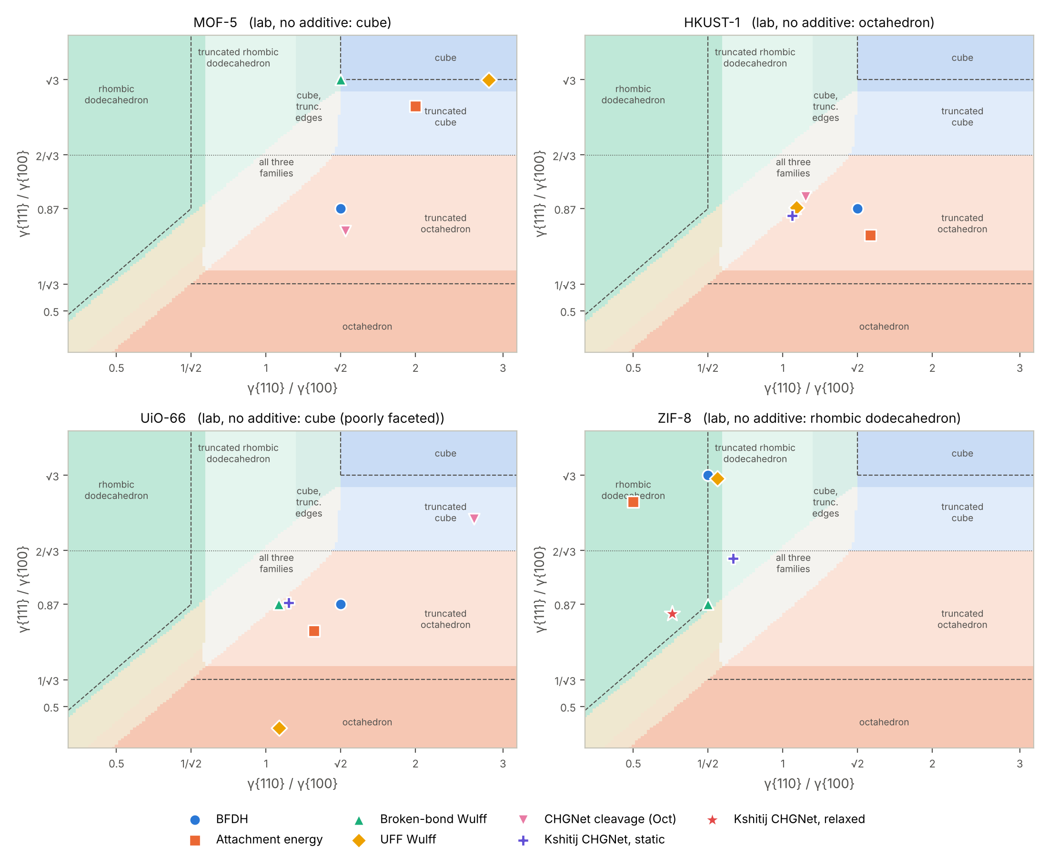
Figure 8. Every model of the project on the morphology map. What it shows: shape regions of the (γ110/γ100, γ111/γ100) plane, the closed-form limits as dashed lines, and each model's point for four MOFs, with the additive-free lab shape in each title. What it says: ZIF-8 is the only MOF where every model lands in the lab's region; for HKUST-1 all models lie on the right side but not far enough. How it was made: keerthi/figures.py from phase_grid.npz and model_points.json.

11.10 Conditions on the map, and possible morphologies of a CIF
Theory. The Gibbs adsorption equation says a face's energy falls as an additive that binds it becomes more concentrated, dγ_F = −Γ_F dμ. With independent binding sites (a Langmuir surface) it integrates to
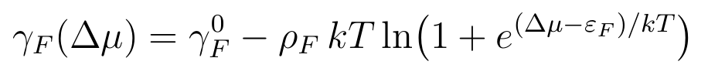
with ρ_F the binding-site density on face F, ε_F the binding energy per site relative to the solvent cap, and Δμ = kT ln(concentration) up to a constant. An additive that binds one family lowers only that family's γ, so the crystal's point moves steadily toward that family's corner of the map, through a fixed order of shapes, and never turns back.
Test 1, lab series (series_test.py). Every controlled series in the dataset with an increasing dose, ratio or time was placed on the map.
Series (source) | Shapes as the condition increases | Moves toward
HKUST-1 + lauric acid (umemura2011) | octahedron → cuboctahedron → cube | {100}
HKUST-1 + inorganic salt (liu2016) | cube → cuboctahedron → octahedron | {111}
HKUST-1 + SDS (wu2020) | cube → cuboctahedron → octahedron | {111}
MOF-5 + H3BTB 0, 2, 4 mol % (suresh2021) | cube → cuboctahedron → octahedron, then "other" | {111}
ZIF-8, Hmim/Zn 1 to 16 (zhang2018) | cube → trunc. rhombic dodecahedron → rhombic dodecahedron | {110}
ZIF-8, time 0.25 to 4 h (cravillon2012) | cube with truncated edges → rhombic dodecahedron | {110}
All six move monotonically along one axis; if the same shapes were listed in random order, the chance that all six would be this orderly is 2.7 × 10⁻⁴. Four other series leave the map (to a plate, irregular crystals, spheres, or start from intergrown crystals); no Wulff model can describe those. For MOF-5 + H3BTB, a dose effect linear at low coverage predicts that doubling the cuboctahedron dose gives an octahedron exactly when the additive-free crystal is a cube, which it is: consistent, though three points prove little.
Test 2, conditions as labels (condition_model.py). The dominant face of 82 cubic-MOF records from 25 papers was predicted with each paper held out in turn; intervals are 95 % bootstrap over papers.
Model | All | No additive (35) | With additive (47)
M0 most common face | 43 % (28–61) | 49 % | 38 %
M1 most common face for that MOF | 54 % (37–72) | 89 % | 28 %
M2 structure only (UFF Wulff) | 57 % (40–77) | 86 % | 36 %
M3 M2 plus "this additive type gives face F" | 45 % (30–62) | 86 % | 15 %
The structure-only prediction matches knowing the answer for that MOF on additive-free records, but adding the additive as a label makes predictions with additives worse: the same additive type moves different MOFs different ways (monocarboxylic acids push UiO-66 to octahedra and HKUST-1 to cubes), and papers report doses in incompatible units. A step-10 model must therefore predict the move from computed binding energies and a common dose unit, not from labels.
Test 3, a modulator cap (modulator_caps.py, first attempt). The lowest water-capped slab of each face was recapped with formate and scored statically: ε_F (per site, {100}/{110}/{111}) is −1.27/−1.36/−1.43 eV for HKUST-1 and −1.35/−1.31/−1.27 eV for ZIF-8, moving HKUST-1 toward octahedra and ZIF-8 toward cubes. For UiO-66 two formates crowd each Zr (closest contact 1.0 Å) and the result is invalid. With unrelaxed caps and γ turning negative at high concentration, this shows the pipeline can compute a direction; it is not yet a result.
Possible morphologies of a given CIF (possible_morphs.py). Starting from a CIF's point and lowering one face energy at a time, as a face-selective modulator does, lists the shapes it can take in the order they should appear.
MOF (start) | Lower γ{100} | Lower γ{110} | Lower γ{111} | Lab shapes generated
MOF-5 (UFF: cube) | stays a cube | cube → cube with truncated edges → trunc. RD → RD | cube → trunc. cube → cuboctahedron → trunc. octahedron → octahedron | 4 of 4
HKUST-1 (trunc. octahedron) | → cuboctahedron → trunc. cube → cube | → all three → RD | → octahedron | 3 of 3
UiO-66 (trunc. octahedron) | → cuboctahedron → trunc. cube → cube | → all three → RD | → octahedron | 3 of 3
ZIF-8 (trunc. RD) | → cube with truncated edges → cube | → RD | → all three → trunc. octahedron → octahedron | 5 of 6
15 of the 16 polyhedral lab shapes for these MOFs are generated (ZIF-8's truncated cube needs two faces lowered together). The count is high partly by construction, since single-face moves reach the cube, octahedron and rhombic dodecahedron from almost anywhere; the 13 lab shapes off the map are not generated. The testable content is the order along each path and shapes not yet reported, such as a rhombic dodecahedron of HKUST-1 or UiO-66 with an additive that binds {110}.
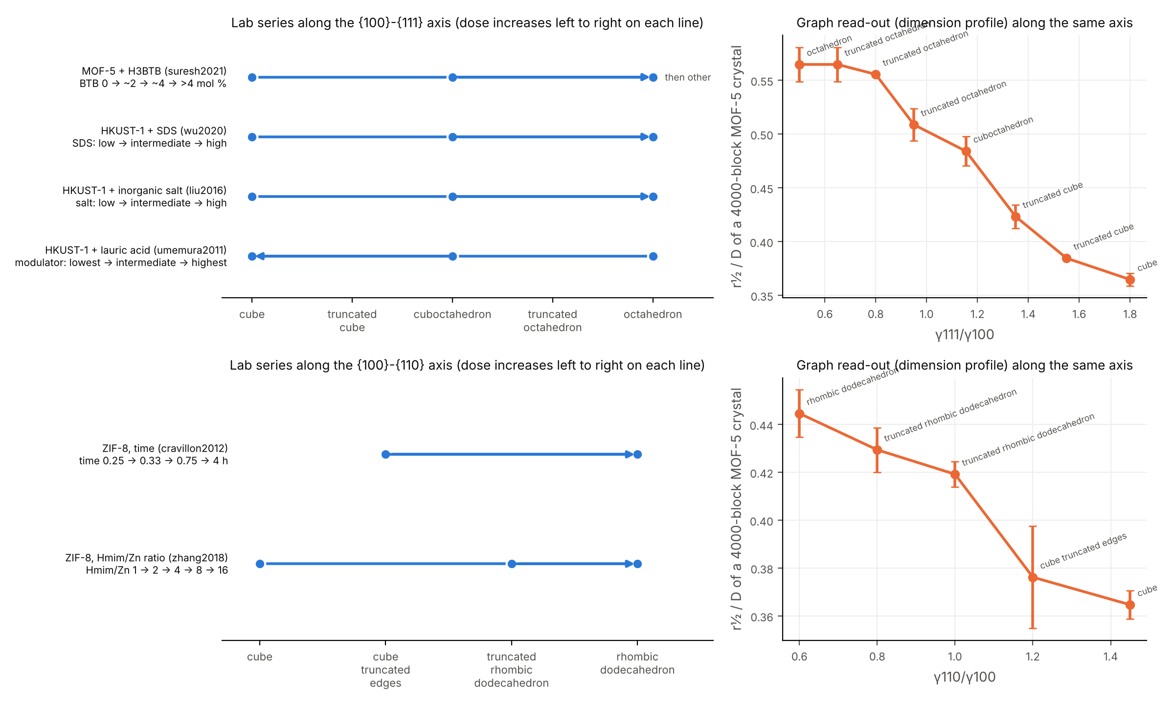
Figure 9. Conditions and the graph read-out on the same map. What it shows: left, the six lab series of Test 1 on the two axes of the map; right, the dimension-profile number r½/D of MOF-5 crystals cut along the same axes (Section 12.6). What it says: lab series move one way along an axis, and the graph measurement changes monotonically along the same axis. How it was made: keerthi/figures.py from series_results.json and dimension_along_map.json.

12. Linking the two parts: spectrum and crystal shape
The periodic Δα says nothing about crystal shape once graph size is controlled; on finite particles Δα responds to flatness and elongation but not to compact shapes; the full mass–radius curve responds to both, which makes it the one graph quantity from Part 1's toolkit that carries shape information.
All four tests live in code/spectrum_shape_relation/. Tests 1–3 were produced by Spectrum_Shape_Relation.ipynb, run by P. M. Radha Krishna in Google Colab on 16 October 2026 with every calculation recomputed (15/15 checks; printed output in results/RUN_REPORT_spectrum_shape_relation.md). Test 4 was produced by run_04_dimension_profile_of_crystal_particles.py and added to the notebook afterwards; the checks now number 21, all passing.
Setting. Every earlier spectrum was measured on a torus (quotient graph tiled with wrap-around), which has no surface and no shape. Here the quotient graph is tiled without wrap-around, each block placed at its Cartesian centroid, and cut to a finite particle: a box of cells, or a polyhedron {x : n_f · x ≤ s R_f} with the face distances of a morphology prediction. Δα settings: top 20% of blocks by degree, radii to half the diameter, 20 trials, seeds 0–4. MOF-5 is used because it is the only demonstration MOF whose file holds an orthogonal conventional cell and whose block graph is connected.

12.1 Test 1: same number of cells, four box shapes (run_01)
Cubes of side 2–6 give the size trend Δα = −1.139 + 0.753 ln D. At 64 cells (2048 blocks):
Shape | Diameter | Δα | Cube trend at that D | Difference
Cube 4×4×4 | 44 | 1.722 ± 0.003 | 1.708 | +0.014
Slab 8×4×2 | 52 | 1.626 ± 0.009 | 1.834 | −0.208
Plate 8×8×1 | 64 | 1.591 ± 0.006 | 1.990 | −0.399
Rod 16×2×2 | 76 | 1.410 ± 0.008 | 2.120 | −0.710
The plate and rod have larger diameters than the cube yet lie below the cube trend, so the effect is not just diameter. The numbers equal code_19 exactly (checked in the run). ZIF-8's block graph is in 34–238 pieces and is not used.

12.2 Test 2: the compact shapes the methods predict (run_02)
For MOF-5 the methods disagree: BFDH truncated octahedron, blend truncated cube, UFF Wulff cube, CHGNet truncated octahedron. Each was built at about 2000 and 4000 blocks with cube, octahedron and rhombic dodecahedron references. Against the cube trend in block count (Δα = −0.481 + 0.279 ln N, largest residual 0.043), every compact shape lies within −0.044 to +0.050, the size of the trend's own scatter, and the order of shapes changes between the two sizes. Compared at equal diameter they differ by up to +0.32, but only because an octahedron has a much smaller graph diameter than a cube of equal N: in a pcu net graph distance behaves like taxicab distance, and the octahedron is the taxicab ball. Equal-diameter comparisons are therefore misleading. Δα does not separate the compact shapes.

12.3 Test 3: across 55 real MOFs (run_03)
For the 55 CoRE MOF structures with a Part 1 Δα (code_17), the BFDH shape was computed (faces to index 4, 40 widest families) and described by sphericity and aspect ratio. Spearman ρ raw and with ln(node count) held fixed; p-values from 10,000 permutations, intervals from 5,000 bootstrap resamples.
Structures | Pair | n | Raw ρ (p) | ρ with size fixed (p) | 95% interval, size fixed
All usable | Width vs sphericity | 55 | −0.384 (0.0045) | +0.003 (0.981) | −0.32 to +0.34
All usable | Width vs aspect ratio | 55 | +0.504 (0.0003) | +0.001 (0.993) | −0.32 to +0.34
All usable | Width vs cell length ratio | 55 | +0.623 (0.0001) | +0.095 (0.493) | −0.15 to +0.35
One connected piece | Width vs sphericity | 52 | −0.419 (0.0027) | −0.072 (0.620) | −0.42 to +0.31
One connected piece | Width vs aspect ratio | 52 | +0.567 (0.0001) | +0.132 (0.356) | −0.19 to +0.43
One connected piece | Width vs cell length ratio | 52 | +0.638 (0.0001) | +0.122 (0.399) | −0.15 to +0.39
The raw links are real but vanish with size fixed: Δα rises with node count (ρ = +0.80) and more stretched predicted shapes come with bigger periodic graphs (sphericity against node count ρ = −0.48). This is the Part 1 confound again, caught this time because size was controlled from the start.

12.4 Test 4: the dimension profile (run_04)
Why. Tests 1–3 compress the whole scaling behaviour into one number. Test 4 keeps the curve, using the mass–radius (cluster-growing) method of the Fractals and Scaling course: M(r) is the mean number of blocks within graph distance r of a centre, and d(r) = d ln M / d ln r by central differences.
Method. Boxes of about 1000 cells (cube 10³ = 32,000 blocks; slab 16×16×4, plate 32×32×1, rod 64×4×4 = 32,768 each); the seven polyhedra of Test 2 at about 4000 and 8000 blocks; 64 random centres × 5 seeds, breadth-first search. Read-outs: d at the half-mass radius r½, and r½/D (D = largest distance found, a lower bound on the diameter). Calibration on lattices of known dimension, because a finite graph never reaches 1, 2 or 3.
Graph | Blocks | Peak d(r) | d at r½
Cubic grid 41³ (3D reference) | 68,921 | 2.64 | 1.78
Square grid 121² (2D reference) | 14,641 | 1.83 | 1.40
Path of 4001 vertices (1D reference) | 4001 | 0.99 | 0.83
MOF-5 cube 10×10×10 | 32,000 | 2.69 | 1.80 ± 0.02
MOF-5 slab 16×16×4 | 32,768 | 2.62 | 1.55 ± 0.01
MOF-5 plate 32×32×1 | 32,768 | 2.25 | 1.41 ± 0.01
MOF-5 rod 64×4×4 | 32,768 | 2.55 | 0.94 ± 0.02
Result 1. The cube, plate and rod have the local dimension of a 3D, 2D and nearly 1D lattice at the half-mass radius (1.80 vs 1.78, 1.41 vs 1.40, 0.94 vs 0.83). The plate, one cell thick, follows the square grid almost from the start; the rod, four cells wide, is 3D at short range and approaches the path beyond about a third of its diameter. This is consistent with Test 1: over the radii the spectrum is fitted on, plates and rods are lower-dimensional than the cube.
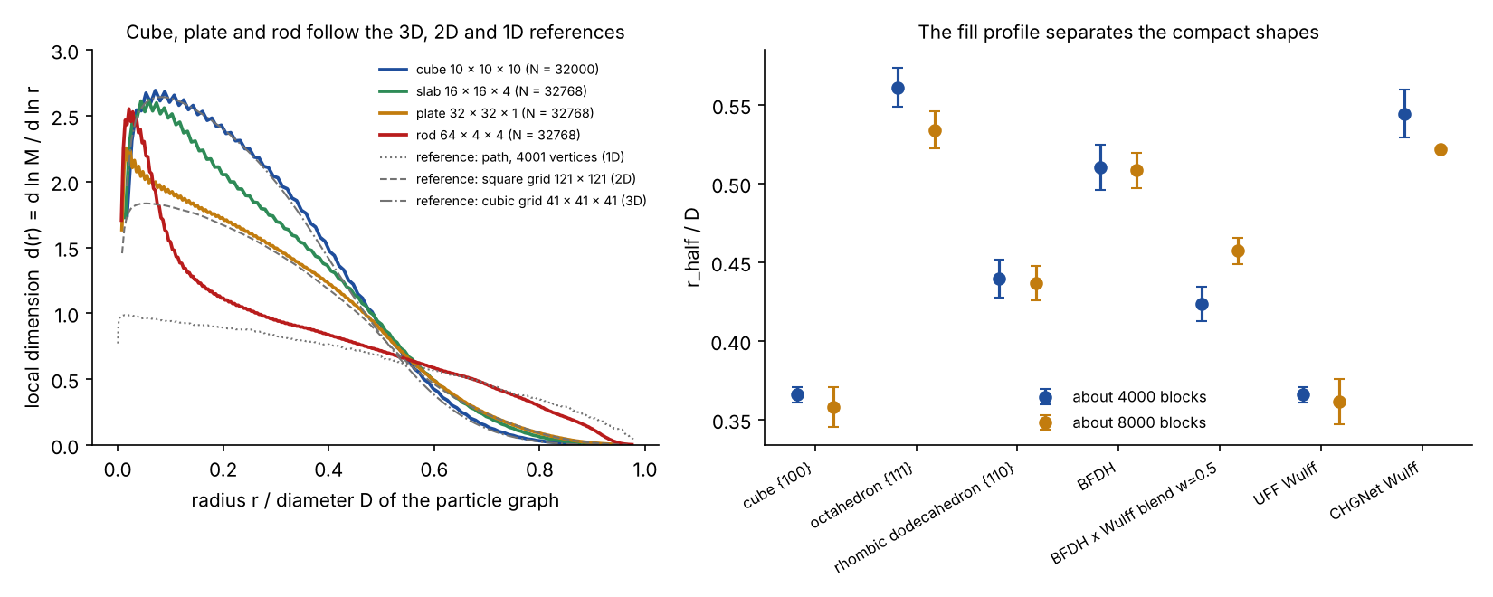
Figure 7. The dimension profile of MOF-5 particles. What it shows (left): the local dimension d(r) against r/D for the four MOF-5 boxes, with the cubic grid, square grid and path drawn in grey as 3D, 2D and 1D references; (right) r½/D for the seven compact shapes at about 4000 and 8000 blocks. What it says: the cube follows the 3D reference, the plate the 2D reference almost from the start, and the rod approaches the 1D reference beyond about a third of its diameter. How it was made: code/spectrum_shape_relation/make_figures_spectrum_shape_relation.py (fig04) from results/04_dimension_profile_MOF5.json.
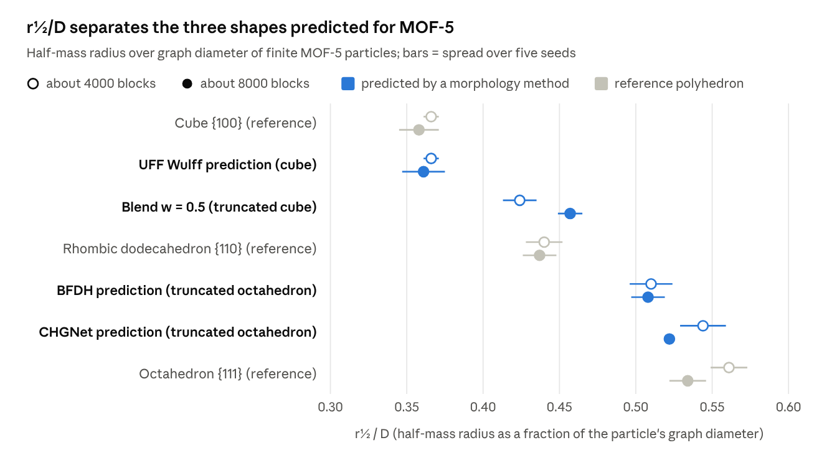
code/spectrum_shape_relation/results/04_dimension_profile_MOF5.json (run_04_dimension_profile_of_crystal_particles.py) · MOF-5, 7 shapes at two sizes, 64 centres × 5 seeds
Result 2. r½/D separates the compact shapes that Δα could not. The three different MOF-5 predictions fall in the same order at both sizes: UFF Wulff (cube) 0.37 and 0.36, blend (truncated cube) 0.42 and 0.46, BFDH (truncated octahedron) 0.51 and 0.51; each gap is at least 3.6 times the largest seed spread. CHGNet, also a truncated octahedron, sits close to BFDH. The reason is geometric: graph distance in the pcu net behaves like taxicab distance. A cube has far corners in that metric, so its diameter is large compared with the radius that holds half its blocks; the octahedron is the taxicab ball and has no far corners, so half its blocks are reached only at a larger fraction of its diameter. Truncation moves a shape between these two limits, which is why the ratio orders the cube, truncated cube and truncated octahedron.
What this does and does not show. The dimension profile identifies a particle's shape from its graph alone. It does not predict which shape a MOF grows and adds no evidence for or against any morphology model. Its value is a shape-sensitive graph descriptor from the same machinery as the spectrum, usable on particles produced by any method (a growth simulation, a generative model). Limits: one MOF; one particle-building rule (block centroid inside the polyhedron, surfaces a one-block staircase); four of the fourteen polyhedra leave detached corner blocks (at most 2.5%, the octahedron at about 4000), and only the largest piece is used; r½ is an integer radius, so r½/D moves in steps of about 0.02.

12.5 What carries over from Part 1
Question | Answer | Evidence
Does Δα of a finite particle depend on how flat or long it is? | Yes, for MOF-5, beyond size | Test 1
Does it separate compact shapes? | No; differences are within the method's scatter | Test 2
Does the periodic Δα predict a MOF's crystal shape? | No, once graph size is controlled | Test 3
Does the mass–radius curve of a finite particle carry shape information? | Yes: dimensionality and the compact shapes | Test 4
What carries over is the labelled quotient graph (used in Phase 3), the habit of controlling size, and the scaling machinery in its mass–radius form.

12.6 The dimension profile along the morphology map (keerthi/dimension_along_map.py)
Test 4 showed that r½/D separates a handful of compact shapes. The morphology map (Section 11.9) turns this into a continuous statement: MOF-5 crystals of about 4000 building blocks were cut at points along each axis of the map and measured exactly as in run_04 (64 random centres per seed; 3 seeds here instead of 5).
Axis | Shapes from one end to the other | r½/D | Order kept?
γ111/γ100 from 1.80 to 0.50 | cube → truncated cube (×2) → cuboctahedron → truncated octahedron (×3) → octahedron | 0.365, 0.385, 0.423, 0.484, 0.509, 0.556, 0.565, 0.565 | yes, never reverses
γ110/γ100 from 1.45 to 0.60 | cube → cube with truncated edges → trunc. rhombic dodecahedron (×2) → rhombic dodecahedron | 0.365, 0.376, 0.419, 0.429, 0.445 | yes, never reverses
Seed standard deviations are 0.00 to 0.02. The graph measurement therefore reads a crystal's position on the same map the surface energies and conditions predict: prediction and measurement meet in one coordinate. This is the combination the guide asked for, and it keeps the spectrum work in the project as the measurement side rather than as a predictor. Limits: one number cannot name a point of a two-dimensional map (a rhombic dodecahedron, 0.445, falls between a truncated cube and a cuboctahedron); at 4000 blocks it does not separate an octahedron from a lightly truncated one (both 0.565); and all shapes were cut from the MOF-5 net, so this tests geometry, not each MOF's own net.

13. Mistakes: what went wrong, how it was found, how it was corrected
Thirty-two substantive mistakes and twelve smaller slips were found and corrected in our own work up to 8 November, plus eleven problems in the team's steps 1–8 notebook and two slips of our own on 10 November (Section 13.8); none was hidden, and the website's Mistakes page keeps each one with its reason, because the surviving results are trustworthy only if the failed ones are visible.

13.1 Four patterns behind the mistakes
Pattern | Where it showed up | The habit that fixes it
A number that looks good is trusted before it is stressed | The size correlation, the force-field cube, the "best" hybrid weight | Vary the thing you did not control, then report what survived
Code written for the examples at hand | Cubic labels, hydrogens dropped, one-cell graphs | Test on a deliberately different case (eight CoRE MOFs, six crystal systems)
One value per thing that varies | One shape per MOF, one class per structure | Record conditions and error bars next to every value
Words and numbers drifting apart | Text described one graph, code used another; status tables lagged the work | Generate numbers from data files, check pages with tests, audit summaries

13.2 Part A: the spectrum work
# | Mistake | How it was found | Consequence | Correction | Where
A1 | τ(q) fitted with a free intercept instead of through the origin | The ∩-shape test (section 5.4) failed for every spectrum; then the paper was re-read line by line | 0 of 77 spectra valid; apex flattened | τ = Σxy/Σx²; 77 of 77 valid; free-intercept R² kept only as a power-law test | code_12 defect D; code_10._compute_tau_wrong kept as demonstration
A2 | Spectrum computed on the subgraph induced by influential nodes | Every distance came out infinite: metal clusters touch only through linkers | No measure at all | Cover the full graph, read the measure at influential nodes | Project notes defect 2
A3 | Probabilities averaged over trials before taking logarithms | Spectra were implausibly narrow; Jensen's inequality predicts the bias direction | Widths more than 10× too small | Build Z per trial, take ln Z, then average; a test fails if reversed | Project notes defect 3 (fixed 31 Aug)
A4 | One-cell graph without lattice translations | UiO-66 coordination did not match the published 12 | Wrong connectivity, or a star graph | Labelled quotient graph in Python and JavaScript | code_09; Network page
A5 | Narrow/Medium/Wide classes narrower than the error bar | The run's own isomorphism check: hMOF-94 and hMOF-96 identical but in different classes | Labels described the random seed | assign_classes() refuses when class width < error bar | code_12
A6 | A "result" that was graph size (the pore-size claim; the four-structure gap) | Partial correlation with size; the 61 real structures did not land where the four had | Claims retracted; both bands withdrawn | Size-controlled correlation reported beside every raw one | Results page
A7 | Text described the coarse-grained graph; numbers came from the atomic graph | Saved outputs: analysed vertex counts were atom counts; influential count exceeded block count. A first correction then misquoted "diameter 8–12" | Methods text false for both bands | Four estimators documented; both bands withdrawn | Project notes
A8 | Graphs capped too small to measure scaling | Fits over four points; diameter 8–12, less than a decade | No scaling range | Coarse-grain first (48–675× cheaper, proved identical); diameter gate ≥ 8 | _prove_ordering_equivalence.py
A9 | Sample where 48 of 76 structures were the same graph | code_14 graph signatures | Band narrow for a trivial reason | require_topological_diversity(); rht not found and stated | code_16
A10 | Data provenance: requested CoRE MOF 2019, received 150/150 hMOF | Every name began "hMOF-" | Hypothetical structures presented as real | Dataset relabelled; each record now filtered on its own database field | Project notes, known traps

13.3 Part B: the morphology work
# | Mistake | How it was found | Consequence | Correction | Where
B1 | First hybrid notebook assumed every crystal is cubic | Wrong names and shape on hMOF-0 | Wrong shapes for non-cubic MOFs | General version with spglib families and primitive-to-conventional index conversion; tested on eight CoRE MOFs | mofmorph/hybrid.py
B2 | Hydrogens left out of the ZIF-8 energy cell | Independent review, 14 October | ZIF-8 {111} 0.312 instead of 0.619 J/m² (shape unchanged) | atoms_for_energy rebuilds the full cell; test added | hybrid.py, tests_review.py
B3 | "CHGNet will never give a shape" | Analysis of the rank of the pair equations (MOF-5 {111}: 37 unknowns, rank 20) | Overstated limit | Cleavage-energy upper bound implemented; symmetric slabs tested (expensive terminations) | Experiment sections 4–5
B4 | Force-field MOF-5 cube trusted because it matched experiment | Bond-cost sensitivity test | Cube becomes truncated cube (f = 0.5) and truncated octahedron (f = 0.25) | Cube quoted only with caveat; DFT plan written | run_bond_sensitivity.py, DFT_CHECK_PLAN.md
B5 | One "correct" shape per MOF | Literature series: ZIF-8 changes over 4 h, HKUST-1 with modulator | Unfair comparisons | Dataset with full conditions (134 records); benchmark uses additive-free crystals only | data/experimental_morphology/
B6 | Loose slab pieces read as split metal clusters | Pieces named by formula before and after relaxation | Wrong chemistry explanation | Pieces are H, O, CH, C₂H₂, released CO₂; no shape changes | slab_check.py
B7 | HKUST-1 described as "a cube with cut corners"; MOF-5 Wulff said to have cut corners | Face fractions read from the result file | Wrong descriptions | Shapes named only from computed face fractions | Surface Energy page
B8 | A free weight that can be tuned to the test set | Counting parameters against test cases (one weight, four MOFs) | Any "best w" is overfit | Shown at w = 0.5 only, not ranked; held-out test planned | Hybrid page

13.4 Part C: found in the audit of 23–25 October
# | Mistake | How it was found | Correction
C1 | Pages claimed a UiO-66 match, though additive-free UiO-66 forms poorly faceted cubes | Every page compared with comparison.csv | All pages read the experimental shape from comparison.csv; UiO-66 stated as no test
C2 | Status tables lagged: surface energy "Not started" a week after it was done; "the spectrum is not reused" after the relation page existed | Page-by-page reading | One phase numbering (0–6, with 4b–4i) everywhere
C3 | Figures without their producing script; four early scripts lost | Tracing each image to code | figure_sources.py table; a source line under every figure; a test fails if any is missing; lost scripts stated
C4 | Footer: "every number on this site is computed in your browser" (false for morphology pages) | Comparing the footer with the build scripts | Footer states both routes
C5 | Work in several copies (laptop, older GitHub dataset, CHGNet zips and folders) | File-by-file comparison by size and content | One repository layout; CHGNet folders verified identical (1118 files); every script re-run with identical results

13.5 Stage 12 and the preparation of this report
# | Mistake | How it was found | Correction
D1 | First explanation of d(r) < 3 blamed linkers | A cubic grid, which has no linkers, also peaks at 2.64 | Reference lattices added; particles compared with them
D2 | README and home page: "ZIF-8 is reproduced by every model" | Checking comparison.csv: the graph rule (pcu, fcu only) and CHGNet were never applied to ZIF-8 | "by every model applied to it"
D3 | Spectrum-shape Colab bundle missing the 61 CoRE MOF structures after the reorganisation | Unpacking the bundle and counting files | Bundle reads data/structures/core_mof_2019/; written to an ignored build/ folder
D4 | Git history and contributor list carried references to an AI coding tool | Visible as a contributor on GitHub | History rewritten: file, commit-message trailers and image metadata removed; branch kept
A full re-run of every script while this report was written (8 November) found more, all now fixed in the repository and included in the final bundle:
# | Mistake | How it was found | Correction
D5 | Six scripts still pointed at pre-reorganisation paths: run_phase1.py, run_phase3.py, figs_phase3.py (CIFs and Part 1 modules), make_figures.py and make_real_band_figures.py (repository root; one line had become a tuple), build_real_csv.py, keerthi_vs_lab.py (old run folder) | Running every script in a clean copy of the repository | Paths corrected; every re-run gives results identical to the committed ones
D6 | Two definitions of the "naive" graph gave different degrees (textbook table 1, 4, 2, 1; figure 2, 5, 2, 1) | Recomputing the figure's numbers for this report | Textbook, Network page and this report use the figure's definition (cell-crossing bonds dropped) and state the milder merge-pairs error separately
D7 | Check counts ("9 checks" for cell deformation; tests_deform.py has 11), CI described as manual-only, Spectrum ↔ Shape page described as "three calculations", Test 4 explained loosely, a lesson citing a removed review file | Cross-reading pages with the code | All corrected
D8 | MOFid citation pages in two module headers (6487–6495 instead of 6682–6697) | Comparing with the References page | Corrected
D9 | keerthi_vs_lab.py, an early CHGNet analysis, still listed UiO-66 as octahedra | Re-running it | Marked as superseded by comparison.csv, with the reason

13.6 Smaller slips
Slip | Fix
Plot title said "MOF-5" for a different structure | Titles follow the input NAME
Primitive-cell indices mapped to nothing (HKUST-1) | Converted through the primitive-to-conventional matrix
Crash looking up a face and its negative | One canonical family key (family_of)
"Max relax steps" typed as 4 in the first hMOF-0 CHGNet run | Re-run with the default 500
An older zip uploaded by mistake | Noticed because git showed no changes
Self-referencing CSS tokens blanked colours on every page | Never alias a token to itself
Sideways scrolling on every page | min-width:0 on the content grid, overflow-x:clip
"Grows as 0.78 ln D" (HKUST-1 only) quoted as universal | 0.69–0.89 depending on the net
npm test called test files that no longer existed | run_all_tests.js runs every suite
Temperature range printed as "125–125 °C" | Single value when both ends are equal
A team member's name spelt two ways | "Kshitij" everywhere, as in the paper and certificate
Team page said 104 records, 28 papers, 14 MOFs | 134 records, 35 papers, 12 MOFs

13.7 What is still not safe
- Force-field energies are unrelaxed, without solvent, charges or temperature: a baseline, not a measurement.
- CHGNet has not been checked against DFT for MOF surfaces.
- Only four MOFs have a clean experimental shape; no method can be ranked.
- Δα still depends on size and cannot be used as a stand-alone classifier.

13.8 Found in the steps 1–8 notebook (10 November)
These are in Kshitij's mofwulff.py, found while running and reading it (Section 11.8). Five change results; six are smaller. Each has a script that shows it.
# | Problem | How it was found | Effect | Fix
K11 | After the bulk relaxation the relaxed primitive cell is written to CIF and read back, which re-orients the lattice; primitive_miller() assumes the conventional and primitive cells share one frame | Full mode ran out of memory on HKUST-1; the rebuilt slab was four times too large. run/k11.py: HKUST-1 (100) becomes primitive (3, 1, 0), spacing 5.38 Å instead of 13.17 Å; every other HKUST-1 and Mg-MOF-74 face fails conversion | Relaxed mode cuts the wrong planes, or falls back to the unrelaxed cell | Fixed: relaxed fractional coordinates put back on the original lattice (one line, kshitij_k11fix/mofwulff.py)
K1 | name_habit() calls any shape with more than 20 % {100} and 20 % {111} a cuboctahedron | checks/naming.py against the exact limits: every shape with γ111/γ100 from 0.87 to 1.20 is named cuboctahedron; the true cuboctahedron is the single value 2/√3 | UiO-66 (77 % {111}, a truncated octahedron) reported as a cuboctahedron | Name from the exact ratio limits (keerthi/cubic_wulff.py)
K2 | Mg–O bonds to carboxylate and phenolate O count as metal–linker bonds, so the Mg–O rod of Mg-MOF-74 is split into single-Mg nodes and the rod flag never fires | Step 2 output: node:Mg1 × 6, infinite_inorganic_unit: False | {001} slabs cut the rod and water-cap it, γ001 comes out low, and the shape is a block, not a rod | Treat a metal and every O shared by two or more metals as one inorganic unit
K3 | block_slabs() keeps the smaller oriented cell and, on a tie, the unrelaxed conventional one, while the bulk energy comes from the relaxed cell | Bulk relaxation lowers CHGNet energy by 0.0995 eV/atom (HKUST-1) and 0.0344 (Mg-MOF-74) | Adds N·Δe/2A to static γ: +0.51 J/m² for HKUST-1 {110}, +0.23 for Mg-MOF-74 {001}; biases which terminations are relaxed | Fixed: prefer the relaxed cell on a tie (one line)
K4 | UiO-66's reference habit is given as an additive-free octahedron | Our dataset: additive-free UiO-66 gives cubes; octahedra only with benzoic or acetic acid. Mg-MOF-74 rods also need additives | A wrong target makes a wrong prediction look right | Take reference habits from the dataset with their conditions
K5–K10 | Smaller: RASPA2 UiO-66 has dehydroxylated nodes (K5); a missing face family is named a rod (K6, checks/open_shape.py); the d_hkl ranking ignores systematic absences (K7); Spearman over three faces can only be ±1 or ±0.5 (K8); CP2K inputs lack a dipole correction and the Cu²⁺ spin state (K9); slab thickness (15–26 Å) not checked for convergence (K10) | Reading the code and outputs | Limits trust in individual numbers | Noted for Kshitij
Two slips of my own on the same day: two runs were killed for memory because a second CHGNet or MACE job was started beside them, and the first possible-morphology paths skipped the cuboctahedron because it is a single line on the map and is crossed, not sampled. Both were corrected (jobs now run one at a time; a crossing of y = 2/√3 is recorded as a cuboctahedron).

13.9 Found in the audit of 12 November
Every script was re-run from another folder and the most-quoted numbers were recomputed from their result files. None of the findings below changes a conclusion.
The released spectrum dataset (data/spectrum_descriptors) described its numbers as coming from the building-block quotient graph with covalent-radius bonds; they were computed on the atomic supercell graph with fixed distance cutoffs (2.80, 2.45, 1.70, 1.45, 1.90 Å by element pair). README.md and metadata.json now say so at the top; the data are unchanged and remain withdrawn.
The Overview page called the control variable of the withdrawn pore-size correlation the number of blocks; it is the number of vertices (atoms) of the analysed graph. Recomputed: partial r = +0.101.
Test 2 of the morphology map: the advantage of the structure-only model over the additive-label model on the 47 records with additives is significant but small (exact McNemar p = 0.041; bootstrap over papers, 95 % interval +0.02 to +0.50). Test 1: the joint chance 2.7 × 10⁻⁴ is conditional on the 6 of 10 series that stay on the map and assumes every order is equally likely. Both now stated.
The UiO-66 convergence slope (0.692) rests on three supercells, not five; now stated.
Two helper scripts (chgnet_wulff/diag.py, frag.py) imported names that never existed; fixed. The four input CIFs of the steps 1–8 check are now in the repository with checksums, and the quick run reproduces its results exactly. modulator_caps.py reproduces to within 0.003 eV per site; the committed file is the 10 November run.
Not yet done, because they need someone other than the author: a second person re-extracting a sample of the 134 laboratory records, and an independent check of the 16 proofs.

14. Verification, website, repository and documentation
Every number the project reports is produced by a script in the repository and checked by at least one automated test: 89 Python checks and 12 website test suites, all passing on 6 November 2026, run on every push by GitHub Actions.

14.1 Automated checks
Suite | Checks | What it guards
code/morphology/tests.py | 14 | Lattice absences, exact shape thresholds, known solids, diamond-silicon glide
code/morphology/tests_phase3.py | 11 | Textbook nets (Kossel, fcc, bcc), fcc 2/√3, linker contraction
code/morphology/tests_phase4.py | 4 | Exact surface energies; Lennard-Jones fcc against a brute-force slab
code/morphology/tests_deform.py | 11 | Subgroup symmetry; Proposition 16 on 75 random cells
code/morphology/tests_review.py | 28 | Every fix of the 14 October review
code/spectrum_shape_relation/check_spectrum_shape_relation.py | 21 | Known answers (including the exact path-graph local dimension), agreement with code_19, internal consistency of all four tests
code/spectrum_pipeline/_ci_smoke_test.py | 4 nets | Coordination numbers 4, 6, 4, 12
website/tests/ (12 Node.js suites, jsdom) | 2300+ assertions | Every page loads; engines fill their panels; every link and anchor resolves; every figure exists and names its script; every stated number equals the result files; Python and JavaScript engines agree number by number
The website suites exist because the site's typical failure is a silently blank panel, not an error. test_morphology.js compares the browser morphology engine with the Python package number by number; test_real_band_numbers.js recomputes every CoRE MOF and hMOF statistic stated on the site; test_bridge_pages.js checks the Hybrid, Spectrum ↔ Shape, Mistakes and How We Got Here pages against the JSON files.
Continuous integration. .github/workflows/pages.yml runs the website suites and the Python smoke test on every push and pull request, checks that the committed pages equal a fresh build, and on main deploys the website/ folder to GitHub Pages.

14.2 The website (radha-krishna-19.github.io/fyp)
A static site of 26 pages that also opens offline from the folder. Two kinds of content, each labelled: numbers computed in the reader's browser from the four CIFs (decomposition, network, spectrum, shape explorers) and tables and figures generated from the Python result files by the build scripts. Pages are never edited by hand; website/_build/build_site.py writes them from fragments and result files, and every figure carries a source line generated from figure_sources.py.
Group | Pages
Orientation | Overview, How We Got Here, Methodology
Part 1 | Decomposition, Network, Spectrum, Results
Teaching | Learn (crystal shape), Learn 2 (energies, statistics, tools), Maths (16 propositions), Glossary
Part 2 | From a CIF to a shape, Morphology, Cell Deform, Graph Faces, Surface Energy, Hybrid, Experiment, Morphology map
Link and record | Why Shape, Spectrum ↔ Shape, Mistakes
Reference | Source (every source file readable in the browser), Resources, References, Team

14.3 The repository (github.com/Radha-Krishna-19/fyp)
Folder | Content
code/spectrum_pipeline/ | Part 1: MOFid translation (code_00–07), analysis (code_09–19), checks, four demonstration CIFs, Systre exports
code/morphology/ | Part 2: mofmorph package, run and figure scripts, tests, chgnet_wulff/, morphology_map/ and steps1_8_check/ (10 November), notebook builders, DFT plan
code/spectrum_shape_relation/ | The link study: tools, run_01–04, figures, 21 checks, notebook and Colab bundle builder
data/structures/ | 77 hMOF and 61 CoRE MOF 2019 CIFs
data/spectrum_descriptors/ | Withdrawn band CSVs (CC BY 4.0, with metadata), size-scaling results, the independent CG run of the paper
data/experimental_morphology/ | 134-record dataset, unverified records held apart, comparison scripts and comparison.csv
data/chgnet_morphograph_runs/ | Four CHGNet run folders
notebooks/ | Spectrum notebooks; MorphoGraph-MOF notebooks; links to Keerthi's Colab working copies
docs/ | Team paper, primer and Phase 1 report (with sources), technical enrichment and certificates, panel slides, textbook (11 chapters), concept notes, report figures, references, project notes
website/ | The 26 pages, engines, build scripts, tests
Every folder has a README with working relative links (checked: 0 broken). The repository was reorganised from numbered folders into this layout on 23–25 October after a file-by-file comparison of the local copy with GitHub, with every script re-run to confirm identical results.

14.4 Reports and documents
Document | Content
docs/paper/G070_Paper.pdf | Topology-Based Coarse-Graining for Multifractal Spectrum Analysis in Metal-Organic Frameworks (8 pages, submitted version)
docs/reports/MOF_morphology_primer.pdf | From Unit Cell to Crystal Shape (23 pages): the theory behind Part 2
docs/reports/Phase1_morphology_report.pdf | Phase 1 Report: Crystal Morphologies Generated from the Unit Cell (7 pages)
docs/textbook/ | Eleven chapters on Part 1 for readers with no background
docs/presentation/ | Panel-review slides and script
docs/project_notes.md | Verified findings, decisions, conventions, traps

15. Team, roles and certifications
Five members divided each half of the project by module, and each completed one online course tied to the part they work on; all five certificates were completed on 23–24 October 2026.

15.1 Roles
Member | Roll number | Part 1: spectrum of the MOF graph | Part 2: crystal morphology
Pasupuleti Meena Radha Krishna | CB.SC.U4CSE23134 | Problem framing, methodology, integration; pipeline driver; convergence and full-band analyses (code_12–code_19); website, build and test tooling | Phases 0–4 (symmetry, allowed faces, BFDH, graph rule, graph faces, force-field Wulff, deformed cells), the BFDH × Wulff blend, the spectrum–shape study and its notebook run, the dimension profile
Kshitij Varma Pinnamaraju | CB.SC.U4CSE23122 | The mathematical model: partition function, τ(q), Legendre transform (code_10, code_11) | DFT check of the faces where the force field and CHGNet disagree (planned)
Rohith Abhinav Sai Komal Gullolla | CB.SC.U4CSE23141 | The interactive platform: 3D viewer, browser decomposition engine, module walkthrough | Experimental morphology dataset (134 records, 35 papers, 12 MOFs); ran the CHGNet notebook for MOF-5, HKUST-1 and UiO-66; added the CHGNet Wulff pipeline (code/morphology/chgnet_wulff/, branch extended-morphology-work)
Keerthi Sree Jonnakuti | CB.SC.U4CSE23031 | Results and validation: band analysis notebook, confound testing, hold-out, provenance checks | The MorphoGraph-MOF notebook (CHGNet relaxation of bulk and slabs, surface energies, atomistic particles); Colab notebooks for the coarse-grained spectrum, Wulff shapes and morphologies
Isha Sri Prakash | CB.SC.U4CSE23029 | Design decisions, the τ defect, network construction, defect simulation, roadmap | Solvent, modulator and temperature effects on face energies (planned)
Guide: Dr. T. Ramraj, Assistant Professor (Sl. Gd.), Department of Computer Science and Engineering, School of Computing, Amrita Vishwa Vidyapeetham, Coimbatore.

15.2 Certifications (technical enrichment, 20 marks)
Member | Course and provider | Completed | How it supports the project
P. M. Radha Krishna | Fractals and Scaling, Santa Fe Institute (Complexity Explorer; D. Feldman) | 24 Oct 2026 | Box-counting dimension, power-law fitting, size scaling: the mathematics of Δα and its size dependence. Applied directly in Test 4 (the dimension profile)
Keerthi Sree Jonnakuti | Introduction to Complexity, Santa Fe Institute (Complexity Explorer; M. Mitchell) | 23 Oct 2026 | Fractals, network models (random, small-world, scale-free) against which a MOF graph is judged; self-organisation and growth ideas behind crystal habit
Kshitij Varma Pinnamaraju | Graph Theory, Udemy (M. Fattah), 10 h | 24 Oct 2026 | Paths, connectivity, trees, graph parameters: the quotient graph, its diameter, connected-component checks
Rohith Abhinav Sai Komal Gullolla | Advanced Algorithms (Graph Algorithms) in Java, Udemy (H. Balazs), 12.5 h; Social Network Analysis, Udemy (T. Khan), 3 h | 24 Oct 2026 | BFS, shortest paths, spanning trees, centrality: the algorithms that make distance and box covering affordable on particle graphs of 10⁴–10⁵ blocks
Isha Sri Prakash | Graph Algorithms for Machine Learning, TigerGraph University | 23 Oct 2026 | Graph features, community detection, embeddings: the route to learning face energies from graph descriptors (the planned graph neural network step)
Certificates: docs/technical_enrichment/certificates/G070_<roll>_OnlineCourse.pdf.
Group activities (15 marks, at least three of eight). Four in hand: (4) project website, (5) open-source repository with READMEs, tests and CI, (3) dataset release (data/spectrum_descriptors/, CC BY 4.0; data/experimental_morphology/), (1) research paper draft (G070). Still to do: course summaries per member, guide approval recorded for each activity, an optional Zenodo DOI for the dataset, and a similarity report for the paper.

15.3 Audited progress against the Panel Review 1 rubric (Part 1)
The Team page separates what runs from what is established, because one percentage hides the difference.
View | Score | Basis
Engineering (what runs) | about 88% | CIF ingestion, bond perception, decomposition, quotient graph, spectrum, descriptor extraction, second implementation, platform and CI, batch ingestion all run and are integrated; the published bands used the atomic graph and the two engines are not cross-checked at supercell size
Scientific validation (what is established) | 35% | Spectrum mathematics correct (20%); confound analysis sound (15%); convergence failed (0 of 25%); generalisation and transfer not evaluable; property prediction not started
Overall | about 55% | Validation failure treated as gating, not averaged
An earlier version of the Team page reported about 85% overall by averaging the two; that hid a gating failure and was corrected. Part 2 is reported phase by phase (section 16).

16. Assessment: what was achieved, and is the direction correct?
The panel's question is answered and the method is sound, but the project has not yet shown that any of its models predicts real crystals better than another, and nothing in it yet touches adsorption, which was the original motivation; the direction is correct if the next phase closes those two gaps rather than adding more models.

16.1 Objectives against outcomes
Objective (section 2.4) | Status | Evidence
1. CIF to labelled quotient graph | Achieved | Coordination 4, 6, 4, 12 verified; two independent implementations; ordering equivalence proved
2. Test Δα as a structural descriptor | Achieved, negative answer | Δα grows linearly in ln D on every net; classes are size strata; bands withdrawn
3. Shapes from the unit cell | Achieved | Phases 1–4 and 1b; 16 propositions proved; seven models
4. Experimental benchmark and scoring | Achieved, weak | 134 records; four benchmark MOFs; no model reproduces all four; models cannot be ranked
5. Link the two parts | Achieved | Periodic Δα carries no shape information beyond size; finite-particle dimension profile identifies shape
6. Traceable documentation | Achieved | Every number from a script, 89 Python checks and 12 website suites, every figure sourced, mistakes public

16.2 What is genuinely new
The literature search (to be confirmed with Scopus or Google Scholar) found no prior work doing the following, so these are the project's candidate contributions:
- Hartman–Perdok face classes (F/S/K) and attachment numbers computed exactly from a MOF's labelled quotient graph, with counts per unit area from one cell (Proposition 13), validated on textbook nets and applied to four MOF nets.
- A systematic comparison of seven morphology models, from lattice-only to machine-learned, against a condition-annotated experimental dataset, with an explicit additive-free benchmark.
- The negative result that the multifractal width of a periodic MOF graph grows as ln D on every net tested, with its mechanism, and the demonstration that graph size explains every apparent correlation of Δα with pore size or shape.
- The dimension profile of finite crystal particles, calibrated on reference lattices, as a graph-only shape descriptor that separates cube, truncated cube and truncated octahedron.
- The finding that CHGNet slab pair equations are underdetermined for MOF faces, and that symmetric slabs are high-energy terminations (1.4–9× the cleavage bound), so they cannot recover the shape-determining faces.

16.3 Is the direction correct?
What is right.
- The project followed the evidence. When Δα failed the size test it was withdrawn, not tuned; that is the correct scientific response, and it makes the Part 2 results credible.
- The morphology work answers exactly the question the panel asked, in both readings, with proofs and independent implementations.
- Size is now controlled in every comparison, which is why the link study did not repeat the Part 1 error.
- The dimension profile reuses Part 1's scaling machinery productively, so the two halves are one project, not two.
What is at risk.
- Validation, not more models. Seven models scored on four MOFs, one of which (UiO-66) is not a test and one of which (ZIF-8) every model passes, leaves only MOF-5 to discriminate, and the MOF-5 result depends on one constant. Another model would not change that; DFT validation and more benchmark MOFs would.
- The physics that real shapes depend on is absent. Solvent and modulators decide UiO-66 and HKUST-1 habits in practice; none of the models contains them.
- The original motivation is not yet reached. The attached project brief speaks of improving adsorption selectivity and capacity. Neither half computes an adsorption property. The morphology route connects to adsorption through exposed facets (which pore windows face the gas) and diffusion length, but that link is argued, not computed.
- The dimension profile is identification, not prediction. It is useful only once there are particles whose shape is unknown (from a growth simulation or a generative model); on its own it predicts nothing.
Verdict. The direction is correct for a final-year project whose deliverable is a validated, reproducible method: the work is careful, honest and coherent. To finish strongly, the remaining time should go to (1) one decisive validation (DFT on the six slabs of the DFT plan: the four MOF-5 and UiO-66 faces in dispute and two HKUST-1 controls), (2) a held-out test of any tunable parameter, (3) more benchmark MOFs, and (4) one concrete, computed link to the original adsorption aim, rather than to additional models or pages.
Update of 10 November: is the next phase worth doing? A teammate's AI assistant proposed a cheap test before building the rest: run the structure layer on MOFs with known additive-free shapes and see whether most, some or none come out right. That test has now been run, and the answer is the middle case: some right, and the failures follow a pattern.
The structure layer gets… | MOFs | Why
the lab shape | ZIF-8 (every model, and the relaxed steps 1–8 run) | the additive-free crystal is an equilibrium shape
the lab's largest face, not the full shape | HKUST-1 (every model); MOF-5 (3 of 5 models give the cube) | right direction on the map, not far enough
the wrong shape | UiO-66, Mg-MOF-74 | additive-free UiO-66 is poorly faceted or intergrown, and Mg-MOF-74 rods need additives, so growth kinetics or additives set the shape; the code also cuts the Mg-MOF-74 rod (K2) and the UiO-66 file has the wrong node chemistry (K5)
Two claims from that discussion do not hold for our data: a labelled dataset does exist (134 records, 35 papers), and a conditions-only model does not stand without the structure layer (15 % against 36 % on records with additives). One warning is confirmed: relaxed water-capped energies are near zero, so a DFT check is required.
Revised verdict. The direction is right if the goal is stated at the right size. The project can defend (1) the additive-free shape from structure where it is an equilibrium shape; (2) the direction and order in which a shape changes as an additive or ratio increases, which the map fixes exactly and the lab series support; (3) a list of possible morphologies from a unit cell, which is the panel's request; and (4) a clear statement of where the method fails (kinetic shapes, rods, plates). Effort would be wasted on a neural network trained on about 80 usable records, on more CHGNet runs before the fixes in Section 13.8, or on a claim to predict any MOF's shape under any condition.

16.4 Answers to questions a panel will ask
Question | Answer
Why did you abandon the spectrum? | It was not abandoned: it was tested and found to measure graph size. Withdrawing it, with the evidence public, is the result. Its scaling machinery is reused in Test 4.
Why network theory on a chemistry problem? | MOF properties follow connectivity; the labelled quotient graph is exact for the infinite crystal and gives verifiable coordination numbers.
Why BFDH when it ignores chemistry? | It uses only the input the panel specified (the cell) and gives a shape for any CIF; chemistry enters through the graph rule, UFF and CHGNet.
Why UFF and not DFT? | UFF covers every element and every face in seconds; DFT costs hours per slab. A DFT check of the decisive faces is planned.
Which model is best? | None can be ranked with four MOFs; MOF-5 is the only discriminating case and its result depends on the bond cost.
You tuned the hybrid weight? | No: it is shown at w = 0.5 only, because choosing w on four MOFs would fit the test set.
What does the dimension profile add? | A graph-only measure that separates compact shapes Δα could not; it identifies shape, it does not predict growth.

17. What is left, and the plan
The repository and website are published and current (section 17.1); the research plan then puts validation first (DFT, held-out weight, more MOFs), physics second (solvent and modulators), and the adsorption link and final paper last.

17.1 The repository and website (state on 12 November)
The reorganised history was pushed to GitHub on 11 November (main and extended-morphology-work), and GitHub Pages serves the site at radha-krishna-19.github.io/fyp, redeploying on every push to main. The team's working copy is C:\Dev\fyp\04_Repository\fyp, outside OneDrive. Later updates are ordinary pushes:
cd C:\Dev\fyp\04_Repository\fyp
git pull
git push origin main
Teammates who cloned before 11 November must clone again, because the history was rewritten then. The folder C:\Dev\fyp holds the papers and reports for Phase 1 (01_Phase1_Connectivity_Spectrum), Phase 2 (02_Phase2_Crystal_Morphology), this report (03_Final_Report), the repository (04_Repository) and old working files (99_Old_and_working_files), with a README in each.

17.2 Research plan
Priority | Task | Owner | Why it matters | Done when
1 | DFT check of six CHGNet slabs (MOF-5 and UiO-66 faces where UFF and CHGNet disagree, and HKUST-1 as a control) | Kshitij | Decides whether the MOF-5 cube (UFF) or truncated octahedron (CHGNet) is right; the only discriminating case | DFT γ for the six slabs in code/morphology/DFT_CHECK_PLAN.md, compared with both
2 | ZIF-8 CHGNet run; symmetric-slab notebook run | Rohith | Completes the CHGNet column of the benchmark | ZIF-8 cleavage energies and shape on the Experiment page
3 | Held-out choice of the hybrid weight w | Radha | Only a held-out test can say whether the blend beats BFDH or Wulff | w chosen on some MOFs, scored on others
4 | More benchmark MOFs with clean additive-free shapes (from the 12 MOFs in the dataset: IRMOF-3, SNU-70, IRMOF-8, Zn₄O(FMA)₃ and others) | Rohith, Radha | Four MOFs cannot rank models | At least eight scored MOFs
5 | Solvent, modulator and temperature in face energies (Phase 5) | Isha | The only route to UiO-66 and to additive-grown habits; the additive records are its test set | A model that changes face energies with an additive, scored on additive records
6 | Thickness convergence of CHGNet slabs (one face at 15, 30, 45 Å) | Keerthi | CHGNet numbers are not converged | Converged γ for one face
7 | Dimension profile on deformed-cell plates and rods, a second MOF with a connected block graph, and CHGNet atomistic particles | Radha | Tests whether Test 4 generalises beyond MOF-5 boxes and polyhedra | Same read-outs on at least one more MOF
8 | One computed link to adsorption: facet-resolved pore-window exposure or diffusion length per predicted shape | Team | Connects the morphology work to the original selectivity and capacity aim | A shape-dependent quantity reported for the four MOFs
9 | Final paper on the morphology work and the spectrum–shape link (Phase 6) | Team | The project's main written output | Draft with similarity report
10 | Technical-enrichment paperwork | Each member | Required for the 35 marks | Course summaries, guide approvals, optional Zenodo DOI

17.3 Proposals not yet tested
- A size-independent spectrum descriptor. The slope of Δα against ln D (code_15) varied 0.41–0.82 across hMOF and 0.22–1.47 across CoRE MOF in a capped, single-seed sweep. It may carry structural signal or noise; a full, multi-seed sweep would decide.
- Learning face energies from graph descriptors. Graph features of a slice (attachment number, broken links, rank) as inputs to a model trained on CHGNet or DFT energies: the graph-neural-network step planned in the MorphoGraph-MOF pipeline.
- Capped slabs. Make cheap asymmetric slabs symmetric by capping exposed metal sites with formate or solvent, as real surfaces are capped; needs chemical potentials for the capping group.
- Guest fragments in the decomposition. Several CoRE MOF classes average more than one connected component, meaning solvent or guest fragments survive as linkers; worth a cleaning step.

17.4 Added on 10 November, and the question for the guide
Priority | Task | Owner (proposed) | Done when
1 | Fix K1–K4 in mofwulff.py (K3 and K11 already fixed) and rerun steps 1–8 on a Colab GPU with the notebook's own settings | Kshitij | Relaxed γ for all faces of the four MOFs, MACE cross-check run
2 | Modulator caps in step 5 (acetate for UiO-66, laurate or acetate for HKUST-1, formate for ZIF-8) with relaxed caps; report ε_F and ρ_F per face | Kshitij | Direction of shape change computed for at least two MOF–additive pairs and compared with the lab series
3 | Convert every additive amount in the dataset to equivalents per metal; mark each controlled series | Keerthi, Rohith | One dose unit across the dataset
4 | Step-10 model on the map: predict the move from the additive-free point using ε_F, ρ_F and dose; score leave one paper out against M2 | Keerthi | Beats M2 on records with additives
5 | r½/D with 5 seeds and on each MOF's own net | Radha Krishna | Same monotone check on at least one more net
6 | Non-cubic map for Mg-MOF-74 after K2 is fixed | Team | Rod habit tested
Open question for the guide (asked on 10 November). No existing database lists, for a given CIF, the morphologies that MOF can form and under which conditions. Ours is hand-collected from papers: 134 results for about 12 MOFs, most of them for five MOFs, with doses in incompatible units. That is enough to test a method but not to train a general model. Options put to the guide: (1) narrow the goal to a few well-studied families and validate the predicted shape sequence rather than claim a general predictor; (2) a contact in a chemistry or materials group who synthesises MOFs, for a small controlled series of SEM images; (3) library access to about five paywalled papers with controlled modulator series; (4) HPC time for one DFT check of the surface energies.

18. Appendices

Appendix A. How to reproduce every result
Requirements: Python 3.11–3.13 with numpy networkx scipy matplotlib ase spglib (requirements.txt); pymatgen only for slab_options_check.py; Node.js for the website tests; CHGNet notebooks run in Google Colab with a GPU.
pip install -r requirements.txt
# Part 1: decomposition and spectrum
cd code/spectrum_pipeline
python code_00_pipeline_driver.py HKUST-1.cif
python _ci_smoke_test.py
python _run_size_scaling.py
python code_17_full_correct_band.py
# Part 2: morphology
cd ../morphology
python tests.py && python tests_phase3.py && python tests_phase4.py && python tests_deform.py && python tests_review.py
python run_phase1.py && python run_phase3.py && python run_phase4.py && python run_deform.py
python run_hybrid.py && python run_bond_sensitivity.py && python run_core.py
python slab_check.py && python run_chgnet_cleavage.py && python figs_experiment.py
cd ../../data/experimental_morphology && python compare/compare_with_project.py
# Link study
cd ../../code/spectrum_shape_relation
python run_04_dimension_profile_of_crystal_particles.py
python check_spectrum_shape_relation.py
# Website
cd ../..
python website/_build/update_code_sources.py
python website/_build/build_site.py
cd website/tests && npm install && npm test

Appendix B. Where each result in this report comes from
Report section | Script | Result file
3.2, 4.3 coordination numbers | code_09_network_analysis.py, _ci_smoke_test.py | printed
4.5 λ₂ and defects | code_09_network_analysis.py | printed; Network page
8.3 ordering equivalence | _prove_ordering_equivalence.py | printed
9.1 withdrawn bands | notebooks/spectrum/mof_band_analysis.ipynb, real_mof_band.ipynb | results.json, real_results.json, data/spectrum_descriptors/*.csv
9.2 two regimes | code_13_scaling_regimes.py | size_scaling/scaling_regimes.json
9.3 chart and slopes | _run_size_scaling.py | size_scaling/convergence_sweep.json
9.4 classes, full bands | code_14, code_17, code_18 | size_strata.json, full_band_*_cg.json, subband_explain_*.json
10.2 Phase 1 | run_phase1.py | code/morphology/results/phase1_results.json
10.4 Phase 1b | run_deform.py | deform_results.json
10.5 Phase 3 | run_phase3.py | phase3_results.json
10.6 Phase 4 | run_phase4.py | phase4_results.json
10.7 Hybrid | run_hybrid.py | hybrid_results.json
11.2 Scores | compare/compare_with_project.py | compare/comparison.csv
11.3 CHGNet | run_chgnet_cleavage.py (chgnet_post.py) | chgnet_cleavage_results.json
11.4 Slab checks | slab_check.py, slab_options_check.py | slab_pieces.json, slab_options.json
11.5 Bond cost | run_bond_sensitivity.py | bond_sensitivity.json
11.6 CoRE MOFs | run_core.py | core_results.json
12.1–12.4 Tests 1–4 | run_01 … run_04 in code/spectrum_shape_relation/ | results/01_*.json … 04_*.json
Added 10 November, in the repository since 12 November. The work of Sections 11.8–11.10, 12.6 and 13.8 is in code/morphology/steps1_8_check/ (runner for the steps 1–8 notebook, its four input CIFs with checksums, a copy of the notebook, quick and fixed full-mode results, k11.py, checks/naming.py, checks/open_shape.py, kshitij_k11fix/mofwulff.py with the two marked fixes) and code/morphology/morphology_map/ (cubic_wulff.py, phase_grid.py, model_points.py, series_test.py, condition_model.py, modulator_caps.py, possible_morphs.py, dimension_along_map.py, figures.py), each with a README; the website page is morphology_map.html, written by website/_build/build_map_fragment.py from the result files. Inputs: the four RASPA2 CIFs, data/experimental_morphology/dataset/experimental_morphology.csv and code/morphology/results/. Software: CHGNet 0.3.0 (pip 0.4.2), pymatgen, ASE, spglib, scikit-learn.

Appendix C. Glossary of the main terms
Term | Meaning
MOF | Metal-organic framework: a porous crystal of metal clusters joined by organic linkers
Node / SBU | The metal cluster of a MOF (secondary building unit)
Linker | The organic molecule joining nodes
CIF | Crystallographic Information File: cell, atoms, symmetry; no bonds
Metal-oxo decomposition | MOFid rule: cut every metal bond, take connected components
Labelled quotient graph | One vertex per block in one cell; each edge carries the lattice translation it crosses
Supercell / finite particle | The quotient graph tiled n×n×n with wrap-around / without wrap-around, cut to a shape
Degree | Number of edges at a vertex; for a node, its coordination number
λ₂ | Algebraic connectivity: second-smallest Laplacian eigenvalue
Box growing / box covering | Deterministic ball counting / random tiling with boxes
τ(q), α, f(α) | Mass exponent; local scaling exponent; multifractal spectrum
Δα | Spectrum width, α_max − α_min
M(r), d(r) | Mass within graph distance r; local dimension d ln M / d ln r
r½/D | Half-mass radius over graph diameter
Miller indices (hkl), {hkl} | A family of lattice planes; its symmetry family
d_eff | Effective plane spacing after systematic absences
BFDH | Growth rate ∝ 1/d_eff (lattice only)
Wulff shape | Equilibrium shape with face distances ∝ surface energy
Attachment energy | Energy released when a slice attaches; growth rate ∝ E_att
F / S / K face | Flat, stepped, kinked: periodic bond chains in 2, 1 or 0 directions within a slice
Surface / cleavage energy | Cost per area of a face / half the cheapest cut (an upper bound without inversion symmetry)
Slab, termination | Layer with vacuum on both sides / which atoms a cut leaves on a face
UFF | Universal Force Field (bond cost plus Lennard-Jones)
CHGNet | A machine-learned interatomic potential (graph neural network trained on DFT)
DFT | Density functional theory, the quantum-mechanical reference
Additive / modulator | Molecule added to a synthesis that changes face growth (e.g. acetic or benzoic acid)
Ψ, κ², Q_l | Sphericity; asphericity; face-normal order parameters
Spearman ρ, partial correlation | Rank correlation; correlation with a confounder held fixed

Appendix D. Principal references
- B. J. Bucior et al., "Identification Schemes for Metal–Organic Frameworks to Enable Rapid Search and Cheminformatics Analysis," Cryst. Growth Des. 19, 6682–6697 (2019). MOFid and the metal-oxo decomposition.
- J. Xiao, B. Wang, X. Li, "Deciphering the Generating Rules and Functionalities of Complex Networks," Sci. Rep. 11, 22964 (2021). NMFA and iNMFA.
- C. Song, S. Havlin, H. A. Makse, "Self-Similarity of Complex Networks," Nature 433, 392–395 (2005). Box covering and cluster growing.
- O. Delgado-Friedrichs, M. O'Keeffe, Acta Cryst. A 59, 351–360 (2003). Systre.
- M. O'Keeffe et al., "The Reticular Chemistry Structure Resource," Acc. Chem. Res. 41, 1782–1789 (2008).
- M. Eddaoudi et al., "Modular Chemistry: Secondary Building Units," Acc. Chem. Res. 34, 319–330 (2001).
- N. S. Bobbitt, J. Chen, R. Q. Snurr, "MOFX-DB," J. Chem. Eng. Data 68, 483–498 (2023).
- C. E. Wilmer et al., "Large-Scale Screening of Hypothetical Metal–Organic Frameworks," Nature Chem. 4, 83–89 (2012). hMOF.
- Y. G. Chung et al., "CoRE MOF 2019," J. Chem. Eng. Data 64, 5985–5998 (2019).
- B. Cordero et al., "Covalent Radii Revisited," Dalton Trans. 2832–2838 (2008).
- S. S.-Y. Chui et al., Science 283, 1148–1150 (1999). HKUST-1.
- H. Li, M. Eddaoudi, M. O'Keeffe, O. M. Yaghi, Nature 402, 276–279 (1999). MOF-5.
- K. S. Park et al., PNAS 103, 10186–10191 (2006). ZIF-8.
- J. H. Cavka et al., J. Am. Chem. Soc. 130, 13850–13851 (2008). UiO-66.
- G. C. Shearer et al., "Defect Engineering … UiO-66," Chem. Mater. 28, 3749–3761 (2016).
- M. Fiedler, "Algebraic Connectivity of Graphs," Czech. Math. J. 23, 298–305 (1973).
- U. Brandes, "A Faster Algorithm for Betweenness Centrality," J. Math. Sociol. 25, 163–177 (2001).
- A. H. Larsen et al., "The Atomic Simulation Environment," J. Phys. Condens. Matter 29, 273002 (2017).
- A. A. Hagberg, D. A. Schult, P. J. Swart, "Exploring Network Structure … using NetworkX," SciPy 2008, 11–15.
- P. Chen et al., "Machine-Learning-Guided Morphology Engineering of Nanoscale Metal-Organic Frameworks," Matter 2, 1651–1666 (2020).
- X. Wu, J. Jiang, "Precision-engineered metal–organic frameworks," Chem. Sci. 15, 16467–16479 (2024).
- R. F. P. Grimbergen et al., "On the prediction of crystal morphology. I. The Hartman–Perdok theory revisited," Acta Cryst. A 54, 491–500 (1998).
- S. Miracle-Solé, "Wulff shape of equilibrium crystals," arXiv:1307.5180 (2013).
- P. Cubillas, M. W. Anderson, M. P. Attfield, Chem. Eur. J. 18, 15406–15415 (2012). MOF-5 growth.
- Q. Liu, J. Yang, L. Jin, W. Sun, CrystEngComm 18, 4127–4132 (2016). HKUST-1 shapes.
- X.-Y. Liu et al., Nano Lett. 20, 1774–1780 (2020). ZIF-8 shapes.
- Y. Pan et al., CrystEngComm (2011). ZIF-8 attachment-energy shapes.
- A. Togo, I. Tanaka, "Spglib," arXiv:1808.01590 (2018).
- A. K. Rappé et al., "UFF," J. Am. Chem. Soc. 114, 10024–10035 (1992).
- B. Deng et al., "CHGNet," Nat. Mach. Intell. 5, 1031–1041 (2023).
- S. P. Ong et al., "pymatgen," Comput. Mater. Sci. 68, 314–319 (2013).
- J. Cravillon et al., CrystEngComm 14, 492–498 (2012). ZIF-8 shape against time.
- A. Umemura et al., J. Am. Chem. Soc. 133, 15506–15513 (2011). HKUST-1 coordination modulation.
- V. V. Butova et al., Nanomaterials 13, 1675 (2023). Octahedral UiO-66 with benzoic acid.
- D. Morelli Venturi et al., ACS Sustainable Chem. Eng. 8, 17154–17164 (2020). UiO-66 with acetic acid.
The full list of the 35 sources behind the experimental dataset, with DOIs, is in data/experimental_morphology/dataset/sources.jsonl; BibTeX for the project references is in docs/references/references.bib.

