From a CIF File to a Crystal Shape
Worked solutions, every step shown
G070 Final Year Project, Phase II · 23CSE498 · 13 November 2026
Rule used throughout (BFDH)
Growth rate of a face ∝ 1 / d_{eff}. A face is placed at distance R = d_{eff,max} / d_{eff} from the centre. The crystal is the region inside all faces.

Part A. MOF-5 (file MOF5.cif)

Problem 1. Cell, metric and volume
Given
a = b = c = 25.86584 Å, α = β = γ = 90°
424 atoms: Zn 32, O 104, C 192, H 96
To find: the cell vectors, the metric G and the volume V; show the cell is cubic.
Step 1. Cell vectors
a = (25.86584, 0, 0), b = (0, 25.86584, 0), c = (0, 0, 25.86584)
Step 2. Metric G (all dot products)
G_{ij} = a_{i} · a_{j} = |a_{i}| |a_{j}| cos θ_{ij}
G₁₁ = 25.86584 × 25.86584 × cos 0° = 669.042 Å² = G₂₂ = G₃₃
G₁₂ = 25.86584 × 25.86584 × cos 90° = 0 = G₁₃ = G₂₃
G = 669.042 × I
Step 3. Volume
V = √(det G) = √(669.042³) = 25.86584³ = 17 305.3 Å³
Step 4. Cubic test
Cubic ⇔ G = a² I. Here G = 669.042 I with a² = 669.042.
∴ the cell is cubic, a = √669.042 = 25.866 Å.
Answer
G = 669.042 I Å², V = 17 305.3 Å³, cell is cubic.

Problem 2. Centring
Given
Zn1 at (0.293367, 0.293367, 0.206633)
A shift t is a symmetry if every atom moved by t lands on an atom of the same element.
To find: whether the lattice is P, I or F.
Step 1. Test t = (½, ½, 0) on Zn1
(0.293367 + 0.5, 0.293367 + 0.5, 0.206633 + 0) = (0.793367, 0.793367, 0.206633)
Atom Zn31 is at (0.793367, 0.793367, 0.206633) ⇒ match ✓
Step 2. Test t = (½, ½, ½) on Zn1
(0.793367, 0.793367, 0.706633) ⇒ no Zn atom there ✗
Step 3. All 424 atoms
Shift t | Atoms matched | Symmetry?
(½, ½, 0) | 424 / 424 | yes
(½, 0, ½) | 424 / 424 | yes
(0, ½, ½) | 424 / 424 | yes
(½, ½, ½) | 104 / 424 | no
∴ all three face shifts are symmetries, the body shift is not.
Answer
The lattice is face-centred (F). Atoms per lattice point = 424 ÷ 4 = 106.

Problem 3. Point group
To find: the rotations that map the crystal onto itself.
Operation | (x, y, z) → | Atoms matched
Inversion | (−x, −y, −z) | 424 / 424
3-fold about [111] | (z, x, y) | 424 / 424
4-fold about [001] | (−y, x, z) | 424 / 424
4-bar about [001] | (y, −x, −z) | 424 / 424
∴ inversion, 3-fold, 4-fold and 4-bar are all present.
Answer
Point group m-3m (48 operations). With F centring: space group Fm-3m (No. 225).

Problem 4. Plane spacings
Given
a = 25.86584 Å (cubic)
To find: d_{hkl} for the low-index families.
d_{hkl} = a / √(h² + k² + l²)
d₁₀₀ = 25.86584 / √1 = 25.86584 / 1 = 25.866 Å
d₁₁₀ = 25.86584 / √2 = 25.86584 / 1.41421 = 18.290 Å
d₁₁₁ = 25.86584 / √3 = 25.86584 / 1.73205 = 14.934 Å
d₂₁₀ = 25.86584 / √5 = 25.86584 / 2.23607 = 11.568 Å
d₂₁₁ = 25.86584 / √6 = 25.86584 / 2.44949 = 10.560 Å
d₃₁₁ = 25.86584 / √11 = 25.86584 / 3.31662 = 7.799 Å
Answer
d₁₀₀ = 25.866, d₁₁₀ = 18.290, d₁₁₁ = 14.934, d₂₁₀ = 11.568, d₂₁₁ = 10.560, d₃₁₁ = 7.799 (Å)

Problem 5. Which planes cancel (systematic absences)
Given
F centring: every atom at x has a copy at x + (½, ½, 0), x + (½, 0, ½), x + (0, ½, ½)
Structure factor: F(hkl) = Σ Z × exp[2πi(hx + ky + lz)], summed over all atoms (Z = atomic number)
To find: the condition for F(hkl) ≠ 0.
Step 1. Group each atom with its three copies
F(hkl) = [1 + e^{πi(h+k)} + e^{πi(h+l)} + e^{πi(k+l)}] × Σ_{basic atoms} Z exp[2πi(hx + ky + lz)]
Step 2. Evaluate the bracket (e^{πi n} = +1 if n even, −1 if n odd)
h, k, l all even or all odd: h+k, h+l, k+l all even ⇒ 1 + 1 + 1 + 1 = 4
mixed (e.g. h odd; k, l even): h+k odd, h+l odd, k+l even ⇒ 1 − 1 − 1 + 1 = 0
∴ F(hkl) ≠ 0 only if h, k, l are all even or all odd.
Step 3. Apply
(hkl) | Parity | Bracket | Result
(100) | odd, even, even | 0 | absent
(200) | all even | 4 | present
(110) | odd, odd, even | 0 | absent
(220) | all even | 4 | present
(111) | all odd | 4 | present
(210) | even, odd, even | 0 | absent
(420) | all even | 4 | present
Step 4. Check with the real atoms (Σ Z = 3040)
|F(100)| = 0, |F(200)| = 1870.2, |F(110)| = 0, |F(220)| = 853.9, |F(111)| = 74.2
Answer
First surviving order: {100} → (200), n = 2; {110} → (220), n = 2; {111} → (111), n = 1.

Problem 6. Effective spacings and BFDH distances
d_{eff} = d / n, R = d_{eff,max} / d_{eff}
Step 1. Effective spacings
d_{eff}{111} = 14.934 / 1 = 14.934 Å
d_{eff}{100} = 25.866 / 2 = 12.933 Å
d_{eff}{110} = 18.290 / 2 = 9.145 Å
∴ d_{eff,max} = 14.934 Å, from {111}.
Step 2. Distances
R₁₁₁ = 14.934 / 14.934 = 1.0000
R₁₀₀ = 14.934 / 12.933 = 1.1547
R₁₁₀ = 14.934 / 9.145 = 1.6330
Step 3. Exact form
R₁₀₀ = (a/√3) / (a/2) = 2/√3 = 1.1547 R₁₁₀ = (a/√3) / (a/(2√2)) = 2√2/√3 = 1.6330
Answer
R₁₁₁ = 1, R₁₀₀ = 2/√3 = 1.1547, R₁₁₀ = 1.6330 (independent of a)

Problem 7. Construct the crystal
Given
A face with unit normal n at distance R keeps the points n · x ≤ R.
Step 1. The 8 {111} faces, n = (±1, ±1, ±1)/√3, R = 1
(±x ± y ± z)/√3 ≤ 1 ⇒ |x| + |y| + |z| ≤ √3 = 1.7321 (octahedron, vertex (1.7321, 0, 0))
Step 2. The 6 {100} faces, n = (±1, 0, 0), …, R = 1.1547
|x| ≤ 1.1547, |y| ≤ 1.1547, |z| ≤ 1.1547 (cube)
1.1547 < 1.7321 ⇒ the cube faces cut off the 6 vertices of the octahedron
Step 3. Vertices (on the face x = 1.1547)
|y| + |z| ≤ 1.7321 − 1.1547 = 0.5774
vertices: (1.1547, ±0.5774, 0), (1.1547, 0, ±0.5774)
number of vertices = 6 faces × 4 = 24
Step 4. Do the {110} faces touch? n = (±1, ±1, 0)/√2, R = 1.6330
(|x| + |y|)/√2 ≤ 1.6330 ⇒ |x| + |y| ≤ 2.3094
largest |x| + |y| on the solid: at (1.1547, 0.5774, 0) = 1.1547 + 0.5774 = 1.7321
1.7321 < 2.3094 ⇒ {110} does not touch
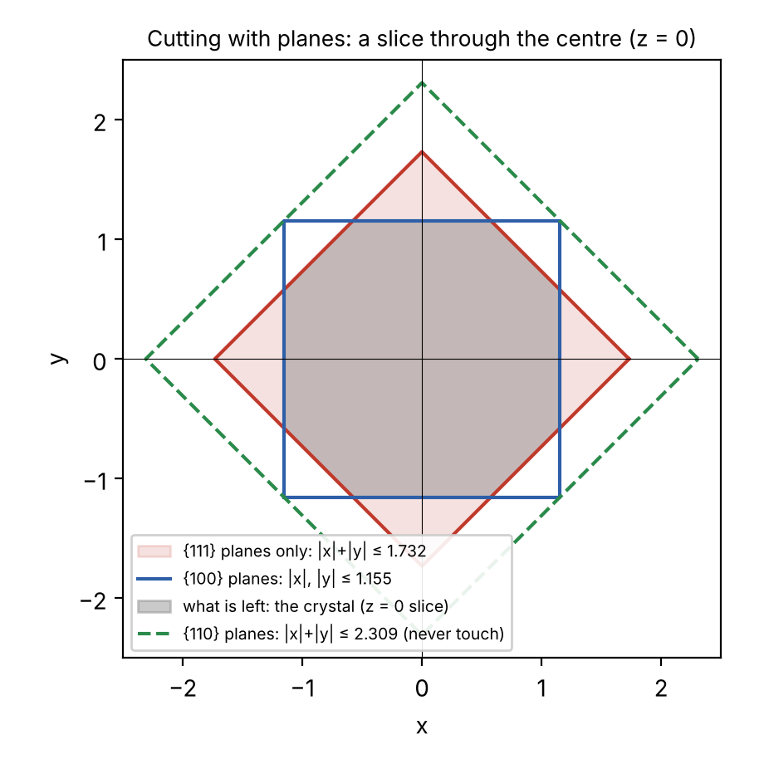
Figure 1. Section z = 0: {111} (red), {100} (blue), {110} (green, not touching); grey = crystal.
Answer
The crystal is bounded by 8 {111} and 6 {100} faces, with 24 vertices.

Problem 8. Name and measure the shape
Step 1. Edge lengths
square edge: (1.1547, 0.5774, 0) to (1.1547, 0, 0.5774) = √(0² + 0.5774² + 0.5774²) = 0.8165
hexagon–square edge: (1.1547, 0.5774, 0) to (0.5774, 1.1547, 0) = √(0.5774² + 0.5774² + 0²) = 0.8165
∴ all edges equal, s = 0.8165, s² = 0.6667, s³ = 0.5443.
Step 2. Euler check
V − E + F = 24 − 36 + 14 = 2 ✓
Step 3. Areas
square = s² = 0.6667; 6 squares = 6 × 0.6667 = 4.0000
hexagon = (3√3/2) s² = 2.5981 × 0.6667 = 1.7321; 8 hexagons = 8 × 1.7321 = 13.8564
A = 4.0000 + 13.8564 = 17.8564
{111} share = 13.8564 / 17.8564 = 0.776 = 77.6 %; {100} share = 4.0000 / 17.8564 = 0.224 = 22.4 %
Step 4. Volume
V = 8√2 s³ = 11.3137 × 0.5443 = 6.158
Step 5. Sphericity
Ψ = π^{1/3} (6V)^{2/3} / A
6V = 36.95; (36.95)^{2/3} = 11.09; π^{1/3} = 1.4646
Ψ = 1.4646 × 11.09 / 17.8564 = 0.910
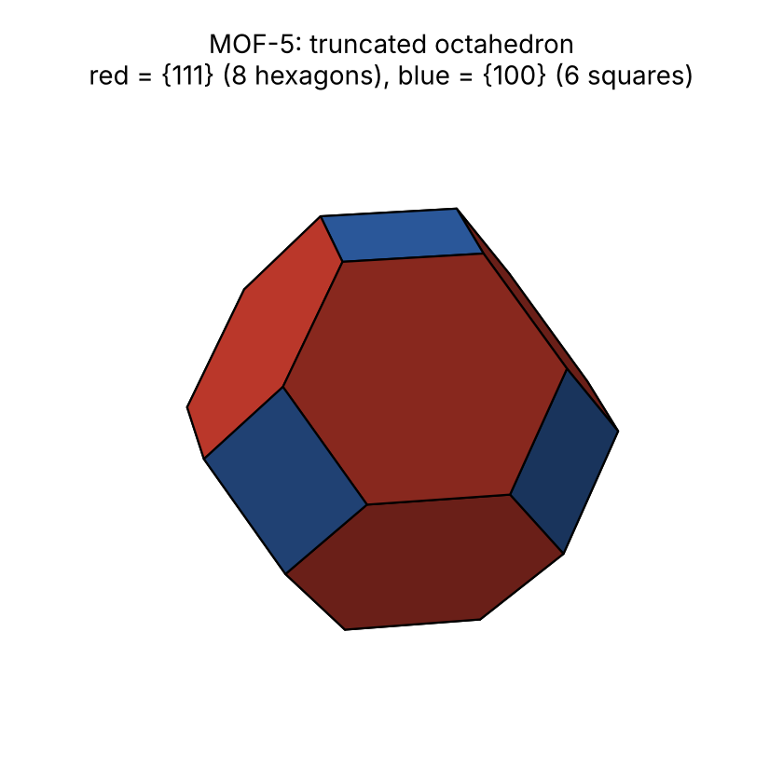
Figure 2. MOF-5: truncated octahedron. Red {111}, blue {100}.
Answer
Truncated octahedron: 8 hexagons {111} (77.6 %) + 6 squares {100} (22.4 %); A = 17.856, V = 6.158, Ψ = 0.910.
Program output: 77.6 % : 22.4 %, V = 6.1584, A = 17.8564, Ψ = 0.9099 ✓

Problem 9. Shape for any R111 / R100
To find: the ratios at which the shape changes.
Step 1. Octahedron: cube faces just reach the octahedron vertex
vertex (√3 R₁₁₁, 0, 0) on x = R₁₀₀ ⇒ √3 R₁₁₁ = R₁₀₀ ⇒ R₁₁₁/R₁₀₀ = 1/√3 = 0.577
Step 2. Cuboctahedron: octahedron faces pass through cube edge midpoints
(R₁₀₀, R₁₀₀, 0) on (x + y + z)/√3 = R₁₁₁ ⇒ 2R₁₀₀/√3 = R₁₁₁ ⇒ R₁₁₁/R₁₀₀ = 2/√3 = 1.155
Step 3. Cube: octahedron faces just reach the cube corner
(R₁₀₀, R₁₀₀, R₁₀₀) on (x + y + z)/√3 = R₁₁₁ ⇒ 3R₁₀₀/√3 = R₁₁₁ ⇒ R₁₁₁/R₁₀₀ = √3 = 1.732
R₁₁₁ / R₁₀₀ | Shape
≤ 0.577 | octahedron
0.577 – 1.155 | truncated octahedron
= 1.155 | cuboctahedron
1.155 – 1.732 | truncated cube
≥ 1.732 | cube
MOF-5: R₁₁₁/R₁₀₀ = 1/1.1547 = 0.866 ⇒ 0.577 < 0.866 < 1.155
Answer
MOF-5 lies in the truncated-octahedron range.

Part B. Mg-MOF-74 (file MgMOF-74.cif)

Problem 10. Cell and metric
Given
a = b = 26.136 Å, c = 6.942 Å, α = β = 90°, γ = 120°
9 atoms listed + 18 symmetry operations ⇒ 162 atoms; space group R-3 (18 operations found)
Step 1. Metric
G₁₁ = G₂₂ = a² = 26.136² = 683.09; G₃₃ = c² = 6.942² = 48.19
G₁₂ = a² cos 120° = 683.09 × (−0.5) = −341.55; G₁₃ = G₂₃ = 0
G ≠ a² I ⇒ not cubic (hexagonal axes)
Answer
Hexagonal axes; the cubic formula for d does not apply.

Problem 11. Plane spacings (hexagonal)
1/d² = (4/3)(h² + hk + k²)/a² + l²/c²
(2, −1, 0): h² + hk + k² = 4 − 2 + 1 = 3; 1/d² = (4/3)(3)/683.09 = 0.005856; d = 13.068 Å
(1, 0, 0): h² + hk + k² = 1; 1/d² = (4/3)/683.09 = 0.001952; d = 22.634 Å
(1, 0, 1): 1/d² = 0.001952 + 1/48.19 = 0.001952 + 0.020750 = 0.022702; d = 6.637 Å
(0, 0, 1): 1/d² = 1/48.19 = 0.020750; d = 6.942 Å
Answer
d₂₋₁₀ = 13.068, d₁₀₀ = 22.634, d₁₀₁ = 6.637, d₀₀₁ = 6.942 (Å)

Problem 12. Absences (R centring)
Given
Centring shifts (⅔, ⅓, ⅓) and (⅓, ⅔, ⅔)
Step 1. Bracket for the three copies
1 + e^{2πi(2h+k+l)/3} + e^{2πi(h+2k+2l)/3}
= 3 if −h + k + l ≡ 0 (mod 3); = 1 + ω + ω² = 0 otherwise (ω = e^{2πi/3})
Step 2. Apply
(hkl) | −h + k + l | Multiple of 3? | Result
(2, −1, 0) | −2 − 1 + 0 = −3 | yes | present, n = 1
(1, 0, 1) | −1 + 0 + 1 = 0 | yes | present, n = 1
(1, 0, 0) / (2, 0, 0) / (3, 0, 0) | −1 / −2 / −3 | no / no / yes | n = 3
(0, 0, 1) / (0, 0, 2) / (0, 0, 3) | 1 / 2 / 3 | no / no / yes | n = 3
Answer
{2-10}: n = 1; {101}: n = 1; {100}: n = 3; {001}: n = 3.

Problem 13. Effective spacings, distances and shape
Step 1. d_{eff} and R
{2-10}: d_{eff} = 13.068 / 1 = 13.068; R = 13.068 / 13.068 = 1.000
{100}: d_{eff} = 22.634 / 3 = 7.545; R = 13.068 / 7.545 = 1.732
{101}: d_{eff} = 6.637 / 1 = 6.637; R = 13.068 / 6.637 = 1.969
{001}: d_{eff} = 6.942 / 3 = 2.314; R = 13.068 / 2.314 = 5.647
Step 2. Sides
6 faces {2-10} at R = 1 around the c axis ⇒ hexagonal prism, half-width 1.000 (1.155 to the edges)
{100} at R = 1.732 > 1.155 ⇒ does not touch
Step 3. Ends
{001} at R = 5.647: far away. Ends closed by {101}: unit normal (0.254, 0.147, 0.956)
tip on the axis: z = R / n_{z} = 1.969 / 0.956 = 2.060
length = 2 × 2.060 = 4.12; width = 2 × 1.000 = 2.00; length / width = 2.06
Step 4. Habit (Zingg): principal radii a ≥ b ≥ c of the solid
a : b : c = 1 : 0.479 : 0.479
b/a = 0.479 < 2/3 = 0.667 ⇒ elongated; c/b = 1.000 ≥ 0.667 ⇒ not flat
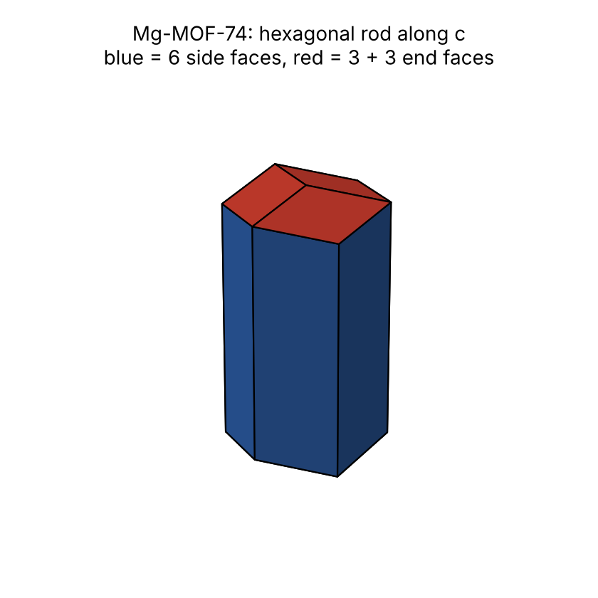
Figure 3. Mg-MOF-74: hexagonal rod along c. Blue {2-10} sides, red {101} ends.
Answer
Rod along [001] (the c axis): 6 sides {2-10} (77.4 %) + 6 end faces {101} (22.6 %); length / width ≈ 2.

Summary
 | MOF-5 | Mg-MOF-74
Cell | cubic, a = 25.866 Å | hexagonal axes, a = 26.136, c = 6.942 Å
Centring / group | F, Fm-3m (192 operations with centring; 48 rotations) | R, R-3 (18)
Largest d_{eff} | {111}: 14.934 Å | {2-10}: 13.068 Å
Faces on the crystal | {111} 77.6 %, {100} 22.4 % | {2-10} 77.4 %, {101} 22.6 %
Shape | truncated octahedron (compact) | hexagonal rod along c

